LECTURE NOTES
ON
COMPUTER ORGANIZATION
III B-Tech I Semester(JNTUH-R13)



COMPUTER SCIENCE & ENGINEERING
CMR ENGINEERING COLLEGE
KANDLAKOYA (V), MEDCHAL (M), R.R.DIST.

UNIT-1

- Instruction Formats One address.

Two address. Zero address.
Three addresses and comparison.

- Addressing modes with numeric examples.

- Program control. Status bit conditions.
Conditional branch instructions.

- Program interrupts.

- Types of Interrupts.

INSTRUCTION FORMATS

The physical and logical structure of computers is normally described in reference manuals provided with the system. Such manuals explain the internal construction of the CPU, including the processor registers available and their logical capabilities. They list all hardware-implemented instructions, specify their binary code format, and provide a precise definition of each instruction. A computer will usually have a variety of instruction code formats. It is the function of the control unit within the CPU to interpret each instruction code and provide the necessary control functions needed to process the instruction.

The format of an instruction is usually depicted in a rectangular box symbolizing the bits of the instruction as they appear in memory words or in a control register. The bits of the instruction are divided into groups called fields. The most common fields found in instruction formats are:

1 An operation code field that specifies the operation to be performed.

- An address field that designates a memory address or a processor registers.

- A mode field that specifies the way the operand or the effective address is determined.

Other special fields are sometimes employed under certain circumstances, as for example a field that gives the number of shifts in a shift-type instruction.

The operation code field of an instruction is a group of bits that define various processor operations, such as add, subtract, complement, and shift. The bits that define the mode field of an instruction code specify a variety of alternatives for choosing the operands from the given address. The various addressing modes that have been formulated for digital computers are presented in Sec. 5.5. In this section we are concerned with the address field of an instruction format and consider the effect of including multiple address fields is an instruction.

Operations specified by computer instructions are executed on some data stored in memory or processor registers, Operands residing in processor registers are specified with a register address. A register address is a binary number of k bits that defines one of 2^{k} registers in the CPU. Thus a CPU with 16 processor registers R0 through R15 will have a register address field of four bits. The binary number 0101, for example, will designate register R5.

Computers may have instructions of several different lengths containing varying number of addresses. The number of address fields in the instruction format of a computer depends on the internal organization of its registers. Most computers fall into one of three types of CPU organizations:

- Single accumulator organization.

- General register organization.

- Stack organization.

An example of an accumulator-type organization is the basic computer presented in Chap. 5. All operations are performed with an implied accumulator register. The instruction format in this type of computer uses one address field. For example, the instruction that specifies an arithmetic addition is defined by an assembly language instruction as ADD.

Where X is the address of the operand. The ADD instruction in this case results in the operation AC ← AC + M[X]. AC is the accumulator register and M[X] symbolizes the memory word located at address X.

An example of a general register type of organization was presented in Fig. 7.1. The instruction format in this type of computer needs three register address fields. Thus the instruction for an arithmetic addition may be written in an assembly language as

ADD | R1, R2, R3

To denote the operation R1 ← R2 + R3. The number of address fields in the instruction can be reduced from three

to two if the destination register is the same as one of the source registers. Thus the instruction

ADD | R1, R2

Would denote the operation R1 ← R1 + R2. Only register addresses for R1 and R2 need be specified in this

instruction.

Computers with multiple processor registers use the move instruction with a mnemonic MOV to symbolize a

transfer instruction. Thus the instruction

MOV R1, R2

Denotes the transfer R1 ← R2 (or R2 ← R1, depending on the particular computer). Thus transfer-type instructions

need two address fields to specify the source and the destination.

General register-type computers employ two or three address fields in their instruction format. Each address field

may specify a processor register or a memory word. An instruction symbolized by

ADD R1, X

Would specify the operation R1 ← R + M [X]. It has two address fields, one for register R1 and the other for the

memory address X.

The stack-organized CPU was presented in Fig. 8-4. Computers with stack organization would have PUSH and

POP instructions which require an address field. Thus the instruction

PUSH X

Will push the word at address X to the top of the stack. The stack pointer is updated automatically. Operation-type

instructions do not need an address field in stack-organized computers. This is because the operation is performed on the two items that are on top of the stack. The instruction

ADD

In a stack computer consists of an operation code only with no address field. This operation has the effect of popping the two top numbers from the stack, adding the numbers, and pushing the sum into the stack. There is no need to specify operands with an address field since all operands are implied to be in the stack.

Most computers fall into one of the three types of organizations that have just been described. Some computers combine features from more than one organization structure. For example, the Intel 808- microprocessor has seven CPU registers, one of which is an accumulator registerAs a consequence; the processor has some of the characteristics of a general register type and some of the characteristics of a accumulator type. All arithmetic and logic instruction, as well as the load and store instructions, use the accumulator register, so these instructions haveonly one address field. On the other hand, instructions that transfer data among the seven processor registers have a format that contains two register address fields. Moreover, the Intel 8080 processor has a stack pointer and instructions to push and pop from a memory stack. The processor, however, does not have the zero-address-type instructions which are characteristic of a stack-organized CPU.

To illustrate the influence of the number of addresses on computer programs, we will evaluate the arithmetic statement X = (A + B) ∗ (C + D).

.

Using zero, one, two, or three address instruction. We will use the symbols ADD, SUB, MUL, and DIV for the four arithmetic operations; MOV for the transfer-type operation; and LOAD and STORE for transfers to and from memory and AC register. We will assume that the operands are in memory addresses A, B, C, and D, and the result must be stored in memory at address X.

THREE-ADDRESS INSTRUCTIONS

Computers with three-address instruction formats can use each address field to specify either a processor register or

a memory operand. The program in assembly language that evaluates X = (A + B) ∗ (C + D) is shown below, together with comments that explain the register transfer operation of each instruction.

ADD | R1, A, B | R1 ← M [A] + M [B]
ADD | R2, C, D | R2 ← M [C] + M [D]
MUL | X, R1, R2 | M [X] ← R1 ∗ R2

It is assumed that the computer has two processor registers, R1 and R2. The symbol M [A] denotes the operand at memory address symbolized by A.

The advantage of the three-address format is that it results in short programs when evaluating arithmetic expressions. The disadvantage is that the binary-coded instructions require too many bits to specify three addresses. An example of a commercial computer that uses three-address instructions is the Cyber 170. The instruction formats in the Cyber computer are restricted to either three register address fields or two register address fields and one memory address field.

TWO-ADDRESS INSTRUCTIONS

Two address instructions are the most common in commercial computers. Here again each address field can specify either a processor register or a memory word. The program to evaluate X = (A + B) ∗ (C + D) is as follows:

MOV | R1, A | R1 | ← M [A]
ADD | R1, B | R1 | ← R1 + M [B]
MOV | R2, C | R2 | ← M [C]
ADD | R2, D | R2 | ← R2 + M [D]
MUL | R1, R2 | R1 | ← R1∗R2
MOV | X, R1 | M [X] ← R1

The MOV instruction moves or transfers the operands to and from memory and processor registers. The first symbol listed in an instruction is assumed to be both a source and the destination where the result of the operation is transferred.

ONE-ADDRESS INSTRUCTIONS

One-address instructions use an implied accumulator (AC) register for all data manipulation. For multiplication and division there is a need for a second register. However, here we will neglect the second and assume that the AC contains

the result of tall operations. The program to evaluate X = (A + B) ∗ (C + D) is

LOAD | A | AC ← M [A]
ADD | B | AC ← A [C] + M [B]

STORE | T | M [T] ← AC
LOAD | C | AC ← M [C]
ADD | D | AC ← AC + M [D]
MUL | T | AC ← AC ∗ M [T]
STORE | X | M [X] ← AC

All operations are done between the AC register and a memory operand. T is the address of a temporary memory location required for storing the intermediate result.

ZERO-ADDRESS INSTRUCTIONS

A stack-organized computer does not use an address field for the instructions ADD and MUL. The PUSH and POP

instructions, however, need an address field to specify the operand that communicates with the stack. The following program shows how X = (A + B) ∗ (C + D) will be written for a stack organized computer. (TOS stands for top of stack)

PUSH | A | TOS ← A
PUSH | B | TOS ← B
ADD |  | TOS ← (A + B)
PUSH | C | TOS ← C
PUSH | D | TOS ← D
ADD |  | TOS ← (C + D)
MUL |  | TOS ← (C + D) ∗ (A + B)
POP | X | M [X] ← TOS

To evaluate arithmetic expressions in a stack computer, it is necessary to convert the expression into reverse Polish notation. The name “zero-address” is given to this type of computer because of the absence of an address field in the computational instructions.

ADDRESSING MODES

The operation field of an instruction specifies the operation to be performed. This operation must be executed on some data stored in computer registers or memory words. The way the operands are chosen during program execution in dependent on the addressing mode of the instruction. The addressing mode of the instruction. The addressing mode specifies a rule for interpreting or modifying the address field of the instruction before the operand is actually referenced. Computers use addressing mode techniques for the purpose of accommodating one or both of the following provisions:

- To give programming versatility to the user by providing such facilities as pointers to Memory, counters for loop control, indexing of data, and program relocation

- To reduce the number of bits in the addressing field of the instruction.

3 The availability of the addressing modes gives the experienced assembly language programmer flexibility for writing programs that are more efficient with respect to the number of instructions and execution time.

To understand the various addressing modes to be presented in this section, it is imperative that we understand the basic operation cycle of the computer. The control unit of a computer is designed to go through an instruction cycle that is

divided into three major phases:

- Fetch the instruction from memory

- Decode the instruction.

- Execute the instruction.

There is one register in the computer called the program counter of PC that keeps track of the instructions in the program stored in memory. PC holds the address of the instruction to be executed next and is incremented each time an instruction is fetched from memory. The decoding done in step 2 determines the operation to be performed, the addressing mode of the instruction and the location of the operands. The computer then executes the instruction and returns to step 1 to fetch the next instruction in sequence.

In some computers the addressing mode of the instruction is specified with a distinct binary code, just like the operation code is specified. Other computers use a single binary code that designates both the operation and the mode of the instruction. Instructions may be defined with a variety of addressing modes, and sometimes, two or more addressing modes are combined in one instruction.

An example of an instruction format with a distinct addressing mode field is shown in Fig. 1. The operation code specified the operation to be performed. The mode field is sued to locate the operands needed for the operation. There may or may not be an address field in the instruction. If there is an address field, it may designate a memory address or a processor register. Moreover, as discussed in the preceding section, the instruction may have more than one address field, and each address field may be associated with its own particular addressing mode.

Although most addressing modes modify the address field of the instruction, there are two modes that need no address field at all. These are the implied and immediate modes.

1 Implied Mode: In this mode the operands are specified implicitly in the definition of theinstruction. For example, the instruction “complement accumulator” is an implied-mode instruction because the operand in the accumulator register is implied in the definition of the instruction. In fact, all register reference instructions that sue an accumulator are implied-mode instructions.

Op code | Mode | Address

Figure 1: Instruction format with mode field

Zero-address instructions in a stack-organized computer are implied-mode instructions since the operands are implied to be on top of the stack.

2 Immediate Mode: In this mode the operand is specified in the instruction itself. Inother words, an immediate-mode instruction has an operand field rather than an address field. The operand field contains the actual operand to be used in conjunction with the operation specified in the instruction. Immediate-mode instructions are useful for initializing registers to a constant value.

It was mentioned previously that the address field of an instruction may specify either a memory word or a processor register. When the address field specifies a processor register, the instruction is said to be in the register mode.

3 Register Mode: In this mode the operands are in registers that reside within the CPU.The particular register is selected from a register field in the instruction. A k-bit field can specify any one of 2^{k} registers.
4 Register Indirect Mode: In this mode the instruction specifies a register in the CPUwhose contents give the address of the operand in memory. In other words, the selected register contains the address of the operand rather than the

operand itself. Before using a register indirect mode instruction, the programmer must ensure that the memory address fo the operand is placed in the processor register with a previous instruction. A reference to the register is then equivalent to specifying a memory address. The advantage of a register indirect mode instruction is that the address field of the instruction sues fewer bits to select a register than would have been required to specify a memory address directly.

5 Auto increment or Auto decrement Mode: This is similar to the register indirect modeexcept that the register is incremented or decremented after (or before) its value is used to access memory. When the address stored in the register refers to a table of data in memory, it is necessary to increment or decrement the register after every access to the table. This can be achieved by using the increment or decrement instruction. However, because it is such a common requirement, some computers incorporate a special mode that automatically increments or decrements the content of the register after data access.

The address field of an instruction is used by the control unit in the CPU to obtain the operand from memory. Sometimes the value given in the address field is the address of the operand, but sometimes it is just an address from which the address of the operand is calculated. To differentiate among the various addressing modes it is necessary to distinguish between the address part of the instruction and the effective address used by the control when executing the instruction. The effective address is defined to be the memory address obtained from the computation dictated by the given addressing mode. The effective address is the address of the operand in a computational-type instruction. It is the address where control branches in response to a branch-type instruction. We have already defined two addressing modes in previous chapter.

6 Direct Address Mode: In this mode the effective address is equal to the address part ofthe instruction. The operand resides in memory and its address is given directly by the address field of the instruction. In a branch-type instruction the address field specifies the actual branch address.

7 Indirect Address Mode: In this mode the address field of the instruction gives theaddress where the effective address is stored in memory. Control fetches the instruction from memory and uses its address part to access memory again to read the effective address.

8 Relative Address Mode: In this mode the content of the program counter is added to theaddress part of the instruction in order to obtain the effective address. The address part of the instruction is usually a signed number (in 2’s complement representation) which can be either positive or negative. When this number is added to the content of the program counter, the result produces an effective address whose position in memory is relative to the address of the next instruction. To clarify with an example, assume that the program counter contains the number 825 and the address part of the instruction contains the number 24. The instruction at location 825 is read from memory during the fetch phase and the program counter is then incremented by one to 826 + 24 = 850. This is 24 memory locations forward from the address of the next instruction. Relative addressing is often used with branch-type instructions when the branch address is in the area surrounding the instruction word itself. It results in a shorter address field in the instruction format since the relative address can be specified with a smaller number of bits compared to the number of bits required to designate the entire memory address.

9 Indexed Addressing Mode: In this mode the content of an index register is added to theaddress part of the instruction to obtain the effective address. The index register is a special CPU register that contains an index value. The address field of the instruction defines the beginning address of a data array in memory. Each operand in the array is stored in memory relative to the beginning address. The distance between the beginning address and the address of the operand is the index value stores in the index register. Any operand in the array can be accessed with the same instruction provided that the index register contains the correct index value. The index register can be incremented to facilitate access to consecutive operands. Note that if an index-type instruction does not include an address field in its format, the instructionconverts to the register indirect mode of operation. Some computers dedicate one CPU register to function solely as an index register. This register is involved implicitly when the index-mode instruction is used. In computers with many processor registers, any one of the CPU registers can contain the index number. In such a case the register must be specified explicitly in a register field within the instruction format.

10 Base Register Addressing Mode: In this mode the content of a base register is added tothe address part of the instruction to obtain the effective address. This is similar to the indexed addressing mode except that the register is now called a base register instead of an index register. The difference between the two modes is in the way they are used rather than in the way that they are computed. An index register is assumed to hold an index number that is relative to the address part of the instruction. A base register is assumed to hold a base address and the address field of the instruction gives a displacement relative to this base address. The base register addressing mode is used in computers to facilitate the relocation of programs in memory. When programs and data are moved from one segment of memory to another, as required in multiprogramming systems, the address values of the base register requires updating to reflect the beginning of a new memory segment.

Numerical Example

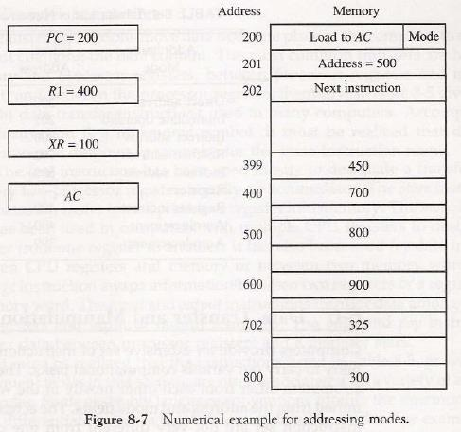
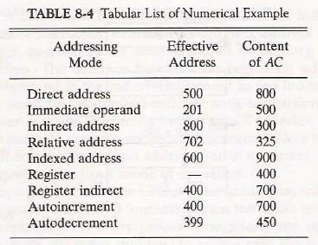

Program Control

Instructions are always stored in successive memory locations. When processed in the CPU, the instructions are fetched from consecutive memory locations and executed

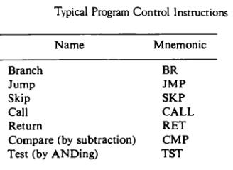

Status Bit Conditions

It is sometimes convenient to supplement the ALU circuit in the CPU with a status register where status bit conditions can be stored for further analysis. Status bits are also called condition-code bits or flag bits.

The four status bits are symbolized by C, S, Z, and V. The bits are set or cleared as a result of an operation performed in the ALU.

- Bit C (carry) is set to 1 if the end cany C8 is 1. It is cleared to 0 if the canyisO.

- Bit S (sign) is set to 1 if the highest-order bit F? is 1. It is set to 0 if the bit is 0.

- Bit Z (zero) is set to 1 if the output of the ALU contains all 0's. It is cleared to 0 otherwise. In other words, Z = 1 if the output is zero and Z = 0 if the output is not zero.

4. Bit V (overflow) is set to 1 if the exclusive-OR of the last two carries is equal to 1, and Cleared to 0 otherwise. This is the condition for an overflow when negative numbers are In 2's complement.

For the 8-bit ALU, V = 1 if the output is greater than +127 or less than -128.

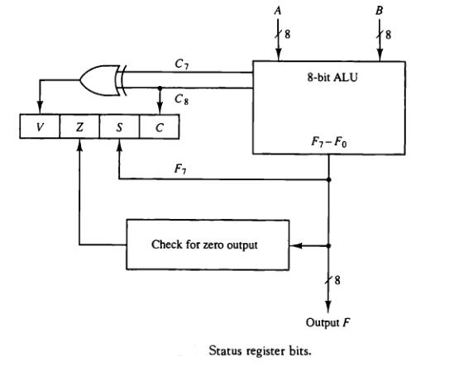

Conditional Branch Instructions

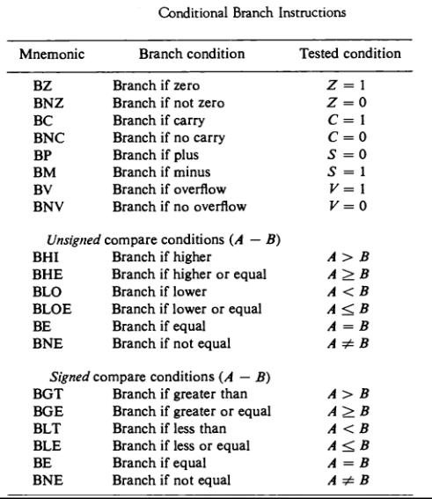
Some computers consider the C bit to be a borrow bit after a subtraction operation A — B. A Borrow does not occur if

A ^ B, but a bit must be borrowed from the next most significant Position if A < B. The condition for a borrow is the complement of the carry obtained when the subtraction is done by taking the 2's complement of B. For this reason, a processor that considers the C bit to be a borrow after a subtraction will complement the C bit after adding the 2's complement of the subtrahend and denote this bit a borrow.

Subroutine Call and Return

- A subroutine is a self-contained sequence of instructions that performs a given computational task.

  - The instruction that transfers program control to a subroutine is known by different names. The most common names used are call subroutine, jump to subroutine, branch to subroutine, or branch and save address.

- The instruction is executed by performing two operations:

- The address of the next instruction available in the program counter (the return address) is Stored in a temporary location so the subroutine knows where to return

- Control is transferred to the beginning of the subroutine.

Different computers use a different temporary location for storing the return address.

- Some store the return address in the first memory location of the subroutine, some store it in a fixed location in memory, some store it in a processor register, and some store it in a memory stack. The most efficient way is to store the return address in a memory stack. The advantage of using a stack for the return address is that when a succession of subroutines is called, the sequential return addresses can be pushed into the stack. The return from subroutine instruction causes the stack to pop and the contents of the top of the stack are transferred to the program counter.

- A subroutine call is implemented with the following micro operations: SP ←SP - 1 Decrement stack pointer

M [SP] ←PC Push content of PC onto the stack

PC ← effective address Transfer control to the subroutine

- If another subroutine is called by the current subroutine, the new return address is pushed into The stack and so on. The instruction that returns from the last subroutine is implemented by the Micro operations:

PC←M [SP] Pop stack and transfer to PC SP ←SP + 1 Increment stack pointer

Program Interrupt

- Program interrupt refers to the transfer of program control from a currently running program to another service program as a result of an external or internal generated request. Control returns to the original program after the service program is executed.

- The interrupt procedure is, in principle, quite similar to a subroutine call except for three Variations:

(1) The interrupt is usually initiated by an internal or external signal rather than from the Execution of an instruction (except for software interrupt as explained later);

(2) The address of the interrupt service program is determined by the hardware rather than from the address field of an instruction.

(3) An interrupt procedure usually stores all the information

- The state of the CPU at the end of the execute cycle (when the interrupt is recognized) is determined

From:

- The content of the program counter

- The content of all processor registers

- The content of certain status conditions

  - Program status word the collection of all status bit conditions in the CPU is sometimes called a program status word or PSW. The PSW is stored in a separate hardware register and contains the status information that characterizes the state of the CPU.

Types of Interrupts

- There are three major types of interrupts that cause a break in the normal execution of a

Program. They can be classified as:

- External interrupts

- Internal interrupts

- Software interrupts

  - External interrupts come from input-output (I/O) devices, from a timing device, from a circuit monitoring the power supply, or from any other external source.

  - Internal interrupts arise from illegal or erroneous use of an instruction or data. Internal interrupts are also called traps. Examples of interrupts caused by internal error conditions are register overflow, attempt to divide by zero, an invalid operation code, stack overflow, and protection violation.

  - A software interrupt is initiated by executing an instruction. Software interrupt is a special call instruction that behaves like an interrupt rather than a subroutine call. It can be used by the programmer to initiate an interrupt procedure at any desired point in the program.

UNIT-2

I/O Vs memory Bus

Isolated Vs Memory-Mapped I/O

Asynchronous data Transfer

Strobe control Hand Shaking
Asynchronous Serial transfer

Asynchronous Communication interface Modes of transfer

Programmed I/O

Interrupt Initiated I/O

DMA DMA controller DMA Transfer

IOP-CPU-IOP Communication

Intel 8089 IOP.

INPUT-OUTPUT INTERFAC

Input-output interface provides a method for transferring information between internal storage and external I/O devices. Peripherals connected to a computer need special communication links for interfacing them with the central processing unit. The purpose of the communication link is to resolve the differences that exist between the central computer and each peripheral. The major differences are:

- Peripherals are electromechanical and electromagnetic devices and their manner of operation is different from the operation of the CPU and memory, which are electronic devices. Therefore, a conversion of signal values may be required.

- The data transfer rate of peripherals is usually slower than the transfer rate of the CPU, and consequently, a synchronization mechanism may be need.

- Data codes and formats in peripherals differ from the word format in the CPU and memory.

- The operating modes of peripherals are different from each other and each must be controlled so as not to disturb the operation of other peripherals connected to the CPU.

To resolve these differences, computer systems include special hardware components between the CPU and peripherals to supervise and synchronize all input and output transfers. These components are called interface units because they interface between the processor bus and the peripheral device. In addition, each device may have its own controller that supervises the operations of the particular mechanism in the peripheral.

I/O BUS AND INTERFACE MODULES

A typical communication link between the processor and several peripherals is shown in below Fig.The I/O bus consists of data lines, address lines, and control lines. The magnetic disk, printer, and terminal are employed in practically any general-purpose computer. The magnetic tape is used in some computers for backup storage. Each peripheral device has associated with it an interface unit. Each interface decodes the address and control received from the I/O bus, interprets them for the peripheral, and provides signals for the peripheral controller. It also synchronizes the data flow and supervises the transfer between peripheral and processor. Each peripheral has its own controller that operates the particular electromechanical device. For example, the printer controller controls the paper motion, the print timing, and the selection of printing characters. A controller may be housed separately or may be physically integrated with the peripheral.

The I/O bus from the processor is attached to all peripheral interfaces. To communicate with a particular device, the processor places a device address on the address lines. Each interface attached to the I/O bus contains an address decoder that monitors the address lines. When the interface detects its own address, it activates the path between the bus lines and the device that it controls. All peripherals whose address does not correspond to the address in the bus are disabled their interface.

At the same time that the address is made available in the address lines, the processor provides a function code in the control lines. The interface selected responds to the function code and proceeds to execute it.

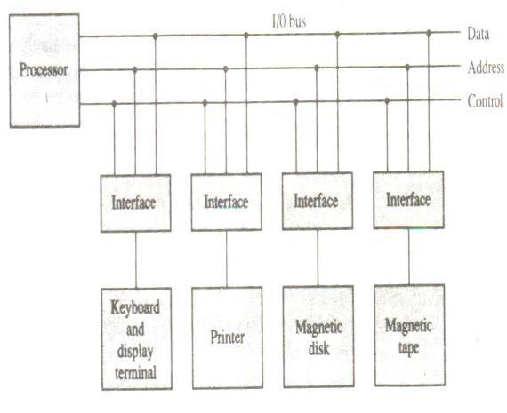

Figure -Connection of I/O bus to input devices.

The function code is referred to as an I/O command and is in essence an instruction that is executed in the interface and its attached peripheral unit. The interpretation of the command depends on the peripheral that the processor is addressing. There are four types of commands that an interface may receive. They are classified as control, status, status, data output, and data input.

A control command is issued to activate the peripheral and to inform it what to do. For example, a magnetic tape unit may be instructed to backspace the tape by one record, to rewind the tape, or to start the tape moving in the forward direction. The particular control command issued depends on the peripheral, and each peripheral receives its own distinguished sequence of control commands, depending on its mode of operation.

A status command is used to test various status conditions in the interface and the peripheral. For example, the computer may wish to check the status of the peripheral before a transfer is initiated. During the transfer, one or more errors may occur which are detected by the interface. These errors are designated by setting bits in a status register that the processor can read at certain intervals.

A data output command causes the interface to respond by transferring data from the bus into one of its registers. Consider an example with a tape unit. The computer starts the tape moving by issuing a control command. The processor then monitors the status of the tape by means of a status command. When the tape is in the correct position, the processor issues a data output command. The interface responds to the address and command and transfers the information from the data lines in the bus to its buffer register. The interface then communicates with the tape controller and sends the data to be stored on tape.

The data input command is the opposite of the data output. In this case the interface receives an item of data from the peripheral and places it in its buffer register. The processor checks if data are available by means of a status command and then issues a data input command. The interface places the data on the data lines, where they are accepted by the processor.

I/O VERSUS MEMORY BUS

In addition to communicating with I/O, the processor must communicate with the memory unit. Like the I/O bus, the memory bus contains data, address, and read/write control lines. There are three ways that computer buses can be used to communicate with memory and I/O:

- Use two separate buses, one for memory and the other for I/O.

- Use one common bus for both memory and I/O but have separate control lines for each.

- Use one common bus for memory and I/O with common control lines.

In the first method, the computer has independent sets of data, address, and control buses, one for accessing memory and the other for I/O. This is done in computers that provide a separate I/O processor (IOP) in addition to the central processing unit (CPU). The memory communicates with both the CPU and the IOP through a memory bus. The IOP communicates also with the input and output devices through a separate I/O bus with its own address, data and control lines. The purpose of the IOP is to provide an independent pathway for the transfer of information between external devices and internal memory.

ISOLATED VERSUS MEMORY-MAPPED I/O

Many computers use one common bus to transfer information between memory or I/O and the CPU. The distinction between a memory transfer and I/O transfer is made through separate read and write lines. The CPU specifies whether the address on the address lines is for a memory word or for an interface register by enabling one of two possible read or write lines. The I/O read and I/O writes control lines are enabled during an I/O transfer. The memory read and memory write control lines are enabled during a memory transfer. This configuration isolates all I/O interface addresses from the addresses assigned to memory and is referred to as the isolated I/O method for assigning addresses in a common bus.

In the isolated I/O configuration, the CPU has distinct input and output instructions, and each of these instructions is associated with the address of an interface register. When the CPU fetches and decodes the operation code of an input or output instruction, it places the address associated with the instruction into the common address lines. At the same time, it enables the I/O read (for input) or I/O write (for output) control line. This informs the external components that are attached to the common bus that the address in the address lines is for an interface register and not for a memory word. On the other hand, when the CPU is fetching an instruction or an operand from memory, it places the memory address on the address lines and enables the memory read or memory write control line. This informs the external components that the address is for a memory word and not for an I/O interface.

The isolated I/O method isolates memory word and not for an I/O addresses so that memory address values are not affected by interface address assignment since each has its own address space. The other alternative is to use the same address space for both memory and I/O. This is the case in computers that employ only one set of read and write signals and do not distinguish between memory and I/O addresses. This configuration is referred to as memory-mapped I/O. The computer treats an interface

Register as being part of the memory system. The assigned addresses for interface registers cannot be used for memory words, which reduce the memory address range available.

In a memory-mapped I/O organization there are no specific inputs or output instructions. The CPU can manipulate I/O data residing in interface registers with the same instructions that are used to manipulate memory words. Each interface is organized as a set of registers that respond to read and write requests in the normal address space. Typically, a segment of the total address space is reserved for interface registers, but in general, they can be located at any address as long as

There is not also a memory word that responds to the same address.

Computers with memory-mapped I/O can use memory-type instructions to access I/O data. It allows the computer to use the same instructions for either input-output transfers or for memory transfers. The advantage is that the load and store instructions used for reading and writing from memory can be used to input and output data from I/O registers. In a typical computer, there are more memory-reference instructions than I/O instructions. With memory-mapped I/O all instructions that refer to memory are also available for I/O.

ASYNCHRONOUS DATA TRANSFER

The internal operations in a digital system are synchronized by means of clock pulses supplied by a common pulse generator. Clock pulses are applied to all registers within a unit and all data transfers among internal registers occur simultaneously during the occurrence of a clock pulse. Two units, such as a CPU and an I/O interface, are designed independently of each other. If the registers in the interface share a common clock with the CPU registers, the transfer between the two units is said to be synchronous. In most cases, the internal timing in each unit is independent from the other in that each uses its own private clock for internal registers. In that case, the two units are said to be asynchronous to each other. This approach is widely used in most computer systems.

Asynchronous data transfer between two independent units requires that control signals be transmitted between the communicating units to indicate the time at which data is being transmitted. One way of achieving this is by means of a strobe pulse supplied by one of the units to indicate to the other unit when the transfer has to occur. Another method commonly used is to accompany each data item being transferred with a control signal that indicates the presence ofdata in the bus. The unit receiving the data item responds with another control signal to acknowledge receipt of the data. This type of agreement between two independent units is referred to as handshaking.

The strobe pulse method and the handshaking method of asynchronous data transfer are not restricted to I/O transfers. In fact, they are used extensively on numerous occasions requiring the transfer of data between two independent units. In the general case we consider the transmitting unit as the source and the receiving unit as the destination. For example, the CPU is the source unit during an output or a write transfer and it is the destination unit during an input or a read transfer. It is customary to specify the asynchronous transfer between two independent units by means of a timing diagram that shows the timing relationship that must exist between the control signals and the data in buses. The sequence of control during an asynchronous transfer depends on whether the transfer is initiated by the source or by the destination unit.

STROBE CONTROL

The strobe control method of asynchronous data transfer employs a single control line to time each transfer. The strobe may be activated by either the source or the destination unit. Figure-(a) shows a source-initiated transfer.

 |  |  |  | Data bus
 | Source |  |  |  |  |  |  |  | Destination
 | unit |  |  | Strobe |  |  |  |  | unit
 |  |  |  | (a) Block diagram
Data |  |  |  |  | Valid data



Strobe

(b) Timing diagram

Figure- Source-initiated strobe for data transfer.

The data bus carries the binary information from source unit to the destination unit. Typically, the bus has multiple lines to transfer an entire byte or word. The strobe is a single line that informs the destination unit when a valid data word is available in the bus.

As shown in the timing diagram of Fig.-(b), the source unit first places the data on the data bus. After a brief delay to ensure that the data settle to a steady value, the source activates the strobe pulse. The information on the data bus and the strobe signal remain in the active state for a sufficient time period to allow the destination unit to receive the data. Often, the destination unit uses the falling edge of the strobe pulse to transfer the contents of the data bus into one of its internal registers. The source removes the data from the bus a brief period after it disables its strobe pulse. Actually, the source does not have to change the information in the data bus. The fact that the strobe signal is disabled indicates that the data bus does not contain valued data. New valid data will be available only after the strobe is enabled again.

Below Figure shows a data transfer initiated by the destination unit. In this case the destination unit activates the strobe pulse, informing the source to provide the data. The source unit responds by placing the requested binary information on the data bus. The data must be valid and remain in the bus long enough for the destination unit to accept it. The falling edge of the Strobe pulse can beused again to trigger a destination register. The destination unit then disables the strobe. The source removes the data from the bus after a predetermined time interval.

In many computers the strobe pulse is actually controlled by the clock pulses in the CPU. The CPU is always in control of the buses and informs the external units how to transfer data. For example, the strobe of above Fig. could be a memory -write control signal from the CPU to a memory unit. The source, being the CPU, places a word on the data bus and informs the memory units.

 |  |  |  |  |  |  | Data bus
 |  | Source |  |  |  |  |  |  |  |  |  | Destination
 |  |  |  |  |  |  | Strobe |  |  |  |  | Destination
 |  | unit |  |  |  |  |  |  |  |  |  | unit
 |  |  |  |  |  | (a) Block diagram |  |  |  |  |  | unit
Data |  |  |  |  |  |  | Valid data

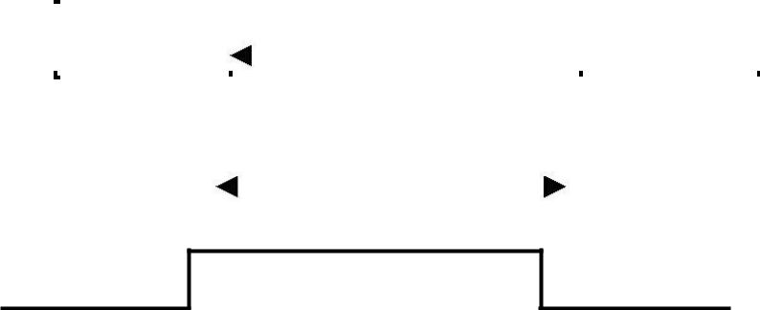
Strobe

(b) Timing diagram

Figure -Destination-initiated strobe for data transfer.

This is the destination, that this is a write operation. Similarly, the strobe of Figure -Destination-initiated strobe for data transfer. Could be a memory -read control signal from the CPU to a memory unit. The destination, the CPU, initiates the read operation to inform the memory, which is the source, to place a selected word into the data bus.

The transfer of data between the CPU and an interface unit is similar to the strobe transfer just described. Data transfer between an interface and an I/O device is commonly controlled by a set of handshaking lines.

HANDSHAKING

The disadvantage of the strobe method is that the source unit that initiates the transfer has no way of knowing whether the destination unit has actually received the data item that was placed in the bus. Similarly, a destination unit that initiates the transfer has no way of knowing whether the source unit has actually placed the data on the bus,. The handshake method solves this problem by introducing a second control signal that provides a reply to the unit that initiates the transfer. The basic principle of the two-write handshaking method of data transfer is as follows. One control line is in the same direction as the data flow in the bus from the source to the destination. It is used by the source unit to inform the destination unit whether there are valued data in the bus. The other control line is in the other direction from the destination to the

source. It is used by the destination unit to inform the source whether it can accept data. The sequence of control during the transfer depends on the unit that initiates the transfer.

Figure shows the data transfer procedure when initiated by the source. The two handshaking lines are data valid, which is generated by the source unit, and data accepted, generated by the destination unit. The timing diagram shows the exchange of signals between the two units. The sequence of events listed in part (c) shows the four possible states that the system can be at any given time. The source unit initiates the transfer by placing the data on the bus and enabling its data valid signal. The data accepted signal is activated by the destination unit after it accepts the data from the bus. The source unit then disables its data valid signal, which invalidates the data on the bus. The destination unit then disables its data accepted signal and the system goes into its initial state. The source dies not send the next data item until after the destination unit shows its readiness to accept new data by disabling its data accepted signal. This scheme allows arbitrary delays from one state to the next and permits each unit to respond at its own data transfer rate. The rate of transfer is determined by the slowest unit.

The destination -initiated transfer using handshaking lines is shown in Fig. Note that the name of the signal generated by the destination unit has been changed to ready from data to reflect its new meaning. The source unit in this case does not place data on the bus until after it receives the ready for data signal from the destination unit. From there on, the handshaking procedure follows the same pattern as in the source-initiated case. Note that the sequence of events in both cases would be identical if we consider the ready for data signal as the complement of data accepted. In fact, the only difference between the source-initiated and the destination-initiated transfer is in their choice of initial state.

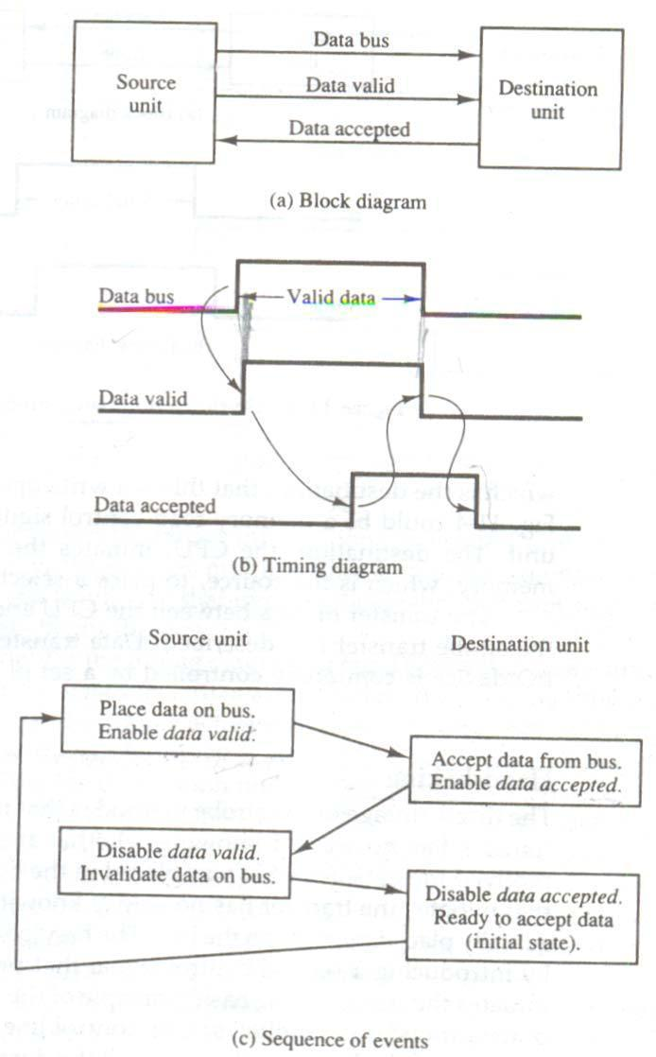

Figure -Source-initiated transfer using handshaking.

Figure-Destination-initiated transfer using handshaking.

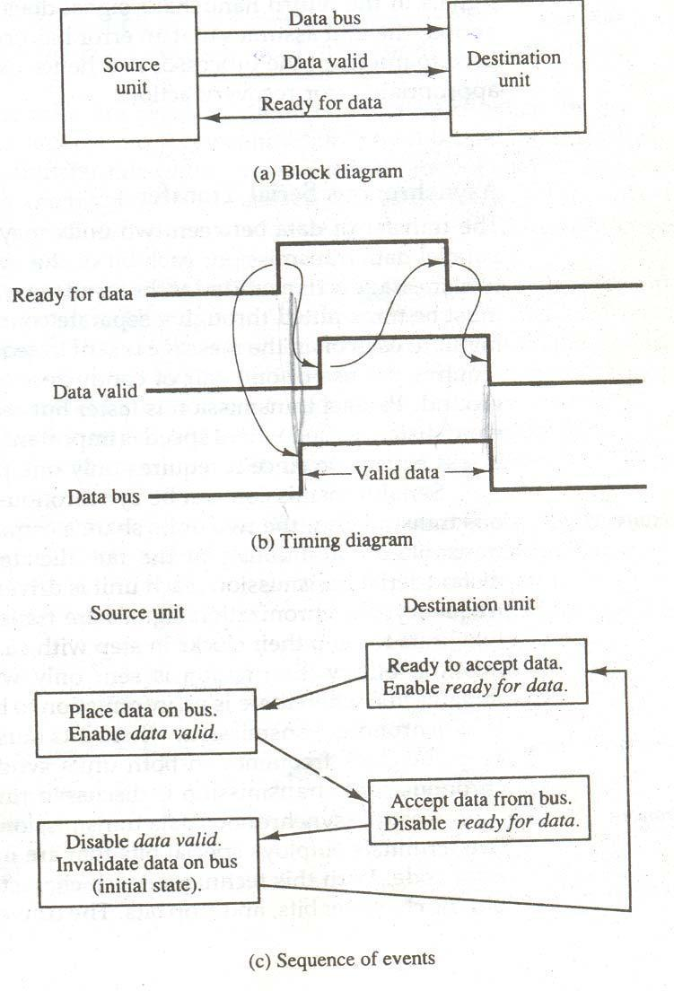

The handshaking scheme provides a high degree of flexibility and reality because the successful completion of a data transfer relies on active participation by both units. If one unit is faulty, the data transfer will not be completed. Such an error can be detected by means of a timeout mechanism, which produces an alarm if the data transfer is not completed within a predetermined time. The timeout is implemented by means of an internal clock that starts counting time when the unit enables one of its handshaking control signals. If the return handshake signal does not respond within a given time period, the unit assumes that an error has occurred. The timeout signal can be used to interrupt the processor and hence execute a service routine that takes appropriates error recovery action.

ASYNCHRONOUS SERIAL TRANSFER

The transfer of data between two units may be done in parallel or serial. In parallel data transmission, each bit of the message has its own path and the total message is transmitted at the same time. This means that an n-bit message must be transmitted through in n separate conductor paths. In serial data transmission, each bit in the message is sent in sequence one at a time. This method requires the use of one pair of conductors or one conductor and a common ground. Parallel transmission is faster but requires many wires. It is used for short distances and where speed is important. Serial transmission is slower but is less expensive since it requires only one pair of conductors.

Serial transmission can be synchronous or asynchronous. In synchronous transmission, the two units share a common clock frequency and bits are transmitted continuously at the rate dictated by the clock pulses. In long-distant serial transmission, each unit is driven by a separate clock of the same frequency. Synchronization signals are transmitted periodically between the two units to keep their clocks in step with each other. In asynchronous transmission, binary information is sent only when it is available and the line remains idle when there is no information to be transmitted. This is

In contrast to synchronous transmission, where bits must be transmitted continuously to deep the clock frequency in both units synchronized with each other.

Serial asynchronous data transmission technique used in many interactive terminals employs special bits that are inserted at both ends of the character code. With this technique, each character consists of three parts: a start bit, the character bits, and stop bits. The convention is that the transmitter rests at the 1-state when no characters are transmitted. The first bit, called the start bit, is always a 0 and is used to indicate the beginning of a character. The last bit called the stop bit is always a 1. An example of this format is shown in below Fig.

A transmitted character can be detected by the receiver from knowledge of the transmission rules:

- When a character is not being sent, the line is kept in the 1-state.

- The initiation of a character transmission is detected from the start bit, which is always 0.

- The character bits always follow the start bit.

- After the last bit of the character is transmitted, a stop bit is detected when the line returns To the 1-state for at least one bit time.

Using these rules, the receiver can detect the start bit when the line gives from 1 to 0. A clock in the receiver

examines the line at proper bit times. The receiver knows the transfer rate of the bits and the number of character bits to accept. After the character bits are transmitted, one or two stop bits are sent. The stop bits are always in the 1-state and frame the end of the character to signify the idle or wait state.

At the end of the character the line is held at the 1-state for a period of at least one or two bit times so that both the transmitter and receiver can resynchronize. The length of time that the line stays in this state depends on the amount of time required for the equipment to resynchronize. Some older electromechanical terminals use two stop bits, but newer terminals use one stop bit. The line remains in the 1-state until another character is transmitted. The stop time ensures that a new character will not follow for one or two bit times.

As illustration, consider the serial transmission of a terminal whose transfer rate is 10 characters per second. Each transmitted character consists of a start bit, eight information bits, of

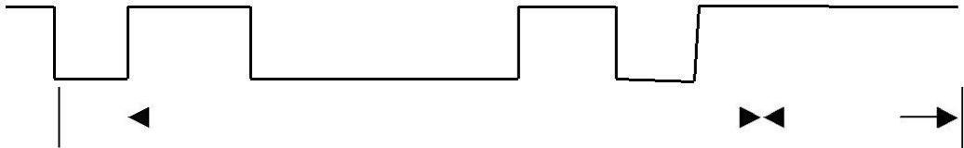

Start |  |  | Character bits |  |  |  |  | Stop
 |  |  | Character bits |  |  |  |  | bits

Figure - Asynchronous serial transmission

a start bit, eight information bits, and two stop bits, for a total of 11 bits. Ten characters per second means that each character takes 0.1s for transfer. Since there are 11 bits to be transmitted, it follows that the bit time is 9.09 ms.The baud rate is defined as the rate at which serial information is transmitted and is equivalent to the data transfer in bits per second. Ten characters per second with an 11-bit format has a transfer rate of 110 baud.

The terminal has a keyboard and a printer. Every time a key is depressed, the terminal sends 11 bits serially along a wire. To print a character. To print a character in the printer, an 11-bit message must be received along another wire. The terminal interface consists of a transmitter and a receiver. The transmitter accepts an 8-bit character room the computer and proceeds to send a serial 11-bit message into the printer line. The receiver accepts a serial 11-bit message from the keyboard line and forwards the 8-bit character code into the computer. Integrated circuits are available which are specifically designed to provide the interface between computer and similar interactive terminals. Such a circuit is called an asynchronous communication interface or a universal asynchronous receiver-transmitter (UART).

Asynchronous Communication Interface

Fig shows the block diagram of an asynchronous communication interface is shown in Fig. It acts as both a transmitter and a receiver. The interface is initialized for a particular mode of transfer by means of a control byte that is loaded into its control register. The transmitter register accepts a data byte from the CPU through the data bus. This byte is transferred to a shift register for serial transmission. The receiver portion receives serial information into an- other shift register, and when a complete data byte is accumulated, it is transferred to the receiver register. The CPU can select the receiver register to read the byte through the data bus. The bits in the status register are used for input and output flags and for recording certain errors that may occur during the transmission. The CPU can read the status register to check the status of the flag bits and to determine if any errors have occurred. The chip select and the read and write control lines communicate with the CPU. The chip select (CS) input is used to select the interface through the address bus. The register select (RS) is associated with the read (RD)andwrites (WR) controls. Two registers are write-only and two are read-only. The register selected is a function of the RS value and the RD and WR status, as listed in the table accompanying the diagram.

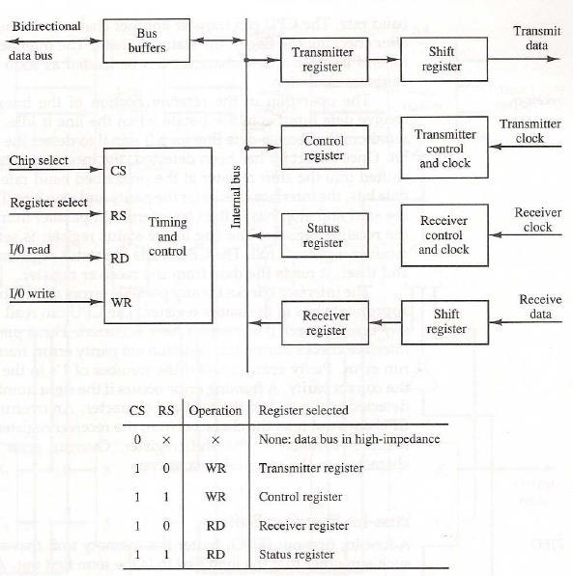
MODES OF TRANSFER

Binary information received from an external device is usually stored in memory for later processing. Information transferred from the central computer into an external device originates in the memory unit. The CPU merely executes the I/O instructions and may accept the data temporarily, but the ultimate source or destination is the memory unit. Data transfer between the central computer and I/O devices may be handled in a variety of modes. Some modes use the CPU as

An intermediate path; other transfer the data directly to and from the memory unit. Data transfer to and from peripherals may be handled in one of three possible modes:

    - Programmed I/O

  - Interrupt-initiated I/O

- Direct memory access (DMA)

Programmed I/O operations are the result of I/O instructions written in the computer program. Each data item transfer is initiated by an instruction in the program. Usually, the transfer is to and from a CPU register and peripheral. Other instructions are needed to transfer the data to and from CPU and memory. Transferring data under program control requires constant monitoring of the peripheral by the CPU. Once a data transfer is initiated, the CPU is required to monitor the interface to see when a transfer can again be made. It is up to the programmed instructions executed in the CPU to keep close tabs on everything that is taking place in the interface unit and the I/O device.

In the programmed I/O method, the CPU stays in a program loop until the I/O unit indicates that it is ready for data transfer. This is a time-consuming process since it keeps the processor busy needlessly. It can be avoided by using an interrupt facility and special commands to inform the interface to issue an interrupt request signal when the data are available from thedevice. In the meantime the CU can proceed to execute another program. The interface meanwhile keeps monitoring the device. When the interface determines that the device is ready for data transfer, it generates an interrupt request to the computer. Upon detecting the external interrupt signal, the CPU momentarily stops the task it is processing, branches to a service program to process the I/O transfer, and then returns to the task it was originally performing.

Transfer of data under programmed I/O is between CPU and peripheral. In direct memory access (DMA), the interface transfers data into and out of the memory unit through the memory bus. The CPU initiates the transfer by supplying the interface with the starting address and the number of words needed to be transferred and then proceeds to execute other tasks. When the transfer is made, the DMA requests memory cycles through the memory bus. When the request is granted by the memory controller, the DMA transfers the data directly into memory. The CPU merely delays its memory access operation to allow the direct memory I/O transfer. Since peripheral speed is usually slower than processor speed, I/O-memory transfers are infrequent compared to processor access to memory.

Many computers combine the interface logic with the requirements for direct memory access into one unit and call it an I/O processor (IOP). The IOP can handle many peripherals through a DMPA and interrupt facility. In such a system, the computer is divided into three separate modules: the memory unit, the CPU, and the IOP.

EXAMPLE OF PROGRAMMED I/O

In the programmed I/O method, the I/O device dies not have direct access to memory. A transfer from an I/O device to memory requires the execution of several instructions by the CPU, including an input instruction to transfer the data from the device to the CPU, and a store instruction to transfer the data from the CPU to memory. Other instructions may be needed to verify that the data are available from the device and to count the numbers of words transferred.

An example of data transfer from an I/O device through an interface into the CPU is shown in below Fig. The device transfers bytes of data one at a time as they are available. When a byte of data is available, the device places it in the I/O

bus and enables its data valid line. The interface accepts the byte into its data register and enables the data accepted line. The interface sets it in the status register that we will refer to as an F or “flag” bit. The device can now disable the data valid line, but it will not transfer another byte until the data accepted line is disabled by the interface. This is according to the handshaking procedure established in Fig.

A program is written for the computer to check the flag in the status register to determine if a byte has been placed in the data register by the I/O device. This is done by reading the status register into a CPU register and checking the value of
The flag bit. If the flag is equal to 1, the CPU reads the data fromthe data register. The flag bit is then cleared to 0 by either the CPU or the interface, depending on how the interface circuits are designed. Once the flag is cleared, the interface disables the data accepted line and the device can then transfer the next data byte.

A flowchart of the program that must be written for the CPU is shown in Fig. Flowcharts for CPU program to input data. It is assumed that the device is sending a sequence of bytes that must be stored in memory. The transfer of each byte requires three instructions:

- Read the status register.

- Check the status of the flag bit and branch to step 1 if not set or to step 3 if set.

- Read the data register.

Each byte is read into a CPU register and then transferred to memory with a store instruction. A common I/O programming task is to transfer a block of words form an I/O device and store them in a memory buffer. A program that stores input characters in a memory buffer using theinstructions mentioned in the earlier chapter.

Figure -Data transfer form I/O device to CPU

 |  | Data bus |  |  | Interface |  |  |  |  | 1/0 bus
 |  | Address bus |  |  | Data register |  |  |  |  | Data valid
CPU |  | 1/0 read
 |  |  |  |  |  |  |  |  |  | Data accepted |  | device
 |  | 1/0 write |  |  | Status |  | F |  |  |  |  | device
 |  |  |  |  | register |  | F
 |  |  |  | F = Flag bit

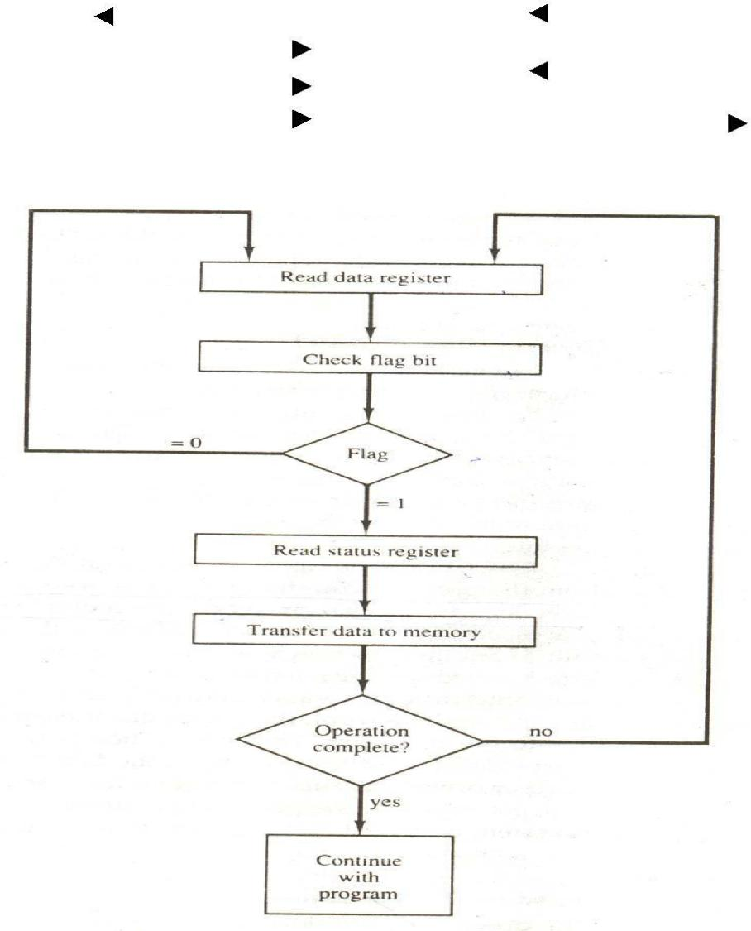

Figure -Flowcharts for CPU program to input data

The programmed I/O method is particularly useful in small low-speed computers or in systems that are dedicated to monitor a device continuously. The difference in information transfer rate between the CPU and the I/O device makes this type of transfer inefficient. To see why this is inefficient, consider a typical computer that can execute the two instructions that read the status register and check the flag in 1 πs. Assume that the input device transfers its data at an average rate of 100 bytes per second. This is equivalent to one byte every 10,000 π s. This means that the CPU will check the flag 10,000 times between each transfer. The CPU is wasting time while checking the flag instead of doing some other useful processing task.

INTERRUPT-INITIATED I/O

An alternative to the CPU constantly monitoring the flag is to let the interface inform the computer when it is ready to transfer data. This mode of transfer uses the interrupt facility. While the CPU is running a program, it does not check the flag. However, when the flag is set, the computer is momentarily interrupted from proceeding with the current program and is informed of the fact that the flag has been set. The CPU deviates from what it is doing to take care of the input or output transfer. After the transfer is completed, the computer returns to the previous program to continue what it was doing before the interrupt.

The CPU responds to the interrupt signal by storing the return address from the program counter into a memory stack and then control branches to a service routine that processes the required I/O transfer. The way that the processor chooses the branch address of the service routine varies from tone unit to another. In principle, there are two methods for accomplishing this. One is called vectored interrupt and the other, no vectored interrupt. In a non-vectored interrupt, the branch address is assigned to a fixed location in memory. In a vectored interrupt, the source that interrupts supplies the branch information to the computer. This information is called the interrupt vector. In some computers the interrupt vector is the first address of the I/O service routine. In other computers the interrupt vector is an address that points to a location in memory where the beginning address of the I/O service routine is stored.

DIRECT MEMORY ACCESS (DMA)

The transfer of data between a fast storage device such as magnetic disk and memory is often limited by the speed of the CPU. Removing the CPU from the path and letting the peripheral device manage the memory buses directly would improve the speed of transfer. This transfer technique is called direct memory access (DMA). During DMA transfer, the CPU is idle and has no control of the memory buses. A DMA controller takes over the buses to manage the transfer directly between the I/O device and memory.

The CPU may be placed in an idle state in a variety of ways. One common method extensively used in microprocessors is to disable the buses through special control signals. Figure- CPU bus signals for DMA transfer.Shows two control signals in the CPU that facilitate the DMA transfer. The bus request (BR) input is used by the DMA controller to request the CPU to relinquish control of the buses. When this input is active, the CPU terminates the execution of the current instruction and places the address bus, the data bus, and the read and write lines into a high-impedance state behaves like an open circuit, which means that the output is disconnected and does not have a logic significance. The CPU activates the Bus grant (BG) output to inform the external DMA that the buses are in the high -impedance state. The DMA that originated the bus request can now take control of the buses to conduct memory transfers without processor intervention. When the DMA terminates the transfer, it disables the bus request line. The CPU disables the bus grant, takes control of the buses, and returns to its normal operation.

When the DMA takes control of the bus system, it communicates directly with the memory. The transfer can be made in several ways. In DMA burst transfer, a block sequence consisting of a number of memory words is transferred in a continuous burst while the DMA controller is master of the memory buses. This mode of transfer is needed for fast devices such as magnetic disks, where data transmission cannot be stopped or slowed down until an entire block is transferred. An alternative technique called cycle stealing allows the DMA controller to transfer one data word at a time after which it must return control of the buses to the CPU. The CPU merely delays its operation for one memory cycle to allow the direct memory I/O transfer to

“steal” one memory cycle.

DMA CONTROLLER

The DMA controller needs the usual circuits of an interface to communicate with the CPU and I/O device. In addition, it needs an address register, a word count register, and a set of address lines. The address registers and addresses lines

Figure -CPU bus signals for DMA transfer.

Bus request |  |  |  | BR |  |  | Data bus | High-impedance
 |  |  |  | CPU |  |  | Address bus | (disable)
 |  |  |  | CPU |  |  | Read | when BG is
Bus grant |  |  |  | BG |  |  | Write | enabled


Are used for direct communication with the memory. The word count register specifies the number of words that must be transferred. The data transfer may be done directly between the device and memory under control of the DMA.

Below Figure shows the block diagram of a typical DMA controller. The unit communicates with the CPU via the data bus and control lines. The registers in the DMA are selected by the CPU through the address bus by enabling the DS (DMA select) and RS (register select) inputs. The RD (read) and WR (write) inputs are bidirectional. When the BG (bus grant) input is 0, the CPU can communicate with the DMA registers through the data bus to read from or write to the DMA registers. When BG = 1, the CPU has relinquished the buses and the DMA can communicate directly with the memory by specifying an address in the address bus and activating the RD or WR control. ; The DMA communicates with the external peripheral through the request and acknowledge lines by using a prescribed handshaking procedure.

The DMA controller has three registers: an address register, a word count register, and a control register. The address register contains an address to specify the desired location in memory. The address bits go through bus buffers into the address bus. The address register is incremented after each word that is transferred to memory. The word count register is incremented after each word that is transferred to memory. The word count register holds the number of words to be transferred. This register is decremented by one after each word transfer and internally tested for zero. The control register specifies the mode of transfer. All registers in the DMA appear to the CPU as I/O interface registers. Thus the CPU can read from or write into the DMA registers under program control via the data bus.

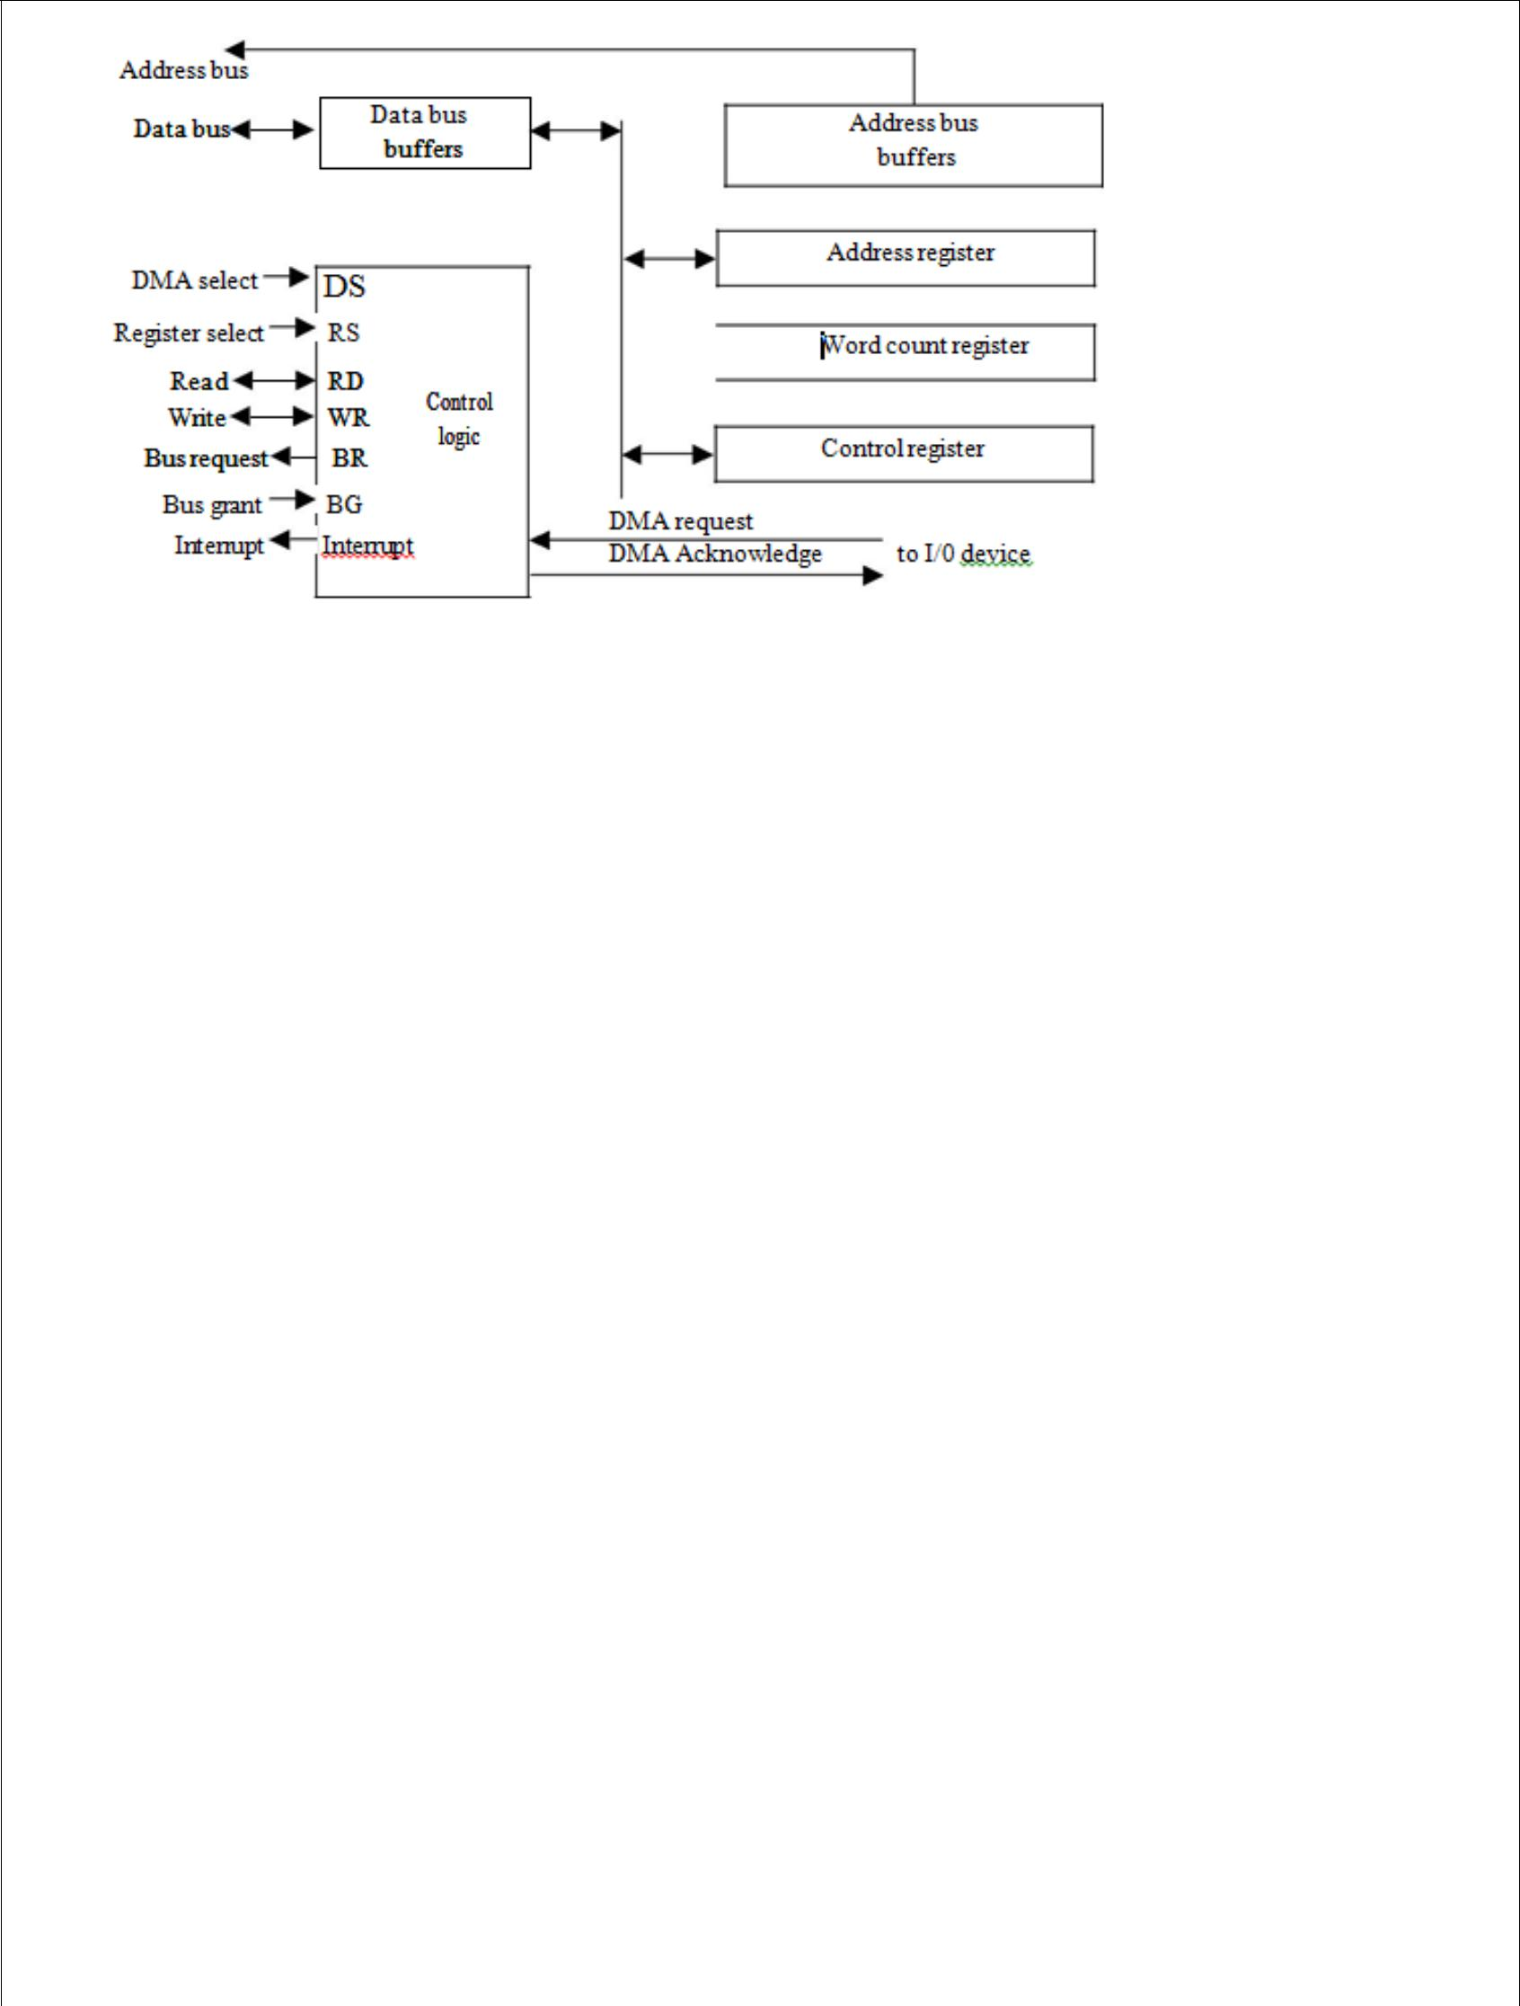

Figure-Block diagram of DMA controller.

The DMA is first initialized by the CPU. After that, the DMA starts and continues to transfer data between memory and peripheral unit until an entire block is transferred. The initialization process is essentially a program consisting of I/O instructions that include the address for selecting particular DMA registers. The CPU initializes the DMA by sending the following information through the data bus:

1. The starting address of the memory block where data are available (for read) or where data are to be stored (for write)

- The word count, which is the number of words in the memory block

- Control to specify the mode of transfer such as read or write

- A control to start the DMA transfer

The starting address is stored in the address register. The word count is stored in the word count register, and the control information in the control register. Once the DMA is initialized, the CPU stops communicating with the DMA unless it receives an interrupt signal or if it wants to check how many words have been transferred.

DMA TRANSFER

The position of the DMA controller among the other components in a computer system is illustrated in below Fig. The CPU communicates with the DMA through the address and data buses as with any interface unit. The DMA has its own address, which activates the DS and RS lines. The CPU initializes the DMA through the data bus. Once the DMA receives the start control command, it can start the transfer between the peripheral device and the memory.

When the peripheral device sends a DMA request, the DMA controller activates the BR line, informing the CPU to relinquish the buses. The CPU responds with its BG line, informing the DMA that its buses are disabled. The DMA then puts the current value of its address register into the address bus, initiates the RD or WR signal, and sends a DMA acknowledge to the peripheral device. Note that the RD and WR lines in the DMA controller are bidirectional. Thedirection of transfer depends on the status of the BG line. When BG line. When BG = 0, the RD and WR are input lines allowing the CPU to communicate with the internal DMA registers. When BG = 1, the RD and WR and output lines from the DMA controller to the random-access memory to specify the read or write operation for the data.

When the peripheral device receives a DMA acknowledge, it puts a word in the data us (for write) or receives a word from the data bus (for read). Thus the DMA controls the read or write operations and supplies the address for the memory. The peripheral unit can then communicate with memory through the data bus for direct transfer between the two units while the CPU is momentarily disabled.

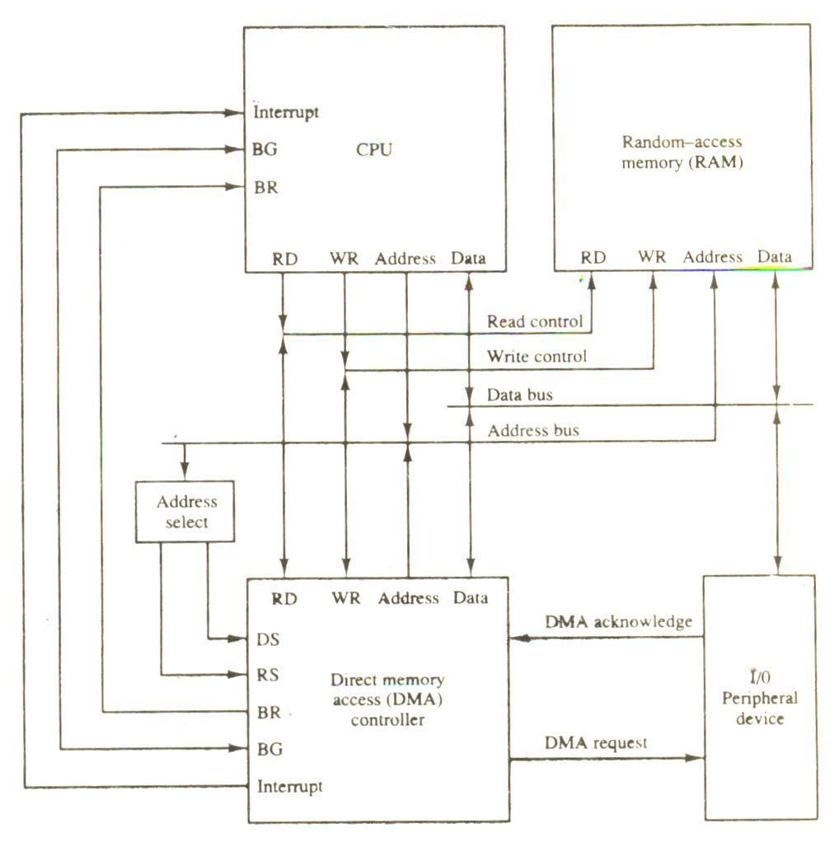

Figure-DMA transfer in a computer system.

For each word that is transferred, the DMA increments its address registers and decrements its word count register. If the word count does not reach zero, the DMA checks the request line coming from the peripheral. For a high-speed device, the line will be active as soon as the previous transfer is completed. A second transfer is then initiated, and the process continues until the entire block is transferred. If the peripheral speed is slower, the DMA request line may come somewhat later. In this case the DMA disables the bus request line so that the CPU can continue to execute its program. When the peripheral requests a transfer, the DMA requests the buses again.

It the word count register reaches zero, the DMA stops any further transfer and removes its bus request. It also informs the CPU of the termination by means of an interrupt. When the CPU responds to the interrupt, it reads the content of the word count register. The zero value of this register indicates that all the words were transferred successfully. The CPU can read this register at any time to check the number of words already transferred.

A DMA controller may have more than on channel. In this case, each channel has a request and acknowledges pair of control signals which are connected to separate peripheral devices. Each channel also has its own address register and word count register within the DMA controller. A priority among the channels may be established so that channels with high priority

are serviced before channels with lower priority.

DMA transfer is very useful in many applications. It is used for fast transfer of information between magnetic disks and memory. It is also useful for updating the display in an interactive terminal. Typically, an image of the screen display of the terminal is kept in memory which can be updated under program control. The contents of the memory can be transferred to the screen periodically by means of DMA transfer.

Input-output Processor (IOP)

The IOP is similar to a CPU except that it is designed to handle the details of I/O processing. Unlike the DMA controller that must be set up entirely by the CPU, the IOP can fetch and execute its own instructions. IOP instructions are specially designed to facilitate I/O transfers. In addition, the IOP can perform other processing tasks, such as arithmetic, logic, branching, and code translation.

The block diagram of a computer with two processors is shown in below Figure. The memory unit occupies a central position and can communicate with each processor by means of direct memory access. The CPU is responsible for processing data needed in the solution of computational tasks. The IOP provides a path for transfer of data between various peripheral devices and the memory unit.

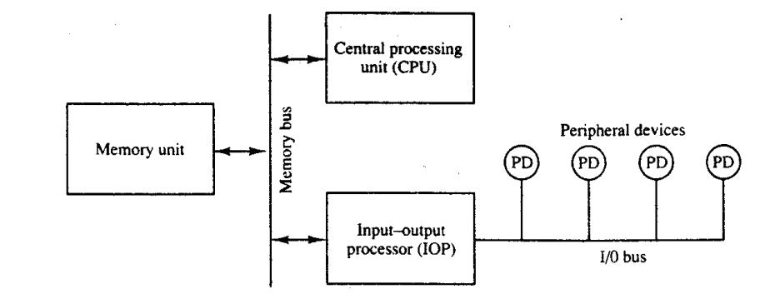

Figure- Block diagram of a computer with I/O processor

The data formats of peripheral devices differ from memory and CPU data formats. The IOP must structure data words from many different sources. For example, it may be necessary to take four bytes from an input device and pack them into one 32-bit word before the transfer to memory. Data are gathered in the IOP at the device rate and bit capacity while the CPU is executing its own program. After the input data are assembled into a memory word, they are transferred from IOP directly into memory by "stealing" one memory cycle from the CPU. Similarly, an output word transferred from memory to the IOP is directed from the IOP to the output device at the device rate and bit capacity.

The communication between the IOP and the devices attached to it is similar to the program control method of transfer. The way by which the CPU and IOP communicate depends on the level of sophistication included in the system. In most computer systems, the CPU is the master while the IOP is a slave processor. The CPU is assigned the task of initiating all operations, but I/O instructions are execute in the IOP. CPU instructions provide operations to start an I/O transfer and also to test I/O status conditions needed for making decisions on various I/O activities. The IOP, in turn, typically asks for CPU attention by means of an interrupt. It also responds to CPU requests by placing a status word in a prescribed location in memory to be examined later by a CPU program. When an I/O operation is desired, the CPU informs the IOP where to find the I/O program and then leaves the transfer details to the IOP.

CPU-IOP Communication

The communication between CPU and IOP. These are depending on the particular computer considered. In most cases the memory unit acts as a message center where each processor leaves information for the other. To appreciate the operation of a typical IOP, we will illustrate by a specific example the method by which the CPU and IOP communicate. This is a simplified example that omits many operating details in order to provide an overview of basic concepts.

The sequence of operations may be carried out as shown in the flowchart of below Fig. The CPU sends an instruction to test the IOP path. The IOP responds by inserting a status word in memory for the CPU to check. The bits of the status word indicate the condition of the IOP and I/O device, such as IOP overload condition, device busy with another transfer, or device ready for I/O transfer. The CPU refers to the status word in memory to decide what to do next. If all is in order, the CPU sends the instruction to start I/O transfer. The memory address received with this instruction tells the IOP where to find its program.

The CPU can now continue with another program while the IOP is busy with the I/O program. Both programs refer to memory by means of DMA transfer. When the IOP terminates the execution of its program, it sends an interrupt request to the CPU. The CPU responds to the interrupt by issuing an instruction to read the status from the IOP. The IOP responds by placing the contents of its status report into a specified memory location.

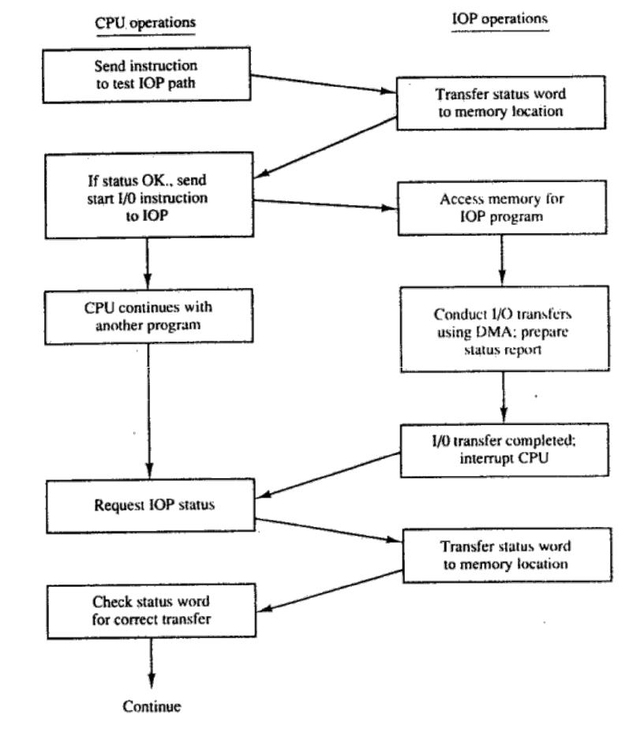

Figure - CPU-IOP communication

The IOP takes care of all data transfers between several I/O units and the memory while the CPU is processing another program. The IOP and CPU are competing for the use of memory, so the number of devices that can be in operation is limited by the access time of the memory.

INTEL 8089 IOP

The Intel 8089 I/O processor is contained in a 40-pin integrated circuit package. Within the 8089 are two independent units called channels. Each channel combines the general characteristics of a processor unit with those of a direct memory access controller. The 8089 is designed to function as an IOP in a

Microcomputer system where the Intel 8086 microprocessor is used as the CPU. The 8086 CPU initiates an I/O operation by building a message in memory that describes the function to be performed. The 8089 IOP reads the message from memory, carries out the operation, and notifies the CPU when it has finished.

In contrast to the IBM 370 channel, which has only six basic I/O commands, the 8089 IOP has 50 basic instructions that can operate on individual bits, on bytes, or 16-bit words. The IOP can execute programs in a manner similar to a CPU except that the instruction set is specifically chosen to provide efficient input-output processing. The instruction set includes general data transfer instructions, basic arithmetic and logic operations, conditional and unconditional branch operations, and subroutine call and return capabilities. The set also includes special instructions to initiate DMA transfers and issue an interrupt request to the CPU. It provides efficient data transfer between any two components attached to the system bus, such as I/O to memory, memory to memory, or I/O to I/O.

A microcomputer system using the Intel 8086/8089 pair of integrated circuits is shown in Fig. (a). The 8086 functions as the CPU and the 8089 as the IOP. The two units share a common memory through a bus controller connected to a system bus, which is called a "multibus" by Intel. The IOP uses a local bus to communicate with various interface units connected to I/O devices. The CPU communicates with the IOP by enabling the channel attention line. The select line is used by the CPU to select one of two channels in the 8089. The IOP gets the attention of the CPU by sending an interrupt request.

The CPU and IOP communicate with each other by writing messages for one another in system memory. The CPU prepares the message area and signals the IOP by enabling the channel attention line. The IOP reads the message, performs the required I/O functions, and executes the appropriate channel program. When the channel has completed its program, it issues an interrupt request to the CPU.

The communication scheme consists of program sections called "blocks," which are stored in memory as shown in Fig. (b). each block contains control and parameter information as well as an address pointer to its successor block. The address of the control block is passed to each IOP channel during initialization. The busy flag indicates whether the IOP is busy or ready to perform a new I/O operation. The CCW (channel command word) is specified by the CPU to indicate the of operation required from the IOP. The CCW in the 8089 does not have the same meaning as the command word in the IBM

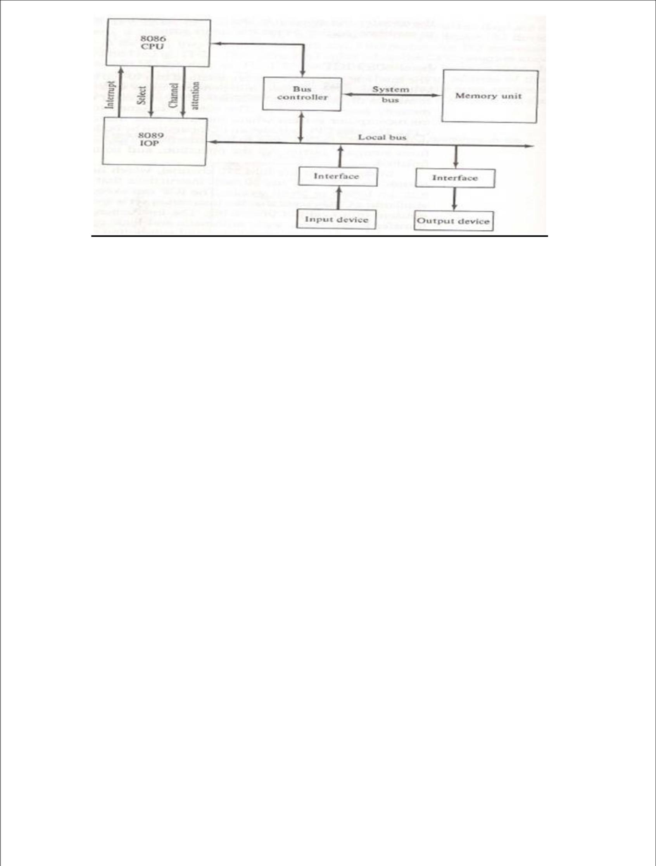

Fig (a)- Intel 8086/8089 Microcomputer system block diagram.

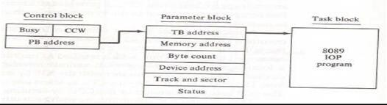

Fig (b) – Location of information in memory for I/O operations in the Intel8086/8089 microcomputer system.

The CPU and IOP work together through the control and parameter blocks. The CPU obtains use of the shared memory after checking the busy flag to ensure that the IOP is available. The CPU then fills in the information in the parameter block and writes a "start operation" command in the CCW. After the communication blocks have been set up, the CPU enables the channel attention signal to inform the IOP to start its I/O operation. The CPU then continues with another program. The IOP responds to the channel attention signal by placing the address of the control block into its program counter. The IOP refers to the control block and sets the busy flag. It then checks the operation in the CCW. The PB (parameter block) address and TB (task block) address are then transferred into internal IOP registers. The IOP starts executing the program in the task block using the information in the parameter block. The entries in the parameter block depend on the I/Odevice. Theparameters listed in Fig. (b)are suitable for data transfer to or from a magnetic disk. The memory address specifies the beginning address of a memory buffer. The byte count gives the number of bytes to be transferred. The device address specifies the particular I/O device to be used. The track and sector numbers locate the data on the disk. When the I/O operation is completed, the IOP stores its status bits in the status word location of the parameter block and interrupts the CPU. The CPU can refer to the status word to check if the transfer has been completed satisfactorily.

UNIT-3

Memory hierarchy Main Memory

RAM ROM Chips

Memory Address map Memory Connection to CPU Associate memory

Cache Memory Data cache Instruction cache Miss and Hit ratio Access time Associative mapping

Set associative mapping Waiting into cache Introduction to virtual memory

MEMORY HIERARCHY

The memory unit is an essential component in any digital computer since it is needed for storing programs and data. A very small computer with a limited application may be able to fulfill its intended task without the need of additional storage capacity. Most general-purpose computers would run more efficiently if they were equipped with additional storage beyond the capacity of the main memory. There is just not enough space in one memory unit to accommodate all the programs used in a typical computer. Moreover, most computer users accumulate and continue to accumulate large amounts of data-processing software. Not all accumulated information is needed by the processor at the same time. Therefore, it is more economical to use low-cost storage devices to serve as a backup for storing the information that is not currently used by the CPU. The memory unit that communicates directly with the CPU is called the main memory. Devices that provide backup storage are called auxiliary memory. The most common auxiliary memory devices used in computer systems are magnetic disks and tapes. They are used for storing system programs, large data files, and other backup information. Only programs and data currently needed by the processor reside in main memory. All other information is stored in auxiliary memory and transferred to main memory when needed.

The total memory capacity of a computer can be visualized as being a hierarchy of components. The memory hierarchy system consists of tall storage devices employed in a computer system from the slow but high-capacity auxiliary memory to a relatively faster main memory, to an even smaller and faster cache memory accessible to the high-speed processing logic. Figure illustrates the components in a typical memory hierarchy. At the bottom of the hierarchy are the relatively slow magnetic tapes used to store removable files. Next are the magnetic disks used as backup storage. The main memory occupies a central position by being able to communicate directly with the CPU and with auxiliary memory devices through an I/O processor. When programs not residing in main memory are needed by the CPU, they are brought in from auxiliary memory. Programs not currently needed in main memory are transferred into auxiliary memory to provide space for currently used programs and data.

A special very-high speed memory called a cache is sometimes used to increase the speed of processing by making current programs and data available to the CPU at a rapid rate. The cache memory is employed in computer systems to compensate for the speed differential between main memory access time and processor logic. CPU logic is usually faster than main memory access time, with the result that processing speed is limited primarily by the speed of main memory. A technique used to compensate for the mismatch in operating speeds is to employ in extremely fast, small cache between the CPU and main memory whose access time is close to processor logic clock cycle time. The cache is used for storing segments of programs currently being executed in the CPU and temporary data frequently needed in the present calculations by
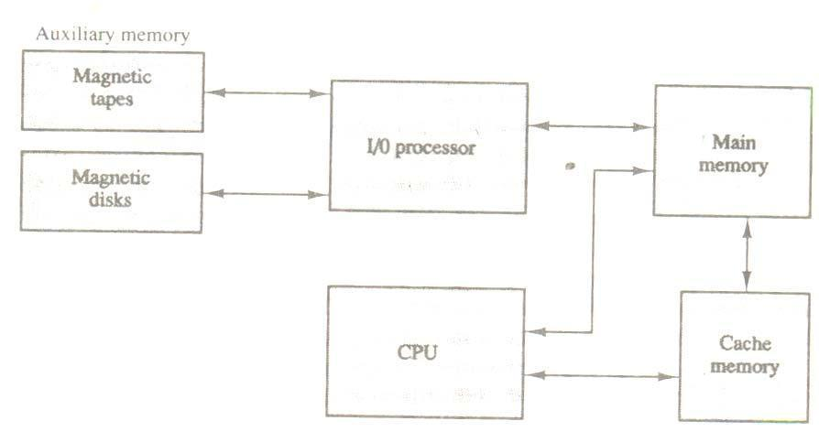

Figure - Memory hierarchy in a computer system.

Making programs and data available at a rapid rate, it is possible to increase the performance rate of the

computer.

While the I/O processor manages data transfers between auxiliary memory and main memory, the cache organization is concerned with the transfer of information between main memory and CPU. Thus each is involved with a different level in the memory hierarchy system. The reason for having two or three levels of memory hierarchy is economics. As the storage capacity of the memory increases, the cost per bit for storing binary information decreases and the access time of the memory becomes longer. The auxiliary memory has a large storage capacity, is relatively inexpensive, but has low access speed compared to main memory. The cache memory is very small, relatively expensive, and has very high access speed. Thus as the memory access speed increases, so does its relative cost. The overall goal of using a memory hierarchy is to obtain the highest-possible average access speed while minimizing the total cost of the entire memory system.

While the I/O processor manages data transfers between auxiliary memory and main memory, the cache organization is concerned with the transfer of information between main memory and CPU. Thus each is involved with a different level in the memory hierarchy system. The reason for having two or three levels of memory hierarchy is economics. As the storage capacity of the memory increases, the cost per bit for storing binary information decreases and the access time of the memory becomes longer. The auxiliary memory has a large storage capacity, is relatively inexpensive, but has low access speed compared to main memory. The cache memory is very small, relatively expensive, and has very high access speed. Thus as the memory access speed increases, so does its relative cost. The overall goal of using a memory hierarchy is to obtain the highest-possible average access speed while minimizing the total cost of the entire memory system.

Auxiliary and cache memories are used for different purposes. The cache holds those parts of the program and data that are most heavily used, while the auxiliary memory holds those parts that are not presently used by the CPU. Moreover, the CPU has direct access to both cache and main memory but not to auxiliary memory. The transfer from auxiliary to main memory is usually done by means of direct memory access of large blocks of data. The typical access time ratio between cache and main memory is about 1 to 7. For example, a typical cache memory may have an access time of 100ns, while main memory access time may be 700ns. Auxiliary memory average access time is usually 1000 times that of main memory. Block size in auxiliary memory typically ranges from256 to 2048 words, while cache block size is typically from 1 to 16 words.

Many operating systems are designed to enable the CPU to process a number of independent programs concurrently. This concept, called multiprogramming, refers to the existence of two or more programs indifferent parts of the memory hierarchy at the same time. In this way it is possible to keep all parts of the computer busy by working with several programs in sequence. For example, suppose that a program is being executed in the CPU and an I/O transfer is required. The CPU initiates the I/O processor to start executing the transfer. This leaves the CPU free to execute another program. In a multiprogramming system, when one program is waiting for input or output transfer, there is another program ready to utilize the CPU.

MAIN MEMORY

The main memory is the central storage unit in a computer system. It is a relatively large and fast memory used to store programs and data during the computer operation. The principal technology used for the main memory is based on semiconductor integrated circuits. Integrated circuit RAM chips are available in two possible operating modes, static and dynamic. The static RAM consists essentially of internal flip-flops that store the binary information. The stored information remains valid as long as power is applied to unit. The dynamic RAM stores the binary information in the form of electric charges that are applied to capacitors. The capacitors are provided inside the chip by MOS transistors. The stored charges on the capacitors tend to discharge with time and the capacitors must be periodically recharged by refreshing the dynamic memory. Refreshing is done by cycling through the words every few milliseconds to restore the decaying charge. The dynamic RAM offers reduced power consumption and larger storage capacity in a single memory chip. The static RAM is easier to use and has shorted read and write cycles.

Most of the main memory in a general-purpose computer is made up of RAM integrated circuit chips, but a portion of the memory may be constructed with ROM chips. Originally, RAM was used to refer to a random-access memory, but now it is used to designate a read/write memory to distinguish it from a read-only memory, although ROM is also random access. RAM is used for storing the bulk of the programs and data that are subject to change. ROM is used for storing programs that are permanently resident in the computer and for tables of constants that do not change in value one the production of the computer is completed.

Among other things, the ROM portion of main memory is needed for storing an initial program called a bootstrap loader. The bootstrap loader is a program whose function is to start the computer software operating when power is turned on. Since RAM is volatile, its contents are destroyed when power is turned off. The contents of ROM remain unchanged after power is turned off and on again. The startup of a computer consists of turning the power on and starting the execution of an initial program. Thus when power is turned on, the hardware of the computer sets the program counter to the first address of the bootstrap loader. The bootstrap program loads a portion of the operating system from disk to main memory and control is then transferred to the operating system, which prepares the computer from general use.

RAM and ROM chips are available in a variety of sizes. If the memory needed for the computer is larger than the capacity of one chip, it is necessary to combine a number of chips to form the required memory size. To demonstrate the chip interconnection, we will show an example of a 1024 × 8 memory constructed with 128 × 8 RAM chips and 512 × 8 ROM chips.

RAM AND ROM CHIPS

A RAM chip is better suited for communication with the CPU if it has one or more control inputs that select the chip only when needed. Another common feature is a bidirectional data bus that allows the transfer of data either from memory to CPU during a read operation or from CPU to memory during a write operation. A bidirectional bus can be constructed with three-state buffers. A three-state buffer output can be placed in one of three possible states: a signal equivalent to logic 1, a signal equivalent to logic 0, or a high-impedance state. The logic 1

and 0 are normal digital signals. The high-impedance state behaves like an open circuit, which means that the output does not carry a signal and has no logic significance. The block diagram of a RAM chip is shown in Fig. The capacity of the memory is 128 words of eight bits (one byte) per word. This requires a 7-bit.

Figure- Typical RAM Chip.

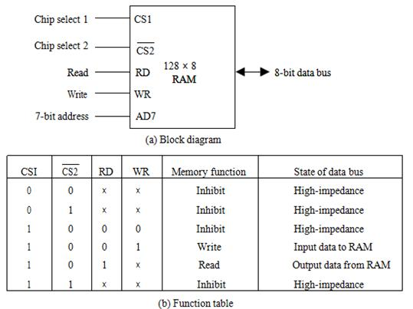

Address and an 8-bit bidirectional data bus. The read and write inputs specify the memory operation and the two chips select (CS) control inputs are for enabling the chip only when it is selected by the microprocessor. The availability of more than one control input to select the chip facilitates the decoding of the address lines when multiple chips are used in the microcomputer. The read and write inputs are sometimes combined into one line labeled R/W. When the chip is selected, the two binary states in this line specify the two operations or read or write.

The function table listed in Fig. (b) Specifies the operation of the RAM chip. The unit is in operation only when CSI = 1 and CS2 = 0. The bar on top of the second select variable indicates that this input in enabled when it is equal to 0. If the chip select inputs are not enabled, or if they are enabled but the read but the read or write inputs are not enabled, the memory is inhibited and its data bus is in a high-impedance state. When SC1 = 1 and CS2 = 0, the memory can be placed in a write or read mode. When the WR input is enabled, the memory stores a byte from the data bus into a location specified by the address input lines. When the RD input is enabled, the content of the selected byte is placed into the data bus. The RD and WR signals control the memory operation as well as the bus buffers associated with the bidirectional data bus.

A ROM chip is organized externally in a similar manner. However, since a ROM can only read, the data bus can only be in an output mode. The block diagram of a ROM chip is shown in below Fig. For the same-size chip, it is possible to have more bits of ROM occupy less space than in RAM. For this reason, the diagram specifies a 512-byte ROM, while the RAM has only 128 bytes.

The nine address lines in the ROM chip specify any one of the 512 bytes stored in it. The two chip select inputs must be CS1 = 1 and CS2 = 0 for the unit to operate. Otherwise, the data bus is in a high-impedance state. There is no need for a read or write control because the unit can only read. Thus when the chip is enabled by the two select inputs, the byte selected by the address lines appears on the data bus.

MEMORY ADDRESS MAP

The designer of a computer system must calculate the amount of memory required for the particular application and assign it to either RAM or ROM. The interconnection between memory and processor is then established form knowledge of the size of memory needed and the type of RAM and ROM chips available. The addressing of memory can be established by means of a table that specifies the memory address assigned to each chip. The table, called a memory address map, is a pictorial representation of assigned address space for each chip in the system.

To demonstrate with a particular example, assume that a computer system needs 512 bytes of RAM and 512 bytes of ROM. The RAM and ROM chips

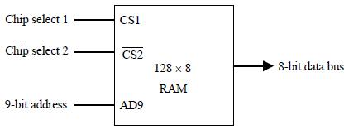

Figure-Typical ROM chip.

To be used are specified in Fig Typical RAM chip and Typical ROM chip. The memory address map for this configuration is shown in Table 7-1. The component column specifies whether a RAM or a ROM chip is used. The hexadecimal address column assigns a range of hexadecimal equivalent addresses for each chip. The address bus lines are listed in the third column. Although there are 16 lines in the address bus, the table shows only 10 lines because the other 6 are not used in this example and are assumed to be zero. The small x’s under the address bus lines designate those lines that must be connected to the address inputs in each chip. The RAM chips have 128 bytes and need seven address lines. The ROM chip has 512 bytes and needs 9 address lines. The x’s are always assigned to the low-order bus lines: lines 1 through 7 for the RAM and lines 1 through 9 for the ROM. It is now

necessary to distinguish between four RAM chips by assigning to each a different address. For this particular example we choose bus lines 8 and 9 to represent four distinct binary combinations. Note that any other pair of unused bus lines can be chosen for this purpose. The table clearly shows that the nine low-order bus lines constitute a memory space from RAM equal to 2⁹ = 512 bytes. The distinction between a RAM and ROM address is done with another bus line. Here we choose line 10 for this purpose. When line 10 is 0, the CPU selects a RAM, and when this line is equal to 1, it selects the ROM.

The equivalent hexadecimal address for each chip is obtained forms the information under the address bus assignment. The address bus lines are subdivided into groups of four bits each so

TABLE-Memory Address Map for Microprocomputer

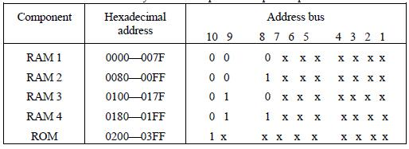

That each group can be represented with a hexadecimal digit. The first hexadecimal digit represents lines 13 to 16 and is always 0. The next hexadecimal digit represents lines 9 to 12, but lines 11 and 12 are always 0. The range of hexadecimal addresses for each component is determined from the x’s associated with it. This x’s represent a binary number that can range from an all-0’s to an all-1’s value.

MEMORY CONNECTION TO CPU

RAM and ROM chips are connected to a CPU through the data and address buses. The low-order lines in the address bus select the byte within the chips and other lines in the address bus select a particular chip through its chip select inputs. The connection of memory chips to the CPU is shown in below Fig. This configuration gives a memory capacity of 512 bytes of RAM and 512 bytes of ROM. It implements the memory map of Table 7-1. Each RAM receives the seven low-order bits of the address bus to select one of 128 possible bytes. The particular RAM chip selected is determined from lines 8 and 9 in the address bus. This is done through a 2 × 4 decoder whose outputs go to the SCI input in each RAM chip. Thus, when address lines 8 and 9 are equal to 00, the first RAM chip is selected. When 01, the second RAM chip is selected, and so on. The RD and WR outputs from the microprocessor are applied to the inputs of each RAM chip.

The selection between RAM and ROM is achieved through bus line 10. The RAMs are selected when the bit in this line is 0, and the ROM when the bit is 1. The other chip select input in the ROM is connected to the

RD control line for the ROM chip to be enabled only during a read operation. Address bus lines 1 to 9 are applied to the input address of ROM without going through the decoder. This assigns addresses 0 to 511 to RAM and 512 to 1023 to ROM. The data bus of the ROM has only an output capability, whereas the data bus connected to the RAMs can transfer information in both directions.

The example just shown gives an indication of the interconnection complexity that can exist between memory chips and the CPU. The more chips that are connected, the more external decoders are required for selection among the chips. The designer must establish a memory map that assigns addresses to the various chips from which the required connections are determined.
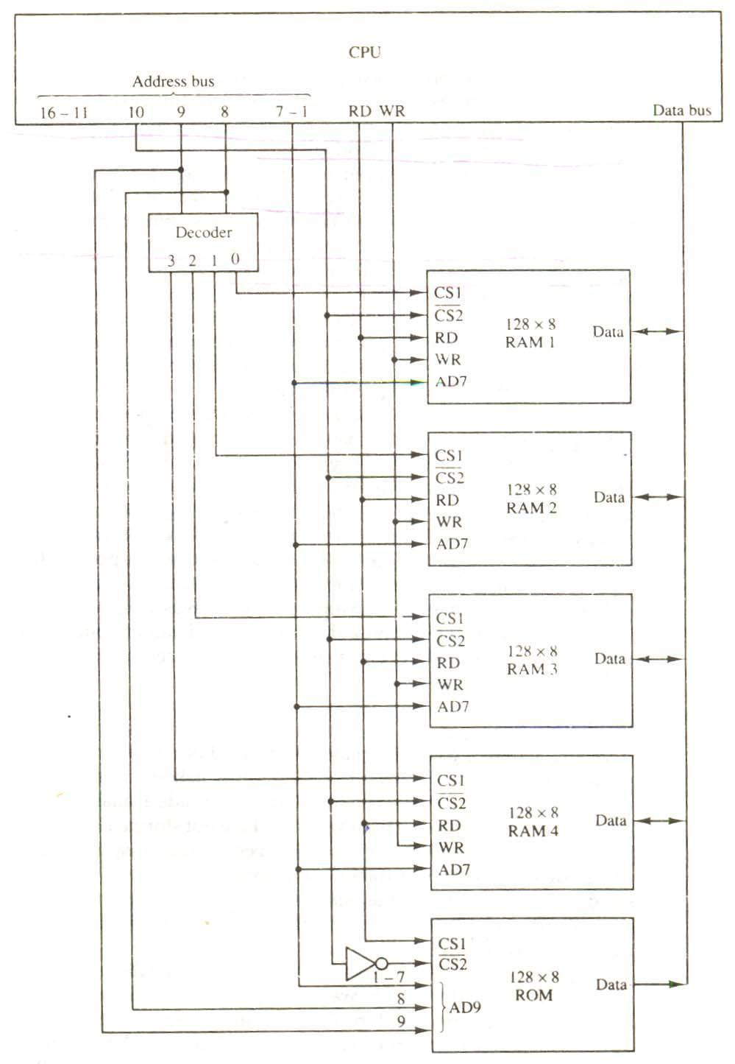

Figure -Memory connection to the CPU.

ASSOCIATIVE MEMORY

Many data-processing applications require the search of items in a table stored in memory. An assembler program searches the symbol address table in order to extract the symbol’s binary equivalent. An

account number may be searched in a file to determine the holder’s name and account status. The established way to search a table is to store all items where they can be addressed in sequence. The search procedure is a strategy for choosing a sequence of addresses, reading the content of memory at each address, and comparing the information read with the item being searched until a match occurs. The number of accesses to memory depends on the location of the item and the efficiency of the search algorithm. Many search algorithms have been developed to minimize the number of accesses while searching for an item in a random or sequential access memory.

The time required to find an item stored in memory can be reduced considerably if stored data can be identified for access by the content of the data itself rather than by an address. A memory unit accessed by content is called an associative memory or content addressable memory (CAM). This type of memory is accessed simultaneously and in parallel on the basis of data content rather than by specific address or location. When a word is written in an associative memory, no address is given,. The memory is capable of finding an empty unused location to store the word. When a word is to be read from an associative memory, the content of the word, or part of the word, is specified. The memory locaters all words which match the specified content and marks them for reading.

Because of its organization, the associative memory is uniquely suited to do parallel searches by data association. Moreover, searches can be done on an entire word or on a specific field within a word. An associative memory is more expensive then a random access memory because each cell must have storage capability as well as logic circuits for matching its content with an external argument. For this reason, associative memories are used in applications where the search time is very critical and must be very short.

HARDWARE ORGANIZATION

The block diagram of an associative memory is shown in below Fig. It consists of a memory array and logic from words with n bits per word. The argument register A and key register K each have n bits, one for each bit of a word. The match register M has m bits, one for each memory word. Each word in memory is compared in parallel with the content of the argument register. The words that match the bits of the argument register set a corresponding bit in the match register. After the matching process, those bits in the match register that have been set indicate the fact that their corresponding words have been matched. Reading is accomplished by a sequential access to memory for those words whose corresponding bits in the match register have been set.

The key register provides a mask for choosing a particular field or key in the argument word. The entire argument is compared with each memory word if the key register contains all 1’s. Otherwise, only those bits in the argument that have 1’s in their corresponding position of the key register are compared. Thus the key provides a mask or identifying piece of information which specifies how the reference to memory is made.

Figure- Block diagram of associative memory

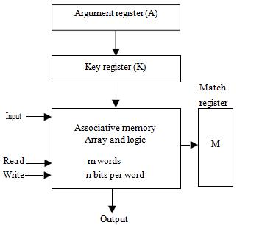

To illustrate with a numerical example, suppose that the argument register A and the key register K have the bit configuration shown below. Only the three leftmost bits of A are compared with memory words because K has 1’s in these positions.

A | 101 | 111100
K | 111 | 000000
Word 1 | 100 | 111100 | no match
Word 2 | 101 | 000001 | match

Word 2 matches the unmasked argument field because the three leftmost bits of the argument and the word are equal.

The relation between the memory array and external registers in an associative memory is shown in below Fig. The cells in the array are marked by the letter C with two subscripts. The first subscript gives the word number and the second specifies the bit position in the word. Thus cell Cij is the cell for bit j in word i. A bit A j in the argument register is compared with all the bits in column j of the array provided that K j = 1. This is done for all columns j = 1, 2,…,n. If a match occurs between all the unmasked bits of the argument and the bits in word i, the corresponding bit Mi in the match register is set to 1. If one or more unmasked bits of the argument and the word do not match, Mi is cleared to 0.

Figure -Associative memory of m word, n cells per word

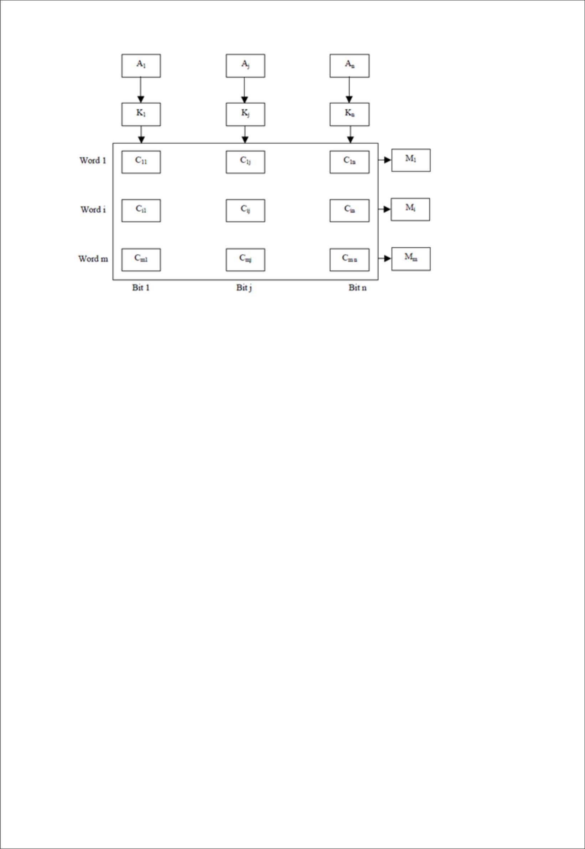

The internal organization of a typical cell Cij is shown in Fig.. It consists of a flip-

Flop storage element Fij and the circuits for reading, writing, and matching the cell. The input bit is transferred into the storage cell during a write operation. The bit stored is read out during a read operation. The match logic compares the content of the storage cell with the corresponding unmasked bit of the argument and provides an output for the decision logic that sets the bit in Mi.

MATCH LOGIC

The match logic for each word can be derived from the comparison algorithm for two binary numbers. First, we neglect the key bits and compare the argument in A with the bits stored in the cells of the words. Word i is equal to the argument in A if Aj = Fij for j = 1, 2,…, n. Two bits are equal if they are both 1 or both 0. The equality of two bits can be expressed logically by the Boolean function

xj = AjFij + A'jFij'

Where xj = 1 if the pair of bits in position j are equal; otherwise, xj = 0.

For a word i to be equal to the argument in a we must have all xj variables equal to 1. This is the condition for setting the corresponding match bit Mi to 1. The Boolean function for this condition is
Mi = x1 x2 x3 … xn

And constitutes the AND operation of all pairs of matched bits in a word. Figure One cell of associative memory.

Figure - One cell of associative memory.

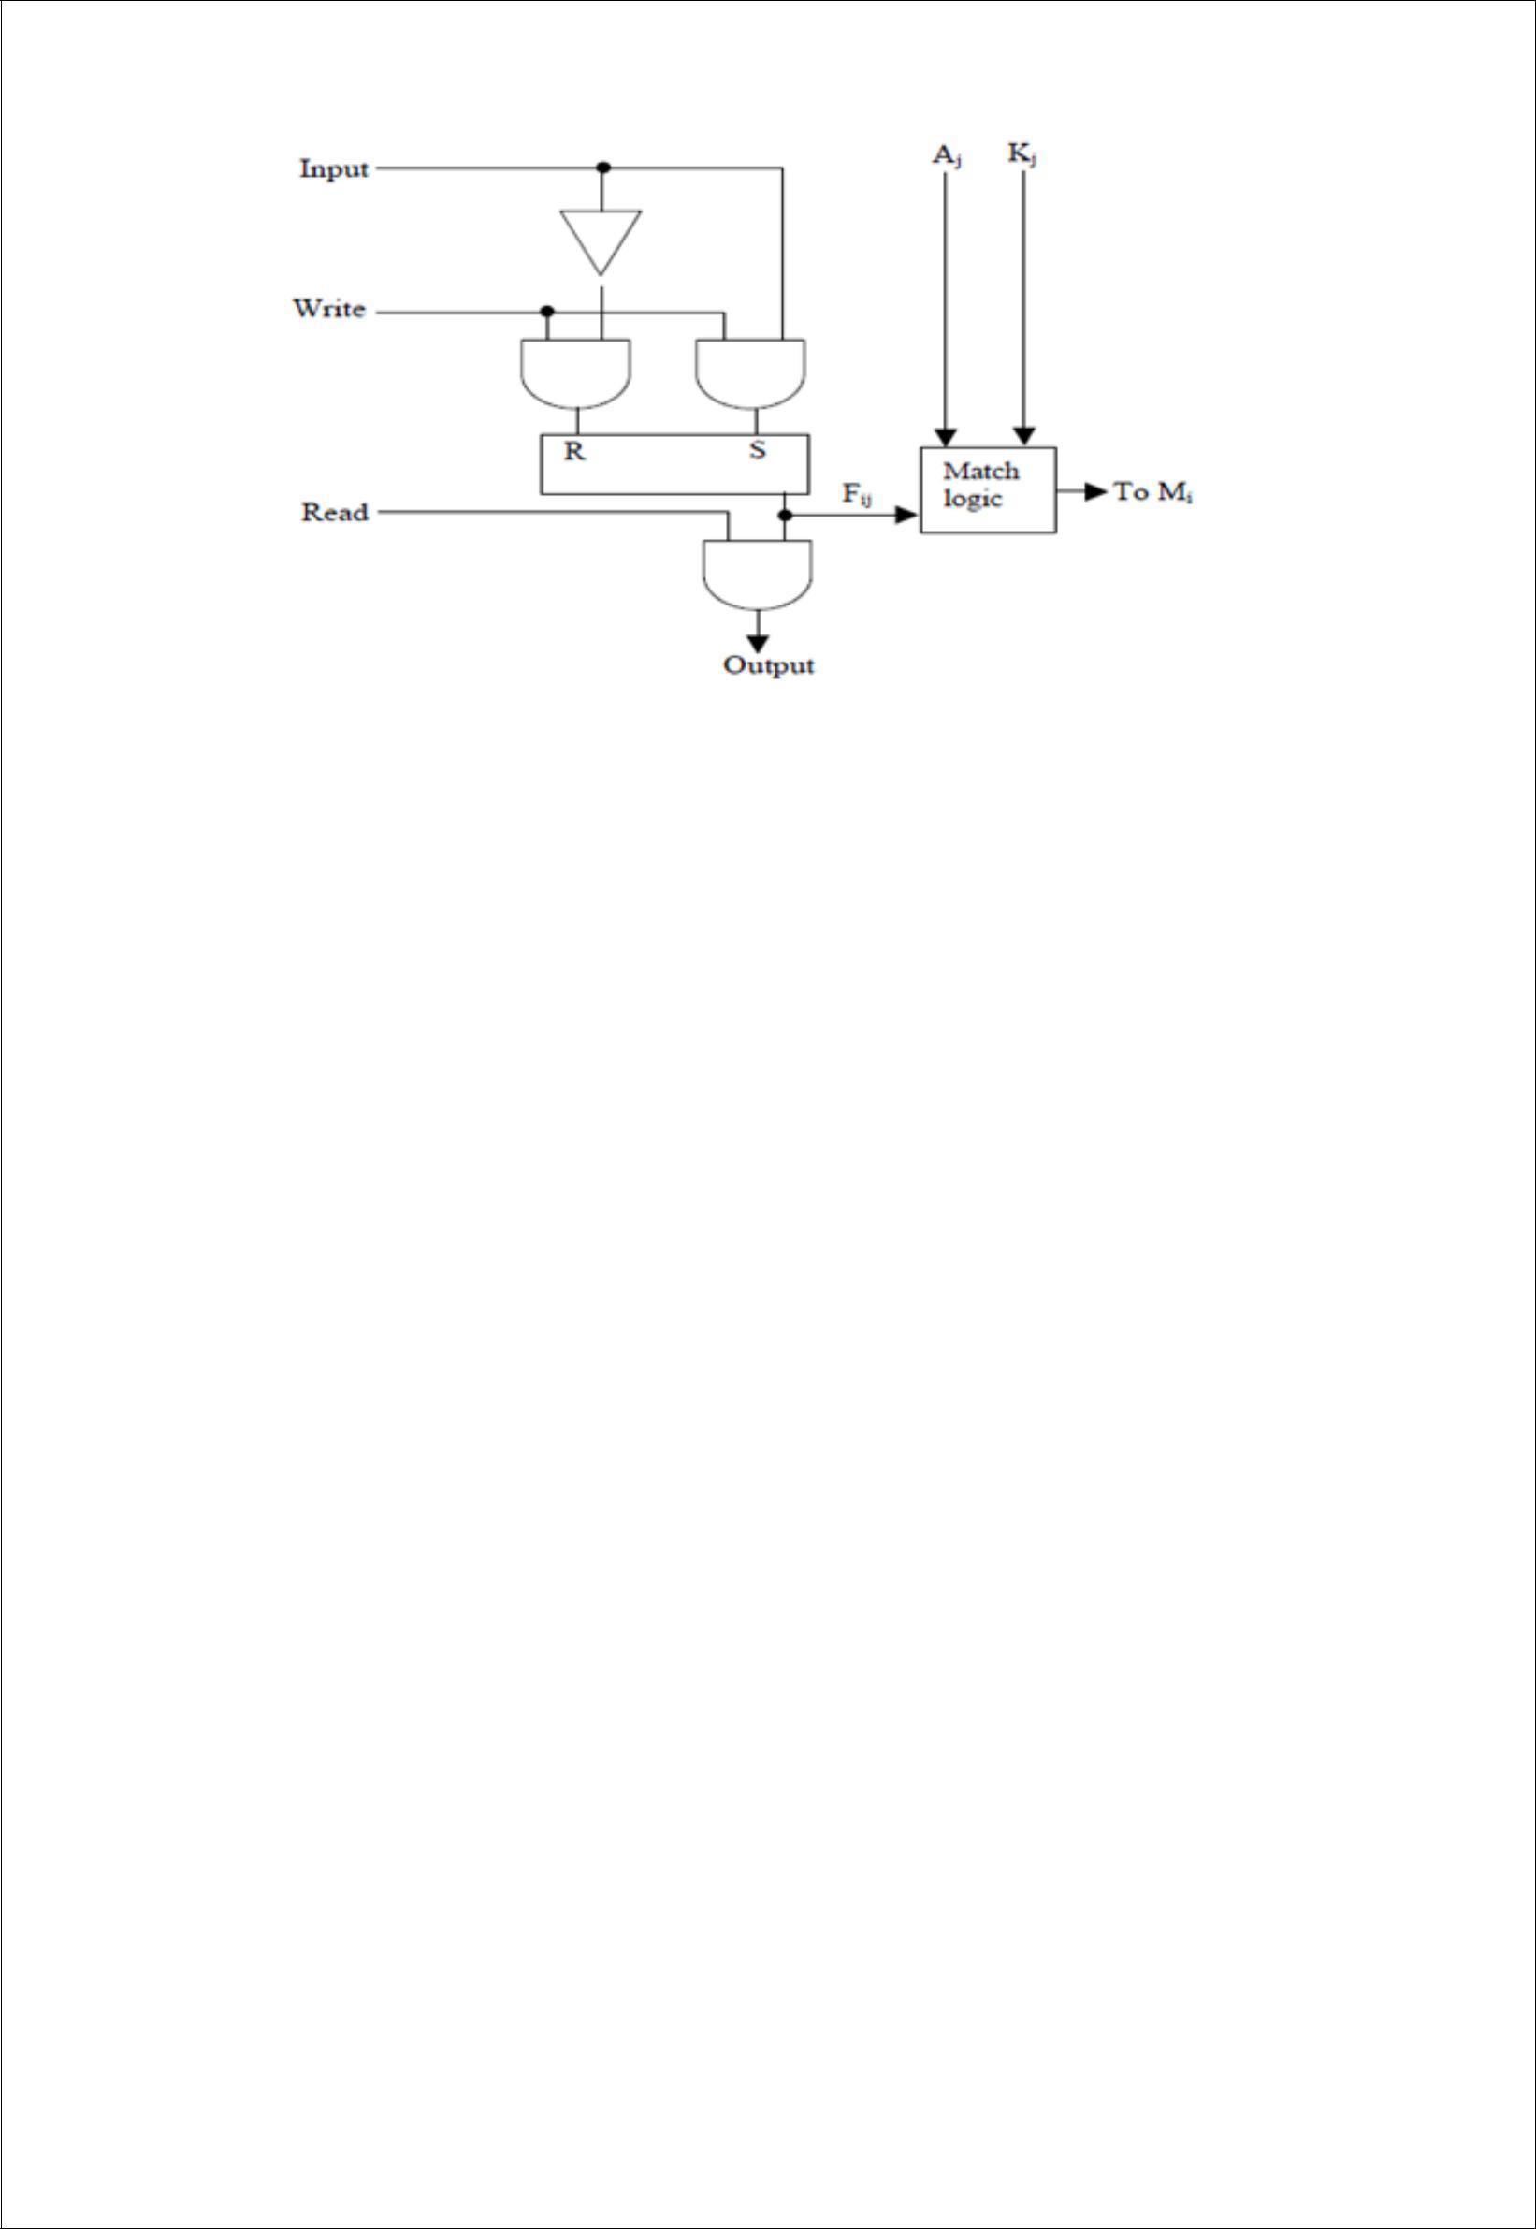

We now include the key bit Kj in the comparison logic. The requirement is that if Kj = 0, the corresponding bits of Aj and Fij need no comparison. Only when Kj = 1 must they be compared. This requirement is achieved by ORing each term with Kj’ , thus:
x | if K | =1
j |  | j
xj + K’j =
1 | if K | = 0

j

When K j = 1, we have K j ’ = 0 and xj + 0 = xj. When Kj = 0, then Kj’ = 1 xj + 1 = 1. A term (xj + Kj’) will be in the 1 state if its pair of bitsis not compared. This is necessary because each term is ANDed with all other terms so that an output of 1 will have no effect. The comparison of the bits has an effect only when Kj = 1. The match logic for word i in an associative memory can now be expressed by the following Boolean function:

Mi = (x1 + K 'j ) (x2 + K 'j ) (x3 + K 'j ) …. (xn + K 'j )

Each term in the expression will be equal to 1 if its corresponding K 'j = 0. ifKj = 1, the term will be either 0 or 1 depending on the value of xj. A match will occur and Mi will be equal to 1 if all terms are equal to 1.

If we substitute the original definition of xj. The Boolean function above can be expressed as follows:

Mi = ∏ (AjFij + A 'j F 'j + K 'j )

j=1

Where ∏ is a product symbol designating the AND operation of all n terms. We need m such functions, one for each word i = 1, 2, 3, …., m.

The circuit for catching one word is shown in below Fig. Each cell requires two AND gates and one OR gate. The inverters for Aj and Kj are needed once for each column and are used for all bits in the column. The output of all OR gates in the cells of the same word go to the input of a common AND gate to generate the match signal for Mi.Mi will be logic 1 if a catch occurs and 0 if no match occurs. Note that if the key register

contains all 0’s, output Mi will be a 1 irrespective of the value of A or the word. This occurrence must be avoided during normal operation.

READ OPERATION

If more than one word in memory matches the unmasked argument field, all the matched words will have 1’s in the corresponding bit position of the catch register. It is then necessary to scan the bits of the match register on eat a time. The matched words are read in sequence by applying a read signal to each word line whose corresponding Mi bit is a 1.
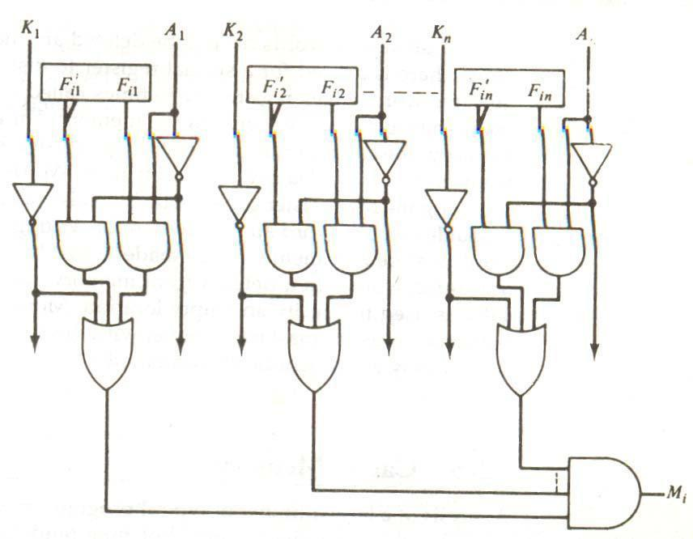

Figure - Match logic for one word of associative memory

In most applications, the associative memory stores a table with no two identical items under a given key. In this case, only one word may match the unmasked argument field. By connecting output Mi directly to the read line in the same word position (instead of the M register), the content of the matched word will be presented automatically at the output lines and no special read command signal is needed. Furthermore, if we exclude words having zero content, an all-zero output will indicate that no match occurred and that the searched item is not available in memory.

WRITE OPERATION

An associative memory must have a write capability for storing the information to be searched. Writing in an associative memory can take different forms, depending on the application. If the entire memory is loaded with new information at once prior to a search operation then the writing can be done by addressing each location in sequence. This will make the device a random-access memory for writing and a content addressable memory for reading. The advantage here is that the address for input can be decoded as in a random-access memory. Thus instead of having m address lines, one for each word in memory, the number of address lines can

be reduced by the decoder to d lines, where m = 2^{d}.

If unwanted words have to be deleted and new words inserted one at a time, there is a need for a special register to distinguish between active and inactive words. This register, sometimes called a tag register, would have as many bits as there are words in the memory. For every active word stored in memory, the corresponding bit in the tag register is set to 1. A word is deleted from memory by clearing its tag bit to 0. Words are stored in memory by scanning the tag register until the first 0 bit is encountered. This gives the first available inactive word and a position for writing a new word. After the new word is stored in memory it is made active by setting its tag bit to 1. An unwanted word when deleted from memory can be cleared to all 0’s if this value is used to specify an empty location. Moreover, the words that have a tag bit of 0 must be masked (together with the Kj bits) with the argument word so that only active words are compared.

CACHE MEMORY

Analysis of a large number of typical programs has shown that the references, to memory at any given interval of time tend to be confined within a few localized areas in memory. The phenomenon is known as the property of locality of reference. The reason for this property may be understood considering that a typical computer program flows in a straight-line fashion with program loops and subroutine calls encountered frequently. When a program loop is executed, the CPU repeatedly refers to the set of instructions in memory that constitute the loop. Every time a given subroutine is called, its set of instructions is fetched from memory. Thus loops and subroutines tend to localize the references to memory for fetching instructions. To a lesser degree, memory references to data also tend to be localized. Table-lookup procedures repeatedly refer to that portion in memory where the table is stored. Iterative procedures refer to common memory locations and array of numbers are confined within a local portion of memory. The result of all these observations is the locality of reference property, which states that over a short interval of time, the addresses generated by a typical program refer to a few localized areas of memory repeatedly, while the remainder of memory is accessed relatively frequently.

If the active portions of the program and data are placed in a fast small memory, the average memory access time can be reduced, thus reducing the total execution time of the program. Such a fast small memory is referred to as a cache memory. It is placed between the CPU and main memory as illustrated in below Fig. The cache memory access time is less than the access time of main memory by a factor of 5 to 10. The cache is the fastest component in the memory hierarchy and approaches the speed of CPU components.

The fundamental idea of cache organization is that by keeping the most frequently accessed instructions and data in the fast cache memory, the average memory access time will approach the access time of the cache. Although the cache is only a small fraction of the size of main memory, a large fraction of memory requests will be found in the fast cache memory because of the locality of reference property of programs.

The basic operation of the cache is as follows. When the CPU needs to access memory, the cache is

examined. If the word is found in the cache, it is read from the fast memory. If the word addressed by the CPU is not found in the cache, the main memory is accessed to read the word. A block of words containing the one just accessed is then transferred from main memory to cache memory. The block size may vary from one word (the one just accessed) to about 16 words adjacent to the one just accessed. In this manner, some data are transferred to cache so that future references to memory find the required words in the fast cache memory.

The performance of cache memory is frequently measured in terms of a quantity called hit ratio. When the CPU refers to memory and finds the word in cache, it is said to produce a hit. If the word is not found in cache, it is in main memory and it counts as a miss. The ratio of the number of hits divided by the total CPU references to memory (hits plus misses) is the hit ratio. The hit ratio is best measured experimentally by running representative programs in the computer and measuring the number of hits and misses during a given interval of time. Hit ratios of 0.9 and higher have been reported. This high ratio verifies the validity of the locality of reference property.

The average memory access time of a computer system can be improved considerably by use of a cache. If the hit ratio is high enough so that most of the time the CPU accesses the cache instead of main memory, the average access time is closer to the access time of the fast cache memory. For example, a computer with cache access time of 100 ns, a main memory access time of 1000 ns, and a hit ratio of 0.9 produces an average access time of 200 ns. This is a considerable improvement over a similar computer without a cache memory, whose access time is 1000 ns.

The basic characteristic of cache memory is its fast access time. Therefore, very little or no time must be wasted when searching for words in the cache. The transformation of data from main memory to cache memory is referred to as a mapping process. Three types of mapping procedures are of practical interest when considering the organization of cache memory:

- Associative mapping

- Direct mapping

- Set-associative mapping

To helping the discussion of these three mapping procedures we will use a specific example of a memory organization as shown in below Fig. The main memory can store 32K words of 12 bits each. The cache is capable of storing 512 of these words at any given time. For every word stored in cache, there is a duplicate copy in main memory.

The CPU communicates with both memories. It first sends a 15-bit address to cache. If there is a hit, the CPU accepts the 12 -bit data from cache. If there is a miss, the CPU reads the word from main memory and the word is then transferred to cache.

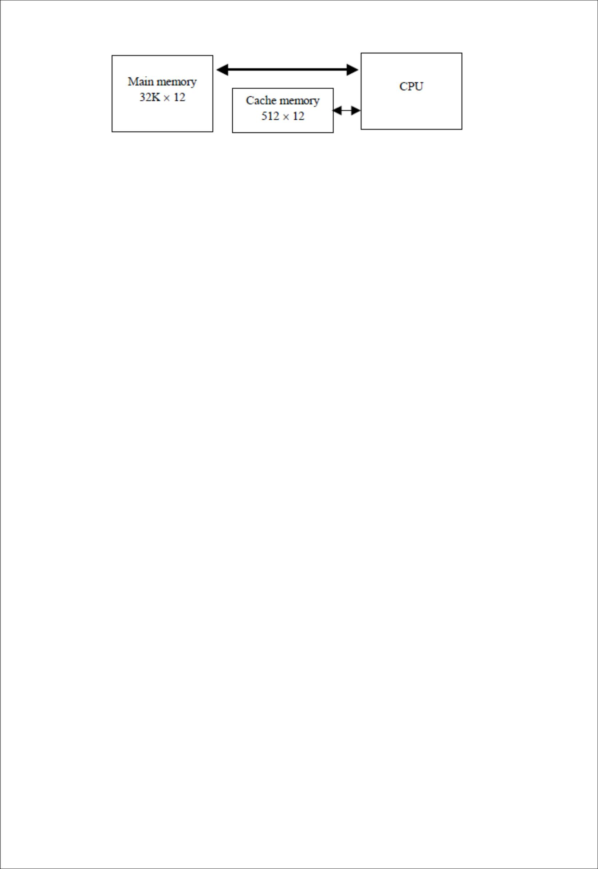

Figure - Example of cache memory

ASSOCIATIVE MAPPING

The fasters and most flexible cache organization use an associative memory. This organization is illustrated in below Fig. The associative memory stores both the address and content (data) of the memory word. This permits any location in cache to store any word from main memory. The diagram shows three words presently stored in the cache. The address value of 15 bits is shown as a five-digit octal number and its corresponding 12-bit word is shown as a four-digit octal number. A CPU address of 15 bits is placed in the argument register and the associative memory is searched for a matching address. If the address is found, the corresponding 12-bit data is read

Figure-Associative mapping cache (all numbers in octal) CPU address (15 bits)
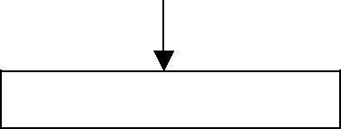

Argument register
Address |  |  |  |  | Data
0 | 1 | 0 | 0 | 0 | 3 | 4 | 5 | 0
0 | 2 | 7 | 7 | 7 | 6 | 7 | 1 | 0
2 | 2 | 3 | 4 | 5 | 1 | 2 | 3 | 4
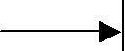

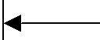

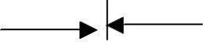

And sent to the CPU. If no match occurs, the main memory is accessed for the word. The address-data pair is then transferred to the associative cache memory. If the cache is full, an address−data pair must be displaced to make room for a pair that is needed and not presently in the cache. The decision as to what pair is replaced is determined from the replacement algorithm that the designer chooses for the cache. A simple procedure is to replace cells of the cache in round-robin order whenever a new word is requested from main memory. This constitutes a first-in first-out (FIFO) replacement policy.

DIRECT MAPPING

Associative memories are expensive compared to random-access memories because of the added logic associated with each cell. The possibility of using a random-access memory for the cache is investigated in Fig. The CPU address of 15 bits is divided into two fields. The nine least significant bits constitute the index field and the remaining six bits from the tag and the index bits. The number of bits in the index field is equal to the number of address bits required to access the cache memory.

In the general case, there are 2^{k} words in cache memory and 2^{n} words in main memory. The n-bit memory address is divided into two fields: k bits for the index field and n − k bits for the tag field. The direct mapping cache organization uses the n-bit address to access the main memory and the k-bit index to access the cache. The internal organization of the words in the cache memory is as shown in Fig. (b). Each word in cache consists of the data word and its associated tag. When a new word is first brought into the cache, the tag bits are stored alongside the data bits. When the CPU generates a memory request, the index field is used for the address to access the cache.

The tag field of the CPU address is compared with the tag in the word read from the cache. If the two tags match, there is a hit and the desired data word is in cache. If the two tags match, there is a hit and the desired data word is in cache. If there is no match, there is a miss and the required word is read from main memory. It is then stored in the cache together with the new tag, replacing the previous value. The disadvantage of direct mapping is that the hit ratio can droop considerably if two or more words whose addresses have the same index but different tags are accessed repeatedly. However, this possibility is minimized by the fact that such words are relatively far apart in the address range (multiples of 512 locations in this example).

To see how the direct-mapping organization operates, consider the numerical example shown in Fig. The word at address zero is presently stored in the cache (index = 000, tag = 00, data = 1220). Suppose that the CPU now wants to access the word at address 02000. The index address is 000, so it is sued to access the cache. The two tags are then compared. The cache tag is 00 but the address tag is 02, which does not produce a match. Therefore, the main memory is accessed and the data word 5670 is transferred to the CPU. The cache word at index address 000 is then replaced with a tag of 02 and data of 5670.

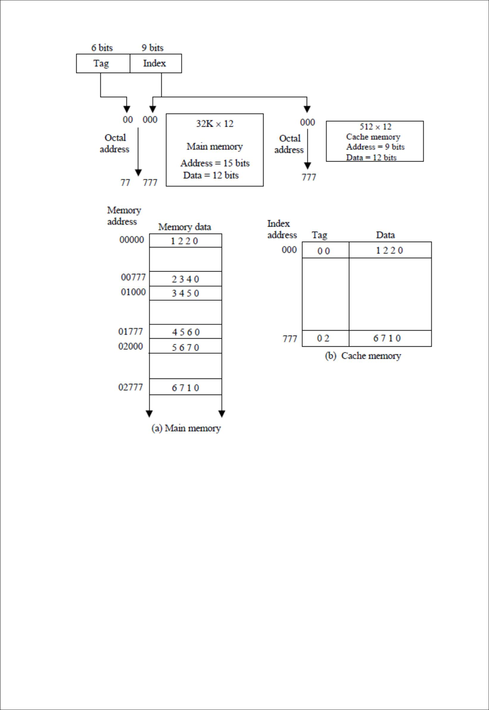

Fig-Direct mapping cache organization

The direct-mapping example just described uses a block size of one word. The same organization but using a block size of 8 words is shown in below Fig. The index

 |  | Index | Tag | Data | 6 |  | 6 | 3
 |  | 000 | 0 1 | 3 4 5 0 |  | Tag | Block |  | Word
Block 0 |  |  |  |  |  | Tag | Block |  | Word
007 |  |  | 0 1 | 6 5 7 8
 |  | 010 |  |  |  |  |  | Index
Block 1
 | 017
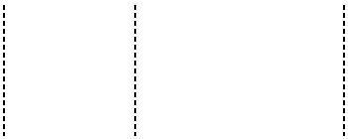
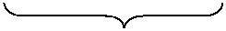

 | 770 | 0 2
Block 63
 | 777 | 0 2 | 6 7 1 0

Fig

Field is now divided into two parts: the block field and the word field. In a 512-word cache there are 64 block of 8 words each, since 64 × 8 = 512. The block number is specified with a 6-bit field and the word within the block is specified with a 3-bit field. The tag field stored within the cache is common to all eight words of the same block. Every time a miss occurs, an entire block of eight words must be transferred from main memory to cache memory. Although this takes extra time, the hit ratio will most likely improve with a larger block size because of the sequential nature of computer programs.

SET-ASSOCIATIVE MAPPING

It was mentioned previously that the disadvantage of direct mapping is that two words with the same index in their address but with different tag values cannot reside in cache memory at the same time. A third type of cache organization, called set-associative mapping, is an improvement over the direct-mapping organization in that each word of cache can store two or more words of memory under the same index address. Each data word is stored together with its tag and the number of tag-data items in one word of cache is said to form a set. An example of a set-associative cache organization for a set size of two is shown in Fig. Each index address refers to two data words and their associated tags. Each tag requires six bits and each data word has 12 bits, so the word length is 2(6 + 12) = 36 bits. An index address of nine bits can accommodate 512 words. Thus the size of cache memory is 512 × 36. It can accommodate 1024 words of main memory since each word of cache contains two data words. In general, a set-associative cache of set size k will accommodate k words of main memory in each word of cache.

Index | Tag | Data | Tag | Data
000 | 0 1 | 3 4 5 0 | 0 2 | 5 6 7 0

777 | 6 7 1 0 | 0 0 | 2 3 4 0

Figure- Two-way set-associative mapping cache.

The octal numbers listed in above Fig. are with reference to the main memory content illustrated in Fig.(a). The words stored at addresses 01000 and 02000 of main memory are stored in cache memory at index address 000. Similarly, the words at addresses 02777 and 00777 are stored in cache at index address 777. When the CPU generates a memory request, the index value of the address is used to access the cache. The tag field of

the CPU address is then compared with both tags in the cache to determine if a catch occurs. The comparison logic is done by an associative search of the tags in the set similar to an associative memory search: thus the name “set-associative”. The hit ratio will improve as the set size increases because more words with the same index but different tag can reside in cache. However, an increase in the set size increases the number of bit s in words of cache and requires more complex comparison logic.

When a miss occurs in a set-associative cache and the set is full, it is necessary to replace one of the tag-data items with a new value. The most common replacement algorithms used are: random replacement, first-in, first out (FIFO), and least recently used (LRU). With the random replacement policy the control chooses one tag-data item for replacement at random. The FIFO procedure selects for replacement the item that has been in the set the longest. The LRU algorithm selects for replacement the item that has been least recently used by the CPU. Both FIFO and LRU can be implemented by adding a few extra bits in each word of cache.

WRITING INTO CACHE

An important aspect of cache organization is concerned with memory write requests. When the CPU finds a word in cache during read operation, the main memory is not involved in the transfer. However, if the operation is a write, there are two ways that the system can proceed.

The simplest and most commonly used procedure is to up data main memory with every memory write operation, with cache memory being updated in parallel if it contains the word at the specified address. This is called the write-through method. This method has the advantage that main memory always contains the same data as the cache,. This characteristic is important in systems with direct memory access transfers. It ensures that the data residing in main memory are valid at tall times so that an I/O device communicating through DMA would receive the most recent updated data.

The second procedure is called the write-back method. In this method only the cache location is updated during a write operation. The location is then marked by a flag so that later when the words are removed from the cache it is copied into main memory. The reason for the write-back method is that during the time a word resides in the cache, it may be updated several times; however, as long as the word remains in the cache, it does not matter whether the copy in main memory is out of date, since requests from the word are filled from the cache. It is only when the word is displaced from the cache that an accurate copy need be rewritten into main memory. Analytical results indicate that the number of memory writes in a typical program ranges between 10 and 30 percent of the total references to memory.

CACHE INITIALIZATION

One more aspect of cache organization that must be taken into consideration is the problem of initialization. The cache is initialized when power is applied to the computer or when the main memory is loaded with a complete set of programs from auxiliary memory. After initialization the cache is considered to be empty, built in effect it contains some non-valid data. It is customary to include with each word in cache a valid bit to indicate whether or not the word contains valid data.

The cache is initialized by clearing all the valid bits to 0. The valid bit of a particular cache word is set to 1 the first time this word is loaded from main memory and stays set unless the cache has to be initialized again. The introduction of the valid bit means that a word in cache is not replaced by another word unless the valid bit is set to 1 and a mismatch of tags occurs. If the valid bit happens to be 0, the new word automatically replaces the invalid data. Thus the initialization condition has the effect of forcing misses from the cache until it fills with valid data.

VIRTUAL MEMORY

In a memory hierarchy system, programs and data are brought into main memory as they are needed by the CPU. Virtual memory is a concept used in some large computer systems that permit the user to construct programs as though a large memory space were available, equal to the totality of auxiliary memory. Each address that is referenced by the CPU goes through an address mapping from the so-called virtual address to a physical address in main memory. Virtual memory is used to give programmers the illusion that they have a very large memory at their disposal, even though the computer actually has a relatively small main memory. A virtual memory system provides a mechanism for translating program-generated addresses into correct main memory locations. This is done dynamically, while programs are being executed in the CPU. The translation or mapping is handled automatically by the hardware by means of a mapping table.

ADDRESS SPACE AND MEMORY SPACE

An address used by a programmer will be called a virtual address, and the set of such addresses the address space. An address in main memory is called a location or physical address. The set of such locations is called the memory space. Thus the address space is the set of addresses generated by programs as they reference instructions and data; the memory space consists of the actual main memory locations directly addressable for processing. In most computers the address and memory spaces are identical. The address space is allowed to be larger than the memory space in computers with virtual memory.

As an illustration, consider a computer with a main -memory capacity of 32K words (K = 1024). Fifteen bits are needed to specify a physical address in memory since 32K = 2¹⁵. Suppose that the computer has available auxiliary memory for storing 2²⁰ = 1024K words. Thus auxiliary memory has a capacity for storing information equivalent to the capacity of 32 main memories. Denoting the address space by N and the memory

space by M, we then have for this example N = 1024K and M = 32K.

In a multiprogramming computer system, programs and data are transferred to and from auxiliary memory and main memory based on demands imposed by the CPU. Suppose that program 1 is currently being executed in the CPU. Program 1 and a portion of its associated data re moved from auxiliary memory into main memory as shown in Fig. Portions of programs and data need not be in contiguous locations in memory since information is being moved in and out, and empty spaces may be available in scattered locations in memory.

In a virtual memory system, programmers are told that they have the total address space at their disposal. Moreover, the address field of the instruction code has a sufficient number of bits to specify all virtual addresses. In our example, the address field of an instruction code will consist of 20 bits but physical memory addresses must be specified with only 15 bits. Thus CPU will reference instructions and data with a 20-bit address, but the information at this address must be taken from physical memory because access to auxiliary storage for individual words will be prohibitively long. (Remember

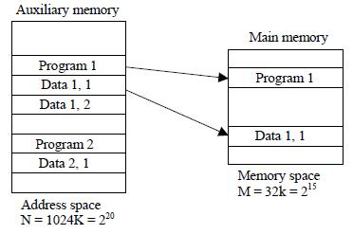

Fig-Relation between address and memory space in a virtual memory system

That for efficient transfers, auxiliary storage moves an entire record to the main memory). A table is then needed, as shown in Fig, to map a virtual address of 20 bits to a physical address of 15 bits. The mapping is a dynamic operation, which means that every address is translated immediately as a word is referenced by CPU.

The mapping table may be stored in a separate memory as shown in Fig. or in main memory. In the first case, an additional memory unit is required as well as one extra memory access time. In the second case, the table

Figure - Memory table for mapping a virtual address.

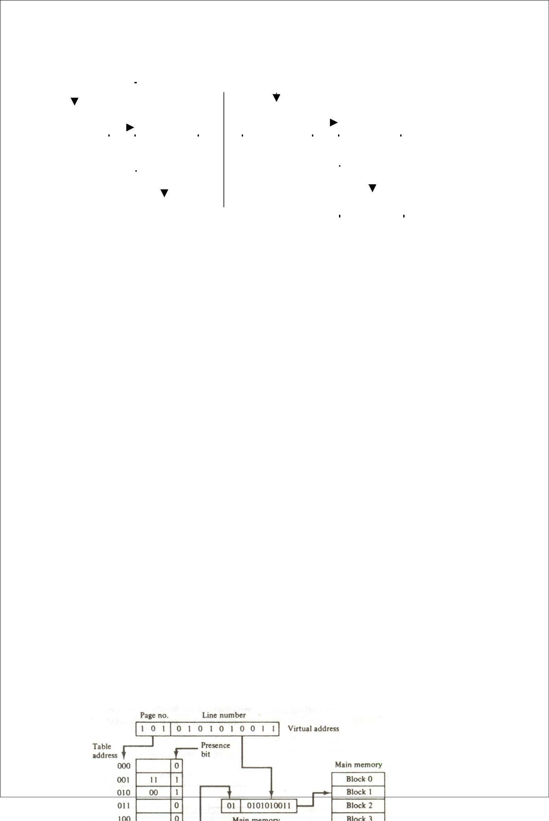
Virtual address
 |  |  |  |  |  |  |  |  | Main memory
Virtual |  |  |  |  | Memory |  |  |  |  |  |  |  |  | Main
 |  |  |  |  |  |  |  |  | address
address
 |  |  |  |  | mapping |  |  |  | registered |  |  |  |  | memory
register
(20 bits) |  |  |  |  | table |  |  |  | (15 bits)

 |  |  | Main memory
Memory table |  |  | Main memory
Memory table |  |  | buffer register
buffer register |  |  | buffer register

Takes space from main memory and two accesses to memory are required with the program running at half speed. A third alternative is to use an associative memory as explained below.

ADDRESS MAPPING USING PAGES

The table implementation of the address mapping is simplified if the information in the address space and the memory space are each divided into groups of fixed size. The physical memory is broken down into groups of equal size called blocks, which may range from 64 to 4096 words each. The term page refers to groups of address space of the same size. For example, if a page or block consists of 1K words, then, using the previous example, address space is divided into 1024 pages and main memory is divided into 32 blocks. Although both a page and a block are split into groups of 1K words, a page refers to the organization of address space, while a block refers to the organization of memory space. The programs are also considered to be split into pages. Portions of programs are moved from auxiliary memory to main memory in records equal to the size of a page.

The term “page frame” is sometimes used to denote a block.

Consider a computer with an address space of 8K and a memory space of 4K. If we split each into groups of 1K words we obtain eight pages and four blocks as shown in Fig. At any given time, up to four pages of address space may reside in main memory in any one of the four blocks.

The mapping from address space to memory space is facilitated if each virtual address is considered to be represented by two numbers: a page number address and a line within the page. In a computer with 2^{p} words per page, p bits are used to specify a line address and the remaining high-order bits of the virtual address specify the page number. In the example of Fig, a virtual address has 13 bits. Since each page consists of 2¹⁰ = 1024 words, the high-order three bits of a virtual address will specify one of the eight pages and the low-order 10 bits give the line address within the page. Note that the line address in address space and memory space is the same; the only mapping required is from a page number to a block number.

Figure - Memory table in a paged system.

The word to the main memory buffer register ready to be used by the CPU. If the presence bit in the word read from the page table is 0, it signifies that the content of the word referenced by the virtual address does not reside in main memory. A call to the operating system is then generated to fetch the required page from auxiliary memory and place it into main memory before resuming computation.

ASSOCIATIVE MEMORY PAGE TABLE

A random-access memory page table is inefficient with respect to storage utilization. In the example of below Fig. we observe that eight words of memory are needed, one for each page, but at least four words will always be marked empty because main memory cannot accommodate more than four blocks. In general, system with n pages and m blocks would require a memory-page table of n locations of which up to m blocks will be marked with block numbers and all others will be empty. As a second numerical example, consider an address space of 1024K words and memory space of 32K words. If each page or block contains 1K words, the number of pages is 1024 and the number of blocks 32. The capacity of the memory-page table must be 1024 words and only 32 locations may have a presence bit equal to 1. At any given time, at least 992 locations will be empty and not in use.

A more efficient way to organize the page table would be to construct it with a number of words equal to the number of blocks in main memory. In this way the size of the memory is reduced and each location is fully utilized. This method can be implemented by means of an associative memory with each word in memory containing a page number together with its corresponding block number The page field in each word is compared with the page number in the virtual address. If a match occurs, the word is read from memory and its corresponding block number is extracted.

Figure -An associative memory page table.

 |  |  |  | Virtual address
 | Page no.
 | 1 0 1 |  |  |  |  |  |  | Line number |  | Argument register
 | 1 | 1 | 1 | 0 |  |  | 0 |  | Key register
 | 0 | 0 | 1 |  | 1 |  | 1
 | 0 | 1 | 0 |  | 0 |  | 0 |  | Associative memory
 | 1 | 0 | 1 |  | 0 |  | 1
 | 1 | 1 | 0 |  | 1 |  | 0
 | Page no. |  |  |  |  | Block no .
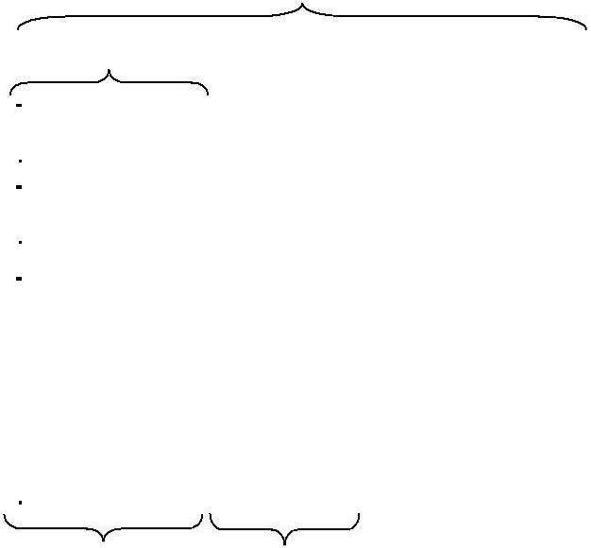
Consider again the case of eight pages and four blocks as in the example of Fig. We replace the random access memory-page table with an associative memory of four words as shown in Fig. Each entry in the associative memory array consists of two fields. The first three bits specify a field from storing the page number. The last two bits constitute a field for storing the block number. The virtual address is placed in the argument register. The page number bits in the argument are compared with all page numbers in the page field of the associative memory. If the page number is found, the 5-bit word is read out from memory. The corresponding block number, being in the same word, is transferred to the main memory address register. If no match occurs, a call to the operating system is generated to bring the required page from auxiliary memory.

PAGE REPLACEMENT

A virtual memory system is a combination of hardware and software techniques. The memory management software system handles all the software operations for the efficient utilization of memory space. It must decide (1) which page in main memory ought to be removed to make room for a new page, (2) when a new page is to be transferred from auxiliary memory to main memory, and (3) where the page is to be placed in main memory. The hardware mapping mechanism and the memory management software together constitute the architecture of a virtual memory.

When a program starts execution, one or more pages are transferred into main memory and the page table is set to indicate their position. The program is executed from main memory until it attempts to reference a page that is still in auxiliary memory. This condition is called page fault. When page fault occurs, the execution of the present program is suspended until the required page is brought into main memory. Since loading a page from auxiliary memory to main memory is basically an I/O operation, the operating system assigns this task to the I/O processor. In the meantime, controls transferred to the next program in memory that is waiting to be processed in the CPU. Later, when the memory block has been assigned and the transfer completed, the original program can resume its operation.

When a page fault occurs in a virtual memory system, it signifies that the page referenced by the CPU is not in main memory. A new page is then transferred from auxiliary memory to main memory. If main memory is full, it would be necessary to remove a page from a memory block to make room for the new page. The policy for choosing pages to remove is determined from the replacement algorithm that is used. The goal of a replacement policy is to try to remove the page least likely to be referenced in the immediate future.

Two of the most common replacement algorithms used are the first-in first-out (FIFO) and the least recently used (LRU). The FIFO algorithm selects for replacement the page the has been in memory the longest time. Each time a page is loaded into memory, its identification number is pushed into a FIFO stack. FIFO will be full whenever memory has no more empty blocks. When a new page must be loaded, the page least recently brought in is removed. The page to be removed is easily determined because its identification number is at the top of the FIFO stack. The FIFO replacement policy has the advantage of being easy to implement. It has the disadvantages that under certain circum-stances pages are removed and loaded form memory too frequently.

The LRU policy is more difficult to implement but has been more attractive on the assumption that the least recently used page is a better candidate for removal than the least recently loaded pages in FIFO. The LRU algorithm can be implemented by associating a counter with every page that is in main memory. When a page is referenced, its associated counter is set to zero. At fixed intervals of time, the counters associated with all pages presently in memory are incremented by 1. The least recently used page is the page with the highest count. The counters are often called aging registers, as their count indicates their age, that is, how long ago their associated pages have been reference.

8086 CPU Pin Diagram

Introduction to processor:

- A processor is the logic circuitry that responds to and processes the basic instructions that drive a computer.

- The term processor has generally replaced the term central processing unit (CPU). The processor in a personal computer or embedded in small devices is often called a microprocessor.

- The processor (CPU, for Central Processing Unit) is the computer's brain. It allows the processing of numeric data, meaning information entered in binary form, and the execution of instructions stored in memory.

Evolution of Microprocessor:

A microprocessor is used as the CPU in a microcomputer. There are now many

different microprocessors available.

  - Microprocessor is a program-controlled device, which fetches the instructions from memory, decodes and executes the instructions. Most Micro Processor are single-chip devices.

  - Microprocessor is a backbone of computer system. which is called CPU

  - Microprocessor speed depends on the processing speed depends on DATA BUS

WIDTH.

- A common way of categorizing microprocessors is by the no. of bits that their ALU can

Work with at a time

- The address bus is unidirectional because the address information is always given by the Micro Processor to address a memory location of an input / output devices.

- The data bus is Bi-directional because the same bus is used for transfer of data between Micro Processor and memory or input / output devices in both the direction.

- It has limitations on the size of data. Most Microprocessor does not support floating-point operations.

- Microprocessor contain ROM chip because it contain instructions to execute data.

- What is the primary & secondary storage device? - In primary storage device the

- Storage capacity is limited. It has a volatile memory. In secondary storage device the storage capacity is larger. It is a nonvolatile memory.

  - Primary devices are: RAM (Read / Write memory, High Speed, Volatile Memory) / ROM (Read only memory, Low Speed, Non Voliate Memory)

  - Secondary devices are: Floppy disc / Hard disk

Compiler: Compiler is used to translate the high-level language program into machine code at a time. It doesn’t require special instruction to store in a memory, it stores automatically.

The Execution time is less compared to Interpreter.

1.4-bit Microprocessor:

- The first microprocessor (Intel 4004) was invented in 1971. It was a 4-bit calculation device with a speed of 108 kHz. Since then, microprocessor power has grown exponentially. So what exactly are these little pieces of silicone that run our computers(" Common Operating Machine Particularly Used For Trade Education And Research ")

- It has 3200 PMOS transistors.

- It is a 4-bit device used in calculator.

2.8-Bit microprocessor:

- In 1972, Intel came out with the 8008 which is 8-bit.

- In 1974, Intel announced the 8080 followed by 8085 is a 8-bit processor Because 8085 processor has 8 bit ALU (Arithmetic Logic Review). Similarly 8086 processor

has 16 bit ALU. This had a larger instruction set then 8080. used NMOS transistors, so it operated much faster than the 8008.

The 8080 is referred to as a “Second generation Microprocessor”

- Limitations of 8 Bit microprocessor:

  - Low speed of execution

  - Low memory addressing capability

  - Limited number of general purpose registers

  - Less power full instruction set

- Examples for 4/ 8 / 16 / 32 bit Microprocessors:

- 4-Bit processor – 4004/4040

- 8-bit Processor - 8085 / Z80 / 6800

- 16-bit Processor - 8086 / 68000 / Z8000

- 32-bit Processor - 80386 / 80486

- What are 1st / 2nd / 3rd / 4th generation processor?

  - The processor made of PMOS technology is called 1st generation processor, and it is made up of 4 bits

  - The processor made of NMOS technology is called 2nd generation processor, and it is made up of 8 bits

  - The processor made of CMOS technology is called 3rd generation processor, and it is made up of 16 bits

  - The processor made of HCMOS technology is called 4th generation processor, and it is made up of 32 bits (HCMOS : High-density n- type Complementary Metal Oxide Silicon field effect transistor)

Block diagram of microprocessor:
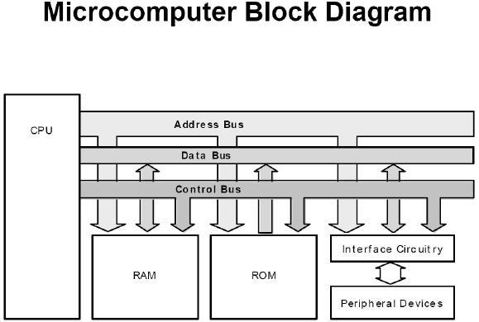

The Central Processing Unit (CPU):

This device coordinates all operations of a micro computer. It fetches programs stored in ROM‟s or RAMs and executes the instructions depending one a specific Instructions set,

which is characteristic of each type of CPU, and which is recognized by the CPU.

The Random Access Memory (RAM): Temporary or trail programs are written. Besides the ROM area, every computer has some memory space for temporary

storage of data as well as for programs under development. These memory devices are RAMs or Read – write memory. The contents of it are not permanent and are altered when power is turned off. So the RAM memory is considered to be volatile memory.

The Read Only Memory (ROM): Permanent programs are stored.

The permanent memory device/area is called ROM, because whatever be the memory contents of ROMs, they cannot be over written with some other information.

For a blank ROM, the manufacturer supplies the device without any inf. In it, information can be entered electrically into the memory space. This is called burning a ROM or PROM.

Data Lines/Data Bus:

The no .of data lines, like add. Lines vary with the specific CPU .The set of data lines is database like the address bus unlike add. Bus, the data bus is bidirectional because while the information on the address Bus always flows out of the CPU; the data can flow both out of the CPU as well as into the CPU.

Control lines/ control Bus:

The no. of control lines also depends on the specific CPU one is using. Ex: Read; Write lines are examples of control lines

CLOCK:

The clock is a symmetrical square wave signal that drives the CPU

Instructions:An instruction is an elementary operation that the processor can accomplish. Instructions are stored in the main memory, waiting to be processed by the processor. An instruction has two fields:

- Operation code, which represents the action that the processor must execute;

- Operand code, which defines the parameters of the action. The operand code depends on the operation. It can be data or a memory address.

Note: Micro uses units

Macro makes units

8086 ARCHITECTURE

- Introduction to 8085 Microprocessor:

    - 8085 is a 8-bit Microprocessor

  - The salient features of 8085 Microprocessor are:

    - It is an 8 bit microprocessor.

    - It is manufactured with N-MOS technology.

    - It has 16-bit address bus and hence can address up to 216 = 65536 bytes (64KB) memory locations through A0-A15.

    - The first 8 lines of address bus and 8 lines of data bus are multiplexed AD0 – AD7.

    - Data bus is a group of 8 lines D0 – D7.

    - It supports external interrupt request.

    - A 16 bit program counter (PC)

    - A 16 bit stack pointer (SP)

    - Six 8-bit general purpose register arranged in pairs: BC, DE, HL.

    - It requires a signal +5V power supply and operates at 3.2 MHZ single phase clock.

    - It is enclosed with 40 pins DIP (Dual in line package).

- 8085 Pin Diagram:

SID (Serial Input Data) line:
- There is an One bit Input line inside the 8085 CPU (Pin number 5)

- 1 bit data can be externally read and stored using this SID line

- The data that is read is stored in the A7th bit of the Accumulator

SOD (Serial Output Data) Line:

- There is a One bit Output port inside the 8085 CPU (Pin number 4

- 1 bit data can be externally written in this port.

- To write data into this port, SIM instruction is used.

- The data that is to be written in this port must be stored in the A7th bit of the Accumulator

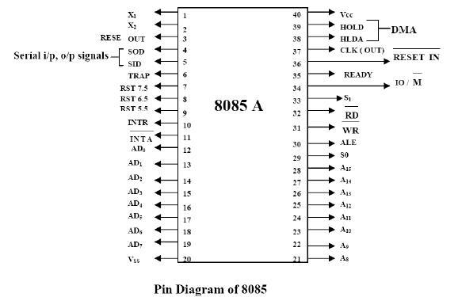

- Functional Description:

  - The 8085 is an 8-bit up capable of add. up to 64k bytes (216 = 65,536) of memory

  - It has 8-addressable 8-bit registers, six of which can also be used as three pairs of 16-bit

Registers.

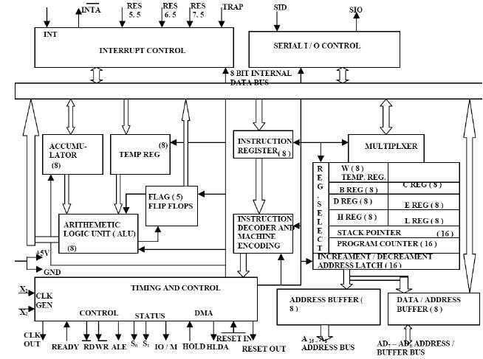

1.3 Instruction Set:

8085 instruction set consists of the following instructions

  - Data moving instructions.

  - Arithmetic - add, subtract, increment and decrement.

  - Logic - AND, OR, XOR and rotate.

  - Control transfer - conditional, unconditional, call subroutine, return from subroutine and restarts.

  - Input/Output instructions.

  - Other - setting/clearing flag bits, enabling/disabling interrupts, stack operations, etc.

- Addressing modes

  - Register - references the data in a register or in a register pair.

  - Register indirect - instruction specifies register pair containing address, where the data is located.

  - Direct, Immediate - 8 or 16-bit data.

- FLAG Register:

  - Sign flag:

The bit 7 (MSB) of the 8-bits is used for the sign of data in the accumulator, then the numbers can be used in the range -128 to +127.

0 → positive

1 → negative

➢ zero flag:
If the result obtained after executing an instruction is zero. ZF = 1

Otherwise ZF = 0

If result is zero, and carry is present then both ZF=1 and CF = 1

➢ carry flag:
In both addition and subtraction involving two 8-bit no.s,

Addition: overflow from higher order bit substation: Borrow

DF is set to 1.

➢ Auxiliary carry flag (AC):
This flag is used in BCD arithmetic. This is set for an over flow out of bit

3.

➢ parity flag:
Parity is defined by the no. of 1‟s present in the Accumulator.

If parity is even, P →‟1‟

If parity is odd, P →‟0‟

INTERNAL CLOCK GENERATOR:

The maximum Frequency of 8085 CPU can operate at is 3.125 MHZ, using a Quartz Crystal oscillator.

Whether it is external or internally generated clock signal, this signal freq is halved before it is used in the timing operations

1.6 INTERRUPTS:

The five H/W interrupts are classified into three types depending on their maskability and the way they can be masked.

First: INTR

Second: RST 5.5 RST 6.5 RST 7.5
Third: TRAP

- INTR: This interrupt is maskable. It can be enabled by the instruction ENABLE INTERRUPT (EI) and disabled by DISABLE INTERRUPT (DI).

The INTR interrupt requires external H/W to generate a Restart (RST) inst. (There are eight such inst. RST0-RST7, which point to a fixed memory address), which is laced externally on the databus

INTR can also be controlled by the peripheral chip 8259

- RST 5.5, RST 6.5, RST 7.5:

  - These are also maskable by the use of SIM (Set Interrupt mask) instruction. To enable or disable the Interrupts, specific data is first loaded into the Accumulator. The status of Interrupt masks at a given time could be read by a RIM instruction. SIM and RIM for interrupts:

  - The 8085 provide additional masking facility for RST 7.5, RST 6.5 and RST 5.5 using SIM instruction.

  - The status of these interrupts can be read by executing RIM instruction.

  - The masking or unmasking of RST 7.5, RST 6.5 and RST 5.5 interrupts can be performed by moving an 8-bit data to accumulator and then executing SIM instruction.

The format of the 8-bit data is shown below.
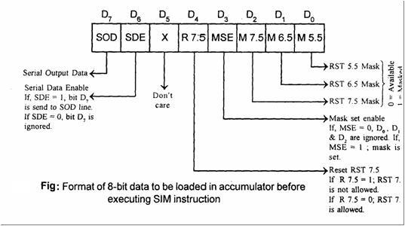
3. TRAP is unmaskable

Hardware Interrupts on the 8085 CPU:
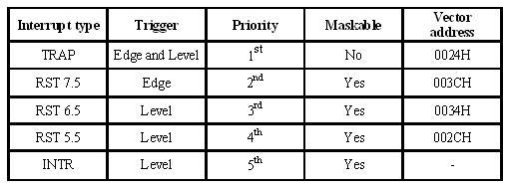

- Introduction to 8086:

1.7.1 Overview of 8086:

  - In1978, Intel came out with the 8086 processor.The Intel 8086 is a 16-bit microprocessor, implemented in N – channel, depletion load, silicon gate technology (HMOS) and packaged it in a 40 pin dual in line package.

  - The Intel 8086 is a 16-bit Micro processor. The term 16-bit means that its ALU, its internal registers, and most of its instructions are designed to work with16-bit binary words.

  - The Intel 8088 has same ALU, the same registers, and the same instruction set as 8086.

(8086: 16-bit add.bus and 8-bit data bus)

  - The Intel 80186 is an improved version of 8086 and 80188 is an improved version of 8088.

  - The Intel 80286 is a 16-bit, advanced version of 8086 which was specifically designed for used in a multiuser or multi tasking computer.

  - Next Intel 80386 is a 32-bit up which can directly address up to 4 GB of memory.

  - Lastly 80486, is an evolutionary step up from the 80386.

- Features of 8086 Microprocessor are:

  - It is a 16-bit µp.

- 8086 has a 20 bit address bus can access up to 220 memory locations (1 MB) .

- It can support up to 64K I/O ports.

- It provides 14, 16 -bit registers.

• It has multiplexed address and data bus AD0- AD15 and A16 – A19.

  - It requires single phase clock with 33% duty cycle to provide internal timing.

  - 8086 is designed to operate in two modes, Minimum and Maximum.

  - It can prefetches upto 6 instruction bytes from memory and queues them in order to speed up instruction execution.

  - It requires +5V power supply.

  - A 40 pin dual in line package

- Register organization of 8086:

8086 has two types of registers. All the registers of 8086 are 16-bit registers

  - General purpose register (GPR)

  - Special purpose register (SPR)

- General purpose registers (GPR):

GPR register can be used as 8-bit or 16-bit.These registers are generally used for holding data, variables and intermediate results temporarily. They can also used as a counters or used for sorting offset address for some particular addressing mode

8086 CPU has 8 general purpose registers; each register has its own name:

AX - the accumulator register (divided into AH / AL): Accumulator register consists of 2-8-bit registers AL and AH, which can be combined together and used as a 16-bit register AX. AL in this case contains the low-order byte of the word, and AH contains the high-order byte. Accumulator can be used for I/O operations and string manipulation.

- Generates shortest machine code

- Arithmetic, logic and data transfer

- One number must be in AL or AX

- Multiplication & Division

- Input & Output

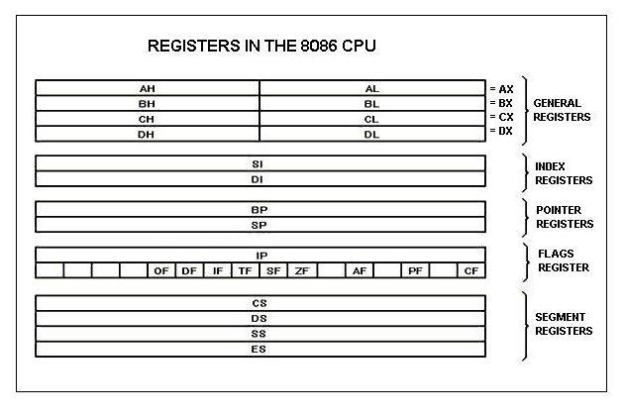

BX - the base address register (divided into BH / BL): Base register consists of 2 8-bit registers BL and BH, which can be combined together and used as a 16-bit register BX. BL in this case contains the low-order byte of the word, and BH contains the high-order byte. BX register usually contains a data pointer used for based, based indexed or register indirect addressing

CX - the count register (divided into CH / CL): Count Register consists of 2 8-bit registers CL and CH, which can be combined together and used as a 16-bit register CX. When combined, CL register contains the low-order byte of the word, and CH contains the high-order byte. Count register can be used as a counter in string manipulation and shift/rotate instructions

- Iterative code segments using the LOOP instruction

- Repetitive operations on strings with the REP command

- Count (in CL) of bits to shift and rotate

DX - the data register (divided into DH / DL): Data register consists of 2 8-bit registers DL and DH, which can be combined together and used as a 16-bit register DX. When combined, DL register contains the low-order byte of the word, and DH contains the high-order byte. Data register can be used as a port number in I/O operations. In integer 32-bit multiply and divide instruction the DX register contains high-order word of the initial or resulting number.

- DX: AX concatenated into 32-bit register for some MUL and DIV operations

- Specifying ports in some IN and OUT operations

2. SPECIAL PURPOSE REGISTERS (SPR):

SPR are used as segment registers, pointers, index registers or as offset storage registers for addressing modes

We categories the registers are

  - Segment registers

  - Pointers and index registers

  - Flag registers

- Segment registers:

Segment registers to the 16-bit address to form a 20-bit address.

The physical address of the 8086 is 20 bit wide to access 1 Mbyte memory locations.1 Mbyte of memory is divided into segments, with a maximum size of segment as 64 Kbytes

The 8086 allows only four active segments at a time, as shown the below figure, these four registers are:

Code segment (CS) is a 16-bit register containing address of 64 KB segment with processor

instructions.

Stack segment (SS) is a 16-bit register containing address of 64KB segment with program

stack

Data segment (DS) is a 16-bit register containing address of 64KB segment with program

data.

Extra segment (ES) is a 16-bit register containing address of 64KB segment, usually with

program data

Functions of segment registers:

  - The CS register holds the upper 16-bits of the starting address of the segment from which the BIU is currently fetching the instruction code byte

  - The SS registers is used for the upper 16-bit of the starting address for the program stack

  - ES registers and DS registers are used to hold the upper 16 bit of the starting address of the two memory segments which are used for data

- Pointers and index registers:

SI - source index register:

- Can be used for pointer addressing of data

- Used as source in some string processing instructions

- Offset address relative to DS

DI - destination index register:

- Can be used for pointer addressing of data

- Used as destination in some string processing instructions

- Offset address relative to ES

BP - base pointer:

- Primarily used to access parameters passed via the stack

- Offset address relative to SS

SP - stack pointer:

- Always points to top item on the stack

- Offset address relative to SS

- Always points to word (byte at even address)

- An empty stack will had SP = FFFEh

Memory organization:

The total memory of 1MB is divided into 16 segments and each segment can store 64kb of data and the segments available are CS, DS, ES, and SS

1.8.1 Physical address calculation:

Physical address calculation = segment address+offset address

In segment we use always four registers i.e. CS, DS, ES, and SS

Offset register are BP, SP, SI, DI, IP

Move the code segment address to left side and add zero

Eg: let 4000

40000 8000-offset

4000-segment address

Physical address represented as 4000:8000

For CS we use IP, for DS we use SI, DI, for Es we use SI, DI, for SS we use SP

1.8.2 8086 FLAG REGISTER:

There are nine types of flag registers in 8086 these are divided into two.

- Conditional flag

- Control flag

Flag registers is used to indicate the results of arithmetic operations
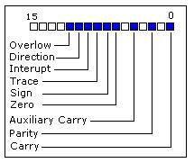

- Carry Flag (CF): - this flag is set to 1 when there is an unsigned overflow. For example when you add bytes 255 + 1 (result is not in range 0...255). When there is no overflow this flag is set to 0. (OR) If this bit is one it indicates it as carry And zero means no carry

- Parity Flag (PF): this flag is set to 1 when there is even number of one bits in result, and to 0 when there is odd number of one bits.

- Auxiliary Flag (AF): set to 1 when there is an unsigned overflow for low nibble (4 bits).

- Zero Flag (ZF): set to 1 when result is zero. For non-zero result this flag is set to 0.

- Sign Flag (SF): set to 1 when result is negative. When result is positive it is set to0. (This flag takes the value of the most significant bit.)

- Overflow Flag (OF): set to 1 when there is a signed overflow. For example, when you add bytes 100 + 50 (result is not in range -128...127).

The above six flags are called as conditional flags.

- Direction Flag (DF): this flag is used by some instructions to process data chains, when this flag is set to 0 - the processing is done forward, when this flag is set to 1the processing is done backward.

- Trap Flag (TF) - Used for on-chip debugging.

- Interrupt enable Flag (IF) - when this flag is set to 1 CPU reacts to interrupts from External devices.

1.9 Architecture of 8086:

- 8086 has two blocks BIU (BUS INTERFACR UNIT) and EU (EXECUTION UNIT)

- The BIU performs all bus operations such as instruction fetching, reading and writing operands for memory and calculating the addresses of the memory operands. The instruction bytes are transferred to the instruction queue.

- EU executes instructions from the instruction system byte queue.

- Both units operate asynchronously to give the 8086 an overlapping instruction fetch and execution mechanism which is called as Pipelining. This results in efficient use of the system bus and system performance.

- BIU contains Instruction queue, Segment registers, Instruction pointer, and Address adder.

- EU contains Control circuitry, Instruction decoder, ALU, Pointer and Index register, Flag register.

1. BUS INTERFACR UNIT:

• It provides a full 16 bit bidirectional data bus and 20 bit address bus.

•The bus interface unit is responsible for performing all external bus operations

•Instruction fetch, Instruction queuing, Operand fetch and storage, Address relocation and

Bus control.

•The BIU uses a mechanism known as an instruction stream queue to implement a pipeline architecture.

•This queue permits prefetch of up to six bytes of instruction code. Whenever the queue of the BIU is not full, it has room for at least two more bytes and at the same time the EU is not requesting it to read or write operands from memory, the BIU is free to look ahead in the program by prefetching the next sequential instruction.

•These prefetching instructions are held in its FIFO queue. With its 16 bit data bus, the BIU fetches two instruction bytes in a single memory cycle

•The BIU is also responsible for

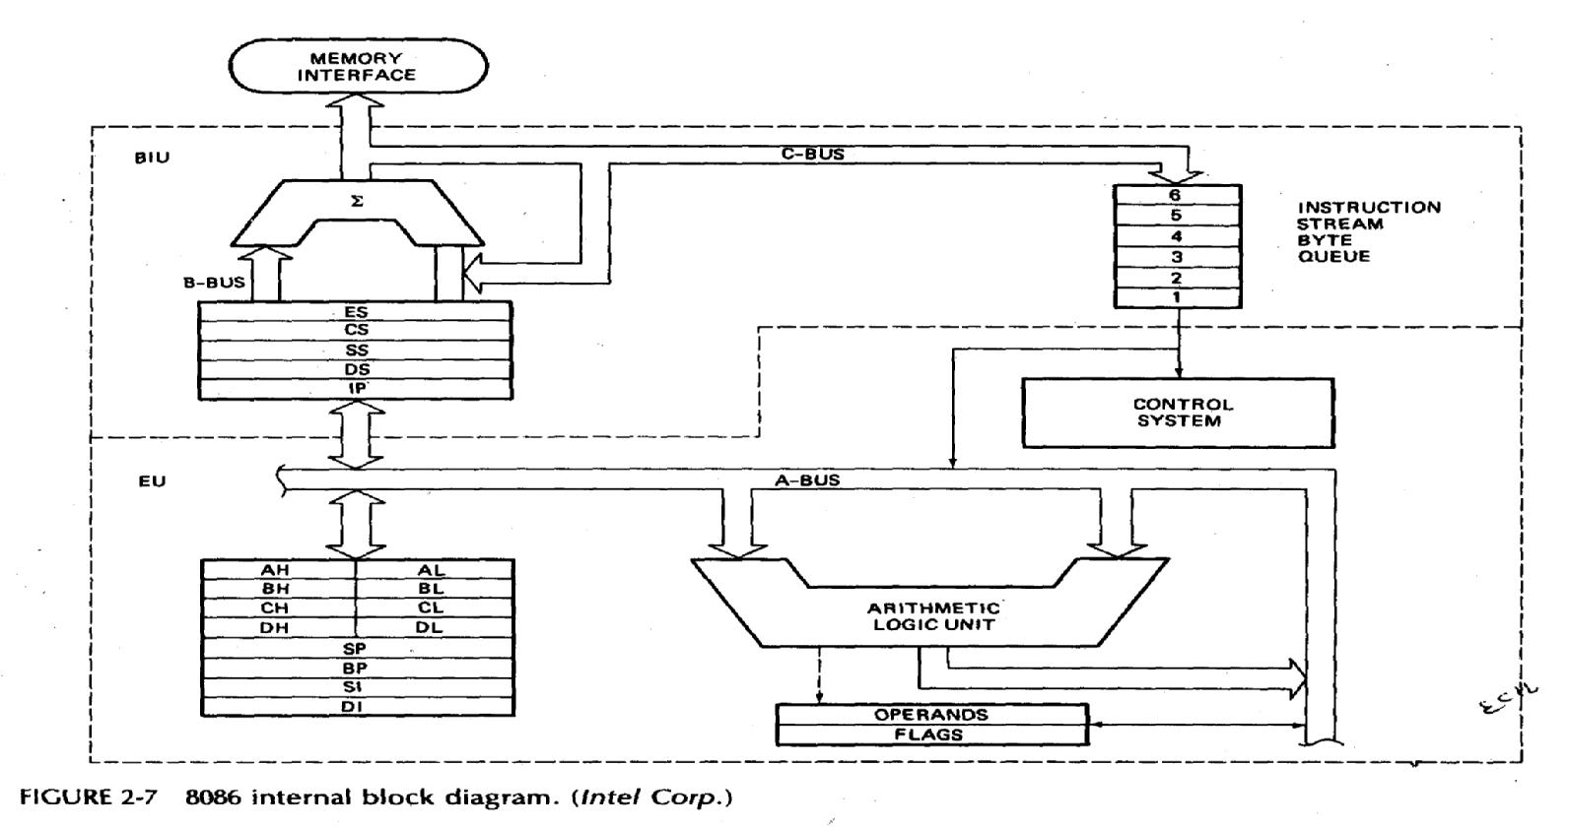

8086 Internal block diagram

Generating bus control signals such as those for memory read or write and I/O read or write.

- EXECUTION UNIT

  - The Execution unit is responsible for decoding and executing all instructions.

  - The EU extracts instructions from the top of the queue in the BIU, decodes them, generates operands if necessary, passes them to the BIU and requests it to perform the read or write bys cycles to memory or I/O and perform the operation specified by the instruction on the operands.

  - During the execution of the instruction, the EU tests the status and control flags and updates them based on the results of executing the instruction.

  - If the queue is empty, the EU waits for the next instruction byte to be fetched and shifted to top of the queue.

  - When the EU executes a branch or jump instruction, it transfers control to a location corresponding to another set of sequential instructions.

  - Whenever this happens, the BIU automatically resets the queue and then begins to

fetch instructions from this new location to refill the queue.

•

1.10 Programming Model of 8086:

Programming Languages

To run a program, a microcomputer must have the program stored in binary form in successive memory locations, as shown in Figure 2-12. There are three language levels that can be used to write a program for a microcomputer
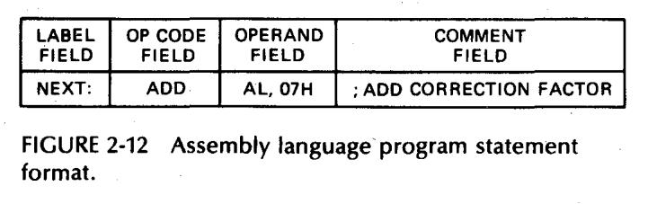

Machine Language:

- Programs can be written as simply a sequence of binary codes for the instructions that a microcomputer executes.

- This binary form of the program is referred to as machine Language, b/c it is the form required by the m/c.

- However, it is easy for an error to occur when working with a long series of 0‟s and 1‟s.

- Therefore, Hexadecimal representation is used for memory addresses.

- They are easy and compact, every nibble (4-bits) can b converted into Hex from.

Ex: | 1 | 2 | 3 | 4 | H
 | 0001 | 0010 | 0011 | 0100 | Binary

Assembly Language: (Low –Level language):

- To make programming easier, many programmers write programs in assembly language. They then translate it to m/c language so that it can be loaded into memory and run

- Assembly language used two, three or four letter mnemonics to rep. each instruction type.

- A mnemonic is just a device to help you remember something

Ex: for sub traction, the mnemonic is SUB

  - To copy data from one location to other, MOV

  - Assembly language Program Statement format:

- Label: It is a symbol or group of symbols used to rep. an address which is not specifically known at the time the statement is written. Labels are followed by a colon. They are optional

- OP code field: It contains mnemonic for the instruction to be performed. Instruction nemonics are also called operation codes.

- Operand field:

  - It contains the data, the memory address, the port address, other name of the register on which the instruction is to be performed.

  - It is just another name for the data items acted on the instruction.

  - In the previous example, there are two operands AL and 07H.

- Comment field: (optional)

They start with a semicolon.

- There are two ways for translating an assembly language tom/c language.

- One way is to work out the binary code for each instruction a bit at a time using the templates given in the manufacturer‟s data books.

- The second method of doing the translation is with an assembler.

High Level languages:

Ex: C, Pascal

An interpreter program or a compiler program is used to translate higher level language Statements tom/c codes which are loaded into memory and then executed

- These programs can be written fastly.

- However, programs written in HLL execute more slowly and require more memory than the programs written in assembly language.

1.11 SIGNAL DESCRIPTIONS OF 8086:

The microprocessor 8086 is a 16-bit CPU available in three clock rates, i.e. 5, 8 and 10 MHz, packaged in a 40 pin DIP package. The 8086 operates in single processor or multiprocessor configurations to achieve high performance

The pin configuration is shown in below figure
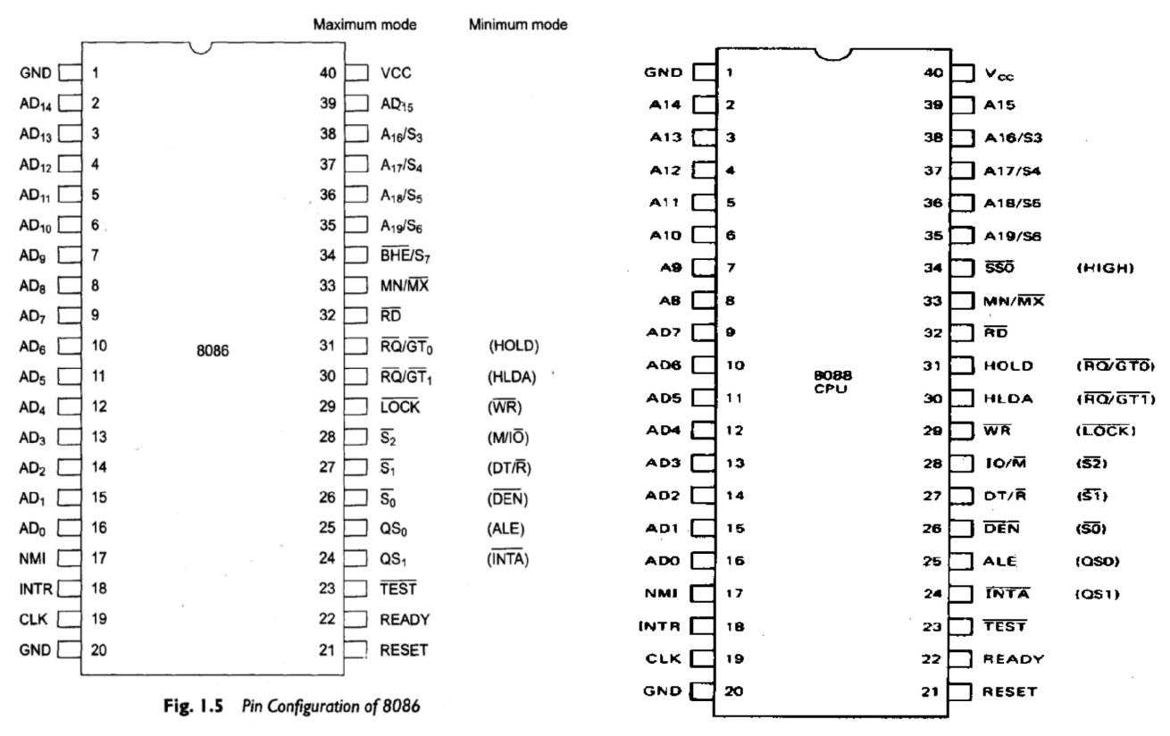

- Some of the pins serve a particular function in minimum mode (single processor mode) and others function in maximum mode (multiprocessor mode) configuration. The 8086 signals can be categorized in three groups

- The first are the signals having common functions in minimum as well as maximum mode

- the second are the signals which have special functions for minimum mode

- The third are the signals having special functions for maximum mode.

The following signal descriptions are common for both the minimum and maximum modes.

AD15-AD0:

These are the time multiplexed address and data lines. Address remains on the lines during T1 state, while the data is available on the data bus during T2, T3,Tw and T4.. Here T1,T2,T3,T4 and Tw are the clock states of a machine cycle. Tw is a wait state. These lines are active high and float to a tristate during interrupt acknowledge and local bus hold acknowledge cycles.

A19-A16/S6-S3:

- These are the time multiplexed address and status lines during T1, these are the most significant address lines for memory operations. During I/O operations, these lines are low. During memory or I/O operations,

- status information is available on those lines for T2,T3, Tw and T4. The status of the interrupt enable flag bit (displayed on S5) is updated at the beginning of each clock cycle. The S4 and S3 together indicate which segment register is presently being used for memory accesses, as shown in Table

- The address bits are separated from the status bits using latches controlled by the ALE signal.
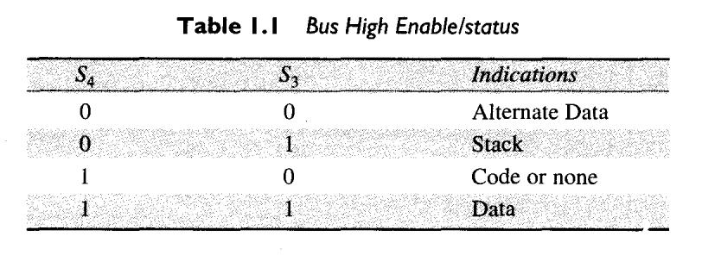

BHE /S7: (Bus High Enable/Status):

The bus high enable signal is used to indicate the transfer of data over the higher order (D15-D8) data bus as shown in Table 1.2. It goes low for the data transfers over D15-D8 and is used to derive chip selects of odd address memory bank or peripherals.
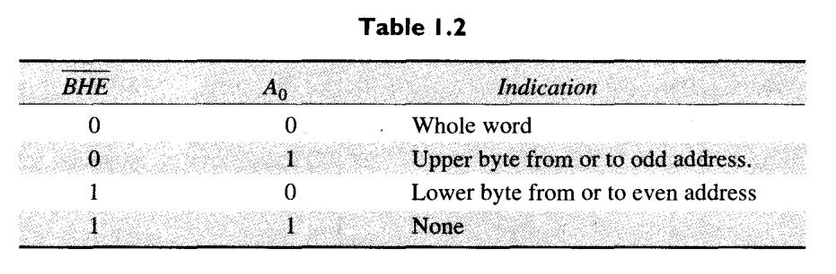

RD : (Read):

when low, indicates the peripherals that the processor is performing a memory or

I/O read operation. RD is active low and shows the state for T2, T3, Tw of any read cycle. The signal remains tristated during the ‘hold acknowledge’.

READY: This is the acknowledgement from the slow devices or memory that they have completed the data transfer. The signal is active high.

INTR: (Interrupt Request), this is a level triggered input. This is sampled during the last clock cycle of each instruction to determine the availability of the request. If any interrupt request is pending, the processor enters the interrupt acknowledge cycle. This can be internally masked by resetting the interrupt enable flag. This signal is active high and internally synchronized.

TEST : This input is examined by a ‘WAIT’ instruction. If the TEST input goes low, execution will continue, else, the processor remains in an idle state.

NMI: (Non-maskable Interrupt), this is an edge-triggered input which causes a Type 2 interrupt. The NMI is not maskable internally by software. A transition from low to high initiates the interrupt response at the end of the current instruction.

RESET: This input causes the processor to terminate the current activity and start execution from FFFFOH. The signal is active high and must be active for at least four clock cycles. It restarts execution when the RESET returns low.

CLK: (Clock) The clock input provides the basic timing for processor operation and bus control activity. The range of frequency for different 8086 versions is from 5MHz to 10MHz.

Vcc: +5V power supply for the operation of the internal circuit.

GND: Ground for the internal circuit.

MN/ MX : The logic level at this pin decides whether the processor is to operate in either minimum (single processor) or maximum (multiprocessor) mode.

The following pin functions are for the minimum mode operation of 8086:

M/ I/O : (Memory/IO) This is a status line logically equivalent to S 2 in the maximum mode. When it is low, it indicates the CPU is having an I/O operation, and when it is high, it indicates that the CPU is having a memory operation.

INTA : (Interrupt Acknowledge) When it goes low, it means that the processor has accepted the interrupt. It is active low during T2, T3 and Tw of each interrupt acknowledge cycle.

ALE: (Address Latch Enable) This output signal indicates the availability of the valid address on the address/data lines, and is connected to latch enable input of latches. This signal is active high.

DT/R : (Data Transmit / Receive) This output is used to decide the direction of data flow through the transreceivers (bidirectional buffers). When the processor sends out data, this signal is high and when the processor is receiving data, this signal is low.

DEN : (Data Enable) This signal indicates the availability of valid data over the address/data lines. It is used to enable the transreceivers (bidirectional buffers) to separate the data from the multiplexed address/data signal. It is active from the middle of 2 until the middle of 4.
DEN is tristated during ‘hold acknowledge’ cycle.

HOLD, HLDA: (Hold / Hold Acknowledge) When the HOLD line goes high, it indicates to the processor that another master is requesting the bus access. The processor, after receiving the HOLD request, issues the hold acknowledge signal on HLDA pin, in the middle of the next clock cycle after completing the current bus (instruction) cycle. At the same time, the processor floats the local bus and control lines. When the processor detects the HOLD line low, it lowers the HLDA signal.

The following pin functions are applicable for maximum mode operation of 8086.

S2, S1, S0 : (Status Lines) These are the status lines which indicate the type of operation, being carried out by the processor. These become active during T4 of the previous cycle and remain active during T1 and T2 of the current bus cycle. The status lines return to passive state during T3 of the current bus cycle. These status lines are encoded in Table 1.3.
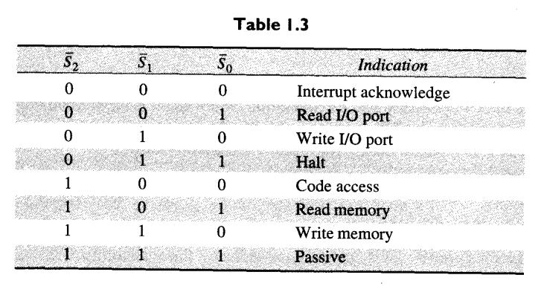

LOCK : This output pin indicates that other system bus masters will be prevented from gaining the system bus, while the LOCK signal is low. The LOCK signal is activated by the

‘LOCK’ prefix instruction and remains active until the completion of the next instruction.

When the CPU is executing a critical instruction which requires the system bus, the LOCK prefix instruction ensures that other processors connected in the system will not gain the control of the bus.

QS1, QS0: (Queue Status) These lines give information about the status of the code-prefetch queue. These are active during the CLK cycle after which the queue operation is performed. These are encoded as shown in Table 1.4.
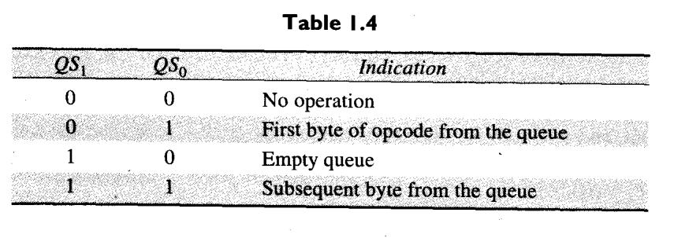

RQ/GT0, RQ/GT1 : (Request/Grant) These pins are used by other local bus masters, in maximum mode, to force the processor to release the local bus at the end of the processors current bus cycle. Each of the pins is bidirectional with RQ/GT 0 having higher priority than

RQ/GT1 .

Common Function signals of 8086:
AD7-AD0 |  |  |  |  |  | The 8088 address/data bus lines compose the multiplexed address data bus of
 |  |  |  |  |  | the 8088
A15-A8 |  |  |  |  |  | The 8088 address bus provides the upper-half memory address.
AD15-AD8 |  |  |  |  |  | The 8086 address/data bus lines compose the upper multiplexed address/data
 |  |  |  |  |  | bus on the 8086.
A19/S6- |  |  |  |  |  | The address/status bus bits are multiplexed to provide address signals A19-A16
A16/S3 |  |  |  |  |  | and also status bits S6-S3.
 |  |  |  |  |  | Whenever the read signal is a logic 0, the data bus is receptive to data from the
 | RD
 |  |  |  |  |  | memory or I/O devices connected to the system.
INTR |  |  |  |  |  | Interrupt request is used to request a hardware interrupt.
NMI |  |  |  |  |  | The non-maskable interrupt.
RESET |  |  |  |  |  | The reset input causes the microprocessor to reset.
CLK |  |  |  |  |  | The clock pin provides the basic timing signal to the microprocessor.
 |  |  |  |  |  | The minimum/maximum mode pin selects either minimum mode or maximum
 | MN / MX
 |  |  |  |  |  | mode operation for the microprocessor.
 |  |  |  |  |  | The bus high enable pin is used in the 8086 to enable the most-significant data
 | BHE/S7
 |  |  |  |  |  | bus bits (D15-D8) during a read or a write operation. The state of S7 is always
 |  |  |  |  |  | a logic 1.

Minimum Mode Pins:

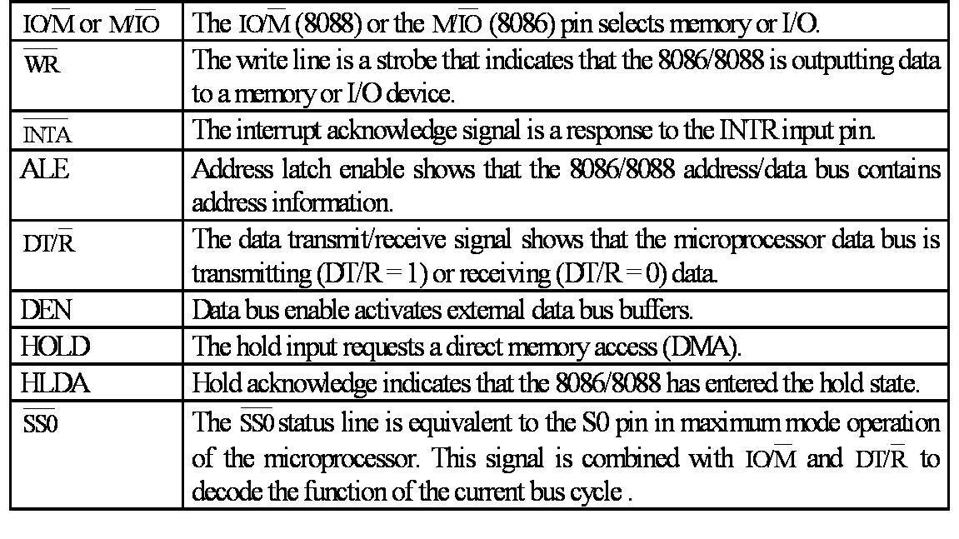

Maximum Mode Pins:
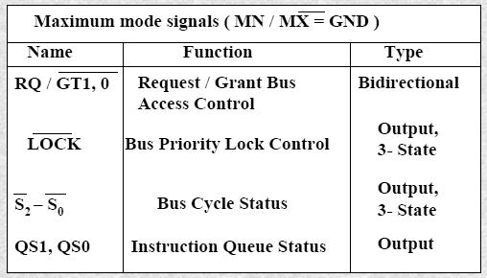

1.13 PHYSICAL MEMORY ORGANISATION:

In an 8086 based system, the 1M bytes memory is physically organised as an odd bank and an even bank, each of 512 Kbytes, addressed in parallel by the processor. Byte data with an even address is transferred on D7-D0, while the byte data with an odd address is

transferred on D15-D8 bus lines. The processor provides two enable signals, BHE and A0 for selection of either even or odd or both the banks. While referring to word data, the BIU

requires one or two memory cycles, depending upon whether the starting byte is located at an even or odd address. It is always better to locate the word data at an even address. To read or write a complete word from/to memory, if it is located at an even address, only one read or write cycle is required. If the word is located at an odd address, the first read or write cycle is required for accessing the lower byte while the second one is required for accessing the upper byte. Thus, two bus cycles are required, if a word is located at an odd address.

8086 is a 16-bit microprocessor and hence can access two bytes of data in one memory or I/O read or writes operation. But the commercially available memory chips are only byte size, i.e. they can store only one byte in a memory location. Obviously, to store 16-bit data, two successive memory locations are used and the lower byte of 16-bit data can be stored in the first memory location while the second byte is stored in the next location.

- Minimum mode for 8086 system:

  - In a minimum mode 8086 system, the microprocessor 8086 is operated in minimum mode by strapping its MN/MX pin to logic 1.

  - In this mode, all the control signals are given out by the microprocessor chip itself. There is a single microprocessor in the minimum mode system.

  - The remaining components in the system are latches, transreceivers, clock generator, memory and I/O devices.

  - The clock generator also synchronizes some external signal with the system clock.

It has 20 address lines and 16 data lines, the 8086 CPU requires three octal address latches and two octal data buffers for the complete address and data separation.

- Latches are generally buffered output D-type flip-flops like 74LS373 or 8282. They are used for separating the valid address from the multiplexed address/data signals and are controlled by the ALE signal generated by 8086.

- Transreceivers are the bidirectional buffers and some times they are called as data amplifiers. They are required to separate the valid data from the time multiplexed address/data signals.

They are controlled by two signals namely, DEN and DT/R.

- The DEN signal indicates the availability of valid data over the address/data lines. The DT/R signal indicates direction of data, i.e. from or to the processor.

- Usually, EPROM are used for monitor storage, while RAM for users program storage. A system may contain I/O devices

Hence the timing diagram can be categorized in two parts,

- The timing diagram for read cycle

- The timing diagram for write cycle.

- The read cycle begins in T1 with the assertion of address latch enable (ALE) signal and also M / IO signal. During the negative going edge of this signal, the valid address is latched on the local bus.

- The BHE and A0 signals address low, high or both bytes. From T1 to T4 , the M/IO signal indicates a memory or I/O operation.

- At T2, the address is removed from the local bus and is sent to the output. The bus is then tristated. The read (RD) control signal is also activated in T2.

- The read (RD) signal causes the address device to enable its data bus drivers. After RD goes low, the valid data is available on the data bus.

- The addressed device will drive the READY line high. When the processor returns the read signal to high level, the addressed device will again tristate its bus drivers.

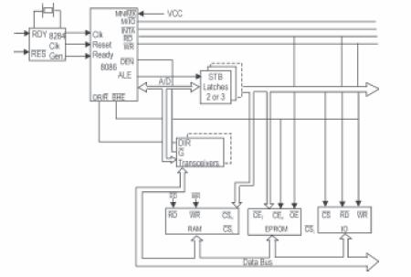

1.14.1 Timing diagram for minimum mode Read cycle:

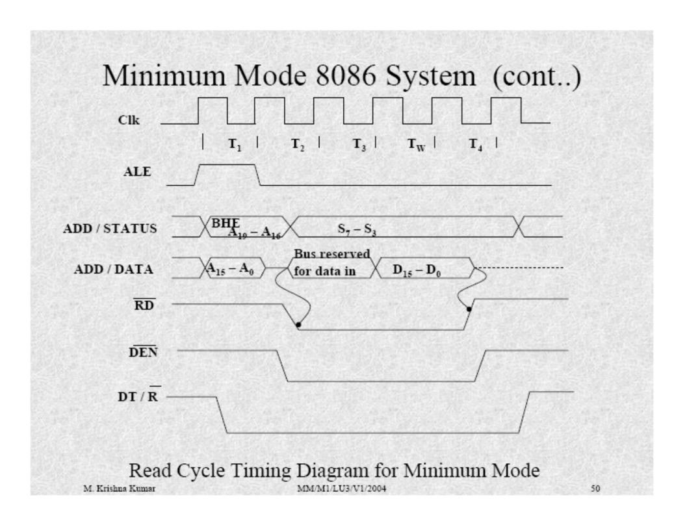

1.14.2 Timing diagram for minimum mode write cycle:

- A write cycle also begins with the assertion of ALE and the emission of the address. The M/IO signal is again asserted to indicate a memory or I/O operation. In T2, after sending the address in T1, the processor sends the data to be written to the addressed location.

- The data remains on the bus until middle of T4 state. The WR becomes active at the beginning of T2 (unlike RD is somewhat delayed in T2 to provide time for floating).

- The BHE and A0 signals are used to select the proper byte or bytes of memory or I/O word to be read or write.

- The M/IO, RD and WR signals indicate the type of datatransfer as specified in table below.

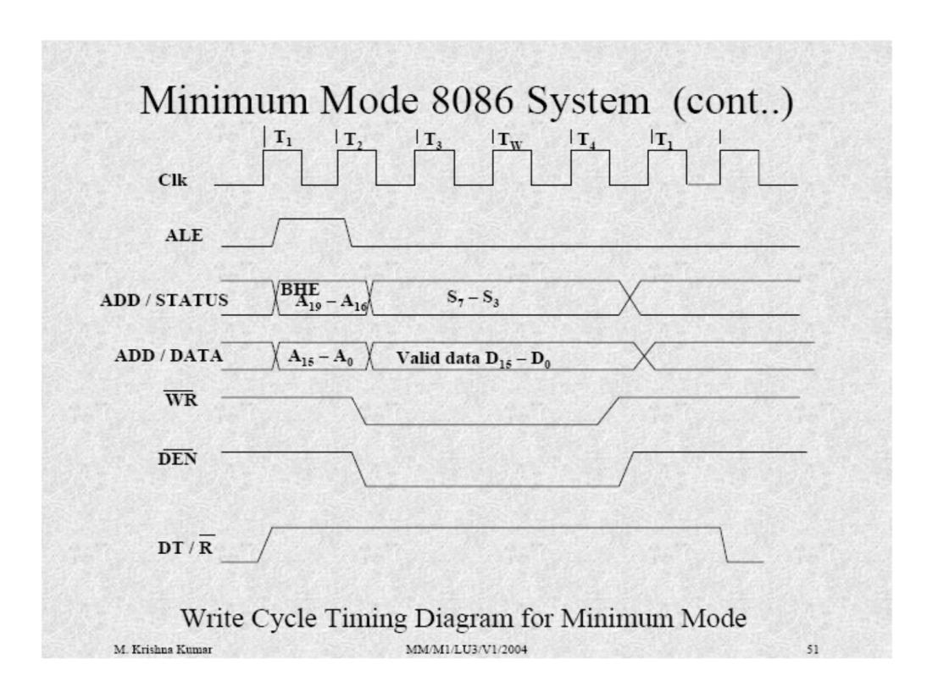

1.14.3 Hold Response sequence:

- The HOLD pin is checked at leading edge of each clock pulse.

- If it is received active by the processor before T4 of the previous cycle or during T1 state of the current cycle, the CPU activates HLDA in the next clock cycle and for succeeding bus cycles, the bus will be given to another requesting master.

- The control of the bus is not regained by the processor until the requesting master does not drop the HOLD pin low. When the request is dropped by the requesting master, the HLDA is dropped by the processor at the trailing edge of the next clock
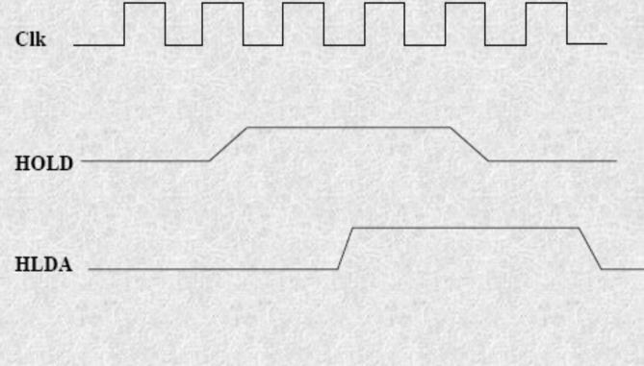
1.15 Maximum mode for 8086 system:

- In the maximum mode, the 8086 is operated by strapping the MN/MX pin to ground.

- In this mode, the processor derives the status signal S2, S1, S0. Another chip called bus controller derives the control signal using this status information

- In the maximum mode, there may be more than one microprocessor in the system configuration.

- The components in the system are same as in the minimum mode system.

- The basic function of the bus controller chip IC8288 is to derive control signals like RD and WR (for memory and I/O devices), DEN, DT/R, ALE etc. using the information by the processor on the status lines.

- The bus controller chip has input lines S2, S1, S0 and CLK. These inputs to 8288 are driven by CPU.

- It derives the outputs ALE, DEN, DT/R, MRDC, MWTC, AMWC, IORC, IOWC and AIOWC. The AEN, IOB and CEN pins are specially useful for multiprocessor systems.
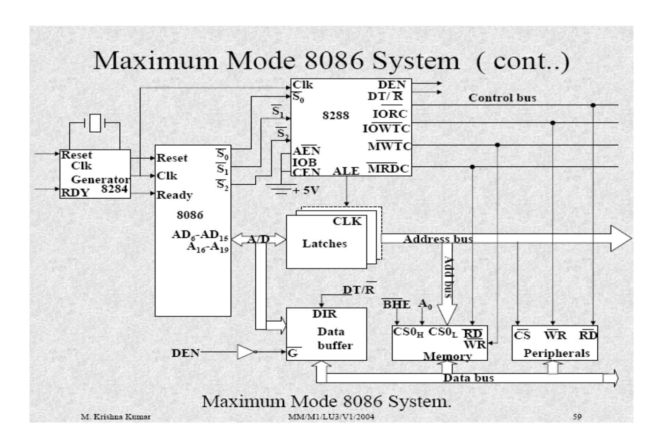
1.15.1 Maximum mode read cycle:
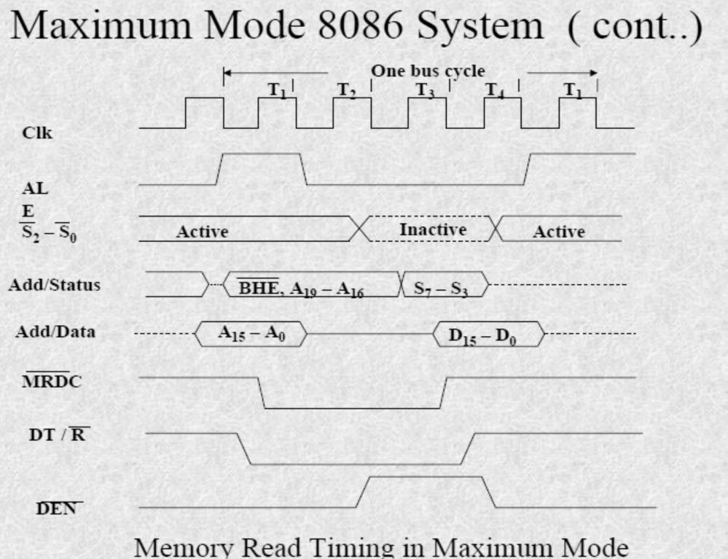

1.15.2 Maximum mode Write cycle:
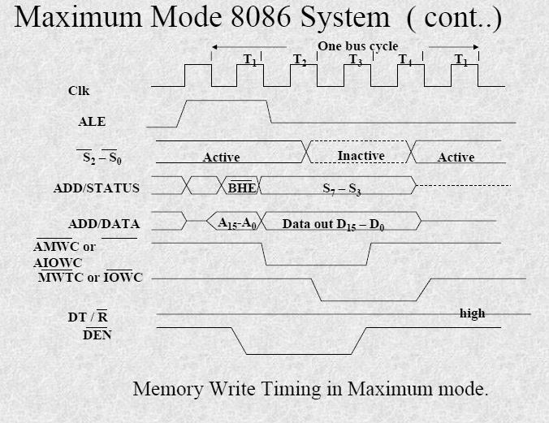
1.15.3 RQ/GT Timings in Maximum Mode:
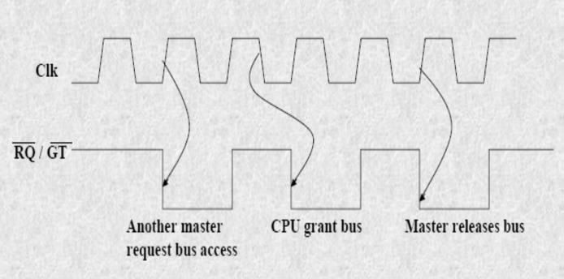

- The request/grant response sequence contains a series of three pulses. The request/grant pins are checked at each rising pulse of clock input.

- When a request is detected and if the condition for HOLD request are satisfied, the processor issues a grant pulse over the RQ/GT pin immediately during T4 (current) or T1 (next) state.

- When the requesting master receives this pulse, it accepts the control of the bus, it sends a release pulse to the processor using RQ/GT pin.

1.16 Interrupts of 8086:

- An 8086 Interrupt can come from any of three sources.

    - Hardware Interrupt

- External interrupt applied to nonmaskable interrupt NMI.

- External interrupt applied to maskable interrupt INTR.

    - Software Interrupt

  - Execution of INT instruction.

In the 8086 there are a total of 256 interrupts (or interrupt types)

- INT 00

- INT 01

- …

- INT FF

- In 80x86, the memory location to which an interrupt goes is always four times the value of the interrupt number.

- INT 03h goes to 000Ch

Interrupt Vector Table IVT:
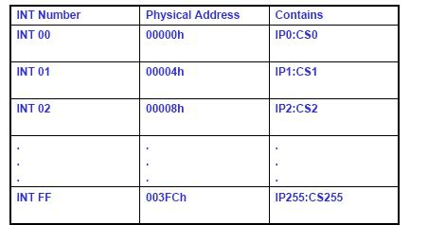

- The lowest five types are dedicated to specific interrupts.

- Interrupts 5 to 31 are reserved by INTEL for complex Processors

- Upper 224 interrupt types ( 32 to 255) available to use for hardware or software interrupts.

Interrupt Type zero – INT 0

- Divide by zero interrupt.

- If the quotient is too large to fit into AL/AX

- Divide by zero interrupt invoked

Interrupt Type one – INT 1

- Single step Interrupt

- If trap flag is set 8086 will do a type 1 interrupt after every instruction execution.

Non Maskable Interrupt – Type 2

- When 8086 receives a low to high transition on its NMI input.

- Type 2 interrupt response cannot be disabled

- (Masked) by any program instruction.

- Could be used for handling critical situations

- Like power failure detection.

Break Point Interrupt – Type 3

- INT 3 instruction – to implement breakpoint routines.

- The system execute instruction up to break point and then goes to break point routine. Used for debugging.

Overflow Interrupt – Type 4

- INTO: Interrupt on overflow instruction used for invoking an interrupt after overflow in an arithmetic operation. If no overflow it will be a NOP instruction.

(OR)

8086 INTERRUPT TYPES:

256 INTERRUPTS OF 8086 ARE DIVIDED IN TO 3 GROUPS

1. TYPE 0 TO TYPE 4 INTERRUPTS-

THESE ARE USED FOR FIXED OPERATIONS AND

HENCE ARE CALLED DEDICATED INTERRUPTS

- TYPE 5 TO TYPE 31 INTERRUPTS

NOT USED BY 8086, RESERVED FOR HIGHER PROCESSORS LIKE 80286 80386 ETC

- TYPE 32 TO 255 INTERRUPTS

AVAILABLE FOR USER, CALLED USER DEFINED INTERRUPTS

THESE CAN BE H/W INTERRUPTS AND ACTIVATED THROUGH INTR LINE

OR CAN BE S/W INTERRUPTS

TYPE – 0 DIVIDE ERROR INTERRUPT

QUOTIENT IS LARGE CANT BE FIT IN AL/AX OR DIVIDE BY ZERO

TYPE –1 SINGLE STEP INTERRUPT

USED FOR EXECUTING THE PROGRAM IN SINGLE STEP MODE BY

SETTING TRAP FLAG

TO SET TRAP FLAG PUSHF

MOV BP,SP

OR [BP+0],0100H;SET BIT8

POPF

TYPE – 2 NON MASKABLE INTERRUPT

THIS INTERRUPT IS USED FOR EXECUTING ISR OF NMI PIN (POSITIVE EGDE

SIGNAL). NMI CAN’T BE MASKED BY S/W

TYPE – 3 BREAK POINT INTERRUPT

USED FOR PROVIDING BREAK POINTS IN THE PROGRAM

TYPE – 4 OVER FLOW INTERRUPT

USED TO HANDLE ANY OVERFLOW ERROR AFTER SIGNED ARITHMETIC

Interrupt Priority

INTERRUPT TYPE | PRIORITY
INT0,INT3-INT 255,INTO | HIGHEST
NMI(INT2)
INTR
SINGLE STEP | LOWEST
8086-instruction formats

ADDRESSING MODES:

The different ways in which a source operand is denoted in an instruction are known as the addressing modes. There are 8 different addressing modes in 8086 programming. They are

- Immediate addressing mode

- Register addressing mode

- Direct addressing mode

- Register indirect addressing mode

- Based addressing mode

- Indexed addressing mode.

- Based indexed addressing mode

- Based, Indexed with displacement.

Immediate addressing mode: The addressing mode in which the data operand is a part of the instruction itself is called Immediate addressing mode.

For Ex: MOV CX, 4847 H
ADD AX, 2456 H
MOV AL, FFH

Register addressing mode : Register addressing mode means, a register is the source of an operand for an instruction.

For Ex : MOV AX, BX copies the contents of the 16-bit BX register into the 16-bit AX register.
EX : ADD CX,DX

Direct addressing mode: The addressing mode in which the effective address of the memory location at which the data operand is stored is given in the instruction.i.e the effective address is just a 16-bit number is written directly in the instruction.

For Ex: MOV BX, [1354H]
MOV BL,[0400H]

. The square brackets around the 1354 H denotes the contents of the memory location. When executed, this instruction will copy the contents of the memory location into BX register. This addressing mode is called direct because the displacement of the operand from the segment base is specified directly in the instruction.

Register indirect addressing mode: Register indirect addressing allows data to be addressed at

any memory location through an offset address held in any of the following registers: BP, BX,

DI and SI.

Ex: MOV AX, [BX]. Suppose the register BX contains 4675H ,the contents of the 4675 H are moved to AX.

ADD CX,{BX}

Based addressing mode: The offset address of the operand is given by the sum of contents of

the BX or BP registers and an 8-bit or 16-bit displacement.

Ex: MOV DX, [BX+04]

ADD CL,[BX+08]

Indexed Addressing mode: The operands offset address is found by adding the contents of SI

or DI register and 8-bit or 16-bit displacements.

Ex: MOV BX,[SI+06]
ADD AL,[DI+08]

Based -index addressing mode: The offset address of the operand is computed by summing the base register to the contents of an Index register.

Ex: ADD CX,[BX+SI]

MOV AX,[BX+DI]

Based Iindexd with displacement mode: The operands offset is computed by adding the base register contents, an Index registers contents and 8 or 16-bit displacement.

Ex : MOV AX,[BX+DI+08] ADD CX,[BX+SI+16]

INSTRUCTION SET OF 8086/8088

The 8086 microprocessor supports 6 types of Instructions. They are

- Data transfer instructions

- Arithmetic instructions

- Bit manipulation instructions

  - String instructions

  - Program Execution Transfer instructions (Branch & loop Instructions)

  - Processor control instructions

- Data Transfer instructions: These instructions are used to transfer the data from source operand to destination operand. All the store, move, load, exchange, input and output instructions belong to this group.

General purpose byte or word transfer instructions:
MOV : Copy byte or word from specified source to specified destination
PUSH | : | Push the specified word to top of the stack
POP | : | Pop the word from top of the stack to the specified location
PUSHA | : | Push all registers to the stack
POPA | : | Pop the words from stack to all registers

XCHG : Exchange the contents of the specified source and destination operands one of which may be a register or memory location.

XLAT : Translate a byte in AL using a table in memory

Simple input and output port transfer instructions

- IN : Reads a byte or word from specified port to the accumulator

- OUT : Sends out a byte or word from accumulator to a specified port

Special address transfer instructions
1. | LEA : Load effective address of operand into specified register
2. | LDS | : Load DS register and other specified register from memory
3. | LES | : Load ES register and other specified register from memory.
Flag transfer registers
1. | LAHF : Load AH with the low byte of the flag register
2. | SAHF | : Store AH register to low byte of flag register
3. | PUSHF : Copy flag register to top of the stack
4. | POPF | : Copy word at top of the stack to flag register

2. Arithmetic instructions : These instructions are used to perform various mathematical operations like addition, subtraction, multiplication and division etc….

Addition instructions

1.ADD : Add specified byte to byte or word to word 2.ADC : Add with carry

3.INC : Increment specified byte or specified word by 1 4.AAA : ASCII adjust after addition

5.DAA : Decimal (BCD) adjust after addition

Subtraction instructions
- SUB : Subtract byte from byte or word from word
- SBB : Subtract with borrow
3. | DEC | : Decrement specified byte or word by 1
4. | NEG : Negate or invert each bit of a specified byte or word and add 1(2’s complement)
5. | CMP | : Compare two specified byte or two specified words
6. | AAS | : ASCII adjust after subtraction
7. | DAS | : Decimal adjust after subtraction

Multiplication instructions
- MUL : Multiply unsigned byte by byte or unsigned word or word.
- IMUL : Multiply signed bye by byte or signed word by word

- AAM : ASCII adjust after multiplication

Division instructions
1. | DIV | : Divide unsigned word by byte or unsigned double word by word
2. | IDIV : Divide signed word by byte or signed double word by word
3. | AAD | : ASCII adjust after division
4. | CBW | : Fill upper byte of word with copies of sign bit of lower byte
5. | CWD | : Fill upper word of double word with sign bit of lower word.

3. Bit Manipulation instructions : These instructions include logical , shift and rotate instructions in which a bit of the data is involved.

Logical instructions
- NOT :Invert each bit of a byte or word.
- AND : ANDing each bit in a byte or word with the corresponding bit in another byte
or word.

3. OR : ORing each bit in a byte or word with the corresponding bit in another byte or word.

- XOR : Exclusive OR each bit in a byte or word with the corresponding bit in another byte or word.

- TEST :AND operands to update flags, but don’t change operands.

Shift instructions
1. | SHL/SAL : Shift bits of |  | a word or byte left, put zero(S) in LSBs.
2. | SHR | : Shift bits of | a word or byte right, put zero(S) in MSBs.
3. | SAR | : Shift bits of a word or byte right, copy old MSB into new MSB.
Rotate instructions
1. | ROL | : Rotate bits of byte or word left, MSB to LSB and to Carry Flag [CF]
2. | ROR | : Rotate bits of byte or word right, LSB to MSB and to Carry Flag [CF]
3. | RCR | :Rotate bits of byte or word right, LSB TO CF and CF to MSB
4. | RCL | :Rotate bits of byte or word left, MSB TO CF and CF to LSB

4. String instructions

A string is a series of bytes or a series of words in sequential memory locations. A string often consists of ASCII character codes.

1. REP : An instruction prefix. Repeat following instruction until CX=0

- REPE/REPZ : Repeat following instruction until CX=0 or zero flag ZF=1
- REPNE/REPNZ : Repeat following instruction until CX=0 or zero flag ZF=1
- MOVS/MOVSB/MOVSW: Move byte or word from one string to another
- COMS/COMPSB/COMPSW: Compare two string bytes or two string words
- INS/INSB/INSW: Input string byte or word from port
- OUTS/OUTSB/OUTSW : Output string byte or word to port

- SCAS/SCASB/SCASW: Scan a string. Compare a string byte with a byte in AL or a string word with a word in AX

- LODS/LODSB/LODSW: Load string byte in to AL or string word into AX

5.Program Execution Transfer instructions

These instructions are similar to branching or looping instructions. These instructions include conditional & unconditional jump or loop instructions.

Unconditional transfer instructions
1. | CALL | : Call a procedure, save return address on stack
2. | RET | : Return from procedure to the main program.
3. | JMP | : Goto specified address to get next instruction
Conditional transfer instructions
1. | JA/JNBE |  | : Jump if above / jump if not below or equal
2. | JAE/JNB |  | : Jump if above /jump if not below
3. | JBE/JNA |  | : Jump if below or equal/ Jump if not above
4. | JC |  | : jump if carry flag CF=1
5. | JE/JZ |  | : jump if equal/jump if zero flag ZF=1
6. | JG/JNLE |  | : Jump if greater/ jump if not less than or equal
7. | JGE/JNL |  | : jump if greater than or equal/ jump if not less than
8. | JL/JNGE |  | : jump if less than/ jump if not greater than or equal
9. | JLE/JNG |  | : jump if less than or equal/ jump if not greater than
10. | JNC |  | : jump if no carry (CF=0)
11. | JNE/JNZ |  | : jump if not equal/ jump if not zero(ZF=0)
12. | JNO |  | : jump if no overflow(OF=0)
13. | JNP/JPO |  | : jump if not parity/ jump if parity odd(PF=0)
14. | JNS |  | : jump if not sign(SF=0)
15. | JO |  | : jump if overflow flag(OF=1)
16. | JP/JPE |  | : jump if parity/jump if parity even(PF=1)
17. | JS |  | : jump if sign(SF=1)

6.Iteration control instructions

These instructions are used to execute a series of instructions for certain number of times.
1. | LOOP :Loop through a sequence of instructions until CX=0
2. | LOOPE/LOOPZ : Loop through a sequence of instructions while ZF=1 andCX = 0
- LOOPNE/LOOPNZ : Loop through a sequence of instructions while ZF=0 and CX =0

- JCXZ : jump to specified address if CX=0

7. Interrupt instructions
1. | INT | : Interrupt program execution, call service procedure
2. | INTO : Interrupt program execution if OF=1
3. | IRET | : Return from interrupt service procedure to main program

8.High level language interface instructions
- ENTER : enter procedure
- LEAVE :Leave procedure

- BOUND : Check if effective address within specified array bounds

9.Processor control instructions
Flag set/clear instructions

1. | STC | : Set carry flag CF to 1
2. | CLC | : Clear carry flag CF to 0
3. | CMC : Complement the state of the carry flag CF
4. | STD | : Set direction flag DF to 1 (decrement string pointers)
5. | CLD | : Clear direction flag DF to 0
6. | STI | : Set interrupt enable flag to 1(enable INTR input)
7. | CLI | : Clear interrupt enable Flag to 0 (disable INTR input)
10. External Hardware synchronization instructions
1. | HLT | : Halt (do nothing) until interrupt or reset
2. | WAIT : Wait (Do nothing) until signal on the test pin is low
3. | ESC | : Escape to external coprocessor such as 8087 or 8089
4. | LOCK | : An instruction prefix. Prevents another processor from taking the bus while the adjacent
 | instruction executes.
11. No operation instruction
1. | NOP | : No action except fetch and decode

ASSEMBLER DIRECTIVES :

Assembler directives are the directions to the assembler which indicate how an operand

or section of the program is to be processed. These are also called pseudo operations which are not executable by the microprocessor. The various directives are explained below.

1. ASSUME : The ASSUME directive is used to inform the assembler the name of the logical segment it should use for a specified segment.

Ex: ASSUME DS: DATA tells the assembler that for any program instruction which refers to the data segment ,it should use the logical segment called DATA.

2.DB -Define byte. It is used to declare a byte variable or set aside one or more storage locations of type byte in memory.

For example, CURRENT_VALUE DB 36H tells the assembler to reserve 1 byte of memory for a variable named CURRENT_ VALUE and to put the value 36 H in that memory location when the program is loaded into RAM .

3. DW -Define word. It tells the assembler to define a variable of type word or to reserve storage locations of type word in memory.

4. DD(define double word) :This directive is used to declare a variable of type double word or restore memory locations which can be accessed as type double word.

5.DQ (define quadword) :This directive is used to tell the assembler to declare a variable 4 words in length or to reserve 4 words of storage in memory .

6.DT (define ten bytes):It is used to inform the assembler to define a variable which is 10 bytes

in length or to reserve 10 bytes of storage in memory.

7. EQU –Equate It is used to give a name to some value or symbol. Every time the assembler

finds the given name in the program, it will replace the name with the value or symbol we have equated with that name

8.ORG -Originate : The ORG statement changes the starting offset address of the data.

It allows to set the location counter to a desired value at any point in the program.For example

the statement ORG 3000H tells the assembler to set the location counter to 3000H.

9 .PROC- Procedure: It is used to identify the start of a procedure. Or subroutine.

10. END- End program .This directive indicates the assembler that this is the end of the program module.The assembler ignores any statements after an END directive.

11. ENDP- End procedure: It indicates the end of the procedure (subroutine) to the assembler.

12.ENDS-End Segment: This directive is used with the name of the segment to indicate the end of that logical segment.

Ex: CODE SEGMENT : Start of logical segment containing code

CODE ENDS : End of the segment named CODE.

ASSEMBLY LANGUAGE DEVELOPMENT TOOLS:

To develop an assembly language program we need certain program development tools

.The various development tools required for 8086 programming are explained below.

1. Editor : An Editor is a program which allows us to create a file containing the assembly language statements for the program. Examples of some editors are PC write Wordstar. As we

type the program the editor stores the ACSII codes for the letters and numbers in successive RAM locations. If any typing mistake is done editor will alert us to correct it. If we leave out a program statement an editor will let you move everything down and insert a line. After typing all the program we have to save the program for a hard disk. This we call it as source file. The next step is to process the source file with an assembler. While using TASM or MASM we should give a file name and extension .ASM.

Ex: Sample. asm

2.Assembler : An Assembler is used to translate the assembly language mnemonics into machine language( i.e binary codes). When you run the assembler it reads the source file of your program from where you have saved it. The assembler generates two files . The first file is the Object file with the extension .OBJ. The object file consists of the binary codes for the instructions and information about the addresses of the instructions. After further processing, the contents of the file will be loaded in to memory and run. The second file is the assembler list file with the extension .LST.

3. Linker : A linker is a program used to connect several object files into one large object file. While writing large programs it is better to divide the large program into smaller modules. Each module can be individually written, tested and debugged. Then all the object modules are linked together to form one, functioning program. These object modules can also be kept in library file and linked into other programs as needed. A linker produces a link file which contains the binary codes for all the combined modules. The linker also produces a link map file which contains the address information about the linked files. The linkers which come with TASM or MASM assemblers produce link files with the .EXE extension.

4.Locator : A locator is a program used to assign the specific addresses of where the segments of object code are to be loaded into memory. A locator program called EXE2BIN comes with the IBM PC Disk Operating System (DOS). EXE2BIN converts a .EXE file to a .BIN file which has physical addresses.

5. Debugger: A debugger is a program which allows to load your object code program into system memory, execute the program, and troubleshoot or debug it. The debugger allows to look into the contents of registers and memory locations after the program runs. We can also

change the contents of registers and memory locations and rerun the program. Some debuggers allows to stop the program after each instruction so that you can check or alter memory and register contents. This is called single step debug. A debugger also allows to set a breakpoint at any point in the program. If we insert a break point , the debugger will run the program up to the instruction where the breakpoint is put and then stop the execution.

6. Emulator: An emulator is a mixture of hard ware and software. It is usually used to test and debug the hardware and software of an external system such as the prototype of a microprocessor based instrument.

