I N D U R

INSTITUTE OF ENGINEERING & TECHNOLOGY

SIDDIPET, Medak DIST. – 502277

LABORATORY MANUAL



DATA MINING LAB
4nd Year 1st Sem. CSE
(As per 2014-15 Academic Regulation)
Prepared and verified by
1 MD.ELIAZ
2. T.BENARJI

DEPARTMENT
OF
COMPUTER SCIENCE AND ENGINEERING

PREFACE
The course addresses the concepts, skills, methodologies, and models of data warehousing. The course addresses proper techniques for designing data warehouses for various business domains, and covers concepts for potential uses of the data warehouse and other data repositories in mining opportunities. Data mining, the extraction of hidden predictive information from large databases, is a powerful new technology with great potential to help companies focus on the most important information in their data warehouses. Data mining tools predict future trends and behaviors, allowing businesses to make proactive, knowledge-driven decisions.

Course Objectives:
Student undergoing this course are expected to:
- Differentiate online transaction processing and online analytical processing.
- Learn multidimensional schemas suitable for data warehousing.
- Understand various Data Mining functionalities.
- Inculcate knowledge on data mining query languages.
- Know in detail about data mining algorithms.

Course Outcome:
After Undergoing The Course, Student I Will Be Able To Understand:
- Design Datamart or Data warehouse for any organization.
- Develop skills to write queries using DMQL.
- Extract knowledge using Data mining techniques.
- Adapt to new Data mining tools.
- Explore recent trends in Data mining such as Web mining, spatial, temporal mining.

LAB CODE

- Students should report to the concerned labs as per the time table schedule.

- Students who turn up late to the labs will in no case be permitted to perform the experiment scheduled for the day.

- After completion of the experiment, certification of the concerned staff in-charge in the observation book is necessary.

- Staff member in-charge shall award marks based on continuous evaluation for each
Experiment out of maximum 10 marks and should be entered in the notebook

- Students should bring a note book of about 100 pages and should enter the readings/observations into the note book while performing the experiment.

- The record of observations along with the detailed experimental procedure of the experiment performed in the immediate last session should be submitted and certified by the staff member in-charge.

- Not more than three students in a group are permitted to perform the experiment on a setup.

- The group-wise division made in the beginning should be adhered to, and no mix up of student among different groups will be permitted later.

- The components required pertaining to the experiment should be collected from stores in-charge after duly filling in the requisition form.

- When the experiment is completed, students should disconnect the setup made by them, and should return all the components/instruments taken for the purpose.

- Any damage of the equipment or burn-out of components will be viewed seriously either by putting penalty or by dismissing the total group of students from the lab for the semester/year.

- Students should be present in the labs for the total scheduled duration.

- Students are required to prepare thoroughly to perform the experiment before coming to Laboratory.

- Procedure sheets/data sheets provided to the students’ groups should be maintained neatly and to be returned after the experiment.

I N D E X

Sl. No. | Name of the Experiment | Page No.
1 | WEKA INTRODUCTION | 07-15
2 | ARFF FILE FORMAT | 16-20
3 | EXPLORER | 21-37
4 | EXPERIMENTER | 38-87
5 | KNOWLEDGE FLOW | 88-96

DATA MINING LAB - SYLLABUS
Credit Risk Assessment :
Description: The business of banks is making loans. Assessing the credit worthiness of an applicant is of crucial importance. You have to develop a system to help a loan officer decide whether the credit of a customer is good. Or bad. A bank’s business rules regarding loans must consider two opposing factors. On the one hand, a bank wants to make as many loans as possible. Interest on these loans is the banks profit source. On the other hand, a bank cannot afford to make too many bad loans. Too many bad loans could lead to the collapse of the bank. The bank’s loan policy must involve a compromise. Not too strict and not too lenient.
To do the assignment, you first and foremost need some knowledge about the world of credit. You can acquire such knowledge in a number of ways.
- Knowledge engineering: Find a loan officer who is willing to talk. Interview her and try to represent her knowledge in a number of ways.
- Books: Find some training manuals for loan officers or perhaps a suitable textbook on finance. Translate this knowledge from text from to production rule form.
- Common sense: Imagine yourself as a loan officer and make up reasonable rules which can be used to judge the credit worthiness of a loan applicant.
- Case histories: Find records of actual cases where competent loan officers correctly judged when and not to. Approve a loan application.

The German Credit Data :
Actual historical credit data is not always easy to come by because of confidentiality rules. Here is one such data set. Consisting of 1000 actual cases collected in Germany.
In spite of the fact that the data is German, you should probably make use of it for this assignment (Unless you really can consult a real loan officer!)
There are 20 attributes used in judging a loan applicant (ie., 7 Numerical attributes and 13 Categorical or Nominal attributes). The goal is to classify the applicant into one of two categories. Good or Bad.
Subtasks:
- List all the categorical (or nominal) attributes and the real valued attributes separately.
- What attributes do you think might be crucial in making the credit assessment? Come up withsome simple rules in plain English using your selected attributes.
- One type of model that you can create is a Decision tree . train a Decision tree using the complete data set as the training data. Report the model obtained after training.
- Suppose you use your above model trained on the complete dataset, and classify credit good/bad for each of the examples in the dataset. What % of examples can you classify correctly?(This is also called testing on the training set) why do you think can not get 100% training accuracy?
- Is testing on the training set as you did above a good idea? Why or why not?
- One approach for solving the problem encountered in the previous question is using crossvalidation? Describe what is cross validation briefly. Train a decision tree again using cross validation and report your results. Does accuracy increase/decrease? Why?
- Check to see if the data shows a bias against “foreign workers” or “personal-status”. One way to do this is to remove these attributes from the data set and see if the decision tree created in those cases is significantly different from the full dataset case which you have already done. Did removing these attributes have any significantly effect? Discuss.
- Another question might be, do you really need to input so many attributes to get good results? May be only a few would do. For example, you could try just having attributes 2,3,5,7,10,17 and 21. Try out some combinations.(You had removed two attributes in problem 7. Remember to reload the arff data file to get all the attributes initially before you start selecting the ones you want.)
- Sometimes, The cost of rejecting an applicant who actually has good credit might be higher than accepting an applicant who has bad credit. Instead of counting the misclassification equally in both cases, give a higher cost to the first case ( say cost 5) and lower cost to the second case. By using a cost matrix in weak. Train your decision tree and report the Decision Tree and cross validation results. Are they significantly different from results obtained in problem 6.
- Do you think it is a good idea to prefect simple decision trees instead of having long complex decision tress? How does the complexity of a Decision Tree relate to the bias of the model?
- You can make your Decision Trees simpler by pruning the nodes. One approach is to use Reduced Error Pruning. Explain this idea briefly. Try reduced error pruning for training your Decision Trees using cross validation and report the Decision Trees you obtain? Also Report your accuracy using the pruned model Does your Accuracy increase?
- How can you convert a Decision Tree into “if-then-else rules”. Make up your own small Decision Tree consisting 2-3 levels and convert into a set of rules. There also exist different classifiers that output the model in the form of rules. One such classifier in weka is rules. PART, train this model and report the set of rules obtained. Sometimes just one attribute can be good enough in making the decision, yes, just one ! Can you predict what attribute that might be in this data set? OneR classifier uses a single attribute to make decisions(it chooses the attribute based on minimum error).Report the rule obtained by training a one R classifier. Rank the performance of j48,PART,oneR.

- Weka Introduction

Weka is created by researchers at the university WIKATO in NewZealand. University of Waikato, Hamilton, New Zealand Alex Seewald (original Command-line primer) David Scuse (original Experimenter tutorial)
• It is java based application.
• It is collection often source, Machine Learning Algorithm.
• The routines (functions) are implemented as classes and logically arranged in packages.
• It comes with an extensive GUI Interface.
• Weka routines can be used standalone via the command line interface.
The Graphical User Interface
The Weka GUI Chooser (class weka.gui.GUIChooser) provides a starting point for launching Weka’s main GUI applications and supporting tools. If one prefers a MDI (“multiple document interface”) appearance, then this is provided by an alternative launcher called “Main” (class weka.gui.Main). The GUI Chooser consists of four buttons—one for each of the four major Weka applications—and four menus.
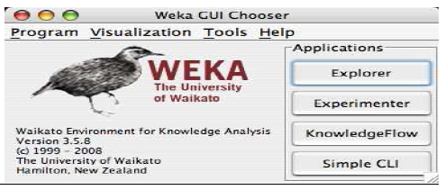

The buttons can be used to start the following applications:
• Explorer An environment for exploring data with WEKA (the rest of this documentation deals with this application in more detail).
• Experimenter An environment for performing experiments and conducting statistical tests between learning schemes.
• Knowledge Flow This environment supports essentially the same functions as the Explorer but with a drag-and-drop interface. One advantage is that it supports incremental learning.
• SimpleCLI Provides a simple command-line interface that allows direct execution of WEKA commands for operating systems that do not provide their own command line interface.

I. Explorer
The Graphical user interface
Section Tabs
At the very top of the window, just below the title bar, is a row of tabs. When the Explorer is first started only the first tab is active; the others are greyed out. This is because it is necessary to open (and potentially pre-process) a data set before starting to explore the data.
The tabs are as follows:
1. Preprocess. Choose and modify the data being acted on.
2. Classify. Train & test learning schemes that classify or perform regression
3. Cluster. Learn clusters for the data.
4. Associate. Learn association rules for the data.
5. Select attributes. Select the most relevant attributes in the data.
6. Visualize. View an interactive 2D plot of the data.
Once the tabs are active, clicking on them flicks between different screens, on which the respective actions can be performed. The bottom area of the window (including the status box, the log button, and the Weka bird) stays visible regardless of which section you are in. The Explorer can be easily extended with custom tabs. The Wiki article “Adding tabs in the Explorer” [7] explains this in detail.

II. Experimenter
Introduction
The Weka Experiment Environment enables the user to create, run, modify, and analyse experiments in a more convenient manner than is possible when processing the schemes individually. For example, the user can create an experiment that runs several schemes against a series of datasets and then analyse the results to determine if one of the schemes is (statistically) better than the other schemes.
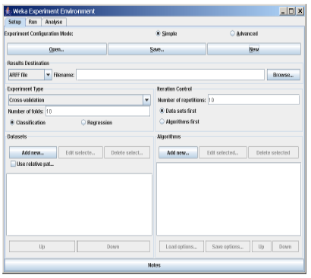
The Experiment Environment can be run from the command line using the Simple CLI. For example, the following commands could be typed into the CLI to run the OneR scheme on the Iris dataset using a basic train and test process. (Note that the commands would be typed on one line into the CLI.) While commands can be typed directly into the CLI, this technique is not particularly convenient and the experiments are not easy to modify. The Experimenter comes in two flavours, either with a simple interface that provides most of the functionality one needs for experiments, or with an interface with full access to the Experimenter’s capabilities. You can choose between those two with the Experiment Configuration Mode radio buttons:
• Simple
• Advanced
Both setups allow you to setup standard experiments, that are run locally on a single machine, or remote experiments, which are distributed between several hosts. The distribution of experiments cuts down the time the experiments will take until completion, but on the other hand the setup takes more time. The next section covers the standard experiments (both, simple and advanced), followed by the remote experiments and finally the analysing of the results.

III. Knowledge Flow
Introduction
The Knowledge Flow provides an alternative to the Explorer as a graphical front end to WEKA’s core algorithms.
The KnowledgeFlow presents a data-flow inspired interface to WEKA. The user can selectWEKA components from a palette, place them on a layout canvas and connect them together in order to form a knowledge flow for processing and analyzing data. At present, all of WEKA’s classifiers, filters, clusterers, associators, loaders and savers are available in the KnowledgeFlow along withsome extra tools.
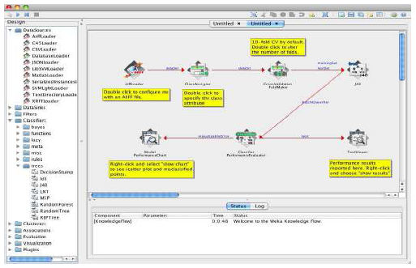
The Knowledge Flow can handle data either incrementally or in batches (the Explorer handles batch data only). Of course learning from data incrementally requires a classifier that can be updated on an instance by instance basis. Currently in WEKA there are ten classifiers that can handle data incrementally.
The Knowledge Flow offers the following features:
•intuitive data flow style layout
•process data in batches or incrementally
•process multiple batches or streams in parallel (each separate flow executes in its own thread)
•process multiple streams sequentially via a user-specified order of execution
•chain filters together
•view models produced by classifiers for each fold in a cross validation
•visualize performance of incremental classifiers during processing (scrolling plots of classification accuracy, RMS error, predictions etc.)
• plugin “perspectives” that add major new functionality (e.g. 3D data visualization, time series forecasting environment etc.)
IV. Simple CLI
Introduction
The Simple CLI provides full access to all Weka classes, i.e., classifiers, filters, clusterers, etc., but without the hassle of the CLASSPATH (it facilitates the one, with which Weka was started). It offers a simple Weka shell with separated command line and output.

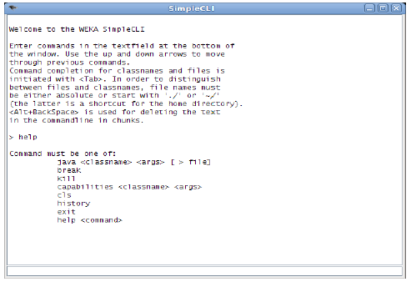
4.1 Commands
The following commands are available in the Simple CLI:
• java <classname> [<args>]
invokes a java class with the given arguments (if any)
• break
stops the current thread, e.g., a running classifier, in a friendly manner killstops the current thread in an unfriendly fashion
• cls
clears the output area
• capabilities <classname> [<args>]
lists the capabilities of the specified class, e.g., for a classifier with its
option:
capabilities weka.classifiers.meta.Bagging -W weka.classifiers.trees.Id3
• exit
exits the Simple CLI

• help [<command>]
provides an overview of the available commands if without a command name as argument, otherwise more help on the specified command
4.2 Invocation
In order to invoke a Weka class, one has only to prefix the class with ”java”. This command tells the Simple CLI to load a class and execute it with any given parameters. E.g., the J48 classifier can be invoked on the iris dataset with the following command:
java weka.classifiers.trees.J48 -t c:/temp/iris.arff
This results in the following output:
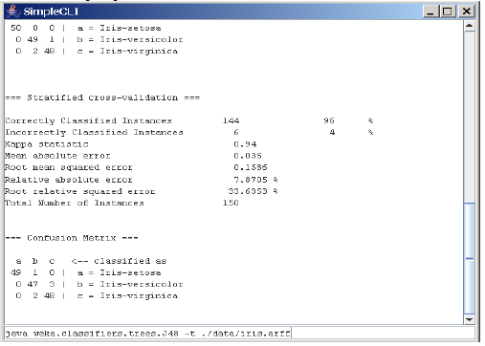
4.3 Command redirection
Starting with this version of Weka one can perform a basic redirection:
java weka.classifiers.trees.J48 -t test.arff > j48.txt
Note: the > must be preceded and followed by a space, otherwise it is not recognized as redirection, but part of another parameter.
4.4 Command completion
Commands starting with java support completion for classnames and filenames via Tab (Alt+BackSpace deletes parts of the command again). In case that there are several matches, Weka lists all possible matches.
• package name completion
java weka.cl<Tab>
results in the following output of possible matches of package names:
Possible matches:
weka.classifiers
weka.clusterers
• classname completion
java weka.classifiers.meta.A<Tab>
lists the following classes
Possible matches:
weka.classifiers.meta.AdaBoostM1
weka.classifiers.meta.AdditiveRegression
weka.classifiers.meta.AttributeSelectedClassifier
• filename completion
In order for Weka to determine whether a the string under the cursor is a classname or a filename,
filenames need to be absolute (Unix/Linx: /some/path/file;Windows: C:\Some\Path\file) or
relative and starting with a dot (Unix/Linux: ./some/other/path/file;Windows:
.\Some\Other\Path\file).

2. ARFF File Format
An ARFF (= Attribute-Relation File Format ) file is an ASCII text file that describes a list of instances sharing a set of attributes.
ARFF files are not the only format one can load, but all files that can be converted with Weka’s “core converters”. The following formats are currently supported:
• ARFF (+ compressed)
• C4.5
• CSV
• libsvm
• binary serialized instances
• XRFF (+ compressed)
2.1 Overview
ARFF files have two distinct sections. The first section is the Header information, which is followed the Data information. The Header of the ARFF file contains the name of the relation, a list of the attributes (the columns in the data), and their types.
An example header on the standard IRIS dataset looks like this:
% 1. Title: Iris Plants Database
%
% 2. Sources:
% (a) Creator: R.A. Fisher
% (b) Donor: Michael Marshall (MARSHALL%PLU@io.arc.nasa.gov)
% (c) Date: July, 1988
%
@RELATION iris
@ATTRIBUTE sepallength NUMERIC
@ATTRIBUTE sepalwidth NUMERIC
@ATTRIBUTE petallength NUMERIC
@ATTRIBUTE petalwidth NUMERIC
@ATTRIBUTE class {Iris-setosa,Iris-versicolor,Iris-virginica}
The Data of the ARFF file looks like the following:
@DATA
5.1,3.5,1.4,0.2,Iris-setosa
4.9,3.0,1.4,0.2,Iris-setosa
4.7,3.2,1.3,0.2,Iris-setosa
4.6,3.1,1.5,0.2,Iris-setosa
5.0,3.6,1.4,0.2,Iris-setosa
5.4,3.9,1.7,0.4,Iris-setosa
4.6,3.4,1.4,0.3,Iris-setosa
5.0,3.4,1.5,0.2,Iris-setosa
4.4,2.9,1.4,0.2,Iris-setosa
4.9,3.1,1.5,0.1,Iris-setosa
Lines that begin with a % are comments.
The @RELATION, @ATTRIBUTE and @DATA declarations are case insensitive.

The ARFF Header Section
The ARFF Header section of the file contains the relation declaration and attribute declarations.

The @relation Declaration
The relation name is defined as the first line in the ARFF file. The format is:
@relation <relation-name>
where <relation-name> is a string. The string must be quoted if the name includes spaces.

The @attribute Declarations
Attribute declarations take the form of an ordered sequence of @attribute statements. Each attribute in the data set has its own @attribute statement which uniquely defines the name of that attribute and it’s data type. The order the attributes are declared indicates the column position in the data section of the file. For example, if an attribute is the third one declared then Weka expects that all that attributes values will be found in the third comma delimited column.

The format for the @attribute statement is:
@attribute <attribute-name> <datatype>
where the <attribute-name> must start with an alphabetic character. If spaces are to be included in the name then the entire name must be quoted.

The <datatype> can be any of the four types supported by Weka:
• numeric
• integer is treated as numeric
• real is treated as numeric
• <nominal-specification>
• string
• date [<date-format>]
• relational for multi-instance data (for future use)
where <nominal-specification> and <date-format> are defined below. The keywords numeric, real, integer, string and date are case insensitive.

Numeric attributes
Numeric attributes can be real or integer numbers.

Nominal attributes
Nominal values are defined by providing an <nominal-specification> listing the possible values: <nominal-name1>, <nominal-name2>, <nominal-name3>,
...
For example, the class value of the Iris dataset can be defined as follows:
@ATTRIBUTE class {Iris-setosa,Iris-versicolor,Iris-virginica}
Values that contain spaces must be quoted.

String attributes
String attributes allow us to create attributes containing arbitrary textual values. This is very useful in text-mining applications, as we can create datasets with string attributes, then writeWeka Filters to manipulate strings (like String- ToWordVectorFilter). String attributes are declared as follows:
@ATTRIBUTE LCC string

Date attributes
Date attribute declarations take the form:
@attribute <name> date [<date-format>]
where <name> is the name for the attribute and <date-format> is an optional string specifying how date values should be parsed and printed (this is the same format used by SimpleDateFormat). The default format string accepts the ISO-8601 combined date and time format: yyyy-MMdd’T’HH: mm:ss. Dates must be specified in the data section as the corresponding string representations of the date/time (see example below).

Relational attributes
Relational attribute declarations take the form:
@attribute <name> relational
<further attribute definitions>
@end <name>
For the multi-instance dataset MUSK1 the definition would look like this (”...” denotes an omission):
@attribute molecule_name {MUSK-jf78,...,NON-MUSK-199}
@attribute bag relational
@attribute f1 numeric
...
@attribute f166 numeric
@end bag
@attribute class {0,1}
...
The ARFF Data Section
The ARFF Data section of the file contains the data declaration line and the actual instance lines.

The @data Declaration
The @data declaration is a single line denoting the start of the data segment in the file. The format is: @data

The instance data
Each instance is represented on a single line, with carriage returns denoting the end of the instance. A percent sign (%) introduces a comment, which continues to the end of the line.
Attribute values for each instance are delimited by commas. They must appear in the order that they were declared in the header section (i.e. the data corresponding to the nth @attribute declaration is always the nth field of the attribute).

Missing values are represented by a single question mark, as in:
@data
4.4,?,1.5,?,Iris-setosa
Values of string and nominal attributes are case sensitive, and any that contain space or the commentdelimiter character % must be quoted. (The code suggests that double-quotes are acceptable and that a backslash will escape individual characters.)
An example follows:
@relation LCCvsLCSH
@attribute LCC string
@attribute LCSH string
@data
AG5, ’Encyclopedias and dictionaries.;Twentieth century.’
AS262, ’Science -- Soviet Union -- History.’
AE5, ’Encyclopedias and dictionaries.’
AS281, ’Astronomy, Assyro-Babylonian.;Moon -- Phases.’
AS281, ’Astronomy, Assyro-Babylonian.;Moon -- Tables.’
Dates must be specified in the data section using the string representation specified in the attribute declaration.
For example:
@RELATION Timestamps
@ATTRIBUTE timestamp DATE "yyyy-MM-dd HH:mm:ss"
@DATA
"2001-04-03 12:12:12"
"2001-05-03 12:59:55"
Relational data must be enclosed within double quotes ”. For example an instance of the MUSK1 dataset (”...” denotes an omission):
MUSK-188,"42,...,30",1

3. EXPLORER
3.1. PREPROCESS TAB
3.1.1. Loading Data
The first four buttons at the top of the preprocess section enable you to load data into WEKA:
1. Open file.... Brings up a dialog box allowing you to browse for the data file on the local file system.
2. Open URL.... Asks for a Uniform Resource Locator address for where the data is stored.
3. Open DB.... Reads data from a database. (Note that to make this work you might have to edit the file in
weka/experiment/DatabaseUtils.props.)
4. Generate.... Enables you to generate artificial data from a variety of Data Generators. Using the
Open file... button you can read files in a variety of formats: WEKA’s ARFF format, CSV format, C4.5
format, or serialized Instances format. ARFF files typically have a .arff extension, CSV files a .csv
extension, C4.5 files a .data and .names extension, and serialized Instances objects a .bsi extension.

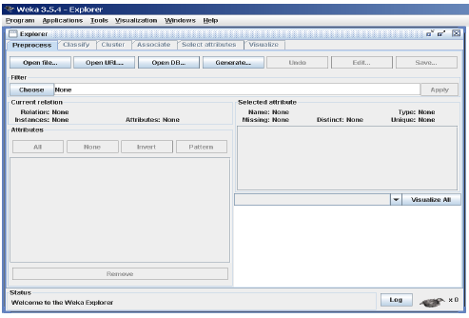
The Current Relation: Once some data has been loaded, the Preprocess panel shows a variety of information. The Current relation box (the “current relation” is the currently loaded data, which can be interpreted as a single relational table in database terminology) has three entries:
1. Relation. The name of the relation, as given in the file it was loaded from. Filters (described below) modify the name of a relation.
2. Instances. The number of instances (data points/records) in the data.
3. Attributes. The number of attributes (features) in the data.
3.2.2 Working with Attributes
Below the Current relation box is a box titled Attributes. There are four Buttons, and beneath them is a list of the attributes in the current relation.
The list has three columns:
1. No... A number that identifies the attribute in the order they are specified in the data file.
2. Selection tick boxes. These allow you select which attributes are present in the relation.
3. Name. The name of the attribute, as it was declared in the data file. When you click on different rows in the list of attributes, the fields change in the box to the right titled Selected attribute.
This box displays the characteristics of the currently highlighted attribute in the list:
1. Name. The name of the attribute, the same as that given in the attribute list.
2. Type. The type of attribute, most commonly Nominal or Numeric.
3. Missing. The number (and percentage) of instances in the data for which this attribute is missing (unspecified).
4. Distinct. The number of different values that the data contains for this attribute.
5. Unique. The number (and percentage) of instances in the data having a value for this attribute that no other instances have.

Below these statistics is a list showing more information about the values stored in this attribute, which differ depending on its type. If the attribute is nominal, the list consists of each possible value for the attribute along with the number of instances that have that value. If the attribute is numeric, the list gives four statistics describing the distribution of values in the data—the minimum, maximum, mean and standard deviation. And below these statistics there is a coloured histogram, colour-coded according to the attribute chosen as the Class using the box above the histogram. (This box will bring up a drop-down list of available selections when clicked.) Note that only nominal Class attributes will result in a colour-coding. Finally, after pressing the Visualize All button, histograms for all the attributes in the data are shown in a separate window.
Returning to the attribute list, to begin with all the tick boxes are unticked. They can be toggled on/off by clicking on them individually. The four buttons above can also be used to change the selection:

PREPROCESSING
1. All. All boxes are ticked.
2. None. All boxes are cleared (unticked).
3. Invert. Boxes that are ticked become unticked and vice versa.
4. Pattern. Enables the user to select attributes based on a Perl 5 Regular Expression. E.g., .* id selects all attributes which name ends with id.
Once the desired attributes have been selected, they can be removed by clicking the Remove button below the list of attributes. Note that this can be undone by clicking the Undo button, which is located next to the Edit button in the top-right corner of the Preprocess panel.

Working With Filters
The preprocess section allows filters to be defined that transform the data in various ways. The Filter box is used to set up the filters that are required. At the left of the Filter box is a Choose button. By clicking this button it is possible to select one of the filters in WEKA. Once a filter has been selected, its name and options are shown in the field next to the Choose button. Clicking on this box with the left mouse button brings up a GenericObjectEditor dialog box. A click with the right mouse button (or Alt+Shift+left click) brings up a menu where you can choose, either to display the properties in a GenericObjectEditor dialog box, or to copy the current setup string to the clipboard
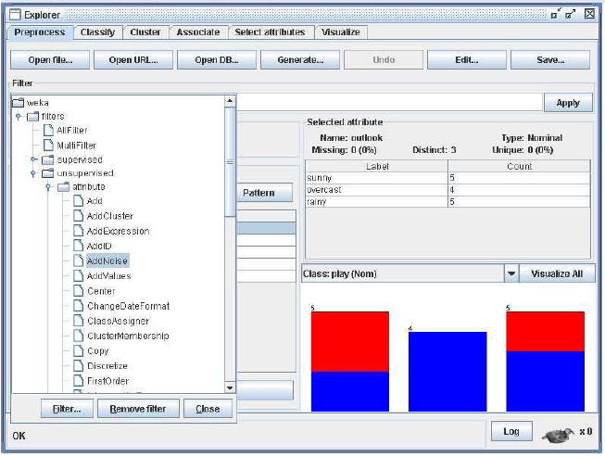

The GenericObjectEditor Dialog Box
The GenericObjectEditor dialog box lets you configure a filter. The same kind of dialog box is used to configure other objects, such as classifiers and clusterers (see below). The fields in the window reflect the available options. Right-clicking (or Alt+Shift+Left- Click) on such a field will bring up a popup menu, listing the following options:
- Show properties... has the same effect as left-clicking on the field, i.e., a dialog appears allowing you to alter the settings.
- Copy configuration to clipboard copies the currently displayed configuration string to the system’s clipboard and therefore can be used anywhere else in WEKA or in the console. This is rather handy if you have to setup complicated, nested schemes.
- Enter configuration... is the “receiving” end for configurations that got copied to the clipboard earlier on. In this dialog you can enter a class name followed by options (if the class supports these). This also allows you to transfer a filter setting from the Preprocess panel to a Filtered Classifier used in the Classify panel.

Left-Clicking on any of these gives an opportunity to alter the filters settings. For example, the setting may take a text string, in which case you type the string into the text field provided. Or it may give a drop-down box listing several states to choose from. Or it may do something else, depending on the information required. Information on the options is provided in a tool tip if you let the mouse pointer hover of the corresponding field. More information on the filter and its options can be obtained by clicking on the More button in the About panel at the top of the GenericObjectEditor window.
Some objects display a brief description of what they do in an About box, along with a More button. Clicking on the More button brings up a window describing what the different options do. Others have an additional button, Capabilities, which lists the types of attributes and classes the object can handle.
At the bottom of the GenericObjectEditor dialog are four buttons. The first two, Open... and Save... allow object configurations to be stored for future use. The Cancel button backs out without remembering any changes that have been made. Once you are happy with the object and settings you have chosen, click OK to return to the main Explorer window.

Applying Filters
Once you have selected and configured a filter, you can apply it to the data by pressing the Apply button at the right end of the Filter panel in the Preprocess panel. The Preprocess panel will then show the transformed data. The change can be undone by pressing the Undo button. You can also use the Edit...button to modify your data manually in a dataset editor. Finally, the Save... button at the top right of the Preprocess panel saves the current version of the relation in file formats that can represent the relation, allowing it to be kept for future use.
Note: Some of the filters behave differently depending on whether a class attribute has been set or not (using the box above the histogram, which will bring up a drop-down list of possible selections when clicked). In particular, the “supervised filters” require a class attribute to be set, and some of the “unsupervised attribute filters” will skip the class attribute if one is set. Note that it is also possible to set Class to None, in which case no class is set.

3.2. SELECTING A CLASSIFIER
At the top of the classify section is the Classifier box. This box has a text field that gives the name of the currently selected classifier, and its options. Clicking on the text box with the left mouse button brings up a GenericObjectEditor dialog box, just the same as for filters, that you can use to configure the options of the current classifier. With a right click (or Alt+Shift+left click) you can once again copy the setup string to the clipboard or display the properties in a GenericObjectEditor dialog box. The Choose button allows you to choose one of the classifiers that are available in WEKA.
Test Options
The result of applying the chosen classifier will be tested according to the options that are set by clicking in the Test options box. There are four test modes:
- Use training set. The classifier is evaluated on how well it predicts the class of the instances it was trained on.
- Supplied test set. The classifier is evaluated on how well it predicts the class of a set of instances loaded from a file. Clicking the Set... button brings up a dialog allowing you to choose the file to test on.
- Cross-validation. The classifier is evaluated by cross-validation, using the number of folds that are entered in the Folds text field.
- Percentage split. The classifier is evaluated on how well it predicts a certain percentage of the data which is held out for testing. The amount of data held out depends on the value entered in the % field.

Note: No matter which evaluation method is used, the model that is output is Always the one build from all the training data. Further testing options can be Set by clicking on the More options... button:
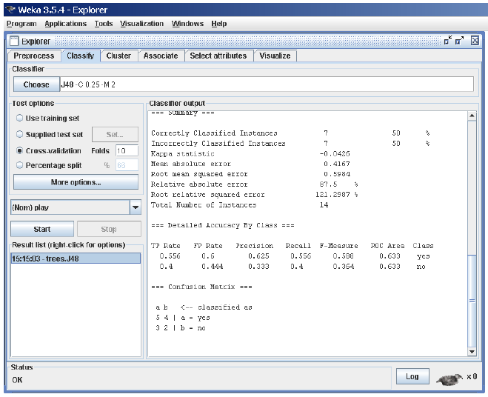

- Output model. The classification model on the full training set is output so that it can be viewed, visualized, etc. This option is selected by default.
- Output per-class stats. The precision/recall and true/false statistics for each class are output. This option is also selected by default.
- Output entropy evaluation measures. Entropy evaluation measures are included in the output. This option is not selected by default.
- Output confusion matrix. The confusion matrix of the classifier’s predictions is included in the output. This option is selected by default.
- Store predictions for visualization. The classifier’s predictions are remembered so that they can be visualized. This option is selected by default.
- Output predictions. The predictions on the evaluation data are output.

Note that in the case of a cross-validation the instance numbers do not correspond to the location in the data!

- Output additional attributes. If additional attributes need to be output alongside the predictions, e.g., an ID attribute for tracking misclassifications, then the index of this attribute can be specified here. The usual Weka ranges are supported,“first” and “last” are therefore valid indices as well (example: “first-3,6,8,12-last”).
- Cost-sensitive evaluation. The errors is evaluated with respect to a cost matrix. The Set... button allows you to specify the cost matrix used.
- Random seed for xval / % Split. This specifies the random seed used when randomizing the data before it is divided up for evaluation purposes.
- Preserve order for % Split. This suppresses the randomization of the data before splitting into train and test set.
- Output source code. If the classifier can output the built model as Java source code, you can specify the class name here. The code will be printed in the “Classifier output” area.
2.1. The Class Attribute
The classifiers in WEKA are designed to be trained to predict a single ‘class’ attribute, which is the target for prediction. Some classifiers can only learn nominal classes; others can only learn numeric classes (regression problems) still others can learn both.
By default, the class is taken to be the last attribute in the data. If you want to train a classifier to predict a different attribute, click on the box below the Test options box to bring up a drop-down list of attributes to choose from.
2.2. Training a Classifier
Once the classifier, test options and class have all been set, the learning process is started by clicking on the Start button. While the classifier is busy being trained, the little bird moves around. You can stop the training process at any time by clicking on the Stop button. When training is complete, several things happen. The Classifier output area to the right of the display is filled with text describing the results of training and testing. A new entry appears in the Result list box. We look at the result list below; but first we investigate the text that has been output.

2.3. The Classifier Output Text
The text in the Classifier output area has scroll bars allowing you to browse the results. Clicking with the left mouse button into the text area, while holding Alt and Shift, brings up a dialog that enables you to save the displayed output
in a variety of formats (currently, BMP, EPS, JPEG and PNG). Of course, you can also resize the Explorer window to get a larger display area.

The output is Split into several sections:
- Run information. A list of information giving the learning scheme options, relation name, instances, attributes and test mode that were involved in the process.
- Classifier model (full training set). A textual representation of the classification model that was produced on the full training data.
- The results of the chosen test mode are broken down thus.
- Summary. A list of statistics summarizing how accurately the classifier was able to predict the true class of the instances under the chosen test mode.
- Detailed Accuracy By Class. A more detailed per-class break down of the classifier’s prediction accuracy.
- Confusion Matrix. Shows how many instances have been assigned to each class. Elements show the number of test examples whose actual class is the row and whose predicted class is the column.
- Source code (optional). This section lists the Java source code if one chose “Output source code” in the “More options” dialog.

3.3. CLUSTERING TAB
3.1. Selecting a Cluster
By now you will be familiar with the process of selecting and configuring objects. Clicking on the clustering scheme listed in the Clusterer box at the top of the window brings up a GenericObjectEditor dialog with which to choose a new clustering scheme.

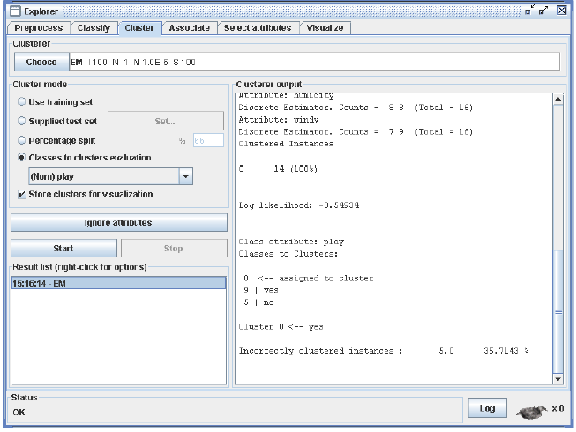

Cluster Modes
The Cluster mode box is used to choose what to cluster and how to evaluate the results. The first three options are the same as for classification: Use training set, Supplied test set and Percentage split (Section 5.3.1)—except that now the data is assigned to clusters instead of trying to predict a specific class. The fourth mode, Classes to clusters evaluation, compares how well the chosen clusters match up with a pre-assigned class in the data. The drop-down box below this option selects the class, just as in the Classify panel.
An additional option in the Cluster mode box, the Store clusters for visualization tick box, determines whether or not it will be possible to visualize the clusters once training is complete. When dealing with datasets that are so large that memory becomes a problem it may be helpful to disable this option.

3.2 Ignoring Attributes
Often, some attributes in the data should be ignored when clustering. The Ignore attributes button brings up a small window that allows you to select which attributes are ignored. Clicking on an attribute in the window highlights it, holding down the SHIFT key selects a range of consecutive attributes, and holding down CTRL toggles individual attributes on and off. To cancel the selection, back out with the Cancel button. To activate it, click the Select button. The next time clustering is invoked, the selected attributes are ignored.

3.3 Working with Filters
The Filtered Clusterer meta-clusterer offers the user the possibility to apply filters directly before the clusterer is learned. This approach eliminates the manual application of a filter in the Preprocess panel, since the data gets processed on the fly. Useful if one needs to try out different filter setups.

3.4. Learning Clusters
The Cluster section, like the Classify section, has Start/Stop buttons, a result text area and a result list. These all behave just like their classification counterparts. Right-clicking an entry in the result list brings up a similar menu, except that it shows only two visualization options: Visualize cluster assignments and Visualize tree. The latter is grayed out when it is not applicable.

3.4. ASSOCIATE TAB
4.1 Setting Up
This panel contains schemes for learning association rules, and the learners are chosen and configured in the same way as the clusterers, filters, and classifiers in the other panels.

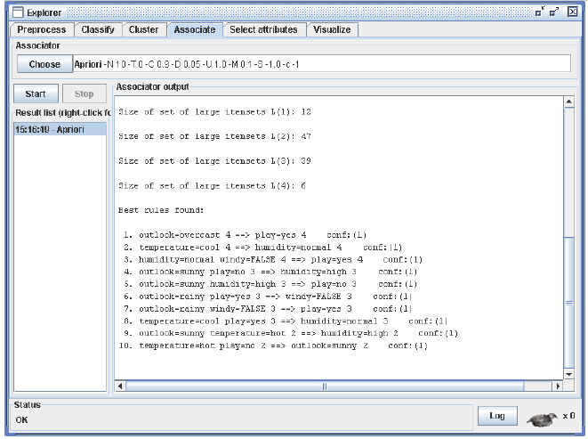

4.2 Learning Associations
Once appropriate parameters for the association rule learner have been set, click the Start button. When complete, right-clicking on an entry in the result list allows the results to be viewed or saved.

3.5. SELECTING ATTRIBUTES TAB
5.1 Searching and Evaluating
Attribute selection involves searching through all possible combinations of attributes in the data to find which subset of attributes works best for prediction. To do this, two objects must be set up: an attribute evaluator and a search method. The evaluator determines what method is used to assign a worth to each subset of attributes. The search method determines what style of search is performed.

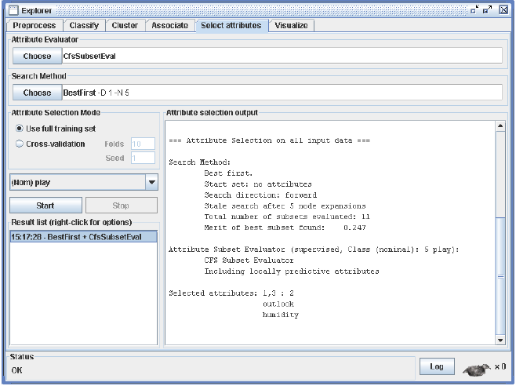

5.2 Options
The Attribute Selection Mode box has two options:
- Use full training set. The worth of the attribute subset is determined using the full set of training data.
- Cross-validation. The worth of the attribute subset is determined by a process of cross-validation The Fold and Seed fields set the number of folds to use and the random seed used when shuffling the data. As with Classify (Section 5.3.1), there is a drop-down box that can be used to specify which attribute to treat as the class.

5.3 Performing Selection

Clicking Start starts running the attribute selection process. When it is finished, the results are output into the result area, and an entry is added to the result list. Right-clicking on the result list gives several options. The first three, (View in main window, View in separate window and Save result buffer), are the same as for the classify panel. It is also possible to Visualize reduced data, or if you have used an attribute transformer such as Principal Components, Visualize transformed data. The reduced/transformed data can be saved to a file with the Save reduced data... or Save transformed data... option.

In case one wants to reduce/transform a training and a test at the same time and not use the Attribute Selected Classifier from the classifier panel, it is best to use the Attribute Selection filter (a supervised attribute filter) in batch mode (’-b’) from the command line or in the Simple CLI. The batch mode allows one to specify an additional input and output file pair (options -r and -s), that is processed with the filter setup that was determined based on the training data.

3.6. VISUALIZING TAB
WEKA’s visualization section allows you to visualize 2D plots of the current relation.
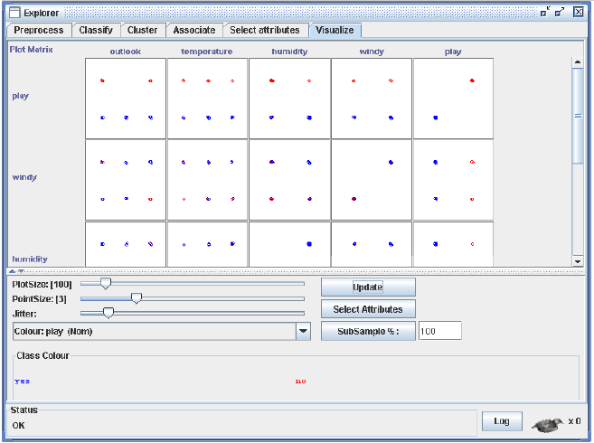
6.1 The scatter plot matrix
When you select the Visualize panel, it shows a scatter plot matrix for all the attributes, colour coded according to the currently selected class. It is possible to change the size of each individual 2D plot and the point size, and to randomly jitter the data (to uncover obscured points). It also possible to change the attribute used to colour the plots, to select only a subset of attributes for inclusion in the scatter plot matrix, and to sub sample the data. Note that changes will only come into effect once the Update button has been pressed.
6.2 Selecting an individual 2D scatter plot
When you click on a cell in the scatter plot matrix, this will bring up a separate window with a visualization of the scatter plot you selected. (We described above how to visualize particular results in a separate window—for example, classifier errors—the same visualization controls are used here.) Data points are plotted in the main area of the window. At the top are two drop-down list buttons for selecting the axes to plot. The one on the left shows which attribute is used for the x-axis; the one on the right shows which is used for the y-axis.
Beneath the x-axis selector is a drop-down list for choosing the colour scheme. This allows you to colour the points based on the attribute selected. Below the plot area, a legend describes what values the colours correspond to. If the values are discrete, you can modify the colour used for each one by clicking on them and making an appropriate selection in the window that pops up.
To the right of the plot area is a series of horizontal strips. Each strip represents an attribute, and the dots within it show the distribution of values of the attribute. These values are randomly scattered vertically to help you see concentrations of points. You can choose what axes are used in the main graph by clicking on these strips. Left-clicking an attribute strip changes the x-axis to that attribute, whereas right-clicking changes the y-axis. The ‘X’ and ‘Y’ written beside the strips shows what the current axes are (‘B’ is used for ‘both X and Y’).
Above the attribute strips is a slider labelled Jitter, which is a random displacement given to all points in the plot. Dragging it to the right increases the amount of jitter, which is useful for spotting concentrations of points. Without jitter, a million instances at the same point would look no different to just a single lonely instance.
6.3 Selecting Instances
There may be situations where it is helpful to select a subset of the data using the visualization tool. (A special case of this is the User Classifier in the Classify panel, which lets you build your own classifier by interactively selecting instances.)
Below the y-axis selector button is a drop-down list button for choosing a selection method. A group of data points can be selected in four ways:
- Select Instance. Clicking on an individual data point brings up a window listing its attributes. If more than one point appears at the same location, more than one set of attributes is shown.
- Rectangle. You can create a rectangle, by dragging, that selects the points inside it.
- Polygon. You can build a free-form polygon that selects the points inside it. Left-click to add vertices to the polygon, right-click to complete it. The polygon will always be closed off by connecting the first point to the last.
- Polyline. You can build a polyline that distinguishes the points on one side from those on the other. Left-click to add vertices to the polyline, right-click to finish. The resulting shape is open (as opposed to a polygon, which is always closed).
Once an area of the plot has been selected using Rectangle, Polygon or Polyline, it turns grey. At this point, clicking the Submit button removes all instances from the plot except those within the grey selection area. Clicking on the Clear button erases the selected area without affecting the graph.
Once any points have been removed from the graph, the Submit button changes to a Reset button. This button undoes all previous removals and returns you to the original graph with all points included. Finally, clicking the Save button allows you to save the currently visible instances to a new ARFF file.

4. EXPERIMENTER
4.1. Introduction Experimenter
The Weka Experiment Environment enables the user to create, run, modify, and analyse experiments in a more convenient manner than is possible when processing the schemes individually. For example, the user can create an experiment that runs several schemes against a series of datasets and then analyse the results to determine if one of the schemes is (statistically) better than the other schemes.
The Experiment Environment can be run from the command line using the Simple CLI. For example, the following commands could be typed into the CLI to run the OneR scheme on the Iris dataset using a basic train and test process.
(Note that the commands would be typed on one line into the CLI.)

java weka.experiment.Experiment -r -T data/iris.arff
-D weka.experiment.InstancesResultListener
-P weka.experiment.RandomSplitResultProducer --
-W weka.experiment.ClassifierSplitEvaluator --
-W weka.classifiers.rules.OneR
While commands can be typed directly into the CLI, this technique is not particularly convenient and the experiments are not easy to modify.
The Experimenter comes in two flavours, either with a simple interface that provides most of the functionality one needs for experiments, or with an interface with full access to the Experimenter’s capabilities. You can choose between those two with the Experiment Configuration Mode radio buttons:
• Simple
• Advanced
Both setups allow you to setup standard experiments, that are run locally on a single machine, or remote experiments, which are distributed between several hosts. The distribution of experiments cuts down the time the experiments will take until completion, but on the other hand the setup takes more time.
The next section covers the standard experiments (both, simple and ad- vanced), followed by the remote experiments and finally the analysing of the results.

4.2. Standard Experiments
2.1 Simple
2.1.1 New experiment
After clicking New default parameters for an Experiment are defined.

2.1.2 Results destination
By default, an ARFF file is the destination for the results output. But you can choose between
• ARFF file
• CSV file
• JDBC database
ARFF file and JDBC database are discussed in detail in the following sec- tions. CSV is similar to ARFF, but it can be used to be loaded in an external spreadsheet application.

ARFF file
If the file name is left empty a temporary file will be created in the TEMP directory of the system. If one wants to specify an explicit results file, click on Browse and choose a filename, e.g., Experiment1.arff.

Click on Save and the name will appear in the edit field next to ARFF file.

The advantage of ARFF or CSV files is that they can be created without any additional classes besides the ones from Weka. The drawback is the lack of the ability to resume an experiment that was interrupted, e.g., due to an
error or the addition of dataset or algorithms. Especially with time-consuming experiments, this behavior can be annoying.
JDBC database
With JDBC it is easy to store the results in a database. The necessary jar archives have to be in the CLASSPATH to make the JDBC functionality of a particular database available.
After changing ARFF file to JDBC database click on User... to specify JDBC URL and user credentials for accessing the database.

After supplying the necessary data and clicking on OK, the URL in the main window will be updated.
Note: at this point, the database connection is not tested; this is done when the experiment is started.
The advantage of a JDBC database is the possibility to resume an interrupted or extended experiment. Instead of re-running all the other algorithm/dataset combinations again, only the missing ones are computed.
2.1.3 Experiment type
The user can choose between the following three different types
- Cross-validation (default)
performs stratified cross-validation with the given number of folds
- Train/Test Percentage Split (data randomized)
splits a dataset according to the given percentage into a train and a test file (one cannot specify explicit training and test files in the Experimenter), after the order of the data has been randomized and stratified.

- Train/Test Percentage Split (order preserved)
because it is impossible to specify an explicit train/test files pair, one can abuse this type to un-merge previously merged train and test file into the two original files (one only needs to find out the correct percentage)

Additionally, one can choose between Classification and Regression, depending on the datasets and classifiers one uses. For decision trees like J48 (Weka’s implementation of Quinlan’s C4.5 [3]) and the iris dataset, Classification is necessary, for a numeric classifier like M5P, on the other hand, Regression. Classification is selected by default.
Note: if the percentage splits are used, one has to make sure that the corrected paired T-Tester still produces sensible results with the given ratio
2.1.4 Datasets
One can add dataset files either with an absolute path or with a relative one. The latter makes it often easier to run experiments on different machines, hence one should check Use relative paths, before clicking on Add new....
In this example, open the data directory and choose the iris.arff dataset.
After clicking Open the file will be displayed in the datasets list. If one selects a directory and hits Open, then all ARFF files will be added recursively. Files can be deleted from the list by selecting them and then clicking on Delete selected.
ARFF files are not the only format one can load, but all files that can be converted with Weka’s “core converters”. The following formats are currently supported:

- ARFF (+ compressed)
- C4.5
- CSV
- libsvm
- binary serialized instances
- XRFF (+ compressed)
By default, the class attribute is assumed to be the last attribute. But if a data format contains information about the class attribute, like XRFF or C4.5, this attribute will be used instead.
2.1.5 Iteration control
- Number of repetitions
In order to get statistically meaningful results, the default number of iterations is 10. In case of 10-fold cross-validation this means 100 calls of one classifier with training data and tested against test data.
- Data sets first/Algorithms first
As soon as one has more than one dataset and algorithm, it can be useful to switch from datasets being iterated over first to algorithms. This is the case if one stores the results in a database and wants to complete the results for all the datasets for one algorithm as early as possible.
2.1.6 Algorithms
New algorithms can be added via the Add new... button. Opening this dialog for the first time, ZeroR is presented, otherwise the one that was selected last.
With the Choose button one can open the GenericObjectEditor and choose another classifier.
The Filter... button enables one to highlight classifiers that can handle certain attribute and class types. With the Remove filter button all the selected capabilities will get cleared and the highlighting removed again.
Additional algorithms can be added again with the Add new... button, e.g., the J48 decision tree.

After setting the classifier parameters, one clicks on OK to add it to the list of algorithms.
With the Load options... and Save options... buttons one can load and save the setup of a selected classifier from and to XML. This is especially useful for highly configured classifiers (e.g., nested meta-classifiers), where the manual
setup takes quite some time, and which are used often.
One can also paste classifier settings here by right-clicking (or Alt-Shift-left- clicking) and selecting the appropriate menu point from the popup menu, to either add a new classifier or replace the selected one with a new setup. This is
rather useful for transferring a classifier setup from the Weka Explorer over to the Experimenter without having to setup the classifier from scratch.
2.1.7 Saving the setup
For future re-use, one can save the current setup of the experiment to a file by clicking on Save... at the top of the window.

By default, the format of the experiment files is the binary format that Java serialization offers. The drawback of this format is the possible incompatibility between different versions of Weka. A more robust alternative to the binary
format is the XML format.
Previously saved experiments can be loaded again via the Open... button.
2.1.8 Running an Experiment
To run the current experiment, click the Run tab at the top of the Experiment Environment window. The current experiment performs 10 runs of 10-fold stratified cross-validation on the Iris dataset using the ZeroR and J48 scheme.

Click Start to run the experiment.

If the experiment was defined correctly, the 3 messages shown above will be displayed in the Log panel. The results of the experiment are saved to the dataset Experiment1.arff.

4.3. ADVANCED
3.1 Defining an Experiment
When the Experimenter is started in Advanced mode, the Setup tab is displayed.
Click New to initialize an experiment. This causes default parameters to be defined for the experiment.
To define the dataset to be processed by a scheme, first select Use relative paths in the Datasets panel of the Setup tab and then click on Add new... to open a dialog window.
Double click on the data folder to view the available datasets or navigate to an alternate location. Select iris.arff and click Open to select the Iris dataset.
The dataset name is now displayed in the Datasets panel of the Setup tab.
Saving the Results of the Experiment
To identify a dataset to which the results are to be sent, click on the Instances- ResultListener entry in the Destination panel. The output file parameter is near the bottom of the window, beside the text outputFile. Click on this parameter to display a file selection window.
Type the name of the output file, click Select, and then click close (x). The file name is displayed in the outputFile panel. Click on OK to close the window.
The dataset name is displayed in the Destination panel of the Setup tab.
Saving the Experiment Definition
The experiment definition can be saved at any time. Select Save... at the top of the Setup tab. Type the dataset name with the extension exp (or select the dataset name if the experiment definition dataset already exists) for binary files or choose Experiment configuration files (*.xml) from the file types combobox (the XML files are robust with respect to version changes).
The experiment can be restored by selecting Open in the Setup tab and then selecting Experiment1.exp in the dialog window.
3.2 Running an Experiment
To run the current experiment, click the Run tab at the top of the Experiment Environment window. The current experiment performs 10 randomized train and test runs on the Iris dataset, using 66% of the patterns for training and 34% for testing, and using the ZeroR scheme.
Click Start to run the experiment.
If the experiment was defined correctly, the 3 messages shown above will be displayed in the Log panel. The results of the experiment are saved to the dataset Experiment1.arff. The first few lines in this dataset are shown below.
@relation InstanceResultListener

@attribute Key_Dataset {iris}
@attribute Key_Run {1,2,3,4,5,6,7,8,9,10}
@attribute Key_Scheme {weka.classifiers.rules.ZeroR,weka.classifiers.trees.J48}
@attribute Key_Scheme_options {,’-C 0.25 -M 2’}
@attribute Key_Scheme_version_ID {48055541465867954,-217733168393644444}
@attribute Date_time numeric
@attribute Number_of_training_instances numeric
@attribute Number_of_testing_instances numeric
@attribute Number_correct numeric
@attribute Number_incorrect numeric
@attribute Number_unclassified numeric
@attribute Percent_correct numeric
@attribute Percent_incorrect numeric
@attribute Percent_unclassified numeric
@attribute Kappa_statistic numeric
@attribute Mean_absolute_error numeric
@attribute Root_mean_squared_error numeric
@attribute Relative_absolute_error numeric
@attribute Root_relative_squared_error numeric
@attribute SF_prior_entropy numeric
@attribute SF_scheme_entropy numeric
@attribute SF_entropy_gain numeric
@attribute SF_mean_prior_entropy numeric
@attribute SF_mean_scheme_entropy numeric
@attribute SF_mean_entropy_gain numeric
@attribute KB_information numeric
@attribute KB_mean_information numeric
@attribute KB_relative_information numeric
@attribute True_positive_rate numeric
@attribute Num_true_positives numeric
@attribute False_positive_rate numeric
@attribute Num_false_positives numeric
@attribute True_negative_rate numeric
@attribute Num_true_negatives numeric
@attribute False_negative_rate numeric
@attribute Num_false_negatives numeric
@attribute IR_precision numeric
@attribute IR_recall numeric
@attribute F_measure numeric
@attribute Area_under_ROC numeric
@attribute Time_training numeric
@attribute Time_testing numeric
@attribute Summary {’Number of leaves: 3\nSize of the tree: 5\n’,
’Number of leaves: 5\nSize of the tree: 9\n’,
’Number of leaves: 4\nSize of the tree: 7\n’}
@attribute measureTreeSize numeric
@attribute measureNumLeaves numeric
@attribute measureNumRules numeric

@data

iris,1,weka.classifiers.rules.ZeroR,,48055541465867954,20051221.033,99,51,
17,34,0,33.333333,66.666667,0,0,0.444444,0.471405,100,100,80.833088,80.833088,
0,1.584963,1.584963,0,0,0,0,1,17,1,34,0,0,0,0,0.333333,1,0.5,0.5,0,0,?,?,?,?
2.2.3 Changing the Experiment Parameters
Changing the Classifier
The parameters of an experiment can be changed by clicking on the Result generator panel.

The RandomSplitResultProducer performs repeated train/test runs. The number of instances (expressed as a percentage) used for training is given in the train Percent box. (The number of runs is specified in the Runs panel in the Setup tab.)
A small help file can be displayed by clicking More in the About panel.
Click on the splitEvaluator entry to display the SplitEvaluator properties.
Click on the classifier entry (ZeroR) to display the scheme properties.
This scheme has no modifiable properties (besides debug mode on/off) but most other schemes do have properties that can be modified by the user. The Capabilities button opens a small dialog listing all the attribute and class types this classifier can handle. Click on the Choose button to select a different scheme. The window below shows the parameters available for the J48 decision- tree scheme. If desired, modify the parameters and then click OK to close the
window.
The name of the new scheme is displayed in the Result generator panel.

Adding Additional Schemes
Additional schemes can be added in the Generator properties panel. To begin, change the drop-down list entry from Disabled to Enabled in the Generator properties panel.

Click Select property and expand splitEvaluator so that the classifier entry is visible in the property list; click Select.
The scheme name is displayed in the Generator properties panel.

To add another scheme, click on the Choose button to display the Generic- ObjectEditor window.

The Filter... button enables one to highlight classifiers that can handle certain attribute and class types. With the Remove filter button all the selected capabilities will get cleared and the highlighting removed again.
To change to a decision-tree scheme, select J48 (in subgroup trees).

The new scheme is added to the Generator properties panel. Click Add to add the new scheme.

Now when the experiment is run, results are generated for both schemes. To add additional schemes, repeat this process. To remove a scheme, select the scheme by clicking on it and then click Delete.

Adding Additional Datasets
The scheme(s) may be run on any number of datasets at a time. Additional datasets are added by clicking Add new... in the Datasets panel. Datasets are deleted from the experiment by selecting the dataset and then clicking Delete
Selected.
Raw Output
The raw output generated by a scheme during an experiment can be saved to a file and then examined at a later time. Open the ResultProducer window by clicking on the Result generator panel in the Setup tab.

Click on rawOutput and select the True entry from the drop-down list. By default, the output is sent to the zip file splitEvaluatorOut.zip. The output file can be changed by clicking on the outputFile panel in the window. Now when
the experiment is run, the result of each processing run is archived, as shown below.

The contents of the first run are:
ClassifierSplitEvaluator: weka.classifiers.trees.J48 -C 0.25 -M 2(version
-217733168393644444)Classifier model:
J48 pruned tree
------------------
petalwidth <= 0.6: Iris-setosa (33.0)
petalwidth > 0.6
| petalwidth <= 1.5: Iris-versicolor (31.0/1.0)
| petalwidth > 1.5: Iris-virginica (35.0/3.0)
Number of Leaves : 3
Size of the tree : 5
Correctly Classified Instances 47 92.1569 %
Incorrectly Classified Instances 4 7.8431 %
Kappa statistic 0.8824
Mean absolute error 0.0723
Root mean squared error 0.2191
Relative absolute error 16.2754 %
Root relative squared error 46.4676 %
Total Number of Instances 51
measureTreeSize : 5.0
measureNumLeaves : 3.0
measureNumRules : 3.0

4.4. Other Result Producers

Cross-Validation Result Producer
To change from random train and test experiments to cross-validation experiments, click on the Result generator entry. At the top of the window, click on the drop-down list and select CrossValidationResultProducer. The window
now contains parameters specific to cross-validation such as the number of partitions/folds. The experiment performs 10-fold cross-validation instead of train and test in the given example.
The Result generator panel now indicates that cross-validation will be performed. Click on More to generate a brief description of the CrossValidationResultProducer.
As with the RandomSplitResultProducer, multiple schemes can be run during cross-validation by adding them to the Generator properties panel.
The number of runs is set to 1 in the Setup tab in this example, so that only one run of cross-validation for each scheme and dataset is executed.
When this experiment is analyzed, the following results are generated. Note that there are 30 (1 run times 10 folds times 3 schemes) result lines processed.
Averaging Result Producer
An alternative to the CrossValidationResultProducer is the AveragingResultProducer. This result producer takes the average of a set of runs (which are typically cross-validation runs). This result producer is identified by clicking the
Result generator panel and then choosing the AveragingResultProducer from the GenericObjectEditor.
The associated help file is shown below.
Clicking the resultProducer panel brings up the following window.
As with the other ResultProducers, additional schemes can be defined. When the AveragingResultProducer is used, the classifier property is located deeper in the Generator properties hierarchy.

In this experiment, the ZeroR, OneR, and J48 schemes are run 10 times with 10-fold cross-validation. Each set of 10 cross-validation folds is then averaged, producing one result line for each run (instead of one result line for each fold as
in the previous example using the CrossValidationResultProducer ) for a total of 30 result lines. If the raw output is saved, all 300 results are sent to the archive.

5. ANALYSING RESULTS
5.1 Setup
Weka includes an experiment analyser that can be used to analyse the results of experiments (in this example, the results were sent to an InstancesResultListener ). The experiment shown below uses 3 schemes, ZeroR, OneR, and J48, to classify the Iris data in an experiment using 10 train and test runs, with 66% of the data used for training and 34% used for testing.
After the experiment setup is complete, run the experiment. Then, to analyse the results, select the Analyse tab at the top of the Experiment Environment window.
Click on Experiment to analyse the results of the current experiment.

The number of result lines available (Got 30 results) is shown in the Source panel. This experiment consisted of 10 runs, for 3 schemes, for 1 dataset, for a total of 30 result lines. Results can also be loaded from an earlier experiment file by clicking File and loading the appropriate .arff results file. Similarly, results sent to a database (using the DatabaseResultListener ) can be loaded from the database.
Select the Percent correct attribute from the Comparison field and click Perform test to generate a comparison of the 3 schemes.
The schemes used in the experiment are shown in the columns and the datasets used are shown in the rows.
The percentage correct for each of the 3 schemes is shown in each dataset row: 33.33% for ZeroR, 94.31% for OneR, and 94.90% for J48. The annotation v or * indicates that a specific result is statistically better (v) or worse (*) than the baseline scheme (in this case, ZeroR) at the significance level specified (currently 0.05). The results of both OneR and J48 are statistically better than the baseline established by ZeroR. At the bottom of each column after the first column is a count (xx/ yy/ zz) of the number of times that the scheme was better than (xx), the same as (yy), or worse than (zz), the baseline scheme on the datasets used in the experiment. In this example, there was only one dataset and OneR was better than ZeroR once and never equivalent to or worse than ZeroR (1/0/0); J48 was also better than ZeroR on the dataset.
The standard deviation of the attribute being evaluated can be generated by selecting the Show std. deviations check box and hitting Perform test again. The value (10) at the beginning of the iris row represents the number of estimates that are used to calculate the standard deviation (the number of runs in this case).
Selecting Number correct as the comparison field and clicking Perform test generates the average number correct (out of 50 test patterns - 33% of 150 patterns in the Iris dataset).
Clicking on the button for the Output format leads to a dialog that lets you choose the precision for the mean and the std. deviations, as well as the format of the output. Checking the Show Average checkbox adds an additional line to the output listing the average of each column. With the Remove filter classnames checkbox one can remove the filter name and options from processed datasets (filter names in Weka can be quite lengthy).
The following formats are supported:
• CSV
• GNUPlot
• HTML
• LaTeX
• Plain text (default)
• Significance only
5.2 Saving the Results
The information displayed in the Test output panel is controlled by the currently- selected entry in the Result list panel. Clicking on an entry causes the results corresponding to that entry to be displayed.
The results shown in the Test output panel can be saved to a file by clicking Save output. Only one set of results can be saved at a time but Weka permits the user to save all results to the same file by saving them one at a time and using the Append option instead of the Overwrite option for the second and subsequent saves.
5.3 Changing the Baseline Scheme
The baseline scheme can be changed by clicking Select base... and then selecting the desired scheme. Selecting the OneR scheme causes the other schemes to be compared individually with the OneR scheme.
If the test is performed on the Percent correct field with OneR as the base scheme, the system indicates that there is no statistical difference between the results for OneR and J48. There is however a statistically significant difference between OneR and ZeroR.
5.4 Statistical Significance
The term statistical significance used in the previous section refers to the result of a pair-wise comparison of schemes using either a standard T-Test or the corrected resampled T-Test [2]. The latter test is the default, because the standard T-Test can generate too many significant differences due to dependencies in the estimates (in particular when anything other than one run of an x-fold cross-validation is used). For more information on the T-Test, consult the Weka book [1] or an introductory statistics text. As the significance level is decreased, the confidence in the conclusion increases.
In the current experiment, there is not a statistically significant difference between the OneR and J48 schemes.
5.5 Summary Test
Selecting Summary from Test base and performing a test causes the following information to be generated.
In this experiment, the first row (- 1 1) indicates that column b (OneR) is better than row a (ZeroR) and that column c (J48) is also better than row a. The number in brackets represents the number of significant wins for the column with regard to the row. A 0 means that the scheme in the corresponding column did not score a single (significant) win with regard to the scheme in the row.
5.6 Ranking Test
Selecting Ranking from Test base causes the following information to be generated.
The ranking test ranks the schemes according to the total number of significant wins (>) and losses (<) against the other schemes. The first column (> − <) is the difference between the number of wins and the number of losses.
This difference is used to generate the ranking.

5. KNOWLEDGE FLOW
5.1. The Knowledge Flow GUI
- New graphical user interface for WEKA
- Java-Beans-based interface for setting up and running machine learning experiments
- Data sources, classifiers, etc. are beans and can be connected graphically
- Data “flows” through components: e.g.,
“data source” -> “filter” -> “classifier” -> “evaluator”
- Layouts can be saved and loaded again later

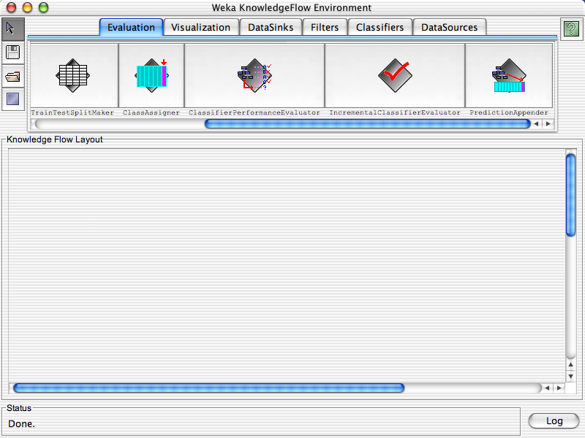

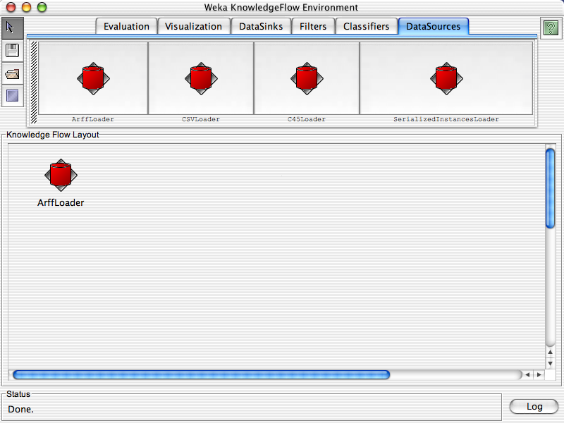
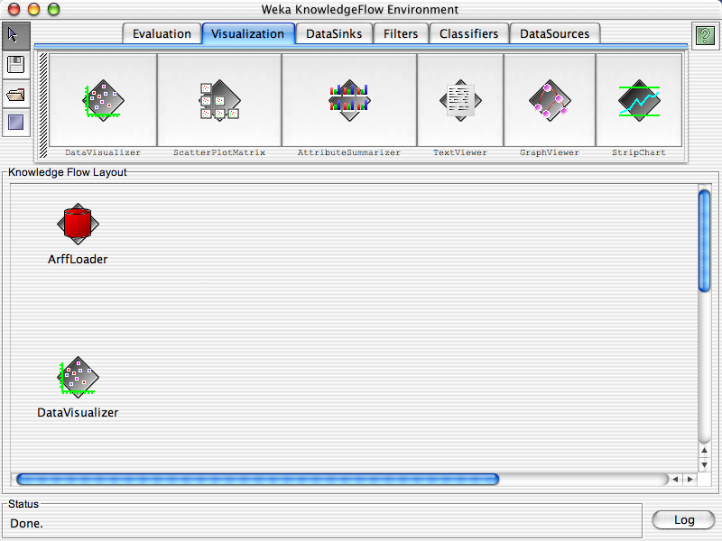
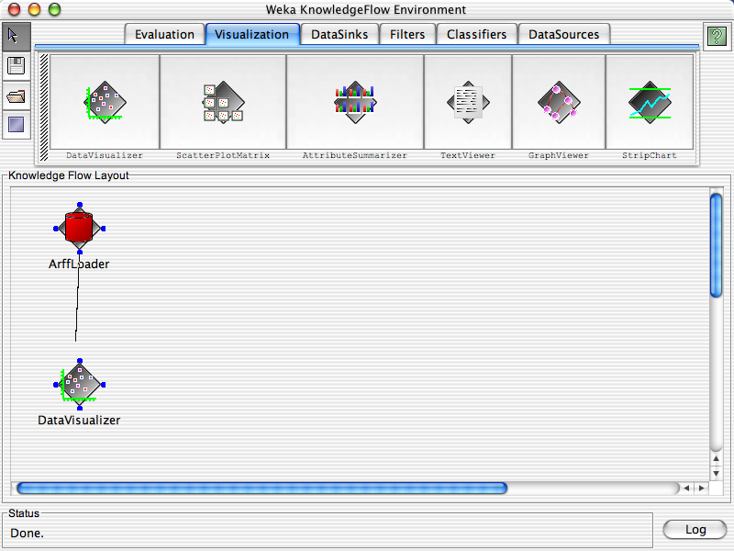
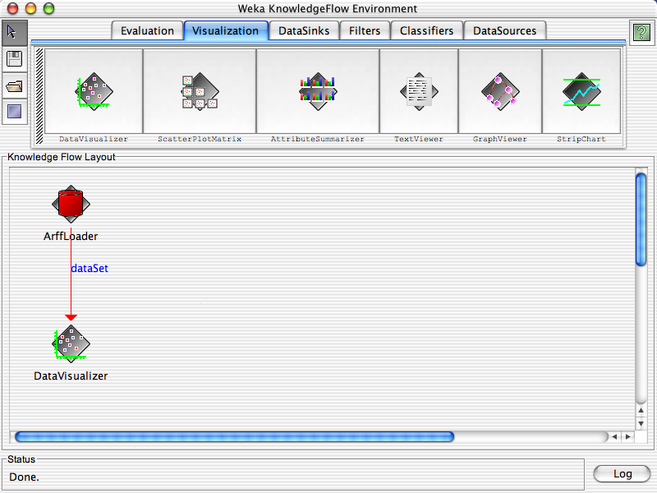
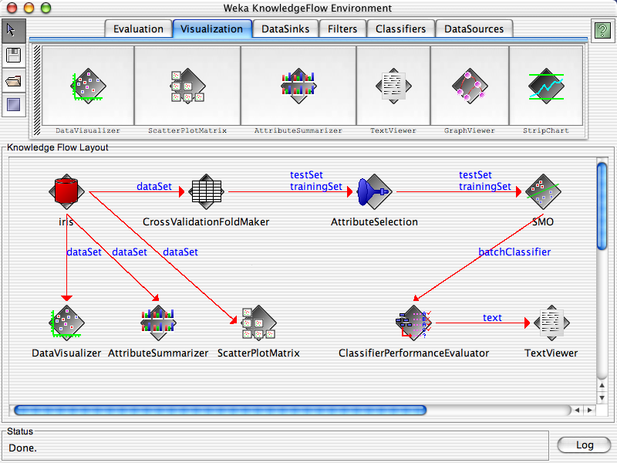
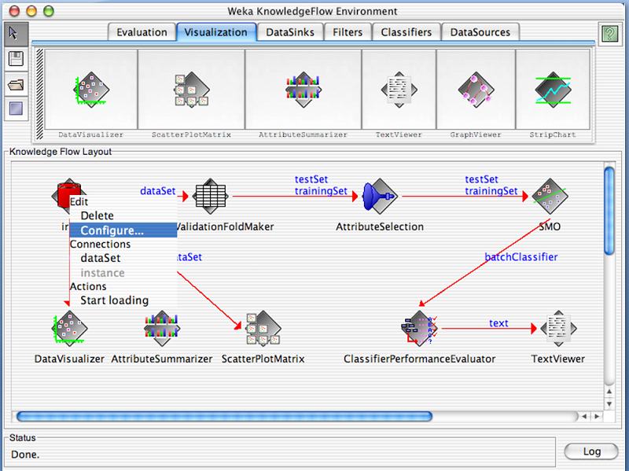
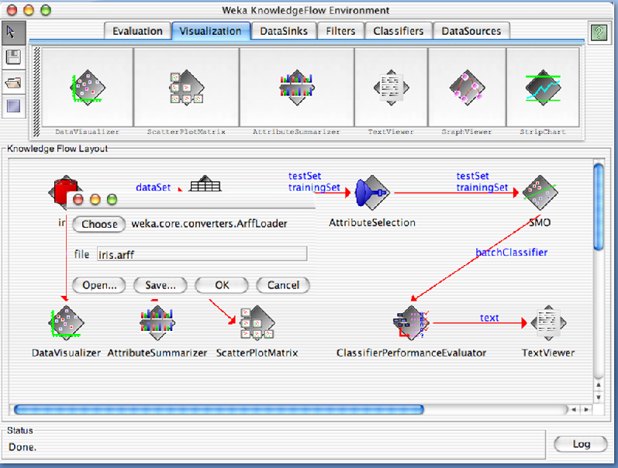
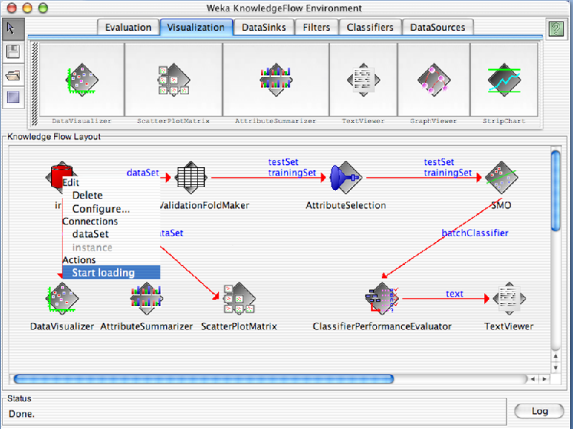
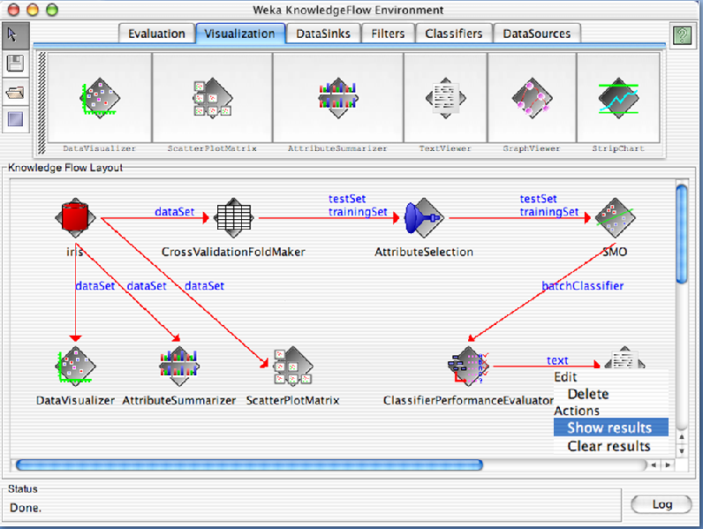
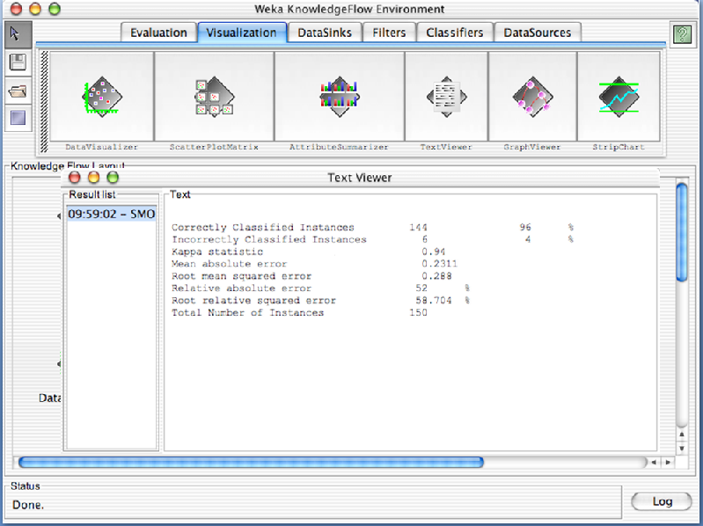

DESCRIPTION OF GERMAN CREDIT DATA.

Credit Risk Assessment
Description: The business of banks is making loans. Assessing the credit worthiness of an applicant is of crucial importance. You have to develop a system to help a loan officer decide whether the credit of a customer is good. Or bad. A bank’s business rules regarding loans must consider two opposing factors. On th one han, a bank wants to make as many loans as possible. Interest on these loans is the banks profit source. On the other hand, a bank can not afford to make too many bad loans. Too many bad loans could lead to the collapse of the bank. The bank’s loan policy must involved a compromise. Not too strict and not too lenient.
To do the assignment, you first and foremost need some knowledge about the world of credit. You can acquire such knowledge in a number of ways.
1. Knowledge engineering: Find a loan officer who is willing to talk. Interview her and try to represent her knowledge in a number of ways.
2. Books: Find some training manuals for loan officers or perhaps a suitable textbook on finance. Translate this knowledge from text from to production rule form.
3. Common sense: Imagine yourself as a loan officer and make up reasonable rules which can be used to judge the credit worthiness of a loan applicant.
4. Case histories: Find records of actual cases where competent loan officers correctly judged when and not to. Approve a loan application.
The German Credit Data
Actual historical credit data is not always easy to come by because of confidentiality rules. Here is one such data set. Consisting of 1000 actual cases collected in Germany.
In spite of the fact that the data is German, you should probably make use of it for this assignment(Unless you really can consult a real loan officer!)
There are 20 attributes used in judging a loan applicant( ie., 7 Numerical attributes and 13 Categorical or Nominal attributes). The goal is the classify the applicant into one of two categories. Good or Bad.
The total number of attributes present in German credit data are.
1. Checking_Status
2. Duration
3. Credit_history
4. Purpose
5. Credit_amout
6. Savings_status
7. Employment
8. Installment_Commitment
9. Personal_status
10. Other_parties
11. Residence_since
12. Property_Magnitude
13. Age
14. Other_payment_plans
15. Housing
16. Existing_credits
17. Job
18. Num_dependents
19. Own_telephone
20. Foreign_worker
21. Class

Tasks (Turn in your answers to the following tasks)

Data Mining Viva Questions:
1. Which of the following forms the logical subset of the complete data warehouse?
(a)Dimensional model
(b)Fact table
(c)Dimensional table
(d)Operational Data Store
(e)Data Mart.
2.Which of the following is not included inModeling Applications?
(a)Forecasting models
(b)Behavior scoring models
(c)Allocation models
(d)Data mining Models
(e)Metadata driven models.
3.Which of the following is a dimension that means the same thing with every possible fact table to
which it can be joined?
(a)Permissible snowflaking
(b)Confirmed Dimensions
(c)Degenerate dimensions
(d)Junk Dimensions
(e)Monster Dimensions.

4.Which of the following is not the managing issue in the modeling process?
(a)Content of primary units column
(b)Document each candidate data source
(c)Do regions report to zones
(d)Walk through business scenarios
(e)Ensure that the transaction edit flat is used for analysis.
5.Which of the following criteria is not used for selecting the data sources?
(a)Data Accessibility
(b)Platform
(c)Data accuracy
(d)Longevity of the feed
(e)Project scheduling.
6.Which of the following does not relate to the data modeling tool?
(a)Link to the dimension table designs
(b)Business user Documentation
(c)Helps assure consistency in naming
(d)Length of the logical column.
(e)Generates physical object DDL.
7.Which of the following is true on building aMatrix for Data warehouse bus architecture?
(a)Data marts as columns and dimensions as rows
(b)Dimensions as rows and facts as columns
(c)Data marts as rows and dimensions as columns
(d)Data marts as rows and facts as columns
(e)Facts as rows and data marts as columns.
8.Which of the following should not be considered for each dimension attribute?
(a)Attribute name
(b)Rapid changing dimension policy
(c)Attribute definition
(d)Sample data
(e)Cardinality.
9.Which of following form the set of data created to support a specific short lived business situation?
(a)Personal Data Marts
(b)Application Models
(c)Downstream systems
(d)Disposable Data Marts
(e)Data mining models.
10.Which of the following does not form future access services?
(a)Authentication
(b)Report linking
(c)Push toward centralized services
(d)Vendor consolidation
(e)Web based customer access.
11.What is the special kind of clustering that identifies events or transactions that occur
simultaneously?
(a)Affinity grouping
(b)Classifying
(c)Clustering
(d)Estimating
(e)Predicting.

12.Of the following team members, who do not form audience for Data warehousing?
(a)Data architects
(b)DBAs
(c)Business Intelligence experts
(d)Managers
(e)Customers/users.
13.The precalculated summary values are called as
(a)Assertions
(b)Triggers
(c)Aggregates
(d)Schemas
(e)Indexes.
14.OLAP stands for
(a)Online Analytical Processing
(b)Online Attribute Processing
(c)Online Assertion Processing
(d)Online Association Processing
(e)Online Allocation Processing.
15.Which of the following employ data mining techniques to analyze the intent of a user query,
provided additional generalized or associated information relevant to the query?
(a)Iceberg QueryMethod
(b)Data Analyzer
(c)Intelligent Query answering
(d)DBA
(e)Query Parser.
16.Of the following clustering algorithm what is the method which initially creates a hierarchical
decomposition of the given set of data objects?
(a)Partitioning Method
(b)Hierarchical Method
(c)Density-based method
(d)Grid-based Method
(e)Model-based Method.
17.Which one of the following can be performed using the attribute-oriented induction in a manner
similar to concept characterization?
(a)Analytical characterization
(b)Concept Description.
(c)OLAP based approach
(d)Concept Comparison
(e)Data Mining.
18.Which one of the following is an efficient association rule mining algorithm that explores the levelwise
mining?
(a)FP-tree algorithm
(b)Apriori Algorithm
(c)Level-based Algorithm
(d)Partitioning Algorithm
(e)Base Algorithm.
19.What allows users to focus the search for rules by providing metarules and additional mining
constraints?
(a)Correlation rule mining
(b)Multilevel Association rule mining
(c)Single level Association rule mining
(d)Constraint based rule mining
(e)Association rule mining.
20.Which of the following can be used in describing central tendency and data description from the
descriptive statistics point of view?
(a)Concept measures
(b)Statistical measures
(c)T-weight
(d)D-weight
(e)Generalization.
21.Which of the following is the collection of data objects that are similar to one another within the
same group?
(a)Partitioning
(b)Grid
(c)Cluster
(d)Table
(e)Data source.
22.In which of the following binning strategy, each bin has approximately the same number of tuples
assigned to it?
(a)Equiwidth binning
(b)Equidepth binning
(c)Homogeneity-based binning
(d)Equilength binning
(e)Frequent predicate set.
23.Which of the following binning strategy has the interval size of each bin the same?
(a)Equiwidth binning
(b)Ordinary binning
(c)Heterogeneity-based binning
(d)Un-Equaling binning
(e)Predicate Set.
24.Which of the following association shows relationships between discrete objects?
(a)Quantitative
(b)Boolean
(c)Single Dimensional
(d)Multidimensional
(e)Bidirectional.
25.What algorithms attempt to improve accuracy by removing tree branches reflecting noise in the
data?
(a)Partitioning
(b)Apriori
(c)Clustering
(d)FP tree
(e)Pruning.
26.Which of the following process includes data cleaning, data integration, data selection, data
transformation, data mining, pattern evolution, and knowledge presentation?
(a)KDD Process
(b)ETL Process
(c)KTL Process
(d)MDX process
(e)DW&DM.

27.What is the target physical machine on which the data warehouse is organized and stored for
direct querying by end users, report writers, and other applications?
(a)Presentation server
(b)Application server
(c)Database server
(d)Interface server
(e)Data staging server.
28.Which of the following cannot form a category of queries?
(a)Simple constraints
(b)Correlated subqueries
(c)Simple behavioral queries
(d)Derived Behavioral queries
(e)Clustering queries.
29.Which of the following is not related to dimension table attributes?
(a)Verbose
(b)Descriptive
(c)Equally unavailable
(d)Complete
(e)Indexed.
30.Type 1: Overwriting the dimension record, thereby loosing the history, Type 2: Create a new
additional dimension record using a new value of the surrogate key and Type 3: Create an old field
in the dimension record to store the immediate previous attribute value. Belong to:
(a)Slow changing Dimensions
(b)Rapidly changing Dimensions
(c)Artificial Dimensions
(d)Degenerate Dimensions
(e)Caveats.

- List all the categorical (or nominal) attributes and the real valued attributes separately.

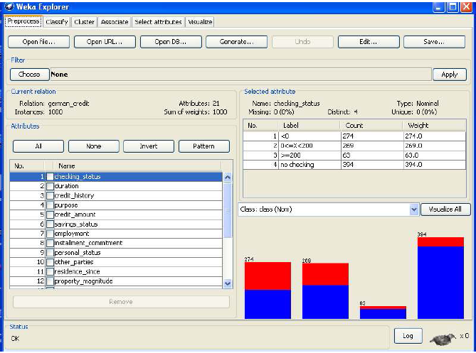

Ans) The following are the Categorical (or Nominal) attributes)
1. Checking_Status
2. Credit_history
3. Purpose
4. Savings_status
5. Employment
6. Personal_status
7. Other_parties
8. Property_Magnitude
9. Other_payment_plans
10. Housing
11. Job
12. Own_telephone
13. Foreign_worker

The following are the Numerical attributes)
1. Duration
2. Credit_amout
3. Installment_Commitment
4. Residence_since
5. Age
6. Existing_credits
7. Num_dependents

- What attributes do you think might be crucial in making the credit assessment? Come up with some simple rules in plain English using your selected attributes.

Ans) The following are the attributes may be crucial in making the credit assessment.
1. Credit_amount
2. Age
3. Job
4. Savings_status
5. Existing_credits
6. Installment_commitment
7. Property_magnitude

- One type of model that you can create is a Decision tree . train a Decision tree using the complete data set as the training data. Report the model obtained after training.
Ans) We created a decision tree by using J48 Technique for the complete dataset as the training data.
The following model obtained after training.
=== Run information ===
Scheme: weka.classifiers.trees.J48 -C 0.25 -M 2
Relation: german_credit
Instances: 1000
Attributes: 21
checking_status
duration
credit_history
purpose
credit_amount
savings_status
employment
installment_commitment
personal_status
other_parties
residence_since
property_magnitude
age
other_payment_plans
housing
existing_credits
job
num_dependents
own_telephone
foreign_worker
class

Test mode: evaluate on training data
=== Classifier model (full training set) ===
J48 pruned tree
------------------
Number of Leaves : 103
Size of the tree : 140
Time taken to build model: 0.08 seconds

=== Evaluation on training set ===
=== Summary ===
Correctly Classified Instances 855 85.5 %
Incorrectly Classified Instances 145 14.5 %
Kappa statistic 0.6251
Mean absolute error 0.2312
Root mean squared error 0.34
Relative absolute error 55.0377 %
Root relative squared error 74.2015 %
Coverage of cases (0.95 level) 100 %
Mean rel. region size (0.95 level) 93.3 %
Total Number of Instances 1000

=== Detailed Accuracy By Class ===

TP Rate FP Rate Precision Recall F-Measure ROC Area Class
0.956 0.38 0.854 0.956 0.902 0.857 good
0.62 0.044 0.857 0.62 0.72 0.857 bad
WeightedAvg. 0.855 0.279 0.855 0.855 0.847 0.857
=== Confusion Matrix ===
a b <-- classified as
669 31 | a = good
114 186 | b = bad

- Suppose you use your above model trained on the complete dataset, and classify credit good/bad for each of the examples in the dataset. What % of examples can you classify correctly?(This is also called testing on the training set) why do you think can not get 100% training accuracy?

Ans) If we used our above model trained on the complete dataset and classified credit as good/bad
for each of the examples in that dataset. We can not get 100% training accuracy only 85.5% of
examples, we can classify correctly.

- Is testing on the training set as you did above a good idea? Why or why not?

Ans)It is not good idea by using 100% training data set.

- One approach for solving the problem encountered in the previous question is using crossvalidation? Describe what is cross validation briefly. Train a decision tree again using cross validation and report your results. Does accuracy increase/decrease? Why?

Ans)Cross-Validation Definition: The classifier is evaluated by cross validation using the number of folds that are entered in the folds text field.
In Classify Tab, Select cross-validation option and folds size is 2 then Press Start Button, next time change as folds size is 5 then press start, and next time change as folds size is 10 then press start.

i) Fold Size-10
Stratified cross-validation ===
=== Summary ===
Correctly Classified Instances 705 70.5 %
Incorrectly Classified Instances 295 29.5 %
Kappa statistic 0.2467
Mean absolute error 0.3467
Root mean squared error 0.4796
Relative absolute error 82.5233 %
Root relative squared error 104.6565 %
Coverage of cases (0.95 level) 92.8 %
Mean rel. region size (0.95 level) 91.7 %
Total Number of Instances 1000

=== Detailed Accuracy By Class ===
TP Rate FP Rate Precision Recall F-Measure ROC Area Class
0.84 0.61 0.763 0.84 0.799 0.639 good
0.39 0.16 0.511 0.39 0.442 0.639 bad
Weighted Avg. 0.705 0.475 0.687 0.705 0.692 0.639
=== Confusion Matrix ===
a b <-- classified as
588 112 | a = good
183 117 | b = bad

ii) Fold Size-5
Stratified cross-validation ===
=== Summary ===
Correctly Classified Instances 733 73.3 %
Incorrectly Classified Instances 267 26.7 %
Kappa statistic 0.3264
Mean absolute error 0.3293
Root mean squared error 0.4579
Relative absolute error 78.3705 %
Root relative squared error 99.914 %
Coverage of cases (0.95 level) 94.7 %
Mean rel. region size (0.95 level) 93 %
Total Number of Instances 1000

=== Detailed Accuracy By Class ===
TP Rate FP Rate Precision Recall F-Measure ROC Area Class
0.851 0.543 0.785 0.851 0.817 0.685 good
0.457 0.149 0.568 0.457 0.506 0.685 bad
Weighted Avg. 0.733 0.425 0.72 0.733 0.724 0.685

=== Confusion Matrix ===
a b <-- classified as
596 104 | a = good
163 137 | b = bad

iii) Fold Size-2
Stratified cross-validation ===
=== Summary ===
Correctly Classified Instances 721 72.1 %
Incorrectly Classified Instances 279 27.9 %
Kappa statistic 0.2443
Mean absolute error 0.3407
Root mean squared error 0.4669
Relative absolute error 81.0491 %
Root relative squared error 101.8806 %
Coverage of cases (0.95 level) 92.8 %
Mean rel. region size (0.95 level) 91.3 %
Total Number of Instances 1000

=== Detailed Accuracy By Class ===
TP Rate FP Rate Precision Recall F-Measure ROC Area Class
0.891 0.677 0.755 0.891 0.817 0.662 good
0.323 0.109 0.561 0.323 0.41 0.662 bad
Weighted Avg. 0.721 0.506 0.696 0.721 0.695 0.662

=== Confusion Matrix ===
a b <-- classified as
624 76 | a = good
203 97 | b = bad
Note: With this observation, we have seen accuracy is increased when we have folds size is 5 and accuracy is decreased when we have 10 folds.

- Check to see if the data shows a bias against “foreign workers” or “personal-status”. One way to do this is to remove these attributes from the data set and see if the decision tree created in those cases is significantly different from the full dataset case which you have already done. Did removing these attributes have any significantly effect? Discuss.

Ans) We use the Preprocess Tab in Weka GUI Explorer to remove an attribute “Foreign-workers” &
“Perosnal_status” one by one. In Classify Tab, Select Use Training set option then Press Start Button,
If these attributes removed from the dataset, we can see change in the accuracy compare to full data
set when we removed.

i) If Foreign_worker is removed
Evaluation on training set ===
=== Summary ===
Correctly Classified Instances 859 85.9 %
Incorrectly Classified Instances 141 14.1 %
Kappa statistic 0.6377
Mean absolute error 0.2233
Root mean squared error 0.3341
Relative absolute error 53.1347 %
Root relative squared error 72.9074 %
Coverage of cases (0.95 level) 100 %
Mean rel. region size (0.95 level) 91.9 %
Total Number of Instances 1000

=== Detailed Accuracy By Class ===
TP Rate FP Rate Precision Recall F-Measure ROC Area Class
0.954 0.363 0.86 0.954 0.905 0.867 good
0.637 0.046 0.857 0.637 0.73 0.867 bad
Weighted Avg 0.859 0.268 0.859 0.859 0.852 0.867
=== Confusion Matrix ===
a b <-- classified as
668 32 | a = good
109 191 | b = bad

i) If Personal_status is removed
Evaluation on training set ===
=== Summary ===
Correctly Classified Instances 866 86.6 %
Incorrectly Classified Instances 134 13.4 %
Kappa statistic 0.6582
Mean absolute error 0.2162
Root mean squared error 0.3288
Relative absolute error 51.4483 %
Root relative squared error 71.7411 %
Coverage of cases (0.95 level) 100 %
Mean rel. region size (0.95 level) 91.7 %
Total Number of Instances 1000

=== Detailed Accuracy By Class ===
TP Rate FP Rate Precision Recall F-Measure ROC Area Class
0.954 0.34 0.868 0.954 0.909 0.868 good
0.66 0.046 0.861 0.66 0.747 0.868 bad
Weighted Avg. 0.866 0.252 0.866 0.866 0.86 0.868
=== Confusion Matrix ===
a b <-- classified as
668 32 | a = good
102 198 | b = bad
Note: With this observation we have seen, when “Foreign_worker “attribute is removed from the Dataset, the accuracy is decreased. So this attribute is important for classification.

- Another question might be, do you really need to input so many attributes to get good results? May be only a few would do. For example, you could try just having attributes 2,3,5,7,10,17 and 21. Try out some combinations.(You had removed two attributes in problem 7. Remember to reload the arff data file to get all the attributes initially before you start selecting the ones you want.)

Ans) We use the Preprocess Tab in Weka GUI Explorer to remove 2nd attribute (Duration). In Classify Tab, Select Use Training set option then Press Start Button, If these attributes removed from the dataset, we can see change in the accuracy compare to full data set when we removed.
=== Evaluation on training set ===
=== Summary ===
Correctly Classified Instances 841 84.1 %
Incorrectly Classified Instances 159 15.9 %
Confusion Matrix ===
a b <-- classified as
647 53 | a = good
106 194 | b = bad
Remember to reload the previous removed attribute, press Undo option in Preprocess tab. We use the Preprocess Tab in Weka GUI Explorer to remove 3rd attribute (Credit_history). In Classify Tab, Select Use Training set option then Press Start Button, If these attributes removed from the dataset, we can see change in the accuracy compare to full data set when we removed.
=== Evaluation on training set ===
=== Summary ===
Correctly Classified Instances 839 83.9 %
Incorrectly Classified Instances 161 16.1 %
== Confusion Matrix ===
a b <-- classified as
645 55 | a = good
106 194 | b = bad
Remember to reload the previous removed attribute, press Undo option in Preprocess tab. We use the Preprocess Tab in Weka GUI Explorer to remove 5th attribute (Credit_amount). In Classify Tab, Select Use Training set option then Press Start Button, If these attributes removed from the dataset, we can see change in the accuracy compare to full data set when we removed.

=== Evaluation on training set ===
=== Summary ===
Correctly Classified Instances 864 86.4 %
Incorrectly Classified Instances 136 13.6 %

= Confusion Matrix ===
a b <-- classified as
675 25 | a = good
111 189 | b = bad
Remember to reload the previous removed attribute, press Undo option in Preprocess tab. We use the Preprocess Tab in Weka GUI Explorer to remove 7th attribute (Employment). In Classify Tab, Select Use Training set option then Press Start Button, If these attributes removed from the dataset, we can see change in the accuracy compare to full data set when we removed.

=== Evaluation on training set ===
=== Summary ===
Correctly Classified Instances 858 85.8 %
Incorrectly Classified Instances 142 14.2 %
== Confusion Matrix ===
a b <-- classified as
670 30 | a = good
112 188 | b = bad
Remember to reload the previous removed attribute, press Undo option in Preprocess tab. We use the
Preprocess Tab in Weka GUI Explorer to remove 10th attribute (Other_parties). In Classify Tab, Select Use Training set option then Press Start Button, If these attributes removed from the dataset, we can see change in the accuracy compare to full data set when we removed.
Time taken to build model: 0.05 seconds
=== Evaluation on training set ===
=== Summary ===
Correctly Classified Instances 845 84.5 %
Incorrectly Classified Instances 155 15.5 %
Confusion Matrix ===
a b <-- classified as
663 37 | a = good
118 182 | b = bad
Remember to reload the previous removed attribute, press Undo option in Preprocess tab. We use the Preprocess Tab in Weka GUI Explorer to remove 17th attribute (Job). In Classify Tab, Select Use Training set option then Press Start Button, If these attributes removed from the dataset, we can see change in the accuracy compare to full data set when we removed.

=== Evaluation on training set ===
=== Summary ===
Correctly Classified Instances 859 85.9 %
Incorrectly Classified Instances 141 14.1 %
=== Confusion Matrix ===
a b <-- classified as
675 25 | a = good
116 184 | b = bad

Remember to reload the previous removed attribute, press Undo option in Preprocess tab. We use the Preprocess Tab in Weka GUI Explorer to remove 21st attribute (Class). In Classify Tab, Select Use Training set option then Press Start Button, If these attributes removed from the dataset, we can see change in the accuracy compare to full data set when we removed.

=== Evaluation on training set ===
=== Summary ===
Correctly Classified Instances 963 96.3 %
Incorrectly Classified Instances 37 3.7 %
=== Confusion Matrix ===
a b <-- classified as
963 0 | a = yes
37 0 | b = no
Note: With this observation we have seen, when 3rd attribute is removed from the Dataset, the accuracy (83%) is decreased. So this attribute is important for classification. when 2nd and 10th attributes are removed from the Dataset, the accuracy(84%) is same. So we can remove any one among them. when 7th and 17th attributes are removed from the Dataset, the accuracy(85%) is same. So we can remove any one among them. If we remove 5th and 21st attributes the accuracy is increased, so these attributes may not be needed for the classification.

- Sometimes, The cost of rejecting an applicant who actually has good credit might be higher than accepting an applicant who has bad credit. Instead of counting the misclassification equally in both cases, give a higher cost to the first case ( say cost 5) and lower cost to the second case. By using a cost matrix in weak. Train your decision tree and report the Decision Tree and cross validation results. Are they significantly different from results obtained in problem 6.

Ans) In Weka GUI Explorer, Select Classify Tab, In that Select Use Training set option . In Classify Tab then press Choose button in that select J48 as Decision Tree Technique. In Classify Tab then press More options button then we get classifier evaluation options window in that select cost sensitive evaluation the press set option Button then we get Cost Matrix Editor. In that change classes as 2 then press Resize button. Then we get 2X2 Cost matrix. In Cost Matrix (0,1) location value change as 5, then we get modified cost matrix is as follows.
0.0 5.0
1.0 0.0
Then close the cost matrix editor, then press ok button. Then press start button.

=== Evaluation on training set ===
=== Summary ===
Correctly Classified Instances 855 85.5 %
Incorrectly Classified Instances 145 14.5 %
=== Confusion Matrix ===
a b <-- classified as
669 31 | a = good
114 186 | b = bad

Note: With this observation we have seen that ,total 700 customers in that 669 classified as good customers and 31 misclassified as bad customers. In total 300cusotmers, 186 classified as bad customers and 114 misclassified as good customers.

- Do you think it is a good idea to prefect simple decision trees instead of having long complex decision tress? How does the complexity of a Decision Tree relate to the bias of the model?

Ans) It is Good idea to prefer simple Decision trees, instead of having complex Decision tree.

- You can make your Decision Trees simpler by pruning the nodes. One approach is to use Reduced Error Pruning. Explain this idea briefly. Try reduced error pruning for training your Decision Trees using cross validation and report the Decision Trees you obtain? Also Report your accuracy using the pruned model Does your Accuracy increase?

Ans) We can make our decision tree simpler by pruning the nodes. For that In Weka GUI Explorer, Select Classify Tab, In that Select Use Training set option . In Classify Tab then press Choose button in that select J48 as Decision Tree Technique. Beside Choose Button Press on J48 –c 0.25 –M2 text we get Generic Object Editor. In that select Reduced Error pruning Property as True then press ok. Then press start button.
=== Evaluation on training set ===
=== Summary ===
Correctly Classified Instances 786 78.6 %
Incorrectly Classified Instances 214 21.4 %

== Confusion Matrix ===
a b <-- classified as
662 38 | a = good
176 124 | b = bad
By using pruned model, the accuracy decreased. Therefore by pruning the nodes we can make our decision tree simpler.

- How can you convert a Decision Tree into “if-then-else rules”. Make up your own small Decision Tree consisting 2-3 levels and convert into a set of rules. There also exist different classifiers that output the model in the form of rules. One such classifier in weka is rules. PART, train this model and report the set of rules obtained. Sometimes just one attribute can be good enough in making the decision, yes, just one ! Can you predict what attribute that might be in this data set? OneR classifier uses a single attribute to make decisions(it chooses the attribute based on minimum error).Report the rule obtained by training a one R classifier. Rank the performance of j48,PART,oneR.

Ans) Sample Decision Tree of 2-3 levles.

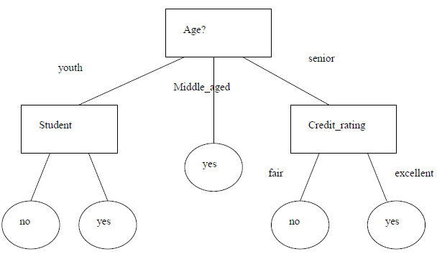

Converting Decision tree into a set of rules is as follows.
Rule1: If age = youth AND student=yes THEN buys_computer=yes
Rule2: If age = youth AND student=no THEN buys_computer=no
Rule3: If age = middle_aged THEN buys_computer=yes
Rule4: If age = senior AND credit_rating=excellent THEN buys_computer=yes
Rule5: If age = senior AND credit_rating=fair THEN buys_computer=no

In Weka GUI Explorer, Select Classify Tab, In that Select Use Training set option .There also exist different classifiers that output the model in the form of Rules. Such classifiers in weka are “PART” and ”OneR” . Then go to Choose and select Rules in that select PART and press start Button.
== Evaluation on training set ===
=== Summary ===
Correctly Classified Instances 897 89.7 %
Incorrectly Classified Instances 103 10.3 %
== Confusion Matrix ===
a b <-- classified as
653 47 | a = good
56 244 | b = bad
Then go to Choose and select Rules in that select OneR and press start Button.
== Evaluation on training set ===
=== Summary ===
Correctly Classified Instances 742 74.2 %
Incorrectly Classified Instances 258 25.8 %
=== Confusion Matrix ===
a b <-- classified as
642 58 | a = good
200 100 | b = bad
Then go to Choose and select Trees in that select J48 and press start Button.
=== Evaluation on training set ===
=== Summary ===
Correctly Classified Instances 855 85.5 %
Incorrectly Classified Instances 145 14.5 %
=== Confusion Matrix ===
a b <-- classified as
669 31 | a = good
114 186 | b = bad
Note: With this observation we have seen the performance of classifier and Rank is as follows
1. PART
2. J48
- OneR

Inference:
Weka is a collection of machine learning algorithms for data mining tasks. The algorithms can either be applied directly to a dataset or called from your own Java code. Weka contains tools for data pre-processing, classification, regression, clustering, association rules, and visualization. It is also well-suited for developing new machine learning schemes.
Weka is a complete set of tools that allow you to extract useful information from large databases. This process is commonly called as data mining. You can work with filters, clusters, classify data, perform regressions, make associations, etc.
Weka includes two executable options: command line or graphical user interface (GUI). The command line interface allows you to execute more functions and uses less memory than the GUI. But the GUI is simpler. The GUI's main menu "Weka GUI Chooser", includes access to the four Weka's main applications: Explorer, Experimenter, KnowledgeFlow and SimpleCLI, but also includes useful features to capture all the worked-out information; view ARFF files in spread-sheet format; represent querying databases in SQL worksheets, and includes tools to work with Bayes nets. One very important aspect of Weka is that you can choose the way the information will be displayed: you can plot a dataset in 2D, plot a receiver operating characteristic (ROC), display direct graphs such as decision trees, visualize XML BIF and DOT format graphs, and visualize classifier decision boundaries in two dimensions.

