LECTURE NOTES
ON
INFORMATION RETRIVAL SYSTEM
III B-Tech I Semester(JNTUH-R13)



COMPUTER SCIENCE & ENGINEERING
CMR ENGINEERING COLLEGE
KANDLAKOYA (V), MEDCHAL (M), R.R.DIST.

Unit- I

1.Definition of Information Retrieval System :

An IR System is a system capable of storage, retrieval, and maintenance of information.

Information: text, image, audio, video, and other multimedia objects Focus on textual information here. An IR system facilitates a user in find the information the user needs.

• Item:

The smallest complete textual unit processed and manipulated by an IR system Depend on how a specific source treats information

• Success measure (Objectives of an IR System) : Minimize the overhead for finding information

• Overhead:

The time a user spends in all of the steps leading to reading an item containing needed information, excluding the time for actually reading the relevant data
- Query generation
- Search composition
- Search execution
- Scanning results of query to select items to read

An Information Retrieval System consists of a software program that facilitates a user in finding the information the user needs. The system may use standard computer hardware or specialized hardware to support the search sub function and to convert non-textual sources to a searchable media (e.g., transcription of audio to text).
2.Objectives of Information Retrieval Systems

The general objective of an IR system is ,

- To minimize the overhead of a user locating needed information

- The two major measures commonly associated with information systems are “precision”and “recall”

- Support of user search generation

- How to present the search results in a format that facilitate the user in determining relevant items

The two major measures commonly associated with information systems are precision and recall. When a user decides to issue a search looking for information on a topic, the total database is logically divided into four segments shown in Figure 1.1. Relevant items are those documents that contain information that helps the searcher in answering his question. Non-relevant items are those

items that do not provide any directly useful information. There are two possibilities with respect to each item: it can be retrieved or not retrieved by the user’s query. Precision and recall are defined as:

Figure 1.1 Effects of Search on Total Document Space
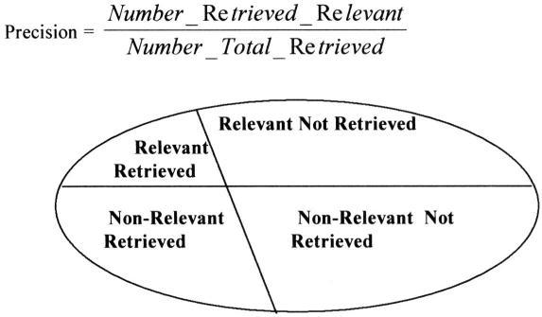

Figure 1.1 Effects of Search on Total Document Space
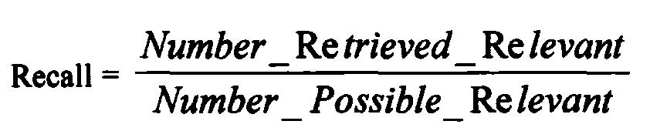

Where Number_Possible_Relevant are the number of relevant items in the database. Number_Total_Retieved is the total number of items retrieved from the query. Number_Retrieved_Relevant is the number of items retrieved that are relevant to the user’s search need.

Two More Objectives of IR Systems :

- Support of user search generation How to specify the information a user needs
- Language ambiguities – “field”

- Vocabulary corpus of a user and item authors Must assist users automatically and through interaction in developing a search specification that represents the need of users and the writing style of diverse authors

- How to present the search results in a format that facilitate the user in determining relevant items ,

A)Ranking in order of potential relevance B)Item clustering and link analysis.

3 Functional Overview :

A total Information Storage and Retrieval System is composed of four major functional processes:

- Item normalization,

- Selective dissemination of information (i.e., “mail”),

- Archival document database search, and

- An index database search along with the

- Automatic file build process that supports index files.

igure 1.4 Total Information Retrieval System

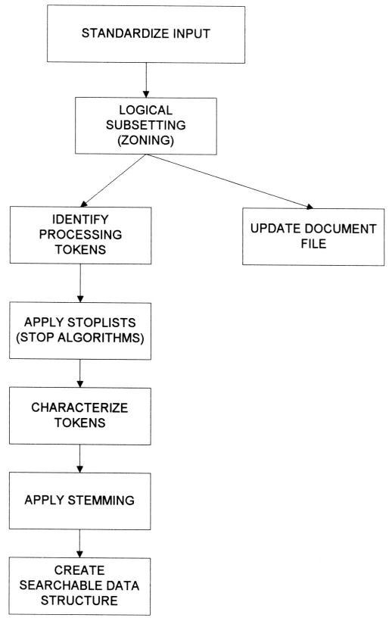

Figure 1.5 The Text Normalization Process

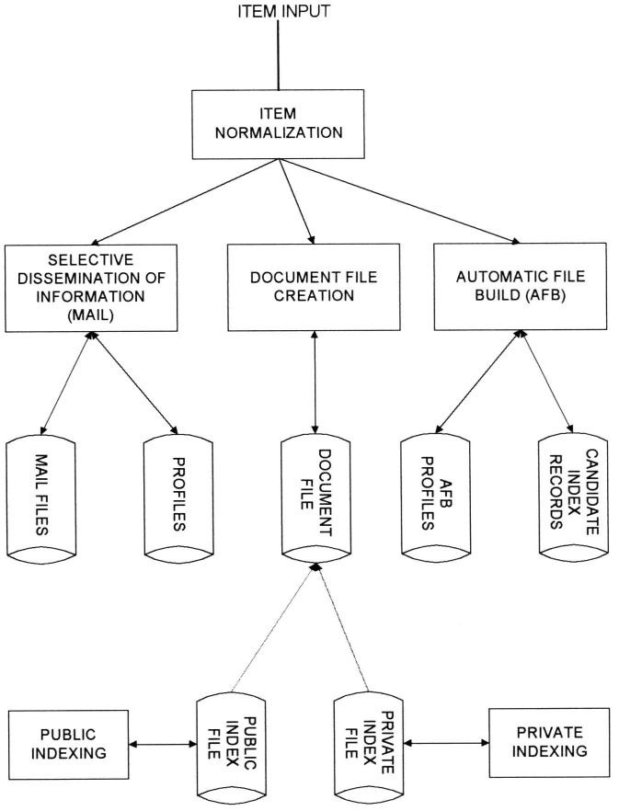

4. Item Normalization:

- Normalize incoming items to a standard format Language encoding

Different file formats…
- Logical restructuring – zoning
- Create a searchable data structure (Indexing)
Identification of processing tokens

Characterization of the tokens – single words, or phrase Stemming of the tokens

Standardize Input:

- Standardizing the input takes the different external format of input data and performs the translation to the formats acceptable to the system.

- Translate foreign language into Unicode Allow a single browser to display the languages and

potentially a single search system to search them
- Translate multi-media input into a standard format
Video: MPEG-2, MPEG-1, AVI, Real Video…
Audio: WAV, Real Audio
Image: GIF, JPEG, BMP…

Logical Subsetting (Zoning) :

- Parse the item into logical sub-divisions that have meaning to user Title, Author, Abstract, Main Text, Conclusion, References, Country, Keyword…

- Visible to the user and used to increase the precision of a search and optimize the display The zoning information is passed to the processing token identification operation to store the information, allowing searches to be restricted to a specific zone display the minimum data required from each item to allow determination of the possible relevance of that item (Display zones such as Title, Abstract…)

Identify Processing Tokens :

- Identify the information that are used in the search process – Processing Tokens (Better than Words)

- The first step is to determine a word
Dividing input symbols into three classes
- Valid word symbols: alphabetic characters,numbers
- Inter-word symbols: blanks, periods, semicolons (nonsearchable)
- Special processing symbols: hyphen (-)

A word is defined as a contiguous set of word symbols bounded by inter-word symbols.

Stop Algorithm:

- Save system resources by eliminating from the set of searchable processing tokens those have little value to the search Whose frequency and/or semantic use make them of no use as searchable token

- Any word found in almost every item
- Any word only found once or twice in the database
Frequency * Rank = Constant
Stop algorithm v.s.

Characterize Tokens :

• Identify any specific word characteristics Word sense disambiguation Part of speech tagging

Uppercase – proper names, acronyms, and organization Numbers and dates

Stemming Algorithm :

- Normalize the token to a standard semantic representation Computer, Compute, Computers, Computing

  - Comput
- Reduce the number of unique words the system has to contain

ex: “computable”, “computation”, “computability”

• small database saves 32 percent of storages
• larger database : 1.6 MB 20 % 50 MB 13.5%

- Improve the efficiency of the IR System and to improve recall -> Decline precision

Create Searchable Data Structure:

- Processing tokens -> Stemming Algorithm -> update to the Searchable data structure

- Internal representation (not visible to user) Signature file, Inverted list, PAT Tree…

- Contains

Semantic concepts represent the items in database
Limit what a user can find as a result of the search

Functional Overview – Selective Dissemination of Information :

  - Provides the capability to dynamically compare newly received items in the information system against standing statements of interest of users and deliver the item to those users whose statement of interest matches the contents of the items

  - Consist of ,

Search process
User statements of interest (Profile)

User mail file

- A profile contains a typically broad search statement along with a list of user mail files that will receive the document if the search statement in the profile is satisfied As each item is received, it is processed against every user’s profile When the search statement is satisfied, the item is placed in the mail file(s) associated with the process User search profiles are different than ad hoc queries in that they contain significant more search terms and cover a wider range of interests .

Document Database Search :

  - Provides the capability for a query to search against all items received by the system

Composed of the search process, user entered queries and document database.

  - Document database contains all items that have been received, processed and store by the system. Usually items in the Document DB do not change May be partitioned by time and allow for archiving by the Time partitions.

  - Queries differ from profiles in that they are typically short and focused on a specific area of interest .

Index Database Search:

  - When an item is determined to be of interest, a user may want to save it (file it) for future reference Accomplished via the index process.

  - In the index process, the user can logically store an item in a file along with additional index terms and descriptive text the user wants to associate with the item. An index can reference the original item, or contain substantive information on the original item Similar to card catalog in a library.

  - The Index Database Search Process provides the capability to create indexes and search them

  - The user may search the index and retrieve the index and/or the document it references

  - The system also provides the capability to search the index and then search the items referenced by the index records that satisfied the index portion of the query Combined file search

  - In an ideal system the index record could reference portions of items versus the total item

  - Two classes of index files: public and private index files Every user can have one or more private index files leading to a very large number of files, and each private index file references only a small subset of the total number of items in the Document database Public index files are maintained by professional library services personnel and typically index every item in the Document database

  - The capability to create private and public index files is frequently implemented via a structured Database Management System (RDBMS)

  - To assist the users in generating indexes, the system provides a process called Automatic File Build (Information Extraction)
Process selected incoming documents and automatically determines
potential indexing for the item
• Authors, date of publication, source, and references

The rules that govern which documents are processed for extraction of index information and the index term extraction process are stored in Automatic File Build Profiles. When an item is processed it results in creation of Candidate Index Records -> for review and edit by a user

Prior to actual update of an index file.

5. Relationship to Database Management Systems :

There are two major categories of systems available to process items:
Information Retrieval Systems and Data Base Management Systems (DBMS).

- An Information Retrieval System is software that has the features and functions required to

manipulate “information” items versus a DBMS that is optimized to handle “structured” data.

- Structured data is well defined data (facts) typically represented by tables. There is a semantic description associated with each attribute within a table that well defines that attribute. For example, there is no confusion between the meaning of “employee name” or “employee salary” and what values to enter in a specific database record. On the other hand, if two different people generate an

abstract for the same item, they can be different. One abstract may generally discuss the most important topic in an item. Another abstract, using a different vocabulary, may specify the details of many topics. It is this diversity and ambiguity of language.

- With structured data a user enters a specific request and the results returned provide the user with the desired information. The results are frequently tabulated and presented in a report format for ease of use. In contrast, a search of “information” items has a high probability of not finding all the items a user is looking for. The user has to refine his search to locate additional items of interest. This process is called “iterative search.

4.From a practical standpoint, the integration of DBMS’s and Information Retrieval Systems is very important. Commercial database companies have already integrated the two types of systems. One of the first commercial databases to integrate the two systems into a single view is the INQUIRE DBMS.

6. Digital Libraries and Data Warehouses :

Two other systems frequently described in the context of information retrieval are,

o Digital Libraries and
  - Data Warehouses (or Data Marts).

- There is a significant overlap between these two systems and an Information Storage and

Retrieval System. All three systems are repositories of information and their
primary goal is to “satisfy user information needs”

- As such, libraries have always been concerned with storing and retrieving information in the media it is created on. As the quantities of information grew exponentially, libraries were forced to make maximum use of electronic tools to facilitate the storage and retrieval process. With the worldwide interneting of libraries and information sources (e.g., publishers, news agencies, wire services,

radio broadcasts) via the Internet, more focus has been on the concept of an electronic library.

  - Indexing is one of the critical disciplines in library science and significant effort has gone into the establishment of indexing and cataloging standards. Migration of many of the library products to a digital format introduces both opportunities and challenges. The full text of items available for search makes the index process.

  - Another important library service is a source of search intermediaries to assist users in finding

information.

  - Information Storage and Retrieval technology has addressed a small subset of the issues associated with Digital Libraries. The focus has been on the search and retrieval of textual data with no concern for establishing standards on the contents of the system.

- Information Retrieval Systems Capabilities :

The capabilities in the information retrieval systems are,

- Querying

- Browsing

- Miscellaneous capabilities

Querying:

Communicate a description of the needed information to the system.

Main paradigms:
- Query term sets

- Query terms connected with Boolean operations

- Weighted terms

- Relaxation or restriction of term matching

- Term expansion

- Natural language

Query Term Sets :

Describe the information needed by specifying a set of query terms.
- System retrieves all documents that contain at least one

- of the query terms.

- Documents are ranked by the number of terms they

- include :
o documents

o documents containing all query terms but one appear second; o documents containing only one query term appear last.

Boolean Queries :

Describe the information needed by relating multiple terms with Boolean operators.
o Operators : AND, OR, NOT (sometimes XOR).

o Corresponding set operations : intersection, union, difference. Operate on the sets of documents that contain the query terms.

- Precedence : NOT, AND, OR; use parentheses to override; process left-to-right among operators with same precedence.

o M-form-N: Find any document containing N of the terms T1,…,TM. May be expressed as a Boolean query
o Weighting : A weight is associated with each term.

Example: This example uses standard operator precedence (Note: the combination AND NOT is usually abbreviated NOT)
COMPUTER OR SEVER AND NOT MAINFRAME

Select all documents that discuss computers, or documents that discuss servers that do not discuss mainframes.

OR SERVER) AND NOT MAINFRAME

Select all documents that discuss computers or servers, do not select any documents that discuss mainframes.
COMPUTER AND NOT (SERVER OR MAINFRAME)

Select all documents that discuss computers, and do not discuss either servers or mainframes.

Proximity Constraints :

Restrict the distance within a documents between two search terms.

- Proximity specifications limit the acceptable occurrences and hence increase the precision of the search.

- Important for large documents.

- General Format: TERM1 within m units of TERM2

- UNIT may be character, word, paragraph, etc.

- Direction operator: specify which term should appear first.

- Adjacent Example:
VENETIAN ADJ BLIND
Find documents that discuss “Venetian Blinds” but not “Blind Venetians”.
UNITED WITHIN 5 WORDS OF AMERICAN

Find documents that discuss “United Airlines and American Airlines” but not “United States of America and the American dream”.
NUCLEAR WITHIN 0 PARAGRAPHS OF CLEANUP.
Find documents that discuss “nuclear” and “cleanup” in the same paragraph.

Contiguous Word Phrase Matches :

Treat a sequence of N words as a single semantic unit.

Example: “United States of America”.

N-ary (not Boolean) operator.
Cannot be expressed as Boolean query.

(or the proximity operator with m = 1 in forward direction).

ng.

Fuzzy (Approximate) matching :

Match terms that are similar to the query term.

- Fuzzy matching compensates for spelling errors, especially when documents were scanned-in and then subjected to optical character recognition (OCR).

- Increased recall (more documents qualify because new terms may be matched) at the expense of deceased precision (erroneous matches may introduce nonrelevant documents).

Example: COMPUTER may match COMPITER, CONPUTER, etc.

o Usually, should not match if the closely-spelled word is legitimate in itself (e.g., COMMUTER. This would help maintain precision.

- Rules needed to indicate allowed differences (e.g., one character replacement, or one transposition of adjacent characters).

- Similar method may be used to overcome phonetic spelling errors.Should be distinguished from fuzzy set theory solutions.

Term masking:

Match terms that contain the query term.

- Single position mask: accept any term that will match the query term, once the character in a certain position is disregarded.

  - Example: the term MULTI$NATIONAL will be matched by “multi-national” or “multinational” (but not by “multi national” since it is a sequence of two terms! )

- Variable length mask: accept any term that will match the query term, once a sequence of any number of characters in a certain position is disregarded.

    - Suffix: *WARE will match terms that end with “ware”.

    - Prefix: WARE* will match terms that begin with “ware”. The most common mask ( sometimesapplied by default).

    - Imbedded: *WARE* will match terms that contain “ware

Number and data Ranges :

Match numeric or date terms that are in the range of the query term.

- Numeric query terms: >125 (matches all numbers greater that 125) or 125-425 (matched all numbers between 125 and 425).

- Date query terms: 9/1/97 - 8/31/98 ( matches all dates between 1 September 1997 and 31 August 1998).

- In a way, term-masking handles “string ranges”.

Term Expansion :

Expand/restrict the query terms via thesauri or concept hierarchies/networks.
- Concept hierarchy: A hierarchy(tree) of concepts.

  - Replacing a query term(e.g. BOOK) by an ancestor(more general) term (e.g.,PUBLICATION) increases recall and decreases precision.

  - Replacing a query term by a descendant ( more specific)term (e.g. PAPERBACK)decreases recall and increase precision.

- Concept network: Terms are related by associations.

  - Often,associations are specific to the database(the context).

  - Example:CONCERT is generalized by PERFORMANCE and associated with TICKET

- Semantic thesaurus:Groups together terms that are similar in meaning (a single level concept hierarchy). A query term is matched by every term in its thesaurus group.

– Must avoid expanding with “synonyms” that change the meaning.Like (in the sense of “akin”) might be expanded with “prefer”.

– Expansion may introduce terms not found in the document database.
– Thesauri and concept networks should be expandable by users.

- Statistical thesaurus:Groups together terms that are statistically related(occur together in the same documents).

– Terms in a class may have no shared meaning.
– Specific to a given document database.
– Must be updated when the document database is updated.

Natural Language :

Describe the information needed in natural language prose.

– Example: Find all the documents that discuss oil reserves and current attempts to find oil reserves. Include any documents that discuss the international financial aspects of the old production process. Do not include documents about the oil industry in the United States.

– Pseudo NL processing: System scans the prose and extracts recognized terms and Boolean connectors. The grammaticality of the text is not important.

– Problem: Recognize the negation in the search statement(“Do not include…”)
– Compromise: Use enter natural language sentences connected with Boolean operators.

- Explain the Browsing capabilities

Determine the retrieved documents that are of interest

- The query phase ends, and the browse phase begins, with a summary display of the result. Summary displays use either

  - Line item status
  - Data visualization

- Powerful browsing capabilities are particularly important when precision is low.

Item summary

o Typically,each retrieved document is displayed in one status line, and as many documents are displayed as can fit in the screen.

o The status line may contain the relevance factor (if computed), the title,and possibly some other zones.

o Documents may be displayed in more than one line (less documents per screen).

Summary order

o Boolean systems: All retrieved documents equally meet the query criteria. Documents are displayed in arbitrary,or in sorted order(alphabetically by title or chronologically by date).
o Relevance: In systems that compute relevance, retrieved documents

are sorted by relevance. Usually relevance is normalized to a range 0-1 .0-100. A threshold value defines the documents that are not relevant.
- Explain the Miscellaneous Capabilities

Vocabulary browse

Users enter a term and are positioned in an alphabetically-sorted list of all the terms that appear in the database.

With each term the number of documents in which it appears is shown.

Assists users who are not familiar with the vocabulary.

Help users determine the impact of using individual terms

Iterative search(query refinement)

The result of a previous search is subjected to a new query

Same as repeating the previous query with additional conditions.

Relevance feedback

The old query is replaced by a new query

The new query is a transformation of the old query, reflecting feedback about the relevance of the documents retrieved by the first query

Canned(stored) queries Users tend to reuse previous queries Allows users to store previously-used queries and incorporate Canned queries tend to be large.

10. what is Automatic Indexing and explain different types of indexing techniques .
Overview
• Automatic indexing is the capability to automatically determine the index terms to be assigned to an item
➢ Simplest case: total document indexing
➢ Complex: emulate a human indexer and determine a limited number of index terms for the major concepts in the item
• Human indexing VS Automatic indexing
➢ Adv: ability to determine concept abstraction and judge the value of a concept
➢ Disadv: cost, processing time, and consistency
➢ Processing time of an item by a human indexer varies significantly based upon the indexer’s knowledge of the concepts being indexed, the exhaustivity and specificity guidelines and the amount and accuracy of preprocessing via Automatic File Build. Usually take at least five minutes per item.
• Automatic indexing requires only a few seconds or less of computer time based upon the size of the processor and the complexity of the algorithms to generate the index.
• If the indexing is being performed automatically, by an algorithm, there is consistency in the index term selection process.
• Automatic indexing: weighted and un-weighted;

Indexing by term and indexing by concept
Un-weighted Automatic Indexing:
• The existence of an index term in a document and sometimes its word location(s) are kept as part of the searchable data structure
• No attempt is made to discriminate between the value of the index terms in representing concepts in the item
➢ Not possible to tell the difference between the main topics in the item and a casual reference to a concept
➢ Query against unweighted systems are based on Boolean logic and the items in the resultant Hit file are considered equal in value

Weighted Automatic Indexing :
• An attempt is made to place a value on the index term’s representation of its associated concept in the document
• An index term’s weight is based on a function associated with the frequency of occurrence of the term in the item.
• Luhn postulated that the significance of a concept in an item is directly proportional to the frequency of use of the word associated with the concept in the document
➢ Values for the index terms are normalized between zero and one

- Information Extraction & Summarization

There are two processes associated with information extraction:
Determination of facts to go into structured fields in a database
➢ In this case only a subset of the important facts in an item may be identified and extracted.

Extraction of text that can be used to summarize an item.
➢ In summarization all of the major concepts in the item should be represented in the summary.

The process of extracting facts to go into indexes is called Automatic File Build. Its goal is to process incoming items and extract index terms that will go into a structured database.
This differs from indexing in that its objective is to extract specific types of information versus understanding all of the text of the document.
An Information Retrieval System’s goal is to provide an indepth representation of the total contents of an item
Information Extraction system only analyzes those portions of a document that potentially contain information relevant to the extraction criteria
The objective of the data extraction is in most cases to update a structured database with additional facts. The updates may be from a controlled vocabulary or substrings from the item as defined by the extraction rules.
The term “slot” is used to define a particular category of information to be extracted.
Slots are organized into templates or semantic frames.
Information extraction requires multiple levels of analysis of the text of an item. It must understand the words and their context (discourse analysis).
Recall refers to how much information was extracted from an item versus how much should have been extracted from the item. It shows the amount of correct and relevant data extracted versus the correct and relevant data in the item.
Precision refers to how much in formation was extracted accurately versus the total information extracted.
- Metrics used are over generation and fallout.
Over generation measures the amount of irrelevant information that is extracted.
This could be caused by templates filled on topics that are not intended to be extracted or slots that get filled with non-relevant data.
Fallout measures how much a system assigns incorrect slot fillers as the number of potential incorrect slot fillers increases.
The goal of document summarization is to extract a summary of an item maintaining the most important ideas while significantly reducing the size.
Examples of summaries that are often part of any item are titles, table of contents, and abstracts with the abstract being the closest
The abstract can be used to represent the item for search purposes or as a way for a user to determine the utility of an item without having to read the complete item.
It is not feasible to automatically generate a coherent narrative summary of an item with proper discourse, abstraction and language usage
Restricting the domain of the item can significantly improve the quality of the Output
The more restricted goals for much of the research is in finding subsets of the item that can be extracted and concatenated (usually extracting at the sentence level) and represents the most important concepts in the item
There is no guarantee of readability as a narrative abstract and it is seldom achieved.
Different algorithms produce different summaries. Just as different humans create different abstracts for the same item, automated techniques that generate different summaries does not intrinsically imply major deficiencies between the summaries.
Most automated algorithms approach summarization by calculating a score for each sentence and then extracting the sentences with the highest scores
Kupiec et al. are pursuing statistical classification approach based upon a training set reducing the heuristics by focusing on a weighted combination of criteria to produce “optimal” scoring scheme (
They selected the following five feature sets as a basis for their algorithm:
- Sentence Length Feature that requires sentence to be over five words in length
- Fixed Phrase Feature that looks for the existence of phrase “cues” (e.g.,“in conclusion)
- Paragraph Feature that places emphasis on the first ten and last five paragraphs in an item and also the location of the sentences within the paragraph
- Thematic Word Feature that uses word frequency
- Uppercase Word Feature that places emphasis on proper names and acronyms.

12. Simple term frequency Algorithm

Simple term frequency Algorithm
•The term frequency tft,d of term t in document d is defined as the number of times that t occurs in d.
•The weight is equal to the term frequency
–TF (Term Frequency) : Frequency of Occurrence of PT in an existing item
–TOTF (Total Term Frequency ) : Frequency of Occurrence of PT in an existing database
–IF /DF (Item / Document Frequency ) : No. of Unique items in the database that contain the processing token
•Emphasize the use of particular PT within an item
•“computer” occurs 15 times within an item ➔ a weight of 15
•Problems: normalization between items and use of the PT within the database
•The longer an item is, the more often a PT may occur within the item
•Use of absolute value biases weights toward longer items.
•Hence Normalization is done
•Ex
(1+log(TF)/1+log(average(TF))
----------------------------------------------------------------
(1-slope)*pivot + slope * no. of unique terms
Pivot : avg no. of unique terms occurring in the collection

Maximum Term Frequency
•In the first technique, the term frequency for each word is divided by the maximum frequency of the word in any item. This normalizes the term frequency values to a value between zero and one.
•problem : the maximum term frequency can be so large that it decreases the value of term frequency in short items to too small a value and loses significance.

Logaritmetic Term Frequency
•In this technique the log of the term frequency plus a constant is used to replace the term frequency. The log function will perform the normalization when the term frequencies vary significantly due to size of documents.

COSINE function
•COSINE function used as a similarity measure can be used to normalize values in a document.
•This is accomplished by treating the index of a document as a vector and divide the weights of all terms by the length of the vector. This will normalize to a vector of maximum length one.
•This uses all of the data in a particular item to perform the normalization and will not be distorted by any particular term.

The problem occurs when there are multiple topics within an item. The COSINE technique will normalize all values based upon the total length of the vector that represents all of topics.
•If a particular topic is important but briefly discussed, its normalized value could significantly reduce its overall importance in comparison to another document that only discusses the topic.
penalizing long documents
•Singhal did experiments that showed longer documents in general are more likely to be relevant to topics then short documents.
• normalization was making all documents appear to be the same length.
•To compensate, a correction factor was defined that is based upon document length that maps the Cosine function into an adjusted normalization function.
•The function determines the document length crossover point for longer

documents where the probability of relevance equals the probability of retrieval, (given a query set).
•This value called the "pivot point" is used to apply an adjustment to the normalization process.

The theory is based upon straight lines so it is a matter of determining slope of the lines.
New normalization = (slope)*(old normalization)+k
- K is generated by the rotation of the pivot point to generate the new line
and the old normalization = the new normalization at that point.
- Substituting pivot for both old and new value in the above formula we can
solve for K at that point.
•Then using the resulting formula for K and substituting in the above formula produces the following formula:

New normalization = (slope)*(old normalization)+(1.0-slope)*(pivot)
Slope and pivot are constants for any document/query set.
•problem: Cosine function favors short documents over long documents and also favors documents with a large number of terms.
•In documents with large number of terms the Cosine factor is approximated by the square root of the number of terms.
•This suggests that using the ratio of the logs of term frequencies would work best for longer items in the calculations:
- Explain the The Porter stemming algorithm
• The Porter algorithm consists of a set of condition/action rules.
• The condition fall into three classes
➢ Conditions on the stem
➢ Conditions on the suffix
➢ Conditions on rules

Conditions on the stem :
1. The measure , denoted m ,of a stem is based on its alternate vowel-consonant sequences.

[C] (VC) m [V]
Measure Example
M=0 TR, EE, TREE, Y, BY
M=1 TROUBLE, OATS, TREES, IVY
M=2 TROUBLES, PRIVATE, OATEN
2.*<X> ---the stem ends with a given letter X
3.*v*---the stem contains a vowel
7 4.*d ---the stem ends in double consonant
5.*o ---the stem ends with a consonant-vowel-consonant, sequence, where the final
consonant is not w, x or y
Suffix conditions take the form:
(current_suffix == pattern)
Conditions on rules :
The rules are divided into steps. The rules in a step are examined in sequence , and only
one rule from a step can apply
{
step1a(word);
step1b(stem);
if (the second or third rule of step 1b was used)
step1b1(stem);
step1c(stem);

c. 6.2.1
www.jntuworld.com
www.
step2(stem);
step3(stem);
step4(stem);
step5a(stem);
step5b(stem);
}
13 Table / Dictionary Look up and Successor Stemmer:
15
• Store a table of all index terms and their stems.
• The original term or stemmed version of the term is looked up in a dictionary and

Replaced by the stem that best represents it.
• Implemented in INQUERY, Retrieval Ware systems
• Stem a table look up algorithm implemented in INQUERY uses the following six data

Files
➢ Dictionary of words (lexicon)
➢ Supplemental list of words for the dictionary
➢ Exceptions list for those words that should retain an “e” at the end
o (e.g., “suites” to “suite” but “suited” to “suit”)
➢ Direct_Conflation - allows definition of direct conflation via
o word pairs that override the stemming algorithm
➢ Country_Nationality - conflations between nationalities and
o countries (“British” maps to “Britain”)
➢ Proper Nouns - a list of proper nouns that should not be stemmed.

Successor Stemmer :
• Successor Stemmer based on the length of prefixes that optionally stem expansions of additional suffixes
• The alg investigates word and morpheme boundaries based on the distribution of phonemes that distinguishes one word form other
• The process determines the successor variety for a word, uses this information to divide a word into segments and selects one of the segment as stem
• The successor variety of a segment of a word in a set of words is the no. of distinct letters that occupy the segment length plus one character

Ex : The successor variety for the first 3 letters of a 5 letter word is the no. of
words that have the same first 3 letters but a different 4th letter plus one
• The successor variety of any prefix of a word is the no. of children associate with the node in the symbol tree representing that prefix
Successor variety for the first letter “b” is three. The successor variety for the prefix “ba” is two.
Affix Removal Stemmers:
• Affix removal algorithms remove suffixes and/or prefixes from terms leaving a stem
• If a word ends in “ies” but not ”eies” or ”aies ” (Harman 1991)

Then “ies” -> “y”
• If a word ends in “es” but not ”aes” , or ”ees ” or “oes”

Then “es” -> “e”
• If a word ends in “s” but not ”us” or ”ss ”

Then “s” -> “NULL”
Related Data Structures for PT Searchable Files:
• Inverted file system
➢ Minimize secondary storage access when multiple search terms are applied across the total database
• N-gram
➢ Break process tokens into smaller string units and uses the token fragment for search
➢ Improve efficiencies and conceptual manipulation over full word inversion
• PAT Trees and Arrays
➢ View the text of an item as a single long stream versus a juxtaposition of words
• Signature file
➢ Fast elimination of non-relevant items reducing the searchable items into a

manageable subset
• Hypertext
➢ Manually or automatically create imbedded links within one item to a related item

- Inverted File Structure:

• Commonly used in DBMS and IR
• For each word, a list of documents in which the word is found in is stored
• Composed of three basic files
➢ Document files
➢ Inversion lists: contains the document identifier
➢ Dictionary: list all the unique word or other information used in query optimization (e.q. length of inversion lists)
• The inversion list contains Doc-id for each DOC in which the word is found.
• To support proximity, continuous word phrase & term weighting all occurrences of a word are stored in the inversion list along with the word position.
• For Systems that supports ranking, the list is re-organized into rank order.

Complete data structures material

➢ The higher the weight, the more the term represents a concept discussed in the item

• The query process uses the weights along with any weights assigned to terms in the query to determine a rank value used in predicting the likelihood that an item satisfies the query
➢ Thresholds or a parameter specifying the maximum number of items to be returned are used to bound the number of items returned to a user.

- Indexing by Term:
• The terms of the original item are used as a basis of the index process
• Two major techniques: statistical and natural language
• Statistical techniques
➢ Calculation of weights use statistic information such as the frequency of occurrence of words and their distributions in the searchable DB
➢ Vector models and probabilistic models
• Natural language processing
➢ Process items at the morphological, lexical, semantic, syntax, and discourse levels
➢ Each level uses information from the previous level to perform it additional analysis
➢ Events, and event relationships

Indexing by Concept:
• The basis for concept indexing is that there are many ways to express the same ideas and increased retrieval performance comes from using a single representation
• Indexing by term treats each of these occurrences as a different index and then uses thesauri or other query expansion techniques to expand a query to find the different ways the same thing has been represented
• Concept indexing determines a canonical set of concepts based on a test set of terms and uses them as a basis for indexing all items

- Inverse Document Frquency Idf
• dft is the document frequency of t: the number of documents that contain t
– dft is an inverse measure of the informativeness of t
– dft  N
• We define the idf (inverse document frequency) of t by

– We use log (N/dft) instead of N/dft to “dampen” the effect of idf.
) /df ( log idf 10 t t N 
Will turn out the base of the log is immaterial. Se

The weight equal to the frequency of occurrence of the processing token in the database
•WEIGHTij=Tfij*[Log2(n)-Log2(IFj)+1]

–WEIGHTij : assigned to term “j”in item “i”
–TFij : frequency of term “j” in item “i”
–IFij : number of items in the database that have term “j” in them
–n : number of items in the database

17.Signal Weighting
• IDF does not account the term frequency distribution of the PT in the items that contain the term
• The distribution of the frequency of processing tokens within an item can affect the ability to rank items
Item Distribution SAW DRILL A 10 2 B 10 2 C 10 18 D 10 10 E 10 1

An instance of an event that occurs all the time has less information value than an instance of a seldom occurring event

If there are many independent occurring event
–Maximum when the value for every pk is the same
–pk can be defined as TFik/TOTFk

- Problems with Weighting Schemes
•The two weighting schemes, IDF and signal, use total frequency and item frequency factors which makes them dependent on distributions of PTs within the DB
–These factors are changing dynamically
•Approaches to compensate for changing values
–Ignore the variances and calculates weights based on current values, with the factors changing over time. Periodically rebuild the complete search database
–Use a fixed value while monitoring changes in the factors. When the changes reach a certain threshold, start using the new value and update all existing vectors with the new value
–Store the invariant values (e.g. TF) and at search time calculate the latest weights for PTs in items need

Side effect of maintaining currency in the DB for term weights
–The same query over time returns a different ordering of items
–A new word in the DB undergoes significant changes in its weight structure from initial introduction until its frequency in the DB reaches a level where small changes do not have significant impact on changes in weight values

A major problem comes in the vector model when there are multiple topics being discussed in a particular item
–Assume an item has an in-depth discussion of “oil” in “Mexico” and also “coal” in “Pennsylvania”
•This item results in a high value in a search for “coal in Mexico”
•Cannot handle “proximity searching”

- Explain The Procedure Of Clustering :
➢ Clustering: provide a grouping of similar objects into a class under a more general title
➢ Clustering also allows linkage between clusters to be specified
➢ An information database can be viewed as being composed of a number of independent items indexed by a series of index terms

 Term clustering :

➢ Used to create a statistical thesaurus
➢ Increase recall by expanding searches with related terms (query expansion)

 Document clustering :

➢ Used to create document clusters
➢ The search can retrieve items similar to an item of interest, even if the query would not have retrieved the item (resultant set expansion)
➢ Result-set clustering
Process of Clustering :
 Define the domain for clustering

– Thesaurus: “medical terms”
– Documents: set of items to be clustered
– Identify those objects to be used in the clustering process and reduce the potential for erroneous data that could induce errors in the clustering process
 Determine the attributes of the objects to be clustered

– Thesaurus: determine the specific words in the objects to be used
– Documents: may focus on specific zone within the items that are to be used to determine similarity
– Reduce erroneous association
 Determine the relationships between the attributes whose co-occurrence in objects suggest those objects should be in the same class

– Thesaurus: determine which words are synonyms and the strength of their relationships
– Documents: define a similarity function based on word co-occurrences that determine the similarity between two items
• Apply some algorithm to determine the class(es) to which each object will be assigned

Guidelines on the Characteristics of the Classes :
• A well-defined semantic definition should exist for each class
– There is a risk that the name assigned to the semantic definition of the class could also be misleading
• The size of the classes should be within the same order of magnitude
• Within a class, one object should not dominate the class
• Whether an object can be assigned to multiple classes or just one must be decided at creation time

Additional Decisions for Thesaurus:
• Word coordination approach: specify if phrases as well as individual terms are to be clustered
• Word relationships
– Equivalence, hierarchical, non-hierarchical
– Parts-Wholes, Collocation, Paradigmatic, Taxonomy and Synonym, and Antonym
– Contrasted words, child-of, parent-of, is-part-of, has-part
• Homograph resolution
• Vocabulary constraints
– Normalization: constrain the thesaurus to stems vs. complete words
– Specificity: eliminate specific words or use general terms for class identifiers

Thesaurus Generation:
• Automatically generated thesauri contain classes that reflect the use of words in the corpus
• The classes do not naturally have a name, but are just a groups of statistically similar terms
• Basic idea for term clustering: the more frequently two terms co-occur in the same items, the more likely they are about the same concept
• Term-clustering algorithms differ by the completeness with which terms are correlated
– The more complete the correlation, the higher the time and computational overhead to create the clusters

- Complete Term Relation Method:
• The similarity between every term pair is calculated as a basis for determining the clusters
• Using the vector model for clustering

similarity measure is required to calculate the similarity between to terms

Term-Term Matrix Threshold = 10

The final step in creating clusters is to determine when two objects (words) are in the same cluster
– Cliques, single link, stars, and connected components
Cliques : Cliques require all terms in a cluster to be within the threshold of all other terms
– Class 1 (Term 1, Term 3, Term 4, Term 6)
– Class 2 (Term 1, Term 5)
– Class 3 (Term2, Term 4, Term 6)
– Class 4 (Term 2, Term 6, Term 8

Clique Algorithm:

Single Link :
• Any term that is similar to any term in the cluster an be added to the cluster
• It is impossible for a term to be in two different clusters

Star :
• Select a term and then places in the class all terms that are related to that term
• Terms not yet in classes are selected as new seeds until all terms are assigned to a class
• There are many different classes that can be created using the Star technique
• If we always choose as the starting point for a class the lowest numbered term not already

Class 1 (Term 1, Term 3, Term 4, Term 5, Term 6)
– Class 2 (Term 2, Term 4, Term 8, Term 6)
– Class 3 (Term 7)

String :
• Starts with a term and includes in the class one additional term that is similar to the term selected and not already in a class
• The new term is then used as the new node and the process is repeated until no new terms can be added because the term being analyzed does not have another term related to it or the terms related to it are already in the class
• A new class is started with any terms not currently in any existing class
• Using the guidelines to select the lowest number term similar to the current term and not to select any term already in an existing class produces the following classes

Class 1 (Term 1, Term 3, Term 4, Term 2, Term 6, Term 8)
– Class 2 (Term 5)
– Class 3 (Term 7 )

Network Diagram of Term Similarities

Comparison :
• Clique
– Produce classes that have the strongest relationships between all of the words in the class
– The class is more likely to be describing a particular concept
– Produce more classes than the other techniques
• Single link
– Partition the term into classes
– Produce the fewest number of classes and the weakest relationship between terms
– It is possible that two terms that have a similarity value of zero will be in the same class
– Classes will not be associated with a concept but cover diverse concepts
• The selection of the technique is also governed by the density of the term relationship

Term relationship matrix
• Sparse: toward single link
• Dense: toward clique
– Objects of the thesaurus
• Cliques provide the highest precision when the statistical thesaurus is used for query term expansion
• The single link algorithm maximize recall but can cause selection of many non-relevant items
• The single link algorithm has the least overhead in assignment of terms to classes: O(n2) comparisons

