UNIT - II
PRODUCTION FUNCTION

Introduction:
The production function expresses a functional relationship between physical inputs and physical outputs of a firm at any particular time period. The output is thus a function of inputs
Definition:
Samuelson defines the production function as "the technical relationship which reveals the maximum amount of output capable of being produced by each set of inputs". It is defined for a given state of technical knowledge.

Input-OutputRelationship or Production Function

The inputs for any product or service are land, labour, capital, organization and technology. In other words, the production here is the function here of these five variable inputs. Mathematically, this is expressed as
Q=F (L1, L2, C, O, T)

L1 =land
L2 =labour
C = capital
O = organization
T = technology

Where Q is the quantity of production, f explains the function, that is, the type of relation between inputs and outputs these inputs have been taken in conventional terms. In reality, materials also can be included in a set of inputs.

In a specific situation, some factors of production may be important and the relative importance of the factors depends upon the final product to be manufactured. For example, in the case of the software industry, land is not an input factor as significant as that in case of an agricultural product.

In the case of an agricultural product, increasing the other factors of production can increase the production; but beyond a point, increased output can be had only with increased use of agricultural land. Investment in land forms a significant portion of the total cost of production for output. With change in industry and the requirements, the production function also needs to be modified to suit to the situation.

Assumptions:
Production function has the following assumptions.
- The production function is related to a particular period of time.
- There is no change in technology.
- The producer is using the best techniques available.
- The factors of production are divisible.
- Production function can be fitted to a short run or to long run.

ProductionFunction with One Variable Inputs and Laws Of Returns

Assume that a firms production function consists of fixed quantities of all inputs (land, equipment, etc.) except labour which is a variable input when the firm expands output by employing more and more labour it alters the proportion between fixed and the variable inputs. The law can be stated as follows:

“When total output or production of a commodity is increased by adding units of a variable input while the quantities of other inputs are held constant, the increase in total production becomes after some point, smaller and smaller”.
Three stages of law:

The behaviors of the Output when the varying quantity of one factor is combines with a fixed quantity of the other can be divided in to three district stages. The three stages can be better understood by following the table.
Fixed factor | Variable factor (Labour) | Total product | Average Product | Marginal Product
1 | 1 | 100 | 100 | - | Stage I
1 | 2 | 220 | 120 | 120 | Stage I
1 | 3 | 270 | 90 | 50 | Stage I
1 | 4 | 300 | 75 | 30 | Stage II
1 | 5 | 320 | 64 | 20 | Stage II
1 | 6 | 330 | 55 | 10 | Stage II
1 | 7 | 330 | 47 | 0 | Stage III
1 | 8 | 320 | 40 | -10 | Stage III

Above table reveals that both average product and marginal product increase in the beginning and then decline of the two marginal products drops of faster than average product.
Total product is maximum when the farmer employs 6th worker, nothing is produced by the 7th worker and its marginal productivity is zero, whereas marginal product of 8th worker is ‘-10’, by just creating credits 8th worker not only fails to make a positive contribution but leads to a fall in the total output.

Production function with one variable input and the remaining fixed inputs is illustrated as below

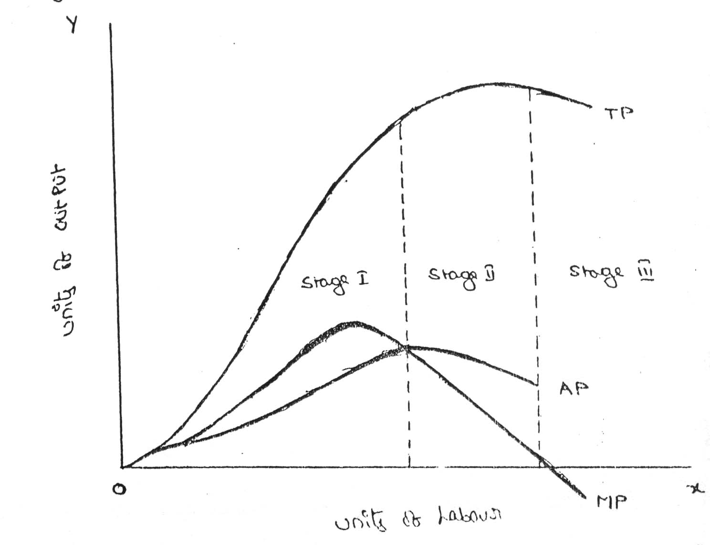

From the above graph the law of variable proportions operates in three stages. In the first stage, total product increases at an increasing rate. The marginal product in this stage increases at an increasing rate resulting in a greater increase in total product. The average product also increases. This stage continues up to the point where average product is equal to marginal product. The law of increasing returns is in operation at this stage.

The law of diminishing returns starts operating from the second stage awards. At the second stage total product increases only at a diminishing rate. The average product also declines. The second stage comes to an end where total product becomes maximum and marginal product becomes zero. The marginal product becomes negative in the third stage. So the total product also declines. The average product continues to decline

STAGES | TP | MP | AP
1 | Increase at an increasing rate | Increase reach  the maximum | Increase and reach  the maximum
2 | Increase atDiminishing rate Till it reaches Maximum | Diminish equal to zero | Starts Diminish
3 | Start declining | Because negative | Continues to decline

ProductionFunction with Two Variable Inputs and Laws of Returns

Let us consider a production process that requires two inputs, capital(c) and labour (L) to produce a given output (Q). There could be more than two inputs in a real life situation, but for a simple analysis, we restrict the number of inputs to two only. In other words, the production function based on two inputs can be expressed as:
Q=f(C,L)

Normally, both capital and labour are required to produce a product. To some extent, these two inputs can be substituted for each other. Hence the product may choose any combination of labour and capital that gives him the required number of units of output. For any given level of output, a producer may hire both capital and labour, but he is free to choose any one combination of labour and capital out of several such combinations. The alternative combinations of labour and capital yielding a given level of output are such that if the use of one factor input is increased, that of another will decrease and vice versa.

ISOQUANTS:

The term Isoquants is derived from the words ‘iso’ and ‘quant’ – ‘Iso’ means equal and ‘quent’ implies quantity. Isoquant therefore, means equal quantity. A family of iso-product curves or isoquants or production difference curves can represent a production function with two variable inputs, which are substitutable for one another within limits.
Isoquants are the curves, which represent the different combinations of inputs producing a particular quantity of output. Any combination on the isoquant represents the some level of output.
Q= f (L, K)
Where ‘Q’, the units of output is a function of the quantity of two inputs ‘L’ and ‘K’.
Thus an isoquant shows all possible combinations of two inputs, which are capable of producing equal or a given level of output. Since each combination yields same output, the producer becomes indifferent towards these combinations.

Combinations | Labour (units) | Capital (Units) | Output (quintals)
A | 1 | 10 | 50
B | 2 | 7 | 50
C | 3 | 4 | 50
D | 4 | 4 | 50
E | 5 | 1 | 50
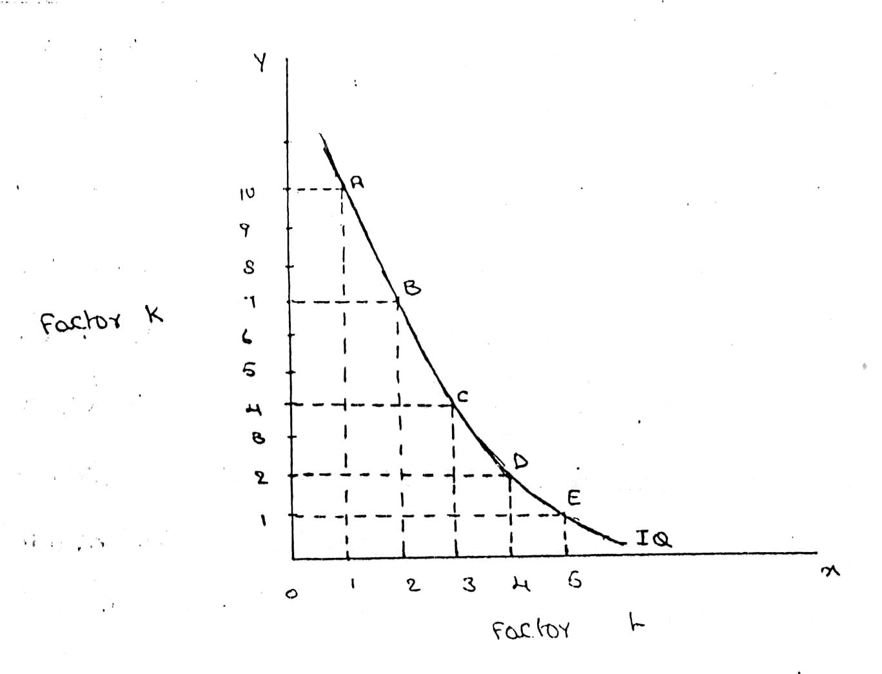

FEATURES OF AN ISOQUANT

(1).DOWNWARD SLOPING:-Isoquants are downward sloping curves because, if one input increases, the other one reduces. There is no question of increase in both the inputs to yield a given output.
A degree of substitution is assumed between the factors of production. In other words, an isoquant cannot be increasing, as increase in both the inputs does not yield same level of output. If it is constant, it means that the output remains constant though the use of one of the factors is increasing, which is not true, isoquants slope from left to right.

(2).CONVEX TO ORIGIN:-Isoquants are convex to the origin. It is because the input factors are not perfect substitutes. One input factors were perfect substituted by other input factor in a 'diminishing marginal rate'. If the input factors were perfect substitutes, the isoquant would be a falling straight line. When the inputs are used in fixed proportion, and substitution of one input for the other cannot take place, the isoquant will be L shaped.

(3).DO NOT INTERSECT:-Two isoproducts do not intersect with each other. It is because, each of these denote a particular level of output. If the manufacturer wants to operate at a higher level of output, he has to switch over to another isoquant with a higher level of output and vice versa.

(4).DO NOT TOUCH AXES:-The isoquant touches neither x-axis nor y-axis, as both inputs are required to produce a given product.
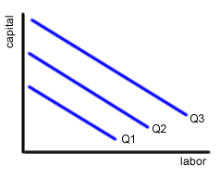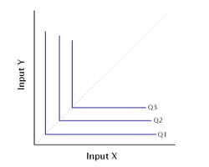
isoquant perfect substitute isoquant not perfect substitute
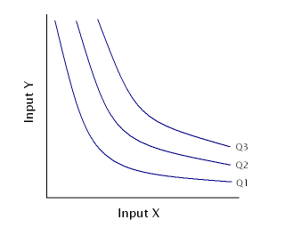
It showing different volume of output

ISO COST

Definition:
A firm can produce a given level of output using efficiently different combinations of two inputs. For choosing efficient combination of the inputs, the producer selects that combination of factors which has the lower cost of production. The information about the cost can be obtained from theisocost lines.

Explanation:
An isocost line is also called outlay line or price line or factor cost line. An isocost line shows all the combinations of labor and capital that are available for a given total cost to-the producer..

In economics, the isocost is the set of combinations of goods that have the same total cost; this can be represented by a curve on a graph.
In economics an `isocost` line shows all combinations of inputs which cost the same total amount

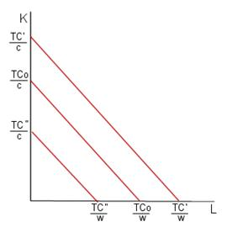

Isoquant and Isocost

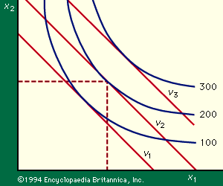

Marginal rate of technical substitution

In economic theory, the Marginal Rate of Technical Substitution (MRTS) - or Technical Rate of Substitution (TRS) - is the amount by which the quantity of one input has to be reduced ( − Δx₂) when one extra unit of another input is used (Δx₁ = 1), so that output remains constant ().
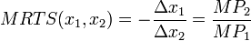
where MP₁ and MP₂ are the marginal products of input 1 and input 2, respectively, and MRTS(x₁,x₂) is Marginal Rate of Technical Substitution of the input x₁ for x₂.Along an isoquant, the MRTS shows the rate at which one input (e.g. capital or labor) may be substituted for another, while maintaining the same level of output. The MRTS can also be seen as the slope of an isoquant at the point in question.
Combinations | Labour (units) | Capital (Units) | Output (quintals) | MRTS
A | 20 | 1 | 50
B | 15 | 2 | 50 | 5:1
C | 11 | 3 | 50 | 4:1
D | 8 | 4 | 50 | 3:1
E | 6 | 5 | 50 | 2:1
F | 5 | 6 | 50 | 1:1

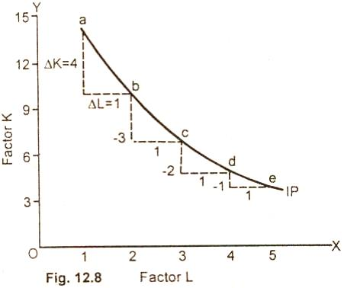

Least cost combination of inputs

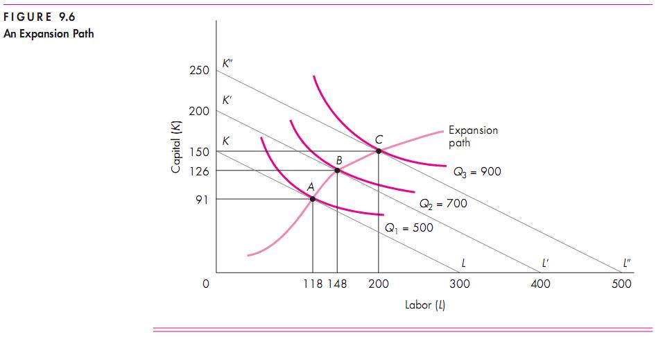

Cobb-Douglas production function:
Production function of the linear homogenous type is invested by and first tested by C. W. Cobb and P. H. Dougles in 1899 to1922. This famous statistical production function is known as Cobb-Douglas production function. Originally the function is applied on the empirical study of the American manufacturing industry. Cabb – Douglas production function takes the following mathematical form.
Y= (bK^{X} L^{1-x})
Where Y=output k=Capital L=Labour

The production function shows that one percent change in labour, capital reaming the same is associated with a 0.75 %change in output. One percent change in capital, labour reaming the same, is associated with a 0.25 %change in output.

Assumptions:
It has the following assumptions
- The function assumes that output is the function of two factors viz. capital and labour.
- It is a linear homogenous production function of the first degree
- The function assumes that the logarithm of the total output of the economy is a linear function of the logarithms of the labour force and capital stock.
- There are constant returns to scale
- All inputs are homogenous(same)

RETURNS TO SCALE

Another important attribute of production function is how output responds in the long run to changes in the scale of the firm i.e. when all inputs are increased in the same proportion (by say 10%), how does output change.

Clearly, there are 3 possibilities. If output increases by more than an increase in inputs (i.e.by more than 10%), then the situation is one of increasing returns to scale (IRS).
If output increases by less than the increase in inputs, then it is a case of decreasing returns to scale (DRS).
Lastly, output may increase by exactly the same proportion as inputs. For example a doubling of inputs may
Lead to a doubling of output. This is a case of constant returns to scale (CRS).

Capital (Units) | Labour (units) | % increase in both inputs | Output (quintals) | % increase in both output | Law applications
1 | 3 |  | 50
2 | 6 | 100 | 120 | 140 | increase
4 | 12 | 100 | 240 | 100 | constant
8 | 24 | 100 | 360 | 50 | decrease

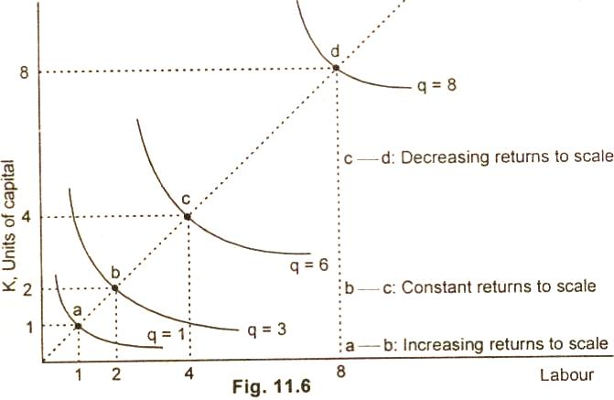

ECONOMIES OF SCALE
The economics of scale result because of increase in the scale of production. Marshal divides the economies of scale into two groups:
Internal economies
External; economies
Internal economies:
It refers to the economies in production cost which accrue to the firm alone whenit expands it output. the internal economies occur as results of increase in the scale of production.
The internal economies divide into following type:

- Managerial economies :
As the firm expands the firm need qualified managerial personnel to handle each of its functions such as marketing, finace, ect functional specilisational ensure minimum wastage and lower the cost of productions in the long run.
- Commercial economies
The transactions of buying and selling raw material and other operating supplies such as spares and so on. There could be cheaper saving in the procurement, transportation and storage costs. This will leads to lower cost and increase profits.
- Financial economies
There could be cheaper credit facility from the financial institution to meet the capital expenditure or working capital requirement .a large firm to give security to financial institution
- Technical economies
Increase in the scale of production follows when there is sophisticated technology available and the firm is in a position to hire qualified technology manpower to make use of it.
- Marketing economies
As the firm grow lager and lager it can afford to maintain a full fledged marketing departmentindependently to handle the issues related to design of customer ,promotion ,marketing staff.
- Risk bearing economies
As there is growth in size of firm there is increase in the risk also. Sharing in the risk with the insurance companies is the first priority for any firm. The firm insureit machinery and other assets against the fire theft ect.the lager firm can spread their risk so that they do not keep all their eggs in one basket.
- Economies of research and development
Large organizations such as dr.reddy labs,HCL, ect bring out several innovative products.

External economies
It refers to the entire firm in the industry, because of growth of the on industry as a whole or because of growth of industry.

- Economies concentration
Because all firm are located at one place ,it is likely that there is better infrastructure in term of approach roads, tans potation ect
- Economies of R&D
The entire firm can pool resource together to finance research and development activity and thus shares benefits of research.
- Economies of welfare
There could be common facility such as canteen, industryhousing, community halls,ect which can be used in common by the employee in the whole industry.

Production may be carried on a small scale or o a large scale by a firm. When a firm expands its size of production by increasing all the factors, it secures certain advantages known as economies of production. Marshall has classified these economies of large-scale production into internal economies and external economies.

Internal economies are those, which are opened to a single factory or a single firm independently of the action of other firms. They result from an increase in the scale of output of a firm and cannot be achieved unless output increases.

BREAKEVEN ANALYSIS

The study of cost-volume-profit relationship is often referred as BEA. The term BEA is interpreted in two senses. In its narrow sense, it is concerned with finding out BEP; BEP is the point at which total revenue is equal to total cost. It is the point of no profit, no loss. In its broad determine the probable profit at any level of production

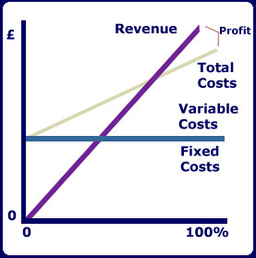

- Fixed cost: Expenses that do not vary with the volume of production are known as fixed expenses. Eg. Manager’s salary, rent and taxes, insurance etc. It should be noted that fixed changes are fixed only within a certain range of plant capacity. The concept of fixed overhead is most useful in formulating a price fixing policy. Fixed cost per unit is not fixed.
- Variable Cost: Expenses that vary almost in direct proportion to the volume of production of sales are called variable expenses. Eg. Electric power and fuel, packing materials consumable stores. It should be noted that variable cost per unit is fixed.
- Contribution: Contribution is the difference between sales and variable costs and it contributed towards fixed costs and profit. It helps in sales and pricing policies and measuring the profitability of different proposals. Contribution is a sure test to decide whether a product is worthwhile to be continued among different products.

Contribution = Sales – Variable cost
Contribution = Fixed Cost + Profit.
- Margin of safety: Margin of safety is the excess of sales over the break even sales. It can be expressed in absolute sales amount or in percentage. It indicates the extent to which the sales can be reduced without resulting in loss. A large margin of safety indicates the soundness of the business. The formula for the margin of safety is:
Present sales – Break even sales or
- Break – Even- Point: If we divide the term into three words, then it does not require further explanation.
Break-divide
Even-equal
Point-place or position
Break Even Point refers to the point where total cost is equal to total revenue. It is a point of no profit, no loss. This is also a minimum point of no profit, no loss. This is also a minimum point of production where total costs are recovered. If sales go up beyond the Break Even Point, organization makes a profit. If they come down, a loss is incurred.

- Break Even point (Units) =
- Break Even point (In Rupees) =

Merits:
- Information provided by the Break Even Chart can be understood more easily then those contained in the profit and Loss Account and the cost statement.
- Break Even Chart discloses the relationship between cost, volume and profit. It reveals how changes in profit. So, it helps management in decision-making.
- It is very useful for forecasting costs and profits long term planning and growth
- The chart discloses profits at various levels of production.
- It serves as a useful tool for cost control.
- It can also be used to study the comparative plant efficiencies of the industry.
- Analytical Break-even chart present the different elements, in the costs – direct material, direct labour, fixed and variable overheads.

Demerits:
- Break-even chart presents only cost volume profits. It ignores other considerations such as capital amount, marketing aspects and effect of government policy etc., which are necessary in decision making.
- It is assumed that sales, total cost and fixed cost can be represented as straight lines. In actual practice, this may not be so.
- It assumes that profit is a function of output. This is not always true. The firm may increase the profit without increasing its output.
- A major draw back of BEC is its inability to handle production and sale of multiple products.
- It is difficult to handle selling costs such as advertisement and sale promotion in BEC.
- It ignores economics of scale in production.
- Fixed costs do not remain constant in the long run.
- Semi-variable costs are completely ignored.
- It assumes production is equal to sale. It is not always true because generally there may be opening stock.
- When production increases variable cost per unit may not remain constant but may reduce on account of bulk buying etc.

COST ANALAYSIS

(A)ActualCost
Actual cost is defined as the cost or expenditure which a firm incurs for producing or acquiring a good or service. The actual costs or expenditures are recorded in the books of accounts of a business unit. Actual costs are also called as "Outlay Costs" or "AbsoluteCosts"or"AcquisitionCosts".
Examples: Costofrawmaterials,WageBilletc.

OpportunityCost
Opportunity cost is concerned with the cost of forgone opportunities/alternatives. In other words, it is the return from the second best use of the firms resources which the firms forgoes in order to avail of the return from the best use of the resources. It can also be said as the comparison between the policy that was chosen and the policy that was rejected. The concept of opportunity cost focuses on the net revenue that could be generated in the next best use of a scare input. Opportunity cost is also called as "Alternative Cost".
If a firm owns a land, there is no cost of using the land (ie., the rent) in the firms account. But the firm has an opportunity cost of using the land, which is equal to the rent forgone by not letting the land out on rent.
(C) Sunk Cost
Sunk costs are those do not alter by varying the nature or level of business activity. Sunk costs are generally not taken into consideration in decision - making as they do not vary with the changes in the future. Sunk costs are a part of the outlay/actual costs. Sunk costs are also called as "Non-Avoidable costs" or "Inescapable costs".
Examples: All the past costs are considered as sunk costs. The best example is amortization of past expenses, like depreciation.
(D) Incremental Cost
Incremental costs are addition to costs resulting from a change in the nature of level of business activity. As the costs can be avoided by not bringing any variation in the activity in the activity, they are also called as "Avoidable Costs" or "Escapable Costs". More ever incremental costs resulting from a contemplated change is the Future, they are also called as "Differential Costs"
Example: Change in distribution channels adding or deleting a product in the product line.
(E) Explicit Cost
Explicit costs are those expenses/expenditures that are actually paid by the firm. These costs are recorded in the books of accounts. Explicit costs are important for calculating the profit and loss accounts and guide in economic decision-making. Explicit costs are also called as "Paid out costs"
Example: Interest payment on borrowed funds, rent payment, wages, utility expenses etc.
(F) Implicit Cost
Implicit costs are a part of opportunity cost. They are the theoretical costs ie., they are not recognised by the accounting system and are not recorded in the books of accounts but are very important in certain decisions. They are also called as the earnings of those employed resources which belong to the owner himself. Implicit costs are also called as "Imputed costs".
Examples: Rent on idle land, depreciation on dully depreciated property still in use, interest on equity capital etc.
(G) Book Cost
Book costs are those business costs which don't involve any cash payments but a provision is made in the books of accounts in order to include them in the profit and loss account and take tax advantages, like provision for depreciation and for unpaid amount of the interest on the owners capital.
(H) Out Of Pocket Costs
Out of pocket costs are those costs are expenses which are current payments to the outsiders of the firm. All the explicit costs fall into the category of out of pocket costs.
Examples: Rent Payed, wages, salaries, interest etc
(I) Accounting Costs
Accounting costs are the actual or outlay costs that point out the amount of expenditure that has already been incurred on a particular process or on production as such accounting costs facilitate for managing the taxation need and profitability of the firm.
Examples: All Sunk costs are accounting costs
(J) Economic Costs
Economic costs are related to future. They play a vital role in business decisions as the costs considered in decision - making are usually future costs. They have the nature similar to that of incremental, imputed explicit and opportunity costs.
(K) Direct Cost
Direct costs are those which have direct relationship with a unit of operation like manufacturing a product, organizing a process or an activity etc. In other words, direct costs are those which are directly and definitely identifiable. The nature of the direct costs are related with a particular product/process, they vary with variations in them. Therefore all direct costs are variable in nature. It is also called as "Traceable Costs"
Examples: In operating railway services, the costs of wagons, coaches and engines are direct costs.
(L) Indirect Costs
Indirect costs are those which cannot be easily and definitely identifiable in relation to a plant, a product, a process or a department. Like the direct costs indirect costs, do not vary ie., they may or may not be variable in nature. However, the nature of indirect costs depend upon the costing under consideration. Indirect costs are both the fixed and the variable type as they may or may not vary as a result of the proposed changes in the production process etc. Indirect costs are also called as Non-traceable costs.
Example: The cost of factory building, the track of a railway system etc., are fixed indirect costs and the costs of machinery, labour etc..,

