Java Unit-4

Java collection framework is a collection of interfaces and classes used to storing and processing a group of individual objects as a single unit. The java collection framework holds several classes that provide a large number of methods to store and process a group of objects. These classes make the programmer task super easy and fast.
Java collection framework was introduced in java 1.2 version.
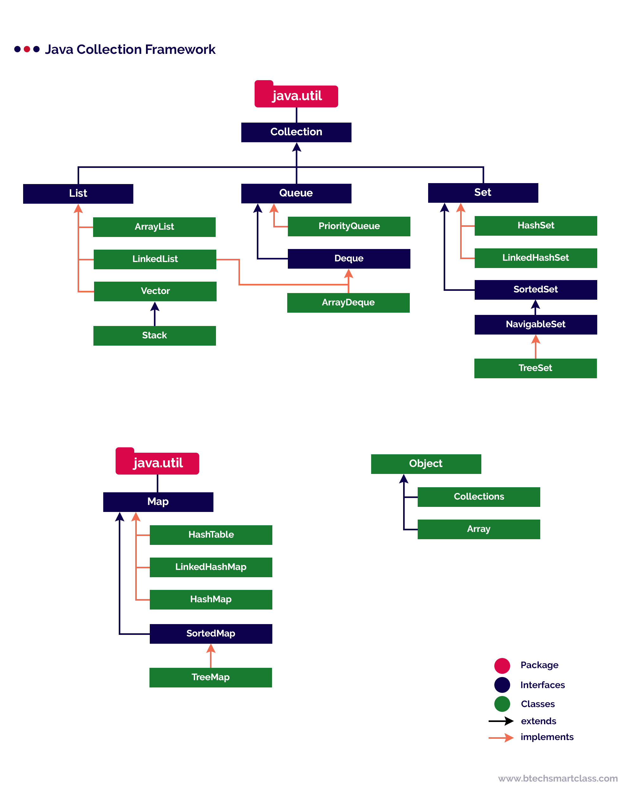
The java collection framework contains List, Queue, Set, and Map as top-level interfaces. The List, Queue, and Set stores single value as its element, whereas Map stores a pair of a key and value as its element.
Java Collection Interfaces
The Collection interface is the root interface for most of the interfaces and classes of collection framework. The Collection interface is available inside the java.util package. It defines the methods that are commonly used by almost all the collections.
The Collection interface defines the following methods.

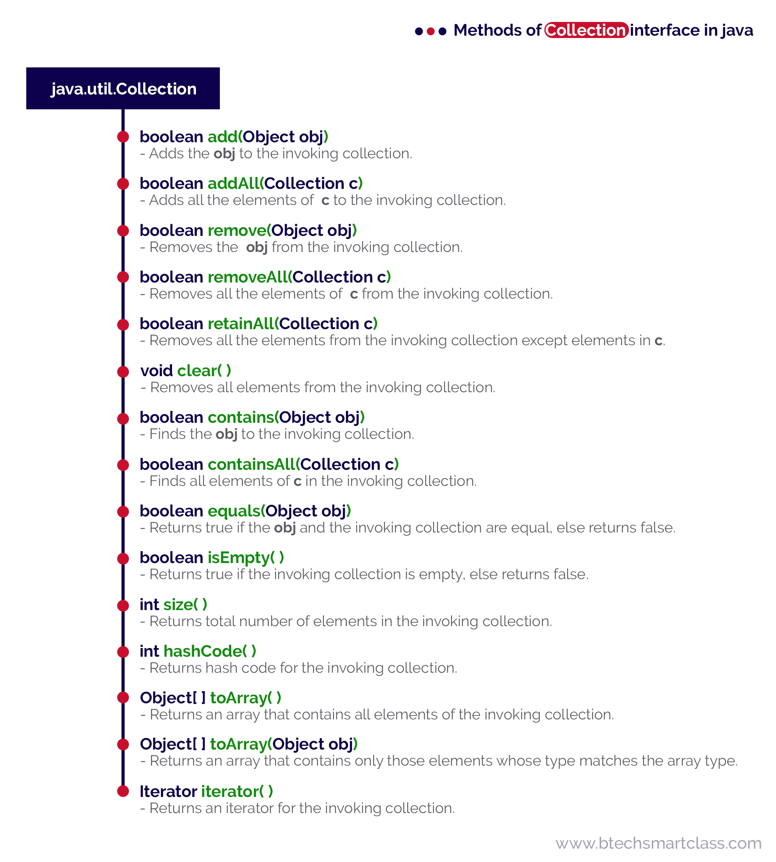
The Collection interface extends Iterable interface.
Let's consider an example program on ArrayList to illustrate the methods of Collection interface.
The ArrayList class is a part of java collection framework. It is available inside the java.util package. The ArrayList class extends AbstractList class and implements List interface.
The elements of ArrayList are organized as an array internally. The default size of an ArrayList is 10.
The ArrayList class is used to create a dynamic array that can grow or shrunk as needed.
🔔 The ArrayList is a child class of AbstractList
🔔 The ArrayList implements interfaces like List, Serializable, Cloneable, and RandomAccess.
🔔 The ArrayList allows to store duplicate data values.
🔔 The ArrayList allows to access elements randomly using index-based accessing.
🔔 The ArrayList maintains the order of inserti
Operation on ArrayList
The ArrayList class allow us to perform several operations like adding, accesing, deleting, updating, looping, etc. Let's look at each operation with examples.
Adding Item
The ArrayList class has the following methods to add items.
- boolean add(E element) - Appends given element to the ArrayList.
- boolean addAll(Collection c) - Appends given collection of elements to the ArrayList.
- void add(int index, E element) - Inserts the given element at specified index.
- boolean addAll(int index, Collection c) - Inserts the given collection of elements at specified index.

import java.util.*;
public class CollectionInterfaceExample
{
public static void main(String[] args)
{
List list_1 = new ArrayList();
List<String> list_2 = new ArrayList<String>();
list_1.add(10);
list_1.add(20);
list_2.add("BTech");
list_2.add("Smart");
list_2.add("Class");
list_1.addAll(list_2);
System.out.println("Elements of list_1: " + list_1);
System.out.println("Search for BTech: " + list_1.contains("BTech"));
System.out.println("Search for list_2 in list_1: " + list_1.containsAll(list_2));
System.out.println("Check whether list_1 and list_2 are equal: " + list_1.equals(list_2));
System.out.println("Check is list_1 empty: " + list_1.isEmpty());
System.out.println("Size of list_1: " + list_1.size());
list_1.remove(0);
System.out.println(list_1);
list_1.retainAll(list_2);
System.out.println(list_1);
list_1.removeAll(list_2);
System.out.println(list_1);
list_2.clear();
System.out.println(list_2);
}
}

LinkedList Class
The LinkedList class is a part of java collection framework. It is available inside the java.util package. The LinkedList class extends AbstractSequentialList class and implements List and Deque interface.
The elements of LinkedList are organized as the elements of linked list data structure.

The LinkedList is a child class of AbstractSequentialList
🔔 The LinkedList implements interfaces like List, Deque, Cloneable, and Serializable.
🔔 The LinkedList allows to store duplicate data values.
🔔 The LinkedList maintains the order of insertion.

LinkedList class constructors
The LinkedList class has the following constructors.
- LinkedList( ) - Creates an empty List.
- LinkedList(Collection c) - Creates a List with given collection of elements.

Operations on LinkedList
The LinkedList class allow us to perform several operations like adding, accesing, deleting, updating, looping, etc. Let's look at each operation with examples.

Adding Items
The LinkedList class has the following methods to add items.
- boolean add(E element) - Appends given element to the List.
- boolean addAll(Collection c) - Appends given collection of elements to the List.
- void add(int position, E element) - Inserts the given element at specified position.
- boolean addAll(int position, Collection c) - Inserts the given collection of elements at specified position.
- void addFirst(E element) - Inserts the given element at beggining of the list.
- void addLast(E element) - Inserts the given element at end of the list.
- boolean offer(E element) - Inserts the given element at end of the list.
- boolean offerFirst(E element) - Inserts the given element at beggining of the list.
- boolean offerLast(E element) - Inserts the given element at end of the list.
- void push(E element) - Inserts the given element at beggining of the list.
Let's consider an example program to illustrate adding items to the LinkedList.
import java.util.*;

public class LinkedListExample {

public static void main(String[] args) {

LinkedList<String> list_1 = new LinkedList<String>();
LinkedList list_2 = new LinkedList();

list_2.add(10);
list_2.add(20);
list_2.addFirst(5);
list_2.addLast(25);
list_2.offer(2);
list_2.offerFirst(1);
list_2.offerLast(10);
list_2.push(40);

list_1.addAll(list_2);

System.out.println("List_1: " + list_1);

System.out.println("List_2: " + list_2);

}

}

Java HashSet Class
The HashSet class is used to create a collection that uses a hash table for storing set of elements.
🔔 The HashSet is a child class of AbstractSet
🔔 The HashSet implements interfaces like Set, Cloneable, and Serializable.
🔔 The HashSet does not allows to store duplicate data values, but null values are allowed.
🔔 The HashSet does not maintains the order of insertion.
🔔 The HashSet initial capacity is 16 elements.
🔔 The HashSet is best suitable for search operations.

HashSet class declaration
The HashSet class has the following declaration.
Example
public class HashSet<E> extends AbstractSet<E> implements Set<E>, Cloneable, Serializable

HashSet class constructors
The HashSet class has the following constructors.
- HashSet( ) - Creates an empty HashSet with the default initial capacity (16).
- HashSet(Collection c) - Creates a HashSet with given collection of elements.
- HashSet(int initialCapacity) - Creates an empty HashSet with the specified initial capacity.
- HashSet(int initialCapacity, float loadFactor) - Creates an empty HashSet with the specified initial capacity and loadFactor.

Operations on HashSet
The HashSet class allow us to perform several operations like adding, accesing, deleting, updating, looping, etc. Let's look at each operation with examples.

Adding Items
The HashSet class has the following methods to add items.
- boolean add(E element) - Inserts given element to the HashSet.
- boolean addAll(Collection c) - Inserts given collection of elements to the HashSet.
Let's consider an example program to illustrate adding items to the HashSet.
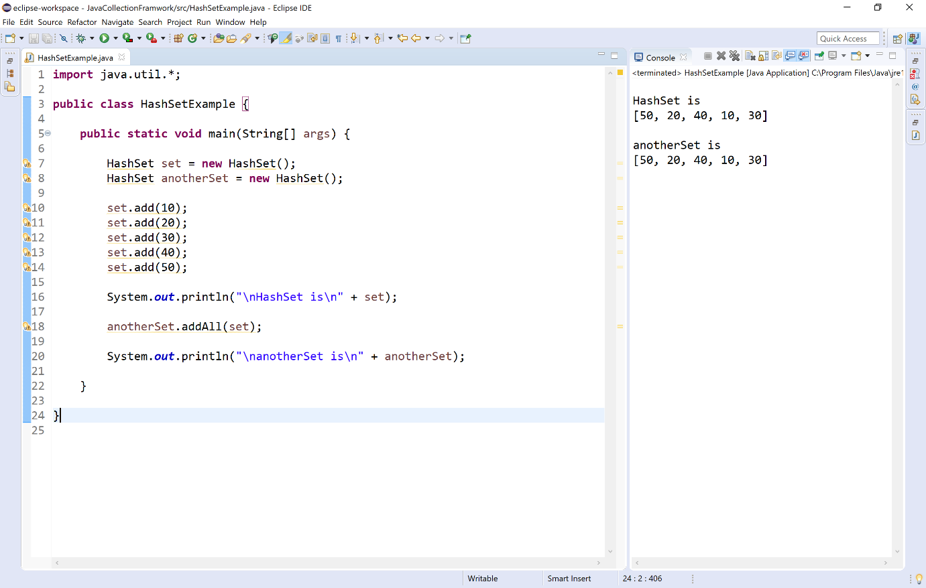

Accessing Items
The HashSet class has no methods to access items, we can access whole set using its name.

Updating Items
The HashSet class has no methods to update or change items.

Removing Items
The HashSet class has the following methods to remove items.
- boolean remove(Object o) - Removes the specified element from the invoking HashSet.
- boolean removeAll(Collection c) - Removes all the elements of specified collection from the invoking HashSet.
- boolean removeIf(Predicate p) - Removes all of the elements of HashSet collection that satisfy the given predicate.
- boolean retainAll(Collection c) - Removes all of the elements of HashSet collection except specified collection of elements.
- void clear( ) - Removes all the elements from the HashSet.
- 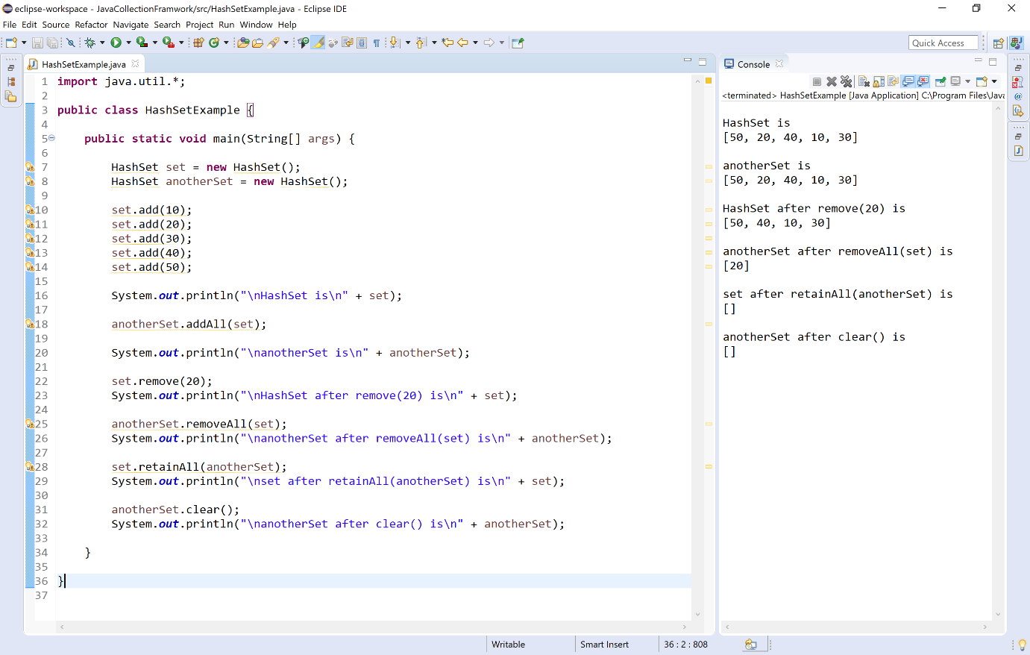

Other utility methods
The HashSet class has the following methods to work with elements of it.
- int size( ) - Returns the total number of elements in the invoking HashSet.
- boolean isEmpty( ) - Returns true if the HashSet is empty otherwise returns false.
- HashSet clone( ) - Returns a copy of the invoking HashSet.
- boolean contains(Object element) - Returns true if the HashSet contains given element otherwise returns false.
- boolean containsAll(Collection c) - Returns true if the HashSet contains given collection of elements otherwise returns false.
- boolean equals(Object o) - Compares the specified object with invoking HashSet collection for equality.
- int hashCode( ) - Returns the hash code of the invoking HashSet.
- Object[ ] toArray( ) - Returns an array of Object instances that contains all the elements from invoking HashSet.
- Spliterator spliterator( ) - Creates spliterator over the elements in a HashSet.
- Iterator iterator( ) - Returns an iterator over the elements in the HashSet. The iterator does not return the elements in any particular order.
Let's consider an example program to illustrate other utility methods of the HashSet.

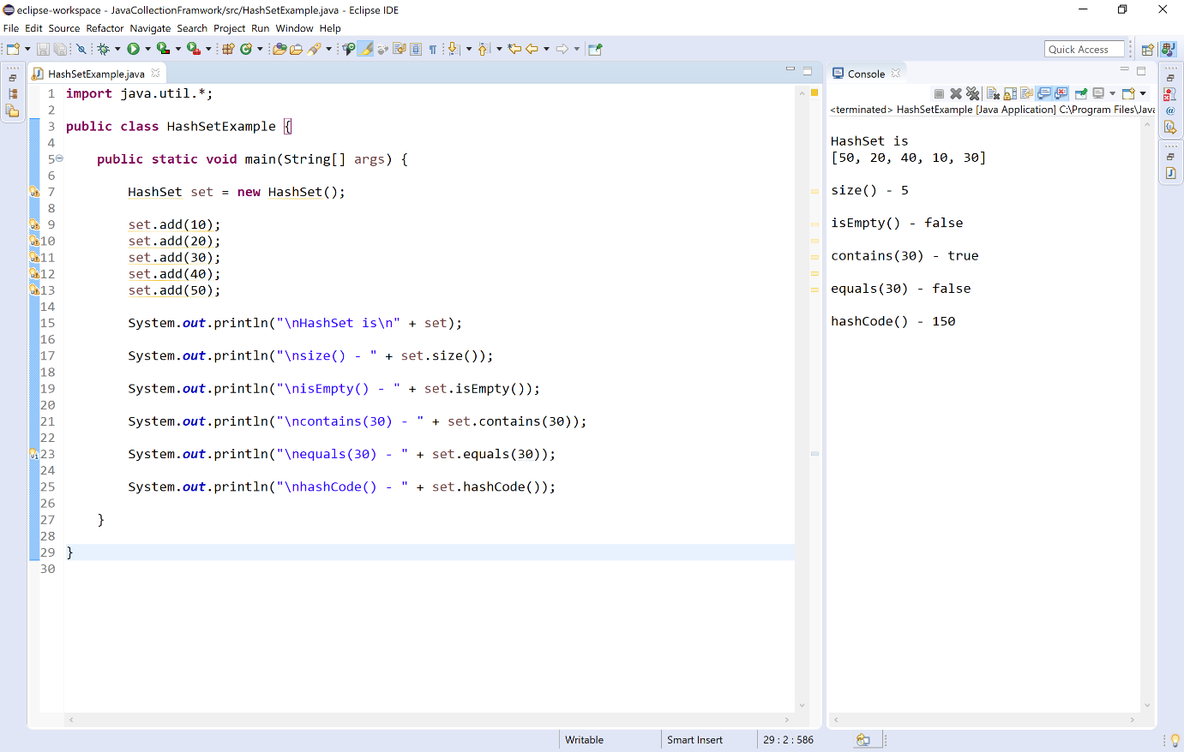

Consolidated list of methods
The following table providess a consolidated view of all methods of HashSet.
Method | Description
boolean add(E element) | Appends given element to the HashSet.
boolean addAll(Collection c) | Appends given collection of elements to the HashSet.
boolean remove(Object element) | Removes the first occurence of the given element from the invoking HashSet.
boolean removeAll(Collection c) | Removes all the elements those are in the specified collection from the invoking HashSet.
boolean removeIf(Predicate p) | Removes all of the elements of the HashSet collection that satisfy the given predicate.
boolean retainAll(Collection c) | Removes all the elements except those are in the specified collection from the invoking HashSet.
void clear( ) | Removes all the elements from the HashSet.
int size( ) | Returns the total number of elements in the invoking HashSet.
boolean isEmpty( ) | Returns true if the HashSet is empty otherwise returns false.
boolean equals( ) | Compares the specified object with invoking HashSet collection for equality.
boolean contains(Object element) | Returns true if the HashSet contains given element otherwise returns false.
boolean containsAll(Collection c) | Returns true if the HashSet contains all elements of given collection otherwise returns false.
int clone( ) | Returns a copy of the invoking HashSet.
int hashCode( ) | Returns the hash code of the invoking HashSet.
Object[ ] toArray( ) | Returns an array of Object instances that contains all the elements from invoking HashSet.
Spliterator spliterator( ) | Creates spliterator over the elements in a HashSet.
Iterator iterator( ) | Returns an iterator over the elements in the HashSet. The iterator does not return the elements in any particular order.

Java TreeSet class
The TreeSet class is a part of java collection framework. It is available inside the java.util package. The TreeSet class extends AbstractSet class and implements NavigableSet, Cloneable, and Serializable interfaces.
The elements of TreeSet are organized using a mechanism called tree. The TreeSet class internally uses a TreeMap to store elements. The elements in a TreeSet are sorted according to their natural ordering.
The TreeSet is a child class of AbstractSet
🔔 The TreeSet implements interfaces like NavigableSet, Cloneable, and Serializable.
🔔 The TreeSet does not allows to store duplicate data values, but null values are allowed.
🔔 The elements in a TreeSet are sorted according to their natural ordering.
🔔 The TreeSet initial capacity is 16 elements.
🔔 The TreeSet is best suitable for search operations.

TreeSet class declaration
The TreeSet class has the following declaration.
Examplesorting order
public class TreeSet<E> extends AbstractSet<E> implements NavigableSet<E>, Cloneable, Serializable

TreeSet class constructors
The TreeSet class has the following constructors.
- TreeSet( ) - Creates an empty TreeSet in which elements will get stored in default natural sorting order.
- TreeSet(Collection c) - Creates a TreeSet with given collection of elements.
- TreeSet(Comparator c) - Creates an empty TreeSet with the specified sorting order.
- TreeSet(SortedSet s) - This constructor is used to convert SortedSet to TreeSet.

Operations on TreeSet
The TreeSet class allow us to perform several operations like adding, accesing, deleting, updating, looping, etc. Let's look at each operation with examples.

Adding Items
The TreeSet class has the following methods to add items.
- boolean add(E element) - Inserts given element to the TreeSet if it does not exist.
- boolean addAll(Collection c) - Inserts given collection of elements to the TreeSet.
Let's consider an example program to illustrate adding items to the TreeSet.
Example
import java.util.*;

public class TreeSetExample {

public static void main(String[] args) {

TreeSet set = new TreeSet();
TreeSet anotherSet = new TreeSet();

set.add(10);
set.add(20);
set.add(15);
set.add(5);

System.out.println("\nset is\n" + set);

anotherSet.addAll(set);

System.out.println("\nanotherSet is\n" + anotherSet);

}

}

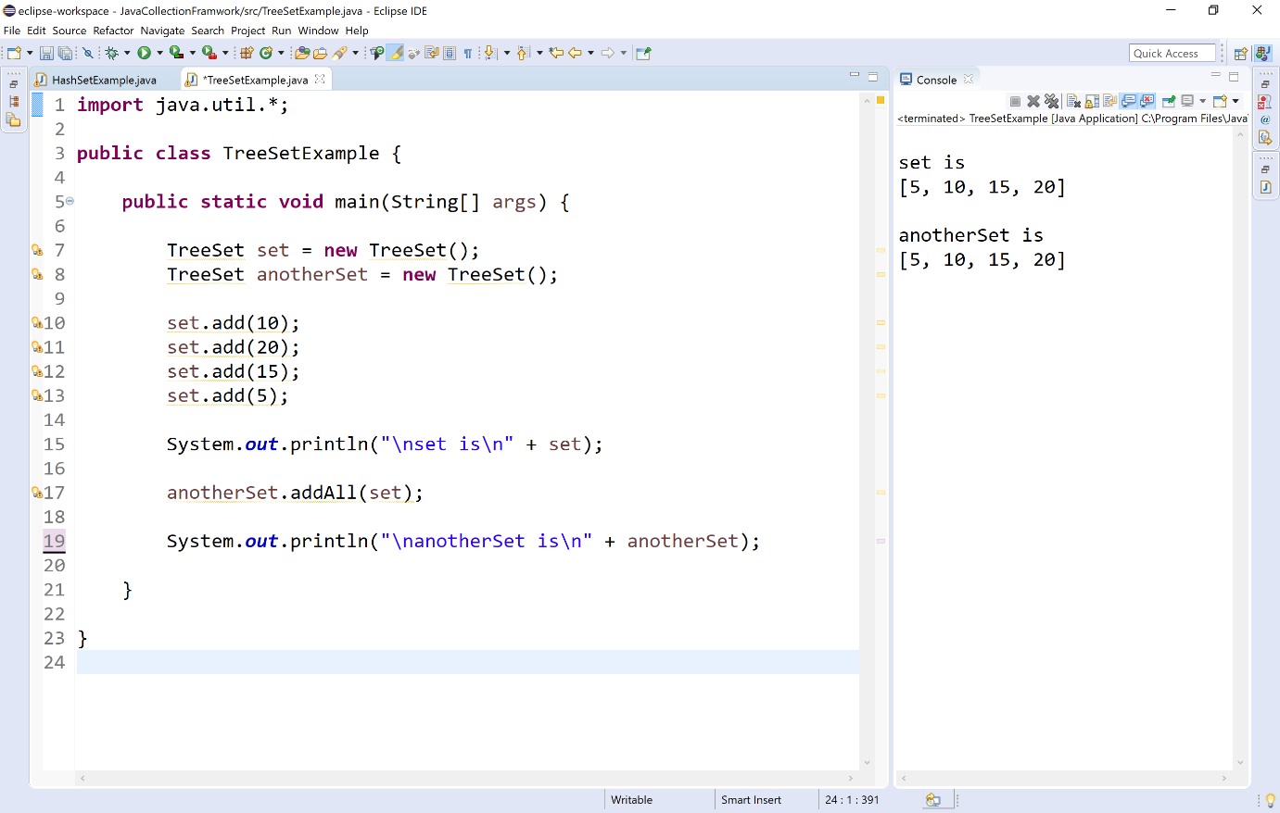

Accessing Items
The TreeSet class has provides the following methods to access items.
- E First( ) - Returns the first (smallest) element from the invoking TreeSet.
- E last( ) - Returns the last (largest) element from the invoking TreeSet.
- E higher(E obj) - Returns the largest element e such that e>obj. If it does not found returns null.
- E lower(E obj) - Returns the largest element e such that e<obj. If it does not found returns null.
- E ceiling(E obj) - Returns the smallest element e such that e>=obj. If it does not found returns null.
- E floor(E obj) - Returns the largest element e such that e<=obj. If it does not found returns null.
- SortedSet subSet(E fromElement, E toElement) - Returns a set of elements that lie between the given range which includes fromElement and excludes toElement.
- NavigableSet subSet(E fromElement, boolean fromInclusive, E toElement, boolean toInclusive) - Returns a set of elements that lie between the given range from the invoking TreeSet.
- SortedSet tailSet(E fromElement) - Returns a set of elements that are greater than or equal to the specified fromElement from the invoking TreeSet.
- NavigableSet tailSet(E fromElement, boolean inclusive) - Returns a set of elements that are greater than or equal to (if, inclusive is true) the specified element from the invoking TreeSet.
- SortedSet headSet(E fromElement) - Returns a set of elements that are smaller than or equal to the specified fromElement from the invoking TreeSet.
- NavigableSet headSet(E fromElement, boolean inclusive) - Returns a set of elements that are smaller than or equal to (if, inclusive is true) the specified element from the invoking TreeSet.
Let's consider an example program to illustrate accessing items from a TreeSet.
Example
import java.util.*;

public class TreeSetExample {

public static void main(String[] args) {

TreeSet set = new TreeSet();
Random num = new Random();
for(int i = 0; i < 10; i++)
set.add(num.nextInt(100));

System.out.println("\nset is\n" + set);

System.out.println("\nfirst() - " + set.first());

System.out.println("\nlast() - " + set.last());

System.out.println("\nhigher(20) - " + set.higher(20));

System.out.println("\nlower(20) - " + set.lower(20));

System.out.println("\nceiling(30) - " + set.ceiling(30));

System.out.println("\nfloor(30) - " + set.floor(30));

System.out.println("\nsubSet(10, 50)\n" + set.subSet(10, 50));

System.out.println("\nsubSet(10, false, 50, true)\n" + set.subSet(10, false, 50, true));

System.out.println("\nheadSet(20)\n" + set.headSet(20));

System.out.println("\nheadSet(20, false)\n" + set.headSet(20, false));

System.out.println("\ntailSet(20)\n" + set.tailSet(20));

System.out.println("\ntailSet(20, false)\n" + set.tailSet(20, false));
}
}

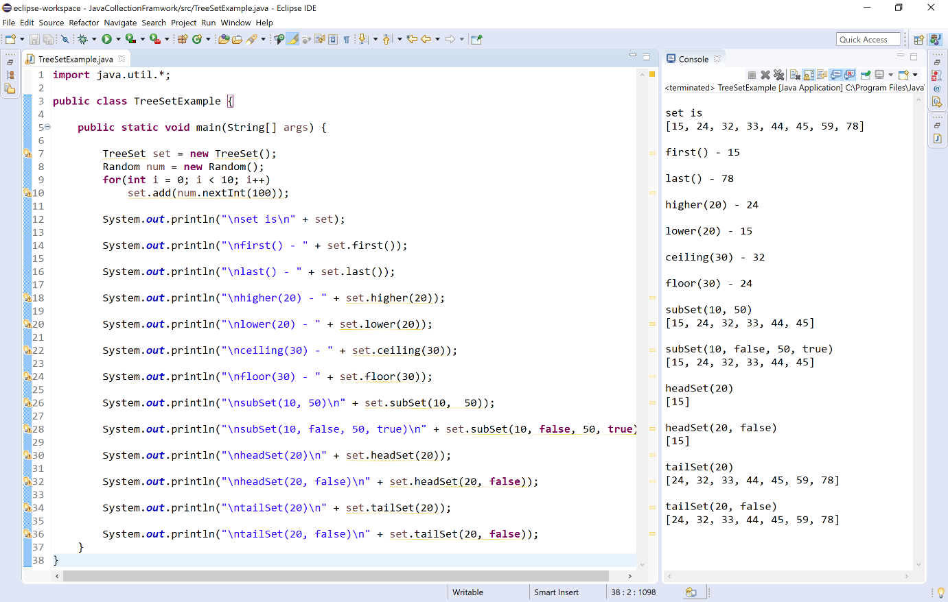

Updating Items
The TreeSet class has no methods to update or change items.

Removing Items
The TreeSet class has the following methods to remove items.
- boolean remove(Object o) - Removes the specified element from the invoking TreeSet.
- boolean removeAll(Collection c) - Removes all the elements those are in the specified collection from the invoking TreeSet.
- boolean removeIf(Predicate p) - Removes all of the elements of the TreeSet collection that satisfy the given predicate.
- boolean retainAll(Collection c) - Removes all the elements except those are in the specified collection from the invoking TreeSet.
- E pollFirst( ) - Removes the first (smallest) element from the invoking TreeSet, and returns the same.
- E pollLast( ) - Removes the last (largest) element from the invoking TreeSet, and returns the same.
- void clear( ) - Removes all the elements from the TreeSet.
Let's consider an example program to illustrate removing items from the TreeSet.
Example
import java.util.*;

public class TreeSetExample {

public static void main(String[] args) {

TreeSet set = new TreeSet();
TreeSet anotherSet = new TreeSet();
Random num = new Random();
for(int i = 0; i < 10; i++)
set.add(num.nextInt(100));

anotherSet.add(10);
anotherSet.add(20);
anotherSet.add(30);

System.out.println("\nset is\n" + set);
System.out.println("\nanotherSet is\n" + anotherSet);

set.remove(50);
System.out.println("\nset after remove(50) is\n" + set);

set.removeIf(n->n.equals(60));
System.out.println("\nset after removeIf(n->n.equals(60)) is\n" + set);

set.pollFirst();
System.out.println("\nset after pollFirst( ) is\n" + set);

set.pollLast();
System.out.println("\nset after pollLast( ) is\n" + set);

set.removeAll(anotherSet);
System.out.println("\nset after removeAll(anotherSet) is\n" + set);

set.retainAll(anotherSet);
System.out.println("\nset after retainAll(anotherSet) is\n" + set);
}
}

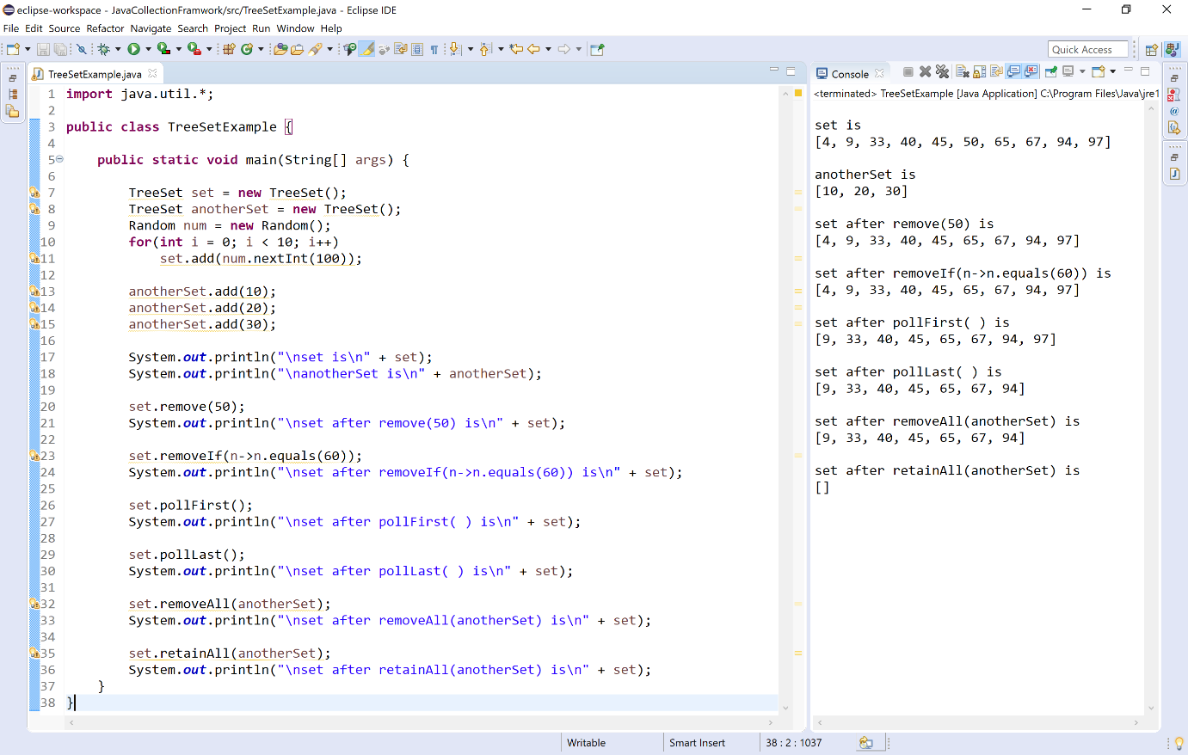

Other utility methods
The TreeSet class has the following methods to work with elements of it.
- int size( ) - Returns the total number of elements in the invoking TreeSet.
- boolean isEmpty( ) - Returns true if the TreeSet is empty otherwise returns false.
- TreeSet clone( ) - Returns a copy of the invoking TreeSet.
- boolean contains(Object element) - Returns true if the TreeSet contains given element otherwise returns false.
- boolean containsAll(Collection c) - Returns true if the TreeSet contains given collection of elements otherwise returns false.
- boolean equals(Object o) - Compares the specified object with invoking TreeSet collection for equality.
- int hashCode( ) - Returns the hash code of the invoking TreeSet.
- Object clone( ) - Returns a shallow copy of invoking TreeSet instance.
- Spliterator spliterator( ) - Creates spliterator over the elements in a TreeSet.
- Iterator iterator( ) - Returns an iterator over the elements in the TreeSet. The iterator does not return the elements in any particular order.
Let's consider an example program to illustrate other utility methods of the TreeSet.
Example
import java.util.*;

public class TreeSetExample {

public static void main(String[] args) {

TreeSet set = new TreeSet();
TreeSet anotherSet = new TreeSet();
Random num = new Random();
for(int i = 0; i < 10; i++)
set.add(num.nextInt(100));

anotherSet.add(10);
anotherSet.add(20);
anotherSet.add(30);

System.out.println("\nset is\n" + set);
System.out.println("\nanotherSet is\n" + anotherSet);

System.out.println("\nset size() - " + set.size());

System.out.println("\nset isEmpty() - " + set.isEmpty());

System.out.println("\nset contains(50) - " + set.contains(50));

System.out.println("\nset contains(anotherSet) - " + set.containsAll(anotherSet));

System.out.println("\nset equals(anotherSet) - " + set.equals(anotherSet));

System.out.println("\nset hashCode() - " + set.hashCode());

}
}

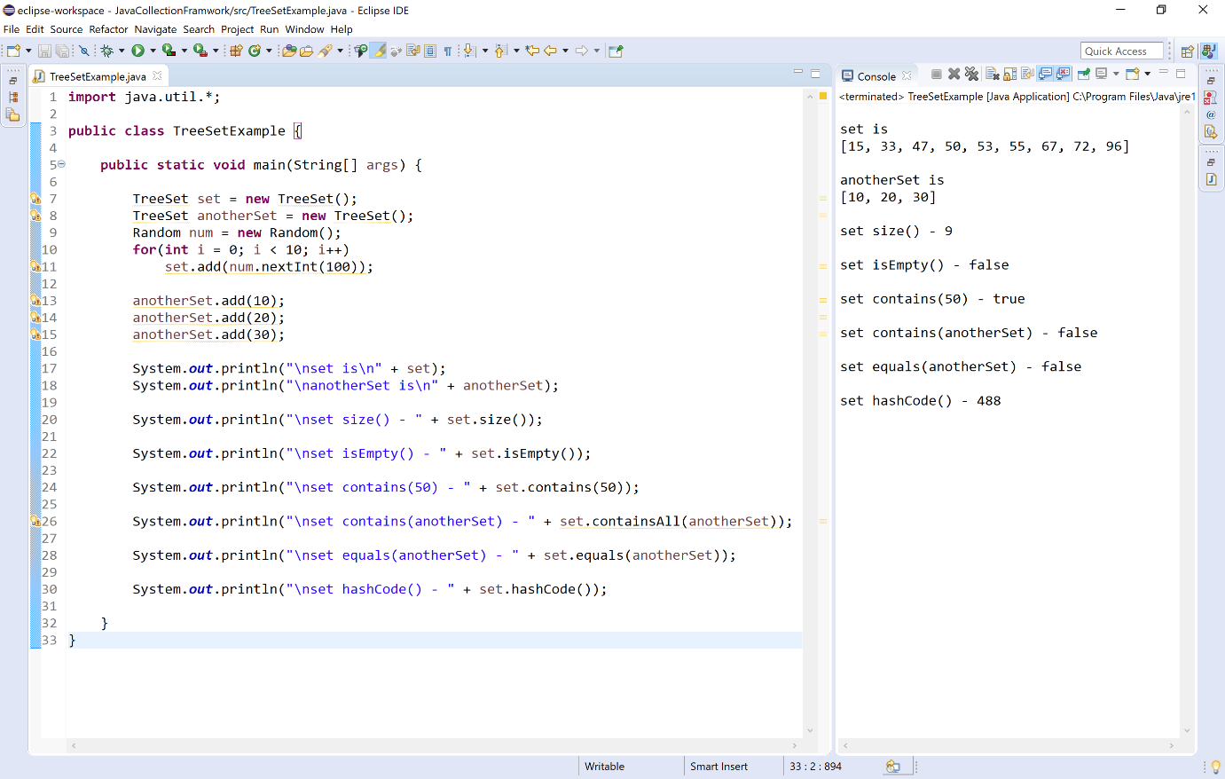

Consolidated list of methods
The following table providess a consolidated view of all methods of TreeSet.
Method | Description
boolean add(E element) | Appends given element to the TreeSet.
boolean addAll(Collection c) | Appends given collection of elements to the TreeSet.
E First( ) | Returns the first (smallest) element from the invoking TreeSet.
E last( ) | Returns the last (largest) element from the invoking TreeSet.
E higher(E obj) | Returns the largest element e such that e>obj. If it does not found returns null.
E lower(E obj) | Returns the largest element e such that e<obj. If it does not found returns null.
E ceiling(E obj) | Returns the smallest element e such that e>=obj. If it does not found returns null.
E floor(E obj) | Returns the largest element e such that e<=obj. If it does not found returns null.
SortedSet subSet(E fromElement, E toElement) | Returns a set of elements that lie between the given range which includes fromElement and excludes toElement.
NavigableSet subSet(E fromElement, boolean fromInclusive, E toElement, boolean toInclusive) | Returns a set of elements that lie between the given range from the invoking TreeSet.
SortedSet tailSet(E fromElement) | Returns a set of elements that are greater than or equal to the specified fromElement from the invoking TreeSet.
NavigableSet tailSet(E fromElement, boolean inclusive) | Returns a set of elements that are greater than or equal to (if, inclusive is true) the specified element from the invoking TreeSet.
SortedSet headSet(E fromElement) | Returns a set of elements that are smaller than or equal to the specified fromElement from the invoking TreeSet.
NavigableSet headSet(E fromElement, boolean inclusive) | Returns a set of elements that are smaller than or equal to (if, inclusive is true) the specified element from the invoking TreeSet.
boolean remove(Object element) | Removes the first occurence of the given element from the invoking TreeSet.
boolean removeAll(Collection c) | Removes all the elements those are in the specified collection from the invoking TreeSet.
boolean removeIf(Predicate p) | Removes all of the elements of the TreeSet collection that satisfy the given predicate.
boolean retainAll(Collection c) | Removes all the elements except those are in the specified collection from the invoking TreeSet.
void clear( ) | Removes all the elements from the TreeSet.
int size( ) | Returns the total number of elements in the invoking TreeSet.
boolean isEmpty( ) | Returns true if the TreeSet is empty otherwise returns false.
boolean equals( ) | Compares the specified object with invoking TreeSet collection for equality.
boolean contains(Object element) | Returns true if the HashSet contains given element otherwise returns false.
boolean containsAll(Collection c) | Returns true if the TreeSet contains all elements of given collection otherwise returns false.
int clone( ) | Returns a copy of the invoking TreeSet.
int hashCode( ) | Returns the hash code of the invoking TreeSet.
Spliterator spliterator( ) | Creates spliterator over the elements in a TreeSet.
Iterator iterator( ) | Returns an iterator over the elements in the TreeSet. The iterator does not return the elements in any particular order.
Java PriorityQueue class
The PriorityQueue class is used to create a dynamic queue of elements that can grow or shrunk as needed.
🔔 The PriorityQueue is a child class of AbstractQueue
🔔 The PriorityQueue implements interface Serializable.
🔔 The PriorityQueue allows to store duplicate data values, but not null values.
🔔 The PriorityQueue maintains the order of insertion.
🔔 The PriorityQueue used priority heap to organize its elements.

PriorityQueue class declaration
The PriorityQueue class has the following declaration.
Example
public class PriorityQueue<E> extends AbstractQueue<E> implements Serializable

PriorityQueue class constructors
The PriorityQueue class has the following constructors.
- PriorityQueue( ) - Creates an empty PriorityQueue with the default initial capacity (11) that orders its elements according to their natural ordering.
- PriorityQueue(Collection c) - Creates a PriorityQueue with given collection of elements.
- PriorityQueue(int initialCapacity) - Creates an empty PriorityQueue with the specified initial capacity.
- PriorityQueue(int initialCapacity, Comparator comparator) - Creates an empty PriorityQueue with the specified initial capacity that orders its elements according to the specified comparator.
- PriorityQueue(PriorityQueue pq) - Creates a PriorityQueue with the elements in the specified priority queue.
- PriorityQueue(SortedSet ss) - Creates a PriorityQueue with the elements in the specified SortedSet.

Operations on PriorityQueue
The PriorityQueue class allow us to perform several operations like adding, accesing, deleting, updating, looping, etc. Let's look at each operation with examples.

Adding Items
The PriorityQueue class has the following methods to add items.
- boolean add(E element) - Appends given element to the PriorityQueue.
- boolean addAll(Collection c) - Appends given collection of elements to the PriorityQueue.
- boolean offer(E element) - Appends given element to the PriorityQueue.
Let's consider an example program to illustrate adding items to the PriorityQueue.
Example
import java.util.*;

public class PriorityQueueExample {

public static void main(String[] args) {

PriorityQueue queue = new PriorityQueue();
PriorityQueue anotherQueue = new PriorityQueue();

queue.add(10);
queue.add(20);
queue.add(15);

System.out.println("\nQueue is " + queue);

anotherQueue.addAll(queue);

System.out.println("\nanotherQueue is " + anotherQueue);

anotherQueue.offer(25);

System.out.println("\nanotherQueue is " + anotherQueue);

}

}

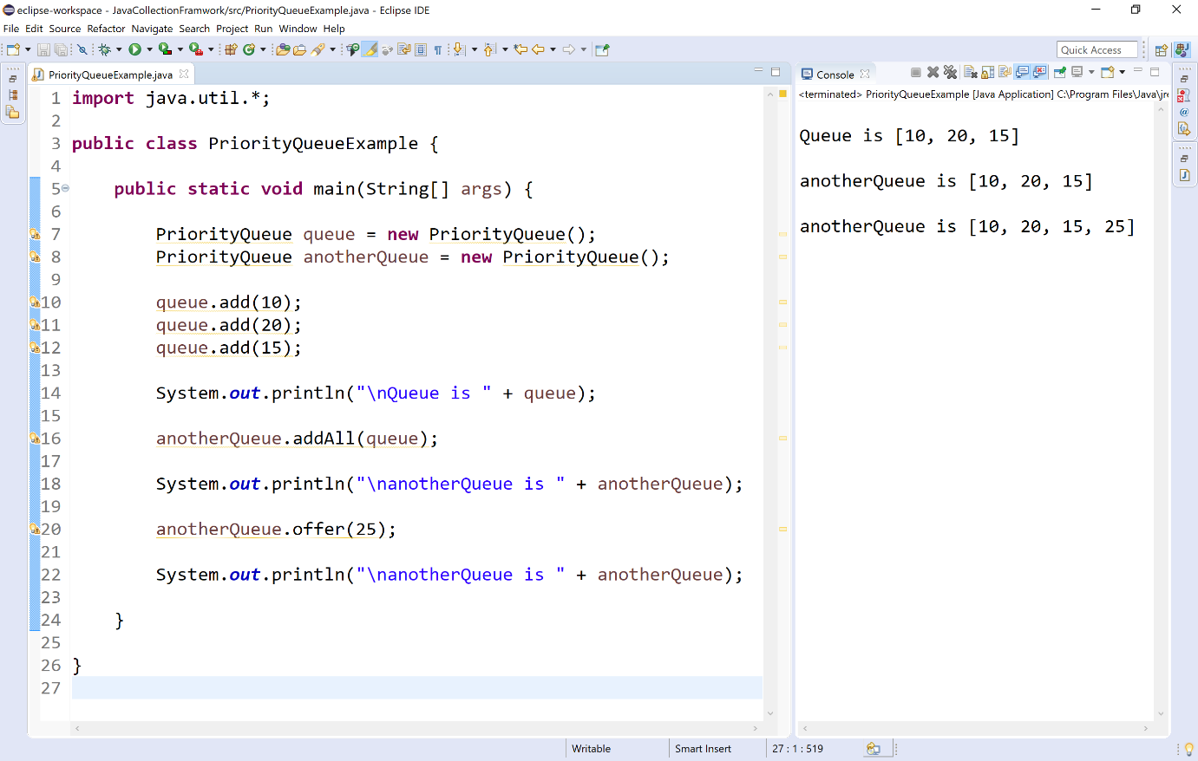

Accessing Items
The PriorityQueue class has the following methods to access items.
- E element( ) - Returns the first element from the invoking PriorityQueue.
- E peek( ) - Returns the first element from the invoking PriorityQueue, returns null if this queue is empty.
Let's consider an example program to illustrate accessing items from the PriorityQueue.
Example
import java.util.*;

public class PriorityQueueExample {

public static void main(String[] args) {

PriorityQueue queue = new PriorityQueue();

queue.add(10);
queue.add(20);
queue.add(15);

System.out.println("\nQueue is " + queue);

System.out.println("\nelement() - " + queue.element());

System.out.println("\npeek() - " + queue.peek());

}

}

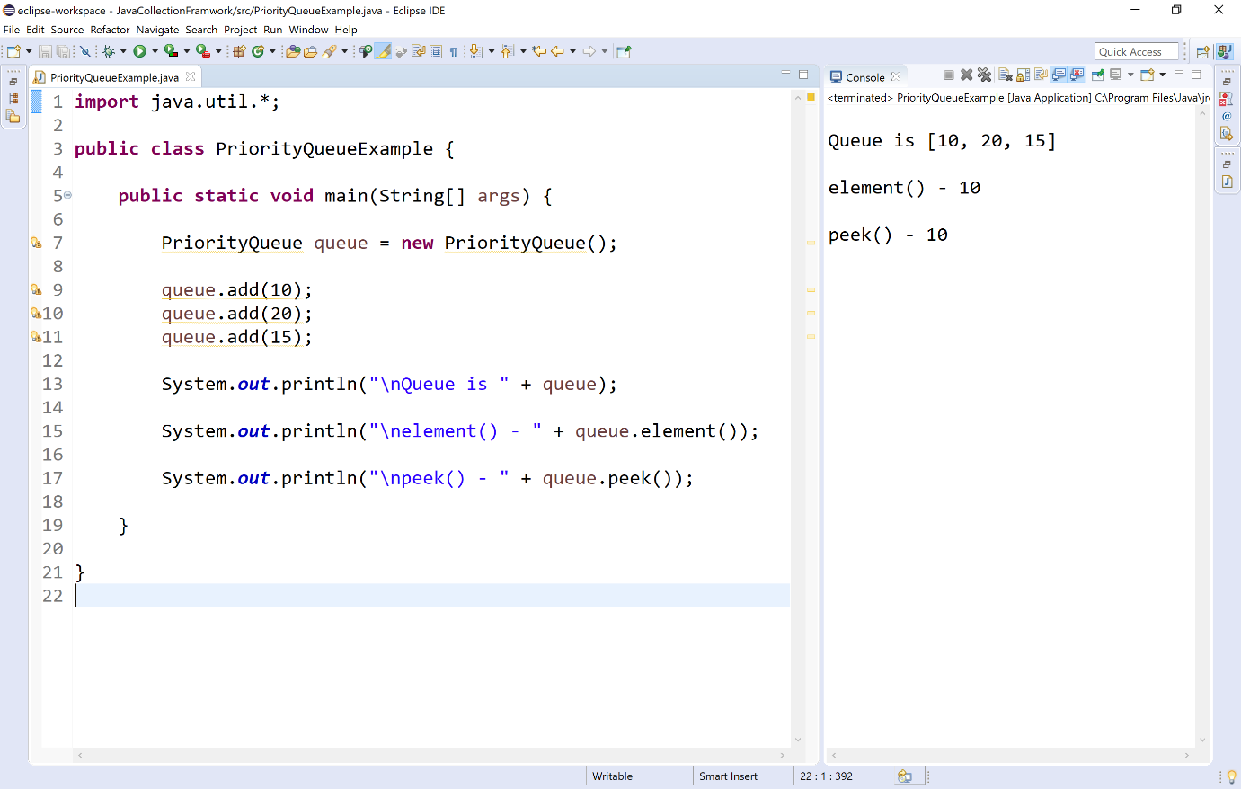

Updating Items
The PriorityQueue class has no methods to update or change items.

Removing Items
The PriorityQueue class has the following methods to remove items.
- E remove( ) - Removes the first element from the invoking PriorityQueue.
- boolean remove(Object element) - Removes the first occurrence of the given element from the invoking PriorityQueue.
- boolean removeAll(Collection c) - Removes all the elements of specified collection from the invoking PriorityQueue.
- boolean removeIf(Predicate p) - Removes all of the elements of this collection that satisfy the given predicate.
- boolean retainAll(Collection c) - Removes all the elements except those are in the specified collection from the invoking PriorityQueue.
- E poll( ) - Removes the first element from the PriorityQueue, and returns null if the list is empty.
- void clear( ) - Removes all the elements from the PriorityQueue.
Let's consider an example program to illustrate removing items from the PriorityQueue.
Example
import java.util.*;

public class PriorityQueueExample {

public static void main(String[] args) {

PriorityQueue queue = new PriorityQueue();
PriorityQueue anotherQueue = new PriorityQueue();

for(int i = 1; i <= 10; i++)
queue.add(i);
anotherQueue.add(5);
anotherQueue.add(7);
anotherQueue.add(8);
System.out.println("\nQueue initially is\n" + queue);

queue.remove();
System.out.println("\nQueue after remove() is\n" + queue);

queue.remove(8);
System.out.println("\nQueue after remove(8) is\n" + queue);

queue.poll();
System.out.println("\nQueue after poll() is\n" + queue);

queue.removeIf(n->n.equals(6));
System.out.println("\nQueue after removeIf(n->n.equals(6) is\n" + queue);

queue.retainAll(anotherQueue);
System.out.println("\nQueue after retainAll(anotherQueue) is\n" + queue);

queue.removeAll(anotherQueue);
System.out.println("\nQueue after removeAll(anotherQueue) is\n" + queue);

queue.clear();
System.out.println("\nQueue after clear() is\n" + queue);
}
}

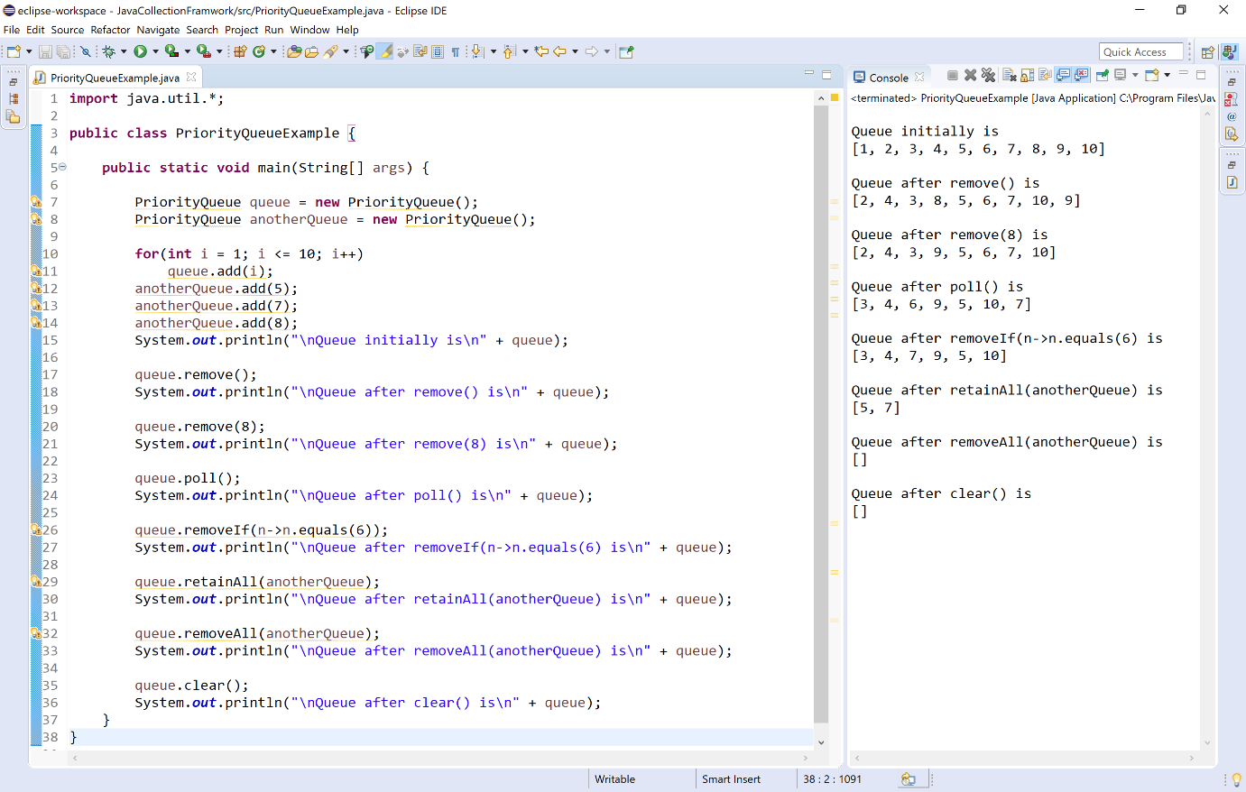

Other utility methods
The PriorityQueue class has the following methods to work with elements of it.
- int size( ) - Returns the total number of elements in the invoking PriorityQueue.
- boolean isEmpty( ) - Returns true if the list is empty otherwise returns false.
- boolean contains(Object element) - Returns true if the list contains given element otherwise returns false.
- Object[ ] toArray( ) - Returns an array of Object instances that contains all the elements from invoking LinkedList.
- Spliterator spliterator( ) - Creates spliterator over the elements in a list.
- void trimToSize( ) - Used to trim a LinkedList instance to the number of elements it contains.
- Iterator iterator( ) - Returns an iterator over the elements in the PriorityQueue. The iterator does not return the elements in any particular order.
Let's consider an example program to illustrate other utility methods of the PriorityQueue.
Example
import java.util.*;

public class PriorityQueueExample {

public static void main(String[] args) {

PriorityQueue queue = new PriorityQueue();

for(int i = 1; i <= 10; i++)
queue.add(i);

System.out.println("\nQueue initially is\n" + queue);

System.out.println("\nsize() - " + queue.size());

System.out.println("\nisEmpty() - " + queue.isEmpty());

System.out.println("\ncontains(3) - " + queue.contains(3));
}
}

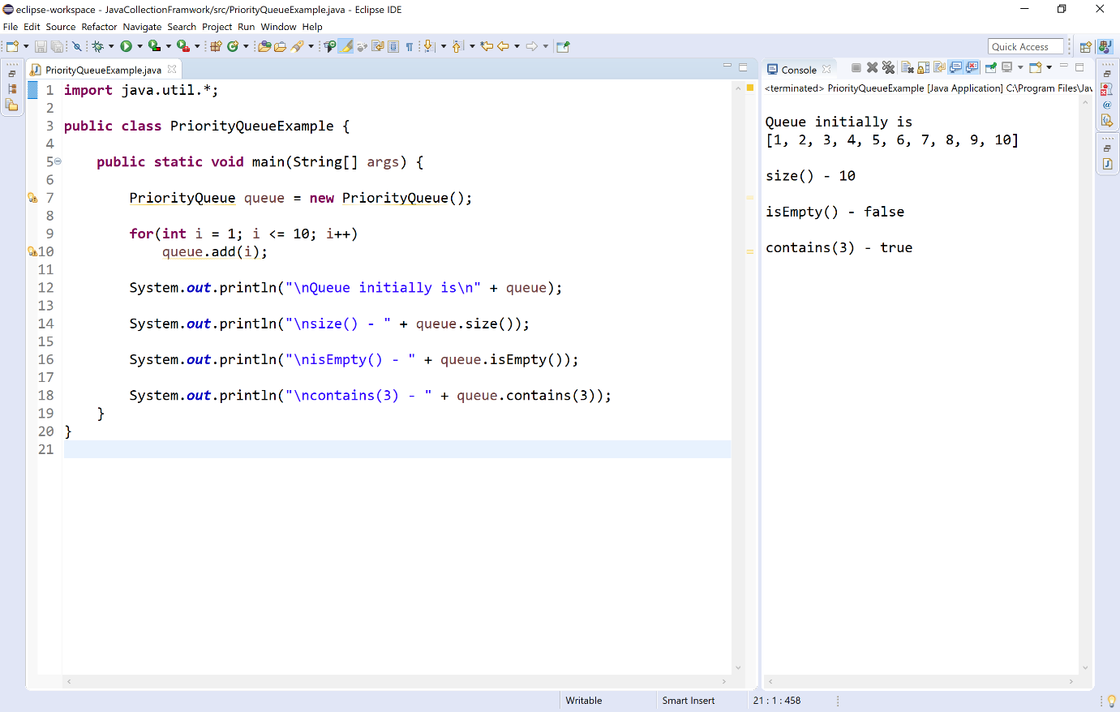

Consolidated list of methods
The following table providess a consolidated view of all methods of PriorityQueue.
Method | Description
boolean add(E element) | Appends given element to the PriorityQueue.
boolean addAll(Collection c) | Appends given collection of elements to the PriorityQueue.
boolean offer(E element) | Inserts the given element at end of the PriorityQueue.
E element( ) | Returns the first element from the PriorityQueue.
E peek( ) | Returns the first element from the PriorityQueue.
E remove() | Removes the first element from the invoking PriorityQueue.
boolean remove(Object element) | Removes the first occurence of the given element from the invoking PriorityQueue.
boolean removeAll(Collection c) | Removes the given collection of elements from the invoking PriorityQueue.
boolean removeIf(Predicate p) | Removes all of the elements of this collection that satisfy the given predicate.
boolean retainAll(Collection c) | Removes all the elements except those are in the specified collection from the invoking PriorityQueue.
E poll( ) | Removes the first element from the PriorityQueue, and returns null if the PriorityQueue is empty.
void clear( ) | Removes all the elements from the PriorityQueue.
int size( ) | Returns the total number of elements in the invoking PriorityQueue.
boolean isEmpty( ) | Returns true if the PriorityQueue is empty otherwise returns false.
boolean contains(Object element) | Returns true if the PriorityQueue contains given element otherwise returns false.
Object[ ] toArray( ) | Returns an array of Object instances that contains all the elements from invoking PriorityQueue.
Spliterator spliterator( ) | Creates spliterator over the elements in a PriorityQueue.
void trimToSize( ) | Used to trim a PriorityQueue instance to the number of elements it contains.

ArrayDeque class
The ArrayDeque class is used to create a dynamic double ended queue of elements that can grow or shrunk as needed.
🔔 The ArrayDeque is a child class of AbstractCollection
🔔 The ArrayDeque implements interfaces like Deque, Cloneable, and Serializable.
🔔 The ArrayDeque allows to store duplicate data values, but not null values.
🔔 The ArrayDeque maintains the order of insertion.
🔔 The ArrayDeque allows to add and remove elements at both the ends.
🔔 The ArrayDeque is faster than LinkedList and Stack.

ArrayDeque class declaration
The ArrayDeque class has the following declaration.
Example
public class ArrayDeque<E> extends AbstractCollection<E> implements Deque<E>, Cloneable, Serializable

ArrayDeque class constructors
The PriorityQueue class has the following constructors.
- ArrayDeque( ) - Creates an empty ArrayDeque with the default initial capacity (16).
- ArrayDeque(Collection c) - Creates a ArrayDeque with given collection of elements.
- ArrayDeque(int initialCapacity) - Creates an empty ArrayDeque with the specified initial capacity.

Operations on ArrayDeque
The ArrayDeque class allow us to perform several operations like adding, accesing, deleting, updating, looping, etc. Let's look at each operation with examples.

Adding Items
The ArrayDeque class has the following methods to add items.
- boolean add(E element) - Appends given element to the ArrayDeque.
- boolean addAll(Collection c) - Appends given collection of elements to the ArrayDeque.
- void addFirst(E element) - Adds given element at front of the ArrayDeque.
- void addLast(E element) - Adds given element at end of the ArrayDeque.
- boolean offer(E element) - Adds given element at end of the ArrayDeque.
- boolean offerFirst(E element) - Adds given element at front of the ArrayDeque.
- boolean offerLast(E element) - Adds given element at end of the ArrayDeque.
- void push(E element) - Adds given element at front of the ArrayDeque.
Let's consider an example program to illustrate adding items to the ArrayDeque.
Example
import java.util.*;

public class ArrayDequeExample {

public static void main(String[] args) {

ArrayDeque deque = new ArrayDeque();
ArrayDeque anotherDeque = new ArrayDeque();

deque.add(10);
deque.addFirst(5);
deque.addLast(15);
deque.offer(20);
deque.offerFirst(10);
deque.offerLast(30);

System.out.println("\nDeque is\n" + deque);

anotherDeque.addAll(deque);

System.out.println("\nanotherDeque is\n" + anotherDeque);

anotherDeque.push(40);

System.out.println("\nanotherDeque after push(40) is\n" + anotherDeque);
}

}

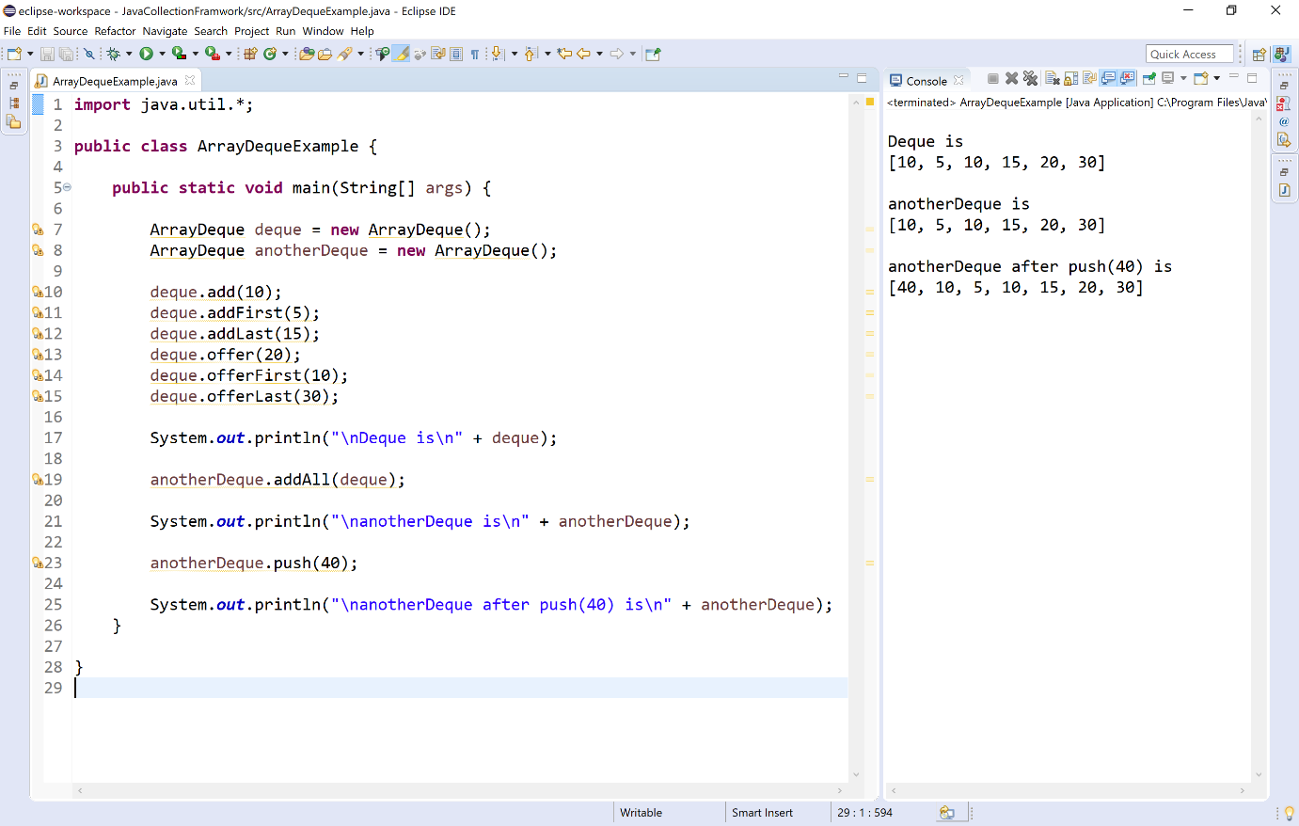

Accessing Items
The ArrayDeque class has the following methods to access items.
- E element( ) - Returns the first element from the invoking ArrayDeque.
- E getFirst( ) - Returns the first element from the invoking ArrayDeque.
- E getLast( ) - Returns the last element from the invoking ArrayDeque.
- E peek( ) - Returns the first element from the invoking ArrayDeque, returns null if this queue is empty.
- E peekFirst( ) - Returns the first element from the invoking ArrayDeque, returns null if this queue is empty.
- E peekLast( ) - Returns the last element from the invoking ArrayDeque, returns null if this queue is empty.
Let's consider an example program to illustrate accessing items from the ArrayDeque.
Example
import java.util.*;

public class ArrayDequeExample {

public static void main(String[] args) {

ArrayDeque deque = new ArrayDeque();

for(int i = 1; i <= 10; i++)
deque.add(i);

System.out.println("\nDeque is\n" + deque);

System.out.println("\nelement() - " + deque.element());

System.out.println("\ngetFirst() - " + deque.getFirst());

System.out.println("\ngetLast() - " + deque.getLast());

System.out.println("\npeek() - " + deque.peek());

System.out.println("\npeekFirst() - " + deque.peekFirst());

System.out.println("\npeekLast() - " + deque.peekLast());
}

}

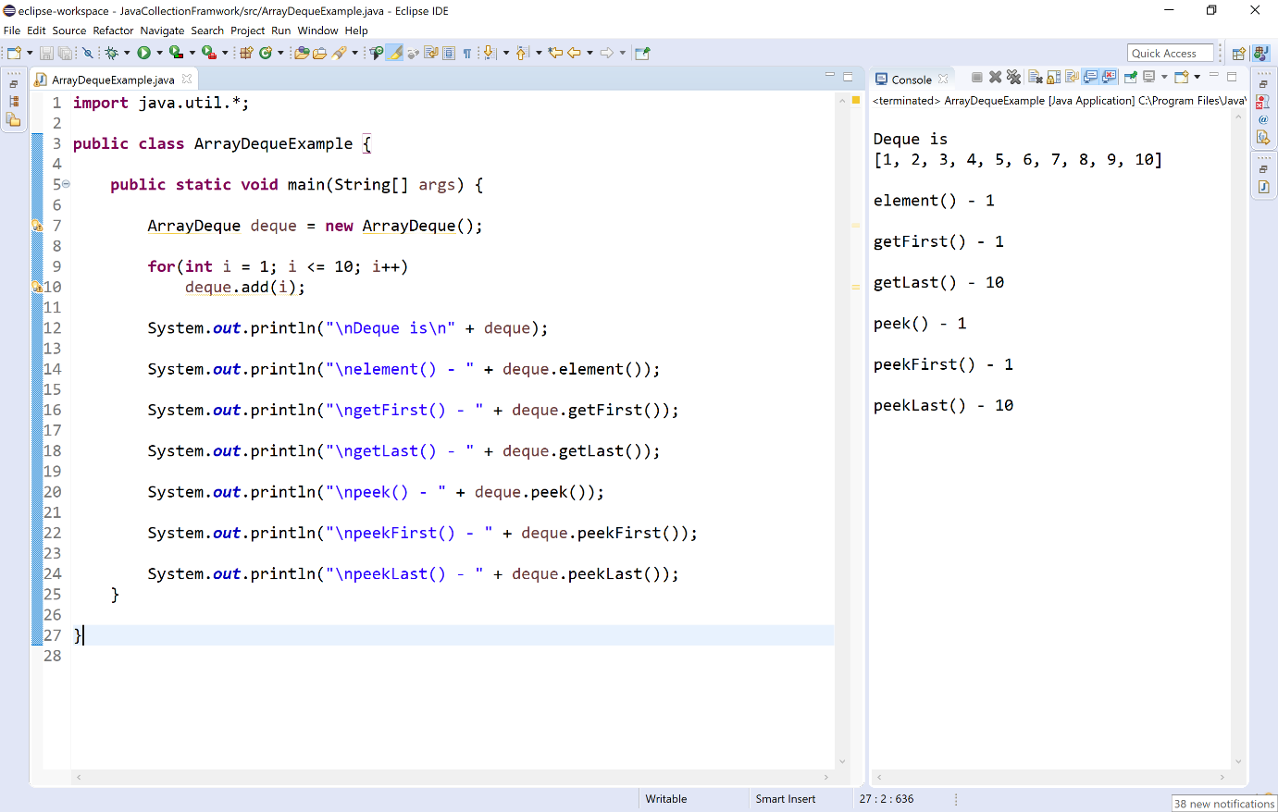

Updating Items
The ArrayDeque class has no methods to update or change items.

Removing Items
The ArrayDeque class has the following methods to remove items.
- E remove( ) - Removes the first element from the invoking ArrayDeque.
- E removeFirst( ) - Removes the first element from the invoking ArrayDeque.
- E removeLast( ) - Removes the last element from the invoking ArrayDeque.
- boolean remove(Object o) - Removes the specified element from the invoking ArrayDeque.
- boolean removeFirstOccurrence(Object o) - Removes the first occurrence of the specified element in this ArrayDeque.
- boolean removeLastOccurrence(Object o) - Removes the last occurrence of the specified element in this ArrayDeque.
- boolean removeIf(Predicate p) - Removes all of the elements of ArrayDeque collection that satisfy the given predicate.
- boolean retainAll(Collection c) - Removes all of the elements of ArrayDeque collection except specified collection of elements.
- E poll( ) - Removes the first element from the ArrayDeque, and returns null if the list is empty.
- E pollFirst( ) - Removes the first element from the ArrayDeque, and returns null if the list is empty.
- E pollLast( ) - Removes the last element from the ArrayDeque, and returns null if the list is empty.
- E pop( ) - Removes the first element from the ArrayDeque.
- void clear( ) - Removes all the elements from the PriorityQueue.
Let's consider an example program to illustrate removing items from the ArrayDeque.
Example
import java.util.*;

public class ArrayDequeExample {

public static void main(String[] args) {

ArrayDeque deque = new ArrayDeque();

for(int i = 1; i <= 10; i++)
deque.add(i);

System.out.println("\nDeque is\n" + deque);

deque.remove();
System.out.println("\nDeque after remove()\n" + deque);

deque.removeFirst();
System.out.println("\nDeque after removeFirst()\n" + deque);

deque.removeLast();
System.out.println("\nDeque after removeLast()\n" + deque);

deque.remove(5);
System.out.println("\nDeque after remove(5)\n" + deque);

deque.poll();
System.out.println("\nDeque after poll()\n" + deque);

deque.pollFirst();
System.out.println("\nDeque after pollFirst()\n" + deque);

deque.pollLast();
System.out.println("\nDeque after pollLast()\n" + deque);

deque.pop();
System.out.println("\nDeque after pop()\n" + deque);

deque.clear();
System.out.println("\nDeque after clear()\n" + deque);
}
}

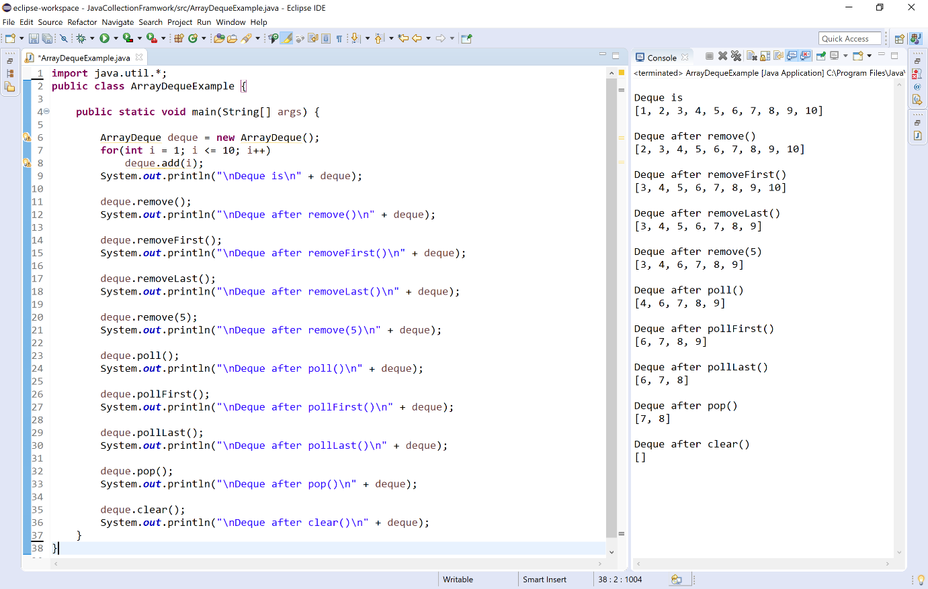

Other utility methods
The ArrayDeque class has the following methods to work with elements of it.
- int size( ) - Returns the total number of elements in the invoking ArrayDeque.
- boolean isEmpty( ) - Returns true if the ArrayDeque is empty otherwise returns false.
- ArrayDeque clone( ) - Returns a copy of the invoking ArrayDeque.
- boolean contains(Object element) - Returns true if the ArrayDeque contains given element otherwise returns false.
- boolean containsAll(Collection c) - Returns true if the ArrayDeque contains given collection of elements otherwise returns false.
- boolean equals(Object o) - Compares the specified object with invoking ArrayDeque collection for equality.
- int hashCode( ) - Returns the hash code of the invoking ArrayDeque.
- Object[ ] toArray( ) - Returns an array of Object instances that contains all the elements from invoking ArrayDeque.
- Spliterator spliterator( ) - Creates spliterator over the elements in a ArrayDeque.
- Iterator iterator( ) - Returns an iterator over the elements in the ArrayDeque. The iterator does not return the elements in any particular order.
Let's consider an example program to illustrate other utility methods of the ArrayDeque.
Example
import java.util.*;

public class ArrayDequeExample {

public static void main(String[] args) {

ArrayDeque deque = new ArrayDeque();

for(int i = 1; i <= 10; i++)
deque.add(i);

System.out.println("\nDeque is\n" + deque);

System.out.println("\nsize() - " + deque.size());

System.out.println("\nisEmpty() - " + deque.isEmpty());

System.out.println("\ncontains(6) - " + deque.contains(6));

System.out.println("\nhashCode() - " + deque.hashCode());

System.out.println("\nequals(6) - " + deque.equals(6));
}
}

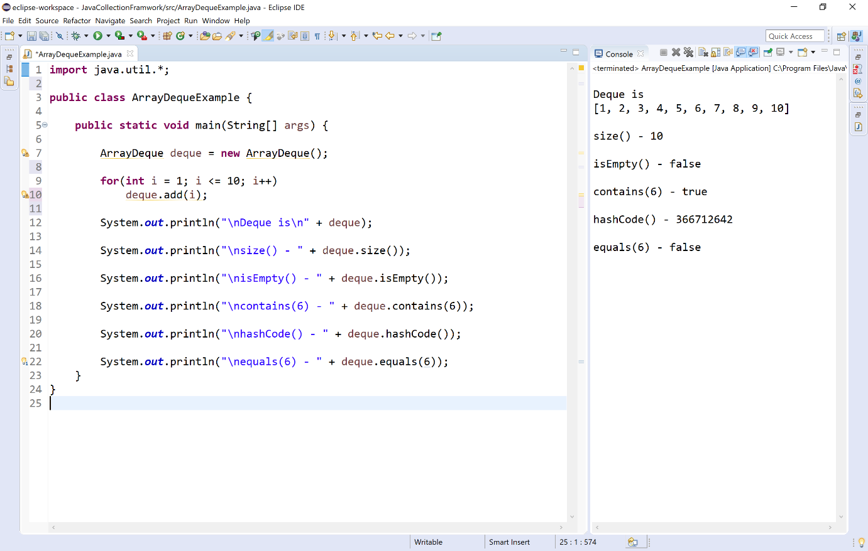

Consolidated list of methods
The following table providess a consolidated view of all methods of ArrayDeque.
Method | Description
boolean add(E element) | Appends given element to the ArrayDeque.
boolean addAll(Collection c) | Appends given collection of elements to the ArrayDeque.
void addFirst(E element) | Inserts the given element at front of the ArrayDeque.
void addLast(E element) | Inserts the given element at end of the ArrayDeque.
boolean offer(E element) | Inserts the given element at end of the ArrayDeque.
boolean offerFirst(E element) | Inserts the given element at front of the ArrayDeque.
boolean offerLast(E element) | Inserts the given element at end of the ArrayDeque.
void push(E element) | Inserts the given element at front of the ArrayDeque.
E element( ) | Returns the first element from the ArrayDeque.
E getFirst( ) | Returns the first element from the ArrayDeque.
E getLast( ) | Returns the last element from the ArrayDeque.
E peek( ) | Returns the first element from the invoking ArrayDeque, returns null if this queue is empty.
E peekFirst( ) | Returns the first element from the invoking ArrayDeque, returns null if this queue is empty.
E peekLast( ) | Returns the last element from the invoking ArrayDeque, returns null if this queue is empty.
E remove() | Removes the first element from the invoking ArrayDeque.
E removeFirst() | Removes the first element from the invoking ArrayDeque.
E removeLast() | Removes the last element from the invoking ArrayDeque.
boolean remove(Object element) | Removes the first occurence of the given element from the invoking ArrayDeque.
boolean removeFirstOccurrence(Object element) | Removes the first occurrence of the specified element in this ArrayDeque.
boolean removLastOccurrence(Object element) | Removes the last occurrence of the specified element in this ArrayDeque.
boolean removeIf(Predicate p) | Removes all of the elements of the ArrayDeque collection that satisfy the given predicate.
boolean retainAll(Collection c) | Removes all the elements except those are in the specified collection from the invoking ArrayDeque.
E poll( ) | Removes the first element from the ArrayDeque, and returns null if the ArrayDeque is empty.
E pollFirst( ) | Removes the first element from the ArrayDeque, and returns null if the ArrayDeque is empty.
E pollLast( ) | Removes the last element from the ArrayDeque, and returns null if the ArrayDeque is empty.
E pop() | Removes the first element from the invoking ArrayDeque.
void clear( ) | Removes all the elements from the ArrayDeque.
int size( ) | Returns the total number of elements in the invoking ArrayDeque.
boolean isEmpty( ) | Returns true if the ArrayDeque is empty otherwise returns false.
boolean equals( ) | Compares the specified object with invoking ArrayDeque collection for equality.
boolean contains(Object element) | Returns true if the ArrayDeque contains given element otherwise returns false.
boolean containsAll(Collection c) | Returns true if the ArrayDeque contains all elements of given collection otherwise returns false.
int hashCode( ) | Returns the hash code of the invoking ArrayDeque.
Object[ ] toArray( ) | Returns an array of Object instances that contains all the elements from invoking ArrayDeque.
Spliterator spliterator( ) | Creates spliterator over the elements in a ArrayDeque.
Iterator iterator( ) | Returns an iterator over the elements in the ArrayDeque. The iterator does not return the elements in any particular order.

Accessing a Collection via an Iterator
The java collection framework often we want to cycle through the elements. For example, we might want to display each element of a collection. The java provides an interface Iterator that is available inside the java.util package to cycle through each element of a collection.
🔔 The Iterator allows us to move only forward direction.
🔔 The Iterator does not support the replacement and addition of new elements.
We use the following steps to access a collection of elements using the Iterator.
- Step - 1: Create an object of the Iterator by calling collection.itertor( ) method.
- Step - 2: Use the method hasNext( ) to access to check does the collection has the next element. (Use a loop).
- Step - 3: Use the method next( ) to access each element from the collection. (use inside the loop).
- The Iterator has the following methods.
Method | Description
Iterator iterator( ) | Used to obtain an iterator to the start of the collection.
boolean hasNext( ) | Returns true if the collection has the next element, otherwise, it returns false.
E next( ) | Returns the next element available in the collection.

Let's consider an example program to illustrate accessing elements of a collection via the Iterator.
Example
import java.util.*;

public class TreeSetExample {

public static void main(String[] args) {

TreeSet set = new TreeSet();

Random num = new Random();
for(int i = 0; i < 10; i++)
set.add(num.nextInt(100));

Iterator collection = set.iterator();

System.out.println("All the elements of TreeSet collection:");
while(collection.hasNext())
System.out.print(collection.next() + ", ");

}
}

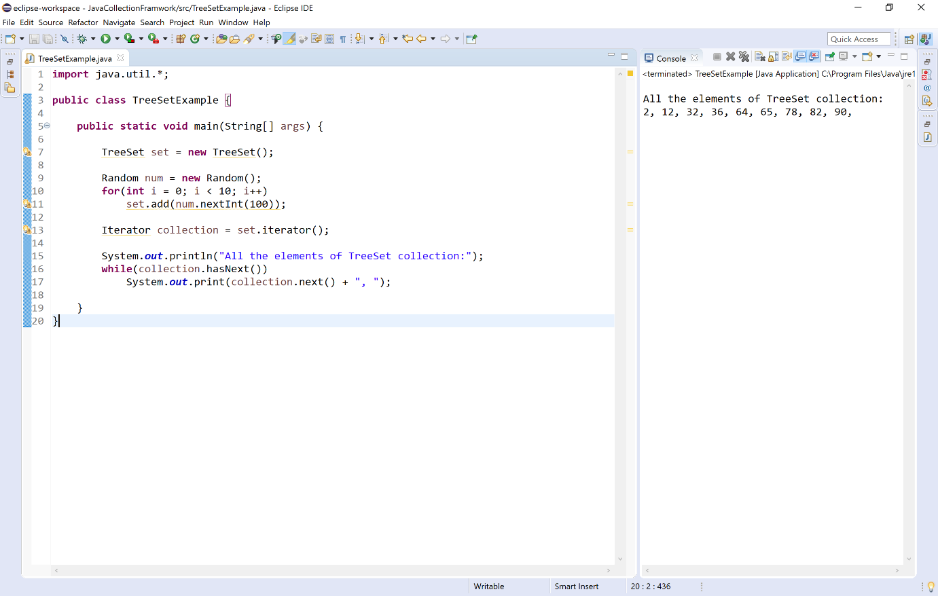

The For-Each alternative
Using for-each, we can access the elements of a collection. But for-each can only be used if we don't want to modify the contents of a collection, and we don't want any reverse access.
Alternatively, we can use the Iterator to access or cycle through a collection of elements.
Let's consider an example program to illustrate The for-each alternative.
Example
import java.util.*;

public class TreeSetExample {

public static void main(String[] args) {

ArrayList list = new ArrayList();
PriorityQueue queue = new PriorityQueue();

Random num = new Random();
for(int i = 0; i < 10; i++) {
list.add(num.nextInt(100));
queue.add(num.nextInt(100));
}

// Accessing using for-each statement
System.out.println("\n\nAll the elements of ArrayList collection:");
for(Object element:list) {
System.out.print(element + ", ");
}

// Accessing using Iterator
Iterator collection = queue.iterator();
System.out.println("\n\nAll the elements of PriorityQueue collection:");
while(collection.hasNext()) {
System.out.print(collection.next() + ", ");
}

}
}

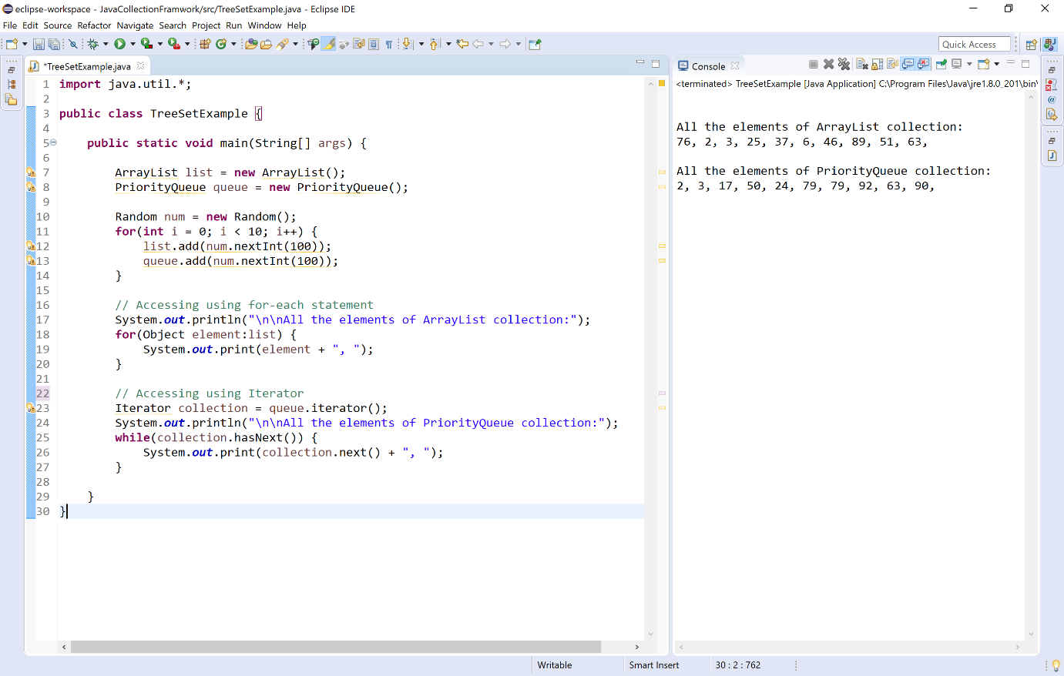

Map Interfaces and Classes
The java collection framework has an interface Map that is available inside the java.util package. The Map interface is not a subtype of Collection interface.
The Map interface has the following three classes.
Class | Description
HashMap | It implements the Map interface, but it doesn't maintain any order.
LinkedHashMap | It implements the Map interface, it also extends HashMap class. It maintains the insertion order.
TreeMap | It implements the Map and SortedMap interfaces. It maintains the ascending order.

Commonly used methods defined by Map interface
Method | Description
Object put(Object k, Object v) | It performs an entry into the Map.
Object putAll(Map m) | It inserts all the entries of m into invoking Map.
Object get(Object k) | It returns the value associated with given key.
boolean containsKey(Object k) | It returns true if map contain k as key. Otherwise false.
Set keySet() | It returns a set that contains all the keys from the invoking Map.
Set valueSet() | It returns a set that contains all the values from the invoking Map.
Set entrySet() | It returns a set that contains all the entries from the invoking Map.
Now, let's look at each class in detail with example programs.

HashMap Class
The HashMap class is a child class of AbstractMap, and it implements the Map interface. The HashMap is used to store the data in the form of key, value pair using hash table concept.

Key Properties of HashMap
- HashMap is a child class of AbstractMap class.
- HashMap implements the interfeaces Map, Cloneable, and Serializable.
- HashMap stores data as a pair of key and value.
- HashMap uses Hash table concept to store the data.
- HashMap does not allow duplicate keys, but values may be repeated.
- HashMap allows only one null key and multiple null values.
- HashMap does not follow any oreder.
- HashMap has the default capacity 16 entries.
Let's consider an example program to illustrate HashMap.
Example
import java.util.*;

public class HashMapExample {

public static void main(String[] args) {

Scanner read = new Scanner(System.in);

HashMap employeeInfo = new HashMap();
HashMap contactInfo = new HashMap();

employeeInfo.put(1, "Raja");
employeeInfo.put(2, "Gouthami");
employeeInfo.put(3, "Heyansh");
employeeInfo.put(4, "Yamini");
employeeInfo.put(5, "ManuTej");

System.out.println("Employee Information\n" + employeeInfo);

System.out.println("\nPlease enter the ID and Contact number");
System.out.println("Employee IDs : " + employeeInfo.keySet());
System.out.print("Enter ID: ");
int id = read.nextInt();
System.out.print("Enter Contact Number: ");
long contactNo = read.nextLong();
if(employeeInfo.containsKey(id)) {
contactInfo.put(id, contactNo);
}

System.out.println("\n\nEmployee Contact Information\n");
System.out.println("ID - " + id);
System.out.println("Name - " + employeeInfo.get(id));
System.out.println("Contact Number - " + contactInfo.get(id));

}

}

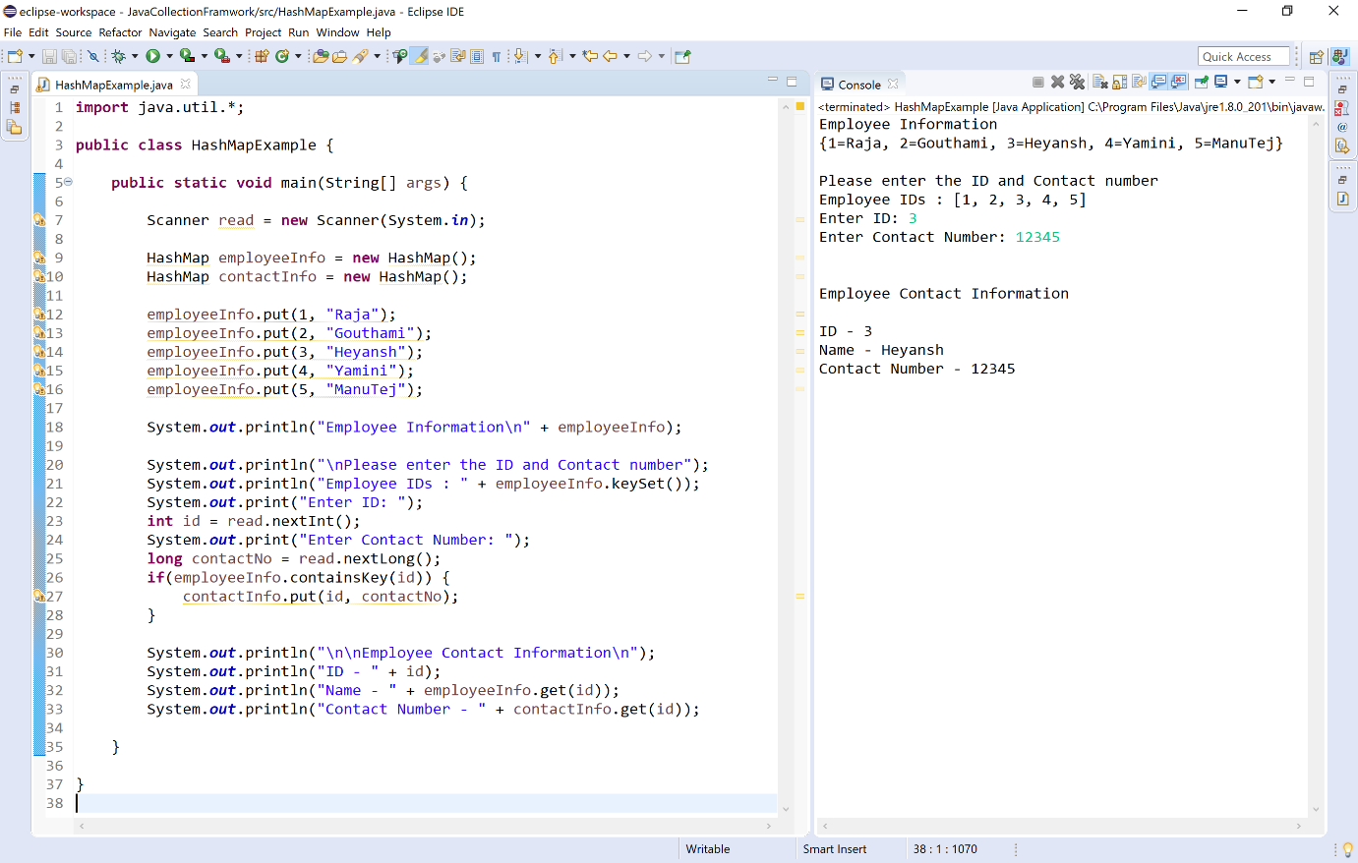

LinkedHashMap Class
The LinkedHashMap class is a child class of HashMap, and it implements the Map interface. The LinkedHashMap is used to store the data in the form of key, value pair using hash table and linked list concepts.

Key Properties of LinkedHashMap
- LinkedHashMap is a child class of HashMap class.
- LinkedHashMap implements the Map interface.
- LinkedHashMap stores data as a pair of key and value.
- LinkedHashMap uses Hash table concept to store the data.
- LinkedHashMap does not allow duplicate keys, but values may be repeated.
- LinkedHashMap allows only one null key and multiple null values.
- LinkedHashMap follows the insertion oreder.
- LinkedHashMap has the default capacity 16 entries.
Let's consider an example program to illustrate LinkedHashMap.
Example
import java.util.*;

public class HashMapExample {

public static void main(String[] args) {

Scanner read = new Scanner(System.in);

LinkedHashMap employeeInfo = new LinkedHashMap();
LinkedHashMap contactInfo = new LinkedHashMap();

employeeInfo.put(1, "Raja");
employeeInfo.put(2, "Gouthami");
employeeInfo.put(3, "Heyansh");
employeeInfo.put(4, "Yamini");
employeeInfo.put(5, "ManuTej");

System.out.println("Employee Information\n" + employeeInfo);

System.out.println("\nPlease enter the ID and Contact number");
System.out.println("Employee IDs : " + employeeInfo.keySet());
System.out.print("Enter ID: ");
int id = read.nextInt();
System.out.print("Enter Contact Number: ");
long contactNo = read.nextLong();
if(employeeInfo.containsKey(id)) {
contactInfo.put(id, contactNo);
}

System.out.println("\n\nEmployee Contact Information\n");
System.out.println("ID - " + id);
System.out.println("Name - " + employeeInfo.get(id));
System.out.println("Contact Number - " + contactInfo.get(id));

}

}

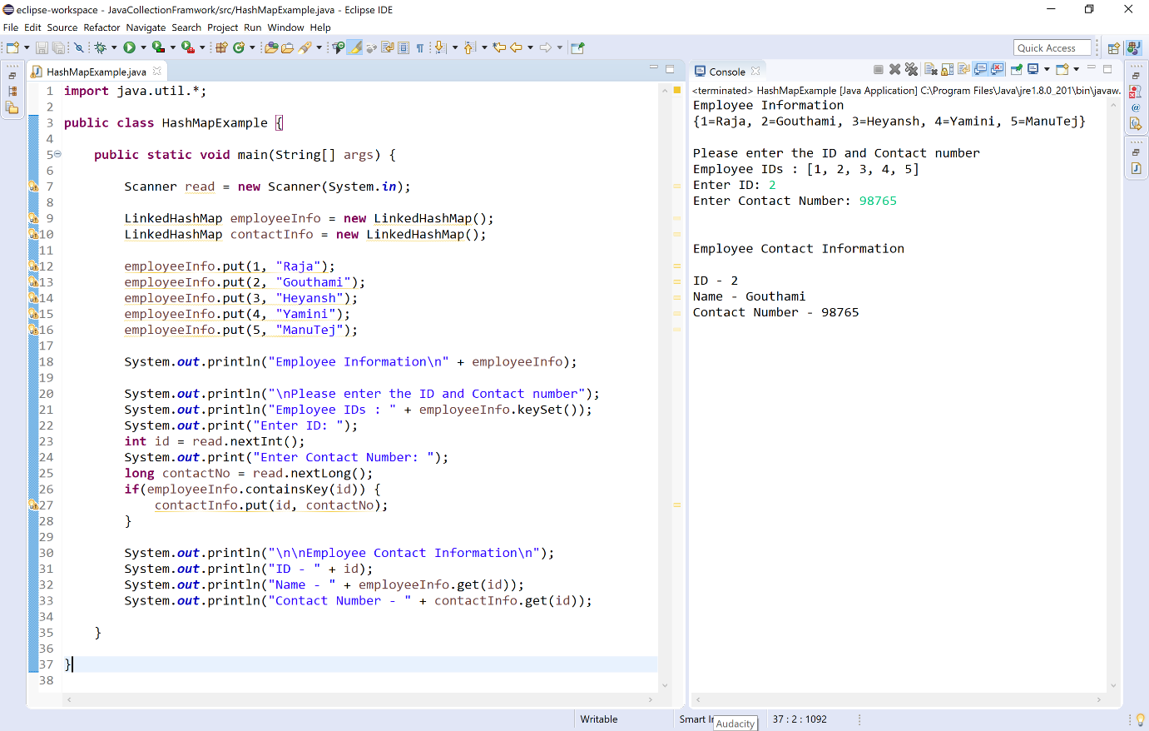

TreeMap Class
The TreeMap class is a child class of AbstractMap, and it implements the NavigableMap interface which is a child interface of SortedMap. The TreeMap is used to store the data in the form of key, value pair using a red-black tree concepts.

Key Properties of TreeMap
- TreeMap is a child class of AbstractMap class.
- TreeMap implements the NavigableMap interface which is a child interface of SortedMap interface.
- TreeMap stores data as a pair of key and value.
- TreeMap uses red-black tree concept to store the data.
- TreeMap does not allow duplicate keys, but values may be repeated.
- TreeMap does not allow null key, but allows null values.
- TreeMap follows the ascending oreder based on keys.
Let's consider an example program to illustrate TreeMap.
Example
import java.util.*;

public class HashMapExample {

public static void main(String[] args) {

Scanner read = new Scanner(System.in);

TreeMap employeeInfo = new TreeMap();
TreeMap contactInfo = new TreeMap();

employeeInfo.put(1, "Raja");
employeeInfo.put(4, "Gouthami");
employeeInfo.put(5, "Heyansh");
employeeInfo.put(3, "Yamini");
employeeInfo.put(2, "ManuTej");

System.out.println("Employee Information\n" + employeeInfo);

System.out.println("\nPlease enter the ID and Contact number");
System.out.println("Employee IDs : " + employeeInfo.keySet());
System.out.print("Enter ID: ");
int id = read.nextInt();
System.out.print("Enter Contact Number: ");
long contactNo = read.nextLong();
if(employeeInfo.containsKey(id)) {
contactInfo.put(id, contactNo);
}

System.out.println("\n\nEmployee Contact Information\n");
System.out.println("ID - " + id);
System.out.println("Name - " + employeeInfo.get(id));
System.out.println("Contact Number - " + contactInfo.get(id));

}

}

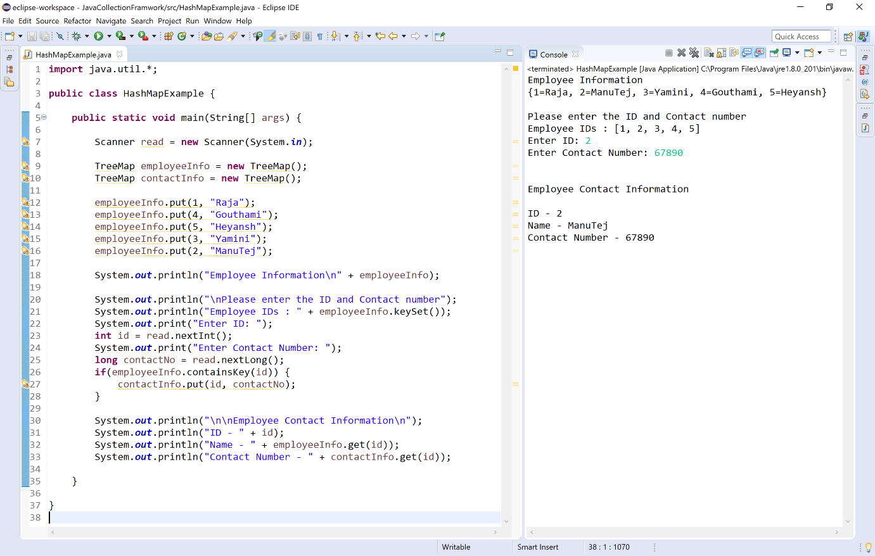
Comparators in Java
he Comparator is an interface available in the java.util package. The java Comparator is used to order the objects of user-defined classes. The java Comparator can compare two objects from two different classes.
Using the java Comparator, we can sort the elements based on data members of a class. For example, we can sort based on roolNo, age, salary, marks, etc.
The Comparator interface has the following methods.
Method | Description
int compare(Object obj1, Object obj2) | It is used to compares the obj1 with o bj2 .
boolean equals(Object obj) | It is used to check the equity between current object and argumented object.
The Comparator can be used in the following three ways.
- Using a seperate class that implements Comparator interface.
- Using anonymous class.
- Using lamda expression.

Using a seperate class
We use the following steps to use Comparator with a seperate class.
- Step - 1: Create the user-defined class.
- Step - 2: Create a class that implements Comparator interface.
- Step - 3: Implement the comapare( ) method of Comparator interface inside the above defined class(step - 2).
- Step - 4: Create the actual class where we use the Compatator object with sort method of Collections class.
- Step - 5: Create the object of Compatator interface using the class crearted in step - 2.
- Step - 6: Call the sort method of Collections class by passing the object created in step - 6.
- Step - 7: Use a for-each (any loop) to print the sorted information.
Let's consider an example program to illustrate Comparator using a separate class.
Example
import java.util.*;

class Student{

String name;
float percentage;

Student(String name, float percentage){
this.name = name;
this.percentage = percentage;
}

}

class PercentageComparator implements Comparator<Student>{
public int compare(Student stud1, Student stud2) {
if(stud1.percentage < stud2.percentage)
return 1;
return -1;
}
}

public class StudentCompare{

public static void main(String args[]) {

ArrayList<Student> studList = new ArrayList<Student>();

studList.add(new Student("Gouthami", 90.61f));
studList.add(new Student("Raja", 83.55f));
studList.add(new Student("Honey", 85.55f));
studList.add(new Student("Teja", 77.56f));
studList.add(new Student("Varshith", 80.89f));

Comparator<Student> com = new PercentageComparator();

Collections.sort(studList, com);

System.out.println("Avg % --> Name");
System.out.println("---------------------");
for(Student stud:studList) {
System.out.println(stud.percentage + " --> " + stud.name);
}
}
}

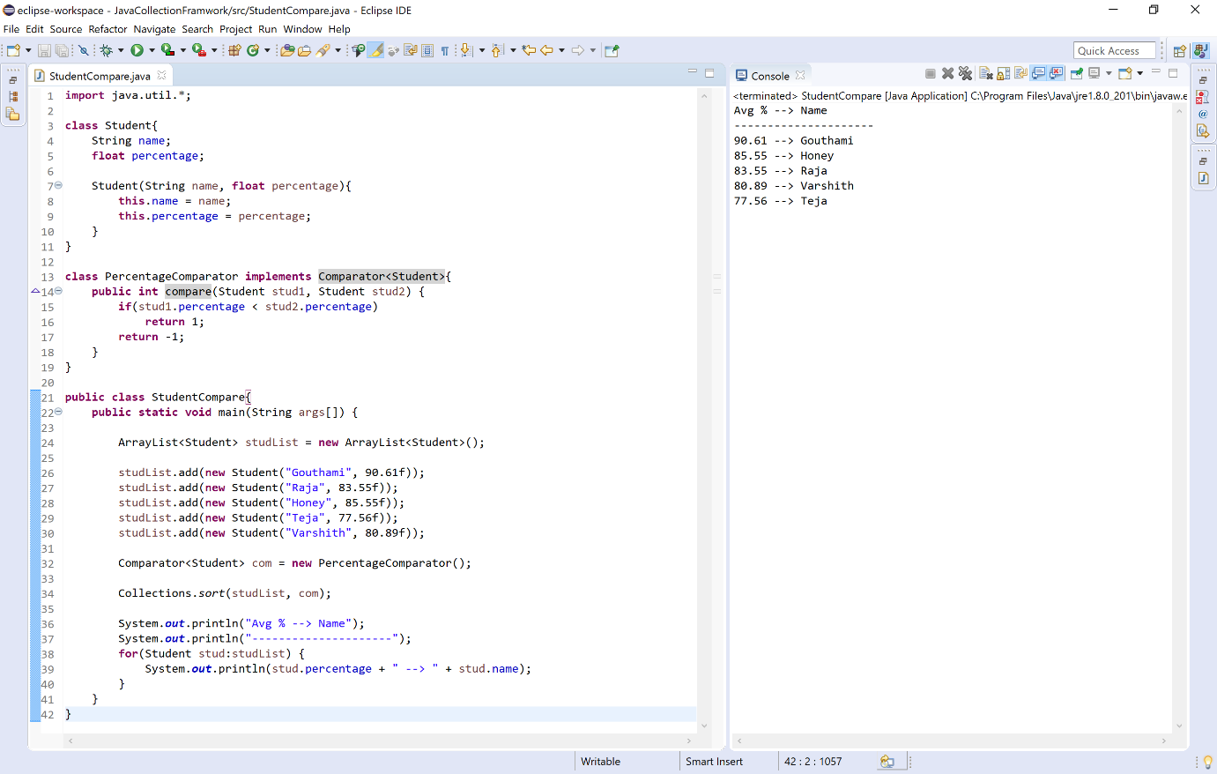

Using anonymous class
We use the following steps to use Comparator with anonymous class.
- Step - 1: Create the user-defined class.
- Step - 2: Create the actual class where we use the Compatator object with sort method of Collections class.
- Step - 3: Create the object of Compatator interface using anonymous class and implement compare method of Comparator interface.
- Step - 4: Call the sort method of Collections class by passing the object created in step - 6.
- Step - 5: Use a for-each (any loop) to print the sorted information.
Let's consider an example program to illustrate Comparator using a separate class.
Example
import java.util.*;

class Student{

String name;
float percentage;

Student(String name, float percentage){
this.name = name;
this.percentage = percentage;
}

}

public class StudentCompare{

public static void main(String args[]) {

ArrayList<Student> studList = new ArrayList<Student>();

studList.add(new Student("Gouthami", 90.61f));
studList.add(new Student("Raja", 83.55f));
studList.add(new Student("Honey", 85.55f));
studList.add(new Student("Teja", 77.56f));
studList.add(new Student("Varshith", 80.89f));

Comparator<Student> com = new Comparator<Student>() {
public int compare(Student stud1, Student stud2) {
if(stud1.percentage < stud2.percentage)
return 1;
return -1;
}
};

Collections.sort(studList, com);

System.out.println("Avg % --> Name");
System.out.println("---------------------");
for(Student stud:studList) {
System.out.println(stud.percentage + " --> " + stud.name);
}
}
}

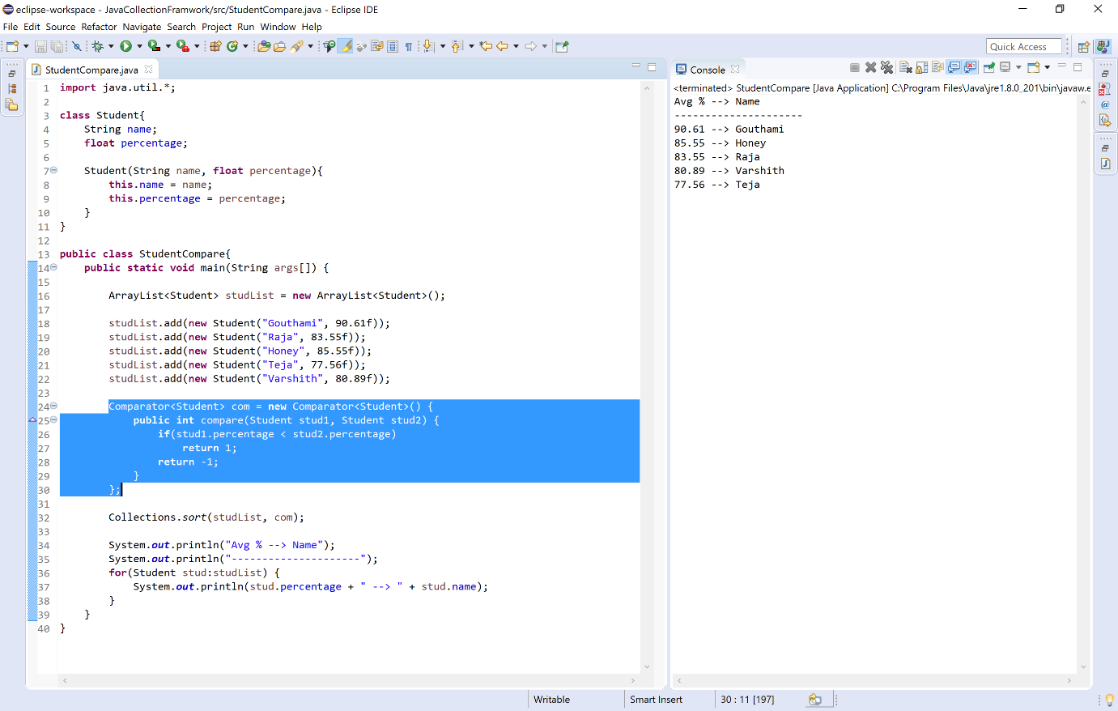

Using lamda expression
We use the following steps to use Comparator with lamda expression.
- Step - 1: Create the user-defined class.
- Step - 2: Create the actual class where we use the Compatator object with sort method of Collections class.
- Step - 3: Create the object of Compatator interface using lamda expression and implement the code for compare method of Comparator interface.
- Step - 4: Call the sort method of Collections class by passing the object created in step - 6.
- Step - 5: Use a for-each (any loop) to print the sorted information.
Let's consider an example program to illustrate Comparator using a separate class.
Example
import java.util.*;

class Student{

String name;
float percentage;

Student(String name, float percentage){
this.name = name;
this.percentage = percentage;
}
}

public class StudentCompare{

public static void main(String args[]) {

ArrayList<Student> studList = new ArrayList<Student>();

studList.add(new Student("Gouthami", 90.61f));
studList.add(new Student("Raja", 83.55f));
studList.add(new Student("Honey", 85.55f));
studList.add(new Student("Teja", 77.56f));
studList.add(new Student("Varshith", 80.89f));

Comparator<Student> com = (stud1, stud2) -> {
if(stud1.percentage < stud2.percentage)
return 1;
return -1;
};

Collections.sort(studList, com);

System.out.println("Avg % --> Name");
System.out.println("---------------------");
for(Student stud:studList) {
System.out.println(stud.percentage + " --> " + stud.name);
}
}
}

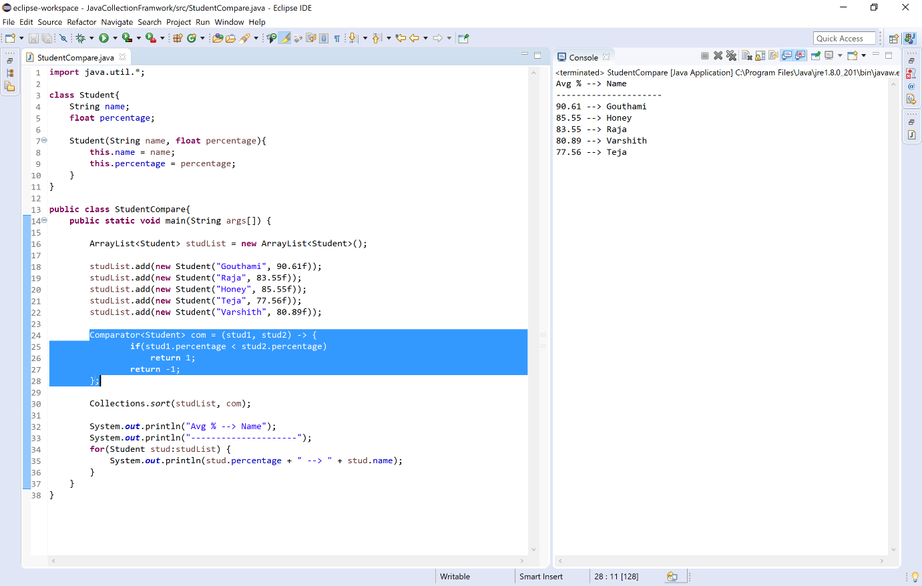
Collection Algorithms in Java
The java collection framework defines several algorithms as static methods that can be used with collections and map objects.
All the collection algorithms in the java are defined in a class called Collections which defined in the java.util package.
All these algorithms are highly efficient and make coding very easy. It is better to use them than trying to re-implement them.
The collection framework has the following methods as algorithms.
Method | Description
void sort(List list) | Sorts the elements of the list as determined by their natural ordering.
void sort(List list, Comparator comp) | Sorts the elements of the list as determined by Comparator comp.
void reverse(List list) | Reverses all the elements sequence in list.
void rotate(List list, int n) | Rotates list by n places to the right. To rotate left, use a negative value for n.
void shuffle(List list) | Shuffles the elements in list.
void shuffle(List list, Random r) | Shuffles the elements in the list by using r as a source of random numbers.
void copy(List list1, List list2) | Copies the elements of list2 to list1.
List nCopies(int num, Object obj) | Returns num copies of obj contained in an immutable list. num can not be zero or negative.
void swap(List list, int idx1, int idx2) | Exchanges the elements in the list at the indices specified by idx1 and idx2.
int binarySearch(List list, Object value) | Returns the position of value in the list (must be in the sorted order), or -1 if value is not found.
int binarySearch(List list, Object value, Comparator c) | Returns the position of value in the list ordered according to c, or -1 if value is not found.
int indexOfSubList(List list, List subList) | Returns the index of the first match of subList in the list, or -1 if no match is found.
int lastIndexOfSubList(List list, List subList) | Returns the index of the last match of subList in the list, or -1 if no match is found.
Object max(Collection c) | Returns the largest element from the collection c as determined by natural ordering.
Object max(Collection c, Comparator comp) | Returns the largest element from the collection c as determined by Comparator comp.
Object min(Collection c) | Returns the smallest element from the collection c as determined by natural ordering.
Object min(Collection c, Comparator comp) | Returns the smallest element from the collection c as determined by Comparator comp.
void fill(List list, Object obj) | Assigns obj to each element of the list.
boolean replaceAll(List list, Object old, Object new) | Replaces all occurrences of old with new in the list.
Enumeration enumeration(Collection c) | Returns an enumeration over Collection c.
ArrayList list(Enumeration enum) | Returns an ArrayList that contains the elements of enum.
Set singleton(Object obj) | Returns obj as an immutable set.
List singletonList(Object obj) | Returns obj as an immutable list.
Map singletonMap(Object k, Object v) | Returns the key(k)/value(v) pair as an immutable map.
Collection synchronizedCollection(Collection c) | Returns a thread-safe collection backed by c.
List synchronizedList(List list) | Returns a thread-safe list backed by list.
Map synchronizedMap(Map m) | Returns a thread-safe map backed by m.
SortedMap synchronizedSortedMap(SortedMap sm) | Returns a thread-safe SortedMap backed by sm.
Set synchronizedSet(Set s) | Returns a thread-safe set backed by s.
SortedSet synchronizedSortedSet(SortedSet ss) | Returns a thread-safe set backed by ss.
Collection unmodifiableCollection(Collection c) | Returns an unmodifiable collection backed by c.
List unmodifiableList(List list) | Returns an unmodifiable list backed by list.
Set unmodifiableSet(Set s) | Returns an unmodifiable thread-safe set backed by s.
SortedSet unmodifiableSortedSet(SortedSet ss) | Returns an unmodifiable set backed by ss.
Map unmodifiableMap(Map m) | Returns an unmodifiable map backed by m.
SortedMap unmodifiableSortedMap(SortedMap sm) | Returns an unmodifiable SortedMap backed by sm.
Let's consider an example program to illustrate Collections algorithms.
Example
import java.util.*;

public class CollectionAlgorithmsExample {

public static void main(String[] args) {

ArrayList list = new ArrayList();
PriorityQueue queue = new PriorityQueue();
HashSet set = new HashSet();
HashMap map = new HashMap();

Random num = new Random();

for(int i = 0; i < 5; i++) {
list.add(num.nextInt(100));
queue.add(num.nextInt(100));
set.add(num.nextInt(100));
map.put(i, num.nextInt(100));
}

System.out.println("List => " + list);
System.out.println("Queue => " + queue);
System.out.println("Set => " + set);
System.out.println("Map => " + map);
System.out.println("---------------------------------------");

Collections.sort(list);
System.out.println("List in ascending order => " + list);

System.out.println("Largest element in set => " + Collections.max(set));

System.out.println("Smallest element in queue => " + Collections.min(queue));

Collections.reverse(list);
System.out.println("List in reverse order => " + list);

Collections.shuffle(list);
System.out.println("List after shuffle => " + list);
}
}

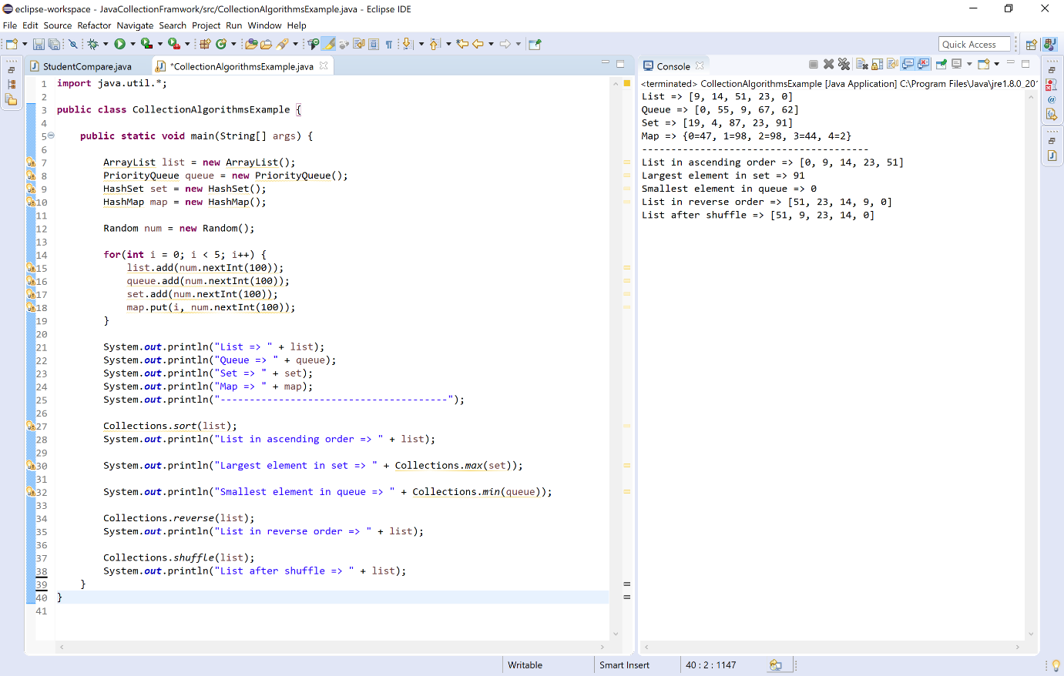

Array class in java
The java collection framework has a class Arrays that provides methods for creating dynamic array and perform various operations like search, asList, campare, etc.
The Arrays class in java is defined in the java.util package. All the methods defined by Arrays class are static methods.
The Arrays class in java has the following methods.
Method | Description
List<T> asList(T[] arr) | It returns a fixed-size list backed by the specified Arrays.
int binarySearch(T[] arr, element) | It searches for the specified element in the array with the help of Binary Search algorithm, and returns the position.
int binarySearch(T[] arr, int fromIndex, int toIndex, T key, Comparator c) | It searches a range of the specified array for the specified object using the binary search algorithm.
T[] copyOf(T[] originalArr, int newLength) | It copies the specified array, truncating or padding with the default value (if necessary) so the copy has the specified length.
T[] copyOfRange(T[] originalArr, int fromIndex, int endIndex) | It copies the specified range of the specified array into a new Arrays.
boolean equals(T[] arr1, T[] arr2) | It returns true if the two specified arrays of booleans are equal to one another, otherwise retruns false.
boolean deepEquals(T[] arr1, T[] arr2) | It returns true if the two specified arrays of booleans are deeply equal to one another, otherwise retruns false (it compares including nested arrays).
int hashCode(T[] arr) | It returns the hash code for the specified array.
int deepHashCode(T[] arr) | It returns the hash code for the specified array including nested arrays.
String toString(T[] arr) | It Returns a string representation of the contents of the specified array.
String deepToString(T[] arr) | It Returns a string representation of the contents of the specified array including nested arrays.
void fill(T[] arr, T value) | It assigns the specified value to each element of the specified array.
void fill(T[] arr, int fromIndex, int toIndex, T value) | It assigns the specified value to each element of the specified range of the specified array. The range to be filled extends from fromIndex, inclusive, to toIndex, exclusive.
void parallelPrefix(T[] arr, BinaryOperator o) | It Cumulates, in parallel, each element of the given array in place, using the supplied function.
void setAll(T[] arr, FunctionGenerator) | It sets all elements of the specified array, using the provided generator function to compute each element.
void parallelSetAll(T[] arr, FunctionGenerator) | It Sets all elements of the specified array, in parallel, using the provided generator function to compute each element.
void sort(T[] arr) | It sorts the specified array into ascending order.
void parallelSort(T[] arr) | It sorts the specified array of objects into ascending order, according to the natural ordering of its elements.
Of<T> spliterator(T[] arr) | It returns a Spliterator.Of<T> covering all of the specified array.
Stream<T> stream(T[] arr) | It returns a sequential Stream with the specified array as its source.
Let's consider an example program to illustrate methods of Arrays class.
Example
import java.util.*;

public class ArraysClassExample {

public static void main(String[] args) {

int[] arr1 = {10, 3, 50, 7, 30, 66, 28, 54, 42};

int[] arr2 = {67, 2, 54, 67, 13, 56, 98};

System.out.print("Array1 => ");
for(int i:arr1)
System.out.print(i + ", ");
System.out.print("\nArray2 => ");
for(int i:arr2)
System.out.print(i + ", ");
System.out.println("\n-------------------------------------------");

System.out.println("Array1 as List => " + Arrays.asList(arr1));

System.out.println("Position of 30 in Array1 => " + Arrays.binarySearch(arr1, 30));

System.out.println("equity of array1 and array2 => " + Arrays.equals(arr1, arr2));

System.out.println("Hash code of Array1 => " + Arrays.hashCode(arr1));

Arrays.fill(arr1, 15);
System.out.print("fill Array1 with 15 => ");
for(int i:arr1)
System.out.print(i + ", ");

Arrays.sort(arr2);
System.out.print("\nArray2 in sorted order => ");
for(int i:arr2)
System.out.print(i + ", ");
}
}

When we execute the above code, it produce the following output.
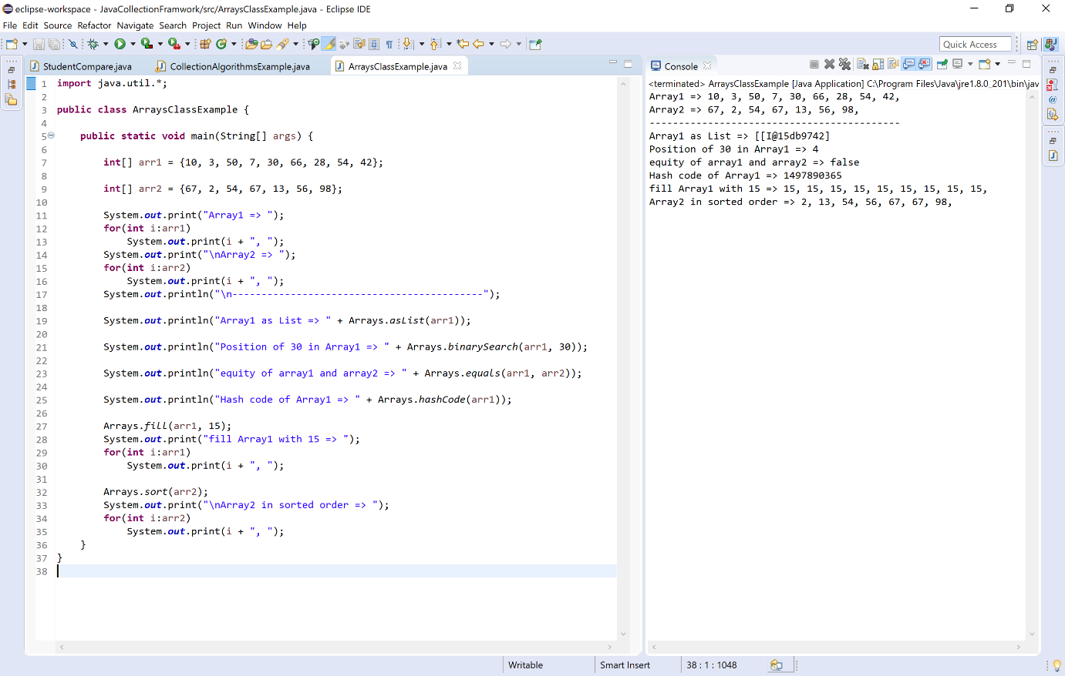

Dictionary class in java
In java, the package java.util contains a class called Dictionary which works like a Map. The Dictionary is an abstract class used to store and manage elements in the form of a pair of key and value.
The Dictionary stores data as a pair of key and value. In the dictionary, each key associates with a value. We can use the key to retrieve the value back when needed.
🔔 The Dictionary class is no longer in use, it is obsolete.
🔔 As Dictionary is an abstract class we can not create its object. It needs a child class like Hashtable.
The Dictionary class in java has the following methods.
S. No. | Methods with Description
1 | Dictionary( )  It's a constructor.
2 | Object put(Object key, Object value)  Inserts a key and its value into the dictionary. Returns null on success; returns the previous value associated with the key if the key is already exist.
3 | Object remove(Object key)  It returns the value associated with given key and removes the same; Returns null if the key does not exist.
4 | Object get(Object key)  It returns the value associated with given key; Returns null if the key does not exist.
5 | Enumeration keys( )  Returns an enumeration of the keys contained in the dictionary.
6 | Enumeration elements( )  Returns an enumeration of the values contained in the dictionary.
7 | boolean isEmpty( )  It returns true if dictionary has no elements; otherwise returns false.
8 | int size( )  It returns the total number of elements in the dictionary.
Let's consider an example program to illustrate methods of Dictionary class.
Example
import java.util.*;

public class DictionaryExample {

public static void main(String args[]) {

Dictionary dict = new Hashtable();

dict.put(1, "Rama");
dict.put(2, "Seetha");
dict.put(3, "Heyansh");
dict.put(4, "Varshith");
dict.put(5, "Manutej");

System.out.println("Dictionary\n=> " + dict);

// keys()
System.out.print("\nKeys in Dictionary\n=> ");
for (Enumeration i = dict.keys(); i.hasMoreElements();)
{
System.out.print(" " + i.nextElement());
}

// elements()
System.out.print("\n\nValues in Dictionary\n=> ");
for (Enumeration i = dict.elements(); i.hasMoreElements();)
{
System.out.print(" " + i.nextElement());
}

//get()
System.out.println("\n\nValue associated with key 3 => " + dict.get(3));
System.out.println("Value associated with key 30 => " + dict.get(30));

//size()
System.out.println("\nDictionary has " + dict.size() + " elements");

//isEmpty()
System.out.println("\nIs Dictionary empty? " + dict.isEmpty());
}
}

When we execute the above code, it produce the following output.
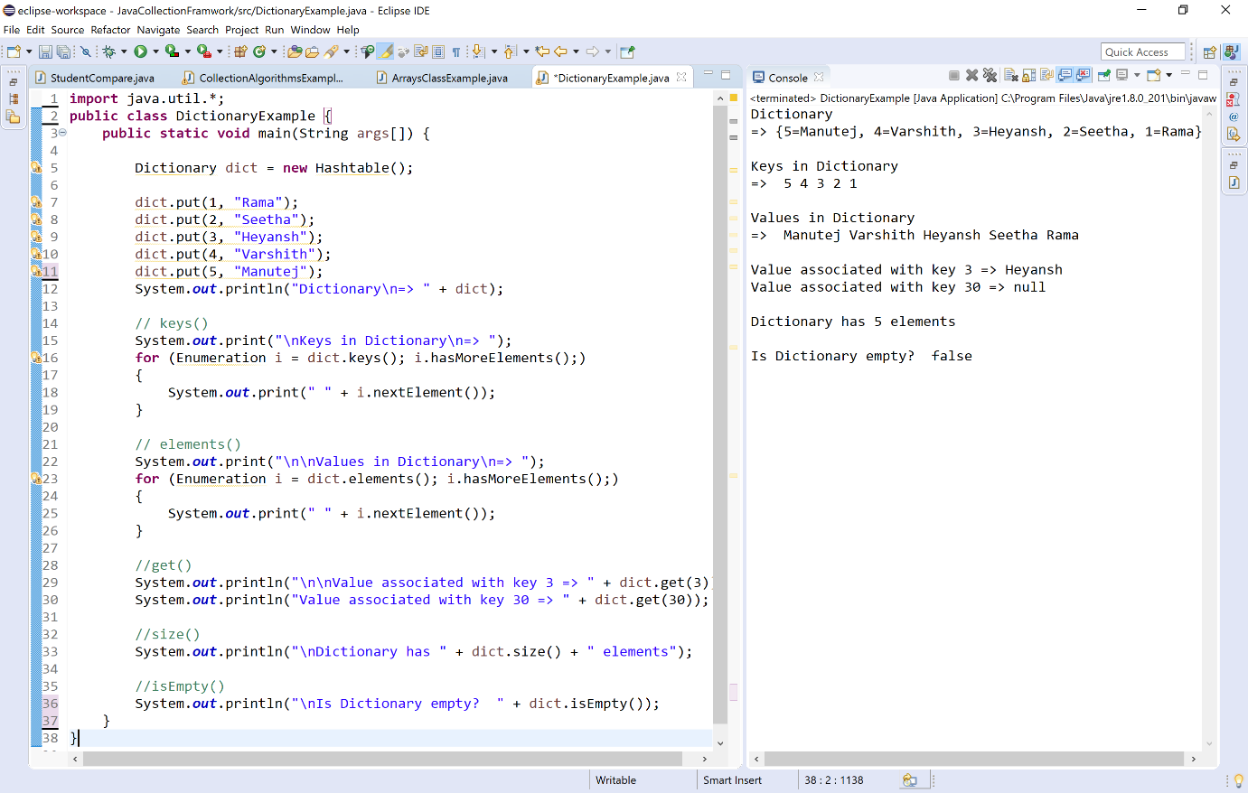

Hashtable class in Java
In java, the package java.util contains a class called Hashtable which works like a HashMap but it is synchronized. The Hashtable is a concrete class of Dictionary. It is used to store and manage elements in the form of a pair of key and value.
The Hashtable stores data as a pair of key and value. In the Hashtable, each key associates with a value. Any non-null object can be used as a key or as a value. We can use the key to retrieve the value back when needed.
🔔 The Hashtable class is no longer in use, it is obsolete. The alternate class is HashMap.
🔔 The Hashtable class is a concrete class of Dictionary.
🔔 The Hashtable class is synchronized.
🔔 The Hashtable does no allow null key or value.
🔔 The Hashtable has the initial default capacity 11.
The Hashtable class in java has the following constructors.
S. No. | Constructor with Description
1 | Hashtable( )  It creates an empty hashtable with the default initial capacity 11.
2 | Hashtable(int capacity)  It creates an empty hashtable with the specified initial capacity.
3 | Hashtable(int capacity, float loadFactor)  It creates an empty hashtable with the specified initial capacity and loading factor.
4 | Hashtable(Map m)  It creates a hashtable containing elements of Map m.
The Hashtable class in java has the following methods.
S. No. | Methods with Description
1 | V put(K key, V value)  It inserts the specified key and value into the hash table.
2 | void putAll(Map m))  It inserts all the elements of Map m into the invoking Hashtable.
3 | V putIfAbsent(K key, V value)  If the specified key is not already associated with a value associates it with the given value and returns null, else returns the current value.
4 | V getOrDefault(Object key, V defaultValue)  It returns the value associated with given key; or defaultValue if the hashtable contains no mapping for the key.
5 | V get(Object key)  It returns the value associated with the given key.
6 | Enumeration keys()  Returns an enumeration of the keys of the hashtable.
7 | Set keySet()  Returns a set view of the keys of the hashtable.
8 | Collection values()  It returns a collection view of the values contained in the Hashtable.
9 | Enumeration elements()  Returns an enumeration of the values of the hashtable.
10 | Set entrySet()  It returns a set view of the mappings contained in the hashtable.
11 | int hashCode()  It returns the hash code of the hashtable.
12 | Object clone()  It returns a shallow copy of the Hashtable.
13 | V remove(Object key)  It returns the value associated with given key and removes the same.
14 | boolean remove(Object key, Object value)  It removes the specified values with the associated specified keys from the hashtable.
15 | boolean contains(Object value)  It returns true if the specified value found within the hash table, else return false.
16 | boolean containsValue(Object value)  It returns true if the specified value found within the hash table, else return false.
17 | boolean containsKey(Object key)  It returns true if the specified key found within the hash table, else return false.
18 | V replace(K key, V value)  It replaces the specified value for a specified key.
19 | boolean replace(K key, V oldValue, V newValue)  It replaces the old value with the new value for a specified key.
20 | void replaceAll(BiFunction function)  It replaces each entry's value with the result of invoking the given function on that entry until all entries have been processed or the function throws an exception.
21 | void rehash()  It is used to increase the size of the hash table and rehashes all of its keys.
22 | String toString()  It returns a string representation of the Hashtable object.
23 | V merge(K key, V value, BiFunction remappingFunction)  If the specified key is not already associated with a value or is associated with null, associates it with the given non-null value.
24 | void forEach(BiConsumer action)  It performs the given action for each entry in the map until all entries have been processed or the action throws an exception.
25 | boolean isEmpty( )  It returns true if Hashtable has no elements; otherwise returns false.
26 | int size( )  It returns the total number of elements in the Hashtable.
27 | void clear()  It is used to remove all the lements of a Hashtable.
28 | boolean equals(Object o)  It is used to compare the specified Object with the Hashtable.
Let's consider an example program to illustrate methods of Hashtable class.
Example
import java.util.*;

public class HashtableExample {

public static void main(String[] args) {

Random num = new Random();
Hashtable table = new Hashtable();

//put(key, value)
for(int i = 1; i <= 5; i++)
table.put(i, num.nextInt(100));

System.out.println("Hashtable => " + table);

//get(key)
System.out.println("\nValue associated with key 3 => " + table.get(3));
System.out.println("Value associated with key 30 => " + table.get(30));

//keySet()
System.out.println("\nKeys => " + table.keySet());

//values()
System.out.println("\nValues => " + table.values());

//entrySet()
System.out.println("\nKey, Value pairs as a set => " + table.entrySet());

//hashCode()
System.out.println("\nHash code => " + table.hashCode());

//hashCode()
System.out.println("\nTotal number of elements => " + table.size());

//isEmpty()
System.out.println("\nEmpty status of Hashtable => " + table.isEmpty());
}
}

When we execute the above code, it produce the following output.
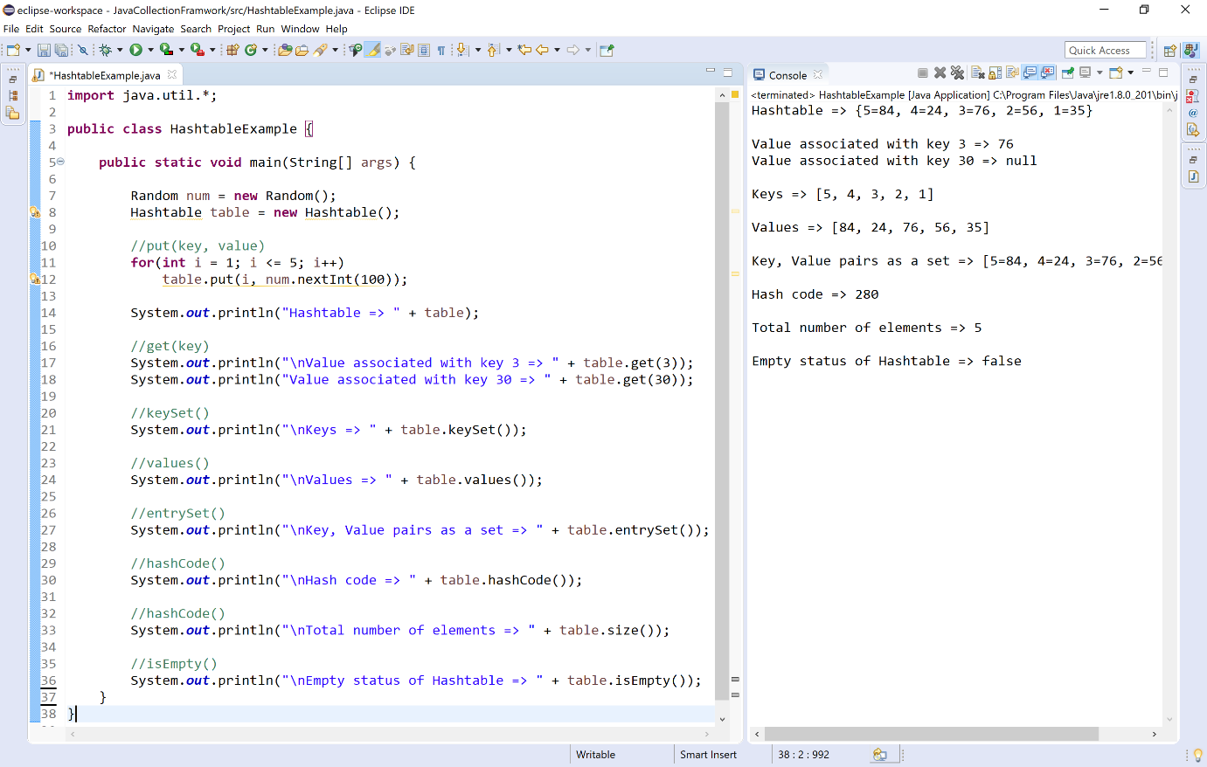

Properties class in java
The Properties class used to store configuration values managed as key, value pairs. In each pair, both key and value are String values. We can use the key to retrieve the value back when needed.
The Properties class provides methods to get data from the properties file and store data into the properties file. It can also be used to get the properties of a system.
🔔 The Properties class is child class of Hashtable class.
🔔 The Properties class implements Map, Cloneable, and Serializable interfaces.
🔔 The Properties class used to store configuration values.
🔔 The Properties class stores the data as key, value pairs.
🔔 In Properties class both key and value are String data type.
🔔 Using Properties class, we can load key, value pairs into a Properties object from a stream.
🔔 Using Properties class, we can save the Properties object to a stream.
The Properties class in java has the following constructors.
S. No. | Constructor with Description
1 | Properties( )  It creates an empty property list with no default values.
2 | Properties(Properties defaults)  It creates an empty property list with the specified defaults.
The Properties class in java has the following methods.
S.No. | Methods with Description
1 | void load(Reader r)  It loads data from the Reader object.
2 | void load(InputStream is)  It loads data from the InputStream object.
3 | void store(Writer w, String comment)  It writes the properties in the writer object.
4 | void store(OutputStream os, String comment)  It writes the properties in the OutputStream object.
5 | String getProperty(String key)  It returns value associated with the specified key.
6 | String getProperty(String key, String defaultValue)  It returns the value associated with given key; or defaultValue if the Properties contains no mapping for the key.
7 | void setProperty(String key, String value)  It calls the put method of Hashtable.
8 | Enumeration propertyNames())  It returns an enumeration of all the keys from the property list.
9 | Set stringPropertyNames()  Returns a set view of the keys of the Properties.
10 | void list(PrintStream out)  It is used to print the property list out to the specified output stream.
11 | void loadFromXML(InputStream in)  It is used to load all of the properties represented by the XML document on the specified input stream into this properties table.
12 | void storeToXML(OutputStream os, String comment)  It writes the properties in the writer object for generating XML document.
13 | void storeToXML(Writer w, String comment, String encoding)  It writes the properties in the writer object for generating XML document with the specified encoding.
Let's consider an example program to illustrate methods of Properties class to store a user configuration details to a properties file.
Example
import java.io.*;
import java.util.*;

public class PropertiesClassExample {

public static void main(String[] args) {

FileOutputStream fos = null;
File configFile = null;

try {
configFile = new File("config.properties");
fos = new FileOutputStream(configFile);
Properties configProperties = new Properties();

configProperties.setProperty("userName", "btechsmartclass");
configProperties.setProperty("password", "java");
configProperties.setProperty("email", "user@btechsmartclass.com");

configProperties.store(fos, "Login Details");

fos.close();

System.out.println("Configuration saved!!!");
}
catch(Exception e) {
System.out.println("Something went wrong while opening file");
}
}
}

When we execute the above code, it produce the following output.
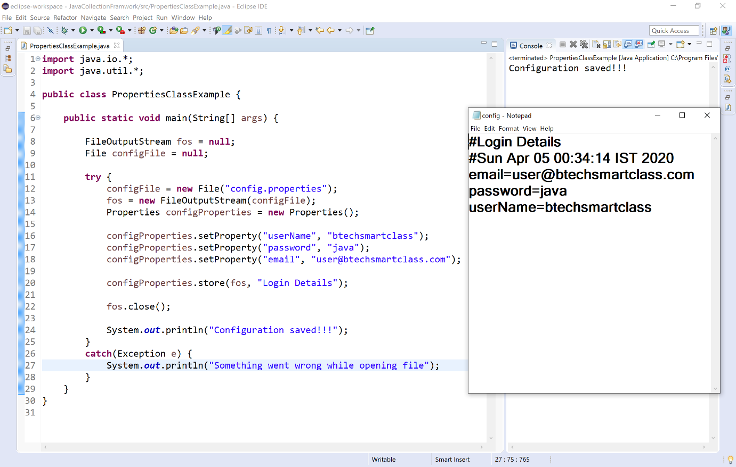

Let's consider another example program to illustrate methods of Properties class using console.
Example
import java.util.*;

public class PropertiesClassExample {

public static void main(String[] args) {

Properties sites = new Properties();
String str;

sites.put("search", "www.google.com");
sites.put("learn", "www.btechsmartclass.com");
sites.put("mail", "www.gmail.com");
sites.put("social", "www.facebook.com");
sites.put("watch", "www.youtube.com");

System.out.println("Keys => " + sites.keySet() + "\n");

Iterator itr = sites.keySet().iterator();
while(itr.hasNext())
{
str = (String)itr.next();
System.out.println("The link for " + str + " is " + sites.getProperty(str));
}

System.out.println("\nThe link for learn is " + sites.getProperty("learn"));
System.out.println("\nThe link for learning is " + sites.getProperty("learning", "not found"));
}

}

When we execute the above code, it produce the following output.
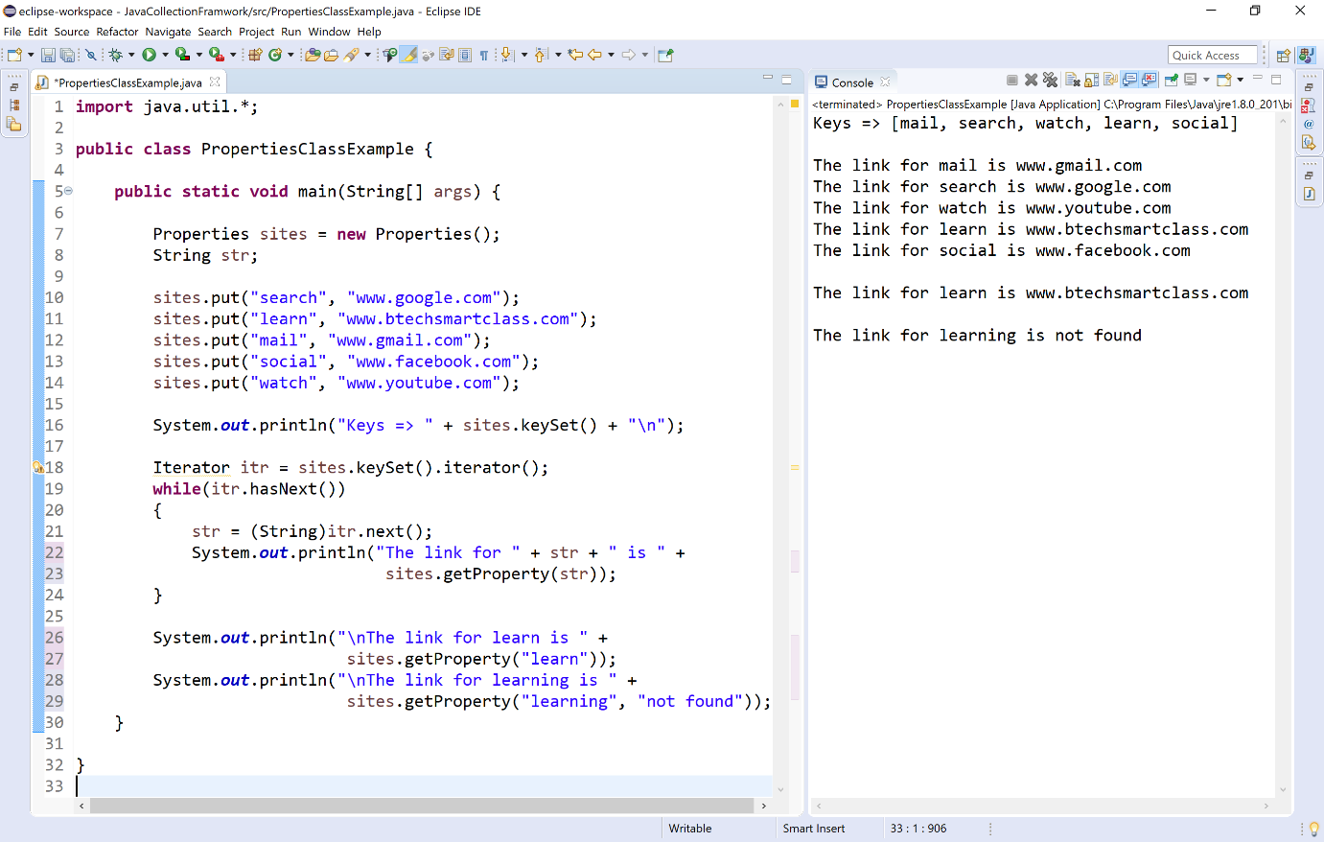

Stack class in java
In java, the package java.util contains a class called Stack which is a child class of Vector class. It implements the standard principle Last-In-First-Out of stack data structure.
The Stack has push method for inesrtion and pop method for deletion. It also has other utility methods.
🔔 In Stack, the elements are added to the top of the stack and removed from the top of the stack.
The Stack class in java has the following constructor.
S. No. | Constructor with Description
1 | Stack( )  It creates an empty Stack.
The Stack class in java has the following methods.
S.No. | Methods with Description
1 | Object push(Object element)  It pushes the element onto the stack and returns the same.
2 | Object pop( )  It returns the element on the top of the stack and removes the same.
3 | int search(Object element)  If element found, it returns offset from the top. Otherwise, -1 is returned.
4 | Object peek( )  It returns the element on the top of the stack.
5 | boolean empty()  It returns true if the stack is empty, otherwise returns false.
Let's consider an example program to illustrate methods of Stack class.
Example
import java.util.*;

public class StackClassExample {

public static void main(String[] args) {

Stack stack = new Stack();

Random num = new Random();

for(int i = 0; i < 5; i++)
stack.push(num.nextInt(100));

System.out.println("Stack elements => " + stack);

System.out.println("Top element is " + stack.peek());

System.out.println("Removed element is " + stack.pop());

System.out.println("Element 50 availability => " + stack.search(50));

System.out.println("Stack is empty? - " + stack.isEmpty());

}

}

When we execute the above code, it produce the following output.
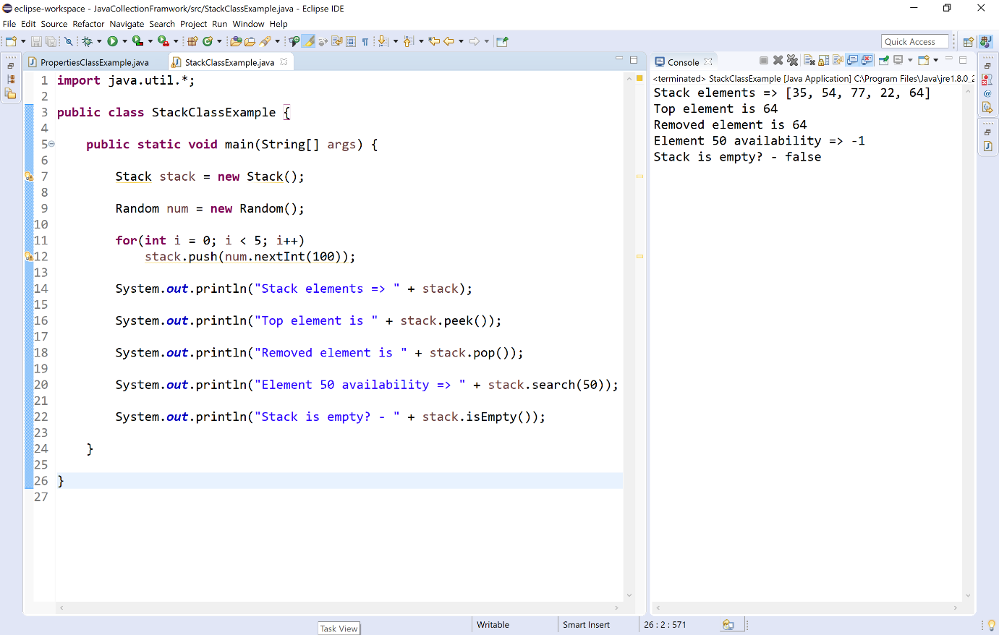

Vector Class in Java
In java, the package java.util contains a class called Vector which implements the List interface.
The Vector is similar to an ArrayList. Like ArrayList Vector also maintains the insertion order. But Vector is synchronized, due to this reason, it is rarly used in the non-thread application. It also lead to poor performance.
🔔 The Vector is a class in the java.util package.
🔔 The Vector implements List interface.
🔔 The Vector is a legacy class.
🔔 The Vector is synchronized.
The Vector class in java has the following constructor.
S. No. | Constructor with Description
1 | Vector( )  It creates an empty Vector with default initail capacity of 10.
2 | Vector(int initialSize)  It creates an empty Vector with specified initail capacity.
3 | Vector(int initialSize, int incr)  It creates a vector whose initial capacity is specified by size and whose increment is specified by incr.
4 | Vector(Collection c)  It creates a vector that contains the elements of collection c.
The Vector class in java has the following methods.
S.No. | Methods with Description
1 | boolean add(Object o)  It appends the specified element to the end of this Vector.
2 | void add(int index, Object element)  It inserts the specified element at the specified position in this Vector.
3 | void addElement(Object obj)  Adds the specified object to the end of the vector, increasing its size by one.
4 | boolean addAll(Collection c)  It appends all of the elements in the specified Collection to the end of the Vector.
5 | boolean addAll(int index, Collection c)  It inserts all of the elements in in the specified Collection into the Vector at the specified position.
6 | Object set(int index, Object element)  It replaces the element at the specified position in the vector with the specified element.
7 | void setElementAt(Object obj, int index)  It sets the element at the specified index of the vector to be the specified object.
8 | Object remove(int index)  It removes the element at the specified position in the vector.
9 | boolean remove(Object o)  It removes the first occurrence of the specified element in the vector.
10 | boolean removeElement(Object obj)  It removes the first occurrence of the specified element in the vector.
11 | void removeElementAt(int index)  It removes the element at specified index in the vector.
12 | void removeRange(int fromIndex, int toIndex)  It removes from the Vector all of the elements whose index is between fromIndex, inclusive and toIndex, exclusive.
13 | boolean removeAll(Collection c)  It removes from the vector all of its elements that are contained in the specified Collection.
14 | void removeAllElements()  It removes all the elements from the vector.
15 | boolean retainAll(Collection c)  It removes all the elements from the vector except elements those are in the given collection.
16 | Object elementAt(int index)  It returns the element at specified index in the Vector.
17 | Object get(int index)  It returns the element at specified index in the Vector.
18 | Enumeration elements()  It returns the Enumeration of all the elements of the Vector.
19 | Object firstElement()  It returns the first element of the Vector.
20 | Object lastElement()  It returns the last element of the Vector.
21 | int indexOf(Object element)  It returns the index value of the first occurence of the given element in the Vector.
22 | int indexOf(Object elem, int index)  It returns the index value of the first occurence of the given element, search beginning at specified index in the Vector.
23 | int lastIndexOf(Object elememnt)  It returns the index value of the last occurence of the given element, search beginning at specified index in the Vector.
24 | List subList(int fromIndex, int toIndex)  It returns a list containing elements fromIndex to toIndex in the Vector.
25 | int capacity()  It returns the current capacity of the Vector.
26 | void clear()  It removes all the elements from the Vector.
27 | Object clone()  It returns a clone of the Vector.
28 | boolean contains(Object element)  It returns true if element found in the Vector, otherwise returns false.
29 | boolean containsAll(Collection c)  It returns true if all the elements of geven collection found in the Vector, otherwise returns false.
30 | void ensureCapacity(int minCapacity)  It increases the capacity of this vector, if necessary, to ensure that it can hold at least the number of components specified by the minimum capacity argument.
31 | boolean equals(Object o)  It compares the specified Object with this vector for equality.
32 | int hashCode()  It returns the hash code of the Vector.
33 | boolean isEmpty()  It returns true if Vector has no elements, otherwise returns false.
34 | void setSize(int newSize)  It sets the size of the vector.
35 | int size()  It returns total number of elements in the vector.
36 | Object[] toArray()  It returns an array containing all the elements of the Vector.
37 | String toString()  It returns a string representation of the Vector.
38 | void trimToSize()  It trims the capacity of the vector to be the vector's current size.
Let's consider an example program to illustrate methods of Vector class.
Example
import java.util.*;

public class VectorClassExample {

public static void main(String[] args) {

Vector list = new Vector();

list.add(10);
list.add(30);
list.add(0, 100);
list.addElement(50);

System.out.println("Vector => " + list);

System.out.println("get(2) => " + list.get(2));

System.out.println("firstElement() => " + list.firstElement());

System.out.println("indexOf(50) => " + list.indexOf(50));

System.out.println("contains(30) => " + list.contains(30));

System.out.println("capacity() => " + list.capacity());

System.out.println("size() => " + list.size());

System.out.println("isEmpty() => " + list.isEmpty());

}

}

When we execute the above code, it produce the following output.
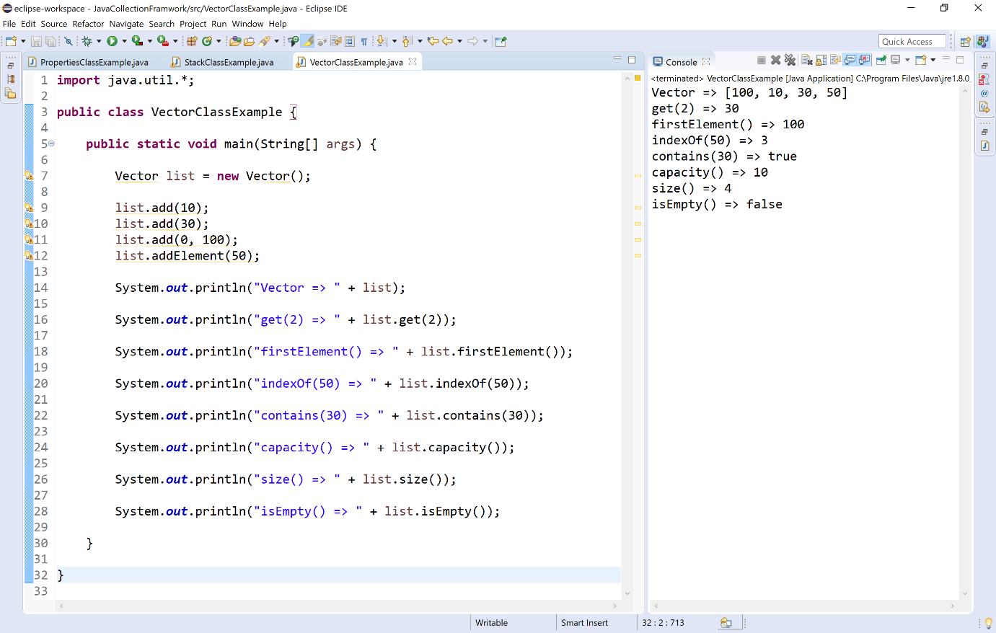

String Tokenizer
The StringTokenizer is a built-in class in java used to break a string into tokens. The StringTokenizer class is available inside the java.util package.
The StringTokenizer class object internally maintains a current position within the string to be tokenized.
🔔 A token is returned by taking a substring of the string that was used to create the StringTokenizer object.
The StringTokenizer class in java has the following constructor.
S. No. | Constructor with Description
1 | StringTokenizer(String str)  It creates StringTokenizer object for the specified string str with default delimeter.
2 | StringTokenizer(String str, String delimeter)  It creates StringTokenizer object for the specified string str with specified delimeter.
3 | StringTokenizer(String str, String delimeter, boolean returnValue)  It creates StringTokenizer object with specified string, delimeter and returnValue.
The StringTokenizer class in java has the following methods.
S.No. | Methods with Description
1 | String nextToken()  It returns the next token from the StringTokenizer object.
2 | String nextToken(String delimeter)  It returns the next token from the StringTokenizer object based on the delimeter.
3 | Object nextElement()  It returns the next token from the StringTokenizer object.
4 | boolean hasMoreTokens()  It returns true if there are more tokens in the StringTokenizer object. otherwise returns false.
5 | boolean hasMoreElements()  It returns true if there are more tokens in the StringTokenizer object. otherwise returns false.
6 | int countTokens()  It returns total number of tokens in the StringTokenizer object.
Let's consider an example program to illustrate methods of StringTokenizer class.
Example
import java.util.StringTokenizer;

public class StringTokenizerExample {

public static void main(String[] args) {

String url = "www.btechsmartclass.com";
String title = "BTech Smart Class";

StringTokenizer tokens = new StringTokenizer(title);
StringTokenizer anotherTokens = new StringTokenizer(url, ".");

System.out.println("\nTotal tokens in title is " + tokens.countTokens());

System.out.print("Tokens in the title => ");
while(tokens.hasMoreTokens()) {
System.out.print(tokens.nextToken() + ", ");
}

System.out.println("\n\nTotal tokens in url is " + anotherTokens.countTokens());

System.out.println("Tokens in the url with delimeter (.) => ");
while(anotherTokens.hasMoreElements()) {
System.out.print(anotherTokens.nextElement() + ", ");
}

}

}

When we execute the above code, it produce the following output.
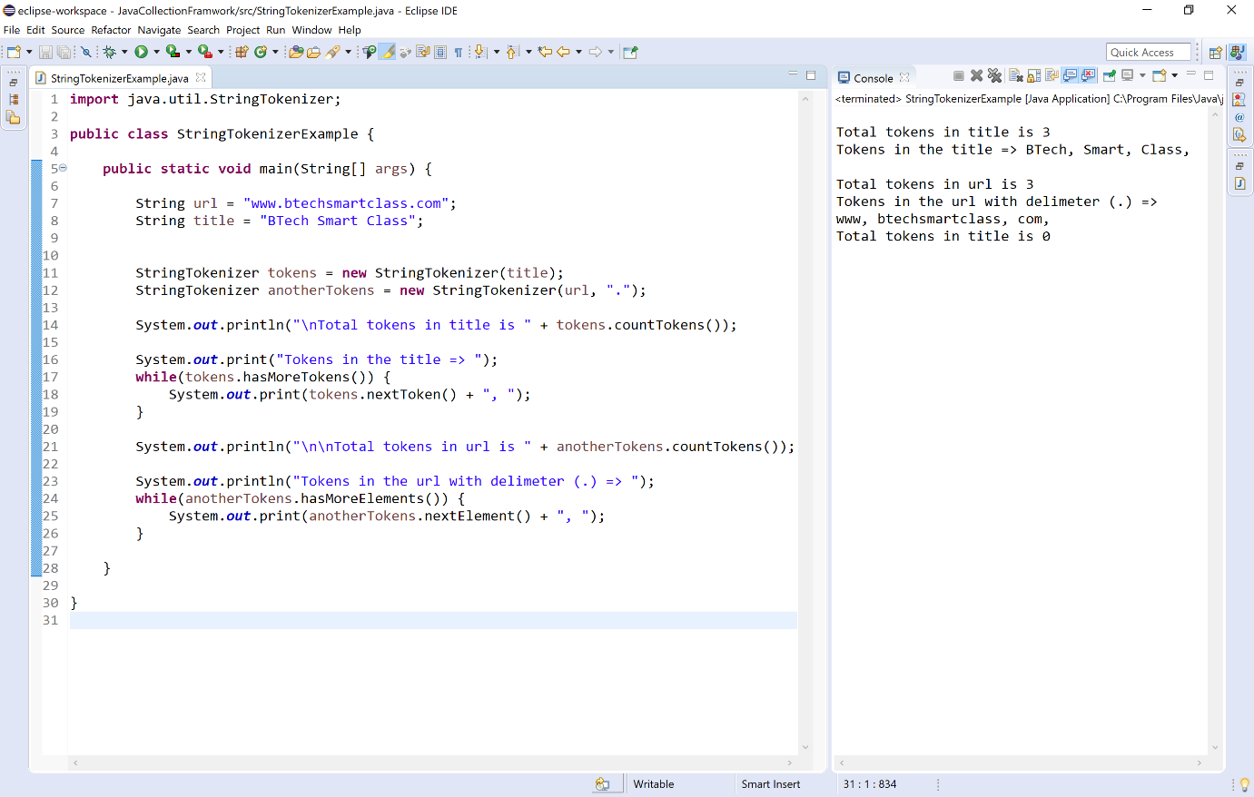

BitSet class in Java
The BitSet is a built-in class in java used to create a dynamic array of bits represented by boolean values. The BitSet class is available inside the java.util package.
The BitSet array can increase in size as needed. This feature makes the BitSet similar to a Vector of bits.
🔔 The bit values can be accessed by non-negative integers as an index.
🔔 The size of the array is flexible and can grow to accommodate additional bit as needed.
🔔 The default value of the BitSet is boolean false with a representation as 0 (off).
🔔 BitSet uses 1 bit of memory per each boolean value.
The BitSet class in java has the following constructor.
S. No. | Constructor with Description
1 | BitSet( )  It creates a default BitSet object.
2 | BitSet(int noOfBits)  It creates a BitSet object with number of bits that it can hold. All bits are initialized to zero.
The BitSet class in java has the following methods.
S.No. | Methods with Description
1 | void and(BitSet bitSet)  It performs AND operation on the contents of the invoking BitSet object with those specified by bitSet.
2 | void andNot(BitSet bitSet)  For each 1 bit in bitSet, the corresponding bit in the invoking BitSet is cleared.
3 | void flip(int index)  It reverses the bit at specified index.
4 | void flip(int startIndex, int endIndex)  It reverses all the bits from specified startIndex to endIndex.
5 | void or(BitSet bitSet)  It performs OR operation on the contents of the invoking BitSet object with those specified by bitSet.
6 | void xor(BitSet bitSet)  It performs XOR operation on the contents of the invoking BitSet object with those specified by bitSet.
7 | int cardinality( )  It returns the number of bits set to true in the invoking BitSet.
8 | void clear( )  It sets all the bits to zeros of the invoking BitSet.
9 | void clear(int index)  It set the bit specified by given index to zero.
10 | void clear(int startIndex, int endIndex)  It sets all the bits from specified startIndex to endIndex to zero.
11 | Object clone( )  It duplicates the invoking BitSet object.
12 | boolean equals(Object bitSet)  It retruns true if both invoking and argumented BitSets are equal, otherwise returns false.
13 | boolean get(int index)  It retruns the present state of the bit at given index in the invoking BitSet.
14 | BitSet get(int startIndex, int endIndex)  It returns a BitSet object that consists all the bits from startIndex to endIndex.
15 | int hashCode( )  It returns the hash code of the invoking BitSet.
16 | boolean intersects(BitSet bitSet)  It returns true if at least one pair of corresponding bits within the invoking object and bitSet are 1.
17 | boolean isEmpty( )  It returns true if all bits in the invoking object are zero, otherwise returns false.
17 | int length( )  It returns the total number of bits in the invoking BitSet.
18 | int nextClearBit(int startIndex)  It returns the index of the next cleared bit, (that is, the next zero bit), starting from the index specified by startIndex.
19 | int nextSetBit(int startIndex)  It returns the index of the next set bit (that is, the next 1 bit), starting from the index specified by startIndex. If no bit is set, -1 is returned.
20 | void set(int index)  It sets the bit specified by index.
21 | void set(int index, boolean value)  It sets the bit specified by index to the value passed in value.
22 | void set(int startIndex, int endIndex)  It sets all the bits from startIndex to endIndex.
23 | void set(int startIndex, int endIndex, boolean value)  It sets all the bits to specified value from startIndex to endIndex.
24 | int size( )  It returns the total number of bits in the invoking BitSet.
25 | String toString( )  It returns the string equivalent of the invoking BitSet object.
Let's consider an example program to illustrate methods of BitSet class.
Example
import java.util.*;

public class BitSetClassExample {

public static void main(String[] args) {

BitSet bSet_1 = new BitSet();
BitSet bSet_2 = new BitSet(16);

bSet_1.set(10);
bSet_1.set(5);
bSet_1.set(0);
bSet_1.set(7);
bSet_1.set(20);

bSet_2.set(1);
bSet_2.set(15);
bSet_2.set(20);
bSet_2.set(77);
bSet_2.set(50);

System.out.println("BitSet_1 => " + bSet_1);
System.out.println("BitSet_2 => " + bSet_2);

bSet_1.and(bSet_2);
System.out.println("BitSet_1 after and with bSet_2 => " + bSet_1);

bSet_1.andNot(bSet_2);
System.out.println("BitSet_1 after andNot with bSet_2 => " + bSet_1);

System.out.println("Length of the bSet_2 => " + bSet_2.length());
System.out.println("Size of the bSet_2 => " + bSet_2.size());

System.out.println("Bit at index 2 in bSet_2 => " + bSet_2.get(2));

bSet_2.set(2);
System.out.println("Bit at index 2 after set in bSet_2 => " + bSet_2.get(2));
}
}

When we execute the above code, it produce the following output.
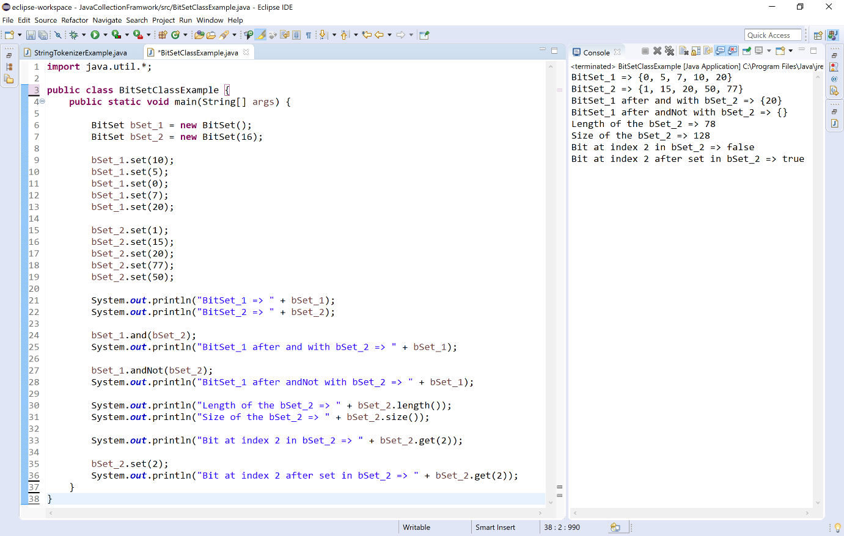

Date class in Java
The Date is a built-in class in java used to work with date and time in java. The Date class is available inside the java.util package. The Date class represents the date and time with millisecond precision.
The Date class implements Serializable, Cloneable and Comparable interface.
🔔 Most of the constructors and methods of Date class has been deprecated after Calendar class introduced.
The Date class in java has the following constructor.
S. No. | Constructor with Description
1 | Date( )  It creates a Date object that represents current date and time.
2 | Date(long milliseconds)  It creates a date object for the given milliseconds since January 1, 1970, 00:00:00 GMT.
3 | Date(int year, int month, int date) - Depricated  It creates a date object with the specified year, month, and date.
4 | Date(int year, int month, int date, int hrs, int min) - Depricated  It creates a date object with the specified year, month, date, hours, and minuts.
5 | Date(int year, int month, int date, int hrs, int min, int sec) - Depricated  It creates a date object with the specified year, month, date, hours, minuts and seconds.
5 | Date(String s) - Depricated  It creates a Date object and initializes it so that it represents the date and time indicated by the string s, which is interpreted as if by the parse(java.lang.String) method.
The Date class in java has the following methods.
S.No. | Methods with Description
1 | long getTime()  It returns the time represented by this date object.
2 | boolean after(Date date)  It returns true, if the invoking date is after the argumented date.
3 | boolean before(Date date)  It returns true, if the invoking date is before the argumented date.
4 | Date from(Instant instant)  It returns an instance of Date object from Instant date.
5 | void setTime(long time)  It changes the current date and time to given time.
6 | Object clone( )  It duplicates the invoking Date object.
7 | int compareTo(Date date)  It compares current date with given date.
8 | boolean equals(Date date)  It compares current date with given date for equality.
9 | int hashCode()  It returns the hash code value of the invoking date object.
10 | Instant toInstant()  It converts current date into Instant object.
11 | String toString()  It converts this date into Instant object.
Let's consider an example program to illustrate methods of Date class.
Example
import java.time.Instant;
import java.util.Date;

public class DateClassExample {

public static void main(String[] args) {

Date time = new Date();

System.out.println("Current date => " + time);

System.out.println("Date => " + time.getTime() + " milliseconds");

System.out.println("after() => " + time.after(time) + " milliseconds");

System.out.println("before() => " + time.before(time) + " milliseconds");

System.out.println("hashCode() => " + time.hashCode());

}

}

When we execute the above code, it produce the following output.
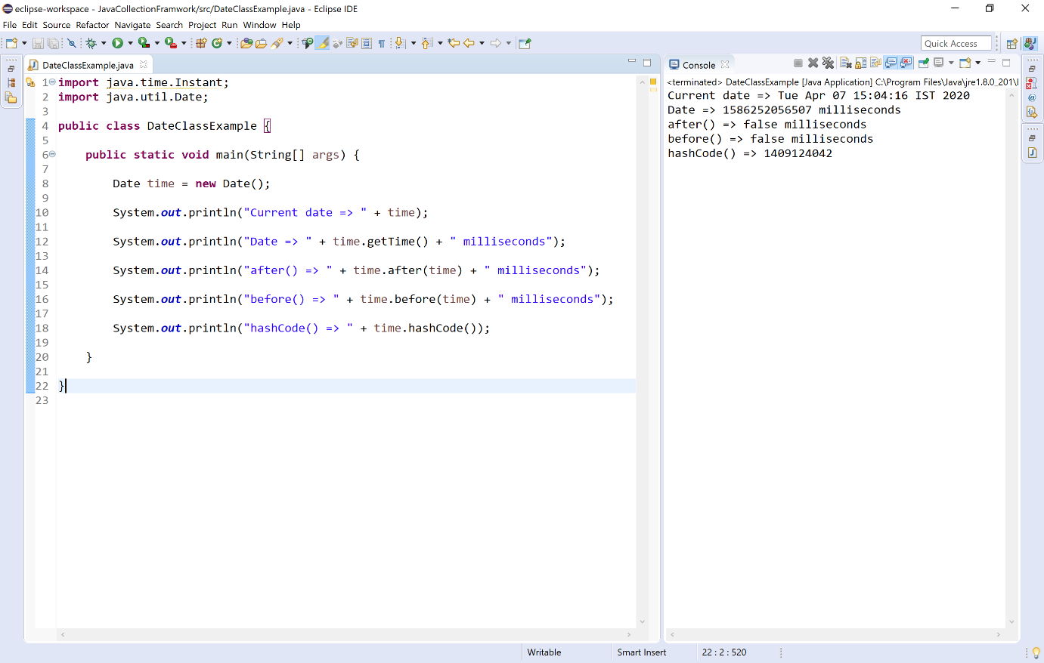

Calendar class in Java
The Calendar is a built-in abstract class in java used to convert date between a specific instant in time and a set of calendar fields such as MONTH, YEAR, HOUR, etc. The Calendar class is available inside the java.util package.
The Calendar class implements Serializable, Cloneable and Comparable interface.
🔔 As the Calendar class is an abstract class, we can not create an object using it.
🔔 We will use the static method Calendar.getInstance() to instantiate and implement a sub-class.
The Calendar class in java has the following methods.
S.No. | Methods with Description
1 | Calendar getInstance()  It returns a calendar using the default time zone and locale.
2 | Date getTime()  It returns a Date object representing the invoking Calendar's time value.
3 | TimeZone getTimeZone()  It returns the time zone object associated with the invoking calendar.
4 | String getCalendarType()  It returns an instance of Date object from Instant date.
5 | int get(int field)  It rerturns the value for the given calendar field.
6 | int getFirstDayOfWeek()  It returns the day of the week in integer form.
7 | int getWeeksInWeekYear()  It retruns the total weeks in week year.
8 | int getWeekYear()  It returns the week year represented by current Calendar.
9 | void add(int field, int amount)  It adds the specified amount of time to the given calendar field.
10 | boolean after (Object when)  It returns true if the time represented by the Calendar is after the time represented by when Object.
11 | boolean before(Object when)  It returns true if the time represented by the Calendar is before the time represented by when Object.
12 | void clear(int field)  It sets the given calendar field value and the time value of this Calendar undefined.
13 | Object clone()  It retruns the copy of the current object.
14 | int compareTo(Calendar anotherCalendar)  It compares and retruns the time values (millisecond offsets) between two calendar object.
15 | void complete()  It sets any unset fields in the calendar fields.
16 | void computeFields()  It converts the current millisecond time value time to calendar field values in fields[].
17 | void computeTime()  It converts the current calendar field values in fields[] to the millisecond time value time.
18 | boolean equals(Object object)  It returns true if both invoking object and argumented object are equal.
19 | int getActualMaximum(int field)  It returns the Maximum possible value of the specified calendar field.
20 | int getActualMinimum(int field)  It returns the Minimum possible value of the specified calendar field.
21 | Set getAvailableCalendarTypes()  It returns a string set of all available calendar type supported by Java Runtime Environment.
22 | Locale[] getAvailableLocales()  It returns an array of all locales available in java runtime environment.
23 | String getDisplayName(int field, int style, Locale locale)  It returns the String representation of the specified calendar field value in a given style, and local.
24 | Map getDisplayNames(int field, int style, Locale locale)  It returns Map representation of the given calendar field value in a given style and local.
25 | int getGreatestMinimum(int field)  It returns the highest minimum value of the specified Calendar field.
26 | int getLeastMaximum(int field)  It returns the highest maximum value of the specified Calendar field.
27 | int getMaximum(int field)  It returns the maximum value of the specified calendar field.
28 | int getMinimalDaysInFirstWeek()  It returns required minimum days in integer form.
29 | int getMinimum(int field)  It returns the minimum value of specified calendar field.
30 | long getTimeInMillis()  It returns the current time in millisecond.
31 | int hashCode()  It returns the hash code of the invoking object.
32 | int internalGet(int field)  It returns the value of the given calendar field.
33 | boolean isLenient()  It returns true if the interpretation mode of this calendar is lenient; false otherwise.
34 | boolean isSet(int field)  If not set then it returns false otherwise true.
35 | boolean isWeekDateSupported()  It returns true if the calendar supports week date. The default value is false.
36 | void roll(int field, boolean up)  It increase or decrease the specified calendar field by one unit without affecting the other field
37 | void set(int field, int value)  It sets the specified calendar field by the specified value.
38 | void setFirstDayOfWeek(int value)  It sets the first day of the week.
39 | void setMinimalDaysInFirstWeek(int value)  It sets the minimal days required in the first week.
40 | void setTime(Date date)  It sets the Time of current calendar object.
41 | void setTimeInMillis(long millis)  It sets the current time in millisecond.
42 | void setTimeZone(TimeZone value)  It sets the TimeZone with passed TimeZone value.
43 | void setWeekDate(int weekYear, int weekOfYear, int dayOfWeek)  It sets the current date with specified integer value.
44 | Instant toInstant()  It converts the current object to an instant.
45 | String toString()  It returns a string representation of the current object.
Let's consider an example program to illustrate methods of Calendar class.
Example
import java.util.*;

public class CalendarClassExample {

public static void main(String[] args) {

Calendar cal = Calendar.getInstance();

System.out.println("Current date and time : \n=>" + cal);
System.out.println("Current Calendar type : " + cal.getCalendarType());
System.out.println("Current date and time : \n=>" + cal.getTime());
System.out.println("Current date time zone : \n=>" + cal.getTimeZone());
System.out.println("Calendar filed 1 (year): " + cal.get(1));
System.out.println("Calendar day in integer form: " + cal.getFirstDayOfWeek());
System.out.println("Calendar weeks in a year: " + cal.getWeeksInWeekYear());
System.out.println("Time in milliseconds: " + cal.getTimeInMillis());
System.out.println("Available Calendar types: " + cal.getAvailableCalendarTypes());
System.out.println("Calendar hash code: " + cal.hashCode());
System.out.println("Is calendar supports week date? " + cal.isWeekDateSupported());
System.out.println("Calendar string representation: " + cal.toString());
}
}

When we execute the above code, it produce the following output.
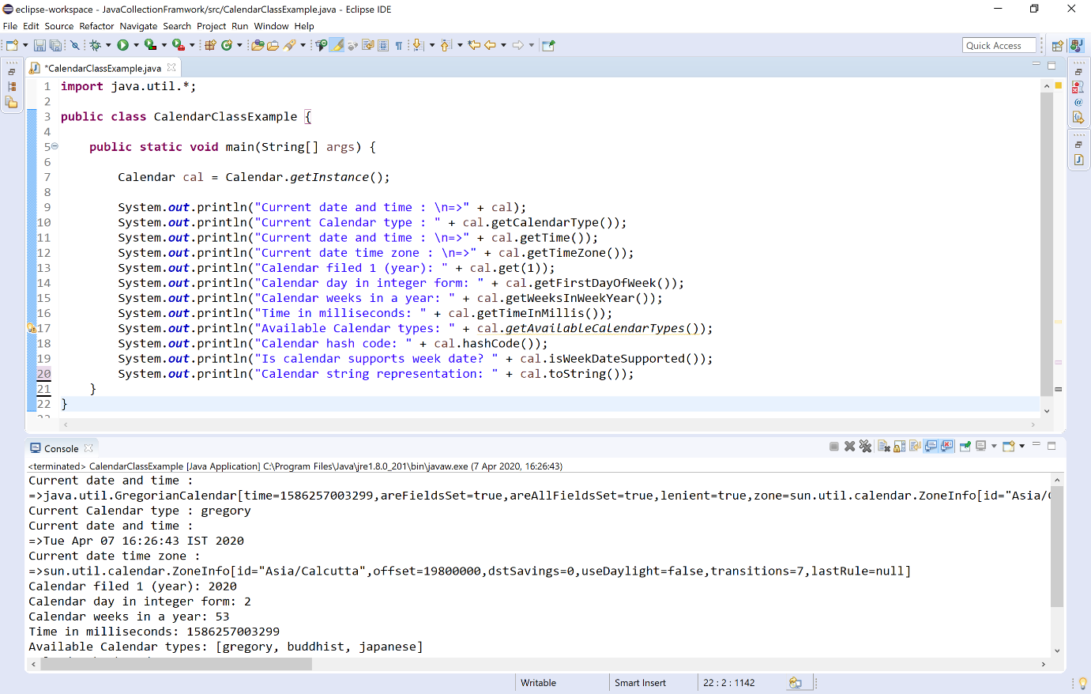

Random class in Java
The Random is a built-in class in java used to generate a stream of pseudo-random numbers in java programming. The Random class is available inside the java.util package.
The Random class implements Serializable, Cloneable and Comparable interface.
🔔 The Random class is a part of java.util package.
🔔 The Random class provides several methods to generate random numbers of type integer, double, long, float etc.
🔔 The Random class is thread-safe.
🔔 Random number generation algorithm works on the seed value. If not provided, seed value is created from system nano time.
The Random class in java has the following constructors.
S.No. | Constructor with Description
1 | Random()  It creates a new random number generator.
2 | Random(long seedValue)  It creates a new random number generator using a single long seedValue.
The Random class in java has the following methods.
S.No. | Methods with Description
1 | int next(int bits)  It generates the next pseudo-random number.
2 | Boolean nextBoolean()  It generates the next uniformly distributed pseudo-random boolean value.
3 | double nextDouble()  It generates the next pseudo-random double number between 0.0 and 1.0.
4 | void nextBytes(byte[] bytes)  It places the generated random bytes into an user-supplied byte array.
5 | float nextFloat()  It generates the next pseudo-random float number between 0.0 and 1.0..
6 | int nextInt()  It generates the next pseudo-random int number.
7 | int nextInt(int n)  It generates the next pseudo-random integer value between zero and n.
8 | long nextLong()  It generates the next pseudo-random, uniformly distributed long value.
9 | double nextGaussian()  It generates the next pseudo-random Gaussian distributed double number with mean 0.0 and standard deviation 1.0.
10 | void setSeed(long seedValue)  It sets the seed of the random number generator using a single long seedValue.
11 | DoubleStream doubles()  It returns a stream of pseudo-random double values, each conforming between 0.0 and 1.0.
12 | DoubleStream doubles(double start, double end)  It retruns an unlimited stream of pseudo-random double values, each conforming to the given start and end.
13 | DoubleStream doubles(long streamSize)  It returns a stream producing the pseudo-random double values for the given streamSize number, each between 0.0 and 1.0.
14 | DoubleStream doubles(long streamSize, double start, double end)  It returns a stream producing the given streamSizenumber of pseudo-random double values, each conforming to the given start and end.
15 | IntStream ints()  It returns a stream of pseudo-random integer values.
16 | IntStream ints(int start, int end)  It retruns an unlimited stream of pseudo-random integer values, each conforming to the given start and end.
17 | IntStream ints(long streamSize)  It returns a stream producing the pseudo-random integer values for the given streamSize number.
18 | IntStream ints(long streamSize, int start, int end)  It returns a stream producing the given streamSizenumber of pseudo-random integer values, each conforming to the given start and end.
19 | LongStream longs()  It returns a stream of pseudo-random long values.
20 | LongStream longs(long start, long end)  It retruns an unlimited stream of pseudo-random long values, each conforming to the given start and end.
21 | LongStream longs(long streamSize)  It returns a stream producing the pseudo-random long values for the given streamSize number.
22 | LongStream longs(long streamSize, long start, long end)  It returns a stream producing the given streamSizenumber of pseudo-random long values, each conforming to the given start and end.
Let's consider an example program to illustrate methods of Random class.
Example
import java.util.Random;

public class RandomClassExample {

public static void main(String[] args) {

Random rand = new Random();

System.out.println("Integer random number - " + rand.nextInt());
System.out.println("Integer random number from 0 to 100 - " + rand.nextInt(100));
System.out.println("Boolean random value - " + rand.nextBoolean());
System.out.println("Double random number - " + rand.nextDouble());
System.out.println("Float random number - " + rand.nextFloat());
System.out.println("Long random number - " + rand.nextLong());
System.out.println("Gaussian random number - " + rand.nextGaussian());

}

}

When we execute the above code, it produce the following output.
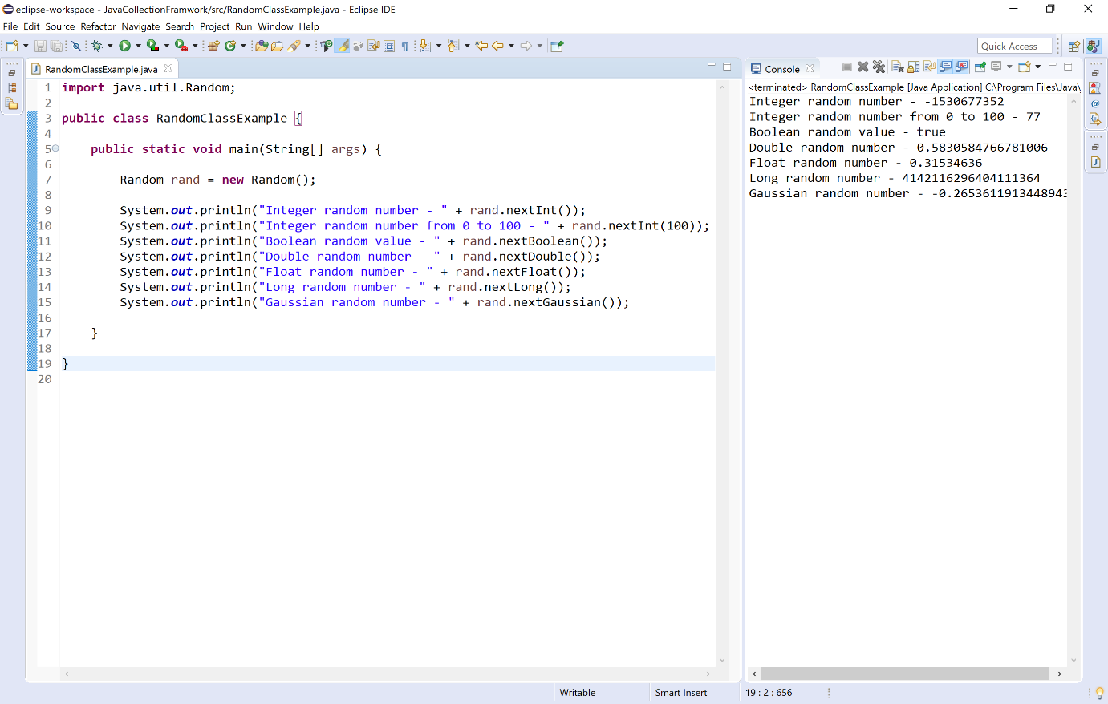

Formatter class in Java
The Formatter is a built-in class in java used for layout justification and alignment, common formats for numeric, string, and date/time data, and locale-specific output in java programming. The Formatter class is defined as final class inside the java.util package.
The Formatter class implements Cloneable and Flushable interface.
The Formatter class in java has the following constructors.
S.No. | Constructor with Description
1 | Formatter()  It creates a new formatter.
2 | Formatter(Appendable a)  It creates a new formatter with the specified destination.
3 | Formatter(Appendable a, Locale l)  It creates a new formatter with the specified destination and locale.
4 | Formatter(File file)  It creates a new formatter with the specified file.
5 | Formatter(File file, String charset)  It creates a new formatter with the specified file and charset.
6 | Formatter(File file, String charset, Locale l)  It creates a new formatter with the specified file, charset, and locale.
7 | Formatter(Locale l)  It creates a new formatter with the specified locale.
8 | Formatter(OutputStream os)  It creates a new formatter with the specified output stream.
9 | Formatter(OutputStream os, String charset)  It creates a new formatter with the specified output stream and charset.
10 | Formatter(OutputStream os, String charset, Locale l)  It creates a new formatter with the specified output stream, charset, and locale.
11 | Formatter(PrintStream ps)  It creates a new formatter with the specified print stream.
12 | Formatter(String fileName)  It creates a new formatter with the specified file name.
13 | Formatter(String fileName, String charset)  It creates a new formatter with the specified file name and charset.
14 | Formatter(String fileName, String charset, Locale l)  It creates a new formatter with the specified file name, charset, and locale.
The Formatter class in java has the following methods.
S.No. | Methods with Description
1 | Formatter format(Locale l, String format, Object... args)  It writes a formatted string to the invoking object's destination using the specified locale, format string, and arguments.
2 | Formatter format(String format, Object... args)  It writes a formatted string to the invoking object's destination using the specified format string and arguments.
3 | void flush()  It flushes the invoking formatter.
4 | Appendable out()  It returns the destination for the output.
5 | Locale locale()  It returns the locale set by the construction of the invoking formatter.
6 | String toString()  It converts the invoking object to string.
7 | IOException ioException()  It returns the IOException last thrown by the invoking formatter's Appendable.
8 | void close()  It closes the invoking formatter.
Let's consider an example program to illustrate methods of Formatter class.
Example
import java.util.*;

public class FormatterClassExample {

public static void main(String[] args) {

Formatter formatter=new Formatter();
formatter.format("%2$5s %1$5s %3$5s", "Smart", "BTech", "Class");
System.out.println(formatter);

formatter = new Formatter();
formatter.format(Locale.FRANCE,"%.5f", -1325.789);
System.out.println(formatter);

String name = "Java";
formatter = new Formatter();
formatter.format(Locale.US,"Hello %s !", name);
System.out.println("" + formatter + " " + formatter.locale());

formatter = new Formatter();
formatter.format("%.4f", 123.1234567);
System.out.println("Decimal floating-point notation to 4 places: " + formatter);

formatter = new Formatter();
formatter.format("%010d", 88);
System.out.println("value in 10 digits: " + formatter);
}
}

When we execute the above code, it produce the following output.
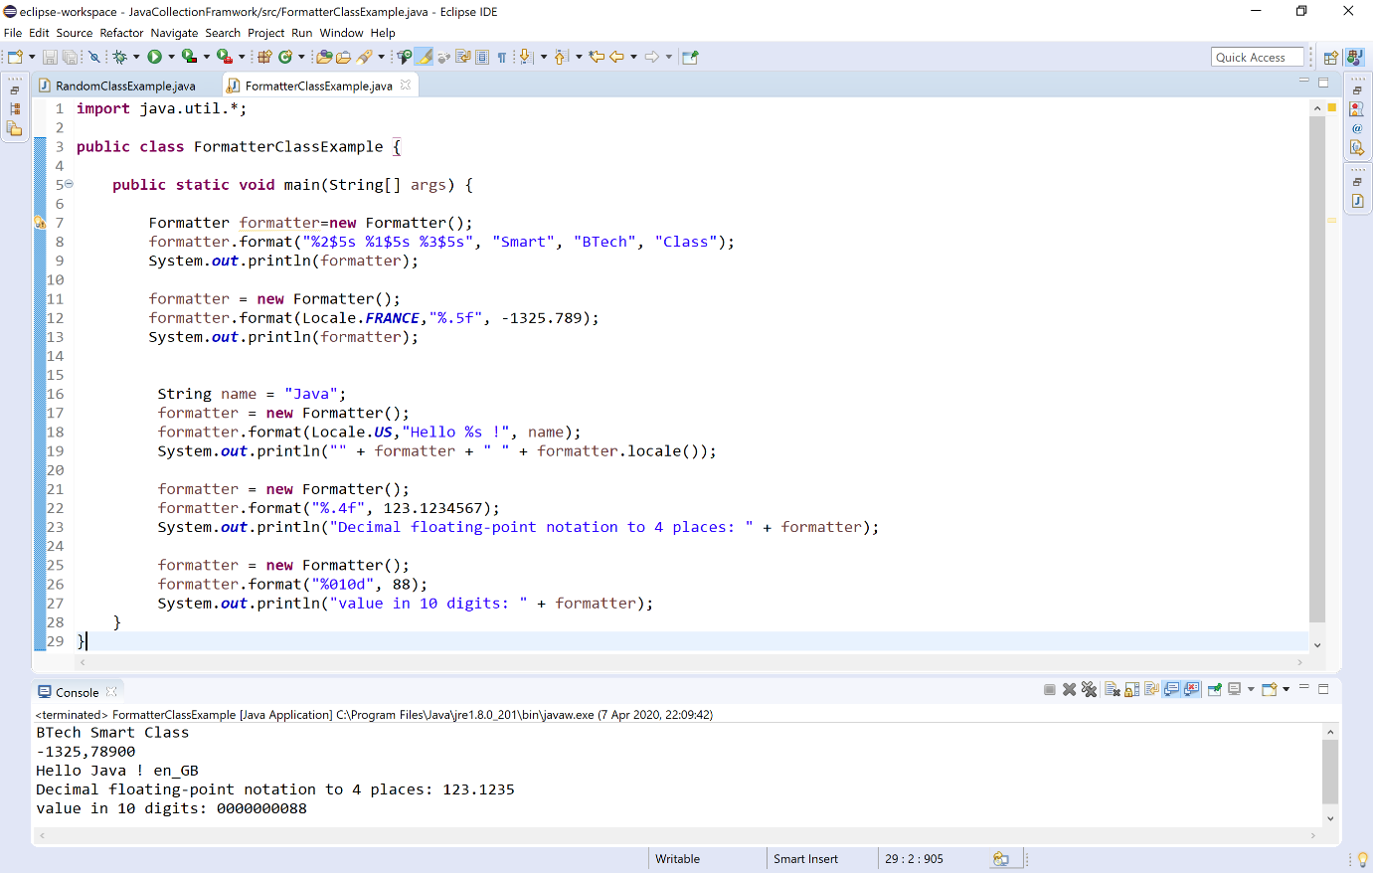

Scanner class in Java
The Scanner is a built-in class in java used for read the input from the user in java programming. The Scanner class is defined inside the java.util package.
The Scanner class implements Iterator interface.
The Scanner class provides the easiest way to read input in a Java program.
🔔 The Scanner object breaks its input into tokens using a delimiter pattern, the default delimiter is whitespace.
The Scanner class in java has the following constructors.
S.No. | Constructor with Description
1 | Scanner(InputStream source)  It creates a new Scanner that produces values read from the specified input stream.
2 | Scanner(InputStream source, String charsetName)  It creates a new Scanner that produces values read from the specified input stream.
3 | Scanner(File source)  It creates a new Scanner that produces values scanned from the specified file.
4 | Scanner(File source, String charsetName)  It creates a new Scanner that produces values scanned from the specified file.
5 | Scanner(String source)  It creates a new Scanner that produces values scanned from the specified string.
6 | Scanner(Readable source)  It creates a new Scanner that produces values scanned from the specified source.
7 | Scanner(ReadableByteChannel source)  It creates a new Scanner that produces values scanned from the specified channel.
8 | Scanner(ReadableByteChannel source, String charsetName)  It creates a new Scanner that produces values scanned from the specified channel.
The Scanner class in java has the following methods.
S.No. | Methods with Description
1 | String next()  It reads the next complete token from the invoking scanner.
2 | String next(Pattern pattern)  It reads the next token if it matches the specified pattern.
3 | String next(String pattern)  It reads the next token if it matches the pattern constructed from the specified string.
4 | boolean nextBoolean()  It reads a boolean value from the user.
5 | byte nextByte()  It reads a byte value from the user.
6 | double nextDouble()  It reads a double value from the user.
7 | float nextFloat()  It reads a floating-point value from the user.
8 | int nextInt()  It reads an integer value from the user.
9 | long nextLong()  It reads a long value from the user.
10 | short nextShort()  It reads a short value from the user.
11 | String nextLine()  It reads a string value from the user.
12 | boolean hasNext()  It returns true if the invoking scanner has another token in its input.
13 | void remove()  It is used when remove operation is not supported by this implementation of Iterator.
14 | void close()  It closes the invoking scanner.
Let's consider an example program to illustrate methods of Scanner class.
Example
import java.util.Scanner;

public class ScannerClassExample {

public static void main(String[] args) {

Scanner read = new Scanner(System.in); // Input stream is used

System.out.print("Enter any name: ");
String name = read.next();

System.out.print("Enter your age in years: ");
int age = read.nextInt();

System.out.print("Enter your salary: ");
double salary = read.nextDouble();

System.out.print("Enter any message: ");
read = new Scanner(System.in);
String msg = read.nextLine();

System.out.println("\n------------------------------------------");
System.out.println("Hello, " + name);
System.out.println("You are " + age + " years old.");
System.out.println("You are earning Rs." + salary + " per month.");
System.out.println("Words from " + name + " - " + msg);
}
}

When we execute the above code, it produce the following output.
