Unit # 4

Input-Output Organization

Dr. Rajesh Tiwari Professor ( CSE – AIML) CMREC, Hyderabad, Telangana

Input-Output Interface
- Input-output interface provides a method for transferring information between internal storage and external I/0 devices.

- Peripherals connected to a computer need special communication links for interfacing them with the central processing unit.

- The purpose of the communication link is to resolve the differences that exist between the central computer and each peripheral.

Input-Output Interface
  - The major differences are:
    - Peripherals are electromechanical and electromagnetic devices and their manner of operation is different from the operation of the CPU and memory, which are electronic devices. Therefore, a conversion of signal values may be required.
    - The data transfer rate of peripherals is usually slower than the transfer rate of the CPU, and consequently, a synchronization mechanism may be needed.
    - Data codes and formats in peripherals differ from the word format in the CPU and memory.
    - The operating modes of peripherals are different from each other and each must be controlled so as not to disturb the operation of other peripherals connected to the CPU.

Input-Output Interface
  - To resolve these differences, computer systems include special hardware components between the CPU and peripherals to supervise and synchronize all input and output transfers.

  - These components are called interface units because they interface between the processor bus and the peripheral device.

  - Each device may have its own controller that supervises the operations of the particular mechanism in the peripheral.

I/0 Bus and Interface Modules
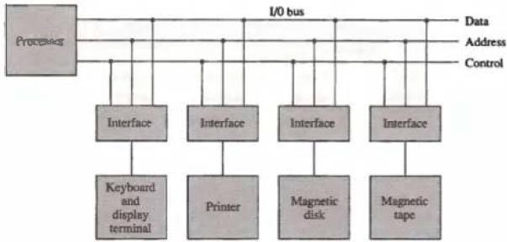
Figure 4·1: Connection of I/O bus to input-output device 5

  - The communication link between the processor and several peripherals is shown in Fig. 4·1.
  - The I/0 bus consists of data lines, address lines, and control lines.
  - The magnetic disk, printer, and terminal are employed in practically any general-purpose computer.
  - Each peripheral device has associated with it an interface unit.
  - Each interface decodes the address and control received from the I/O bus, interprets them for the peripheral, and provides signals for the peripheral controller.

  - It also synchronizes the data flow and supervises the transfer between peripheral and processor.

  - Each peripheral has its own controller that operates the particular electromechanical device.

  - Example,
    - the printer controller controls the paper motion, the print timing, and
the selection of printing characters.
  - A controller may be housed separately or may be physically integrated with the peripheral.

  - The I/O bus from the processor is attached to all peripheral interfaces.
  - To communicate with a particular device, the processor places a device address on the address lines.
  - Each interface attached to the I/0 bus contains an address decoder that monitors the address lines.
  - When the interface detects its own address, it activates the path between the bus lines and the device that it controls.
  - All peripherals whose address does not correspond to the address
in the bus are disabled by their interface.

  - Same time that the address is made available in the address lines, the processor provides a function code in the control lines.
  - The interface selected responds to the function code and
proceeds to execute it.
  - The function code is referred to as an I/O command and is in essence an instruction that is executed in the interface and its attached peripheral unit.
  - The interpretation of the command depends on the peripheral that the processor is addressing.
  - There are four types of commands that an interface may receive.
They are classified as control, status, data output, and data input.

  - A control command is issued to activate the peripheral and to inform it what to do.

  - For example,
    - a magnetic tape unit may be instructed to backspace the tape by one record, to rewind the tape, or to start the tape moving in the forward direction.

  - The particular control command issued depends on the peripheral, and each peripheral receives its own distinguished sequence of control commands, depending on its mode of operation.

  - A status command is used to test various status conditions in the interface and the peripheral.

  - For example,
    - the computer may wish to check the status of the peripheral before a transfer is initiated.
    - During the transfer, one or more errors may occur which are detected by the interface.
    - These errors are designated by setting bits in a status register that the
processor can read at certain intervals.

- A data output command causes the interface to respond by transferring data from the bus into one of its registers.
- Consider an example with a tape unit.
- The computer starts the tape moving by issuing a control command.
- The processor then monitors the status of the tape by means of a status command.
- When the tape is in the correct position, the processor issues a data output
command.
- The interface responds to the address and command and transfers the information from the data lines in the bus to its buffer register.
- The interface then communicates with the tape controller and sends the data
to be stored on tape.

  - The data input command is the opposite of the data output.

  - In this case the interface receives an item of data from the peripheral and places it in its buffer register.

  - The processor checks if data are available by means of a status command and then issues a data input command.

  - The interface places the data on the data lines, where they are
accepted by the processor.

Asynchronous Data Transfer
  - Asynchronous data transfer between two independent units requires that control signals be transmitted between the communicating units to indicate the time at which data is being transmitted.
  - One way of achieving this is by means of a strobe pulse supplied by one of the units to indicate to the other unit when the transfer has to occur.
  - Another method commonly used is to accompany each data item being transferred with a control signal that indicates the presence of data in the bus.
  - The unit receiving the data item responds with another control signal to acknowledge receipt of the data. This type of agreement between two independent units is referred to as handshaking .

  - The asynchronous transfer between two independent units by means of a timing diagram that shows the timing relationship that must exist between the control signals and the data in the buses.

  - The sequence of control during an synchronous transfer depends on whether the transfer is initiated by the source or by the destination unit.

Strobe Control
  - The strobe control method of asynchronous data transfer employs a single control line to time each transfer.
  - The strobe may be activated by either the source or the
destination unit.
  - Figure 4.2 shows a source-initiated transfer.
  - The data bus carries the binary information from source unit to the destination unit.
  - The bus has multiple lines to transfer an entire byte or word.
  - The strobe is a single line that informs the destination unit when a valid data word is available in the bus.

  - The timing diagram of Fig. 4.2(b), the source unit first places the data on the data bus.
  - After a brief delay to ensure that the data settle to a steady value, the
source activates the strobe pulse.
  - The information on the data bus and the strobe signal remain in the active state for a sufficient time period to allow the destination unit to receive the data.
  - Often, the destination unit uses the falling edge of the strobe pulse to
transfer the contents of the data bus into one of its internal registers.
  - The source removes the data from the bus a brief period after it disables its strobe pulse.
  - Actually, the source does not have to change the information in the data bus.
  - The fact that the strobe signal is disabled indicates that the data bus
does not contain valid data.
  - New valid data will be available only after the strobe is enabled again.

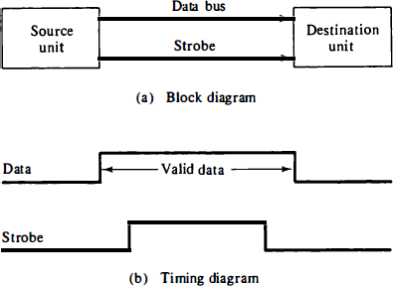

Figure 4.2: Source-initiated strobe for data transfer 18

  - Figure 4.3 shows a data transfer initiated by the destination unit.
  - In this case the destination unit activates the strobe pulse, informing the source to provide the data.
  - The source unit responds by placing the requested binary information on the data bus.
  - The data must be valid and remain in the bus long enough for the destination unit to accept it.
  - The falling edge of the strobe pulse can be used again to trigger a destination register.
  - The destination unit then disables the strobe.
  - The source removes the data from the bus after a predetermined time interval.

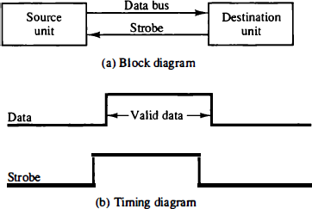

Figure 4.3: Destination-initiated strobe for data transfer

Handshaking
- The disadvantage of the strobe method is that the source unit that initiates the transfer has no way of knowing whether the destination unit has actually received the data item that was placed in the bus.
- A destination unit that initiates the transfer has no way of knowing whether the source unit has actually placed the data on the bus.
- The handshake method solves this problem by introducing a second control signal that provides a reply to the unit that initiates the transfer.
- The basic principle of the two-wire handshaking method of data transfer is as follows.
  - One control line is in the same direction as the data flow in the bus from the source to the destination. It is used by the source unit to inform the destination unit whether there are valid data in the bus.
  - The other control line is in the other direction from the destination to the source. It is used by the destination unit to inform the source whether it can accept data.

- Figure 4.4 shows the data transfer procedure when initiated by the source.
- The two handshaking lines are data valid, which is generated by the source unit, and data accepted, generated by the destination unit.
- The timing diagram shows the exchange of signals between the two units.
- The sequence of events listed in part (c) shows the four possible states that the system can be at any given time.
- The source unit initiates the transfer by placing the data on the bus and enabling its data valid signal.

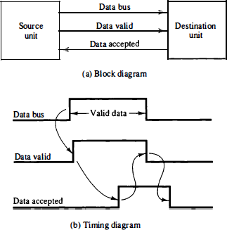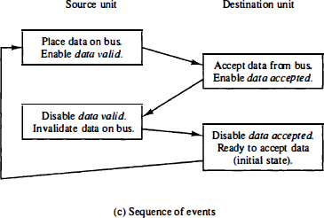

Figure 4.4: Source-initiated transfer using handshaking

- The data accepted signal is activated by the destination unit after it accepts the data from the bus.
- The source unit then disables its data valid signal, which invalidates the data on the bus.
- The destination unit then disables its data accepted signal and the system goes into its initial state.
- The source does not send the next data item until after the destination unit shows its readiness to accept new data by disabling its data accepted signal.
- This scheme allows arbitrary delays from one state to the next and permits each unit to respond at its own data transfer rate. The rate of transfer is determined by the slowest unit.

- Destination-initiated transfer using handshaking

Modes of Transfer
- Data transfer between the central computer and I/O devices may be handled in a variety of modes.
- Some modes use the CPU as an intermediate path; others transfer the data directly to and from the memory unit.
- Data transfer to and from peripherals may be handled in one of three possible modes:
  - Programmed I/O
  - Interrupt-initiated I/O
  - Direct memory access (DMA)

Programmed I/0
- This operations are the result of I/O instructions written in the computer program.
- Each data item transfer is initiated by an instruction in the program.
- Normally, the transfer is to and from a CPU register and peripheral.
- Other instructions are needed to transfer the data to and from CPU and memory.
- Transferring data under program control requires constant monitoring of the peripheral by the CPU.
- Once a data transfer is initiated, the CPU is required to monitor
the interface to see when a transfer can again be made.
- It is up to the programmed instructions executed in the CPU to keep close tabs on everything that is taking place in the interface unit and the I/O device. 27

Interrupt-initiated I/O
- In the programmed I/0 method, the CPU stays in a program loop until the I/O unit indicates that it is ready for data transfer.
- This is a time-consuming process since it keeps the processor busy needlessly.
- It can be avoided by using an interrupt facility and special commands to inform the interface to issue an interrupt request signal when the data are available from the device.
- In the meantime the CPU can proceed to execute another program.
- The interface meanwhile keeps monitoring the device. When the interface determines that the device is ready for data transfer, it generates an interrupt request to the computer.
- Upon detecting the external interrupt signal, the CPU momentarily stops the task it is processing, branches to a service program to process the I/O transfer, and then returns to the task it was originally performing. 28

Direct memory access (DMA)
- Transfer of data under programmed I/O is between CPU and peripheral.
- In direct memory access (DMA), the interface transfers data into and out of the memory unit through the memory bus.
- The CPU initiates the transfer by supplying the interface with the starting address and the number of words needed to be transferred and then proceeds to execute other tasks.
- When the transfer is made, the DMA requests memory cycles through the memory bus.
- When the request is granted by the memory controller, the DMA transfers the data directly into memory.
- The CPU merely delays its memory access operation to allow the direct memory I/O transfer. Since peripheral speed is usually slower than processor speed, I/O-memory transfers are infrequent compared to processor access to memory. 29

Priority Interrupt
- Data transfer between the CPU and an I/O device is initiated by the CPU.
- The CPU cannot start the transfer unless the device is ready to communicate with the CPU.
- The readiness of the device can be determined from an interrupt signal.
- The CPU responds to the interrupt request by storing the return address from PC into a memory stack and then the program branches to a service routine that processes the required transfer.

- In a typical application a number of I/O devices are attached to the computer, with each device being able to originate an interrupt request.

- The first task of the interrupt system is to identify the source of the interrupt.

- There is also the possibility that several sources will request service simultaneously.

- In this case the system must also decide which device to service first.

- A priority interrupt is a system that establishes a priority over the various sources to determine which condition is to be serviced first when two or more requests arrive simultaneously.
- The system may also determine which conditions are permitted to interrupt the computer while another interrupt is being serviced.
- Higher-priority interrupt levels are assigned to requests which, if delayed or interrupted, could have serious consequences.
- Devices with high speed transfers such as magnetic disks are given high priority, and slow devices such as keyboards receive low priority.
- When two devices interrupt the computer at the same time, the computer services the device, with the higher priority first.

- Establishing the priority of simultaneous interrupts can be done by software or hardware.
- A polling procedure is used to identify the highest-priority source by software means.
- In this method there is one common branch address for all interrupts.
- The program that takes care of interrupts begins at the branch address and polls the interrupt sources in sequence.
- The order in which they are tested determines the priority of each interrupt.
- The highest-priority source is tested first, and if its interrupt signal is on, control branches to a service routine for this source.
- Otherwise, the next-lower-priority source is tested, and so on. 33

Daisy-Chaining Priority
- Daisy-chaining method of establishing priority consists of a serial connection of all devices that request an interrupt.
- The device with the highest priority is placed in the first position, followed by lower-priority devices up to the device with the lowest priority, which is placed last in the chain.
- This method of connection between three devices and the CPU is shown in Fig. 4.5.
- The interrupt request line is common to all devices and forms a
wired logic connection.
- If any device has its interrupt signal in the low-level state, the interrupt line goes to the low-level state and enables the interrupt input in the CPU.

- When no interrupts are pending, the interrupt line stays in the high- level state and no interrupts are recognized by the CPU.
- This is equivalent to a negative logic OR operation.
- The CPU responds to an interrupt request by enabling the interrupt
acknowledge line.
- This signal is received by device 1 at its PI (priority in) input.
- The acknowledge signal passes on to the next device through the PO (priority out) output only if device 1 is not requesting an interrupt.
- If device 1 has a pending interrupt, it blocks the acknowledge signal from the next device by placing a 0 in the PO output.
- It then proceeds to insert its own interrupt vector address (V AD) into the data bus for the CPU to use during the interrupt cycle.

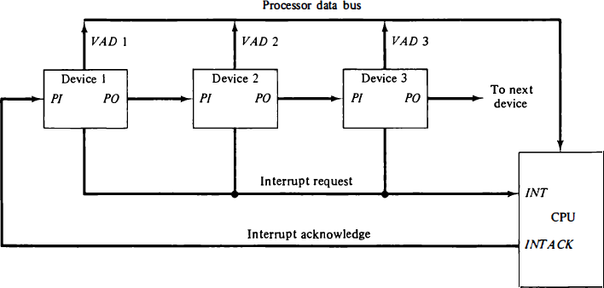

Figure 4.5: Daisy - chain priority interrupt. 36

- A device with a 0 in its PI input generates a 0 in its PO output to inform the next-lower-priority device that the acknowledge signal has been blocked.
- A device that is requesting an interrupt and has a 1 in its PI input will intercept the acknowledge signal by placing a 0 in its PO output.
- If the device does not have pending interrupts, it transmits the acknowledge signal to the next device by placing a 1 in its PO output.
- Thus the device with PI = 1 and PO = 0 is the one with the highest priority that is requesting an interrupt, and this device places its VAD on the data bus.
- The daisy chain arrangement gives the highest priority to the device that receives the interrupt acknowledge signal from the CPU.
- Farther the device is from the first position, the lower is its priori3t7y.

Priority Encoder

The priority encoder is a circuit that implements the priority function.
- The logic of the priority encoder is such that if two or more inputs arrive at the same time, the input having the highest priority will take precedence.

The truth table of a four-input priority encoder is given in Table 4.1.
- The x's in thr table designate don't-care conditions.

Input I₀ has the highest priority; so regardless of the values of other inputs, when this input is 1, the output generates an output xy : 00.

TABLE 4.1 Priority Encoder Truth Table
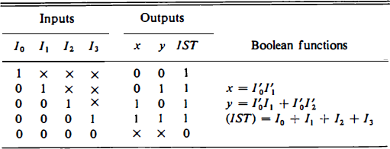

- I₁ has the next priority level. The output is 01 if I₁ = 1 provided that I₀ = 0, regardless of the values of the other two lower- priority inputs.
- The output for I₂ is generated only if higher-priority inputs are 0, and so on down the priority level.
- The interrupt status IST is set only when one or more inputs are equal to 1.
- If all inputs are 0, IST is cleared to 0 and the other outputs of the encoder are not used, so they are marked with don't-care conditions.

Direct Memory Access (DMA)
- The data formats of peripheral devices differ from memory and CPU data formats.
- The IOP must structure data words from many different sources.
- For example, it may be necessary to take four bytes from an input device and pack them into one 32-bit word before the transfer to memory.
- Data are gathered in the IOP at the device rate and bit capacity while the CPU is executing its own program.
- After the input data are assembled into a memory word, they are transferred from IOP directly into memory by "stealing" one memory cycle from the CPU.
- An output word transferred from memory to the IOP is directed from the IOP to the output device at the device rate and bit capacity.

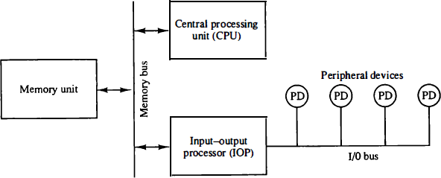

Figure 4.6: Block diagram of a computer with l/0 processor. 42

Direct Memory Access (DMA)
- Direct Memory Access (DMA) transfers the block of data between the memory and peripheral devices of the system, without the participation of the processor.

- The unit that controls the activity of accessing memory directly is called a DMA controller.

- The processor relinquishes the system bus for a few clock cycles.

- The DMA controller can accomplish the task of data transfer via
the system bus.

Direct Memory Access (DMA)
- We have two other methods of data transfer, programmed I/O and Interrupt driven I/O.

- In programmed I/O, the processor keeps on scanning whether any device is ready for data transfer.
- If an I/O device is ready, the processor fully dedicates itself in transferring the data between I/O and memory.
- It transfers data at a high rate, but it can’t get involved in any other activity during data transfer.
- This is the major drawback of programmed I/O.

  - In Interrupt driven I/O, whenever the device is ready for data transfer, then it raises an interrupt to processor.

  - Processor completes executing its ongoing instruction and saves its current state.

  - It then switches to data transfer which causes a delay.

  - Here, the processor doesn’t keep scanning for peripherals ready for data transfer. But, it is fully involved in the data transfer process.

  - So, it is also not an effective way of data transfer.

- The DMA controller transfers the data in three modes:
- Burst Mode: Once the DMA controller gains the charge of the system bus, then it releases the system bus only after completion of data transfer. Till then the CPU has to wait for the system buses.

- Cycle Stealing Mode: The DMA controller forces the CPU to stop its operation and relinquish the control over the bus for a short term to DMA controller. After the transfer of every byte, the DMA controller releases the bus and then again requests for the system bus. In this way, the DMA controller steals the clock cycle for transferring every byte.

- Transparent Mode: The DMA controller takes the charge of system bus only if the processor does not require the system bus.

  - DMA controller is a hardware unit that allows I/O devices to access memory directly without the participation of the processor.

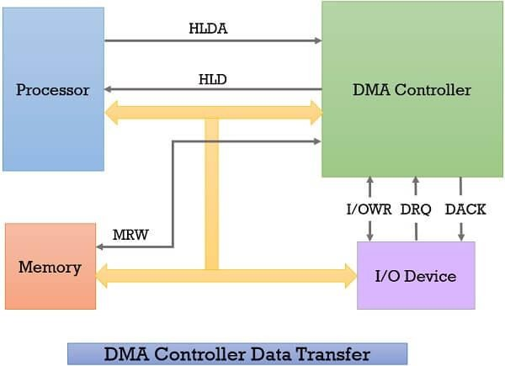

- Whenever an I/O device wants to transfer the data to or from memory, it sends the DMA request (DRQ) to the DMA controller. DMA controller accepts this DRQ and asks the CPU to hold for a few clock cycles by sending it the Hold request (HLD).

- CPU receives the Hold request (HLD) from DMA controller and relinquishes the bus and sends the Hold acknowledgement (HLDA) to DMA controller.

- After receiving the Hold acknowledgement (HLDA), DMA controller acknowledges I/O device (DACK) that the data transfer can be performed and DMA controller takes the charge of the system bus and transfers the data to or from memory.

- When the data transfer is accomplished, the DMA raise an interrupt to let know the processor that the task of data transfer is finished and the processor can take control over the bus again and start processing where it has left.

Direct Memory Access Diagram
- Whenever a processor is requested to read or write a block of data, i.e. transfer a block of data, it instructs the DMA controller by sending the following information.
  - The first information is whether the data has to be read from memory or the data has to be written to the memory. It passes this information via read or write control lines that is between the processor and DMA controllers control logic unit.
  - The processor also provides the starting address of/ for the data block in the memory, from where the data block in memory has to be read or where the data block has to be written in memory. DMA controller stores this in its address register. It is also called the starting address register.
  - The processor also sends the word count, i.e. how many words are to be read or written. It stores this information in the data count or the word count register.
  - The most important is the address of I/O device that wants to read or write data. This information is stored in the data register.

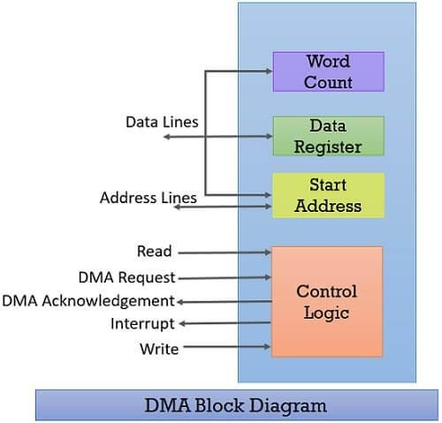

DMA Advantages and Disadvantages

Advantages:
  - Transferring the data without the involvement of the processor will speed up the read-write task.
  - DMA reduces the clock cycle requires to read or write a block of data.
  - Implementing DMA also reduces the overhead of the processor.

Disadvantages:
  - As it is a hardware unit, it would cost to implement a DMA controller in the system.
  - Cache coherence problem can occur while using DMA controller.

Thank You

