Unit # 5
Pipeline and Vector Processing

Dr. Rajesh Tiwari Professor ( CSE – AIML) CMREC, Hyderabad, Telangana

Characteristics of multiprocessors
- A multiprocessor system is an interconnection of two or more CPUs with memory and input-output equipment.
- The term “processor” in multiprocessor can mean either a central processing unit (CPU) or an input-output processor (IOP).
- Multiprocessors are classified as multiple instruction stream, multiple data stream (MIMD) systems
- The similarity and distinction between multiprocessor and multicomputer are:

Similarity
    - Both support concurrent operations
  - Distinction
    - The network consists of several autonomous computers that may or may not communicate with each other.
    - A multiprocessor system is controlled by one operating system that provides interaction between processors and all the components of the system cooperate in the solution of a problem.

Characteristics of multiprocessors
- Multiprocessing improves the reliability of the system.
- The benefit derived from a multiprocessor organization is an improved system performance.
  - Multiple independent jobs can be made to operate in parallel.
  - A single job can be partitioned into multiple parallel tasks.
- Multiprocessing can improve performance by decomposing a program into parallel executable tasks.
  - The user can explicitly declare that certain tasks of the program be
executed in parallel.
    - This must be done prior to loading the program by specifying the parallel executable segments.
  - The other is to provide a compiler with multiprocessor software that
can automatically detect parallelism in a user’s program.

Characteristics of multiprocessors
- Multiprocessor are classified by the way their memory is organized.
  - A multiprocessor system with common shared memory is classified as a shared-memory or tightly coupled multiprocessor.
    - Tolerate a higher degree of interaction between tasks.
  - Each processor element with its own private local memory is classified as a distributed-memory or loosely coupled system.
    - Are most efficient when the interaction between tasks is minimal

Interconnection Structures
- The components that form a multiprocessor system are CPUs, IOPs connected to input-output devices, and a memory unit.
- The interconnection between the components can have different physical configurations, depending on the number of transfer paths that are available
  - Between the processors and memory in a shared memory system
  - Among the processing elements in a loosely coupled system
- There are several physical forms available for establishing an interconnection network.
  - Time-shared common bus
  - Multiport memory
  - Crossbar switch
  - Multistage switching network
  - Hypercube system

Time Shared Common Bus
- A common-bus multiprocessor system consists of a number of processors connected through a common path to a memory unit.
- Disadvantage.:
  - Only one processor can communicate with the memory or another processor at any given time.
  - As a consequence, the total overall transfer rate within the system is limited by the speed of the single path
- A more economical implementation of a dual bus structure is depicted in Fig. 5.1 and Fig. 5.2.
- Part of the local memory may be designed as a cache memory attached to the CPU.

Time Shared Common Bus

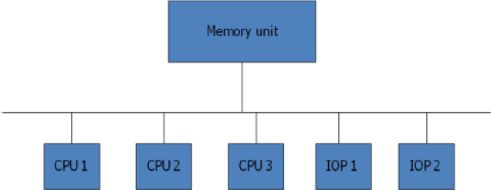

Figure 5.1: Time shared common bus organization

Time Shared Common Bus

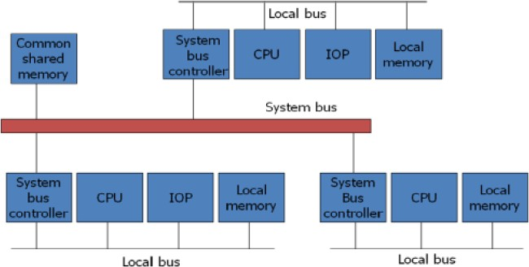

Figure 5.2: System bus structure for multiprocessors

Multiport Memory
- A multiport memory system employs separate buses between each memory module and each CPU.
- The module must have internal control logic to determine which port will have access to memory at any given time.
- Memory access conflicts are resolved by assigning fixed priorities to each memory port.
- Advantage:
  - The high transfer rate can be achieved because of the multiple paths.
- Disadvantage:
  - It requires expensive memory control logic and a large number of
cables and connections
- Fig. 5.3 shows multiport memory system.

Multiport Memory

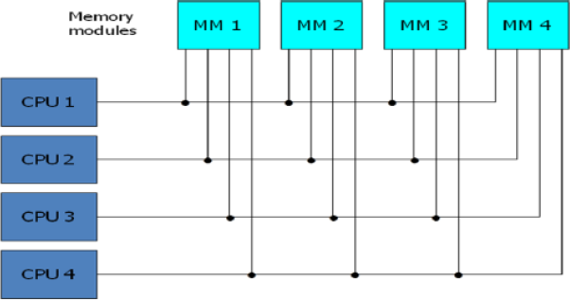

Figure 5.3: Multiport memory organization

Crossbar Switch
- This consists of a number of crosspoints that are placed at intersections between processor buses and memory module paths.
- The small square in each crosspoint is a switch that determines
the path from a processor to a memory module.

Advantage:
  - Supports simultaneous transfers from all memory modules

Disadvantage:
  - The hardware required to implement the switch can become quite large and complex.
- Fig. 5.4 shows the functional design of a crossbar switch
connected to one memory module.
- Figure 5.5 shows Block diagram of crossbar switch.

Crossbar Switch

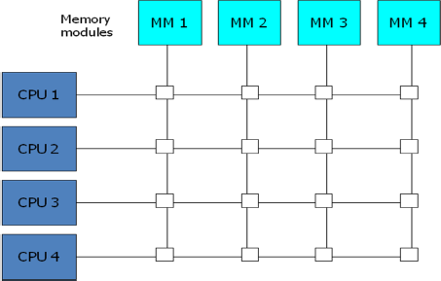
Figure 5.4: Crossbar switch

Crossbar Switch

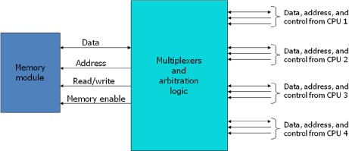

Figure 5.5: Block diagram of crossbar switch

Multistage Switching Network
- The basic component of a multistage network is a two-input, two- output interchange switch as shown in below Figure.

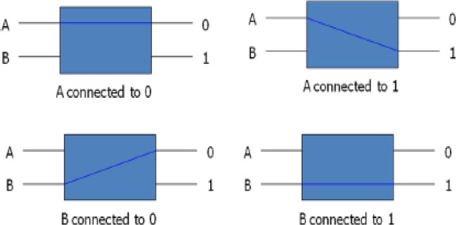

Multistage Switching Network
  - Using the 2x2 switch as a building block, it is possible to build a multistage network to control the communication between a number of sources and destinations.
    - To see how this is done, consider the binary tree shown in below Figure.
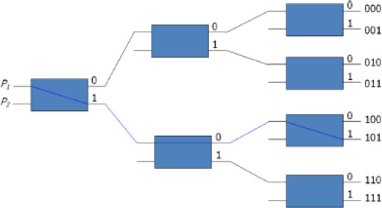
    - Certain request patterns cannot be satisfied simultaneously. i.e., if P1 - 000~011, then P2 - 100~111

Multistage Switching Network
- One such topology is the omega switching network shown in Fig. 5.6.

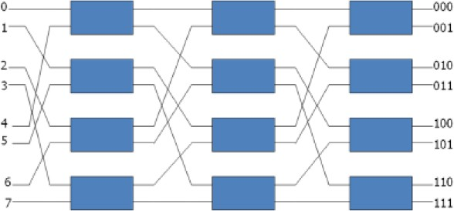

Fig. 5.6: 8 x 8 Omega Switching Network

Multistage Switching Network
- Some request patterns cannot be connected simultaneously. i.e., any two sources cannot be connected simultaneously to destination 000 and 001
- In a tightly coupled multiprocessor system, the source is a processor and the destination is a memory module.

- Set up the path transfer the address into memory transfer the data

Hypercube System
  - The hypercube or binary n-cube multiprocessor structure is a loosely coupled system composed of N=2n processors interconnected in an n-dimensional binary cube.
    - Each processor forms a node of the cube, in effect it contains not only a CPU but also local memory and I/O interface.
    - Each processor address differs from that of each of its n neighbors by exactly one bit position.
  - Fig. 5.7 shows the hypercube structure for n=1, 2, and 3.
  - Routing messages through an n-cube structure may take from one to n links from a source node to a destination node.
    - A routing procedure can be developed by computing the exclusive-OR of
the source node address with the destination node address.
    - The message is then sent along any one of the axes that the resulting binary value will have 1 bits corresponding to the axes on which the two nodes differ.

Multistage Switching Network
- A representative of the hypercube architecture is the Intel iPSC computer complex.
- It consists of 128(n=7) microcomputers, each node consists of a CPU, a floating-point processor, local memory, and serial communication interface units.
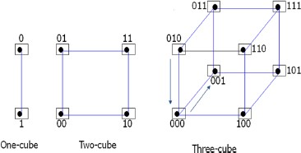
Fig. 5.7: Hypercube structures for n=1,2,3

Multistage Switching Network

