Java AWT (Abstract Window Toolkit) is an API to develop Graphical User Interface (GUI) or windows-based applications in Java.
Java AWT components are platform-dependent i.e. components are displayed according to the view of operating system. AWT is heavy weight i.e. its components are using the resources of underlying operating system (OS).
The java.awt package provides classes for AWT API such as TextField, Label, TextArea, RadioButton, CheckBox, Choice, List etc.
The AWT tutorial will help the user to understand Java GUI programming in simple and easy steps.
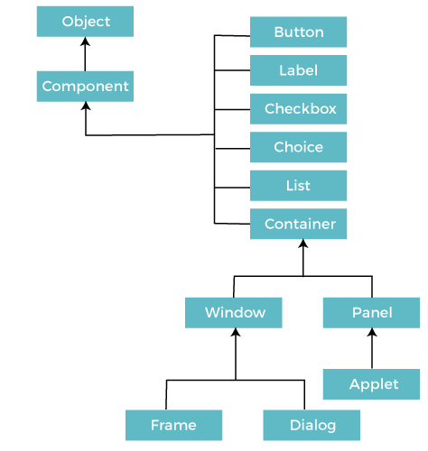

MVC Architecture
The Model-View-Controller (MVC) is a well-known design pattern
in the web development field. It is way to organize our code. It specifies that a program or application shall consist of data model, presentation information and control information. The MVC pattern needs all these components to be separated as different objects.
The MVC pattern architecture consists of three layers:
- Model: It represents the business layer of application. It is an object to carry the data that can also contain the logic to update controller if data is changed.
- View: It represents the presentation layer of application. It is used to visualize the data that the model contains.
- Controller: It works on both the model and view. It is used to manage the flow of application, i.e. data flow in the model object and to update the view whenever data is changed.
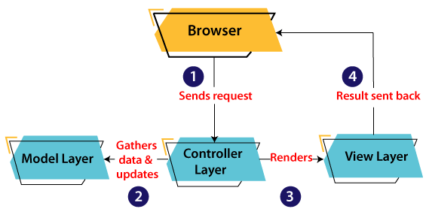

Components
All the elements like the button, text fields, scroll bars, etc. are called components. In Java AWT, there are classes for each component as shown in above diagram. In order to place every component in a particular position on a screen, we need to add them to a container.

Container
The Container is a component in AWT that can contain another components like buttons, textfields, labels etc. The classes that extends Container class are known as container such as Frame, Dialog and Panel.
It is basically a screen where the where the components are placed at their specific locations. Thus it contains and controls the layout of components.
There are four types of containers in Java AWT:
- Window
- Panel
- Frame
- Dialog

Useful Methods of Component Class
Method | Description
public void add(Component c) | Inserts a component on this component.
public void setSize(int width,int height) | Sets the size (width and height) of the component.
public void setLayout(LayoutManager m) | Defines the layout manager for the component.
public void setVisible(boolean status) | Changes the visibility of the component, by default false.

Layout Manager
The LayoutManagers are used to arrange components in a particular manner. The Java LayoutManagers facilitates us to control the positioning and size of the components in GUI forms. LayoutManager is an interface that is implemented by all the classes of layout managers.
Flow Layout,
The Java FlowLayout class is used to arrange the components in a line, one after another (in a flow). It is the default layout of the applet or panel.

Fields of FlowLayout class
- public static final int LEFT
- public static final int RIGHT
- public static final int CENTER
- public static final int LEADING
- public static final int TRAILING

Constructors of FlowLayout class
- FlowLayout(): creates a flow layout with centered alignment and a default 5 unit horizontal and vertical gap.
- FlowLayout(int align): creates a flow layout with the given alignment and a default 5 unit horizontal and vertical gap.
- FlowLayout(int align, int hgap, int vgap): creates a flow layout with the given alignment and the given horizontal and vertical gap.

Example of FlowLayout class: Using FlowLayout() constructor
FileName: FlowLayoutExample.java

- // import statements
- import java.awt.*;
- import javax.swing.*;

- public class FlowLayoutExample
- {

- JFrame frameObj;

- // constructor
- FlowLayoutExample()
- {
- // creating a frame object
- frameObj = new JFrame();

- // creating the buttons
- JButton b1 = new JButton("1");
- JButton b2 = new JButton("2");
- JButton b3 = new JButton("3");
- JButton b4 = new JButton("4");
- JButton b5 = new JButton("5");
- JButton b6 = new JButton("6");
- JButton b7 = new JButton("7");
- JButton b8 = new JButton("8");
- JButton b9 = new JButton("9");
- JButton b10 = new JButton("10");

- // adding the buttons to frame
- frameObj.add(b1); frameObj.add(b2); frameObj.add(b3); frameObj.add(b4);
- frameObj.add(b5); frameObj.add(b6); frameObj.add(b7); frameObj.add(b8);
- frameObj.add(b9); frameObj.add(b10);

- // parameter less constructor is used
- // therefore, alignment is center
- // horizontal as well as the vertical gap is 5 units.
- frameObj.setLayout(new FlowLayout());

- frameObj.setSize(300, 300);
- frameObj.setVisible(true);
- }

- // main method
- public static void main(String argvs[])
- {
- new FlowLayoutExample();
- }
- }
Output:
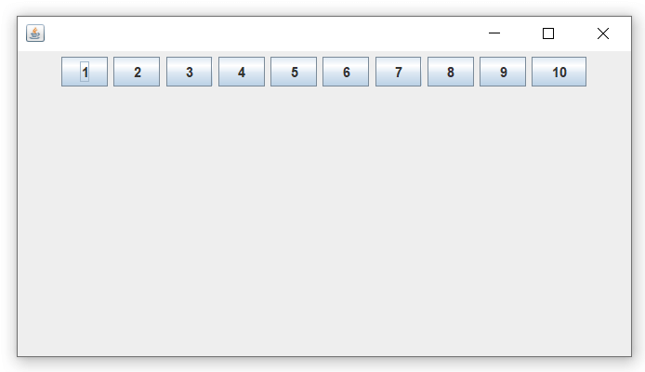

Border Layout,
The BorderLayout is used to arrange the components in five regions: north, south, east, west, and center. Each region (area) may contain one component only. It is the default layout of a frame or window. The BorderLayout provides five constants for each region:
- public static final int NORTH
- public static final int SOUTH
- public static final int EAST
- public static final int WEST
- public static final int CENTER

Constructors of BorderLayout class:
- BorderLayout(): creates a border layout but with no gaps between the components.
- BorderLayout(int hgap, int vgap): creates a border layout with the given horizontal and vertical gaps between the components.

Example of BorderLayout class: Using BorderLayout() constructor
FileName: Border.java
import java.awt.*;
import javax.swing.*;

public class Border
{
JFrame f;
Border()
{
f = new JFrame();

// creating buttons
JButton b1 = new JButton("NORTH");; // the button will be labeled as NORH
JButton b2 = new JButton("SOUTH");; // the button will be labeled as SOUH
JButton b3 = new JButton("EAST");; // the button will be labeled as EAST
JButton b4 = new JButton("WEST");; // the button will be labeled as WEST
JButton b5 = new JButton("CENTER");; // the button will be labeled as CENTER

f.add(b1, BorderLayout.NORTH); // b1 will be placed in the North Direction
f.add(b2, BorderLayout.SOUTH); // b2 will be placed in the South Directi
f.add(b3, BorderLayout.EAST); // b2 will be placed in the East Direction
f.add(b4, BorderLayout.WEST); // b2 will be placed in the West Direction
f.add(b5, BorderLayout.CENTER); // b2 will be placed in the Center

f.setSize(300, 300);
f.setVisible(true);
}
public static void main(String[] args) {
new Border();
}
}
Output:

Grid Layout,
The Java GridLayout class is used to arrange the components in a rectangular grid. One component is displayed in each rectangle.

Constructors of GridLayout class
- GridLayout(): creates a grid layout with one column per component in a row.
- GridLayout(int rows, int columns): creates a grid layout with the given rows and columns but no gaps between the components.
- GridLayout(int rows, int columns, int hgap, int vgap): creates a grid layout with the given rows and columns along with given horizontal and vertical gaps.

Example of GridLayout class: Using GridLayout(int rows, int columns) Constructor
FileName: MyGridLayout.java
- import java.awt.*;
- import javax.swing.*;
- public class MyGridLayout{
- JFrame f;
- MyGridLayout(){
- f=new JFrame();
- JButton b1=new JButton("1");
- JButton b2=new JButton("2");
- JButton b3=new JButton("3");
- JButton b4=new JButton("4");
- JButton b5=new JButton("5");
- JButton b6=new JButton("6");
- JButton b7=new JButton("7");
- JButton b8=new JButton("8");
- JButton b9=new JButton("9");
- // adding buttons to the frame
- f.add(b1); f.add(b2); f.add(b3);
- f.add(b4); f.add(b5); f.add(b6);
- f.add(b7); f.add(b8); f.add(b9);

- // setting grid layout of 3 rows and 3 columns
- f.setLayout(new GridLayout(3,3));
- f.setSize(300,300);
- f.setVisible(true);
- }
- public static void main(String[] args) {
- new MyGridLayout();
- }
- }
Output:
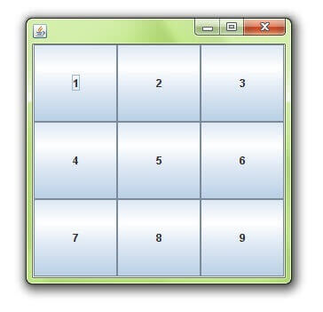
Card Layout,
The Java CardLayout class manages the components in such a manner that only one component is visible at a time. It treats each component as a card that is why it is known as CardLayout.

Constructors of CardLayout Class
- CardLayout(): creates a card layout with zero horizontal and vertical gap.
- CardLayout(int hgap, int vgap): creates a card layout with the given horizontal and vertical gap.

Commonly Used Methods of CardLayout Class
- public void next(Container parent): is used to flip to the next card of the given container.
- public void previous(Container parent): is used to flip to the previous card of the given container.
- public void first(Container parent): is used to flip to the first card of the given container.
- public void last(Container parent): is used to flip to the last card of the given container.
- public void show(Container parent, String name): is used to flip to the specified card with the given name.

Example of CardLayout Class: Using Default Constructor
The following program uses the next() method to move to the next card of the container.
FileName: CardLayoutExample1.java

- // import statements
- import java.awt.*;
- import javax.swing.*;
- import java.awt.event.*;

- public class CardLayoutExample1 extends JFrame implements ActionListener
- {

- CardLayout crd;

- // button variables to hold the references of buttons
- JButton btn1, btn2, btn3;
- Container cPane;

- // constructor of the class
- CardLayoutExample1()
- {

- cPane = getContentPane();

- //default constructor used
- // therefore, components will
- // cover the whole area
- crd = new CardLayout();

- cPane.setLayout(crd);

- // creating the buttons
- btn1 = new JButton("Apple");
- btn2 = new JButton("Boy");
- btn3 = new JButton("Cat");

- // adding listeners to it
- btn1.addActionListener(this);
- btn2.addActionListener(this);
- btn3.addActionListener(this);

- cPane.add("a", btn1); // first card is the button btn1
- cPane.add("b", btn2); // first card is the button btn2
- cPane.add("c", btn3); // first card is the button btn3

- }
- public void actionPerformed(ActionEvent e)
- {
- // Upon clicking the button, the next card of the container is shown
- // after the last card, again, the first card of the container is shown upon clicking
- crd.next(cPane);
- }

- // main method
- public static void main(String argvs[])
- {
- // creating an object of the class CardLayoutExample1
- CardLayoutExample1 crdl = new CardLayoutExample1();

- // size is 300 * 300
- crdl.setSize(300, 300);
- crdl.setVisible(true);
- crdl.setDefaultCloseOperation(EXIT_ON_CLOSE);
- }
- }
OutputASA Announces New Milestone in Mystery of Universe's Expansion Rate
Next

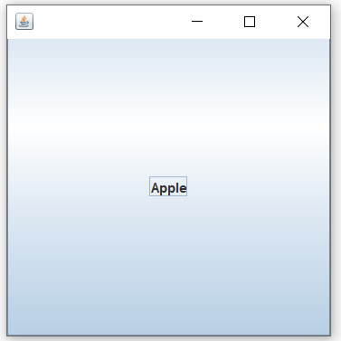
When the button named apple is clicked, we get
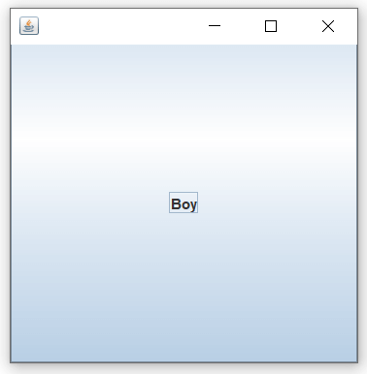
When the boy button is clicked, we get
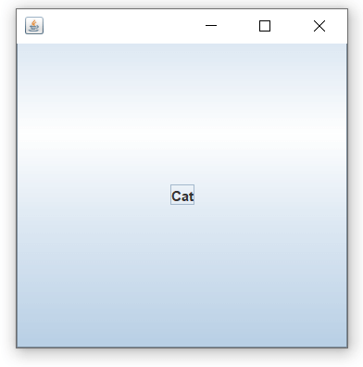
Again, we reach the first card of the container if the cat button is clicked, and the cycle continues.

Grid Bag Layout
The Java GridBagLayout class is used to align components vertically, horizontally or along their baseline.
GridBagLayout(): The parameterless constructor is used to create a grid bag layout manager.
- import java.awt.Button;
- import java.awt.GridBagConstraints;
- import java.awt.GridBagLayout;

- import javax.swing.*;
- public class GridBagLayoutExample extends JFrame{
- public static void main(String[] args) {
- GridBagLayoutExample a = new GridBagLayoutExample();
- }
- public GridBagLayoutExample() {
- GridBagLayoutgrid = new GridBagLayout();
- GridBagConstraints gbc = new GridBagConstraints();
- setLayout(grid);
- setTitle("GridBag Layout Example");
- GridBagLayout layout = new GridBagLayout();
- this.setLayout(layout);
- gbc.fill = GridBagConstraints.HORIZONTAL;
- gbc.gridx = 0;
- gbc.gridy = 0;
- this.add(new Button("Button One"), gbc);
- gbc.gridx = 1;
- gbc.gridy = 0;
- this.add(new Button("Button two"), gbc);
- gbc.fill = GridBagConstraints.HORIZONTAL;
- gbc.ipady = 20;
- gbc.gridx = 0;
- gbc.gridy = 1;
- this.add(new Button("Button Three"), gbc);
- gbc.gridx = 1;
- gbc.gridy = 1;
- this.add(new Button("Button Four"), gbc);
- gbc.gridx = 0;
- gbc.gridy = 2;
- gbc.fill = GridBagConstraints.HORIZONTAL;
- gbc.gridwidth = 2;
- this.add(new Button("Button Five"), gbc);
- setSize(300, 300);
- setPreferredSize(getSize());
- setVisible(true);
- setDefaultCloseOperation(EXIT_ON_CLOSE);

- }

- }
Output:
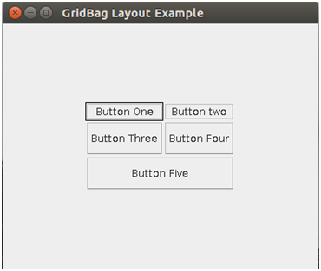

Delegation Event Model in Java
The Delegation Event model is defined to handle events in GUI programming languages. The GUI stands for Graphical User Interface, where a user graphically/visually interacts with the system.
The GUI programming is inherently event-driven; whenever a user initiates an activity such as a mouse activity, clicks, scrolling, etc., each is known as an event that is mapped to a code to respond to functionality to the user. This is known as event handling.
. 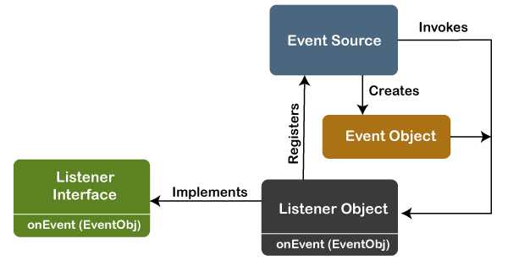

Java Program to Implement the Event Deligation Model
The below is a Java program to handle events implementing the event deligation model:
TestApp.java:
import java.awt.*;
import java.awt.event.*;

public class TestApp {
public void search() {
// For searching
System.out.println("Searching...");
}
public void sort() {
// for sorting
System.out.println("Sorting....");
}

static public void main(String args[]) {
TestApp app = new TestApp();
GUI gui = new GUI(app);
}
}

class Command implements ActionListener {
static final int SEARCH = 0;
static final int SORT = 1;
int id;
TestApp app;

public Command(int id, TestApp app) {
this.id = id;
this.app = app;
}

public void actionPerformed(ActionEvent e) {
switch(id) {
case SEARCH:
app.search();
break;
case SORT:
app.sort();
break;
}
}
}

class GUI {

public GUI(TestApp app) {
Frame f = new Frame();
f.setLayout(new FlowLayout());

Command searchCmd = new Command(Command.SEARCH, app);
Command sortCmd = new Command(Command.SORT, app);

Button b;
f.add(b = new Button("Search"));
b.addActionListener(searchCmd);
f.add(b = new Button("Sort"));
b.addActionListener(sortCmd);

List l;
f.add(l = new List());
l.add("Alphabetical");
l.add("Chronological");
l.addActionListener(sortCmd);
f.pack();

f.show();
}
}
Output:
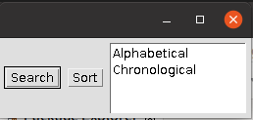
Searching...

Java AWT Example
To create simple AWT example, you need a frame. There are two ways to create a GUI using Frame in AWT.

- By extending Frame class (inheritance)
- By creating the object of Frame class (association)

AWT Example by Inheritance
Let's see a simple example of AWT where we are inheriting Frame class. Here, we are showing Button component on the Frame.
import java.awt.*;

// extending Frame class to our class AWTExample1
public class AWTExample1 extends Frame {

// initializing using constructor
AWTExample1() {

// creating a button
Button b = new Button("Click Me!!");

// setting button position on screen
b.setBounds(30,100,80,30);

// adding button into frame
add(b);

// frame size 300 width and 300 height
setSize(300,300);

// setting the title of Frame
setTitle("This is our basic AWT example");

// no layout manager
setLayout(null);

// now frame will be visible, by default it is not visible
setVisible(true);
}

// main method
public static void main(String args[]) {

// creating instance of Frame class
AWTExample1 f = new AWTExample1();

}

}
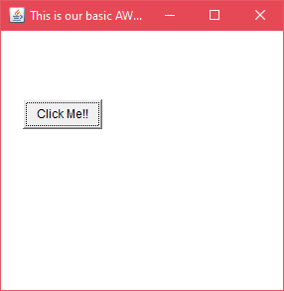

AWT Example by Association
Let's see a simple example of AWT where we are creating instance of Frame class. Here, we are creating a TextField, Label and Button component on the Frame.

AWTExample2.java
// importing Java AWT class
import java.awt.*;
// class AWTExample2 directly creates instance of Frame class
class AWTExample2
{ // initializing using constructor
AWTExample2()
{ // creating a Frame
Frame f = new Frame();
// creating a Label
Label l = new Label("Employee id:");
// creating a Button
Button b = new Button("Submit");
// creating a TextField
TextField t = new TextField();
// setting position of above components in the frame
l.setBounds(20, 80, 80, 30);
t.setBounds(20, 100, 80, 30);
b.setBounds(100, 100, 80, 30);
// adding components into frame
f.add(b);
f.add(l);
f.add(t);
// frame size 300 width and 300 height
f.setSize(400,300);
// setting the title of frame
f.setTitle("Employee info");
// no layout
f.setLayout(null);
// setting visibility of frame
f.setVisible(true);
}
// main method
public static void main(String args[])
{

// creating instance of Frame class
AWTExample2 awt_obj = new AWTExample2();

}

}

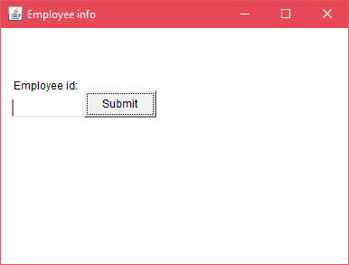

Event and Listener (Java Event Handling)
Changing the state of an object is known as an event. For example, click on button, dragging mouse etc. The java.awt.event package provides many event classes and Listener interfaces for event handling.

Java Event classes and Listener interfaces
Event Classes | Listener Interfaces
ActionEvent | ActionListener
MouseEvent | MouseListener and MouseMotionListener
MouseWheelEvent | MouseWheelListener
KeyEvent | KeyListener
ItemEvent | ItemListener
TextEvent | TextListener
AdjustmentEvent | AdjustmentListener
WindowEvent | WindowListener
ComponentEvent | ComponentListener
ContainerEvent | ContainerListener
FocusEvent | FocusListener

Steps to perform Event Handling
Following steps are required to perform event handling:
- Register the component with the Listener

Registration Methods
For registering the component with the Listener, many classes provide the registration methods. For example:
- Button
  - public void addActionListener(ActionListener a){}
- MenuItem
  - public void addActionListener(ActionListener a){}
- TextField
  - public void addActionListener(ActionListener a){}
  - public void addTextListener(TextListener a){}
- TextArea
  - public void addTextListener(TextListener a){}
- Checkbox
  - public void addItemListener(ItemListener a){}
- Choice
  - public void addItemListener(ItemListener a){}
- List
  - public void addActionListener(ActionListener a){}
  - public void addItemListener(ItemListener a){}

Java Event Handling Code
import java.awt.*;
import java.awt.event.*;
class AEvent extends Frame implements ActionListener{
TextField tf;
AEvent(){

//create components
tf=new TextField();
tf.setBounds(60,50,170,20);
Button b=new Button("click me");
b.setBounds(100,120,80,30);

//register listener
b.addActionListener(this);//passing current instance

//add components and set size, layout and visibility
add(b);
add(tf);
setSize(300,300);
setLayout(null);
setVisible(true);
}
public void actionPerformed(ActionEvent e){
tf.setText("Welcome");
}
public static void main(String args[]){
new AEvent();
}
}
Handling mouse and keyboard events

Handling mouse
The Java MouseListener is notified whenever you change the state of mouse. It is notified against MouseEvent. The MouseListener interface is found in java.awt.event package. It has five methods.

Methods of MouseListener interface
The signature of 5 methods found in MouseListener interface are given below:
public abstract void mouseClicked(MouseEvent e);
public abstract void mouseEntered(MouseEvent e);
public abstract void mouseExited(MouseEvent e);
public abstract void mousePressed(MouseEvent e);
public abstract void mouseReleased(MouseEvent e);
import java.awt.*;
import java.awt.event.*;
public class MouseListenerExample extends Frame implements MouseListener{
Label l;
MouseListenerExample(){
addMouseListener(this);

l=new Label();
l.setBounds(20,50,100,20);
add(l);
setSize(300,300);
setLayout(null);
setVisible(true);
}
public void mouseClicked(MouseEvent e) {
l.setText("Mouse Clicked");
}
public void mouseEntered(MouseEvent e) {
l.setText("Mouse Entered");
}
public void mouseExited(MouseEvent e) {
l.setText("Mouse Exited");
}
public void mousePressed(MouseEvent e) {
l.setText("Mouse Pressed");
}
public void mouseReleased(MouseEvent e) {
l.setText("Mouse Released");
}
public static void main(String[] args) {
new MouseListenerExample();
}
}
Output:
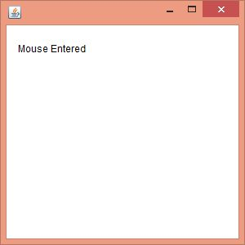

keyboard events
The Java KeyListener is notified whenever you change the state of key. It is notified against KeyEvent. The KeyListener interface is found in java.awt.event package, and it has three methods.

Following is the declaration for java.awt.event.KeyListener interface:
- public interface KeyListener extends EventListener

Methods of KeyListener interface
The signature of 3 methods found in KeyListener interface are given below:
Sr. no. | Method name | Description
1. | public abstract void keyPressed (KeyEvent e); | It is invoked when a key has been pressed.
2. | public abstract void keyReleased (KeyEvent e); | It is invoked when a key has been released.
3. | public abstract void keyTyped (KeyEvent e); | It is invoked when a key has been typed.

// importing awt libraries
import java.awt.*;
import java.awt.event.*;
// class which inherits Frame class and implements KeyListener interface
public class KeyListenerExample extends Frame implements KeyListener {
// creating object of Label class and TextArea class
Label l;
TextArea area;
// class constructor
KeyListenerExample() {
// creating the label
l = new Label();
// setting the location of the label in frame
l.setBounds (20, 50, 100, 20);
// creating the text area
area = new TextArea();
// setting the location of text area
area.setBounds (20, 80, 300, 300);
// adding the KeyListener to the text area
area.addKeyListener(this);
// adding the label and text area to the frame
add(l);
add(area);
// setting the size, layout and visibility of frame
setSize (400, 400);
setLayout (null);
setVisible (true);
}
// overriding the keyPressed() method of KeyListener interface where we set te text of the label when key is pressed
public void keyPressed (KeyEvent e) {
l.setText ("Key Pressed");
}
// overriding the keyReleased() method of KeyListener interface where we set the text of the label when key is released
public void keyReleased (KeyEvent e) {
l.setText ("Key Released");
}
// overriding the keyTyped() method of KeyListener interface where we set the text of the label when a key is typed
public void keyTyped (KeyEvent e) {
l.setText ("Key Typed");
}
// main method
public static void main(String[] args) {
new KeyListenerExample();
}
}
Output:
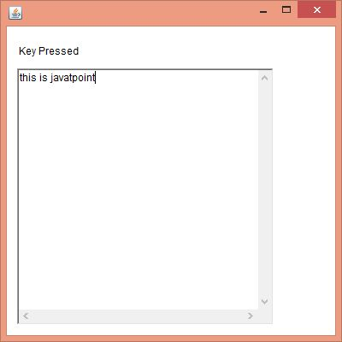

Java Adapter Classes
Java adapter classes provide the default implementation of listener interfaces
. If you inherit the adapter class, you will not be forced to provide the implementation of all the methods of listener interfaces. So it saves code.

Pros of using Adapter classes:
- It assists the unrelated classes to work combinedly.
- It provides ways to use classes in different ways.
- It increases the transparency of classes.
- It provides a way to include related patterns in the class.
- It provides a pluggable kit for developing an application.
- It increases the reusability of the class.
The adapter classes are found in java.awt.event, java.awt.dnd and javax.swing.event packages
. The Adapter classes with their corresponding listener interfaces are given below.

java.awt.event Adapter classes

Adapter class | Listener interface
WindowAdapter | WindowListener
KeyAdapter | KeyListener
MouseAdapter | MouseListener
MouseMotionAdapter | MouseMotionListener
FocusAdapter | FocusListener
ComponentAdapter | ComponentListener
ContainerAdapter | ContainerListener
HierarchyBoundsAdapter | HierarchyBoundsListener

java.awt.dnd Adapter classes
Adapter class | Listener interface
DragSourceAdapter | DragSourceListener
DragTargetAdapter | DragTargetListener

javax.swing.event Adapter classes
Adapter class | Listener interface
MouseInputAdapter | MouseInputListener
InternalFrameAdapter | InternalFrameListener

Java WindowAdapter Example
In the following example, we are implementing the WindowAdapter class of AWT and one its methods windowClosing() to close the frame window.
AdapterExample.java
51.9M
1K
Exception Handling in Java - Javatpoint

// importing the necessary libraries
import java.awt.*;
import java.awt.event.*;

public class AdapterExample {
// object of Frame
Frame f;
// class constructor
AdapterExample() {
// creating a frame with the title
f = new Frame ("Window Adapter");
// adding the WindowListener to the frame
// overriding the windowClosing() method
f.addWindowListener (new WindowAdapter() {
public void windowClosing (WindowEvent e) {
f.dispose();
}
});
// setting the size, layout and
f.setSize (400, 400);
f.setLayout (null);
f.setVisible (true);
}

// main method
public static void main(String[] args) {
new AdapterExample();
}
}
Output:
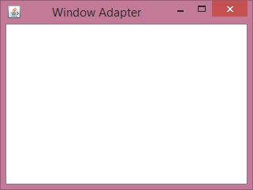

Java MouseAdapter Example
In the following example, we are implementing the MouseAdapter class. The MouseListener interface is added into the frame to listen the mouse event in the frame.
MouseAdapterExample.java

// importing the necessary libraries
import java.awt.*;
import java.awt.event.*;

// class which inherits the MouseAdapter class
public class MouseAdapterExample extends MouseAdapter {
// object of Frame class
Frame f;
// class constructor
MouseAdapterExample() {
// creating the frame with the title
f = new Frame ("Mouse Adapter");
// adding MouseListener to the Frame
f.addMouseListener(this);
// setting the size, layout and visibility of the frame
f.setSize (300, 300);
f.setLayout (null);
f.setVisible (true);
}
// overriding the mouseClicked() method of the MouseAdapter class
public void mouseClicked (MouseEvent e) {
// creating the Graphics object and fetching them from the Frame object using getGaphics() method
Graphics g = f.getGraphics();
// setting the color of graphics object
g.setColor (Color.BLUE);
// setting the shape of graphics object
g.fillOval (e.getX(), e.getY(), 30, 30);
}
// main method
public static void main(String[] args) {
new MouseAdapterExample();
}
}
Output:
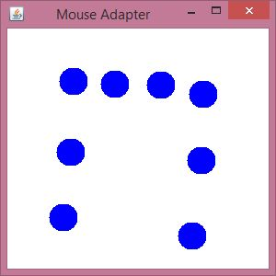

Java MouseMotionAdapter Example
In the following example, we are implementing the MouseMotionAdapter class and its different methods to listen to the mouse motion events in the Frame window.
MouseMotionAdapterExample.java

// importing the necessary libraries
import java.awt.*;
import java.awt.event.*;
// class which inherits the MouseMotionAdapter class
public class MouseMotionAdapterExample extends MouseMotionAdapter {
// object of Frame class
Frame f;
// class constructor
MouseMotionAdapterExample() {
// creating the frame with the title
f = new Frame ("Mouse Motion Adapter");
// adding MouseMotionListener to the Frame
f.addMouseMotionListener (this);
// setting the size, layout and visibility of the frame
f.setSize (300, 300);
f.setLayout (null);
f.setVisible (true);
}
// overriding the mouseDragged() method
public void mouseDragged (MouseEvent e) {
// creating the Graphics object and fetching them from the Frame object using getGraphics() method
Graphics g = f.getGraphics();
// setting the color of graphics object
g.setColor (Color.ORANGE);
// setting the shape of graphics object
g.fillOval (e.getX(), e.getY(), 20, 20);
}
public static void main(String[] args) {
new MouseMotionAdapterExample();
}
}
Output:
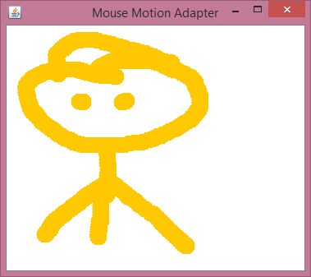

Java KeyAdapter Example
In the following example, we are implementing the KeyAdapter class and its method.
KeyAdapterExample.java

// importing the necessary libraries
import java.awt.*;
import java.awt.event.*;
// class which inherits the KeyAdapter class
public class KeyAdapterExample extends KeyAdapter {
// creating objects of Label, TextArea and Frame
Label l;
TextArea area;
Frame f;
// class constructor
KeyAdapterExample() {
// creating the Frame with title
f = new Frame ("Key Adapter");
// creating the Label
l = new Label();
// setting the location of label
l.setBounds (20, 50, 200, 20);
// creating the text area
area = new TextArea();
// setting the location of text area
area.setBounds (20, 80, 300, 300);
// adding KeyListener to text area
area.addKeyListener(this);
// adding the label and text area to frame
f.add(l);
f.add(area);
// setting the size, layout and visibility of frame
f.setSize (400, 400);
f.setLayout (null);
f.setVisible (true);
}
// overriding the keyReleased() method
public void keyReleased (KeyEvent e) {
// creating the String object to get the text fromTextArea
String text = area.getText();
// splitting the String into words
String words[] = text.split ("\\s");
// setting the label text to print the number of words and characters of given string
l.setText ("Words: " + words.length + " Characters:" + text.length());
}
// main method
public static void main(String[] args) {
new KeyAdapterExample();
}
}
Output:
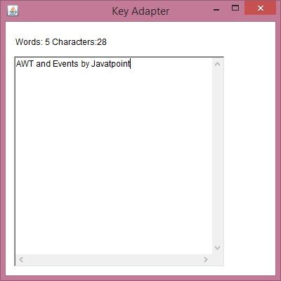

Anonymous Inner classes

Java anonymous inner class is an inner class without a name and for which only a single object is created. An anonymous inner class can be useful when making an instance of an object with certain "extras" such as overloading methods of a class or interface, without having to actually subclass a class.
In simple words, a class that has no name is known as an anonymous inner class in Java. It should be used if you have to override a method of class or interface. Java Anonymous inner class can be created in two ways:
- Class (may be abstract or concrete).
- Interface

Java anonymous inner class example using class
TestAnonymousInner.java
abstract class Person{
abstract void eat();
}
class TestAnonymousInner{
public static void main(String args[]){
Person p=new Person(){
void eat(){System.out.println("nice fruits");}
};
p.eat();
}
}

Output: nice fruits

Java anonymous inner class example using interface

interface Eatable{
void eat();
}
class TestAnnonymousInner1{
public static void main(String args[]){
Eatable e=new Eatable(){
public void eat(){System.out.println("nice fruits");}
};
e.eat();
}
}

Java Applet Basics
An applet is a Java program that can be embedded into a web page. It runs inside the web browser and works at client side. An applet is embedded in an HTML page using the APPLET or OBJECT tag and hosted on a web server.
Applets are used to make the website more dynamic and entertaining.

Important points :
- All applets are sub-classes (either directly or indirectly) of java.applet.Applet class.
- Applets are not stand-alone programs. Instead, they run within either a web browser or an applet viewer. JDK provides a standard applet viewer tool called applet viewer.
- In general, execution of an applet does not begin at main() method.
- Output of an applet window is not performed by System.out.println(). Rather it is handled with various AWT methods, such as drawString().
Life cycle of an applet :
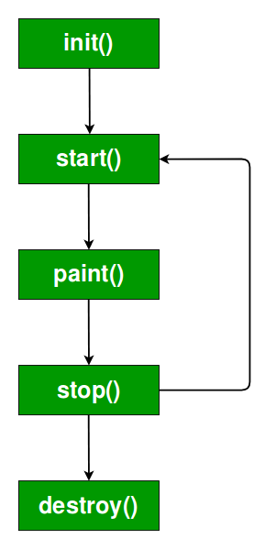
It is important to understand the order in which the various methods shown in the above image are called. When an applet begins, the following methods are called, in this sequence:
- init( )
- start( )
- paint( )
When an applet is terminated, the following sequence of method calls takes place:
- stop( )
- destroy( )
Let’s look more closely at these methods.
1. init( ) : The init( ) method is the first method to be called. This is where you should initialize variables. This method is called only once during the run time of your applet.
2. start( ) : The start( ) method is called after init( ). It is also called to restart an applet after it has been stopped. Note that init( ) is called once i.e. when the first time an applet is loaded whereas start( ) is called each time an applet’s HTML document is displayed onscreen. So, if a user leaves a web page and comes back, the applet resumes execution at start( ).
3. paint( ) : The paint( ) method is called each time an AWT-based applet’s output must be redrawn. This situation can occur for several reasons. For example, the window in which the applet is running may be overwritten by another window and then uncovered. Or the applet window may be minimized and then restored.
paint( ) is also called when the applet begins execution. Whatever the cause, whenever the applet must redraw its output, paint( ) is called.
The paint( ) method has one parameter of type Graphics. This parameter will contain the graphics context, which describes the graphics environment in which the applet is running. This context is used whenever output to the applet is required.
Note: This is the only method among all the method mention above, which is parameterized. It’s prototype is
public void paint(Graphics g)
where g is an object reference of class Graphic.

Creating Hello World applet :
// A Hello World Applet
// Save file as HelloWorld.java

import java.applet.Applet;
import java.awt.Graphics;

// HelloWorld class extends Applet
public class HelloWorld extends Applet
{

public void paint(Graphics g)
{
g.drawString("Hello World", 20, 20);
}

}

Explanation:
- The above java program begins with two import statements. The first import statement imports the Applet class from applet package. Every AWT-based(Abstract Window Toolkit) applet that you create must be a subclass (either directly or indirectly) of Applet class. The second statement import the Graphics class from AWT package.
- The next line in the program declares the class HelloWorld. This class must be declared as public because it will be accessed by code that is outside the program. Inside HelloWorld, paint( ) is declared. This method is defined by the AWT and must be overridden by the applet.
- Inside paint( ) is a call to drawString( ), which is a member of the Graphics class. This method outputs a string beginning at the specified X,Y location. It has the following general form:
void drawString(String message, int x, int y)
Here, message is the string to be output beginning at x,y. In a Java window, the upper-left corner is location 0,0. The call to drawString( ) in the applet causes the message “Hello World” to be displayed beginning at location 20,20.
Notice that the applet does not have a main( ) method. Unlike Java programs, applets do not begin execution at main( ). In fact, most applets don’t even have a main( ) method. Instead, an applet begins execution when the name of its class is passed to an applet viewer or to a network browser.
Running the HelloWorld Applet :
After you enter the source code for HelloWorld.java, compile in the same way that you have been compiling java programs(using javac command). However, running HelloWorld with the java command will generate an error because it is not an application.
java HelloWorld

Error: Main method not found in class HelloWorld,
please define the main method as:
public static void main(String[] args)
There are two standard ways in which you can run an applet :
- Executing the applet within a Java-compatible web browser.
- Using an applet viewer, such as the standard tool, applet-viewer. An applet viewer executes your applet in a window. This is generally the fastest and easiest way to test your applet.
Each of these methods is described next.
1. Using java enabled web browser : To execute an applet in a web browser we have to write a short HTML text file that contains a tag that loads the applet. We can use APPLET or OBJECT tag for this purpose. Using APPLET, here is the HTML file that executes HelloWorld :
<applet code="HelloWorld" width=200 height=60>
</applet>
The width and height statements specify the dimensions of the display area used by the applet. The APPLET tag contains several other options. After you create this html file, you can use it to execute the applet.
NOTE : Chrome and Firefox no longer supports NPAPI (technology required for Java applets). Refer here
2. Using appletviewer : This is the easiest way to run an applet. To execute HelloWorld with an applet viewer, you may also execute the HTML file shown earlier. For example, if the preceding HTML file is saved with
RunHelloWorld.html, then the following command line will run HelloWorld :
appletviewer RunHelloWorld.html
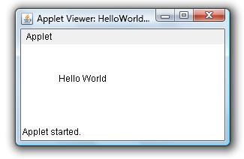

Parameter in Applet
We can get any information from the HTML file as a parameter. For this purpose, Applet class provides a method named getParameter(). Syntax:
- public String getParameter(String parameterName)

Example of using parameter in Applet:

- import java.applet.Applet;
- import java.awt.Graphics;

- public class UseParam extends Applet{

- public void paint(Graphics g){
- String str=getParameter("msg");
- g.drawString(str,50, 50);
- }

- }

myapplet.html
- <html>
- <body>
- <applet code="UseParam.class" width="300" height="300">
- <param name="msg" value="Welcome to applet">
- </applet>
- </body>
- </html>

Creating a Swing Applet
we can use JApplet that can have all the controls of swing. The JApplet class extends the Applet class.

Example of EventHandling in JApplet:

- import java.applet.*;
- import javax.swing.*;
- import java.awt.event.*;
- public class EventJApplet extends JApplet implements ActionListener{
- JButton b;
- JTextField tf;
- public void init(){

- tf=new JTextField();
- tf.setBounds(30,40,150,20);

- b=new JButton("Click");
- b.setBounds(80,150,70,40);

- add(b);add(tf);
- b.addActionListener(this);

- setLayout(null);
- }

- public void actionPerformed(ActionEvent e){
- tf.setText("Welcome");
- }
- }
In the above example, we have created all the controls in init() method because it is invoked only once.

myapplet.html
- <html>
- <body>
- <applet code="EventJApplet.class" width="300" height="300">
- </applet>
- </body>
- </html>

Java Swing
Java swing is a part of Java Foundation Classes (JFC) that is used to create window-based applications. It is built on the top of AWT (Abstract Windowing Toolkit) API and entirely written in java.
Unlike AWT, Java Swing provides platform-independent and lightweight components.
The javax.swing package provides classes for java swing API such as JButton, JTextField, JTextArea, JRadioButton, JCheckbox, JMenu, JColorChooser etc.

Difference between AWT and Swing
There are many differences between java awt and swing that are given below.
50.6M
988
C++ vs Java
No. | Java AWT | Java Swing
1) | AWT components are platform-dependent. | Java swing components are platform-independent.
2) | AWT components are heavyweight. | Swing components are lightweight.
3) | AWT doesn't support pluggable look and feel. | Swing supports pluggable look and feel.
4) | AWT provides less components than Swing. | Swing provides more powerful components such as tables, lists, scrollpanes, colorchooser, tabbedpane etc.
5) | AWT doesn't follows MVC(Model View Controller) where model represents data, view represents presentation and controller acts as an interface between model and view. | Swing follows MVC.

What is JFC
The Java Foundation Classes (JFC) are a set of GUI components which simplify the development of desktop applications.

Hierarchy of Java Swing classes
The hierarchy of java swing API is given below.
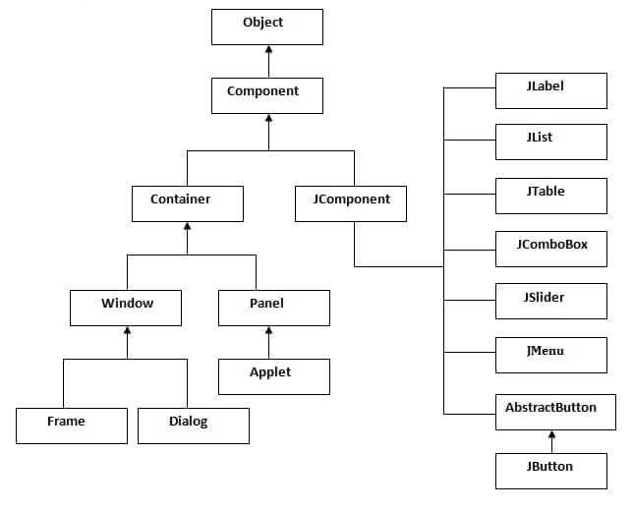

Simple Java Swing Example
Let's see a simple swing example where we are creating one button and adding it on the JFrame object inside the main() method.
File: FirstSwingExample.java
import javax.swing.*;
public class FirstSwingExample {
public static void main(String[] args) {
JFrame f=new JFrame();//creating instance of JFrame

JButton b=new JButton("click");//creating instance of JButton
b.setBounds(130,100,100, 40);//x axis, y axis, width, height

f.add(b);//adding button in JFrame

f.setSize(400,500);//400 width and 500 height
f.setLayout(null);//using no layout managers
f.setVisible(true);//making the frame visible
}
}
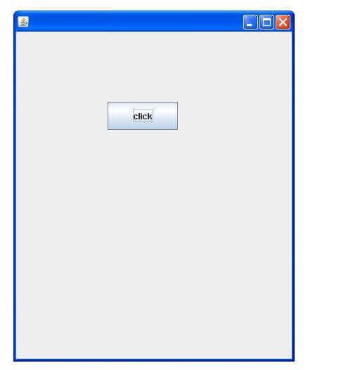
Java JButton Example
import java.awt.event.*;
import javax.swing.*;
public class ButtonExample {
public static void main(String[] args) {
JFrame f=new JFrame("Button Example");
final JTextField tf=new JTextField();
tf.setBounds(50,50, 150,20);
JButton b=new JButton("Click Here");
b.setBounds(50,100,95,30);
b.addActionListener(new ActionListener(){
public void actionPerformed(ActionEvent e){
tf.setText("Welcome to Javatpoint.");
}
});
f.add(b);f.add(tf);
f.setSize(400,400);
f.setLayout(null);
f.setVisible(true);
}
}
Output:
Skip Ad
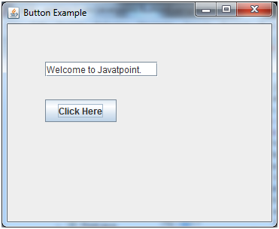

JToggle Button
JToggleButton is used to create toggle button, it is two-states button to switch on or off.

Methods
Modifier and Type | Method | Description
AccessibleContext | getAccessibleContext() | It gets the AccessibleContext associated with this JToggleButton.
String | getUIClassID() | It returns a string that specifies the name of the l&f class that renders this component.
protected String | paramString() | It returns a string representation of this JToggleButton.
Void | updateUI() | It resets the UI property to a value from the current look and feel.

JToggleButton Example
import java.awt.FlowLayout;
import java.awt.event.ItemEvent;
import java.awt.event.ItemListener;
import javax.swing.JFrame;
import javax.swing.JToggleButton;

public class JToggleButtonExample extends JFrame implements ItemListene {
public static void main(String[] args) {
new JToggleButtonExample();
}
private JToggleButton button;
JToggleButtonExample() {
setTitle("JToggleButton with ItemListener Example");
setLayout(new FlowLayout());
setJToggleButton();
setAction();
setSize(200, 200);
setVisible(true);
setDefaultCloseOperation(JFrame.EXIT_ON_CLOSE);
}
private void setJToggleButton() {
button = new JToggleButton("ON");
add(button);
}
private void setAction() {
button.addItemListener(this);
}
public void itemStateChanged(ItemEvent eve) {
if (button.isSelected())
button.setText("OFF");
else
button.setText("ON");
}
}
Output
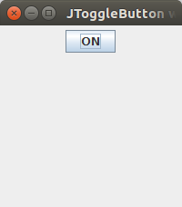

JCheck Box
The JCheckBox class is used to create a checkbox. It is used to turn an option on (true) or off (false). Clicking on a CheckBox changes its state from "on" to "off" or from "off" to "on ".It inherits JToggleButton class.

Java JCheckBox Example
import javax.swing.*;
public class CheckBoxExample
{
CheckBoxExample(){
JFrame f= new JFrame("CheckBox Example");
JCheckBox checkBox1 = new JCheckBox("C++");
checkBox1.setBounds(100,100, 50,50);
JCheckBox checkBox2 = new JCheckBox("Java", true);
checkBox2.setBounds(100,150, 50,50);
f.add(checkBox1);
f.add(checkBox2);
f.setSize(400,400);
f.setLayout(null);
f.setVisible(true);
}
public static void main(String args[])
{
new CheckBoxExample();
}}
Output:
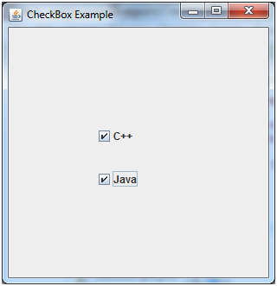

JRadio Button

The JRadioButton class is used to create a radio button. It is used to choose one option from multiple options. It is widely used in exam systems or quiz.
It should be added in ButtonGroup to select one radio button only.

Java JRadioButton Example with ActionListener

import javax.swing.*;
import java.awt.event.*;
class RadioButtonExample extends JFrame implements ActionListener{
JRadioButton rb1,rb2;
JButton b;
RadioButtonExample(){
rb1=new JRadioButton("Male");
rb1.setBounds(100,50,100,30);
rb2=new JRadioButton("Female");
rb2.setBounds(100,100,100,30);
ButtonGroup bg=new ButtonGroup();
bg.add(rb1);bg.add(rb2);
b=new JButton("click");
b.setBounds(100,150,80,30);
b.addActionListener(this);
add(rb1);add(rb2);add(b);
setSize(300,300);
setLayout(null);
setVisible(true);
}
public void actionPerformed(ActionEvent e){
if(rb1.isSelected()){
JOptionPane.showMessageDialog(this,"You are Male.");
}
if(rb2.isSelected()){
JOptionPane.showMessageDialog(this,"You are Female.");
}
}
public static void main(String args[]){
new RadioButtonExample();
}}
Output:
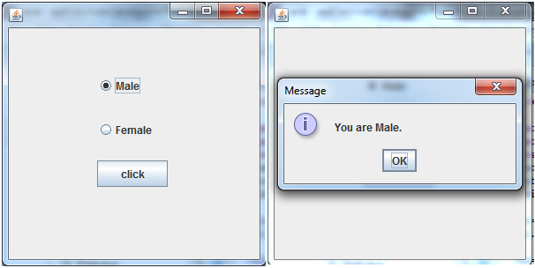

JTabbed Pane
The JTabbedPane class is used to switch between a group of components by clicking on a tab with a given title or icon. It inherits JComponent class.

Java JTabbedPane Example
import javax.swing.*;
public class TabbedPaneExample {
JFrame f;
TabbedPaneExample(){
f=new JFrame();
JTextArea ta=new JTextArea(200,200);
JPanel p1=new JPanel();
p1.add(ta);
JPanel p2=new JPanel();
JPanel p3=new JPanel();
JTabbedPane tp=new JTabbedPane();
tp.setBounds(50,50,200,200);
tp.add("main",p1);
tp.add("visit",p2);
tp.add("help",p3);
f.add(tp);
f.setSize(400,400);
f.setLayout(null);
f.setVisible(true);
}
public static void main(String[] args) {
new TabbedPaneExample();
}}
Output:
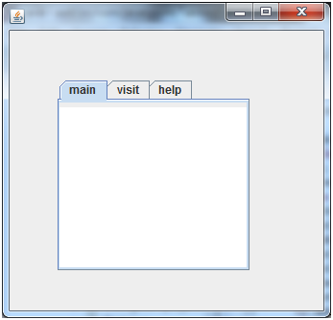

JScroll Pane
A JscrollPane is used to make scrollable view of a component. When screen size is limited, we use a scroll pane to display a large component or a component whose size can change dynamically.

ScrollPane Example
import java.awt.FlowLayout;
import javax.swing.JFrame;
import javax.swing.JScrollPane;
import javax.swing.JtextArea;

public class JScrollPaneExample {
private static final long serialVersionUID = 1L;

private static void createAndShowGUI() {

// Create and set up the window.
final JFrame frame = new JFrame("Scroll Pane Example");

// Display the window.
frame.setSize(500, 500);
frame.setVisible(true);
frame.setDefaultCloseOperation(JFrame.EXIT_ON_CLOSE);

// set flow layout for the frame
frame.getContentPane().setLayout(new FlowLayout());

JTextArea textArea = new JTextArea(20, 20);
JScrollPane scrollableTextArea = new JScrollPane(textArea);

scrollableTextArea.setHorizontalScrollBarPolicy(JScrollPane.HORIZONTA_SCROLLBAR_ALWAYS);
scrollableTextArea.setVerticalScrollBarPolicy(JScrollPane.VERTICAL_SCROLLBAR_ALWAYS);

frame.getContentPane().add(scrollableTextArea);
}
public static void main(String[] args) {

javax.swing.SwingUtilities.invokeLater(new Runnable() {

public void run() {
createAndShowGUI();
}
});
}
}
Output:
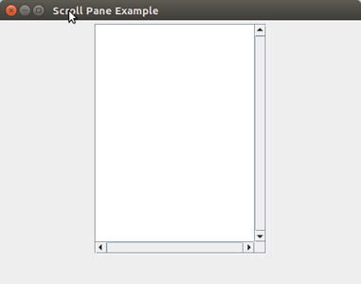

JList
The object of JList class represents a list of text items. The list of text items can be set up so that the user can choose either one item or multiple items. It inherits JComponent class.

Java JList Example
import javax.swing.*;
public class ListExample
{
ListExample(){
JFrame f= new JFrame();
DefaultListModel<String> l1 = new DefaultListModel<>();
l1.addElement("Item1");
l1.addElement("Item2");
l1.addElement("Item3");
l1.addElement("Item4");
JList<String> list = new JList<>(l1);
list.setBounds(100,100, 75,75);
f.add(list);
f.setSize(400,400);
f.setLayout(null);
f.setVisible(true);
}
public static void main(String args[])
{
new ListExample();
}}
Output:
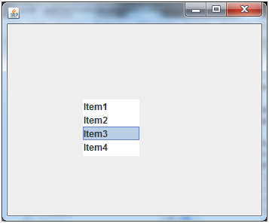

JCombo Box
The object of Choice class is used to show popup menu of choices. Choice selected by user is shown on the top of a menu
. It inherits JComponent
class.

Java JComboBox Example

import javax.swing.*;
public class ComboBoxExample {
JFrame f;
ComboBoxExample(){
f=new JFrame("ComboBox Example");
String country[]={"India","Aus","U.S.A","England","Newzealand"};
JComboBox cb=new JComboBox(country);
cb.setBounds(50, 50,90,20);
f.add(cb);
f.setLayout(null);
f.setSize(400,500);
f.setVisible(true);
}
public static void main(String[] args) {
new ComboBoxExample();
}
}
Output:
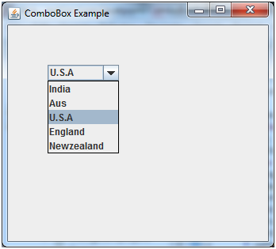

Swing Menus
The JMenuBar class is used to display menubar on the window or frame. It may have several menus.
The object of JMenu class is a pull down menu component which is displayed from the menu bar. It inherits the JMenuItem class.
The object of JMenuItem class adds a simple labeled menu item. The items used in a menu must belong to the JMenuItem or any of its subclass.

JMenuBar class declaration
- public class JMenuBar extends JComponent implements MenuElement, Accessible

JMenu class declaration
- public class JMenu extends JMenuItem implements MenuElement, Accessible

JMenuItem class declaration
- public class JMenuItem extends AbstractButton implements Accessible, MenuElement

Java JMenuItem and JMenu Example
import javax.swing.*;
class MenuExample
{
JMenu menu, submenu;
JMenuItem i1, i2, i3, i4, i5;
MenuExample(){
JFrame f= new JFrame("Menu and MenuItem Example");
JMenuBar mb=new JMenuBar();
menu=new JMenu("Menu");
submenu=new JMenu("Sub Menu");
i1=new JMenuItem("Item 1");
i2=new JMenuItem("Item 2");
i3=new JMenuItem("Item 3");
i4=new JMenuItem("Item 4");
i5=new JMenuItem("Item 5");
menu.add(i1); menu.add(i2); menu.add(i3);
submenu.add(i4); submenu.add(i5);
menu.add(submenu);
mb.add(menu);
f.setJMenuBar(mb);
f.setSize(400,400);
f.setLayout(null);
f.setVisible(true);
}
public static void main(String args[])
{
new MenuExample();
}}
Output:

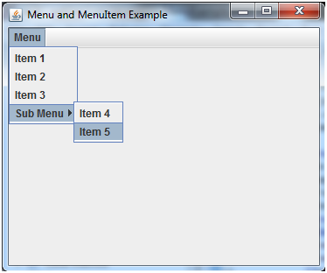

Dialogs

Java JDialog
The JDialog control represents a top level window with a border and a title used to take some form of input from the user. It inherits the Dialog class.

JDialog class declaration
Let's see the declaration for javax.swing.JDialog class.
- public class JDialog extends Dialog implements WindowConstants, Accessible, RootPaneContainer

Commonly used Constructors:
Constructor | Description
JDialog() | It is used to create a modeless dialog without a title and without a specified Frame owner.
JDialog(Frame owner) | It is used to create a modeless dialog with specified Frame as its owner and an empty title.
JDialog(Frame owner, String title, boolean modal) | It is used to create a dialog with the specified title, owner Frame and modality.

Java JDialog Example
import javax.swing.*;
import java.awt.*;
import java.awt.event.*;
public class DialogExample {
private static JDialog d;
DialogExample() {
JFrame f= new JFrame();
d = new JDialog(f , "Dialog Example", true);
d.setLayout( new FlowLayout() );
JButton b = new JButton ("OK");
b.addActionListener ( new ActionListener()
{
public void actionPerformed( ActionEvent e )
{
DialogExample.d.setVisible(false);
}
});
d.add( new JLabel ("Click button to continue."));
d.add(b);
d.setSize(300,300);
d.setVisible(true);
}
public static void main(String args[])
{
new DialogExample();
}
}

