**UNIT – IV**

**OBJECT SEGMENTION**

**Object Segmentation**: Regression Vs Segmentation – Supervised and Unsupervised Learning, Tree Building – Regression, Classification, over fitting, Pruning and Complexity, Multiple Decision Trees etc.

**Time Series Methods**: Arima, Measures of Forecast Accuracy, STL approach, Extract features from generated model as Height, Average Energy etc and Analyze for prediction

Object segmentation

Object segmentation in data analytics involves using techniques from computer vision and machine learning to analyze images and extract information about the objects within them. The goal is to automatically identify and isolate individual objects or regions of interest within an image or video.

Object segmentation can be applied to a wide range of industries and use cases. For example, in healthcare, it can be used to analyze medical images and identify abnormalities or lesions in the body. In agriculture, it can be used to identify and track the growth of crops and monitor the health of plants. In manufacturing, it can be used to detect defects in products and ensure quality control.

There are several techniques that can be used for object segmentation in data analytics. Traditional computer vision methods include thresholding, edge detection, and region growing. More advanced techniques use machine learning algorithms such as convolutional neural networks (CNNs) and deep learning frameworks like Mask R-CNN.

In CNN-based object segmentation, the neural network is trained on a large dataset of labeled images, where the objects of interest are annotated with bounding boxes or pixel-level masks. The network learns to detect and segment objects based on features learned from the training data.

Mask R-CNN, on the other hand, is a deep learning framework that combines object detection and instance segmentation. This allows it to detect and classify multiple objects within an image and provide a precise segmentation mask for each object.

Overall, object segmentation in data analytics can help organizations extract valuable insights and information from visual data, leading to improved decision-making and better outcomes.

Regression and segmentation

Regression and segmentation are two different techniques used in data analytics for different types of data analysis tasks.

Regression analysis is a statistical technique used to model the relationship between a dependent variable and one or more independent variables. The goal of regression analysis is to identify the nature and strength of the relationship between the variables, and to make predictions about the dependent variable based on the values of the independent variables.

Regression can be used for a variety of tasks, including predicting sales or revenue based on marketing spend, estimating the impact of a particular factor on customer satisfaction, or forecasting future trends based on historical data.

Segmentation, on the other hand, involves dividing a larger dataset into smaller groups or segments based on similarities or differences in the data. The goal of segmentation is to identify patterns and relationships within the data that may not be apparent when analyzing the dataset as a whole.

Segmentation can be used for a variety of tasks, including market research, customer profiling, and product development. For example, a company may use segmentation to identify different customer groups based on demographic or behavioral factors, and then tailor their marketing strategies to each group.

While regression and segmentation are both important techniques in data analytics, they are used for different types of analysis tasks. Regression is used when analyzing the relationship between one or more dependent variables and independent variables, while segmentation is used when analyzing patterns and relationships within a larger dataset.

Supervised and Unsupervised Learning

Supervised learning

Supervised learning, as the name indicates, has the presence of a supervisor as a teacher. Basically supervised learning is when we teach or train the machine using data that is well-labelled. Which means some data is already tagged with the correct answer. After that, the machine is provided with a new set of examples (data) so that the supervised learning algorithm analyses the training data (set of training examples) and produces a correct outcome from labeled data.

For instance, suppose you are given a basket filled with different kinds of fruits. Now the first step is to train the machine with all the different fruits one by one like this



If the shape of the object is rounded and has a depression at the top, is red in color, then it will be labeled as –Apple.

If the shape of the object is a long curving cylinder having Green-Yellow color, then it will be labeled as –Banana.

Now suppose after training the data, you have given a new separate fruit, say Banana from the basket, and asked to identify it.



Since the machine has already learned the things from previous data and this time has to use it wisely. It will first classify the fruit with its shape and color and would confirm the fruit name as BANANA and put it in the Banana category. Thus the machine learns the things from training data(basket containing fruits) and then applies the knowledge to test data(new fruit).

Supervised learning is classified into two categories of algorithms:

* **Classification**: A classification problem is when the output variable is a category, such as “Red” or “blue” , “disease” or “no disease”.
* **Regression**: A regression problem is when the output variable is a real value, such as “dollars” or “weight”.

Supervised learning deals with or learns with “labeled” data. This implies that some data is already tagged with the correct answer.

**Types:-**

* Regression
* Logistic Regression
* Classification
* Naive Bayes Classifiers
* K-NN (k nearest neighbors)
* Decision Trees
* Support Vector Machine

**Advantages:-**

* Supervised learning allows collecting data and produces data output from previous experiences.
* Helps to optimize performance criteria with the help of experience.
* Supervised machine learning helps to solve various types of real-world computation problems.
* It performs classification and regression tasks.
* It allows estimating or mapping the result to a new sample.
* We have complete control over choosing the number of classes we want in the training data.

**Disadvantages:-**

* Classifying big data can be challenging.
* Training for supervised learning needs a lot of computation time. So, it requires a lot of time.
* Supervised learning cannot handle all complex tasks in Machine Learning.
* Computation time is vast for supervised learning.
* It requires a labelled data set.
* It requires a training process.

https://media.geeksforgeeks.org/wp-content/uploads/20200804234851/Untitled-300x49.png

Unsupervised learning

Unsupervised learning is the training of a machine using information that is neither classified nor labeled and allowing the algorithm to act on that information without guidance. Here the task of the machine is to group unsorted information according to similarities, patterns, and differences without any prior training of data.

Unlike supervised learning, no teacher is provided that means no training will be given to the machine. Therefore the machine is restricted to find the hidden structure in unlabeled data by itself.   
**For instance**, suppose it is given an image having both dogs and cats which it has never seen. 



Thus the machine has no idea about the features of dogs and cats so we can’t categorize it as ‘dogs and cats ‘. But it can categorize them according to their similarities, patterns, and differences, i.e., we can easily categorize the above picture into two parts. The first may contain all pics having **dogs** in them and the second part may contain all pics having **cats** in them. Here you didn’t learn anything before, which means no training data or examples.

It allows the model to work on its own to discover patterns and information that was previously undetected. It mainly deals with unlabelled data.

Unsupervised learning is classified into two categories of algorithms:

* **Clustering**: A clustering problem is where you want to discover the inherent groupings in the data, such as grouping customers by purchasing behavior.
* **Association**: An association rule learning problem is where you want to discover rules that describe large portions of your data, such as people that buy X also tend to buy Y.

Types of Unsupervised Learning:-

**Clustering**

1. Exclusive (partitioning)
2. Agglomerative
3. Overlapping
4. Probabilistic

**Clustering Types:-**

1. Hierarchical clustering
2. K-means clustering
3. Principal Component Analysis
4. Singular Value Decomposition
5. Independent Component Analysis

**Supervised vs. Unsupervised Machine Learning:**

|  |  |  |
| --- | --- | --- |
| **Parameters** | **Supervised machine learning** | **Unsupervised machine learning** |
| Input Data | Algorithms are trained using labeled data. | Algorithms are used against data that is not labeled |
| Computational Complexity | Simpler method | Computationally complex |
| Accuracy | Highly accurate | Less accurate |
| No. of classes | No. of classes is known | No. of classes is not known |
| Data Analysis | Uses offline analysis | Uses real-time analysis of data |
| Algorithms used | Linear and Logistics regression, Random forest,  Support Vector Machine, Neural Network, etc. | K-Means clustering, Hierarchical clustering,  Apriori algorithm, etc. |
| Output | Desired output is given. | Desired output is not given. |
| Training data | Use training data to infer model. | No training data is used. |
| Complex model | It is not possible to learn larger and more complex models than with supervised learning. | It is possible to learn larger and more complex models with unsupervised learning. |
| Model | We can test our model. | We can not test our model. |
| Called as | Supervised learning is also called classification. | Unsupervised learning is also called clustering. |
| Example | Example: Optical character recognition. | Example: Find a face in an image. |

**Advantages of unsupervised learning:**

* It does not require training data to be labeled.
* Dimensionality reduction can be easily accomplished using unsupervised learning.
* Capable of finding previously unknown patterns in data.
* **Flexibility**: Unsupervised learning is flexible in that it can be applied to a wide variety of problems, including clustering, anomaly detection, and association rule mining.
* **Exploration**: Unsupervised learning allows for the exploration of data and the discovery of novel and potentially useful patterns that may not be apparent from the outset.
* **Low cost**: Unsupervised learning is often less expensive than supervised learning because it doesn’t require labeled data, which can be time-consuming and costly to obtain.

**Disadvantages of unsupervised learning :**

* Difficult to measure accuracy or effectiveness due to lack of predefined answers during training.
* The results often have lesser accuracy.
* The user needs to spend time interpreting and label the classes which follow that classification.
* **Lack of guidance**: Unsupervised learning lacks the guidance and feedback provided by labeled data, which can make it difficult to know whether the discovered patterns are relevant or useful.
* **Sensitivity to data quality**: Unsupervised learning can be sensitive to data quality, including missing values, outliers, and noisy data.
* **Scalability**: Unsupervised learning can be computationally expensive, particularly for large datasets or complex algorithms, which can limit its scalability.

**Difference b/w Supervised and Unsupervised Learning :**

|  |  |  |
| --- | --- | --- |
|  | **SUPERVISED LEARNING** | **UNSUPERVISED LEARNING** |
| Input Data | Uses Known and Labeled Data as input | Uses Unknown Data as input |
| Computational Complexity | Less Computational Complexity | More Computational Complex |
| Real Time | Uses off-line analysis | Uses Real Time Analysis of Data |
| Number of Classes | Number of Classes are known | Number of Classes are not known |
| Accuracy of Results | Accurate and Reliable Results | Moderate Accurate and Reliable Results |
| Output data | Desired output is given. | Desired output is not given. |
| Model | In supervised learning it is not possible to learn larger and more complex models than with supervised learning | In unsupervised learning it is possible to learn larger and more complex models than  with unsupervised learning |
| Training data | In supervised learning training data is used to infer model | In unsupervised learning training data is not used. |
| Another name | Supervised learning is also called classification. | Unsupervised learning is also called clustering. |
| Test of model | We can test our model. | We can not test our model. |
| Example | Optical Character Recognition | Find a face in an image. |

What Are Regression Trees ?

. A regression tree is basically a decision tree that is used for the task of regression which can be used to predict continuous valued outputs instead of discrete outputs.

Mean Square Error

In Decision Trees for Classification, we saw how the tree asks right questions at the right node in order to give accurate and efficient classifications. The way this is done in Classification Trees is by using 2 measures , namely Entropy and Information Gain. But since we are predicting continuous variables, we cannot calculate the entropy and go through the same process. We need a different measure now. A measure that tells us how much our predictions deviate from the original target and that’s the entry-point of mean square error.

TREE BUILDING

In regression, tree building refers to the construction of a decision tree model to predict continuous numerical values. The process involves dividing the feature space into distinct regions or segments, where each segment corresponds to a specific predicted value.

Decision Tree is one of the most commonly used, practical approaches for supervised learning. It can be used to solve both Regression and Classification tasks with the latter being put more into practical application.

It is a tree-structured classifier with three types of nodes. The ***Root Node***is the initial node which represents the entire sample and may get split further into further nodes. The ***Interior Nodes***represent the features of a data set and the branches represent the decision rules. Finally, the ***Leaf Nodes*** represent the outcome. This algorithm is very useful for solving decision-related problems.

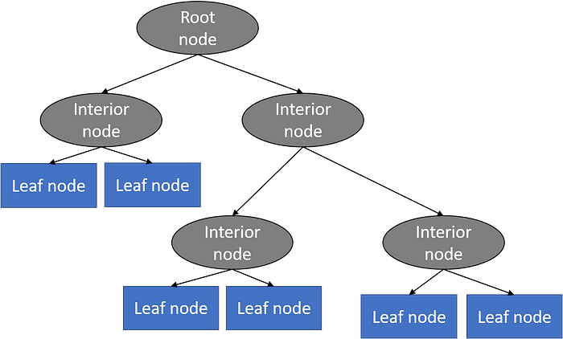

With a particular data point, it is run completely through the entirely tree by answering *True/False* questions till it reaches the leaf node. The final prediction is the average of the value of the dependent variable in that particular leaf node. Through multiple iterations, the Tree is able to predict a proper value for the data point.

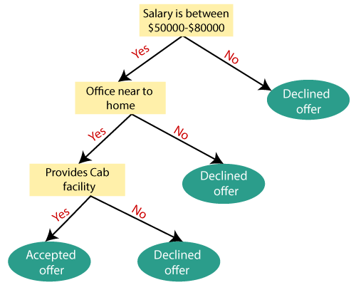

Here's a general overview of the tree building process in regression:

1. Data Preparation: Start with a dataset that includes input features (independent variables) and corresponding target values (dependent variable). Ensure the data is cleaned and preprocessed, handling missing values and outliers as needed.
2. Splitting Criteria: Choose a splitting criterion that determines how to divide the data at each node of the decision tree. Popular splitting criteria for regression include mean squared error (MSE), mean absolute error (MAE), or variance reduction.
3. Root Node: Begin by creating the root node of the tree, considering all the available features and the corresponding target values.
4. Recursive Splitting: At each internal node, the algorithm evaluates different feature and threshold combinations to find the best split that minimizes the chosen splitting criterion. The goal is to create child nodes that capture distinct subsets of the data with more homogeneous target values.
5. Terminal Nodes: The splitting process continues until certain stopping conditions are met. These conditions can include a predefined maximum depth of the tree, a minimum number of samples required to split a node, or a minimum improvement in the chosen splitting criterion.
6. Prediction: Once the tree is built, each leaf node represents a segment of the feature space. The target value assigned to a leaf node is typically the average (or median) of the target values within that segment.
7. Prediction for New Data: To predict the target value for new data, traverse the decision tree by evaluating the input features at each node and following the appropriate branch until reaching a leaf node. The predicted value is then based on the target value associated with that leaf node.

It's worth mentioning that decision trees can suffer from overfitting, especially when they are allowed to grow deeply. Techniques like pruning, ensemble methods (e.g., random forests, gradient boosting), or regularization can be applied to mitigate overfitting and improve the performance of the regression tree model.

**Tree building in classification**

Tree building in classification refers to the process of constructing a decision tree model to classify data into discrete categories or classes. Decision trees are a popular machine learning algorithm for classification tasks due to their interpretability and ability to handle both categorical and numerical features.

Here's a general overview of the tree building process in classification:

1. Data Preparation: Start with a labeled dataset where each data point has a set of features (independent variables) and a corresponding class label (dependent variable). Ensure the data is cleaned, preprocessed, and encoded appropriately, handling missing values and categorical variables as needed.
2. Splitting Criteria: Choose a splitting criterion that determines how to divide the data at each node of the decision tree. Common splitting criteria for classification include Gini impurity and information gain (entropy).
3. Root Node: Begin by creating the root node of the tree, considering all the available features and their corresponding class labels.
4. Recursive Splitting: At each internal node, the algorithm evaluates different feature and threshold combinations to find the best split that maximizes the chosen splitting criterion. The goal is to create child nodes that separate the data into subsets with more homogeneous class labels.
5. Terminal Nodes: The splitting process continues until certain stopping conditions are met. These conditions can include a predefined maximum depth of the tree, a minimum number of samples required to split a node, or a minimum improvement in the chosen splitting criterion. At the end of the process, the tree will have leaf nodes that represent the predicted class labels.
6. Prediction: To classify new data, traverse the decision tree by evaluating the input features at each node and following the appropriate branch until reaching a leaf node. The predicted class label is then based on the majority class of the training samples associated with that leaf node.
7. Pruning and Regularization: Decision trees can suffer from overfitting, where they become too complex and tailored to the training data, leading to poor generalization. Techniques like pruning, which remove or collapse nodes in the tree, and regularization methods can be applied to reduce overfitting and improve the performance of the classification tree model.

It's important to note that decision trees are prone to high variance and can be sensitive to small changes in the data. Ensemble methods such as random forests and gradient boosting are commonly used to mitigate these issues and improve the accuracy and stability of the classification models.

**OVERFITTING**

Overfitting is a common issue that can occur in decision tree models, where the model becomes too complex and captures noise or irrelevant patterns in the training data, leading to poor generalization on unseen data. Overfitting in decision trees can result in high variance and decreased performance.

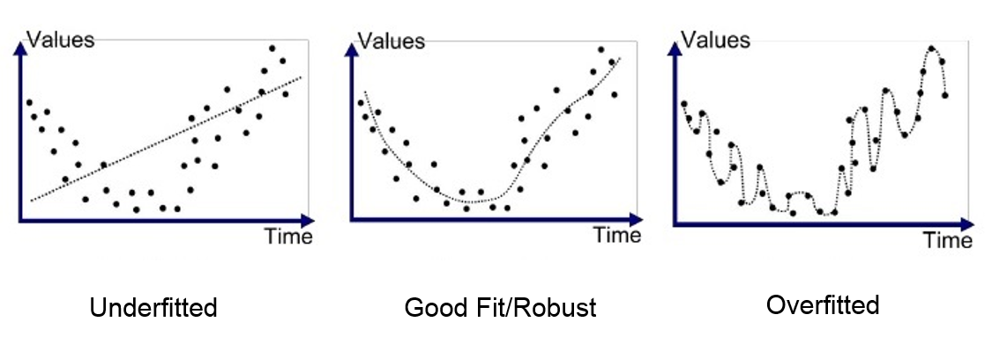

**Above figures represents overfitting in regression**

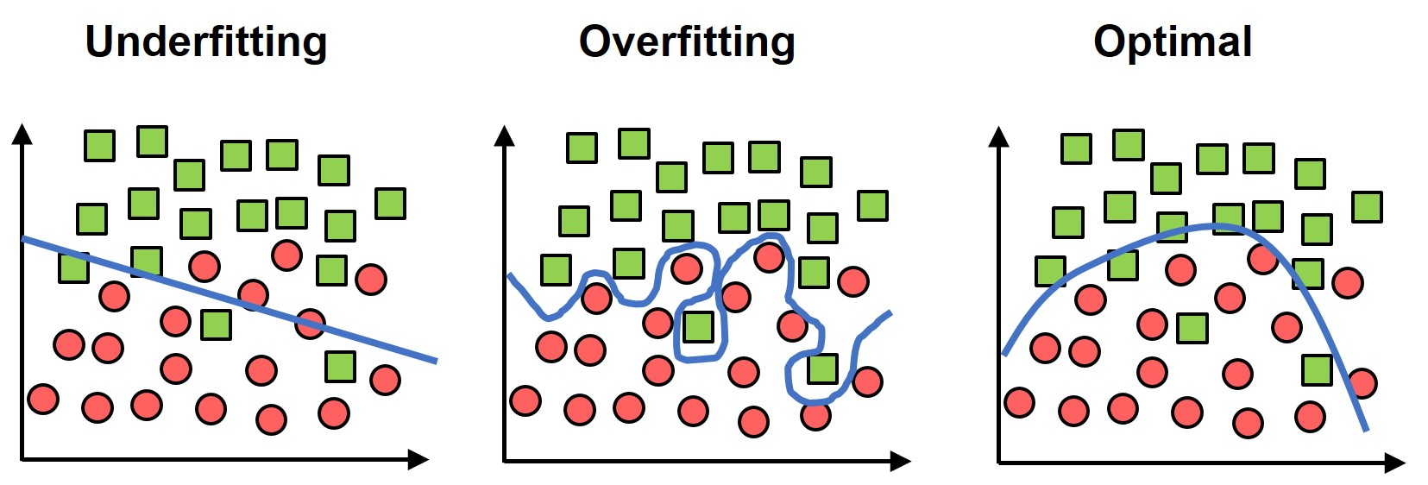

**Above figure represents overfitting in classification**

Here are some reasons why decision trees can be prone to overfitting and techniques to mitigate this problem:

1. Tree Depth: Decision trees with excessive depth tend to overfit the training data, as they can memorize specific instances or noise. Setting a maximum depth or limiting the number of nodes can help control the complexity of the tree.
2. Minimum Samples for Split: Setting a minimum number of samples required to split a node can prevent the tree from creating overly specific and noise-sensitive splits. It ensures that a node must have enough representative samples before further division.
3. Pruning: Pruning is a technique used to remove or collapse nodes from a decision tree to simplify it and reduce overfitting. Post-pruning, also known as backward pruning, involves pruning nodes after the tree has been fully grown. Pruning can be based on metrics such as the reduction in impurity or the decrease in error on validation data.
4. Feature Selection: Decision trees can be sensitive to irrelevant or noisy features. Careful feature selection or feature engineering can help eliminate or reduce the impact of such features, leading to a more robust and less overfit model.
5. Ensemble Methods: Ensemble methods, such as Random Forests and Gradient Boosting, can help mitigate overfitting in decision trees. These methods involve combining multiple decision trees to make predictions, which helps reduce the individual tree's overfitting and improve overall performance and generalization.
6. Regularization: Regularization techniques can be applied to decision trees to prevent overfitting. One such technique is to introduce constraints on the tree structure, such as limiting the number of leaf nodes, restricting the depth, or imposing a penalty on the complexity of the tree during training.
7. Cross-Validation: Proper evaluation of the model using cross-validation techniques can help detect and mitigate overfitting. Cross-validation provides a more robust estimate of the model's performance by assessing its generalization ability on multiple subsets of the data.

By employing these strategies, it is possible to reduce overfitting in decision trees and build more reliable and generalizable models.

**PRUNING AND COMPLEXITY**

Pruning and controlling the complexity of decision trees are important techniques to prevent overfitting and improve the generalization ability of the model. Pruning involves removing or collapsing nodes from the tree, simplifying its structure and reducing overfitting. Here's a closer look at pruning and managing complexity in decision trees:

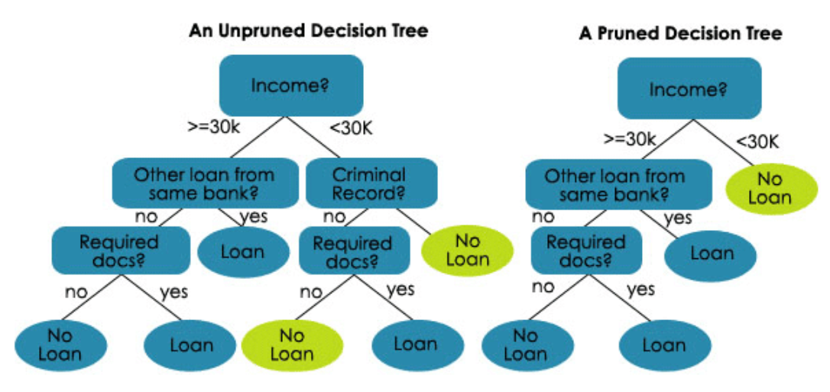

1. Pre-Pruning:
   * Maximum Depth: Set a maximum depth for the tree, limiting the number of levels or splits. This prevents the tree from growing too deep and capturing noise or irrelevant patterns.
   * Minimum Samples for Split: Define a minimum number of samples required to split a node. Nodes with fewer samples than the specified threshold are not split further, avoiding the creation of very specific and noise-sensitive splits.
   * Minimum Samples per Leaf: Specify a minimum number of samples required to be present in a leaf node. If a potential split would result in a leaf node with fewer samples, the split is not performed, preventing overly complex and overfitted branches.
2. Post-Pruning:
   * Reduced-Error Pruning: Start with a fully grown decision tree and iteratively evaluate the impact of removing or replacing nodes on a validation dataset. If removing a node leads to an improvement in performance, prune it. This process continues until further pruning results in performance degradation.
   * Cost-Complexity Pruning: Assign a cost or complexity parameter to each node in the tree based on its impurity or error rate. By iteratively evaluating the impact of removing nodes with the lowest cost-complexity ratio, a sequence of trees with different complexities is generated. The optimal complexity is determined by cross-validation or using a separate validation dataset.
3. Complexity Parameters:
   * Tree Depth: Limiting the depth of the tree controls its complexity. A shallower tree is less likely to overfit and may generalize better.
   * Minimum Impurity Decrease: Define a threshold for the minimum impurity decrease required for a split to occur. This prevents splits that do not contribute significantly to improving the overall purity or classification accuracy.
   * Maximum Leaf Nodes: Set a maximum number of leaf nodes in the tree, which indirectly controls the complexity. A smaller number of leaf nodes results in a simpler tree.
4. Ensemble Methods:
   * Random Forests: Random Forests combine multiple decision trees by training them on different subsets of the data and averaging their predictions. The randomness in feature selection and training data reduces overfitting.
   * Gradient Boosting: Gradient Boosting trains decision trees sequentially, with each subsequent tree correcting the mistakes of the previous ones. Regularization techniques, such as shrinkage or learning rate, help manage complexity.

By using pruning techniques and controlling the complexity of decision trees, you can strike a balance between capturing useful patterns in the data and avoiding overfitting, resulting in more reliable and generalizable models.

Using multiple decision trees in object segmentation is a common approach to improve the accuracy and robustness of the segmentation task. One popular ensemble method for object segmentation is the Random Forest-based segmentation.

Here's an overview of how multiple decision trees can be used for object segmentation:

1. Training Data Preparation: Collect a labeled dataset consisting of input images and corresponding ground truth segmentation masks. Each pixel or region in the image should be labeled as either part of the object or background.
2. Feature Extraction: Extract relevant features from the input images to represent the pixel or region characteristics. These features can include color, texture, gradient, or other image descriptors.
3. Random Forest Training:
   * Construct a Random Forest ensemble by training multiple decision trees using the labeled training dataset.
   * Each decision tree is trained using a random subset of the training data and a random subset of the features.
   * At each pixel or region, the decision trees learn to predict the class label (object or background) based on the extracted features.
4. Inference:
   * For a new input image, pass each pixel or region through the ensemble of decision trees.
   * Each decision tree provides a prediction for the class label of the pixel or region.
   * The final segmentation result is obtained by aggregating the predictions from all the decision trees. For example, voting or averaging can be used to determine the final class label.

Using multiple decision trees in object segmentation offers several advantages:

* Robustness: The ensemble can handle complex object boundaries and variations in the input images, improving robustness to noise and occlusions.
* Accuracy: By combining predictions from multiple decision trees, the segmentation accuracy can be enhanced compared to using a single decision tree.
* Efficiency: The decision trees can be trained and evaluated in parallel, making the approach computationally efficient.

Additionally, other ensemble methods, such as Gradient Boosting or Convolutional Neural Networks (CNNs), can also be utilized for object segmentation, providing further improvements in accuracy and performance.

**TIME SERIES METHOD**

Time series methods are specifically designed to analyze and forecast data that exhibits a temporal or sequential order. These methods take into account the dependence and patterns present in time-dependent data. Here are some commonly used time series methods:

1. Moving Averages (MA): Moving averages smooth out the irregularities in a time series by calculating the average of a sliding window of consecutive data points. They are useful for identifying trends and removing short-term fluctuations or noise.
2. Autoregressive (AR) Models: AR models assume that the value of a variable in the time series is linearly dependent on its previous values. An AR(p) model considers the previous p values to predict the current value. The model coefficients are estimated using techniques like the Yule-Walker equations or maximum likelihood estimation.
3. Moving Average with Exogenous Inputs (ARMAX): ARMAX models extend the autoregressive model by incorporating exogenous variables that may influence the time series. These models are useful when the variable of interest is affected by external factors.
4. Autoregressive Integrated Moving Average (ARIMA): ARIMA models combine the autoregressive (AR) and moving average (MA) components with differencing to handle non-stationary time series. The differencing step removes trends and seasonality, making the time series stationary before applying the AR and MA components.
5. Seasonal ARIMA (SARIMA): SARIMA models are an extension of ARIMA models that can handle seasonal patterns in the data. They incorporate additional seasonal components to capture recurring patterns within a given season.
6. Exponential Smoothing: Exponential smoothing methods forecast future values by assigning exponentially decreasing weights to past observations. This includes simple exponential smoothing (SES), Holt's linear exponential smoothing, and Holt-Winters' seasonal exponential smoothing for data with trend and/or seasonality.
7. Vector Autoregression (VAR): VAR models are used when analyzing multiple time series variables that influence each other. VAR models capture the interdependencies among variables and can be used for forecasting and understanding the dynamic relationships between them.
8. State Space Models: State space models represent a time series as a combination of unobserved (latent) states and observed outputs. They are widely used for modeling and forecasting complex time series data and can handle various structures and dependencies.
9. Machine Learning Approaches: Machine learning algorithms, such as Support Vector Machines (SVM), Random Forests, and Recurrent Neural Networks (RNN), can be applied to time series analysis and forecasting. These models can capture complex patterns and dependencies in the data but often require larger datasets and more computational resources.

The choice of method depends on the characteristics of the time series, including trend, seasonality, data volume, and the presence of exogenous variables. It is important to consider the specific requirements and properties of the data when selecting an appropriate time series method**.**

**ARIMA (Autoregressive Integrated Moving Average**) is a time series forecasting method and is not directly applicable to object segmentation tasks. Object segmentation involves identifying and delineating objects within an image or video, while ARIMA is used for modeling and predicting values in a time series.

However, in certain cases, time series analysis techniques can be used as a pre-processing step in object segmentation tasks. For example, if you have a video sequence of images and want to segment objects based on their motion or temporal patterns, you can apply motion-based or spatio-temporal methods that incorporate time series analysis.

Here are some ways in which time series analysis techniques can be used in object segmentation:

1. Optical Flow: Optical flow methods estimate the motion vectors of pixels or regions between consecutive frames in a video. By analyzing the temporal changes in pixel intensity, optical flow can help identify object boundaries and track their movements over time.
2. Temporal Smoothing: Time series smoothing techniques, such as moving averages or exponential smoothing, can be applied to temporal sequences of pixel intensities to reduce noise or short-term fluctuations. Smoothing can improve the accuracy of subsequent segmentation algorithms that rely on stable and smooth intensity profiles.
3. Temporal Context: The temporal context of an object's appearance and motion can be leveraged to enhance segmentation. By considering the evolution of an object's appearance over time, you can incorporate temporal consistency constraints to refine object boundaries or handle occlusions.
4. Temporal Segmentation: Time series clustering or segmentation algorithms can be used to identify temporal segments or regions in a video that exhibit similar patterns. This can be useful for segmenting objects with distinct temporal behaviors or activities.

It's important to note that while time series analysis techniques can complement object segmentation, they are not the primary methods used for segmenting objects in images or videos. Traditional object segmentation techniques, such as thresholding, region-based methods, or deep learning-based approaches like semantic segmentation and instance segmentation, are more commonly employed for accurate and robust object segmentation tasks.

Top of Form

**Measures of forecast accuracy**

Measures of forecast accuracy are used to assess the performance and reliability of forecasting models. These measures help quantify the accuracy of predictions by comparing the forecasted values to the actual values. Here are some commonly used measures of forecast accuracy:

1. Mean Absolute Error (MAE): MAE calculates the average absolute difference between the forecasted values and the actual values. It measures the average magnitude of errors without considering their direction, making it a robust measure. The formula for MAE is:

MAE = (1/n) * Σ|Actual - Forecast|

1. Mean Squared Error (MSE): MSE calculates the average of the squared differences between the forecasted values and the actual values. It penalizes larger errors more than MAE and is commonly used in many forecasting applications. The formula for MSE is:

MSE = (1/n) * Σ(Actual - Forecast)^2

1. Root Mean Squared Error (RMSE): RMSE is the square root of MSE and provides an interpretable measure in the same units as the original data. It is widely used and is helpful in understanding the average size of errors. The formula for RMSE is:

RMSE = sqrt(MSE)

1. Mean Absolute Percentage Error (MAPE): MAPE measures the average percentage difference between the forecasted values and the actual values. It is useful when the scale of the data varies widely and provides a relative measure of accuracy. The formula for MAPE is:

MAPE = (1/n) * Σ(|(Actual - Forecast) / Actual|) * 100

1. Symmetric Mean Absolute Percentage Error (SMAPE): SMAPE is another measure of percentage error, but it addresses some of the limitations of MAPE by using the average of the absolute differences relative to the sum of the actual and forecast values. The formula for SMAPE is:

SMAPE = (1/n) * Σ(|Actual - Forecast| / ((|Actual| + |Forecast|) / 2)) * 100

These measures provide different perspectives on forecast accuracy and have their strengths and weaknesses. Some measures are more sensitive to outliers or extreme errors, while others focus on the overall magnitude of errors. It is important to choose the appropriate measure based on the specific requirements and characteristics of the forecasting task.

**The STL (Seasonal and Trend decomposition using Loess**)

this approach is a popular time series decomposition method that separates a time series into three components: seasonality, trend, and residual. It is particularly useful when dealing with time series that exhibit both trend and seasonal patterns.

Here's an overview of the STL approach:

1. Seasonal Component: The STL approach first estimates the seasonal component of the time series. It does this by applying a locally weighted regression (loess) to smooth out the series and identify the underlying seasonal patterns. The loess method fits a smooth curve to the data, giving more weight to nearby observations. The seasonal component represents the repeating patterns at fixed intervals, such as daily, weekly, or yearly cycles.
2. Trend Component: After extracting the seasonal component, the STL approach estimates the trend component. This is done by applying another loess smoothing, but this time on the detrended series. The detrended series is obtained by removing the seasonal component from the original time series. The trend component captures the long-term direction or tendency of the time series.
3. Residual Component: The residual component represents the remaining variation in the time series after removing the seasonal and trend components. It contains the irregular or unpredictable fluctuations that are not accounted for by the seasonal and trend patterns. The residual component can be further analyzed for identifying any remaining patterns or to model the random component of the series.

The STL approach has several advantages:

* It provides a robust and flexible method for decomposing time series data into interpretable components.
* It handles irregularities, outliers, and non-linear patterns in the data effectively.
* It allows for separate analysis and modeling of the individual components, enabling better understanding and forecasting of the time series.

Once the time series is decomposed using STL, the individual components can be analyzed, modeled, and forecasted independently. For example, forecasting can be done separately for the trend and seasonal components, and then combined to obtain the forecast for the original series.

STL is widely used in various fields, including finance, economics, and environmental studies, to analyze and forecast time series data. It provides a valuable tool for understanding the underlying patterns and extracting meaningful information from complex time series.

**extract features from generated model as height,average energy etc and analyze for prediction**

To extract features from a generated model, such as a decision tree or random forest, as height and average energy, and analyze them for prediction, you can follow these steps:

1. Traverse the Model: Start at the root node of the decision tree or the ensemble of trees in the random forest. Traverse the model by following the branching logic based on the splitting criteria until you reach the leaf nodes.
2. Track Depth or Height: As you traverse the model, keep track of the depth or height of each node you visit. The depth represents the number of levels from the root node to the current node. Store the depth for each feature node.
3. Calculate Average Energy: At each leaf node, calculate the average energy of the training samples associated with that node. The energy measure can be specific to your domain or problem. It could be a statistical measure like mean, variance, or any other relevant metric that captures the energy or magnitude of the samples associated with that leaf node.
4. Extract Features: Extract the features you are interested in, such as feature names or indices, depth or height, and average energy, for each feature node in the model.
5. Analyze for Prediction: Once you have extracted the features, you can analyze them for prediction purposes. Here are some possible analyses:
   * Feature Importance: Analyze the relationship between the extracted features and the target variable. You can examine the importance of each feature based on their heights, average energy, or any other relevant measure. This analysis can help identify the most influential features in the model.
   * Feature Selection: Use the extracted features as inputs for further analysis or prediction tasks. You can apply feature selection techniques, such as filtering or wrapper methods, to select a subset of features that are most relevant for your prediction task. This can help reduce dimensionality and improve prediction accuracy.
   * Model Evaluation: Evaluate the performance of your model using the extracted features. Compare different models or variations of your model based on their prediction accuracy, using appropriate evaluation metrics such as accuracy, precision, recall, or F1-score.
   * Interpretation: Analyze the relationship between the extracted features and the model's decision-making process. Investigate how the features' heights and average energy contribute to the model's predictions. This can provide insights into the internal workings and behavior of the model.

By extracting features such as height and average energy from your generated model and conducting analysis for prediction, you can gain a better understanding of the model's behavior and potentially improve prediction performance by selecting important features or incorporating feature-related insights into your prediction pipeline.

Top of Form