A Course File
On
CAD/CAM
IV- B. Tech. – I– Semester
Submitted to
DEPARTMENT OF MECHANICAL ENGINEERING

By
Mr.M.V.Kishor kumar
Assist.Professor, Dept. of ME


CMR INSTITUTE OF TECHNOLOGY
Kandlakoya(V), Medchal Road, Hyderabad – 501 401
Ph. No. 08418-222042, 22106 Fax No. 08418-222106

2017-18

CONTENTS

Sl. No. | Particulars | Page No.
1 | JNTUH Syllabus | 3
2 | Student Entry Behavior or Pre-requisites | 4
3 | Course Objectives | 4
4 | Course Outcomes | 4
5 | Mapping of Course with PEOs-PSOs-POs | 5
6 | Mapping Of Course Outcomes with PEOs | 9
7 | Mapping Of Course Outcomes with PSOs | 10
8 | Mapping Of Course Outcomes with POs | 11
9 | Direct Course Assessment | 12
10 | Indirect Course Assessment | 13
11 | Overall Course Assessment and Attainment level | 17
12 | Pi diagrams, Bar charts, Histograms for representing results | 18
13 | Lesson/Course Plan | 19
14 | Actions and Assessment Plan | 20
15 | Lecturer Notes | 23
16 | Question Bank | 348
17 | Internal Examination Question Papers with key | 350
18 | External/End Examination Question Papers | 363

- JNTUH SYLLABUS
CAD/CAM
UNIT – I
Computers in industrial manufacturing, product cycle, CAD/CAM hardware, basic structure, CPU, memory types, Input devices, display devices, hard copy devices, and storage devices. Raster scan graphics, coordinate system, database structure for Geometric modeling graphics modeling, Transformation of geometry, 3D transformations, mathematics of projections, clipping, and hidden surface removal.
UNIT – II
Solid modeling and surface modelling: Requirements, geometric models, geometric construction models, curve rep. methods, Surface representation methods, modeling facilities desired. Basic geometric commands, layers, Display control commands, editing, dimensioning, and solid modeling.
UNIT – III
Numerical control: NC,NC modes, NC elements, NC machine tools, structure of CNC machine tools, Features of machining center, turning center, CNC part programming, Fundamentals ,manual part programming, computer assisted part programming,
UNIT – IV
Group Tech: part family, coding and classification, production flow analysis, advantages and limitations,
CAPP: Introduction, Retrieval type and Generative type
UNIT – V
Flexible manufacturing system: F.M.S equipment, FMS layouts, analysis methods for FMS, benefits of FMS.
Computer aided quality control: automated inspection ;off line, online contact inspection methods, Non-contact inspection methods, coordinate measuring machines, machine vision
CIMS: CIM system,CIMS benefits
TEXT BOOKS:
1. CAD/CAM by Groover M.P./PearsonEducation
2. CAD/CAM Concepts and Applications/Alavala/Phi
REFERENCES:
1. Automation, production systems & Computer integrated manufacturing/Groover/PE
2. Compter Aided Design and Manufacturing/Lalith Narayana,etal/PI
3. CAD/CAM/CIM/Radhakrishnan and Subramanian/New Age
4. CAD/CAM: Concepts and Applications/Alavala/PHI
5.Computer Numerical Control Concpts and Programming/Warre S Seames/Thomson

2. Student Entry Behaviour (Pre-Requisite Course if Any from I/II/III/IV Year): Independent

3. Course Objectives
Course  Objectives | Course Objective Statements
Objective-1 | The objectives of the topics are to know the computer graphics and the CAD/CAM hardware.
Objective-2 | Users have to know the generation of geometric models using mathematical representations.
Objective-3 | To describe the concepts of NC, CNC, DNC systems and develop part programs.
Objective-4 | The objective of the GT is to classify model parts based on bar codes for computer aided process planning.
Objective-5 | Describe the computer aided inspection and testing of NC components.
Objective-6 | The objective of CIMS is to communicate with the CAD/CAM systems, material handling systems and QC systems.

4. Course Outcomes
Course  Outcomes | Course Outcome Statements
CO-1 | Students understand the basic concepts of computer, computer graphics, and components of CAD/CAM systems.
CO -2 | Students understand the creation of different geometric models.
CO -3 | Students learn the working of NC, CNC, DNC systems with newly developed part programs. Students are advised to visit CNC industries.
CO -4 | Students understand the GT based bar coded model parts which are displayed in computer aided process planning.
CO -5 | Students understand the inspection of parts using computer controlled CMM and by Non-contact inspection methods.
 | Students understand the integration of CAD/CAM systems and human being involvement in CIMS.

Course Objectives & Outcomes Mapping
Course Objectives
Course Objectives | CO-1 | CO-2 | CO-3 | CO-4 | CO-5
Objective-1 | √
Objective-2 |  | √
Objective-3 |  |  | √
Objective-4 |  |  |  | √
Objective-5 |  |  |  |  | √
Objective-6

5. Mapping of Course with PEOs-PSOs-Pos

Program Educational Objectives (PEOs)
Sl. No. | PEOs Name | Program Education Objective Statements
1 | PEO - 1 | Impart profound knowledge in humanities and basic sciences along with core engineering concepts for practical understanding & project development.[PO’s: 1,2,3,4,5,7,8,9,10,11 and 12] [PSO’s: 1 and 2]
2 | PEO – 2 | Enrich analytical skills and Industry-based modern technical skills in core and interdisciplinary areas for accomplishing research, higher education, entrepreneurship and to succeed in various engineering positions globally. [PO’s: 1,2,3,4,5,6,7,8,9,10 and 12] [PSO’s: 1, 2 and 3]
3 | PEO – 3 | Infuse life-long learning, professional ethics, responsibilities and adaptation to innovation along with effective communication skills with a sense of social awareness. [PO’s: 1,2,3,4,5,6,7,8,9,10,11 and 12] [PSO’s: 2 and 3]

Program Specific Objectives (PSOs)
Sl. No. | PSOs Name | Program Specific Objective Statements
1 | PSO - 1 | Use mathematical abstractions and Algorithmic design along with open source programming tools to solve complexities involved in efficient programming.[PO:1,2,3,4 and 5] & [PEO:1 and 2]
2 | PSO – 2 | Ensure programming & documentation skills for each individual student in relevant subjects i.e., C, C⁺⁺, Java, DBMS, Web Technologies (Development), Linux, Data Warehousing & Data Mining and on Testing Tools.[PO:1,2,3,4,5,10 and 11] & [PEO:1,2 and 3]
3 | PSO – 3 | Ensure employability and career development skills through Industry oriented mini & major projects, internship, industry visits, seminars and workshops. [PO:6,7,8,9,10,11 and 12] & [PEO:1,2 and 3]

Program Outcomes (POs)

PO Names | Graduate Attributes | PO Statements
PO1 | Engineering knowledge | Apply the knowledge of mathematics, science, engineering fundamentals, and an engineering specialization to the solution of complex engineering problems. [PEO’s: 1,2 and 3] [PSO’s: 1,2 and 3]
PO 2 | Problem analysis | Identify, formulate, review research literature, and analyze complex engineering problems reaching substantiated conclusions using first principles of mathematics, natural sciences, and engineering sciences. [PEO’s: 1,2 and 3] [PSO’s: 1,2 and 3]
PO 3 | Design/ development of solutions | Design solutions for complex engineering problems and design system components or processes that meet the specified needs with appropriate consideration for the public health and safety, and the cultural, societal, and environmental considerations. [PEO’s: 1,2 and 3] [PSO’s: 1,2 and 3]
PO 4 | Conduct investigations of complex problems | Use research-based knowledge and research methods including design of experiments, analysis and interpretation of data, and synthesis of the information to provide valid conclusions. [PEO’s: 1,2 and 3] [PSO’s: 1,2 and 3]
PO 5 | Modern tool usage | Create, select, and apply appropriate techniques, resources, and modern engineering and IT tools including prediction and modeling to complex engineering activities with an understanding of the limitations. [PEO’s: 1,2 and 3] [PSO’s: 1,2 and 3]
PO 6 | The engineer and society | Apply reasoning informed by the contextual knowledge to assess societal, health, safety, legal and cultural issues and the consequent responsibilities relevant to the professional engineering practice. [PEO’s: 2 and 3]
PO 7 | Environment and sustainability | Understand the impact of the professional engineering solutions in societal and environmental contexts, and demonstrate the knowledge of, and need for sustainable development. [PEO’s: 1,2 and 3]
PO 8 | Ethics | Apply ethical principles and commit to professional ethics and responsibilities and norms of the engineering practice. [PEO’s: 1,2 and 3] [PSO’s: 2 and 3]
PO 9 | Individual and team work | Function effectively as an individual, and as a member or leader in diverse teams, and in multidisciplinary settings. [PEO’s: 1,2 and 3] [PSO’s: 3]
PO 10 | Communication | Communicate effectively on complex engineering activities with the engineering community and with society at large, such as, being able to comprehend and write effective reports and design documentation, make effective presentations, and give and receive clear instructions. [PEO’s: 1,2 and 3] [PSO’s: 2 and 3]
PO 11 | Project management and finance | Demonstrate knowledge and understanding of the engineering and management principles and apply these to one’s own work, as a member and leader in a team, to manage projects and in multidisciplinary environments. [PEO’s: 1 and 3] [PSO’s: 2 and 3]
PO 12 | Life-long learning | Recognize the need for, and have the preparation and ability to engage in independent and life-long learning in the broadest context of technological change. [PEO’s: 1,2 and 3] [PSO’s: 1,2 and 3]

Course Mapping

Course Name | PEO1 | PEO2 | PEO3 | PSO1 | PSO2 | PSO3
CAD/CAM | √ | √ | √ | √ | √ | √

Course Name | Po₁ | Po₂ | Po₃ | Po₄ | Po₅ | Po₆ | Po₇ | Po₈ | Po₉ | Po₁₀ | Po₁₁ | Po₁₂
CAD/CAM | √ | √ | √ | √ | √ | √ | √ | √ | √ | √ | √ | √

6. Mapping of Course Outcomes with PEOs

Mapping of Course Outcomes with PEOs
No | Course Outcomes | PEO1 | PEO2 | PEO3
1 | CO - 1 | √ | √ | -
2 | CO – 2 | √ | √ | √
3 | CO – 3 | √ | √ | √
4 | CO – 4 | √ | - | √
5 | CO – 5 | √ | - | √

Correlation of Course Outcomes with PEOs
No | Course Outcomes | PEO1 | PEO2 | PEO3
1 | CO - 1 | H | H | --
2 | CO – 2 | H | M | H
3 | CO – 3 | H | H | H
4 | CO – 4 | H | -- | H
5 | CO – 5 | H | -- | H

7. Mapping of Course Outcomes with PSOs

Mapping of Course Outcomes with PSOs
No | Course Outcomes | PSO1 | PSO2 | PSO3
1 | CO - 1 | √ | - | √
2 | CO – 2 | √ | √ | √
3 | CO – 3 | √ | √ | √
4 | CO – 4 | √ | - | √
5 | CO – 5 | √ | - | √

Correlation of Course Outcomes with PSOs
No | Course Outcomes | PSO1 | PSO2 | PSO3
1 | CO - 1 | H | -- | H
2 | CO – 2 | H | H | H
3 | CO – 3 | H | H | H
4 | CO – 4 | H | -- | H
5 | CO – 5 | H | -- | M

8. Mapping of Course Outcomes with POs

Mapping of Course Outcomes with POs

No | Course Outcomes | Po₁ | Po₂ | Po₃ | Po₄ | Po₅ | Po₆ | Po₇ | Po₈ | Po₉ | Po₁₀ | Po₁₁ | Po₁₂
1 | CO - 1 | √ | √ | √ | √ | √ | √ | √ | √ | √ | √ | √ | √
2 | CO – 2 | √ | √ | √ | √ | √ | √ | √ | - | √ | √ | √ | √
3 | CO – 3 | √ | √ | √ | √ | √ | √ | √ | √ | √ | √ | √ | √
4 | CO – 4 | √ | √ | √ | √ | √ | √ | √ | √ | √ | √ | √ | √
5 | CO – 5 | √ | √ | √ | √ | √ | √ | - | √ | √ | √ | √ | √

Correlation of Course Outcomes with POs
No | Course Outcomes | Po₁ | Po₂ | Po₃ | Po₄ | Po₅ | Po₆ | Po₇ | Po₈ | Po₉ | Po₁₀ | Po₁₁ | Po₁₂
1 | CO - 1 | 3 | 3 | 3 | 2 | 2 | 2 | 3 | 2 | 2 | 3 | 3 | 3
2 | CO – 2 | 3 | 3 | 3 | 3 | 2 | 2 | 3 | 0 | 3 | 2 | 3 | 3
3 | CO – 3 | 3 | 3 | 3 | 3 | 3 | 2 | 3 | 3 | 2 | 3 | 3 | 3
4 | CO – 4 | 3 | 1 | 3 | 3 | 3 | 2 | 1 | 3 | 3 | 3 | 2 | 3
5 | CO – 5 | 3 | 3 | 2 | 3 | 3 | 3 | 0 | 3 | 3 | 3 | 3 | 3

9. Direct Course Assessment

Tools Used: Internal Exams, External Exams, Clearing Subject & Assignments.
No | Description | Targeted Performance | Actual Performance | Remarks | Course Attainment
1 | Internal Marks(25) | 60% of Students(36 Students) should Secure 60% of Internal Marks i.e., 15 Marks | 41 Students Secured 15 Marks | All Course the Outcomes in general attained & Marks Awarded or Attainment Level is 3(Strong & High)
2 | External Marks(75) | 50% of Students(31 Students) should Secure 50% of External Marks i.e., 38 Marks | 27 Students Secured 38 Marks | All the Course Outcomes in general attained & Marks Awarded or Attainment Level is 3(Strong & High)
3 | Clearing of Subject or acquiring credit as mentioned | A minimum of 90% of Students(55 Students) should clear this course in first attempt | 60 Students should secure 40 Marks or 3 Credits whichever is lower | All the Course Outcomes in general attained & Marks Awarded or Attainment Level is 3(Strong & High)
4 | Assignments | 65% of Students should secure 80% of Assignment Marks i.e., 5M. | 46 Students out of 61 students got 4 Marks | All Course Outcomes in general attained Marks Awarded or Attainment Level is 3(Strong & High)
 | Average Course Attainment=(3+3+3+3)/4=(12/4)=3.00 Strong & High
- Course Attainment Level=3M(High)
- Performance in Internal & End Exams is Substantial.
- Hence all the Course Outcomes are summarily Attained
- As Direct Assessment is equal to 80% of 3 Marks i.e., 2.4 Marks

10. Indirect Course Assessment

(As mentioned-strong (3), moderate (2), weak (1) & no comment (0))

Mission Statements of ME
- Provide fundamentals and state of art technical knowledge in frontier areas of Mechanical Engineering.
- Emphasize on collaborative research and consultancy by initiating MOUs with industries and R&D organizations.
- Enrich self learning, professional ethics, entrepreneurship and leadership through effective interaction with stakeholders to handle real world challenges.

Correlation of Mission Elements with Mission Statement of ME Department related to the Course

No | Mission Elements | Strong | Moderate | Weak | No Comment
M-1 | Provide fundamentals and state of art technical knowledge in frontier areas of Mechanical Engineering. | √ |  |  | -
M-2 | Emphasize on collaborative research and consultancy by initiating MOUs with industries and R&D organizations. |  | √ |  | -
M-3 | Enrich self learning, professional ethics, entrepreneurship and leadership through effective interaction with stakeholders to handle real world challenges. | √ |  |  | -

Correlation of Mission Elements with Mission Statement of ME Department related to the Course

No | Mission Elements | Strong | Moderate | Weak | No Comment
M-1 | Provide fundamentals and state of art technical knowledge in frontier areas of Mechanical Engineering. | 3
M-2 | Emphasize on collaborative research and consultancy by initiating MOUs with industries and R&D organizations. |  | 2
M-3 | Enrich self learning, professional ethics, entrepreneurship and leadership through effective interaction with stakeholders to handle real world challenges. | 3

Indirect Course Assessment through Student Satisfaction Survey

(Using Indirect Assessment Technique through a feedback for a Weightage of 20%)
Year & Semester: IV/I Academic Year: 2015-16
Course Title: CAD/CAM
No. of Students on Rolls as per Attendance Register: 127 (Response by:120 )
Name of the Faculty: D.Dev singh, Designation:Assoc.Prof
No | Question Based on PEO/PO/PSO/CO | Mission Element | Medium/Parameter | Strong/ high (3) | Moderate/ medium (2) | Weak/ low (1) | No comment (0) | Total | Grade %
1 | To what extent the course provide fundamentals knowledge with state of art technology to promote quality education? | Provide fundamentals and state of art technology to promote quality education | Class room teaching, simulations, labs, practice, mini & main Projects, conferences, professional and student association activities, technical clubs, guest lectures, workshops, student technical fests | 100 | 10 | 10 |  | 330 | 2.75
2 | To what extent the course emphasize on collaborative research? | Emphasize on collaborative research | simulations, labs, practice, mini & main Projects, conferences, prof. and student association activities, technical clubs, guest lectures, workshops, student technical fests | 105 | 10 | 5 |  | 340 | 2.83
3 | Does the course have any scope for interaction with stakeholders | Interaction | Class room teaching, simulations, labs, practice, mini & main Projects, conferences, prof. and student association activities, technical clubs, guest lectures, workshops, student technical fests | 100 | 10 | 10 |  | 325 | 2.75
4 | Rate focus of the course towards addressing professional & ethical issues w.r.t. realistic problems | Professional ethics,  with realistic problems | NSS Activities, Environmental Events, Literary events/activities, professional association activities | 98 | 18 | 4 |  | 334 | 2.78
5 | Rate the role of the facilitator in mentoring and promoting the self learning abilities to excel academically and professionally? | Continuous self learning ability | TLP, use & availability of digital library, internet access, industrial visits | 100 | 9 | 11 |  | 329 | 2.74
6 | Rate the methodology adopted and techniques used in teaching learning processes. | TLP | Tools, techniques, methods, teaching aids used in class room instructions | 100 | 10 | 10 |  | 330 | 2.75
7 | Rate the course in applying sciences & engineering fundamentals in providing research based conclusions with the help of modern tools? | Applying fundamentals & use of modern tools for R&D | Mini and main projects, latest software, and R&D activities | 110 | 5 | 5 |  | 340 | 2.88
8 | Did the course have any scope to design, develop and test a system or component? | Design, develop and test a system or component | Main Projects, seminars, workshops, training programmes | 110 | 5 | 5 |  | 340 | 2.88
9 | Rate scope of this course in addressing cultural, legal, health, environment and safety issues? | Cultural, legal, health, environment and safety issues | NSS Activities, Environmental Events, Literary events/activities, professional association activities | 98 | 18 | 4 |  | 334 | 2.78
10 | Scope of applying management fundamentals to demonstrate effective technical project presentations & report writing? | use of management fundamentals for effective project management & control techniques | Group projects, Team Events, simulations, practice, conferences, prof. and student association activities, technical clubs, workshops, student technical fests | 110 | 5 | 5 |  | 340 | 2.88
Average Course Attainment Level is 2.80(High) |  |  |  |  |  |  |  |  | 2.80
Indirect Assessment(20% *2.80)=0.5604

- Overall Course Assessment
(80% Direct + 20% Indirect, if any)

No | Assessment Type | Weightage | Attainment Level
1 | Direct-Assignment, Quiz, Subjective, University Exams, Results, Bench Marks | 0.80 | 0.80( )= Max
2 | Indirect-Surveys-Questionnaire | 0.20 | 0.20(2.80)=0.5604Max
 | Overall | 1.00 | 2.942 High

Course Attainment level: 2.942 (Strong&High)

- Pi diagrams, Bar charts, Histograms
(Assignments, Quiz, Subjective & External):
Distribution of Marks

Description | Marks
Internal Assignment | 5
Internal Quiz | 10
Internal Subjective | 10
External(Univ. Exams) | 75

13. Lesson/Course Plan

UNIT NO. | NAME OF THE TOPIC | NO. OF CLASSES | TEXT BOOKS
 | Computers in industrial manufacturing, product cycle, CAD/CAM hardware, basic structure, CPU, memory types | 6 | T1
 | Input devices, display devices, hard copy devices, storage devices | 6 | T1
 | Computer Graphics: Raster scan graphics, coordinate system, database structure for graphics modeling | 5 | T2
 | Transformation of geometry, 3D transformations, mathematics of projections, clipping, hidden surface removal | 5 | T2
 | Geometric modeling: Requirements, geometric models, geometric construction models, curve rep. methods | 6 | T2
 | Surface representation methods, modeling facilities desired | 6 | T2
 | Drafting and Modeling systems: Basic geometric commands, layers | 3 | T2
 | Display control commands, editing, dimensioning, solid modeling | 3 | T2
 | Numerical control: NC,NC modes, NC elements, NC machine tools, structure of CNC machine tools, Features of machining center, turning center | 6 | T1
 | CNC part programming, Fundamentals ,manual part programming, computer assisted part programming | 8 | T1
 | Group Tech: part family, coding and classification, production flow analysis, advantages and limitations | 5 | T2
 | CAPP: Introduction, Retrieval type and Generative type | 2 | T2
 | Computer aided quality control: Terminology in QC, computers in QC, contact inspection methods | 5 | T2
 | Non-contact inspection methods- optical and non-optical, computer aided testing, integration of CAQC with CAD/CAM | 5 | T2
 | CIMS: Types of manufacturing systems, machine tools and related equipments, material handling systems | 5 | T2
 | Computer control systems, human labour in the manufacturing systems, CIMS benefits | 4 | T2
Total number of classes required: 80
14.Actions and Assessment Plan

Students should have to attend the lecture classes and maintain and follow the lecture notes of the subject. There are other requirements other than attending the classes. The following actions taken to improve the course plan and to meet the objectives.
8.1.) Actions

8.1.1. Assignments
Assignments were given to students on weekly basis. Every week one topic will be given based on previous year question papers and important topics from each unit as and when then topic is thought to the students. Students’ evaluation will be done on the basis of performance in the assignments and feedback will be given to improve their performance.

8.1.2. Mini Project
Students will be made to undergo a Mini Project for duration of 15 days along with their class work. The project enables the students to be aware of CAD/CAM processes.

  - Workshop & Seminars
Students are encouraged to attend various workshops held at different organizations in order to improve their knowledge in CAD/CAM subject. Seminars are conducted every fortnightly at college premises and students take active participation in seminars on CAD/CAM.

  - Paper Presentations
Paper presentations on various topics of CAD/CAM will be given by students during weekend sessions. Faculty members also use various techniques to make the subject more interesting and lively while teaching to the students.

8.1.3. Case Study
Case studies will be taken from imminent journals like Elsevier and Springer and made solved by students.

8.2.) Slip Tests:

Slip tests are conducted in the class rooms.
8 slip tests are conducted per semester per course.
2 questions are given for each slip test.
Instructions:
Slip test should be in written documents with the following requirements.
1) Cover page with name, roll number, course name and course section.
2) A page with questions.
3) Solutions/Explanations.

QUESTIONS FOR SLIP TESTS

UNIT- I ,II , III , IV , V
1. Discuss briefly product cycle.
2. Define CAD, CAM, CAD/CAM TOOLS.
3. Explain Refresh display.
4. Briefly discuss about all input devices.
5. What are the different memory types?
6. Discuss about storage devices.
7. Discuss about color display.

1. Discuss about Raster scan graphics.
2. Explain about 2D transformation.
3. Discuss about DBMS.
4. What are hidden surface removal methods?

1. What are the wireframe entities?
2. Explain the Bezier cuve.
3. Explain coon patch and blending surface.
4. Derive the parametric equation of Hermite bicubic surface.

1. Explain about geometric commands.
2. Write about Birepresentation.
3. Discuss about CSG.
4. What are the display control commands and explain.

1. Explain about NC elements.
2. Write about machining and turning centers.
3. Explain about CNC system.
4. Discuss about DNC systems.
5. Write a manual part program by considering any work piece.

- Explain part classification and coding systems.
- Write about Opitz coding system.
- What are the advantages and limitations of group technology?
- Explain Retrieval type of CAPP.

- What are the terminology in the quality control.
- Explain Inspection and testing.
- Write about machine vision.
- Explain about computer control CMM with a neat sketch.
- Explain in detail about CIM circle.
- Write about different machine tools used in CIMS.
- Explain about all industrial trucks.
- What are the benefits of CIMS.

15. Lecturer Notes

UNIT-I

COMPUTER HARDWARE AND SOFTWARE

UNIT-I

COMPUTER HADWARE

  - INTRODUCTION

There are two basic components in a computer system used in CIM. They are:

- Computer Hardware

- Software

Hardware consists of the various types of computers like personal computers, (PCs), graphics workstations, input devices like mouse, keyboard and digitizer and output devices like plotter and printer.

Computer software includes:

- The operating system which controls the basic house-keeping operations in a computer.

- Software packages used for conceptual design like Alias and for geometric modeling like solid modeling (Solid Works, Unigraphics, CATIA, Pro/Engineer etc).

- Application software which includes the programs for design analysis, simulation and synthesis, tool design, process planning, enterprise resource planning, PDM, PLM, CNC programming, computer aided inspection etc. These also cover finite element analysis, kinematics analysis, piping design, architecture, PCB design, VLSI design, computational fluid dynamics, expert systems, and several application-specific software packages.
CAD/CAM

COMPUTER FUNDAMENTALS

Several computer platforms can be used for running the software packages for computer integrated manufacturing. Figure 4.1 shows a typical computer hardware configuration. Usually a powerful server computer and a number of client nodes will be used. The server will be usually a high performance computer, configured to meet the specific operational requirements. The nodes may be a personal computer (PC) or a graphics workstation. The heart of any computer is a microprocessor, which is designed on the basis of the length of the word it can handle. Thus, we have 16 bit, 32 bit and 64 bit microprocessors. The microprocessor carries out arithmetic operations such as addition and subtraction. They also carry out logic operations and alter the sequence in which instructions are carried out depending upon the statements contained in the program. The server stores data and the programs (operating system and application programs) in a part of its primary memory. The remaining part of this memory acts as the working storage and buffer storage for input and output. The contents of this memory are lost when the power is switched off and therefore it is called volatile memory. This memory is called Random Access Memory (RAM) or read-write Memory. Another type of primary memory is the Read Only Memory (ROM) in which some programs stay resident. These programs are permanently stored by the computer manufacturer. The Basic Input/Output System (BIOS) is usually stored in ROM. The nodes may also have adequate memory and processing capabilities depending on the application requirements.
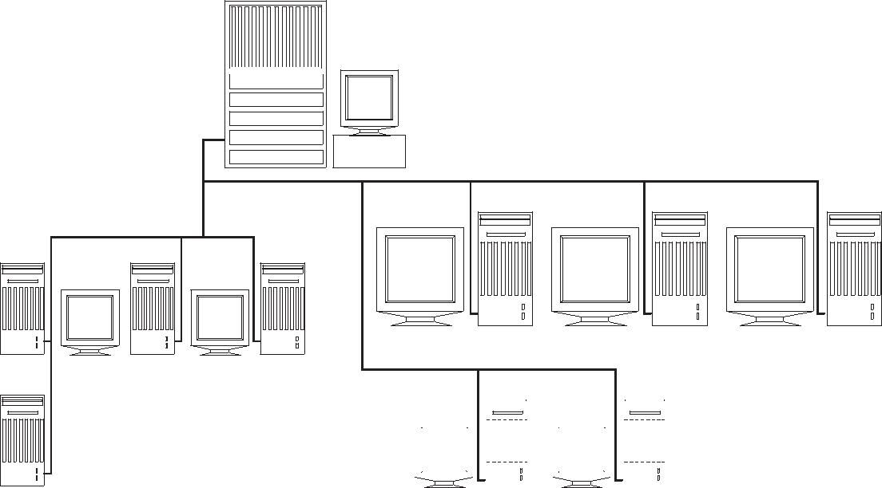

ENTERPRISE

SERVER

DESIGN WORKSTATIONS


PC NODES |  |  |  |  |  |  |  |  |  | PC NODES

Fig. 1.1 A Typical Computer Hardware Configuration

The computer will have a number of mass storage devices built into it. Common types of mass storage devices are floppy discs, hard discs, CD-ROMS and removable

Computer Hardware

storage devices. Another type of mass storage device is the cartridge tape. Softwares are usually stored in the hard disc and they can be loaded into the primary memory as and when required. In a networked environment, the software is stored in the hard disc of the server and the users can access the software from the different terminals or nodes connected to the server. Hard discs are also used for storing data files, drawing files and other related files. A magnetic tape is used to backup the files so that vital files and information are not lost in the event of a disc failure. Optical discs (CD-ROMs) are widely used nowadays for mass storage.

The display of the programs and drawing is done on the monitor. Several types of monitors or video display units (VDU’s) are used as display devices. These include monochrome and color monitors. Super Video Graphics Array (SVGA) is the type of monitor that is widely used on PC’s today. A number of input devices are also used, the most popular being the ubiquitous mouse, used for command input, menu selection or pointing on the screen. The keyboard is indispensable for computer operation and is used for command input. A digitizer tablet is also a convenient input device, often used in design. Special input devices are used in laptop computers. Hard copy outputs are usually taken on a plotter. Printed reports and files and print plot drawings can be obtained using a printer.

CLASSIFICATION OF COMPUTERS

Computers are commonly divided into the following types:

- Personal Computer or Microcomputers

- Mini Computers

- Mainframes

- Supercomputers

Today the distinction between various types is blurring with advances in microprocessor and microelectronics technologies and processing approaches. Processing speed, accessible memory and cost are the factors used to classify computers. Both processing speed and memory depend on word length.

MICRO COMPUTERS AND PERSONAL COMPUTERS

The personal computers are so named because these were originally developed as a single user desk-top system to increase the productivity of employees. Apple Computer Company is the pioneer in popularizing PC’s. IBM introduced their personal computer in the year 1981 and presently IBM or their licensees and Apple Computers (Macintosh series of computers) are the major computer companies who are world leaders in the PC

market. Many dedicated microcomputers and super micros optimized for CAD applications are now sold as Windows NT based graphic workstations. The IBM personal computer and the microcomputers that run on the same software (called

CAD/CAM

compatibles) are very popular with designers. These systems have a powerful CPU, and a fast system clock (a timing signal that co-ordinates the data flow in CPU) of 2.8 GHz or even higher. Most Personal Computers (PC’s) are designed around a single processor chip as CPU which will have either 32 or 64 bit word length. Presently the minimum memory quoted on a low end PC (Pentium 4 at 2.8 GHz) is 512 MB. These PC’s are based on 32 bit 80586 microprocessors.

Most CAD applications require at least one floppy disc (storage capacity of 1.44 MB) drive and a hard disc drive which storage capacity starting from 40 GB and a CD-ROM drive. The relatively fast access speed of hard disc drive is particularly useful in CIM. Personal computers are also often used as front-end systems of many turnkey CIM systems where more powerful computers are used for data intensive activities like finite element analysis. Several computer companies manufacture IBM PC compatible computers in India. Notable among them are HCL, HP, Wipro, Zenith etc.

Table 4.1 gives the specifications of a typical personal computer.

Table 1.1 Specifications of a Typical PC

2.8 GHz or faster CPU

ATX Motherboard with on board LAN or network adapter 512 MB RAM

40 GB or higher 7200 rpm IDE hard disc drive 1.44 MB 3.5” Floppy disc drive

CD- RW 40 X Read, 24X Write, 10 X Rewrite drive 17’’ LCD Monitor or 17’’ CRT Monitor

On- board sound or Creative Live sound card and amplified speakers PS2 Key Board and Mouse

nVidia GeForce video card, on board Intel Extreme Graphics Card

OVERVIEW OF PENTIUM PC

The hardware of a Pentium computer consists of the following:

- Mother board

- Hard disc/floppy disc controller card

- Graphics adapter card

- Input/Output card

- Switch mode power supply

- Floppy disc drive

- Hard disc drive

- CD-ROM drive

Computer Hardware
ISA and PCI slots | AGP slot | Joystick 25 pin parallel port connector
 | Audio Chipset | port | 29 pin serial port connector
 |  |  |  | PS/2 Connector
 |  |  |  | Key board C onnector
 |  |  |  | USB Connector
 |  |  |  | Slot1 Connector
 |  |  |  | Intel1440 BX
 |  |  |  | Chipset
 |  |  |  | DIM M sockets
Flash |  |  |  | ATX power supply
BIOS
 |  |  |  | Lithium back up
 |  |  |  | battery
Adaptec | Ultra wide |  | Ultra DMA | Floppy drive connector
7880 SCSI | SCSI connector |  | EIDE | Floppy drive connector
chipset |  |  | connector
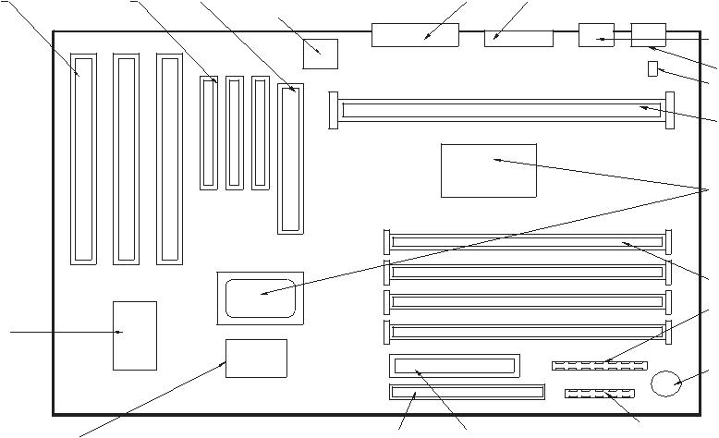
Fig. 1.2 Layout of the Mother Board of a Pentium Computer
A Switch Mode Power Supply (SMPS) provides the main board with power and each of the expansion slots up to 1 Ampere per slot. It can sense any spike in the incoming power line voltage and reduce the current to zero thereby protecting the computer circuitry. This also provides the DC voltages necessary for the operation of the computer.

- Alphanumeric keys: Alphabetic, numeric and symbol keys are arranged in a fashion similar to a typewriter. The shift key is used to shift from capital or lower case or vice versa. “Caps lock” key enable the selection of capital letters when the “Caps lock” condition is on. A separate numeric keypad is provided on the right side.
- Function keys: These are soft keys which can be programmed in the software and special functions can be assigned to each one of these keys. These are marked F1 to F12.
- Cursor control keys: There are four cursor control keys. These keys are useful in editing programs, controlling cursor in graphics applications etc.

- Special keys: These include control, alt, break, number lock, page up, page down, home, insert, tab, delete, print screen etc. Function keys, cursor control

keys and special keys can be used to improve the productivity of software operation considerably.

CAD/CAM

1 | 2 | 3 | 4 | 5 | 6 | 7 | 8 | 9 | 0 | - | =

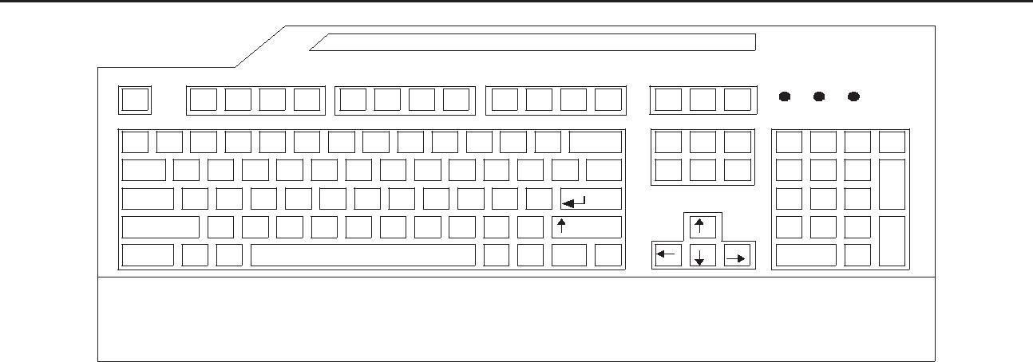

Fig.1 keybord
The operating system of a Pentium PC can be Windows 95, Windows 98, Windows XP or Windows NT. With Windows NT operating system, the personal computer can act as a server for a number of nodes too.

MINI COMPUTERS

Mini computers are 64 bit machines and can access more memory. Most turnkey CAD/ CAM systems are based on standard mini computers and a substantial amount of third party software is available to perform sophisticated design, analysis and related tasks. Mini computers are very popular with design departments because of their capability to support several interactive terminals, permitting widespread access to engineering and design databases. Minis have perhaps also the best price/performance ratio with a lower initial cost compared to mainframe. Most manufacturers of mini computers offer a range of desk top units to super mini’s that rival main frames in speed and memory. This wider range enables firms to progressively use more and more powerful and costly computers using the same software. Mini computers with adequate computing power can be configured as enterprise servers for CIM implementation in small and medium enterprises.

Super minis with a capability of carrying out floating point operations of 500 MFLOPS or more are now being increasingly used in design applications. Another characteristic common to most minicomputers is the virtual memory, a feature which allows execution of large programs in stages which cannot otherwise be handled by the available memory. As a result the computer can run programs requiring storage of considerable data. This facility is essential for data and compute intensive tasks such as finite element analysis (FEA).

MAIN FRAME COMPUTER

Main frames have developed from original computers and are typified by their large size and massive memory. Main frames are used today in applications requiring substantial data processing at high speeds. Main frames typically support several terminals and can drive a large number of peripheral units including printers, disc drives, tape drives etc.

Computer Hardware

Large memory is an essential requirement of main frames as they are frequently used for data intensive operations like design analysis, database management, weather forecasting, traffic and financial operations. Main frames can operate in batch mode or can be used in a time-sharing environment. Main frames are often used to provide processing power after a problem has been set up with a personal computer or mini computer. Main frames are also linked to several smaller computers, which enable the latter to access the large data base of the main frames. This feature is particularly advantageous for design in large design offices where a single data base environment is desirable. The work stations located in the design offices can access the main frame computer of the company for analysis and data, thereby simpler design analysis and drafting are done locally and part of the data intensive design analysis like FEA and solid modeling are carried out at the main frame. For large enterprises, mainframe based computing environment could be a cost effective solution for implementing CIM.

SUPER COMPUTERS

Super computers take advantage of the most recent advancement in electronic circuit design, processing techniques and memory organization to attain computing speeds many times that of main frames. Typically main frames operate at a few megaflops (one megaflop is a million floating point operations per second) whereas supercomputers can have speeds between 20-400 megaflops.

Though these computers are priced very high, because of their high processing speed, the processing cost may be low even in the case of very complex CAD applications which require evaluation of several alternatives or which require several iterations to be carried out. Applications of super computers include modeling and simulation tasks such as solid modeling, kinematical analysis , modal analysis, finite element analysis and computational fluid dynamics. An advantage of supercomputers is the vector processing facility which can drastically increase computing speed. Data pipelining, high speed circuits and large internal memories enable complex design and analysis operations handled conveniently. The performance of a supercomputer can also be achieved by using several processors working in parallel mode.

DATA COMMUNICATIONS

Computers need to communicate with printers, terminals and other computers. This kind of input/output is typically called data communications, since streams of data are transferred between sources and destinations. This flow must be synchronized. This is typically done under the control of “handshaking” conventions that use either dedicated hardware lines or special character sequences. A simple example of handshaking involves a printer capable of printing only 120 characters per second, but receiving data at 10 times that rate. When the printer’s input buffer is full, it sends a busy signal to the data source (by pulling high a line connecting the two), indicating that it cannot accept any more

CAD/CAM

for a while. Later it can accept more data. The “busy” signal here is what is meant by a handshake signal.

Some popular devices for transferring digital data are considered below:

  - Parallel interface

  - Serial RS 232 data link

  - IEEE 488 interface bus (also called General Purpose Interface Bus — GPIB)
  - USB port

  - Modems

  - Computer to computer communications.
PARALLEL INTERFACE

A parallel interface is one that moves information 8 bits or more at a time. Centronics printer interface is a standard parallel interface. This interface allows data to be transferred to a printer, 8 bits at a time. Fig. 4.4 shows the timing diagram of a Centronics parallel interface. When the computer sends a byte of data to the printer it also sends a pulse down the strobe line. When the printer has read the data byte and is ready to accept another, it acknowledges that fact by sending back a pulse on the ACKNLG Line. IBM PC typically uses the BUSY line for handshaking in a polled mode. Polling means that computer hangs in a little loop, testing the line until the desired condition occurs. As soon as the BUSY Line goes low the PC’s ROM BIOS routine pulses the STROBE line low, telling the printer that a new byte is ready.

D ATA |  |  | 0 .5∝S |  |  | 0 .5∝S
S T R O B E |  |  |  |  |  | 0 .5∝S
 |  |  |  |  |  | 0 .5∝S
B U S Y
A C K
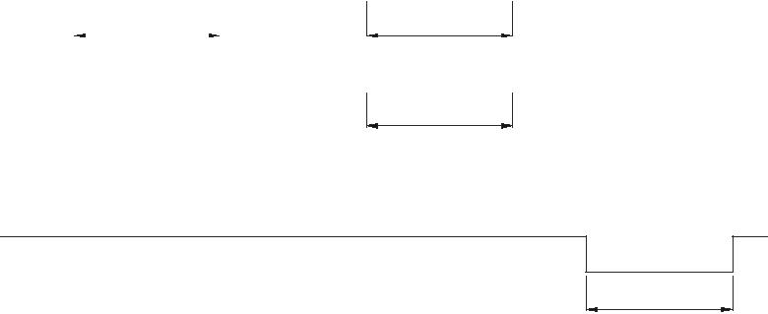
0 .5∝S
Fig. 1.4 Timing Diagram of Centronics Parallel Interface
Figure 4.5 shows a Centronics interface connector, pin-numbers as they appear on the 36-pin D-shell Connector.

Name | Adapter Pin Number
Data Strobe (low) | 1
Data bit 1 (LSB) | 2
Data bit 2 | 3
Data bit 3 | 4

Fig. 1.5 (Contd...)

Computer Hardware
 |  | Name | Adapter Pin Number
 |  | Data bit 4 | 5
 |  | Data bit 5 | 6
 |  | Data bit 6 | 7
 |  | Data bit 7 | 8
 |  | Data bit 8 (LSB) | 9
 |  | Acknowledge | 10
 |  | Busy (High) | 11
 |  | Paper End (High) | 12
 |  | Select (High) | 13
 |  | Supply Ground | 14 | 4
 |  | Oscillator Transmit | 15
 |  | Logical Ground | 16
 |  | Chassis GND | 17
 |  | +5 V DC | 18

Fig. 1.5 Centronics Interface Connector
  - PARALLEL/SERIAL CONVERSION

When extremely high data rates are not required, the number of wires required for data communication can be reduced substantially by converting the bytes to be transmitted into a serial bit stream. This requires only two wires for bi-directional transmission and a ground line. In a serial bit stream the bits are represented by codes having specific time intervals. The standard asynchronous serial formats used in data communications allocate a time interval known as baud period to each bit (Baud is used to honor a Frenchman named Baudot). The bits are transmitted in separate groups, usually 8 bits long, called characters. The name “character” is used because each group of bits represents one letter of the alphabet when text is being sent. In the standard asynchronous format, the time between characters when no data is being transmitted is indicated by a steady high voltage called a mark. The transmitter tells the receiver that a character is about to start by sending a low-bit known as start bit as shown in Fig. 1.6

0 1 2 3 4 5* 6* 7* P* SP

Fig. 1.6 Serial Bit Stream Format

Each character is preceded by a low-level start bit, which synchronizes the receiver and transmitter clocks. The character (5, 6, 7 or 8) bits follow, least significant bit first. The asterisk (*) indicates optional bits. An optional parity bit and one or more stop (high-level) bits terminate the character. Each bit lasts one baud rate period. Serial receivers and transmitters can be instructed to send or receive as few as 5 or as many as 8 bits per character. After the desired number is sent out an optional parity bit may follow. The parity bit P is useful if the data line is suspected to be noisy for accurate transmission. For even parity

CAD/CAM

P=1 if the number of 1’s in the character is odd and P=0, if the number of 1’s is even. At the end of the bits the transmitter inserts one or more high stop bits into the data stream. Because any amount of time can elapse between characters the serial data transmission method is called asynchronous method. The standard baud rates are 110, 150, 300, 600, and 1200. 2400, 4800, 9600 and 19200. Printers and other hard copy devices are usually restricted to low baud rates. Using an 8-bit character with one parity and one stop bit, there is a total of 10 bits. A transmission rate of 300 baud yields 30 characters/sec.

A UART or Universal Asynchronous Receiver Transmitter is a special chip used to simultaneously transmit and receive serial data performing the appropriate parallel/serial conversions and inserting or checking extra bits used to keep serial data synchronized. Bytes sent as 8 bit parallel data to the output data port are converted into a standard format serial bit stream for transmission inside UART. Similarly an incoming serial bit stream is detected by the receiver inside the UART and converted to parallel data.

  - RS-232 INTERFACE

RS-232 is a serial transmission mode which is a voltage level convention. While the current loop signal can be sent over large distances and can be easily implemented using opto-isolators which prevents wiring mistakes from doing any damage, RS-232 may cause hardware damage if improperly connected. The RS-232 is rated for distances only up to 15 m. This is often used for terminal-modem and terminal-computer connections.

RS-232 is a standard set by Electronic Industries Association and represents 1’s by -3 to -20 V and 0’s +3 to 20 V. The standard connector is the 25 DB connector. Two IC’s are normally used to handle the TTL level signals to RC-232 and vice versa. They, respectively, are 1488 and 1489. Fig. 1.7 shows pin numbers for most commonly used RS-232 lines.

RS-232 Definition | I/O | Data Terminal | Data Communication
 |  | Equipment (DTE) | Equipment (DCE)
Signal Ground |  | 1 | 1
Transmit Data | 0 | 2 | 3
Receive Data | 1 | 3 | 2
Request to send (RTS) | 0 | 4 | 5
Clear to send (CTS) | 1 | 5 | 4
Data set ready (DSR) | 1 | 6 | 20
Chassis Ground |  | 7 | 7
Carrier Detect |  | 8 | 8
Data terminal ready | 0 | 20 | 6

Fig. 1.7 Pin Numbers For RS 232 Lines

Computer Hardware
UNIVERSAL SERIAL BUS

Universal Serial Bus (USB), the most successful interconnecting port in computer history so far is a connectivity specification developed by Intel and other technology leaders. It operates at a speed of 480 Mbps and is used in millions of PCs and mobile devices. USB is now a standard feature in all PCs. Using USB port one can plug standard peripherals as well as devices like portable computing devices, cell phones, digital cameras and MP3 players to PCs. High speed wireless USBs also have a bandwidth of 480 Mbps.
MODEMS

It is often necessary to communicate between workstations at different locations separated by a considerable distance. In such cases an interface element called modem can be used at each end of a data transmission channel. A modem is a modulation — demodulation device that converts the discrete stream of digital pulses to variable analog wave patterns which can be transmitted over telephone lines and at the digital data from the transmitted signal (demodulation). Figure 4.8 shows a typical arrangement. Telephone lines can also be used to transmit the analog signals between modems. The usage can be an external modem or a plug-in modem card.
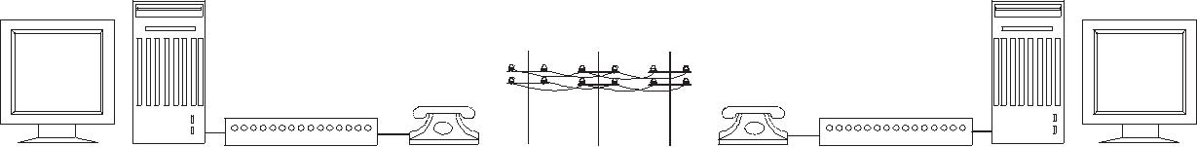

COMPUTER MODEM PHONE TELECOM PHONE MODEM COMPUTER
LINE
Fig. 1.8 Modem Connection
COMPUTER TO COMPUTER COMMUNICATIONS

A design office can make use of a number of different computer systems and peripherals. The networking of this computers enables the sharing of peripherals, application software and databases. Across the network the users can also communicate or transfer data or files. The networking if restricted to short distances, say a department or a building, is called a Local Area Network (LAN). A LAN is a system made from the following building blocks that can be added or configured as needed:

Network server Network interface card Storage disc Connecting Cable Workstations
LAN’s use special systems to manage the shared resources on the network. These systems are called servers. A server is a combination of hardware and software. A hardware can be a personal computer like a Pentium or a more powerful RISC based workstation or
CAD/CAM

a minicomputer. The central mass storage disc contains the files and programs that are shared by the designers. Typically a LAN server may require at least 20 to 200 GB of storage space. In order to communicate to a computer, an interface card with the components necessary for sending and receiving messages has to be plugged into the computer. This printed circuit board is called the network interface card or network adapter. The computers to be connected in a LAN may include personal computers of different families, workstations and minicomputers. Each device in the network is attached to a transmission cable so that messages can be sent from one device to another. LANs are run on cables varying from low-cost twisted pair telephone wire to single or multi-channel co-axial cable or expensive high performance fibre optics cable.

(a) B U S (b) S TA R (c) R IN G
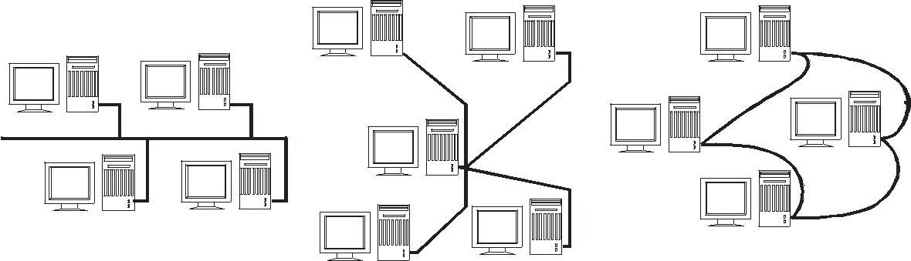

Fig. 1.9 LAN Topologies
There are different topologies used for networking. The important topologies are described briefly below:

- Bus topology

The bus topology is a simple design with a single length of cable known as bus. All devices on the LAN are attached to the bus and share this single communications medium (Fig. 4.9 a).

- Star topology

In star topology the computers are arranged on the form of a star, with each device connected to the network server with a separate cable. Though the cable length is more the system has a higher reliability (Fig. 4.9 b).

- Ring network

Figure 4.9 c shows the ring network. Here the networking is carried out such that the messages pass through the intermediate computers between the sending and receiving computer.

- Hybrid schemes

Many practical LAN schemes combine some of the above topologies for best performance. Network technologies are discussed in detail in a later chapter.

Computer Hardware

A typical workstation will have the following networking features as options:

- Ethernet networking connector

- Asynchronous and synchronous communication ports

- Transmission control protocol/Internet protocol (TCP/IP) or XNS

- ISO/OSI, SNA, DEC net, Netware.

v. Wireless LAN (WLAN)
Wireless LAN extends the reach of existing wired networks through high frequency
radio waves to the entire organization. This is also known as Wi-Fi. IEEE 802.11
is the set of standards for Wireless Local Area Networks. Each computer, mobile,
portable or fixed is referred to as a station in 802.11. Portable stations can be used
only at fixed points. Mobile stations can access the LAN even while moving. When
two or more stations come together to communicate with each other, they constitute
a basic service set (BSS). A BSS that stands alone (not connected to a base) is called
an Independent Basic Service Set (IBSS). It is also referred to as an Ad-Hoc network.
In an ad-hoc network stations are connected only peer to peer. Two or more BSS’s
are interconnected using a Distribution System (DS). Entry into DS is accomplished
using an Access Point (AP). Large and complex networks could be created using
several BSS’s and DS’s.
DESIGN WORK STATIONS
Engineering workstations are computer systems with adequate computing power, based
on 32 or 64 bit microprocessors. Workstations are typically divided into two broad
categories: Low-end and high-end.
Low-end work stations generally consist of personal computers. Appropriate software
and special hardware like graphics accelerator cards are added to these for boosting the
performance. Personal computers have the additional advantage of being able to run a
substantial amount of software such as programs for analysis, database management, etc.
The processing capability of personal computers is generally enhanced by the addition of
a co-processor in the microprocessor circuit which increases the processing speed by two
or three times. Special custom-built graphics boards increase resolution and decrease
High-end workstations are designed around one or more powerful RISC processors.
Examples of such processors are PA-RISC, MIPS, and SPARC etc. Hardware
generally consists of high resolution graphics display of 1024 X 1024 pixels, or more, a
processor capable of 2 to 4 MIPS or more and 512 MB to 8GB core memory and mass
storage in the range of 36-146 GB (Giga Byte), with optional magnetic tape back up. These

CAD/CAM

Computers used for high end workstations are optimized for engineering analysis and graphics work. Many of them use custom-built processors often incorporating hardware features to boost the speed of processing. However the systems using standard processors have the advantage of several software packages with practically little customization.

Workstations consist of three basic components:

A primary processor

Associated memory

Graphics display system and software

Leading workstations like SUN, IBM, Silicon Graphics, Hewlett-Packard etc., use special architecture based on RISC (Reduced Instruction Set Computing) chips and specialized graphic boards. The graphic features like display manipulation are realized in hardware for fast response. Workstations typically place emphasis on graphics display and manipulation. The features of a display system are directly related to the processing power of the display driver. Functions such as color fill; entity generation and transformation of displays are controlled by the display processor and associated hardware.

Networking ability is a standard feature often incorporated in Workstations. Workstation can be used in a variety of ways. First, they can act as dedicated stand alone processors for certain design or analysis tasks. They can also be networked with each workstations is as front end processors for large host computers. An important feature of a workstation is that they operate in a windows environment using graphic user interfaces like X-Windows or OSF/MOTIF which enables effective implementation of CAE and concurrent engineering approaches.
  - ARCHITECTURE OF A TYPICAL GRAPHICS WORKSTATION

Figure 1.10 shows a system level block diagram of a typical high end CAD workstation. A color (RGB) monitors with 19” screen size and resolution of 1280 x1024 pixels is the standard. Some workstations will have monitors with resolution of 1920 x 1200 pixels. Workstations enable the display of the drawings in several colors.

 |  |  |  |  |  |  |  |  |  | VIDEO OUTPUT
 |  |  |  |  |  |  |  |  |  |  | ETHERNET
 |  |  |  |  |  |  |  |  |  |  | SERIAL PORT
 |  | RGB |  |  |  | CPU |  |  |  |  | Parallel Port
MONITOR |  |  |  |  |  | BOARD
 |  |  |  |  |  |  |  |  |  |  | AUDIO
 |  |  |  |  |  |  |  |  |  |  | SCSI
 |  |  |  |  |  | GRAPHICS
 |  |  |  |  |  | BOARD
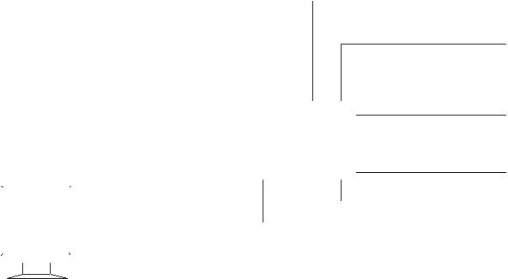

Fig. 1.10 System Level Block Diagram of a Graphics Workstation

Computer Hardware

Selectable palette of 256 colors out of 17.6 million colors is normally available. The hardware include a CPU board with a RISC (Reduced Instruction Set Computing) microprocessor with Cache Memory and 512 MB RAM. Many CAD/CAM applications require at least 24 GB or more of disc capacity. Disc capacity can go up to 140 Gbytes in a sophisticated graphics workstation. The communication facilities include two or more serial ports, one or more parallel ports, and TCP/IP Ethernet controller or other facilities for networking. A graphic workstation has also to fit into other networking environments like NFS (Networking File System), IBM Emulation, Hypernet etc.

The distinguishing feature of a graphics workstation is the graphics board which does the display generation and manipulation. The graphics subsystem is discussed in detail in the following sections.

GRAPHICS SYSTEM

Graphics system consists of four subsystems:

- Geometry engine subsystem

- Scan conversion subsystem

- Raster subsystem

- Display subsystem

These subsystems are shown in Figure 1.11 schematically.
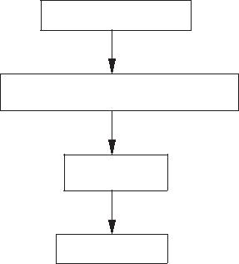
GEOMETRY

SCAN CONVERSION

RASTER

DISPLAY

Fig. 1.11 Subsystems of a Graphics Engine

GEOMETRY ENGINE

The geometry engine accepts 3-D world co-ordinate data and converts them into X, Y screen co-ordinates. Depth information is manipulated using Z-buffer. Colors are also processed. The geometry pipeline facilitates among other functions lighting, clipping, and 3D to 2D projection, viewing transformations, rotation, scaling and translation.

SCAN CONVERSION

The scan conversion subsystem carries out polygon decomposition, edge slope calculations, span slope calculations and span interpolation. The output of the scan conversion is the pixel information to the raster subsystem.

CAD/CAM

RASTER SUBSYSTEM

The raster subsystem will have usually 24 bit planes. This will provide eight bit planes for each primary color (RGB) so that (28) shades of a single color can thus obtain.

Since the different colors are obtained by the three primary colors a total of (28)3colors are available on the screen.

In a typical raster engine five 256K X 4D RAM provide 4 bits of Z-depth. The raster information is stored in the frame buffer. Twenty 64 K X 4 video RAM provide 4 bits for each pixel of 1280 X 1024 resolution. Entry level systems will have 12 bit planes and high end systems will have 32 bit planes for the frame buffer. These provide the color and depth for the images.
DISPLAY SUBSYSTEM

The display subsystem has multi-mode graphics processors which manage the display, send the Red, Green, Blue color (RGB) data to the respective digital to analog converters as well as provide a video output.

CAPABILITIES FOR MODELING IN A TYPICAL GRAPHICS WORKSTATION ENVIRONMENT

The following modeling capabilities are desired in a workstation:

- 2D and 3D modeling and drafting facilities

- Display of text

- Animation

- Color selection (usually a palette of 256 colors)

- 3D viewing

- Z-buffering

- Gouraud shading

- Depth cueing

- Lighting models

- Anti-aliasing

- Texture mapping

The RISC based workstations function with UNIX operating system in a Windows environment. A graphics workstation will also provide a graphics library like OPEN GL which provides easy to use and flexible high level graphics subroutines with broad functionalities in a high level language like C or an object orient language like C++ or graphic modules like ACIS and Parasolid. These can be used for creation of graphic models including real time interactive solid models. The user can create a customized graphic software with the aid of such a graphics library.

Computer Hardware

  - SPECIFICATIONS OF TYPICAL GRAPHICAL WORKSTATION

Brief specifications of a few typical workstations are given below:
Technical Specifications of a HP Workstation

System Processing Unit
Central processor | : | PA-8800 or PA 8900 dual core
Clock frequency | : | 900 MHz
Number of processors | : | 1 to 4

The above data are given for general information. As technology advances, the specifications will be continuously ramped up. The readers are advised to refer to the catalogues of manufacturers to obtain current information on the hardware, performance specifications etc.

  - INTERACTIVE DISPLAY DEVICES

INTERACTIVE GRAPHIC TERMINALS

Interactive graphics is an important component of CAD providing a window through which the communication with the computer can be realized. Such systems which enable communication between the human operators and the computer are called “user-friendly” or simply friendly computers. In an interactive graphics session, the user constructs a geometric model by specifying points, lines, arcs and circles on the screen. When each command is issued, the software will request additional data often supplying some of the information needed. There is always a “HELP” feature which the designer can consult if he is in doubt. Technically the model is the mathematical representation of the diagram in the computer data base. The operator uses the display screen almost in the same manner as a drawing board to create various projections or views of the object. But unlike manual drafting, CAD incorporates several features to speed up drafting and increase drafting productivity. The display devices be can classified into two groups:

- Display devices based on CRT principle

- Flat screens

Most interactive CAD systems use CRT based graphic monitors. CRT is a glass enclosed tube in which a finely focused electron beam is deflected to a phosphor coated screen. The screen then glows to produce a visible trace when excited by impinging electrons. The principle of operation of a monitor is given below.

DISPLAY DEVICES BASED ON CRT

The position of the visible trace on the CRT screen is controlled by a focusing system

and a set of horizontal and vertical deflection plates as shown in Fig. 1.12.

CAD/CAM

In a color CRT, there are three electron guns, one each for red, green and blue. The phosphor dots for red, green and blue are arranged in a triangular pattern. The individual beams intersect at a shadow mask which directs a red beam to a red phosphor dot and so on.

 | GLASS TUBE
FOCUSING | ANODE
SYSTEM
CATHODE
 | PHOSPHOR
 | COATING
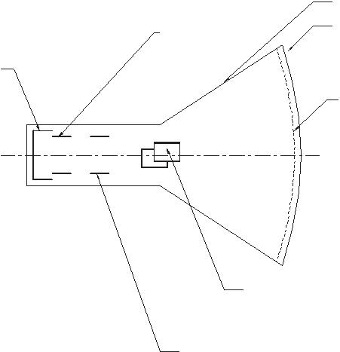

VERTICAL

DEFLECTION

PLATES

HORIZONTAL

DEFLECTION

PLATES

Fig. 1.12 Principle of a CRT
RASTER SCAN TECHNIQUE

The screen of a monitor can be considered to consist of a large number of minute subdivisions called picture elements (pixels, in short). For example, in a typical SVGA monitor, the screen is divided horizontally into 1024 units and vertically into 768 units. The resolution of this monitor is then 1024 x 768.

A raster CRT graphics device can be considered a matrix of discrete cells each of which can be made bright. Thus it is basically a point plotting device. If a line is to be drawn, it can be approximated by a series of dots close to the path of the line. Figure 1.13 illustrates this concept.
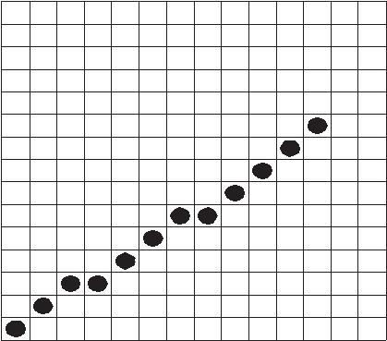

ig. 4.13 Line Drawing

Computer Hardware

Let us assume that a line AB is to be drawn. On a raster scan monitor, the adjacent pixels closer to the path of the line are addressed and the resulting “line” appears to have a staircase like look or is said to be jagged. However, the resolution is is more, then the line appears smooth. Vertical or horizontal lines appear smooth, irrespective of the resolution.
A frame buffer is a common method of implementing a raster CRT graphics device. It can be considered to be a large contiguous piece of computer memory. In the simplest can, there can be one memory bit for each pixel in the raster. This amount of memory is called a bit plane. A 320 X 200 raster requires 64 K memory bits in a single plane. The picture is built in the frame buffer one bit at a time. The memory bits can be either in 0 or 1 state. If a particular pixel is to be addressed, the corresponding bit in the frame buffer is changed from 0 to 1. Since the raster CRT is an analog device, it requires an electrical voltage and the digital data of the frame buffer has to be converted to an analog voltage through a digital to analog converter (DAC). This is schematically shown in Fig. 1.14.
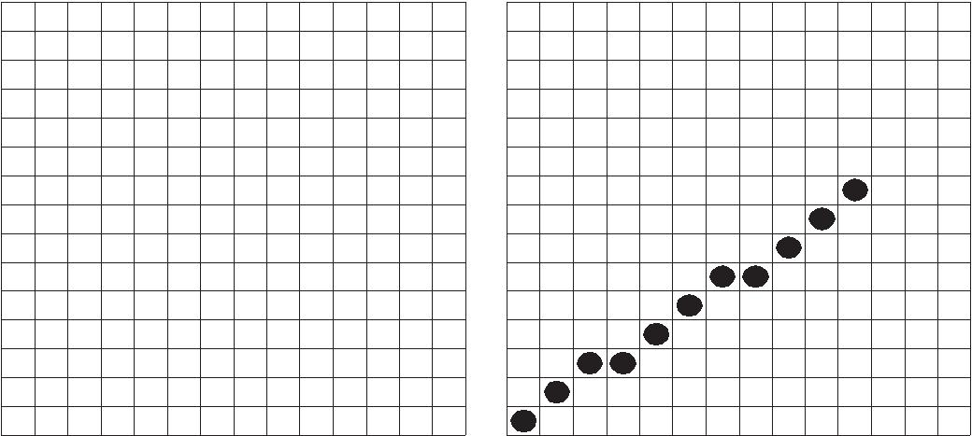
0 | 0 | 0 | 0 | 0 | 0 | 0 | 0 | 0 | 0 | 0 | 0 | 0 | 0
0 | 0 | 0 | 0 | 0 | 0 | 0 | 0 | 0 | 0 | 0 | 0 | 0 | 0
0 | 0 | 0 | 0 | 0 | 0 | 0 | 0 | 0 | 0 | 0 | 0 | 0 | 0
0 | 0 | 0 | 0 | 0 | 0 | 0 | 0 | 0 | 0 | 0 | 0 | 0 | 0
0 | 0 | 0 | 0 | 0 | 0 | 0 | 0 | 0 | 0 | 0 | 0 | 0 | 0
0 | 0 | 0 | 0 | 0 | 0 | 0 | 0 | 0 | 0 | 0 | 0 | 0 | 0
0 | 0 | 0 | 0 | 0 | 0 | 0 | 0 | 0 | 0 | 1 | 0 | 0 | 0
0 | 0 | 0 | 0 | 0 | 0 | 0 | 0 | 0 | 1 | 0 | 0 | 0 | 0
0 | 0 | 0 | 0 | 0 | 0 | 0 | 0 | 1 | 0 | 0 | 0 | 0 | 0
0 | 0 | 0 | 0 | 0 | 0 | 1 | 1 | 0 | 0 | 0 | 0 | 0 | 0
0 | 0 | 0 | 0 | 0 | 1 | 0 | 0 | 0 | 0 | 0 | 0 | 0 | 0
0 | 0 | 0 | 0 | 1 | 0 | 0 | 0 | 0 | 0 | 0 | 0 | 0 | 0
0 | 0 | 1 | 1 | 0 | 0 | 0 | 0 | 0 | 0 | 0 | 0 | 0 | 0
0 | 1 | 0 | 0 | 0 | 0 | 0 | 0 | 0 | 0 | 0 | 0 | 0 | 0
1 | 0 | 0 | 0 | 0 | 0 | 0 | 0 | 0 | 0 | 0 | 0 | 0 | 0

Fig. 1.14 Frame Buffer

A single bit plane yields a black and white display. Color or different grey levels can be achieved by using additional bit planes. Fig. 1.15 shows 4 bit plane frame buffer. The intensity of each pixel in the CRT is decided by the combination of the pixel values. (1111 in the picture shown). Since there are four bit planes, there can be 2⁴ (=16) combinations. The resulting binary number is interpreted as an intensity level between 0 and 2⁴ – 1 (=15). This is converted into a voltage between 0 (dark) and 15 (full intensity), by the digital to analog converter.

Thus this arrangement can represent 16 grey levels or color shades.

The color graphics monitors are usually referred to as RGB monitors since the different colors are obtained by mixing three primary colors, Red I, Green (G), and Blue (B). A simple color frame buffer can be implemented with three bit planes, one for each primary color.

 |  |  |  |  |  |  |  |  |  |  |  |  |  |  |  |  |  |  |  |  | CAD/CAM/CIM
 |  |  | 3 | 0 | 0 | 0 | 0 | 0 | 0 | 0 | 0 | 0 | 0 | 0 | 0 | 0 | 0 |  |  | P O IN T P L O T T E D
 |  | 2 0
 | 1 |  |  | 0 | 0 | 0 | 0 | 0 | 0 | 0 | 0 | 0 | 0 | 0 | 0 | 0 | 0
0 | 1 | 0 | 0 | 0 | 0 | 0 | 0 | 0 | 0 | 0 | 0 | 0 | 0 | 0 | 0 | 0 | 0
0 | 0 | 0 | 0 | 0 | 0 | 0 | 0 | 0 | 0 | 0 | 0 | 0 | 0 | 0 | 0 | 0 | 0
 | 0 | 0 | 0 | 0 | 0 | 0 | 0 | 0 | 0 | 0 | 0 | 0 | 0 | 0 | 0 | 1 ⁰
 | 0 | 0 | 0 | 0 | 0 | 0 | 0 | 0 | 0 | 0 | 0 | 0 | 0 | 0 | 1 | 0 | 0
 | 0 | 0 | 0 | 0 | 0 | 0 | 0 | 0 | 0 | 0 | 0 | 0 | 0 | 1 | 0 | 0 | 0 |  |  | D IG IT A L
 | 0 | 0 | 0 | 0 | 0 | 0 | 0 | 0 | 0 | 0 | 0 | 0 | 1 ⁰ |  | 0 | 0 | 0 |  |  | D IG IT A L
 | 0 | 0 | 0 | 0 | 0 | 0 | 0 | 0 | 0 | 0 | 0 | 0 | 0 | 0 | 0 | 0 | 0 |  |  | T O
 | 0 | 0 | 0 | 0 | 0 | 0 | 0 | 0 | 0 | 0 | 0 | 0 | 0 | 0 | 0 | 0 | 0 |  |  | T O
 |  |  |  |  |  |  |  |  |  |  |  |  |  |  |  |  |  |  |  | A N A L O G
 | 0 | 0 | 0 | 0 | 0 | 0 | 0 | 0 | 0 | 0 | 0 | 0 | 0 | 0 | 0 | 0 | 0 |  |  | A N A L O G
 | 0 | 0 | 0 | 0 | 0 | 0 | 0 | 0 | 0 | 0 | 0 | 0 | 0 | 0 | 0 | 0 | 0 |  |  | C O N V E R T E R
 | 0 | 0 | 0 | 0 | 0 | 0 | 0 | 0 | 0 | 0 | 0 | 0 | 0 | 0 | 0 | 0 | 0 |  |  | C O N V E R T E R
 | 0 | 0 | 0 | 0 | 0 | 0 | 0 | 0 | 0 | 0 | 0 | 0 | 0 | 0 | 0 | 0 | 0
 | 0 | 0 | 0 | 0 | 0 | 0 | 0 | 0 | 0 | 0 | 0 | 0 | 0 | 0 | 0 | 0 | 0
 | 0 | 0 | 0 | 0 | 0 | 0 | 0 | 0 | 0 | 0 | 0 | 0 | 0 | 0 | 0 | 0
 | 0 | 0 | 0 | 0 | 0 | 0 | 0 | 0 | 0 | 0 | 0 | 0 | 0 | 0 | 0
 | 0 | 0 | 0 | 0 | 0 | 0 | 0 | 0 | 0 | 0 | 0 | 0 | 0 | 0
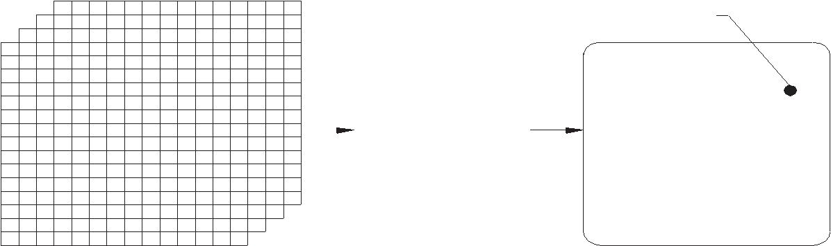
S C R E E N
4 — B IT P L A N E
F R A M E B U F F E R

Fig. 1.15 4-bit Plane Frame Buffer

Each bit plane drives as individual color given for each of the three primary colors. This arrangement can lead to eight colors as given in the Table 1.3.

Table 1.3 Color Table

Black | 0 | 0 | 0
Red | 1 | 0 | 0
Green | 0 | 1 | 0
Blue | 0 | 0 | 1
Yellow | 1 | 1 | 0
Cyan | 0 | 1 | 1
Magenta | 1 | 0 | 1
White | 1 | 1 | 1

Additional bit planes can be used for each of the three color guns. In a 24 bit plane buffer 8 bit planes are used for each color. Each group drives a 8 bit Digital to Analog Converter (DAC) and can generate 2⁸ = 256 intensities of red, green and blue. This when combined together can result in (2⁸)³ = 16, 777, 216 or 16.7 million possible colors.

FLAT SCREENS

CRT has the disadvantage that it is extremely bulky. Moreover, CRT consumes considerable power with increased heat dissipation requirements. Portability is reduced because of the size and the material of CRT. These disadvantages have prompted the manufacturers try different types of flat screens as output devices for computers. Flat screens are necessary for laptop, notebook and palm top computers. Flat screens operate on the principle of liquid crystal display.

Computer Hardware

  - INPUT DEVICES

For interactive graphic tasks more often several input devices are used. These allow entering data in an easily interpretable graphic form. The task is usually accomplished by controlling the position of a set of cursor cross hairs on the screen. Some devices like light pen are touched on the screen for more direct interaction. Some of the input devices which are employed for graphic applications are described in the following sections.

KEYBOARD

The keyboard interacts with the computer on a hardware and software level. The keyboard contains a keyboard controller (like 8042 or 8048) to check if any key is pressed or released. If any key remains closed for more than half a second the controller sends a repeat action at specific intervals. It has limited diagnostic and error checking capabilities. A buffer is normally available to store a certain number of key actions if the computer is busy.

TOUCH SCREENS

Touch screens are direct devices. They are used by simply touching CRT display with one’s finger or a pointing device. Two types of touch screens (mechanical and optical) are used in CAD applications.

Mechanical type is a transparent screen overlay which detects the location of the touch. Optical touch screen systems use rows of light emitters and receptors mounted just in front of the screen with the touched location determined by broken beams.

Mechanical systems have a resolution of 0.25 mm in position detection. These devices are more popular as cursor control systems. Optical systems are of low resolution and are mainly used for menu selection.

JOYSTICKS

Joystick is a potentiometric device that contains sets of variable resistors which feed signals that indicates the device position to the computer. These devices rely on the operator’s sense of touch and hand-eye co-ordination to control the position of the cursor on the screen. (Fig. 1.16)
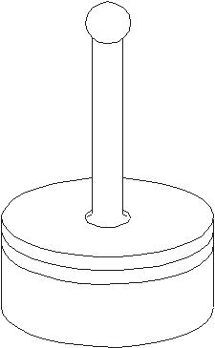

Fig. 1.16 Joy Stick

CAD/CAM

Joystick devices are normally set so that side-to-side movement produces change in X Co-ordinates and front to back movements produce change in Y Co-ordinates. Thus they are best suited for pointing in tasks such as menu selection or creating simple schematics. Many users prefer joysticks because they allow rapid cursor movement for relatively small device movements, enabling graphic operations to be performed quickly. Three dimensional capability is possible by moving the handle up and down or by twisting it to provide data entry in the Z-axis.

TRACK BALLS

Track ball has a ball and socket construction but the ball must be rolled with fingers or the palm of the hand. The cursor moves in the direction of the roll at a rate corresponding to rotational speed. The user must rely heavily on the tactile sense when using a trackball since there is no correspondence between the position of the cursor and the ball. The ball momentum provides a tactile feed back. Trackballs are effective for tracking, following or pointing at moving elements. Track discs also perform a similar function.

MOUSE

Mouse is today one of the widely used input devices in graphics applications. Mouse is a small hand held puck like instrument which is attached to the computer (Fig. 1.17). Mouse can be moved around by the operator on any flat surface to provide graphic input. Its ability to rapidly position the cursor on the screen is its most important advantage. Mouse is available as a mechanical or optical graphic input device. In the case of a mechanical mouse, the rolling ball at the bottoms of the mouse causes two encoders to rotate. The movement of the mouse is thus converted into pulses which move the cursor in the X and Y direction in proportion to the movement of the mouse. Mouse can be operated in a limited space. Since the mouse can be used without looking at it, the user can concentrate on the screen and hence design productivity can be considerably increased.
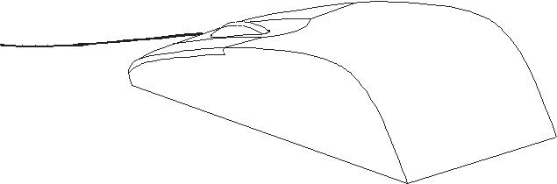

Fig. 1.17 Mouse

An optical mouse works on the basis of signal generated by the reflecting light from a special metallic plate or which the mouse is moved. The source of light is an LED located underneath the mouse. There are no moving parts in an optical mouse and that is an advantage over the mechanical mouse. Slippage at the contacting surfaces is a disadvantage of mouse

Computer Hardware

DIGITIZER

Digitizer boards or tablets are electro-mechanical vector graphic input devices that resemble a drafting board. These are used together with a movable stylus or reticule called a cursor or a puck. They are used to enter drawings into computer graphics systems by taping the drawing to the surface of the digitizing board and placing the cursor over points whose co-ordinates are to be entered. Figure 1.18 shows a digitizer.

S T Y L U S
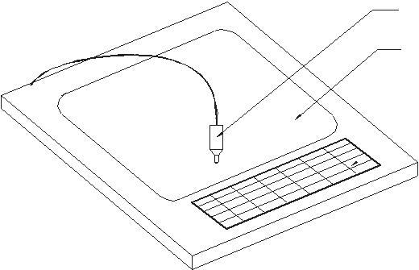
T A B L E T

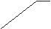M E N U

Fig. 1.18 Digitizer
A digitizer consists of three basic elements: a locator in the form of a pen or stylus or puck or cursor, a tablet and a software package. A digitizer can be used to copy existing drawings and send the geometric data directly to the computer. But more frequently digitizers are used to create a drawing using an interactive drafting package to enter a sketch or a drawing which can then be redrawn or edited as the display appears on the CRT screen. The operation of a digitizer is similar to that of a mouse. The user moves the stylus or puck across the flat surface of the tablet. The surface of the tablet is magnetized and is embedded with wires in X and Y directions. The tablet surface can be configured to represent the screen. The physical motion of the stylus is converted by the wires into digital location signals received by the locator. The coded electrical or acoustic signal is then routed to the computer and displayed on the graphic terminal.

Digitizers are available in various sizes up to 1250 X 1600 mm. Of the two commonly used locators, the puck cursor is generally more accurate. Its cursor has a sighting device, usually a lens with cross hairs and integral push button pads for entering commands, defining points and making other digitizing operations. In many of these systems, the work surfaces on which drawing data are entered also contain the function menu.

Data can be picked up by the cursor in two general modes. In the point mode, the user locates specific points with the cursor and presses the appropriate function buttons to enter the data. A typical operation will be to enter the end points of a straight line. In the stream mode, a continuous flow of data points is sent to the processor with the data rate determining digitizer’s resolution. This method is used for entering curves and shapes of irregular nature.

CAD/CAM

Some type of digitizers can pick 3-dimensional information from a model, moving the tip of a wand along the model. These systems generate signals that are analyzed to produce co-ordinates. This type of digitizer is very useful for reverse engineering. In the case of sonic digitizers a spark gap in the stylus tip creates a sound pulse that is detected by two strip microphones one for X and one for Y axis. The location of the source of sound is indicated by the time it takes for the sound to reach the microphones. The sonic digitizer does not require a tablet.

The major sub-groups of standard digitizers are free cursor digitizers, constrained cursor digitizers and motorized cursor digitizers.
THUMB WHEEL

Thumb wheels are potentiometric devices. Two of them are provided for X and Y movements of cursor. These also have the advantage that one can look at the screen and move the cursor.
AUTOMATED ENTRY

One of the major needs of design offices switching over to CAD is the necessity to convert existing paper drawings to computer files. Many automated devices are now available for entering drawings into CAD database. These units can scan a drawing and convert them into a form useful for CAD with little manual intervention. A typical automated drawing entry device contains a scanner and a workstation for viewing and editing the drawing. Software is required for rasterizing and vectorizing the scanned drawings.

Most systems begin the data entry process by scanning a document to create a raster image. A scanning rate of 13 dots/mm is adequate for most engineering applications. The pixel data may be stored or manipulated by converting it into vectors with the aid of sophisticated software. At the work station vectors are organized into graphic primitives such as line, arcs, circles, etc. symbols and text may also be recognized by the system and are converted into a single piece of data. Many systems can even recognize handwritten lettering.

Recently artificial intelligence techniques similar to those employed in robot vision technology have been used for automatic entry of drawing into the computer. Texts are usually entered in separate layers to enable easy revision.

OUTPUT DEVICES

A CAD system is not complete unless it can make hard copies of designs or analysis created on the computer. Determining the best output device for a typical CIM application is a three-step process: specifying how hard copies will be used, identifying quality and cost criteria and selecting equipment most suitable for the application.

Hard copies are used for a variety of purposes, including shop use, file storage, reports and presentations. Design iterations can be reduced by making hard copies at crucial stages and distributing them to key personnel for review. Documents and drawings are required

Computer Hardware

for archival purposes, to be used in proposals, reports, as well as illustrations. Quality of the hard copy depends on the resolution of the hard copy unit. Speed and frequency of operation of hard copy equipment are also of importance.
PLOTTERS

Plotters are classified based several factors. Depending on the maximum size of the drawing plotters are designated as A0, A1, A2, A3 and A4. There are plotters capable of creating drawings larger than A0 size. Generally plotters plot drawings on cut sheets. Some special plotters are capable of creating drawings on rolls also. Drawings are created through a series of short vectors which requires movement to the pen in X and Y direction. Plotters can be classified on the basis of their construction. A flat bed plotter has the pen moving on a flat surface on which the drawing paper is fixed. The linear movements in the X and Y direction generate the required drawing. In the case of a drum plotter, the paper is wound around on a cylindrical drum. The pen holder is attached to a moving slide.
The co-ordinated motion generated by the rotation of the drum and linear movement draws the pictures on the paper. In the third type, i.e. the pinch roller plotter, the paper is tightly held between two sets of rollers. One roller in each pair has a rough surface and the linear motion to the paper in one direction is imparted by the rotation of the roller. The movement in the other direction is through a linear motion imparted to the pen holder.

Plotters can also classify as pen plotters and electrostatic plotters. Pen plotters use 1, 4, 8 or more different color pens. The drawings thus can be made in several colors. Pencil plotters are also available. Electrostatic plotters are faster but there is no color variety. They are also cheaper.
Plotters have high resolution which is specified by dots/mm. The pen speed and pen pressure are programmable. Various line thicknesses can be obtained by using pens of different tip sizes. Generally fibre tip pens are used.

Pen plotters are slow and shading is difficult. Pen plotters also require more maintenance and the ink or fibre tip or ball point pens should be changed frequently to keep line quality high.

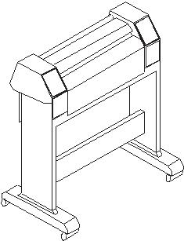
Inkjet plotters are the ones that are now commonly used. These are available in color or monochrome versions. These are fast, reliable and more accurate than pen plotters. Figure 1.19 shows a plotter.

Fig. 1.19 Plotter

CAD/CAM

PRINTERS

Several types of printers are available:

- Impact printers: They use small hammers or print heads containing small pins to strike a ribbon to form dot matrix images. Colors are introduced through the use of multiple ribbons or single ribbons with different color bands. Color intensity is fixed and creating shades is almost impossible. Because of the low resolution, copy quality is poor. Impact printers are suitable for high speed, low cost, high volume hard copies.

- Inkjet printer: Inkjet printers produce images by propelling fine droplets of ink on to the medium to be printed. Droplets can be generated in continuous streams or pulses. Some of the droplets get charged and are returned to the reservoir, while uncharged droplets attach to the printing surface to form graphics. The laser jet printers are capable of giving good quality color prints with shading at reasonable cost.

- Laser printer: Laser printer is one of the most widely used output devices. This type combines high speed with high resolution and the quality of output is very fine.

DETAIL EXPLANTION SOME TOPICS

What is CAD?
CAD if often defined in a variety of ways and includes a large range of activities. Very broadly it can be said to be the integration of computer science (or software) techniques in engineering design. At one end when we talk of modeling, iIt encompasses the following:
- Use of computers (hardware & software) for designing products
- Numerical method, optimizations etc.
- 2D/3D drafting
- 3D modeling for visualization
- Modeling curves, surfaces, solids, mechanism, assemblies, etc.
The models thus developed are first visualized on display monitors using avariety of techniques including wire frame displa, shaded image display, hidden surface removed display and so on. Once the designer is satisfied, these models are then used for various types of analysis / applications. Thus, at the other end it includes a number of analysis activities. These could be:
- Stress (or deflection) analysis, i.e. numerical methods meant for estimating the chedule of an artifact with respect to these parameters. It includes tools like the Finite Element Method (FEM).
- Simulation of actual use
- Optimization
- Other applications like
  - CAD/CAM integration
  - Process planning
These are activities which normally use models developed using one or more of the techniques mentioned above. These activities are often included in other umbrellas like CAM or CAE. A term often used is Cax to include this broad set of activities. They all use CAD models and often the kind of application they have to be used ina determines the kind of amodel to be developed. Hence, in this course I cover them under the umbrella of CAD. In this course we will strive to give an overview of chedule techniques followed by some applications, specifically CAM.
Thus there are three aspects to CAD.
- Modeling
- Display/ Visualization
- Applications

MODELING
Modelling typically includes a set of activities like
- Defining objects
- Defining relation between objects
- Defining properties of objects
- Defining the orientations of the objects in suitable co-ordinate systems
- Modification of existing definition (editing)
The figure below explains what a typical CAD model would need to define, what kind of entities need to be defined and what relationships exist between them.
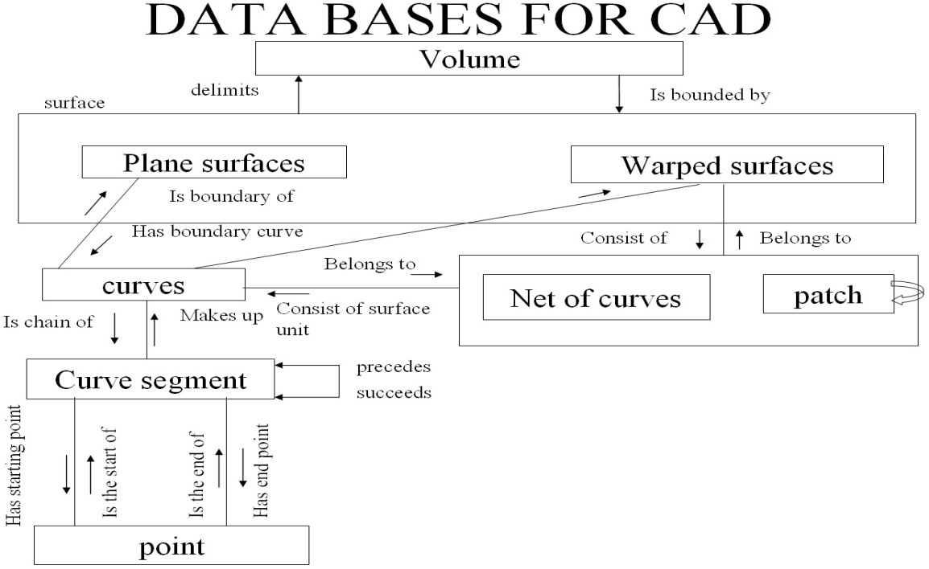
At the highest level we have the volume which is defined by (or “delimited by”) a set of surfaces. These surfaces can be either planar or curved / warped. A planar surface can be bounded by a set of curves. A curved surface can be seen as a net of curves. These curves are typically a succession of curve chedule which define the complete the curve. The curve segment is defined using a set of end points / control points which govern the nature of the curve. Thus a relation ship is defined between entities at each level.
Once such a relationship is defined, a geometric model of the artifact is available. In any design there might be manysuch artifacts. One then has to define properties of each of these artifacts and define a relationship between them. The properties and the relationships needed are dependant on the application the model is to be used for subsequently. But one common application that all models have to go through is visualization of the model (s).

DISPLAY / VISUALIZATION
Displaying the model requires the following:
- Mapping objects onto screen coordinates: Models are typically made in a model coordinate system. This could be the world coordinate system, or a coordinate system local to the object. These coordinate systems are typically three dimensional in nature. To display the object on a 2D screen, the object coordinates need to be mapped on to the 2D coordinate system of the screen. This requires two steps:
  - Viewing transformations: The coordinates of the object are transformed in a manner as if one is looking at the object through the screen. This coordinate system is referred to as the viewing coordinate system.
  - Projections: The object in the viewing coordinate system is then projected onto the two dimensional plane of the screen.
- Surface display or shading / rendering: In displaying the objects on the screen one often likes to get a shaded display of the object and get a good feel of the three dimensional shape of the object. This requires special techniques to render the surface based on its shape, lighting conditions and its texture.
- Hidden line removal when multiple surfaces are displayed: In order to get a proper feel of the three dimensional shape of an object, one often desires that the lines / surfaces which are not visible should not be displayed. This is referred to as hidden line / surface removal.
Once a model is visualized on the screen and approved by the conceptual designer, it has to go through a number of analysis. Some of the kinds of usage this model might have to go through are the following:
- Estimating stresses / strains / deflections in the objects under various static loading conditions
- Estimating the same under dynamic loading conditions
- Visualizing how a set of objects connected together would move when subject to external loading. This leads to a whole set of activities under simulation. These activities would vary depend upon the application the object is to be subject to.
- Optimizing the objects for
- Developing 2D engineering drawings of the object
- Developing a process plan of the object
- Manufacturing the object using NC / CNC machines and generating the programs for these machines so as to manufacture these objects.
Having given the overview of the kind of chedule that can come under the umbrella of CAD the uses these CAD models can be put to, I know highlight what aspects of these would be covered in this course. Needless to say, all these activities would be well beyond the scope of one single course. Therefore this course, which is targeted to give an overview of CAD and its applications would include the following:
- An overview of the hardware systems used in CAD
- 2D and 3D transformations used to shift between coordinate systems
- Projection transformation used to get the object in screen coordinate systems
- Modeling of curves and surfaces
- Modeling of solids

Hardware and Software Requirements of CAD

VIDEO DISPLAY DEVICES

Typically, the primary output device in a graphics system is a video monitor(Fig.below). The operation of most video monitor is based on the standard cathode-ray tube(CRT) design.
- Refresh Cathode-Ray Tubes
- Raster-Scan Displays
- Random-Scan Displays
- Color CRT Monitors
- Flat-Panel Displays

Refresh Cathode-Ray Tubes

Fig.below illustrates the basic operation of a CRT. A beam of electrons (cathode rays), emitted by an electron gun, passes through focusing and deflection systems that direct the beam towards specified position on the phosphor-coated screen. The phosphor then emits a small spot of light at each position contacted by the electron beam. Because the light emitted by the phosphor fades very rapidly, some method is needed for maintaining the screen picture. One way to keep the phosphor glowing is to redraw the picture repeatedly by quickly directing the electron beam back over the same points. This type of display is called a refresh CRT.
The primary components of an electron gun in a CRT are the heated metal cathode and a control grid (fig.below). Heat is supplied to the cathode by directing a current through a coil of wire, called the filament, inside the cylindrical cathode structure. This causes electrons to be “boiled off” the hot cathode surface. In the vacuum inside the CRT envelope, negatively charged electrons are then accelerated toward the phosphor coating by a high positive voltage. The accelerating voltage can be generated with a positively charged metal coating on the in side of the CRT envelope near the phosphor screen, or an accelerating anode can be used, a in fig below . Sometimes the electron gun is built to contain the accelerating anode and focusing system within the same unit.
Spots of light are produced on the screen by the transfer of the CRT beam energy to the phosphor. When the electrons in the beam collide wit the phosphor coating , they are stopped and there are stopped and their kinetic energy is absorbed by the phosphor. Part of the beam energy s converted by friction into heat energy, and the remainder causes electron in the phosphor atoms to move up to higher quantum-energy levels. After a short time, the “excited” phosphor electrons begin dropping back to their stable ground state, giving up their extra energy as small quantums of light energy. What we see on the screen is the combined effect of all the electrons light emissions: a glowing spot that quickly fades after all the excited phosphor electrons have returned to their ground energy level. The frequency ( or color ) of the light emitted by the phosphor is proportional to the energy difference between the excited quantum state and the ground state.
Different kinds of phosphor are available for use in a CRT. Besides color, a major difference between phosphors is their persistence: how long they continue to emit light ( that is, have excited electrons returning to the ground state ) after the CRT beam is removed. Persistence is defined as the time it take the emitted light from the screen to decay to one-tenth of its original intensity. Lower-persistence phosphors require higher refresh rates to maintain a picture on the screen without flicker. A phosphor with low persistence is useful for animation ; a high-persistence phosphor is useful for displaying highly complex, static pictures. Although some phosphor have a persistence greater than 1 second, graphics monitor are usually constructed with a persistence in the range from 10 to 60 microseconds

Raster-Scan Displays

In a raster- scan system, the electron beam is swept across the screen, one row at a time from top to bottom. As the electron beam moves across each row, the beam intensity is turned on and off to create a pattern of illuminated spots. Picture definition is stored in memory area called the refresh buffer or frame buffer. This memory area holds the set of intensity values for all the screen points. Stored intensity values are then retrieved from the refresh buffer and “ painted” on the screen one row (scan line) at a time (fig.below). Each screen point is referred to as a pixel or pel (shortened forms of picture element).
Refreshing on raster-scan displays is carried out at the rate of 60 to 80 frames per second, although some systems are designed for higher refresh rates. Sometimes, refresh rates are described in units of cycles per second, or Hertz (Hz), where a cycle corresponds to one frame. At the end of each scan line, the electron beam returns to the left side of the screen to begin displaying the next scan line. The return to the left of the screen, after refreshing each scan line, is called the horizontal retrace of the electron beam. And at the end of each frame (displayed in 1/80th to 1/60th of a second), the electron beam returns (vertical retrace)to the top left corner of the screen to begin the next frame.
On some raster-scan systems (and in TV sets), each frame is displayed in two passes using an interlaced refresh procedure. In the first pass, the beam sweeps across every other scan line from top to bottom. Then after the vertical retrace, the beam sweeps out the remaining scan lines(fig.below). Interlacing of the scan lines in this way allows us to see the entire screen displayed in one-half the time it would have taken to sweep across all the lines at once from top to bottom.
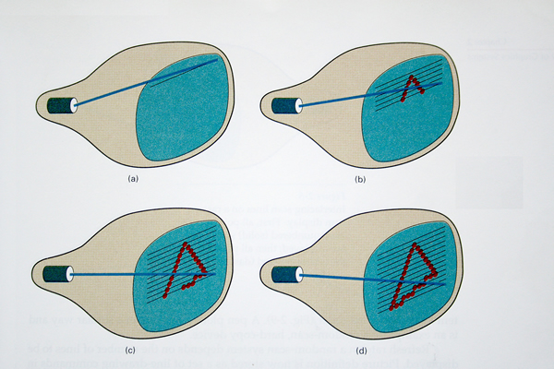

Random-Scan Displays

Random scan monitors draw a picture one line at a time and for this reason are also referred to as vector displays (or stroke-writing or calligraphic displays).The component lines of a picture can be drawn and refreshed by a random-scan system in any specified order .
Refresh rate on a random-scan system depends on the number of lines to be displayed . Picture definition is now stored as a set of line-drawing commands in an area of memory referred to as the refresh display file. Sometimes the refresh display file is called the display list, display program, or simply the refresh buffer. To display a specified picture, the system cycles through the set of commands in the display file, drawing each component line in turn. After all line- drawing commands have been processed, the system cycles back to the first line command in the list. Random-scan displays are designed to draw al the component lines of a picture 30 to 60times each second.

Color CRT Monitors

The beam penetration method for displaying color pictures has been used with random-scan monitors. Two layers of phosphor, usually red and green, are coated on to theinside of the CRT screen, and the displayed color depends on how far the electron beam penetrates into the phosphor layers.
Shadow-mask methods are commonly used in raster-scan systems (including color TV) because they produce a much wider range of color than the beam penetration method. A shadow-mask CRT has three phosphor color dots at each pixel position. One phosphor dot emits a red light, another emits a green light, and the third emits a blue light. This type of CRT has three electron guns, one for each color dot, and a shadow- mask grid just behind the phosphor –coated screen.Fig.below illustrates the delta-delta shadow-mask method, commonly used in color CRT systems. The three electron beam are deflected and focused as a group onto the shadow mask, which contains a series of holes aligned with the phosphor-dot patterns. When the three beams pass through a hole in the shadow mask, they activate a dot triangle, which appears as a small color spot the screen the phosphor dots in the triangles are arranged so that each electron beam can activate only its corresponding color dot when it passes through the shadow mask. 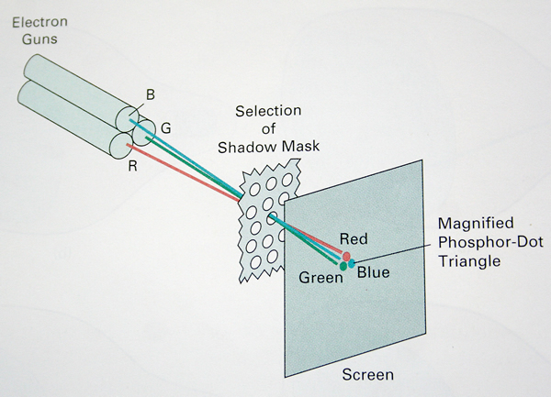

Flat-Panel Displays

The term flat–panel displays refers to a class of video devices that have reduced volume, weight, and power requirements compared to a CRT. A significant feature of flat-panel displayed is that they are thinner than CRTs, and we can hang themon walls or wear them on our wrists.
We can separate flat-panel displays into two categories: emissive displays and nonemissive displays. The emissive displays (or emitters) are devices that displays, and light-emitting diodes are examples of emissive displays. Nonemissive displays( or nonemitters) use optical effects to convert sunlight or light from some other source into graphics patterns. The most important example of a nonemissive flat-panel display is a liquid- crystal device.
Plasma panels, also called gas discharge displays, are constructed by filling the region between two glass plates with a mixture of gases that usually include neon. A series of vertical conducting ribbons is placed on one glass panel, and a set of horizontal ribbons is built into the other glass panel (fig.below). Firing voltages applied to a pair of horizontal and vertical conductors cause the gas at the intersection of the of two conductors to break down into a glowing plasma of electrons and ions. Picture definition is stored in a refresh buffer, and the firing voltages are applied to refresh the pixel positions ( at the intersections of the conductors) 60 times per second.
Another type of emissive device is the light-emitting diode (LED). A matrix of diodes is arranged to form the pixel positions in the display, and picture chedule is stored in refresh buffer. As in scan- line refreshing of a CRT, information is read from the refresh buffer and converted to voltage levels that are applied to the diodes to produce the light patterns in the display.
Liquid- crystal displays (LCDs) are commonly used in systems, such as calculators (fig.below) and portable, laptop computers (fig.below). These nonemissive devices produce a picture by passing polarized light from the surrounding or from an internal light source through a liquid- crystal material that can be aligned to either block or transmit the light.
The term liquid crystal refers to the fact that these compounds have a crystalline arrangement of molecules, yet they flow like a liquid . Flat-panel displays commonly use nematic (threadlike) liquid-crystal compounds that tend to keep the long axes of the rod-shaped molecules aligned. A flat-panel display can then be constructed with a nematic liquid crystal, as demonstrated in fig. below. Two glass plates, each containing a light polarizer at right angles to the other palate, sandwich the liquid-crystal material. Rows of horizontal transparent conductors are built into one glass plate, and columns of vertical conductors are put into the other plate. The intersection of two conductors defines a pixel position. Normally, the molecules are aligned as shown in the “on state”of fig.below. Polarized light passing through the material is twisted so that it witll pass through the opposite polarizer. The light is reflected back to the viewer. To turn off the pixel, we apply voltage to the two intersecting conductors to align the molecules so that the light is not twisted. This type of flat-panel device is referred to as a passive matrix LCD. Picture definition are stored in a refresh buffer, and the screen is refreshed at the rate of 60 frames per second, as in the emissive devices. Back lighting is also commonly applied using solid-state electronic devices, so that the system is not completely dependent on outside light sources. Colors can be displayed by using different materials or dyes and by placing a triad of color pixels at each screen location. Another method for constructing LCDs is to place a transistor at each pixel location, using thin-film transistor technology.
The transistors are used to control the voltage at pixel locations and to prevent charge from gradually leaking out of the liquid-crystal cells. These devices are called active-matrix displays.

INPUT DEVICES

Various devices are available for data input on graphics workstations. Most systems have a keyboard and one or more additional devices specially designed for interactive input. These include a mouse, trackball, spaceball, joystick, digitizers, dials, and button boxes. Some other input devices used in particular applications are data gloves, touch panels, image scanners, and voice systems.
Keyboards
An alphanumeric keyboard on a graphics system is used primarily as device for entering text strings. The keyboard is an efficient device for inputting such nongraphic data as picture labels associated with a graphics display. Keyboards can also be provided with features to facilitate entry of screen coordinates, menu selections, or graphics functions.
Mouse
A mouse is small hand-held box used to position the screen cursor. Wheels or rollers on the bottom of the mouse can be used to record the amount and direction of movement. Another method for detecting mouse motion is with an optical sensor,. For these systems, the mouse is moved over a special mouse pad that has a grid of horizontal and vertical lines. The optical sensor detects movement across the lines in the grid.
Since a mouse can be picked up and put down at another position without change in cursor movement, it is used for making relative changes in the position of the screen cursor. One, two, or three buttons are usually included on the top of the mouse for signaling the execution of some operation, such as recording cursor position or invoking a function.
Joysticks
A joystick consists of a small, vertical lever (called the stick) mounted on a base that is used to steer the screen cursor around. Most joysticks select screen positions with actual stick movement; others respond to pressure on the stick. Figure below shows a movable joystick. Some joysticks are mounted on a keyboard; others function as stand-alone units.
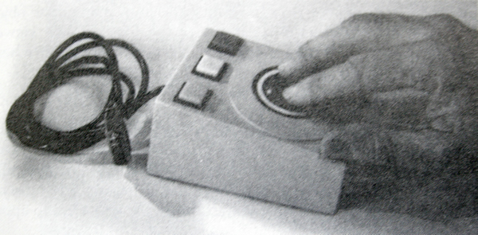Digitizers
A common device for drawing, painting, or interactively selecting coordinate positions on an object is a digitizer. These devices can be used to input coordinate values in either a two-dimensional or a three-dimensional space. Typically, a digitizer is used to scan over a drawing or object and to input a set of discrete coordinate positions, which can be joined with straight-line segments to approximate the curve or surface shapes.
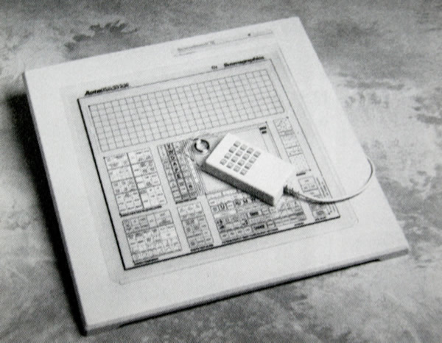One type of digitizer is the graphics tablet (also referred to as a data tablet), which is used to input two-dimensional coordinates by activating a hand cursor or stylus at selected positions on a flat surface. A hand cursor contains cross hairs for sighting positions, while a stylus is a pencil-shaped device that is pointed at positions on the tablet. Figures below show examples of desktop and floor-model tablets, using hand cursors that are available with 2, 4, or 16 buttons. Examples of stylus input with a tablet are shown in Figs. Below. The artist’s digitizing system in Fig. below uses electromagnetic resonance to detect the three-dimensional position of the stylus. This allows an artist to produce different brush strokes with different pressures on the tablet surface. Tablet size varies from 12 by 12 inches for desktop models to 44 by 60 inches or larger for floor models. Graphics tablets provide a highly accurate method for selecting coordinate positions, with an accuracy that varies from about 0.2 mm on desktop models to about 0.05 mm or less on larger models.
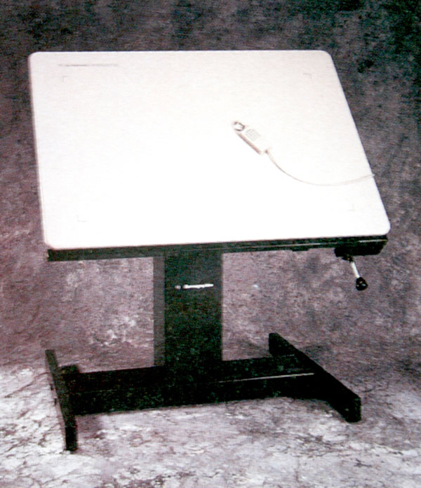
Many graphics tablets are constructed with a rectangular grid of wires embedded in the tablet surface. Electromagnetic pulses are generated in sequence along the wires, and an electric signal is induced in a wire coil in an activated stylus or hand cursor to record a tablet position. Depending on the technology, either signal strength, coded pulses, or phase shifts can be used to determine the position on the tablet.
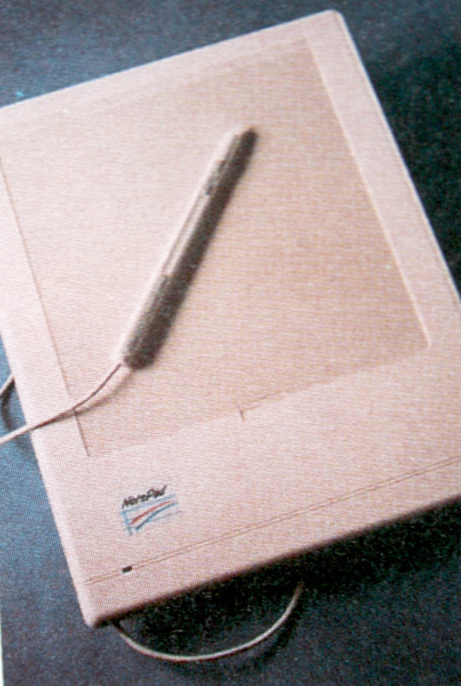

HARD-COPY DEVICES

We can obtain hard-copy output for our images in several formats. Eg: Dot matrix printer, laser printer & inkjet printer are commonly used.
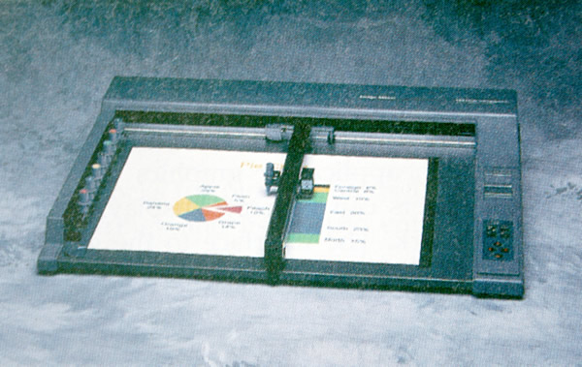Drafting layouts and other drawings are typically generated with ink-jet or pen plotters. A pen plotter has one or more pens mounted on a carriage, or crossbar, that spans a sheet of paper. Pens with varying colors and widths are used to produce a variety of shadings and line styles. Wet-ink, ball-point, and felt-tip pens are all possible choices for use with a pen plotter. Plotter paper can lie flat or be rolled onto a drum or belt. Crossbars can be either moveable or stationary, while the pen moves back and forth along the bar. Either clamps, a vacuum, or an electrostatic charge hold the paper in position. An example of a table-top flatbed pen plotter is given in Figure below, and a larger, rollfeed pen plottershown in Fig.below
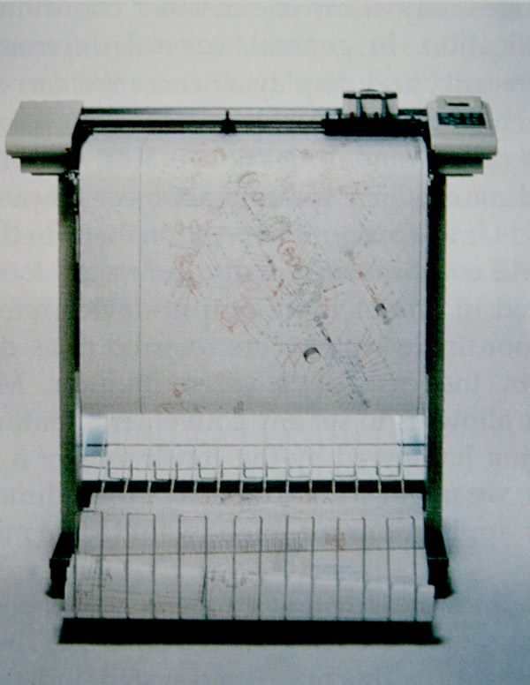

PRODUCT DEVELOPMENT CYCLE

Industries have to continuously upgrade their products as well as introduce new products in the market in order to retain as well as to increase their market share. The product development is the responsibility of the research and development (R&D) department of a manufacturing company. When a product is initially introduced the sales volume will be low. If the product is good and satisfies the customers, the sales will pick up. Sometimes, if there are any problems in the product the company will have to make changes or improvements in the product which is a very expensive proposition. If the defect is serious enough the company may have to recall an entire batch of products at enormous cost and loss of goodwill. The sales and service department usually takes care of attending to the customers’ problems. That is why manufacturers of automobiles, entertainment electronic goods, fast moving consumer goods like washing machines and refrigerators etc have elaborate sales and service network.

The sales volume will pick up gradually and peak after some time. The product will continue to sell for some time. The sales will then start gradually declining owing to availability of better products in the market. It is time for the company to introduce a new and improved product in the market as well as to retire the old product. The companies will usually advice the customers that the old product will be further supported by the sales and service department only for a limited period of time.
The cycle through which a product goes through from development to retirement is called the product life cycle. The variation of the sales volume during the life cycle of a product is graphically shown in Fig.2.1.
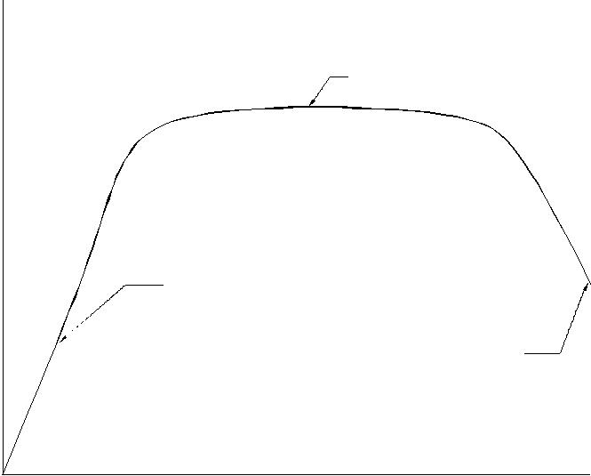

 | P E AK S ALE S
le s Vo lu m e
Sa | P R O D U C T
Sa | IN TR O D U C T IO N
 | R E TIR E M E N T

Life of a Product

Fig. 1.20 Variation of the Sales Volume Vs Life of a Product

The product development cycle starts with developing the product concept, evolving the design, engineering the product, manufacturing the part, marketing and servicing. This is shown in Fig. 1.20. The idea of a product may come from a patent, suggestion of the customers, feedback of the sales and service department, market research carried out by the marketing department or from the R&D department itself. The next stage is the conceptualization of the product. The cost at which the product could be sold in the market is decided and the overall design in terms of shape, functional specifications, ergonomics, aesthetics etc are considered in detail and finalized at this stage. The work of product development is then taken to the next stage by the design department who carefully designs each assembly and each component of the assembly. Detailed design analysis and optimization is carried out at this stage. A design may have several variants. For example, a passenger car may have what is called a stripped down version with the bare minimum options and luxury versions with several add on functionalities. Between these two extreme versions, there will be a number of models or variants to meet the needs of customers with different paying capacities. In a similar way, a satellite launch vehicle may be designed for different payloads. A fighter aircraft may have different versions. A refrigerator will have to be marketed with different capacities. The design department creates these designs through a top down approach or a bottom up approach. In top down approach, the entire assembly is designed first and individual designs are done latter. In bottom up approach, the component design is done first and the product is realized by assembling the components suitably. The design also will involve preparation of detail drawings

Engineering the product consists of process planning, tool design, facility design, capacity planning, quality assurance activities, procurement, assembly planning, etc. Marketing department will have the responsibility of carrying out appropriate product launch activities as well as planning the sales and service network, advertising and training of sales and service personnel.

Concept
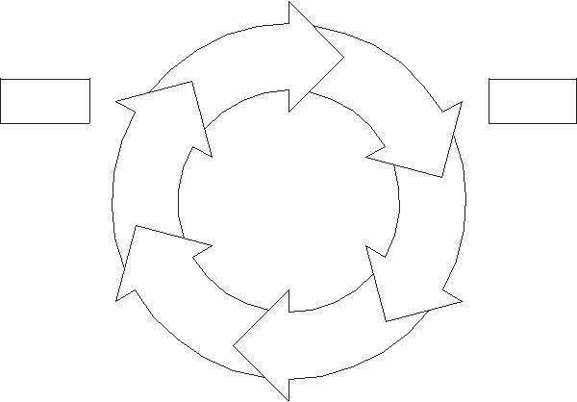

Service | Design

Marketing | Planning

Manufacture

Fig. 1.21 Product Development Cycle

In actual practice product development activities form a spiral as shown in Fig. 2.3. The product goes through a series of continuous refinement and improvements, additions etc. A typical example is a software package improved versions of which are released as new versions at periodic intervals. The feedback from the marketing and services leads to improvements in design and/or evolution of new designs. As an example, the reader is advised to make a study of the evolution of the various models of aircraft or passenger cars over the last five decades.

This is how most of the present products have been evolved over the period. One can evidently realize it by comparing a 1928 model T Ford car with the current jelly bean shaped cars. However, the design evolution however does not stop at any stage and is a continuous process.

Similarly one can observe the vast improvements that have taken place in the design of entertainment electronic goods, computers, aircrafts and even domestic appliances like refrigerators. Often an altogether new concept may make a design obsolete. Songs were recorded at different times on discs, tapes, cassettes and CD-ROMS. Correspondingly, the design of the music player has also undergone radical changes from the old gramophone record player to the present MP3 player. It is interesting to note the rate of obsolescence of technology in music players.

 | M a nufacture
 |  | Q ua lity C on tro l
P lan ning | M a nufacture | M a rke tin g
 |  | Q u a lity C on tro l
 | M a nu fa c tu r e | M a rke tin g
P lan ning |  | S e rvice
 | D esign
P lan nin g |  | M a rke tin g
P lan nin g |  | S e rvice
 | D esign
 |  | S e rvice
 | D e sign
 |  | C o n ce p t
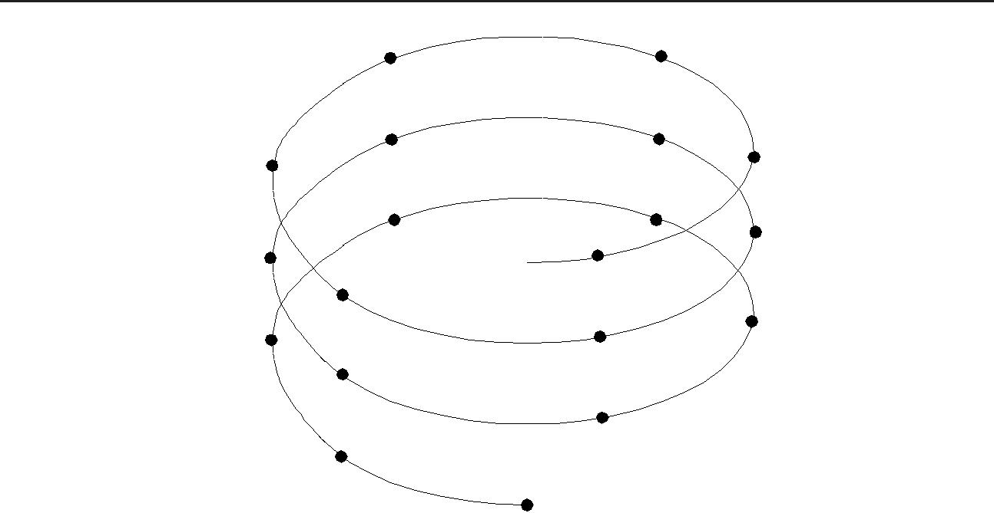
Fig. 1.22 Product Development Spiral

QUESTIONS

- Describe the principal features and list the major specifications of a personal computer.
- Sketch and describe the layout of the mother board of a Pentium PC.

- How does a mainframe computer differ from a PC?

- What are the output interfaces available on a PC? How do they differ from each other?

- Describe the advantages of a local area network in a design environment?

- What are the salient features of a UNIX based design workstation?

- What are the principal subsystems of a graphics engine?

- List the major specifications of a design workstation.

- Describe the principle of working of a CRT.

- How is a line displayed on a graphics monitor?

- What is the function of a frame buffer?

- What is the advantage of a mouse as an input device?

PRINCIPLES OF COMPUTER GRAPHICS

INTRODUCTION

Traditionally drawings are prepared on plane drawing sheets. This has several limitations. The sketches have to be made only in two dimensions. Though the depth can be represented by pictorial projections like isometric and perspective projections, the projections have to be necessarily reduced to two dimensions.

Use of computer graphics has opened up tremendous possibilities for the designer. Some of them are listed below:

- The object is represented by its geometric model in three dimensions (X, Y and Z).

- The mathematical representation reduces creation of views like orthographic, isometric, axonometric or perspective projections into simple viewing transformations.

- Though the size of the screen is limited, there is no need to scale the drawings.

- Drawings can be made very accurate.

- The geometric models can be represented in color and can be viewed from any angle.

- Sections can be automatically created.

- The associativity ensures that any change made in one of the related views will automatically reflect in other views.

- Revision and revision control are easy.

- Drawings (geometric models) can be modified easily.

- More important than all, drawings can be reused conveniently.

- Storage and retrieval of drawings are easy.
Modern computer graphics displays are simple in construction. They consist of basically three components.

- Monitor

- Digital Memory or Frame Buffer

- Display Controller

Most of the computer graphics displays use raster CRT which is a matrix of discrete cells each of which can be made bright. A graphic entity like line or circle is represented as a series of “points or dots” on the screen. Therefore, it is called as a point plotting device.

The video display screen is divided into very small rectangular elements called a picture element or pixel. This happens to be the smallest addressable screen element. Graphic images are formed by setting suitable intensity and color to the pixels which compose the image. Depending upon the resolution screens may have varying number of pixels. For example, an SVGA monitor with a resolution of 1024 x 768 will have 1024 pixels in every row (X — direction) and 768 pixels in every column (Y-direction). Monitors of larger size will have resolution of 1024 x 1024 or more. A raster scan system displays the image on a CRT in a certain fixed sequence.

The refresh rate is the number of complete images or frames scanned per second. In the case of interlaced refresh cycle odd numbered raster lines are refreshed during 1/60th of a second. Even numbered raster lines are refreshed during the next 1/60th of a second. In non-interlaced displays, all lines are refreshed in 1/60th of a second. The quality of non-interlaced display is hence, superior. These systems, however, require expensive frame buffer memory and display controller.

GRAPHIC PRIMITIVES

A drawing is created by an assembly of points, lines, arcs, circles. For example, drawing shown in Fig 2.1 consists of several entities. In computer graphics also drawings are created in a similar manner. Each of these is called an entity. The drawing entities that a user may find in a typical CAD package include :

point line

construction line, multi-line, polyline circle

spline arc ellipse polygon rectangle

CIRCLE _{LINE}
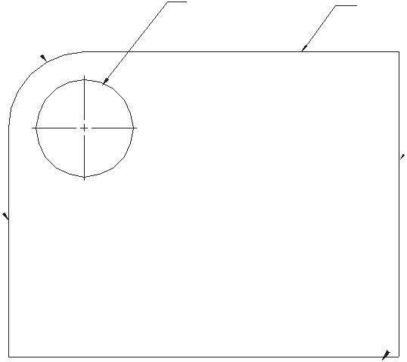
ARC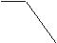

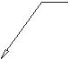LINE

LINE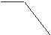

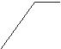LINE

Fig. 2.1 A Simple Drawing

The fundamental principles of generation of some of these entities are discussed below :

POINT PLOTTING

The frame buffer display is an example of a point plotting device. The smallest unit accepted by such displays is a single pixel. To construct a useful picture on a point plotting device, a picture must be built out of several hundreds of pixels.

DRAWING OF LINES

Straight line segments are used a great deal in computer generated pictures. The following criteria have been stipulated for line drawing displays :

- Lines should appear straight

- Lines should terminate accurately

- Lines should have constant density

- Line density should be independent of length and angle

- Line should be drawn rapidly

The process of turning on the pixels for a line segment is called vector generation. If the end points of the line segment are known, there are several schemes for selecting the pixels between the end pixels. One method of generating a line segment is a symmetrical digital differential analyzer (DDA).

DDA ALGORITHM

The digital differential analyzer generates lines from their differential equations. The DDA works on the principle that X and Y are simultaneously incremented by small steps proportional to the first derivatives of X and Y. In the case of a straight line the first derivatives are constant and are proportional to DX and DY, where D is a small quantity

In the real world of limited precision displays, addressable pixels only must be generated. This can be done by rounding to the next integer after each incremental step. After rounding, a pixel is displayed at the resultant X and Y locations. An alternative to rounding is the use of arithmetic overflow. X and Y are kept in registers that have integer and fractional parts. The incrementing values which are less than unity are repeatedly added to the fractional part and whenever the result overflows the corresponding integer part is incremented. The integer parts of X and Y are used to plot the line. This would normally have the effect of truncating. The DDA is therefore initialized by adding 0.5 in each of the fractional parts to achieve true rounding.

The symmetrical DDA generates reasonably accurate lines since a displayed pixel is never away from a true line by half the pixel unit. A Pascal procedure for a simple DDA is given below :

Procedure DDA (X1, Y1, X2, Y2 : integer) ;

length : var ;

I : integer;

X, Y, X-incr, Y-incr : real ;

begin

length : = abs (X2– X1) ;

if abs (Y2–Y1) < length then length: = abs (Y2–Y1);

X — incr : = (X2 – X1) /length ;

Y — incr : = (Y2 – Y1) /length ;

X : = X1 + 0.5 ; Y = Y1 + 0.5 ;

for I : = 1 to length do

begin

plot (ched (X) ; ched(Y) ;

X : = X + X — incr ;

Y : = Y + Y — incr ;

end;

end.

  - example

To draw a straight line from connecting two points (2, 7) and (15, 10)

X1 = 2, X2 = 15 abs(X2 – X1) = 13

Y1 = 7, Y2 = 10 abs(Y2 – Y1) = 3

Principles of Computer Graphics
Length = 13
X incr | = |  | X2–X1 |  | = |  |  | 13 | =1
X incr |  |  | Length |  |  |  |  |  | =1
 |  |  |  |  | 13
Y incr | = |  | Y2–Y1 |  | = |  | 3 |  | = 0.23
Y incr |  |  | Length |  |  |  |  |  | = 0.23
 |  |  |  |  | 13
Initial values of X and Y are
X | = 2.5 |  |  | Y = 7.5
The X and Y are tabulated in Table 2.1 and Fig. 2.2 shows a plot of the line.
 |  |  |  |  |  |  |  | Table 2.1 Pixel Values
 |  |  | X |  |  |  |  | Y |  | ched (X) | ched (Y)
 |  |  | 2.5 |  |  | 7.50 |  |  |  | 2 | 7
 |  |  | 3.5 |  |  | 7.73 |  |  |  | 3 | 7
 |  |  | 4.5 |  |  | 7.96 |  |  |  | 4 | 7
 |  |  | 5.5 |  |  | 8.19 |  |  |  | 5 | 8
 |  |  | 6.5 |  |  | 8.42 |  |  |  | 6 | 8
 |  |  | 7.5 |  |  | 8.65 |  |  |  | 7 | 8
 |  |  | 8.5 |  |  | 8.88 |  |  |  | 8 | 8
 |  |  | 9.5 |  |  | 9.11 |  |  |  | 9 | 9
 |  |  | 10.5 |  |  | 9.34 |  |  |  | 10 | 9
 |  |  | 11.5 |  |  | 9.57 |  |  |  | 11 | 9
 |  |  | 12.5 |  |  | 9.80 |  |  |  | 12 | 9
 |  |  | 13.5 |  |  | 10.23 |  |  |  | 13 | 10
 |  |  | 14.5 |  |  | 10.46 |  |  |  | 14 | 10
 |  |  | 15.5 |  |  | 10.69 |  |  |  | 15 | 10
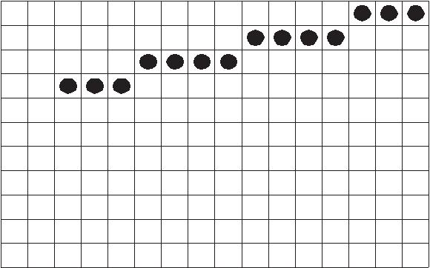

10

9

8

7

6

5

4

3

2

1

0

0 1 2 3 4 5 6 7 8 9 10 11 12 13 14 15

Fig. 2.2 Plotting a Line

It can be noted that lines drawn on a raster display may have a jagged or staircase appearance unless the lines are vertical or horizontal. This is because the points that are plotted must be pixel grid points and many of these may not lie on the actual line.
DRAWING OF CIRCLES

Circle is another important entity like line. Several circle drawing algorithms have been described in literature. A simple procedure for drawing a circle is described in this section.

This procedure calculates points on the circle centred about the origin and then adds co-ordinates of the centre (X ,Y ) to the X and Y values respectively.

Program mcircle;

var xc, yc, radius : integer; ($I GRAPH.P)

Procedure dcircle (xc, yc,

radius: integer) ;

var

dtheta,

cdtheta, sdtheta, x, y,

xtemp: real ; z: integer ;

begin

dtheta : = 1/radius ; cdtheta: = cos(dtheta) ; sdtheta: = sin(dtheta) ;

- = radius;

- = 0;

for z: 0 to 45 do begin
plot (round (xc + x), round (yc + y), 1); plot (round (xc – x), round (yc + y), 1); plot (round (xc + x), round (yc – y), 1); plot (round (xc – x), round (yc – y), 1); plot (round (xc + y), round (yc + x), 1); plot (round (xc – y), round (yc + x), 1); plot (round (xc + y), round (yc – x), 1); plot (round (xc – y), round (yc – x), 1);
xtemp: = x
x : = (x* cdtheta – y*sdtheta) ; y : = (y*cdtheta + x*sdtheta) ;

end ;

end ;

begin

writln(enter xc,yc,radius); readln(xc);

readln(yc);

readln(radius);

clrscr;

graphcolormode;

palette(3);

dcircle(xc,yc,radius) end of a circle.

BRESENHAM’S CIRCLE ALGORITHM

Bresenham’s algorithm enables the selection of optimum raster locations to represent a straight line. In this algorithm either pixels along X or Y directions are incremented by one unit depending upon the slope of the line. The increment in the other direction is determined by examining the error or distance between actual line location and the nearest grid locations.

The principle of Bresenham’s algorithm can be explained with the aid of Fig 3.3 a. If the slope of the line (in the first octant) is more than ½, the pixel point in the Y direction is shifted by one. Thus lines L1 and L2 passes through pixel (0,0). For line L2 slope is greater than ½ ; hence the pixel point is (1,1) whereas for L1 the slope is less than ½ and hence (1,0) is the pixel point.

Bresenham’s algorithm selects optimum raster locations with minimum computation. To accomplish this, the algorithm always increments by one unit in either X or Y depending upon the slope of the line. The increment in the other variable either zero or one is determined by examining the distance (error) between the actual line location and the nearest grid location. Only the sign of this error needs be examined.

Consider the line of slope m = 0.4 and passing through (0,0) in Fig 2.3 (a). The error team e is initialized to –1/2. The next raster point can be determined by adding the slope
(m) to the error term.

i.e. e = e + m

e = – 0.5 + 0.4 = – 0.1
Since e is negative, the line will pass below the middle of the pixel. Hence the pixel is at the same horizontal level i.e., (0,1). For the next location X is incremented to 2. Error e = -0.1 + 0.4 = 0.3. Since e is positive the line passes above the middle of the raster line. Hence the location of pixel is (2,1). Before examining the next pixel location the error term has to be re-initialized as its value is positive. Re-initialization is done by subtracting one from the current e value. Hence e = 0.3 — 1 = -0.7. Adding the slope 0.4 we get e = -0.3. Table 3.2 shows the computed values and the location of pixels. A plot of the pixel location is shown in Fig. 2.3 (b).

Table 2.2 Calculation of Pixel Position

X |  |  | Error |  | Y | Remarks
0 | – 0 | .5 |  |  | 0 | initial pixel
1 | – 0.5 + 0 .4 = – 0 .1 |  |  |  | 0
2 | – 0.1 + 0 .4 = 0 .3 |  |  |  | 1 | reinitialize the error by
 | 0 | .3 | – 1 = – | 0 .7 |  | reinitialize the error by
3 | – 0 | .7 | + 0 .4 = | – 0 .3 | 1 | subtracting one
4 | – 0.3 + 0 .4 = 0 .1 |  |  |  | 2
 | 0.1 – = – 0 .9 |  |  |  | 2
5 | – 0.9 + 0 .4 = – 0 .5 |  |  |  | 2
5 | – 0.5 + 0 .4 = – 0 .1 |  |  |  | 2
6

 | L2
0,1 | 1,1
 | 1
 | L1
 | (Slope <0.5) ⁰
 | 0 | 1 | 2 | 3
0,0 | 1,0
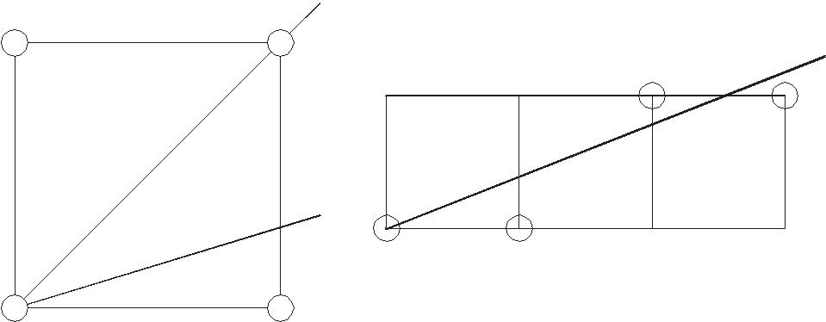
Fig. 2.3 (a) Location of Pixels Using Fig. 2.3 (b) Pixels for Line of

Bresenham Algorithm Slope, m = 0.4

The speed of the Bresenham’s algorithm can be increased by using integer arithmetic and eliminating division to determine slope.

The pseudo code and a C-program for implementing Bresenham’s algorithm are given below:

Pseudo code for Bresenham’s line-drawing algorithm

Given a line from x1, y1 to x2, y2 ...

dx is the difference between the x components of end points dy is the difference between the y components of end points

- is the absolute value of dx iy is the absolute value of dy inc is the larger of dx, dy plotx is x1

ploty is y1 (the beginning of line)

- starts at 0

y starts at 0

plot a pixel at plotx, ploty increment x using ix increment y using iy plot is false

if x is greater than inc plot is true

decrement x using inc increment plotx if dx is positive decrement plotx id dx is negative

if y is greater than inc plot is true

decrement y using inc increment ploty if dy is positive decrement ploty if dy is negative

if plot is true, plot a pixel at plotx, ploty increment i.

Program in Turbo-C to draw a line

- include <stdio. H>

- include <graphics. H>

- include <stdlb. H>

void draw line (int x1, int y1, int x2, int y2), void main (void)

{

draw line (100, 100, 50, 50) ;

}

void draw line (int x1, int y1, int x2 m int y2)

{

int dx, dy, inc, ix, iy, x, y, plot, plotx, ploty, I ;
int gd, gm ; gd = DETECT ;

initgraph (&gd, &gm, “ “) ; dx = x1 – x2 ;
dy = y1 – y2 ;

- = abs (dx) ; iy = abs (dy) ;
inc = max (ix, iy) ;

- = y = 0 ;

plot x = x1 ; plot y = y1 ;

for (I = 0 ; I <inc ; I ++)

{

x + = ix ; y + iy ; plot = 0 if (x > inc)

{

plot = 1 ; x – = inc ; if (dx < 0)

plot x – = 1 ;

else

plotx + = 1 ;

}

if (y > inc)

{

plot = 1 ; y – = inc ; if (dy)

ploty – = 1 ;

else

ploty + = 1 ;

}

if (plot)

putpixel (plotx, ploty, 1)

else

}

getch ( ) ; closegraph ( ) ;

Bresenham’s circle algorithm

An efficient algorithm for generating a circle has been developed by J. Bresenham. Values of a circle centred at the origin are computed in the sector X = 0 to X = R /2 where R is the radius of the circle. The symmetry of the circle is used to obtain the pixels corresponding to other sectors.

Bresenham’s circle algorithm can be explained as follows:

Consider an origin-centred circle. The algorithm begins at X = 0 and Y = R. In the first quadrant of the circle, Y is a monotonically decreasing function of X. Referring to Fig. 3.4, (Xi, Yi) is a point on the circle. For clockwise generation of the circle there are only three possible selections of the next pixel, which represents the circle. These positions are also shown in Fig. 3.4. The algorithm is designed to choose the pixel which minimizes the square of the distance between one of these pixels and the true circle, i.e., the minimum of

H = [ (Xi + 1) ² + (Yi)² – R ²]

V = [ (Xi ) ² + ( Yi – 1) ² – R ² ]

D = [ ( Xi + 1) ² + ( Yi – 1 ) ² – R ² ]

Xi, Yi Xi+1, Yi

H
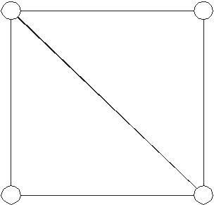

V ^{D}

Xi, Yi-1 Xi+1, Yi-1

Fig. 2.4 First Quadrant Pixel Position

A flow chart to obtain the pixel values for representing a circle is given in Fig. 2.5. It is sufficient to obtain the pixel values for 1/8th of a circle, the remaining obtained by symmetry.

A program which implements Bresenham’s algorithm follows.

Include <stdio.h> include <graphics.h>

Void draw circle (int xc, int yc, int y) ; Void symmetry (int x, int y, int xc, int yc) ; double ratio ;

Void main (void)

{

draw circle (300, 150, 50) ;

}

int d, x ; int gd, gm ;

gd = DETECT ;

initgraph (&gd, &gm, “ “) ; d = 3 — 2 * y ;

ratio = 1.5 x = 0 ;

while (x < y)

{

symmetry (x, y, xc, yc) ; if (d < 0)

d + = 4 * x + 6 ; else

{

d + = 4 * (X – Y) + 10 ; y - :

}

x++ ;

if (x = = y)

symmetry (x, y, xc, yc) ;

}

getch ( ) ; closegraph ( ) ;

}

void symmetry (int x, int y, int xc, int yc)

{

int x start, x end, x out ;

int y start, y end, y out ; x start = x * ratio

x end = (x + 1) * ratio ; y start = y * ratio ;

y end = (y + 1) * ratio
for (x out = x start ; x out < x end ; ++ x out)
{
put pixel (x out + xc, y + yc, 1 ) ;
put pixel (x out + xc, –y + yc, 1) ; |  |  |  |  |  | 3
put pixel (-x out + xc, –y + yc, 1) ; |  |  |  |  |  | 3
put pixel (-x out + xc, y + yc, 1) ;
}
(y out = y start ; y out < y end ; ++y out)
{
put pixel (y out + xc, x + yc, 1 ) ;
put pixel (y out + xc, –x + yc, 1) ;
put pixel (-y out + xc, –x + yc, 2) ;
put pixel (-y out + xc, x + yc, 1) ;
}
 |  |  | Start
 |  |  | X =0,Y = R
 |  |  | = 2(1 —R)
 |  |  | Lim it=0
 |  |  | Plot(X,Y)
 | Yes |  | Y<= Lim it | Yes | End
 |  |  | No
 |  |  | < 0 | Yes
 |  |  | No | =2 | +2Y –1
 | Yes |  |  | =2 | +2Y –1
 | Yes |  | < 0
 | Yes |  | No | No | =< 0
= 2 | – 2X– 1 |  | No |  | =< 0
 |  |  | X=X+1
 | – 0 |  | Y=Y–1
 | – 0 | = | + 2X –2Y+2
 |  |  |  | X=X+1
Y=Y –1 |  |  |  | = | + 2X+ 1
= | –2Y + 1
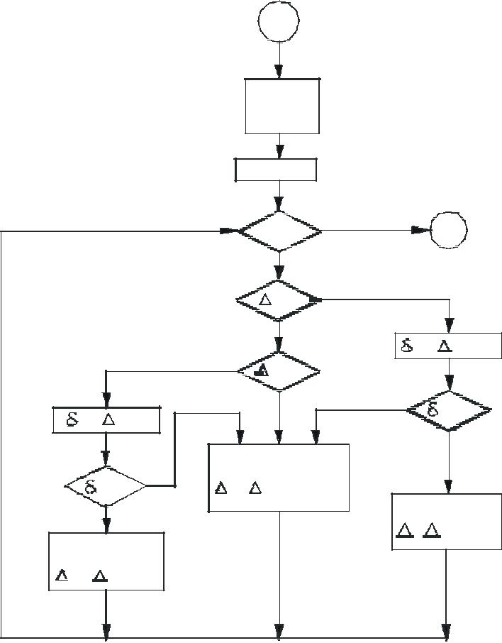

Fig. 2.5 Flow Chart to Determine Pixel Values

Example of bresenham’s algorithm

Consider a circle with centre at the origin and radius equal to 10 units. Because of symmetry only the first octant is considered here.

X = 0

Y = 10

I = 2 (1–10) = –18 LIMIT = 0 PLOT (0, 10)

Y1 > LIMIT CONTINUE I < 0 GOTO 2

  - = 2 (–18) + 2 (10) –1 = –17 < 0 GOTO 10 10 X = 0 + 1 = 1

I = –17 + 2 + 1 = –14 GOTO 1

- PLOT (1, 10)

Yi > LIMIT CONTINUE

I < 0

  - 2 (–14) + 2 (10) –1

  - –9 < 0 GOTO 10 X = 1 + 1

- = –14 + 2 (2) + 1

= –9

GOTO 1

PLOT (2, 10)

The procedure is to be continued till the required point is reached. The results are given in Table 2.3 and are plotted in Fig. 2.6.

 |  | Table 2.3 Pixel Values for Circle
 | i |  |  | X | Y |  | Plot
-18 |  |  |  | 0 | 10 |  | 0, 10
-15 |  |  | -17 | 1 | 10 |  | 1, 10
-10 |  |  | -11 | 2 | 10 |  | 2, 10
- | 3 |  | - 1 | 3 | 10 |  | 3, 10
-14 |  |  | 13 | 4 | 9 |  | 4, 9
- | 3 |  | -11 | 5 | 9 |  | 5, 9
- | 3 |  | 3 | 6 | 8 |  | 6, 8
- | 1 |  | 5 | 7 | 7 |  | 7, 7

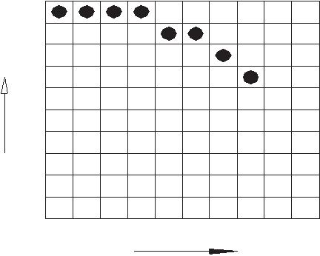
9

8

_{Y} 7 6

5

4

3

2

1

0

0 1 2 3 4 5 6 7 8 9 X

Fig. 2.6 Plot of First Octant of a Circle

ELLIPSE

The ellipse is a variation of a circle. Stretching a circle in one direction produces an ellipse. The polar equations for an ellipse with centre at X_{C}, Y_{C} are:

- = X_{C} + a * cos (θ)

- = Y_{C} + b * sin (θ)

The above equations can be used to plot an ellipse in a manner similar to that of generating a circle.

2-D Geometric Transformation

BASIC TRANSFORMATION

Animation are produced by moving the ‘camera’ or the objects in a scene along animation paths. Changes in orientation, size and shape are accomplished with geometric transformations that alter the coordinate descriptions of the objects. The basic geometric transformations are translation, rotation, and scaling. Other transformations that are often applied to objects include reflection and shear.
Use of transformations in CAD

In mathematics, “Transformation” is the elementary term used for a variety of operation such as rotation, translation, scaling, reflection, shearing etc. CAD is used throughout the engineering process from conceptual design and layout, through detailed engineering and analysis of components to definition of manufacturing methods. Every aspect of modeling in CAD is dependent on the transformation to view model from different directions we need to perform rotation operation. To move an object to a different location translation operation is done. Similarly Scaling operation is done to resize the object.
Coordinate Systems

In CAD three types of coordinate systems are needed in order to input, store and display model geometry and graphics. These are the Model Coordinate System (MCS), the World Coordinate System (WCS) and the Screen Coordinate System (SCS).
Model Coordinate System
The MCS is defined as the reference space of the model with respect to which all the model geometrical data is stored. The origin of MCS can be arbitrary chosen by the user.
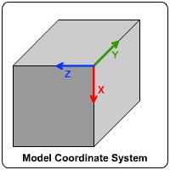

World Coordinate System
As discussed above every object have its own MCS relative to which its geometrical data is stored. Incase of multiple objects in the same working space then there is need of a World Coordinate System which relates each MCS to each other with respect to the orientation of the WCS. It can be seen by the picture shown below.
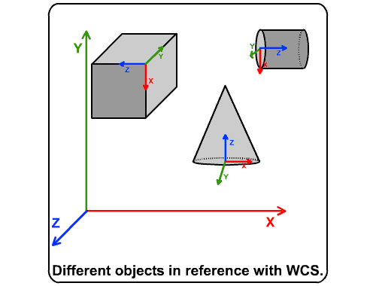

Screen Coordinate System
In contrast to the MCS and WCS the Screen Coordinate System is defined as a two dimensional device-dependent coordinate system whose origin is usually located at the lower left corner of the graphics display as shown in the picture below. A transformation operation from MCS coordinates to SCS coordinates is performed by the software before displaying the model views and graphics.
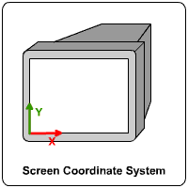

Viewing Transformations

As discussed that the objects are modeled in WCS, before these object descriptions can be projected to the view plane, they must be transferred to viewing coordinate system. The view plane or the projection plane, is set up perpendicular to the viewing z_{v} axis. The World coordinate positions in the scene are transformed to viewing coordinates, then viewing coordinates are projected onto the view plane.
The transformation sequence to align WCS with Viewing Coordinate System is.
1. Translate the view reference point to the origin of the world coordinate system.
2. Apply rotations to align x_{v}, y_{v}, and z_{v} with the world x_{w}, y_{w} and z_{w} axes, respectively.

TRANSLATION

A translation is applied to an object by repositioning it along a straight line path from one coordinate location to another. We translate a two-dimensional point by adding translation distances, t_{x} and t_{y}, to the original coordinate position (x,y) to move the point to a new position (x’,y’)
The translation distance pair (tx, ty) is called translation vector or shift vector

Matrix representation of translation

This allows us to write the two-dimensional translation equations in the matrix form:

ROTATION

A two-dimensional rotation is applied to an object by repositioning it along a circular path in the x-y plane. When we generate a rotation we get a rotation angle (θ) and the position about which the object is rotated (xr , yr) this is known as rotation point or pivot point. The transformation can also be described as a rotation about rotation axis that is perpendicular to x-y plane and passes through the pivot point. Positive values for the rotation angle define counter-clockwise rotations about the pivot point and the negative values rotate objects in the clockwise direction.
Suppose the pivot point be at origin, to understand the relationship between angular and coordinate points of original and transformed position lets look at the figure below:

Here, r - constant distance of the point from the origin.
Φ - original angular position of the point from the horizontal
θ - rotation angle
we can express the transformation by the following equations
we know the coordinate of x and y in polar form
on expanding and equating we get
The same equations we can write in matrix form as
Where the rotation matrix R is
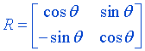
Hence it is
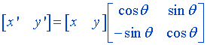

SCALING

Scaling is a kind of transformation in which the size of an object is changed. Remember the change is size does no mean any change in shape. This kind of transformation can be carried out for polygons by multiplying each coordinate of the polygon by the scaling factor. S_{x} and S_{y} which in turn produces new coordinate of (x,y) as (x’,y’). The equation would look like
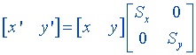
or
here S represents the scaling matrix.
NOTE: If the values of scaling factor are greater than 1 then the object is enlarged and if it is less that 1 it reduces the size of the object. Keeping value as 1 does not changes the object.
Uniform Scaling: To achieve uniform scaling the values of scaling factor must be kept equal.
Differential Scaling: Unequal or Differential scaling is produce incases when values for scaling factor are not equal.
As per usual phenomenon of scaling an object moves closer to origin when the values of scaling factor are less than 1. To prevent object from moving or changing its position while is scaling we can use a point that is would be fixed to its position while scaling which is commonly referred as fixed point (x_{f} y_{f}).

REFLECTION

Reflection is nothing more than a rotation of the object by 180º. In case of reflection the image formed is on the opposite side of the reflective medium with the same size. Therefore we use the identity matrix with positive and negative signs according to the situation respectively.
The reflection about the x-axis can be shown as:
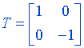
The reflection about the y-axis can be shown as:
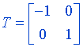
REFLECTION ABOUT A ORIGIN

When both the x and y coordinates are flipped then the reflection produced is relative to an axis that is perpendicular to x-y plane and that passes through the coordinate origin. This transformation is referred as a reflection relative to coordinate origin and can be represented using the matrix below.
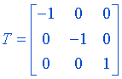
REFLECTION ABOUT AN ARBITRARY LINE

Reflection about any line y= mx + c can be accomplished with a combination of translate-rotate-reflect transformations.
Steps are as follows
1. Translate the working coordinate system (WCS) so that the line passes through the origin.
2. Rotate the WCS such that one of the coordinate axis lies onto the line.
3. Reflect about the aligned axis
4. Restore the WCS back by using the inverse rotation and translation transformation.

REFLECTION ABOUT AN ARBITRARY POINT

As seen in the example above, to reflect any point about an arbitrary point P (x,y) can be accomplished by translate-reflect transformation i.e. the origin is first translated to the the arbitrary point and then the reflection is taken about the origin. And finally the origin is translated back to its original position.
The whole process can be visualized using the animation below.

HOMOGENEOUS COORDINATES

We have seen that basic transformations can be expressed in matrix form. But many graphic application involve sequences of geometric transformations. Hence we need a general form of matrix to represent such transformations. This can be expressed as:
Where P and P’ - represent the row vectors.
T₁ - is a 2 by 2 array containing multiplicative factors.
T₂ - is a 2 element row matrix containing translation terms.
We can combine multiplicative and translational terms for 2D geometric transformations into a single matrix representation by expanding the 2 by 2 matrix representations to 3 by 3 matrices. This allows us to express all transformation equations as matrix multiplications, providing that we also expand the matrix representations for coordinate positions. To express any 2D transformations as a matrix multiplication, we represent each Cartesian coordinate position (x,y) with the homogeneous coordinate triple (x_{h},y_{h},h),
such that
Thus, a general homogeneous coordinate representation can also be written as (h.x, h.y, h). For 2D geometric transformations, we can choose the homogeneous parameter h to any non-zero value. Thus, there is an infinite number of equivalent homogeneous representations for each coordinate point (x,y). A convenient choice is simply to h=1. Each 2D position is then represented with homogeneous coordinates (x,y,1). Other values for parameter h are needed, for eg, in matrix formulations of 3D viewing transformations.
Expressing positions in homogeneous coordinates allows us to represent all geometric transformation equations as matrix multiplications. Coordinates are represented with three element row vectors and transformation operations are written as 3 by 3 matrices.
For Translation, we have
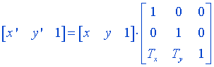
or
Similarly for Rotation transformation, we have
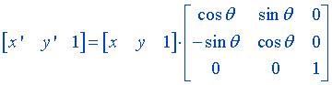
or
Finally for Scaling transformation, we have
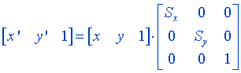
or

2-D Composite Transformation
INTRODUCTION

With the matrix representations of the transformations, we can set up a matrix for any sequence of transformations as a composite transformation matrix by calculating the matrix product of the individual transformations.
If two successive transformations T₁ and T₂ are applied to a coordinate position P, the final transformed location P’ is calculated as:
Where

TRANSLATION

In translation, an object is displayed a given distance and direction from its original position. If the displacement is given by the vector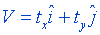the new object point P’(x’,y’) can be found by applying the transformation T_{v} to P(x,y)
where
and
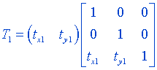

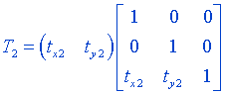
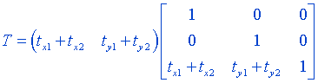

ROTATION

A generalized rotation about an arbitrary point (a,b) can be obtained by performing the following transformations
- Translate the object so that the pivot-point position is moved to coordinate origin.
- Rotate the object about the coordinate origin.
- Translate the object so that the pivot point is returned to its original position.

The composite matrix for this sequence is obtained as:
where,
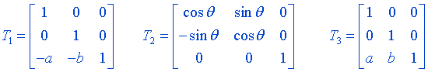
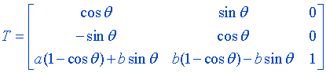
ROTATION

A generalized rotation about an arbitrary point (a,b) can be obtained by performing the following transformations
- Translate the object so that the pivot-point position is moved to coordinate origin.
- Rotate the object about the coordinate origin.
- Translate the object so that the pivot point is returned to its original position.

The composite matrix for this sequence is obtained as:
where,

SCALING

The animation illustrates a transformation sequence to produce scaling with respect to a selected fixed position (a,b) using a scaling function that can only scale relative to the coordinate origin.
- Translate object so that the fixed point coincides with the coordinate origin.
- Scale the object with respect to the coordinate origin.
- Use the inverse translation of step 1 to return the object to its original position.

The composite matrix for this sequence is obtained as:
where,
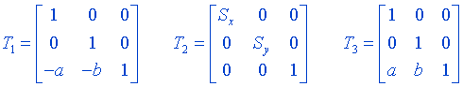
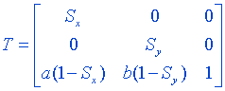

3-D Geometric & Modeling Transformation

TRANSLATION

In three-dimensional homogeneous coordinate representation, when a point P is translated to P’ with coordinated (x,y,z) and (x’,y’,z’) can be represented in matrix form as:

Where,



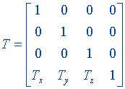

ROTATION

Unlike 2D, rotation in 3D is carried out around any line. The most simple rotations could be around coordinate axis. As in 2D positive rotations produce counter-clockwise rotations.
Rotation in term of general equation is expressed as
Where,
R = Rotation Matrix
Rotation matrix when an object is rotated about X axis can be expressed as:
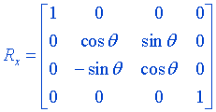

Rotation matrix when an object is rotated about Y axis can be expressed as:
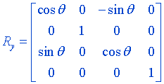

Rotation matrix when an object is rotated about Z axis can be expressed as:
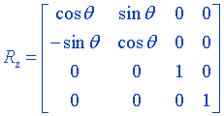

SCALING
Scaling an object in three-dimensional is similar to scaling an object in two-dimensional. Similar to 2D scaling an object tends to change its size and repositions the object relative to the coordinate origin. If the transformation parameter are unequal it leads to deformation of the object by changing its dimensions. The perform uniform scaling the scaling factors should be kept equal
i.e.
Where,
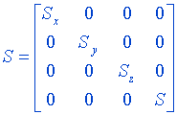
NOTE: A special case of scaling can be represented as reflection.
If the value of Sx, Sy or Sz be replaced by -1 it will return the reflection of the object against the standard plane whose normal would be either x axis, y axis or z axis respectively.
REFLECTION

In 3D-reflection the reflection takes place about a plane whereas 2D reflection it used take place about an axis. The matrix in case of pure reflections, along basic planes, viz. X-Y plane, Y-Z plane and Z-X plane are given below:

Transformation matrix for a reflection through X-Y plane is:

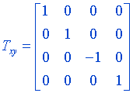
Transformation matrix for a reflection through Y-Z plane is:
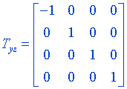

Transformation matrix for a reflection through Z-X plane is:
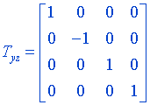

3-D Projections
ORTHOGRAPHIC PROJECTION

The simplest of the Parallel projections is the orthographic projection, commonly used for engineering drawings. They accurately show the correct or true size and shape of single plane face of an object. Orthographic projections are projections onto one of the coordinate planes x=0, y=0, z=0.The matrix for projection onto the z plane is
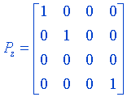
Notice that the third column (the z column) is all zeros. Consequently, the effect of the transformation is to set the z coordinate of a position vector to zero.
Similarly, the matrices for projection on to x=0 and y=0 planes are
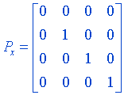
and
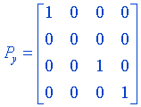

AXONOMETRIC PROJECTION

A single orthographic projection fails to illustrate the general three-dimensional shape of an object. Axonometric projections overcome this limitation. An axonometric projection is constructed by manipulating the object using rotations and translations, such that at least three adjacent faces are shown. The result is then projected from the center of projection at infinity on to one of the coordinate plane unless a face is parallel to the plane of projection, an axonometric projection does not show its true shape. However, the relative lengths of originally parallel lines remain constant, i.e., parallel lines are equally foreshortened.
Foreshortening factor-it is the ratio of the projected length of a line to its true length
Types of axonometric projections —
1.Trimetric
2.Dimetric
3.Isometric
Trimetric projection is the least restrictive and isometric projection is the most restrictive
Trimetric Projection — A trimetric projection is formed by arbitrary rotations in arbitrary order, about any or all of the coordinate axes, followed by parallel projection on to the z=0 plane. The wide variety of trimetric projections precludes giving a general equation for these ratios
For any specific trimetric projection, the foreshortening ratios are obtained by applying transformation matrix to the unit vector along the principal axis specifically,
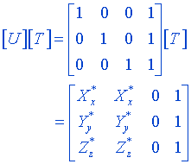
where [U] is the matrix of unit vectors along the untransformed x, y and z axes respectively, and [T] is the concatenated trimetric projection matrix. The foreshortening factors along the projected principal axes are then
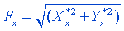
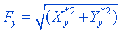
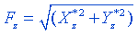

OBLIQUE PROJECTION

oblique projections illustrate the general 3 dimensional shape of the object. However only faces of the object parallel to the plane of projection are shown at there true size and shape, that is angles and lengths are preserved for these faces only. In fact ,the oblique projection of these faces is equivalent to an orthographic front view.
TYPES OF OBLIQUE PROJECTIONS
1.Cavalier
2.Cabinet
Cavalier Projection-A cavalier projection is obtained when the angle between oblique projectors and the plane of projection is 45 degree. In a cavalier projection the foreshortening factors for all three principal direction are equal. The resulting figure appears too thick. A cabinet projection is used to correct this deficiency.
Cabinet projection- An oblique projection for which the foreshortening factor for edges perpendicular to the plane of projection is one half is called a cabinet projection.
STANDARD PERSPECTIVE PROJECTION

A perspective transformation is the transformation from one three space in to another three space. In contrast to the parallel transformation , in perspective transformations parallel lines converge, object size is reduced with increasing distance from the center of projection, and non uniform foreshortening of lines in the object as a function of orientation and the distance of the object from the center of projection occurs. All of these effects laid the depth perception of the human visual system., but the shape of the object is not preserved. Perspective drawings are characterized by perspective foreshortening and vanishing points .Perspective foreshortening is the illusion that object and lengths appear smaller as there distance from the center of projection increases. The illusion that certain sets of parallel lines appear to meet at a point is another feature of perspective drawings. These points are called vanishing points .Principal vanishing points are formed by the apparent intersection of lines parallel to one of the three x,y or z axis. The number of principal vanishing points is determined by the number of principal axes interested by the view plane
Perspective Anomalies
1.Perspective foreshortening- The farther an object is from the center of projection ,the smaller it appears
2.vanishing Points- Projections of lines that are not parallel to the view plane (i.e. lines that are not perpendicular to the view plane normal) appear to meet at some point on the view plane. This point is called the vanishing point. A vanishing point corresponds to every set of parallel lines. Vanishing points corresponding to the three principle directions are referred to as “Principle Vanishing Points (PVPs)”. We can thus have at most three PVPs. If one or more of these are at infinity (that is parallel lines in that direction continue to appear parallel on the projection plane), we get 1 or 2 PVP perspective projection.
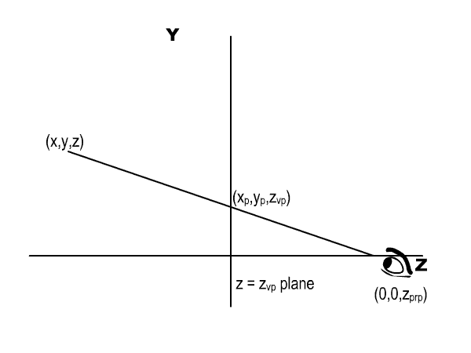
Transformation Matrix for Standard Perspective Projection

View plane at


or
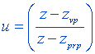
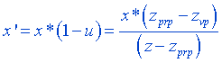
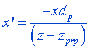

Similarly,
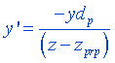

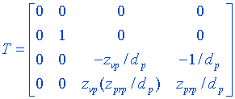

QUESTIONS

1. Explain the database structure for graphics modeling.
2. Explain the 2D transformation.
3. Write in detail about hidden surface removal.
4. Explain the 3D transformation

GEOMETRIC MODELING

{CURVES &SURFACES}

CURVES

INTRODUCTION

A curve segment is a point bounded collection of points whose coordinates are given by continuous, one-parameter, single-valued mathematical functions of the form.
X = x(u) y = y(u) z = z(u)
The parametric value of u is constrained to the interval u Є [0,1]. The curve is bounded between two points at u=0 and the other at u=1.
Any point on the curve can be treated as a component of vector p(u). This p(u) is the vector to the point x(u), y(u), z(u) and p^{u}(u) is the tangent vector to the curve at the same point.
Here
vector components are:
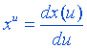
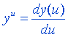
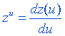
and the tangent vector is:
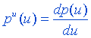
A simple example of parametric equation of a curve would be a set of linear parametric equations above is gives a straight line starting at Point p(0) = [a b c] and ending at point p(1) = [(a + l) (b + m) (c + n)] where a, b, c and l, m, n are constants. The direction cosines of the line would be proportional to l, m, n.

GEOMETRIC CONTINUITY CONDITIONS

An alternate method for joining two successive curve sections is to specify conditions for geometric continuity. In This case, we only require parametric derivatives of the two sections to be proportional to each other at their common boundary instead of equal to each other.
Zero- order geometric continuity, described as G⁰ continuity, is the same as zero- order parametric continuity. That is, the two curves sections must have the same coordinate position at the boundary point. First order geometric continuity, or G¹ continuity, means that the parametric first derivatives are proportional at the intersection on two successive sections. If we denote the parametric position on the curve as P(u), the direction of the tangent vector P’(u), but not necessarily its magnitude, will be the same for two successive curve sections at their joining point under G¹ continuity. Second-order geometric continuity, or G² continuity, means that both the first and second parametric derivatives of the two curve sections are proportional at their boundary. Under G² continuity, curvatures of two curve sections will match at the joining position.
A curve generated with geometric continuity conditions is similar to one generated with parametric continuity, but with slight differences in curve shape. Figure below provides a comparison of geometric and parametric continuity. With geometric continuity, the curve is pulled toward the section with the greater tangent vector.
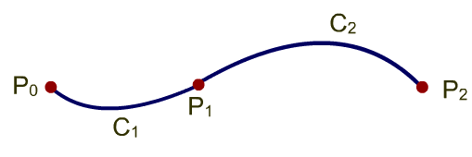
Figure3.1: Curves with C¹ continuity
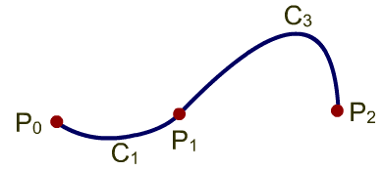
Figure 3.2: Curves with C¹ continuity

SPLINE SPECIFICATIONS
There are three equivalent methods for specifying a particular spline representation: (1) We van state the set of boundary conditions that are imposed on the spline; or (2) we can state the matrix that characterizes the spline; or (3) we can state the set of blending functions (or basis functions) that determine how specified geometric constraints on the curve are calculate positions along the curve path.
To illustrate these three equivalent specifications, suppose we have the following parametric cubic polynomial representation for the x coordinate along the path of a cubic spline section:
Boundary conditions for this curve might be set, for example, on the endpoint coordinates x(0)and x(1) and on the parametric first derivatives at the endpoints x’(0) and x’(1). These four boundary conditions are sufficient to determine the values of the four coefficients a_{x},b_{x},c_{x} and d_{x}.
From the boundary conditions, we can obtain the matrix that characterizes this spline curve by first rewriting Eq. above as the matrix product.
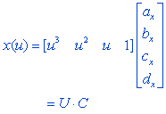
Where U is the row matrix of powers of parameter u, and C is the coefficient column matrix. If x(0), x(1), x’(0) and x’(1) are known using the equation above we can right the boundary conditions in matrix form and solve for the coefficient matrix C as
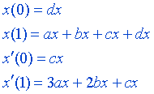
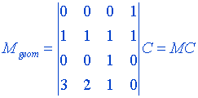

Where is a four-element column matrix containing the geometric constraint values (boundary conditions) on the spline

and C is the 4-by-4 matrix of the polynomial coefficients given by

and M is the matrix of the coefficients in the equation.
The equation x=UC can now be rewritten as follows:
or as
Finally, we can expand equation above to obtain a polynomial representation for coordinate x in terms of the geometric constraint parameters
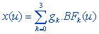
where g_{k} are the constraint parameters, such as the control-point coordinates and slope of the curve at the control points, and BF_{k}(u) are the polynomial blending functions. These blending functions can be written in a matrix form as
where M_{blend} is the set of coefficients of these blending functions. The curve equation can then be expressed as
where B is the matrix of the input points.
In the following sections, we discuss some commonly used splines and their matrix and blending-function specifications.

ALGEBRAIC AND GEOMETRIC FORMS

The Algebraic form of a parametric cubic (pc) curve segment is given by the following three polynomials

A set of 12 constant coefficients are called algebraic coefficients. Each unique set of algebraic coefficient determines a unique pc curve. If two similar curves occupy different positions in space then their algebraic coefficients are different.
The same set of polynomial equation can be written in a compact for as given below:
.......................................................(1.1)
here p(u) is the position vector of any point on the curve, and a₀, a₁, a₂, a₃ are the vector equivalents of the scalar algebraic coefficients. Again the restriction on the parametric variable u is expressed as u Є [0,1].
The geometric form of a pc curve is more convenient way of controlling the shape of a curve in typical modeling situations. For a space curve there are several conditions to choose from: end points coordinates, tangents, curvature, torsion, plus any number of conditions dependent on higher order derivatives.
Therefore by using the equation 1.1 we get:
Where p(0) and p(1) are simply calculated by substituting u with 0 and 1 respectively and p^{u}(0) and p^{u}(1) are calculated by differentiating p(u) with respect to u.
By solving this set of four equations, we can define the algebraic coefficients in terms of the boundary conditions.
On substituting their value in equation 1.1 we get
From the above equation we obtain:
Thus equation 1.2 can be written as:
On dropping the function notation the final equation would look like:
This is the geometric form, and are called geometric coefficients. The F terms are blending functions.
This can be written in the “Standard Geometric Form” as
This form is also the same as the Hermite Splines.

CUBIC SPLINE INTERPOLATION METHODS

This class of spline is most often used to set up paths for object motions or to provide a representation for an existing object or drawing, but interpolation splines are also used sometimes to design object shapes. Cubic polynomials offer a reasonable compromise between flexibility and speed of computation. Compared to higher – order polynomials, cubic splines require less calculations and memory and they are more stable. Compared to lower-order polynomials, cubic splines are more flexible for modeling arbitrary curve shapes.
Given a set of control points, cubic interpolation splines are obtained by fitting the input points with a piecewise cubic polynomial curve that passes through every control point. Suppose we have n+1 control points specified with coordinates
A cubic interpolation fit of these points is illustrated in figure below. We can describe the parametric cubic polynomial that is to be fitted between each pair of control points with the following set of equations:
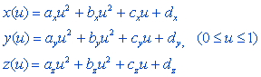
For each of these three equations, we need to determine the values of the four coefficients a, b, c, and d in the polynomial representation for each of the n curve sections between the n+1 control points. We do this by setting enough boundary conditions at the “joints” between curves sections so that we can obtain numerical values for all the coefficients. In the following sections, we discuss common methods for setting the boundary conditions for cubic interpolation splines.
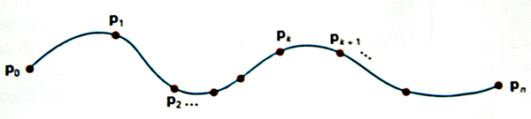

Figure 3.3 Cubic spline interpolations

REPRESENTATION OF CURVES AND SURFACES

A curve or a surface may be described or represented by a set of equations. These equations can be categorized into two forms:

- Generic form

The generic form in which any generic point (x, y, z) satisfies a relationship in implicit form in x, y, and z i.e. f(x, y, z) = 0. A single such constraint generally describes a surface while two constraints considered together can be thought of as a curve which is the intersection of two surfaces. This may be expressed in an explicit form in the following manner:

  - = g¹(y, z)

  - = g²(x, z)

  - = g³(x, y)

- Parametric form

A parametric curve is one whose defining equations are in terms of a simple, common independent variable known as parametric variable.

In the parametric form, the representation is done by a set of functions. A curve may be represented by

- = x (u)

- = y (u)

- = z (u)

where x, y, z are co-ordinates of the points on the curve which are functions of some parameter u and the parametric variable is constrained in the interval. For example, a point (x, y) is located at an angle θ from +X axis on a circle with centre at (0, 0) and radius

- 1 can be described in parametric form as:

  - = Cos θ

  - = Sin θ

where θ is the parameter. Surfaces are described similarly for which x, y and z are functions two independent parameters u and v. Parametric design is very popular in computer aided design for a variety of reasons, which are listed below:

• | Separation of variables
• Each variable is treated alike
• | More degrees of freedom/control
• | Parametric equations can be transformed directly
• | Infinite slopes can be handled without computational breakdown
• Easy to express as vectors
• | Amenable to plotting and digitizing
• | Inherently bounded

DESIGN OF CURVED SHAPES

Design of curved shapes should satisfy the following requirements:

- It should be possible to represent the shape mathematically.

- The modeling should involve minimum computation.

- It should be possible to generate a CNC program to machine the surfaces (2, 3, 4 and 5 axis machining) or to prepare a mould or die to make the part (as in plastic injection molding or casting or automobile panel pressing).

A component can be designed using the curves and shapes which can be mathematically described e.g. arc, circle, conics, ellipsoid, hyperbolic paraboloid, sphere, and cone, cylinder, linear, conical — and circular swept surfaces etc. However very often the designer starts with specifying a few points which roughly describe the shape.

Two approaches are available to designers to model curves and surfaces in such cases: interpolation and approximation. The interpolation essentially tries to pass a curve on a surface called interpolant through all these points. Approximation tries to fit a smoother curve on surface which may be close to these points but may not actually pass through each of them. Fig. 3.4 illustrates the difference between interpolation (a) and approximation (b).

IN TE R PO LATIO N
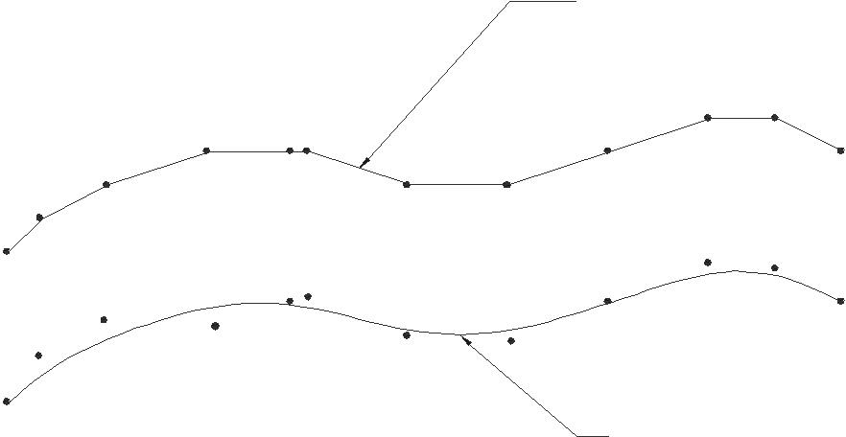

A PPR O XIM ATION

Fig. 3.4 Interpolation and Approximation

One of the popular methods of interpolation is to use the Lagrange polynomial, which is the unique polynomial of degree n passing through n + 1 points. However, Lagrange polynomial is unsuitable in modeling of curves because of:

- Large number of computations involved and

- Tendency for the curve to oscillate between data points when the data points are large.
=
Another approach is to look for a polynomial of fewer degrees than W passing through these W + 1 data points. This is done by combining polynomials of lesser degree passing through several consecutive data points and smoothly piecing several such curve segments together by blending. In general, the modeling of curves is done to satisfy the following:

  - Axis independence

  - Global and local control

  - Smoothness of curves

  - Versatility

  - Continuity between adjoining segments of curve.

HERMITE CUBIC SPLINE

Splines are functions that are used for fitting a curve through a number of data points. A cubic spline has the property that the three co-ordinate functions x (u), y (u), and z (u) are each cubic polynomials in the variable u:

x (u) = a u³ + b u² + c u + d

y (u) = e u³ + f u² + g u + h

z (u) = j u³ + k u² + l u + m

Whereas parametric curves are generally considered to be defined over an infinite range of parameter values of u, it is always necessary to limit these to a finite interval when modeling shapes on a computer. The domain u is, therefore taken as 0 < u < = 1 in the discussion that follows:

A spline passes through two end points and satisfies differentiality condition at these end points. These four conditions require a polynomial degree of at least 3. The derivations of cubic splines for x, y and z are similar. The difference will be only in the end point co-ordinates and derivatives at the end points. Therefore only the derivation of x(u) is considered here.

Let x(0), x(1), x’(0) and x’(1) are the end points and the derivatives at the end points respectively.

Since | x(u) | = | au³ + bu² + cu + d, we get
 | x (0) | = | d
 | x (1) | = | a + b + c + d
 | x’(0) | = | c
 | x’(1) | = | 3a + 2b + c

The above equations can be solved to obtain the four equations given below:

- = 2X(0) – 2X(1) + X’(0) + X’(1)

- = –3X(0) + 3X(1) – 2X’(0) – X’(1)

 |  | c | = | X’(0)
 |  | d | = | X(0)
(or)
 | a |  |  |  | 2 | −2 | 1 | −1 |  |  | x(0)
 | b |  |  |  | −3 | 3 | −2 |  |  |  | x(1)
 | b |  |  |  | −3 | 3 | −2 | −1 |  |  | x(1)
c |  |  | = |  | 0 | 0 | 1 | 0 |  | x’(0)
 | d |  |  |  | 1 | 0 | 0 | 0 |  |  | x’(1)

The coefficients of cubic spline polynomials y(u) and z(u) are similarly obtained by replacing x data by y and z data.

In a vectorial form the parametric cubic curve can be expressed as:

P(u) = au³ + bu² + cu + d

where u∈ (0,1)

P(u) | = | [u³ | u² | u 1] [ a b c d]^{T}
Let U | = | [u³ | u² | u 1] and A = [a b c d]^{T}
P | = | U A

Curves are defined by interpolating points and tangents at these points. The parametric cubic curve can be designed using the four vectors P(0), P(1), P’(0) and P’(1). Each one of these vectors has three components.

P₀ = d

P₁ = a + b + c + d

P’(0) = c

P’(1) = 3a + 2b + c

P = (2u³ –3u² + 1)P₀+ (–2u³ + 3u² )P₁+ (u³– 2u²+u) P’₀+ (u³– u²) P’₁ Let F₁ = 2u³ – 3u² + 1

F₂ = -2u³ + 3u²

F₃ = u³ – 2u² + u F₄ = u³ – u²

then P = F₁ P₀ + F₂ P₁ + F₃ P’ + F₄ P’

Let F = [ F₁ F₂ F₃ F₄ ] and B = [ P₀ P₁ P’₀ P’₁] then P = F B

F₁ , F₂ , F₃ , F₄ , are called blending function or Hermite polynomial basis functions. B is the matrix of geometric coefficients. F is the blending function matrix. The blending function matrix F can be written as the product of two matrices.

 | F | = | U M
Where
 |  |  | 2 |  | − 2 | 1 | 1
 |  |  |  | −3 | 3 | −2
 |  |  |  | −3 | 3 | −2 | −1
 | M = |  |  | 0 | 0 | 1 | 0
 |  |  |  | 1 | 0 | 0 | 0
where M is called universal transformation matrix.
Therefore | P | = | U M B
 | P | = | U A
Hence | A | = | M B
and conversely
 | B = |  | M^{–1} A

where
 | 0 |  | 0 | 0 | 1
 |  | 1 | 1 | 1 | 1
M^{–1} = | 0 |  | 0 | 1 | 0
 |  | 3 | 2 | 1 | 0
For a given set of end points P₀ and P₁ and slopes P’₀ and P’₁ several sets of curves can be generated by varying the magnitude of the tangent vectors. (unit tangent vector t = Pu / |Pu| ).
Figure 6.28 shows a cubic spline connecting four points. There are several other formulations of cubic splines. Ferguson used cubic polynomials for curve and surface design in aircrafts. However, these methods generally suffer from the fact that they do not allow the user to change the smoothness of the curve.

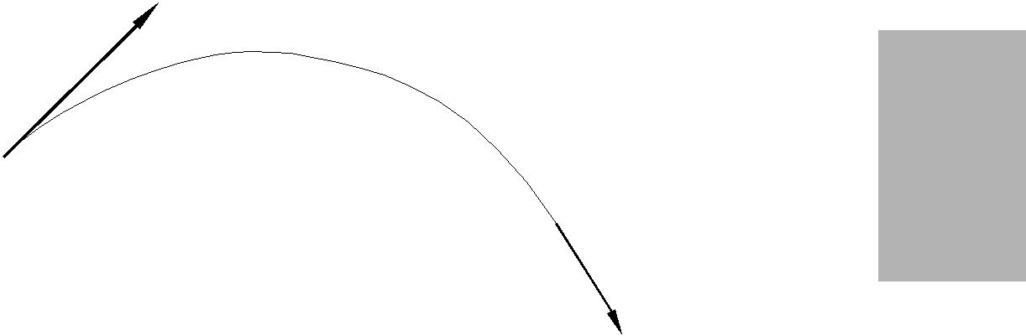
X’(0)

X(0)
X(1)

X’(1)
Fig. 3.5 Cubic Spline

BEZIER CURVES

Bezier curves, developed by P.Bezier at Ranault Automobile Company and P. de Casteljau at Citreon, France are used for curve and surface design of automobile panels. A Bezier curve is blended at the joints and is completely defined by four consecutive points (X0, Y0), (X1,y1), (X2,Y2), (X3,Y3). The curve passes only through the first and fourth point. The two intermediate points are used to define the slope of the curve at the end points. If X0, X1, X2 and X3 are the X- co-ordinates of the control points, it is assumed that :

- The curve passes through the end points X0 and X3

- The slope at the points are:

X’(0) = 3(X1 – X0)

X’(1) = 3(X3– X2)

Using these properties, the coefficients of Bezier curve for x term can be expressed as :

a |  |  | −1 3 |  |  | −3 1 |  |  |  | LX0O
 |  |  |  | 3 | −6 |  | 3 | 0 |  | M | P
 | b |  |  |  |  |  |  |  |  | M^{X1}P
c |  | = | −3 3 |  |  |  | 0 | 0 |  | MX2P
 |  |  |  | 1 | 0 |  | 0 | 0 |  | M | P
 | d |  |  | 1 | 0 |  | 0 | 0 |  | N^{X3}Q
The cubic polynomial x(t) in the Bezier form can be expressed as :

 |  | −1 3 |  |  | −3 1 |  |  |  | LX0O
 |  |  | 3 | −6 |  | 3 | 0 |  | M | P
 | = (u ³ u ² |  |  |  |  |  |  |  | M^{X1}P
x t | = (u ³ u ² | u¹ ) −3 3 |  |  |  | 0 | 0 |  | MX2P
( ) |  |  |  |  |  |  |  |  | M | P
 |  |  | 1 | 0 |  | 0 | 0 |  | M | P
 |  |  | 1 | 0 |  | 0 | 0 |  | N^{X3}Q
The advantages of Bezier curve over cubic spline is that the direction of the curve at the joints can be defined and changed simply by specifying the position of the second and third data points. Changing a control point not only affects the shape of the curve near the control point but has an influence throughout the curve. This lack of local control is a major weakness of Bezier curve. Fig. 3.6 shows Bezier cubic segments for two sets of values of X.

X1 | X3 | X2
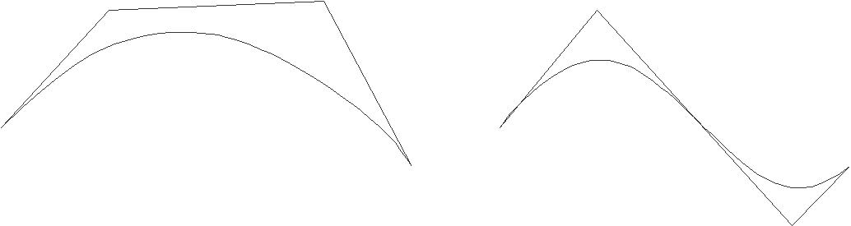

X1 | X1 | X4
X1 | X4
 |  | X3
 | Fig. 3.6 Bezier Curve

The Bezier cubic segment discussed above is a special case of the more general Bezier polynomial curve segment

 |  | 3
u | ) | ₌ ∑P_{i} , B_{i} ,3( u)
P ( | ) | i=0

where u ∈ [0,1]

With blending functions: B_{i,n} (u) = C_{(n,i)} u^{i} (1 – u)^{n-I} where n is the binomial coefficient

C (n i) ,= | n! |  | ( n −1)!
C (n i) ,= | I! |  | ( n −1)!

and p(u) are the control points and there are n+1 of them defining the vertices of the characteristic polygon.

β-SPLINES

This form of cubic segments uses a third set of basis functions different from the types discussed earlier. A cubic β-spline curve is a special case of spline curve. The equation for this curve can be written as:

n
P (u) = ∑ P _{I} N _{I, k} (u)
i=1

u ∈ [0, (n– k + 2)]

This generates what is known as piecewise polynomial. The N(u) blending functions are defined recursively as :

N (u) = | 1 if t_{i} < u < t_{i}+1
= | 0 otherwise
N (u ) = |  | (u —t)N , K (u ) |  | + | (t — u)N , K (u )
N (u ) = |  | t₁ —t |  | + | t₁ —t

The resulting parametric polynomials are of degree (k — 1). The t are called knot values. For an open curve there are

t_{i} | = | 0 | if I < k
t_{i} | = I – k +1 |  | if k ≤ I ≤ n | I ∈ [0, n + k]
t_{i} | = | n – k + 2 | if I > n

The blending functions confine the effects of a control point movement to the immediate locale. Thus the curve change shape is local and not global as it is for Bezier curves.
 | 1 |  | 4 | 1 | 0 |  | ^{x}i−2
 |  | −3 | 0 | 3 | 0 |  |  | ^{x}i−1
x(u) = (1 u u² u³ ) 1/6 |  | 3 | −6 | 3 | 0 |  |  | x_{i}
 |  | −1 3 |  | −3 1 |  |  |  | ^{x}i+1

When the control points are distinct, this curve is continuous in slope and in curvature between successive segments but it does not pass through any of the intermediate control points. The cubic β-spline has the advantage that the control points may be moved without affecting slope and curvature continuity and only four spans of the overall curve will be affected by the change. Moreover, by allowing two control points to coincide it is possible to create a curvature discontinuity. A slope discontinuity, similarly, can be introduced by choosing three successive control points to be coincident.

It is possible to represent complex curve shapes by considering composite curves constructed from individual segments, in the case of cubic spline, Bezier and B-spline techniques.

NURBS AND β-SPLINES

Two important surface representation schemes exist that extend the control of shape beyond movement of control vertices. These are NURBS (Non Uniform Rational β-Splines) and β-splines. In the case of NURBS a local vertex is extended to a four dimensional co-ordinate, the extra parameter being a weight that allows a subtle form of control which is different in effect to moving a control vertex. In the simplest form of β-spline control two global parameters (bias and tension) are introduced which affect the whole curve.

NURBS

A non-uniform β-spline curve is defined on a knot vector where the interior knot spans are not equal. A rational β-spline is defined by a set of four dimensional control points.

P = (W_{i} X_{i} , W_{i} Y_{i} , W_{i} Z_{i} , W_{i} )

The perspective map of such a curve in three dimensional space is called a rational β-spline curve.

 |  | N | w
P(u) = H [∑^{P}i ^{N} I , k ⁽ ^{u)]}
 |  | i=0
 | H | n | P | W | N
P(u) = | H |  | P |  | N | I, K | (u )
P(u) = |  | ∑ i |  |  |  | I, K
 |  | i=0
 | n |  |  |  |  |  | n |  | (u )
= ∑PiWi,K (u ) |  |  |  |  |  | ∑Wi,K |  |  | (u )
 | i=0 |  |  |  |  | i=0
- ∑^{P}i ^{R}i, K (^{u} )
  - =0^{n}

W_{i} associated with each control point is called a weight and can be viewed as an extra shape parameter. Wi affects the curve only locally and can be interpreted geometrically as a coupling factor. The curve is pulled towards a control point if W increases.

β- SPLINES

β- splines are obtained from β-splines by introducing two new degrees of freedom: bias and tension. These can be applied uniformly or non-uniformly.

REPRESENTATION OF SURFACES

A surface can be defined as the locus of points which satisfy a constraint equation in the form of F(X, Y, Z) = 0. In parametric form a surface may be represented as

- = X (u, v)

- = Y (u, v)

- = Z (u, v)

where X, Y and Z are suitable functions of two parameters u and v. For example, the parametric representation of the surface of a sphere whose centre is at the origin of co-ordinates and of radius R is

x | = | X ( , φ) | = R sin φ cos θ
y | = | Y ( , φ) | = R sin φ sin θ
z | = | Z ( , φ) | = R cos φ

DESIGN OF SURFACES

The design of surfaces may be based on quadrics like ellipsoid, hyperboloid, cone, hyperbolic cylinder, parabolic cylinder, elliptic cylinder and elliptic paraboloid. A surface may be generated by sweeping a pattern curve along a spline curve. The swept surface may also be linear, conical linear or circular swept surface.

PARAMETRIC DESIGN OF SURFACES

Parametric surfaces may be defined in one of the following methods:

- In terms of points of data (positions, tangents, normals)

- In terms of data on a number of space curves lying in these surfaces.

Array of data points which may be regarded as defining a series of curves in one parameter direction which in turn are interpolated or approximated in the direction of the other parameter to generate the surface. Fig. 3.7 shows the parameter curves on a surface patch defined by a rectangular array of data points.

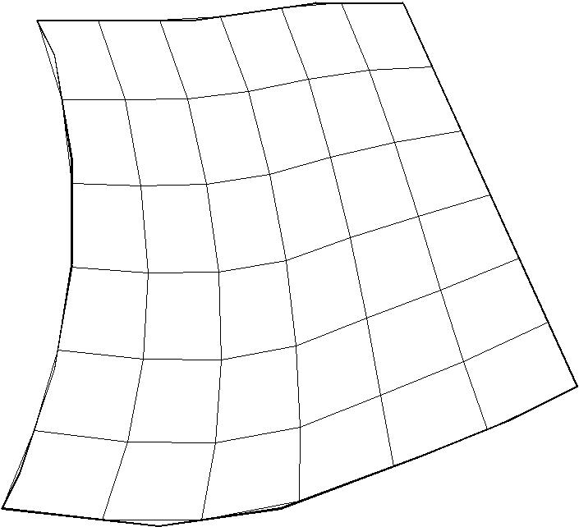

Fig 3.7 A Surface Patch

BICUBIC POLYNOMIAL SURFACE PATCHES

A bicubic polynomial surface can be represented in the form:

r = |  |  | ! a_{ij} |  | v
r = |  | u u u | ! a_{ij}
 |  |  |  | v
 |  |  |  |  |  | !
 |  |  |  | v
where a_{ij} (I, j = 0, 1, 2, 3) is the 4×4 matrix of vector coefficients. A general representation of bicubic surface patch is:

r | = | R (u, v) = U M A M VT
Where M is the basis matrix
U | = | [1 u u² u³]
A | = | ªij

V = [1 v v₂ v₃]

For Coon’s patch, the basis function M is identical to that of cubic spline segment.

 | 1 |  | 0 |  | 0 | 0
 |  | 0 | 1 |  | 0 | 0
M = |  | 0 | 1 |  | 0 | 0
M = | − 3 3 |  |  | − 2 −1
 |  | 2 | − 2 |  | 1 | 1

The vector coefficients for Coon’s patches are given by

 | R(0,0) |  | R(0,1) | R(0,0) | R(0,1)
 |  | R(1,0) | R(1,1) | R(1,0) | R(1,1)
A =
A = |  |  | R(0,1) | R(0,0)
 | R(0,0) |  | R(0,1) | R(0,0) | R(0,1)
 |  | R(1,0) | R(1,1) | R(1,1) | R(1,1)

The position and derivative data on two adjacent corners effectively define not only the edge curve which joins them but also the cross slope at each point on the edge. This makes it possible to combine two or more patches with continuity of position and slope.

BEZIER BICUBIC SURFACE PATCHES

The Bezier bicubic surface patch uses the basis matrix:

 | 1 |  | 0 | 0 | 0
 |  | − 3 | 3 | 0 | 0
M =
M = | − 3 |  | 6 | 3 | 0
 |  | −1 | 3 | −1 | 1

The vector coefficients are given by a 4 × 4 matrix of position vectors for sixteen points forming a characteristic polyhedron. Fig. 6.31 shows the characteristic polyhedron for a Bezier surface. The four corner points R (0,0), R (3,0), R (3,3) and R (0,3) lie at the corners of the surface patch itself whereas remaining points do not lie on the patch. The four points along each edge of the polyhedron define the four edge curves of the patch. The four interior points determine the cross derivatives at the corner and cross slopes along the nearest edges to them.

CUBIC B-SPLINE SURFACES

The basis function for a cubic B-spline surface is the same as that of cubic B-spline curve.

As in the case of B-spline curve, none of the control points forming the characteristic polyhedron lies on the surface.

Composite surfaces can be obtained by combining several surface patches. Table 3.1 gives the properties of the surfaces generated by the common methods.

Table 3.1 Properties of Surfaces Created by Different Methods

 | Method | Property
 | Coon’s patch | Slope and position continuity
 | Bezier Bicubic patch | Position continuity
 | Uniform B-spline | Second order continuity

The surfaces patches described above cover a rectangular domain in u-v space. There are also methods proposed for interpolation on triangular and pentagonal domains.

SURFACE MODELING IN COMMERCIAL DRAFTING AND MODELING SOFTWARE

Surface types available for geometric modeling range from simple planes to complex sculptured surfaces. These surfaces are usually represented on the workstation terminal
as a set of ruled lines. However, computer recognizes these lines as continuous surfaces. Users select surface types from a menu to model individual details or fully envelope parts. Some of the features of surface modeling packages are given below:

SURFACE MODELING COMMANDS

There are a number of commands to create a surface model

- 3-D face: The different faces of an object can be modeled using this command. The X,Y,Z co-ordinates of each vertex are input one after another to model a face and each of the faces is defined one after another in this manner.

- P face: The P-face command produces a general polygon mesh of a arbitrary topology. Using this command, it is possible to avoid defining a single vertex several times as is done in 3-D face command. The user defines all vertices and then defines the faces in terms of the vertices.

- Rulesurf: This command creates a polygon representing the ruled surface between two curves. Figure 3.8 shows an example of ruled surfaces.

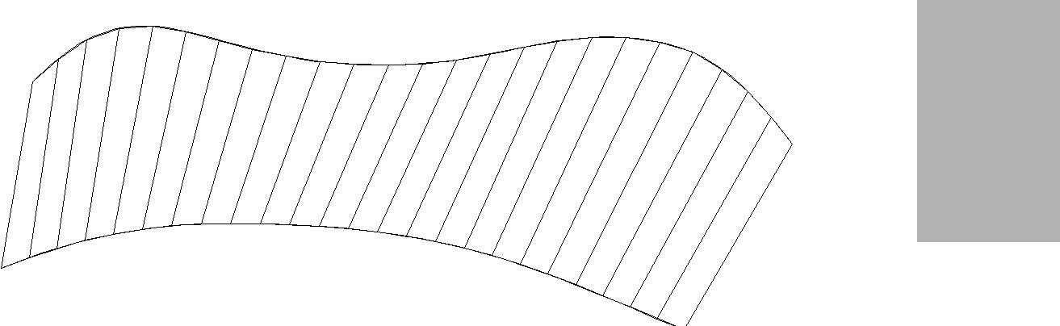

Fig3.8 Ruled Surface

- Tabsurf: A polygon mesh representing general tabulated mesh defined by a path curve and a direction vector (generatrix) is created by this command. Fig. 3.9 shows a typical surface created by this command.

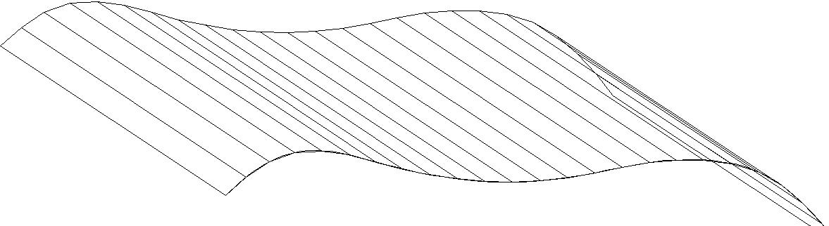

Fig. 3.9 Examples of Tabulated Surface

- Revsurf: A surface of revolution is created by rotating a path curve or profile about an axis. The rotation can be through 360 degrees or part of it.

- Edgesurf: This command constructs a Coon’s surface patch using four adjoining curved edges, an example of edgesurf commands is shown in Fig3.10.

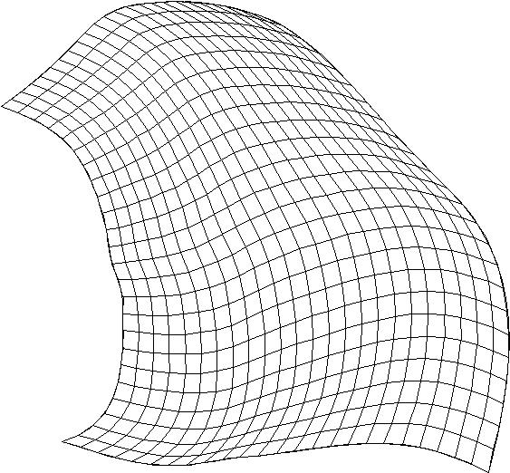

Fig. 3.10 Example of Edge Surface

SURFACE MODELING FACILITIES AVAILABLE IN AN ADVANCED MODELER

An advanced surface modeler helps to design complex sculptured surfaces easily. They provide a number of tools for model creation, shape control and visualization.

- Model creation features for curves and surfaces:

  - Accurate fitting of unevenly spaced points

  - Control over tangency, curvature and inflection

  - Capability of one surface on to another

  - Projection of one surface on to another

  - Offset curves

  - Planar and ruled surfaces

  - Surfaces of revolution

  - Lofting

  - Sweeping

  - Blending

  - Surface created from 3-D digitized points

  - Interpolation of surfaces

  - Offset surfaces

  - Split and merging of surfaces

  - Shape control of surfaces:

Advanced surface modeling softwares make it easy to effect changes in design and shape. They provide what is called variational constraint based shape control. Shape control can be effected through dimensional or geometric constraints and can have tangent associativity. Surface can also be controlled by equations. Advanced energy based shape control helps to:

    - fair curves

    - achieve higher order edge/tangency control

    - introduce local bulges or inflections

    - shape curves locally to fit a specific point

- Visualization:

Surface models have visualization tools for shading, hidden line elimination, creation of perspective views and evaluated surface displays.

  - UNDERSTANDING CURVE AND SURFACE DESIGN

Judicious design of curves and surfaces will make a product visually pleasing. The interactive approach for the design of curves and surfaces is briefly described below:

DESIGN OF CURVES

A curve is drawn through two or more defining points called control points. Every point on a curve has a position, (X, Y and Z co-ordinates), a tangent and a curvature. The tangent determines the direction of the curve at any given point. The internal points their tangents are created and maintained by the design software.

In Fig3.11 a curve is shown to be created using the defining points 1, 2, 3 and 4. The curve passes through the end points 1 and 4 and the direction of the curve and shape of the curve are decided by the tangents and the position of control points 2 and 3. By changing the position of control points, the shape can be changed interactively. The curvature at each point is a measure of how rapidly the curve is changing the direction. General curves have a different curvature value at every point. A curvature plot can be used to evaluate a curve. Fig. 3.12 shows a curvature plot.

2 | END POINT 2 | TANGENT @ 2
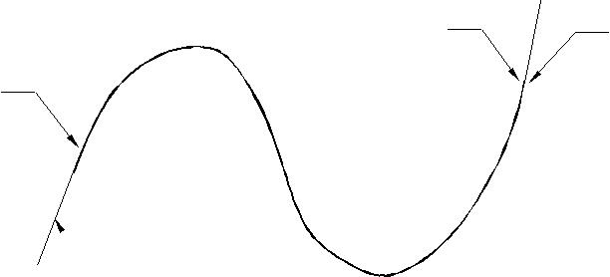
END POINT 1 | 4
 | 1

- TANGENT @ 1

3

Fig3.11 Curve Design
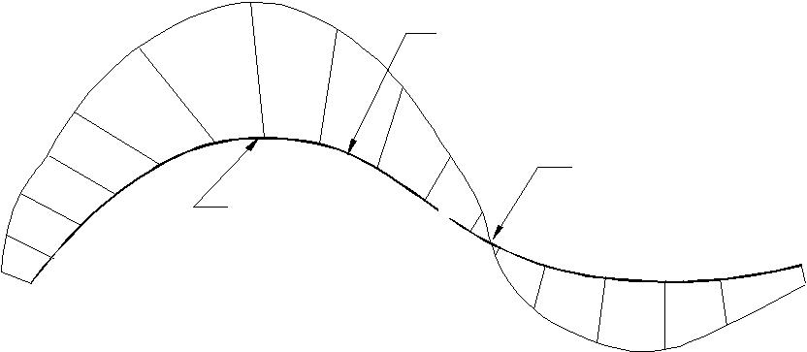

C urve

R egion of low
R egion of high ^{C urvature}
C urvature

Fig. 3.12 Curvature Plot

A complex curve required for a product design is usually a continuous combination of several curve segments. There are three measures of curve continuity. The terms C⁰, C¹ and C² continuity levels are used to describe how curves relate to each other. C⁰ continuity occurs when two C¹ curves meet at their end points but may not share same tangency or curvature. C¹ continuity occurs when two curves have the same tangent at the matched end points. C² continuity is obtained when two C¹ curves have the same curvature at the end point i.e. they have a smooth transition from one curve to another. Fig. 3.13 shows examples for C⁰,C¹ and C² continuity.

T A N G E N T
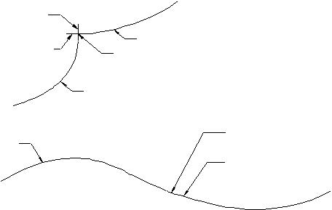
T O C U R V E 1
T A N G E N T T O | C U R V E 2
C U R V E 2 | C U R V E 2 | C ⁰ C o n tin u ity
C U R V E 2 | M E E T IN G | C ⁰ C o n tin u ity
 | P O IN T
 | C U R V E 1
C U R V E 1 |  | M E E T IN G
C U R V E 1 |  | P O IN T
 |  | C U R V E 2
 |  | C ¹ C o n tin u ity

M E E T IN G
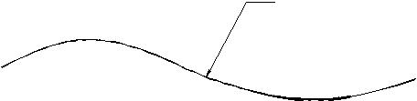
P O IN T

C ² C o n tin u ity

Fig. 3.13 C⁰, C¹ and C² Continuity

SURFACES

Aesthetic curves are the building blocks for pleasing surfaces which are the key to create good products. The curves that define a surface are called boundary curves. While creating surfaces, surface singularities must be avoided. Fig. 3.14 shows how singularity was avoided by over building the top surface and trimming it with a curve on surface. Avoidance of singularity is important to create a surface design which has good manufacturability.

S IN G U L A R
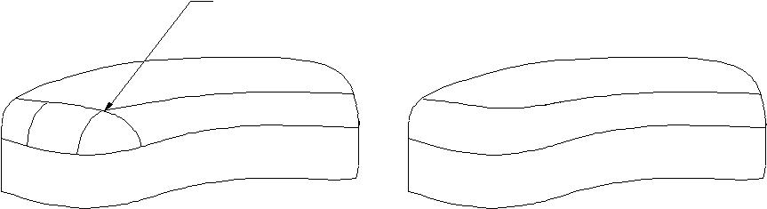
P O IN T

S u rfa c e w ith a | S in g u la r p o in t r e m o v e d w ith
s in g u la r p o in t | c u r v e o n | s u rfa c e a n d
 | trim m in g | a fte rw a r d s

Fig. 3.14 Avoiding Singularity

Surfaces have two sides -—inside as well as outside. Surface normals are helpful to clearly distinguish the orientation of the surfaces. There can be different surface types:

- Rectangular: This type of surface is characterized by four boundary curves. (Fig. 3.15)

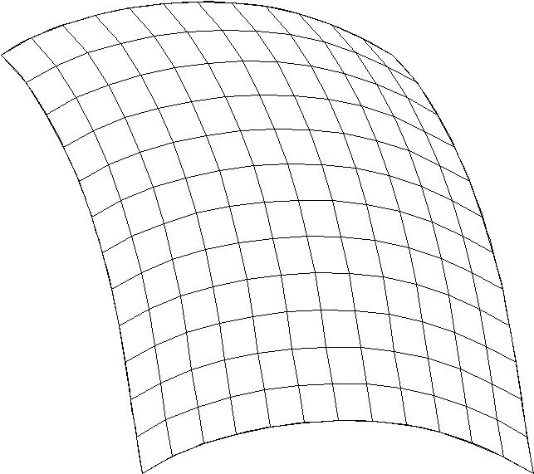

Fig. 3.15 Rectangular Surface

iriangular: A surface defined by three boundary curves (Fig. 3.16)
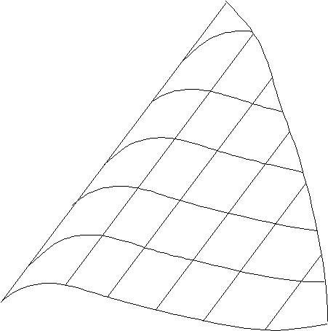

Fig. 3.16 Triangular Surface

i-sided: The surface defined by an arbitrary number of curves (Fig. 3.17)

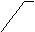edge 1
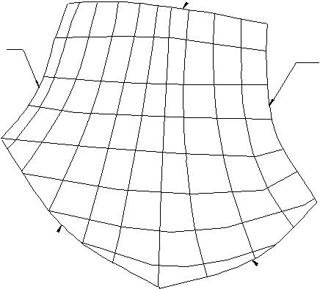
edge 5

edge 2

edge 4

edge 3

Fig. 3.17 N-sided Surface

- Sweep: A surface defined by moving a set of profile curves smoothly along one or two guide curves (Fig. 3.18)
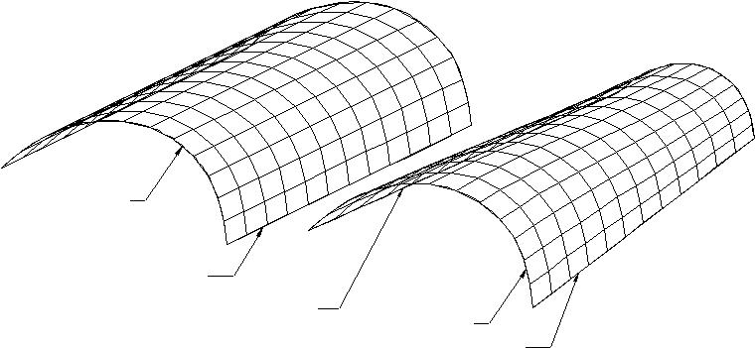

PR O FILE C U R VE

PA TH C U R VE

PA TH C U R VE 1
PR O FILE C U R VE

PA TH C U R VE 2

Fig. 3.18 Sweep Surface

vadius fillet: A blend surface between two sets of surfaces (Fig. 3.19)
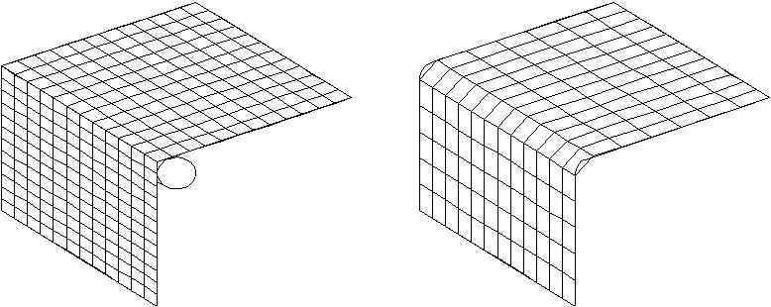

F IL L E T

Fig. 3.19 Fillet Surface
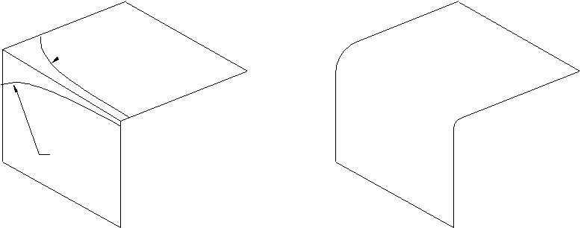

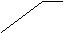BLEND CURVE 1

BLEND

CURVE 2
BLEND

Fig. 3.20 Blend

- Blend: This is a special form of sweep. The guide curves are two curves on surface. The blend allows user to blend the surfaces together or make a variable fillet from their defined curves. This type of fillet (Fig. 3.20)needs a curve on each surface for construction.

- Offset: An offset surface is created by offsetting a surface at a distance from an existing surface. (Fig. 3.21)
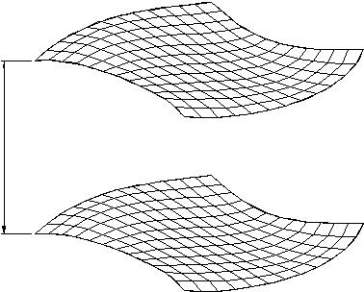

OFFSET 

OFFSET SURFACE

ORIGINAL SURFACE

Fig. 3.21 Offset Surface

EXAMPLES OF OPERATIONS ON SURFACES

Creating a model requires facilities for local modification of surfaces. These facilities are described in the following section:

- Trimming surfaces

A trim is a portion of a surface that can have different attributes. A trimmed surface can be created from an existing surface by specifying a set of curves that partition the original surfaces. Fig. 3.22 shows a trimming operation on a surface.

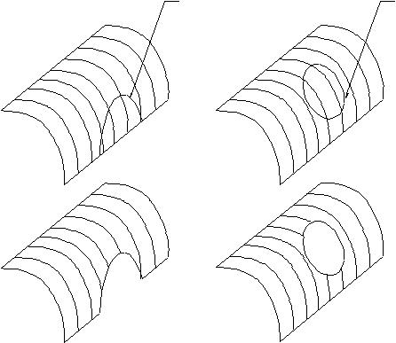
C U R V E O N S U R F A C E C U R V E O N S U R F A C E

Fig. 3.22 Trimming

ilending two surfaces

It is often necessary to blend two curved surface. An example is illustrated in Fig. 3.23.

- Create a surface (shown with patches).

- Create a curve outline using curve on surface (COS) tool.

- Project the curve on to the surface and trim the surface.

- Create one more cross sectional curve for the flare.

- Create the flare surface.

- Blend the two surfaces.
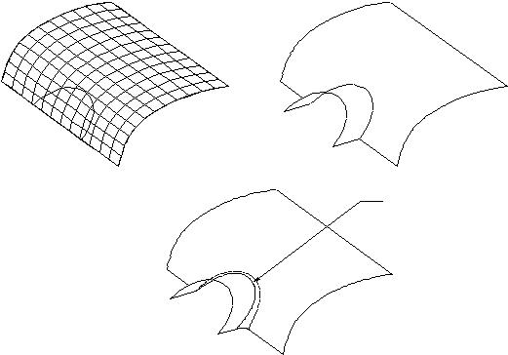

B L E N D

Fig. 3.23 Flare

- Creating a lens hollow on a camera surface

Figure 3.24 shows the surface camera body. It is desired to create a lens hollow. This requires the creation of surfaces that blend smoothly from the main body of the camera into the lens aperture. This can be achieved by creating four curves. An ellipse represents the outer surface of the lens hollow. A circle is to define the geometry of the lens holder. The shape of the connecting surface is defined by two hollow curves. The ellipse and the circle are split at four points. Curves are created the joining the four points on the ellipse and the circle. The tangents are adjusted to make the curves meet the circle and ellipse smoothly. A smooth surface is then created using surface tools.
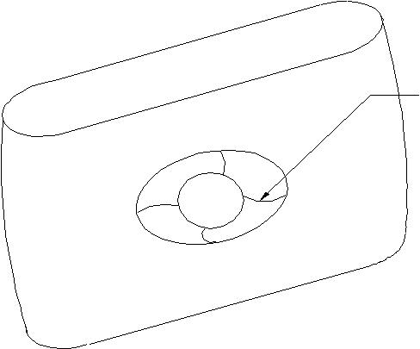

Hollow

Curve

Fig. 3.24 Creation of a Lens Hollow on a Camera Body

- Creating a insert for view finder

A cut out on the camera surface is to be created to locate the view finder. Fig. 3.25 shows the camera body. The cut out is created by a curve on surface (COS) tool.
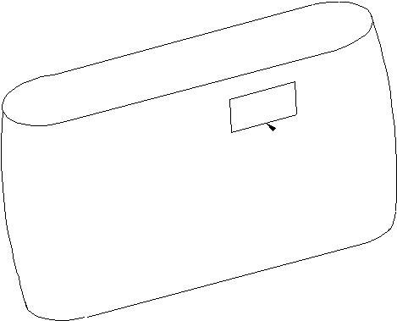

C u rv e o n s u rfa c e

Fig. 3.25 Creating a Cut Out Using a Curve on Surface Tool

CURVE ON SURFACE (Fig3.26)

Curve on a surface (COS) is a special kind of curve. This can be defined by a set of points which are constrained to lie on a surface. COS are very useful in conceptual design because of their use in trimming a surface to blend it with another surface. A COS can be created by:

Projecting a curve on to a surface.

Cutting a planar section through a surface.

Specifying points on a surface through which the curve has to pass through.
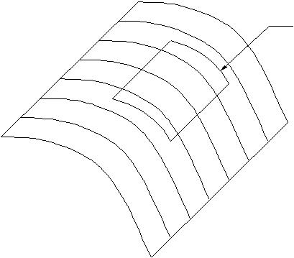

C u r v e o n s u r fa c e

Fig. 3.26 Curve on Surface

MEASURES OF SMOOTHNESS OF SURFACES

As in the case of curves, smoothness of the boundaries of two surfaces can be ensured by three parameters:

- C⁰ continuity means that two surfaces share a common boundary.

- C¹ continuity. In this case the two surfaces blend tangentially across the shared boundary curve.

- C² continuity ensures that the boundary of two surfaces have a curvature continuity in addition to position and tangent continuity.
F
ig. 6.53 illustrates the three measures of continuity of surfaces. It can be seen that C² continuity condition yields smoother surfaces.
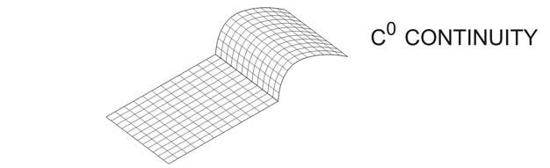

Fig. 3.27 (Contd.)

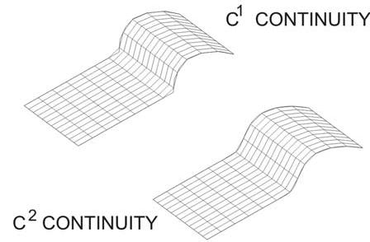

Fig. 3.28 Smoothness of Surfaces

OTHER FEATURES USEFUL FOR CONCEPTUAL DESIGN

In addition to the sketching facilities, additional features are available to enhance design capabilities:

i. | Photo rendering -—Rendering facilitates the evaluation of the model and better | 6
 | communication of design ideas,
ii. | Surfaces can be evaluated by accurate reflections, highlights and shadows.
 | Materials can be applied in the rendering process. Material properties usually
available include transparency, brightness and intensity as well as the basic color definition of hue, saturation and brightness.

DATA TRANSFER TO OTHER SOFTWARES

Once the conceptual design is completed, model data can be transferred to other design softwares directly or using neutral files. Many CAID packages provide direct translators to CAD packages like CATIA, Unigraphics, I-DEAS etc.

BEZIER SURFACES

Two set of orthogonal Bezier curves can be used to design an object surface by specifying by an input mesh of control points. The parametric vector function for the Bezier surface is formed as the Cartesian product of Bezier blending functions:
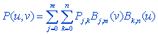
with P_{j,k} specifying the location of a point in the array of (m +1) by (n + 1) control points.
Figure 3.29 below illustrates two Bezier surface plots. The control points are connected by dashed lines, and the solid lines show curves of constant u and constant . Each curve of constant u is plotted by varying over the interval from 0 to 1, with u fixed at one of the values in this unit interval. Curves of
constant are plotted similarly.

.
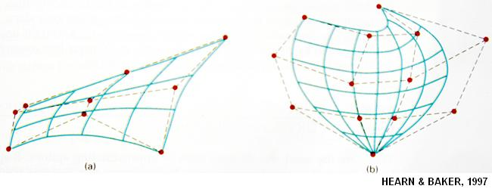
Figure 3.29: Bezier surfaces
Bezier surfaces have the same properties as Bezier curves, and they provide a convenient method for interactive design applications. For each surface patch, we can select a mesh of control points in the xy “ground” plane, then we choose elevations above the ground plane for the z-coordinate values of the control points. Patches can then be pieced together using the boundary constraints.
Figure 2 below illustrates a surface formed with two Bezier sections. As with curves, a smooth transition from one section to the other is assured by establishing both zero and first order continuity. Zero-order continuity is obtained by matching control points at the boundary. First-order continuity is obtained by choosing control points along a straight line across the boundary and by maintaining a constant ratio of collinear line segments for each set of specified control points across section boundaries.
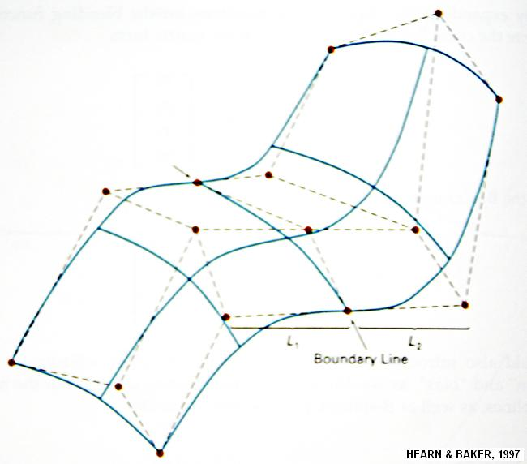
Figure 3.30: Two adjacent Bezier patches with C¹ continuity

B-SPLINE SURFACES

Formulation of a B-spline surface is similar to that for B-splines. We can obtain a vector point function over a B-spline surface using the Cartesian product of B-spline blending functions in the form
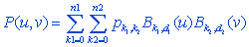
where vector values for p_{k1,k2} specify positions of (n₁ + 1) by (n₂ + 1) control points.
B-Spline surfaces exhibit the same properties as those of their component B-spline curves. A surface can be constructed from selected values for parameters d₁ and d₂ (which determine the polynomial degrees to be used) and from the specified knot vectors in the two directions.

QUADRIC SURFACES

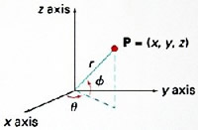A frequently used class of objects is the quadric surfaces, which are described with second -—degree equations (quadratics). They include spheres, ellipsoids, tori, paraboloids, and hyperboloids. Quadric surfaces, particularly spheres and ellipsoids, are common elements of graphics scenes, and they are often available in graphics packages as primitives from which more complex objects can be constructed.
Sphere
In Cartesian coordinates, a spherical surface with radius r centered on the coordinate origin is defined as the set of points (x, y, z) that satisfy the equation
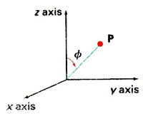
We can also describe the spherical surface in parametric form, using latitude and longitude angles Figure below:

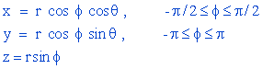

The parametric representation in Equ. Below provide a symmetric range for the angular parameters and alternatively, we could write the parametric equations using standard spherical coordinates, where angle is specified as the colatitudes fig. below. Then is defined over the range , and is often taken in the range . We could also set up the representation using parameters u and v defined over the range from 0 to 1 by substituting and .
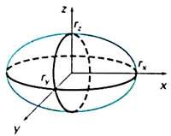Ellipsoid
An ellipsoidal surface can be described as an extension of a spherical surface where the radii in three mutually perpendicular directions can have different values fig. below. The Cartesian representation for points over the surface of an ellipsoid centered on the origin is
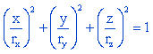
And a parametric representation for the ellipsoid in terms of the latitude angle and the longitude angle in fig. below
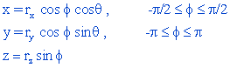

Torus
A torus is a doughnut-shaped object, as shown in fig. below. It can be generated by rotating a circle or other conic about a specified axis. The Cartesian representation for points over the surface of a torus can be written in the form.
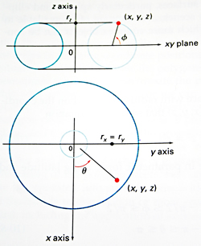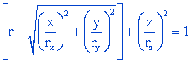
Where r is any given offset value. Parametric representations for a torus are similar to those for an ellipse, except that angle extends over 3600.using latitude and longitude angles and , we can describe the torus surface as the set of points that satisfy
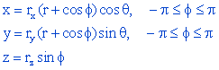

QUESTIONS:
1escribe briefly the following methods of surface modeling with a few application examples:

  - Revsurf

  - Tabcyl

  - Bicubic surface

  - Bezier surface

2.Suggest the procedure that you will adopt to create the following surface geometries:

  - The surfaces of the vanes and inner projections of the shroud of a mixed flow impeller.

  - The surface of a propeller.

xercises

  - Create an assembly of a reduction gearbox and prepare geometric models of individual components.

  - Create a surface model of a mouse.

  - Create a solid model of a bracket and extract plan, elevation, end view and a sectional view, with dimensions.

  - Create a frame type structure in C.I and extract mass properties.

reate a solid model and generate a STEP file. Write a program to extract all flat surfaces and holes. Study typical consumer durable products like electric iron, coffee percolator, water heater etc. and analyze the impact of shape design on their sales appeal. Study the shape of a passenger car and analyze how the blending of various surfaces of body panels is done. Compare the measures of continuity of curves and surfaces.

5tudy typical consumer durable products like electric iron, coffee percolator, water heater etc. and analyze the impact of shape design on their sales appeal.

6tudy the shape of a passenger car and analyze how the blending of various surfaces of body panels is done.

- Compare the measures of continuity of curves and surfaces.
- Explain the hermit cubic curve.
- Explain the Bezier surface.

DRAFTING AND MODELING SYSTEMS

DEFINATION: Drafting is one of the first computer applications used by many users. It refers to the engineering model is communicated for manufacturing or any other application.

BASIC FACILITIES IN AUTOCAD

The release 2000 screen is shown in fig1. This has the familiar windows look and feel, in terms of the various buttons and an easier interface. It has set of dropdown windows for various menu options. From among them:

New: This allows for starting a new drawing.

Open: This allows opening an old drawing for editing.

Save: Allows saving the current drawing.

Save as: Allows saving the current drawing with new name.

Export: Allows for exporting the current drawing into other format. Suitable for other programs such as….3D studio.

Eg:-

BMP: Device-independent bit map.

DWG: AutoCAD drawing file.

DWF: AutoCAD drawing web format.

DXF: AutoCAD R14 drawing inter change.

SCREEN DISPLAY

From fig1.the status line is the bottom most line. On the right side a column is displayed for providing the possible menu selections. The column can be removed from the screen if necessary by changing the option in the AutoCAD set up. At the bottom a command area is provided which is generally designed for three lines. Rest screen is designed as the drawing area.

MENU

AutoCAD is a completely menu driven system. Also no. of menu commands available are many.

Direct command entry.

Through the side bar menu.

Through the pop-up window from the menu bar.

Through the button bars located in any portion of the screen.(fig2)

PLANING FOR A DRAWING

This is carried out by set up operations.

UNITS:

This lets us set up the units in which the AutoCAD would have to work. It would be working in default co-ordinates called as drawing units. This is achieved by using “units” command. [fig3]

It offers following types of units.

 Scientific.
 Decimal.

Engineering.
Architectural.

Fractional.

CO-ORDINATE SYSTEM:

It generally uses the rectangular Cartesian co-ordinate system which follows right hand rule. It also uses rectangular co-ordinate system designed as x, y, & z axis. Co-ordinates can be imputed into the system in a no of ways by direct input of co-ordinate values in their respective order.

COMMAND: LINE<LR>

FROM POINT: 3.5, 12.0<LR>

CR: Carriage return.

Fig: 4 show the co-ordinate being given in absolute system.

LIMITS:

It is normally necessary to specify the limits of the drawing that one is about to use. The actual size of drawing would have to be specified using limit command.

Limits establishes the size of the drawing and the associated drawing guide such as grids, rullers etc……in proper format.

However, limits check option is kept on, and then AutoCAD would not allow you to specify any point beyond the limits.

GRID:

Working on a plane drawing area s difficult since there is no means for the user to understand or correlate the relative position or straightness of the various objects or entities made in the drawing. The grid command controls the display of a grid of alignment to assist the placement of objects in the drawing.

SNAP:

The resolution of the cursor can be effectively controlled by using SNAP command. When the cursor is moving in the drawing area, it moves in increments of the snap spacing value specified. This is useful for inputting data through the digester or mouse.

Functional key: F9

ORTHO:

It allows to control “orthogonal” drawing mode. As a result all lines and traces drawn while this mode is on are constrained to be horizontal or vertical.

Functional key: F8

HELP:

AutoCAD provides complete help at any point of working in the program.

OBJECT PROPERTIES:

LINE TYPE:

AutoCAD allows the user to draw various types of lines in the drawing. To change the line type of existing object, use the “CHANGE “command. To control large line type use “LAYER” command. It can also load line type definitions from a library file.

BASIC GEOMETRIC COMMANDS

The various entities that can be used for making an AutoCAD drawing in 2D are:
- POINT

- LINE

- ARC

- CIRCLE

- ELLIPSE

- POLYGON

- POLYLINE

- DOUGH NUT

- SKETCH

- TEXT

- BLOCK

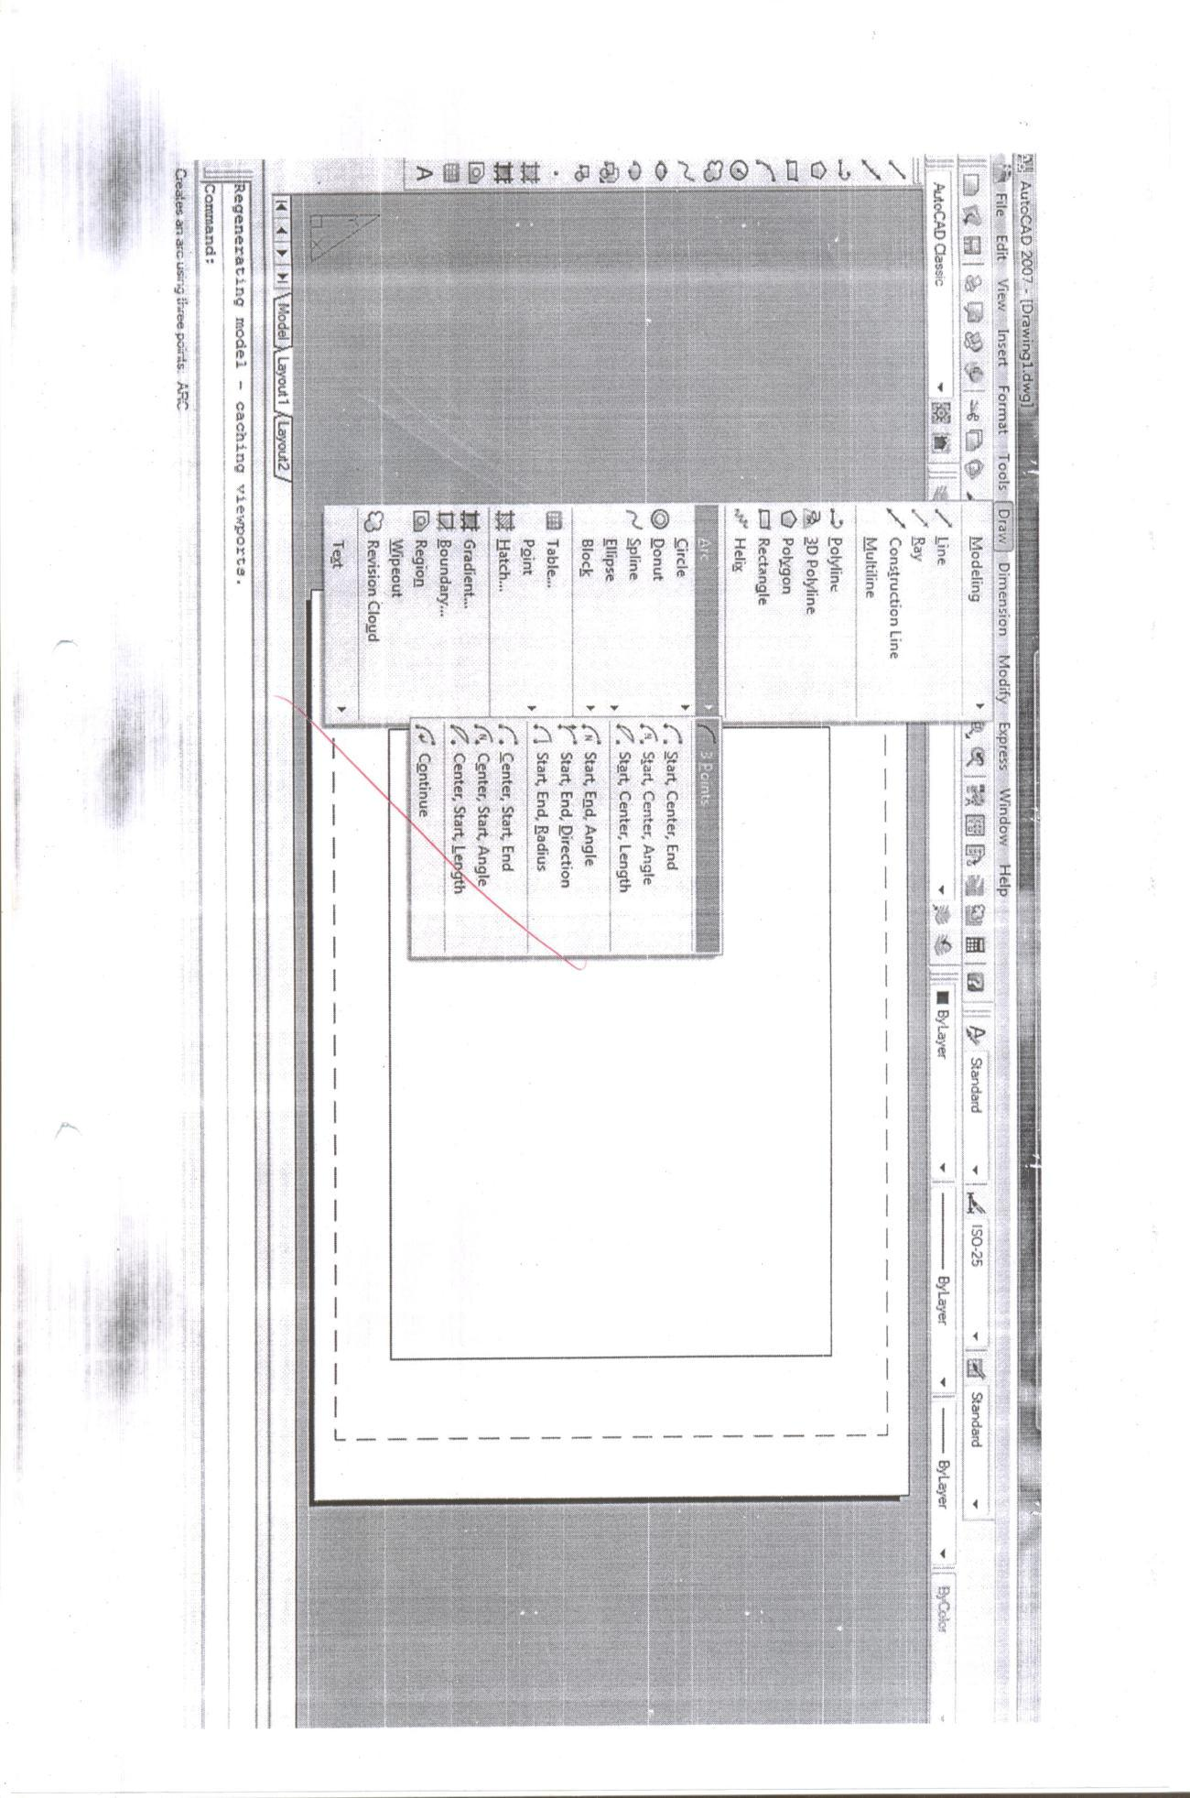

POINT:

It is used to specify a point or a node in the drawing for any given purpose. It is also used as NODE in object snap option.

It is also possible to specify the co-ordinates in incremental format as the distance from the current cursor position in the drawing area. The distance is specified by using the “@” parameter before the actual value.

COMMAND: POINT<CR>

Co-ordinates of point: @34.5, 12.0<CR>

LINE:

It allows you to draw straight line. You can specify the desired end points using either 2D or 3D co-ordinates. To erase the latest line segment without exiting the line command enters

“U”.

Lines may be constrained to horizontal or vertical by the “ORTHO” command. The close option uses the start point of the first line in the current line command.

CIRCLE:

It is used to draw a full circle. We can specify a circle in many ways. For specifying the circle we need at least two values.
- Centre point and radius.

- Centre point and diameter.

- 2p\3p\ttr methods.

ARC:

It enables to draw an arc as specified by following methods.
- Three points on the arc.

- Start point, centre and end point.

- Start, centre and included angle.

- Start, centre and length of chord.

- Start, end and radius.

- Start, end and included angle.

- Start, end and direction of start.

The arc is always drawn in counter clock wise direction. Depending on the data available it is necessary to plan carefully the sequence in which the data is specified.

LAYERS
A layer is basically one which contains some information which can be geometric or alpha-numeric. The reason of distributes all the information present in the drawing into various layers is that at any given time some of the layers can be deleted from the view(off) or can be made visible(on). This helps in organizing the information in a drawing. Thus each layer may be considered as a transparent sheet having some information.
- Each layer has a name which can be up to 31 characters.

- Default layer name given by AutoCAD is 0.

- A layer could be ON or OFF. When a layer is ON the information present in it would be visible on screen.

- layer is either “current or inactive”.

- If the current layer is ON then the information being entered would be visible on screen.

- Each layer has a colour associated with it. The colour of individual information can be altered by using “CHANGE” command or by using “COLOR” command.

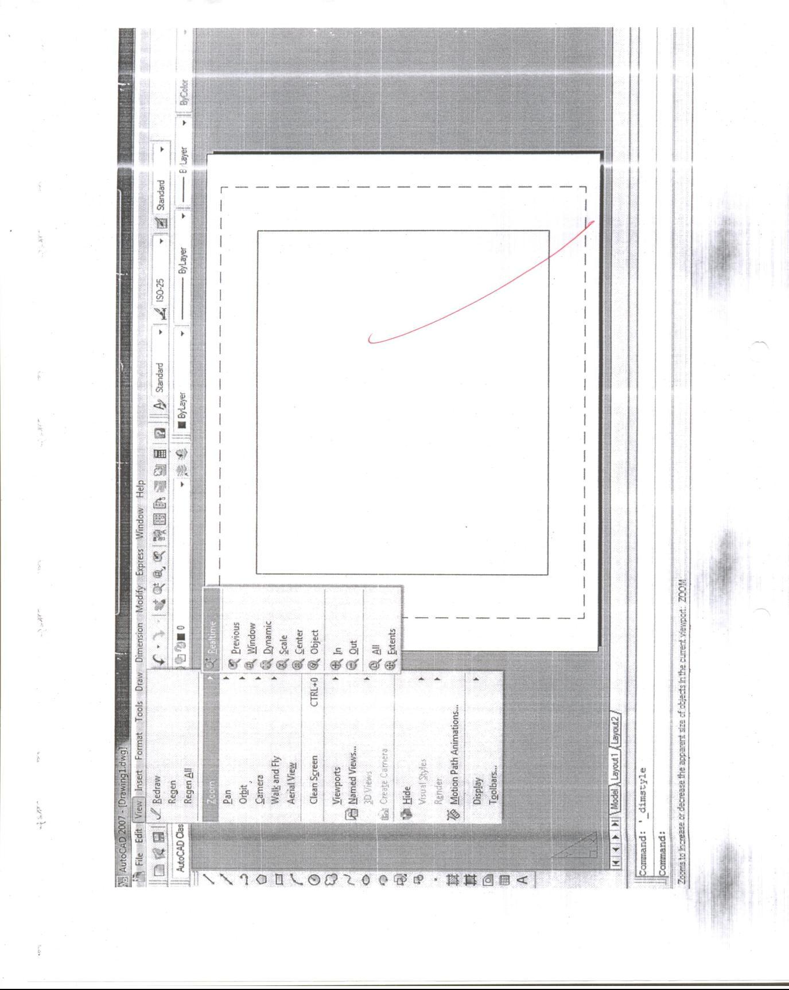
DISPLAY CONTROL COMMAND

ZOOM:

Zoom is used to change the scale of display. This can be used to magnify a part of the drawing to any higher scale of or closely observing some file details in the drawing. There are no. of options available within zoom.

SCALE<X>: A numeric zoom factor. A value less than 1 zoom out and greater than 1 zoom in.

ALL : Zoom out to original drawing limits.

DYNAMIC: Graphically selects any portion of the drawing as your next screen view.

CENTRE | : Pick a centre and picture top and bottom by selecting two end points of height.
EXTENTS: Shows everything in the file.
LEFT | : Pick a lower left corner and a height of how much drawing information you want to
 | Display to fill up the screen.

PREVIOUS: Restores the last zoom setting.

Choosing the dynamic option displays all the drawing up to limits in a small window. So that the entire drawing is visible in the display screen. The current visible window would be shown in rectangular linked to the cursor.

PAN:

It allows you to move the display window in any direction without changing the display magnification. This means the display being seen is through a window in an opaque sheet covering the drawing limits.

OBJECT SNAP:

By selecting the OSNAP option the system would be able to automatically calculate the tangent point in the region selected. The various OSANP options are as follows…..

CENTRE: center or arc or circle

ENDPOINT: closest end point if line/arc etc….

INSERTION: insertion point of text/block etc…

INTERSECTION: intersection of lines/arcs/circles etc…

MIDPOINT: midpoint of lines/arcs/circles etc…

NEAREST: nearest point on line/arc/circle.

NODE: nearest point entity.

PERPENDICULAR: perpendicular to line/arc/circle.

QUADRANT: quadrant point of arc or circle.

TANGENT: tangent to arc or circle.

TEXT HANDLING:

AutoCAD provides a large range of text entering capabilities including various fonts and other text handling features.

EDITING A DRAWING

Editing capabilities are the most useful part of AutoCAD to export the productivity potential, making use of the already existing objects in the drawing.

ARRAY: places multiple copies of objects with a single command.

BREAK: cuts existing objects and /or erase portions of objects.

CHANGE: Changes spatial properties of some objects.

COPY: makes copies of objects.

ERASE: Allows selecting objects in the drawing file and erasing them.

MIRROR: creates a mirror image.

MOVE: picks up existing objects and puts them in another location of drawing.

ROTATE: Turns existing object to any angular position.

SCALE: Scales object up or down to your specification.

MOVE:

It is used to move one or more existing drawing entities from one location to another location. You can draw the object into position on the screen by giving base point and second point. The selected objects will follow the movements of the screen crosshair.

OBJECT: the default selects a set by picking individual objects.

WINDOW: objects are completely inside a window drawn by the cursor control device.

LAST: uses only the last object created.

CROSSING: works like a window, it also includes any object which is partially within the

Window.

REMOVE: it removes any objects that are accidentally selected by any of the object.

ADD: used o adding when the remove option is specified.

MULTIPLE: allows multiple objects in close proximity.

PREVIOUS: adds the entire previous selection list to the current selection list.

UNDO: undo the last selection operation.

SELECT ALL: selects all objects in drawing.

WINDOW POLYGON: Here, rectangular window is replaced by polygon of as many vertices as

Required.

CROSSING POLYGON: similar to the window polygon except that the polygon here is not

Would be selected.

COPY:

This command is used to duplicate one or more existing drawing entities at another location without erasing original. You can drag the object into position on the screen. The selected object will follow the movements of the screen cross hairs.

To make multiple copies, respond to the base point prompt with „M‟. when you have made required number of copies give a null response to the second point prompt to come out of the copy command.

CHAMFER:

It creates a bevel between two intersecting lines at a given distance from their intersection. It can also trim the lines from the bevel edge and connect the trimmed ends with a new line of TRIMMODE variable is set to 1. Chamfer can only be applied between line segments and not any other objects.

FILLET:

It connects two lines, arcs, or circles with a smooth curve of specified radius. It adjusts the length of the original line or arcs so they end exactly on the fillet arc. The fillet valve specified remains in force until it is altered by another valve. If the fillet radius is „0‟ then two lines will meet exactly at a point which is normally used to make a sharp corner.

Filleting can also be done to two circles, a line and a circle, a line and an arc and a circle and an arc.

OFFSET:

This command constructs an entity parallel to another entity at either a specified point. You can OFFSET a line, arc, circle or polygon. Offset lines are parallel, while the offset circles and arcs make concentric circles. Once object is selected it is highlighter on the screen.

Side to offset:

Through point:

The selected object will be de highlighted and the “select object to offset”.

ARRAY:

It makes multiple copies of selected objects in a rectangular or polar pattern.

For a rectangular array you are asked for the no. of columns & rows and the spacing between them. The array is built along a base line defined by the current snap rotation angle set by the “SNAP ROTATE” command.

For polar array a centre point needs to be supplied. Following this, you must supply two of following…
- The number of items in the array.

- The number of degrees to fill

- The angle between items in the array.

DIMENSIONING

After creating the various views of the model or after preparing the drawing it is necessary to add dimensions at the appropriate places. AutoCAD provides semi automatic dimensions. As a result once dimensions is created. AutoCAD gives great control over the way dimensions may appear in the drawing. The dimension familiars are as follows…
- Linear

- Diameter

- Radial

- Angular

- Ordinate

- Leader

- Aligned

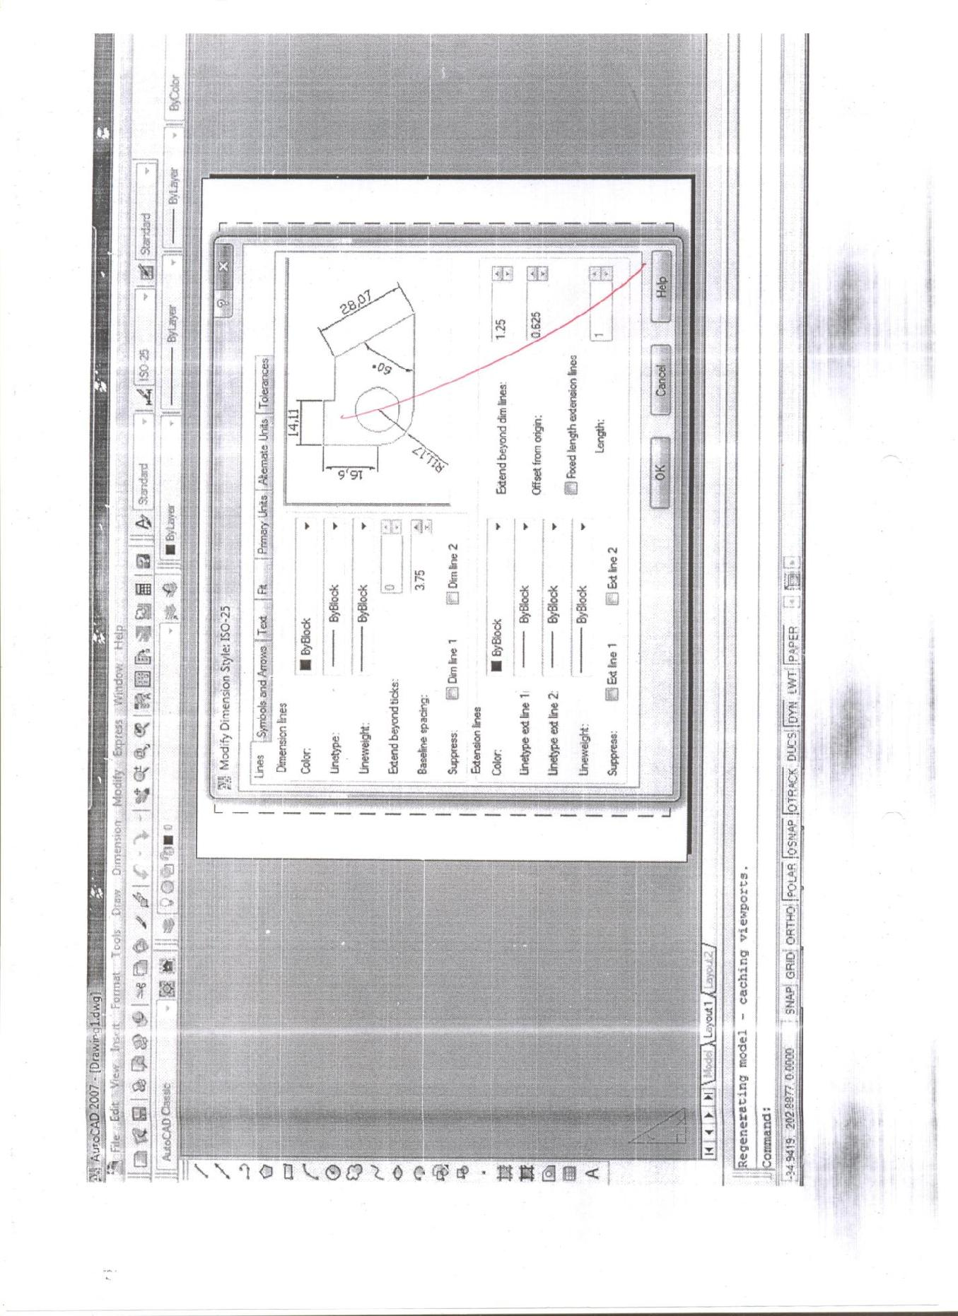

3D- MODELING

Creates 3D polygon mesh objects in common geometric shapes that can be hidden, shaded, or rendered.

Command entry: 3d

Enter an option

[Box/Cone/DIsh/DOme/Mesh/Pyramid/Sphere/Torus/Wedge]:

1.BOX

Creates a 3D box polygon mesh.

Specify corner point of box:

Specify length of box: Specify a distance

Specify width of box or [Cube]: Specify a distance or enter C
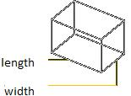

Width

Specifies the width of the box.

Enter a distance or specify a point relative to the corner point of the box
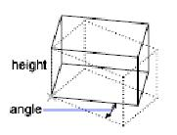

.

Specify height of box: Specify a distance

Specify rotation angle of box about the Z axis or [Reference]: Specify an angle or enter r

Rotation Angle Rotates the box about the first corner specified. If you enter 0, the box remains orthogonal to the current X and Y axes.

Reference Aligns the box with other objects in the drawing or relative to an angle you specify. The base point for the rotation is the first corner of the box.Specify the reference angle <0>:

Specify a point, enter an angle, or press Enter

You can define a reference angle by specifying two points or an angle from the X axis on the XY plane. For example, you can rotate the box to align two specified points on the box with a point on another object. After defining a reference angle, specify a point for the reference angle to align with. The box then rotates around the first corner relative to the angle of rotation specified for the reference angle.

If you enter 0 as a reference angle, the new angle alone determines the rotation

of the box.

Specify the new angle: Specify a point or enter an angle

To specify the new angle of rotation, specify a point relative to the base point. The base point for the rotation is the first corner of the box. The box rotates by the angle between the reference angle and the new angle.

If you want to align the box with another object, specify two points on the target object to

define the new angle of rotation for the box. If the reference angle of rotation is 0, the box rotates the angular distance entered relative to the first corner of the box.

2.CUBE

Creates a cube using the length for the width and height of the box.
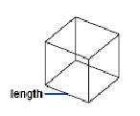

Specify rotation angle of box about the Z axis or [Reference]: Specify an angle or enter r

Rotation Angle Rotates the cube about the first corner of the box. If you enter 0, the box remains orthogonal to the current X and Y axes.

Reference Aligns the box with other objects in the drawing or relative to an angle you specify. The base point for the rotation is the first corner of the box.

Specify the reference angle <0>: Specify a point, enter an angle, or press Enter

You can define a reference angle by specifying two points or an angle from the X axis on the XY plane. For example, you can rotate the box to align two specified points on the box with a point on another object.

After defining a reference angle, specify a point for the reference angle to align with. The box then rotates around the first corner relative to the angle of rotation specified

for the reference angle. If you enter 0 as a reference angle, the new angle alone determines the rotation of the box.

Specify the new angle: Specify a point or enter an angle

To specify the new angle of rotation, specify a point relative to the base point. The base point for the rotation is the first corner of the box. The box rotates the angular distance between the reference angle and the new angle. If you want to align the box with another object, specify two points on the target object to define the new angle of rotation for the box. If the reference angle of rotation is 0, the box rotates the angular distance entered relative to the first corner point of the box.

3.CONE
Creates a cone-shaped polygon mesh.

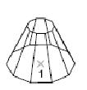

Specify center point for base of cone: Specify a point (1)

Specify radius for base of cone or [Diameter]: Specify a distance or enter d

Radius for Base

Defines the base of the cone by its radius.

Specify radius for top of cone or [Diameter] <0>: Specify a distance, enter d, or press Enter

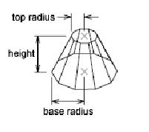

Radius for Top Defines the top of the cone by its radius. A value of 0 produces a cone. A value greater than 0 produces a truncated cone.

Specify height of cone: Specify a distance

Enter number of segments for surface of cone <16>: Enter a value greater than 1 or press Enter

Diameter for Top Defines the top of the cone by its diameter. A value of 0 produces a cone. A value greater than 0 produces a truncated cone.

Specify diameter for top of cone <0>: Specify a distance or press Enter Specify height of cone: Specify a distance

Enter number of segments for surface of cone <16>: Enter a value greater than 1 or press Enter

Diameter for Base

Defines the base of the cone by its diameter.

Specify diameter for base of cone: Specify a distance

Specify radius for top of cone or [Diameter] <0>: Specify a distance, enter d, or press Enter

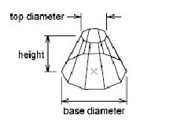

Radius for Top Defines the top of the cone by its radius. A value of 0 produces a cone. A value greater than 0 produces a truncated cone.

Specify height of cone: Specify a distance

Enter number of segments for surface of cone <16>: Enter a value greater than 1 or press Enter

Diameter for Top Defines the top of the cone by its diameter. A value of 0 produces a cone. A value greater than 0 produces a truncated cone.

Specify diameter for top of cone <0>: Specify a distance

Specify height of cone: Specify a distance

Enter number of segments for surface of cone <16>: Enter a value greater than 1 or press Enter

4.PYRAMID

Creates a pyramid or a tetrahedron.

Specify first corner point for base of pyramid: Specify a point (1)

Specify second corner point for base of pyramid: Specify a point (2)

Specify third corner point for base of pyramid: Specify a point (3)

Specify fourth corner point for base of pyramid or [Tetrahedron]: Specify a point (4) or enter t

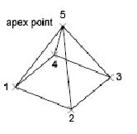

Fourth Corner Point

Defines the fourth corner point of the base of a pyramid.

Specify apex point of pyramid or [Ridge/Top]: Specify a point (5) or enter an option.

The Z value of the point specified determines the height for the pyramid'’ apex, top, or ridge line.

Apex Point Defines the top of the pyramid as a point (apex).

Ridge Defines the top of the pyramid as a ridge line. The two endpoints must lie in the same direction as the base points to prevent a self-intersecting wireframe.

Specify first ridge end point of pyramid: Specify a point (1)

Specify second ridge end point of pyramid: Specify a point (2)

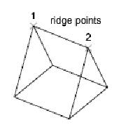

Top Defines the top of the pyramid as a rectangle. If the top points cross, they create a self-intersecting polygon mesh.

Specify first corner point for top of pyramid: Specify a point

Specify second corner point for top of pyramid: Specify a point

Specify third corner point for top of pyramid: Specify a point

Specify fourth corner point for top of pyramid: Specify a point

SOLID MODEL BASED ASSEMBLY DESIGN

Once components are created as solid models, assembly software enables the designer to create a complete software mock up of the product. Assembly software is an interactive tool for creating and manipulating large mechanical assemblies. This software helps to position a part relative to the other using intuitive positing and mating relationships which define the design intent. Design changes to any part navigate through the entire assembly, dynamically updating part and subassembly positions. Positioning relationships include face-to-face and edge-to-edge commands making it easy to specify mating, alignment, and offset, and insertion, parallel and angular relationships among parts.

A top down approach is used in assembly design. The design leader can layout and plan assembly and create a product structure for the entire team. The product structure is associative to assembly geometry and remains accessible to the project team. Outline geometry and spatial envelopes to a subassembly or part can be defined and included in the hierarchy.

As and when the design team details designs of parts these designs are included in the assembly in the place of spatial envelopes. The design gradually growns in complexity while maintaining the spatial constraints defined earlier. Throughout the design process, multiple users can access the assembly design. The design and data management capabilities of the assembly software provides a design check out and referencing system for multiple users. Changes can be communicated not only to members of the design team but also to other product assemblies which use them.

Assembly design software provides other facilities too. The designer can track part numbers, part names, revisions and versions easily. In fact, versions can be assigned automatically as design changes. In order to create Bill of Materials (BOM), BOM attributes can be added to part or assembly. When parts are revised, the assemblies which use these parts are modified automatically. When assembly or parts within assembly change associated drawings created by the drafting software are automatically updated.
Assembly design software is a powerful tool for design evaluation. Since parts are designed in solid models the design can carry out checks for interference between mating parts and subassemblies. It is also possible to animate kinematic assemblies to evaluate how mechanisms work. Since variational geometry is used, the designer can vary the dimensions of the links to study the impact of design changes and articulate the mechanism in real time.

Assembly level mass and inertial properties can also be calculated. The rendering capabilities available in the modeling package enable true to life presentation of the assembly to management, marketing, manufacturing, purchase and other downstream users for review. Their feedback will be useful to avoid costly design changes at the end of product development cycle.

SOLID MODEL BASED DRAFTING

The drafting process creates production drawings. When solid model based design is followed, the production drawings can be generated from the solid model itself. Some drafting systems allow either a single user or dual user. In the single user mode, the entire design/ drafting job is done by a single designer by creating a design with solid or assembly modeler and documenting that model using the drafting module. Bi-directional associativity helps to make changes to the solid model by incorporating a change in the detail drawing. The dual user approach is suitable for organizations where design and drafting tasks are carried out by separate persons. This mode of work enables the draftsman to begin his work even before the designer completes his design. Concurrent associativity allows the drawing to be updated while maintaining design change control with the design engineer. Drafting module provides the following additional facilities also:

- Set up and create associative single or multiple cross sections through parts with automatic cross hatching

- Associative detail views can be added

- Make first angle or third angle projections, isometric, auxiliary or true projections

- Multiple view of one or more drawings can be placed on one drawing or multiple drawings

- Automatic removal or display of hidden line by dashed lines

- Border, title block or the necessary drawing format can be added

- Different layers for different parts of the drawing can be specified.

Many solid modeling packages provide exhaustive symbol libraries or facilities to create symbols which expedite detailing of drawings. A variety of dimensioning techniques are available. Dimensioning can be automatic or a dynamic navigation style with user interaction can be adopted. In the latter, as the draftsman traverses the drawing, the geometry entities are highlighted. Appropriate icons are displayed next to the curser that represent the dimensions. These dimensions can be added simply by picking with the cursor. Dimensioning supports ANSI, ISO, DIN, BIS and JIS. Geometric dimensioning and
tolerancing methods are also available in the package. Provision for adding text or annotations in different languages is also available. Another facility available is the associative cross hatching facility with ability to recognize internal holes and islands.

Another feature of a drafting module is the dynamic Bill of Materials that automatically updates when changes are made to the drawing. This ensures that BOM accurately reflects the data of the drawing.

In addition to the above the drafting module includes integrated drawing management capabilities. Some of these capabilities are listed below:

- Lists the solid model associated with the part drawing

- Lists all drawings associated with a model

- Searches for a drawing by name, number or the draftsman

- Stores the drawings in libraries

- Retrieve drawings

- Tracks drawing stage (in-design, check, released etc)

- Tracks revisions and versions

- Compiles total time spent on a drawing

- Tracks drawings read from STEP, IGES and DXF files

- Creates of engineering change order

- Provides project configurations

Drafting modules associated with solid modeling packages can also be used for stand alone drafting. The features of a drafting package are discussed in a subsequent section in this chapter.

SOLID MODEL BASED MECHANISM DESIGN

Solid model based kinematic analysis can be used to determine complex motions of mechanisms. A mechanical design software is used for this purpose. Mechanism models are defined directly on the assembly model geometry. Rigid models are defined directly on the assembly model geometry. Rigid bodies are automatically understood and joints and constraints are defined simply by selecting appropriate locations on the assembly. Motions of mechanisms and loads are defined using a forms based user interface and can be defined by mathematical expressions or sketches. All solid geometry and inertia properties can be accessed from the assembly design. Mechanism design capabilities include the following :

Joint definition

Revolve

Universal

Planar

General (screw, rack & pinion)

Ball

Translational

Cylindrical

Constraints

Ground

Spring/damper

Coupler

Gears

Motions

Rotational about revolute or cylindrical joint

Translation along a cylindrical or transitional joint

Loads

Rotational and translational forces

Gravity

Torque

Velocity

Acceleration

Functions

Ability to display several simultaneous functions

Functions defined by mathematical expressions

Transformations to manipulate functions

Geometry checking to determine the validity of mechanisms

Once joints, constraints and functions have been defined the mechanism can be solved using an internal solver. Some of the capabilities of a typical mechanism solver are given below:

- Analysis of open and closed loop mechanisms

- Shaded animation

- Determination of position, velocity and acceleration of all bodies

- Automatic solid model based interference checking

- Joint, inertia and spring forces are automatically calculated

- Relative position, velocity and acceleration between any two arbitrary points can be obtained

- Plotting facilities are available

This kinematic analysis module as an add on to solid modeling packages also will have facility to preprocess data to be used in an advanced kinematic analysis package like ADAMS or DADS.

FINITE ELEMENT MODELING FROM SOLID MODELS

Optimization of designs require detailed analysis to determine stresses, deflection, natural frequencies, mode shapes, temperature distribution, heat flow rates etc. Finite element technique is used to carry out these analysis is to create a finite element model. The solid model geometry can be used directly to create the FE model.

Automatic mesh generation and application of loads and boundary conditions can also be carried out while creating the finite element model.

It is often necessary to modify design geometry to create an effective finite element model. Automatic mesh generation can be done either through free meshing or adaptive meshing. A comprehensive library of finite elements is available in the software. The elements will be linear or parabolic. Shell, solid, beam, rod, spring, damper, mass and gap are some of the elements available for the purpose of modeling. A FE modeling software provides extensive capabilities to define loading and boundary conditions to correctly simulate the environment that a part will be subjected in operation.

Loads can be:

- Structural loads

- Heat transfer loads

Physical and material properties can be obtained from the material database of the solid model. Facilities for mode checking and model optimization are also available.

The optimized model can be solved by any one of the analysis package like ANSYS, NISA, ABAQUS or NASTRAN. Finite element modeling, analysis, simulation and optimization are discussed in the next chapter.

GENERATIVE CNC MACHINING BASED ON SOLID MODELING

The geometry of solid models can serve as the basis for generating CNC codes for manufacturing the component. Solid modeling based generative machining software helps to:

- evolve stock model

- capture manufacturing planning

- design the tooling

- develop feature driven machining programs

Solid modeling based machining software encompasses the complete machining environment. The tool paths generated by it avoid grouping of parts, avoid collision with clamps and optimize motion.
Thus solid modeling technique helps in

- conceptualize the design

- provide interface to analysis

- generate NC tool paths

A number of software packages are available now for modeling. Important among them are:

AUTOCAD

IDEAS

PRO/ENGINEER

UNIGRAPHICS

CADDS V

CATIA

CADAM

IEMS

SOLID WORKS

SOLID EDGE

IRON CAD

THE CONCEPTUAL DESIGN PROCESS

Traditionally designers used to make 2-D or 3-D sketches as starting point of shape designs. From these sketches, models in materials like wood, clay, sheet metal or poly-urethane foam will be made. These models were then displayed to public or groups of interested persons like management or customers to obtain the customer preferences or reactions or feed back. The final design shape is then arrived at by altering the models created incorporating engineering and manufacturing feedback. This process used to take considerable time and constituted a significant portion of product development cycle time.

With the emphasis on time compression in product development, the accent today is in using the computer itself for conceptual design. Once the shape design is completed, the model data could be transferred to the solid modeling software to complete the design analysis and optimization. The software used for conceptual design is also called computer aided industrial design (CAID) package. CAID package is a conceptual front end of the product development process and are specifically designed to stimulate creativity by providing a wide variety of design options. This tool can quickly create and modify the shape, form and surface qualities of 3D models. A CAID package will have photorealistic rendering and lighting capabilities. Several software packages offer the CAID capabilities. Prominent among them are:

- Alias

- PTC

- SolidWorks

- SDRC

- UGS

- think3

- Raindrop Geomagic

- McNeel & Associates

A conceptual design or CAID package should have the following features:

- Integrated 2D sketching and 3D modeling

- Ease of manipulation of shape, form and texture

- Create and modify freeform bodies

- Presentation capabilities

- Data transfer to mechanical CAD for detailed design

A CAID package will have typically the capabilities like Modeling (Global deformation, curve tools, blend tools, sweep curves, surfacing, scaling, filleting, trimming, offsetting, stitching, aligning, smoothing etc), advanced surfacing and direct modeling functions, sketching, evaluation tools, animation and rendering tools etc.

Styling is very important in automobile design. Automobile styling demands quality, precision and accuracy. CAID packages specially designed for Class-A surfacing are available. These packages incorporate advanced modeling and reverse engineering tools. The major modules of such packages are:

- Cloud point data processing

- Direct, patch based modeling

- Procedural curve based modeling

- Real time diagnostic feedback

- Dynamic surface evaluation

- CAD integration

Cloud point data can be captured by several methods. A popular method is laser scanning. Laser scanners are fast and accurate. Mechanical scanning can also be done. A number of scanners are available to capture cloud point data. The surfaces thus created can be subjected to surface quality evaluation, interactive shading and surface curvature analysis. This technique requires a model to be made in a suitable material.

It is more common to carry out the design by sketching. Using the conceptual design software the design process is carried out in a more or less similar fashion as outlined below:
Create an outline of the model by picking points in a window and letting the software to connect them to form surfaces.

- Use the curves to form the model. Create 3-D surfaces from the curves which each surface is an area enclosed by three or more curves.

- Analyze the quality of the curves to identify and eliminate potential manufacturing problems.

- Improve the model by editing the curves and surfaces to arrive at an aesthetically pleasing design.

The geometry of the model can be created by:

- A set of curves that define the geometry which acts as the frame work for the model’s surfaces or

- The geometry can be created by using surfaces which are larger than what is required and the geometry can be trimmed to suit the requirements.

A model can be created using a combination of the above techniques also.

SKETCHING THE GEOMETRY

Conceptual modeling software provides a number of facilities to create sketches. Sketches should be made to scale and should be made with reference to an origin. The sketching can be done in two ways.

- Sketch orthogonal views like plan, side view, point view, rear view etc.:

In this method the different views of the object are sketched with the help of orthogonal views as shown in Fig. 6.35. The curve design tools could be used to outline the shape of the model, connect the curves and define the regions which could be later used to create surfaces.
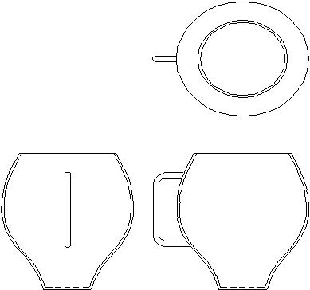

Fig. 4.6 Shape Design with Orthogonal Sketches

- Sketch 2-D perspective or 3-D perspective:

Using the 2-D perspective option is similar to loading a sketch in the side view to create geometry. Fig. 6.36 shows a perspective sketch. In perspective sketching the location of the vanishing point is important. Hand drawn sketches could be scanned and converted into TIFF or similar format and could be loaded into the conceptual modeling software.
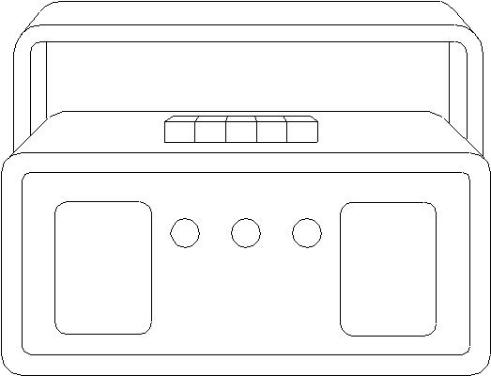

Fig. 4.7 Perspective Sketch

Once the sketches are loaded, the software can be used to align the sketch.

QUESTIONS

- How do you classify modeling package?

- Compare 2-D and 3-D wire frame models.

- Discuss the hardware required for a PC based drafting environment

- Study a CAD package and describe the drawing entities available.

- What are the commands and their sequence to create 2D and 3D wire frame models of the following components?
  - A bracket

  - a spur gear

Discuss the use of various editing commands available in a CAD package.

- Describe the display commands available in a drafting package.

- How will be set the dimension variables for:

  - Aligned dimensioning

  - Unilateral dimensioning

  - Chain dimensioning

  - To indicate the tolerances on dimensions

- How do you create a block?

- How do you redefine a block in a drawing?

- Study the symbol creation facilities available in a drafting package and create symbols for indicating surface roughness

- Study the various files available in a CAD package and their functions.

- Write a short note on the advantages of customizing a software.

- What is meant by configuring a software?

- How does CAD help drawing office management?

- How will you create the bill of materials from a CAD file?

- Describe the importance of curve and surface modeling in computer aided graphics and design.

- What is the advantage of parametric programming in designing curves and surfaces?

- Compare the splines for the same control points created by B-spline and Bezier spline techniques.

- Draw a Bezier spline for the following control points: (0,0), (4,3), (8,4) & (12,0)
W
- hat is the common modeling methods available for surface design in a surface modeling software?

NC, CNC MACHINE TOOLS

INTRODUCTION

After the Second World War, there was a big spurt in the design and development of aerospace products like satellites, launch vehicles, civil and military aircraft etc. The hydraulic copying and electrical program controlled machines used at that time could not meet the manufacturing challenges posed by the complex aerospace designs. The manufacturing engineers were therefore looking for a better way of automating the machining operations. Numerical control (NC) was developed in early 50’s to meet the critical requirements of aerospace Industry. Many components used in aircraft and space vehicles are machined from solid raw materials, often involving removal of considerable stock and requiring several hundred positioning movements of the machine tool slides. Manual operation under these circumstances is not only tedious but also less efficient and unproductive. Often the part after several hours of machining is liable to be rejected due to machining errors.

Digital technology developed for communication purposes became very handy for designers of control of machine tools. Since the information required to actuate and control slides was coded numerically, this technology came to be known as numerical control.

Early numerically controlled machines were fully hardwired machines as the entire control logic was implemented in hardware. This posed several difficulties in the operation of NC machines apart from serious limitations on reliability of operation. The designers of NC machines achieved a major breakthrough during mid-six tees when they could integrate a NC machine tool with a mini-computer. The technology was then renamed as computer numerical control. The integration of computers with NC machine tools resulted in the following advantages:

- Increase in the memory for part program processing

- Increase in capacity for storing large part programs

- Easy editing of part programs on the control console

- Realization of control logic through software

- Significant improvement in the reliability of operation of the machines

- Integration of N.C. machines in the manufacturing system as a whole.

Further developments in large scale integration resulted in the development of microprocessors around which computers could be designed. This naturally led to the development of CNC systems based on microprocessors. Today all CNC machines are microprocessor based and both NC and CNC mean computer numerical control.

PRINCIPLE OF OPERATION OF A NUMERICAL CONTROLLED MACHINE

The CNC machine differs from a conventional manual machine in several respects. The principle of operation of a numerical controlled machine can be explained with the help of Fig. 5.1. The figure shows a vertical milling machine. For carrying out an operation like end milling the spindle head is to be positioned in Z- axis and the table in X and Y coordinate axes. The feed movement is to be realized by the individual or simultaneous movement of X and Y axes. Thus the milling machine requires three slide movements, which are usually referred as axes feed drives. A special feature of a CNC machine is that a separate motor called a servomotor individually drives each axis. AC servomotors are the preferred choice for this purpose today. DC servomotors were widely used earlier. The slides are driven by the servomotors through re-circulating ball screw and nut assemblies. The use of re-circulating ball screw reduces friction, backlash and wear. The low friction reduces the torque required at the motor and the lost motion through torsional deflection of the screw. The use of ball screws also improves the dynamic response of the system. In some modern designs, particularly in the case of high-speed machines, linear motors are used in the place of servomotor ball screw combination.

 | Z-AXIS SERVO MOTOR
 | COLUMN
 | SPINDLE MOTOR
 | SPINDLE HEAD
 | Z
 | TOOL
X-AXIS | TABLE
SERVO | X
MOTOR | X
 | Y-AXIS SERVO
 | MOTOR
 | Y
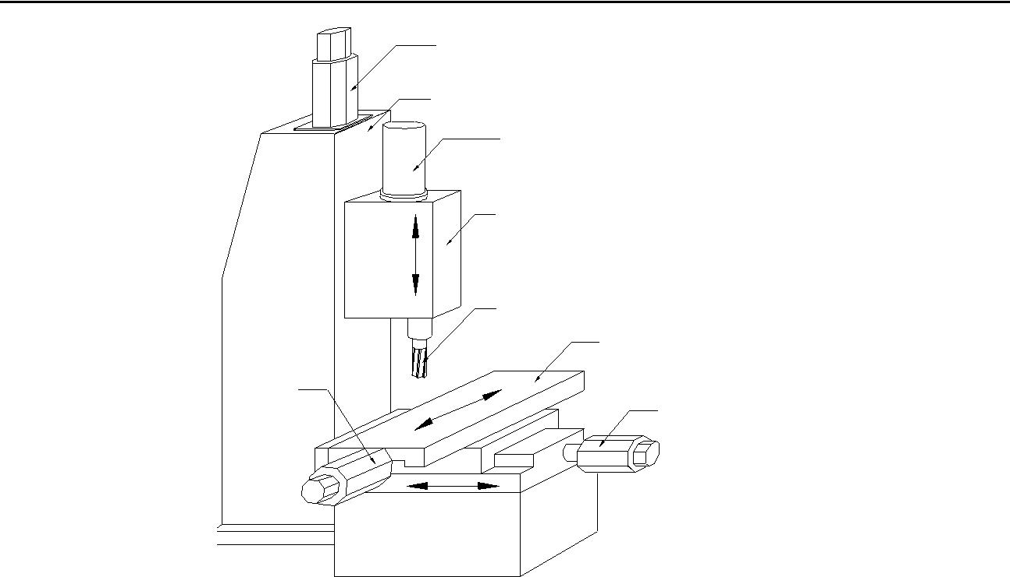
Fig. 5.1 Sketch of a NC machine Tool

In order to carry out the milling operation on the workpiece the coordinate information (X, and Y coordinates) of the starting point and the ending point has to be coded in the NC program. Similarly, the information regarding the direction of rotation and speed of the spindle, use of coolant, and the feed rate is also coded suitably. The CNC controller decodes the positioning information coded in the NC program and the slide is moved to the programmed position at the required feed rate. Each slide is fitted with a feedback transducer, which continuously monitors the slide position and compares with the programmed position as well as the fchedule The feedback transducer is mounted either on the slide or on the servomotor and measures the displacement or position of the slide.

For example, let us assume that a hole is to be drilled at the location X = 100.0 and Y = 150.0. The corresponding block of the program is read by the control system and the necessary inputs are sent to the X and Y-axis servomotors. These motors drive the respective slides to the commanded position. When the distance information from the feedback devices equals the programmed values, the slide movement stops. The input is then given to the Z-axis servomotor to perform the drilling operation. The system switches on the motor driving the spindle carrying the drill and commands the Z-axis servomotor to move at the programmed fcheduleinto the workpiece till the programmed depth is reached. The Z-axis feedback transducer ensures the correct depth and fchedule The drill is then withdrawn to the desired height and the machine starts the positioning movements to the next location of the drill. This procedure thus ensures production of accurate workpieces.
The feedback transducer used may be analog (synchro resolver) or digital (encoders). Another classification of feedback transducer is based on their nature of measurement-absolute or incremental. They are also classified as linear or rotary depending upon their construction. Linear feedback devices include optical scales, inductosyn etc. Rotary feedback devices are mounted either on the ball screw or on the motor shaft and measure the slide position indirectly. Rotary encoders, optical scales, and synchro resolvers are the commonly used rotary feed back devices.

The measured and the targeted positions are compared and the servo system ensures that the correct positioning is achieved to make this error (difference between targeted and measured positions) zero. The resolution of axis feed drive is usually one mchedule Since positioning is done electronically, it is possible to achieve accuracy and repeatability of the order of 5-10 micrometres even under heavy-duty cutting conditions. Two servo loops are incorporated in feed drive -—one for the position and the other for the feed. In addition to this, the selection of spindle speed is also under servo control. The principle of operation of the servo system used in a CNC Machine tool is described below.

PRINCIPLES OF OPERATION OF A CNC SERVO SYSTEM

A CNC servo system works on the digital principle. In a digital system, the control signal is in the form of electrical pulses. Figure5.2 shows a typical pulse train. A pulse train will have a low voltage level (say 1.2 V) and higher voltage level (say 5 V). Low voltage level is referred to as ‘O’ state and high voltage level ‘1’ state. Higher voltage may be negative also. Different higher voltage levels may also be used for control purposes.

5
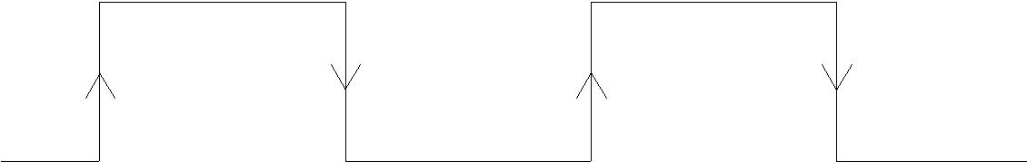

1 . 2 V

Fig. 5.2 A Typical Pulse Train

Consider the turning operation shown in Fig.5.3. The tool has to move through a distance of 100 mm to carry out the turning operation. This distance is converted into pulses- one pulse for each mchedule(1/1000 of a mm). For 100 mm distance, a command signal of 10 0000 pulses is generated by the control system.

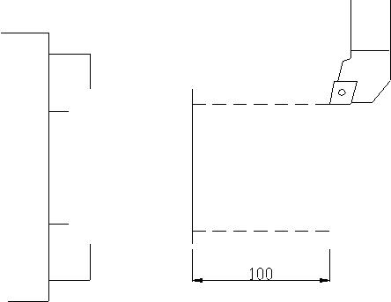

Fig. 5.3 Turning Operation

The resolution of the system can be improved by a factor called Command Multiply Ratio (CMR). If the feed is 0.2 mm/rev, and the spindle rpm 1000, the slide velocity will be 1000 x 0.2 = 200 mm/min. If the pitch of the ball screw is 10 mm, the rotational speed of the Z servomotor should be 200/10 = 20 rpm. The command signal (+ V) from the velocity control unit will have a magnitude proportional to the speed required. Plus or minus signal denotes the rotation in clockwise or anticlockwise direction which is necessary for positive and negative movements of the table in any axis.

The feed back unit is a significant element of a CNC control system. The feedback involves measurement of position as well as feed velocity (feed rate). In a majority of cases, the encoder, which is used as the feed back device, generates 2000, 2500 or 3000 pulse per revolution. The detect multiple ratio (DMR) matches the resolution of the

feedback transducer (thereby the pulses produced by the transducer) and the pulses necessary to move the slide to the required position. The feedback encoder is usually mounted on the rear side of the axis servomotor itself to simplify the electrical connections. From Fig. 5.4 it can be seen that there are two servo loops in the axis drive -—the outer loop for position and the inner loop for feed rate. The feedback signal for the feed rate is the pulse rate or pulse frequency. The frequency/voltage converter converts the pulse frequency into an analog voltage and this is compared with the input signal to the motor.
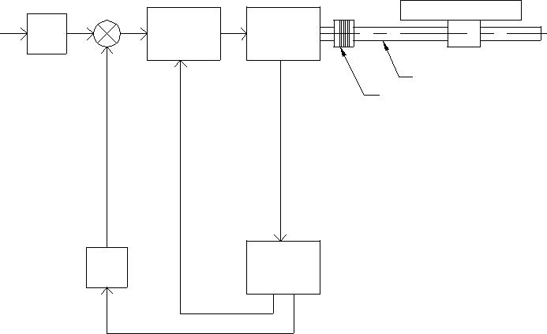

 | VELOCITY | TABLE
 | VELOCITY | SERVO
CMR | CONTROL | SERVO
CMR | CONTROL | MOTOR
 | UNIT | MOTOR
 | UNIT | NUT
 |  | BALL SCREW
 |  | FLEXIBLE
 |  | COUPLING

DMR | ENCODER

CMR: Command multiply ratio DMR: Detect multiply ratio

Fig. 5.4 Block Diagram of Servo Control
The encoder generates pulses corresponding to the rotation of the motor (which is proportional to the table movement). The detect multiply ratio (DMR) is used to equalize the command pulse and the pulse generated by the encoder. The pulses corresponding to the table position are compared to (or subtracted from) the command pulse. When the feed back pulses become equal to the command pulse, the table reaches the stipulated position in the program.
The encoder generates the feedback pulses. Pulses are generated by allowing light to pass through a two glass discs, one mounted on the motor shaft and rotating along with it and a small auxiliary disc mounted in the encoder housing. A source of light is located on one side of the disc. Interference fringes are created when the motor shaft rotates. In the simplest case, two light receiving stations (usually solar cells) are located on the other side (A and B) on which the light falls. The interference causes variation in the intensity of light falling on the solar cells. This results in a cyclic change of resistance, which could be utilized to create a pulse train using suitable electronic circuitry. The two solar cells are so placed that the distance between them is equal to (n+1/4λ) where λ is the pitch distance of the gratings. This is shown in Fig. 5.5.
The two solar cells then generate two pulse trains with a phase difference of 1¼wavelength. Depending on the direction of rotation, the pulses from B will precede

Main Grating
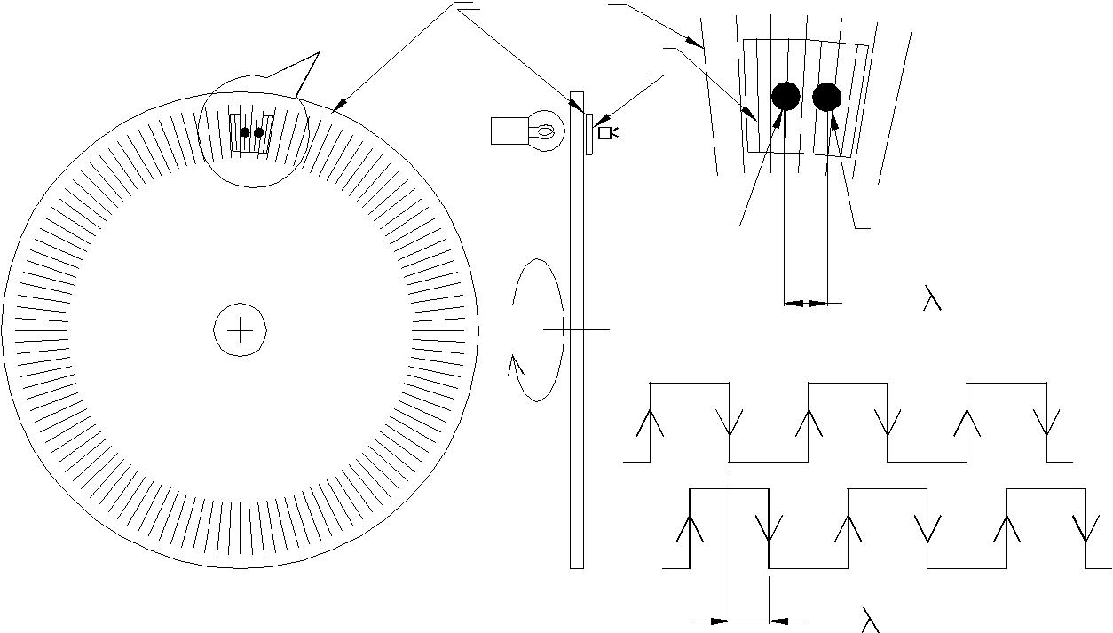

C | Source of
 | Light

Auxiliary
Grating
 | Detail
Solar | at C
Cell
Solar
Cell A | Solar
 | Cell B
 | (n+1/4)
 | Signal From A
 | Signal from B
 | 1¼

Fig. 5.5 Feedback Using Encoder

or follow the signal from A. This property is used to sense the direction of movement of the slide. This is illustrated in Fig. 5.6. When the disc rotates in the clockwise direction the signal from A precedes the signal from B. When the rotation is in the anticlockwise direction, the signal from B precedes that of the signal from the solar cell A.

Signal From A
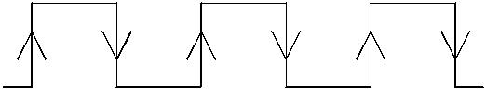

Pulse Train During
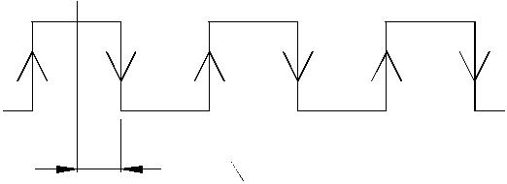
Clockwise Rotation

Signal from B
1¼

Signal From A
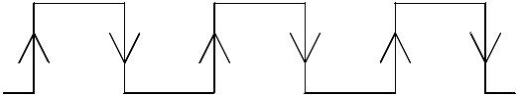

1¼
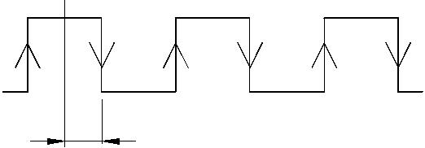

Pulse Train During
Anticlockwise Rotation

Signal from

Fig. 5.6 Detection of Direction

An overview of a 3-axis CNC system is shown in Fig.5.7. It can be seen that there are three major subsections in the CNC system. The first section consists of AC Power unit, programmable machine control PCB, the mchedulecabinet, operator’s panel and manual pulse generator (MPG). The axis control and drive control PCBs have interfaces with this section and controls the positioning as well as velocity control of the 3 axes. The spindle speed control is also shown. The actuator section consists of servomotors and feed back units (Encoders or linear scales). The spindle is fitted with a spindle encoder. This will be useful in during thread cutting to enable the tool to enter in the groove created in the previous pass in the same angular position. This will also be useful for cutting multi-start threads as well as to monitor spindle speed. There will also be an interface for manual pulse generator (MPG), which is used to move the slides in the manual mode.

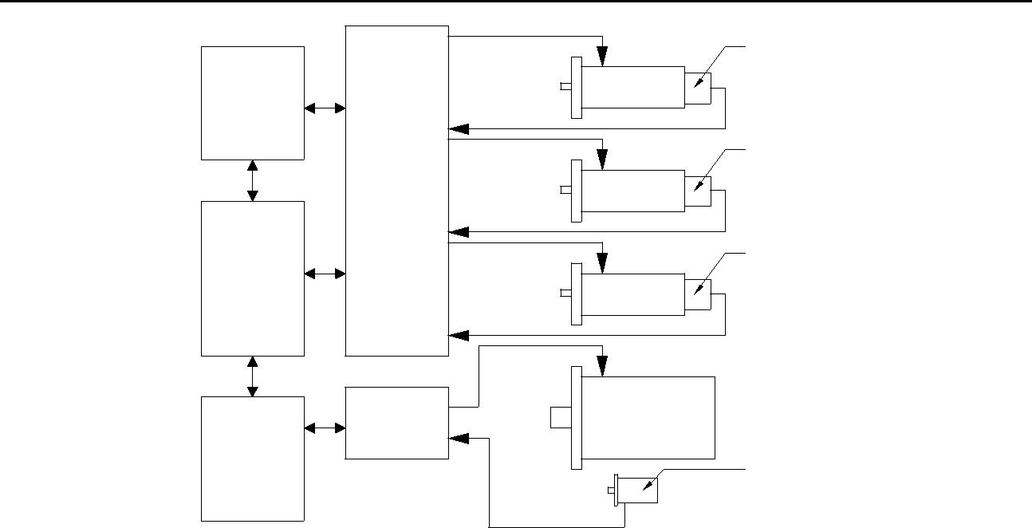
 |  | ENCODER
CONTROL |  | X-AXIS
CONTROL |  | MOTOR
CONSOLE |  | MOTOR
 | AXIS | ENCODER
 | CONTROL | Y-AXIS
 | CARD | Y-AXIS
 | CARD | MOTOR
CNC |  | ENCODER
SYSTEM |  | Z-AXIS
 |  | MOTOR
 | MAIN | MAIN
 | MAIN | SPINDLE
 | DRIVE | SPINDLE
 | DRIVE | MOTOR
MAGNETICS | CARD | MOTOR
MAGNETICS | CARD | TACHO

Fig. 5.7 An Overview of a 3-axis CNC System

In some systems, only one encoder is used and it serves as both position and velocity feed back unit. The encoder is mounted at the back of the servomotor (semi-closed loop system). This is illustrated in Fig. 5.8. In other systems (closed loop system illustrated in Fig. 5.9), separate feed back units for position and velocity are used. In this case, the position feed back is derived from the table position and velocity feed back is obtained from the servomotor speed. If the position feed back is obtained this way, errors due to backlash, pitch error, ball screw compliance etc. can be eliminated.

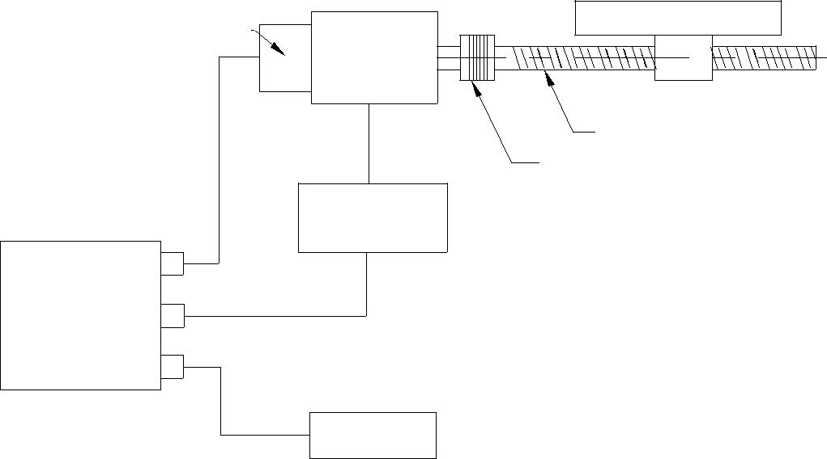
 | ENCODER |  | TABLE
 | ENCODER | SERVO
 |  | MOTOR
 |  |  | NUT
 |  |  | BALL SCREW
 |  |  | FLEXIBLE
 |  | SERVO | COUPLING
 |  | AMPLIFIER
TYPE A
INTERFACE | COMMAND
CONTROL
CARD
 |  | BATTERY

Fig. 5.8 Semi Closed Loop System

CNC Machine Tools

 |  | LINEAR ENCODER | TABLE
 | ENCODER | SERVO
 |  | MOTOR
 |  |  | NUT
 |  |  | BALL SCREW
 |  |  | FLEXIBLE
COMMAND |  | SERVO | COUPLING
& FEEDBACK |  | SERVO
& FEEDBACK |  | AMPLIFIER
TYPE B
INTERFACE
CONTROL
CARD |  | RELAY
 |  | UNIT
 |  | BATTERY
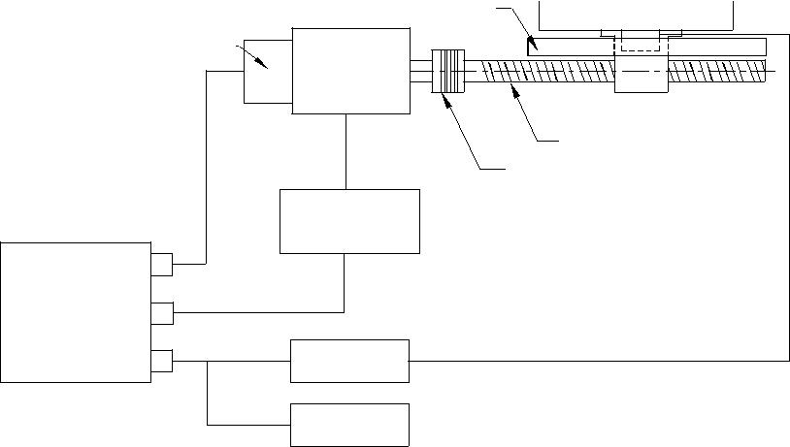
Fig. 5.9 Closed Loop System

CNC machine tools employ AC motors (DC motors in older versions of CNC machines), which offer infinite variation of spindle speeds over a wide range of speeds. Digital technology is used in the modem AC drives. AC motors are capable of delivering high power at low base speeds. The main advantages of AC motors are their ruggedness and low cost.

CODING OF INFORMATION IN NC MACHINES

NC as described earlier is control by numbers. NC is control by information contained in a part program, which is a set of coded instructions given as numbers for the automatic control of a machine in a pre-determined sequence.

Figure 12.10 shows the machining a taper on a cylindrical component. To carry out this operation on a CNC lathe, we write a program block as follows:

N005 G01 U20 W-50 S1200 F0.2 M08;
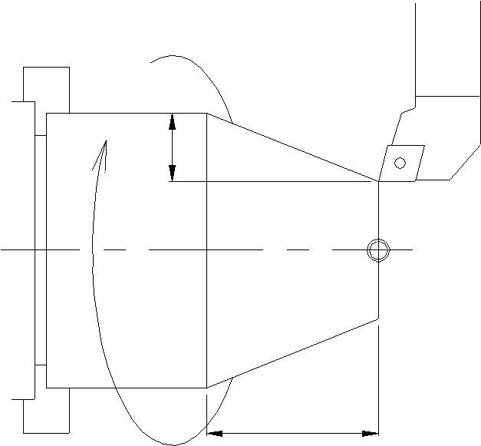
1200 rpm

50

Fig. 5.10 Machining a Taper

The program block codes the information necessary to operate the lathe, and is given

below:
N005 | Block number
G01 | Linear interpolation
U20 | X increment in slide movement
W-50 | Z increment in slide movement
S1200 | Spindle speed, 1200, rpm
F0.2 | Feed, 0.2 mm/rev
M08 | Coolant on

- End of block

Each of the above consists of an alphabet or a word address (N, G, U, W, S etc.) and a numeric value (005, 01, 20, -50, 1200), which represents a function or a slide displacement position or machining data. These alphanumeric data is digitally coded either in the ISO (International Standardization Organization) system or EIA (Electronics Industries Association, USA) system. The symbol ’;’denotes end of the block.

CODING OF INFORMATION

Early NC systems coded only numeric data and they did not use any alphabetic characters. Since all the information necessary to carry out the machining operation is passed on to the control system through these coded numerical data, the control came to be known as numerical control (NC).

The numeric data is usually represented in decimal format. For the purpose of the convenience in processing in a digital computer, the data is to be converted (coded) into binary form. A decimal number is represented in binary form as a power of 2.

To represent large number a binary coded decimal (BCD) system is employed. Consider the 4-track coding system shown below. Rightmost track is 2⁰ (least significant) and leftmost track is 2³ (most significant). For example the number 358 can be represented as:

2³ | 2² | 2¹ | 2⁰
0 | 0 | 1 | 1 | 3 | (2+1)
0 | 1 | 0 | 1 | 5 | (4+1)
1 | 0 | 0 | 0 | 8 | (8)

There are two standards for coding, one proposed by ISO (International Standardization Organization) and the other by EIA (Electronics Industries Association of USA). There are several other codes popular with the designers of NC systems.
HISTORICAL DEVELOPMENT

As mentioned in the beginning of this chapter, the need for a new technology to control machine movement was felt during late 40’s to meet the challenges in the production of aerospace components. The manufacture of many of these components involves several thousands of machine movements.

A major contribution to this development was made by John Parsons who developed a technique to machine accurate templates to manufacture helicopter blades. This involved calculating 200 points on a curve and drilling them on a precision jig mill. He subsequently developed in 1948 a 3- D method of machining using ball end mill on a SIP jig bore and a De Vlieg jig mill. The successive settings of the tool were determined using the IBM punched card reader. Parsons was later entrusted with the development of a (NC) milling machine working on the same principle. The U S Air Force was the funding agency for the NC development. Parsons found that card reader is too slow and approached Massachusetts Institute of Technology (MIT) to develop a tape reader and power drive for the proposed machine. The collaboration between Parsons and M I T ran into difficulties later. U S Air force, then, awarded a contract to M I T. The Servomechanisms Laboratory of M I T developed the first N C Machine in 1952. Giddings and Lewis, General Electric and Bendix are the companies who took interest in developing NC technology, in its early years.

The development of the machine hardware and the programming technique called Automatic Positioning of Tools (APT) was undertaken almost simultaneously at MIT. It must also be noted here that another project undertaken at that time at M I T (Whirl Wind Project) led to development of Interactive Computer Graphics. This ultimately led to the development of CAD technology through stages like 2-D drafting, 3-D modeling, surface modeling, solid modeling etc. The project to develop drives resulted in the development of DC variable speed drives. The first CNC system developed at MIT used relays. Subsequent developments in electronics and VLSI design led to the development of present generation CNC machines and computer aided manufacturing technology. The efforts to integrate CAD and CAM and later all other activities connected with manufacture resulted in the development of Computer Integrated Manufacturing. (CIM). It can be said that the path breaking development of John Parsons is the beginning of the CIM technology.

Presently, all the NC machines produced are computer numerical control machines, as the NC system (or CNC system) is designed and built around one or more microprocessors. CNC Machine tools now form a major part of output of machine tools in advanced countries. Table 5.1 gives the status of CNC Machine tool production in India in 2002.

 |  | Table 5.1 Production of CNC Machines in India During 2002
 |  | Type of Machine | Number
 |  | Lathes | 732
 |  | EDM | 339
 |  | Vertical Machining Centre | 251
 |  | Horizontal Machining Centre | 37
 |  | Other Types of machining Centres | 6
 |  | Boring | 12
 |  | Milling | 41
 |  | Grinding | 49
 |  | Gear Cutting | 25
 |  | SPM | 27
 |  | Bending, Folding etc. | 82
 |  | Punch, Shear etc. | 20
 |  | Others | 34

(Courtesy: Indian Machine Tool Manufacturers Association)

GENERATIONS OF CNC MACHINES

Development of CNC machines closely followed the developments in computer technology. Therefore the generations of CNC technology bear a close resemblance to generations of digital computers.

First Generation: The control system of the first generation numerically controls machines was built with vacuum tubes and associated devices. The system was bulky, consumed lot of power and reliability was poor.

Second Generation: Second Generation machines were built with transistors. The size of the control elements was reduced. However, all the functions had to be realized through electronic circuits. The number of printed circuits boards was large. Since there were thousands of components and connections involved, the reliability was again poor.

Third Generation: Third generation NC machines were built with integrated circuits. The IC’s with medium scale integration improved the reliability of the system. Drive technology also made considerable progress. Thyristor controlled DC drive become popular during this period. Reliable and compact DC controllers were developed both for main drives and for the control of servomotors for axes feed drive.

The various logic functions in the early NC systems (during 50’s and 60’s) were realized through fixed circuitry and hence were called hard-wired systems. The integration of minicomputers with NC machines that led to the development of CNC machine tools was one of the two major significant developments during mid 60’s. Initially minicomputers were interfaced with NC machine tools. This development helped to introduce the much-needed flexibility. From the totally hardwired design, the design of the NC machine tools became soft-wired. Instead of reading and executing programs block by block it was now

possible to store the program in the computer memory and execute the program. Several limitations of the NC systems could also be overcome by CNC systems. Program editing became much easier and several NC functions could be implemented in software. The other development was the evolution the concept of Direct Numerical Control (DNC) technique by which several NC machine tools could be controlled from a single computer. This technology enabled the NC user to by-pass the tape reader and control a number of NC machine tools from a single computer. DNC system manufacturers also introduced the concept of NC data transfer from a computer or remote station using telecommunication wires. A detailed description of DNC systems is provided later in this chapter.

Fourth Generation: Towards the end of 70’s the computer design underwent changes and microprocessor came to be used as the CPU of computers. This change also influenced the design of NC machines. The designers started developing NC systems around microprocessors. This simplified the logic and control and design and instead of several PCB’s in the case of NC machines, the entire control could be implemented with just one PCB for CNC machines. Initially 8 and 16 bit microprocessors were used. Later control systems with several processors (Multi-processing Systems) were introduced. The reliability of the system was considerably improved. The developments in CNC systems still continue. Today many CNC systems are based on 32 bit as well as 64 bit microprocessors. Several personal computer based CNC systems are also available in the market. Features available in modern CNC systems are discussed later in this chapter.

TYPES OF CNC MACHINES

Computer numerical control is applied to a variety of machines. Most of these find ready application in aircraft, automobile and general engineering industry. Some of them are listed below:

- Machining Centre

  - Horizontal

  - Vertical

  - Universal

- CNC Lathes

- CNC Turning Centres

- Turn-mill Centres

- CNC Milling/Drilling Machines, Plane Milling Machines

- Gear Hobbing Machines

- Gear Shaping Machines

- Wire Cut EDM/EDM

- Tube Bending

- Electron Beam Welding

- Laser/Arc/Plasma Cutting

- Co-ordinate Measuring Machines

- Grinding Machines

  - Surface Grinder

  - Cylindrical Grinder

  - Centreless Grinder

- Tool and Cutter Grinder

- CNC Boring and Jig Boring Machines

- PCB Drilling Machines

- Press Brakes

- CNC Guillotines

- CNC Transfer Lines, SPM’s

- Electrochemical Milling Machines

- Abrasive Water Jet Cutting Machines

- Flow Forming Machines

- Roll Forming Machines

- Turret Punch Press

Brief descriptions of some of these machines are given below:

MACHINING CENTRES

Manufacture of prismatic components like gear boxes, bulkheads, frames, brackets, casings, covers etc require milling, boring, drilling, tapping and many other related machining operations to be performed. Before the introduction of machining centres, these machining operations had to be carried out on different machines resulting in considerable lead time for production. Machining centres are very important types of CNC machine tools and are multifunction machines equipped with automatic tool changers and are capable of carrying out milling, drilling, reaming, tapping, boring, counter boring and allied operations without operator intervention for change of tools. Tool changing is carried out using an automatic tool changer and is accomplished in 0.5 to 6 seconds depending upon the machine.

An indexable tool magazine, which can store several tools, characterizes a machining centre. The tool magazine may carry 16 to 100 tools depending upon its capacity. An automatic tool changer (ATC) is provided to pick up the programmed tool from the tool magazine and mount it on the spindle. The removed tool is put back into the magazine and the ATC picks up the next tool. The ATC is thus ready with the tool for the next operation and awaits the current operation to be over to replace the tool.

Machining centres are often provided with two or more work tables called pallets. In a 2-pallet machine while the job on one pallet is being machined, the operator can set up the next job on the free pallet. The automatic pallet changer (APC) then moves away the pallet with the finished job from the working zone and moves the other pallet with the new workpiece to the working zone. The machining operation on the new workpiece begins with a lapse of only a few minutes.

The operator can now unload the finished job from the first pallet and set up a new workpiece on it without interruption of the machining operations.

There are machining centres with six, eight or more pallets. Workpieces can be set up in all pallets and the machine can be programmed to accept a new pallet when work on the previous pallet is completed. The workpieces may be different and may require different part programs. The supervisory computer will do the selection of the right program. Thus the two major sources of non-productive time (tool change and setting up the workpiece) are reduced to very low values. This enables machining centres to have high productivity as well as considerable reduction in the lead-time of production of complex components. This also reduces work in process (WIP) appreciably.

Machining centres are classified according to the spindle configuration as:

- Horizontal spindle machining centres

- Vertical spindle machining centres
- Universal machining centres

Horizontal Spindle Machining Centres

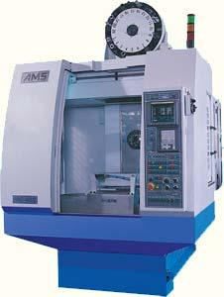
Horizontal spindle machining centres are generally single spindle machines with automatic tool changers. Some exceptions are machines with turret type tool magazine, combination horizontal/vertical spindles etc. Horizontal spindle machining centres are generally bed type machines with the structural configuration as shown in Fig5.11

Fig. 5.11 Horizontal Machining Centre (Courtesy: AMS)

In this type of machining X-axis table or column provides traverse and spindle head provides Y-axis traverse. The saddle or column, or headstock or spindle head provides the Z-axis traverse. The axes of machining centre are also shown in Fig. 12.11. These machines are invariably used with a rotary indexing table to facilitate multiphase machining at different angles in a single setup. The axis of rotary table is parallel to Y-axis and is called ‘B’ axis.

The rotation of the table can be used for machining contours on surfaces of workpieces located on the rotary table, if CNC control is available for B-axis. The provision of B-axis enables the machining of all the four sides of the component in one set up. Use of modular fixtures on horizontal machining centers permits machining of more or more components in one set up, thereby increasing productivity and reducing machining cost. Table5.2 gives the specifications of a typical horizontal machining centre.

Table 5.2 Specifications of a typical Horizontal Machining Centre

Traverses
Saddle -—longitudinal | X-axis | 800 mm
Spindle head-vertical | Y-axis | 700 mm
Column-cross | Z axis | 800 mm
Feeds
Rapid traverse | all axes | 12000 mm/min
Feed rate | all axes | 1-4000 mm/min
Spindle
Spindle taper | BT 50
Speed | Infinitely variable
Range | 20-4000 rpm
Power | 15 kW (AC)
Automatic Tool Changer (A T C)
Tool capacity | 32 (nos)
Maximum tool diameter | 100 mm
Maximum tool length | 400 mm
Tool changing time | 4 sec
Tool selection | Random bi-directional
Accuracies: (Japanese Industrial Standard)
Positioning accuracy | +/– 0.005
Repeatability | +/– 0.0025
Index table (1)
Position accuracy | +/– 3 sec
Repeatability | +/– 2 sec
Automatic Pallet changer
No. of pallets | 2 nos
Pallet changing time | 40 sec

The present day trend is to build the machines with traveling column construction with all the movements behind the tool so that the work module is independent of the basic machine. This enables choice of work holders to suit the user’s requirements and also enables the use of machining centre in NC transfer lines.

Vertical Spindle Machining Centres

Figure 5.12 shows a typical vertical spindle machining centre

Fig. 12.12 Vertical Spindle Machining Centre (Courtesy: AMS)
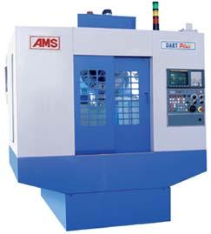

Vertical spindle machining centres are also bed type machines with:

- Single spindle and automatic tool changers

- Multi spindle with turret head (Turret machining centres) X-axis traverse provided by table or column

Y-axis traverse provided by the saddle or the column or ram

Z-axis traverse provided by the headstock

Vertical spindle machines are not suitable for large widths as this increases the throat distance. For very large widths horizontal spindle configuration or bridge type configuration (double column planer type) is used. Table 12.3 gives specifications of a typical vertical machining centre.

Table 5.3 Specifications of a Vertical Machining Centre
Effective table area (mm) | : | 550 x 1400
Loading capacity of table (kg) | : | 1500
Travels (mm)
X-axis | : | 1000
Y-axis | : | 550
Z-axis | : | 550
Distance (mm) from spindle to table surface | : | 200 -—750
Distance (mm) from spindle centre to column front face | : | 590
Rapid traverse (m/min) | : | 15
Feed rate (mm/min) | : | 1 -—4000
Spindle diameter (mm) | : | 100
Spindle nose taper | : | JIS -—6101 -—No: 50
Spindle speed (rpm) | : | 20 -—4000
Spindle drive motor (kW) | : | AC 7.5
30 min rating (kW) | : | 10
Automatic tool changer:
No. of tools | : | 40
Max.tool weight (kg) | : | 15
Max.tool dimensions (mm) | : | 120 x L400
Tool selection | : | Random Memory
 |  | (Bi-directional)
Machine weight (kg) | : | 7800

Universal Machining Centres

These are similar to horizontal machining centres but with the spindle axis capable of tilting from horizontal to the vertical position continuously under computer control. This constitutes the fifth axis of the machine. In some cases tilting of the table instead of the spindle provides the movement. Such machines facilitate access to the top surface of workpiece mounted on a horizontal machining centre so that all the five sides of a component can be machined in a single set up. The fifth axis facility is essential for machining of some components, which require the cutter axis to be perpendicular to the surface being machined. Machining centres can be easily integrated into a flexible work cell. Provision of bi-directional random memory tool magazines, automatic tool offset measurement, magazine changers, advanced tool management techniques, tool breakage detection techniques, rail guided work transport, palletizing stations, in-process gauging, devices for automatic workpiece loading and unloading etc., are useful options to improve productivity and to realize flexibility in operation and to achieve unmanned operation of machining centres.

Recent Advances in Machining Centres

Some of the recent technological developments in machining centres are described below:

- Vector Spindle Drive

Vector drive optimizes the slip angle between the rotor and the stator of the spindle motor to double the low speed torque and acceleration resulting in a fast and most powerful spindle. Fig. 12.13 shows typical torque speed characteristics of vector control drive.

- Brushless A.C. Servomotors

A typical A.C. servomotor used in a machining center will have 32000 divisions per revolution for high accuracy. These motors provide higher acceleration/ deceleration rates, higher power and reliability.
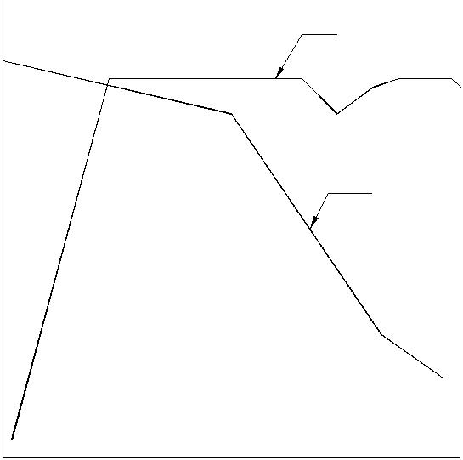

POWER

TORQUE

RPM OF MOTOR

Fig. 5.13 Vector Drive

iii. | Hydraulic Counterbalance
 | Conventional lead and chain counterweight systems used in machines are
 | found to cause a bouncing effect during peck drilling, shock during quick
 | reversals, vibration etc. These affect the quality of the surface finish of the
 | component. Hydraulic counterbalance eliminates the bounce, reduces the z-axis
 | inertia to half and provide a smooth and fast Z-axis response.
iv. | Spindle Cooling
 | With the introduction of high speed spindles, considerable amount of heat is
 | generated at the spindle and this heat unless removed will cause thermal distortion
 | to the spindle head. Spindle cooling has therefore become very critical. Several
 | innovative techniques are used to remove the heat generated in the spindle. A
 | common method adopted is to circulate refrigerated oil to the bearings. In another
 | design, cool air is drawn from the rear of the machine and is allowed to exit at
 | the top of the spindle, thereby effecting cooling through natural heat convection.

- Electronic Spindle Orientation

Spindle orientation is important for smoother and faster tool change. Electronic orientation used in the machining centres provides reliable and trouble free operation and enables reduction in tool changing time.

- High Speed Machining Centres

High-speed machining centres have spindle speeds ranging 12 000- 50 000 rpm. These machines are usually designed with hybrid (ceramic) bearings, oil mist lubrication and water or oil cooling of spindles for maintaining constant temperature. Dynamic feed drives with low friction ball screws and linear roller guide ways are some of the special features of these machines. These machines are fitted with control systems, which feature processors and intelligent control strategies that provide extremely rapid response and precise traverse. Some of the features include advanced look-ahead, various methods of spline interpolation and full compensation for lag errors.

Two significant aspects of high speed machining centres are high rapid traverse rates and high spindle speeds. Figure 5.14 compares the rapid traverse rates and spindle speeds of conventional machining centres and high speed machining centres. The total machining time can be significantly reduced with high speed machining.
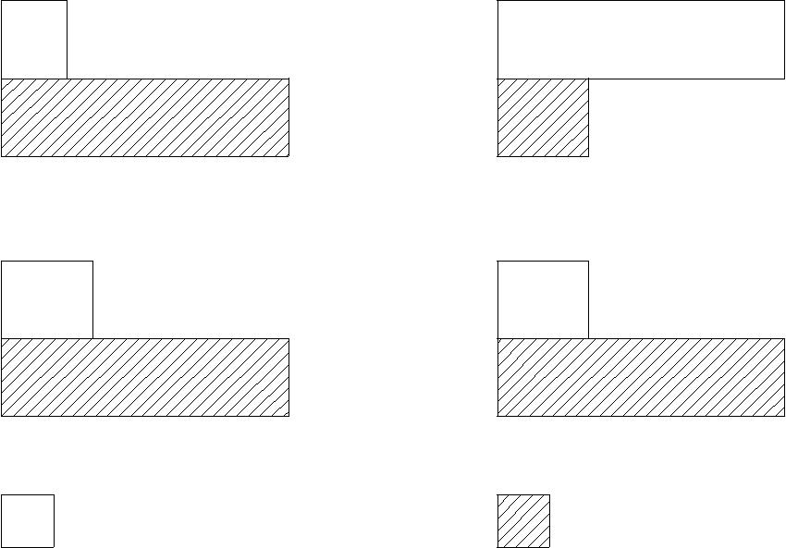

RAPID TRAVERSE RATE

MACHINING TIME

SPINDLE SPEED | PRODUCTIVITY
CONVENTIONAL | HIGH SPEED
MACHINING | MACHINING

Fig. 5.14 Comparison of High Speed and Conventional Machining Centres

TURNING CENTRES / CNC LATHES

CNC lathes are widely used in making components with axisymmetric geometry. These are generally machined with 2-axis control. (Z-axis parallel to the spindle and X-axis perpendicular to spindle axis). A CNC lathe is shown in Fig. 5.15. Some CNC lathes have an additional Y-axis. CNC lathes are usually designed with a slant bed for easy removal of chips, at the same time maintaining the rigidity of a closed box structure. A chip conveyor (either magnetic or mechanical) is usually provided for easy chip disposal. The control console is located on the front on top side. The spindle is driven usually by an infinitely variable speed AC drive through a set of V-belts or poly belts. The high power series motors employed provide almost constant power for a large portion of the speed range. High-speed machines usually have integral rotor spindles. AC servomotors drive the X and Z slides usually. Sliding doors (sometimes automatic) with bulletproof glass windows are provided for safety and visibility of the machining zone. Hydraulic chucks are provided for clamping the workpieces. CNC lathes, being high-speed machines require special highly accurate and well-balanced chucks. Tools are mounted in indexable turrets which can hold 8, 12 or 16 tools.

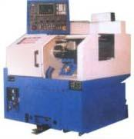
Fig. 5.15 CNC Lathe (Courtesy: ACE)

A tool is called in the part program by the number of the pocket in which it is held. For example T06 means the tool in the 6th pocket. Tool stations are indexed using a Geneva mechanism powered electrically or hydraulically. An encoder or a similar device is used to index the turret. A curvic coupling is used to ensure high accuracy in indexing-usually 2 to 3 seconds of an arc. Both axial tools (boring tools, Internal grooving tools, internal threading tools, drills, face grooving tools, taps, dies etc) and radial tools (external turning, facing, threading, grooving, cut off etc) are mounted on the turret. It is a good practice not to mount axial tools in adjacent pockets. Tools, which are used more often, are provided in more than one pocket so that if the tool life of one tool is over the, other tool can take over the machining work without interruption to facilitate tool change or indexing of inserts. Short tool holders are recommended for better rigidity. A variety of adaptors are provided to mount different tools. Tool length offset must be measured and
input in the memory of the machine. Some machines will have an automatic tool length offset measuring device, usually mounted on the headstock.

CNC lathes and turning centres are used for chuck work and shaft work. These are classified as:

- Horizontal machines and

- Vertical Machines

The horizontal machines are further classified as:

- Chucking machines

- Universal machines

In chucking machines short workpieces held only in the chuck are machined. Examples of such components are gear blanks, flanges, pump impellers, bearing races etc. Universal machines have a tailstock, which supports long workpieces like shafts at their ends.

- Chucking Machines

Chucking machines usually have shorter beds and a single saddle with hexagonal, octagonal, disc or drum type turret, which accommodates both ID and OD tools and two independent saddles with separate turrets. Many of the present day chuckers offer optional swing-in-tail-stock to facilitate shaft work. During normal working as a chucker, the tailstock is swung away from the work area. Chucking machines are fitted with additional sub-spindle to carry out both first and second operation in the same set up. These spindles will have synchronized drives to enable transfer of work from one spindle to another. In some machines the sub-spindle is fixed and work transfer is achieved with the aid of two turrets. Chucking machines are often fitted with bar feeding mechanisms. Twin spindle chuckers ensure high productivity. These are used for workpieces, which are to be finished in two end operations. The first operation is performed on the first spindle and the second operation on the second spindle. These will have an automatic work transfer system, which transfers the workpiece from one spindle to another. The advantage of these machines is that they ensure a continuous supply of parts for assembly operations. A typical example of a workpiece suited for such machines is the impeller of a centrifugal pump.

- Universal lathes

Universal lathes are suitable for both chucking and for bar work. They are often fitted with steady rest and follower rest to accurately machine slender components. 4-axis machines have two turrets; each mounted on an independent slide and facilitates simultaneous machining with two tools.

Some lathes have rotating tools in the turrets to facilitate off-axis machining such as drilling, milling, reaming, tapping, boring etc. These machines have in addition to the conventional X and Z-axes, CNC control of the spindle rotation i.e. C-axis. Such machines are known as turning centres. Turning centres eliminate the need for separate setting for milling, drilling and allied operations. Turning centres enable the components to be finished in one set up thereby reducing lead time and improving the accuracy of machined parts. An automatic tool changer (ATC) can be used with CNC lathes also using the Block tooling system of Sandvik or Multiflex tooling system of Widia. CNC turning centres have rotating tools on the turret. With these tools operations like off-centre drilling, milling (keyway or slot milling), tapping etc. can be done on workpieces after turning. A servomotor is provided on the tool turret to drive the live tools.

This requires an additional axis called C-axis (spindle orientation control). Some machines will have special main drive, which will also serve the function of C-axis drive. Flexible turning centres are fitted with gantry loading and unloading devices, software and hardware for in-process and post-process metrology, automatic tool changers, automatic tool offset measuring devices, automatic offset correction, tool magazines, automatic chuck changers, chuck jaw changers etc., This type of machines use cartridge type tools which facilitate automatic tool change. Flexible turning centres easily get integrated in a CIM set up.

Productivity of CNC turning centres could be increased by attaching a gantry device for unloading and loading of components. Another approach is to use a robot for loading and unloading the component. Fig. 5.16 shows a typical robotic loading device.

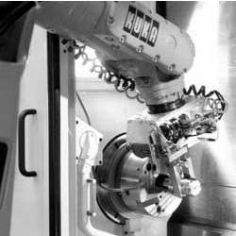
Fig. 5.16 Loading a Part Using a Robot (Courtesy- Kuka Robots)

- Tooling and Turret slide

The present trend is to have a single heavy disc type turret capable of accommodating both external and internal working tools. Some machines have two independent slides with one turret on each slide, one for external working tools and the other for internal tools. This arrangement will need 4-axis CNC. External and Internal machining can be carried out simultaneously. Alternatively both slides can be fitted with turrets carrying external turning tools to facilitate simultaneously machining of steps of the shafts from either direction
Vertical CNC Lathes (Turn Mill Centres)

Vertical CNC lathes are widely used for machining heavy components. Figure 5.17 shows a typical vertical CNC lathe. Some of these machines can also be used for milling operations. Such machines are sometimes known as turn mill centres. This type of machines is very popular in aerospace industries where components of large diameters need to be turned, drilled and milled. The machine shown in Fig.5.17 has five axes-four longitudinal axes and one rotary axis.
Multitasking Machines

Multitasking is a recent concept in CNC machines. Multitasking machines incorporate several processes in a single work center. For example, if a component requires milling, turning and grinding, a multitasking machine can be designed to carry out all these operations.

Multitasking machines eliminate this need thereby increasing the integrity of the part. Another advantage of multitasking is the possibility of cost reduction because of reduction in set ups, eliminating the need for several fixtures.

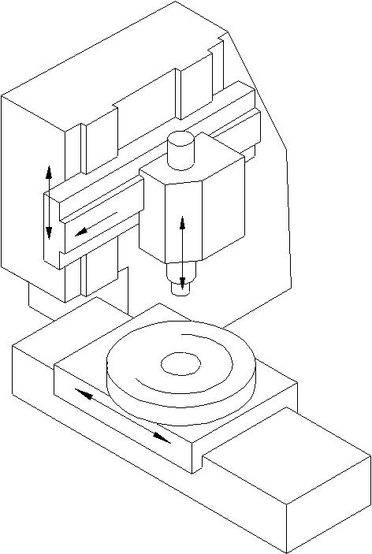

R

X Z

C

Y

Fig. 5.17 CNC Turn Mill Centre
Table 5.4 gives typical specifications of a CNC Turning Centre. Table 5.5 gives typical specifications of CNC Lathe.
Table 5.4 Specifications of a Typical CNC Turning Centre

 | Capacity
 | Swing over bed | 580 mm
 | Max turning dia (chucking) | 550 mm
 | Max turning length | 529/1030/1530 mm
 | Max turning dia (shaft) | 400 mm
 | Type of the bed | slant bed
 | Spindle
 | Spindle nose/bore | A2-8 / dia 80
 | Speeds
 | Spindle speed | 10-3000
 | Type of the drive | A C drive
 | Feed Drive
 | Feed range (Both axes) | 1 – 30 000 mm/min
 | Rapid traverse -—x axis | 30 m /min
 | Rapid traverse -—z axis | 30 m / min
 | Resolution | 0.001 mm
 | Tailstock
 | Tailstock quill dia/stroke | 90/80 mm
 | Type of the centre | MT4
 | Turret
 | Turret indexing positions | 12
 | Turning tool shank size | 25 x 25 mm
 | Max shank dia for drilling and boring tools in turret | 4 nos
 | Driven tools | 4 nos
 | Motors
 | Main motor AC | 20 kW
 | Coolant motor | 0.35 kW
 | Hydraulic pump motor | 1.5 kW
 | Table 5.5 Specifications of a CNC Lathe
 | Maximum swing over cross slide, mm | 170
 | Maximum swing over longitudinal slide, mm | 310
 | Maximum turning length, mm | 250
 | Main spindle motor, kW | 8.5
 | Main spindle torque, Nm | 75

 | Spindle speeds, rpm | 50-5000
 | Spindle nose | A2-8
 | Travel, mm | X 200, Z630
 | Feed, mm/min | 1-30000 mm/min
 | Rapid traverse, mm/min | 30 m/min
 | Type of tool turret | Bi-directional
 | No. of tools | 8

CNC DRILLING AND MILLING MACHINES

CNC drilling and milling machines are used for production drilling of holes at different co-ordinate positions in workpieces with automatic cycles consisting of X-Y positioning, rapid approach of tool to workpiece, drilling with required feed rate to the required depth and rapid retraction of tool or various types of milling operations. The automatic cycle is controlled by the CNC system.
CNC GRINDING MACHINES

The grinding process is unique compared to other machining processes in that there is a very heavy “tool” (wheel) wear and that the process is very sensitive to process parameters like grinding pressure, speed and feed rates and flow of coolant etc. CNC has been successfully applied to all types of grinding machines. The workpiece size control is achieved by some method of automatic wheel wear compensation included in the grinding cycle or through an interactive in-process gauging system which is interfaced with the wheel in-feed drive. CNC can be used either to regulate the machine slides to generate a workpiece or to dress the wheel to the required shape to enable plunge grinding.

Surface Grinding

In horizontal spindle reciprocating table surface grinding machines, CNC is applied only to the wheel head slide (Y-axis), as the most critical operation in these machines is the depth control. Conventional hydraulic drives are retained for feed and longitudinal traverse. In some machines the cross feed is replaced by an electric drive with a timer circuit or open loop control for feed. A closed loop control on the cross feed axis can be used directly to generate contours in the Y-Z plane while reciprocating the table in the longitudinal axis or to contour-dress the wheel for plunge grinding. In some cases the longitudinal traverse of the table is also provided with an electric drive. Table5.6 gives specification of a typical surface grinding machine.

Table 5.6 Specifications of Typical Surface Grinding Machine

Technical Specifications:
Hydraulic pump motor | 1.5 kW
Maximum size of workpiece, (mm) | 650×400
Maximum height of workpiece, (mm) | 405
Table size (including the guards), (mm) | 1885×470

Contd....

Average table speed, (m/min) |  | 0 -—30
Automatic cross feed on the table reversal, (mm) |  | 0 -—20
Grinding wheel diameter, (mm) |  | 300 × 50
Spindle speed, (rpm) |  | 1450 -—2900
Automatic vertical feed on table or saddle reversal, (mm) |  | 0.005 -—0.025
Installed power, (kW) |  | 11
Cylindrical Grinding
In many cases CNC is provided only for wheel head slide to control diameters. In some
cases CNC is provided for longitudinal traverse and wheel head traverse (2-axis) to control
length of shoulders and diameter steps. Workpiece size is achieved by dressing the wheel
with reference to fixed dressing point or by use of an interactive size control unit. Such
machines can generate solids of revolution involving tapers, circular arcs and curved
surfaces. Similar controls are available for internal grinders. Table 5.7 gives specifications
of typical cylindrical grinding machines.
Figure 12.18 shows the schematic arrangement of a CNC grinding machine. X-axis is
the in-feed direction of the grinding wheel. The longitudinal traverse of the grinding
wheel is the Z-axis. The spindle rotation is the S1 axis. If the grinding wheel rpm is
programmable, it provides the S2 axis. Swiveling of the wheel head is B-axis. Swiveling
axis for dressing the wheel is the A-axis. C-axis is also provided on some machines.
Figure shows only X, Z and S1 axes.
Table 5.7 Specifications of a Typical Cylindrical Grinding Machine
Job accommodation
Height of centres | 180 mm
Grinding dia min/max | 20/300 mm
Distance between centres | 1000 mm
Work head
Barrel taper | MT5
Barrel actuation
Forward/reverse | Hydraulic
Table
Type of drive | AC
Feed rate | 0.01 -—12 m/min
Rapid traverse | 12 mm / min
Wheel Head slide
In-feed stroke | 300 mm
Type of drive | AC
Rapid traverse | 6/6min
Feed rate | 0.01 -—6000 mm/min

Configuration |  | Right hand angular wheel
 |  | / straight wheel
Approach angle |  | 30 deg / 0 deg
Size of wheel max |  | 750 mm
Wheel peripheral speed |  | 45 m/min
Wheel head power |  | 17.5 kW
Type of drive |  | AC
 |  | Spindle Head
 |  | Grinding
X |  | Wheel
 |  | Wheel
 | 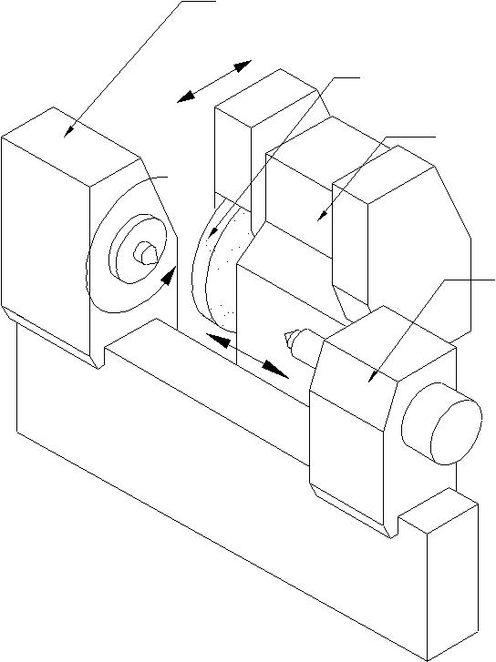  S1 |  | Head
 |  |  | Tailstock
 |  |  | Z

Fig. 5.18 Cylindrical Grinding Machine

Tool and Cutter Grinders

CNC has been applied to complex tool and cutter grinders involving as many as eight axes. The control system working in an interactive mode with the part program residing in the memory leads the operator step by step reducing the programming effort to the absolute minimum.

Profile Grinders

CNC has been used to advantage even on optical profile grinders. The control system has linear, circular and helical interpolation to generate complex contours, and has provision to dress the wheel and to compensate for wheel wear. Optics serves for tool setting, positioning the workpiece, checking wheel dressing and inspection of workpiece without removing it from the fixture.

ELECTRICAL DISCHARGE MACHINING

Electric discharge machine is an important machine in tool rooms. There are several types of electric discharge machines, which are fitted with computer numerical control.

Ram Type EDM

In this type of machine the electrode has to have the same size and shape of the counterpart of the workpiece being machined. Servo control is used to maintain the gap between the electrode and the workpiece.

Orbital EDM

In this type of machines, the electrode is in the form of a ball-ended cutter and spins about its own axis. The relative position of the electrode and workpiece is regulated by a 3-axis CNC system to generate any three dimensional surface.

Wire EDM

Wire cut EDM is an indispensable machine in tool rooms. This is used to make dies for blanking and piercing. The special feature of wire EDM is that the electrode is in the form of a thin wire of about 0.2 mm in dia. A small hole is drilled into the workpiece and the wire electrode is threaded through the workpiece onto a take-up roll. The movements of the work table through computer numerical control in X and Y directions enable cutting the component to the required shapes. In some cases where a relief is required for the die or the punch being machined, a 3-axis NC is used to tilt the wire axis relative to workpiece surface in the required direction. The direction of tilt varies with the contour and is controlled by the third axis of the CNC. Some of the latest wire EDM machines have the automatic drilling and self threading facility.

TURRET PUNCH PRESS

CNC has become very popular with punching and nibbling machine used for sheet metal work. Many of these machines are equipped with a turret head. Such machines are called turret punch presses. This machine is widely used in press shops. Main application of the turret punch press is to cut various types of holes/openings in sheet metal for manufacturing machine frames or control cabinets out of sheet metal. Modular tooling systems available simplify tooling. Interactive programming facilities are available with the machine controls. Off line programming and simulation are adopted to utilize the machine fully and to obtain correct workpiece. Some of the turret punch presses have an additional plasma arc or a laser cutting head to generate contoured patterns. Some of the latest machines have automatic work handling, automatic tool change and automatic measuring systems interfaced with the machine. CNC has also been applied to other forming machines such as plate bending, tube bending, flow turning and stretch forming as well. Table 5.8 gives specifications of a typical CNC Turret Punch Press.

Table 5.8 Specifications of a Typical Turret Punch Press
Sheet size with one reposition | 2040 x 1540 mm
Axis speed | 40 m/min
Max sheet weight | 75 kg
Max material thickness (MS) | 6.35 mm
Punching accuracy | +/-0.13 mm
Turret layout | 15 stations
Nibbling rate | 180 hmp
Max hit rate @25 mm increments | 180 hmp
Ram stroke | 25 mm
Minimum material thickness | 0.8 mm
Press motor | 4.5 kW
Axis drive | AC servo
Clutch | Air combination
Brake | Air combination
Weight | 8100 kg
Regrinding life of punch | 10 mm

GEAR CUTTING MACHINES

CNC has been introduced to automate various types of gear cutting machines.

- Gear Hobbing Machines

- Gear Shaping Machines

- Gear Grinders

- Bevel Gear Generators

CNC enables elimination of change gears in gear cutting machines. The relative rotary and translation movements of the tool and the workpiece are controlled by CNC systems and can be easily programmed through keyboard of CNC system to facilitate quick setting up of the machine. CNC gear cutting machines employ the concept of an electronic gearbox. CNC increases both the productivity and accuracy of gear cutting machine appreciably.

Three to six-axis control is very common in CNC gear hobbing machines. Many CNC gear hobbing machines incorporate direct hob drives, automatic hob shift, quick-change hobs, and automatic hob head swiveling. High-speed hob spindles make effective use of multi-start TiN coated, carbide coated or carbide insert hobs. Table 12.9 gives specifications of a typical Gear Hobbing Machine.

Use of CNC in gear shaping machine eliminates the need for change gears. CNC control is provided for the axial movement of cutter head slide, radial movement of column slide, rotary movement of cutter spindle and rotary movement of worktable.

Table 5.9 Specifications of a Typical Gear Hobbing Machine

Max dia of workpiece

Max module in steel

Max axial travel

Min/max no. of teeth

Working range

Dia of work table/bore

Distance between hob and work axis Max dia. of hob

Max length of hob Max hob shift Max helix angle

Speeds and feeds

Hob speed

Work speed

Axial feed

Radial feed

Tangential feed

Hob swiveling

CNC system

Power

Main motor

200 mm

6m

250 mm 6/120

215/60 mm

220 (max): 20 (min)

150 mm

220 mm

170 mm

45 deg

120-500 rpm

50 rpm

1-3000 mm/min

1-3000 mm/min

1-540 mm/min

1-500 deg/min

6xes CNC control system, Sinumerik 3GA with electronic Gear box for synchronization

12.5 kW

CNC PRESS BRAKES

A press brake is basically a sheet bending machine. This machine finds extensive use in fabrication of control panels, enclosures etc. Provision of CNC increases the productivity and significantly improves the quality of the final product. CNC systems of press brakes provide interactive help for programming. A tool library is also provided. Simulation capability in the programming software helps in the development of correct programs.

SPECIAL PURPOSE CNC MACHINES

Many SPM’s are now designed with computer numerical control to provide the necessary flexibility to the machine. A typical example is a moving column SPM that is designed for boring and reaming operations. Under the guidance of CNC the tool is positioned at a desired point or the tool is made to follow any contour for machining operations. Switch over from one type of machining operations to other is completely automatic through the provision of Automatic Tool Changer (ATC). The column traverse and fixed table module contribute to higher transfer efficiency and flexibility in line production. Hence these CNC special purpose machines can be integrated with other machine tools into flexible manufacturing line for greater flexibility in producing a variety of totally finished
components. Table5.10 gives specification of a moving column SPM. CNC is also used in transfer lines today
Table 5.10 Specifications of Moving Column SPM

Traverse
Saddle | X-axis | 630 mm
Spindle head | Y axis | 400 mm
Column | Z axis | 500 mm
Feeds
Rapid traverse | all axes | 14000 mm/min
Feed rate | all axes | 14000 mm/min (step less)
Spindle
Spindle Taper | BT 50
Speed | Infinitely variable
Range | 120-3000 rpm
Power | 7.5 kW
Type of motor | Variable Speed AC
Spindle thrust | 1000 kg
Automatic Tool Changer (ATC)
Tool capacity | 12 (nos)
Maximum tool diameter | 100 mm
Maximum tool length | 270 mm
Tool changing time | 8 sec
Tool Selection | Random bi-directional
Accuracies: (JIS)
Positioning accuracy | +/– 0.012
Repeatability | +/– 0.006
Hydraulic power pack
Motor power | 3.7 kW
CNC system | SINUMERIK 3M
Power requirement | 35 KVA

Other CNC Machines/ Accessories

CNC is used to control several other machines. Some of them are:

- Horizontal / Vertical boring machines

- Jig boring and jig grinding machines

- Plano millers

- Co-ordinate measuring machines

- CNC welding machines

- Assembly machines

- Printed circuit board drilling machines

- CNC forming machines

    - Tube bending machines

    - Plate bending machines

    - Stretch forming machines

    - Flow forming machines

- Tool handling systems

- Work handling systems

- Cleaning and washing stations

- Heat treatment equipment

- Packaging equipment

- Electron beam welding machine

- Fettling machines

- CNC press brakes

- Laser cutting machines

- Water jet cutting machines.

USE OF CNC MACHINES AS INSPECTION MACHINES

Since CNC machine slides are fitted with feedback devices, they can also be used for post process metrology. Many of the present day machines are fitted with touch trigger probes, which can be used for inspection of workpiece and for setting the tool offsets. On machining centres the probe can be stored in one of the pockets of the tool magazine. The probe is inserted into the spindle under program control and then can be used like a co-ordinate measuring machine to inspect the component being machined.

The probe can be used to compensate for fixture offsets, thermal deformations etc. A similar probe located at a fixed reference point can be used to set the offsets of the tools located in the spindle. Such probes are also used on turning machines to set the tool offsets and for monitoring the size of the workpiece.

FEATURES OF CNC SYSTEMS

The brain of a CNC machine is the control system. This is designed around one or more of the advanced microprocessors. Because of the advancement in the hardware technology, CNC systems are highly reliable with a very high mean time between failures. Several control systems, which are dedicated to different families of machines, are available today. Each model will have several variations to cater to the various requirements of machine tool builders and users. Several new CNC systems are fitted with PC based CNC systems too. A CNC system can be fitted to machine tools in order
to effect control over several machine functions. In order to perform these functions, a CNC system is characterized by a number of features. These functions can be broadly classified as follows:

- Control system features

- Memory features

- Programming features

- PLC features

- Diagnostic features

CONTROL SYSTEM FEATURES

These features provide information about the characteristics of the CNC system and its capabilities. Important features are given below:

Technology of System

Currently two types of architectures are being used in CNC systems

- Single microprocessor based systems

- Multi microprocessor based systems (Multiprocessor systems)

Single microprocessor architecture: In this type of system a 16, 32 or 64 bit microprocessor is used.

Multiprocessor architecture: This type of the architecture is widely used in many CNC systems today. The control functions are carried out by a set of microprocessors, each doing an assigned task. This concept helps to implement various functions faster. Both hardware and software structures are modular thereby enhancing the flexibility of the system.

Executive Program

The executive program contains the intelligence needed to carry out different tasks in CNC system. The executive program is resident usually in EPROM/Bubble memory.

Other System Features

Other features of CNC system are:

- C R T display and alphanumeric keyboard

- Manual data input (M D I) and operator programming

- System resolution, ex: 0.1 ∝m, 0.5 ∝m, 1 ∝m or 10 ∝m

- Feed and rapid traverse rates

- Spindle Speeds -—directly programmable or through S codes

- Modes of operation like M D I, Single step, Auto etc.

- Operating controls like Jog, fcheduleand spindle speed override, axis select switch, edit, reference, dry run, test mode

Axis Calibration

This is a very useful feature for obtaining higher positioning accuracy. The error in the pitch of the lead screw can be compensated with this feature.
Reversal Error (Backlash) Compensation

Backlash is due to the play between the screw and nut. Backlash will cause lost motion when the slides are reversed. Even pre-loaded ball screws may develop backlash in the course of time. This feature effects automatic compensation every time the slide is reversed. Error due to backlash in the lead screw can thus be minimized.

Pitch Error Compensation

There are several classes of accuracy for ball screws. There will always be some error from pitch to pitch, however accurate the screw may be. Pitch error will cause error in positioning as well as thread cutting. Hence there is a need to compensate pitch error. The positioning errors that might arise due to error in pitch are compensated through software.

Tool Nose Radius Compensation

The radius of the tool will introduce positioning errors in contouring. This error is compensated by the tool nose radius compensation function.

Machine Setup Data (MSD)

MSD or machine tool parameters indicate the machine tool characteristics, specifications and functions. The contents of each parameter should be set according to the parameter list annexed to the machine. The end user must not change the contents on the parameters. The OEM can use one standard control on several machine sizes and/or types.

Entering machine parameters: These are three methods of entering machine parameters.

i. | Setting through parameter CD-ROM-each block contains a machine set up data
 | code to identify the machine parameter followed by data for that parameter.
ii. | Setting data through MDI -—the machine data can be input through the operator’s
 | control panel by following the procedure for the control system.
iii. Setting data in EPROM’s -—machine parameters can be entered in the erasable
 | programmable read only memories. The data is permanently stored in specific
 | locations in the memory chip. To enter the set up data in EPROM, an EPROM

programmer is necessary.

MEMORY FEATURES
Design | Application | Features
Executive storage | EPROM | Non- volatile and widely used
Part program storage | Dynamic RAM | Semi conductor memory
 | CMOS RAM | Fast access and volatile
 | Bubble memory | Nonvolatile, slower than semi-
 |  | conductor memory
Machine constant | EPROM | Nonvolatile and can be field
 |  | programmed. Needs battery back up
Memory (parameter) | CMOS RAM | Intermediate working
Scratch pad RAM | MOS RAM
Static RAM area
Off-line data storage | Magnetic digital
 | cassette
 | Magnetic disc
 | Floppy disc
 | Hard disc
 | CD-ROM

PROGRAMMING FEATURES

Some standard programming features include:

- Absolute/Incremental programming

- Decimal point programming

- Diameter/Radius Programming

- Linear, circular and helical interpolation

- Multiple part program storage

- Sequence number search

- Feed/min or feed/rev Programming

- Dwell programming (In block containing dwell code, there is no slide movement)

- Tool length and diameter compensation -—The control has a storage area (tool buffer) for making modification to the program due to errors in tool setting length and diameters

- Position preset.

Subroutine Programming / Macro Programming

Repetitive operations can be written as subroutines and main program can call these subroutines. An example of subroutine is dressing program for a grinding wheel. The

advantage of using this subroutine is that it eliminates the need for rewriting a repetitive operation, thereby saving the memory space.

Parametric Programming

Parameters are freely assigned by the control for the purpose of arithmetic calculation in a part program. Trigonometric operations are also possible with R parameters.

Canned Cycles (Fixed Cycles)

This is a powerful control feature intended to shorten the length of the part program thereby conserving memory space. Canned cycles are single block multi pass fixed cycles.

Examples: Canned cycles for rough turning and peck drilling in CNC Lathes. Canned cycles for drilling, boring and tapping in machining centres.

PROGRAMMABLE LOGIC CONTROLLER

Programmable logic controller is a software oriented machine interface between the CNC system and machine tool functions such as miscellaneous functions (coolant on / off, pallet operation, spindle speed functions (M00, M01, M03, M04, etc) and tool functions). Signals from CNC to PLC are on /off type. The programmable logic controllers available today are microprocessor-based units, which are integrated into the CNC system. The programmable logic controllers have memory space to store interface programs.

Some of the common P L C features are listed below:

- Number of inputs and outputs 24, 32, 48 etc., (Both analog and digital)

- Memory capacity 4 k, 8 k etc.

- High-speed microprocessor to execute sequence program processing time of the order of milliseconds

- Software timers and counters

- Data exchange between CNC and PLC

DIAGNOSTIC FEATURES

The CNC systems have diagnostics features for faults or error conditions. Diagnostics are software programs, which check the functioning of the CNC system at various levels. The control system manufacturer gives detailed use and applications of these diagnostic programs. Diagnostics can be grouped as follows:

- Real time diagnostics

- On-line diagnostics

- Off-line diagnostics

Real Time Diagnostics:

D C power supply voltages, low voltage and real time clock are monitored. In case of failure of any one of these, control system automatically assumes the emergency stop conditions and shuts down the drives.
On-line Diagnostics:

On-line diagnostics are active during machine operation. Diagnostic messages are either readable from C R T screen or from LED Indicators. Program diagnostics detect programming errors. (Syntax, Parity etc.)

Off-line Diagnostics:

It is provided in the form of a CD-ROM or ROM board (PCB). Following a malfunction, the off-line diagnostic programs are to be loaded which check the different areas of the system and respond with error codes / error description on C R T Display. Diagnostics are very powerful features of CNC systems. To be productive, the system should have a low MTTR (Mean Time to Repair).

Remote Diagnostics:

It is now possible to send diagnostic programs through Internet to check the errors in CNC Machines. This enables manufacturers to locate faults even if the machine is located in a remote place in another country.

SOME FEATURES OF MODERN CNC SYSTEMS

- Advanced hardware architecture: Custom built very large scale integrated circuits (VLSI) which can handle several functions in a single chip are used in modern CNC systems. This way, the benefits of reduced component count and improved reliability are realized.

- Software modularity: Each function is written as a discrete module -—(structured programming). Additional software features can be added at any time to upgrade the control without affecting the software.

- Adaptive control: Reduces the production time by maximizing the utilization of the machine tool. It acts on measurement taken from external sensors (In-process measurement) and modifies the cutting conditions suitably.

- Conversational programming: The system featuring conversational programming are termed “user friendly” since they are designed with the operator in mind. One example of such a friendly feature is graphic display. With this feature, the operator can create the part drawing on screen and simulate the tool paths in the preparatory phase (Prior to machining). The operator can program in complete safety and be sure that nothing is omitted. The operator can also check the correctness of the part program on graphic display.

- Programming flexibility: In addition to conversational part programming language, high level language commands like IF-THEN ELSE, GO TO etc., can be used to extend the program’s power. Higher mathematical functions can be used to calculate square roots, trigonometric functions etc.

- DNC link. This is discussed separately in detail later.

  - Colour graphics: This provides visual interface between the operator and CNC. Part cross sections can be highlighted. Operating instructions and warning display can be colour coded for more clarity.

  - Machine interface: A high-level language like C is used for programming the machine logic in PC (example: GE 2000 MC). In AB8600, high-level language SIPROM (System Interface-Programming) is used.

  - Automatic selection of cutting speeds: If we specify the tool material and work material, C N C System selects cutting speed and feed from cutting condition technology database.

  - Automatic selection of tools and sequencing of tools: If operation is specified, system selects corresponding tools and sequence of tools. Systems like Mazak Fusion 640 provides this knowledge based approach.

  - Optimization of machine program: This feature will be useful for components with large number of drilling, tapping operations, or repetitive end milling tool paths as in the case of machining of dies and molds etc.

  - Display of finished component: Today CNC systems offer a feature to display the finished component together with dimensions. Sectioning and rotation of the model of the finished part are also possible.

  - Background programming: It is a common facility available in CNC systems. The user can run, edit and simulate another program while a program is being executed on the machine tool.

  - Digital CNC: The new breed of CNC controls use digital technology. The introduction of digital CNC has brought increased speed and precision to machine tool builders. The PC based open architecture controls incorporate such features like acceleration with jerk limitation, direct NURBS interpolation, use of high level languages, execution of large CNC programs from hard disc and increased number of zero offsets. In some of the systems the CNC and drive amplifiers are on the some board at the digital level.

  - Look ahead feature: The control system scans 150 or more blocks ahead of the block that is being executed and carries out interpolation and calculates the acceleration and deceleration requirements in the case of generation of complex tool paths. This helps to produce accurate profiles in high speed machining.

DIRECT NUMERICAL CONTROL (DNC)

Early NC machines used a tape reader for storing and inputting the program into the memory of the NC machine tool. Because of the unreliability of the tape reader as well as the low speed of operation NC engineers were searching for a suitable alternative. The advent of CNC in mid-sixtees opened up the possibility of improving the performance of NC machines by interfacing them with minicomputers. Yet another significant technological development was the interfacing of several NC machines with a computer,
which can store the part programs and transfer them to the NC machine concerned as and when needed. The computer is connected between the tape reader and the NC machine thereby bypassing the tape reader. This system was therefore called as behind the tape reader system (BTR). This development became very popular with NC machine users because of a number of significant advantages.

- A number of NC machines can be connected to a single computer. In many cases a single computer can manage all the machines on a shop floor.

- Programs in full or in segments can be transferred to the NC machines in a multiplexing mode.

- The computer can be conveniently used for program editing.

- Since the computer has large memories there is no limitation on the number or size of programs stored.

- The computer can be used for other tasks like program creation using computer aided part program generation software as well as for operation management tasks like production planning, scheduling etc.

With the development of CNC, DNC concept was extended to CNC machines also mainly for part program management. The DNC computer (sometimes referred to as host computer) could serve a number of CNC machines in shop floor. Figure 5.19 shows a typical DNC network. The DNC computer stores all the part programs and transfers the part programs to the CNC machines in response to the requests of the operators.

DNC COMPUTER
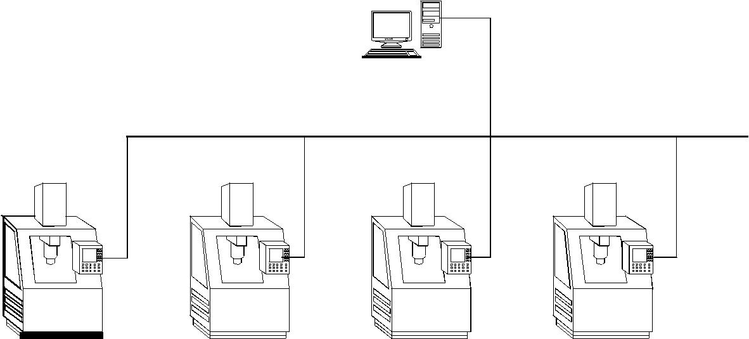

MACHINE 1 MACHINE 2 MACHINE 3 MACHINE 4

Fig. 5.19 DNC System

DNC systems are generally designed for 4, 8, or 16 CNC machines. However, with the wide spread acceptance of the local area network concept, the possibility of connecting more CNC machine in a DNC network has become a reality. The concepts of Internet, Intranet and Extranet have further enlarged the scope of distributed numerical control.

OBJECTIVES OF DNC

DNC serves many purposes and is now considered as essential for the efficient management of CNC machine tools in the shop floor. The main objectives of implementing DNC are given below:

- Upload and download CNC programs to and from machine tools simultaneously and directly from the CNC systems.

- Easy editing of the existing programs.

- Eliminating the use of manual switch boxes to multiplex CNC machines.

- Organizing and cataloguing of all programs for instant access.

- Eliminating the need for manually punching the program at the keyboard thereby saving considerable costly machine time.

- Eliminating the need for paper tape in the old generation of NC machines.

- Copy programs to and from the floppy discs and other media to the DNC computer.

- Compare files edited at the CNC to the original program.

- Rename or delete or update programs or create new programs.

- Show pictures of set ups for graphic catalogue of set up and machining operations.

- Providing system transaction files of all activity on the DNC computer.

- Pass word protection at different points of the CNC system wherever the operator could cause damage to the NC code by overwriting.

- Tool length offsets from tool pre-setters can be transferred directly to machine tool controls. It is also possible to connect co-ordinate measuring machines to DNC networks.

TYPICAL SCREEN OF A CNC SYSTEM

A typical program transfer screen for a DNC system with 4 machines is shown in Fig. 5.20. Besides send and receive, this screen has an option Close that stops the communication in progress. The option Edit loads a file into the editor. Compare enables the operator to see the difference between a files edited at the CNC system against the original file sent to the machine. The option Picture enables the user to see shop floor graphics.
BAR CODE OPTION

Some DNC systems provide an RS-232 bar code reader that is installed at the CNC system which enables the user to bar code the remote requests to receive and send files at the CNC. This eliminates typing and possible mistakes.

SEND | RECEIVE | CLOSE | EDIT | FILES | COMPARE | PICTURE | EXIT
SEND A FILE TO
COMMUNICATION STATUS WINDOW
MACHINE NAME |  |  | FILE NAME | STATUS |  | SENT/RECEIVED
ACE JOBBER |  |  | 94432145 | SEND |  | 68 %
DMG VMC |  |  | 73241561 | RECEIVE |  | 34 %
DMG HMC |  |  | 54321456 | SEND |  | 96 %
MIKRON |  |  | 12356432 | SEND |  | 09 %
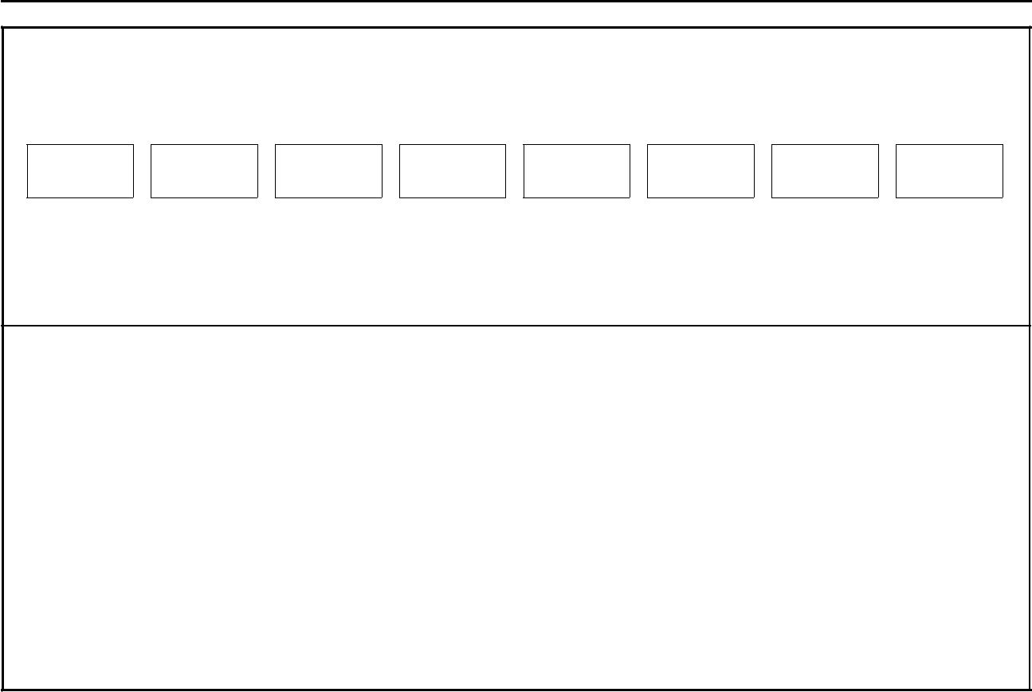

Fig. 5.20 Program Transfer Screen

FILE MANAGEMENT SYSTEM

A DNC system will have a file management system, which has the following features:

- Store and display details like file name, date of creation or updating of the file, time of creation of the file size etc.,

- Files can be picked by mouse or arrow keys.

- The facility for the use of long description will help easy recognition of the workpiece from the program name.

- Files can be sorted in the ascending or descending order by date/time, size or long description.

- Files can be copied, moved or deleted.

 | A typical Editor screen is shown in Fig. 5.21
 |  |  | FILE NAME |  | LONG NAME |  | SORT |  | TAG |  | <OFF> |  | ACCEPT
 |  |  | C:\DNC\NC FILES[Use Mouse to Toggle Menu]
 |  |  | 03450.NC |  | 28-09-04 |  |  | 08:45 |  |  | BRACKET
 |  |  | 12987.NC |  | 30-10-04 |  |  | 12:34 |  |  | RING
 |  |  | 675849.NC |  | 05-12-04 |  |  | 14:50 |  |  | BULKHEAD
 |  |  | 214365.NC |  | 21-02-05 |  |  | 11:15 |  |  | SPAR

Fig. 5.21 Editor Screen

Another feature of DNC is a provision for creating a report file, which is listing of all activities on the computer that is constantly written in the background. This is an ASCII file, which can be exported to databases for MIS purposes.

INTEGRATION OF CAD/CAM SYSTEM WITH DNC

Nowadays CAD/CAM systems are widely used to generate CNC programs. The CAD/ CAM system can be linked to the DNC computer so that the programs created by the CAD/CAM system can be transferred to the DNC computer for routing to the proper CNC machines or for editing. A typical LAN, which includes a DNC system and a CAD/ CAM workstation, is shown in Fig. 5.22.

D NC CO MP U TER
CA D/CA M | 12
Wo rkstatio ns | 12
CN C M achines | Chapter
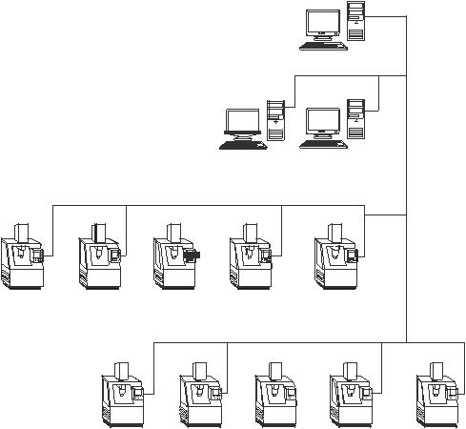

Fig. 5.22 CAD/CAM System in a DNC Network

DISTRIBUTED NUMERICAL CONTROL

Sometimes the abbreviation DNC is used to denote distributed numerical control. A computer network for manufacturing may consist of a main frame computer, CAD/CAM work stations, DNC host computer and the CNC systems connected to it. This configuration can be beneficially used for NC data processing. Any complex calculations required for generating NC data can be transferred to the more powerful mainframe computer. Thus the NC DATA processing is done at different hierarchical levels. In a way many of the DNC systems to day are in fact distributed processing systems.

FUNCTIONS OF A DNC SYSTEM

The functions of a DNC system can be summarized as below:

- Part Program management: Part program stored in the hard disc can be routed to
appropriate machines in the network depending upon the schedule.

- Shop floor editing: Program can be edited or modified to take into account design changes,
ool changes or machine changes.

- Shop floor graphics: The tool path simulation can be carried out on the shop floor.

- Data collection: The DNC computer can be used for shop floor data collection for
scheduling and monitoring.

- Shop scheduling: Since NC program cheduleis interlinked with the schedule,
he DNC computer can be used for scheduling.

- Statistical Process Control (SPC): The SPC function can be integrated into the working
f the DNC computer as it can be interfaced with the shop floor data collection function.

- Tool offset management: Tool offset data is sent to appropriate machine by this function.

The DNC network systems are usually UNIX, Novell or Windows based. They have
multitasking capabilities and Ethernet, arcnet or token ring interfaces. They may also have
limited CAD/CAM capabilities. Efficient built-in security systems will take care of
unauthorized access.

FUNCTIONS AVAILABLE IN A TYPICAL CNC SYSTEM

The functions available in a popular CNC system are listed below:

(i) | Controlled axes | 2, 3, | 4, | 5 | etc.
(ii) | Simultaneous axes | 2, 3, | 4, | 5 | etc.
(iii) | Max. programmable dimensions | 7 digits

- Linear Interpolation

- Multi-quadrant circular Interpolation
T
- hread cutting

- Rapid traverse

- Feed rate override

- Rapid traverse override

- Auto acceleration and retardation

- Exact stop

- Dwell

- Reference point return

- Co-ordinate system setting

- Decimal point input

- X axis dia./radius programming

- Radius programming

- S, T, M codes

- Program number display

- Program number search

- Program/subprogram

- Program format

- Optional block skip

- Canned cycles

- No. of offsets

- Backlash compensation

- Cycle start/Feed hold

    - Reset

  - Manual continuous feed

  - Incremental feed

  - Machine lock

  - Dry run

    - Single block

    - Registerable programs

  - Variable tape storage length

    - Data protect

    - Self diagnostics

    - Emergency stop

    - Stored stop check

(XL) | PMC (programmable machine control)
(XLi) | Spindle speed
( XLii) | T N R C (Tool Nose Radius Compensation)
( XLiii) | Custom macros

(XLiv) | Run Hour/Part display.

5TANDARD CONTROLLERS

There are large number of manufacturers of CNC controllers. Some of those listed below may not be in production today.

- Acramatic

- Aciera CNC

- AEG

- Allen Bradley

- Anilam

- ASEA

- Bendix

- Bosch, 860, 880, alpha 2, alpha 3, CC 100, CC 200, CC 300, CC 330 Bosch micro 5Z, 8Z, PC (PG), system 5

- Boehringer B1 T, B2 T

- Charmilles Robofill

- Cincinnati

- Deckel CNC 2301, contur, FP2-FP4

- DeVlieg

- Dixi NC

- Emco-Turn

- ESAB NCE 301

- FANUC, 0M, 0T, 3TF, 3M, 3TF 3T, 5M, 6MB, 6MA, 7M, 7T, 9, 10, 11, 12, 15, 20, 20A, 2000, 3000, MATE L, MATE M, MATE TS

- Fidia

- GE 550, 1050, 1050HL OX, 7542, CNC2000.

- Gildemeister EPL, EPM(UNI), EPM(ITY), EPM(SET), EPM II (BTR) 22

- Heidenhain TNC 135, 145, 151, 155, 355, 455

- Heller Unipro 80

- Hurco Ultimax B M C40

- Kongsberg NC 300, NC 2000

- MAHO 432

- Mandelli

- Mazak M1, M2, M32, T1, T2, T3, T4, T32

- Meldas 5000

- NUM 560, 750

  - Okuma OSP 330 D, OSP 2000, OSP3000, OSP5000

  - Olivetti Contour

  - Philips 432, 3300, 3353, 6600, 6652.

  - Sinumerik Mate TG, PRIMO S, SPRINT T, SPRINT 3T, 3M, 5M, 5T, 6MA, 6TA, 6MB, 6TB, 7M, 7T, 520, 550C, 560K, 810, 820, 850

  - Traub TX 7,TX8,TX8D

  - Toshiba

  - Yasnac 3000

- Fagor

Fanuc, Sinumerik and GE-Fanuc are the most popular CNC system manufacturers today.

SOME OF THE FEATURES AVAILABLE IN TYPICAL HIGH END CNC SYSTEM
Recently a new generation of CNC controllers have been marketed by several
manufacturers. Some of their important features are:
(i) Automatic determination of optimum tool path: By using data that is interactively
input to define the workpiece contours artificial intelligence is employed to
determine the optimum approach point and tool path to eliminate unnecessary
tool movement. As a result, the overall machining cycle is minimized.
(ii) Feed spindle orientation: By the use of a digitally controlled AC spindle motor,
spindle orientation is fast and precise.
(iii) Automatic fcheduleoverride: Even though only one fcheduleis programmed for
a machining cycle such as a pocket milling, the optimum fchedulefor both the
in-feed direction and corner cutting is automatically determined. Also when
milling pockets, the fcheduleis automatically changed when machining with full
cutter width and when machining with partial cutter width to maintain the
optimum cutting conditions for the minimum machining time.
(iv) Simultaneous S, M and T functions: Simultaneous operation of different units,
such as the ATC and Machine table indexing, A T C and pallet changer can
performed to greatly reduce machine’s non-cutting time.
(v) High speed tapping: The digitally controlled spindle motor allows spindle rotation
and Z axis feed to be synchronized. This advanced design makes high speed, high
precision tapping possible without the use of the floating tap holder. This is also
referred as rigid tapping.
(vi) High speed cutting of complex contours: For complex contours that require
interpolation by extremely small increments, the faster processing of speed of the
32 or 64 bit processor results in a much higher vectorial feed rate than that of
conventional CNC systems.

- D N C interface: The 32 or 64 bit CNC mounted on a machine can be linked with a host computer and transmit and receive data. By DNC interface, information can be shared.

- MAP compatibility: The 32 bit CNC controllers is designed for MAP (Manufacturing Automation Protocol) compatibility -—the international communication standards to be used by equipment in an automated factory.

- Background communication: The high speed 32 bit microprocessors can handle communications of variety of data -—programs, parameters, tool data and programs with a host computer simultaneously while in automatic operation.

- Absolute position detection: If equipped with absolute position detection function, a machine does not have to return to the home position prior to beginning operation. This is especially advantageous for a machining center controlled by host computer.

- Tool life management, Tool breakage detection and recovery: These functions resident in the individual machine’s memory can be communicated with the host computer, thereby facilitating centralized tool management.

- Automatic centering: By the use of a touch sensor mounted in the spindle, measurement of datum holes and surfaces is performed. Based on the measurement results, the work co-ordinate system is automatically shifted and machining begins.

- Adaptive feed rate control: By continually monitoring the load on the spindle motor and Z- axis servo motor, optimum cutting conditions are maintained. When an overload condition is detected, the programmed fcheduleis automatically overridden. As the cutting load becomes smaller, the feed rate will automatically return to the programmed value.

- Process management and program layout displays: The interconnections between processes and subprograms and processes with commonly used tools are indicated on these displays for convenient program restarts.

- Automatic tool length measurement: Tool length can be automatically measured and registered in memory to greatly reduce tool setting time. One setting of the measurement cycle allows up to 13 tools to automatically processed. (This process is semi-automatic for face mills and boring bars in that the tool must first be manually positioned over the measurement unit).

- Workpiece co-ordinates: When using a tool (such as an edge finder) to establish a workpiece datum point, all that is required is to enter the tool radius. The necessary calculations are performed automatically to set the workpiece zero position. When the optional touch sensor is used the angular offset co-ordinates can also be set. This allows high machining accuracy to be obtained even with simple fixtures.
T
  - ool path storage: The tool path storage function can be used to store in memory the point where a tool breaks during the cutting plus the path used to retract the cutter for servicing. This allows fast and smooth program restarting.

  - Automatic cutting conditions editing: Programmed spindle speeds and feed rate are easily altered by override keys according to actual machining conditions. By pushing an appropriate key, the programmed cutting conditions are automatically edited by the override amount on an individual tool basis.

  - Modal information display: The modal information display indicates which G, M, S, f codes are effective. This is extremely convenient for error-free restart of EIA / ISO programs.

  - Deflection compensation: Automatic compensation can be performed for the displacement at one axis in relation to another axis used as the datum.

  - Large reduction of component parts: With a 32 or 64 bit microprocessor as the core, large capacity memory chips, customs LSI’s and other state of the art technology used to the maximum, the number of parts is considerably smaller then that of conventional CNC system resulting in a highly reliable and compact design.

  - Ladder circuit display: The open and close status of individual circuits are displayed on the ladder chart on CRT display to help pinpoint the cause of problems.

  - Optimization of cutting conditions: Several CNC systems access cutting tool databases as well as cutting parameter databases. The interactive programming facilities enable the operator of the machine tool to input the features of the drawing in the CNC system. The system responds with appropriate tool selection and cutting parameter selection. Techniques are also incorporated to optimize the parameters.

GENERAL PROGRAMMING FEATURES OF CNC SYSTEMS

CNC systems can be classified into:

- CNC Systems for machining centres

- CNC Systems for lathes and turning Centres

- CNC Systems for special applications like Grinding Machines, EDM, Electron beam welding etc.
There are many features in these CNC systems which are of general interest and some of them are discussed below:

Absolute and Incremental Programming: Figure 5.23 shows a plate in which 3 holes are to be drilled. The locations of the holes are indicated in the drawing of the component. For the purpose of programming, these dimensions should be specified with respect to the workpiece coordinate system.
The X and Y axes are to be defined first. Figure5.23 shows the X and Y axes at a distance of 20 mm from the edge of the plate. The coordinates of the three hole locations should be calculated with respect to these axes.

In the case of absolute coordinate system all the coordinates should be specified with respect to the workpiece datum. In the case of incremental system, the zero datum is a floating one. Every coordinate is specified with respect to the previous position.

For machining the three holes the slide should be positioned under the drill spindle successively in positions 1, 2 and 3. The reference axes are marked in the figure. Thus the absolute co-ordinates to be used in the program will be:

Position | X | Y
1 | 40 | 50
2 | 40 | 100
3 | 120 | 60

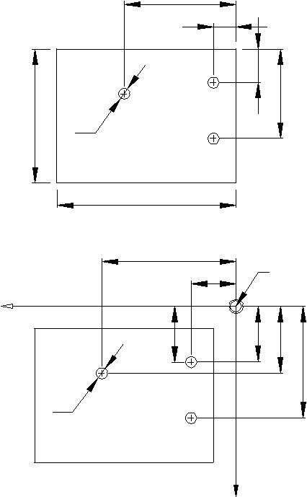

120

X

100

 | 20
 |  | 30
3 | 1 |  | 80
3 |  |  |  |  | Workpiece
Ø5 |  |  |  |  | Workpiece
 | 2 |  |  |  | Drawing
 | 160
 | 120
 | 40 |  | Workpiece
 |  |  | Datum ( X=0, Y=0)
 | 25 | 50 | 60 |  | Coordinates
 | 25 | 50 | 60 | 100 | with reference
 |  |  |  | 100 | to workpiece
Ø5 |  |  |  |  | datum
Fig. 5.23 A Plate with Holes

There are three ways in which the co-ordinate data are input to the machine control. They are:

- Absolute mode

- Incremental mode

iixed mode

In absolute mode, all co-ordinate values are measured from a fixed datum. Referring to Fig 12.24, W is the workpiece datum (X = 0, Z = 0). Points 1, 2, 3 and 4 have co-ordinates.

Point | X | Z
1 | 0 | 0
2 | 20 | 0
3 | 20 | – 40
4 | 30 | – 40

(Note: In programming CNC lathes, the diameter is input instead of radius)

4
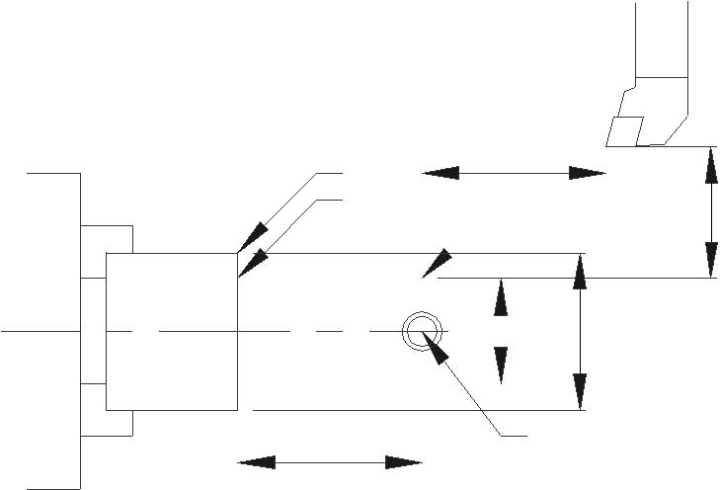
3

35

2

Tool

T

5

0 |  | 0
2 |  | 3

40 | 1

Fig 5.24 Co- ordinates in Turning

In incremental mode, the co-ordinate data input for every movement is the relative distance from the previous point. For example, when the tool moves from point 3 to point 4, the X distance is +5 and Z distance is zero. Thus, the co-ordinates depend on the axis movements.

The co-ordinate distances in incremental mode for Fig5.24 are given below:

Point | X | Z
T to 1 | – 35 | – 25
1 to 2 | + 10 | 0
2 to 3 | 0 | – 40
3 to 4 | + 5 | 0
In mixed mode, the co-ordinates can be either in absolute co-ordinates or incremental co-ordinates. Absolute co-ordinates are labeled X and Z and incremental co-ordinates U and W. For the example given, the co-ordinates can also be input as:

In mixed mode, the co-ordinates can be either in absolute co-ordinates or incremental co-ordinates. Absolute co-ordinates are labeled X and Z and incremental co-ordinates U and W. For the example given, the co-ordinates can also be input as:

Point | Z | Z
1 | X0 | Z0
2 | U10 | Z0
3 | X20 | W – 40
4 | U+5 | W0

In lathes it is convenient to program in mixed mode whereas in the case of machining centres program segments can be either in incremental or absolute mode or the whole program can be in either one of the modes.

- Preparatory codes and miscellaneous codes:

A typical line of a CNC program (called block) is given below:

N 0040 G01 X100.05 Y180.95 S450 M08;

Every block starts with a block number (3 or 4 digits), (N word); A block may have one or more G functions. G- functions like G01 if defined earlier and if the value is the same need not be repeated. For example, in a block if G01 is defined and if the next block also involves G01, this will be implied and need not be explicitly stated. Such G functions are called modal G functions. The block may contain the X, Y and Z co-ordinates of the target point. The feed at which the slide movement is to be executed is specified in the feed value. (e.g. F equal to 400 mm/min). If the feed is same as specified in the previous block it need not be repeated again. The spindle speed is specified by the S address. (e.g. Speed is 450 rpm). The M word represents a miscellaneous function. In this case M08 switches on the coolant motor. Thus each word has a unique alphabetic address. Hence this type of formatting the program is referred to as word address format. Other commonly used word addresses are T for tool, V for cutting speed, A for angle, etc.

G-codes or G functions are mainly NC functions. These are also called preparatory functions. Some of these have been assigned standard functions and others are left to be defined by the CNC system manufacturers. Common preparatory functions in a CNC system for lathes (FANUC 0) include:

- Interpolation functions

  - Positioning (G00)

  - Linear interpolation (G01)

  - Circular interpolation (G02, G03)

  - Polar co-ordinate interpolation (G112, G113)

  - Cylindrical interpolation (G107)

- Thread cutting (G32, G34)

- Feed functions

  - Feed per minute (G98)

  - Feed per revolution (G99)

  - Dwell (G04)

- Reference point

  - Automatic reference point return (G28)

  - 2n^{d,} 3r^{d} and 4t^{h} reference point (G30)

- Co-ordinate system setting (G50)

- Inch-metric conversion (G20, G21)

- Constant surface speed control (G96, G97)

- Canned cycles

  - Outer diameter cutting cycle (G90)

  - Thread cutting cycle (G92)

  - End face turning cycle (G94)

- Multiple repetitive cycle

  - Stock removal in longitudinal turning (G71)

  - Contour parallel turning (G73)

  - Finishing cycle (G70)

  - Thread cutting (G76)

- Canned cycles

  - Front drilling (G83)

  - Side drilling (G87)

  - Front tapping (G84)

  - Front boring (G85)

- Compensation function

  - Tool Nose radius compensation (G40 -—G42)

  - Changing tool offset amount (G10)

- Measurement functions

  - Automatic tool offset (G36, G37)

M- Functions are mainly switching functions. These include spindle on/off, spindle rotation (clockwise or anticlockwise) coolant on/off, tool change, pallet change, turret indexing etc. Earlier, these functions were incorporated in the NC control itself. Nowadays, a separate programmable logic controller (PLC) interface is provided so that the machine tool designer can design his PLC program to incorporate unique control features. This allows considerable flexibility for the designer. Control of auxiliary devices like conveyors, robots, pallet loaders, bar feed systems, quick change of chuck jaw, automatic door open/
CAD/CAM/CIM

close, machining completion buzzer, automatic chuck operation, chuck air blast etc. can be easily integrated in the machine tools either by the manufacturer or by the user.

interpolation
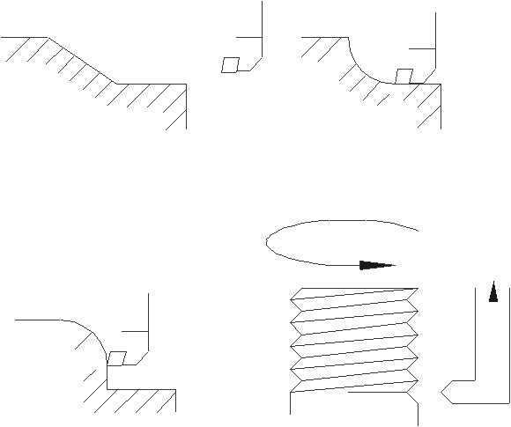

5 | 4
 | 3 | 2
 | 3 | 2
 |  | 1
 |  | 1
(A ) L inea r Interpolation |  | (B ) C ircula r Inte rpolation -— W

2

1

(C ) C ircula r Inte rpolation -— C W (D ) H elica l Inte rpolation

Fig 5.25 Interpolation Methods

The calculation of successive increments in slide position to reach the programmable point is called interpolation. Common methods of interpolation are linear, circular and helical. Figure 5.25 shows commonly used interpolation methods. Linear interpolation is shown in Fig.(A). Length 12 represents a linear movement parallel to X axis. Segments 2-3 and 4-5 are movements parallel to Z-axis. Segment 3-4 involves simultaneous movement in X and Z directions. Depending on the feed specified in the block the CNC system will calculate the individual speeds of the slides so that a taper will be cut on the surface of the workpiece. In Fig.(B) the segment 1-2 is turned using clockwise circular interpolation. It may be noted that the slide velocities in each axes will have to continuously vary to obtain the circular profile. This is also true with the counter clockwise (CCW) circular interpolation shown in Fig.(C). Helical interpolation used to cut threads in machining centers is illustrated in Fig.(D).

- Axes of movement

A CNC machine tool may have several controlled axes. If simultaneous movements in 2-axes only are available, the control is called 2-axis control. The CNC lathe will have two axes i.e. X and Z. A turning center will have three axes i.e. X, Z and C. A machining center will usually have three axes (X,Y and Z).

PROGRAMMING OF CNC MACHINE TOOLS

CNC programming is a term that refers to the methods for generating the instructions that drive the CNC machine tool. For two dimensional components with little geometric complexity, CNC instructions can be written manually. However, as the geometricalcomplexity increases more sophisticated techniques are required, particularly for 3-axis, 4-axis and 5-axis CNC machining.

There are three distinct techniques adopted for creating CNC programs:

- Manual CNC Programming

- Programming using CAM software (CAD/CAM based programming systems)

Manual programming is recommended for simple workpieces which require only a few blocks of program. Programming of complex workpieces requires the help of a CAM software. CAD/CAM based systems have become popular recently and are now being widely adopted. Detailed description of these techniques is given in the following section.

MANUAL PART PROGRAMMING

This technique is widely used for workpieces of relatively simple geometry. The steps in manual programming are:

- Careful study of component drawing- materials, tolerances, surface finish etc

- Select the raw material or blank if not specified.

- Select the number of set ups necessary and the machine/s on which the part is machined.

- Deciding the workpiece datum for each set up.

- Designing the fixtures or holding of the job.

- Deciding the process and sequence of processes to achieve the desired accuracy and tolerances

- Selecting the tools and cutting parameters.

- Writing the program

- Input the program and dry run; correct mistakes if any.

- Produce the first part and inspect.

- Correct the program if necessary and progress to lot production.

- Create documentation for future reference.

- Archive the program and documentation.

It was mentioned earlier that an NC program will consist of a number of lines called blocks. Each block will consist of a number of words. Each word will have two components: a word address and a numeric code representing information. The common word addresses are:

N -—G -—X -—Y -—Z -—A -—B -—C -—F -—S -—T -—M

where

N = sequence number of instructions

G = preparatory function

XYZABC = co-ordinate and angular data

CNC Machine Tools

F = feed

- = spindle speed

- = tool code

M = miscellaneous function

The program is directly input into the machine’s memory through the following methods:

- Manual data input through the keyboard of the NC console.

- A floppy disc and disc drive or magnetic tape.

- DNC mode -—directly from the computer used for programming or storage of program to the memory of the CNC machine.

- The program can be transferred to the machine through a LAN or through Internet.

Today, another form of programming built in the CNC control itself is gaining acceptance. Using CNC programming software, the programmer can generate a set of instructions at the machine control itself. Using basic tool motion commands combined with canned cycles and custom or user defined macros the programmer can enter component geometry information on the front panel CRT, provide supplementary information about tool path and cause the CNC program to be produced automatically within the machine tool control.
NOMENCLATURE OF THE CNC MACHINES AXES

X
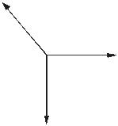
Z

Y

z | X
Y
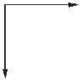

Z
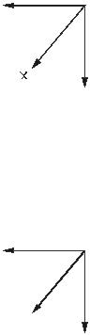

X

Y
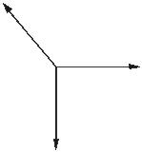
 | X | Y | X
 | X |  | Y
Z | Z |  | Z
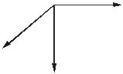
Fig. 5.31 Co-ordinate System

The co-ordinate system for designating the axes is the conventional right hand co-
ordinate system. Some possible dispositions of these co-ordinates are shown in the Fig 5.31. One could use his right hand (as shown in Fig.5.32) to get these alternative relative positions of the same right hand co-ordinate system.

 |  | CAD/CAM/CIM
 | +Y | +Y
 |  | +B
 | +B
 |  | C
 |  | +
 |  | +Z
+C | +A | +X
+C | +A | +A
+Z |  | +X
Direction for Rotary Motions
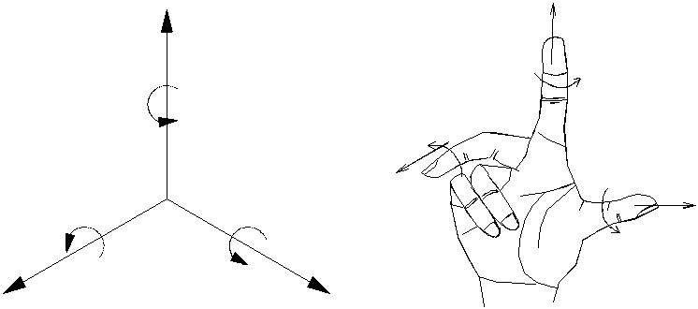
Fig. 5.32 Right Hand Co-ordinate Systems

DESIGNATING THE MOTIONS

- Location: First of all, Z-motion shall be designated. This shall be followed by X and Y motions respectively. Z-axis motion is either along the spindle axis or parallel to the spindle axis.

- Direction: For NC machines the positive (+) Z-motion increases the clearance between the work surface and the tool holder.

- When there are several spindles and slides: In such cases, one of the spindles, preferably perpendicular to the work holding surface may be chosen as the principal spindle. The primary Z-motion is then related to the primary spindle. The tool motion of other spindle quills or other slides, which are termed as secondary and tertiary motions, may be designated as U, V, W and P, Q, R respectively.

Rotary Motions:

A, B and C defines the primary rotary motions.

- Location: These motions are located about the axis parallel to X, Y and Z respectively. If in addition to the above mentioned primary rotary motions, there exist secondary rotary motions, whether parallel or not to A, B and C those should be designated as D or E.

- Direction: Positive (+) A, B and C are in the directions which advance a right hand screw in the positive (+) X, Y and Z directions respectively.

Programming of all CNC machine tools are done more or less on similar lines though there are several variations due to the type of machining involved.

The programming aspects of machining centres are discussed in detail below :

PROGRAMMING ASPECTS OF MACHINING CENTRES

A machining centre may be either 3 or 4 or 5 axis machine. A 3-axis machine may have simultaneous interpolation capability either in two or three axes. A machine usually will

CNC Machine Tools

have at least two pallets so that setting up of the workpiece can be carried out on one pallet while the workpiece on the other pallet is machined. The spindle size is designated by its taper (ISO 40, ISO 50, BT40 etc.). A distinguishing feature of the machining centre is the tool magazine which can hold several tools (32, 40, 80, 120 etc). Normally a tool is identified by the pocket in which it is inserted. The pockets are numbered consecutively. There will be an automatic tool changer (ATC) which transfers the tool between ATC and the spindle. While one operation is going on, ATC is ready with the tool for the next operation. Therefore, while programming, the tool required for the next operation is called at the start of an operation. Typically the tool changing time varies between 4 to 7 seconds. It may be as low as 0.5 sec in the case of high speed machines.

The datum point or surface for programming can be selected conveniently. There are a number of possibilities. Similarly a number of workpiece reference points can also be selected, and used in a program. These are entered in the memory of the system separately.

A machining centre with 3 axis control may also have a rotary table (B axis). If this is under CNC control it gives a fourth axis to the machine. In some machines, only discrete indexing may be available. This table can be indexed in steps of 5 degrees so that machining on several faces can be carried out in a single set up.

Programming requires knowledge of the G-codes and M-codes.

Table 5.11 and 5.12 give the G and M codes available in a typical CNC system.

Table5.11 Preparatory Functions

(G Functions) -—FANUC 0

Group | G Code | Initial State | Description
01 | G00 |  | Positioning (Rapid feed)
 | G01 |  | Linear Interpolation
 | G02 | G01 | Circular Interpolation/helical CW
 | G03 |  | Circular Interpolation/helical CCW
 | G02.1 |  | Circular threading CW
 | G03.1 |  | Circular threading, CCW
 | G02.2 |  | Involute interpolation, CW
 | G03.2 |  | Involute interpolation, CCW
 | G02.3 |  | Exponential function interpolation, CW
 | G03.3 |  | Exponential function interpolation, CCW
00 | G04 |  | Dwell
 | G05.1 |  | Multi-buffer
01 | G06.1 |  | Spline interpolation
00 | G07.1 |  | Cylindrical interpolation
 | G09 |  | Exact stop check
 | G10 |  | Setting offset amount and work zero offset amount
 | G10.1 |  | PMC data setting

 |  |  | CAD/CAM/CIM
Group | G Code | Initial State | Description
 | G10.3 |  | High speed machining registration start
 | G10.6 |  | Tool retract data escape
 | G11 |  | Data setting mode cancel
 | G11.3 |  | High speed machining registration end
25 | G12.1 |  | Polar co-ordinate interpolation
 | G13.1 |  | Polar co-ordinate interpolation cancel model
17 | G15 |  | Polar co-ordinate command cancel
 | G16 |  | Polar co-ordinates command
02 | G17 |  | Selection of XY plane
 | G18 | G17 | Selection of ZX plane
 | G19 |  | Selection of YZ Plane
06 | G20 | As selected | Inch input
 | G21 | before power | Metric Input
 |  | turning off
04 | G22 |  | Stored stroke limit function on
 | G23 | G22 | Stored stroke limit function off
24 | G25 |  | Spindle speed fluctuation detection off
 | G26 |  | Spindle speed fluctuation detection on
00 | G27 |  | Zero return check
 | G28 |  | Return to zero
 | G29 |  | Return from zero
 | G30 |  | Return to second zero
 | G30.1 |  | Floating zero return
 | G31 |  | Skip function
 | G31.1 |  | Multi-step skip function
 | G31.2 |  | Multi-step skip function 2
 | G31.3 |  | Multi-step skip function 3
01 | G33 |  | Thread cutting
00 | G37 |  | Automatic tool length measurement
07 | G40 |  | Cutter radius compensation cancel /
 |  |  | 3-D tool offset cancel
 | G41 | G40 | Cutter radius compensation, left /
 |  |  | 3-D tool offset
 | G42 |  | Cutter radius compensation, right
19 | G40.1 |  | Normal direction control cancel
 | G41.1 |  | Normal direction control left on
 | G42.1 |  | Normal direction control right on
08 | G43 |  | Tool length compensation, plus
 | G44 | G49 | Tool length compensation, minus

Contd....

CNC Machine Tools

Group | G Code | Initial State | Description
 | G49 |  | Tool length compensation cancel
00 | G45 |  | Tool offset extension
 | G46 |  | Tool offset reduction
 | G47 |  | Tool offset, double extension
 | G48 |  | Tool offset, double reduction
11 | G50 |  | Scaling cancel
 | G51 |  | Scaling
12 | G54 |  | Selection of work co-ordinate system 1
 | G54.1 |  | Additional work co-ordinate system
 | G55 |  | Additional work co-ordinate system 2
 | G56 | G54 | Additional work co-ordinate system 3
 | G57 |  | Additional work co-ordinate system 4
 | G58 |  | Additional work co-ordinate system 5
 | G59 |  | Additional work co-ordinate system 6
00 | G60 |  | Single direction positioning
15 | G61 |  | Exact stop check mode
 | G62 |  | Automatic corner override mode
 | G63 |  | Tapping mode
 | G64 | G64 | Continuous cutting mode
00 | G65 |  | Call of user macro
 | G65.3 |  | Call of high speed machining program
12 | G66 |  | Modal call of user macro
12 | G66.1 |  | Macro modal call B
 | G67 | G67 | Modal call of user macro, cancel
16 | G68 |  | Co-ordinate system rotation
 | G69 |  | Co-ordinate system rotation cancel
 | G71 |  | Metric Mode
00 | G72.1 |  | Rotation copy
 | G72.2 |  | Parallel copy
09 | G73 |  | Peck drilling cycle
 | G74 |  | Reverse tapping cycle
 | G76 |  | Fine boring cycle
 | G80 |  | Fixed cycle, cancel
 | G81 |  | Drilling cycle, spot drilling
 | G82 |  | Drilling cycle, counter
 | G83 | G80 | Peck drilling cycle
 | G84 |  | Tapping cycle
 | G84.2 |  | Rigid tapping cycle
 | G85 |  | Boring cycle

Contd....

 |  |  |  | CAD/CAM/CIM
 |  | G86 |  | Boring cycle
 |  | G87 |  | Back boring cycle
 |  | G88 |  | Boring cycle
 |  | G89 |  | Boring cycle
 | 03 | G90 | G91 | Absolute command
 |  | G91 |  | Incremental command
 | 00 | G92 |  | Setting co-ordinates
 |  | G92.1 |  | Work co-ordinate system preset
 | 05 | G93 |  | Inverse time feed
 | 05 | G94 | G94 | Feed rate, mm/min mode
 |  | G95 |  | Feed rate, mm/rev. mode
 | 10 | G98 | G98 | Initial level return in fixed cycle mode
 |  | G99 |  | R level return in fixed cycle mode

Table 5.12 M-Codes in a CNC System

M00 | Program stop
M01 | Optional stop
M02 | End of program
M03 | Spindle CW
M04 | Spindle CCW
M05 | Spindle stop
M06 | Tool change
M07 | Tap Oil on
M08 | Coolant on
M09 | Coolant/Tap Oil off
M10 | B-axis clamp
M11 | B-axis unclamp
M12 | Hydraulic power rotary table on
M14 | Oil hole drill coolant on
M16 | Heavy tool change
M17 | Tap cycle confirmation
M18 | Tap cycle cancel
M19 | Spindle orientation
M20 | Coolant nozzle up
M21 | Coolant nozzle middle
M22 | Coolant nozzle down
M23 | Detection of contact in -—
M24 | Detection of contact in +X
M25 | Detection of contact in -—

Contd....

CNC Machine Tools

M26 | Detection of contact in +Y
M27 | Tool breakage detection
M28 | Automatic gap elimination
M29 | M27 & M28 together
M30 | End of program and rewind
M50 | Air blow on
M52 | Tool length offset measurement
M53 | Tool length Offset execution
M54 | Tool length Offset cancel
M57 | Measurement along Z axis
M58 | Execution along Z axis
M59 | Cancel along Z axis
M60 | Measurement along +X axis
M61 | Measurement along -— axis
M62 | Execution along X axis
M63 | Cancel along X axis
M64 | Measurement along +Y axis
M65 | Measurement along -— axis
M66 | Executing along Y axis
M67 | Cancel along Y axis
M70 | Return to zero rotary table position
M73 | Y Axis mirror image off
M74 | Y Axis mirror image on
M75 | X Axis mirror image off
M76 | X Axis mirror image on
M80 | Rotary table CW rotation
M81 | Rotary table CCW rotation
M82 | Step mode tool removal
M83 | Step mode tool change cycle
M84 | Step mode tool jog operation
M88 | Splash guard open
M89 | Splash guard close
M90 | Pallet change
M92 | Pallet unclamp
M96 | Pallet loading and advance
M97 | Pallet loading retract
M98 | Call of sub program
M99 | End of sub program

CAD/CAM/CIM

PROGRAMMING CODES

Programs are written using the standard word addresses given below :

N Sequence number (1 to 9999)

G Preparatory function: Up to 4 G functions in a block are permitted. Some systems use G codes in three digits too.

X

Y Dimension mode in each axis, up to 3 decimal place

Z

I

J Arc centre offset in X, Y, Z axis + or – Axis direction

K

P, Q Word address codes, meaning depending on G function

B Rotation axis about Y axis

F Feed rate mm/min; eg.F300.0

- Spindle speed; e.g. S630

- Tool function (TXX to TYY), say depending on number of tools in the magazine

- Miscellaneous function

- Offset number

- Dwell function

- Cutter radius offset

- No. of repetitions of fixed cycle and sub program

Example of a program block:

A typical block of program may be written as:
N005 G01 G45 X 50.0 Y 100.1 F300.0 S480 M03 H01;
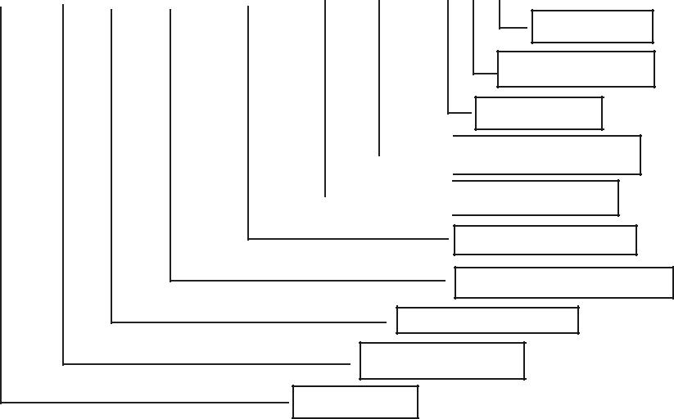
End of Block

Tool Length Offset

Spindle, CW

- Spindle Speed. 480 rpm

Feedrate 300 mm/min

Y Coordinate 100.1 mm

X Coordinate 50 .0 mm

Tool length offset Plus

Linear Interpolation
Line Number

PROGRAMME PREPARATION

An inspection of the component shows that the table positioning movements are for many operations are repetitive in nature and hence these movements can be coded in a sub-programme.

Sub-programme

The sub-programme is written assuming that the spindle is positioned above the reference point (work piece datum) 1. The tool is then successively positioned at locations 2, 3, 4, 5, 6 and 7. Please refer to Fig. 5.33.

Like the main programme sub-programme is given a programme number.

 | 2 00
7 | 2 | 3 | 12
 | Y |  | 12
 |  | X | 12
 | 1 | X | Chapter
6 | 5 | 4 | Chapter
 |  | 100 | Chapter
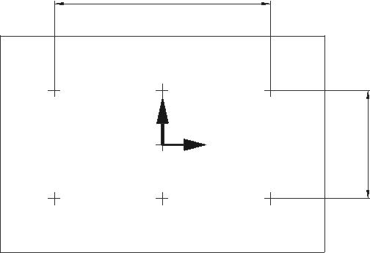

Fig. 5.33 Locations Visited in the Sub Program

CAD/CAM/CIM

027 ;(Programme Number 27. This number is used to call the sub-programme in the main programme.)

X0.0 Y50.0 ; | (Position 2)
X100.0 ; | (Position 2)
Y-50.0 ;
X0.0;
X-100.0 ;
Y50.0 ;
M 99 ; | (Return to the main programme)
Main Programme
018 ; | (Programme number 18)
(Part-name)
G0 G40 G80 ; | (Rapid traverse)
 | (Cutter compensation cancel)
 | (Canned cycle cancel)
G91 G28 X0 Y0 Z0 ; | (Incremental positioning)
 | (XYZ zero return)
/T1 ; | (Call tool in Pocket #1 Centre Drill)
/M06 | (Call tool change)
 | (Tool #1 is now inserted in the spindle)

Note : Block delete switch (/) is used here as these blocks are used only during set up. These blocks with “/” sign are again provided at the end of the programme. Hence during repeated machining the block delete switch is kept in the on position and these lines preceding / symbol are ignored.

M1 ; ( An optional stop code is introduced so that the program will

Temporarily cease execution to facilitate inspection. The

program will continue if the “ Start” button is pressed. Once the program is proven, the optional stop switch is shifted to “off” mode so that M1 code is ignored.)

(Centre Drilling)

N1 T2 ; (Calling next tool i.e. 8.5 Drill)

G0 G90 G54 G43 X0 Y0 Z50.0 H1 S2000 M3 ;

(Select work co-ordinate system (G54) Rapid positioning above location 1 Tool length offset 1 active

Spindle speed 2000 rpm

Spindle rotation clockwise (M03))

CNC Machine Tools
 | G98 G81 Z-8.0 R47.0 F100.0 |  | (Canned cycle (Drilling) G81
 |  | Return to Initial position (G98)
 |  | Drilling depth = –5 mm
 |  | Rapid up to Z = 3 mm
 |  | Feed rate 100 mm / min)
 | M98 P27 ; | (Calling sub programme #27- Centre drilling in 7 locations)
 | G80 G91 G28 Z0 ; | (Fixed cycle cancel
 |  | Z axis zero return)
 | M6 ; | (8.5 mm drill is now inserted in the spindle
 |  | The centre drill is returned to the tool magazine)
 | M1 ; | Optional stop
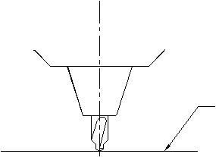

Initial Level

Rapid Level
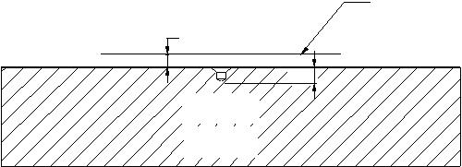
5

5

Work

Piece

Fig. 5.34 Centre Drilling Cycle

(8.5 Drill)

N2 T2 (Process #2, calling Tool #3)

G0 G90 G43 X0 Y0 Z50.0 H2 S936 M3;

G99 G81 Z-38.0 R47.0 F187 L0; (Rapid traverse to stop at Z=3 mm

Depth = 35 mm

Return to initial rapid level (G99)

No machining to be done at this

position (L0))

M98 P27 ;

G80 G91 G28 Z0 ; Returned to Z home position for
M6: tool change

CAD/CAM/CIM

M1 ;

(18 DIA DRILL)

N3 T4 ;

G0 G90 G43 X0 Y0 Z50.0 H3 S442 M3 ; G81 Z41.0 R47.0 F88 ;

M 98 P27 ; M6 ;

M1 ;

(19.5 DRILL)

N4 T5;

G0 G90 G43 X0 Y0 Z50.0 H4 S408 M3 ; G81 Z -38.0 R47.0 F82 ;

G80 G91 G28 Z0 ;

M6 ;

M1 ;

(CHAMFERING) N5 T6 ;
G0 G90 G43 X0 Y0 Z50.0 H3 S442 M3 ; G81 Z-41.0 R47.0 F88 ; G80G91G28Z0;

S500 H5 M3;

G99G81 Z - —.0 R47.0 F51 L0 ; M98 P27

G80 G91 G28 Z0 ;

M6 ;

M1 ;

(M10 × 1.5 TAP)

G0 G90 G43 X0 Y0 Z50.0 H6 S318 M3 ; G84 Z-38.0 R40.0 F477 L0;

(Note: Tapping cycle G84 involves rapid traverse, feed, reverse feed and return)

M98 P27 ;

G80 G91 G28 Z0;

M6 ;

M1 ;

(f20 H7 BORING)

N7 T1 ;

G0 G90 G43 X0 Y0 Z50.0 H7 S1194 M3;

/G81 Z-5.0 R3.0 F119 ;
/G80 G91 G28 Z0 M5 ; /M1 ;
/G0 G90 G43 X0 Y0 Z50.0 H7 M3 ; /G81 Z-8.0 R47.0 F119 ;
/G80 G91 G28 Z0 M5 ; /M1 ;
/G0 G90 G43 X0 Y0 Z50.0 H7 M3 ; G76 Z-35.0 R47.0 P0.5 Q0.5 F119 ;

CNC Machine Tools

limits. That is why the four succeeding lines of programme starts with block delete symbol. Once the setting of the boring bar is proven to be satisfactory the block delete switch can be thrown into the “ON’ position thereby ignoring these lines during regular production run)

(P, Dwell 0.5 Sec, Q, Offset 0.5 mm)

Note: G76 is precision boring operation. At the end of the boring operation the tool is withdrawn along the radial direction at the orientated stop position of the spindle. There is a dwell of 0.5 sec and the boring bar is withdrawn.

G80 G91 G28 Z0 ;

M6 ;

M30 ;

Note: The readers are advised to compare the G and M codes used in this program with the G and M codes of the machines available with them as there may be differences in the G-Codes and m codes from system to system.

QUESTIONS
1. | What is the most popular type of drive for CNC machines today?
2. | Sketch and explain the torque speed characteristics of a spindle drive.
3. | Why is a gearbox used in the main drive of some CNC machines?
4. | Why is separate cooling motor used with DC drives?
5. | List the advantages of AC servomotors over DC servomotors.
6. | Why is a servomotor used for axes feed drive?
7. | Why is often a reduction drive using timing belt, employed in feed drives?
8. | What is the advantage of servomotors with built-in encoders?
9. | What are the four common types of ball screw mounting arrangements?
10. | What are the advantages of Linear Motion guide ways?
11. | What is the type of plastic insert used in CNC machine sideways?
12. | What is the purpose of using LM guides or plastic inserts in sideways?
13. | What is the advantage of using slant bed design for turning machines?
- Why should a brake be used with the X-axis drive in a slant bed lathe?

- What is the principle of operation of a linear motor?

- How is the turret of a CNC lathe indexed?

- What is a bi-directional turret?

- Why are not axial tools kept in adjacent pockets in a tool turret?

- Why is a poly V belt preferred for main drive ?

- What is the advantage of using a linear transducer for feedback measuring?

- What is the advantage of using an absolute measuring system?

- What is the advantage of using an analog measuring system?

- Describe the principle of working of two analog transducers.

- Explain the principle of working of two digital incremental transducers.

- What is a Digital Read Out (DRO) ?

- What is an A/D converter ? Where is it used in a CNC Machine?

- Name three types of bearings used in the mounting of spindles of CNC machines.

- Why is sometimes a spindle oil cooler necessary?

- Is it necessary to keep a CNC machine in an A/C room?

- What type of microprocessors are used in modern CNC systems?

- What is the advantage of multiprocessor CNC system?

- Name three techniques of interpolation.

- Give major specifications of a machining centre.

- Give major specifications of a CNC lathe.

- What are the differences between a CNC lathe and a turning centre?

- What is a typical tool changing time in a modern high speed machining centre?

- How is the slide position referenced?

- What is meant by accuracy?

- What is meant by repeatability?

- How is a CNC machine calibrated?

- What are the following G Functions for a lathe? G04, G09, G27, G54, G7642.
- WHat are the following G Functions for a machining centre? G17, G30, G81, G99
- What are the following M functions for a machining Centre? M03, M19, M06
- Write and explain the standard format of G01 code in a CNC lathe.

- What is a user macro?

- What is the purpose of a tool pre-setter?
47  47. |  | What are the D and H codes in a machining centre program?
48. |  | How is a tapered thread cut in a machining centre?
49. |  | How is a program number designated?
50. |  | What is the difference between absolute and incremental programming?
51. |  | Specify Nine linear axes as per ISO.
52. |  | Specify the different combinations of axes of a 5-axis machining centre.
53. |  | What are the axes of a 4 axes machining centre?
54. |  | Name the roughing and finishing tool holders in a CNC lathe for turning.
55. |  | Name the turning inserts for the above.
56. |  | What is the difference between BT taper and ISO taper for machining centres?
57. |  | What is the code for tool nose radius compensation in a lathe?
58. |  | What is the G code for cutter diameter compensation in milling?
59. |  | Describe the types of milling operations available in a CAM software.
60. |  | Describe the common tool motion statements available in a CAM software.
61. |  | Discuss the stock boundary definition and area clearance in a CAM software.
62. |  | What is the speciality of a tapping tool holder in a machining centre? What is
 |  | the significance of rigid tapping?
63. |  | Why is ceramic tool advantageous than carbide tools in CNC turning?
64. |  | Why is a curvic coupling preferred in indexing devices in a CNC machine?
65. |  | What are the common types of automatic tool changers?
66. |  | Why is a pull stud used in the tool holder of a machining centre?

COMPUTER AIDED PROCESS PLANNING
&
GROUP TECHNOLOGY

INTRODUCTION

Process planning is concerned with determining the sequence of individual manufacturing operations needed to produce a given part or product. The resulting operation sequence is documented on a form typically referred to as operation sheet. The operation sheet is a listing of the production operations and associated machine tools for a work part or assembly. Process planning is an important stage of product development since production tooling like jigs, fixtures, special tools etc. can be designed only after the process is finalized.

Like a group technology - —ased system utilizing classification and coding to retrieve parts, code numbers can be used for retrieval of existing and preferred manufacturing information. The principle of group technology is therefore discussed here as part of process planning. The importance of process planning lies in the fact that process plans have a direct bearing on the cost of the part. As new manufacturing processes and machines are introduced, process plans also undergo changes. Hence process planning is a dynamic activity. The continuous emphasis on cost reduction also requires the process plans to be updated to reduce the cost. Cost information can be included in a computer assisted process planning system, using an automatic time standards (ATS) system.

PROCESS PLANNING

Manufacturing planning, process planning, material processing, process engineering and machine routing are a few titles given to the topic referred to here as process planning.

CAD/CAM
Process planning is that function within a manufacturing facility that establishes which machining process and process parameters are to be used to convert a work material (blank) from its initial form (raw material) to a final form defined by an engineering drawing. Process planning is a common task in small batch, discrete parts metal working industries. The process planning activity can be divided into the following steps:

- Selection of processes and tools

- Selection of machine tools/Manufacturing equipment

- Sequencing the operations

- Grouping of operations

S
- election of work piece holding devices and datum surfaces (set ups)

S
- election of inspection instruments

- Determination of production tolerances

- Determination of the proper cutting conditions

- Determination of the cutting times and non-machining times (setting time, inspection time) for each operation

- Editing the process sheets.

All the information determined by the process planning function is recorded on a sheet called process plan. The process plan is frequently called an operation sheet, route sheet or operation planning sheet. This provides the instructions for the production of the part. It contains the operation sequence, processes, process parameters and machine tools used. Fig 6.1 shows a typical process planning sheet.

 | XYZ GLOBAL MANUFACTURING LTD. VELLORE 632014
PART NUMBER |  | : | 610 415 3426 |  |  |  | MATERIAL: FG 200
PART NAME |  | : | PIN
Process | Process |  | Machine | Tool | Cutting | Spindle | Feed/ | Set Up | Process
Number | Details |  |  | Tip | Speed | Speed | Feed | Time | Time
 |  |  |  | Tool | m/min | rpm | Rate | min | min
 |  |  |  | holder
01 | HOC |  | CNC
 | CC |  | LATHE
 | Drill
02 | Drill |  | CNC
 |  |  | LATHE
03 | Face & |  | CNC
 | Turn |  | LATHE

Computer Aided Process Planning
 | 04 | Grooving | CNC
 |  |  | LATHE
 | 05 | HOC | CNC
 |  |  | LATHE
 | 06 | HOC | CNC
 |  |  | GRINDER

HOC: HOLD ON CHUCK

CC : CENTRE DRILL

Fig. Typical Process Planning Sheet

In conventional production system, a process plan is created by a process planner. It requires a significant amount of time and expertise to determine an optimal routing for each new part design. However, individual engineers will have their own opinions about what constitutes the best routing. Accordingly there are differences among the operation sequences developed by various planners. Efficient process planning requires the service of experienced process planners.

Because of the problems encountered with manual process planning, attempts have been made in recent years to capture the logic, judgment and experience required for this important function and incorporates them into computer programmes. Based on the features of a given part, the program automatically generates the sequence of manufacturing operations. The process planning software provides the opportunity to generate production routings which are rational, consistent and perhaps even optimal. It has the following advantages:
- Reduces the skill required of a planner.

- Reduces the process planning time.
- Reduces the process planning and manufacturing cost.

- Creates more consistent plans.
- Produces more accurate plans.
- Increases productivity.

The current approaches for computer aided process planning can be classified into two groups:

- Variant

- Generative

CAD/CAM

STRUCTURE OF A PROCESS PLANNING SOFTWARE

Fig. 9.2 represents the structure of a computer aided process planning system. In Fig. 6.2 the modules are not necessarily arranged in the proper sequence but can be based on importance or decision sequence. Each module may require execution several times in order to obtain the optimum process plan. The input to the system will most probably be a solid model from a CAD data base or a 2-D model. The process plan after generation and validation can then be routed directly to the production planning system and production control system.
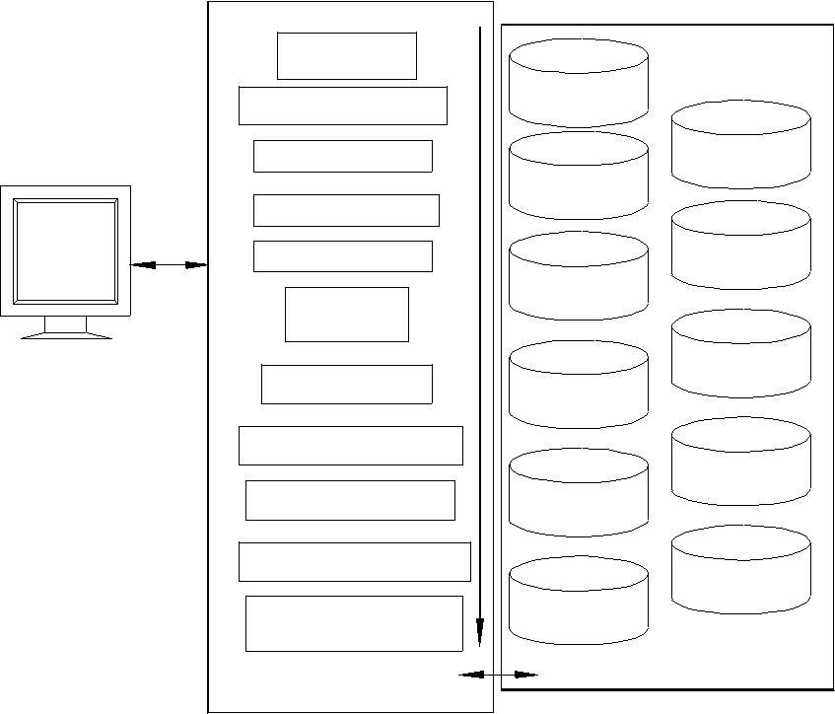

Display

Part
Classification

Feature Recognition

Material Selection

Process Selection

Machine Selection

Parameter

Selection

Fixture Selection

End Effector Selection

Process Sequencing

Cutter Path Generation

Intermediate Surface

Generation

SOFTWARE

MODULES

CAD
Process | Tool
Capability
 | Machinability
Machine
Tool
 | Standard
Material | Time
 | Standard
Fixture | Cost
 | Process
End | Plans
Effector
DATABASES

Fig.6.2 Structure of a Computer Aided Process Planning System

INFORMATION REQUIRED FOR PROCESS PLANNING

The geometric model of the part is the input for the process planning system. The system outputs the process plan (Fig. 6.3). The input to the process planning system may be engineering drawing or CAD model. The other prerequisites for process planning are given below:
- Parts list

- Annual demand/batch size

A
- ccuracy and surface finish requirement (CAD Database)

E
- quipment details (Work centre Database)

Computer Aided Process Planning

- Data on cutting fluids, tools, jigs & fixtures, gauges

- Standard stock sizes

M
- achining data, data on handling and setup

C
OMPONENT
 |  |  |  |  | PROCESS
 | DRAWING |  |  | INPUT | PROCESS | OUTPUT
 |  |  |  |  |  |  | PROCESS
 |  |  |  |  | PLANNING |  | PROCESS
 |  |  |  |  | PLANNING |  | PLAN
 | CAD |  |  |  | SOFTWARE |  | PLAN
 | MODEL
 | MODEL |  |  | Fig. 6.3 Activities in Process Planning
In a computerized process planning system a formal structure and a knowledge database are required in order to transform the engineering design information into the process definition. A brief description of the operation of a computer aided process planning software is given in the following section.

OPERATION OF A TYPICAL COMPUTER AIDED PROCESS PLANNING SOFTWARE

A typical process planning software may provide the following basic functions:

- Process planning

- Initialization function

R
- eport generation

B
rief descriptions of these functions are given below.

PROCESS PLANNING

  - The structure of a process planning module will include modules to: Create a new plan
Retrieve a plan and edit Delete a plan

Display plan on monitor List summary information

CREATING A NEW PLAN

Creation of a new plan involves several stages. Fig. 9.4 shows the header of a typical process plan format. The user has to enter various data as per the above format. The manufacturing sequence is entered in a suitable format. A typical format is given.The process plan gives each operation to be performed in sequence. The example given is for turning and drilling a workpiece.

in the process plan. Some process plans will also give the inspection tool details, jigs and fixtures to be used and will have a column for remarks, which may contain some instructions to the operator.

Table 6.1 Format of Manufacturing Sequence

Serial | Machine | Operation | Set | Production | Tool | Cutting | Feed/ | rpm | Number
Number |  | Description/ | Up | Time |  | Speed | Feed |  | of cuts/
 |  | Assembly | Time |  |  | m/min | rate |  | Passes
 |  | Operations
04 | CNC | Turning | - | 2 | P40 | 240 | 0.5mm/ | 1400 | 4
 | Lathe |  |  |  |  |  | rev.
05 | ” | Drilling | - | 0.2 | BW | 200 | 0.2mm/ | 2200 | 1
 |  |  |  |  | Drill |  | rev.

The process planning software provides some standard strings that are to be used when describing operations. Some examples are given below:

- Hold between centres

- Rough turn xxxx dia. stock to xxxx dia.. for entire length of part

R
- ough turn xxxx dia. to xxxx dia..

F
- inish turn xxxx dia. to xxxx dia.

F
- inish face xxxx dia. and chamfer

B
y selecting various strings, the operations can be entered in the operation description.

RETRIEVAL OF PLANS

A process plan can be retrieved using any of the data fields contained in its header. A single field or a combination of fields may be necessary. Sometimes if we know a word in the description of the part (NOTE) the process planning systems may come up with the

Computer Aided Process Planning

plan numbers or related parts. For example if we are looking for gearbox parts, by searching notes we may get:

Serial Number | Part Number | Part Description
1 | 600-01-001 | Input Shaft
2 | 600-01-002 | Drive Input Gear
3 | 600-01-003 | Input Pulley
4 | 600-01-004 | Key

If the user wants to retrieve the plan for Sl. No. 1 he/she can type 1 and get the plan.
SUMMARY INFORMATION

Summary information will include Account information, Machine information, Material information etc.

Process planning software will have several modules. One such module is the automatic time standards system. Time standards are based on cutting conditions used and therefore calculation of machining time requires selection of cutting parameters. Typical input data for such a system is:

Material | : | C45
Material hardness | : | 220 BHN
Work Centre Number | : | L 120

The module then goes through the operation description looking for a work element (say, a machining operation). It then displays available tool materials:

- Coated Carbide

- Ceramic
- Cubic Boron Nitride
- Diamond coated tools
From the operation description, pertinent dimensions will be retrieved (like starting diameter, finish diameter, cut length and depth of cut).

Similarly there may be modules for time calculation for loading and unloading.

Facilities for archiving the plan are also incorporated in a process planning software.

REPORT GENERATION

Computer aided process planning (CAPP) software packages have normally SQL capabilities incorporated. Reports can be compiled for:

- Parts with identical classification

- Parts using specific machine type

P
  - arts machined using specific tool materials

  - Bill of materials

CAD/CAM

CAD BASED PROCESS PLANNING - —ERTAIN LIMITATIONS AND PROBLEMS

The geometric model of an object is represented by a set of data. The data consists of numerical values, names, codes and symbols. The data are stored in computer memory in an organized manner. This organization represents the relationship of each data element to other elements. Included in this relationship is the topological relationship of the surface geometry.

The common methods of geometric modeling in use today are:

- 2-D modeling

- Surface modeling

- Solid modeling

The techniques of these methods have been discussed in earlier chapters. The creation of process for CNC machining is discussed in Chapter 12. This chapter concentrates on general process design.

With the taxonomy of graphical representation described by above procedures, some general problems of part representation systems can be identified. These problems include:

- The inability to represent special manufacturing techniques like coatings and surface treatment.

- Lack of data interchange between some drafting representations. Since there is no easy way to identify surfaces requiring machining using any of the geometric representations mentioned previously, the best solution is to use a human-computer interactive system to identify the surface.

In order to use a CAD system as the front end for computer aided process planning, the following capabilities are required.

- Location and interactive identification of lines and surfaces.

- Easy dimension retrieval.

- Storage and retrieval of tolerance information.

- Capability of displaying multiple objects.

- Built- in special tags (i.e., drill angle for hole).

- Combining information on special processes like heat treatment, surface treatment and surface finishing techniques with the geometric model.

The addition of automatic feature recognition (AFR) software has made the process planning task considerably easy. CAD software which incorporates this feature highlights

Computer Aided Process Planning

The recent developments in modeling technologies and detailing procedures have helped designers to incorporate auxiliary information like geometric tolerances. These additions have improved the quality of process plans created by CAPP.

In the case of precision components, the process design can be extremely complex. This is particularly so when we consider components with accuracies of the order of a few micrometers and surface finishes at sub micrometer level. Further, the need to achieve the required concentricity, parallelism and perpendicularity etc. requires very careful design of the processes. Such extra precision components will have high rejection levels. Process design even by experienced planners may have to undergo several modifications to realize the ultimate product. The inability to model the dynamics of machine tool - —aterial – work piece - —ixture system is still a major bottleneck in manufacturing. Further, the physical and metallurgical behavior of the work material and the non-deterministic nature of tool wear may necessitate modifications to process plans. Tolerance accumulation in machined components is another major problem.

One of the convenient ways in which process plans can be created for a component is by searching for the availability of similar components in the component database. The similarity can be in geometry, tolerances, materials and processes. If a similar component is available it is likely that their manufacturing process is also proven. In that case it is reasonable to use the process plan with whatever modifications that may be necessary rather than creating a new process plan. Automatic process planning tends to be more successful if such a “variant” approach is adopted. This requires an efficient method of retrieval based on a suitable identification number. Codes based on group technology provide unique identification for part families. Group technology is known and practiced for the last three decades or more in batch manufacturing industries and it is a convenient tool for classifying and coding components, machined components, components made of sheet metal etc. The following sections give a brief introduction to this technology and its uses in CAPP.

There are two types of information that are required by a process planning system:

- Design features of the component.

- Process knowledge/economic alternatives/information of materials/process equipment.

GROUP TECHNOLOGY

Group technology is an operations management philosophy based on the recognition that similarities occur in the design and manufacture of discrete parts. Similar parts can then be arranged into part families. To implement such a system, some form of classification of parts and coding is required.

Part classification and coding is concerned with identifying the similarities and using these similarities to evolve a classification code. Similarities are of two types: design attributes (such as geometric shape and size), and manufacturing attributes (the sequence of processing steps required to make the part).

In companies which employ several design engineers and manufacturing a diverse range of products, such classifications and coding has a number of other uses. One of the major benefits is avoiding the duplication of similar components. This can result in considerable savings in terms of design cost, processing cost and tooling cost. One prime necessity to realize this is to have a good design retrieval system.

The parts classification and coding is required in a design retrieval system, and in computer aided process planning the process routing is developed by recognizing the specific attributes of the part and relating these attributes to the corresponding manufacturing operations.

PART FAMILIES

A part family is a collection of parts which are similar either because of geometry and size or because similar processing steps are required in their manufacture. The parts within a family are different, but their similarities are close enough to merit their identification as members of the part family. The major obstacle in changing over to group technology from a traditional production shop is the problem of grouping parts into families. There are three general methods for solving this problem.

- Visual inspection

- Production flow analysis

P
- arts classification and coding system

W
hat is desirable in a computer integrated manufacturing environment is a software which will analyze the geometric model of the part and come out with a set of alphabetic/ numeric characters which can broadly embed similarities.

PARTS CLASSIFICATION AND CODING SYSTEMS

Parts classification and coding systems can be grouped into three general types:

- Systems based on design attributes

- Systems based on part manufacturing attributes

S
- ystems based on both design and manufacturing attributes

Computer Aided Process Planning

Systems in the first category are useful for design retrieval and to promote design standardization. Systems in the second category are used for computer-aided process planning, tool design, and other production related functions. The third category represents an attempt to combine the functions and advantages of the other two systems into a single classification scheme. The types of design and manufacturing attributes typically included in classification schemes are listed below:

Part Design Attributes

Basic (External/Internal) shape

Axisymmetric/Prismatic/sheet metal

Length/diameter ratio

Material

Major dimensions

Minor dimensions

Tolerances

Surface finish

Part Manufacturing Attributes

Major process of manufacture Surface treatments/coatings Machine tool/processing equipment Cutting tools

Operation sequence Production time Batch quantity Production rate Fixtures needed

If we take a look at a machine tool manufacturing industry, large part families can be grouped as:

- Heavy parts - —eds, columns etc.

- Shafts, characterized by large L/D ratios

Spindles (long shafts, screw rods included)
- Non-rounds (small prismatic parts)
- Gears, disc type parts (whose L/D ratios are small)
From the manufacturing point of view, group technology can bring in considerable economy in tooling, set up time, part changeover times, machine specifications etc. The classification of components in groups can lead to formation of cells where similar

CODING STRUCTURES

A part coding scheme consists of symbols that identify the part’s design and/or manufacturing attributes. The symbols in the code can be all numeric, all alphabetic, or a combination of both types. There are three basic code structures used in group technology applications:

- Hierarchical structure

- Chain type structure

- Hybrid structure which is a combination of the above two

With the hierarchical structure, the interpretation of each succeeding symbol depends on the value of the preceding symbols. In the chain type structure, the interpretation of each symbol in the sequence is fixed and does not depend on the value of preceding digits. Most of the commercial parts coding systems are used in industry are a combination of the two pure structures.

When selecting a coding system for a component’s representation, there are several factors to be considered. They include:

- The geometry of components (i.e., rotational, prismatic, deep drawn, sheet metal etc.)
- The code structure
- The digital representation (i.e., binary, octal, hexadecimal etc.)

- Material of manufacture - —errous, non ferrous, plastics, composites etc.

When using a code to represent an engineering design, it is important to represent the basic features of the design. For process planning, it is desirable to have codes that can distinguish unique production families.

Some of the coding systems that have been successfully implemented in process planning are given below:

- OPITZ system

- The CODE system
- The KK-3 system

- The MICLASS system

- CLASS system

- CODFORM (coding for machining)

When implementing a parts classification and coding system, most companies can purchase a commercially available package or develop a system for their own specific use.

Computer Aided Process Planning

Commercial systems have the advantage of less lead time in implementation. Brief treatment of some commercial systems is given in subsequent sections.

OPITZ CLASSIFICATION SYSTEM

The Opitz coding system uses the following digit sequence:

12345 6789 ABCD

The basic code consists of nine digits, which can be extended by adding four more digits. The first nine digits are intended to convey both design and manufacturing data. The general interpretation of the nine digits is indicated in Fig 9.5. The first five digits, 12345, are called the “form code” and describe the primary design attributes of the part. The next four digits, 6789, constitute the “supplementary code”. It indicates some of the attributes that would be of use to manufacturing (work material, raw work piece shape, and accuracy). The extra four digits, “ABCD”, are referred to as the “secondary code” and are intended to identify the production operation type and sequence. The secondary code can be designed by the firm to serve its own particular needs.

In the form code, the first digit identifies whether the part is a rotational or a non-rotational part. It also describes the general shape and proportions of the part. Fig 6.4 shows the specification scheme. For the rotational work pieces, the coding of the first five digits is given in Fig. 9.6.

Digit 1

Part Class

- L/D<=0.5

- 0.5,L/D<3

L
/D>=3
- Rotational 3 L/D<=2WithDeviationWithDeviation

- L/D >2

- Special A/B<=3

A
- /C>=4
No
- nrotational A/B >=3 A/B <=3
- A/C <4

- Special

 | Digit 2 |  |  |  | Digit 3 |  |  | Digit 4 |  | Digit 5
Main Shape |  |  |  | Rotational |  |  |  | Plane Surface |  | Additional
 |  |  |  | Machining |  |  |  | Machining |  | Features
 | External |  |  |  | Internal
 |  |  |  |  |  |  |  | Machining of
 |  |  |  |  |  |  |  |  |  | Other Holes
 | Shape |  |  |  | Shape |  |  | Machining of |  | Other Holes
 |  |  |  |  | Shape |  |  | Plane Surfaces |  | and Teeth
 | Element |  |  |  | Element |  |  | Plane Surfaces |  | and Teeth
 | Main |  |  | Rotational |  |  |  | Machining of |  | Other Holes
 | Shape |  |  | Machining |  |  |  | Plane Surfaces |  | and Teeth
 | Main
 | Shape
 |  |  |  |  | Main Bore |  |  | Machining of |  | Other Holes
 |  |  |  |  | and |  |  | Machining of |  | Other Holes
 | Main |  |  |  | Rotational |  |  | Plane Surfaces |  | and Teeth
 | Shape |  |  |  | Machining
 | Main
 | Shape
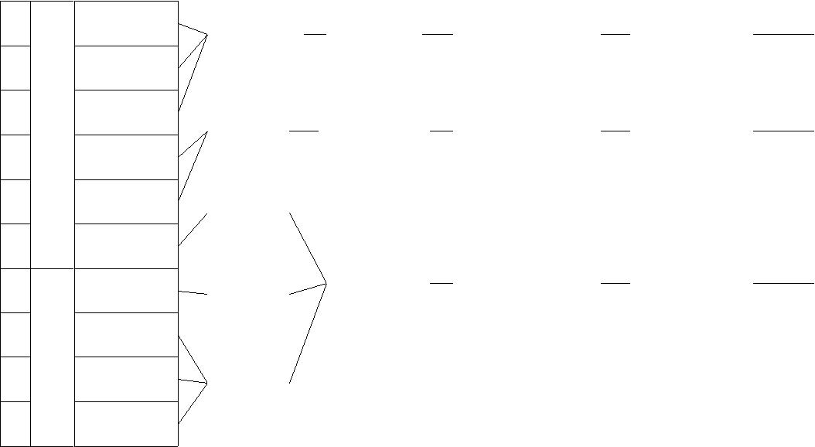
6 8 9

  - Supplementary
Digits

 |  | Raw Material Shape
Dimensions | Material | Raw Material Shape | Accuracy

Fig. 6.4 Specification Scheme

CAD/CAM

DIGIT 1

PART CLASS

0 | Parts | L/D <=0.5
1 | Parts | 0.5<L/D<3
 | Rotational
2 | Rotational | L/D > 3
3 | Rotational
4 | Rotational
5 | Parts
6 | Parts
6 | rotational
7 | rotational
8 | rotational
8 | Non
9 | Non

 |  |  | DIGIT 2 |  |  |  |  |  | DIGIT 3 |  |  |  |  |  | DIGIT 4 |  |  | DIGIT 5
External shape |  |  |  |  |  |  |  | Internal Shape |  |  |  |  |  |  | Plane |  | Auxiliary Holes
External Shape |  |  |  |  |  |  |  | Internal Shape |  |  |  |  |  |  | Surface |  |  | and Gear
 |  | Elements |  |  |  |  |  |  | Elements |  |  |  |  |  | Machining |  |  | Teeth
0 |  | Smoothing |  |  |  |  | 0 |  | No Hole, No |  |  |  |  | 0 | No Surface |  | 0 | No Auxiliary
0 |  | Shape Elements |  |  |  |  | 0 |  | Break Through |  |  |  |  | 0 | Machining |  | 0 | Holes
1 |  | Stepped one end |  | No Shape |  |  | 1 |  | Smooth orSteppedon |  |  | No Shape |  | 1 | Surface Plane/ |  | 1 | Axial, Not on
1 |  | Stepped one end |  | Elements |  |  | 1 |  |  |  | One End | Elements |  | 1 | Curved |  | 1 | Pitch Circle Dia
2 |  | Stepped one end |  | or Smooth | Thread |  | 2 |  |  |  | One End | Thread |  | 2 | External Plane |  | 2 | Axial on Pitch
2 |  | Stepped one end |  | or Smooth | Thread |  | 2 |  |  |  | One End | Thread |  | 2 | Surface, Circular |  | 2 | Axial on Pitch
 |  | Stepped one end |  | or Smooth |  |  |  |  |  |  | One End |  |  |  | Graduation |  |  | Circle Diameter
3 |  | Stepped one end |  | or Smooth | Groove |  | 3 |  |  |  | One End | Groove |  | 3 | External Groove |  | 3 | Radial, Not on
3 |  | Stepped one end |  | or Smooth | Groove |  | 3 |  |  |  | One End | Groove |  | 3 | and/or Slot |  | 3 | Pitch circle Dia.
4 |  | Ends |  | No Shape |  |  | 4 |  | Ends |  | No Shape |  |  | 4 | External |  | 4 | Radial, on
4 |  | Ends |  | Elements |  |  | 4 |  | Ends |  | Elements |  |  | 4 | Spline (Polygon) |  | 4 | Pitch Circle Dia.
 |  | Both |  |  |  |  |  |  | Both
5 |  | Both |  | Thread |  |  | 5 |  | Both |  | Thread |  |  | 5 | External Plane |  | 5 | Axial and/ Radial
5 |  |  |  |  |  |  | 5 |  |  |  |  |  |  | 5 | Surface/Slot |  | 5 | and/ other Direction
 |  | Stepped |  |  |  |  |  |  | Stepped |  |  |  |  |  | Spline
6 |  | Stepped |  | Groove |  |  | 6 |  | Stepped |  | Groove |  |  | 6 | Internal Plane |  | 6 | Spur Gear
6 |  | Stepped |  |  |  |  | 6 |  | Stepped |  |  |  |  | 6 | Surface or Slot |  | 6 | Teeth
7 |  | Functional |  |  |  |  | 7 |  |  | Functional |  |  |  | 7 | Internal Spline |  | 7 | Bevel Gear
7 |  | Cone |  |  |  |  | 7 |  | Cone |  |  |  |  | 7 | (Polygon) |  | 7 | Teeth
8 |  | Operating |  |  |  |  | 8 |  | Operating |  |  |  |  | 8 | Internal or Slot/ |  | 8 | Other Gear
8 |  | Speed |  |  |  |  | 8 |  | Speed |  |  |  |  | 8 | External Polygon |  | 8 | Teeth
9 |  | All Others |  |  |  |  | 9 |  | All Others |  |  |  |  | 9 | All Others |  | 9 | All Others

Fig. 6.5 Coding the First Five Digits

EXAMPLE

Given the part design of Fig. 6.6, the form code for this part is discussed below.
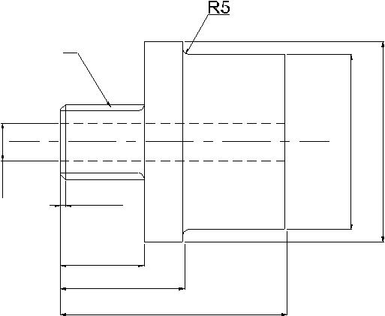

M10 x 1.5

Dia.25
Dia.20

Dia.5 |  | 1 x 45

12.5

20

40

Fig.6.6Example Part

The overall length/diameter ratio, L/D = 1.6, so the first code = 1. The part is stepped on both ends with a screw thread on one end, so the second digit code would be 5 the third digit code is 1 because of the through hole. The fourth and fifth digits are both 0, since no surface machining is required and there are no auxiliary holes or gear teeth on the part. The complete form code in the Opitz system is “15100”. To add the supplementary code, we would have to properly code the sixth through ninth digits with data on dimensions, material, starting work piece shape, and accuracy.

Computer Aided Process Planning

THE MICLASS SYSTEM

The MICLASS classification number can range from 12 to 30 digits. The first 12 digits are universal code that can be applied to any part. Up to 18 additional digits can be used to code data that are specific to the particular company or industry. For example, lot size, piece time, cost data, and operation sequence might be included in the 18 supplementary digits.

The component attributes coded in the first 12 digits of the MICLASS number are as follows:

1st ^{d}igit Main shape

2nd ªnd 3rd ^{d}igits Shape elements

4th ^{d}igit Position of shape elements

5th ªnd 6th ^{d}igits Main dimensions

7th ^{d}igit Dimension ratio

8th ^{d}igit Auxiliary dimension

9th ªnd 10th ^{d}igits Tolerance codes

11th ªnd 12th ^{d}igits Material codes

One of the unique features of MICLASS system is that parts can be coded using a computer interactively. To classify a given part design, the user responds to a series of questions asked by the computer. The number of questions depends on the complexity of the part. For a simple part, as few as seven questions are needed to classify the part. For an average part, the number of questions ranges between 10 and 20. On the basis of responses to its questions, the computer assigns a code number to the part.

THE CODE SYSTEM

The CODE system is a parts classification and coding system developed and marketed by Manufacturing Data System, Inc (MDSI), of Ann Arbor, Michigan. Its most universal application is in design engineering for retrieval of part design data, but it also has applications in manufacturing process planning, purchasing, tool design, and inventory control.

The code number has eight digits. For each digit, there are 16 possible values (zero through 9 and A through F) which are used to describe the parts design and manufacturing characteristics. The initial digit position indicates the basic geometry of the part and is called the major division of the code system. This digit would be used to specify whether the shape was cylinder, flat, block, or other. The interpretation of the remaining digits forms a chain-type structure. Hence the CODE system possesses a hybrid structure.

BENEFITS OF GROUP TECHNOLOGY

Implementation of group technology results in more focused factories. The likely impact of group technology can be seen in Table 6.2.

Table 6.2 Impact of Group Technology

Before | After
Discontinuous, Random Flow of Parts | Structured Flow of Parts
Through the Shop
Reinvent New Parts | Retrieve Parts Already in Production
Multitude of Process Plans for Some Parts | Consistent, Single, Best Process Plans
Continuous Purchase of Components | Regulated Purchase of Components
due to Lack of Total Visibility
Inflexible, Rigid, Unable to Respond to | Flexible
Changing Environment

When group technology is applied, a manufacturing company will typically realize the following benefits:

Product engineering -
—Reduce part proliferation

Help design standardization

Provide manufacturing feed back

Manufacturing engineering -
—Process selection

Tool selection

Machine purchases

Material handling

Production engineering -
—Reduce lead time

Reduce delays

Reduce set-up time

Improve product quality

Production planning and control -
—Group scheduling

Stock accountability

Reduce expediting

Improved product design

Reduced materials handling

Better employee satisfaction

Computer Aided Process Planning

Other benefits:

  - Increased productivity

  - Improved accuracy in estimation of costs

G
  - reater standardization and variety reduction

R
  - educed set up times

B
  - etter product delivery (Helps to implement just-in-time (JIT) manufacturing)

R
  - educed cost of purchasing

I
  - mproved plant efficiency

PROCESS SELECTION

Selecting the manufacturing processes to transform the raw material into the finished part is based on matching requirements with process capabilities. Process capability is the data base of knowledge for each process. It includes:

- The shape and size of part a process can produce

- The dimensions and geometric tolerances that can be obtained

- The surface finish attainable

- The material removal rate

- The relative cost

- Technological parameters

Process engineering does not necessarily imply that all process selection is based on the information above. However, the more the information considered in selecting a process, the more complete the result will be. A computer aided process planning system functions based on this process capability information.

Earlier it was mentioned that planning systems could be classified into variant and generative types. A variant planning system is a retrieval system and is analogous to planning based on experience. In the variant planning system, standard plans are stored based on component shape. These plans are then retrieved based on the similarity of a coded part. A generative system, however, makes processing, tooling and other decision via software logic.
EXPERIENCE-BASED PLANNING

It is always true that the accumulation of experience is knowledge. This is also true in the context of manufacturing process. Even now, many process planning activities still rely on the experience of the process planners. However, there are some problems associated with such a planning approach.
Because of the problems noted above, it is necessary to seek more efficient ways to represent process capability knowledge base so that it might be preserved and installed as part of a decision support system on a computer.
HAND BOOKS/DATA BOOKS/MANUALS

One way to store the process information is to print it in a hand book or manual. This has been a standard practice. Process information is usually presented in tables, figures or listed as guide lines. Many manufacturers usually prepare their own manuals for internal use. Some process information is listed as guide lines, so that the process planners can follow some general rules. For example, the following guidelines can be applied to produce holes.

 | Diameter <= 8 mm | True position > 0.01
i. | Tolerance > H10 | Drill the hole.
ii. | Tolerance <= H8 | Drill and Ream etc.

DECISION TABLES AND DECISION TREES

Decision tables and decision trees are methods of describing or specifying the various actions (decisions) associated with combination of (input) conditions. Both methods have been used for a long time to help decision making. This is also suitable for use with digital computers.

PROCESS CAPABILITY

The process capability depends on the following factors:

- Shape that a process can generate.

- Size limitation (boundaries of the tooling, machine tooling, and fixtures).

- Tolerances (both dimensional and geometric).
- Surface finish attainable.
- Cutting force.
- Tower consumption.

The shape element implies the basic geometry predicable by a process. However, this is difficult task to achieve using a computer that is reasoning the shape capabilities in its natural form (geometry and topology). A feasible alternative is to represent shape by a code. For internal machining process, the size capability is constrained by the available tool size. In external machining, size is constrained by the available machine table size. The other capabilities and limitations can be expressed mathematically. These expressions are straight forward to programme on a computer if the exact equations and constraints can be quantified.

Computer Aided Process Planning

One way to represent process capabilities is to use process boundaries. A process boundary is interpreted as the limiting size, tolerance and surface finish for a process. This can be obtained by careful control of the cutting conditions and process parameters (feed, speed, depth of cut). Machining force and power are not limiting values in process selection, but becomes an important consideration in selecting process parameters. A typical process boundary table is shown in Fig. 9.8.
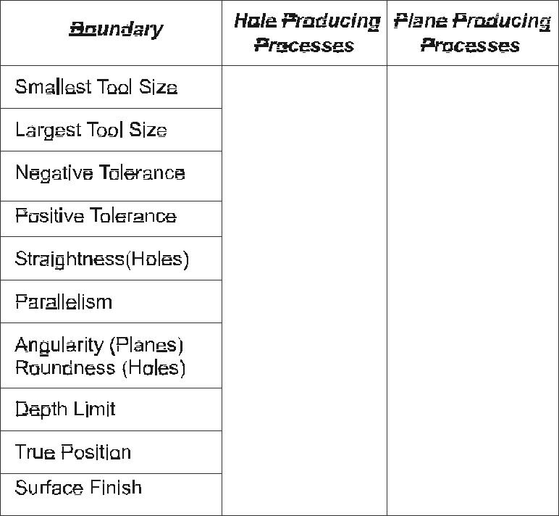

Fig. 6.8 Process Boundary Table

PROCESS PARAMETERS FOR MACHINING

Surface finish, force and power constraints are directly affected by the process parameters-feed, speed and depth of cut. Therefore, process selection becomes an iterative procedure: first a process is selected and then the machining parameters are adjusted to accommodate the system constraints.

- Selection of the machining parameters also affects the time and cost required to produce components.

- Several machinability systems are currently marketed that recommend sets of parameters that either optimize machining cost, time or production rate, or simply retrieve data table or calculated values.

O
ne extensively used data system is CUT DATA from Machinability Data Systems of USA.
Recently computerized machinability systems have been introduced which facilitate

quick selection of optimum process parameters.

CAD/CAM

COST AND TIME MODELS

Machining optimization models can be classified as single pass and multi pass models. In a single pass model, we assume that only one pass is needed to produce the required geometry. In this case, depth of cut is fixed. In multi pass model, this assumption is relaxed and depth of cut also becomes a control variable.

METHODS OF COMPUTER AIDED PROCESS PLANNING

The ultimate goal of a system is to integrate design and production data into a system that generates useable process plans. As already mentioned there are two approaches:

  - Variant process planning

  - Generative process planning

VARIANT PROCESS PLANNING

A variant process planning system uses the similarity among components to retrieve the existing process plans. A process plan that can be used by a family of components is called a standard plan. A standard plan is stored permanently with a family number as its key.

A family is represented by a family matrix which includes all possible members. The variant process planning system has two operational stages:

- A preparatory stage and

- A production stage.

D
uring the preparatory stage, existing components are coded, classified, and subsequently grouped into families. The process begins by summarizing process plans already prepared for components in the family. Standard plans are then stored in a data base and indexed by family matrices (Fig. 9.9).
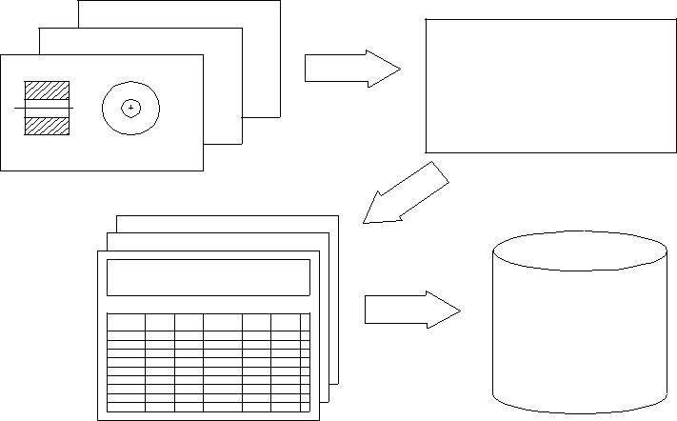

XXX XXX XXXX

YYY YYY YYYY

ZZZ ZZZ ZZZZ

Plan File Indexed by Family Matrix

Fig.6.9 Process Family Matrix

Computer Aided Process Planning

The operation stage occurs when the system is ready for production. An incoming part is first coded. The code is then input to a part family search routine to find the family to which the component belongs. The family number is then used to retrieve a standard plan. Some other functions, such as parameter selection and standard time calculations, can also be added to make the system more complete (Fig. 6.10). This system is used in a machine shop that produces a variety of small components.
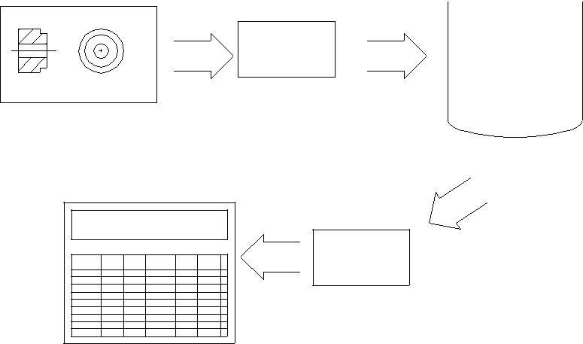

 | YYY YYY YYYY
 | STANDARD
 | PLAN
 | FILE
CAD Model | Coding

Retrieval

YYY YYY YYYY

yyy xyy yyyy

Feasible

Plans

Process Plan

Fig. 6.10 Part Search and Retrieval

SIGN OF VARIANT PROCESS PLANNING SYSTEM

The following are the sequences in the design of a variant process planning system:

- Family formation

- Data base structure design

- Eearch algorithm development and implementation

- Plan editing
- rocess parameter selection/updating

      - Family Formation

Part family classification and coding were discussed earlier. This is based on the manufacturing features of a part. Components requiring similar processes are grouped into the same family. A general rule for part family formation is that all parts must be related. Then, a standard process plan can be shared by the entire family. Minimum modification on the standard plan will be required for such family members.

DATA BASE STRUCTURE DESIGN

The data base contains all the necessary information for an application, and can be accessed by several programs for specific application. There are three approaches to construct a data base: hierarchical, network, and relational.

CAD/CAM/CIM

APROARCH PROCEDURE

The principle of a variant system is to retrieve process plans for similar components. The search for a process plan is based on the search of a part family to which the component belongs. When, the part family is found, the associated standard plan can then be retrieved. A family matrix search can be seen as the matching of the family with a given code. Family matrices can be considered as masks. Whenever, a code can pass through a mask successfully, the family is identified.

PLAN EDITING AND PARAMETER SELECTION

Before a process plan can be issued to the shop, some modification of the standard plan may be necessary, and process parameters must be added to the plan. There are two types of plan editing: One is the editing of the standard plan itself in the data base, and the other is editing of the plan for the component. For editing a standard plan, the structure of the data base must be flexible enough for expansion, additions, and deletions of the data records.
A complete process plan includes not only operations but also process parameters. The data in the process parameter files are linked so that we can go through the tree to find the speed and feed for an operation. The parameter file can be integrated into variant planning to select process parameters automatically.
GENERATIVE PROCESS PLANNING

  - Generative process planning is a system that synthesizes process information in order to create a process plan for a new component automatically. In a generative planning system, process plans are created from information available in manufacturing data base without human intervention. Upon receiving the design model, the system can generate the required operations and operation sequences for the component. Knowledge of manufacturing must be captured and encoded into efficient software. By applying decision logic, a process planner’s decision making can be imitated. Other planning functions, such as machine selection, tool selection, process optimization, and so on, can also be automated using generative planning techniques. The generative planning has the following advantages:
- It can generate consistent process plans rapidly.

- New process plans can be created as easily as retrieving the plans of existing components.
- It can be interfaced with an automated manufacturing facility to provide detailed and up-to-date control information.

Fig. 6.11 shows the modular structure of a generative CAPP system

Computer Aided Process Planning
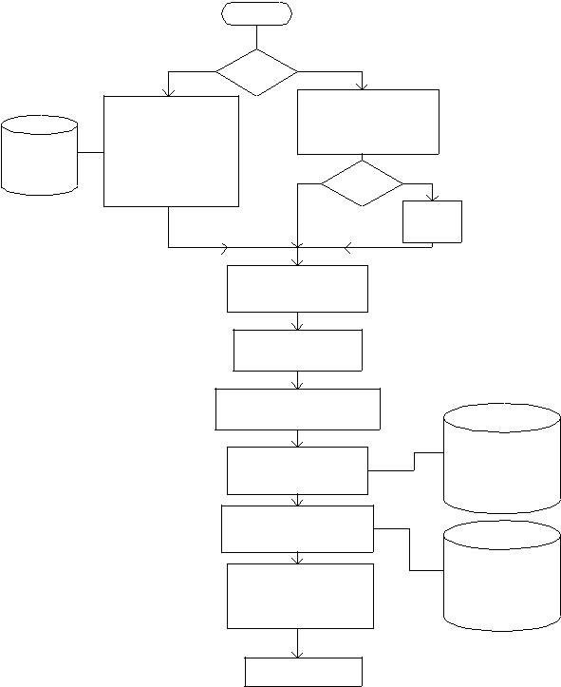

 |  | Start
 | New | New/Old
 | Component
 | Represntaion
 | module
Geometry | 1. Code Gneration
 | 2.Part Geometry
 | Creation

Old

Copy Existing Part Geometry File to Geometry File

N Y
Y/N

Editing

Module

Feature Extraction

and Recognition

Feature-Process

Correlation

Operation Selection &

Sequencing Module

 | Machine
Machine Tool and | Material
Tool Selection | Tool
 | Machinability
Standard Time and
Cost computation
Report Generation | Standard
Report Generation | Time &
Editing | Cost Library
Printing
Process Sheet

Fig. 6.11 Modular Structure of a Generative CAPP System
The generative part consists of:

- Component representation module

- Feature extraction module
- Feature process correlation module
- Operation selection and sequencing module

- Machine tool selection module
- Standard time / cost computation module
- Report generation module
In order to generate a more universal process planning system, variables such as process limitations, and capabilities, process costs and so on, must be defined at the planning stage. Several of methods have been proposed for creating generative process plans. A few methods that have been implemented successfully are:

- Forward and backward planning

- Input Format
- APP based on CAD models

FORWARD AND BACKWARD PLANNING

In generative process planning, when process plans are generated, the system must define an initial state in order to reach the final state (goal). The path taken represents the sequence of processes. For example, the initial state is the raw material and the final state is the component design. Then a planner works in modifying the raw workpiece until it takes on the final design qualities. This is called forward planning.

Backward planning uses a reverse procedure. Assuming that we have a finished component, the goal is to go back to the un-machined workpiece. Each machining process is considered a filling process.

Forward and backward planning may seem similar. However they influence the programming of the system significantly. Planning each process can be characterized by a precondition of the surface to be machined and a post condition of the machining (the end result). For forward planning, we must know the successor surface before we select a process, because the post condition of the first process becomes the precondition for second process. Backward planning eliminates this problem since it begins with the final surfaces from and processes are selected to satisfy the initial requirements.

In forward planning, the steps to obtain the final surface with the desirable attributes must be carefully planned to guarantee the result. On the other hand, backward planning starts with the final requirements and searches for the initial condition.

INPUT FORMAT

The input format of a process planning system affects the ease with which a system can be used, and the capability of the system. The transitional form from the original design (either engineering drawing or CAD model) to a specific input format may be tedious and difficult to automate. However, such input can provide more complete information about a component, and more planning functions can be accomplished using the input.

Many different input formats have been used in process planning systems. Some of the few input formats used are:

CODE: Some generative systems such as APPAS use GT codes as input. Codes used are in generative system are more detailed.

DESCRIPTION LANGUAGE: Specially designed part description languages can provide detailed information for process planning system. For example AUTAP system uses a language similar to a solid modeling language. A component is described by the union of some primitives and modifiers. Material, processes, machine selection, and time estimates can be selected by the system using the input model. Another system CIMS/ PRO uses an input language called CIMS/DEC. CAPP system uses its own special language.

CAPP BASED ON CAD MODELS

Using a CAD model as input to a process planning system can eliminate the human effort of translating a design into code and other descriptive form. A CAD model contains all the details about a design. However, an algorithm is necessary to identify a general machined surface in a CAD model. Additional code is needed to convert the machined surface shape from raw material shape. CAD/CAM system uses a CAD model as its input. Several other systems such as GENPLAN, AUTOPLAN, etc., also use a CAD database interactively for tool and fixture selection

CAPP BASED ON DECISION LOGIC

The decision logic determines how a process or processes are selected. The major function of the decision logic is to match the process capabilities with the design specification. The different techniques in decision logic are:

- Decision trees

- Decision tables

T
hese two techniques are methods of describing or specifying the various actions associated with the combination of input conditions.

CAPP BASED ON ARTIFICIAL INTELLIGENCE (AI)

AI can be defined as the ability of a device to perform functions that are normally associated with the human intelligence. These functions include reasoning, planning, and problem solving. Applications for AI have been in natural language processing, intelligent data base retrieval, expert consulting systems, theorem proving, robotics, scheduling, and perception problems. Process planning applications have been considered as part of an expert consulting system.

There are two types of knowledge involved in process planning systems: Component knowledge, and process knowledge. The component knowledge defines the current state of the problem to be solved (declarative knowledge). On the other hand, the knowledge of processes defines how the component can be changed by processes (procedural knowledge).

There are several methods to represent declarative knowledge:

- First order predicate calculus

- Frames and semantic networks

Procedural knowledge can be represented by IF (condition), THEN (action) statements which are similar to decision trees or decision tables. In AI such rules can be called production rules.

Even after the descriptive and procedural knowledge have been represented, conclusions cannot be deduced, because we do not have mechanism to apply the appropriate rules to the problem. Control knowledge is similar to human knowledge in reasoning, which deduces certain facts from the knowledge base concerning problem. This can be a difficult task to program on a computer.

Computer Aided Process Planning has been an active area of research work in AI for many years. Feature recognition, feature process correlation, process sequencing, blank

CAD/CAM

selection, cutting parameter selection, tool selection etc. are the segments of CAPP where AI can contribute to improve the quality of process plans.

The block diagram representation of an expert CAPP system is shown in Fig.6.12.

 |  |  |  |  |  | Rule |  |  | E xa m p le s
 |  |  |  |  |  | G enerator
 |  |  |  |  |  | Ru le B ase
U s e r | Com ponent
 |  | K nowledge |  |  |  |  |  |  |  |  |  |  |  |  |  |  | User
 | Representation |  |  |  |  |  |  |  |  |  |  |  |  | E ditor
 |  |  |  |  | Inference |  |  |  |  | Database
 |  |  |  |  | E ngine
 |  | O peration |  |  | M achining |  |  |  | Tim e and |  |  |  |  | R e p o rt
 |  | Route |  |  | P aram eter |  |  |  |  |  |  |  | G e n era tio n
 |  | Route |  |  |  |  |  |  | Cost E stim ation
 |  | G eneration |  |  | S election
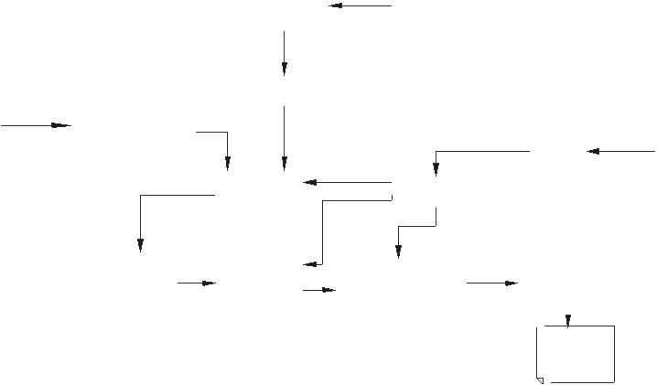
P rocheds
P la n

Fig. 9.12 Block Diagram of Expert CAPP System

PLEMENTATION CONSIDERATIONS

  - The process planning function is manufacturing system dependent. This implies that no one single process planning system can satisfy all of the different manufacturing systems needs. There are several factors that must be considered when one attempts to implement a process planning system. These include:

- Manufacturing system components

- Production volume/batch size
- Number of different production families
For a moderate number of component families and many similar components in each family, a variant process planning system is usually the most economic automated planning alternative. Fig. 6.13 Illustrates the economic regions for the different planning alternatives.
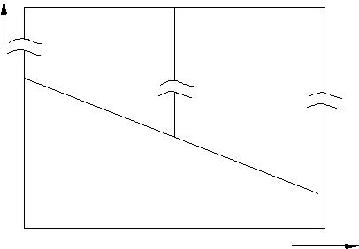

PER FAM ILY COM PO NENTS NUM BER OF AVE RA GE

VARIANT | GE NE RA TIVE
PROCES S | PROCES S
PLANNING | PLANNING

M ANIPROCES S

PLANNING

NUM BER OF PART FAM ILIE S

Fig. 9.13 Economic Regions for Different Types of Process Planning

Computer Aided Process Planning

PROCESS PLANNING SYSTEMS

The majority of existing process planning systems is based on variant process planning approach. Some of them are: CAPP, MIPLAN, MITURN, MIAPP, UNIVATION, CINTURN, COMCAPPV, etc. However, there are some generative system, such as METCAPP, CPPP, AUTAP, and APPAS. Some of the planning systems are discussed in the following paragraph. These are systems continuously evolving in many cases. The descriptions are therefore only approximate.

CAM-I CAPP

The CAM-I (Computer Aided Manufacturing-International) system (CAPP) is perhaps the most widely used of all process planning systems. CAPP is a database management system written in ANSI standard FORTRAN. It provides a structure for a data base, retrieval logic, and interactive editing capability. The coding scheme for part classification and the output format are added by the user.

PI-CAPP, an extension of CAPP, has its own (built-in) coding and classification system. This eliminates the requirement of a user developed coding scheme. A typical CAPP system is shown in Fig. 6.14.
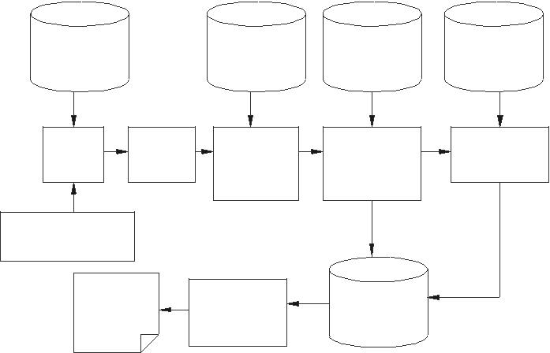

PART FAM ILY |  | STANDAR D | O PERATIO N | APPLICATION
M ATR IX FILE |  | SEQ UENCE | PLA N FILE | PRO G RAM S
 |  | FILE
PART | HEAD ER | STANDAR D | O PERATIO N | W OR K
FAM ILY | DATA | SEQ UENCE | PLAN | ELEM EN T
SEARC H | INPUT | RETRIEVAL | RETRIEVAL/ | PRO CESSO R
 |  | FILE | EDIT
PART
C L A S S IF IC AT IO N
C O D E
PRO CESS |  | PRO CESS | PRO CESS
PLAN |  | PLAN | PLAN
 |  | FOR M ATTER | STO RE

Fig.6.14 CAPP System

MIPLAN AND MULTICAPP

Both MIPLAN and MULTICAPP were developed in conjunction with OIR (Organization for Industrial Research). They are both variant systems that use the MICLASS coding system for part description. They are data retrieval systems which retrieve process plans based on part code, part number, family matrix, and code range. By inputting a part code, parts with a similar code are retrieved. The process plan for each part is then displayed and edited by the user. A typical MULTICAPP system is shown in Fig. 6.15.

 |  |  |  | CAD/CAM
 |  | SIGN ON
 |  | SECURITY
CREATE | FINISH | RETRIEVE | PRINT MANAGEMENT
 |  |  | TYPE
 |  |  | LIST | PROCESS
 |  |  |  | PLANNING
 |  |  |  | FILES
RETRIEVE |  | MULTICLASS | RETRIEVE BY
BY MATRIX |  | CODE AND | INFORMATION | STANDARD
 | MATCH | RETRIEVE | WITHIN PLAN | STANDARD
 |  |  |  | PART FILES
RETRIEVE |  | LIST AND | DRAWING NO
BY DRG.NO |  | DISPLAY | CODE NO
 |  |  |  | SECURITY
 |  | EDIT |  | FILE
REPLACE, | STORE | PRINT | RE-EDIT
DELETE |  |  |  | STANDARD
RENAME |  |  |  | TEXT FILE
RE-EDIT
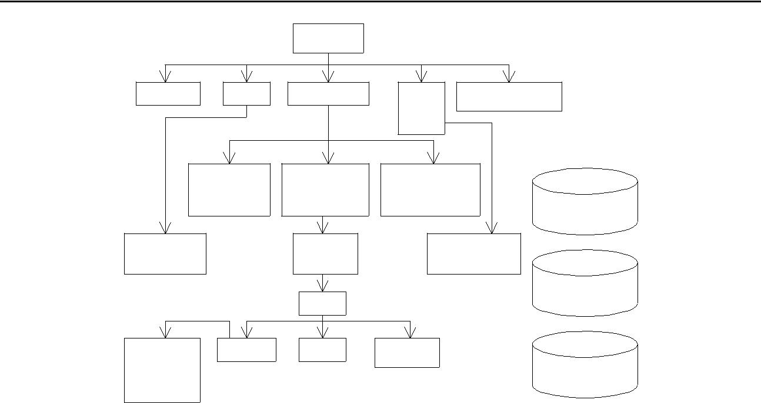
Fig. 6.15 MULTICAPP System

CAPPAS AND CADCAM

APPAS is a generative system for detailed process selection. CADCAM is an example of APPAS. CADCAM operates using a CAD “front end” to interface with APPAS. APPAS describes the detailed technological information of each machined surface by means of a special code. CADCAM provides an interactive graphics interface to APPAS. Components can be modeled graphically and edited interactively.

AUTOPLAN AND RPO

AUTOPLAN is generative only in the detailing of the part. The process selection and process sequencing level do not differ significantly from CAPP or MIPLAN. The four major modules of the system are:

- Group technology retrieval-process plan retrieval.

- Graphical planning aides- tooling layout, verification and work instruction and preparation.
- Generative process planning.
- Process optimization.
AUTAP SYSTEM

The AUTAP system is one of the most complete planning systems in use today. AUTAP uses primitives to construct a part similar to a constructive solid geometry (CSG). AUTAP is a system designed especially to interface with a CAD system. It can be installed as part of an integrated CAD/CAM system.

Computer Aided Process Planning

CAPP

  - CPPP (computerized production process planning) was designed for planning cylindrical parts. CPPP is capable of generating a summary of operations and the detailed operation sheets required for production. The principle behind CPPP is a composite component concept. A composite component can be thought of as an imaginary component which contains all the features of components in one part family. CPPP incorporates a special language, COPPL, to describe the process model. CPPP allows an interactive mode whereby the planner can interact with the system at several fixed interaction points.
GARI

  - GARI is an experimental problem solver which uses artificial intelligence (AI) techniques. The unique feature of the GARI is the representation of planning knowledge. GARI employs a production rule knowledge base to store process capabilities.

TIPPS

Although the process planning steps have been discussed, an integrated approach to generative process planning has yet to be presented. TIPPS is acronym for Totally. TIPPS has the following features:

- It has a modular structure

- It can interact with a CAD system
- t allows for interactive surface identification

- It contains a process/knowledge description language
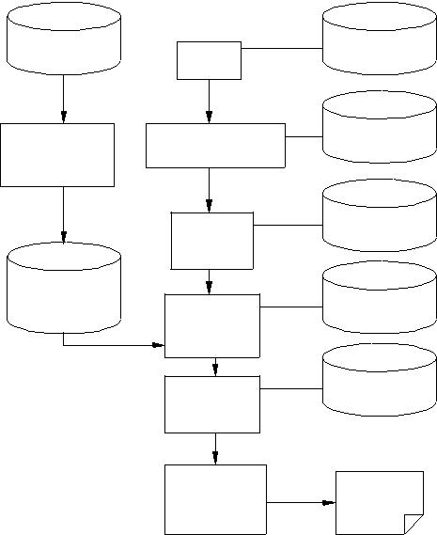

PROCESS | CAD | CAD
KNOWLEDGE | CAD | DATABASE
KNOWLEDGE | MODEL | DATABASE
PROCESS | TIPPS | TIPPS
PROCESS | TIPPS | CAD DATA
KNOWLEDGE | PREPROCESSOR | CAD DATA
INTERPRETER
 | SURFACE | SURFACE
 | SURFACE | FILE
 | MARKING | FILE
 | MODULE
PROCESS |  | PROCESS
KNOWLEDGE | PROCESS | PROCESS
DATA | SELECTION | FILE
 | MODULE
 | PROCESS | PARAMETER
 | PROCESS | FILE
 | PARAMETER | FILE
 | MODULE
 | REPORT | PROCESS
 | GENERATOR | PLAN
 | MODULE

Fig. 6.16 TIPPS

Figure 6.16 shows a block diagram representation of TIPPS software.

CAD/CAM

QUESTIONS

- Discuss the importance of process planning in product development.

- What is the need for computer aided process planning? What are its advantages?

- Describe the structure of a process plan.

- What are the major modules of a process planning software and the databases required?
- What is the need for CAD based process plans?

- Discuss the principle and advantages of group technology coding.

- Classify a component using either OPITZ or MICLASS system.

- Discuss the principle of variant process planning.

- What is generative process planning?

- What are the modules of a generative process planning software?

- Compare variant and generative process planning methodologies.

- Describe any one computer aided process planning software.

- Discuss how group technology is used in designing manufacturing cells.

- How could artificial intelligence (AI) be used in generative process planning?

- Two components are shown in Fig. 6.17. Do they belong to the same part family? Discuss.
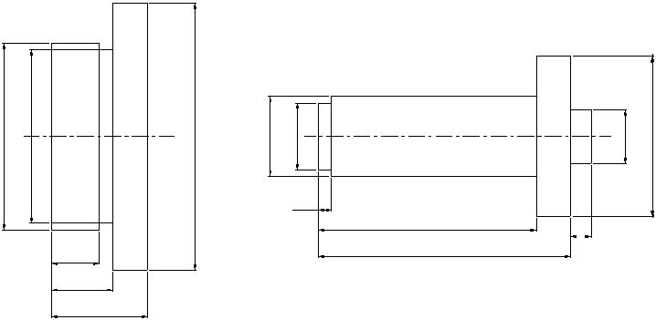

Dia. 140 | Dia.130 | Dia.200 | Dia 60 | Dia 50 |  | Dia40 | Dia.120
 |  |  |  | 10 | 160
 |  |  |  |  | 160 | 15
 |  |  |  |  | 185 | 15
 |  | 35 |  |  | 185
 |  | 45
 |  | 70

Fig. 6.17 Rotational Components

COMPUTER AIDED QUALITY CONTROL

INTRODUCTION

Getting anything right first time costs money. However, it also saves money. While the cost of getting it right increases, the cost of getting it wrong decreases. The important thing is to establish the level at which these curves cross and to achieve the optimum in terms of quality costs. However there is a further factor in the equation i.e. that of customer satisfaction. Quality control, which encompasses inspection, measurement and testing, is a vital part of any manufacturing activity and is applied to ensure consistently high quality in manufactured goods.
The quality control (QC) function has traditionally been performed using manual inspection methods and statistical sampling procedures. Manual inspection is generally a time consuming procedure, which involves precise, yet monotonous work. Parts may have to be removed from the vicinity of the production machines to a separate inspection area. This causes delays and often obstructs smooth flow of the components through different processes. Manufacturing schedules are also often upset because of this delay.

Inherent in the use of statistical sampling procedures is acknowledgement of the risk that some defective parts will slip through. Indeed, statistical quality control implies that a certain expected or average fraction defect rate will be generated during the production/ inspection process. The nature of traditional statistical QC procedures is that something less than 100% good quality must be tolerated.

There is another aspect of statistical QC inspection process, which detracts it from its usefulness. It is often performed after the parts are already made. If the parts are defective they must be scrapped or reworked at an additional cost. There are several economic, social, and technological factors at work to modernize the quality control function. The economic factors include high cost of inspection and desire to eliminate inspection as a source of costly delay in manufacture. The social factors include the ever-increasing demand by customers for near perfection in the quality of manufactured items. The technical factors consist of several important advances, which have been made, in inspection automation.

Computer integrated manufacturing attempts to solve this problem in a different ways

TOTAL QUALITY MANAGEMENT (TQM)

In chapter 3, we discussed the application of concurrent engineering to product development. The total quality management is based on more or less the same philosophy. TQM is based on the assumption that quality cannot be “inspected into” a product; it must be “built into” it. That means any amount of inspection after the products or the components are manufactured will not help to improve the quality. One must look at the process itself to avoid production of poor quality products. To ensure this, consideration of the following aspects is necessary.

- Quality of design: Primary attribute of a good product is that the quality of its design must be superior. There are several factors, which influence the design quality.

These include:

  - Choice of right materials

  - Selection of appropriate raw material shapes
  - Design involving minimum number of parts
  - Use of standardization and variety reduction
  - Reduction in the material removed during processing
  - Economic use of materials
  - Use of standard/bought out parts
A good product can be evolved if the design is analyzed using “Failure Modes, Effects and Criticality Analysis (FMECA)” as well as “Design for Manufacture and Assembly (DFMA)” techniques. Softwares are now available to carry out this task. The use of FMECA and DFMA techniques will ensure that all the weak aspects of design, which affect product quality and make manufacturing difficult, can be identified and rectified before the drawings are released for manufacture.

- Selection of appropriate process and equipment: Proper design of the manufacturing technique plays an important role in the quality of the product.

Computer Aided Quality Control

CIM lays great emphasis on manufacturing technology development for new product development, which often requires new manufacturing techniques or refinement of existing technique. However, choice of appropriate technique of manufacture is a key issue influencing the quality of the product.

- Choice of equipment: Choice of process equipment is another vital factor. The equipment must have the capability to produce parts of requisite quality without extra attention on the part of the operator. Since CIM uses equipment like computerized machines and handling equipment with integrated process monitoring and control, this aspect has been well taken care of.

- Training of personnel: One of the important aspects of quality production is that the personnel involved in the production must be properly and adequately trained to carry out their task. They ought to know how to produce the product, with the required quality. They should be well aware of the quality requirements. The axiom “doing it right, the first time, every time” is significant in this context.

Today, every manufacturer is keen to obtain ISO-9000 certification. Implementation of CIM automatically takes care of many documentation and communication requirements of ISO-9000, right from product design to testing and shipping, covering the entire gamut of manufacture.

QC AND CIM

A wide range of computer-based instrumentation is being used for quality control. In particular the increased sophistication of sensors and transducers, which are part of CIM, is making it easier to carry out pre-process, in-process, and post-process inspection. Inspection and testing are meant to reduce wastage and make maximum use of resources.

The incorporation of digital techniques in manufacturing systems and the use of computers and microprocessors for controlling manufacturing processes have resulted in the introduction of several types of inspection techniques. In modern manufacturing systems, inspection is no longer considered as an appraisal oriented process (ACCEPTED/ REJECTED) but as prevention oriented process. At present, inspection with the use of computers has acquired a status of its own known as COMPUTER AIDED INSPECTION (CAI) and is an integral part of Computer Integrated Manufacturing.

The present day concern in any manufacturing shop is to ensure that every component and the end product produced should meet an established and well-defined quality levels. It should also to aim at a cost effective inspection system. This calls for an inspection system, which should be able to track the production process, and which has the potential for providing information to implement corrective action before the process goes out of

control. This can be carried out by both contact type and non-contact type inspection which can collect the data not only to qualify or classify a component but also to correct the manufacturing process that may cause undesirable deviation. The additional advantages of non-contact type systems are the instant data collection and data evaluation with less human effort. In addition to this, integration of the latest measuring systems with the manufacturing activities and use of computer for controlling, directing, machining, inspecting etc., result in the total integration of manufacturing.

INSPECTION AND TESTING

Inspection is normally used to examine whether a product conforms to the design standards specified for it. For a mechanical component, this would be probably concerned with the dimensions, surface texture and tolerances specified for the part. Non-conforming goods result in scrap, rework, and the loss of customer goodwill.

The common situations that warrant inspection are:

- Incoming materials (raw materials, standard items, subcontracted parts)

- Stage inspection during manufacturing (e.g., when the parts are moved from one production section to another)

A
- t the completion of processing of the parts

B
- efore shipping the final assembled product to the customer.

W
hereas inspection is a regular activity in production, testing is a significant stage of work in product development to prove the capability of the product. Testing is normally associated with the functional aspect of item, and is often directed at the final product rather than its components. Testing consists of the appraisal of the performance of the final product under actual or simulated conditions. If the product successfully passes the tests, it is deemed suitable for use. Testing ascertains the quality of performance of the product.

Various categories of tests used for final product evaluation are listed below:

- Functional tests under normal or simulated operating conditions

- Fatigue or wear tests to determine the product’s life function until failure

O
- verload tests to determine the level of safety factor built into the product

E
- nvironmental testing to determine how well the product will perform under

d
ifferent environments (e.g. humidity, temperature, vibration).

Another test that is often resorted to is destructive testing. This is a procedure that results in destruction of the item in order to measure the property of interest. A common example is the tensile test on a metal specimen to determine the metal’s strength and ductility properties. Destructive testing is often employed as an inspection procedure, because it is often applied to raw materials, partially processed materials and component parts. It can also be applied to the final product. However, destructive test for final products is very expensive and would be done on a very limited sampling basis. Tests at the prototype stage yield valuable information for product improvement.

Computer Aided Quality Control

STATISTICAL PROCESS CONTROL (SPC)

A controlled production process is one in which only random causes influence quality variation. It means that the process parameters which affect the variability of the process is well under control and the process monitoring mechanism can detect any significant change in the process. Statistical process control (SPC) is widely employed in CIM to exercise process control. SPC uses X charts, R charts and SIGMA charts to monitor process variability. Measuring instruments are directly linked to microprocessor-based equipment to process the data and display results.

OBJECTIVES OF CAQC

The objectives of computer-aided quality control are to:

- Improve product quality

- Increase productivity in the inspection process
- Increase productivity
- Reduce lead-time
- Reduce wastage due to scrap/rework

The strategy for achieving these objectives is basically to automate the inspection process through the application of computers combined with sensor technology. Where technically possible and economically feasible, inspection should be done on a 100% basis rather sampling.

ROLE OF COMPUTER IN QC

Computer-aided inspection (CAI) and computer aided testing (CAT) are the two major segments of computer-aided quality control. Whereas these activities have been traditionally performed manually (with the help of gauges, measuring devices and testing apparatus), CAI and CAT are performed automatically using computer and sensor technology. Today, CAI and CAT can be well integrated into the overall CIM system.

The implications of the use of computer-aided quality control are important. The automated methods of CAQC will result in significant improvements in product quality. The following list summarizes the important benefits of CAQC.
With Computer aided inspection and computer aided testing inspection and testing will typically be done on a 100% basis rather by the sampling procedures

normally used in traditional QC. This eliminates any problem in assembly later and therefore is important in CIM.

- Inspection is integrated into the manufacturing process. This will help to reduce the lead-time to complete the parts.

- The use of non-contact sensors is recommended for computer aided inspection and CIM. With contact inspection devices, the part must be stopped and often repositioned to allow the inspection device to be applied properly. These activities take time. With non-contact sensing devices the parts can be inspected while in operation. The inspection can thus be completed in a fraction of a second.
- The on-line non-contact sensors are useful as the feedback element of adaptive control systems. These systems will be capable of making adjustments to the process variables based on analysis of the data including trend analysis. An example of the application of trend analysis can be found in the compensation of gradual wear of cutting tool in a machining operation. This would not only help to identify out-of-tolerance conditions but also to take corrective action. By regulating the process in this manner, parts will be made much closer to the desired nominal dimension rather than merely within tolerance. This will help to reduce scrap losses and improve product quality.
- Sensor technology will not be the only manifestation of automation in CAQC. Intelligent robots fitted with computer vision and other sensors, as an integral part of completely automated test cells is also a feature of CIM.
- An important feature of QC in a CIM environment is that the CAD/CAM database will be used to develop inspection plan.
As mentioned earlier inspection can be either contact or non-contact type. The contact method usually involves the use of coordinate measuring machines (CMM).

COORDINATE MEASURING MACHINE

The coordinate measuring machine (CMM) is the most prominent example of the equipment used for contact inspection of parts. When used for CIM these machines are controlled by CNC. A typical three-dimensional measuring machine consists of a table, which holds the part in a fixed, position, and movable head, which holds a sensing, probe. The probe can be moved in three directions corresponding to the X, Y and Z Coordinates. For manual operation, the control unit is provided with joysticks, or other devices which drive X, Y and Z servo motors (AC/DC).

During operation, the probe is brought into contact with the part surface to be measured and the three co-ordinate positions are indicated to a high level of accuracy. Typical accuracies of these machines are in the neighborhood of + 0.004 mm with a resolution of 0.001 mm. The measuring accuracy of a typical CMM is quoted 2.6 + L/300 micrometers, where L is the measured length in mm.

Computer Aided Quality Control

A typical CNC CMM is shown in Fig. 7.1.
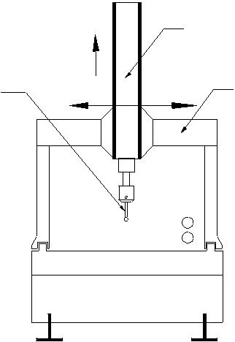

Vertical Slide

_{Probe} Bridge

Monitor
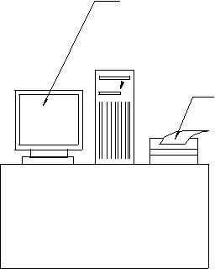
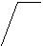Computer

Printer

.

+

Table

The major features of a CMM are:

- Stationary granite measuring table: Granite table provides a stable reference plane for locating parts to be measured. It is provided with a grid of threaded holes defining clamping locations and facilitating part mounting. As the table has a high load carrying capacity and is accessible from three sides, it can be easily integrated into the material flow system of CIM.

- Length measuring system: A 3-axis CMM is provided with digital incremental length measuring system for each axis.

- Air bearings: The bridge, cross beam and spindle of the CMM are supported on air bearings with high rigidity. They are designed insensitive to vibrations.

- Control unit: The control unit allows manual measurement and self teach programming in addition to CNC operation. The control unit is microprocessor controlled. Usually a joystick is provided to activate the drive for manual measurement.

CNC Measuring Centres are provided with dynamic probe heads and a probe changing system, which can be operated manually or automatically.

- Software: The CMM, the computer and the software together represent one system whose efficiency and cost effectiveness depend to a large extent on the software.

The features of CMM software will include:

- Measurement of diameter, centre distances, lengths, geometrical and form errors in prismatic components etc.
- On-line statistics for statistical information in a batch.

- Parameter programming to minimize CNC programming time of similar parts.
- Measurement of plane and spatial curves.
- Data communications.
- Digital input and output commands for process integration
- Programs for the measurement of spur, helical, bevel and hypoid gears.
- Interface to CAD software.

Typical software may also provide a generalized method for reverse engineering complex shaped objects. The component is digitized, taking a dense set of points, using a CNC CMM. The digitized data is then converted into a computer model, which describes the true surface of the component, with allowance for the digitizing probe diameter. The model may then be expanded, offset or mirrored to an allowance for the manufacturing process.

Recent advances in CMM technology are based largely on greater intelligence features provided by the computer software. These advances include the capability for automatic work part alignment on the table, interactive programming of the CMM for inspection personnel who are not experienced in the use of computers. Besides this, the software has the capability to orient the coordinate system as required (between polar and Cartesian coordinate systems). Similarly translation of origin can be effected as desired.

Savings in inspection time by using CMM are significant. Typically between 5 and 10% of the time is required on a CMM compared to traditional manual inspection methods. Other advantages include consistency in the inspection process from one part to the next, which cannot be matched by manual inspection, and reductions in production delays to get approval of the first workpiece in a batch.

ADVANTAGES OF CNC OPERATION OF CMM

CNC operation increases cost effectiveness through the following advantages:

  - Shorter measuring times

  - Higher throughput rates

  - Better repeatability

  - Economical even for small batches

  - Simple operation

  - Unmanned second and third shift inspection of parts if parts are loaded automatically.

NON-CONTACT INSPECTION METHODS

The field of non-contact inspection, in particular optical inspection is composed of the following basic areas:

- Inspection of part dimensions.

- Inspection of surface defects.

- Inspection of completed or semi-completed parts.

Computer Aided Quality Control

The main advantages of non-contact inspection are:

- It eliminates the need to reposition the workpiece.

- Non-contact inspection is faster than contact inspection.

T
- here is no mechanical wear encountered in the contact inspection probe.

T
- he possibility of damage to the surface of a part due to measuring pressure is eliminated.

S
ome of the examples of non-contact inspection are laser interferometer measuring system, laser telemetric measuring system, machine vision system and optical gauging. These are discussed below.

LASER INTERFEROMETER MEASURING SYSTEM

  - Presently lasers are used as length measuring devices. They are commonly used for positional accuracy measurements. They are also used as length measuring machines of high accuracy (accuracy of the order of 0.01 micrometer). The feed back of this can be used for positioning of the machine and also for computation of measurements.

Nowadays it has become a common practice to use laser-measuring system for the calibration of CNC machines. Using laser-measuring system the measurements performed are reliable, accurate and faster compared to conventional methods. The laser interferometer can be directly interfaced with a computer. This makes it easy for the operator to evaluate the results as per the evaluation procedures mentioned in various standards like AMT, AFNOR, VDI, MTTA, and JIS etc. Using different attachments laser interferometer is also used for other measurements like straightness, flatness, squareness, velocity, pitch, yaw etc.

LASER TELEMETRIC MEASURING SYSTEMS

This is a high speed gauging system providing accuracy and repeatability of a contact type gauge with versatility of a non-contact type of gauge. The principle is explained below:

A thin band of laser beam projects from a transmitter to receiver. When an object is placed across the beam, the object casts a shadow. The signal from light entering the receiver is used by the microprocessor to detect the shadow and to calculate the dimension represented by the distance between the edges of the shadow.

The transmitter module contains a low power He-Ne gas laser and its power supply, a specially designed collimating lens, a synchronous motor, multi-faced reflector prism, a synchronous pulse detector and protective window. This produces a collimated parallel scanning laser beam moving at a high and constant speed. The scanning beam appears as a line of red light. The receiver module collects and photo electrically senses the laser light transmitted past the object being measured. The processor electronics takes the receiver signals and converts them to digital signal and displays the dimensions being gauged.

The information thus collected is processed not only to qualify or classify a part but also can be used to correct the manufacturing process that might have caused the undesirable deviation. This is done automatically without touching the part and without the need for human intervention. The microprocessor actuates precise computer control of continuously manufactured parts. The prompting formats guide the operator regarding the gauge setting. The operational procedures notify the operator in case any error occurs in the system by displaying error message on the CRT terminal. It also keeps the operator informed about the product in the production process, displays, prints out and records the complete measured and analyzed results.

Laser telemetric measuring systems give out a number of signal outputs and processing options to make the dimensional measurement more useful in production environment. Examples are listed below:

- A high/low limit alarm option, which activates lights and connector panel, output when the tolerance limits are exceeded.

- A process control option, which makes it possible to provide a closed loop control of the diameter of a continuously processed product..

VISION SYSTEM

A vision system can be defined as a system for automatic acquisition and analysis of images to obtain desired data for interpreting or controlling an activity. In a broader sense, the term is applied to a wide range of non-contact electro-optical sensing techniques from simple triangulation and profiling to a 3D object recognition technique. These are based on sophisticated computerized image analysis routines. The applications range from relatively simple detection and measuring tasks to full-blown robot control, which include quality assurance, sorting, material handling and process control, robot guidance, calibration and testing, machine monitoring and safety.

The schematic diagram of a typical vision system is shown in Fig 7.2. This system involves image acquisition, image processing or image analysis and interpretation. Acquisition requires appropriate lighting, the use of electronic camera and means of storing a digital representation of the image. Processing involves manipulating the digital image to simplify and reduce number of data points that must be handled by subsequent analytical routines used to interpret the data. Computers with suitable softwares are used for this purpose.

Computer Aided Quality Control
 |  |  |  |  |  |  | Digitized |  | Store |  |  |  |  |  |  | Feature
 |  |  |  |  |  |  | Image |  |  |  |  |  |  |  |  | Extraction
 |  |  |  |  |  |  |  |  |  |  | Measurement
 |  |  |  |  |  | Camera |  |  |  |  |  | Software
 | Light Source
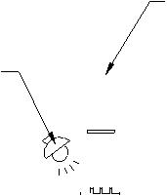

PART TO BE
INSPECTED

Fig. 7.2 Typical Vision System

By using the vision systems measurements can be carried out at any angle along all the three reference axes X, Y and Z without contacting the part. The measured values of the component parameters are then compared with the specified tolerances, which are stored in the memory of the computer.

The measured values, the specified values with the deviation and an indicating on whether the part is passed or not passed are displayed on the VDU. Using a sorting system it is also possible to sort the parts based on these results.

Computer vision systems offer several advantages like reduction of tooling and fixture costs, elimination of need for precise part location for handling by robots and integrated automation of dimensional verification and defect detection.

NON-CONTACT CNC CMM

The non-contact CNC CMM inspects a part by observing it with a video camera, analyzing the image and outputting the results. The construction of this CMM is similar to that of a conventional CMM. These are particularly useful to measure the following workpieces, which are difficult to measure with contact method:

- Printed circuit boards.

- Pins and connectors.

- Injection molded plastic items.

- Pressed parts.

- IC package.

- Ceramic parts.

- Photoelectric parts.

- Etched parts.

Some non-contact CMM’s operate using laser digitization technique. These are particularly suitable for measurement of complex 3-D surfaces. This equipment makes
product data generation for reverse engineering an easy task.

CAD/CAM

PAST PROCESS METROLOGY

The process of measuring the workpieces during machining and automatically updating the machine tool offsets in the control system to maintain the dimensional quality of the workpiece machined without any manual intervention is called post process metrology. Post process gauging in particular embraces a variety of cost saving and quality control techniques.

The advantages of post-process gauging can be seen from Fig. 7.3. which shows the conventional use of CNC machines with a long set-up time and first off approval cycle delaying the start of full speed production. The post process metrology set-up can reduce the cost and time of production. In this case the set up time and first off inspection time constitute the total time for trial production. Also the faults can be rapidly detected and corrected during the process itself.
One of the common methods of post process metrology is by using a touch trigger probe. This can be incorporated into the machining centre or a CNC lathe to perform the gauging operation on workpieces. These are omni-directional probes with inductive, optical or infrared transmission, which incorporates a sensitive electrical contact, and deflect from its home position when the pressure is applied.

At the start of the cycle, the probe is placed in the tool magazine of the machine tool. The probe movement will be programmed as per the gauging of the component for its dimensional parameters. As per the programmed sequence the probe takes the position in the spindle in the place of cutter and moves in the required sequence to gauge the component.
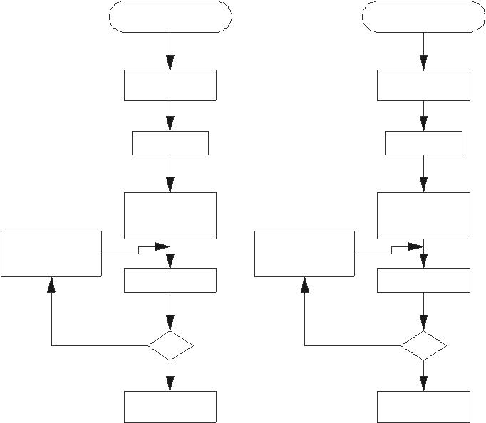

P R O G R A M | P R OG RAM
IN P U T | INP U T
S IM U LAT IO N | S IM U LATIO N
D R Y RU N | D R Y RU N
TR IA L | TR IA L
P R OD UC TIO N | P R OD UC TIO N
M AN U AL | M AN U AL
O F FS E T | O F FS E T
C OR R EC TIO N | C OR R EC TIO N
INS P E C TIO N | P R OB ING
N O | N O
O K | O K
Y E S | Y E S
P R OD UC TIO N | P R OD UC TIO N

Fig. 7.3 Production of Parts with and without Post Process Metrology

Computer Aided Quality Control

The signals from the probe will be transmitted to the control system to initiate the corrective action. After incorporating the correction through tool offset, the full speed production will be started.

The general applications of probe systems are given below:

Inspection

Component verification In-cycle gauging Digitizing
Tool setting Job set up

Tool breakage detection

The data from the probe systems can be communicated to the machine control unit in three ways:

- Inductive transmission

- Hard-wired transmission
- Optical transmission
The actual gauging cycle, contained in the part programme, is brought into action between cutting cycles. Based on the information received from the measuring system corrective action through appropriate offset values will be incorporated in the system to machine the component to the required size.

COMPUTER AIDED INSPECTION USING ROBOTS

Robots can be used to carry out inspection or testing operations for mechanical dimensions and other physical characteristics and product performance. Generally robot must work with other pieces of equipment in order to perform the operations. Examples include machine vision systems, robot manipulated inspection and/or testing equipment.

Checking robot, programmable robot, and co-ordinate robot are some of the titles given to multi-axis measuring machines aimed at high-speed measurement. These machines automatically perform all the basic routines of a CNC co-ordinate measuring machine but at a faster rate than that of a CMM. These machines are designed to be used in environments such as shop floor. They are not as accurate as precision CMM’s but they can check up to accuracies of 5 micrometres which is often sufficient for many applications. However, quality levels can be improved by increasing the number of inspections. By using robots the dimensional drifts can be accurately and quickly detecte
and the appropriate process action can be taken. One example is, segregating the components according to the tolerance specifications.

Using the modern touch trigger probe, a co-ordinate robot or a pair of robots can take successive readings at high speed and evaluate the results using a computer graphics based real time statistical analysis system. This gives high-speed data processing of measured information and can provide early warning of rejection. The computer also monitors the geometry and wear of the tools, which produce the component. After the measurement, if the component is not acceptable it is placed on a conveyor where it slides under gravity into REJECT bin.

INTEGRATED COMPUTER AIDED INSPECTION SYSTEMS

Automation in industries is intended to provide a batch oriented manufacturing. The integration of the activities starting from design to the part coming out of the factory leads to total automation. This closes the loop in a computer integrated manufacturing system. Some of the integrated systems are available in different configurations, examples being integrated CAD/CAM/CAI Systems with robots etc. Some of these are discussed in the following sections:

INTEGRATION OF CAD/CAM WITH INSPECTION SYSTEM

CAD/CAM systems are seen as a natural adjunct to automatic gauging wherein a product is designed, manufactured and inspected in one automatic process. There is a strong trend in the direction of a closed loop, fully adaptive manufacturing system.

One of the critical factors in manufacturing quality assurance is to ensure that every part coming off the production line is within design tolerance. The successful factory constantly monitors quality at each step of design and manufacturing process. In the shop, the coordinate measuring machine assists in this quality assurance function. The productivity of the coordinate measuring machine can be improved by interfacing with a CAD/CAM system. Interfacing with the CAD/CAM database, the operator can use the off-line programming capabilities of the CMM interface to process the input values for the part geometry being measured. This eliminates the laborious manual data entry techniques and reduces preparation time and increases availability of CMM for inspection.

The CAD/CAM-CMM interface helps the programming efforts in the quality assurance office where quick response to engineering changes can be made and current data to the CMM can be provided. Generally the CAD/CAM-CMM interface consists of a number of modules as shown in Fig. 7.4.

Computer Aided Quality Control
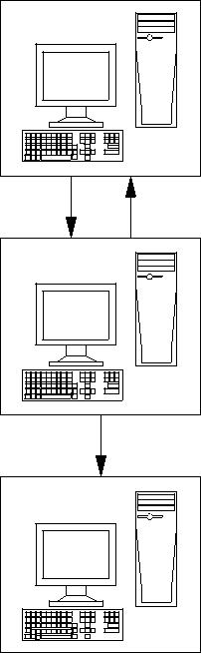

CAD
MODEL

CMM INTERFACE

PRE CMM PROCESSOR

POST CMM PROCESSOR

Fig. 7.4 CAD/CAM-CMM Interface
i. CMM-Interface: This interface allows interacting with the CAD/CAM database
to generate a source file that can be converted to a CMM control data file. During
source file creation, CMM probe path motions are simulated and displayed on
the CAD/CAM workstation for visual verification.
A set of CMM command statements allow the CMM Interface to take advantage
of most of the CMM’s functional capabilities. These command statements include
setup, part datum control, feature construction, geometric relations, tolerancing,
output control and feature measurements like measurements of lines, points,
arcs/circles, splines, conics, planes, analytic surfaces, tabulated cylinders and
sculptured surfaces.
ii. Pre-CMM processor: The pre-CMM processor converts the language source
file generated by CMM Interface into the language of the specified Coordinate
Measuring Machine. The output is a file stored in the CAD/CAM host
operating system level. Whenever, a statement is encountered which is not
supported by the selected CMM, the pre-CMM processor will display a
warning message. This allows generation of multiple CMM control data files
from one source file.
iii. Post-CMM processor: The post-CMM processor creates wire frame surface model
from the CMM-ASCII output file. Comments are inserted into the ASCII-CMM
output file to control the creation of the CAD/CAM entities, which include
points, lines, arcs/circles, conics, splines and analytic surfaces.

CAD/CAM

FLEXIBLE INSPECTION SYSTEM (FIS)

Fig. 7.5 shows the block diagram of a comprehensive flexible inspection system. This system has been developed with the intention of the integration of the inspection done at several places in a factory.

FIS also helps to close the loop between the design intent and product performance and to improve inspection technology and thereby increasing the productivity. A powerful computer serves as a real time processor to handle part dimensional data and as a multi-programming system to perform such tasks as manufacturing process control. The terminal provides interactive communication with personal computers where the programmes are stored. The typical digital input devices used with this system are CMM’s, microprocessor based gauges and other inspection devices. The data from CMM’s and other terminals are fed into the main computer for analysis and feed back control. The quality control data and inspection data from each station are fed through the terminals to the main computer. This type of communication could be from more than one factory location, in which case the data will be communicated through telephone lines. Even data from acceptance tests on new machine tool building plant are fed to this computer for analysis. Machine capability studies are also carried out by taking large samples (30-50 pieces) from a particular machine. Final product audit and inspection are also carried out with the help of CMM’s and other suitable inspection aids with the capability of directly feeding the data to the computer. TESA, CARL JOHANSSON and other manufacturers of metrology equipment supply such integrated systems.

Flexible inspection system involves more than one inspection station. The objective of the flexible inspection system is to have an off-line multi-station automated dimensional verification system to increase the production rate, lessen the inspection time and to maintain the inspection accuracy and data processing integrity. The important features of FIS include dynamic statistical sampling programs, which provide automatic adjustment to modify the number of parts, and part features to be inspected based on the inspection history.
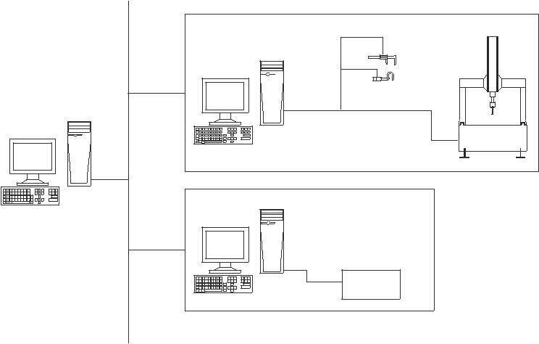

Table

SHOP FLOOR

SERVER

SENSORS

TEST FLOOR

Fig. 7.5 Flexible Inspection System

Computer Aided Quality Control

QUESTIONS

- What is the significance of quality control in CIM?

- Define total quality management and explain its relevance to CIM.

W
- What are the objectives of computer aided quality control?

- Discuss the important benefits of computer-aided quality control.

- Explain the method of part inspection using a CMM.

- What are the important features available in CMM software?

- Discuss major non-contact inspection methods.

- What is the working principle of computer vision systems?

- How is post-process metrology incorporated in CNC Machines?

- Describe the features of a flexible inspection system.

- Discuss the integration of CAD database and CMM operation.

COMPUTER INTEGRATED MANUFACTURING SYSTEMS

INTRODUCTION

Computer Integrated Manufacturing (CIM) encompasses the entire range of product development and manufacturing activities with all the functions being carried out with the help of dedicated software packages. The data required for various functions are passed from one application software to another in a seamless manner. For example, the product data is created during design. This data has to be transferred from the modeling software to manufacturing software without any loss of data. CIM uses a common database wherever feasible and communication technologies to integrate design, manufacturing and associated business functions that combine the automated segments of a factory or a manufacturing facility. CIM reduces the human component of manufacturing and thereby relieves the process of its slow, expensive and error-prone component. CIM stands for a holistic and methodological approach to the activities of the manufacturing enterprise in order to achieve vast improvement in its performance.

This methodological approach is applied to all activities from the design of the product to customer support in an integrated way, using various methods, means and techniques in order to achieve production improvement, cost reduction, fulfillment of scheduled delivery dates, quality improvement and total flexibility in the manufacturing system. CIM requires all those associated with a company to involve totally in the process of product development and manufacture. In such a holistic approach, economic, social and human aspects have the same importance as technical aspects.

CIM also encompasses the whole lot of enabling technologies including total quality management, business process reengineering, concurrent engineering, workflow automation, enterprise resource planning and flexible manufacturing.

A distinct feature of manufacturing today is mass customization. This implies that though the products are manufactured in large quantities, products must incorporate

CAD/CAM

customer-specific changes to satisfy the diverse requirements of the customers. This requires extremely high flexibility in the manufacturing system.

The challenge before the manufacturing engineers is illustrated in Fig.8.1.

QUALITY
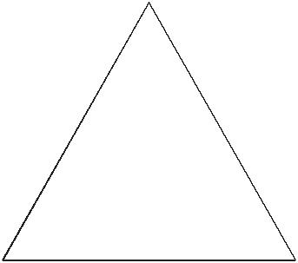

COST |  |  | DELIVERY
 |  |  | TIME
Fig 8.1 Challenges in Manufacturing

Manufacturing industries strive to reduce the cost of the product continuously to remain competitive in the face of global competition. In addition, there is the need to improve the quality and performance levels on a continuing basis. Another important requirement is on time delivery. In the context of global outsourcing and long supply chains cutting across several international borders, the task of continuously reducing delivery times is really an arduous task. CIM has several software tools to address the above needs.

Manufacturing engineers are required to achieve the following objectives to be competitive in a global context.

- Reduction in inventory

- Lower the cost of the product
- Reduce waste
- Improve quality
- Increase flexibility in manufacturing to achieve immediate and rapid response to:
  - Product changes

  - Production changes
  - Process change
  - Equipment change
  - Change of personnel

Integrated Manufacturing

The advances in automation have enabled industries to develop islands of automation. Examples are flexible manufacturing cells, robotized work cells, flexible inspection cells etc. One of the objectives of CIM is to achieve the consolidation and integration of these islands of automation. This requires sharing of information among different applications or sections of a factory, accessing incompatible and heterogeneous data and devices. The ultimate objective is to meet the competition by improved customer satisfaction through reduction in cost, improvement in quality and reduction in product development time.

CIM makes full use of the capabilities of the digital computer to improve manufacturing. Two of them are:

- Variable and Programmable automation

- Real time optimization

T
he computer has the capability to accomplish the above for hardware components of manufacturing (the manufacturing machinery and equipment) and software component of manufacturing (the application software, the information flow, database and so on).

The capabilities of the computer are thus exploited not only for the various bits and pieces of manufacturing activity but also for the entire system of manufacturing. Computers have the tremendous potential needed to integrate the entire manufacturing system and thereby evolve the computer integrated manufacturing system.

TYPES OF MANUFACTURING

The term “manufacturing” covers a broad spectrum of activities. Metal working industries, process industries like chemical plants, oil refineries, food processing industries, electronic industries making microelectronic components, printed circuit boards, computers and entertainment electronic products etc. are examples of manufacturing industries. Manufacturing involves fabrication, assembly and testing in a majority of situations. However, in process industries operations are of a different nature.

Manufacturing industries can be grouped into four categories:

- Continuous Process Industries

In this type of industry, the production process generally follows a specific sequence. These industries can be easily automated and computers are widely used for process monitoring, control and optimization. Oil refineries, chemical plants, food processing industries, etc are examples of continuous process industries.
- Mass Production Industries

Industries manufacturing fasteners (nuts, bolts etc.), integrated chips, automobiles, entertainment electronic products, bicycles, bearings etc. which are all mass produced can be classified as mass production industries. Production lines are specially designed and optimized to ensure automatic and cost effective operation. Automation can be either fixed type or flexible.

CAD/CAM

- Batch Production (Discrete Manufacturing)

The largest percentage of manufacturing industries can be classified as batch production industries. The distinguishing features of this type of manufacture are the small to medium size of the batch, and varieties of such products to be taken up in a single shop. Due to the variety of components handled, work centres should have broader specifications. Another important fact is that small batch size involves loss of production time associated with product changeover.

As mentioned earlier, integration of computer in process industries for production automation, process monitoring and control and optimization is relatively easy. In the case of mass production and batch production computer integration faces a number of problems as there are a large number of support activities which are to be tied together. These are discussed in detail later in this chapter.

Automation of manufacture has been implemented using different techniques since the turn of the 20th ^{C}entury. Fixed automation is the first type to emerge. Single spindle automatic lathe, multi spindle automatic lathe and transfer lines are examples of fixed automation. Fixed automation using mechanical, electrical, pneumatic and hydraulic systems is widely used in automobile manufacturing. This type of automation has a severe limitation - —hese are designed for a particular product and any product change will require extensive modifications to the automation system.

The concept of programmable automation was introduced later. These were electrically controlled systems and programs were stored in punched cards and punched tapes. Typical examples of programmable automation are:

- Electrical programme controlled milling machines

- Hydraulically operated Automatic lathes with programmable control drum

S
- equencing machines with punched card control /plug board control

D
evelopment of digital computers, microelectronics and microprocessors significantly altered the automation scenario during 1950-1990. Machine control systems are now designed around microprocessors and microelectronics is part and parcel of industrial drives and control. The significant advances in miniaturization through integration of large number of components into small integrated chips and the consequent improvement in reliability and performance have increased the popularity of microelectronics. This has resulted in the availability of high performance desktop computing machines as well as file servers which can be used for industrial control with the help of application software packages.

EVOLUTION OF COMPUTER INTEGRATED MANUFACTURING
Computer Integrated Manufacturing (CIM) is considered a natural evolution of the technology of CAD/CAM which by itself evolved by the integration of CAD and CAM. Massachusetts Institute of Technology (MIT, USA) is credited with pioneering the

development in both CAD and CAM. The need to meet the design and manufacturing requirements of aerospace industries after the Second World War necessitated the development these technologies. The manufacturing technology available during late 40’s and early 50’s could not meet the design and manufacturing challenges arising out of the need to develop sophisticated aircraft and satellite launch vehicles. This prompted the US Air Force to approach MIT to develop suitable control systems, drives and programming techniques for machine tools using electronic control.

The first major innovation in machine control is the Numerical Control (NC), demonstrated at MIT in 1952. Early Numerical Control Systems were all basically hardwired systems, since these were built with discrete systems or with later first generation integrated chips. Early NC machines used paper tape as an input medium. Every NC machine was fitted with a tape reader to read paper tape and transfer the program to the memory of the machine tool block by block. Mainframe computers were used to control a group of NC machines by mid 60’s. This arrangement was then called Direct Numerical Control (DNC) as the computer bypassed the tape reader to transfer the program data to the machine controller. By late 60’s mini computers were being commonly used to control NC machines. At this stage NC became truly soft wired with the facilities of mass program storage, off-line editing and software logic control and processing. This development is called Computer Numerical Control (CNC).

Since 70’s, numerical controllers are being designed around microprocessors, resulting in compact CNC systems. A further development to this technology is the distributed numerical control (also called DNC) in which processing of NC program is carried out in different computers operating at different hierarchical levels - —ypically from mainframe host computers to plant computers to the machine controller. Today the CNC systems are built around powerful 32 bit and 64 bit microprocessors. PC based systems are also becoming increasingly popular.

Manufacturing engineers also started using computers for such tasks like inventory control, demand forecasting, production planning and control etc. CNC technology was adapted in the development of co-ordinate measuring machine’s (CMMs) which automated inspection. Robots were introduced to automate several tasks like machine loading, materials handling, welding, painting and assembly. All these developments led to the evolution of flexible manufacturing cells and flexible manufacturing systems in late 70’s.

Evolution of Computer Aided Design (CAD), on the other hand was to cater to the geometric modeling needs of automobile and aeronautical industries. The developments in computers, design workstations, graphic cards, display devices and graphic input and output devices during the last ten years have been phenomenal. This coupled with the development of operating system with graphic user interfaces and powerful interactive (user friendly) software packages for modeling, drafting, analysis and optimization provides the necessary tools to automate the design process.

CAD in fact owes its development to the APT language project at MIT in early 50’s. Several clones of APT were introduced in 80’s to automatically develop NC codes from
the geometric model of the component. Now, one can model, draft, analyze, simulate, modify, optimize and create the NC code to manufacture a component and simulate the machining operation sitting at a computer workstation.

If we review the manufacturing scenario during 80’s we will find that the manufacturing is characterized by a few islands of automation. In the case of design, the task is well automated. In the case of manufacture, CNC machines, DNC systems, FMC, FMS etc provide tightly controlled automation systems. Similarly computer control has been implemented in several areas like manufacturing resource planning, accounting, sales, marketing and purchase. Yet the full potential of computerization could not be obtained unless all the segments of manufacturing are integrated, permitting the transfer of data across various functional modules. This realization led to the concept of computer integrated manufacturing. Thus the implementation of CIM required the development of whole lot of computer technologies related to hardware and software.

CAD/CAM

CIM HARDWARE AND CIM SOFTWARE

CIM Hardware comprises the following:

- Manufacturing equipment such as CNC machines or computerized work centres, robotic work cells, DNC/FMS systems, work handling and tool handling devices, storage devices, sensors, shop floor data collection devices, inspection machines etc.

- Computers, controllers, CAD/CAM systems, workstations / terminals, data entry terminals, bar code readers, RFID tags, printers, plotters and other peripheral devices, modems, cables, connectors etc.,

C
IM software comprises computer programmes to carry out the following functions:

Management Information System

Sales

Marketing

Finance

Database Management

Modeling and Design

Analysis

Simulation

Communications

Monitoring

Production Control

Manufacturing Area Control

Job Tracking

Computer Integrated Manufacturing

Inventory Control

Shop Floor Data Collection

Order Entry

Materials Handling

Device Drivers

Process Planning

Manufacturing Facilities Planning

Work Flow Automation

Business Process Engineering

Network Management

Quality Management

NATURE AND ROLE OF THE ELEMENTS OF CIM SYSTEM

Nine major elements of a CIM system are in Fig 8.2. They are:

Marketing

Product Design

Planning

Purchase

Manufacturing Engineering

Factory Automation Hardware

Warehousing

Logistics and Supply Chain Management

Finance

Information Management
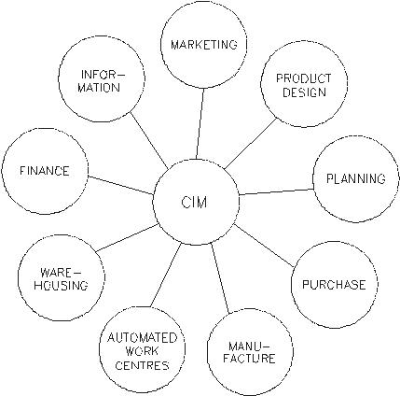

Fig.8.2 Major Elements of a CIM System

CAD/CAM

- Marketing: The need for a product is identified by the marketing division. The specifications of the product, the projection of manufacturing quantities and the strategy for marketing the product are also decided by the marketing department. Marketing also works out the manufacturing costs to assess the economic viability of the product.
- Product Design: The design department of the company establishes the initial database for production of a proposed product. In a CIM system this is accomplished through activities such as geometric modeling and computer aided design while considering the product requirements and concepts generated by the creativity of the design engineer. Configuration management is an important activity in many designs. Complex designs are usually carried out by several teams working simultaneously, located often in different parts of the world. The design process is constrained by the costs that will be incurred in actual production and by the capabilities of the available production equipment and processes. The design process creates the database required to manufacture the part.
- Planning: The planning department takes the database established by the design department and enriches it with production data and information to produce a plan for the production of the product. Planning involves several subsystems dealing with materials, facility, process, tools, manpower, capacity, scheduling, outsourcing, assembly, inspection, logistics etc. In a CIM system, this planning process should be constrained by the production costs and by the production equipment and process capability, in order to generate an optimized plan.
- Purchase: The purchase departments is responsible for placing the purchase orders and follow up, ensure quality in the production process of the vendor, receive the items, arrange for inspection and supply the items to the stores or arrange timely delivery depending on the production schedule for eventual supply to manufacture and assembly.
- Manufacturing Engineering: Manufacturing Engineering is the activity of carrying out the production of the product, involving further enrichment of the database with performance data and information about the production equipment and processes. In CIM, this requires activities like CNC programming, simulation and computer aided scheduling of the production activity.
- Factory Automation Hardware: Factory automation equipment further enriches the database with equipment and process data, resident either in the operator or the equipment to carry out the production process. In CIM system this consists of computer controlled process machinery such as CNC machine tools, flexible

- Manufacturing systems (FMS), Computer controlled robots, material handling systems, computer controlled assembly systems, flexibly automated inspection systems and so on.

Computer Integrated Manufacturing

- Warehousing: Warehousing is the function involving storage and retrieval of raw materials, components, finished goods as well as shipment of items. In today’s complex outsourcing scenario and the need for just-in-time supply of components and subsystems, logistics and supply chain management assume great importance.

- Finance: Finance deals with the resources pertaining to money. Planning of investment, working capital, and cash flow control, realization of receipts, accounting and allocation of funds are the major tasks of the finance departments.
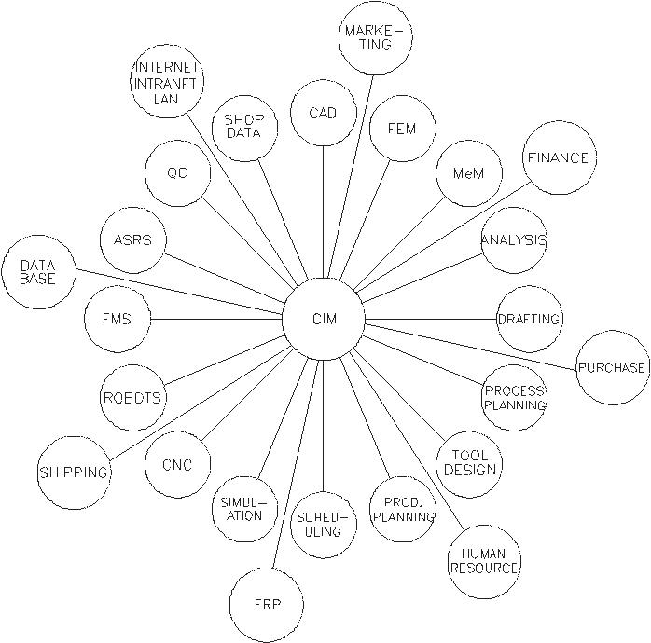

Fig.8.3 Various Activities in CIM

FEM - —inite Element Modeling MeM - —echanism Modeling ERP - —nterprise

Resource Planning

- Information Management: Information Management is perhaps one of the crucial tasks in CIM. This involves master production scheduling, database management, communication, manufacturing systems integration and management information systems.

It can be seen from Fig 1.3 that CIM technology ties together all the manufacturing and related functions in a company. Implementation of CIM technology thus involves basically integration of all the activities of the enterprise.

CAD/CAM

DEVELOPMENT OF CIM

CIM is an integration process leading to the integration of the manufacturing enterprise. Fig 8.4 indicates different levels of this integration that can be seen within an industry. Dictated by the needs of the individual enterprise this process usually starts with the need to interchange information between the some of the so called islands of automation. Flexible manufacturing cells, automatic storage and retrieval systems, CAD/CAM based design etc. are the examples of islands of automation i.e. a sort of computer based automation achieved completely in a limited sphere of activity of an enterprise. This involves data exchange among computers, NC machines, robots, gantry systems etc. Therefore the integration process has started bottom up. The interconnection of physical systems was the first requirement to be recognized and fulfilled.
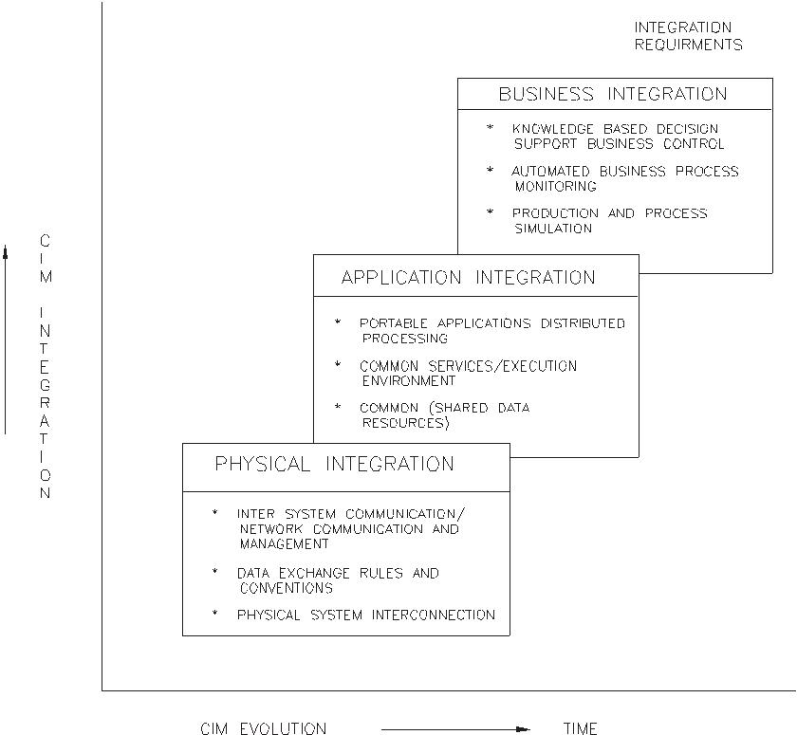

Fig. 8.4 Levels of Integration Against Evolution of CIM

The next level of integration, application integration in Fig 1.4 is concerned with the integration of applications, the term applications being used in the data processing sense. The applications are those which are discussed in section 1.4 under the heading CIM hardware and software. Application integration involves supply and retrieval of information, communication between application users and with the system itself. Thus the application integration level imposes constraints on the physical integration level. There has to be control of the applications themselves also.

Computer Integrated Manufacturing

The highest level of integration, business integration in Fig.1.4 is concerned with the management and operational processes of an enterprise. The management process provides supervisory control of the operational process which in turn co-ordinates the day-to-day execution of the activities at the application level. The business integration level therefore places constraints on the application level. This level offers considerable challenge to the integration activity.

QUESTIONS

- Describe the need for CIM and the issues addressed by CIM.

- What are the different types of manufacturing? Make an assessment of the extent of computer control in specific cases of each types of manufacturing.

- What are the various activities of a manufacturing plant which can be carried out through computer control?

- Discuss the main elements of CIM systems.

- Differentiate among physical integration, application integration and business integration. Give specific examples of each.
- What are the benefits of CIMS?

- QUESTIONS BANK

IMPORTANT QUESTIONS UNIT WISE

UNIT-I
1.Describe the principle of working of a CRT.

2.How is a line displayed on a graphics monitor?

3.What is the function of a frame buffer?

4.What is the advantage of a mouse as an input device?
1. Explain the database structure for graphics modeling.
2. Explain the 2D transformation.
3. Write in detail about hidden surface removal.
4. Explain the 3D transformation

Unit-II
1. Describe briefly the following methods of surface modeling with a few
application examples:

  - Coon patch

  - Tabulated cylinder

  - Bicubic surface

  - Bezier surface
2
.Compare the measures of continuity of curves and surfaces.
3.Explain the hermit cubic curve.
4.Explain the Bezier surface.

Unit-III
- How do you classify modeling package?

2.Compare 2-D and 3-D wire frame models.

3.Discuss the hardware required for a PC based drafting environment
4.Describe the importance of curve and surface modeling in computer aided
graphics and design.
5.Nc,cnc,dnc write the difference?
6.write a program on turning of a work piece for the simulation?

Unit-IV
1.What is the need for CAD based process plans?

2.Discuss the principle and advantages of group technology coding.

3.Classify a component using either OPITZ or MICLASS system.

4.Discuss the principle of variant process planning
5.What is the most popular type of drive for CNC machines today?
6.Sketch and explain the torque speed characteristics of a spindle drive.
7.Why is a gearbox used in the main drive of some CNC machines?
8.Why is separate cooling motor used with DC drives?

Unit-V
1.Explain the method of part inspection using a CMM.

2.What are the important features available in CMM software?

3.Discuss major non-contact inspection methods.

4.What is the working principle of computer vision systems?
5. Describe the need for CIM and the issues addressed by CIM.

6.What are the different types of manufacturing? Make an assessment of the
extent of computer control in specific cases of each types of manufacturing.

7.What are the various activities of a manufacturing plant which can be carried
out through computer control?

8.Discuss the main elements of CIM systems.

- INTERNAL EXAMINATION QUESTION PAPERS

SUBJECTIVE QUESTION PAPERS

1. A.Y.2014-15


CMR INSTITUTE OF TECHNOLOGY SET: 1
Kandlakoya (v), Medchal Road, Hyderabad-501401
INTERNAL EXAM-I
Course: IV B.Tech I Sem Duration: 1 hour
Subject: CAD/CAM Max Marks: 10
Date: 02/09/2017 Time: 10:00AM – 11:00AM

ANSWER ANY TWO OUT OF FOUR QUESTIONS
1. What are the various input devices used in CAD/CAM? Explain about Diziting tablet.
2. Explain the database structures used in graphics modeling.
3. Derive the parametric equation of Bezier curve.
4. What are the types of solid? What are the primitive solids? Discuss the concept of
three Boolean operations used in solid modeling.

CMR INSTITUTE OF TECHNOLOGY SET: 2
Kandlakoya (v), Medchal Road, Hyderabad-501401
INTERNAL EXAM-I
Course: IV B.Tech I Sem Duration: 1 hour
Subject: CAD/CAM Max Marks: 10
Date: 02/09/2017 Time: 10:00AM – 11:00AM

ANSWER ANY TWO OUT OF FOUR QUESTIONS
1. Explain about Direct View Storage (DVST).Write its advantages and disadvantages.
2. Explain the various 2-D transformations required for manipulating the geometric information.
3. Derive the parametric equation of Hermite cubic curve.
4. What are the various basic geometric commands used in CAD? Differentiate wireframe, surface and
solid modeling.

CMR INSTITUTE OF TECHNOLOGY SET: 3
Kandlakoya (v), Medchal Road, Hyderabad-501401
INTERNAL EXAM-I
Course: IV B.Tech I Sem Duration: 1 hour
Subject: CAD/CAM Max Marks: 10
Date: 02/09/2017 Time: 10:00AM – 11:00AM

ANSWER ANY TWO OUT OF FOUR QUESTIONS
1. Explain about Refresh display. Write its advantages and disadvantages.
2. Explain the principle of DDA algorithm for the linear interpolation of graphics
terminal.
3. Derive the parametric equation of Ruled surface and coons patch.
4. What are the various types of display control commands? Explain Zooming and Panning with a neat sketch.

CMR INSTITUTE OF TECHNOLOGY SET: 4
Kandlakoya (v), Medchal Road, Hyderabad-501401
INTERNAL EXAM-I
Course: IV B.Tech I Sem Duration: 1 hour
Subject: CAD/CAM Max Marks: 10
Date: 02/09/2017 Time: 10:00AM – 11:00AM

ANSWER ANY TWO OUT OF FOUR QUESTIONS
1. Explain about Raster display. Write its advantages and disadvantages.
2. Explain the importance of clipping. Write about types of clipping.
3. Derive the parametric equation of Bezier surface.
4. What are the solid representation methods? Explain Boundary representation method.

CMR INSTITUTE OF TECHNOLOGY SET: 1
Kandlakoya (v), Medchal Road, Hyderabad-501401
INTERNAL EXAM-II
Course: IV B.Tech I Sem Duration: 1 hour
Subject: CAD/CAM Max Marks: 10
Date: 18/11/2014 Time: 10:00AM – 11:00AM
ANSWER ANY TWO OUT OF FOUR QUESTIONS
1. The drawing of component is shown in fig.1.Three holes to be drilled and reamed at three places. The speed and feed rate for drilling are 592rpm and 3.55in/min. The speed and feed rate for reaming are 382rpm and 3.82in/min. Write manual part programming
2. (A) How do you classify the part classification an coding system? Explain them.
(B)What are the advantages and disadvantages of group technology?
3. What is the computer controlled CMM? Explain various types of CMMs.
4. (A) How does CIM integrate all activities in an industry
(B) What are the benefits and limitations of CIM.

CMR INSTITUTE OF TECHNOLOGY SET: 2
Kandlakoya (v), Medchal Road, Hyderabad-501401
INTERNAL EXAM-II
Course: IV B.Tech I Sem Duration: 1 hour
Subject: CAD/CAM Max Marks: 10
Date: 18 /11/2014 Time: 10:00AM – 11:00AM
ANSWER ANY TWO OUT OF FOUR QUESTIONS
1. The drawing of component is shown in fig.1.Five holes to be drilled at five places. The speed and feed rate are 592rpm and 100mm/min. respectively. The machine has a floating zero feature and absolute positioning. Thickness of the of the plate is 10mm. Write manual part programming.
2. Define Group Technology. Explain the concept of any two part families and Opitz coding System.
3. What are the types of inspection methods? Explain about Machine Vision and Photogrammetry.
4. Discuss the principles of Material Handling System. Write about industrials trucks.

CMR INSTITUTE OF TECHNOLOGY SET: 3
Kandlakoya (v), Medchal Road, Hyderabad-501401
INTERNAL EXAM-II
Course: IV B.Tech I Sem Duration: 1 hour
Subject: CAD/CAM Max Marks: 10
Date: 18/11/2014 Time: 10:00AM – 11:00AM
ANSWER ANY TWO OUT OF FOUR QUESTIONS
1. The part drawing of component is shown in fig.1.Four holes to be drilled at four places. The speed and feed rate are 592rpm and 100mm/min. respectively. The machine has a floating zero feature and absolute positioning. Thickness of the of the plate is 10mm. Write manual part programming.
2. Define CAPP. Explain the two types of CAPP systems.
3. What are the types Non-Contact inspection methods? Explain Scanning laser beam device.
4. What is CIMS? Explain various types of Material Handlin System used in industries.

CMR INSTITUTE OF TECHNOLOGY SET: 4
Kandlakoya (v), Medchal Road, Hyderabad-501401
INTERNAL EXAM-II
Course: IV B.Tech I Sem Duration: 1 hour
Subject: CAD/CAM Max Marks: 10
Date: 18 /11/2014 Time: 10:00AM – 11:00AM
ANSWER ANY TWO OUT OF FOUR QUESTIONS
1. Explain in detail about CNC system.
2. Define Group Technology. Explain about Opitz coding System.
3. Define CAQC. What are the objectives of CAQC? Explain about CMM used in CAQC.
4. Define CIMS. Explain various types of Automated Guided Vehicles used in manufacturing industries.

2.A.Y.2013-14

CMR INSTITUTE OF TECHNOLOGY
Kandlakoya (v), Medchal Road, Hyderabad-501401
INTERNAL EXAM-I
Course: IV B.Tech I Sem Duration: 1 hour
Subject: CAD/CAM Max Marks: 10
Date: 27/08/2013 Time: 10:00AM – 11:00AM

ANSWER ANY TWO OUT OF FOUR QUESTIONS
1. Explain about Refresh display. Write its advantages and disadvantages.
2. Explain the principle of DDA algorithm for the linear interpolation of graphics
terminal.
3. Derive the parametric equation of Bezier surface.
4. What are the solid representation methods? Explain Boundary representation method.

CMR INSTITUTE OF TECHNOLOGY
Kandlakoya (v), Medchal Road, Hyderabad-501401
INTERNAL EXAM-II
Course: IV B.Tech I Sem Duration: 1 hour
Subject: CAD/CAM Max Marks: 10
Date: 29/11/2013 Time: 10:00AM – 11:00AM
ANSWER ANY TWO OUT OF FOUR QUESTIONS
1. The drawing of component is shown in fig.1.Three holes to be drilled and reamed at three places. The speed and feed rate for drilling are 592rpm and 3.55in/min. The speed and feed rate for reaming are 382rpm and 3.82in/min. Write manual part programming
2. (A) How do you classify the part classification an coding system? Explain them.
(B)What are the advantages and disadvantages of group technology?
3. What are the types of inspection methods? Explain about Machine Vision and Photogrammetry.
4. Discuss the principles of Material Handling System. Write about industrials trucks.

- A.Y.2012-13

CMR INSTITUTE OF TECHNOLOGY
Kandlakoya (v), Medchal Road, Hyderabad-501401
INTERNAL EXAM-I
Course: IV B.Tech I Sem Duration: 1 hour
Subject: CAD/CAM Max Marks: 10
Date:06/09/2012 Time: 10:00AM – 11:00AM

ANSWER ANY TWO OUT OF FOUR QUESTIONS
1. What are the various input devices used in CAD/CAM? Explain about Diziting tablet.
2. Explain the database structures used in graphics modeling.
3. Derive the parametric equation of Bezier curve.
4. What are the types of solid? What are the primitive solids? Discuss the concept of
three Boolean operations used in solid modeling.

CMR INSTITUTE OF TECHNOLOGY
Kandlakoya (v), Medchal Road, Hyderabad-501401
INTERNAL EXAM-II
Course: IV B.Tech I Sem Duration: 1 hour
Subject: CAD/CAM Max Marks: 10
Date: 30/10/2012 Time: 10:00AM – 11:00AM
ANSWER ANY TWO OUT OF FOUR QUESTIONS
1. The drawing of component is shown in fig.1.Three holes to be drilled and reamed at three places. The speed and feed rate for drilling are 592rpm and 3.55in/min. The speed and feed rate for reaming are 382rpm and 3.82in/min. Write manual part programming
2. (A) How do you classify the part classification an coding system? Explain them.
(B)What are the advantages and disadvantages of group technology?
3. What is the computer controlled CMM? Explain various types of CMMs.
4. (A) How does CIM integrate all activities in an industry
(B) What are the benefits and limitations of CIM.

OBJECTIVE QUESTION PAPERS

1.SPTEMBER.2014, MID –I (A.Y 2014-15)

Code No: A107411808 Set No. 1
JAWAHARLAL NEHRU TECHNOLOGICAL UNIVERSITY HYDERABAD
IV B.Tech. I Sem., I Mid-Term Examinations, September – 2014
CAD/CAM
Objective Exam
Name: ______________________________ Hall Ticket No.
Answer All Questions. All Questions Carry Equal Marks.Time: 20 Min. Marks: 20.
I Choose the correct alternative:
1. C² continuity refers to [ C]
A) Common tangent B) Common point C) Common curvature D)common normal
2. The degree of Bezier curve with n control points is [B ]
A) n+1 B) n-1 C) n D) 2n
3. The convex hull property is satisfied by the following surface [D ]
A) Bezier B) B-spline C) NURBS D) All the above
4. The basic geometric building blocks in a cad/cam package are [D ]
A) lines B) Points C) circles D) all of them
5. Following database is used in cad/cam system. [A ]
A) Object orientated database B) Relational database
C) Network database D) Hierarchical database
6. ADAMS, Expert systems,& artificial intelligence are part of [A ]
A) Computer aided analysis B) Computer aided visualization
C) Computer aided synthesis D) CIM
7. Identify the correct sequence of the design process [A ]
A) Recognition of need→ definition of problem →synthesis →analysis and optimization
→evaluation →presentation
B) Recognition of need→ definition of problem → analysis and optimization
→synthesis→ evaluation→ presentation
C) Recognition of need→ definition of problem → synthesis → analysis and optimization→
presentation→ evaluation
D) Recognition of need→ definition of problem→ analysis and optimization→
synthesis→presentation
8. Selective erasing is not possible in [B ]
A) Directed –beam refresh B)DVST C)Raster scan D)None of the above
9. CSG and B –REP are [A ]
A)Two methods of modeling B)utilities of software
C)applications of software D)two methods of computer aided analysis
10. Bresenham algorithm is used for drawing. [C ]
A) Arc B) circle C) line D) ellipse

II Fill in the Blanks
11. Two end points and two tangents are required for to define_hermite cubic spline
12. In cad system, with respect to cad image, the ratio of image width to height is known as spect ratio
13. Ambiguous representation of an object is found in wireframe type of CAD modeling
14. The curve based on Bernstien polynomial interpolation function is called bezier
15. The data model that reprecheduthe data as a tree structure is known as heirarchical
16. Two successive refchedulealut any coordinate axes is equivalent to a single
reflection about the origin
17. TBRL region code is by Cohen –Sutherland algorithm. This algorithm is used in computer graphics for line clipping purpose
18 .Array command makes multiple copies of selected objects in a rectangular or circular ( polar) pattern.
19. Segmentation is a process of splitting a curve or a surface into a number of parts such that the composite curve or surface.
20. Euler operators are used for building model for complex objects
.

November2014, MID –II (A.Y 2014-15)

Code No: A107411808 Set No. 1
JAWAHARLAL NEHRU TECHNOLOGICAL UNIVERSITY HYDERABAD
IV B.Tech. I Sem., II Mid-Term Examinations, November – 2014
CAD-CAM
Objective Exam
Name: ______________________________ Hall Ticket No.
Answer All Questions. All Questions Carry Equal Marks.Time: 20 Min. Marks: 20.
I Choose the correct alternative:
1. ‘BLU ‘ stands for [a ]
a) Basic length unit b) British unit length c) Base unit length d) None of the above
2. The axes of turning machine are [a ]
a) z and x axes b)x and y axes c) z and y axes d) x, y and z axes
3. The first NC machine was developed in the year [d ]
a) 1950 b)1952 c) 1954 d) 1956
4. Retrieval type of process planning works on the principle of [a ]
a) Group Technology b)Knowledge Base c)Data base d) net working
5. The mechanized work transport system to form an automated production line is called
[a ]
a) Transfer machine b) Functional element c) Transfer automation d) none of the above
6. Transfer lines are used for [b ]
a) Large variety of parts b) small variety of parts
c) Medium variety of parts d) None of the above
7. The greatest change as a result of CADS/CAM is taking place in [c ]
a) Aerospace industry b) Medium industry c) Electronics industry d) cartography industry
8. Example of the closed loop system is [b ]
a) BOM b) MRP-II c) MRP d) None of the above
9. CIM technology which implemented to thrives many advantages such as [d ]
a)Reduces design cost by 20% b)Reduces time by 50%
c) Improves product Quality d)All of these
10. While producing a few parts with an accuracy of 0.01 mm, it would be preferable to select [b ]
a) Automatic machine tool b)NC machine tool
c) Transfer machine d) none of the above
II Fill in the Blanks
11. In part programming of CNC machine tool, the ‘M’ code for spindle ON+ coolant ON is M13
12. Father of Group Technology is S.Mitrofanove(USSR)
13. In standard’ EIA ‘type parity check is provided on fifth column.
14. The canned cycle G85 stands for boring operation.
15. The no of NC machines in flexible manufacturing module is one.
16. KIBS is in the case of generative process planning
17. Lean manufacturing aims at systematic elimination of waste.
18. CAD/CAM is the inter-relationship between engineering & manufacturing
19. A device which does the general population associate most with automation is Robot.
20. Production flow analysis is related to which technology is group technology.

2.AUGUST.2013, MID –I (A.Y 2013-14)

Code No: 57024 Set No. 1
JAWAHARLAL NEHRU TECHNOLOGICAL UNIVERSITY HYDERABAD
IV B.Tech. I Sem., I Mid-Term Examinations, August - 2013
CAD – CAM
Objective Exam
Name— ______________________________ Hall Ticket No.
Answer All Questions. All Questions Carry Equal Marks. Time: 20 Min. Marks: 10.
I. Choose the correct alternative:
1. The cam process is a subset of the______ process [b ]
a) Design b) Manufacturing c) Machining d) Modeling
2. The final stage in the implementation of CAD system is [b ]
a) Geometric modeling b) Documentation c) Design Changes d) Drafting & Detailing
3. Programmable automation is suitable for [c ]
a) Job Shop Production b)Man production c) Batch Production d) continuous flow production
4. A 1024 x 1024 raster screen would require more than ____ bits of storage in the frame buffer[d ]
a)10 millions b) 3 millions c) 3 billion d) 1 Million
5. Cursor control devices which have been employed in CAD systems are [ b]
a) Digitizers b) Tracker Balls c) Monitor d) Scanner
6. A n-dimensions transformation matrix in homogeneous representation is mapped as [a
a) n+1 b) n-1 c) n d) None
7. The following represents 3D geometric modelling [d ]
a) Wire frame modelincheduled modelling c) Surface Modeling d) Allchedulee
8. The following geometric modelling usually do not support CAMchedule ]
a) 2D b) 3D c) 1D d) None
9. You can create the circle in the following ways [d ]
a) Center and radius b) two point defining diameter c) Tangent & radius d) All the Above
10. Move command can move the objects [c ]
a) By changing their orientation and size b) By changing their orientation but without changing size
c) Without changing their orientation or size d) None of the above
II Fill in the Blanks:
11. The programming module allows users to customise system
12. Mainframe compucheduleused in major component.
13. The Most common type of computer output device capable of displaying graphical output in use today is Liquid crystal CRT.
14. In orthographic projections, the projectors are parallel or perpendicular to the projection plane.
15. Plotters, printers comes under basic hard copy output devices
16. A valid geometric model is created by the CAD system and its model database is stored.
17. Surface modeling is widely used for shape design and Rep.of complex profiles.
18. The drawing area and turning limits checking ON and OFF with the help of limits command.
19. array creates multiple copies of objects in a pattern.

20.A Bezier curve is also called as _sculpture surface_

OCTOBER.2013, MID –II (A.Y 2013-14)

Code No: 57024 Set No. 1
JAWAHARLAL NEHRU TECHNOLOGICAL UNIVERSITY HYDERABAD
IV B.Tech. I Sem., II Mid-Term Examinations, October - 2013
CAD – CAM
Objective Exam
Name— ______________________________ Hall Ticket No.
Answer All Questions. All Questions Carry Equal Marks. Time: 20 Min. Marks: 10.
I. Choose the correct alternative:
1. The first NC machine was developed in the year [ c ]
a) 1950 b) 1956 c) 1957 d) 1954
2. G03 Stands for [a ]
a) Circular Interpolation, Counter clock wise b) Circular Interpolation, clock wise
c) Tapping cycle d) Start
3. From the following which is not familiar with GT [d]
a) Optiz System b) MICLASS System c) CODE system d) Machining system
4. Tolerance codes consist of how many digits [c ]
a) 7 & 8 Digits b) 8 & 9 Digits c) 9 & 10 Digits d) 11 & 12 Digits
5. The implementation of GT can de done by [c ]
a) Visual Inspection b) Production flow analysis
c) Parts classification & coding d) All the above
6. Flexible inspection system involves more than ____ inspection [a ]
a) One b) Two c) Five d) Three
7. Machine vision is an example of ____. [b ]
a) Contact Inspection b) Online inspection
c) offline Inspection d) None of the above
8. CIM consists of the components [ a]
a) CAD & CAM b) Business Functions
c) Both a & b d) None of the above
9. Benefits of CIM [d ]
a) Greater accuracy of drawing b) Superior Design standards
c) Cost estimating d)All the above
10. ___% of the time is required on a CMM compared to traditional inspection method [a
a) 5- 10% b) 8-15% c) 10-12% d) 1-5%

II Fill in the Blanks:
11. The program of the instruction is the detailed step by step set of operations.
12. The tool path is generated from CAD data base.
13. NC programming deals with the control of machine tool
14. The manufacturing cell can be designed to form production flow lines.
15. MICLASS stands for metal institute classification system.
16. Machine vision is a system for the acquisition of image data.
17. GO/NOGO gauge is used to check the part diameter.
18. CAQC standards for computer aided quality control.
19. Synthesis and analysis are the main sub process that constitutes the design process.
20. Manufacturing Process begins with the process planning & ends with the actual product.

3. AUGUST.2012, MID –I (A.Y 2012-13)

Code No: A107411808 Set No. 1
JAWAHARLAL NEHRU TECHNOLOGICAL UNIVERSITY HYDERABAD
IV B.Tech. I Sem., I Mid-Term Examinations, August – 2012
CAD/CAM
Objective Exam
Name: ______________________________ Hall Ticket No.
Answer All Questions. All Questions Carry Equal Marks.Time: 20 Min. Marks: 20.
I Choose the correct alternative:
1. Which of the following is not considered as a method of input control in a CAD system
[d ]
a) Programmable function box b) joystick.
c) Touch terminal d) plotter
2. Air crafts are manufactured by [c ]
a) Mass production b) batch production
c) job shop production d) continuous flow production
3. The software that is used to provIIe the users with various functions to perform [ b]
Geometric modeling and construction is known as
a) Operating software b) graphics software
c) Application software d) programming software.
4. Bresenham’s algorithm seeks to select the optimum raster locations that represent a [b
a) Arc b) straight line c) circle d) ellipse
5. The degree of Bezier curve with ‘n’ control points is [b ]
a)n-1 b)n+1 c) n d) 2n
6. Coons surface or patch is obtained by blending __________ boundary curves. [ c]
a) 2 b) 5 c) 4 d) All of the above
7. CSG and B- REP are [b ]
a) Two methods of modeling b) utilities software
c) Applications of software d) two methods of computer aided analysis
8. Partial erasing of the image is not possible in [c ]
a) Direct beam refresh b) raster scan c) DVST d) all of the above
9. Ambiguous representation of real objects is seen in [b ]
a) Surface model b) wire frame model
c) Solid model d) product model
10. The lowest form of computer language is called [c ]
a) BASIC b) FORTRAN c) Machine language d) COBOL

II Fill in the blanks
11. array command makes multiple copies Of selected objects in a rectangular or circular polar pattern.
12. The vectors in the drawings are to be converted into its equivalent pixel points. This process is termed as rasteristion
13. Integration of CAD and CAM is called CIM
14. For combining the primitives to form the complex solid, the basic set operators also called Boolean operators

15. Two end points and two tangents are required to define hermit cubic spline
16. The data model that represents the data as a tree like structure is known as CGS
17. Individual transformations are combined in order to achieve the required results is called concatenation
18. The technique of selecting and enlarging portions of a drawing is called windowing.
19. Programming automation is suitable for batch type of production.
20. Light pen works on the principle of light rather than ink.

OCTOBER/NOVEMBER.2013, MID –II (A.Y 2012-13)

JAWAHARLAL NEHRU TECHNOLOGICAL UNIVERSITY HYDERABAD
IV B.Tech. I Sem., II Mid-Term Examinations, Oct/Nov - 2012
CAD – CAM
Objective Exam
N—me: ______________________________ Hall Ticket No.
Answer All Questions. All Questions Carry Equal Marks. Time: 20 Min. Marks: 10.
I. Choose the correct alternative:
1. The advantage of CNC is [d ]
a) Flexibility b) metric conversion c) tape editing at the machine site d) All of the above
2. Direct numerical control machines do not use [c ]
a) CPU b) Software c) Punched taps d) All the above
3. Contouring motion commands are used to specify the continuous path motion involving _______and _______operations [a ]
a) Milling and turning b) Milling and drilling c) Both a & b d) None of these
4. Numerical control can be applied to [ d]
a) Milling machines b) Drilling and boring machines
c) Grinding and sewing machines d) All the above
5. In MICLASS system 11th and 12th codes are ____ [c]
a) Main shape b) Main dimension c) Material codes d) Shape elements
6. Advantage of numerical control on machines is [d ]
a) Reduces non productive time b) Reduces Fixturing
c) Improved quality control d) All the above
7. Dwell is defined by [a ]
a) G04 b) G03 c) G02 d) G01
8. APT is used [b ]
a) In teaching of the beginners b) In CAM for NC machine tools
c) In inventory management d) None of the above
9. In group technology, a part family is a collection of parts based on [d ]
a) Shape b) Size c) Similar processing steps d) Any of the above
10. Machinability database system makes use of [d ]
a) Tool life b) Material file c) Machine life d) Any of the above
II Fill in the Blanks:
11. CNC machines are also known as soft wired
12. Linear interpolation is carried out by G01
13. M03 code is used for spindle speed CW
14. Which is the last statement in APT program End
15. The main objective of DNC system is to eliminate the use of punched tape
16. In Optiz code, the from consists of Digits 9
17. The alternative approaches to CAPP have been developed Retrieval,generative &hybride systems
18. MRP input requires master production scedule.
19. CMM stands for coordinchedulesuring machine
20. The NC modes are broadly classified into three categories.

18. External/End Examination Question Papers

UNIVERSITY QUESTION PAPERS

Code No: 57024 R09
JAWAHARLAL NEHRU TECHNOLOGICAL UNIVERSITY HYDERABAD
IV B.Tech. I Sem., Semester Examinations, December – 2014
CAD/CAM
(Common to ME,AE,AME)
Time:3 hours Max.Marks:75

Answer any five Questions
All questions carry equal Marks.
---
1. a) Briefly discuss the various input devices for the graphics and state their functions.
b)Briefly explain the working of refresh display and DVST.
c)What are the benefits of CAD/CAM.

2. a)What is aliasing? Discuss different methods of carrying out inti-alaising.
b)What are the various types of coordinate system used to input sore.
c)What is database structure?Explain the popular database model with an example.

3. a)How do you classify the varius modeling systems on the basis of the capabilities?
b)Descibe with the help of neat sketches the major surface entities provided by the
CAD/CAM system.

4.a)What is the importance of layer in drafting? Explain with an example.
b)Descibe the Euler-Poincare formula for the boundary representation of solid
modeling with an example.

5.a) Discuss the salient features of machining centers.
b)Under what circumstances the adaptive control machining system is used?
Discuss briefly.

6.a) Discuss the benefits of group technology.
b) What are the part families? What are the methods used for grouping of parts?
c)What is the generative process planning? Explain.

7.a)What are the functions of machine vision? Describe the procedure of machine vision
b)With help of schematic diagram explain the measurement system based used on
scanning laser beam system. Also explain its application in CAQC systems.

8.a)Describe different types of the material handling systems used in CIM briefly.
b)Discuss the roll of comport networks in CIM.

--ooOoo--—

Code No: 07A6EC04 R09
JAWAHARLAL NEHRU TECHNOLOGICAL UNIVERSITY HYDERABAD
IV B.Tech. I Sem., Semester Examinations, December – 2013
CAD/CAM
(Common to ME,AE,AME)
Time:3 hours Max.Marks:75

Answer any five Questions
All questions carry equal Marks.
---

1a)What is raster scanning? Why is it preferred in display devises?
b)How do specify a plotter? Describe various types of storage devices used in CAD
systems

2.a)Explain various graphics transformations required for manipulating the geometric
information.
b)Explain the importance of clipping. Give the details of method used for line clipping.

3.a) Give the classification of different surfaces that can be used in geometric modeling
application.
b) What are the problems with Bezier curves? How are these taken care of ?

4.a)Why layers are required in CAD? Explain various display commands used in CAD
applications.
b)Explain constraint based solid modeling in CAD.

5.a)With a block diagram explain the principle of NC.
b)Explain linear and circular interpolations in CNC system.

6.a)What is the group technology? State advantages and limitations of GT.
b) Define the concept of part family. Explain the one method of classification of parts
in GT.

7.a)Explain non-contact inspection method in CAQC.
b)State advantages and limitations of CAQC.

8.a) Draw a CIM circle and briefly explain main objectives in it.
b) Define AS/AR system. Explain various types material handling systems in
manufacturing industry.

--ooOoo—

Code No: 07A6EC04 R09
JAWAHARLAL NEHRU TECHNOLOGICAL UNIVERSITY HYDERABAD
IV B.Tech. I Sem., Semester Examinations, November – 2012
CAD/CAM
(Common to ME,AE,AME)
Time:3 hours Max.Marks:75

Answer any five Questions
All questions carry equal Marks.
---

1. a) What are the various input devices that are used for graphics information input?
b) A computer display system has resolution of 800 Horizontal X 600 vertical pixels.
If the screen aspect ratio is 4:3, show how a square box of 400 pixels can be drawn.

2. a) Explain the principle of DDA and Bresenham’s algorithm for linear interpolation for
graphics terminal.
b)Discuss why homogeneous coordinate system is generally used in graphics in place
of normal system. State advantages with example.

3. a)Discuss the concept of the three Boolean operations used in solid modeling.
Explain with neat sketches.
b)What are the advantages of using a B-rep scheme?

4. a) What are the types of dimensioning systems are available in CAD drafting system?
b)Why layer command is useful in computer drafting environment?

5. a)What are the main features of CNC machine tool? Explain ATC in CNC machines.
b)Write a manual CNC part program for a simple job and explain various parameters
in the program.

6. a)define and Explain the philosophy of group technology in manufacturing.
b)What is part family? State advantages and limitations of group technology.

7. a)Discuss major non contact inspection systems inCAQC
b) Explain the method of part inspection in computer aided quality control using
conventional CMM.

8. a) Explain the concept of CIM implementation in manufacturing unit. Draw CIM
circle.
b)State benefits and limitation of CIM.

--ooOoo--

