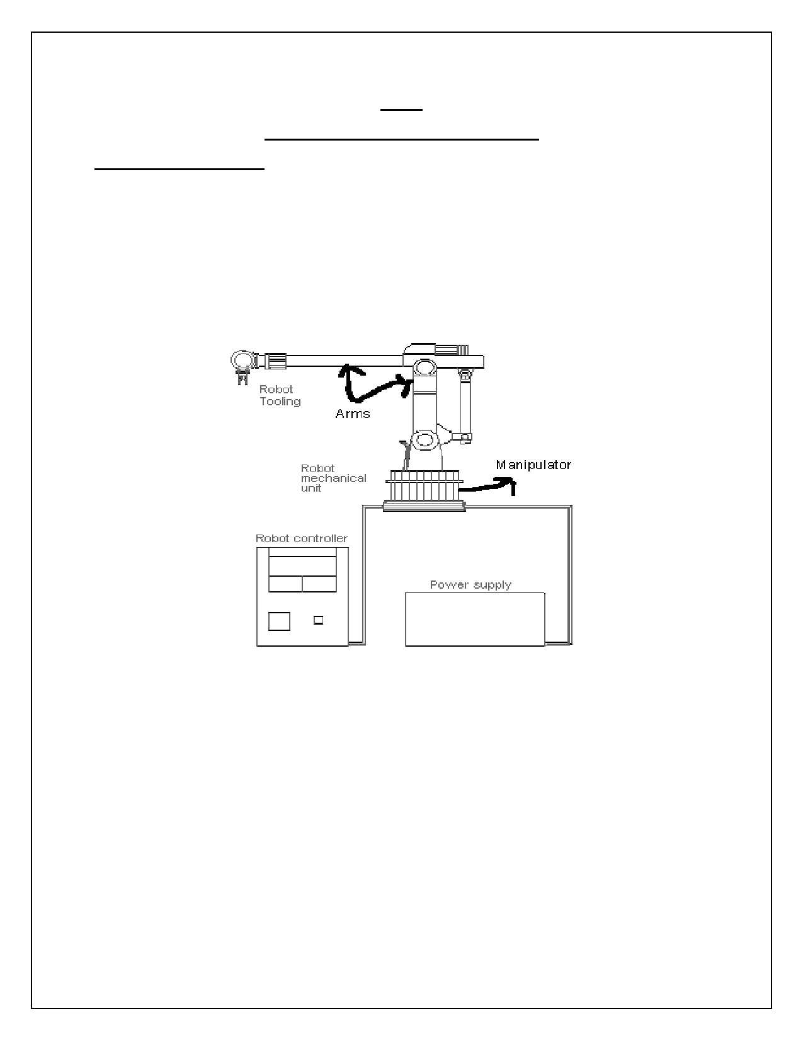

UNIT-2

COMPONENTS OF THE INDUSTRIAL ROBOTICS

Main components of robot:-

A typical stand-alone robot shown in fig below, comprises of the following basic components, namely.

1. Manipulator

2. Sensors devices

3. Robot Tooling

4. Robot controller unit (RCU)

1. Manipulator:

It consists of base, arm, & wrist similar to a human arm. It also includes power source either electric,
hydraulic or pneumatic on receiving signals from robot controller this mechanical unit will be activated.
The movement of manipulator can be in relation to it's coordinate system. Which may be cartesian, cylindrical..etc.

Depending on the controller, movement may be point to point motion or continuous motion.

The manipulator is composed of 3 divisions,

i. The major linkages ii. The minor linkages (wrist components) iii. The end effectors (gripper or tool)

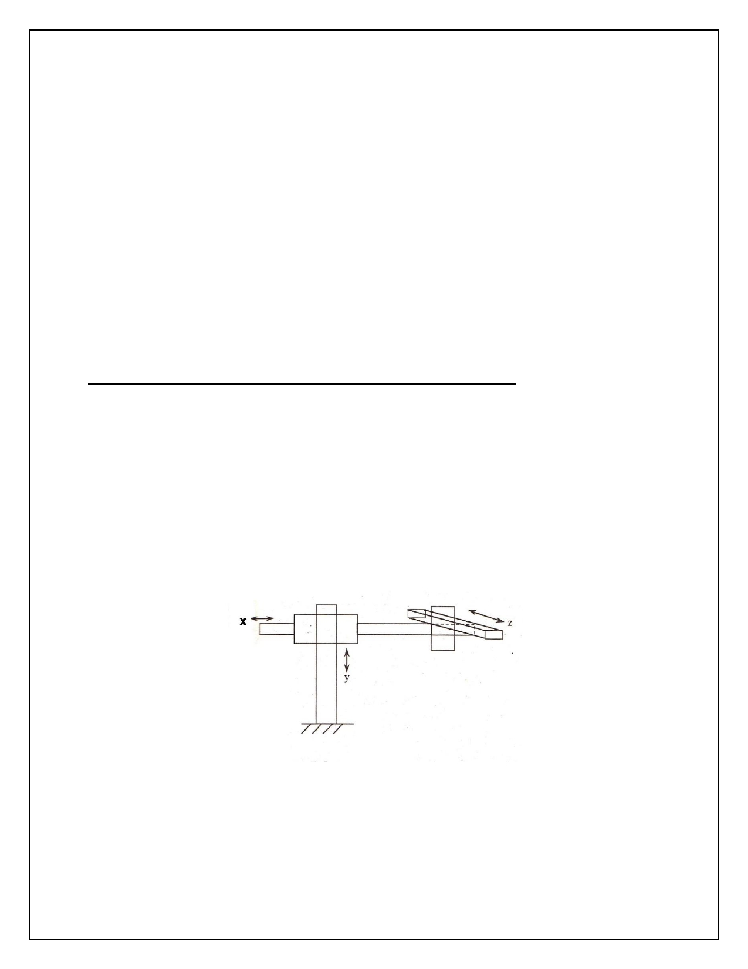

2. Sensors devices:

These elements in form the robot controller about the status of the manipulator. These sensors can be
either analog or digital and combination. These are…

i. visual ii. Non - visual

3. Robot Tooling:

Robot tooling is nothing but hand or gripper of the robot also called as the "" end effector". It is
provided at the end of the arm. It is design depends on the nature of the work to be performed by the robot.

4. Robot controller unit (RCU):

The instructions to the robot to perform the desired tasks are input through the key board of this unit.
The controller converts the input programs to suitable signals which activate the manipulator to perform the desired tasks.

Types of robot arms OR function line diagram representation of robot arms:-

The arms of the robot classified as following:

i. Cartesian robot

ii. Cylinder robot

iii. Polar robot

iv. Joint arm

i. cartesian robot:

Cartesian robot has simplest configuration with prismatic joints. The work envelope of cartesian robot is cuboidal. It has large work volume but low density. It consists of 3 linear axes.

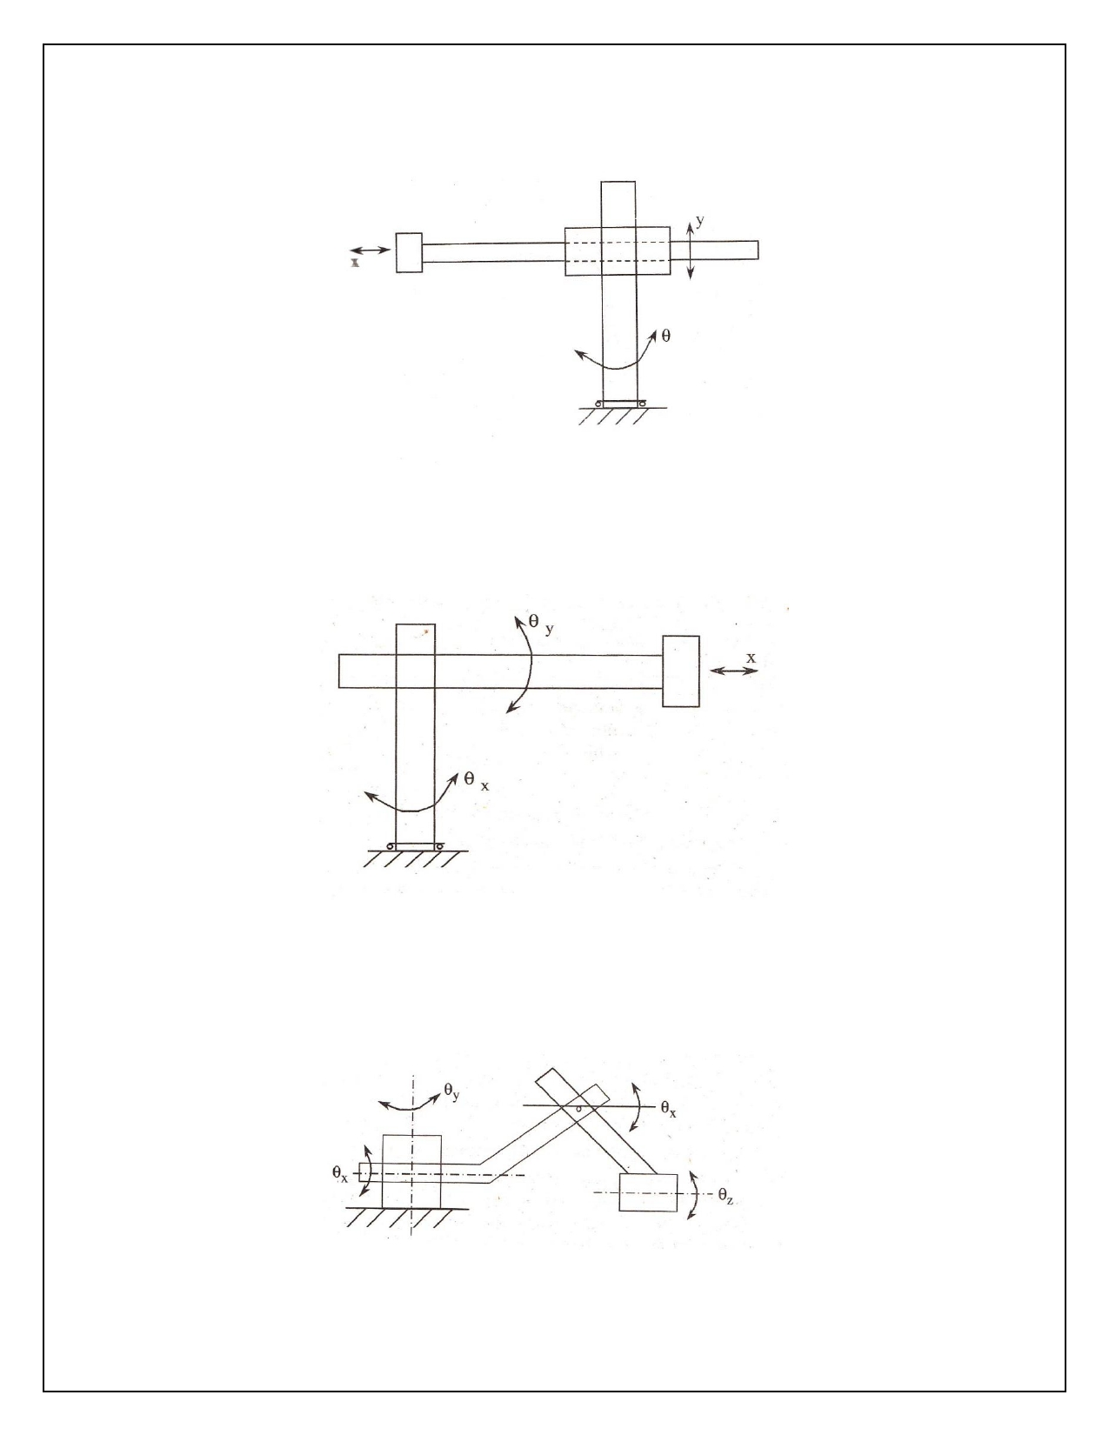

ii. Cylinder robot:

Cylinder robot makes use of two perpendicular prismatic joint and one revolute joint. The work
envelope of cylinder robot approximates to a cylinder. It consists of two linear and one rotary axes.

iii. Polar robot:

Polar robot consists of a rotating base, a telescopic link which can be raised or lowered about a
horizontal revolute joint. It has a work envelope of a partial spherical shell. It consists of one linear and two rotary axes.

iv. Joint arm robot:

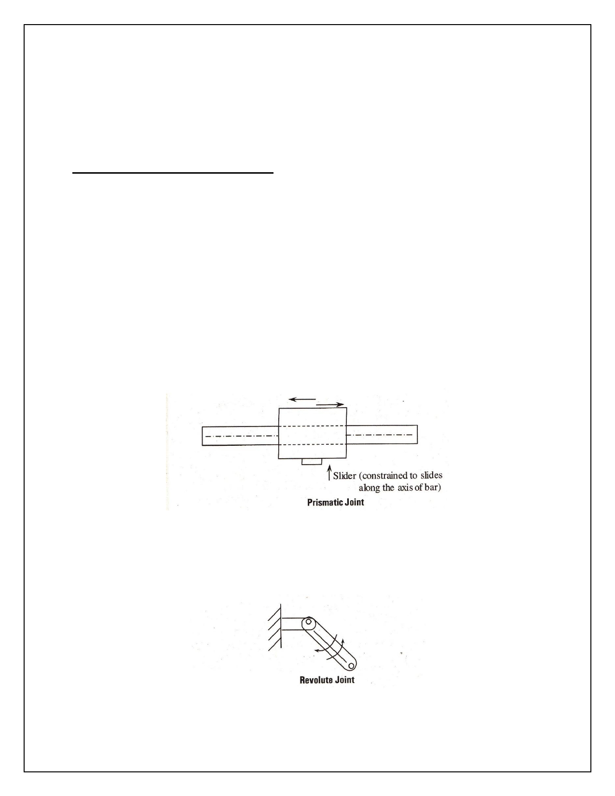

Joint arm robot also known as anthropomorphic robot. It functions similar to the human arm. It consists
of two straight links. Similar to the human forearm and upper arm. These two links are mounted on
rotary table and has a work envelope of spherical shape. It is the most dexterous one since all the joints are revolute joints. It consists of 3 rotary axes.

Different types of joints are used in robots:-

The different types of joint are used in robots are,

1. Prismatic Joint (Linear Motion)

2. Revolute Joint (Rotational Motion)

3. Screw Joint (Linear and Rotational Motion)

4. Spherical Joint

5. Planar Joint

6. Cylindrical Joint

7. Twisting Joint

1. Prismatic Joint (Linear Motion):

Prismatic joints are also called sliders, constituting purely linear motion along the joint axis. The joint
slides in one, of the two directions along a singular axis. This type of motion is common in hydraulic or pneumatic cylinders, there is no rotation. The degree of freedom is one (i.e., translation).

2. Revolute Joint (Rotational Motion):

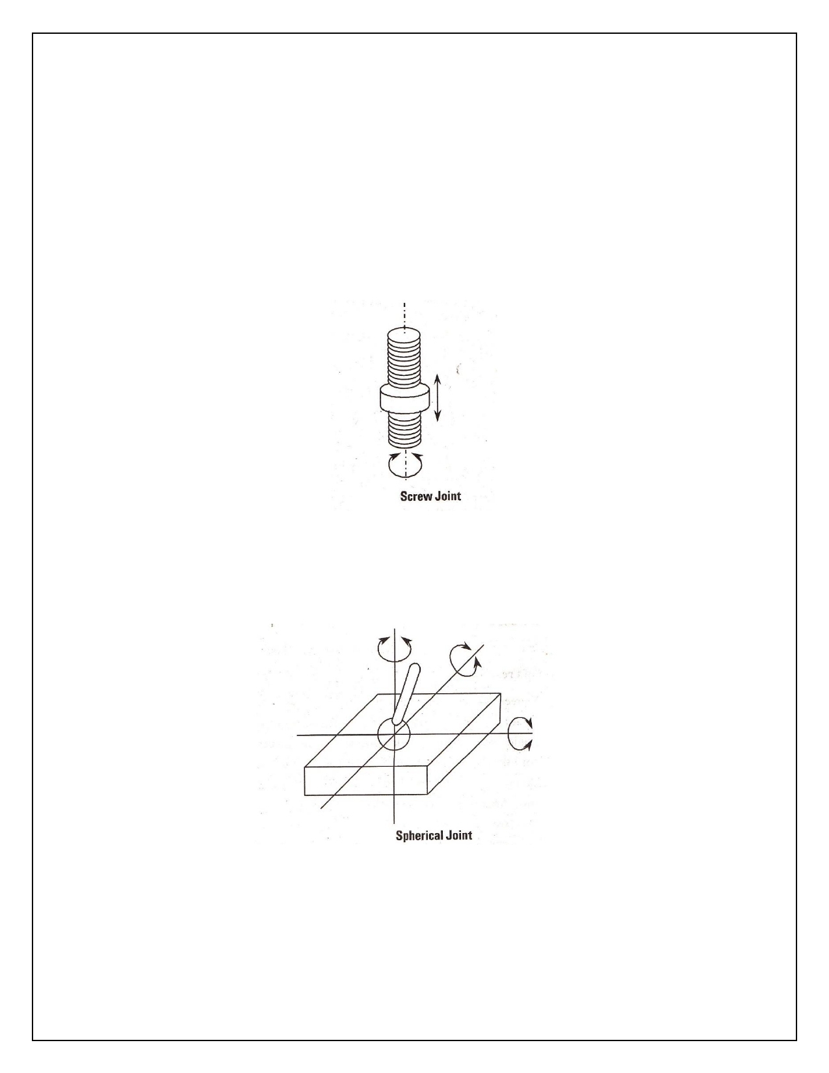

Revolute joints constitute purely rotation motion along the joint axis. Revolute joints are most
commonly found in industrial robots. The degree of freedom is one. There is no translation motion.

Examples:

i. Elbow joint, waist joint.

ii. Most revolute joints cannot rotate through a full 3600, but are mechanically constrained.

3. Screw Joint (Linear and Rotational Motion):

Screw joints are a combination of first two types of joints. They constitute a simultaneous rotation and
linear motion along a joint axis. Screw joints are more often used in tools for a robot end effector rather
than a joint of motion for a robot. This joint follows the thread of the axis in spiral to move along axis.

4. Spherical Joint:

Spherical joints are most utilized joints and just slide causing a revolving movement.

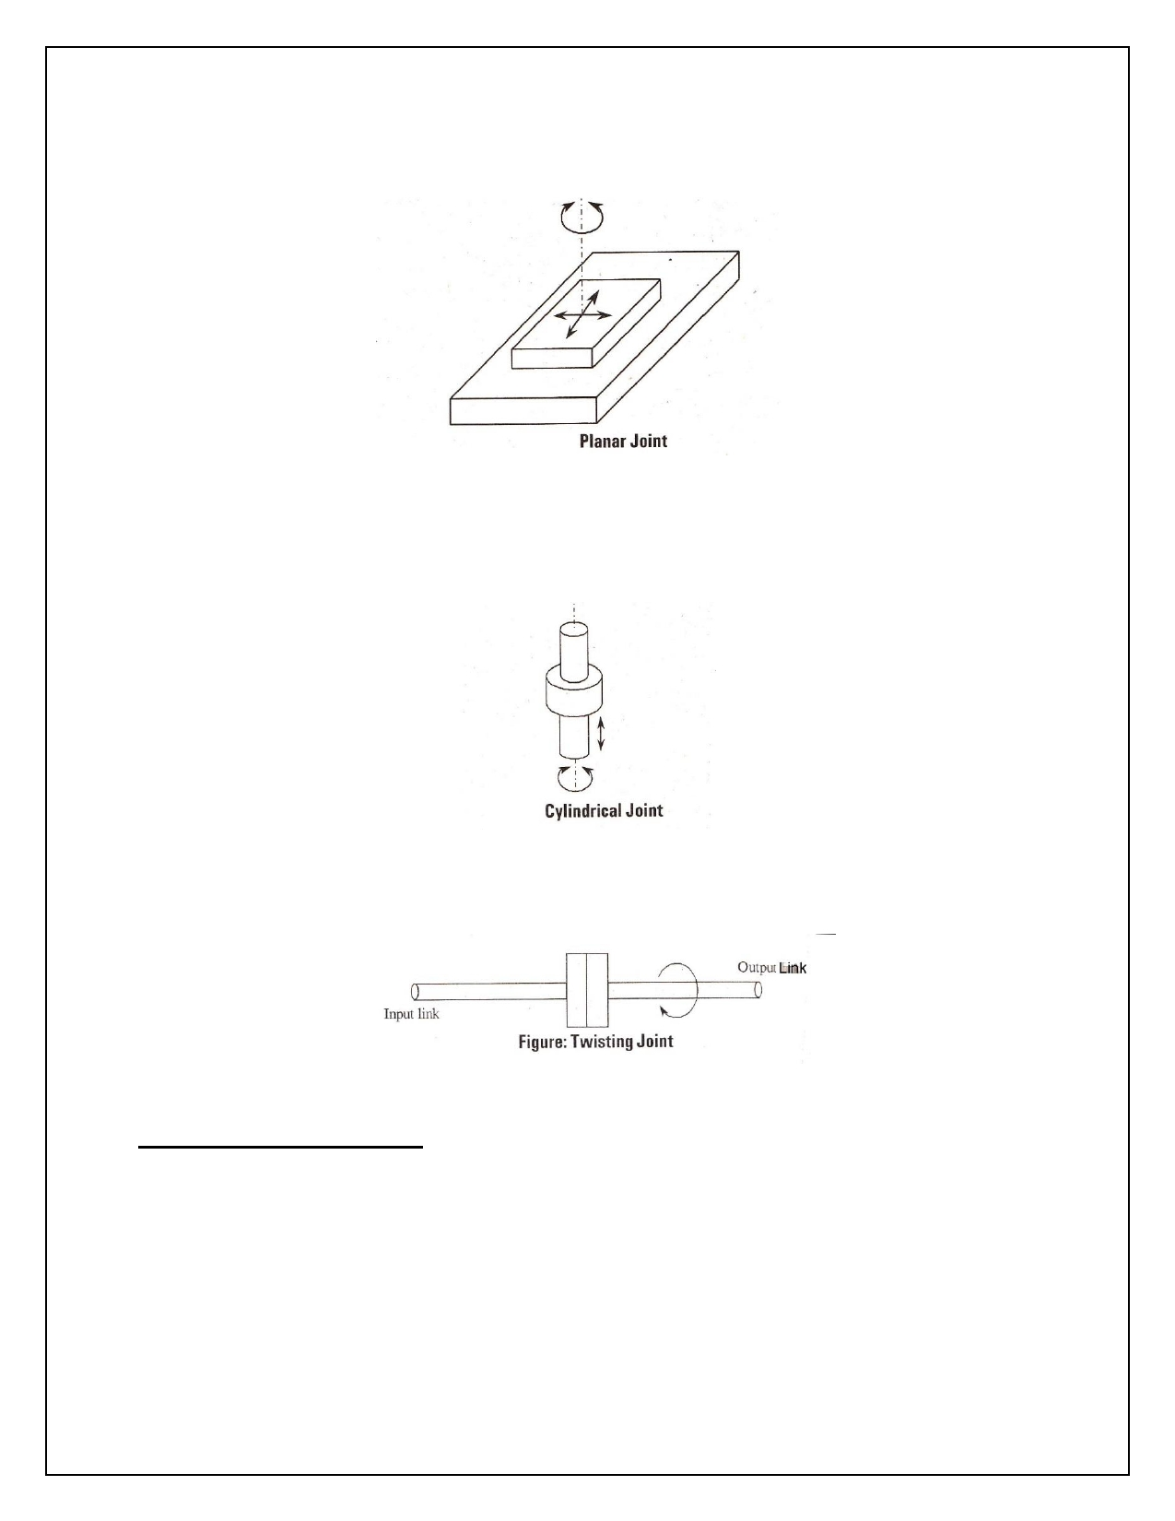

5. Planar Joint:

It consists of three degrees of freedom as the figure i.e., one rotary and two sliding motions.

6. Cylindrical Joint:

It consists of two degrees of freedom as shown in figure i.e., one rotary and one sliding motion.

7. Twisting Joint:

It consists of single degree of freedom as shown in the figure.

Number of degrees of freedom:-

Degrees of freedom:

The number of independent motions or movement that an object can performed in 3-D space, is known as 'DOF'.

A rigid body free to move in space has got 6- degrees of freedom. i.e., 3 translations and 3 revolutions. A manipulator with 6 degrees of freedom is known as a spatial manipulator.

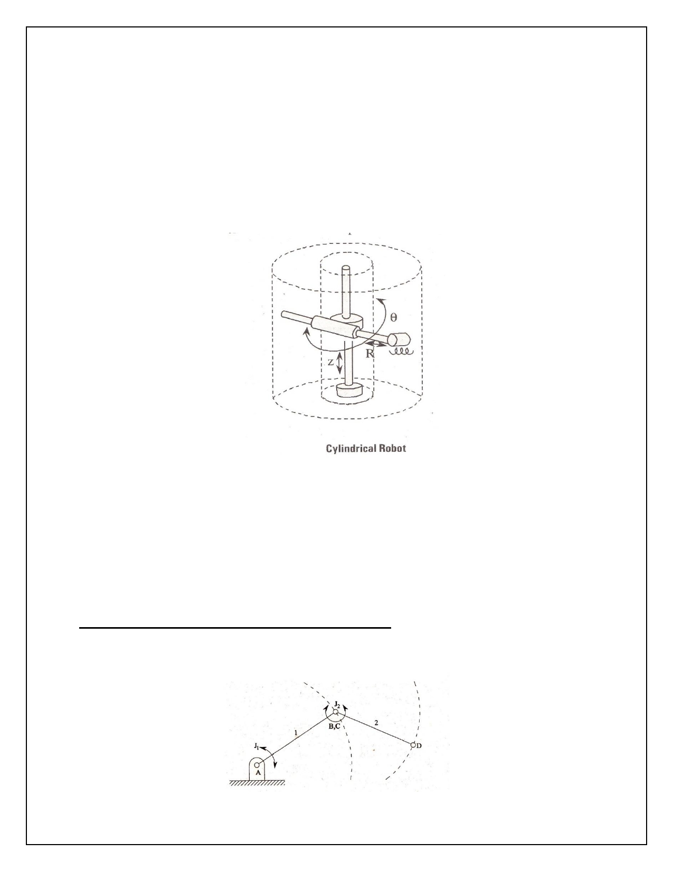

However, there are many manipulators that does not have full 6 degrees of freedom. Since not all tasks require 6 degrees of freedom.

Ex:

Cylindrical parts, can be picked up and placed codependent of gripper orientation with respect to the
cylinder axis. Spatial manipulators having more than 6 DOF with us joints are known as redundant manipulators. These degrees of freedom enhance the robots capability in whirl the subspaces
obstructed by objects by moving them. Depending on the application, the types and cement of the robot manipulator varies considerably.

As shown in the figure, cylindrical robots are made up of two prismatic joints and a revolute joint which allows three degrees of freedom i.e., two linear motions and one rotational motion. The work volume of
a cylindrical robot is a cylinder as shown in the figure by dotted lines. The following are, the three
relative motions of the joints,

1. Radial (R) in or out translation of the horizontal arm.

2. Angular motion (q) about the vertical axis.

3. Up or down motion of the carriage in the z- direction.

Representation of 6 DOF with respect to a co-ordinate frame:-

Consider an open kinematic chain of two links with revolute joints at A and B (or C), as shown in figure.



Here the first link is connected to be ground by joint 'A'. Therefore link 1 can only rotate about joint 'A', and it contributes only 1 DOF. Link 2 can rotate with respect to contribute of joint 'B' so, other degrees of freedom. So, the above figure has got '2' DOF.

➔ The DOF is equal to non of links in an open kinematic chain.
➔ Robot with 6 DOF is called as spatial manipulator (arm, body &wrist) ➔ Robot is more than 6 DOF is called as redundant manipulator.

End effectors:-

In robotics, the physical construction of robot consists of body, arm and wrist of the machine. The body is attached to base and arm assembly attached to body. At the end of the arm wrist is attached, which
consists number of components to allow variety position. Relative motion between body, arm and wrist are provided by joints. The joint motions are either or sliding. The body, arm and wrist assembly is also
called as manipulator. Attached to the robot wrist is a hand (End effector). The end effector is not considered as part of robot. The arm and the body joints keeps the end effector in It is also called gripper.

Types of End- Effectors:

End- Effectors are categorized-into two types,

1. Grippers

2. Tools

1. Grippers:

Grippers would be utilized to grasp an object, usually the work part and hold it during the robot work
cycle. The types of material used for grippers depends on orientation of part & friction between parts &
grippers. The applications include material handling, machine loading, unloading, palletizing and other similar operations.

The operations performed by grippers are

i. To move the fingers with commanded speeds.

ii. To gripper handled part with not more than specified force.

iii. To open, move & also the fingers at specified positions.

iv. To measure dimension of a part.

Grippers are further classified as,

a. Mechanical grippers

b. Magnetized grippers

c. Suctions or vacuum cups

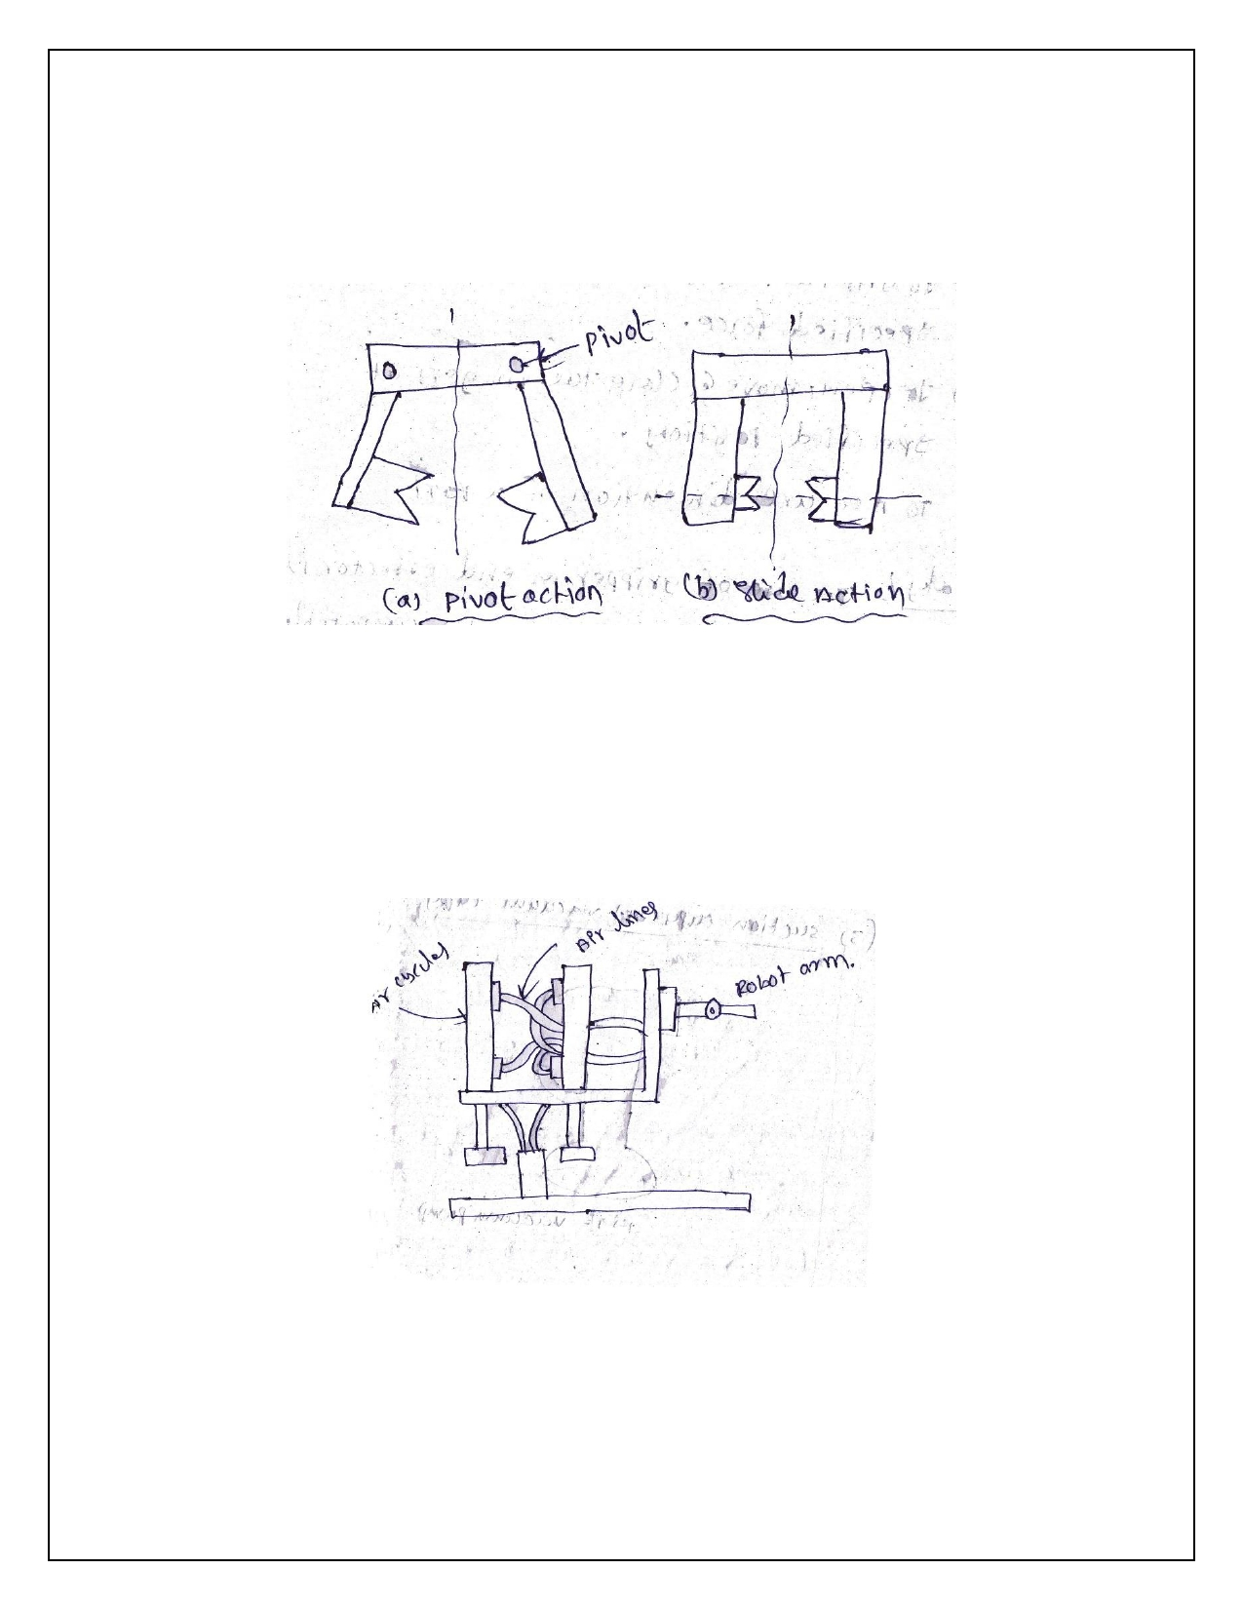

d. Hooks

e. Scopes or ladles.

a. Mechanical grippers:

Mechanical gripper in an end effector, that uses mechanical fingers actuated by a mechanism to grasp an object. The fingers are either attached to the mechanism.

➔ The function of the gripper mechanism is to translate some form of power input into the
grasping action.
➔ The power input is supplied from the robot and can be pneumatic, hydraulic, and electrical. ➔ The mechanism must be able to open and close the fingers.

b. Magnetized grippers:

Magnetic grippers are be divided into 2 types:

i. Electro magnetic
ii. Permanent magnetic.

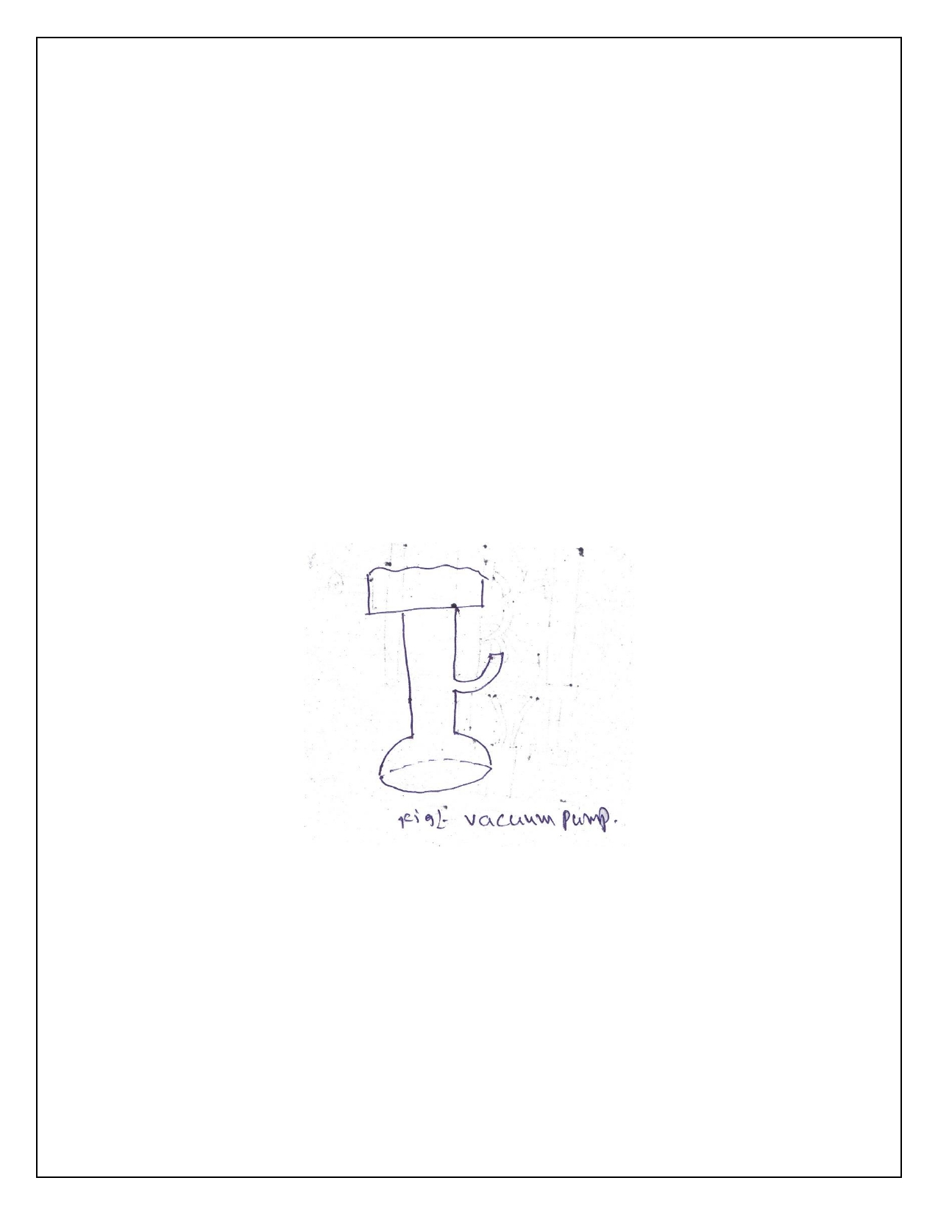

i. Electromagnetic

Electromagnetic grippers include a controller unit and a DC power for handling the materials. This type
of grippers is easy to control, and very effective in releasing the part at the end of the operation than
the permanent magnets. If the work part gripped is to be released, the polarity level is minimized by the controller unit before the electromagnet is turned off.

ii. Permanent magnetic

The permanent magnets do not require any sort of external power as like the electromagnets for handling the materials. After this gripper grasps a work part, an additional device called asstripper push - off pin will be required to separate the work part from the magnet. This device is incorporated at the sides of the gripper.

• This gripper only requires one surface to grasp the materials.
• The grasping of materials is done very quickly.
• It does not require separate designs for handling different size of materials.
• It is capable of grasping materials with holes, which is unfeasible in the vacuum grippers.

c. Suctions or vacuum cups:

It is used to left the flat glass of the work. This type of gripper are typical made of elastic material such
as rubber, soft plastic. The shape of the vacuum is shown in figure Commonly used round type. It means
of removing the air between the up and part surface to create the vacuum tin required the vacuum pump & venture in of to common devices and for those purpose.

The lift capacity of suction cup depend upon the effective area of the cup. The negative air pressure between cup & the object.

F=PA

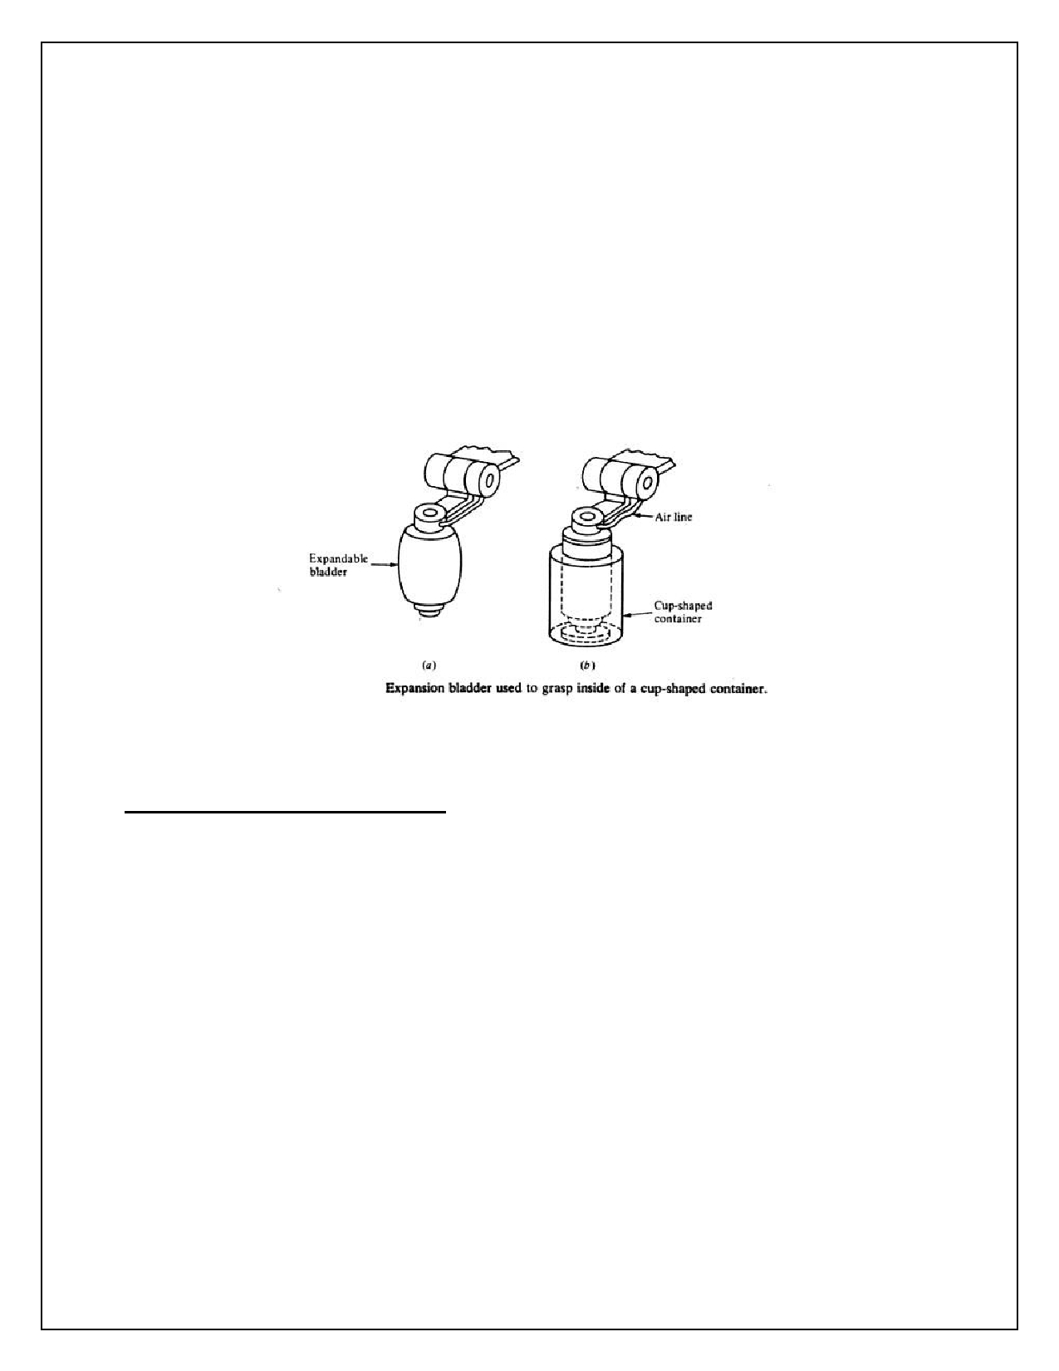

Where,

F=force, P=negative pressure, A= total effective area of the suction cup used to create the vacuum.

d. Hooks gripper:

Hooks can be used as end effectors to handle containers of parts to load and unload parts, hanging
from, power head conveyors. The items to be handled by a hook must have some soft handle to enable the hook to hold it.

e. Scopes or ladles:

Scopes or ladles can be used to handle certain materials in liquid or powder form, chemically in liquid or powder form, good materials etc. that can be handled by a robot using method of handling.

Types of Mechanical gripper actuations:-

There are various ways of classifying mechanical grippers and their actuating mechanisms. One method
is according to the type of finger movement used by the gripper. In this classification, the grippers can
actuate the opening and closing of the Rogers by one of the following motions:

1. Pivoting movement

2. Linear or translational movement

In the pivoting movement. The fingers rotate about fixed pivot points on the gripper to open and close.
The motion is usually accomplished by some kind of linkage mechanism. In the linear movement, the
Hagen open and close by moving in parallel to each other. This is accomplished by means of guide rails
so that each finger base slides along a guide rail during actuation. The translational finger movement
might also be accomplished by means of a linkage which would maintain the Rogers in a parallel orientation to each other during actuation.

Mechanical grippers can also be classed according to the type of kinematic device used to actuate the
Roger movement. In this classification we have the following types:

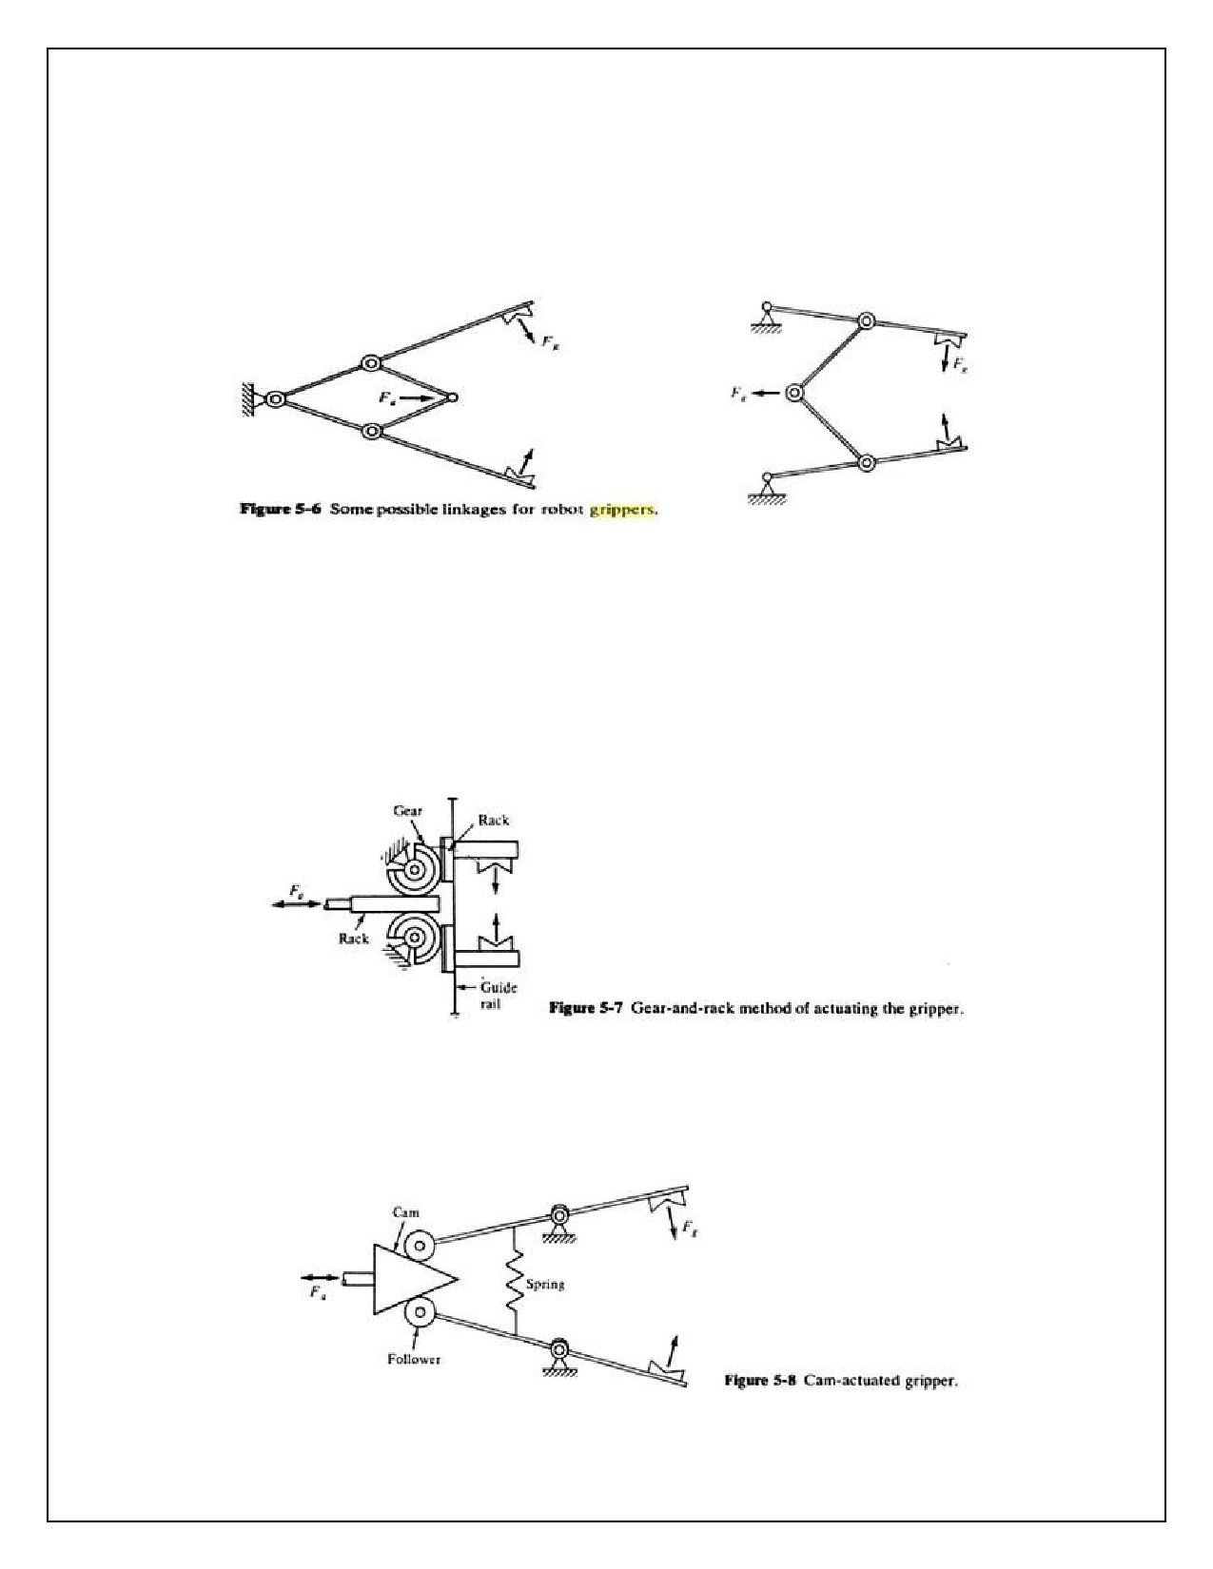

i. Linkage actuation, ii. Gear & rack actuation, iii. Cam actuation, iv. Screw actuation, v. Rope & pulley actuation.

i. Linkage actuation:

The linkage category covers a wide range of design possibilities to actuate the opening and closing of the
gripper. The design of the linkage determines how the input force ′𝐹𝑎′ to the gripper is converted into
the gripping force' 𝐹𝑔′ applied by the fingers. The 'linkage configuration also determines other
operational features such as how wide the gripper fingers will open and how quickly the gripper will
actuate.

ii. Gear & rack actuation:

These are some other mechanism that would provide a linear motion, movement of the rack would drive to partial pinion gears and these would in turn open and close the finger.

iii. Cam actuation:

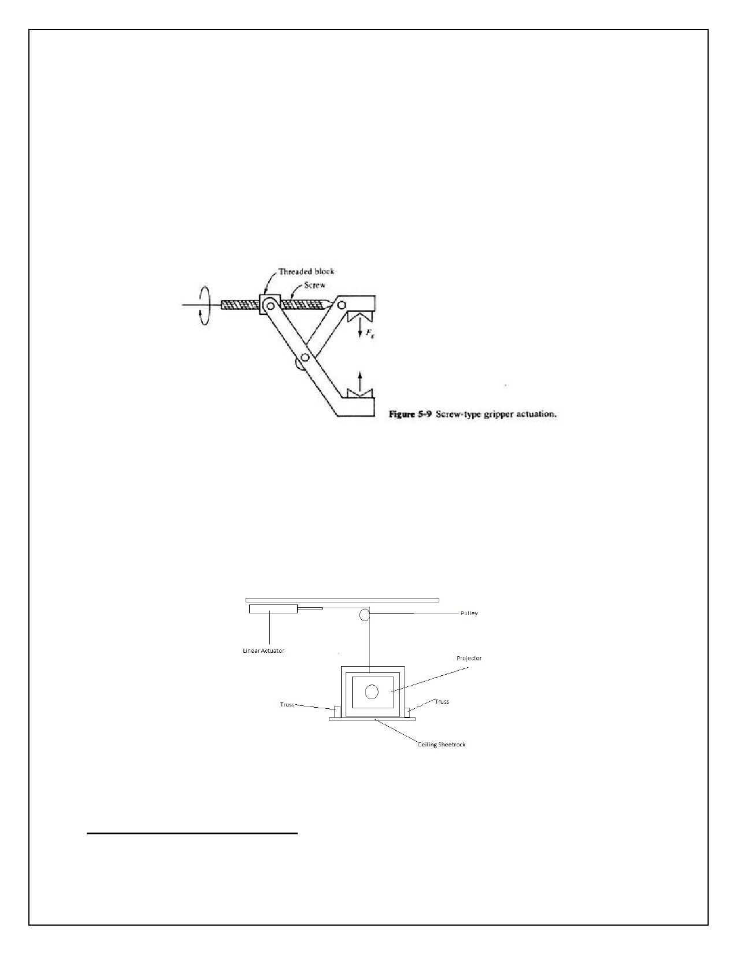

The cam actuated gripper Includes a vanity possible designs, one of which is shown in Fig. A cam-and -
follower arrangement, often using & spring-loaded follower, can provide the opening and closing action of the gripper. For example, movement of the cam in one direction would force the gripper to open. while movement of the cam in the opposite direction would cause the spring to force the gripper to
close. The advantage of this arrangement is that the spring action would accommodate different sized parts. This might be desirable, for example, in a machining operation where a single gripper is used to
handle the raw work part and the finished part. The finished part might be significantly smaller after machining.

iv. Screw actuation:

The screw is turned by a motor. Usually accompanied by a speed reduction mechanism. When the screw
is rotated in one direction, this causes a threaded block to be translated in one direction. When the screw is rotated in the opposite direction. The threaded block moves in the opposite direction. The threaded block is, in turn, connected to the gripper Buyers to cause the corresponding opening and closing action.

v. Rope & pulley actuation:

Rope & pulley actuating can be design to open & closing a mechanical gripper.

Construction the path in the grippers:-

There are two ways of construction the path in the gripper.

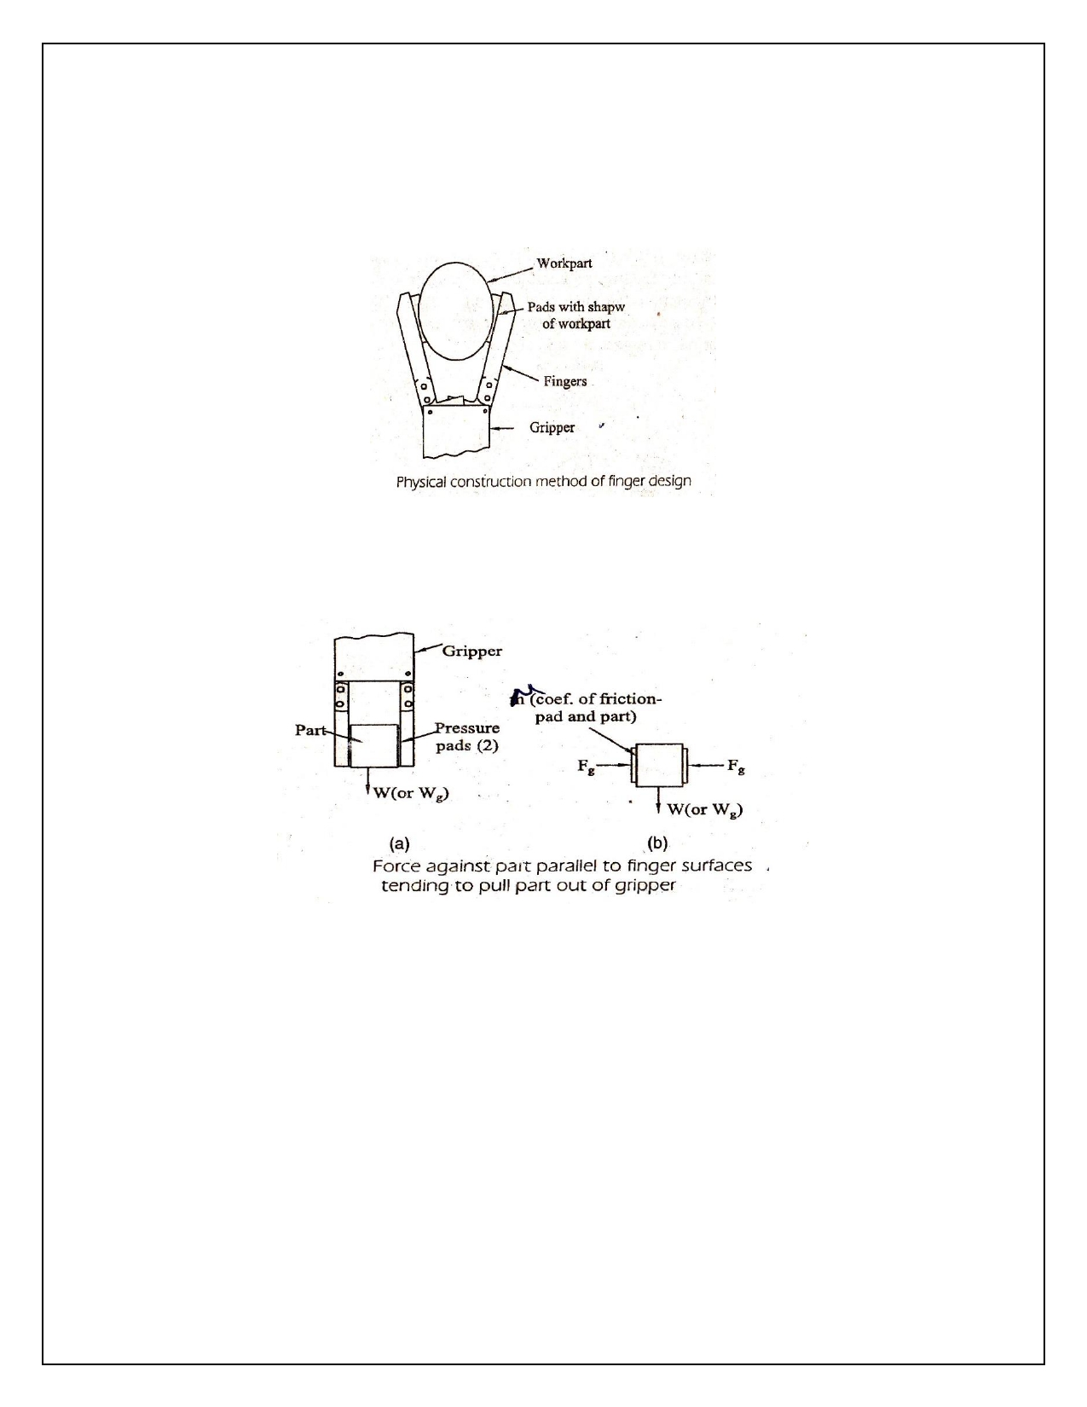

(i) Physical construction of the path with in the finger.

(ii) Holding the path by friction between the finger and the work path.

(i) Physical type:

In this approach, the gripper fingers enclose the part to some extent, thereby constraining the surface of the fingers to be in the approximate shape of the part geometry.

(ii) Holding Method:

In this approach, the fingers must apply a force that is sufficient for friction, to retain the part against gravity, acceleration and any other force that might arise during the holding portion of the work cycle.

The fingers or the pads attached to the fingers which make contact with the part. This tends to increase the coefficient of friction between the part and the contacting finger surface.

If a force of sufficient magnitude is applied against the part in a direction parallel to the friction surfaces of the fingers as shown above fig. the part might ship out of the gripper.

The following force equal can be used to determine the required magnitude of the gripper force as a function of these factors.

𝜇. 𝑛𝑓 . 𝐹𝑔=𝑊
where

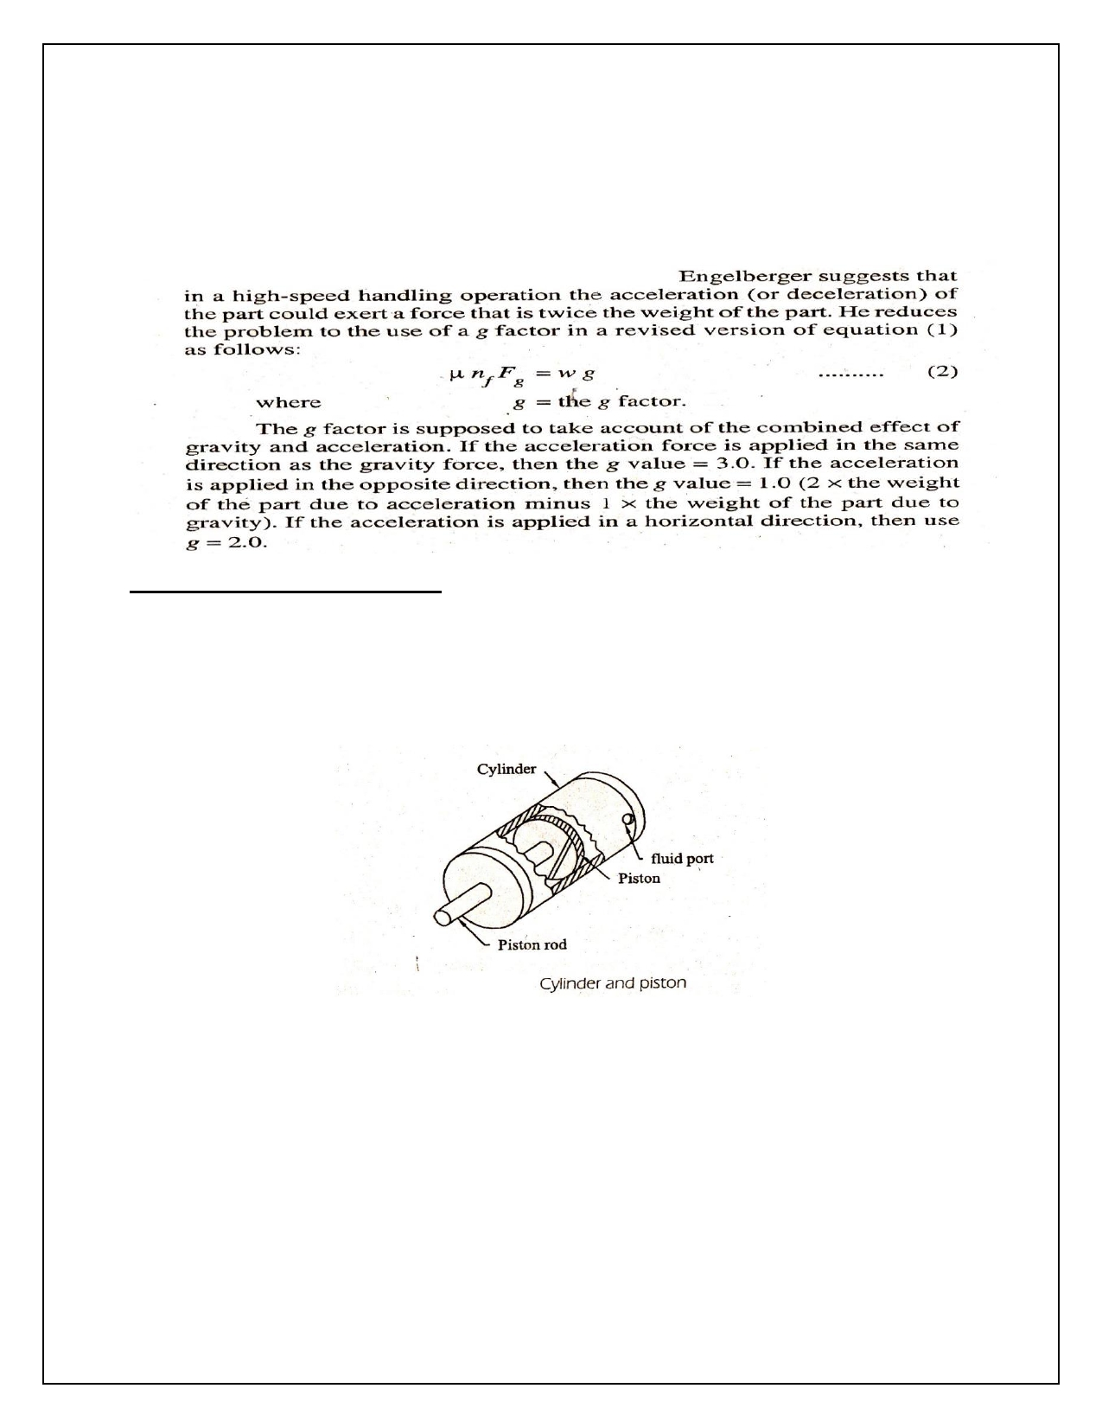

𝜇 =coefficient of friction of the finger contact surface against the part surface

𝑛𝑓 =number of contacting fingers;

𝐹𝑔= gripper force, W = wt. of the part or object being gripped.

Locomotive devices or drive systems:-

Actuators are the devices which provide the actual motive force for the robot joints. They commonly get
their power from one of three sources compressed air, pressurized fluid, or electricity. They are called, respectively, pneumatic, hydraulic, or electric actuators.

(i) Pneumatic Actuators:

Pneumatic and hydraulic actuators are both powered by moving fluids. In the first case the fluid is
compressed air and in the second case the fluid is usually pressurized oil. The operation of these
actuators is generally similar except in their ability to contain the pressure of the fluid. Pneumatic
systems typically operate at about 100 lb/𝑖𝑛2 and hydraulic systems at 1000 to 3000 lb/𝑖𝑛2.

The simplest flied power device is the cylinder as illustrating in fig, which could be used to actuate a
linear joint by means of a moving piston. This example is called a single-ended cylinder as the piston rod only comes out of the cylinder at one end. Other types of cylinders include double-ended cylinders and rod less cylinders.

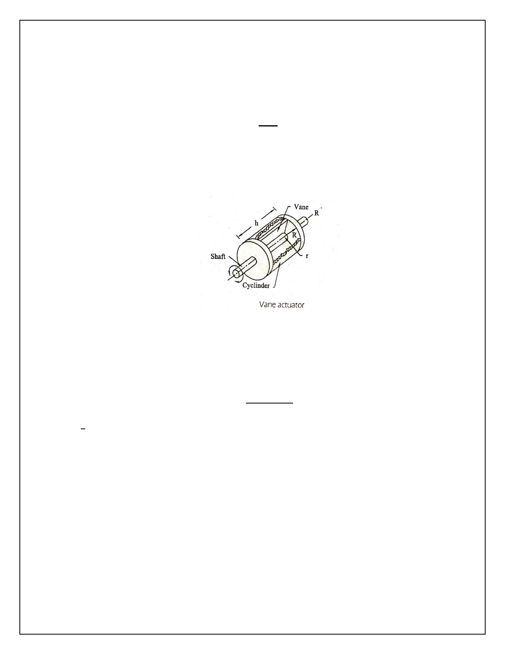

There are two relationships of particular interest when discussing actuators: the velocity of actuator
with respect to the input power and the force of the actuator with respect to the input power and the
force of the actuator with respect to the input power. For the cylinder type actuator these relationships
are given by
𝑓 (𝑡)

Where,
𝑉(𝑡) =
𝐴

V(t) is the velocity of the piston, f (t) is the fluid How rate`(volumetric), F (t) is the force, P(t) is the pressure of the fluid, and A is the area of the piston.

Since the requirements of a robot are to carry a payload at a given speed we can use the relations described for choosing the appropriate actuator.

Another type of fluid power actuator is the rotary Vane actuator, shown in Fig. In a rotary actuator we
are interested in the angular velocity, 𝜔, and the torque, T. The relations describing the output of a
rotary actuator are
2(𝑡)
𝜔 (𝑡) = (𝑅2−𝑟2 )ℎ

T(t) = 1 P(t) h (R-r) (R+r)
2
Where,

R is the outer radius of the vane, r is the inner radius of the vane, h is the thickness of the vane, 𝜔 is the angular velocity in radians per/sec, and T is the torque.

(ii) Electric actuators:

As their capabilities improve, electric motors are becoming more and more the actuator of choice in the design of robots. They provide excellent controllability with a minimum of maintenance required. Here are a variety of types of moors in use in robots; the most common are dc servomotors, stepper motors, and ac servomotors.

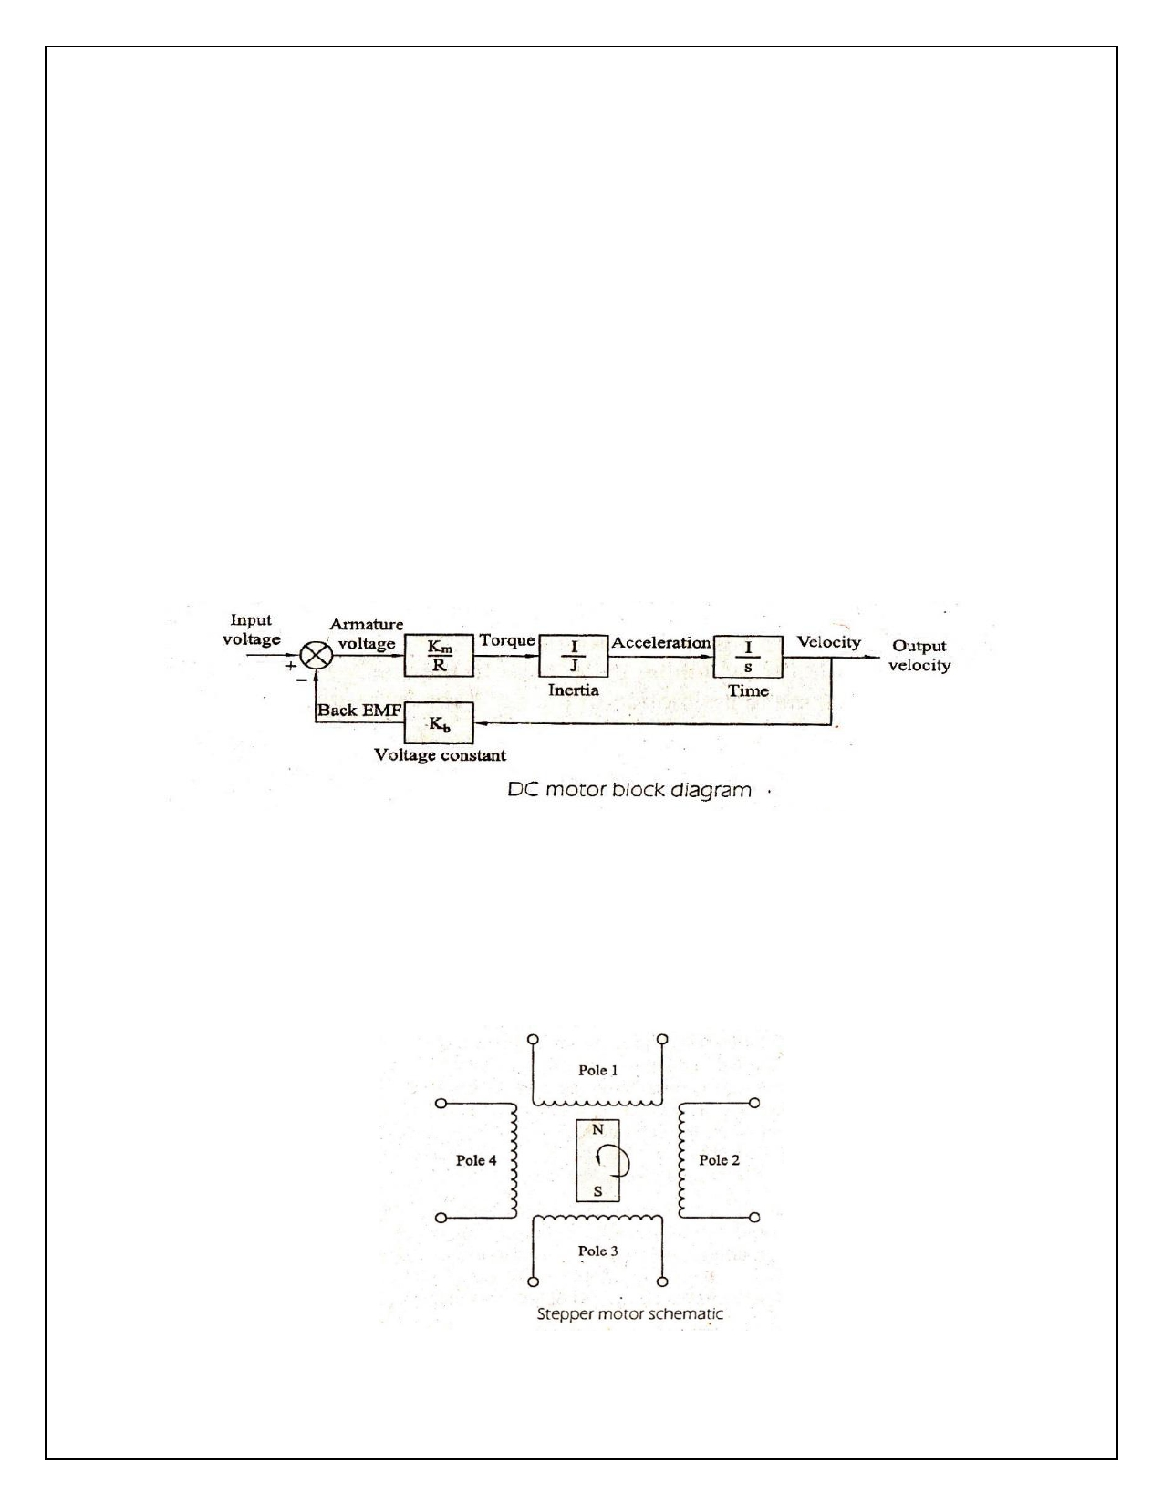

(a) Dc servomotor:

Main components in dc servomotor are the rotor and the stator. Usually, the rotor include the armature and the commutator assembly and the stator includes the permanent magnet and brush assemblies.

When current flows through the windings of the armature it sets up a magnetic field, opposing the field
set up by the magnets. This produces a torque on the rotor. As the rotor rotates, the brush and
commutator assemblies switch the current to the armature. So, that the field remains opposed to the
one set up by the magnets. In this way the torque, produced by the rotor is constant through the
rotation. Since the field strength of the rotor is a function of the current through it, it can be shown that for Dc servomotor.

𝑇𝑚(𝑡) = 𝐾𝑚𝐼𝑎 (𝑡) ……………………..(i)
Where,

𝑇𝑚 = torque of the motor.

𝐾𝑚 = motor torque constant, 𝐼𝑎 = current flowing through armature.

(b) Stepper motors:

Stepper motors (also called stepping motors) are a unique type of actuator and have been used mostly
in computer peripherals. A stepper motor provides output in the form of discrete angular motion
increments. In robotics, stepper motors are used for relatively light duty applications. Also stepper
motors are typically used in open-loop systems rather than the closed - loop systems one which we have been concentrating.

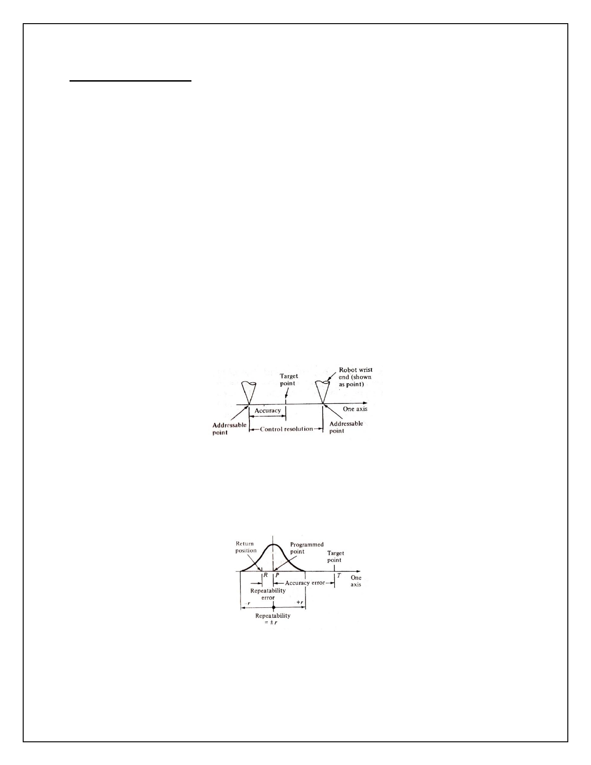

PRECISION OF MOVEMENT:

The preceding discussion of response speed and stability is concerned with the dynamic performance of
the robot. Another measure of performance is precision of the robot's movement. We will define
precision as a function of three features:

1. Spatial resolution

2. Accuracy

3. Repeatability

These terms will be defined with the following assumptions,

1. Spatial resolution:

The spatial resolution of a robot is the smallest increment of movement into robot can divide its work volume. Spatial resolution depends on two the system's control resolution and the robot's mechanical inaccuracies. It is easiest to conceptualize these factors in terms of a robot with 1 degree of freedom.

Number of increments = 2𝑛

n = the number of bits in the control memory.

2. Accuracy:

Accuracy refers to a robot's ability to position its wrist end at a desired target point within the work volume. The accuracy of a robot can be defined in terms of spatial resolution because the ability to
achieve a given target point depends on how closely the robot can define the control increments for each of its joint motions.

3. Repeatability:

Repeatability is concerned with the robot's ability to position its wrist or an end effectors attached to its
wrist at a point in space that had previously been taught to the robot. Repeatability and accuracy refer
to two different aspects of the robot precision. Accuracy relates to the robot's capacity to be programmed to achieve a given target point.

