UNIT-V
HYDRO-ELECTRIC POWER PLANT

Introduction
In hydroelectric power plants the potential energy of water due to its high location is converted into electrical energy. The total power generation capacity of the hydroelectric power plants depends on the head of water and volume of water flowing towards the water turbine.
It is the most widely used form of renewable energy. Once a hydroelectric complex is constructed, the project produces no direct waste, and has a considerably lower output level of the greenhouse gas carbon dioxide (CO₂) than fossil fuel powered energy plants.
Working Principle of Hydroelectric Power Plant
Hydroelectric power plant (Hydel plant) utilizes the potential energy of water stored in a dam built across the river. The potential energy of the stored water is converted into kinetic energy by first passing it through the penstock pipe.

The kinetic energy of water is then converted into mechanical energy in a water turbine. The turbine is coupled to the electric generator. The mechanical energy available at the shaft of the turbine is converted into electrical energy by means of the generator.

Because gravity provides the force which makes the water fall, the energy stored in the water is called gravitational potential energy.

To obtain the high head of water the reservoir of water should as high as possible and power generation unit should be as low as possible. The maximum height of reservoir of water is fixed by natural factors like the height of river bed, the amount of water and other environmental factors. The location of the power generation unit can be adjusted as per the total amount of power that is to be generated. Usually the power generation unit is constructed at levels lower than ground level so as to get the maximum head of water.
The total flow rate of water can be adjusted through the penstock as per the requirements. If more power is to be generated more water can be allowed to flow through it.
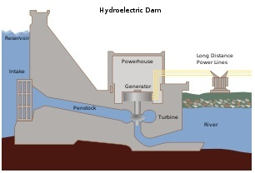
Cross section of a conventional hydroelectric dam.

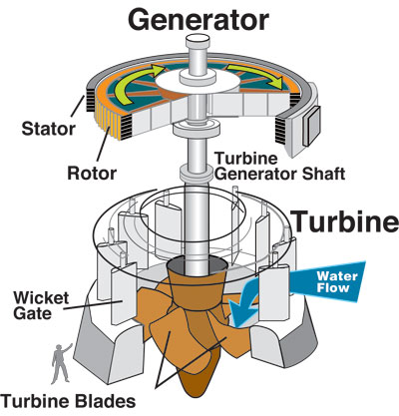
Layout of Hydro electric power plant

Components of Hydro-Electric Power Plant

The main components are

• Water reservoir

• Dam

• Spillway

• Gate

• Pressure tunnel

• Surge tank

• Penstock

• Water turbine

• Draft tube

• Tail race level

• Power house
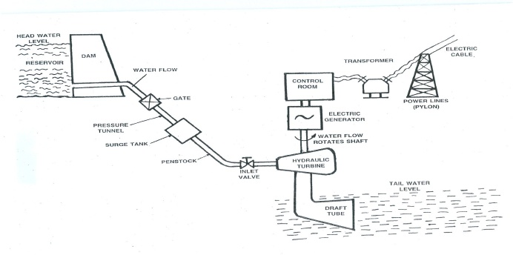
Water reservoir:
In a reservoir the water collected from the catchmentarea during rainy season is stored behind a dam. Catchment area gets itswater from rains and streams. Continuous availability of water is a basic
necessity for a hydroelectric power plant. The level of water surface in thereservoir is called Head water level. The water head available for powergeneration depends on the reservoir height.

Dam:
the purpose of the dam is to store the water and to regulate the outgoing flow of water. The dam helps to store all the incoming water. It alsohelps to increase the head of the water. In order to generate a requiredquantity of power, it is necessary that a sufficient head is available.

Spillway:
Excess accumulation of water endangers the stability of damconstruction. Also in order to avoid the overflow of water out of the damespecially during rainy seasons spillways are provided. This prevents the riseof water level in the dam. Spillways are passages which allow the excesswater to flow to a different storage area away from the dam.

Gate:
A gate is used to regulate or control the flow of water from the dam.

Pressure tunnel:
It is a passage that carries water from the reservoir to thesurge tank.

Surge tank: A surge tank is a small reservoir or tank in which the water level rises or falls due to sudden changes in pressure. There may sudden increase of pressure in the penstock pipe due to sudden backflow of water,as load on the turbine is reduced. This sudden rise of pressure in the penstock pipe is known as water hammer.

A surge tank is introduced between the dam and the turbine and serves
the following purposes:
1.To reduce the distance between the free water surface in the dam andthe turbine, thereby reducing the water hammer effect. Otherwise,penstock will be damages by the water effect.
2.To serve as a supply tank to the turbine when the water in the pipe is accelerated during increased load conditions and as a storage tankwhen the water is decelerating during reduced load conditions.

Penstock:
Penstock pipe is used to bring water from the dam to the hydraulic turbine. Penstock pipes are made up of steel or reinforced concrete. The turbine is installed at a lower level from the dam. Penstock is provided with a gate valve at the inlet to completely close the water supply.It has a control valve to control the water flow rate into the turbine.

Water turbine or hydraulic turbine (Prime mover):
The hydraulicturbine converts the energy of water into mechanical energy. Themechanical energy (rotation) available on the turbine shaft is coupled to theshaft of an electric generator and electricity is produced. The water afterperforming the work on turbine blade is discharged through the draft tube. The prime movers which are in common use are Pelton wheel, Kaplanturbine, Francis turbine.

Draft tube:
Draft tube is connected to the outlet of the turbine. It convertsthe kinetic energy available in the water into pressure energy in thediverging portion. Thus, it maintains a pressure of just above the above theatmospheric at the end of the draft tube to move the water into a tail race.Water from the tail race is released for irrigation purposes.

Tail race level:
Tail race is a water path to lead the water discharged fromthe turbine to the river or canal. The water held in the tail race is called Tailrace water level.

Power House:
The power house accommodates the water turbine,generator, transformer and control room. As the water rushes through theturbine, it spins the turbine shaft, which is coupled to the electric generator. The generator has a rotating electromagnet called a rotor and a stationarypart called a stator. The rotor creates a magnetic field that produces anelectric charge in the stator. The charge is transmitted as electricity. Thestep up transformer increases the voltage of the current coming from thestator. The electricity is distributed through power lines

Classification of Hydro electric power plant
Hydro electric power plants are usually classified according to the available of head of water
• High head power plants
• Medium head power plants
• Low head power plants

High head power plants:
When the operating head of water exceeds 70meters, the plant is known as High head power plant. Pelton wheel turbine isthe prime mover used.

Medium head power plants:
When the water ranges from 15 to 70meters, then the power plant is known as Medium head power plant. It usesFrancis Turbine.

Low head power plants:
When the head is less than 15 meters, the plantis named as Low head power plant. It uses Francis or Kaplan turbine as primemover.

Advantages of hydro electric power plant
1.Water source is perennially available. No fuel is required to be burnt togenerate electricity. It is aptly termed as 'the white coal'. Water passesthrough turbines to produce work and downstream its utility remainsundiminished for irrigation of farms and quenching the thirst of peoplein the vicinity.
2.The running costs of hydropower installations are very low ascompared to thermal or nuclear power stations. 1n thermal stations,besides the cost of fuel, one has to take into account thetransportation cost of the fuel also.
3.There is no problem with regards to the disposal of ash as in a thermalstation. The problem of emission of polluting gases and particulates tothe atmosphere also does not exist. Hydropower does not produce anygreenhouse effect, cause the pernicious acid rain and emit obnoxiousNO
.4.The hydraulic turbine can be switched on and off in a very short time.In a thermal or nuclear power plant the steam turbine is put on turninggear for about two days during start-up and shut-down. .
5.The hydraulic power plant is relatively simple in concept and self-contained in operation. Its system reliability is much greater than that of other power plants.6.Modern hydropower equipment has a greater life expectancy and can easily last 50 years or more. This can be compared with the effective life of about 30 years of a thermal or nuclear station.
7.Due to its great ease of taking up and throwing off the load, the hydro-power can be used as the ideal spinning reserve in a system mix of thermal, hydro and nuclear power stations.
8.Modern hydro-generators give high efficiency over a considerablerange of load. This helps in improving the system efficiency.
9.Hydro-plants provide ancillary benefits like irrigation, flood control,afforestation, navigation and aqua-culture.
10.Being simple in design and operation, the hydro-plants do notrequire highly skilled workers. Manpower requirement is also low.
Disadvantages of Water Power
1.Hydro-power projects are capital-intensive with a low rate of return. The annual interest of this capital cost is a large part of the annual costof hydropower installations.
2.The gestation period of hydro projects is quite large. The gap betweenthe foundation and completion of a project may extend from ten tofifteen years.
3.Power generation is dependent on the quantity of water available,which may vary from season to season and year to year. If the rainfallis in time and adequate, then only the satisfactory operation of theplant can be expected.
4.Such plants are often far way from the load centre and require longtransmission lines to deliver power. Thus the cost of transmission linesand losses in them are more.
5.Large hydro-plants disturb the ecology of the area, by way of deforestation, destroying vegetation and uprooting people. Strongpublic opinion against. Erection of such plants is a deterrent factor. The emphasis is now more on small, mini and micro hydel stations.
Hydro electric power plant in India
Srisailam Hydel power plant – AP – 770 MW
Upper sileru Hydor electric project – AP – 120
Kodayar hydro electric power plant – TN – 100 MW
Iddiki hydel project – Kerala – 800 MW

Pumped-storage
This method produces electricity to supply high peak demands by moving water between reservoirs at different elevations. At times of low electrical demand, excess generation capacity is used to pump water into the higher reservoir. When there is higher demand, water is released back into the lower reservoir through a turbine. Pumped-storage schemes currently provide the most commercially important means of large-scale grid energy storage and improve the daily capacity factor of the generation system.
Run-of-the-river
Run-of-the-river hydroelectric stations are those with comparably smaller reservoir capacities, thus making it impossible to store water.
