UNIT-2

Measurement of Displacement and Temperature
- Measurement of temperature:-

Temperature is probably, most widely measured and frequently controlled variable encountered in industrial processing of all kinds measurement of temperature is involved in thermo dynamics, heat transfer and many chemical operations. Basically all the properties of matter such as size, colour, electrical and magnetic characteristics and the physical states (solid, liquid, gas) change with changing temperature.

Definition:

Temperature may be defined as the degree of hotness and coldness of a body are an environmental measured on a definite scale.

The temperature of a substance is a measure of the hotness, or coldness, of that substance. It is the thermal site of a body or a substance which determines whether it will give heat to, or receive heat from, other bodies. If two bodies are placed in contact then heat tends to flow from a body at a higher temperature to a body at a lower temperature, just as water flows from higher to lower levels.

The terms, heat and temperature, are closely related Temperature may be defined as "degree of heat" but heat is usually taken to mean "quantity of heat” Temperature and heat flow are related quantitatively by the second law of thermodynamics, which states that heat flows. Of its own accord, from a body at a higher temperature to a body at a lower temperature. It is therefore important to remember that in temperature measurement, two bodies in intimate contact are at the same temperature only if there is no heat flow between them.

1 Q ) Explain principle of Bimetallic thermometer:- (or) solid expansion

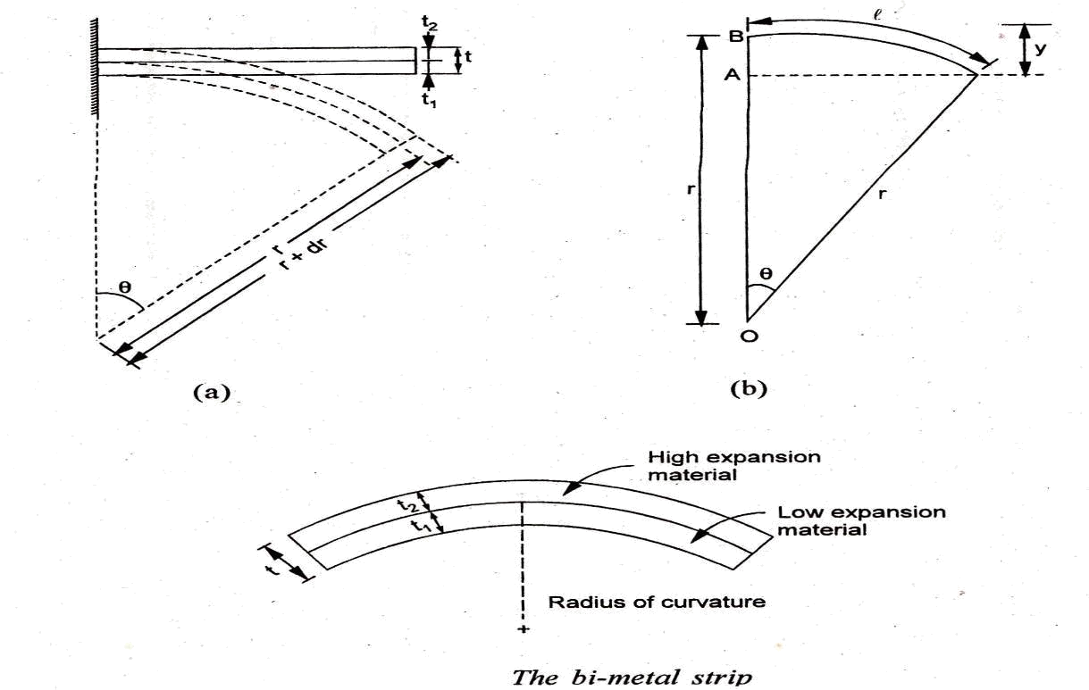

Construction:-

A bimetallic strip consists of two pieces of different materials firmly bonded together by bending. For a bi-metal in the form of a straight cantilever beam temp changes cause the free end to deflect because of the different expansion rates of the components. This deflection can be correlated quantitatively to the temp change.

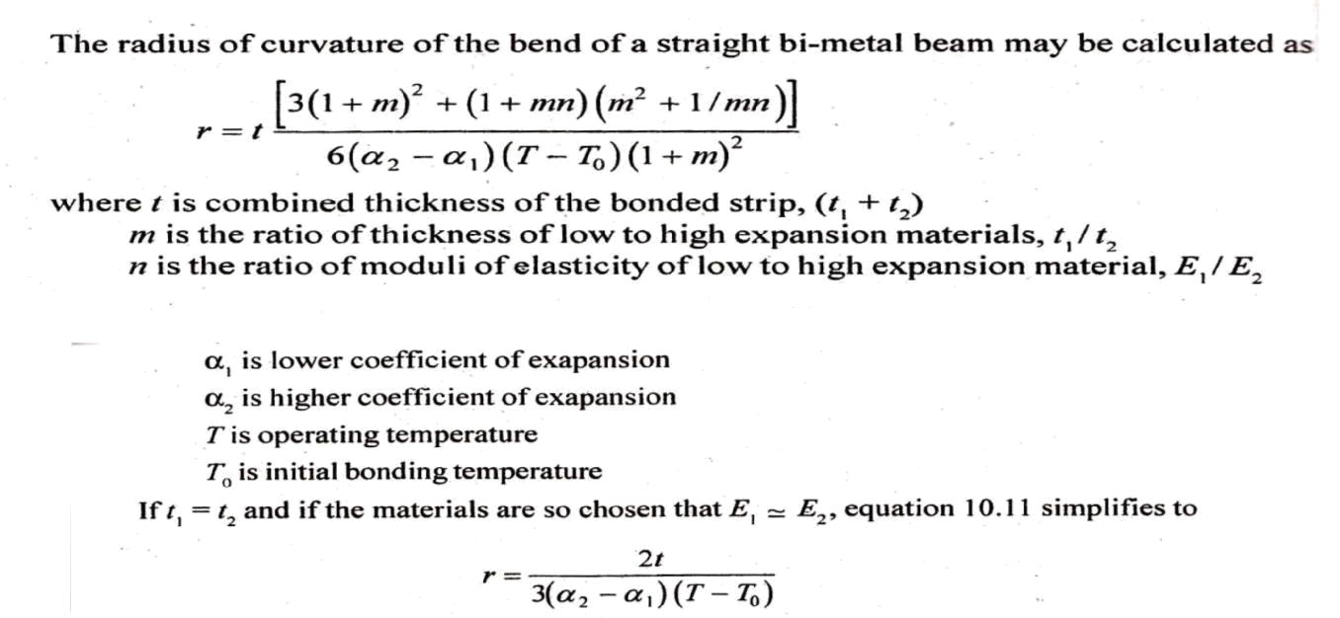

Normally the two expansion material is invar and the high expansion material is brass. The respective coefficient of expansion for invar and brass.

When bimetallic strip in the form of cantilever is assumed to bend to a circular are than
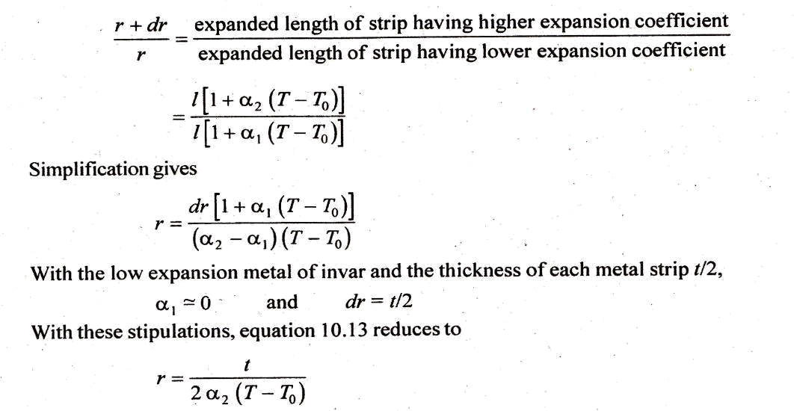

Bimetallic elements can be arranged in the flat spiral the single helix and the multiple helix configuration.

Characteristics:-

- Low cost.

- Simple and compact

Applications:-

- Control of gas flow

- electric iron boxes

- Domestic ovaus.

2Q) Write about Resistance Thermometers and Thermistors and Thermo couples
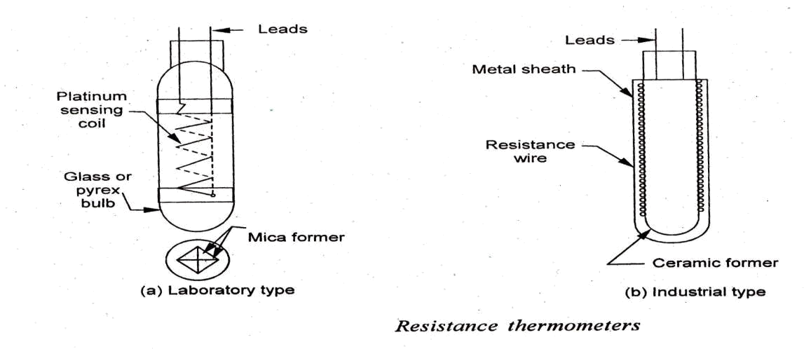

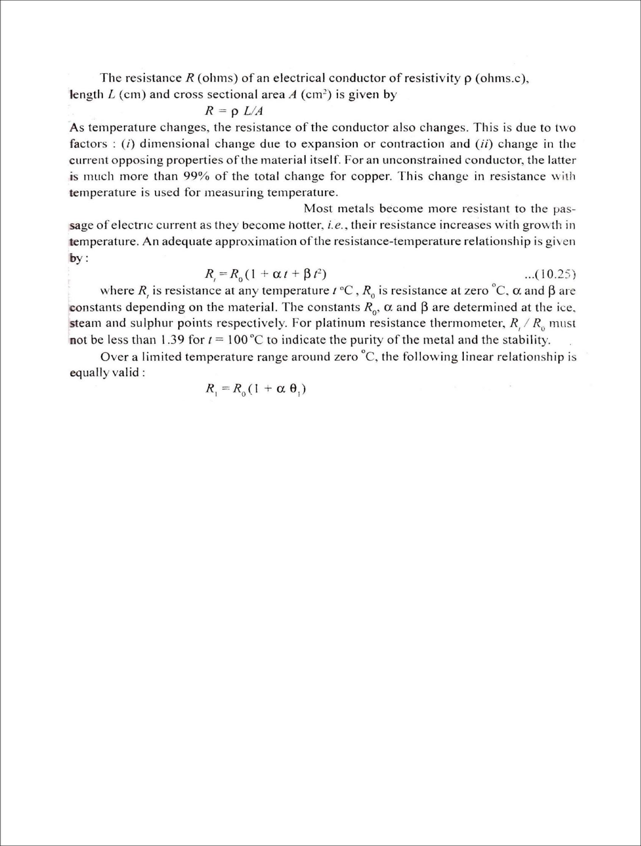

The thermometer comprises a resistance element or bulb, suitable electrical leads and an indicating - recording or resistance measuring instrument. The resistance element is, usually in the form of a coil of very fine platinum, nickel or copper wound non -conductively. Onto an insulating ceramic former which is protected externally by a metal sheath. A laboratory type of resistance thermometer is often wound on a crossed mica former and enclosed in a pyrex tube. The tube may be evacuated or filled with an inert gas to protect the metal wire. Care is to be taken to ensure that the resistance wire is free from m mechanical stresses. A metal which has been strained will suffer a change in the resistance characteristics; the metal is therefore usually annealed at a temperature higher than that at which it is so operate.

Platinum is preferred because,

- Physically stable (i.e., relatively indifferent to its environment, resists corrosion and chemical attack and is not readily oxidised) and has high electrical resistance characteristics.

- Accuracy attainable with a platinum resistance thermometer is of the order of ± 0.01 of upto 500° and within ± 0. 1° of upto 1200 ° .

Advantages:-

- Simplicity and accuracy of operation

- Possibility of easy installation and replacement of sensitive bulb

- Easy check on the accuracy of the measuring circuit 'by substituting a standard resistance for the resistance element.

2. Thermistors:

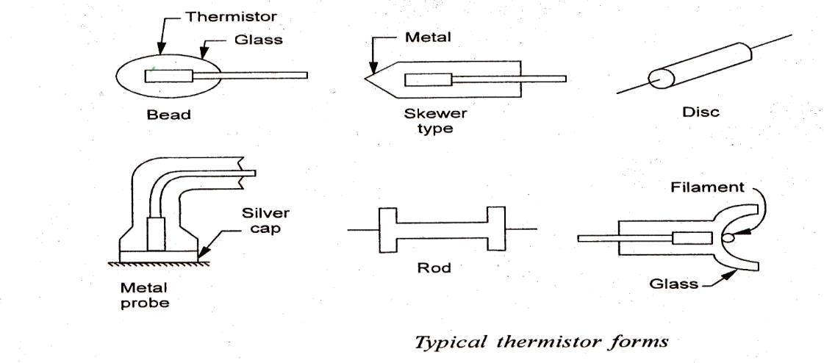

Thermistors is a contraction of term Thermal Resistor. They are essentially semi-conductors which behave as resistors with a high negative temperature coefficient. As -the temperature increases, the resistance goes down, and as the temperature decreases, the resistance goes up. This is just opposite to the effect of temperature changes on metals.

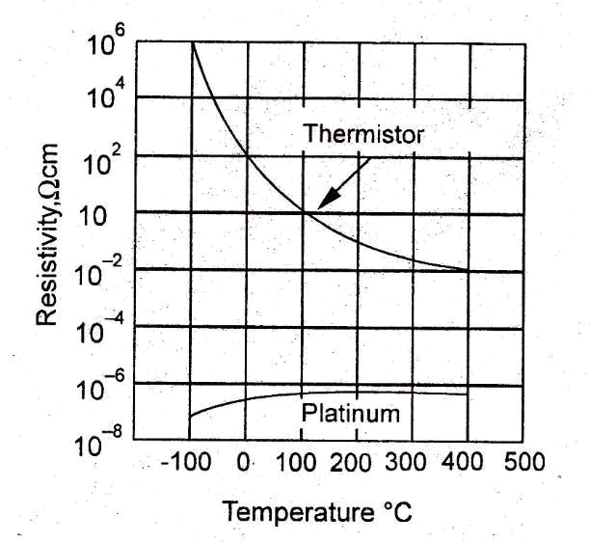

Thermistors are composed of sintered mixture of metallic oxides such as manganese. Nickel, cobalt, copper, iron and uranium. These metallic oxides are milled, mixed in appropriate proportions, are pressed into the desired shape with appropriate binders and finally sintered the electrical terminals are either embedded before sintering or baked afterwards. The electrical characteristics of thermistors are controlled by varying the type of oxide used and physical size and configuration of the thermistor. Thermistors may be shaped in the form of beads, disks, washers, rods and `these standard forms are shown in Fig.

The mathematical expression for the relation- ship between the resistance of a thermistor and absolute temperature of thermistor is

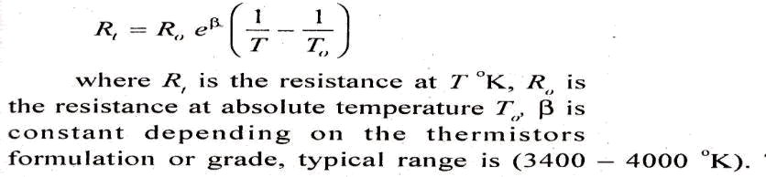

3. Thermo couples:

The basic principle of temperature measurement by thermo-electricity was discovered by Seebeck in 1821 and is illustrated in Fig. 10.20. When two conductors of dissimilar metals M1 and M2 are joined together to form a loop (a thermocouple) and two unequal temperatures Tl1 and T2 are imposed at the two interface connections, an electric current we through the loop.

Experimentally it has been found that -the magnitude of the current is directly related to the two materials M1 and M2, and the temperature difference (T1 – T2 ). In the practical application of the effect, a suitable device is incorporated in the circuit to indicate any electromotive force or Bower current. For convenience of measurement and standardization, one of the two junctions is usually maintained at some constant known temperature. The output voltage of the circuit then indicates the temperature difference relative to the reference temperature. Most tabulations set the reference value to the triple point of water (O° ).

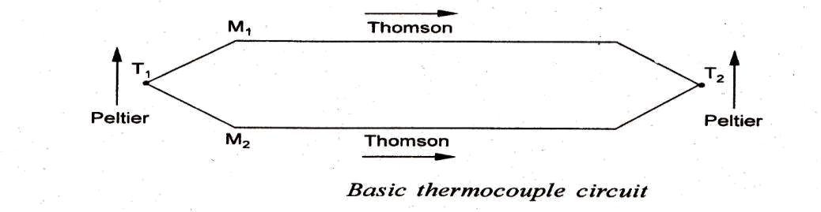

Thermo-electric effects arise in two ways:

- a potential difference always exists between two dissimilar metals in contact with each other (Peltier effect)

- a potential gradient exists even in a single conductor having & temperature gradient (Thomson effect)

In commercial instruments, the thermocouple materials are so chosen that the Peltier and Thomson emfs act in such a manner that the combined value is maximum and that varies directly with temperature.

- Measurement of displacement:-

Introduction:

The direct measurements of displacement, force, torque and speed are very important in industrial processes. Also. Many other quantities such as pressure, temperature, level, flow, etc. are often measured by transducers them to displacement. Motion, or force, and then measuring these parameters which give the required value of a particular quantity. In this chapter some of the methods for measuring displacement, force, torque and speed have been discussed.

Measurement of displacement:

Generally, displacement is thought of in terms of motion of a few millimeters (mm) or less. The measurement of displacement is made frequently to relate to some other measurement and hence displacement transducers are fundamental components of any instrumentation system Displacement is closely associated with motion (from one point to another) and position (i.e. a change from one position to the next). Displacement can be measured by both mechanical and electrical methods, but only electrical methods which are common in industrial use will be described here.

Definition of a Transducer:

Strain gauge is a positive-type resistance transducer which converts a mechanical displacement into a change of resistance. It is the most commonly used transducer for the measurement of displacement. The resistance gauge is essentially a fine wire which changes its resistance, when mechanically strained.

Due to physical effects. Its length and cross-sectional area vary and a change of electrical resistivity also occurs.

A transducer perform the following functions:

i. detects or senses the present and changes in physical quantity being measured.

ii. Provided a proportional output signal.

The strain Range is mounted to the measured surface so that it elongates or contracts with that surface.

This deformation of the sensing materials causes it to undergo a change in resistance.

3Q) How to Classification of transducers and explain

Transducers are broadly classified into two groups as follows:

- Active transducers (self-generating type)

- Passive transducers (Externally powered)

1. Active transducers (self-generating type):

Active transducers are self-generating type. They do not required electric energy. They work on the principle of conservation of energy. The energy required for production of an output signal is obtained from the input or physical phenomenon being measured.

Examples: Thermo couples, Thermoelectric and Piezo-electric devices….etc.

2. Passive transducers (Externally powered):

Passive transducers are externally powered type. Passive transducers are based on principle of energy controlling and they required a secondary electrical source for operation.

Examples: LVDT (Linear variable differential transformer), Thermistors, resistance thermometers, strain gauge devices.

Classification based on the type of output:

- Analog Transducer

- Digital Transducer

1. Analog Transducer:

These transducers convert the input physical phenomenon into an analog output (analog form) which is continuous function of time.

Examples: Thermistor, Thermocouple, strain gauge, LVDT.

2. Digital Transducer:

These transducers convert the input physical phenomenon into an electrical output (digital form) which may be in the form of pulses.

Examples: Turbine flow meter.

Classification based on the electrical principle involved:

- Variable resistance type

  - Strain and pressure gauge

  - Thermistors, resistance thermo meters

  - Photo conductive cell

- Variable inductance type

  - LVDT

  - Reluctance pickup

  - Eddy current type

- Variable capacitance type

  - Capacitor micro phase

  - Pressure gauge

  - Di electric gauge

- Voltage generating type

  - Thermo couple

  - Photo voltaic cell

  - Rotational motion tachometer

  - Piezo- electric pickup

- Voltage divider type

  - Potentiometer position sensor

  - Pressure actuated voltage divider

According to the principle of operation, transducer for the measurement of displacement:

- Variable resistance transducer

- Variable inductance transducer

- Variable capacitance transducer

- Piezo electric transducer
- Photo electric or light detecting transducer

  - Photo conductive

  - Photo voltaic

  - Photo emissive

- Ionization transducers.

4Q) What are the Advantages of electrical transducers over other transducers:

- Mass and inertia effects are minimized

- Amplification or attenuation is minimized

- Effect of friction is minimized

- They are compact in size

- Remote indication is possible

- Power consumption is less and loading errors are minimized.

Limitations:-

1. They need external power supply, 2. High cost

- Instrument electrical properties may change the actual reading of the variable which is to be measured.

5Q) Explain Principal of Piezo Electric transducers:-

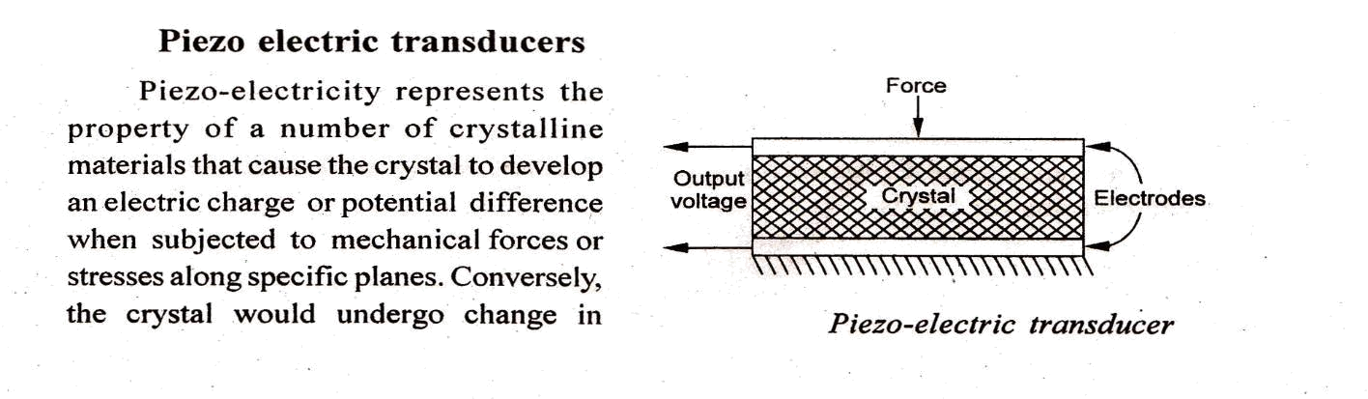

thickness (and thus produce mechanical forces) when charged electrically by a potential difference applied to its proper axis. Elements exhibiting piezo-electric qualities are sometimes known as electro restrictive elements.

A typical mode of operation of a piezo electric device for measuring varying force applied to a simple plate is shown in Fig. Metal electrodes are attached to the selected faces of a crystal in order to detect the electrical charge developed The magnitude and Polarity of the induced charge on the crystal surface is proportional to the magnitude and direction of the applied force and is given by :

Q = K F

Where Q is the charge in coulomb, F is the impressed force in newtons and K is the crystal sensitivity in C/N; it is constant for particular crystals and the manner in which they are cut. The relationship between the force F and the change t in the crystal thickness t is given by the stress-strain relationship.

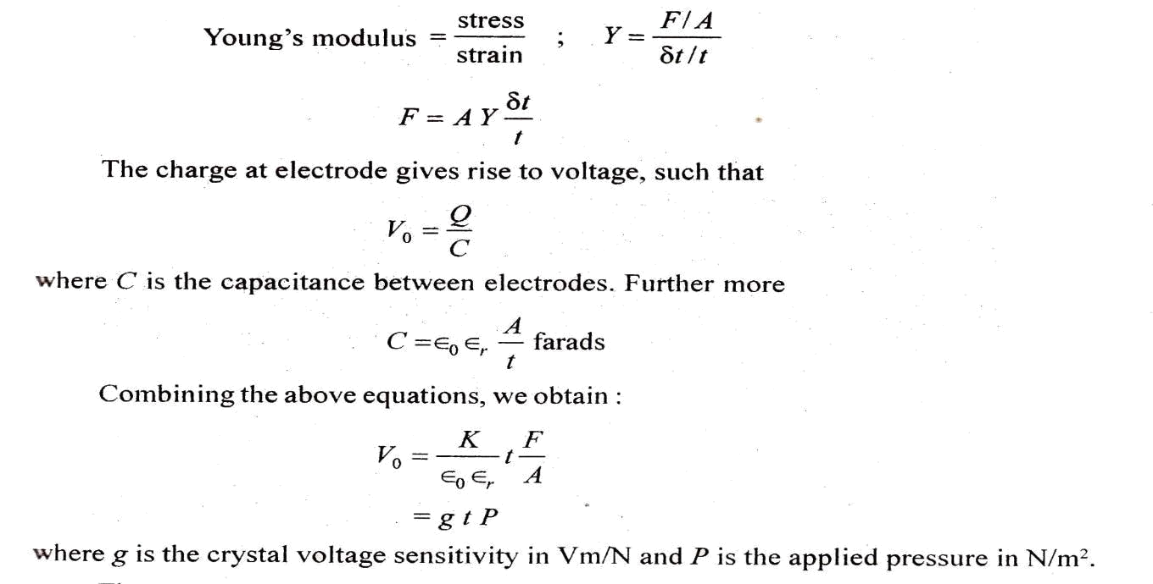

There are two main groups of piezo-electric crystals: (i) natural crystals such as quartz and tourmaline,

- synthetic crystals such as Rochelle salts, lithium sulphate (LS), ammonia hydrogen phosphate (ADP), ethylene diamine tartrate (EDT), potassium tartrate (DKT) etc. The advantages vary from crystal to crystal and one is chosen on the basis of a particular application. Tourmaline `is the least active chemically while tartaric acid is most active electrically.

- Natural crystals have a very low electrical leakage when used with very high input impedance amplifiers and permit the measurement of a slowly varying parameter. They are, therefore, capable of withstanding higher temperatures; operating at low frequencies and sustaining shocks.

- Synthetic crystals exhibit a much high output for an applied stress and are about thousand times more sensitive than natural crystals. However, they are usually unable to withstand high mechanical strain

without fracture. Further, the synthetic crystals have an accelerated rate of deterioration over the natural ones.

The major advantages of piezoelectric transducers are:

- High frequency response,

- High output,

- Rugged construction

- Negligible phase shift, and

- Small size. The small size of the transducer is especially useful for accelerometers where added mass will mechanically load a system.

Applications: Piezo-electric transducers are most often used for accelerometers, pressure cells and force cells in that order.

6Q) Write LVDT (Linear variable differential Transducer) principal and construction

The linear variable-differential transformer (LVDT) is the most widely used inductive transducer to translate linear motion into electrical signal.

Construction: A differential transformer consists of a primary winding and two secondary windings. The windings are arranged concentrically and next to each other. They are wound over a hollow bobbin which is usually of a non-magnetic and insulating material, as shown in Fig.

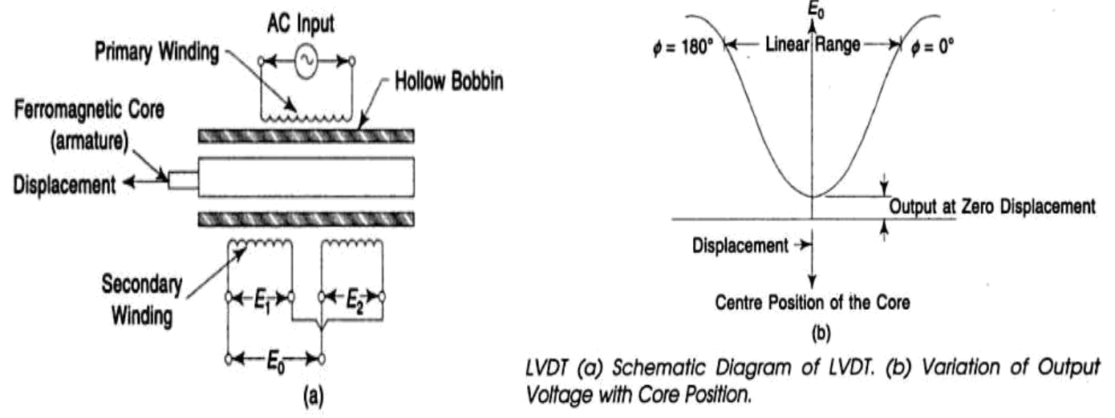

Working: Any physical displacement of the core causes the voltage of one secondary winding to increase while simultaneously, reducing the voltage in the other secondary winding. The difference of the two voltages appears across the output terminals of the transducer and gives a measure of the physical position of the core and hence the displacement.
When the core is in the neutral or zero position, voltages induced in the secondary windings are equal and opposite and the net output is negligible. As the core is moved in one direction from the null position, the differential voltage, i.e. the difference of the secondary voltages, will increase while maintaining an in-phase relationship with the voltage from the input source. In the other direction from the null position, the differential voltage will again increase, but will be 180' out of phase with the voltage from the input source. By comparing the magnitude and phase of the output (differential) voltage with the input source. The amount and direction of movement of the core and hence of displacement may be determined. Variation of output voltage with core position is shown in Fig.

Following are the advantages of LVDT:

- The output voltage of these transducer is practically linear for displacements upto 5 mm.

- They have infinite resolution.

- These transducers possess a high sensitivity.

- These transducers can usually tolerate a high degree of shock and vibration without any adverse effects.

- They are simple, light in weight, and easy to align and maintain.

Following are the disadvantages of LVDT:

- Rela6vely large displacements are required for appreciable differential output.

- They are sensitive to stray magnetic fields but shielding is possible.

- They are inherently low in power output.

7Q) Explain working principle of Photo-electric Transducers

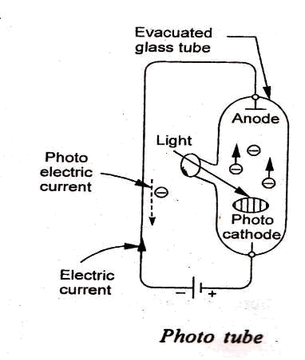

These transducers operate on the principle that when light strikes special combination of materials, a voltage may be generated, a resistance change may take place, or electrons may flow. Photoelectric cells are used for a wide variety of purposes in control engineering for precision measuring devices, in exposure meters used in photography. They are also used in solar batteries as sources of electrical power for rockets and satellites used in space research.

Based on the principle of rotation photo electric transducers are classified into the 3 types. They are,

- Photo-emissive cell: These transducers operate on the photo-emissive effect, i.e., when certain types of materials are exposed to light, electrons readmitted and a current flow is produced. Light sensitive photo-cathode may consist of a very thin film of cesium deposited by isotonic onto an oxidised silver base. Light strikes the cathode, causing the emission electrons which are attracted towards the anode. This phenomenon produces flow of it current in the external circuit; the current being a function of radiant energy striking the cathode.
- Light information ------------------→ current information

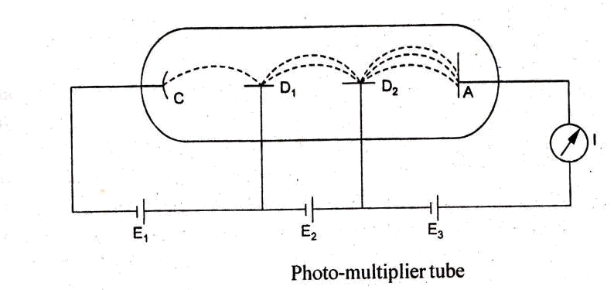

- Photo-conductive cell: These are the variable resistance transducers. They on the principle of photo conductive effect, i.e., some special type of semiconductor oils change their resistance when exposed to light.

Light information ------------------→ resistance information

Figure shows schematically the construction and electrical circuit of a photoconductive cell. The sensitive material usually employed is cadmium selenide, germanium etc in the form of thin coating between the two electrodes on a glass. Further, the cells are used in the circuit as a variable resistance and are put in .series an ammeter and a voltage source. When the light strikes the semiconductor material, is a decrease in the cell resistance thereby producing an increase in the current indicated the ammeter.

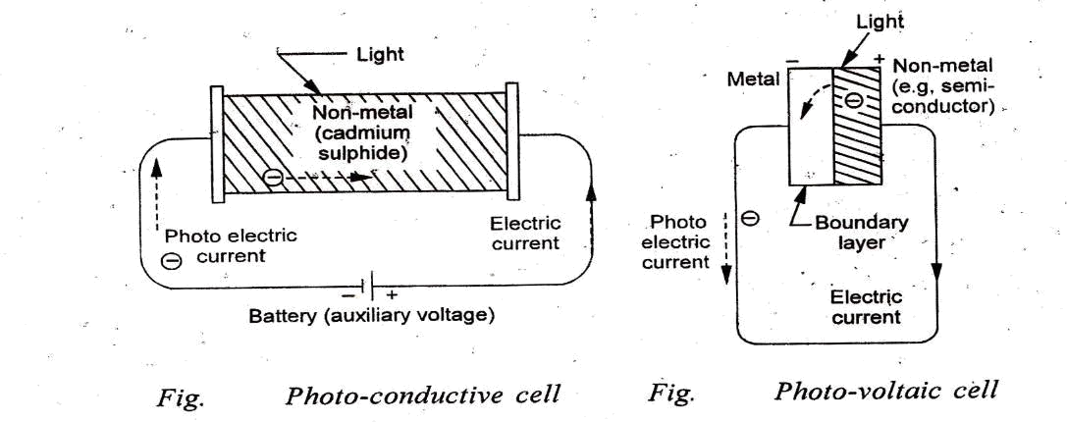

- Photo-voltaic cell: These transducers operate on the photo-valtaic effect, i.e., when light's trikes a junction of certain dissimilar metals, a potential difference is built up.

Light information ------------------→ emf information

The cell consists of a metal base plate, a non-metal semiconductor and a thin transparent metallic layer. Typical examples of the layers are the copper oxide on copper and iron oxide on iron combination. The transparent layer may be in the form of a sprayed conducting lacquer. Light strikes the coating and generates an electric potential. The output is, however, low and is non-linear function of the light intensity. In contrasted photo-tube and photo-conductive cells, the photo-voltaic unit is self-gene, rated and requires no voltage source to operate it.

8Q) Explain working principal of Capacitive Transducers:-

