Introduction:
UNIT-5
ELEMENTS OF CONTROL SYSTEMS

A system is an assemblage of devices and components connected or related by some form of regular interation or interdependence to form an organised whole and perform specified tasks. The system produces an output corresponding to a given input.
Ex: The thermometer and the mass-spring damper system can be indentified as systems. He thermometer has the input x = 𝜃 (temperature) and the output y = l (length of the mercury column in the capillary).
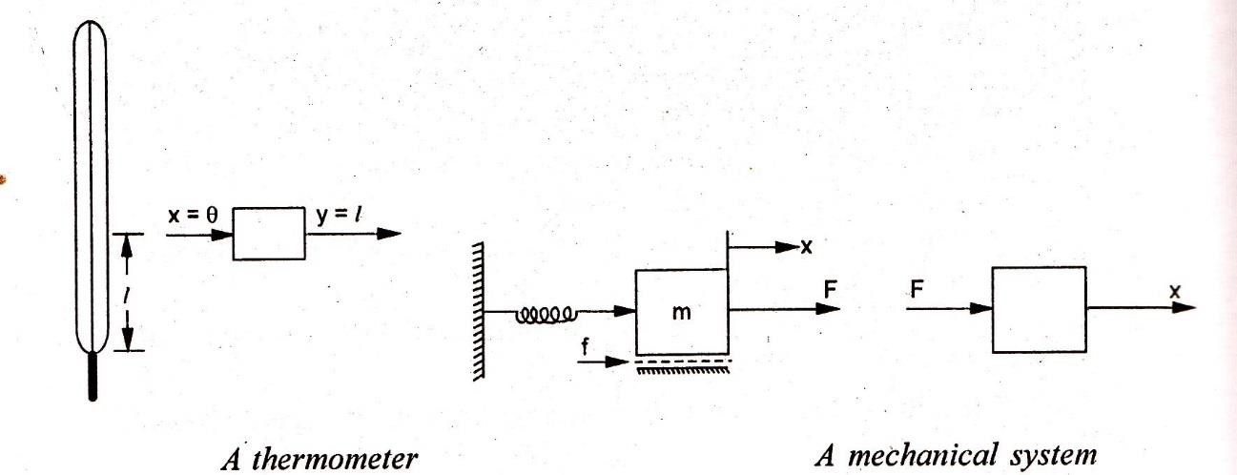
The term control implies to regulate, direct or command. A control system may thus be defined as;
”an assemblage of devices and components connected or related so as to command direct or regulate it self or another system".

EX:1
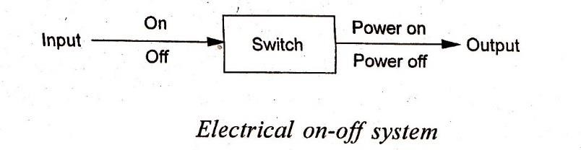
- An electrical switch which serves to control the flow of electricity in a circuit. The input signal (command) is the flippling of the switch on or off; and the corresponding output (controlled) signal is the flow or non-flow of electric current.
- A thermal system where it is desired to maintain the temperature of hot water at a prescribed value. Before the operator can carry out his task satisfactorily, the following requirements must be met:
- The operator must be told what temperature is required for the water. This temperature, called the set point or desired value, constitutes the input to the system.
- The operator must be provided with some means of observing the temperature (sensing element). For that a thermometer is installed in the hot water pipe and it measures measured temperature

compares with the desired value. This difference between the desired value and the actual measurement value is error or actuating signal.
e = r - c
where r refers to the set-point or reference input and c denotes the controlled variable.
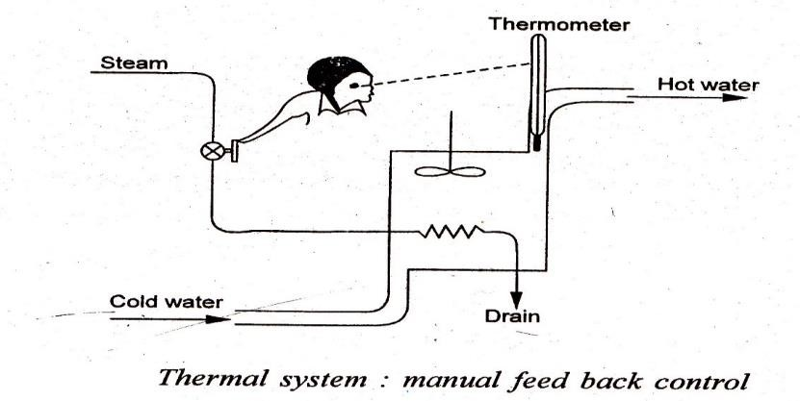
- The operator must be provided with some means of influencing the temperature (control elemeny and must be instructed what to do to move the temperature in a desired direction (control function).
- A driving system of an automobile (accelerator, carburettor and an engine vehicle) where command signal is the force on the acceleration pedal and the automobile speed is the controlled variable. The desired change in engine speed can be obtained by controlling pressure on the accelerator pedal.
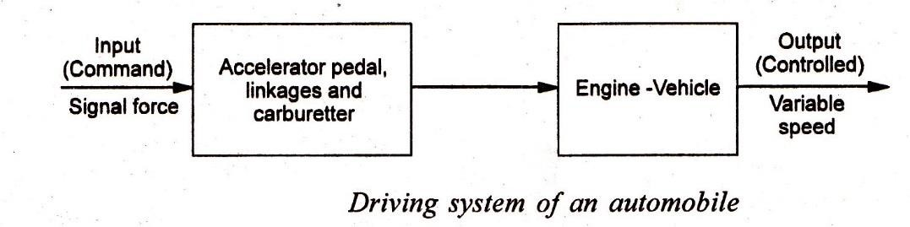
- An automobile steering system where the driver is required to keep the automobile in the appropriate lane of the roadways. The eyes measure the output (heading of the automobile), the brain and hands react to any error existing between the input (appropriate lane) and the output signals, and act to reduce the error to zero.
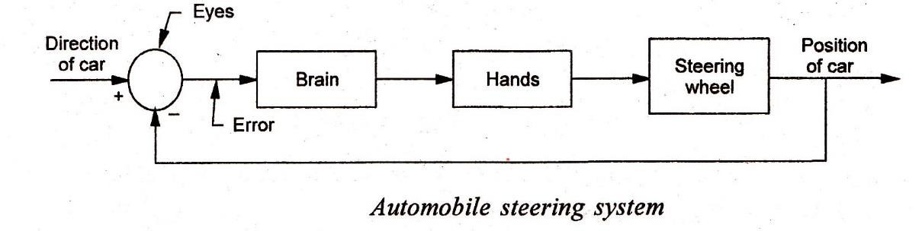
- A biological control system where a person moves his finger to point towards an object. The command signal is the position of the object and the output is the actual pointed direction.

Other well-known examples of control systems are: electric frying pans, water pressure regulators, toilet-tank water level, electric irons, refrigerators and household furnaces with thermostatic control.
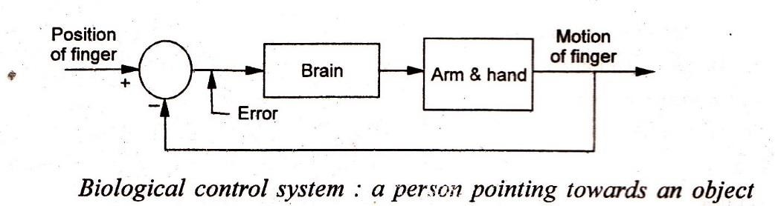

Classification of control systems:

These are two basic types of control systems, 1. open loop and 2. closed loop systems.
1 Open-loop systems (unmonitored control system). The main features of an open loop system are:

- there is no comparison between the actual (controlled) and the desired values of a variable.
- for each reference input, there corresponds a fixed operating condition (output) and this output has no effect on the control action, i. e., the control action is independent of output.
- for the given set-input, there may be a big variation of the controlled variable depending upon the ambient conditions. Since there is no comparision between actual output and the desired value, rapid changes can occur inthe output if there occurs any change in the external load.
Some examples of open-loop system are :
- Trying to guide a car by setting the steering wheel, together with a pattern of subsequent changes of direction, at the beginning of a journey and making no alternation enroute as and when the car deviates form the desired path.
- Hitting the golf ball where the player knows his goal to get the ball into a particular hole. To achieve it, the player hits the ball correctly at the beginning of its flight. Once the moment of impact ispassed, he loses his control on any further flight ofthe ball.
- The automobile traffic control signals at roadway intersections are the open loop systems. The red and green light travels (input to the control action) are predetermined by a calibrated timing mechanism and are in no way influanced by the volume of traffic (output).

An open loop system has the following advantages and limitations:
- simple construction and ease of maintenance
- no stability problems
- convenient when the controlled variable is either difficult to measure or it is economically not feasible
- system affected by internal and external disturbances ; the output may differ from the desired value
- needs frequent and careful calibrations for accurate result.

2. Closed-loop systems (monitored control systems). The main features of a closed loop system are:

- There is comparison between the actual (controlled) and the desired values of the variable. To accomplish it, the output signal is fed back and the loop is completed.
- The error signal (deviation between the reference input the feedback signals) then actuates the control element to minimize the error and bring the system output to the desired value.
- The system operation is continually correcting any error that may exist. As long as the output does not coincide with the desired goal, there is likely to be some kind of actuating signal.
The performance of such a system is evaluated with reference to the following desireable characteristics:
- minimum deviation following a disturbance
*minimum time interval before return to set point
- minimum off-set due to change in operating conditions.
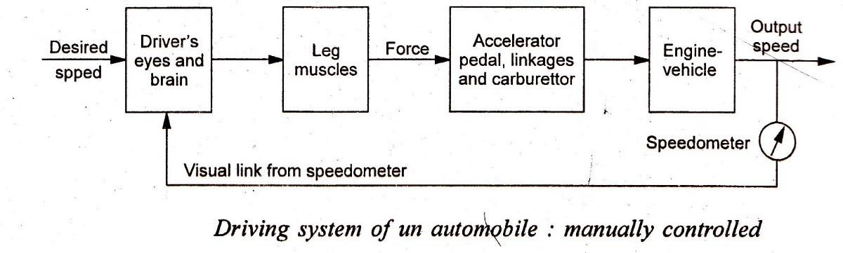
Examples of closed loop systems are:
- The control of the thermal system is a closed loop, when the operator detects that the output temperature is different from the desired or reference temperature, he initiates an action to reduce the discrepency by operating a value that controls the steam supply to water.
- The automobile driving system would become a closed-loop system when the driver makes a visual observation of the speed indicated by a speedometer and compares this mentally with the desired speed.

Example of automatic control systems:
- In the automatic feed-back control of a thermal system (Fig. 15.9), the human operator has been replaced by an automatic controller. The actual temperature of the hot water is measured by a thermometer and is fed to the controller for comparison with the reference temperature whose value has been specified by appropriate, setting of the thermostat/regulator. Based on the error signal, the controller generates an output (correcting signal) which is taken to the control valve in order to change the valve opening for steam supply.
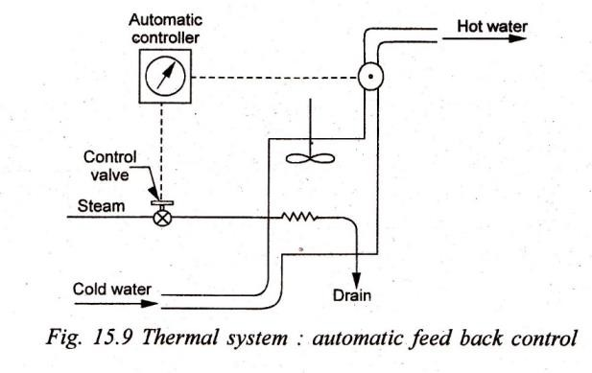
- The level control system depicted in Fig. 15.10 is an automatic control system. Where inflow of water to the tank is dependent on the water; level in the tank. The automatic controller maintains the liquid level by comparing the actual level with a desired level and correcting any error by adjusting the opening of the control valve.
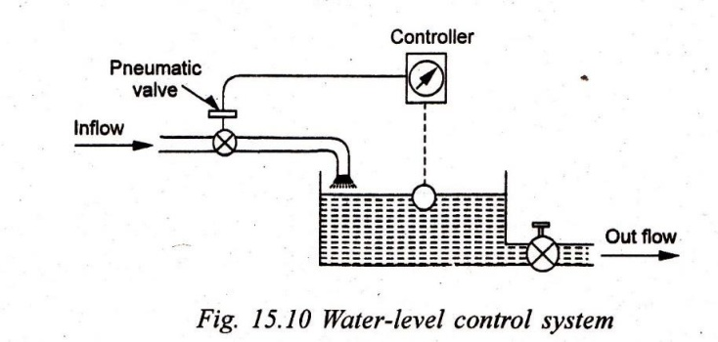
- A pressure control system where the pressure inside the furance is automatically controlled by affecting a change in the position of the damper (Fig 15.12).
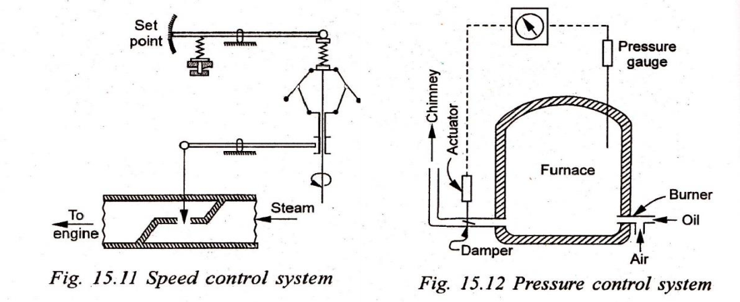

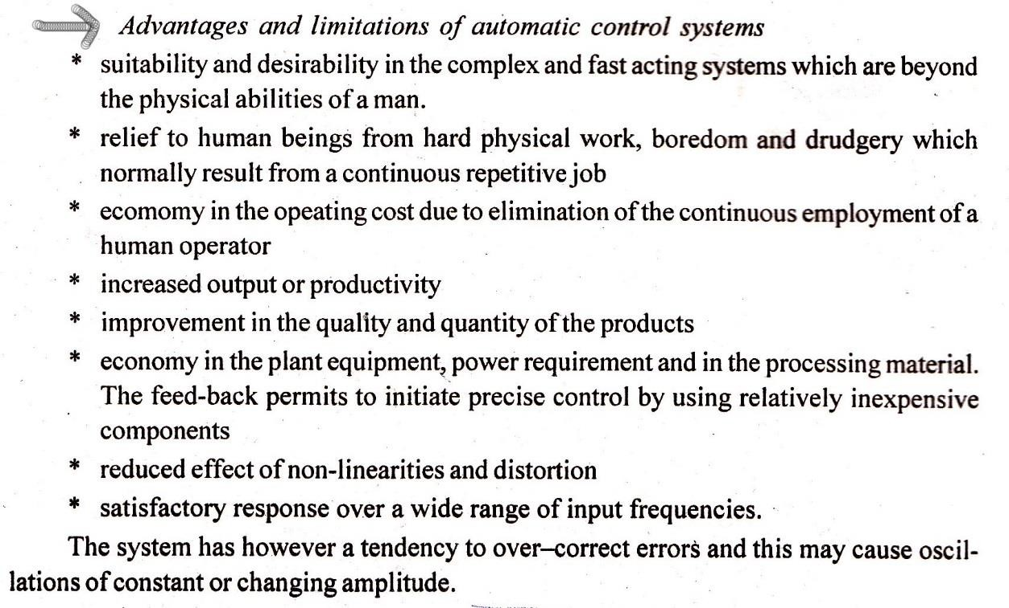
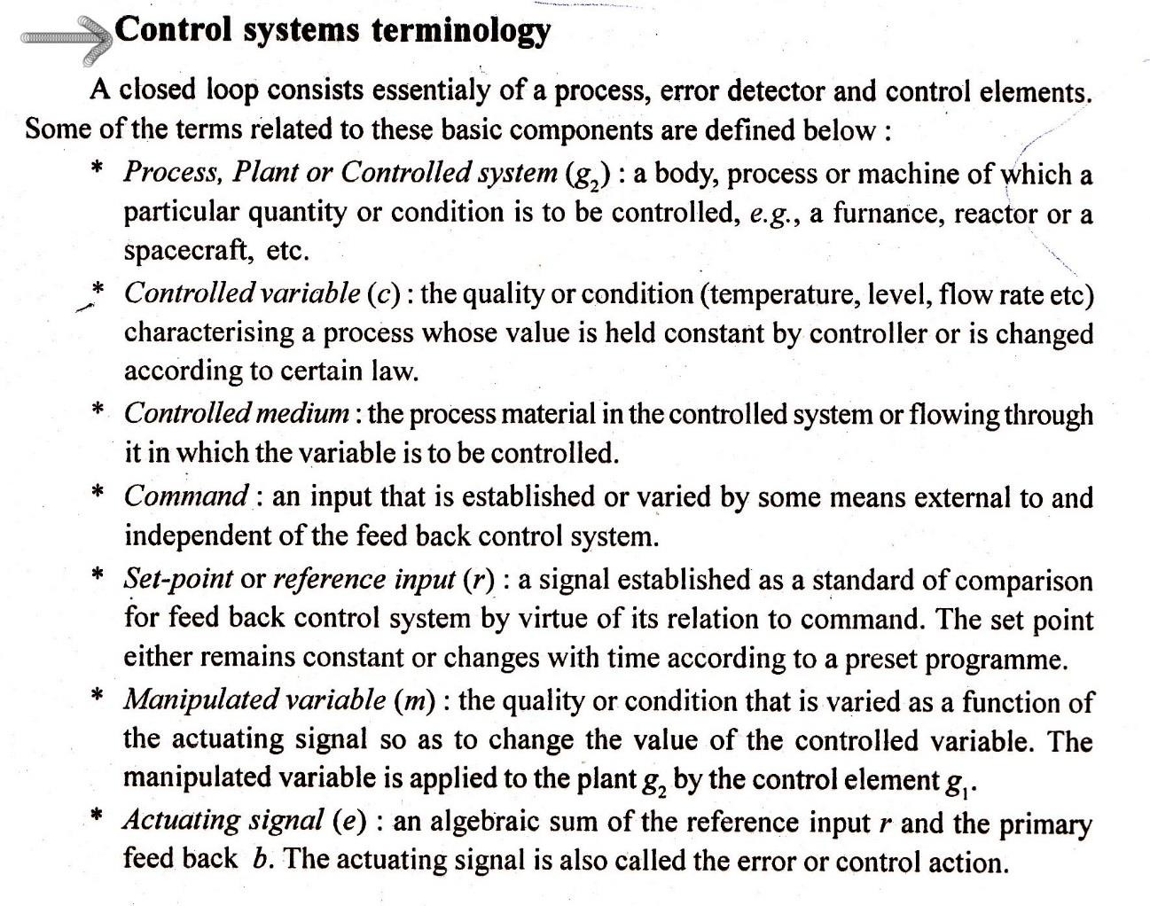

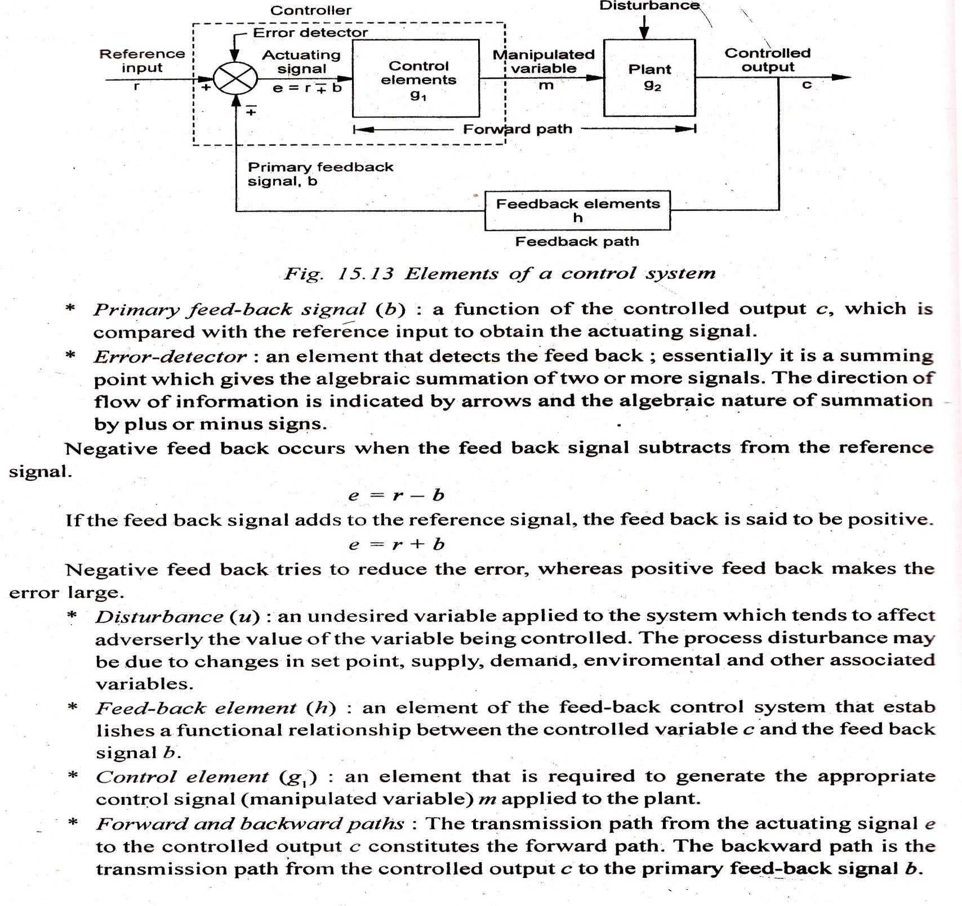

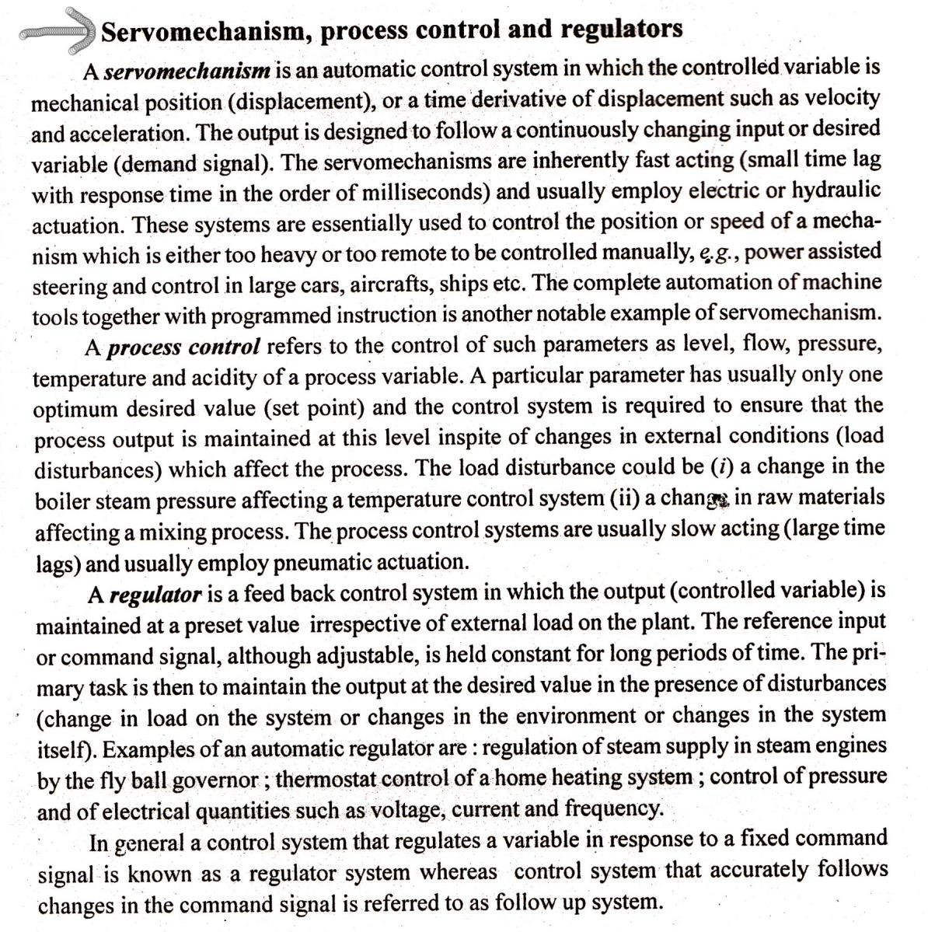

**************THE END**************

