### Unit II KINEMATICS ANALYSIS

**Graphical method**

Analysis of simple mechanisms- Slider crank mechanism and four bar mechanism- for displacement, velocity and acceleration. Shaping machine mechanism- coincident points- coriolis acceleration

**Analytical method**

Analysis of simple mechanisms- Slider crank mechanism and four bar mechanism- Approximate analytical expression for displacement, velocity and acceleration of piston of reciprocating engine mechanism

**Velocity and Acceleration analysis of mechanisms:**

Velocity and acceleration analysis by vector polygons: Relative velocity and accelerations of particles in a common link, relative velocity and accelerations of coincident particles on separate link, C oriolis component of acceleration.

Velocity and acceleration analysis by complex numbers: Analysis of single slider crank mechanism and four bar mechanism by loop closure equations and complex numbers.

### Displacement, velocity and acceleration analysis in simple mechanisms: Important Concepts in Velocity Analysis

* 1. T he absolute velocity of any point on a mechanism is the velocity of that point with reference to ground.
  2. Relative velocity describes how one point on a mechanism moves relative to another point on the mechanism.
  3. T he velocity of a point on a moving link relative to the pivot of the link is given by the equation: V =  r, where   = angular velocity of the link and r = distance from pivot.

### Acceleration Components

* ***Normal Acceleration:* A**n = 2r. Points toward the center of rotation
* ***Tangential Acceleration:* A**t =  r. In a direction perpendicular to the link
* ***Coriolis Acceleration:* A**c = 2 (dr/dt). In a direction perpendicular to the link
* ***Sliding Acceleration:* A**s = d2r/dt2. In the direction of sliding.

A rotating link will produce normal and tangential acceleration components at any point a distance, r, from the rotational pivot of the link. T he total acceleration of that point is the vector sum of the components.

Page 21 of 65

©Einstein C ollege of Engineering

A slider attached to ground experiences only sliding acceleration.

Sub C ode: ME35

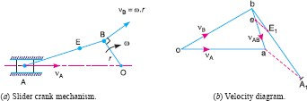

A slider attached to a rotating link (such that the slider is moving in or out along the link as the link rotates) experiences all 4 components of acceleration. Perhaps the most confusing of these is the coriolis acceleration, though the concept of coriolis acceleration is fairly simple. Imagine yourself standing at the center of a merry-go-round as it spins at a constant speed ( ). You begin to walk toward the outer edge of the merry-go-round at a constant speed (dr/dt). Even though you are walking at a constant speed and the merry-go-round is spinning at a constant speed, your total velocity is increasing because you are moving away from the center of rotation (i.e. the edge of the merry-go-round is moving faster than the center). T his is the coriolis acceleration. In what direction did your speed increase? T his is the direction of the coriolis acceleration.

T he total acceleration of a point is the vector sum of all applicable acceleration components:

**A** = **A**n + **A**t + **A**c + **A**s

T hese vectors and the above equation can be broken into x and y components by applying sines and cosines to the vector diagrams to determine the x and y components of each vector. In this way, the x and y components of the total acceleration can be found.

### Graphical Method, Velocity and Acceleration polygons : Graphical velocity analysis:

It is a very short step (using basic trigonometry with sines and cosines) to convert the graphical results into numerical results. T he basic steps are these:

1. Set up a velocity reference plane with a point of zero velocity designated.
2. Use the equation, V =  r, to calculate any known linkage velocities.
3. Plot your known linkage velocities on the velocity plot. A l inkage that is rotating about ground gives an absolute velocity. T his is a vector that originates at the zero velocity point and runs perpendicular to the link to show the direction of motion. T he vector, **V**A, gives the velocity of point A.
4. Plot all other velocity vector directions. A point on a grounded link (such as point B) will produce an absolute velocity vector passing through the zero velocity point and perpendicular to the link. A point on a floating link (such as B relative to point A) will produce a relative velocity vector. T his vector will be perpendicular to the link AB and pass through the reference point (A) on the velocity diagram.

Sub C ode: ME35

1. One should be able to form a closed triangle (for a 4-bar) that shows the vector equation: **V**B = **V**A + **V**B/A where **V**B = absolute velocity of point B, **V**A = absolute velocity of point A, and **V**B/A is the velocity of point B relative to point A.

### Velocity Analysis of Four Bar Mechanisms:

* Problems solving in Four Bar Mechanisms and additional links.

### Velocity Analysis of Slider Crank Mechanisms:

* Problems solving in Slider C rank Mechanisms and additional links.

### Acceleration Analysis of Four Bar Mechanisms:

* Problems solving in Four Bar Mechanisms and additional links.

### Acceleration Analysis of Slider Crank Mechanisms:

* Problems solving in Slider C rank Mechanisms and additional links.

### Kinematic analysis by Complex Algebra methods:

* Analysis of single slider crank mechanism and four bar mechanism by loop closure equations and complex numbers.

### vector Approach:

* Relative velocity and accelerations of particles in a common link, relative velocity and accelerations of coincident particles on separate link

### Computer applications in the kinematic analysis of simple mechanisms:

* C omputer programming for simple mechanisms

### Coincident points, Coriolis Acceleration:

* ***Coriolis Acceleration:* A**c = 2 (dr/dt). In a direction perpendicular to the link. A slider attached to ground experiences only sliding acceleration.

A slider attached to a rotating link (such that the slider is moving in or out along the link as the link rotates) experiences all 4 components of acceleration. Perhaps the most confusing of these is the coriolis acceleration, though the concept of coriolis acceleration is fairly simple. Imagine yourself standing at the center of a merry-go-round as it spins at a constant speed ( ). You begin to walk toward the outer edge of the merry-go-round at a constant speed (dr/dt). Even though you are walking at a constant speed and the merry-go-round is spinning at a constant speed, your total velocity is increasing because you are moving away from the center of rotation (i.e. the edge of the merry-go-round is moving faster than the center). T his is the coriolis acceleration. In what direction did your speed increase? T his is the direction of the coriolis acceleration.

Page 23 of 65

©Einstein C ollege of Engineering

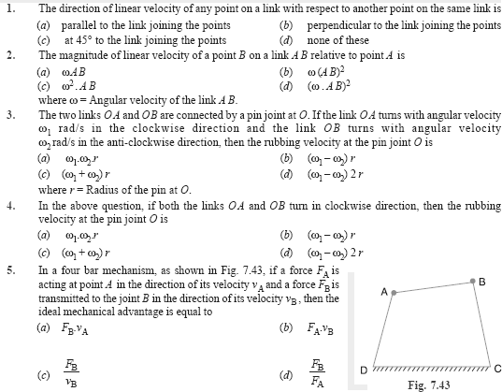

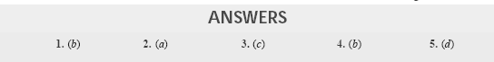

### Question bank – II unit

***Important two questions***

1. **What are the types of motion?**
2. **What is configuration diagram or space diagram?**
3. **Define Coincident points**
4. **Define Coriolis Component**
5. **Write down the expression for Coriolis component of acceleration defining each of terms in**

**the expression.**

1. **What are the types of instantaneous Centres?**
2. Define Kennedy’s theorem.

Page 24 of 65

©Einstein C ollege of Engineering

### Define rubbing velocity at a pin joint.

Sub C ode: ME35

1. **What are the various methods used for finding out velocity of mechanism?**
2. **Define Instantaneous centre.**
3. **Define Angular Velocity ratio theorem.**

***Important descriptive university questions:***

* + **The Crank of a slider crank mechanisms rotates clockwise at a Constant speed of 600 r.p.m. The crank is 125 mm and connecting rod is 500 mm long. Determine 1. Linear velocity and acceleration of the mid Point of the connecting rod, and 2. Angular velocity and angular acceleration of the connecting rod, at a crank angle of 45° from inner dead centre position.**
  + **In a four link mechanism, the dimensions of the links are AB=200 mm, BC=400mm, CD=450 mm and AD=600mm. At the instant when DAB=90°, the link AB has angular velocity of 36 rad/s in the clockwise direction. Determine (i) The velocity of point C, (ii) The velocity of point E on the link BC When BE =200 mm (iii) the angular velocities of links BC and CD, iv) acceleration of link of link BC.**
  + **Derive the expressions for Velocity and acceleration of piston in reciprocating steam engine mechanism with neat sketch**
  + **Derive the expression for Coriolis component of acceleration with neat sketch**
  + **In a slider crank mechanism, the length of the crank and the connecting rod are 100 mm and 400 mm respectively./ The crank [position is 45° from IDC, the crank shaft speed is 600 r.p.m., Clockwise. Using analytical method Determine**

**(1) Velocity and acceleration of the slider, and (2) Angular velocity and angular acceleration of the connecting rod.**

* + **Locate all instantaneous centers of the slider crank mechanism; the length of crank OB and Connecting rod AB are 125 mm and 500 mm respectively. The crank speed is 600 rpm clockwise. When the crank has turned 45° from the IDC,** Determine (i)velocity of slider’ A’ (ii)Angular Velocity of connecting rod ‘AB’.

### References

1. Ambekar A. G., Mecanism and Machine T heory, Prentice Hall of India, New Delhi, 2007.
2. Khurmi R.S., G up., T heory of machines, S. C hand company limited, New Delhi, 2009.

### Web site:

[www.](http://www/) nptel.iitm.ac.in (National programme on technology enhanced learning by IIT , India) <http://www.scribd.com/doc/18424291/Kinematics-of-Machines>