

**2.1 Introduction**

* Linear measurement applies to measurement of lengths, diameters, heights, and thickness including external and internal measurements.
* The line measuring instruments have series of accurately spaced lines marked on them, e.g. scale. The dimension to be measured is aligned with the graduations of the scale.
* Linear measuring instruments are designed either for line instruments, the measurement is taken between two end surfaces as in micrometers, slip gauges etc.
* The instruments used for linear measurements can be classified as:

1. Direct measuring instruments
2. Indirect measuring instruments

* The direct measuring instruments are of two types: 1. Graduated

2. Non Graduated

* The graduated instruments include rules, vernier calipers, vernier height gauges, vernier depth gauges, micrometers, dial indicators etc.
* The non-graduated instruments include calipers, trammels, telescopic gauges, surface gauges, straight gauges, wire gauges, screw pitch gauges, thickness gauges, slip gauges etc. They can also be classified as:

1. Non-precision instruments such as steel rule, calipers etc.
2. Precision measuring instruments, such as vernier instruments, micrometers, dial gauges etc.

**2.2 Vernier Instruments**

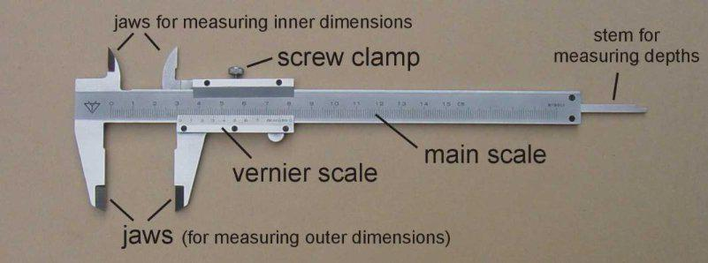

*Figure 2.1 Vernier Instrument*



* The principle of vernier is that when two scales or divisions slightly different in size are used, the difference between them can be utilized to enhance the accuracy of measurement.
* The vernier caliper essentially consists of two steel rules and these can slide along each other. One of the scales, i.e., main scale is engraved on a solid L-shaped frame. On this scale cm graduations are divided into 20 parts so that one small division equals 0.05 cm. One end of the frame contains a fixed jaw which is shaped into a contact tip at its extremity.
* The three elements of vernier caliper, viz, beam, fixed jaw, and sliding jaw permit substantial improvements in the commonly used measuring techniques over direct measurement with line graduated rules.
* The alignment of the distance boundaries with the corresponding graduations of the rule is ensured by means of the positive contact members (the jaws of the caliper gauges).
* The datum of the measurement can be made to coincide precisely with one of the boundaries of the distance to be measured.
* The movable jaw achieves positive contact with the object boundary at the opposite end of the distance to be measured. The closely observable correspondence of the reference marks on the slide with a particular scale value significantly reduces the extent of read-out alignment errors.

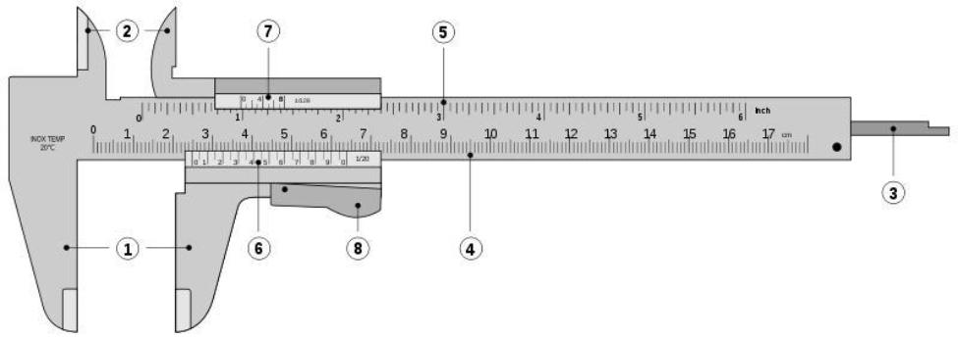

*Figure 2.2 Vernier Instruments*

* A sliding jaw which moves along the guiding surface provided by the main scale is coupled to a vernier scale. The sliding jaw at its left extremity contains another





measuring tip.

* When two measuring tip surfaces are in contact with each other, scale shows zero reading. The finer adjustment of the movable jaw can be done by the adjusting screw
* First the whole movable jaw assembly is adjusted so that the two measuring tips just touch the part to be measured. Then lock nut B is tightened. Final adjustment depending upon the sense of correct feel is made by the adjusting screw.
* The movement of adjusting screw makes the part containing locking nut A and sliding jaw to move, as the adjusting screw rotates on a screw which is in a way fixed to the movable jaw. After final adjustment has been made, the locking nut A is also tightened and the reading is noted down
* . The measuring tips are so designed as to measure inside as well as outside dimensions.
  1. Outside jaws: used to measure external diameter or width of an object
  2. Inside jaws: used to measure internal diameter of an object
  3. Depth probe: used to measure depths of an object or a hole
  4. Main scale: gives measurements of up to one decimal place (in cm).
  5. Main scale: gives measurements in fraction (in inch)
  6. Vernier gives measurements up to two decimal places (in cm)
  7. Vernier gives measurements in fraction (in inch)
  8. Retainer: used to block movable part to allow the easy transferring a measurement

**2.3 Reading the Vernier Scale**

* For understanding the working of vernier scale let us assume that each small division of the main scale is 0.025 units.
* Say, the vernier scale contains 25 divisions and these coincide exactly with 24 divisions of main scale. So now one vernier division is equal to 1/25 of 24 scale divisions, i.e., 1/25 x 24 x 0.025 = 0.024 unit. Therefore, difference between one main scale small division and one vernier division (least count of the instrument) equals 0.025 — 0.024, i.e. 0.001 unit. It means if the zero of main scale and zero of vernier coincide, then the first vernier division will read 0.001 units less than the 1 small scale division. Second vernier division will read 0.002 unit less than 2 small scale divisions and so on. Thus if zero vernier scale lies in between two small divisions on main scale its exact value can be judged by seeing as to which vernier division is coinciding with main scale division.

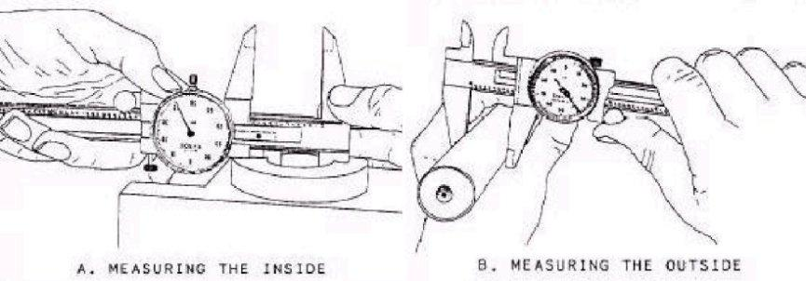

*Figure 2.3 Practical Applications of Vernier Calipers*

* Thus to read a measurement from a vernier caliper, note the units, tenths and fortieths which the zero on the vernier has moved from the zero on the main scale. Note down the vernier division which coincides with a scale division and add to previous reading the number of thousands of a unit indicated by the vernier divisions
* e.g., reading in the scale shown in Fig. is 3 units + 0.1 unit + 0.075 unit + 0.008 unit = 3.183 units. When using the vernier caliper for internal measurements the width of the measuring jaws must be taken into account. (Generally the width of measuring jaw is 10 mm for Metric System).

**2.4 Types of Vernier Calipers**

* According to IS 3651—1974 (Specification for vernier caliper), three types of vernier calipers have been specified to meet the various needs of external and internal measurements **up to 2000 mm** with vernier **accuracy of 0.02, 0.05 and 0.1 mm.**
* The three types are called types A, B, C and have been shown in Figs. 2.75, 2.76 and 2.79 respectively. All the three types are made with only one scale on the front of the beam for direct reading.
* Type A has jaws on both sides for external and internal measurements, and also has a blade for depth measurements. Type B is provided with jaws on one side for external and internal measurements. Type C has jaws on both sides for making the measurements and for marking operations.



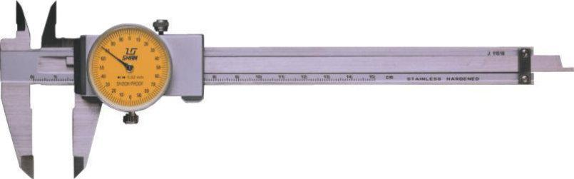

*Figure 2.4 Vernier Caliper with Dial*

* All parts of the vernier calipers are made of **good quality steel** and the measuring faces **hardened** to **650 H.V. minimum.** The recommended measuring ranges (nominal sizes) ofvernier calipers as per IS 3651—1974 are 0—125, 0—200, 0—250. 0—300; 0—500, 0— 750, 0—1000, 750—1500 and 750— 2000 mm.
* On type A, scale serves for both external and internal measurements, whereas in case of types B and C, the main scale serves for external measurements and for marking purposes also in type C, but on types B and C internal measurements are made by adding width of the internal measuring jaws to the reading on the scale. For this reason, the combined width for internal jaws is marked on the jaws in case of types B and C calipers. The combined width shou1d be uniform throughout its length to within 0.01 mm.
* The beam for all the types is made flat throughout its length to within the tolerances of 0.05 mm for nominal lengths up to 300 mm, 0.08 mm from 900 to 1000 mm, and 0.15 mm for 1500 and 2000 mm sizes, and guiding surfaces of the beam are made straight to within 0.01 mm for measuring range of 200 mm and 0.01 mm every 200 mm measuring range of larger size.
* The measuring surfaces are given a fine ground finish. The portions of the jaws between the beam and the measuring faces are relieved. The fixed jaw is made an integral part of the beam and the sliding jaw is made a good sliding fit along with the beam and made to have seizure-free movement along the bar.
* A suitable locking arrangement is provided on the sliding jaw in order to effectively

clamp it on the beam. When the sliding jaw is clamped to the beam at any position within the measuring range, the external measurir1g faces should remain square to the

guiding surface of the beam to within 0.003 mm per 100 mm. The measuring surfaces of the fixed and sliding jaws should be coplanar to within 0.05 mm when the sliding jaw is



clamped to the beam in zero position. The external measuring faces are lapped flat to within 0.005 mm. The bearing faces of the sliding jaw should preferably be relieved in order to prevent damage to the scale on the beam. Each of the internal measuring surfaces should be parallel to the corresponding external measuring surface to within 0.025 mm in case of type B and C calipers. The internal measuring surfaces are formed cylindrically with a radius not exceeding one-half of their combined width.

**Errors in Measurements With Vernier Calipers**

* Errors are usually made in measurements with vernier calipers from manipulation of vernier caliper and its jaws on the work piece.
* For instance, in measuring an outside diameter, one should be sure that the caliper bar and the plane of the caliper jaws are truly perpendicular to the work piece’s longitudinal centre line
* i.e. one should be sure that the caliper is not canted, tilted, or twisted. It happens because the relatively long, extending main bar of the average vernier calipers so readily tips in one direction or the other.
* The accuracy of the measurement with vernier calipers to a great extent depends upon the condition of the jaws of the caliper. The accuracy and the natural wear, and warping of vernier caliper jaws should be tested frequently by closing them together tightly or setting them to the 0.0 point of the main and vernier scales. In this position the caliper is held against a light source. If there is wear, spring or warp a knock-kneed condition as shown in Fig. (a) Will be observed. If measurement error on this account is expected to be greater than 0.005 mm the instrument should not be used and sent for repair.
* When the sliding jaw frame has become worn or warped that it does not slide squarely & snugly on main caliper beam, then jaws would appear as shown in fig. Where a vernier

caliper is used mostly for measuring inside diameters, the jaws may become bowlegged as in Fig. (c) Or it’s outside edges worn clown as in Fig. (d).

**Care inthe Use ofVernierCalliper**

* No play should be there between the sliding jaws on scale, otherwise the accuracy of the vernier caliper will be lost. If play exists then the gib at the back of jaw assembly must be bent so that gib holds the jaw against the frame and play is removed.
* Usually the tips of measuring jaws are worn and that must be taken into account. Most of the errors usually result from manipulation of the vernier caliper and its jaws on the





work piece.

* In measuring an outside diameter it should be insured that the caliper bar and the plane of the caliper jaws are truly perpendicular to the work piece’s longitudinal centre line. It should be ensured that the caliper is not canted, tilted or twisted.
* The stationary caliper jaw of the vernier caliper should be used as the reference point and measured point is obtained by advancing or withdrawing the sliding jaw.
* In general, the vernier caliper should be gripped near or opposite the jaws; one hand for the stationary jaw and the other hand generally supporting the sliding jaw. The instrument should not be held by the over-hanging “tail” formed by the projecting main bar of the caliper.
* The accuracy in measurement primarily depends on two senses, viz., sense of sight and sense of touch (feel).
* The short-comings of imperfect vision can however be overcome by the use of corrective eye-glass and magnifying glass. But sense of touch is an important factor in measurements. Sense of touch varies from person to person and can be developed with practice and proper handling of tools.
* One very important thing to note here is that sense of touch is most prominent in the finger-tips, therefore, the measuring instrument must always be properly balanced in hand and held lightly in such a way that only fingers handle the moving and adjusting screws etc. If tool be held by force, then sense of feel is reduced.
* Vernier calliper must always be held at short leg of main scale and jaws never pulled.

**2.5 Vernier height gauge**

* Vernier height gauge is similar to vernier calliper but in this instrument the graduated bar is held in a vertical position and it is used in conjunction with a surface plate.

∑ **Construction:**

A vernier height gauge consists of

1. A finely ground and lapped base. The base is massive and robust in construction to ensure rigidity and stability.
2. A vertical graduated beam or column supported on a massive base.
3. Attached to the beam is a sliding vernier head carrying the vernier scale and a clamping screw.



1. An auxiliary head which is also attached to the beam above the sliding vernier head. It has fine adjusting and clamping screw.
2. A measuring jaw or a scriber attached to the front of the sliding vernier

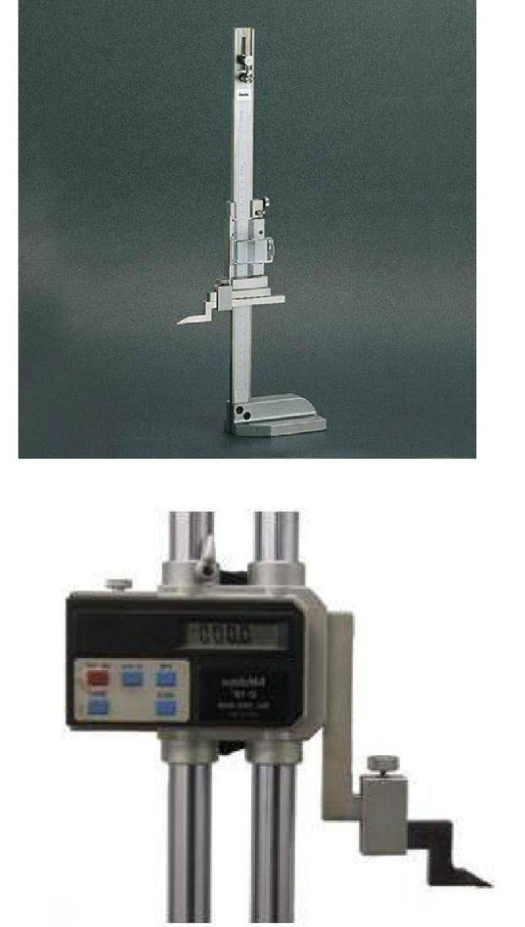

*Figure 2.5 Vernier Height Gauge*





∑ **Use.**

* The vernier height gauge is designed for accurate measurements and marking of vertical heights above a surface plate datum.
* It can also be used to measure differences in heights by taking the vernier scale readings at each height and determining the difference by subtraction.
* It can be used for a number of applications in the tool room and inspection department. The important features of vernier height gauge are:
  + All the parts are made of good quality steel or stainless steel.
  + The beam should be sufficiently rigid square with the base.
  + The measuring jaw should have a clear projection from the edge of the beam at least equal to the projection of the base' from the beam.
  + The upper and lower gauging surfaces of the measuring jaw shall be flat and parallel to the base.
  + The scriber should also be of the same nominal depth as the measuring jaw so that it may be reversed.
  + The projection of the jaw should be at least 25 mm.
  + The slider should have a good sliding fit for all along the full working length of the beam.
  + Height gauges can also be provided with dial gauges instead of vernier.

This provides easy and exact reading of slider movement by dial a gauge which is larger and clear.

∑ **Precautions.**

* When not in use, vernier height gauge should be kept in its case.
* It should be tested for straightness, squareness and parallelism of the working faces of the beam, measuring jaw and scriber.
* The springing of the measuring jaw should always be avoided.

**2.6 Vernier Depth Gauge**

* Vernier depth gauge is used to measure the depths of holes, slots and recesses, to locate centre distances etc. It consists of

1. A sliding head having flat and true base free from curves and waviness.



1. A graduated beam known as main scale. The sliding head slides over the graduated beam.
2. An auxiliary head with a fine adjustment and a clamping screw.

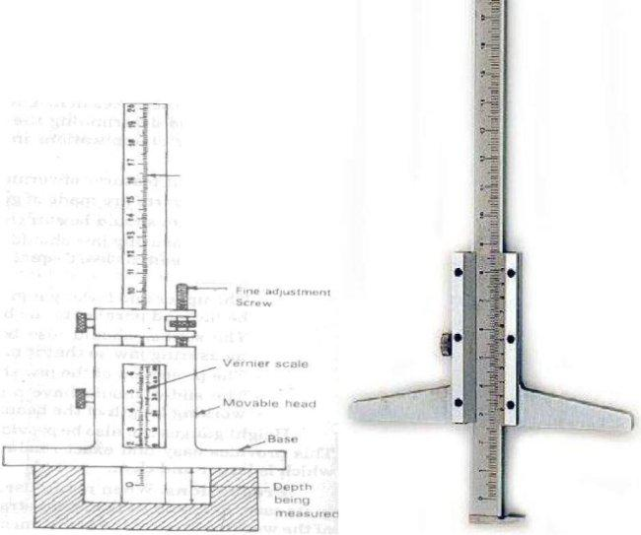

*Figure 2.6 Vernier Depth Gauge*

* The beam is perpendicular to the base in both directions and its ends square and flat.
* The end of the sliding head can be set at any point with fine adjustment mechanism locked and read from the vernier provided on it, while using the instrument, the base is held firmly on the reference surface and lowers the beam into the hole until it contacts the bottom surface of the hole.
* The final adjustment depending upon the sense of correct feel is made by the fine adjustment screw. The clamping screw is then tightened and the instrument is removed from the hole and reading taken in the same way as the vernier calliper. While using theinstrument it should be ensured that the reference surface op which the depth gauge base is rested is satisfactorily true, flat arid square.

**2.7 Micrometers**

* The micrometer screw gauge essentially consists of an accurate screw having about 10 or 20 threads per cm and revolves in a fixed nut.
* The end of the screw forms one measuring tip and the other measuring tip is constituted by a stationary anvil in the base of the frame. The screw is threaded for





certain length and is plain afterwards. The plain portion is called sleeve and its end is the measuring surface.

* The spindle is advanced or retracted by turning a thimble connected to the spindle. The spindle is a slide fit over the barrel and barrel is the fixed part attached with the frame.
* The barrel is graduated in unit of 0.05 cm. i.e. 20 divisions per cm, which is the lead of the screw for one complete revolution.
* The thimble has got 25 divisions around its periphery on circular portion. Thus it sub-divides each revolution of the screw in 25 equal parts, i.e. each division corresponds to 0.002 cm. A lock nut is provided for locking a dimension by preventing motion of the spindle.

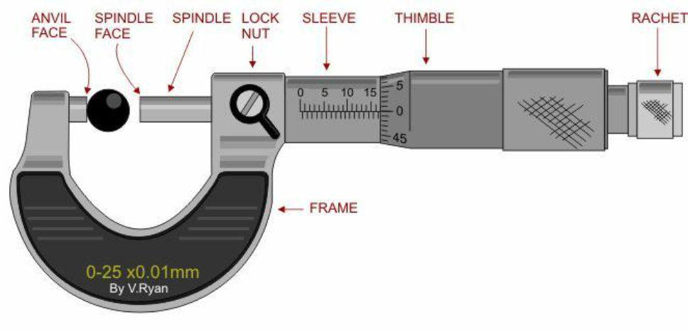

*Figure 2.7 Micrometers*

* Ratchet stop is provided at the end of the thimble cap to maintain sufficient and uniform measuring pressure so that standard conditions of measurement are attained.
* Ratchet stop consists of an overriding clutch held by a weak spring.
* When the spindle is brought into contact with the work at the correct measuring pressure, the clutch starts slipping and no further movement of the spindle takes place by the rotation of ratchet. In the backward movement it is positive due to shape of ratchet.

**Reading a Micrometer:**

* In order to make it possible to read up to **0.0001** inch in micrometer screw gauge, a vernier scale is generally made on the barrel.



* The vernier scale has 10 straight lines on barrel and these coincide with exact 9 divisions on the thimble. Thus one small deviation on thimble is further subdivided into 10 parts and taking the reading one has to see which of the vernier scale division coincides with division of the thimble.
* Accordingly the reading for given arrangement in fig. will be,

|  |  |
| --- | --- |
| On main barrel | : 0.120” |
| On thimble | :0.014” |
| On vernier scale | :0.0001” |
| Total reading | :0.1342” |

* Before taking the reading anvil and spindle must be brought together carefully and initial reading noted down. Its calibration must be checked by using standard gauge blocks.

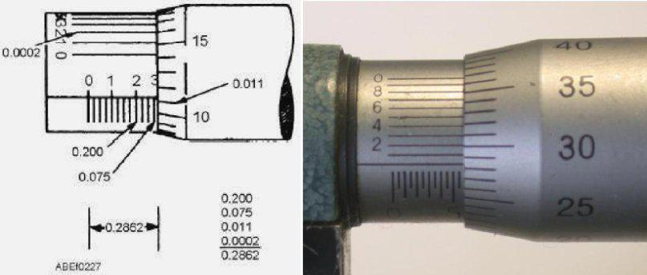

*Figure 2.8 Practical Applications of Micrometers*

* In metric micrometers, the pitch of the screw thread is 0.5 mm so that one revolution of screw moves it axially by 0.5 mm. Main scale on barrel has least division of 0.5 mm. the thimble has 50 divisions on its circumference.
* One division on thimble = 0.5 / 50 mm = 0.1 mm
* If vernier scale is also incorporated then sub divisions on the thimble can be estimated up to an accuracy of 0.001 mm.
* Reading of micrometer is 3.5 mm on barrel and 7 divisions on thimble
  + 3.5+7 x 0.001= 3.5 + 0.07 = 3.57 mm

**Cleaning the Micrometer:**

* Micrometer screw gauge should be wiped free from oil, dirt, dust and grit.





* When micrometer feels gummy and dust ridden and the thimble fails to turn freely, it should never be bodily dunked in kerosene or solvent because just soaking the assembled micrometer fails to float the dirt away.
* Further it must be remembered that the apparent stickiness of the micrometer may not be due to the grit and gum but to a damaged thread and sprung frame or spindle.
* Every time the micrometer is used, measuring surface, the anvil and spindle should be cleaned. Screw the spindle lightly but firmly down to a clean piece of paper held between spindle and anvil.
* Pull the piece of paper put from between the measuring surface. Then unscrew the spindle few turns and blow out any fuzz or particles of papers that may have clung to sharp edges of anvil and spindle.

**Precautions in using Micrometer**

* In order to get good results out of the use of micrometer screw gauge, the inspection of the parts must be made as follows. Micrometer should be cleaned of any dust and spindle should move freely.
* The part whose dimension is to be measured must be held n left hand and the micrometer in right hand. The way for holding the micrometer is to place the small finger and adjoining finger in the U – Shaped frame.
* The forefinger and thumb are placed near the thimble to rotate it and the middle finger supports the micrometer holding it firmly.
* The micrometer dimension is set slightly larger than the size of the part and part is slid over the contact surfaces of micrometer gently. After it, the thimble is turned till the measuring pressure is applied.
* In the case of circular parts, the micrometer must be moved carefully over representative arc so as to note maximum dimension only. Then the micrometer reading is taken.
* The micrometers are available in various sizes and ranges, and corresponding micrometer should be chosen depending upon the dimension.
* Errors in reading may occur due to lack of flatness of anvil, lack of parallelism of the anvils at part of scale or throughout, inaccurate setting of zero reading, etc. various tests to ensure these conditions should be carried out from time to time.

**2.8 Bore gauge:**



* The dial bore gauges shown in fig. are for miniature hole measurements.
* The gauge is supplied with a set of split ball measuring contact points which are hard chrome-plated to retain original spheres.
* Along with the measuring probes, setting rings are also provided to zero set the indicator whenever the probes are interchanged.

Actual ring size is engraved on the ring frames to the closest 0.001 mm value.

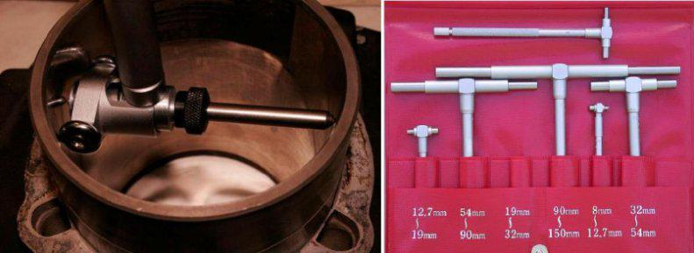

*Figure 2.9 Bore gauges*

**2.9 Dial indicators**

∑ **Introduction**

* Dial indicators are small indicating devices using mechanical means such as gears and pinions or levers for magnification system. They are basically used for making and checking linear measurements.
* Many a times they are also used as comparators. Dial indicator, in fact is a simple type of mechanical comparator.
* When a dial indicator is used as an essential part in the mechanism any set up for comparison measurement purposes; it is called as a gauge.
* The dial indicator measures the displacement of its plunger or a stylus on a circular dial by means of a rotating pointer.
* Dial indicators are very sensitive and versatile instruments.
* They require little skill in their use than other precision instruments, such as micrometer vernier callipers, gauges etc. However, a dial indicator by itself is not of much unless it is properly mounted and set before using for inspection purposes.

**Uses:**





* By mounting a dial indicator on any suitable base and with various attachments, it can be used for variety of purposes as follows.
  1. Determining errors in geometrical forms, e.g., ovality out-of-roundness, taper etc.
  2. Determining positional errors of surfaces, e.g., in squareness, parallelism, alignment etc.
  3. Taking accurate measurements of deformation (extension compression) in tension and compression testing of material.
  4. Comparing two heights or distances between narrow limits (comparator).

The practical applications of the use of dial indicator are:

1. To check alignment of lathe centers by using a suitable accurate bar between centers.
2. To check trueness of milling machine arbors.
3. To check parallelism of the shaper ram with table surface or like.

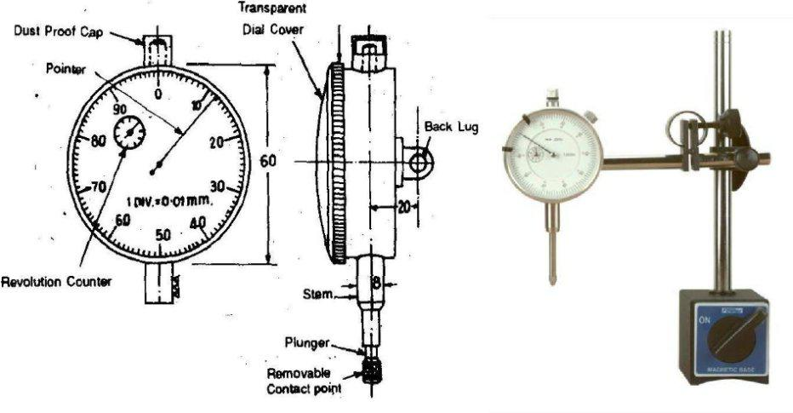

*Figure 2.10 Dial Indicators*

**2.10 Slip Gauges**

* Slip gauges or gauge blocks are universally accepted end standard of length in industry. These were introduced by Johnson, a Swedish engineer, and are also called as johanson gauges

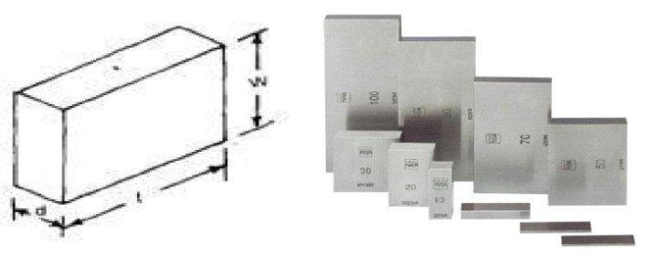

*Figure 2.11 Dimensions of a Slip Gauge*

* Slip gauges are rectangular blocks of high grade steel with exceptionally close tolerances. These blocks are suitably hardened through out to ensure maximum resistance to wear.
* They are then stabilized by heating and cooling successively in stages so that hardening stresses are removed,After being hardened they are carefully finished by high grade lapping to a high degree of finish, flatness and accuracy.
* For successful use of slip gauges their working faces are made truly flat and parallel. A slip gauge is shown in fig. 3.36. Slip gauges are also made from tungsten carbide which is extremely hard and wear resistance.
* The cross-sections of these gauges are 9 mm x 30 mm for sizes up to 10 mm and 9 mm x 35 mm for larger sizes. Any two slips when perfectly clean may be wrung together. The dimensions are permanently marked on one of the measuring faces of gauge blocks

∑ Gauges blocks are used for:

* 1. Direct precise measurement, where the accuracy of the work piece demands it.
  2. For checking accuracy of vernier callipers, micrometers, and such other measuring instruments.
  3. Setting up a comparator to a specific dimension.
  4. For measuring angle of work piece and also for angular setting in conjunction with a sine bar.
  5. The distances of plugs, spigots, etc. on fixture are often best measured with the slip gauges or end bars for large dimensions.
  6. To check gap between parallel locations such as in gap gauges or between two mating parts.

**2.11 Telescopic Gauges**





* The telescopic gauge is used for measuring internal diameter of holes, slots and grooves etc. It consists of a handle with two rods in a tube at one end and a working screw at the other end. The rods having spherical contacts can slide within a tube and are forced apart by an internal spring.
* The locking screw can lock the rods at any desired position through a spring. While taking measurements, the rods are pressed closer and inserted into the hole to be measured. The rods then open out to touch the metal surface, of the hole on both sides. They are then locked in position by means of a locking screw. The telescopic gauge is then taken out from the hole. The dimension across the tips is measured by micrometer or Verniercaliper.

**2.12 Introduction to Angular Measurement**

* Angular measurements are frequently necessary for the manufacture of interchangeable parts. The ships and aero planes can navigate confidently without the help of the site of the land; only because of precise angular measuring devices can be used in astronomy to determine the relation of the stars and their approximate distances.
* The angle is defined as the opening between two lines which meet at a point. If one of the two lines is moved at a point in an arc, a complete circle can be formed.
* The basic unit in angular measurement is the right angle, which is defined as the angle between two lines which intersect so as to make the adjacent angles equal.
* If a circle is divided into 360 equal parts. Each part is called as degree (0). Each degree is divided in 60 minutes (‘), and each minute is divided into 60 seconds (“).
* This method of defining angular units is known as sexagesimal system, which is used for engineering purposes.
* An alternative method of defining angle is based on the relationship between the radius and arc of a circle. It is called as radian.
* Radian is defined as the angle subtended at the centre by an arc of a circle of length equal to its radius.
* It is more widely used in mathematical investigation.

2 radians = 360, giving,

1 radian = 57.2958 degrees.



* In addition linear units such as 1 in 30 or millimeters per meter are often used for specifying tapers and departures from squareness or parallelism.

**2.13 Bevel Protector**

* It is probably the simplest instrument for measuring the angle between two faces of component.
* It consists of a base plate attached to the main body, and an adjustable blade which is attached to a circular plate containing vernier scale. The adjustable blade is capable of rotating freely about the centre of the main scale engraved on the body of the instrument and can be locked in any position.
* An acute angle attachment is provided at the top; as shown in fig. for the purpose of measuring acute angles. The base of the base plate is made flat so that it could be laid flat upon the work and any type of angle measured. It is capable of measurement from 00 to 3600
* The vernier scale has 24 divisions coinciding with 23 main scale divisions. Thus the least count of the instrument is 5’. This instrument is most commonly used in workshops for angular measurements till more precision is required.
* A recent development of the vernier bevel protector is optical bevel protector. In this

instrument, a glass circle divided at 10’ intervals throughout the whole 3600 is fitted inside the main body.

* A small microscope is fitted through which the circle graduations can be viewed. The adjustable blade is clamped to a rotating member who carries this microscope. With the aid of microscope it is possible to read by estimation to about 2’.

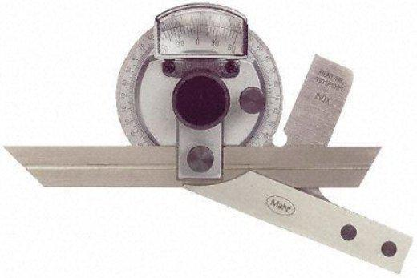

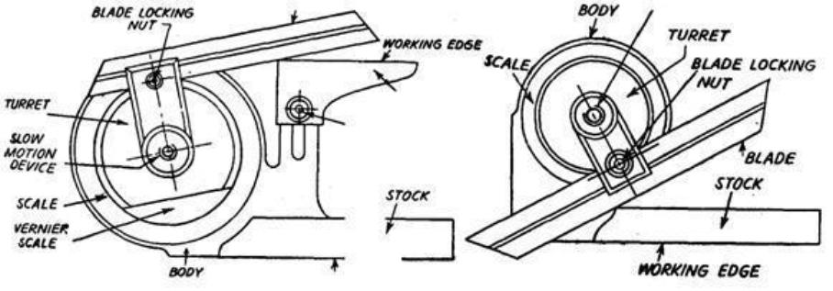

*Figure 2.12 Bevel Protector*

**Universal Bevel Protector**

* It is used for measuring and laying out of angles accurately and precisely within 5

minutes. The protector dial is slotted to hold a blade which can be rotated with the dial to the required angle and also independently adjusted to any desired length. The blade can be locked in any position.

**Bevel Protectors as Per Indian Standard Practice** The bevel protectors are of two types, viz.

1. Mechanical Bevel Protector, and
2. Optical Bevel Protector.
   * 1. **Mechanical bevel protector:**

* The mechanical bevel protectors are further classified into four types; A, B, C and D.
* In types A and B, the vernier is graduated to read to 5 minutes of arc whereas in case of type C, the scale is graduated to read in degrees and the bevel protector is without vernier or fine adjustment device or acute angle attachment.
* The difference between types A and B is that type A is provided with fine adjustment device or acute angle attachment whereas type B is not. The scales of all the types are graduated either as a full circle marked 0—90—0—90 with one vernier or as semicircle marked 0—90—0 with two verniers 1800 apart.
* Type D is graduated in degrees and is not provided with either vernier or fine adjustment device or acute angle attachment.
  + 1. **Optical bevel protector:**
  + In the case of optical bevel protector, it is possible to take readings up to approximately 2 minutes of arc. The provision is made for an internal circular scale which is graduated



in divisions of 10 minutes of arc.

* Readings are taken against a fixed index line or vernier by means of an optical magnifying system which is integral with the instrument. The scale is graduated as a full circle marked 0—90—0—90. The zero positions correspond to the condition when the blade is parallel to the stock. Provision is also made for adjusting the focus of the

system to accommodate normal variations in eye-sight. The scale and vernier are so arranged that they are always in focus in the optical system.

**Various Components of Bevel Protectors**

**Body:**It is designed in such a way that its back is flat and there are no projections beyond itsback so that when the bevel protector is placed on its back on a surface plate there shall be no perceptible rock. The flatness of the working edge of the stock and body is tested by checking the squareness of blade with respect to stock when blade is set at 900.

**Stock:**The working edge of the stock is about 90 mm in length and 7 mm thick. It is veryessential that the working edge of the stock be perfectly straight and if at all departure is there, it should be in the form of concavity and of the order of 0.01 mm maximum over the whole span.

**Blade:**It can be moved along the turret throughout its length and can also be reversed. It isabout 150 or 300 mm long, 13 mm wide and 2 mm thick and ends beveled at angles of 450 and 600 within the accuracy of 5 minutes of arc. Its working edge should be straight upto 0.02 mm and parallel upto 0.03 mm over the entire length of 300 mm. It can be clamped in any position.

**Actual Angle Attachment**

It can be readily fitted into body and clamped in any position. Its working edge should be flat to within 0.005 mm and parallel to the working edge of the stock within 0.015 mm over the entire length of attachment.

The bevel protectors are tested for flatness, squareness, parallelism, straightness and angular intervals by suitable methods.

**2.14 Sine Principle and Sine Bars**

* The sine principle uses the ratio of the length of two sides of a right triangle in deriving a given angle. It may be noted that devices operating on sine principle are capable of “self generation.”





* The measurement is usually limited to 450 from loss of accuracy point of view. The accuracy with which the sine principle can be put to use is dependent in practice, on some form of linear measurement.
* The sine bar in itself is not a complete measuring instrument. Another datum such as a surface plate is needed, as well as other auxiliary equipment, notably slip gauges, and indicating device to make measurements. Sine bars used in conjunction with slip gauges constitute a very good device for the precise measurement of angles.
* Sine bars are used either to measure angles very accurately or for locating any work to a given angle within very close limits.
* Sine bars are made from high carbon, high chromium, corrosion resistant steel, hardened, ground and stabilized.

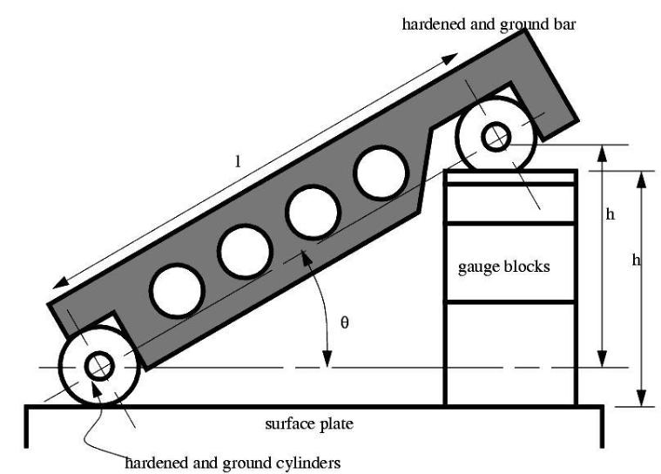

*Figure 2.13 Use of sine bar*

Where, L = distance between centers of ground cylinder (typically 5’’ or 10’’)

H = height of the gauge blocks

* =the angle of the plane
* = a sin (h/l)

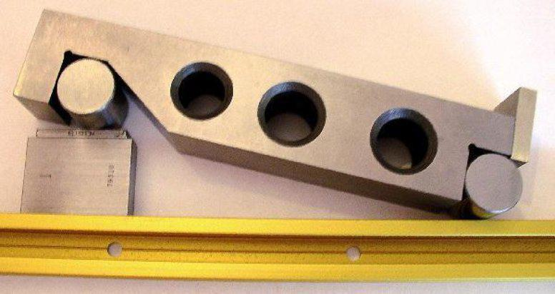

*Figure 2.14 Practical Application of sine bar*

**Use of sine bar:**

1. Measuring known angles or locating any work to a given angle. For this purpose the surface plate is assumed to be having a perfectly flat surface, so that its surface could be treated as horizontal.

One of the cylinders or rollers of sine bar is placed on the surface plate and other roller is placed on the slip gauges of height h. Let the sine bar be set at an angle q. Then sin = h/l, where l is the distance between the center of the rollers. Thus knowing, h can be found out and any work could be set at this angle as the top face of sine bar is inclined at angle  to the surface plate.

The use of angle plates and clamps could —also be made in case of heavy components.

For better results, both the rollers could also be placed on slip gaugesChecking of unknown angles. Many a times, angle of a component to be checked is unknown. In such a case, it is necessary to first find the angle approximately with the help of a bevel protector.

Let the angle be 8. Then the sine bar is set at an angle  and clamped to an angle plate. Next, the work is placed on sine bar and clamped to angle plate as shown in Fig. And a dial indicator is set at one end of the work and moved to the other, and deviation is noted. Again slip gauges are so adjusted (according to this deviation) that dial indicator reads zero across work surface. Fig.

If deviation noted down by the dial indicator is ôh over a length *l'* of work, then





height of slip gauges by which it should be adjusted is equal to = ôh x *l/l'*

Checking of unknown angles of heavy component. In such cases where components are heavy and can’t be mounted on the sine bar, then sine bar is mounted on the component as shown in Fig.

The height over the rollers can then be measured by a vernier height gauge; using a dial test gauge mounted on the anvil of height gauge as the fiducially indicator to ensure constant measuring pressure. The anvil on height gauge is adjusted with probe of dial test gauge showing same reading for the topmost position of rollers of sine bar. Fig. Surface plate shows the use of height gauge for obtaining two readings for either of the Fig. shows the use of height gauge for obtaining two readings for either of the roller of sine bar.

The difference of the two readings of height gauge divided by the centre distance of sine bar gives the sine of the angle of the component to be measured. Where greater accuracy is required, the position of dial test gauge probe can be sensed by adjusting a pile of slip gauges till dial indicator indicates same reading over roller of sine bar and the slip gauges.

**1.4 Angle Gauges**

* The first set of combination of angle gauges was devised by Dr. Tomlinson of N.P.L. With thirteen separate gauges used in conjunction with one square block and one parallel straight-edge, it is possible to set up any angle to the nearest 3” In the same way, as slip gauges are built up to give a linear dimension, I the angle gauges can be build up to give a required angle.
* Angle gauges PIVOT are made of hardened steel and seasoned carefully to ensure permanence of angular accuracy, and the measuring faces are lapped and polished to a high degree of accuracy and flatness like slip gauges. These gauges are about 3 inch (76.2 mm) long, 5/8 inch (15.87 mm) wide with their faces lapped to within 0.0002 mm and angle between the two ends to ±2 seconds.
* The secret of this system in having any angle in step of 3'’ is the adoption of a mathematical series of the values of the angles of various gauges of the set.
* The thirteen gauges can be divided into three series; degrees, minutes and fractions of a



minute. The gauges available in first series are of angle 10, 3 0, 90, 270, and 410. Second series comprises 1', 3', 9’and 27’angle gauges and this series has 0.05’, 0.1', 0.3’and 0.5’ (or 3”, 6”, 18” and 30”) angle gauges.

* All these angle gauges in combination can be added or subtracted, thus, making a large number of combinations possible. There are two sets of gauges available, designated as A and B. The standard A contains all the above 13 gauges. Standard B contains only 12 gauges and does not have, the 0.05' angle gauge.
* Direct combination enables computation of any angle up to 810 40.9’and angles larger than this can be made up with the help of the square block. However, an additional

gauge of 90 can also be supplied with the set to obtain a full 900 angle without the use of the square. Fig. illustrates how the gauges can be used in addition and subtraction. The procedure used for making various angles is as follows e.g. say, we have to build up an angle of 570 38’ 9”.

* First we pay our attention towards degree only. So 570 could be built up as 410 + 270 -90 + 10 - 30
* Next if the minutes are less than 40’, they could be built up directly, otherwise number

of degrees must be increased by 10 and the number of minutes necessary to correct the total is subtracted. Here now 34’could be built 27’+9’—3’+ 1' and lastly 9” is built up as 0.1'+ 0.05’.

* It may be noted that each angle gauge is marked with engraved V which indicates the

direction of included angle. When the angles of individual angle gauges are to be added up then the VS of all angle gauges should be in line and when any angle is to be subtracted, its engraved V should be in other direction.

* Thus it is seen that any angle could be made up but the block formed by the combination of a number of these gauges is rather bulky and, therefore, cannot be always directly applied to the work. But these gauges being used as reference and taking the aid of other angle measuring devices will be a good proposal at many places.
* Angle gauge blocks seem to lack the requisites for use as primary standards because errors are easily compounded when angle blocks are wrung in combination. Further the absolute verification of angle blocks is usually dependent on some other primary standard.



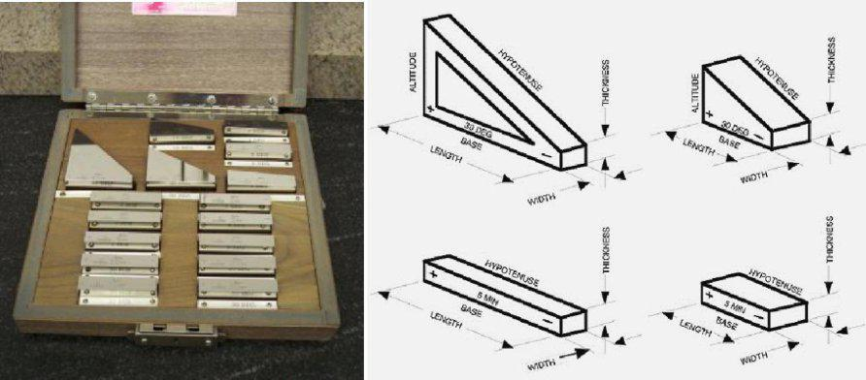

**.**

*Figure 2.15 Set of angle gauges*

**Uses of Angle Gauges**

* Direct use of angle gauges to measure the angle in the die insert:
* To test the accuracy of the angle in the die insert, the insert is placed against an illuminated glass surface plate or in front of an inspection light box. The combination of angle gauges is so adjusted and the built-up combination, of angle gauges carefully inserted in position so that no white light can be seen between the gauge faces and die faces. It may be noted that when all the engraved Vs on the angle gauges are in the

same line, all angles are added up. In case some engraved Vs on angle gauges are on other side, those angles are subtracted.

**Use of angle gauges with square plate:**

* As already indicated, the use of square plate increases the versatility of the application

of angle gauges. Generally, the square plate has its 900 angles guaranteed to within 2 seconds of arc. Where very high degree of accuracy is required, the four corners of the square plate are numbered as A, B, C and D, and a test certificate are issued with each set of angle gauges, giving the measured angle of each corner. The whole set up is placed against an illuminated glass surface plate. It may be noted that the use of slip gauges has to be made in order to facilitate the testing.

So far, we have used angle gauges to obtain a visual comparison of an angular dimension under test. It has also been realized that though it may be possible to obtain good results but it is difficult to give an estimate of the actual angular error. For very precise angular measurements, angle gauges are used in conjunction with angle dekkor.