Strain and Stress:
Measurement and Analysis

ε a =
dL / L
≈ (L2
− L1) / L1
= ΔL / L



ε_{a} = axial strain
L1 = linear dimension or gage length
L2 = final strained linear dimension

L2
D1
D2
L1
L2 – L1

E = σ a
ε a

E = Young’s modulus
σ_{a} = uniaxial stress
ν = − ε L
ε a

ν = Poisson’s ratio
ε_{L} = lateral strain

σ x
ε x =
−νσ y
E
σ y
ε y =
−νσ x

E

σ = E(ε x +νε y ) σ = E(ε y +νε x )
σy

εy
−ν οx
ο y
E
E

x 1−ν 2 y 1−ν 2

Strain Measurement
Extensometer Optical Mechanical
Electrical strain gage Resistive – the most common Capacitive

Inductive Photoelectric

Electrical Resistance Strain Gage

1856 Lord Kelvin demonstrated that the resistances of copper wire and iron wire change when the wires are subjected to mechanical strain

He used a Wheatstone bridge circuit with a galvanometer as the indicator

The first resistance strain gage is made by Carlson in 1931

Pillars were mounted, separated by the gage length, with wires stretched between them
The first bonded strain gage was used by Bloach
It consisted of a carbon film resistance element applied directly to the surface of the strained member

1938 Ruge of M.I.T. conceived the idea of making a preassembly by mounting wire between thin pieces of paper

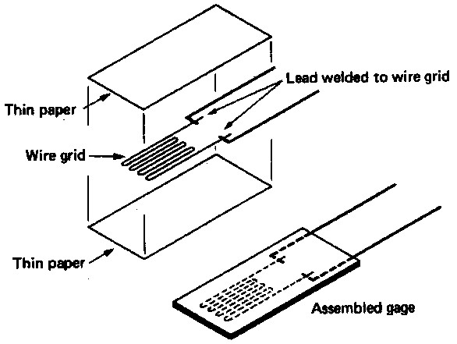

Construction of bonded-wire-type strain gage

Foil-Type Gage

During the 1950s the foil-type gage replaced the the wire gage
The common form consists of a metal foil element on a thin epoxy support

Manufactured using printed-circuit techniques
Major advantage – almost unlimited pane configurations are possible

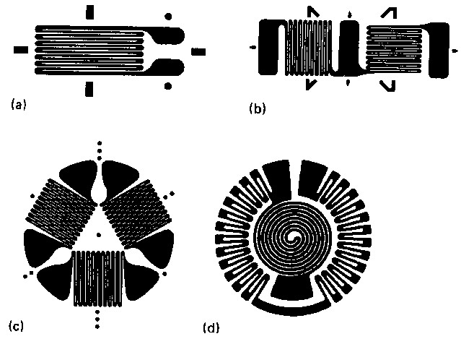

Typical foil-type gages illustrating the following types: (a) single element, (b) two-element rosette, (c) three-element rosette, (d) one example of many different special purpose gages

www.jntuworld.com || www.android.jntuworld.com || www.jwjobs.net || www.android.jwjobs.net

The gage factor
R = ρL
A
= ρL
CD2

F = dR / R
= dR / R
= 1+ 2ν
+ dρ / ρ

dL / L

ε a
ε = 1 ΔR

F R
dL / L

The values of F and R are supplied by the gage manufacturer, and the user determines ΔR corresponding to the input situation being measured.

Selection and Installation Factors
for Bonded Metallic Strain Gages

Grid material and configuration Backing material
Bonding material and method Gage protection
Associated electrical circuitry

Desirable Properties of Grid
Material

High gage factor, F
High sensitivity, ρ
Low temperature sensitivity High electrical stability High yield strength
High endurance limit

Good workability
Good solderability or weldability Low hysteresis
Low thermal emf when joined to other materials
Good corrosion resistance

Temperature Sensitivity

In many applications, compensation is provided in the electrical circuitry – this does not always eliminate the problem
Two factors are involved:

The differential expansion existing between the grid support and the grid proper, resulting in a strain that the gage is unable to distinguish from load strain
The change in resistivity ρ with temperature change

Thermal emf Effect

Thermal emf superimposed on gage output must be avoided if dc circuitry is used
For ac circuitry this factor would be of little importance

Common Grid Materials

Constantan*; Copel* 45% Ni, 55% Cu
Isoelastic* 36% Ni, 8% Cr, 0.5% Mo, Fe remainder

*Trade names

Common Backing Materials

Thin paper
Phenolic-impregnated paper Epoxy-type plastic films Epoxy-impregnated fiberglass

Most foil gages use an epoxy film backing

Protecting the Strain Gage

The strain gages must be protected from ambient conditions:

Mechanical abuse, moisture, oil, dust and dirt
Protection material:
Petroleum waxes, silicone resins, epoxy preparations, rubberized brushing compounds

Temperature Compensation

The adjacent-arm compensating gage – bridge circuitry
Self-temperature compensation

Selected-melt gage
- Through proper manipulation of alloy and processing, grid materials may be prepared to show very low apparent strain versus temperature change
Dual-element gage
- Use two wire elements connected in series in one gage assembly
- The two elements have different temperature characteristics and are selected so that the net temperature-induced strain is minimized

Strain-Measuring Systems

Basic strain indicator, useful for static: single-channel readings
Single-channel system either external to or an integral part of a cathode-ray oscilloscope
Oscillographic systems incorporating either a stylus-and-paper or lightbeam and phtographic paper readout

Data acquisition systems:

Displayed (digitally and/or by a video terminal) Recorded (magnetic tape or hard-copy printout) Fed back into the system for control purpose

Stress-Strain Relationships

Simple uniaxial stress situation Biaxial stress situation

Stress-strain relations for Rosette gages (T 12.4)
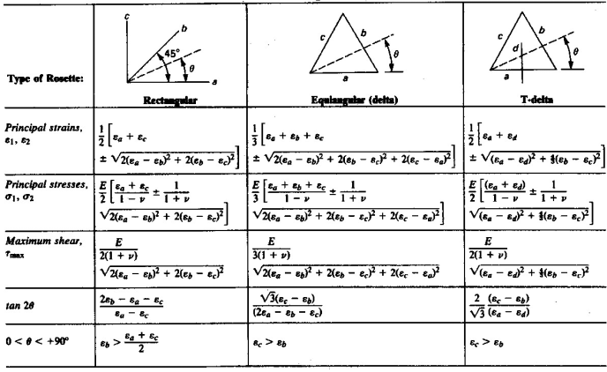

Gage Orientation and
Interpretation of Results
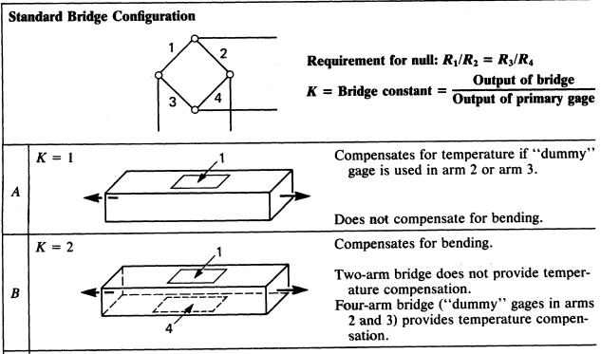

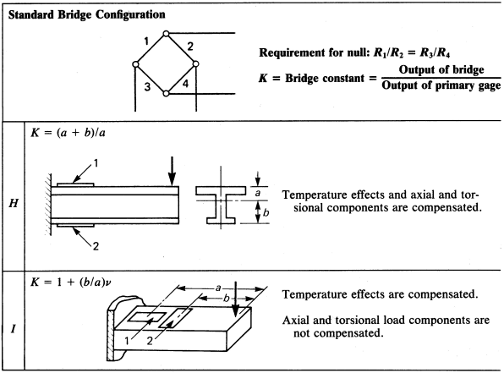

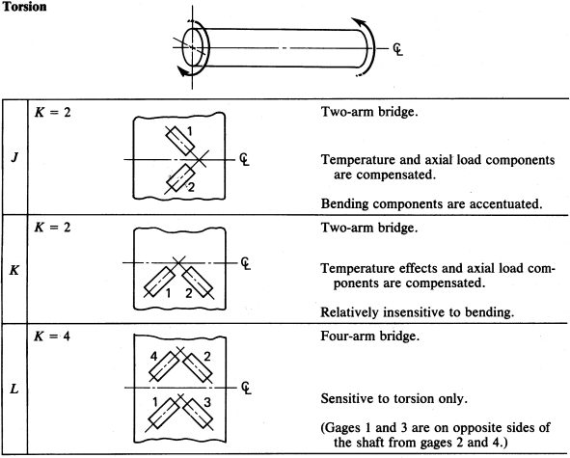

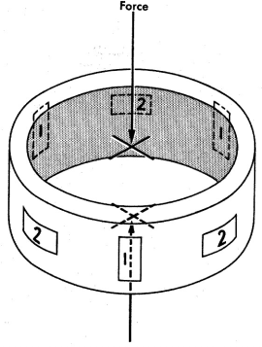Gages Connected in Series

Load cell employing three series-connected axial gages and three series-connected Poisson-ratio gages

Measurement of Force

Mechanical weighing systems

Balance, multiple-lever system, pendulum force-measuring mechanism
Elastic transducers
Proving ring
Strain-gage load cells Piezoelectric-type load cells Hydraulic and pneumatic systems

Proving Ring

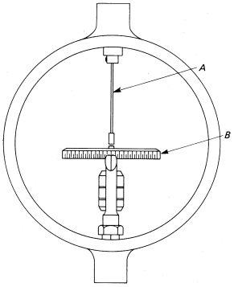
Compression-tywpwwe.jnptuwroorldv.cionmg|| wrwiwn.jwgjobws.neitth vibrating reed

Deflection is used as the measure of applied load, with the deflection measured by means of a precision micrometer

Strain-Gage Load Cells

Measures load in terms of unit strain
One of the possible forms of elastic member is selected, and the gages are mounted to provide maximum output

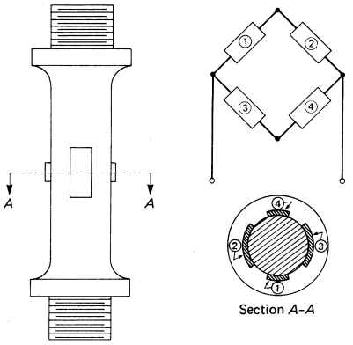

Tension-compression resistance strain-gage load cell

(a) The bridge output is a function of the bending strains only, the axial components being canceled in the bridge arrangement
(b) Greater sensitivity may be obtained because the output includes both the bending and the axial components sensed by gages 1 and 4

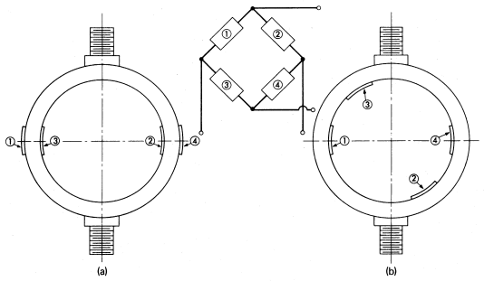
Two arrangements of circular-shaped load cells employing resistance strain gages as secondary transducers

Hydraulic Load Cell

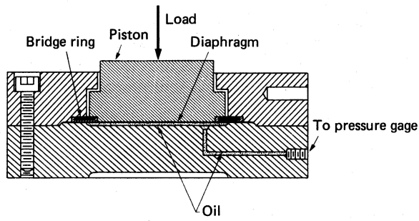

Section through a hydraulic load cell

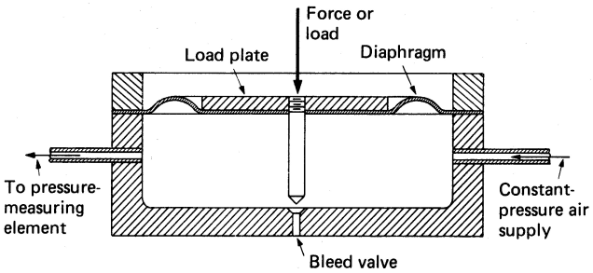

Section through a pneumatic load cell

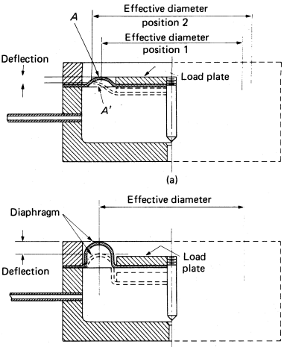

Section through a diaphragm showing how a change in effective area may take place.
- When sufficient “roll” is provided, the effective area remains constant

Pneumatic Load Cell

Use air rather than liquid as the pressurized medium
Use diaphragms of a flexible material rather than pistons

Designed to regulate the balancing pressure automatically

Air pressure is supplied to one side of the diaphragm and allowed to escape through a position-controlling bleed valve
The pressure under the diaphragm is controlled both by source pressure and bleed valve position
The diaphragm seeks the position that will result in just the proper air pressure to support the load

Measurement of Pressure

Absolute pressure Gage pressure Vacuum

Pressure-Measuring Transducers

Gravitational types

Liquid columns
Pistons or loose diaphragm, and weights

Direct-acting elastic types Unsymmetrically loaded tubes Symmetrically loaded tubes Elastic diaphragms

Bellows
Bulk compression
Direct-acting elastic type, a piston with elastic restraining member

Elastic Diaphragms

Use elastic diaphragm as primary pressure transducer
Flat type –

Used in conjunction with electrical secondary transducers whose sensitivity permits quite small diaphragm deflections
Corrugated type is particularly useful when larger deflections are required

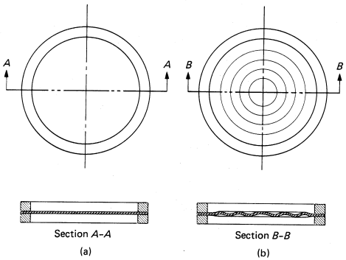

(a) Flat diaphragm (b) Corrugated diaphragm

Diaphragm Design Requirements

Dimensions and total load must be compatible with physical properties of the material used
Flexibility must be such as to provide the sensitivity required by the secondary transducer
Volume of displacement should be minimized to provide reasonable dynamic response

Diaphragm displacement may be transmitted by mechanical means to some form of indicators
For engineering measurements, diaphragm motion is sensed by some form of electrical secondary transducer

Resistive, capacitive, inductive, or piezoelectric

Natural frequency of the diaphragm should be sufficiently high to provide satisfactory frequency response
Output should be linear

Flat Metal Diaphragm

Deflection of flat metal diaphragm is limited either by stress requirements or deviation from linearity
As a general rule the maximum deflection that can be tolerated maintaining a linear pressure-displacement relation is about 30% of the diaphragm thickness

Secondary Transducers Used
with Diaphragms

Resistance strain gages with flat diaphragms Inductive types
Piezoelectric-type pressure cells

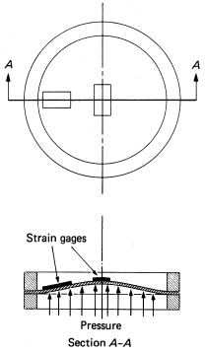
Resistance Strain Gages

Location of strain gages on flat diaphragm

The central gage is subjected to tension while the outer gage senses compression

Apply strain gage directly to a diaphragm surface and calibrate the measured strain in terms of pressure
Drawback – the small physical area available for mounting the gages

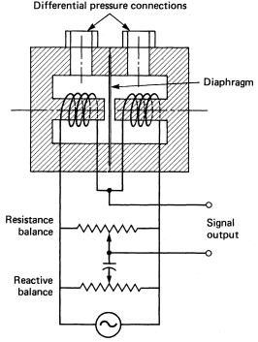
Inductive Types

Differential pressure cell with inductance- type secondary transducer

Flexing the diaphragm due to applied pressure causes it to move toward on pole piece and away from the other 
Altering the relative inductances
Standard laboratory equipment, such as an oscilloscope or electronic voltmeter, as well as recorders, may be used to display the gage output

Cylindrical-Type Pressure Cell
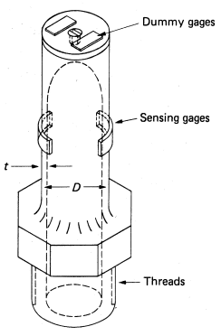

Measurement of Motion

Displacement Velocity Acceleration Jerk

Human Touch

In spite of the tremendous advances made in vibration-measuring instrumentation, one of the most sensitive vibration detectors is the human touch
Fingertips – sinusoidal vibrations having amplitudes as low as 12 μ in
Vibrating member tightly gripped – average minimum detectable amplitude was only slightly greater than 1 μ in
Greatest sensitivity occurred at a frequency of about 300 Hz

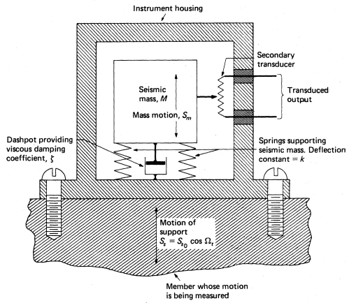

Seismic type of motion-measuring instrument

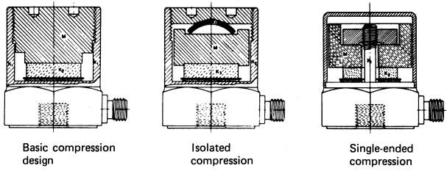

Typical piezoelectric-type accelerometer designs

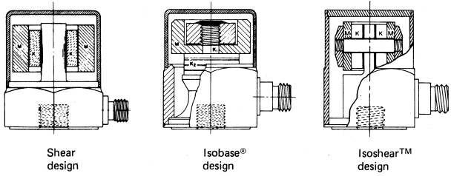

Advantages of Piezoelectric-
Type Accelerometers

High sensitivity Extreme compactness Ruggedness

