1.Define data mining

Data mining is a process of extracting or mining knowledge from huge amount of data.

2.Define pattern evaluation

Pattern evaluation is used to identify the truly interesting patterns representing knowledge based on some interesting measures.

3.Define knowledge representation

Knowledge representation techniques are used to present the mined knowledge to the user.

4.List the five primitives for specification of a data mining task.
task-relevant data
kind of knowledge to be mined
background knowledge
interestingness measures

knowledge presentation and visualization techniques to be used for displaying the discovered patterns

5.What is Visualization?

Visualization is for depiction of data and to gain intuition about data being observed. It assists the analysts in selecting display formats, viewer perspectives and data representation schema
Mention some of the application areas of data mining
DNA analysis
Market analysis
Financial data analysis
Banking industry
Retail Industry
Health care analysis.
Telecommunication industry

6.Define data cleaning

Data cleaning means removing the inconsistent data or noise and collecting necessary information

7.Define Data integration.
Integration of multiple databases, data cubes, or files

8.Why we need Data transformation

Smoothing: remove noise from data min-max normalization
Aggregation: summarization, data z-score normalization cube construction normalization by decimal scaling
Generalization: concept hierarchy Attribute/feature construction climbing
Normalization: scaled to fall within a New attributes constructed from the given ones small, specified range

9.Define Data reduction.

Data reduction Obtains reduced representation in volume but produces the same or similar analytical results.

10.What is meant by Data discretization

It can be defined as Part of data reduction but with particular importance, especially for numerical data

11.What is the discretization processes involved in data preprocessing?

It reduces the number of values for a given continuous attribute by dividing the range of the attribute into intervals. Interval labels can then be used to replace actual data values.

12.Define Concept hierarchy.

It reduce the data by collecting and replacing low level concepts (such as numeric values for the attribute age) by higher level concepts (such as young, middle-aged, or senior).

13.Why we need data preprocessing. Data in the real world is dirty

incomplete: lacking attribute values, lacking certain attributes of interest, or containing only aggregate data

noisy: containing errors or outliers
inconsistent: containing discrepancies in codes or names

14.Give some data mining tools.
DBMiner
GeoMiner
Multimedia miner
WeblogMiner

15.Describe the use of DBMiner.

Used to perform data mining functions, including characterization, association, classification, prediction and clustering.

16.Applications of DBMiner.
The DBMiner system can be used as a general-purpose online analytical mining system for both OLAP and data mining in relational database and data ware houses. Used in medium to large relational databases with fast response time.

17.What are the types of knowledge to be mined?

Characterization
Discrimination
Association
Classification
prediction
▪
Clustering
Outlier analysis
Other data mining tasks

18.Define Relational databases.

A relational database is a collection of tables, each of which is assigned a unique name. Each table consists of a set of attributes (columns or fields) and usually stores a large set of tuples(records or rows).Each tuple in a relational table represents an object identified by a unique key and described by a set of attribute values.

19.Define Transactional Databases.

A transactional database consists of a file where each record represents a transaction. A transaction typically includes a unique transaction identity number (trans_ID), and a list of the items making up the transaction.

21. Define Spatial Databases.

Spatial databases contain spatial-related information. Such databases include geographic (map) databases, VLSI chip design databases, and medical and satellite image databases. Spatial data may be represented in raster format, consisting of n-dimensional bit maps or pixel maps.

22. What is Temporal Database?
Temporal database store time related data .It usually stores relational data that include time related attributes. These attributes may involve several time stamps, each having different semantics.

23. What are Time-Series databases?

A Time-Series database stores sequences of values that change with time,such as data collected regarding the stock exchange.

24. What is Legacy database?

A Legacy database is a group of heterogeneous databases that combines different kinds of data systems, such as relational or object-oriented databases, hierarchical databases, network databases, spread sheets, multimedia databases or file systems.

25 What are the steps in the data mining process?
Data cleaning
Data integration
Data selection
Data transformation
Data mining
Pattern evaluation
Knowledge representation
What is Characterization?
It is a summarization of the general characteristics or features of a target class of data.
27. What is Discrimination?

It is a comparison of the general features of target class data objects with the general features of objects from one or a set of contrasting classes.

28. What is Classification?

Classification is the process of finding a model (or function) that describes and distinguishes data classes or concepts, for the purpose of being able to use the model to predict the class of objects whose class label is unknown. The derived model is based on the analysis of a set of training data

29.What are the classification of data mining system

Classification according to the kinds of databases mined
Classification according to the kinds of knowledge mined
Classification according to the kinds of techniques utilized
Classification according to the applications adapted:

30 what are the scheme of integrating data mining system with a data warehouse

No coupling
Loose coupling:
Semi tight coupling
Tight coupling

31.What are the issues of data mining

Mining methodology and user interaction issues
Mining different kinds of knowledge in databases:

Interactive mining of knowledge at multiple levels of abstraction
Incorporation of background knowledge
Data mining query languages and ad hoc data mining
Presentation and visualization of data mining results
Handling noisy or incomplete data
Pattern evaluation

Performance issues:
Efficiency and scalability of data mining algorithms

Parallel, distributed, and incremental mining algorithms

Issues relating to the diversity of database types: Handling of relational and complex types of data

Mining information from heterogeneous databases and global information systems

32.What is data pre processing.

The real world data’s are normally noise data so before organizing the data warehouse we need to Preprocess the data

33.What is preprocessing technique?

Data cleaning
Data integration
Data transformation
Data reduction
Define data cleaning
Data cleaning means removing the inconsistent data or noise and collecting necessary information

34.Define Data integration.
Integration of multiple databases, data cubes, or files

35.Why we need Data transformation

Smoothing: remove noise from data
Aggregation: summarization, data cube construction
Generalization: concept hierarchy climbing
Normalization: scaled to fall within a small, specified range
Min-max normalization
Z-score normalization
Normalization by decimal scaling

Attribute/feature construction: New attributes constructed from the given ones

36.Define Data reduction.

Data reduction Obtains reduced representation in volume but produces the same or similar analytical results.

37.What is meant by Data discretization

It can be defined as Part of data reduction but with particular importance, especially for numerical data

38.What is the discretization processes involved in data preprocessing?

It reduces the number of values for a given continuous attribute by dividing the range of the attribute into intervals. Interval labels can then be used to replace actual data values.

39.Define Concept hierarchy.

It reduce the data by collecting and replacing low level concepts (such as numeric values for the attribute age) by higher level concepts (such as young, middle-aged, or senior).

40.Why we need data preprocessing. Data in the real world is dirty

incomplete: lacking attribute values, lacking certain attributes of interest, or containing only aggregate data

noisy: containing errors or outliers
inconsistent: containing discrepancies in codes or names

Knowledge Discovery in Databases(KDD)
Some people treat data mining same as Knowledge discovery while some people view dataminingessentialstepinprocessofknowledgediscovery.Hereisthelistofstepsinvolvedinknowledgediscoveryprocess:

DataCleaning-Inthisstepthenoiseandinconsistentdataisremoved.
DataIntegration- Inthisstepmultipledatasourcesarecombined.
DataSelection - Inthissteprelevanttotheanalysistaskareretrievedfromthedatabase.Data Transformation - In this step data are transformed or consolidated into formsappropriate forminingbyperformingsummaryoraggregationoperations.
Data Mining- Inthisstepintelligentmethodsareappliedinordertoextractdatapatterns.
Pattern Evaluation - Inthisstep, datapattern sareevaluated.
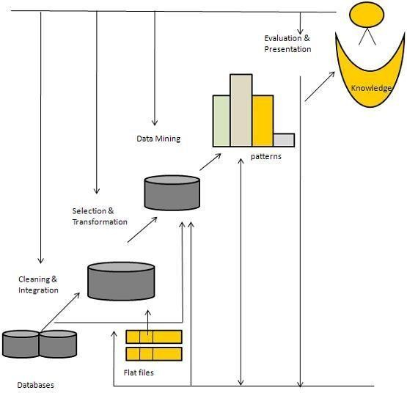
Knowledge Presentation-In this step, knowledge is represented

ArchitectureofKDD

WhatIsDataMining?

Data mining refers to extracting or mining knowledge from large amounts of data. The term isactuallyamisnomer.Thus,dataminingshouldhavebeenmoreappropriatelynamedasknowledgeminingwhichemphasis on miningfromlargeamountsof data.

It is the computational process of discovering patterns in large data sets involving methods at theintersectionofartificialintelligence,machinelearning,statistics,anddatabasesystems.
The overallgoalof thedata miningprocessistoextractinformationfroma data setandtransformit into an understandablestructureforfurther use.

The key properties of data mining areAutomatic discovery of patternsPrediction of likely outcomesCreation of actionable informationFocusonlargedatasetsanddatabases

TheScopeofDataMining

Data mining derives its name from the similarities between searching for valuable businessinformation in a large database — for example, finding linked products in gigabytes of storescanner data — and mining a mountain for a vein of valuable ore. Both processes require eithersifting through an immense amount of material, or intelligently probing it to find exactly wherethe value resides. Given databases of sufficient size and quality, data mining technology cangeneratenewbusiness opportunities byprovidingthesecapabilities:
Automated prediction of trends and behaviors.Data mining automates the process of findingpredictive information in large databases. Questions that traditionally required extensive hands-on analysis can now be answered directly from the data — quickly. A typical example of apredictive problem is targeted marketing. Data mining uses data on past promotional mailings toidentify the targets most likely to maximize return on investment in future mailings. Otherpredictive problems include forecasting bankruptcy and other forms of default, and identifyingsegmentsof apopulationlikelytorespondsimilarlytogiven events.

Automated discovery of previously unknown patterns.Data mining tools sweep throughdatabases and identify previously hidden patterns in one step. An example of pattern discovery isthe analysis of retail sales data to identify seemingly unrelated products that are often purchasedtogether. Other pattern discovery problems include detecting fraudulent credit card transactionsandidentifyinganomalous data that could represent dataentrykeyingerrors.

TasksofDataMining
Datamininginvolvessixcommonclassesoftasks:
Anomalydetection(Outlier/change/deviationdetection)–Theidentificationofunusualdatarecords,thatmightbeinterestingordataerrorsthatrequirefurtherinvestigation.
Associationrulelearning(Dependencymodelling)–Searchesforrelationshipsbetween variables. For example a supermarket might gather data on customer purchasinghabits. Using association rule learning, the supermarket can determine which products arefrequently boughttogetherandusethisinformationfor marketing purposes.Thisissometimesreferred to asmarket basketanalysis.
Clustering – is the task of discovering groups and structures in the data that are in somewayor another "similar",without usingknown structuresin thedata.

Classification – is the task of generalizing known structure to apply to new data. Forexample, an e-mail program might attempt to classify an e-mail as "legitimate" or as"spam".
Regression–attemptstofindafunctionwhichmodelsthedatawiththeleasterror.
Summarization – providing a more compact representation of the data set, includingvisualizationand reportgeneration.

ArchitectureofDataMining

Atypical dataminingsystem mayhavethe followingmajorcomponents.

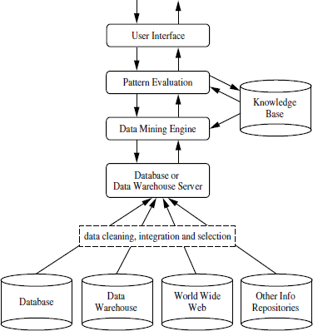

KnowledgeBase:

This is the domain knowledge that is used to guide the search or evaluate theinterestingnessofresultingpatterns.Suchknowledgecanincludeconcepthierarchies,
used to organize attributes or attribute values into different levels of abstraction.Knowledgesuchasuserbeliefs,whichcanbeusedtoassessapattern’sinterestingness based on its unexpectedness, may also be included. Other examples ofdomainknowledgeareadditionalinterestingnessconstraintsorthresholds,andmetadata(e.g., describingdatafrommultipleheterogeneoussources).

DataMiningEngine:

This is essential to the data mining system and ideally consists of a set of functionalmodulesfortaskssuchascharacterization,associationandcorrelationanalysis,classification,prediction,clusteranalysis,outlieranalysis,andevolutionanalysis.

PatternEvaluationModule:

This component typically employs interestingness measures interacts with the datamining modules so as to focus the search toward interesting patterns. It may useinterestingness thresholds to filter out discovered patterns. Alternatively, the patternevaluation module may be integrated with the mining module, depending on theimplementation of the datamining method used. For efficient data mining, it is highlyrecommendedto pushthe evaluation of patterninterestingnessas deepas possibleintothe miningprocess asto confine thesearch toonlythe interestingpatterns.

Userinterface:

This module communicates between users and the data mining system,allowing theuser to interact with the system by specifying a data mining query or task, providinginformation to help focus the search, and performing exploratory datamining based onthe intermediate data mining results. In addition, this component allows the user tobrowsedatabaseanddatawarehouseschemasordatastructures,evaluateminedpatterns,and visualizethe patterns in different forms.

DataMiningProcess:

DataMiningisaprocessofdiscoveringvariousmodels,summaries,andderivedvaluesfromagiven collection ofdata.
The general experimental procedure adapted to data-mining problems involves the followingsteps:

Statetheproblemandformulatethehypothesis

Mostdata-basedmodeling studiesareperformedinaparticularapplicationdomain.Hence, domain-specific knowledge and experience are usually necessary in order to comeup with a meaningful problem statement. Unfortunately, many application studies tend tofocus on the data-mining technique at the expense of a clear problem statement. In thisstep, a modeler usually specifies a set of variables for the unknown dependency and, ifpossible, a general form of this dependency as an initial hypothesis. There may be severalhypotheses formulated for a single problem at this stage. The first step requires thecombined expertise of an application domain and a data-mining model. In practice, itusually means a close interaction between the data-mining expert and the applicationexpert. In successful data-mining applications, this cooperation does not stop in the initialphase;it continuesduringtheentiredata-mining process.

Collectthedata

This step is concerned with how the data are generated and collected. In general, there aretwodistinct possibilities.Thefirstiswhenthedata-generationprocessisunderthecontrol of an expert (modeler): this approach is known as a designed experiment. Thesecond possibility is when the expert cannot influence the data- generation process: this isknown as the observational approach. An observational setting, namely, random datageneration,isassumed inmost data-miningapplications.Typically,the sampling
distribution is completely unknown after data are collected, or it is partially and implicitlygiven in the data-collection procedure. It is very important, however, to understand howdata collection affects its theoretical distribution, since such a priori knowledge can bevery useful for modeling and, later, for the final interpretation of results. Also, it isimportant to make sure that the data used for estimating a model and the data used laterfor testing and applying a model come from the same, unknown, sampling distribution. Ifthis is not the case, the estimated model cannot be successfully used in a final applicationoftheresults.

Preprocessingthedata

In the observational setting, data are usually "collected" from the existing databases, datawarehouses, and data marts. Data preprocessing usually includes at least two commontasks:

- Outlier detection (and removal) – Outliers are unusual data values that are notconsistentwithmostobservations.Commonly,outliersresultfrommeasurementerrors, coding and recording errors, and, sometimes, are natural, abnormal values.Such non representative samples can seriously affect the model produced later. Therearetwo strategies for dealingwithoutliers:

- Detectand eventuallyremove outliersasapartof the preprocessingphase,or
- Developrobustmodelingmethodsthat areinsensitivetooutliers.

- Scaling, encoding, and selecting features – Data preprocessing includes several stepssuch as variable scaling and different types ofencoding.For example, one feature withthe range [0, 1] and the other with the range [−100, 1000] will not have the same weightsin the applied technique; they will also influence the final data-mining results differently.Therefore,itisrecommendedtoscalethemandbringbothfeaturestothesameweightforfurther analysis. Also,application-specificencodingmethods usuallyachieve
dimensionalityreductionbyprovidingasmallernumberofinformativefeaturesforsubsequentdatamodeling.
These twoclassesofpreprocessingtasksareonlyillustrativeexamplesofalargespectrumof preprocessing activities in a data-miningprocess.
Data-preprocessing steps should not be considered completely independent from otherdata-mining phases. In every iteration of the data-mining process, all activities, together,could define new and improved data sets for subsequent iterations. Generally, a goodpreprocessing method provides an optimal representation for a data-mining technique byincorporatingaprioriknowledgeintheformofapplication-specificscalingandencoding.

Estimatethemodel

The selection and implementation of the appropriate data-mining technique is the maintaskinthisphase.Thisprocessisnotstraightforward;usually,inpractice,theimplementation is based on several models, and selecting the best one is an additionaltask. The basic principles of learning and discovery from data are given in Chapter 4 ofthis book. Later, Chapter 5 through 13 explain and analyze specific techniques that areapplied to perform a successful learning process from data and to develop an appropriatemodel.

Interpretthemodelanddrawconclusions

In most cases, data-mining models should help in decision making. Hence, such modelsneed to be interpretable in order to be useful because humans are not likely to base theirdecisions on complex "black-box" models. Note that the goals of accuracy of the modeland accuracy of its interpretation are somewhat contradictory. Usually, simple models aremore interpretable, but they are also less accurate. Modern data-mining methods areexpected to yield highly accurate results using high dimensional models. The problem ofinterpretingthesemodels,alsoveryimportant, isconsideredaseparatetask,withspecific
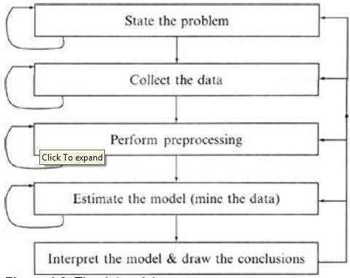
techniques to validate the results. A user does not want hundreds of pages of numericresults. He does not understand them; he cannot summarize, interpret, and use them forsuccessfuldecision making.

TheDataminingProcess

ClassificationofDataminingSystems:
Thedataminingsystemcan be classified accordingto thefollowingcriteria:DatabaseTechnology
StatisticsMachineLearning
Information ScienceVisualization
OtherDisciplines

SomeOtherClassificationCriteria:

Classification according to kind of databases minedClassification according to kind of knowledge minedClassificationaccordingtokindsoftechniquesutilizedClassificationaccordingtoapplicationsadapted

Classificationaccordingtokindofdatabasesmined

We can classify the data mining system according to kind of databases mined. Database systemcan be classified according to different criteria such as data models, types of data etc. And thedata mining systemcanbe classifiedaccordingly.For example ifweclassify the databaseaccording to data model then we may have a relational, transactional, object- relational, or datawarehouseminingsystem.

Classification according to kind of knowledge mined

Wecanclassifythedata miningsystemaccordingtokindofknowledgemined.Itismeansdataminingsystemareclassified on thebasis of functionalitiessuchas:

Characterization
Discrimination
AssociationandCorrelationAnalysisClassification
Prediction
clustering
Outlier AnalysisEvolutionAnalysis

Classificationaccordingtokindsoftechniquesutilized

Wecanclassifythe data miningsystemaccording tokindoftechniquesused.Wecan describesthese techniques according to degree of user interaction involved or the methods of analysisemployed.

Classificationaccordingtoapplicationsadapted

Wecanclassifythedata miningsystemaccordingtoapplicationadapted.Theseapplicationsareasfollows:

FinanceTelecommunicationsDNA
Stock MarketsE-mail

DataPreprocessing:

DataIntegration:

Itcombinesdatafrommultiplesourcesintoacoherentdatastore,asindatawarehousing. Thesesourcesmayincludemultiple databases,datacubes,or flat files.
Thedataintegrationsystemsareformallydefined astriple<G,S,M>WhereG:Theglobal schema
S:Heterogeneoussourceofschemas

M:Mappingbetweenthequeriesofsource and globalschema

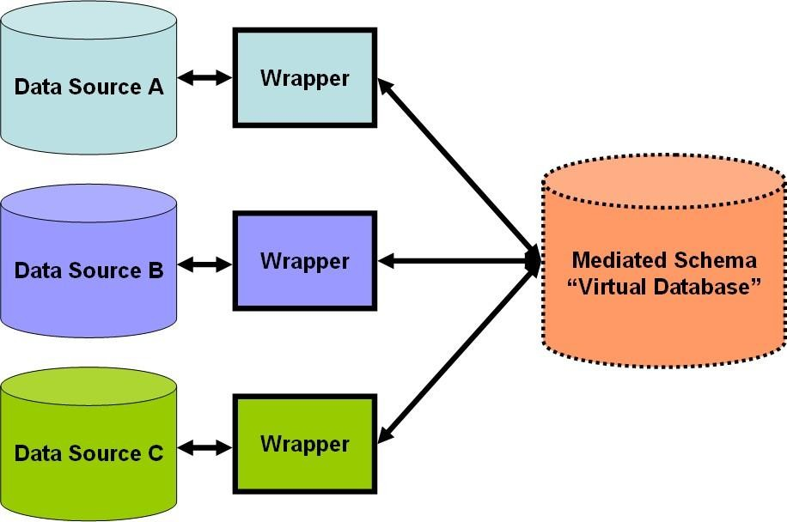

IssuesinDataintegration:

Schemaintegrationandobjectmatching:

Howcanthedataanalystorthecomputerbesurethatcustomeridinonedatabaseandcustomernumber in another referenceto thesameattribute.

Redundancy:

An attribute (such as annual revenue, for instance) may be redundant if it can be derivedfromanotherattributeorsetofattributes.Inconsistenciesinattributeordimensionnamingcan also causeredundanciesin theresultingdataset.

detectionandresolutionof datavalueconflicts:

Forthesamereal-worldentity,attributevaluesfrom differentsourcesmaydiffer.

DataTransformation:

In data transformation, the data are transformed or consolidated into forms appropriate formining.
Datatransformationcaninvolvethefollowing:

Smoothing,whichworkstoremovenoisefrom thedata.Suchtechniquesincludebinning,regression, andclustering.
Aggregation, where summary or aggregation operations are applied to the data. Forexample, the daily sales data may be aggregated so as to compute monthly and annualtotal amounts. This step is typically used in constructing a data cube for analysis of thedataat multiplegranularities

Generalizationof thedata,wherelow-level or ―primitive‖(raw) data are replaced by higher-level concepts through the use of concept hierarchies. For example, categoricalattributes,likestreet, canbegeneralized tohigher-levelconcepts, likecityorcountry.
Normalization, where the attribute data are scaled so as to fall within a small specifiedrange,suchas1:0 to 1:0, or0:0 to 1:0.
Attribute construction (or feature construction),where new attributes are constructedandadded from the givenset ofattributesto help theminingprocess.

DataReduction:

Data reduction techniques can be applied to obtain a reduced representation of the data set that ismuch smaller in volume, yet closely maintains the integrity of the original data. That is, miningon the reduced data set should be more efficient yet produce the same (or almost the same)analyticalresults.
Strategiesfordatareductionincludethefollowing:
Data cube aggregation, where aggregation operations are applied to the data in theconstruction ofadatacube.
Attribute subset selection, where irrelevant, weakly relevant, or redundant attributes ordimensionsmaybedetected andremoved.
Dimensionality reduction, where encoding mechanisms are used to reduce the datasetsize.
Numerosityreduction,where the data are replaced or estimated by alternative, smallerdatarepresentationssuchasparametricmodels(whichneedstoreonlythemodelparametersinsteadoftheactualdata)ornonparametricmethodssuchasclustering,sampling,and the useofhistograms.
Discretization and concept hierarchy generation,where raw data values for attributesare replacedby rangesor higherconceptuallevels.Data discretizationisa formofnumerosityreductionthatisveryusefulfortheautomaticgenerationofconcepthierarchies.Discretizationandconcepthierarchygenerationarepowerfultoolsfordatamining,in that theyallow theminingofdataat multiplelevelsofabstraction.
.

UNIT-III

AssociationRuleMining:
Associationruleminingisapopularandwellresearchedmethodfordiscoveringinterestingrelationsbetween variablesin largedatabases.
Itisintendedtoidentifystrongrulesdiscoveredindatabasesusingdifferentmeasuresofinterestingness.
Basedontheconceptofstrongrules,RakeshAgrawaletal.introduced associationrules.

ProblemDefinition:
Theproblemofassociation ruleminingisdefinedas:
Letbe aset of binaryattributescalleditems.
Letbe a set of transactions called thedatabase.
Eachtransactioninhasa uniquetransactionID andcontainsasubsetofthe itemsin.
Aruleisdefinedas animplicationoftheform whereand.
Thesetsofitems(forshortitemsets)andarecalledantecedent(left-hand-sideorLHS)and
consequent(right-hand-sideorRHS)oftherulerespectively.

Example:
To illustrate theconcepts,we usea smallexample fromthe supermarketdomain. Thesetofitems is and a small database containing the items (1codespresenceand 0absenceofanitem in atransaction)is showninthetable.
An example rule for the supermarket could bemeaning that ifbutter and bread arebought, customers also buymilk.

Exampledatabasewith4itemsand5transactions

TransactionID | milk | bread | butter | beer
1 | 1 | 1 | 0 | 0
2 | 0 | 0 | 1 | 0
3 | 0 | 0 | 0 | 1
4 | 1 | 1 | 1 | 0
5 | 0 | 1 | 0 | 0

ImportantconceptsofAssociationRuleMining:

Thesupportofanitemset is defined as the proportion of transactions in thedata set which contain the itemset. In the example database, the itemset
hasasupportof sinceitoccursin20%of alltransactions(1 out of5transactions).

Theconfidenceofaruleisdefined

.

For example, the rule hasaconfidenceof inthedatabase,whichmeansthatfor100%ofthetransactionscontaining butter and bread the rule is correct (100% of the times a customer buys butterand bread, milk is bought as well). Confidence can be interpreted as an estimate of theprobability,theprobability offinding theRHSoftheruleintransactionsunderthecondition that thesetransactions also contain theLHS.

Theliftof aruleis definedas
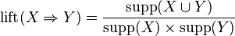

ortheratiooftheobservedsupporttothatexpectedifXandY wereindependent.The
rule hasalift of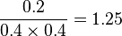.Theconvictionof aruleis definedas

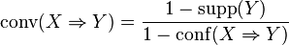.
Therule hasaconvictionof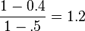,
andcanbeinterpretedastheratiooftheexpectedfrequencythatXoccurswithoutY(that is to say, the frequency that the rule makes an incorrect prediction) if X and Y wereindependent divided bytheobservedfrequencyofincorrectpredictions.

Marketbasketanalysis:

This processanalyzes customer buying habits by finding associations between the different itemsthatcustomersplaceintheirshoppingbaskets.Thediscoveryofsuchassociationscanhelpretailersdevelopmarketingstrategiesbygaininginsightintowhichitemsarefrequentlypurchased together by customers. For instance, if customers are buyingmilk, how likely are theyto also buy bread (and what kind of bread) on the same trip to the supermarket. Such informationcanleadtoincreased salesbyhelpingretailersdoselectivemarketingandplan theirshelfspace.

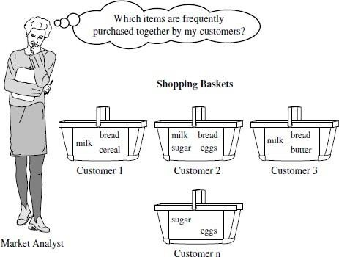

Example:

If customers who purchase computers also tend to buy antivirussoftware at the same time, thenplacing the hardware display close to the software displaymay help increase the sales of bothitems. In an alternative strategy, placing hardware andsoftware at opposite ends of the store mayentice customers who purchase such items topick up other items along the way. For instance,after deciding on an expensive computer,a customer may observe security systems for sale whileheading toward the software displayto purchase antivirus software and may decide to purchase ahome security systemas well. Market basket analysis can also help retailers plan which items toput on saleat reduced prices. If customers tend to purchase computers and printers together,thenhavingasale on printers mayencouragethesale ofprintersaswell ascomputers.

FrequentPatternMining:

Frequentpatternminingcanbeclassifiedinvariousways,basedonthe followingcriteria:

Basedonthecompletenessofpatternstobe mined:

We can mine the complete set of frequent itemsets, the closed frequent itemsets, and themaximalfrequentitemsets, givena minimum supportthreshold.
We can also mine constrained frequent itemsets, approximate frequent itemsets,near-matchfrequent itemsets, top-k frequent itemsets andsoon.

Basedonthelevelsofabstractioninvolvedintheruleset:

Somemethodsforassociationruleminingcanfind rulesatdifferinglevelsofabstraction.

Forexample,supposethatasetofassociationrulesminedincludesthefollowingruleswhereXis avariablerepresentingacustomer:
buys(X,―computer‖))=>buys(X,―HP printer‖) (1)

buys(X,―laptop computer‖)) =>buys(X,―HPprinter‖) (2)

In rule(1)and(2),theitemsboughtarereferencedatdifferentlevelsofabstraction(e.g.,
―computer‖isahigher-level abstraction of―laptopcomputer‖).

Basedonthenumberofdatadimensionsinvolvedintherule:

Iftheitemsor attributesinanassociation rulereferenceonlyonedimension,thenitisasingle-dimensionalassociationrule.
buys(X,―computer‖))=>buys(X,―antivirus software‖)

Ifarulereferences twoormoredimensions,suchasthedimensionsage,income,andbuys,then it is amultidimensional association rule. The following rule is an exampleof amultidimensional rule:
age(X,―30,31…39‖) ^income(X,―42K,…48K‖))=>buys(X,―highresolutionTV‖)

Basedonthetypesof valueshandledintherule:
Ifaruleinvolvesassociationsbetweenthepresenceorabsenceofitems,itisaBooleanassociationrule.
If a rule describes associations between quantitative items or attributes, then it is aquantitativeassociationrule.

Basedonthekindsof rules to be mined:
Frequent pattern analysis can generate various kinds of rules and other interestingrelationships.
Associationrulemining cangenerate alargenumberofrules,manyofwhich areredundantor do notindicateacorrelation relationship amongitemsets.
Thediscoveredassociationscanbefurtheranalyzedtouncoverstatisticalcorrelations,leadingtocorrelationrules.

Based on the kind so fpatterns to be mined:
Many kinds of frequent patterns can be mined from different kinds of data sets.Sequentialpatternminingsearchesforfrequent subsequencesin asequencedataset,whereasequencerecordsan orderingofevents.
For example, with sequential pattern mining, we can study the order in which items arefrequently purchased. For instance, customers may tend to first buy a PC, followed by adigitalcamera,andthen a memorycard.
Structuredpatternminingsearchesforfrequentsubstructuresinastructureddataset.Singleitems arethe simplest formofstructure.
Each element of an itemsetmaycontain a subsequence, a subtree, and so on.Therefore,structuredpatternminingcanbeconsideredasthemostgeneralformoffrequentpatternmining.

EfficientFrequentItemsetMiningMethods:

FindingFrequentItemsetsUsingCandidateGeneration:TheAprioriAlgorithm

Apriori is a seminal algorithm proposed by R. Agrawal and R. Srikant in 1994 for miningfrequentitemsets for Boolean associationrules.
The name of the algorithm is based on the fact that the algorithm uses prior knowledge offrequentitemset properties.
Apriori employs an iterative approach known as a level-wise search, where k-itemsets areusedto explore(k+1)-itemsets.
First, the set of frequent 1-itemsets is found by scanning the database to accumulate thecountforeachitem,andcollectingthoseitemsthatsatisfyminimumsupport.Theresulting set is denoted L1.Next, L1 is used to find L2, the set of frequent 2-itemsets,whichisused tofindL3,andsoon,until nomorefrequentk-itemsetscan befound.
Thefindingofeach Lkrequiresonefullscanof thedatabase.
Atwo-stepprocessisfollowedinAprioriconsistingofjoinandprune action.

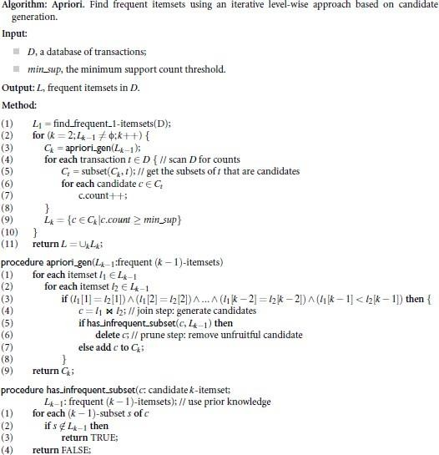

Example:

TID | Listof itemIDs
T100 | I1,I2,I5
T200 | I2,I4
T300 | I2,I3
T400 | I1,I2,I4
T500 | I1,I3
T600 | I2,I3
T700 | I1,I3
T800 | I1,I2,I3,I5
T900 | I1,I2,I3

Thereareninetransactionsinthisdatabase,thatis,|D|=9.
Steps:
- In the first iteration of the algorithm, each item is a member of the set of candidate1-itemsets, C1. The algorithm simply scans all of the transactions in order to countthe number ofoccurrencesof each item.
- Suppose that the minimum support count required is 2, that is, min sup = 2. The set offrequent1-itemsets,L1,canthenbedetermined.Itconsistsofthecandidate1-itemsetssatisfying minimum support.In our example, all of the candidates in C1 satisfy minimumsupport.
- Todiscoverthesetoffrequent2-itemsets,L2,thealgorithmusesthejoinL1 onL1togenerate a candidate set of 2-itemsets, C2.No candidates are removed fromC2 during theprunestepbecauseeachsubsetofthecandidatesis alsofrequent.
- Next, the transactions inDare scanned and the support count of each candidate itemsetInC2 isaccumulated.
- The set of frequent 2-itemsets, L2, is then determined, consisting of those candidate2-itemsetsin C2 havingminimumsupport.
- The generation of the set of candidate 3-itemsets,C3, Fromthejoin step, we first getC3 =L2xL2 = ({I1, I2, I3}, {I1, I2, I5}, {I1, I3, I5}, {I2, I3, I4},{I2, I3, I5}, {I2, I4, I5}. Based on theApriori property that all subsets of a frequentitemsetmust also be frequent, we can determinethatthe four lattercandidates cannotpossiblybefrequent.

- ThetransactionsinDarescannedinordertodetermine L3,consistingofthosecandidate3-itemsetsin C3 having minimumsupport.
- ThealgorithmusesL3xL3togenerateacandidatesetof4-itemsets, C4.

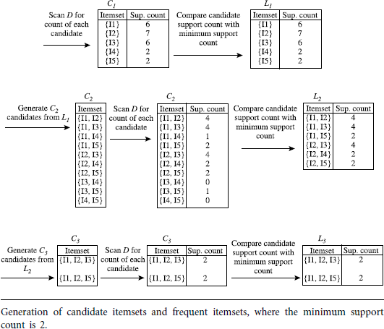

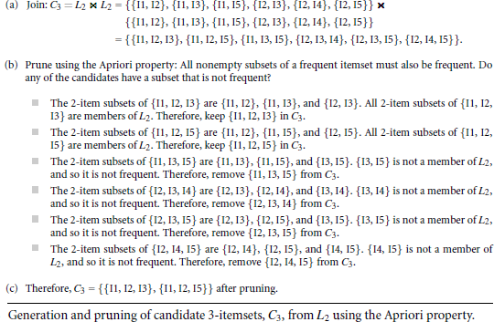

GeneratingAssociationRulesfromFrequentItemsets:
Once the frequent itemsets from transactions in a database D have been found, it isstraightforwardtogenerate strongassociation rulesfrom them.
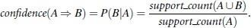

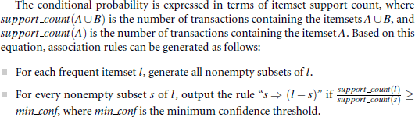

Example:

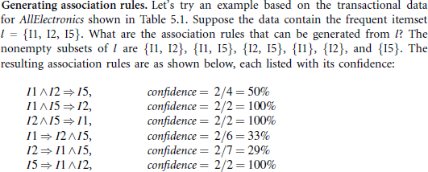

MiningMultilevelAssociationRules:

Formanyapplications,itisdifficulttofindstrongassociationsamongdataitems atloworprimitive levels ofabstraction duetothesparsityofdata at thoselevels.
Strongassociationsdiscoveredathighlevelsofabstractionmayrepresentcommonsenseknowledge.
Therefore,dataminingsystemsshouldprovidecapabilitiesforminingassociationrulesat multiple levels of abstraction, with sufficient flexibility for easy traversalamongdifferentabstraction spaces.
Association rules generated from mining data at multiple levels of abstraction arecalledmultiple-levelor multilevel associationrules.
Multilevel association rules can be mined efficiently using concept hierarchies under asupport-confidenceframework.
In general, a top-down strategy is employed, where counts are accumulated for thecalculation of frequent itemsets at each concept level, starting at the concept level 1 andworkingdownward inthe hierarchy towardthemore specificconceptlevels,untilnomorefrequent itemsets can befound.

Aconcepthierarchydefinesasequenceofmappingsfromasetoflow-levelconceptstohigherlevel,moregeneralconcepts.Datacanbegeneralizedbyreplacinglow-levelconceptswithinthedatabytheirhigher-levelconcepts,orancestors,froma concepthierarchy.

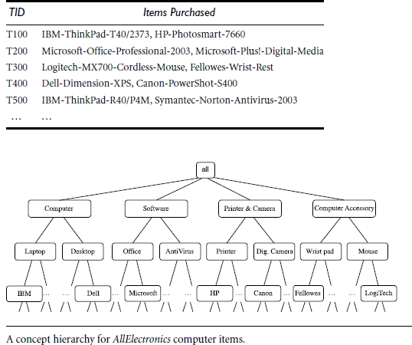
Theconcepthierarchyhasfivelevels,respectivelyreferredtoaslevels 0to4,startingwithlevel0at theroot nodeforall.

Here, Level 1 includes computer, software, printer&camera, and computer accessory.Level2includeslaptopcomputer,desktopcomputer,officesoftware,antivirussoftwareLevel3includesIBMdesktopcomputer,...,Microsoftoffice software,andsoon.
Level4isthemostspecificabstractionlevelofthishierarchy.

2.5.1 ApproachesForMiningMultilevelAssociationRules:

UniformMinimumSupport:
The same minimum support threshold is used when mining at each level of abstraction.When a uniform minimum support threshold is used, the search procedure is simplified.The method is also simple in that users are required to specify only one minimum supportthreshold.
The uniform support approach, however, has some difficulties. It is unlikely thatitems atlowerlevelsofabstractionwilloccurasfrequentlyasthoseathigherlevelsofabstraction.
If the minimum support threshold is set too high, it could miss somemeaningful associationsoccurring at low abstraction levels. If the threshold is set too low, it may generate manyuninterestingassociationsoccurringat highabstractionlevels.

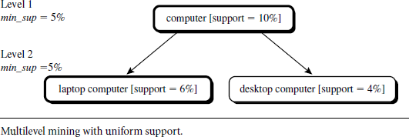

ReducedMinimumSupport:
Eachlevelofabstractionhasitsownminimumsupportthreshold.
Thedeeperthelevelofabstraction, thesmallerthecorrespondingthresholdis.
Forexample,theminimumsupportthresholdsforlevels1and2are5%and3%,respectively.In this way,―computer,‖―laptop computer,‖ and―desktop computer‖areallconsidered frequent.

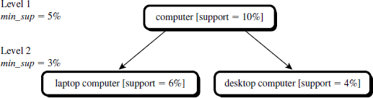

Group-BasedMinimumSupport:
Because users or experts often have insight as to which groups are more important thanothers, it is sometimes more desirable to set up user-specific, item, or group based minimalsupportthresholds whenminingmultilevel rules.
For example, a user could set up the minimum support thresholds based on product price, oronitemsofinterest,suchasbysettingparticularlylowsupportthresholdsforlaptopcomputersand flash drives in order to pay particular attention to the association patternscontainingitems in thesecategories.

MiningMultidimensionalAssociationRulesfromRelationalDatabasesandDataWarehouses:

Singledimensionalorintradimensionalassociationrulecontainsasingledistinctpredicate (e.g., buys)with multiple occurrences i.e., the predicate occurs more than oncewithinthe rule.

buys(X,―digitalcamera‖)=>buys(X,―HP printer‖)

Associationrulesthatinvolvetwoormoredimensionsorpredicatescanbereferredtoasmultidimensional associationrules.
age(X,“20…29”)^occupation(X,“student”)=>buys(X,“laptop”)
Above Rule contains three predicates (age, occupation,and buys), each of which occursonlyoncein therule. Hence, wesaythat it hasnorepeatedpredicates.
Multidimensionalassociationruleswithnorepeatedpredicatesarecalledinterdimensionalassociationrules.
We can also mine multidimensional associationrules with repeated predicates, whichcontainmultipleoccurrencesofsomepredicates.Theserulesarecalledhybrid-dimensional association rules. An example of sucha rule is the following, where thepredicatebuysisrepeated:
age(X,―20…29‖)^buys(X,―laptop‖)=>buys(X,―HP printer‖)

MiningQuantitativeAssociationRules:
Quantitative association rules are multidimensional association rules in which the numericattributes are dynamically discretized during the mining process so as to satisfy some miningcriteria,suchasmaximizingthe confidenceor compactness ofthe rulesmined.
Inthissection,wefocusspecificallyonhowtominequantitativeassociationruleshavingtwoquantitativeattributesontheleft-handsideoftheruleandonecategoricalattributeontheright-hand sideof therule. Thatis
Aquan1^Aquan2=>Acat
whereAquan1 andAquan2aretestsonquantitativeattributeinterval
Acattestsacategoricalattributefromthetask-relevantdata.
Such rules have been referred to as two-dimensional quantitative association rules,becausetheycontain twoquantitative dimensions.
For instance, suppose you are curious about the association relationship between pairs ofquantitative attributes, like customer age and income, and the type of television (such ashigh-definitionTV, i.e.,HDTV) that customers liketobuy.
Anexampleofsucha2-Dquantitativeassociationruleis
age(X, ―30…39‖)^income(X,―42K…48K‖)=>buys(X,―HDTV‖)

FromAssociationMiningtoCorrelationAnalysis:
A correlation measure can be used to augment the support-confidence framework forassociationrules. This leadstocorrelation rulesoftheform
A=>B[support,confidence,correlation]
That is, a correlation rule is measured not only by its support and confidence but alsobythecorrelationbetweenitemsetsAandB.Therearemanydifferentcorrelationmeasuresfrom which to choose. In this section, we study various correlation measurestodeterminewhich wouldbegoodformininglarge data sets.

Liftisasimplecorrelationmeasurethatis given asfollows.TheoccurrenceofitemsetA is independent of the occurrence of itemsetBif = P(A)P(B); otherwise,itemsetsAand B are dependent and correlated as events. This definition can easily beextendedto morethan twoitemsets.

Theliftbetween theoccurrenceofAand Bcanbemeasured bycomputing
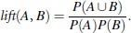
If thelift(A,B)islessthan1,thentheoccurrence ofAisnegativelycorrelatedwiththeoccurrenceofB.
If theresultingvalueisgreaterthan1, thenA andBarepositivelycorrelated,meaningthattheoccurrenceof oneimpliesthe occurrenceof theother.
If theresultingvalueis equalto1,then AandBareindependentandthere is nocorrelationbetweenthem.

UNIT-IV

ClassificationandPrediction:

Classification and prediction are two forms of data analysis that can be used to extractmodelsdescribingimportant dataclassesor to predict futuredata trends.
Classificationpredictscategorical(discrete,unordered)labels,predictionmodelscontinuousvaluedfunctions.
Forexample, we can build a classification model to categorize bankloan applicationsaseither safe orrisky,or a prediction model to predict the expendituresof potential customersoncomputer equipmentgiven their income andoccupation.
A predictor is constructed that predicts a continuous-valued function, or ordered value, asopposedto a categorical label.
Regressionanalysisisastatisticalmethodologythatismostoftenusedfornumericprediction.
Many classification and prediction methods have been proposed by researchers in machinelearning,patternrecognition, and statistics.
Most algorithms are memory resident, typically assuming a small data size. Recent datamining research has built on such work, developing scalable classification and predictiontechniquescapable ofhandlinglargedisk-residentdata.

IssuesRegardingClassificationandPrediction:

PreparingtheDataforClassificationandPrediction:
Thefollowingpreprocessingstepsmaybe appliedtothedatatohelp improvethe accuracy,efficiency,and scalabilityoftheclassification orpredictionprocess.

Datacleaning:
This refers to the preprocessing of data in order to remove or reduce noise (by applyingsmoothing techniques) and the treatment of missingvalues(e.g., by replacing a missingvalue with the most commonly occurring value for that attribute, or with the most probablevaluebased on statistics).
Although mostclassification algorithmshave some mechanisms for handling noisy ormissingdata, this stepcanhelp reduceconfusionduringlearning.

Relevanceanalysis:
Manyof theattributesinthe datamayberedundant.
Correlationanalysiscanbeusedtoidentifywhetheranytwogivenattributesarestatisticallyrelated.
For example, a strong correlation between attributes A1 and A2 would suggest that one ofthetwo could be removed from furtheranalysis.
Adatabasemayalsocontainirrelevantattributes.Attributesubsetselectioncanbeusedin these cases to find a reduced set of attributes such that the resultingprobabilitydistribution of the data classes is as close as possible to the original distribution obtainedusingallattributes.
Hence,relevanceanalysis,intheformofcorrelationanalysisandattributesubsetselection, can be used to detect attributes that do not contribute to the classification orpredictiontask.
Suchanalysiscanhelpimproveclassificationefficiencyandscalability.

DataTransformationAndReduction
Thedata maybetransformed bynormalization, particularlywhen neural networksormethodsinvolvingdistancemeasurementsareused inthelearningstep.
Normalizationinvolvesscalingallvaluesfor a givenattributesothattheyfallwithinasmallspecified range, such as-1 to +1 or0 to 1.
The data can also be transformed by generalizing it to higher-level concepts. Concepthierarchies may be used for this purpose. This is particularly useful for continuousvaluedattributes.
For example, numeric values for the attribute income can be generalized to discreteranges, such as low, medium, and high. Similarly, categorical attributes, like street, canbegeneralized to higher-level concepts, like city.
Data can also be reduced by applying many other methods, ranging from wavelettransformationandprinciplecomponentsanalysis todiscretizationtechniques,suchasbinning, histogram analysis, andclustering.

ComparingClassificationandPredictionMethods:

Accuracy:
The accuracy of a classifier refers to the ability of a given classifier to correctly predicttheclasslabelofneworpreviouslyunseendata(i.e.,tupleswithoutclasslabelinformation).
The accuracy of a predictor refers to how well a given predictor can guess the value ofthepredictedattributefor neworpreviouslyunseendata.

Speed:
Thisreferstothe computationalcosts involvedingeneratingandusingthegiven classifier orpredictor.

Robustness:
Thisisthe abilityof theclassifier orpredictorto makecorrect predictionsgivennoisydata or datawithmissingvalues.

Scalability:
This refers to the ability to construct the classifier or predictor efficientlygivenlargeamountsof data.

Interpretability:
This refers to the level of understanding and insight that is providedby the classifier orpredictor.
Interpretabilityissubjectiveandthereforemoredifficulttoassess.

ClassificationbyDecisionTreeInduction:
Decisiontreeinductionisthelearningofdecisiontreesfromclass-labeledtrainingtuples.Adecision treeis a flowchart-liketreestructure,where
  - Eachinternalnodedenotesatestonan attribute.
  - Eachbranch representsan outcomeof thetest.
  - Eachleafnodeholdsa class label.
  - Thetopmost nodeinatreeis therootnode.

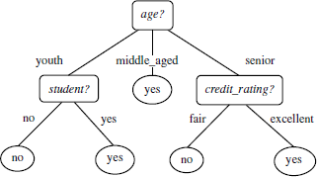

Theconstructionofdecisiontreeclassifiersdoesnotrequireanydomainknowledgeorparametersetting,andthereforeIappropriatefor exploratoryknowledgediscovery.
Decisiontrees canhandlehighdimensionaldata.
Theirrepresentationofacquiredknowledgeintreeformisintuitiveandgenerallyeasytoassimilatebyhumans.
Thelearningandclassificationstepsofdecisiontreeinductionaresimpleandfast.Ingeneral, decisiontreeclassifiers have goodaccuracy.
Decision tree induction algorithmshave been used for classification in many applicationareas, such as medicine,manufacturing and production, financial analysis, astronomy, andmolecularbiology.

AlgorithmForDecisionTreeInduction:

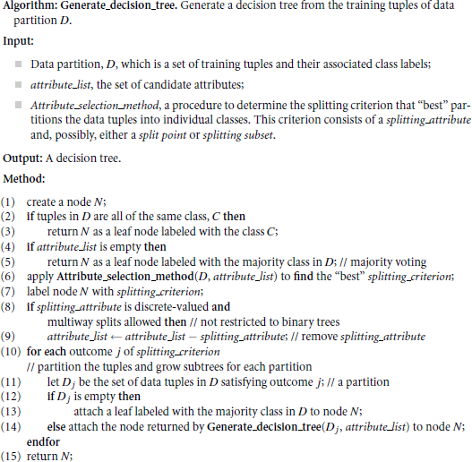

Thealgorithmiscalledwiththreeparameters:
- Datapartition
- Attributelist
- Attributeselectionmethod

Theparameter attributelistisalistofattributesdescribingthetuples.
Attributeselectionmethodspecifiesaheuristicprocedureforselectingtheattributethat
―best‖discriminates thegiven tuples accordingtoclass.
Thetreestartsasasingle node, N,representingthetrainingtuplesinD.
If the tuples in D are all of the same class, then node N becomes a leaf and is labeledwiththat class.
Allof the terminating conditions are explained at the end of the algorithm.Otherwise,thealgorithmcallsAttributeselectionmethodtodeterminethesplittingcriterion.
Thesplittingcriterion tellsuswhich attribute to test at nodeNbydeterminingthe―best‖
waytoseparateorpartitionthetuplesin Dintoindividualclasses.

Therearethreepossiblescenarios.LetAbethesplittingattribute.Ahasvdistinctvalues,
{a1,a2,…,av},basedonthetrainingdata.

Aisdiscrete-valued:

Inthiscase,theoutcomesofthetestat nodeNcorresponddirectlyto theknownvaluesofA.
Abranchiscreatedforeachknownvalue,aj,ofAandlabeled withthatvalue.Aneednot beconsideredin anyfuturepartitioningof thetuples.

Aiscontinuous-valued:

Inthiscase,thetestatnodeNhastwopossibleoutcomes,correspondingtotheconditionsA<=split point and A>split point, respectively
wheresplitpointisthesplit-pointreturnedbyAttributeselectionmethodas partofthesplittingcriterion.

Aisdiscrete-valuedandabinarytreemustbe produced:

Thetest at node Nis of theform―A€SA?‖.
SA is the splitting subset for A, returned by Attribute selection methodas part of the splittingcriterion. It isasubsetof the known values ofA.

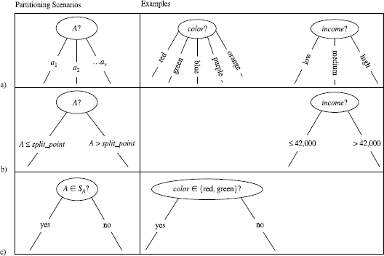

  - If A is Discrete valued (b)If A is continuous valued (c) IfA is discrete-valued and a binarytreemustbeproduced:

BayesianClassification:

Bayesianclassifiersarestatisticalclassifiers.
Theycanpredictclassmembership probabilities,suchasthe probabilitythata giventuplebelongstoa particular class.
BayesianclassificationisbasedonBayes’theorem.

Bayes’Theorem:
Let Xbeadata tuple.InBayesian terms, Xis considered―evidence.‖and it is described by measurementsmadeon aset of nattributes.
LetHbesomehypothesis,suchasthatthedatatupleXbelongstoaspecifiedclass C.
Forclassificationproblems,wewanttodetermineP(H|X),theprobabilitythatthehypothesisHholds given the―evidence‖or observed datatuple X.
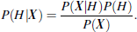
P(H|X) is the posterior probability, or a posteriori probability, of H conditioned on X.Bayes’theoremisusefulinthat itprovidesawayofcalculatingtheposteriorprobability,P(H|X),fromP(H),P(X|H), and P(X).

NaïveBayesianClassification:

ThenaïveBayesianclassifier,orsimpleBayesian classifier,worksasfollows:

- Let D be a training set of tuples and their associated class labels. As usual, each tuple isrepresentedbyann-dimensionalattributevector,X=(x1,x2,…,xn),depictingnmeasurementsmadeonthe tuplefromn attributes,respectively,A1,A2, …,An.
- Supposethattherearem classes,C1,C2,…,Cm.Givenatuple,X,theclassifierwill
predictthatXbelongstotheclasshavingthehighestposteriorprobability,conditionedonX.

That is, the naïve Bayesian classifier predicts that tuple X belongs to the class Ci if and onlyif

ThuswemaximizeP(CijX).TheclassCiforwhichP(CijX)ismaximizediscalledthe
maximumposteriorihypothesis.ByBayes’theorem
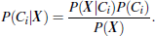
- As P(X) is constant for all classes, only P(X|Ci)P(Ci) need be maximized. If the classprior probabilities are not known, then it is commonly assumed that the classes are equallylikely, that is, P(C1) = P(C2) = …= P(Cm), and we would therefore maximize P(X|Ci).Otherwise,wemaximizeP(X|Ci)P(Ci).
- Given data sets with many attributes, it would be extremely computationally expensivetocompute P(X|Ci). In order to reduce computation in evaluating P(X|Ci), the naive assumptionof class conditional independence is made. This presumes that the values of the attributesareconditionallyindependentofoneanother,giventheclasslabelofthetuple.Thus,
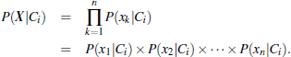

WecaneasilyestimatetheprobabilitiesP(x1|Ci),P(x2|Ci),:::,P(xn|Ci)fromthetrainingtuples.Foreachattribute,welookatwhethertheattributeiscategoricalorcontinuous-valued.Forinstance, tocomputeP(X|Ci), weconsider thefollowing:
- IfAkiscategorical,thenP(xk|Ci)isthenumberoftuplesofclassCiinDhavingthevalue
xkforAk, divided by|Ci,D|the number oftuplesofclass Ciin D.
- If Akis continuous-valued, then we need to do a bit more work, but the calculationis prettystraightforward.
A continuous-valued attribute is typically assumed tohave a Gaussian distribution with ameanμand standard deviation , defined by
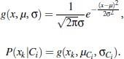

- Inordertopredictthe classlabelof X,P(XjCi)P(Ci)isevaluatedforeachclass Ci.Theclassifier predicts thattheclass label oftupleXistheclassCiif andonlyif

AMultilayerFeed-ForwardNeuralNetwork:
The backpropagation algorithm performs learning on a multilayer feed-forward neuralnetwork.
Ititerativelylearnsasetofweightsforpredictionoftheclasslabeloftuples.A multilayer feed-forward neural network consists of an input layer, one ormorehiddenlayers,andanoutput layer.

Example:
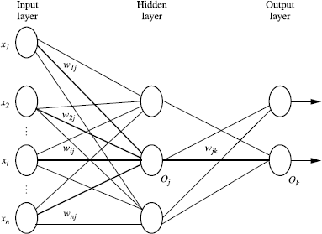

The inputs to the network correspond to the attributes measured for each training tuple. Theinputs are fed simultaneously into the units making up the input layer. These inputs passthrough the input layer and are then weighted and fed simultaneously to a second layerknownasahidden layer.
The outputs of the hidden layer units can be input to another hidden layer, and so on. Thenumberof hidden layersis arbitrary.
Theweightedoutputsofthelasthiddenlayerareinputtounitsmakinguptheoutputlayer,
whichemitsthenetwork’spredictionfor giventuples

3.4.1 ClassificationbyBackpropagation:
Backpropagationisaneural networklearningalgorithm.
Aneuralnetworkisasetofconnectedinput/outputunitsinwhicheachconnectionhasaweightassociatedwith it.
Duringthelearningphase,thenetworklearnsbyadjustingtheweightssoastobeabletopredictthe correct classlabel of theinput tuples.
Neuralnetworklearningisalsoreferredtoasconnectionistlearningduetotheconnectionsbetweenunits.
Neural networks involve long training times and are therefore more suitable forapplicationswherethisis feasible.
Backpropagationlearnsbyiterativelyprocessingadatasetoftrainingtuples,comparing
thenetwork’spredictionforeachtuplewiththeactualknown targetvalue.
The target value may be the known class label of the training tuple (for classificationproblems)oracontinuous value (forprediction).
For each training tuple, the weights are modified so as to minimize the mean squarederrorbetweenthe network’s prediction andthe actual target value. Thesemodificationsaremadeinthe―backwards‖direction,thatis,fromtheoutputlayer,througheachhidden layerdown to thefirsthidden layer hencethenameisbackpropagation.
Although it is not guaranteed, in general the weights will eventually converge, and thelearningprocessstops.

Advantages:
It include their high tolerance of noisy data as well as their ability to classify patterns onwhichtheyhavenot beentrained.
They can be used when you may have little knowledge of the relationships betweenattributesandclasses.
They are well-suited for continuous-valued inputs and outputs, unlike most decision treealgorithms.
They have been successful on a wide array of real-world data, including handwrittencharacter recognition, pathology and laboratory medicine, and training a computer topronounceEnglishtext.
Neural network algorithms are inherently parallel; parallelization techniques can be usedtospeed up the computationprocess.
Process:

Initializethe weights:

Theweightsinthenetwork areinitializedtosmallrandom numbers
ranging from-1.0 to 1.0, or -0.5 to 0.5. Each unit has a bias associated with it. The biases aresimilarlyinitialized to small random numbers.

Eachtrainingtuple,X,isprocessedbythefollowingsteps.

Propagatetheinputsforward:

First, the training tuple is fed to the input layer of thenetwork. The inputs pass through the inputunits, unchanged. That is, for an input unitj, its output, Oj, is equal to its input value, Ij. Next, thenet input and output of eachunit in the hidden and output layers are computed. The net input to aunitin thehiddenoroutputlayers is computed asalinear combination ofitsinputs.
Eachsuchunithasanumberofinputstoitthat are,infact, theoutputsoftheunitsconnectedto itin theprevious layer. Each connection has a weight. To compute the net input to the unit, eachinputconnected tothe unit ismultipliedbyitscorrespondingweight,and thisissummed.

wherewi,jis the weight of the connection from unit iin the previous layer to unit j;Oiistheoutput of unit ifrom theprevious layer
Ɵjisthebiasoftheunit&itactsasathresholdinthatitservestovarytheactivityoftheunit.

Eachunitinthehidden andoutputlayerstakesitsnetinputandthenappliesanactivationfunctionto it.
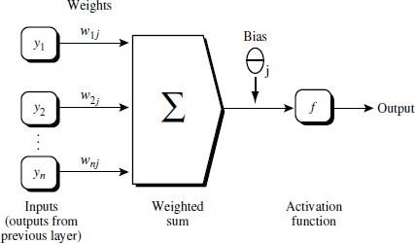

Backpropagatetheerror:

Theerror ispropagated backwardbyupdatingthe weights andbiasestoreflect theerrorof
thenetwork’s prediction.For aunitjin theoutput layer, theerror Errjis computedby
whereOjistheactualoutputofunit j,andTjistheknowntarget valueofthe giventrainingtuple.
Theerror ofahidden layerunitj is
wherewjkistheweightof theconnectionfromunitjtoaunitkinthenexthigherlayer,andErrkis theerror ofunit k.
Weightsareupdatedbythefollowingequations,where Dwi jisthechangein weight wij:
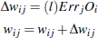
Biasesareupdated bythefollowingequations below
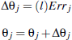
Algorithm:
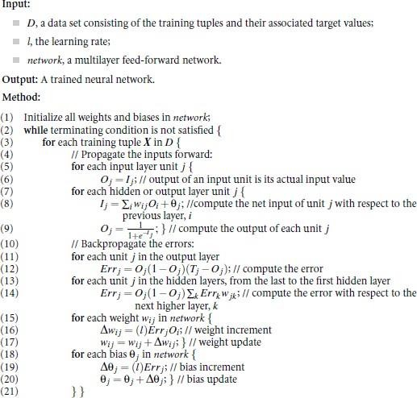

k-Nearest-NeighborClassifier:
Nearest-neighbor classifiersarebasedonlearningbyanalogy,thatis,bycomparingagiventesttuplewith trainingtuplesthat aresimilar to it.
The training tuples are describedbyn attributes. Each tuple represents a point in an n-dimensional space. In this way,all of the training tuples are stored in an n-dimensionalpattern space. When given anunknown tuple, a k-nearest-neighbor classifier searches thepattern space for the k trainingtuples that are closest to the unknown tuple. These k trainingtuplesaretheknearestneighbors of theunknowntuple.
Closenessisdefinedintermsofadistancemetric, such asEuclideandistance.
TheEuclidean distancebetween twopointsor tuples,say,X1=(x11, x12,… ,x1n) and
X2=(x21, x22, … ,x2n), is
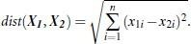
Inotherwords,foreach numericattribute,wetakethedifferencebetweenthecorrespondingvaluesofthatattributeintupleX1and intupleX2,squarethisdifference,and accumulateit.
Thesquarerootistakenofthetotalaccumulateddistancecount.
Min-Maxnormalizationcan beused to transformavaluevof anumericattribute Atov0intherange[0, 1]bycomputing
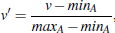

whereminAandmaxAaretheminimumandmaximumvaluesofattribute A

Fork-nearest-neighborclassification,theunknowntupleisassignedthemostcommonclassamongits knearestneighbors.
When k = 1, the unknown tuple is assigned the class of the training tuple that is closest toitin pattern space.
Nearestneighborclassifiers can also be used for prediction, that is, to return a real-valuedpredictionforagiven unknown tuple.
In this case, the classifier returns the averagevalue of the real-valued labels associatedwiththeknearestneighbors ofthe unknowntuple.
OtherClassificationMethods:

GeneticAlgorithms:

Geneticalgorithmsattempttoincorporateideasofnaturalevolution.In general,geneticlearningstartsas follows.
An initial population is created consisting of randomly generated rules. Each rule can berepresentedbyastringofbits.Asasimpleexample,supposethatsamplesinagiven
trainingset aredescribedbytwoBooleanattributes,A1andA2,andthattherearetwoclasses,C1andC2.
The rule ―IF A1ANDNOTA2THENC2‖can be encoded as the bit string ―100,‖where the two leftmost bits represent attributes A1and A2, respectively, and the rightmost bitrepresentstheclass.
Similarly,therule―IFNOTA1ANDNOTA2THENC1‖can beencodedas ―001.‖
Ifanattributehask values,wherek>2,thenkbitsmaybeusedtoencodetheattribute’s
values.
Classescanbeencodedinasimilarfashion.
Basedonthenotionofsurvivalofthefittest,anewpopulationisformed toconsistofthefittestrulesinthecurrent population,aswellasoffspringoftheserules.
Typically,thefitnessof aruleisassessedbyitsclassificationaccuracyonaset oftrainingsamples.
Offspringarecreated byapplyinggeneticoperatorssuchascrossoverandmutation.In crossover, substrings from pairs of rules are swapped to form new pairs of rules.Inmutation,randomlyselected bits ina rule’s stringareinverted.
Theprocessof generatingnewpopulationsbasedonpriorpopulationsofrulescontinuesuntil a population, P, evolves where each rule in P satisfies a pre specifiedfitnessthreshold.
Genetic algorithms are easily parallelizable and have been used for classification aswellasother optimizationproblems.Indatamining, theymaybeused toevaluatethefitnessof otheralgorithms.

FuzzySet Approaches:
Fuzzylogicusestruthvaluesbetween0.0and1.0torepresentthedegree ofmembershipthata certainvaluehasinagiven category.Each categorythen represents afuzzyset.
Fuzzylogicsystemstypicallyprovide graphicaltoolstoassistusersinconvertingattributevalues to fuzzytruthvalues.
Fuzzyset theoryis alsoknown as possibilitytheory.
ItwasproposedbyLotfiZadehin1965asan alternativetotraditionaltwo-valuelogicandprobabilitytheory.
Itletsusworkatahighlevelofabstractionandoffersameansfordealingwithimprecisemeasurementofdata.
Mostimportant, fuzzyset theoryallowsus to dealwithvagueorinexactfacts.
Unlikethenotionoftraditional―crisp‖setswhereanelementeitherbelongstoasetSorits complement, in fuzzyset theory,elementscanbelongto morethan onefuzzyset.
Fuzzyset theoryis useful for data miningsystemsperformingrule-basedclassification.Itprovidesoperations for combiningfuzzymeasurements.
Several procedures exist for translating the resulting fuzzy output into a defuzzifiedor crispvaluethat isreturned bythesystem.
Fuzzylogicsystemshavebeen usedinnumerousareasforclassification,includingmarketresearch,finance,health care,andenvironmentalengineering.

Example:

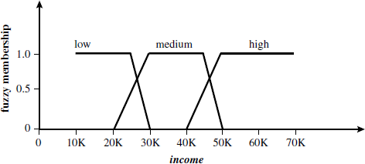

RegressionAnalysis:
Regressionanalysiscan beusedtomodeltherelationshipbetweenoneormoreindependentorpredictorvariables andadependent orresponsevariable whichiscontinuous-valued.
Inthe contextofdatamining,thepredictorvariablesaretheattributesofinterestdescribingthetuple (i.e., makingupthe attributevector).
Ingeneral,thevaluesofthepredictorvariablesareknown.
Theresponsevariableiswhatwewanttopredict.

LinearRegression:
Straight-line regression analysis involves a response variable, y, and a single predictorvariablex.
Itisthesimplestformofregression,andmodelsyasalinearfunctionofx.
Thatis,y=b+wx
wherethevarianceofyisassumedtobeconstant
bandwareregressioncoefficientsspecifyingthe Y-interceptandslopeoftheline.
Theregressioncoefficients,wandb,canalsobethoughtof asweights,sothatwecanequivalentlywrite,y=w0+w1x
Thesecoefficientscanbesolvedforbythemethodofleastsquares,which estimatesthebest-fitting straight line as the one that minimizes the error between the actual data andtheestimateof theline.
Let D be a training set consisting of values of predictor variable, x, for some population andtheir associated values for response variable, y. The training set contains |D| data points oftheform(x1, y1), (x2, y2),… , (x|D|, y|D|).
Theregressioncoefficientscanbeestimatedusingthismethodwiththefollowingequations:
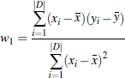

wherex is themeanvalue of x1, x2,… ,x|D|,andyisthemeanvalue ofy1, y2,…,y|D|.Thecoefficientsw0andw1often provide good approximations to otherwisecomplicatedregressionequations.

MultipleLinearRegression:
Itisanextensionofstraight-lineregressionsoas toinvolvemorethanonepredictorvariable.
Itallowsresponsevariable ytobemodeledasalinearfunctionof,say,npredictorvariablesorattributes,A1,A2, …, An,describingatuple,X.
An example of a multiple linear regression model basedon two predictor attributes orvariables,A₁and A₂, isy=w₀+w₁x₁+w₂x₂
wherex1andx2arethevaluesofattributesA1andA2,respectively,inX.
Multipleregressionproblemsareinsteadcommonlysolvedwiththeuseofstatisticalsoftwarepackages,suchasSAS,SPSS, and S-Plus.

NonlinearRegression:
Itcanbemodeledbyaddingpolynomialterms tothebasiclinearmodel.
By applying transformations to the variables, we can convert the nonlinear model into alinearonethat can then besolved bythe method ofleastsquares.
Polynomial Regression is a special case of multiple regression. That is, the addition ofhigh-order terms like x², x³, and so on, which are simple functions of the single variable, x,canbeconsideredequivalent to addingnewindependent variables.

Transformationofapolynomialregressionmodeltoalinearregressionmodel:
Consideracubicpolynomial relationshipgivenby
y=w₀+w₁x+w₂x₂+w₃x₃
Toconvertthisequation tolinearform,wedefinenewvariables:
x₁ =x,x₂ = x² ,x₃ =x³
It can then be converted to linear formby applying the above assignments,resulting in theequationy=w₀+w₁x+w₂x₂+w₃x₃
whichiseasilysolvedbythemethodofleastsquaresusingsoftwareforregressionanalysis.

ClassifierAccuracy:
The accuracy of a classifier on a given test set is the percentage of test set tuples that arecorrectlyclassified bytheclassifier.
In the pattern recognition literature, this is also referred to as the overall recognition rate oftheclassifier, that is, it reflects how well the classifier recognizes tuples of the variousclasses.
The error rate or misclassification rate of a classifier,M, which is simply 1-Acc(M),whereAcc(M)is theaccuracyofM.
Theconfusionmatrixisausefultoolforanalyzinghowwellyourclassifiercan recognizetuplesofdifferent classes.
Truepositivesrefer to thepositivetuplesthat werecorrectlylabeled bytheclassifier.Truenegativesarethe negativetuplesthat werecorrectlylabeled bytheclassifier.
Falsepositives arethe negativetuplesthatwereincorrectlylabeled.
Howwelltheclassifiercanrecognize,forthissensitivityandspecificitymeasurescanbeused.
Accuracyisafunctionofsensitivityandspecificity.
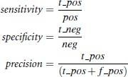

wheret_posisthenumberoftruepositivesposisthe number ofpositivetuples
t _negis the number of true negativesnegisthenumberofnegativetuples,f_posis thenumber offalsepositives

UNIT-V

ClusterAnalysis:
Theprocessof groupingasetofphysicalor abstractobjectsintoclassesofsimilarobjectsiscalled clustering.
Aclusterisacollectionofdataobjectsthataresimilartooneanotherwithinthesameclusterand aredissimilarto theobjects in otherclusters.
Aclusterofdataobjectscanbetreatedcollectivelyasonegroupandsomaybeconsideredasaform of datacompression.
Cluster analysis tools based on k-means, k-medoids, and several methods have also beenbuilt into many statisticalanalysis software packages or systems, such as S-Plus, SPSS, andSAS.

Applications:
Cluster analysis has been widely used in numerous applications, including market research,patternrecognition, dataanalysis,and imageprocessing.
In business, clustering can help marketers discover distinct groups in their customer basesandcharacterizecustomer groups basedon purchasingpatterns.
In biology, it can be used to derive plant and animal taxonomies, categorize genes withsimilarfunctionality,andgaininsightinto structuresinherentinpopulations.
Clustering may also help in the identification of areas of similar land use in an earthobservation database and in the identification of groups of houses in a city according tohousetype,value,andgeographiclocation,aswellastheidentificationofgroupsofautomobileinsurancepolicyholders with ahigh averageclaimcost.
Clusteringisalsocalled datasegmentationinsomeapplicationsbecauseclusteringpartitionslargedata sets into groupsaccordingto theirsimilarity.
Clustering can also be used for outlier detection,Applications of outlier detection includethe detection of credit card fraud and the monitoring of criminal activities in electroniccommerce.

TypicalRequirementsOfClusteringInDataMining:

Scalability:
Many clustering algorithms work well on small data sets containing fewer than severalhundred data objects; however, a large database may contain millions of objects. Clusteringonasampleof a givenlargedata set maylead tobiased results.
Highlyscalableclusteringalgorithmsareneeded.

Abilitytodealwithdifferenttypesofattributes:
Manyalgorithmsaredesignedtoclusterinterval-based(numerical)data.However,applicationsmayrequireclusteringothertypesofdata,suchasbinary,categorical(nominal),and ordinal data, ormixturesofthesedata types.

Discoveryofclusterswitharbitraryshape:
Many clustering algorithms determine clusters based on Euclidean or Manhattan distancemeasures. Algorithms based on such distance measures tend to find spherical clusters withsimilarsizeand density.
However, a cluster could be of any shape. It is important to develop algorithms thatcandetectclusters of arbitraryshape.
- Minimal requirements for domain knowledge to determine input parameters:Many clustering algorithms require users to input certain parameters in cluster analysis(such as the number of desired clusters). The clustering results can be quite sensitive toinput parameters. Parameters are often difficult to determine, especially for data setscontaining high-dimensional objects. This not only burdens users, but it also makes thequalityof clusteringdifficult tocontrol.

Abilitytodealwithnoisydata:
Mostreal-worlddatabasescontainoutliersormissing,unknown,orerroneousdata.
Someclusteringalgorithmsaresensitivetosuchdataandmayleadtoclustersofpoorquality.

Incrementalclusteringandinsensitivitytotheorderofinputrecords:
Some clustering algorithms cannot incorporate newly inserted data (i.e., database updates)into existing clustering structures and, instead, must determine a new clustering fromscratch.Someclusteringalgorithmsaresensitive tothe order ofinputdata.
Thatis,givenasetofdataobjects,suchanalgorithmmayreturndramaticallydifferentclusteringsdependingonthe order ofpresentationof theinput objects.
Itisimportanttodevelopincrementalclusteringalgorithmsandalgorithmsthatareinsensitiveto the order of input.

Highdimensionality:
Adatabaseoradatawarehousecancontainseveraldimensionsorattributes.Manyclustering algorithmsaregoodathandling low-dimensionaldata,involving only twotothree dimensions. Human eyes are good at judging the qualityof clustering for up to threedimensions.Findingclustersofdataobjectsinhighdimensionalspaceischallenging,especiallyconsideringthat suchdata can besparseand highlyskewed.

Constraint-basedclustering:
Real-world applications may need to perform clustering under various kinds of constraints.Suppose that your job is to choose the locations for a given number of new automaticbanking machines (ATMs) in a city. To decide upon this,you may cluster householdswhile considering constraints such as the city’s rivers and highway networks, and the typeand number of customers per cluster. A challenging task is to find groups of data with goodclusteringbehavior that satisfyspecifiedconstraints.

Interpretabilityandusability:
Users expect clustering results to be interpretable, comprehensible, and usable. That is,clustering may need to be tied to specific semantic interpretations and applications. It isimportanttostudy howanapplicationgoalmayinfluencetheselectionofclusteringfeaturesand methods.

MajorClusteringMethods:
  - PartitioningMethods
  - HierarchicalMethods
  - Density-BasedMethods
  - Grid-BasedMethods
  - Model-BasedMethods

PartitioningMethods:
A partitioning method constructs k partitions of the data, where each partition represents acluster and k <= n. That is, it classifies the data into k groups, which together satisfy thefollowingrequirements:
Eachgroupmustcontainatleastoneobject,andEach object must belongto exactlyonegroup.
A partitioning method creates an initial partitioning.It then uses an iterative relocationtechnique that attempts to improve the partitioning by moving objects from one group toanother.
Thegeneralcriterionofa goodpartitioningis thatobjectsinthe sameclusterareclose orrelatedtoeachother,whereasobjectsofdifferentclusters arefarapartorverydifferent.

HierarchicalMethods:
Ahierarchicalmethod createsahierarchicaldecompositionofthegivenset ofdataobjects.Ahierarchical method can be classified as being eitheragglomerative or divisive, based onhowthehierarchical decomposition isformed.
- Theagglomerativeapproach,alsocalledthebottom-upapproach,startswitheachobjectforming a separate group. It successively merges the objects or groups that arecloseto one another, until all of the groups are merged into one or until a terminationcondition holds.
- The divisive approach, also calledthe top-down approach, starts with all of the objects inthe same cluster. In each successiveiteration, a cluster is split up into smaller clusters,untileventuallyeach objectisin onecluster, oruntila termination conditionholds.
Hierarchical methods suffer fromthe fact that once a step (merge or split) is done,it can neverbe undone. This rigidity is useful in that it leads to smaller computationcosts by not havingtoworryabout acombinatorial number ofdifferentchoices.

Therearetwo approachestoimprovingthequalityofhierarchical clustering:

- Perform careful analysis ofobject―linkages‖at each hierarchical partitioning, such as in Chameleon,or
- Integratehierarchicalagglomerationandotherapproachesbyfirstusingahierarchicalagglomerativealgorithmtogroupobjectsintomicroclusters,andthenperformingmacroclustering on the microclusters using another clustering method such asiterativerelocation.

Density-basedmethods:
  - Most partitioning methods cluster objects based on the distance between objects. Suchmethods can find only spherical-shaped clusters and encounter difficulty at discoveringclustersofarbitraryshapes.
  - Other clustering methods have been developed based on the notion of density. Theirgeneral idea is to continue growing the given cluster as long as the density in theneighborhoodexceedssomethreshold;thatis,foreachdatapointwithinagivencluster, the neighborhood of a given radius has to contain at least a minimum number ofpoints. Such a method can be used to filter out noise (outliers)and discover clusters ofarbitraryshape.
  - DBSCANanditsextension,OPTICS,aretypicaldensity-basedmethodsthatgrowclustersaccordingtoadensity-basedconnectivityanalysis.DENCLUEisamethodthat clusters objects based on the analysis of the value distributions of densityfunctions.

Grid-BasedMethods:
  - Grid-based methods quantize the object space into a finite number of cells that form agridstructure.
  - All of the clustering operations are performed on the grid structure i.e., on the quantizedspace.Themainadvantageofthisapproachisitsfastprocessingtime,whichistypically independent of the number of data objects and dependent only on the numberofcellsin each dimension in thequantizedspace.
  - STING is a typical example of a grid-based method. Wave Cluster applies wavelettransformationfor clusteringanalysisandis bothgrid-basedanddensity-based.

Model-BasedMethods:
  - Model-based methods hypothesize a model for each of the clusters and find the best fitofthedata to thegivenmodel.
  - A model-based algorithm may locate clusters by constructing a density function thatreflectsthespatial distribution ofthedatapoints.
  - It also leads to a way of automatically determining the number of clusters based onstandard statistics, taking ―noise‖or outliers into account and thusyielding robust clusteringmethods.

TasksinDataMining:
  - ClusteringHigh-DimensionalData
  - Constraint-BasedClustering
ClusteringHigh-DimensionalData:
It is a particularly important task in cluster analysis because many applicationsrequirethe analysisof objectscontainingalarge numberoffeaturesordimensions.
For example, text documents may contain thousands of terms or keywords asfeatures, and DNA micro array data may provide information on the expressionlevelsof thousands ofgenesunder hundreds of conditions.
Clustering high-dimensional data is challenging due to the curse of dimensionality.Many dimensionsmay notberelevant.Asthenumber ofdimensionsincreases,thedatabecomeincreasinglysparsesothatthedistancemeasurementbetweenpairsofpointsbecomemeaninglessandtheaveragedensityofpointsanywhereinthedataislikelytobelow.Therefore,adifferentclusteringmethodologyneedstobedevelopedforhigh-dimensionaldata.
CLIQUE and PROCLUS are two influential subspace clustering methods, whichsearchforclustersinsubspacesofthedata,ratherthanoverthe entiredataspace.
Frequent pattern–based clustering,another clustering methodology, extractsdistinctfrequent patterns among subsets ofdimensions that occur frequently. It uses suchpatternsto group objectsand generatemeaningfulclusters.

Constraint-BasedClustering:
Itis a clustering approach thatperforms clustering by incorporation ofuser-specifiedorapplication-orientedconstraints.
A constraint expresses a user’s expectation or describes properties of the desiredclusteringresults,andprovidesaneffectivemeansforcommunicatingwiththeclusteringprocess.
Various kinds of constraints can be specified, either by a user or as per applicationrequirements.
Spatial clustering employs with the existence of obstacles and clustering under user-specifiedconstraints.Inaddition,semi-supervisedclusteringemploysforpairwiseconstraintsin order to improvethe qualityoftheresultingclustering.

ClassicalPartitioningMethods:
Themostwell-knownandcommonlyusedpartitioningmethodsare
- Thek-MeansMethod
- k-MedoidsMethod
    - Centroid-BasedTechnique:TheK-MeansMethod:
The k-means algorithm takes the input parameter, k, and partitions a set of n objects intokclusterssothattheresultingintraclustersimilarityishighbuttheinterclustersimilarityislow.
Cluster similarity is measured in regard to the mean value of the objects in a cluster, whichcanbeviewed as thecluster’scentroid orcenter of gravity.
Thek-meansalgorithmproceedsasfollows.
First, it randomly selects k of the objects, each of which initially represents a clustermeanorcenter.
For each of the remaining objects, an object is assigned to the cluster to which it is themost similar, based onthe distancebetween theobject and theclustermean.
Itthencomputesthenewmeanforeachcluster.
Thisprocessiteratesuntilthecriterionfunctionconverges.

Typically,thesquare-errorcriterionisused,definedas
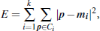
whereEisthesumofthesquareerror forallobjectsinthedatasetpisthepoint in spacerepresentingagiven object
miisthemean of cluster Ci

Thek-meanspartitioningalgorithm:
Thek-meansalgorithmforpartitioning, whereeachcluster’scenterisrepresentedbythe mean
valueofthe objectsin the cluster.
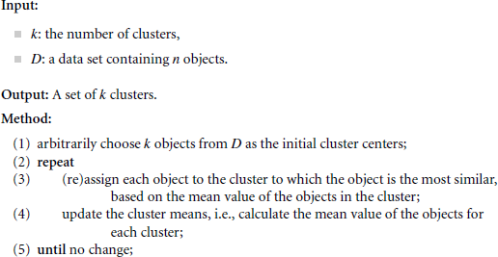

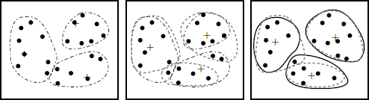

Clusteringof aset of objects based on thek-meansmethod

Thek-MedoidsMethod:

The k-means algorithm is sensitive to outliers because an object with an extremely largevaluemaysubstantiallydistortthedistributionofdata.Thiseffectisparticularlyexacerbateddueto theuseof thesquare-errorfunction.
Insteadof takingthe meanvalue of the objectsina cluster asareference point,wecanpickactualobjectstorepresenttheclusters,usingonerepresentativeobjectpercluster.Eachremaining object is clustered with the representative object to which it is the most similar.Thepartitioningmethodisthenperformedbasedontheprincipleofminimizingthesumofthedissimilaritiesbetweeneachobjectanditscorrespondingreferencepoint.Thatis,anabsolute-errorcriterion is used, definedas
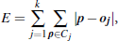

whereEisthesumofthe absoluteerrorforallobjectsinthedataset

pisthepointinspacerepresentinga given objectinclusterCj

ojistherepresentativeobject of Cj
The initial representative objects are chosen arbitrarily. The iterative process of replacingrepresentative objects by non representative objects continues as long as the quality of theresultingclusteringisimproved.
Thisqualityisestimatedusingacostfunctionthatmeasurestheaveragedissimilaritybetweenanobjectand therepresentativeobject ofitscluster.
To determine whether a non representative object, oj random, is a good replacement for acurrent representativeobject, oj, the following four cases are examined for each of thenonrepresentativeobjects.

Case1:

pcurrently belongs to representative object, oj. If ojis replaced by orandomasa representative objectandp isclosest tooneof the otherrepresentativeobjects,oi,i≠j, thenp isreassigned tooi.

Case2:

pcurrently belongs to representative object, oj. If ojis replaced by orandomasa representative objectandp is closest to orandom,then pis reassigned to orandom.

Case3:

pcurrently belongs to representative object, oi, i≠j. If ojis replaced by orandomas a representativeobjectand p isstill closestto oi,then theassignment doesnotchange.

Case4:

pcurrently belongs to representative object, oi, i≠j. If ojis replaced byorandomas a representativeobjectand p is closest to orandom,then p is reassigned
toorandom.

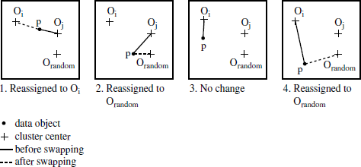

Fourcasesofthe costfunctionfor k-medoidsclustering

    - Thek-MedoidsAlgorithm:

Thek-medoidsalgorithmforpartitioningbasedonmedoidorcentralobjects.

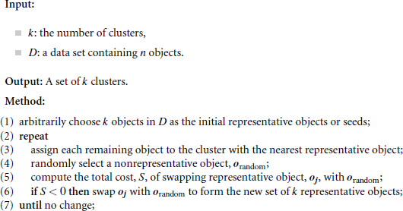
The k-medoids method ismore robust than k-means in the presence of noise and outliers,because a medoid is lessinfluenced by outliers or other extreme values than a mean. However,itsprocessingismore costlythan the k-means method.

HierarchicalClusteringMethods:

Ahierarchical clusteringmethod works bygroupingdata objects into a treeofclusters.
Thequalityofapurehierarchicalclusteringmethodsuffersfromitsinabilitytoperformadjustment once amerge or split decision hasbeen executed. That is, if a particularmerge or split decisionlater turns out to have been apoor choice, the method cannotbacktrackand correctit.
Hierarchical clustering methods can be further classified as either agglomerative or divisive,depending on whether the hierarchical decomposition is formed in a bottom-up or top-downfashion.

Agglomerativehierarchicalclustering:
This bottom-up strategy starts by placing each object in its own cluster and then mergesthese atomic clusters into larger and larger clusters, until all of the objects are in a singleclusteroruntil certain termination conditions aresatisfied.
Most hierarchical clustering methods belong to this category. They differ only in theirdefinitionofinterclustersimilarity.

Divisivehierarchicalclustering:
Thistop-down strategy does the reverse of agglomerativehierarchical clustering bystartingwithall objects in onecluster.
It subdividesthe cluster into smaller and smaller pieces, until each object forms a clusteron itsown or until it satisfies certain termination conditions, such as a desired numberofclustersis obtained orthediameterofeach cluster iswithin acertainthreshold.
.

Typesofoutlierdetection:
- StatisticalDistribution-BasedOutlierDetection
- Distance-BasedOutlierDetection
- Density-BasedLocalOutlierDetection
- Deviation-BasedOutlierDetection

StatisticalDistribution-BasedOutlierDetection:
The statistical distribution-based approach to outlier detection assumes a distributionorprobability model for the given data set (e.g., a normal or Poisson distribution) andthenidentifies outliers with respect to the model using a discordancy test. Application ofthetest requires knowledge of the data set parameters knowledge of distribution parameterssuchasthe meanand varianceandtheexpected numberof outliers.
Astatisticaldiscordancytestexaminestwohypotheses:Aworkinghypothesis
Analternativehypothesis
Aworkinghypothesis,H,isastatementthattheentiredatasetofnobjectscomesfromaninitial distribution model, F, thatis,
The hypothesis is retained if there is no statistically significant evidence supporting itsrejection. A discordancy test verifies whetheran object,oi,issignificantly large (orsmall) in relation to the distribution F. Different test statistics have been proposed for useas a discordancy test, depending on the available knowledge of the data. Assuming thatsome statistic, T, has been chosen for discordancy testing, and the valueof the statisticfor object oi is vi, then the distribution of T is constructed. Significance probability,SP(vi)=Prob(T > vi), is evaluated. If SP(vi) is sufficiently small, then oi is discordant andtheworkinghypothesis isrejected.
An alternative hypothesis, H, which states that oicomes from another distribution model,G, is adopted. The result is very much dependent on which model F is chosen becauseoimaybeanoutlierunderonemodeland aperfectlyvalid valueunderanother.The
alternativedistribution isveryimportantin determiningthepower ofthe test,that is,theprobabilitythat the workinghypothesis isrejectedwhen oi isreallyan outlier.
Therearedifferentkindsofalternativedistributions.

Inherentalternativedistribution:
In this case, the working hypothesis that all of the objects come from distribution F isrejected in favor of the alternative hypothesis that all of the objects arise from anotherdistribution,G:
H:oi € G,wherei=1, 2,…, n
Fand Gmaybedifferentdistributions or differ onlyin parameters of thesamedistribution.
There are constraints on the form of the G distribution in that it must have potential toproduce outliers. For example, it may have a different mean or dispersion, or a longertail.

Mixturealternativedistribution:
The mixture alternative states that discordant values are not outliers in the F population,butcontaminants from some other population,
G.Inthiscase,thealternativehypothesisis

Slippagealternativedistribution:
This alternative states that all of the objects (apart from some prescribed small number)arise independently from the initial model, F, with its given parameters, whereas theremaining objects are independent observations from a modified version of F in whichtheparameters havebeenshifted.
Therearetwobasictypesofproceduresfordetectingoutliers:

Blockprocedures:
Inthiscase,eitherallofthesuspectobjectsaretreatedasoutliersorallofthemareacceptedasconsistent.

Consecutiveprocedures:
Anexampleofsuchaprocedure istheinsideoutprocedure.Itsmainideaisthattheobjectthatisleastlikelytobeanoutlieristestedfirst.Ifitisfoundtobeanoutlier,thenallofthe
more extreme values are alsoconsidered outliers; otherwise, the next most extreme object istested,and soon. Thisproceduretendsto bemore effectivethanblock procedures.

Distance-BasedOutlierDetection:
The notion of distance-based outliers was introduced to counter the main limitationsimposedby statistical methods. An object, o, in a data set, D, is a distance-based (DB)outlier withparameters pct and dmin,that is, a DB(pct;dmin)-outlier, if at least a fraction,pct, of theobjects in D lie at a distance greater than dmin from o. In other words, rather thatrelying onstatistical tests, we can think of distance-based outliers as thoseobjects that do not haveenoughneighbors, where neighbors are defined based ondistance from the given object. Incomparison with statistical-based methods, distancebased outlier detection generalizes theideas behind discordancy testing for various standarddistributions. Distance-based outlierdetection avoids the excessive computationthat can be associated with fitting the observeddistributioninto some standard distributionandin selectingdiscordancytests.
Formanydiscordancytests,it canbeshownthatif anobject,o,isanoutlier accordingtothegiventest,thenoisalsoaDB(pct,dmin)-outlierforsomesuitablydefinedpctanddmin.
Forexample,ifobjectsthatliethreeormorestandarddeviations fromthe mean
areconsideredtobeoutliers,assuminganormaldistribution,then thisdefinitioncanbegeneralized byaDB(0.9988, 0.13s) outlier.
Severalefficientalgorithmsforminingdistance-basedoutliershavebeendeveloped.

Index-basedalgorithm:
Given a data set, the index-based algorithm uses multidimensionalindexing structures, suchas R-trees or k-d trees, to search for neighbors of eachobjecto within radius dminaround thatobject. Let Mbe the maximum number ofobjects within the dmin-neighborhood of an outlier.Therefore, onceM+1 neighborsof object o are found, it is clear that o is not an outlier. Thisalgorithm has a worst-casecomplexity of O(n2k), where n is the number of objects in the datasetandkisthedimensionality.Theindex-basedalgorithmscaleswellaskincreases.However, thiscomplexity evaluation takes only the search time into account, even though thetaskofbuildingan indexin itself can becomputationallyintensive.

Nested-loopalgorithm:
Thenested-loopalgorithmhasthesamecomputationalcomplexityastheindex-basedalgorithm but avoids index structure construction and triesto minimize the number of I/Os. Itdivides the memory buffer space into two halvesand the data set into several logical blocks.By carefully choosing the order in whichblocks are loaded into each half, I/O efficiency canbeachieved.

Cell-basedalgorithm:
To avoidO(n²) computational complexity, a cell-based algorithm was developed for memory-resident data sets. Its complexity is O(c^{k}+n), where c is a constant depending on the numberofcellsand k is the dimensionality.
Inthismethod,thedataspaceispartitionedintocellswithasidelengthequalto Eachcellhastwolayerssurroundingit.Thefirstlayerisonecellthick,whilethesecondis
cells thick, rounded up to the closest integer. The algorithm countsoutliers on acell-by-cellratherthananobject-by-objectbasis.Foragivencell,itaccumulatesthreecounts—thenumberofobjectsinthecell,inthecellandthefirstlayertogether,andinthecell and both layers together. Let’s refer to these counts ascell count, cell + 1 layer count, andcell+2 layers count,respectively.

Let Mbe the maximum number ofoutliers that can exist in the dmin-neighborhood of anoutlier.
An object, o, in the current cell is considered an outlier only if cell + 1 layer countis lessthan or equal to M. If this condition does not hold, then all of the objectsin the cell can beremovedfromfurtherinvestigationastheycannotbeoutliers.
If cell_+ 2_layers_count is less than or equal to M, then all of the objects in thecell areconsidered outliers. Otherwise, if this number is more than M, then itis possible that someoftheobjectsinthecellmaybeoutliers.Todetecttheseoutliers,object-by-objectprocessing is used where, for each object,o, inthe cell,objects in the second layer ofoare examined. For objects in the cell, only thoseobjects having no more than M points intheirdmin-neighborhoodsareoutliers.Thedmin-neighborhoodofanobjectconsistsoftheobject’s cell, all of itsfirstlayer, and someof itssecondlayer.
A variation to the algorithm is linear with respect to n and guarantees that no morethan threepasses over the data set are required. It can be used for large disk-residentdata sets, yet doesnotscale well forhigh dimensions.

Density-BasedLocalOutlierDetection:
Statisticalanddistance-basedoutlierdetectionbothdependontheoverallorglobaldistributionofthegivensetofdatapoints,D.However,dataareusuallynotuniformlydistributed. These methods encounter difficulties when analyzing data with ratherdifferent
densitydistributions.
To define the local outlier factor of an object, we need to introduce the concepts ofk-distance,k-distanceneighborhood,reachabilitydistance,13andlocalreachabilitydensity.Thesearedefined asfollows:
The k-distance of an object p is the maximal distance that p gets from its k-nearestneighbors. This distance is denoted as k-distance(p). It is defined as the distance,d(p, o), between p and an object o 2 D, such that for at least k objects, o02 D, it holds thatd(p,o’)_d(p,o). Thatis,thereareatleastkobjectsinDthatareascloseasor closertopthano,and for at most k-1 objects, o002 D,it holds that d(p;o’’) <d(p,o).

That is, there are at most k-1 objects that are closer to p than o. You may bewondering at thispoint how k is determined. The LOF method links to density-basedclustering in that it sets kto the parameter rMinPts,which specifies the minimumnumberof points for use in identifyingclustersbased on density.
Here,MinPts(ask) isusedtodefine thelocalneighborhood ofanobject,p.
The k-distance neighborhood of an object p is denoted Nkdistance(p)(p), or Nk(p)for short. Bysetting k to MinPts, we get NMinPts(p). It contains the MinPts-nearestneighbors of p. That is, itcontainseveryobject whosedistanceis not greater than theMinPts-distanceof p.
The reachability distance of an object p with respect to object o (where o is withintheMinPts-nearestneighbors ofp), is definedasreach
distMinPts(p,o)=max{MinPtsdistance(o),d(p,o)}.
Intuitively, if an object p is far away , then thereachabilitydistance between the two is simplytheiractualdistance.However,ifthey aresufficientlyclose(i.e.,wherepiswithintheMinPts-distanceneighborhoodofo),thentheactualdistanceisreplacedby theMinPts-distance of o. This helps to significantlyreduce the statistical fluctuations of d(p, o) for all ofthep closeto o.
Thehigher thevalue ofMinPts is,the moresimilaris thereachabilitydistanceforobjectswithinthesame neighborhood.
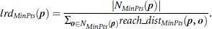
Intuitively, the local reachability density of p is the inverse of the average reachabilitydensitybased on theMinPts-nearestneighbors of p.It isdefined as
The local outlier factor (LOF) of p captures the degree to which we call p an outlier.Itisdefined as
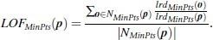
It is the average of the ratio of the local reachability density of p and those of p’sMinPts-nearest neighbors. It is easy to see that the lower p’s local reachability densityis, and the higher the local reachability density of p’s MinPts-nearest neighbors are,thehigherLOF(p) is.

Deviation-BasedOutlierDetection:
Deviation-based outlier detection does not use statistical tests or distance-basedmeasures toidentifyexceptionalobjects.Instead,itidentifiesoutliersbyexaminingthemaincharacteristicsofobjectsinagroup.Objectsthat―deviate‖fromthisdescriptionareconsidered outliers. Hence, in this approach the term deviations is typically used to referto outliers. Inthissection,westudytwotechniquesfordeviation-basedoutlierdetection.Thefirstsequentiallycomparesobjectsinaset,whilethesecondemploysanOLAPdatacubeapproach.

SequentialExceptionTechnique:
Thesequentialexceptiontechniquesimulatesthewayinwhichhumanscandistinguishunusual objects from among a series of supposedly like objects. It uses implicit redundancy of the data. Given a data set, D, of n objects, it builds a sequence of subsets,{D1,D2,…,Dm}, of theseobjects with 2<=m <=n such that

Dissimilarities are assessed between subsets in the sequence. The technique introduces the following key terms.

Exception set:
This is the set of deviations or outliers. It is defined as the smallest subset of objects who seremovalresultsinthe greatest reduction of dissimilarity in there sidualset.

Dissimilarityfunction:
This function does not require a metric distance between theobjects. It is any function that, ifgiven a set of objects, returns a lowvalue if the objectsare similar to one another. The greaterthedissimilarityamongtheobjects,thehigherthevaluereturnedbythefunction.Thedissimilarity of a subset is incrementally computedbased on the subset prior to it in thesequence. Given a subset of n numbers, {x1, …,xn}, a possible dissimilarity function is thevarianceof thenumbers in theset, that is,
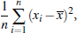

where x is the mean of the n numbers in the set. For character strings, the dissimilarityfunctionmay be in the form of a pattern string (e.g., containing wildcard charactersthat is used to coverall of the patterns seen so far. The dissimilarity increases when the pattern covering all of thestringsin Dj-1doesnot cover anystringin Djthat isnotin Dj-1.

Cardinalityfunction:
Thisistypicallythecountof thenumberof objectsin agiven set.

Smoothingfactor:
This function is computed for each subset in the sequence. Itassesses how much thedissimilaritycanbereducedbyremovingthe subsetfrom theoriginalsetofobjects.

