
CMR ENGINEERING COLLEGE
(Approved by AICTE, Affiliated to JNTU, Hyderabad)
KANDLAKOYA (V), MEDCHALROAD, HYDERABAD-501401.
Ph: 08418200037, 9247022662, Fax: 08418200240, www.cmrec.ac.in
UNIT-1
Short Answers:
- Define Initial Process?
Usually ad hoc and chaotic - Organization operates without formalized procedures, cost estimates, and project plans. Tools are neither well integrated with the process nor uni- firmly applied. Change control is lax, and there is little senior management exposure or understanding of the problems and issues. Since many problems are deferred or even forgotten, software installation and maintenance often present serious problems.

While organizations at this level may have formal procedures for planning and tracking work, there is no management mechanism to insure they are used. Procedures are often abandoned in a crisis in favor of coding and testing. Level 1 organizations don’t use design and code inspections and other techniques not directly related to shipping a product.

Organizations at Level 1 can improve their performance by instituting basic project controls. The most important ones are
•Project management
•Management oversight
•Quality assurance
•Change control
- Define Optimizing Process?
To this point software development managers have largely focused on their products and will typically gather and analyze only data that directly relates to product improvement. In the Optimizing Process, the data are available to tune the process itself.

For example, many types of errors can be identified far more economically by design or code inspections than by testing. However, some kinds of errors are either uneconomical to detect or almost impossible to find except by machine. Examples are errors involving interfaces, performance, human factors, and error recovery.

So, there are two aspects of testing: removal of defects and assessment of program quality. To reduce the cost of removing defects, inspections should be emphasized. The role of functional and system testing should then be changed to one of gathering quality data on the program. This involves studying each bug to see if it is an isolated problem or if it indicates design problems that require more comprehensive analysis.
With Level 5, the organization should identify the weakest elements of the process and fix them. Data are available to justify the application of technology to various critical tasks, and numerical evidence is available on the effectiveness with which the process has been applied to any given product.

- Describe about Repeatable Process?

The Repeatable Process (Level 2)
This level provides control over the way the organization establishes plans and commitments. This control provides such an improvement over Level 1 that the people in the organization tend to believe they have mastered the software problem. This strength, however, stems from their prior experience in doing similar work. Level 2 organizations face major risks when presented with new challenges.
Some major risks:
•New tools and methods will affect processes, thus destroying the historical base on which the organization lies. Even with a defined process framework, a new technology can do more harm than good.
•When the organization must develop a new kind of product, it is entering new territory.
•Major organizational change can be highly disruptive. At Level 2, a new manager has no orderly basis for understanding an organization’s operation, and new members must learn the ropes by word of mouth.
Key actions required to advance from Repeatable to the next stage, the Defined Process, are:
•Establish a process group: A process group is a technical resource that focuses heavily on improving software processes. In most software organizations, all the people are generally devoted to product work. Until some people are assigned full-time to work on the process, little orderly progress can be made in improving it.
•Establish a software development process architecture (or development cycle) that describes the technical and management activities required for proper execution of the development process. The architecture is a structural decomposition of the development cycle into tasks, each of which has a defined set of prerequisites, functional decompositions, verification procedures, and task completion specifications.
      - Introduce a family of software engineering methods and technologies. These include design and code inspections, formal design methods, library control systems, and comprehensive testing methods. Prototyping and modern languages should be considered
- Explain about Managed Process?
Largest problem at Level 4 is the cost of gathering data. There are many sources of potentially valuable measure of the software process, but such data are expensive to collect and maintain. Productivity data are meaningless unless explicitly defined. For example, the simple measure of lines of source code per expended development month can vary by 100 times or more, depending on the interpretation of the parameters.

When different groups gather data but do not use identical definitions, the results are not comparable, even if it makes sense to compare them. It is rare when two processes are comparable by simple measures. The variations in task complexity caused by different product types can exceed five to one. Similarly, the cost per line of code for small modifications is often two to three times that for new programs.

Process data must not be used to compare projects or individuals. Its purpose is too illuminate the product being developed and to provide an informed basis for improving the process. When such data are used by management to evaluate individuals or terms, the reliability of the data itself will deteriorate.

The two fundamental requirements for advancing from the Managed Process to the next level are:
•Support automatic gathering of process data. All data is subject to error and omission, some data cannot be gathered by hand, and the accuracy of manually gathered data is often poor.
•Use process data to analyze and to modify the process to prevent problems and improve efficiency.

- Write brief notes on PSP?

Personal Software Process (PSP) is the skeleton or the structure that assist the engineers in finding a way to measure and improve the way of working to a great extend. It helps them in developing their respective skills at a personal level and the way of doing planning, estimations against the plans.
Objectives of PSP
The aim of PSP is to give software engineers with the regulated methods for the betterment of personal software development processes.
The PSP helps software engineers to:
- Improve their approximating and planning skills.
- Make promises that can be fulfilled.
- Manage the standards of their projects.
- Reduce the number of faults and imperfections in their work.
Time measurement:
Personal Software Process recommend that the developers should structure the way to spend the time. The developer must measure and count the time they spend on different activities during the development.
PSP Planning:
The engineers should plan the project before developing because without planning a high effort may be wasted on unimportant activities which may lead to a poor and unsatisfactory quality of the result.
Levels of Personal Software Process:
Personal Software Process (PSP) has four levels-
- PSP 0 –
The first level of Personal Software Process, PSP 0 includes Personal measurement, basic size measures, coding standards.
- PSP 1 –
This level includes the planning of time and scheduling .
- PSP 2 –
This level introduces the personal quality management ,design and code reviews.
- PSP 3 –
The last level of the Personal Software Process is for the Personal process evolution.

- Write brief notes on PSP?

Team software process (TSP): The primary goal of TSP is to create a team environment for establishing and maintaining a self-directed team, and supporting disciplined individual work as a base of PSP framework. Self-directed team means that the team manages itself, plans and tracks their work, manages the quality of their work, and works proactively to meet team goals. TSP has two principal components: team-building and team working. Team-building is a process that defines roles for each team member and sets up teamwork through TSP launch and periodical relaunch. Team-working is a process that deals with engineering processes and practices utilized by the team. TSP, in short, provides engineers and managers with a way that establishes and manages their team to produce the high-quality software on schedule and budget.
TSP along with the Personal Software Process helps the high-performance engineer to:
• Ensure quality software products
• Create secure software products
• Improve process management in an organization.

- Differences between PSP and TSP?
Differences between PSP and TSP:
- Personal software process is focused on individuals to improve their performance.
- PSP process consists of methods, forms and tricks to guide software engineers in doing their development work.
- Team software process depends on a group of individuals and aimed at improving the performance of the team.
- TSP process consists of programming strategies which will help a software engineering team to build better quality product
Long Answers:
- Describe the Principles of Process change?

People:

•The best people are always in short supply
•You probably have about the best team you can get right now.
•With proper leadership and support, most people can do much better than they are currently doing

Design:

•Superior products have superior design. Successful products are designed by people who understand the application (domain engineer).
•A program should be viewed as executable knowledge. Program designers should have application knowledge.

The Six Basic Principles of Software Process Change:
- Major changes to the process must start at the top.
- Ultimately, everyone must be involved.
- Effective change requires great knowledge of the current process
- Change is continuous
- Software process changes will not be retained without conscious effort and periodic reinforcement
- Software process improvement requires investment

- Discuss about process assessment?
Process assessments help software organizations improve themselves by identifying their crucial problems and establishing improvement priorities. The basic assessment objectives are:
- Learn how the organization works
- Identify its major problems
•Enroll its opinion leaders in the change process
The essential approach is to conduct a series of structured interviews with key people in the organization to learn their problems, concerns, and creative ideas.

ASSESSMENT OVERVIEW
A software assessment is not an audit. Audit are conducted for senior managers who suspect problems and send in experts to uncover them. A software process assessment is a review of a software organization to advise its management and professionals on how they can improve their operation.
The phases of assessment are:
•Preparation - Senior management agrees to participate in the process and to take actions on the resulting recommendations or explain why not. Concludes with a training program for the assessment team
•Assessment - The on-site assessment period. It takes several days to two or more weeks. It concludes with a preliminary report to local management.
•Recommendations - Final recommendations are presented to local managers. A local action team is then formed to plan and implement the recommendations.

Five Assessment Principles:
•The need for a process model as a basis for assessment
•The requirement for confidentiality
•Senior management involvement
•An attitude of respect for the views of the people in the organization be assessed
•An action orientation
Start with a process model - Without a model, there is no standard; therefore, no measure of change.

Observe strict confidentiality - Otherwise, people will learn they cannot speak in confidence. This means managers can’t be in interviews with their subordinates.

Involve senior management - The senior manager (called site manager here) sets the organizations priorities. The site manager must be personally involved in the assessment and its follow-up actions. Without this support, the assessment is a waste of time because lasting improvement must survive periodic crises.

Respect the people in the assessed organization - They probably work hard and are trying to improve. Do not appear arrogant; otherwise, they will not cooperate and may try to prove the team is ineffective. The only source of real information is from the workers.

Assessment recommendations should highlight the three or four items of highest priority. Don’t overwhelm the organization. The report must always be in writing.

Implementation Considerations - The greatest risk is that no significant improvement actions will be taken. Superficial changes won’t help. A small, full-time group should guide the implementation effort, with participation from other action plan working groups. Don’t forget that site managers can change or be otherwise distracted, so don’t rely on that person solely, no matter how committed.

- Difference between CMM and CMMI?
- CMM is a reference model of matured practices in a specified discipline like Systems Engineering CMM, Software CMM, People CMM, Software Acquisition CMM etc. But they were difficult to integrate as and when needed.
- CMMI is the successor of the CMM and evolved as a more matured set of guidelines and was built combining the best components of individual disciplines of CMM (Software CMM, People CMM etc). It can be applied to product manufacturing, People management, Software development etc.
- CMM describes about the software engineering alone where as CMM Integrated describes both software and system engineering. CMMI also incorporates the Integrated Process and Product Development and the supplier sourcing.

- Explain about any two process reference models?
1. CMM
2. PCMM

- CMM
The Capability Maturity Model (CMM) is a procedure used to develop and refine an organization's software development process.
The model defines a five-level evolutionary stage of increasingly organized and consistently more mature processes.
CMM was developed and is promoted by the Software Engineering Institute (SEI), a research and development center promote by the U.S. Department of Defense (DOD).
Capability Maturity Model is used as a benchmark to measure the maturity of an organization's software process.

Methods of SEICMM
There are two methods of SEICMM:
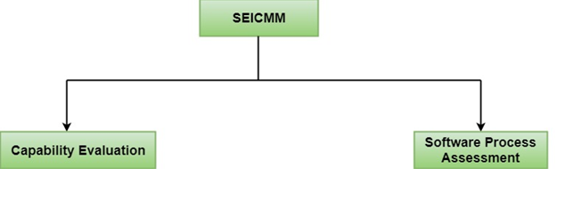

Capability Evaluation: Capability evaluation provides a way to assess the software process capability of an organization. The results of capability evaluation indicate the likely contractor performance if the contractor is awarded a work. Therefore, the results of the software process capability assessment can be used to select a contractor.
Software Process Assessment: Software process assessment is used by an organization to improve its process capability. Thus, this type of evaluation is for purely internal use.
SEI CMM categorized software development industries into the following five maturity levels. The various levels of SEI CMM have been designed so that it is easy for an organization to build its quality system starting from scratch slowly.
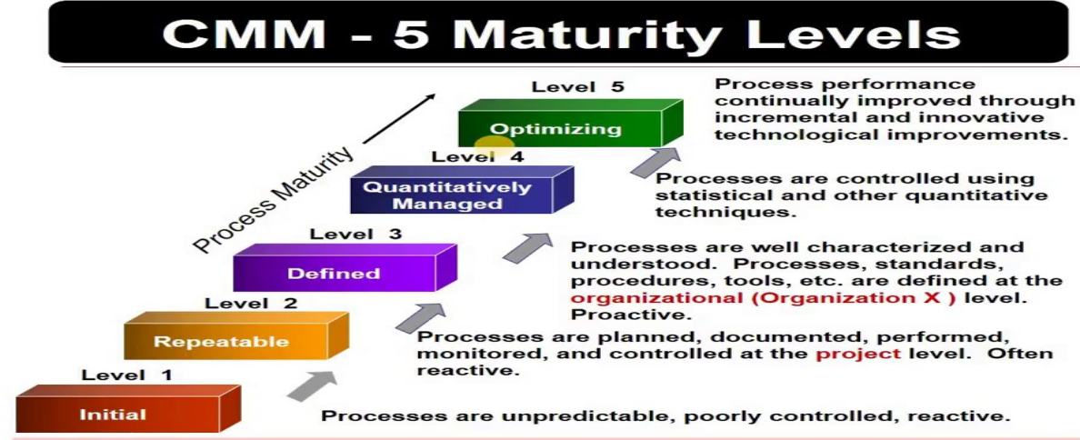

Level 1: Initial
Ad hoc activities characterize a software development organization at this level. Very few or no processes are described and followed. Since software production processes are not limited, different engineers follow their process and as a result, development efforts become chaotic. Therefore, it is also called a chaotic level.

Level 2: Repeatable
At this level, the fundamental project management practices like tracking cost and schedule are established. Size and cost estimation methods, like function point analysis, COCOMO, etc. are used.

Level 3: Defined
At this level, the methods for both management and development activities are defined and documented. There is a common organization-wide understanding of operations, roles, and responsibilities. The ways through defined, the process and product qualities are not measured. ISO 9000 goals at achieving this level.

Level 4: Managed
At this level, the focus is on software metrics. Two kinds of metrics are composed.
Product metrics measure the features of the product being developed, such as its size, reliability, time complexity, understandability, etc.
Process metrics follow the effectiveness of the process being used, such as average defect correction time, productivity, the average number of defects found per hour inspection, the average number of failures detected during testing per LOC, etc. The software process and product quality are measured, and quantitative quality requirements for the product are met. Various tools like Pareto charts, fishbone diagrams, etc. are used to measure the product and process quality. The process metrics are used to analyze if a project performed satisfactorily. Thus, the outcome of process measurements is used to calculate project performance rather than improve the process.

Level 5: Optimizing
At this phase, process and product metrics are collected. Process and product measurement data are evaluated for continuous process improvement.
Except for SEI CMM level 1, each maturity level is featured by several Key Process Areas (KPAs) that contains the areas an organization should focus on improving its software process to the next level. The focus of each level and the corresponding key process areas are shown in the fig.
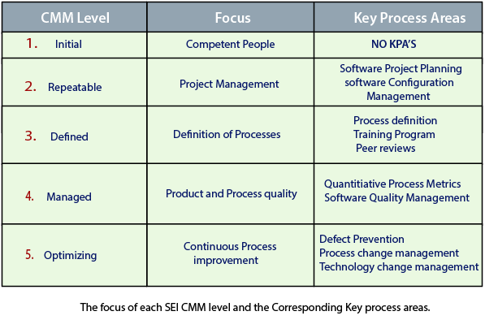
SEI CMM provides a series of key areas on which to focus to take an organization from one level of maturity to the next. Thus, it provides a method for gradual quality improvement over various stages. Each step has been carefully designed such that one step enhances the capability already built up.

People Capability Maturity Model (PCMM)
PCMM is a maturity structure that focuses on continuously improving the management and development of the human assets of an organization.
It defines an evolutionary improvement path from Adhoc, inconsistently performed practices, to a mature, disciplined, and continuously improving the development of the knowledge, skills, and motivation of the workforce that enhances strategic business performance.
The People Capability Maturity Model (PCMM) is a framework that helps the organization successfully address their critical people issues. Based on the best current study in fields such as human resources, knowledge management, and organizational development, the PCMM guides organizations in improving their steps for managing and developing their workforces.
The People CMM defines an evolutionary improvement path from Adhoc, inconsistently performed workforce practices, to a mature infrastructure of practices for continuously elevating workforce capability.
The PCMM subsists of five maturity levels that lay successive foundations for continuously improving talent, developing effective methods, and successfully directing the people assets of the organization. Each maturity level is a well-defined evolutionary plateau that institutionalizes a level of capability for developing the talent within the organization
The five steps of the People CMM framework are:
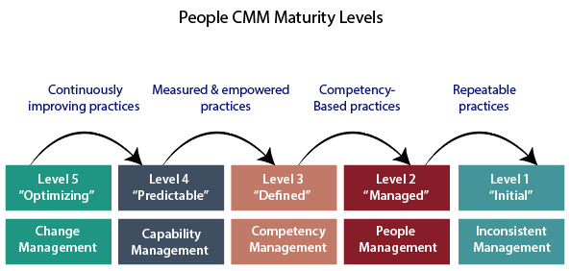

Initial Level: Maturity Level 1
The Initial Level of maturity includes no process areas. Although workforce practices implement in Maturity Level, 1 organization tend to be inconsistent or ritualistic, virtually all of these organizations perform processes that are defined in the Maturity Level 2 process areas.

Managed Level: Maturity Level 2
To achieve the Managed Level, Maturity Level 2, managers starts to perform necessary people management practices such as staffing, operating performance, and adjusting compensation as a repeatable management discipline. The organization establishes a culture focused at the unit level for ensuring that person can meet their work commitments. In achieving Maturity Level 2, the organization develops the capability to handle skills and performance at the unit level. The process areas at Maturity Level 2 are Staffing, Communication and Coordination, Work Environment, Performance Management, Training and Development, and Compensation.

Defined Level: Maturity Level 3
The fundamental objective of the defined level is to help an organization gain a competitive benefit from developing the different competencies that must be combined in its workforce to accomplish its business activities. These workforce competencies represent critical pillars supporting the strategic workforce competencies to current and future business objectives; the improved workforce practices for implemented at Maturity Level 3 become crucial enablers of business strategy.

Predictable Level: Maturity Level 4
At the Predictable Level, the organization handles and exploits the capability developed by its framework of workforce competencies. The organization is now able to handle its capacity and performance quantitatively. The organization can predict its capability for performing work because it can quantify the ability of its workforce and of the competency-based methods they use performing in their assignments.

Optimizing Level: Maturity Level 5
At the Optimizing Level, the integrated organization is focused on continual improvement. These improvements are made to the efficiency of individuals and workgroups, to the act of competency-based processes, and workforce practices and activities.
- Explain about process maturity levels?

PROCESS MATURITY LEVELS

Initial. Until the process is under statistical control, orderly progress in process improvement is not possible. Must at least achieve rudimentary predictability of schedules and costs.
Repeatable. The organization has achieved a stable process with a repeatable level of statistical control by initiating rigorous project management of commitments, costs, schedules, and changes.
Defined. The organization has defined the process as a basis for consistent implementation and better understanding. At this point, advanced technology can be introduced.
Managed.The organization has initiated comprehensive process measurements and analysis. This is when the most significant quality improvements begin.
Optimizing.The organization now has a foundation for continuing improvement and optimization of the process.
These levels are selected because they
•Represent the historical phases of evolutionary improvement of real software organizations
•Represent a measure of improvement that is reasonable to achieve from a prior level
Suggest improvement goals and progress measures
•Make obvious a set of intermediate improvement priorities once an organization’s status in this framework

UNIT-II
Short Answers:
- What is meant by software economics?
Software Economics in software engineering is mature research area that generally deals with most difficult and challenging problems and issues of valuing software and determining or estimation costs usually involved in its production. Boehm and Sullivan outline these difficulties and challenges and also presented how software economics principles can be applied to improve software design, development, and evolution.
Most of software cost models are generally abstracted into function of five basic parameters. These parameters are given below:
1. Size 2. Process 3. Personnel 4.Environment 5. Quality

- Define the term artifact set?
- In order to manage the development of a complete software system, we need to gather distinct collections of information and is organized into artifact sets.
- Set represents a complete aspect of the system.
- Artifact represents interrelated information that is developed and reviewed as a single entity.
- Life cycle software artifacts are organized into five distinct sets that are
- Management (textual formats).
- Requirements (organized text of the problem space).
- Design (models of the solution space).
- Implementation (human-readable programming language and associated source files).
- Deployment (machine - process able languages and associated files)

- List five characteristics of successful object-oriented project.
5 characteristics of a successful object-oriented software project are,
- A ruthless focus on the development of a system that provides a well understood collection of essential minimal characteristics.
- The existence of a culture that is centered on results, encourages communication, and yet is not afraid to fail.
- The effective use of object oriented modeling
- The existence of a strong architectural vision.
- The application of a well-managed iterative and incremental development life cycle.
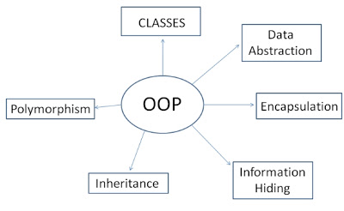
- What do you mean by Production Stage?

The production stage: More predictable but larger teams doing construction, test, and deployment activities. This stage is also decomposed into two distinct phases construction and transition.
- The construction represents a production process, in which emphasis is placed on managing resources and controlling operations to optimize costs, schedules, and quality
- The transition phase is entered when a baseline is mature enough to be deployed in the end user domain.
- Which means the product which is completed and to be deployed in the end user domain.
- The transition phase’s focuses on the activities required to place the software into the hands of the users.

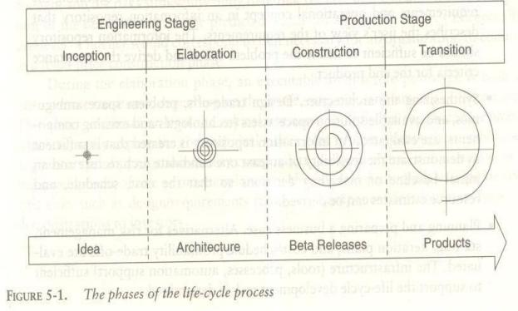

- Write about Primary Objectives of Construction Phase?
PRIMARY OBJECTIVES
- Minimizing development costs by optimizing resources and avoiding unnecessary scrap and rework
- Achieving adequate quality as rapidly as practical
- Achieving useful versions (alpha, beta, and other test releases) as rapidly as practical

- What is ROI? Discuss it in different domains

Return on Investment (ROI) is a performance measure used to evaluate the efficiency of an investment or compare the efficiency of a number of different investments. ROI tries to directly measure the amount of return on a particular investment, relative to the investment's cost.
Return on investment is a very popular metric because of its versatility and simplicity. That is, if an investment does not have a positive ROI, or if there are other opportunities with a higher ROI, then the investment should be not be undertaken.

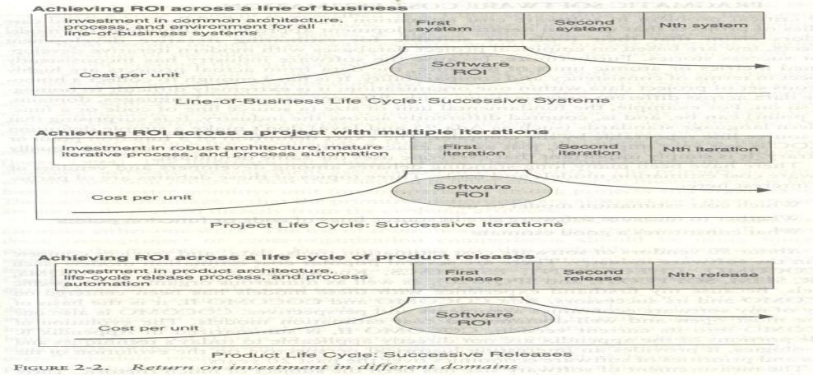
6.Explain the disadvantage of commercial components
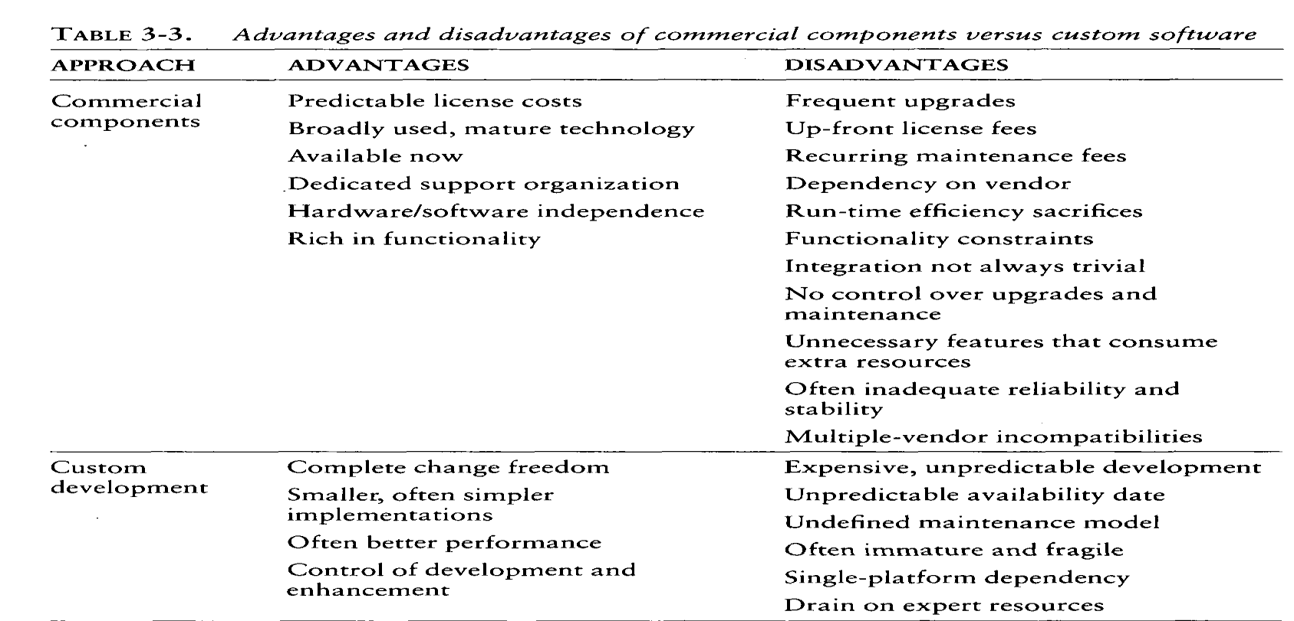
7.Explain cost estimation process?
Project cost estimation is the process of predicting the quantity, cost, and price of the resources required by the scope of a project. Since cost estimation is about the prediction of costs rather than counting the actual cost, a certain degree of uncertainty is involved.
- In order to estimate the cost of a project the following three topics should be considered,
- Which cost estimation model to use?
- Whether to measure software size in SLOC or function point.
- What constitutes a good estimate?
- There are lot of software cost estimation models are available such as, COCOMO, CHECKPOINT, ESTIMACS, Knowledge Plan, Price-S, ProQMS, SEER, SLIM, SOFTCOST, and SPQR/20.
- Among them COCOMO (constructive cost model) is one of the most open and well-documented cost estimation models.
- The software size can be measured by using 1) SLOC 2) Function points.
- Many experts uses SLOC is a measure of size.
- SLOC worked well in applications that were custom built.
- But now a days there are so many automatic source code generators are available and there are so many advanced higher-level languages are available. So SLOC is a uncertain measure.
- A function point is a "unit of measurement" to express the amount of business functionality an information system (as a product) provides to a user.
- The most real-world use of cost models is bottom-up rather than top-down.
- The software project manager defines the target cost of the software, then manipulates the parameters and sizing until the target cost can be justified
- List any 3 attributes for Good software cost estmate.
Following are the attributes that Good Software Cost Estimate Contains :
- It is simply conceived i.e. planned and supported by project manager, architecture team, development team, and test team responsible for performing work and task.
- All the stakeholders generally accept it as ambitious but realizable.
- It is based on a well-defined and efficient cost model of software on a credible basis.
- It is also based on a similar project experience database that includes and contains similar processes, relevant technologies, relevant environments, relevant quality requirements, and all similar people.
- It is also defined and explained in much amount of detail so that all of its key risks are simply understood and probability of success is objectively assessed.

- What is late risk resolution?
- A serious issues associated with the waterfall life cycle was the lack of early risk resolution. The risk profile of a waterfall model is
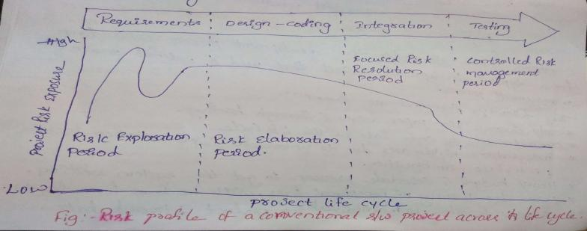
- It includes four distinct periods of risk exposure, where risk is defined as “the probability of missing a cost, schedule, feature, or quality goal”.
- In requirements phase risk is unpredictable.
- In design phase, risk exposure stabilized.
- In coding some of the risks got resolved.
- In integration many real design issues were resolved and engineering tradeoffs were made.
- Resolving the risks in late in the lifecycle was very expensive.
11. Describe five improvements to the basic waterfall process?
- Program design comes first:
- Document the design:
- Do it Twice:
- Plan, control and monitor testing:
- Involve the customer

Long Answers:

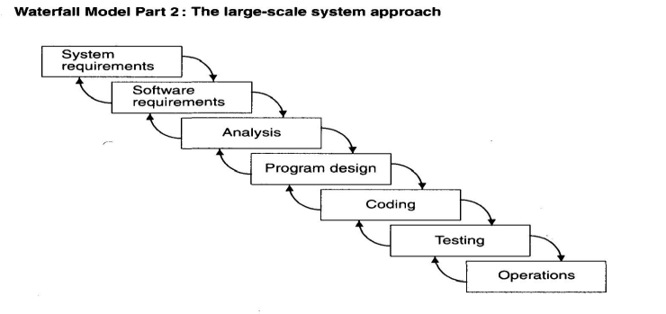
What is waterfall model? Discuss five necessary improvements for this approach?
There are five improvements to the basic waterfall model that would eliminate most of the development risks are as follows:
- Complete program design before analysis and coding begin (program design comes first):
By this technique, the program designer gives surety that the software will not fail because of storage, timing, and data fluctuations.
Begin the design process with program designer, not the analyst or programmers.
Write an overview document that is understandable, informative, and current so that every worker on the project can gain an elemental understanding of the system.
- Maintain current and complete documentation (Document the design):
It is necessary to provide a lot of documentation on most software programs.
Due to this, helps to support later modifications by a separate test team, a separate maintenance team, and operations personnel who are not software literate.
- Do the job twice, if possible (Do it twice):

If a computer program is developed for the first time, arrange matters so that the version finally delivered to the customer for operational deployment is actually the second version insofar as critical design/operations are concerned.
- Plan, control, and monitor testing:
The biggest user of project resources is the test phase. This is the phase of greatest risk in terms of cost and schedule.
In order to carryout proper testing the following things to be done:
Employ a team of test specialists who were not responsible for the original design. Employ visual inspections to spot the obvious errors like dropped minus signs, missing factors of two, jumps to wrong addresses.
Test every logic phase.
Employ the final checkout on the target computer.
- Involve the customer:
It is important to involve the customer in a formal way so that he has committed himself at earlier points before final delivery by conducting some reviews such as,
Preliminary software review during preliminary program design step. Critical software review during program design.
Final software acceptance review following testing.

2. Explain about top 10 principles of conventional software management performance?
CONVENTIONAL SOFTWARE MANAGEMENT PERFORMANCE
- Finding and fixing a software problem after delivery costs 100 times more than finding and fixing the problem in early design phases.
- You can compress software development schedules 25% of nominal (small), but no more.
- For every $1 you spend on development, you will spend $2 on maintenance.
- Software development and maintenance costs are primarily a function of the number of source lines of code.
- Variations among people account for the biggest difference in software productivity.
- The overall ratio of software to hardware costs is still growing. In 1955 it was 15:85; in 1985, 85:15.
- Only about 15% of software development effort is devoted to programming.
- Software systems and products typically cost 3 times as much per SLOC as individual software programs. Software-system products cost 9 times as much.
- Walkthroughs catch 60% of the errors.
- 80% of the contribution comes from 20% of the contributors.
80% of the engineering is consumed by 20% of the requirements.
80% of the software cost is consumed by 20% of the components.
80% of the errors are caused by 20% of the components.
80% of the software scrap and rework is caused by 20% of the errors.
80% of the resources are consumed by 20% of the components.
80% of the engineering is accomplished by 20% of the tools.
80% of the progress is made by 20% of the people.

3. List the symptoms of the project which are in trouble frequently and explain late risk resolution?

Projects destined for trouble frequently exhibit the following symptoms
  - Protracted integration and late design breakage
  - Late risk resolution
  - Requirements driven functional decomposition
  - Adversarial stakeholder relationships
  - Focus on documents and review meetings Late
  - Risk Resolution
A serious issues associated with the waterfall life cycle was the lack of early risk resolution. The risk profile of a waterfall model is, It includes four distinct periods of risk exposure, where risk is
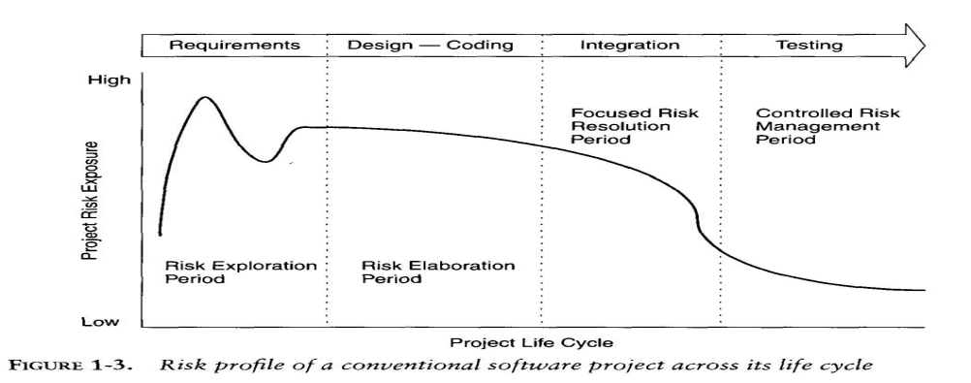

4.Explain about evolution of software economics?
Evolution of Software Economics
Economics means System of interrelationship of money, industry and employment. SOFTWARE ECONOMICS:
The cost of the software can be estimated by considering the following things as parameters to a function.
- Size: Which is measured in terms of the number of Source Lines of Code or the number of function points required to develop the required functionality?
- Process: Used to produce the end product, in particular the ability of the process is to avoid no value adding activities (rework, bureaucratic delays, and communications overhead).
- Personnel: The capabilities of software engineering personnel, and particularly their experience with the computer science issues and the application domain issues of the project.
- Environment: Which is made up of the tools and techniques available to support efficient software development and to automate the process
- Quality: It includes its features, performance, reliability, and flexibility. The relationship among these parameters and estimated cost can be calculated by using,
Effort = (Personnel) (Environment) (Quality) (Size Process)
One important aspect of software economics is that the relationship between effort and size Exhibits a diseconomy of scale and is the result of the process exponent being greater than 1.0. Converse to most manufacturing processes, the more software you build, the more expensive it is per unit item.
There are three generations of basic technology advancement in tools, components, and processes are available.
- Conventional: 1960 and 1970, Craftsmanship. Organizations used custom tools, custom Processes, and virtually all custom components built in primitive languages. Project performance was highly predictable.
- Transition: 1980 and 1990, software engineering. Organizations used more-repeatable processes and off-the-shelf tools, and mostly (>70%) custom components built in higher level languages. Some of the components (<30%) were available as commercial products like, OS, DBMS, Networking and GUI.
- Modern practices: 2000 and later, software production.
- 70% component-based,
- 30% custom
Conventional Transition Modern Practices
- 1960s 1970s - 1980s 1990s - 2000 and on
- Waterfall model - Process improvement - Iterative development
- Functional design - Encapsulation - based - Component-based
- Diseconomy of scale- Diseconomy of scale- ROI
Environments /tools: Custom Off-the-shelf, separate Off-the-shelf, Integrated Size: - 100% custom 30% component-based 70% component-based
- 70% custom 30% custom

5. Explain The principles of conventional software engineering?
1) Make quality #1: Quality must be quantified and mechanisms put into place to motivate its achievement.
2) High-quality software is possible: In order to improve the quality of the product we need to involving the customer, select the prototyping, simplifying design, conducting inspections, and
hiring the best people.
3) Give products to customers early: No matter how hard you try to learn user’s needs during the requirements phase, the most effective way to determine real needs is to give users a product and let them play with it.
4) Determine the problem before writing the requirements: Whenever a problem is raised most engineers provide a solution. Before we try to solve a problem, be sure to explore all the alternatives and don’t be blinded by the understandable solution
5) Evaluate design alternatives: After the requirements are greed upon, we must examine a variety of architectures and algorithms and choose the one which is not used earlier.
6) Use an appropriate process model: For every project, there are so many prototypes (process models). So select the best one that is exactly suitable to our project.
7) Use different languages for different phases: Our ind solutions to complex problems. In order to accomplish this goal choose different languages for different modules/phases if required.
8) Minimize intellectual distance: We have to design the structure of software is as close as possible to the real-world structure.
9) Put techniques before tools: An un disciplined software engineer with a tool becomes a dangerous, undisciplined software engineer.
10) Get it right before you make it faster: It is very easy to make a working program run faster than it is to make a fast program work. Don’t worry about optimization during initial coding.
11) Inspect the code: Examine the detailed design and code is a much better way to find the errors than testing.
12) Good management is more important than good technology
13) People are the key to success: Highly skilled people with appropriate experience, talent, and training are key. The right people with insufficient tools, languages, and process will succeed.
14) Follow with care: Everybody is doing something but does not make it right for you. It may be right, but you must carefully assess its applicability to your environment.
15)Take responsibility: When a bridge collapses we ask “what did the engineer do wrong?”. Similarly if the software fails, we ask the same. So the fact is in every engineering discipline, the best Methods can be used to produce poor results and the most out of date methods to produce stylish design.
16) Understand the customer’s priorities: It is possible the customer would tolerate 90% of the functionality delivered late if they could have 10% of it on time.
17) The more they see, the more they need: The more functionality (or performance) you provide a user, the more functionality (or performance) the user wants.
18)Plan to throw one away .One of the most important critical success factors
is whether or not a product is entirely new. Such brand-new applications,
architectures, interfaces, or algorithms rarely work the first time.
19)Design for change. The architectures, components, and specification techniques you use must accommodate change.
20)Design without documentation is not design.I have often software engineers say,
“I have finished the design.I have finished the design. All that is left is the documentation
21)Use tools, but be realistic. Software tools make their users more efficient.
22) Avoid tricks. Many programmers love to create programs with tricks- constructs that perform a function correctly, but in an obscure way. Show the world how smart you are by avoiding tricky code.
23)Encapsulate. Information-hiding is a simple, proven concept that results in software that is easier to test and much easier to maintain.
24)Use coupling and cohesion. Coupling and cohesion are the best inherent maintainability and adaptability.
25)Use the McCabe complexity measure. Although there are many metrics available to reportThe inherent complexity of software, none is as intuitive and easy to use as Tom McCabe’s.
26) Don’t test your own software. Software developers should never be the primary testers of their own software.
27. Analyze causes for errors. It is far more cost-effective to reduce the effect of an error by preventing it than it is to find and fix it. One way to do this is to analyze the causes of errors as they are detected. change will grow in complexity and become more and more disorganized.
29. People and time are not interchangeable. Measuring a project solely by person-months makes little sense.
30. Expert excellence. Your employees will do much better if you have high expectations for them.

6. Explain the top five principles of modern software management
- Base the process on an architecture-first approach: (Central design element)
  - Design and integration first, then production and test
- Establish an iterative life-cycle process: (The risk management element)
  - Risk control through ever-increasing function, performance, quality.
entire solution, build the software, then test the end product in sequence. Instead, and iterative process that refines the problem understanding, an effective solution, and an effective plan over several iterations encourages balanced treatment of all stakeholder objectives.
Major risks must be addressed early to increase predictability and avoid expensive downstream scrap and rework.
- Transition design methods to emphasize component-based development: (The technology element)
Moving from LOC mentally to component-based mentally is necessary to reduce the amount of human-generated source code and custom development. A component is a cohesive set of preexisting lines of code, either in source or executable format, with a defined interface and behavior.
- Establish a change management environment: (The control element) - Metrics, trends, process instrumentation, The dynamics of iterative development, include concurrent workflows by different teams working on shared artifacts, necessitates objectively controlled baseline.
- Enhance change freedom through tools that support round-trip engineering: (The automation element) - Complementary tools, integrated environment
Round-trip engineering is the environment support necessary to automate and synchronize engineering information in different formats. Change freedom is necessary in an iterative process.

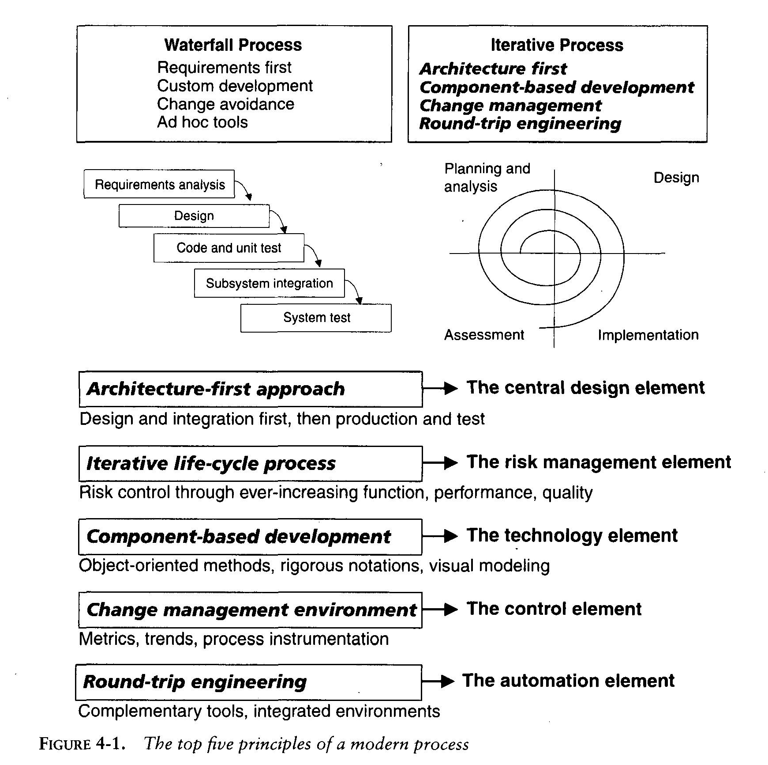

7. Summarize the important trends in improving software economics?
Improving software economics
- It is not that much easy to improve the software economics but also difficult to measure and validate
- There are many aspects are there in order to improve the software economics they are, Size, Process, Personnel, Environment and quality.
- These parameters (aspects) are not independent they are dependent. For example, tools enable size reduction and process improvements, size-reduction approaches lead to process changes, and process improvements drive tool requirements.
- GUI technology is a good example of tools enabling a new and different process. GUI builder tools permitted engineering teams to construct an executable user interface faster and less cost.
- Two decades ago, teams developing a user interface would spend extensive time analyzing factors, screen layout, and screen dynamics. All this would done on paper. Whereas by using GUI, the paper descriptions are not necessary.
- Along with these five basic parameters another important factor that has influenced software technology improvements across the board is the ever-increasing advances in hardware Performance.
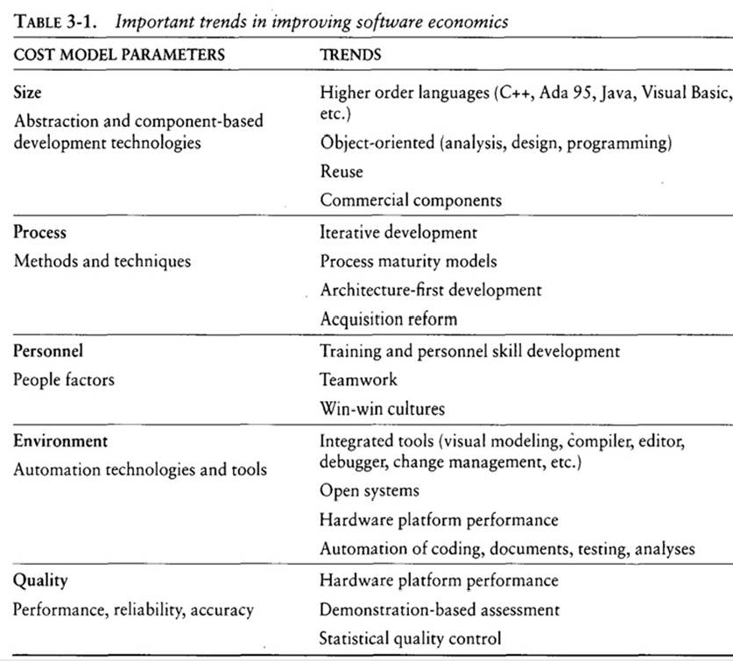
8. Explain the “achieving required quality”?
Achieving required quality: Key elements that improve overall software quality include the following:
- Focusing on powerful requirements and critical use case early in the life Focusing on requirements completeness and traceability late in the life cycle
- Focusing throughout the life cycle on a balance between requirements evolution, design evolution, and plan evolution
- Using metrics and indicators to measure the progress and quality of an architecture as it evolves from high-level prototype into a fully biddable product
- Providing integrated life-cycle environments that support early and continuous configuration control, change management, rigorous design methods, document automation, and regression test automation
- Using visual modeling and higher level languages that support architectural control, abstraction, reliable programming, reuse, and self-documentation
Early and continuous close look into performance issues through demonstration-based evaluations
In order to evaluate the performance the following sequence of events are necessary,
- Project inception
- Initial design review
- Mid-life-cycle design review
- Integration test
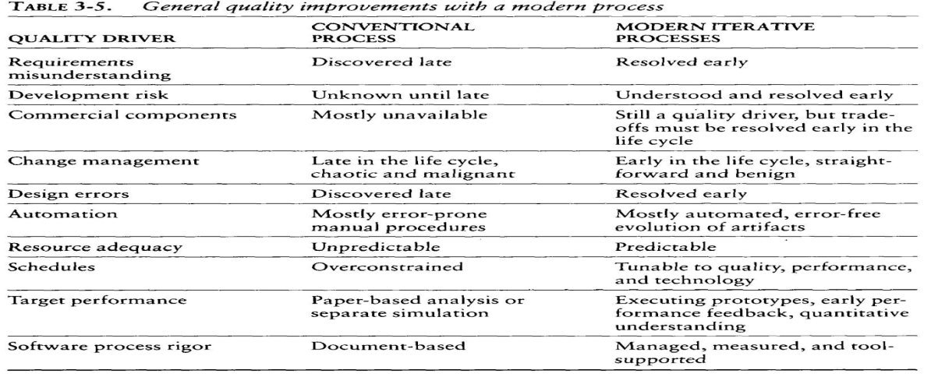
9. Explain the peer inspections?
Peer inspections are frequently overhyped as the key aspect of a quality system. In my experience, peer reviews are valuable as secondary mechanisms, but they are rarely significant contributors to quality compared with the following primary quality mechanisms and indicators, which should be emphasized in the management process:
Transitioning engineering information from one artifact set to another, thereby assessing the consistency, feasibility, understandability, and technology constraints inherent in the engineering artifacts
Major milestone demonstrations that force the artifacts to be assessed against tangible criteria in the context of relevant use cases
Environment tools (compilers, debuggers, analyzers, automated test suites) that ensure representation rigor, consistency, completeness, and change control
Life-cycle testing for detailed insight into critical trade-offs, acceptance criteria, and requirements compliance
Chane management metrics for objective insight into multiple-perspective change trends and convergence or divergence from quality and progress goals

instead of a separate discipline performed by quality assurance specialists. Evaluating and assessing the quality of the evolving engineering baselines should be the job of an engineering team that is independent of the architecture and development team. Their life-cycle assessment of the evolving artifacts would typically include change management, trend analysis, and testing, as well as inspection.

10.Explain the phases of life cycle process?
Engineering and Production Stages :
To achieve economics of scale and higher return on investment, we must move toward a software manufacturing process which is determined by technological improvements in process automation and component based development.
There are two stages in the software development process
- The engineering stage: Less predictable but smaller teams doing design and production activities. This stage is decomposed into two distinct phases inception and elaboration.
- The production stage: More predictable but larger teams doing construction, test, and deployment activities. This stage is also decomposed into two distinct phases construction and transition.
These four phases of lifecycle process are loosely mapped to the conceptual framework of the spiral model is as shown in the following figure

Although I believe that inspections are overemphasized, in certain cases they provide a significant return. One value of inspections is in the professional development of a team. It is generally useful to have the products of junior team members reviewed by senior mentors. Putting the products of amateurs into the hands of experts and vice versa is a good mechanism for accelerating the acquisition of knowledge and skill in new personnel. Gross blunders can be caught and feedback can be appropriately channeled, so that bad practices are not perpetuated. This is one of the best ways for junior software engineers to learn.
Inspections are also a good vehicle for holding authors accountable for quality products. All authors of software and documentation should have their products scrutinized as a natural by- product of the process. Therefore, the coverage of inspections should be across all authors rather than across all components. Junior authors need to have a random component inspected periodically, and they can learn by inspecting the products of senior authors. Varying levels of informal inspection are performed continuously when developers are reading or integrating software with another author's software, and during testing by independent test teams.

However, this "inspection" is much more tangibly focused on integrated and executable aspects of the overall system.
Significant or substantial design errors or architecture issues are rarely obvious from a superficial review unless the inspection is narrowly focused on a particular issue. And most inspections are superficial. Today's systems are highly complex, with innumerable components, concurrent execution, distributed resources, and other equally demanding dimensions of complexity. It would take human intellects similar to those of world-class chess players to comprehend the dynamic interactions within some simple software systems under some simple use cases.

Consequently, random human inspections tend to degenerate into comments on style and first- order semantic issues. They rarely result in the discovery of real performance bottlenecks, serious control issues (such as deadlocks, races, or resource contention), or architectural weaknesses (such as flaws in scalability, reliability, or interoperability). In all but trivial cases, architectural issues are exposed only through more rigorous engineering activities such as the following:
Analysis, prototyping, or experimentation
Committing the current state of the design model to an executable implementation Demonstrating the current implementation strengths and weaknesses in the context of critical subsets of the use cases and scenarios
Incorporating lessons learned back into the models, use cases, implementations, and plans Achieving architectural quality is inherent in an iterative process that evolves the artifact sets together in balance. The checkpoints along the way are numerous, including human review and inspections focused on critical issues. But these inspections are not the primary checkpoints. Early life-cycle artifacts are certainly more dependent on subjective human review than later ones are. Focusing a large percentage of a project's resources on human inspections is bad practice and only perpetuates the existence of low-value-added box checkers who have little impact on project success. Look at any successful software effort and ask the key designers, testers, or developers about the discriminators of their success. It is unlikely that any of them will cite meetings, inspections, or documents.
Quality assurance is everyone's responsibility and should be integral to almost all process activities

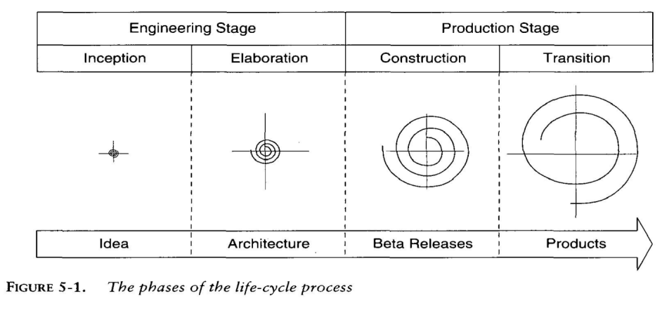

In the above figure the size of the spiral corresponds to the inactivity of the project with respect to the breadth and depth of the artifacts that have been developed.

This inertia manifests itself in maintaining artifact consistency, regression testing, documentation, quality analyses, and configuration control.
Increased inertia may have little, or at least very straightforward, impact on changing any given discrete component or activity.
However, the reaction time for accommodating major architectural changes, major requirements changes, major planning shifts, or major organizational perturbations clearly increases in subsequent phases.

11.Discuss about inception and elaboration phases?
Inception Phase:
The main goal of this phase is to achieve agreement among stakeholders on the life-cycle objectives for the project.
The overriding goal of the inception phase is to achieve concurrence among all stakeholders on the lifecycle objectives for the project. The primary objectives of the inception phase include
--Establishing the project's software scope and boundary conditions, including an operational concept, acceptance criteria and what is intended to be in the product and what is not.
--Discriminating the critical use cases of the system, the primary scenarios of operation that will drive the major design trade-offs.
--Exhibiting, and maybe demonstrating, at least one candidate architecture against some of the primary scenarios
--Estimating the overall cost and schedule for the entire project (and more detailed estimates for the elaboration phase that will immediately follow)
--Estimating potential risks (the sources of unpredictability) The essential activities of the inception phase are:
--Formulating the scope of the project. This involves capturing the context and the most important requirements and constraints to such an extent that you can derive acceptance criteria for the end product.
--Planning and preparing a business case. Evaluating alternatives for risk management, staffing, project plan, and cost/schedule/profitability trade-offs.
--Synthesizing a candidate architecture, evaluating trade-offs in design, and in make/buy/reuse, so that cost, schedule and resources can be estimated.
The outcome of the inception phase is:
--A vision document: a general vision of the core project's requirements, key features, main constraints.
--The use-case model survey (identifying all use cases that can be identified at this early stage).
--An initial glossary.
--An initial business case, which includes:
--Business context.
--Success criteria (revenue projection, market recognition, and so on).
--Financial forecast.
--An initial risk assessment.
--A project plan, showing phases, and iterations.
Elaboration Phase:
- It is the most critical phase among the four phases.
- Depending upon the scope, size, risk, and freshness of the project, an executable architecture prototype is built in one or more iterations.
The primary objectives of the elaboration phase include:
i)Defining, validating and base lining the architecture as rapidly as practical ii)Base lining the vision
- Base lining a high-fidelity plan for the construction phase
iv)Demonstrating that the baseline architecture will support this vision for reasonable cost in a reasonable time.

The essential activities of the elaboration phase are:
i)Elaborating the vision establishing a solid understanding of the most critical use cases that drive the architectural and planning decisions.
ii)Elaborating the process and the infrastructure, the development environment. Putting in place the process, tools and automation support.
iii)Elaborating the architecture and selecting components. Potential components are evaluated and the make/buy/reuse decisions sufficiently understood to determine the construction phase cost and schedule with confidence. The selected architectural components are integrated and assessed against the primary scenarios. Lessons learned from these activities may well result in a redesign of the architecture, taking into consideration alternative designs or reconsideration of the requirements.

The outcome of the elaboration phase is:
- A use-case model (80% complete) - all use cases having been identified in the use-case model survey, all actors having been identified, and most use-case descriptions (requirements capture) having been developed.
ii)Supplementary requirements capturing the non functional requirements and any requirements that are not associated with a specific use case.
iii)An executable architecture and accompanying documentation -the Software Architecture Document, including use-case descriptions (design) for a subset of use cases (use-case view), and an updated glossary.
.
A development plan for the overall project, including the coarse-grained project plan, showing iterations and evaluation criteria for each iteration. A preliminary user manual (optional).

12.Summarize the artifact sets in a diagrammatical manner and management artifacts?

THE ARTIFACT SETS :In order to manage the development of a complete software system, we need to gather distinct collections of information and is organized into artifact sets.
- Set represents a complete aspect of the system where as artifact represents interrelated information that is developed and reviewed as a single entity.
- The artifacts of the process are organized into five sets:
  - Management
  - Requirements
  - Design
  - Implementation
  - Deployment
here the management artifacts capture the information that is necessary to synchronize stakeholder expectations. Where as the remaining four artifacts are captured rigorous notations that support automated analysis and browsing.
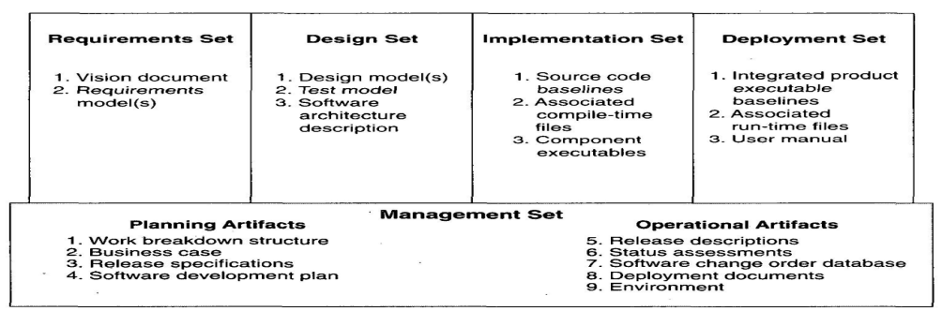
MANAGEMENT ARTIFACTS:
Development of WBS is dependent on product management style , organizational culture, custom performance, financial constraints and several project specific parameters.
- The WBS is the architecture of project plan. It encapsulate change and evolve with appropriate level of details.
- A WBS is simply a hierarchy of elements that decomposes the project plan into discrete work task.
- A WBS provides the following information structure
- A delineation of all significant tasks.
- A clear task decomposition for assignment of responsibilities.
vi)A framework for scheduling ,debugging and expenditure tracking.
vii)Most systems have first level decomposition subsystem. subsystems are then decomposed into their components
viii)Therefore WBS is a driving vehicle for budgeting and collecting cost.
ix)The structure of cost accountability is a serious project planning constraints.

Business Case:
The business case artifact provides all the information necessary to determine whether the project is worth investing in. It details the expected revenue, expected cost, technical and management plans, and backup data necessary to demonstrate the risks and realism of the plans. In large contractual procurements, the business case may be implemented in a full-scale proposal with multiple volumes of information. In a small-scale endeavor for a commercial product, it may be implemented in a brief plan with an attached spreadsheet.
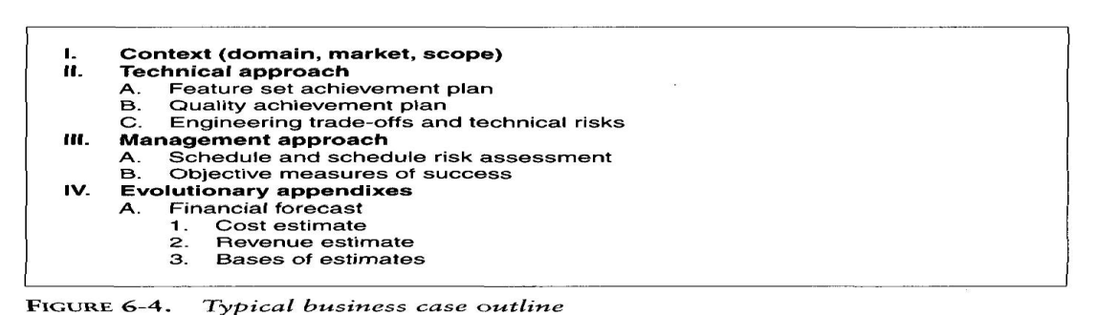
.

Release Specifications
The scope, plan, and objective evaluation criteria for each baseline release are derived from the vision statement as well as many other sources (make/buy analyses, risk management concerns, architectural considerations, shots in the dark, implementation constraints, quality thresholds). These artifacts are intended to evolve along with the process, achieving greater fidelity as the life cycle progresses and requirements understanding matures. Figure 6-6 provides a default outline for a release specification

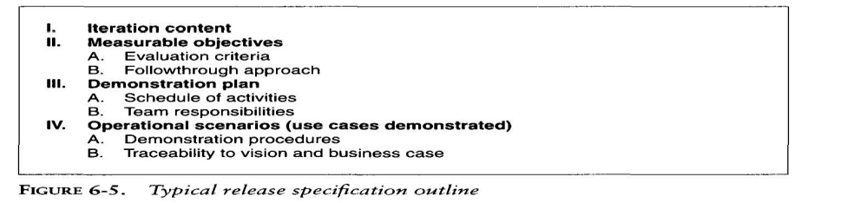

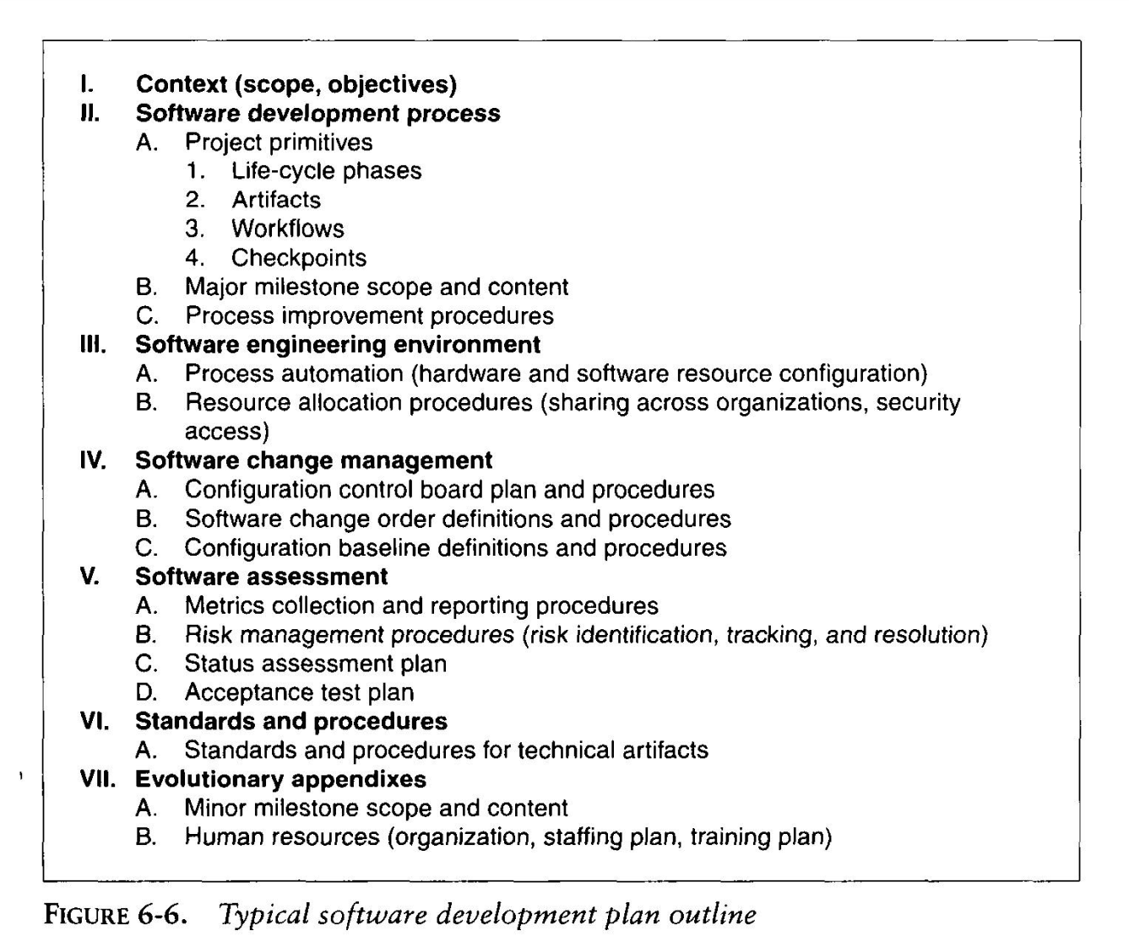

Software Development Plan
The software development plan (SDP) elaborates the process framework into a fully detailed plan. Two indications of a useful SDP are periodic updating (it is not stagnant shelf ware) and understanding and acceptance by managers and practitioners alike. Figure 6-5 provides a default outline for a software development plan.

Release Descriptions
Release description documents describe the results of each release, including performance against each of the evaluation criteria in the corresponding release specification. Release baselines should be accompanied by a release description document that describes the evaluation criteria for that configuration baseline and provides substantiation (through demonstration, testing, inspection, or analysis) that each criterion has been addressed in an acceptable manner. Figure 6-7 provides a default outline for a release description.

Status Assessments
Status assessments provide periodic snapshots of project health and status, including the software project manager's risk assessment, quality indicators, and management indicators. Typical status assessments should include a review of resources, personnel staffing, financial data (cost and revenue), top 10 risks, technical progress (metrics snapshots), major milestone plans and results, total project or product scope & action items

Work Breakdown Structure
Work breakdown structure (WBS) is the vehicle for budgeting and collecting costs. To monitor and control a project's financial performance, the software project man1ger must have insight into project costs and how they are expended. The structure of cost accountability is a serious project planning constraint.

Software Change Order Database
Managing change is one of the fundamental primitives of an iterative development process. With greater change freedom, a project can iterate more productively. This flexibility increases the content, quality, and number of iterations that a project can achieve within a given schedule. Change freedom has been achieved in practice through automation, and today's iterative development environments carry the burden of change management. Organizational processes that depend on manual change management techniques have encountered major inefficiencies.
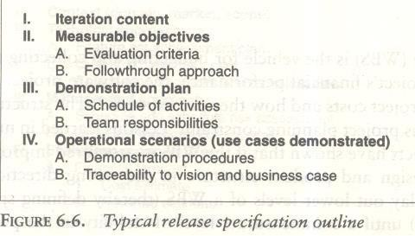

Environment
An important emphasis of a modern approach is to define the development and maintenance environment as a first-class artifact of the process. A robust, integrated development environment must support automation of the development process. This environment should include requirements management, visual modeling, document automation, host and target programming tools, automated regression testing, and continuous and integrated change management, and feature and defect tracking.

Deployment
A deployment document can take many forms. Depending on the project, it could include several document subsets for transitioning the product into operational status. In big contractual efforts in which the system is delivered to a separate maintenance organization, deployment artifacts may include computer system operations manuals, software installation manuals, plans and procedures for cutover (from a legacy system), site surveys, and so forth. For commercial software products, deployment artifacts may include marketing plans, sales rollout kits, and training courses.

Management Artifact Sequences
In each phase of the life cycle, new artifacts are produced and previously developed artifacts are updated to incorporate lessons learned and to capture further depth and breadth of the solution. Figure 6-8 identifies a typical sequence of artifacts across the life-cycle phases.

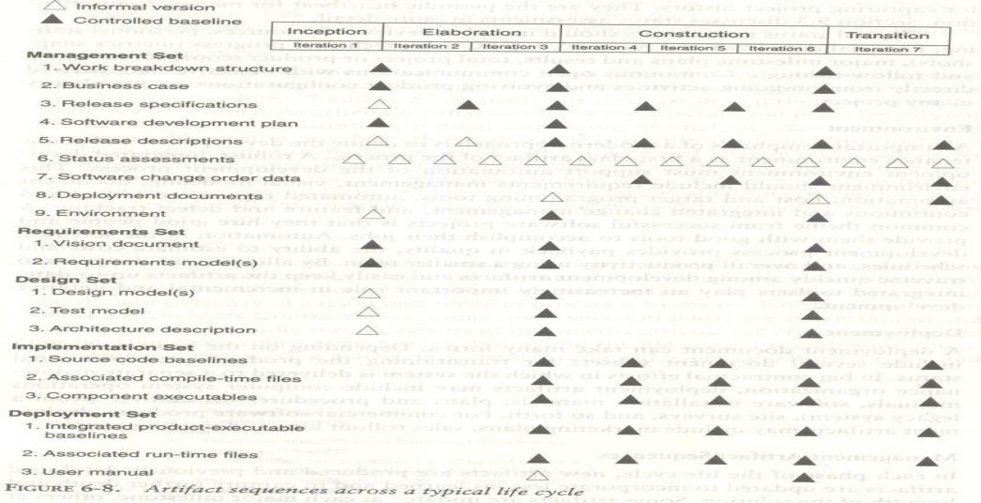
13. Explain about Engineering artifact.

ENGINEERING ARTIFACTS
Most of the engineering artifacts are captured in rigorous engineering notations such as UML, programming languages, or executable machine codes. Three engineering artifacts are explicitly intended for more general review, and they deserve further elaboration.

Vision Document
The vision document provides a complete vision for the software system under development and. supports the contract between the funding authority and the development organization. A project vision is meant to be changeable as understanding evolves of the requirements, architecture, plans, and technology. A good vision document should change slowly. Figure 6-9 provides a default outline for a vision document.
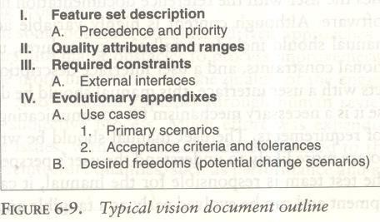

Architecture Description
The architecture description provides an organized view of the software architecture under development. It is extracted largely from the design model and includes views of the design, implementation, and deployment sets sufficient to understand how the operational concept of the requirements set will be achieved. The breadth of the architecture description will vary from project to project depending on many factors. Figure 6-10 provides a default outline for an architecture description.
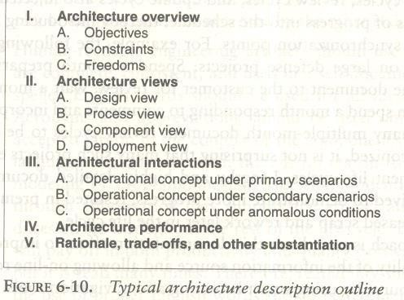

Software User Manual
The software user manual provides the user with the reference documentation necessary to support the delivered software. Although content is highly variable across application domains, the user manual should include installation procedures, usage procedures and guidance, operational constraints, and a user interface description, at a minimum. For software products with a user interface, this manual should be developed early in the life cycle because it is a necessary mechanism for communicating and stabilizing an important subset of requirements. The user manual should be written by members of the test team, who are more likely to understand the user's perspective than the development team.

14. Explain about Pragmatic Artifacts
PRAGMATIC ARTIFACTS
- People want to review information but don't understand the language of the artifact. Many interested reviewers of a particular artifact will resist having to learn the engineering language in which the artifact is written. It is not uncommon to find people (such as veteran software managers, veteran quality assurance specialists, or an auditing authority from a regulatory agency) who react as follows: "I'm not going to learn UML, but I want to review the design of this software, so give me a separate description such as some flowcharts and text that I can understand."
- People want to review the information but don't have access to the tools. It is not very common for the development organization to be fully tooled; it is extremely rare that the/other stakeholders have any capability to review the engineering artifacts on-line. Consequently, organizations are forced to exchange paper documents. Standardized formats (such as UML, spreadsheets, Visual Basic, C++, and Ada 95), visualization tools, and the Web are rapidly making it economically feasible for all stakeholders to exchange information
electronically.
- Human-readable engineering artifacts should use rigorous notations that are complete, consistent, and used in a self-documenting manner. Properly spelled English words should be used for all identifiers and descriptions. Acronyms and abbreviations should be used only where they are well accepted jargon in the context of the component's usage. Readability should be emphasized and the use of proper English words should be required in all engineering artifacts. This practice enables understandable representations, browse able formats (paperless review), more-rigorous notations, and reduced error rates.

Useful documentation is self-defining: It is documentation that gets used.
- Paper is tangible; electronic artifacts are too easy to change. On-line and Web-based artifacts can be changed easily and are viewed with more skepticism because of their inherent volatility.

.

UNIT III
Short Answers:

      - What is Operational capability Milestone
Initial Operational Capability Milestone: These milestones occur late in the construction phase. The goals are to assess the readiness of the software to begin the transition into customer / user sites and to authorize the start of acceptance testing.
      - What is Product Release Milestone
Product Release Milestone: Occur at the end of the transition phase. The goal is to assess the completion of the software and its transition to the support organization, if any. The results of acceptance testing are reviewed, and all open issues are addressed and software quality metrics are reviewed to determine whether quality is sufficient for transition to the support organization.
      - Explain about Iteration Assessment Review
This informal milestone is conducted at the end of each iteration to assess the degree to which the iteration achieved its objectives and to review iteration results, test results, to determine amount of rework to be done, to review impact of the iteration results on the plan for subsequent iterations.
      - Explain about Iteration Readiness Review
This informal milestone is conducted at the start of each iteration to review the detailed iteration plan and the evaluation criteria that have been allocated to this iteration
      - Explain about joint management reviews.
  - Major milestones. These system wide events are held at the end of each development phase. They provide visibility to system wide issues, synchronize the management and engineering perspectives, and verify that the aims of the phase have been achieved.
  - Minor milestones. These iteration-focused events are conducted to review the content of an iteration in detail and to authorize continued work.
  - Status assessments. These periodic events provide management with frequent and regular insight into the progress being made.
      - Explain about Life-cycle Objective Milestone

Life-Cycle Objectives Milestone
The life-cycle objectives milestone occurs at the end of the inception phase. The goal is to present to all stakeholders a recommendation on how to proceed with development, including a plan, estimated cost and schedule, and expected benefits and cost savings. A successfully completed life-cycle objectives milestone will result in authorization from all stakeholders to proceed with the elaboration phase.

Long Answers:
- What is mean by Iterationworkflows?

An iteration consists of a loosely sequential set of activities in various proportions, depending on where the iteration is located in the development cycle. Each iteration is defined in terms of a set of allocated usage scenarios. The components needed to implement all selected scenarios are developed and integrated with the results of previous iterations. An individual iteration's workflow, generally includes the following sequence:
i)Management: iteration planning to determine the content of the release and develop the detailed plan for the iteration; assignment of work packages, or tasks, to the development team
ii)Environment: evolving the software change order database to reflect all new baselines and changes to existing baselines for all product, test, and environment components
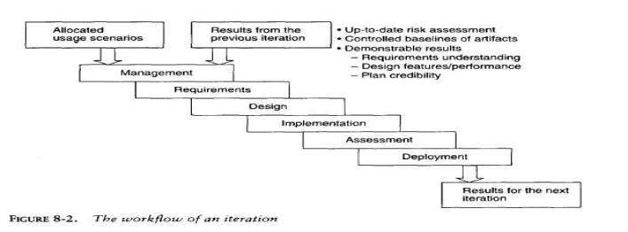

Requirements: analyzing the baseline plan, the baseline architecture, and the baseline requirements set artifacts to fully elaborate the use cases to be demonstrated at the end of this iteration and their evaluation criteria; updating any requirements set artifacts to reflect changes necessitated by results of this iteration's engineering activities

Design: evolving the baseline architecture and the baseline design set artifacts to elaborate fully the design model and test model components necessary to demonstrate against the evaluation criteria allocated to this iteration; updating design set artifacts to reflect changes necessitated by the results of this iteration's engineering activities
Implementation: developing or acquiring any new components, and enhancing or modifying any existing components, to demonstrate the evaluation criteria allocated to this iteration; integrating and testing all new and modified components with existing baselines (previous versions)
Assessment: evaluating the results of the iteration, including compliance with the allocated evaluation criteria and the quality of the current baselines; identifying any rework required and determining whether it should be performed before deployment of this release or allocated to the next release; assessing results to improve the basis of the subsequent iteration's plan .
Deployment: transitioning the release either to an external organization (such as a user, independent verification and validation contractor, or regulatory agency) or to internal closure by conducting a post-mortem so that lessons learned can be captured and reflected in the next iteration. As with any sequence of a software development workflow, many of the activities occur concurrently. For example, requirements analysis is not done all in one continuous lump; it intermingles with management, design, implementation, and so forth.
- Iterations in the inception and elaboration phases focus on management, requirements, and design activities.
- Iterations in the construction phase focus on design, implementation, and assessment.
- Iterations in the transition phase focus on assessment and deployment.
Figure 8-3 shows the emphasis on different activities across the life cycle.
These descriptions are pretty simplistic. In practice, the various sequences and overlaps among iterations become more complex. The terms iteration and increment deal with some of the pragmatic considerations.
An iteration represents the state of the overall architecture and the complete deliverable system.
An increment represents the current work in progress that will be combined with the preceding iteration to form the next iteration.
Figure 8-4, an example of a simple development life cycle, illustrates the difference between iterations and increments. This example also illustrates a typical build sequence from the perspective of an abstract layered architecture.
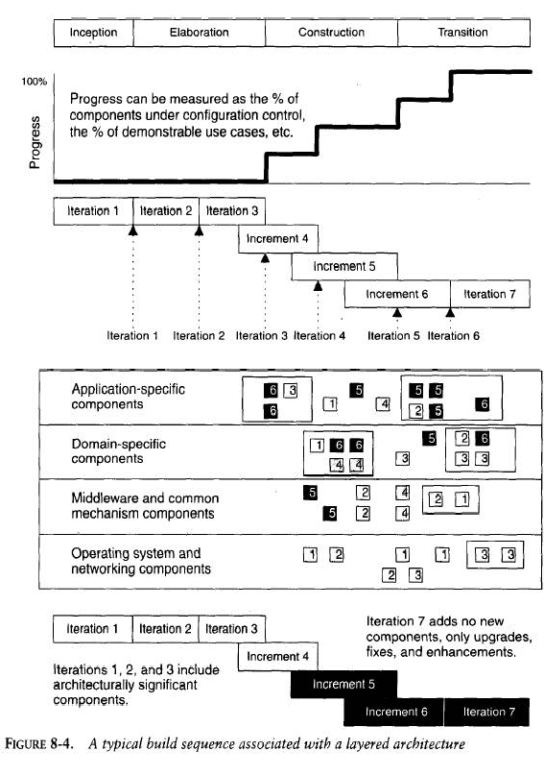

Management reviews that are conducted throughout the process.
Three types of joint management reviews are conducted throughout the process:
Major milestones. These system wide events are held at the end of each development phase. They provide visibility to system wide issues, synchronize the management and engineering perspectives, and verify that the aims of the phase have been achieved.
Minor milestones. These iteration-focused events are conducted to review the content of an iteration in detail and to authorize continued work.
Status assessments. These periodic events provide management with frequent and regular insight into the progress being made, illustrates a typical sequence of project checkpoints for a relatively large project.
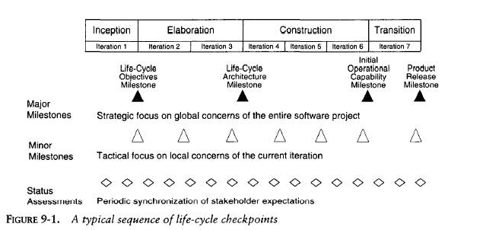

The initial operational capability milestone and product release milestone in detail?

Initial Operational Capability Milestone
The initial operational capability milestone occurs late in the construction phase. The goals are to assess the readiness of the software to begin the transition into customer/user sites and to authorize the start of acceptance testing. Acceptance testing can be done incrementally across multiple iterations or can be completed entirely during the transition phase is not necessarily the completion of the construction phase.

Product Release Milestone: The product release milestone occurs at the end of the transition phase. The goal is to assess the completion of the software and its transition to the support organization, if any. The results of acceptance testing are reviewed, and all open issues are addressed. Software quality metrics are reviewed to determine whether quality is sufficient for transition to the support organization.

Detail about WBS?
Work breakdown structure: WBS is simply a hierarchy of elements that decomposes the project plan into the discrete work tasks. A WBS provides the following information structure:
- A delineation of all significant work
- A clear task decomposition for assignment of responsibilities
- A framework for scheduling, budgeting, and expenditure tracking
Many parameters can drive the decomposition of work into discrete tasks: product subsystems, components, functions, organizational units, life-cycle phases, even geographies. Most systems have a first-level decomposition by subsystem. Subsystems are then decomposed into their components, one of which is typically the software.
CONVENTIONAL WBS ISSUES
Conventional work breakdown structures frequently suffer from three fundamental flaws.
- They are prematurely structured around the product design.
- They are prematurely decomposed, planned, and budgeted in either too much or too little detail.
- They are project-specific, and cross-project comparisons are usually difficult or impossible.
Conventional work breakdown structures are prematurely structured around the product design. Figure shows a typical conventional WBS that has been structured primarily around the subsystems of its product architecture, then further decomposed into the components of each subsystem. A WBS is the architecture for the financial plan.
Conventional work breakdown structures are prematurely decomposed, planned, and budgeted in either too little or too much detail. Large software projects tend to be over planned and small

projects tend to be under planned. The basic problem with planning too much detail at the outset is that the detail does not evolve with the level of fidelity in the plan.
Conventional work breakdown structures are project-specific, and cross-project comparisons are usually difficult or impossible. With no standard WBS structure, it is extremely difficult to compare plans, financial data, schedule data, organizational efficiencies, cost trends, productivity trends, or quality trends across multiple projects.
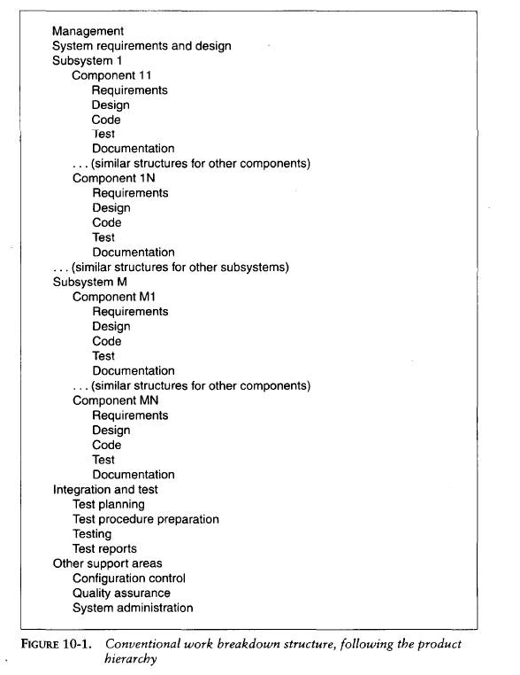

EVOLUTIONARY WORK BREAKDOWN STRUCTURES :
An evolutionary WBS should organize the planning elements around the process framework rather than the product framework. The basic recommendation for the WBS is to organize the hierarchy as follows:
- First-level WBS elements are the workflows (management, environment, requirements, design, implementation, assessment, and deployment).
- Second-level elements are defined for each phase of the life cycle (inception, elaboration, construction, and transition).
- Third-level elements are defined for the focus of activities that produce the artifacts of each phase.
This recommended structure provides one example of how the elements of the process framework can be integrated into a plan. It provides a framework for estimating the costs and schedules of each element, allocating them across a project organization, and tracking expenditures.
The structure shown is intended to be merely a starting point. It needs to be tailored to the specifics of a project in many ways.
- Scale. Larger projects will have more levels and substructures.
- Organizational structure. Projects that include subcontractors or span multiple organizational entities may introduce constraints that necessitate different WBS allocations.
- Degree of custom development. Depending on the character of the project, there can be very different emphases in the requirements, design, and implementation workflows.
- Business context. Projects developing commercial products for delivery to a broad customer base may require much more elaborate substructures for the deployment element.
- Precedent experience. Very few projects start with a clean slate. Most of them are developed as new generations of a legacy system (with a mature WBS) or in the context of existing organizational standards (with preordained WBS expectations).
The WBS decomposes the character of the project and maps it to the life cycle, the budget,
and the personnel. Reviewing a WBS provides insight into the important attributes, priorities, and structure of the project plan.
Another important attribute of a good WBS is that the planning fidelity inherent in each element is commensurate with the current life-cycle phase and project state. One of the primary reasons for organizing the default WBS the way I have is to allow for planning elements that range from planning packages (rough budgets that are maintained as an estimate for future elaboration rather than being decomposed into detail) through fully planned activity networks (with a well-defined budget and continuous assessment of actual versus planned expenditures).

- . What are the key principles of modern software engineering?
- Architecture-first approach: Extensive requirements analysis, design, implementation, and assessment activities are performed before the construction phase.
It mainly focuses on implementing and testing the architecture must precede focus on completeness and quality of the entire product features.
- Iterative life-cycle process: Some projects may require only one iteration in a phase; other may require several iterations.
- The point is that the activities and artifacts of any given workflow may require more than one pass to achieve adequate results.
- Round-trip engineering: Raising the environment activities to a first-class workflow is critical. The environment is the tangible picture of the project’s process, methods, and notations for producing the artifacts.
- Demonstration-based approach: Implementation and assessment activities are initiated early in the life cycle, reflecting the emphasis on constructing executable subsets of the evolving architecture.

- Write brief notes on major milestones in software process
Major milestones: These are the system wide events are held at the end of each development phase. They provide visibility to system wide issues.
Life-Cycle Objective Milestone: These milestones occur at the end of the inception phase. The goal is to present to all stakeholders a recommendation on how to proceed with development, including a plan, estimated cost and schedule, and expected benefits and cost savings.
Life- Cycle Architecture Milestone: These milestones occur at the end of the elaboration phase. Primary goal is to demonstrate an executable architecture to all stakeholders. A more detailed plan for the construction phase is presented for approval.
Initial Operational Capability Milestone: These milestones occur late in the construction phase. The goals are to assess the readiness of the software to begin the transition into customer / user sites and to authorize the start of acceptance testing.
Product Release Milestone: Occur at the end of the transition phase. The goal is to assess the completion of the software and its transition to the support organization, if any. The results of acceptance testing are reviewed, and all open issues are addressed and software quality metrics are reviewed to determine whether quality is sufficient for transition to the support organization.
- Discuss about the cost and schedule estimating process?
The cost and schedule estimating process:
- Project plans need to be derived from two perspectives:
1) Forward-looking, top-down approach: It starts with an understanding requirements and constraints, derives a macro-level budget and schedule, then decomposes these elements into lower level budgets and intermediate milestones.
- From this perspective the following planning sequences would occur:
a) The software project manager develops a characterization of the overall size, process, environment, people, and quality required for the project.
b) A macro-level estimate of the total effort and schedule is developed using a software cost estimation model.
c) The software project manager partitions the estimate for the effort into a top-level WBS using guidelines and also partitions the schedule into major milestone dates and partition the effort into a staffing profile using guidelines..
d) Subproject managers are given the responsibility for decomposing each of the WBS elements into lower levels using their top-level allocation, staffing profile, and major milestone dates as constraints
2)Backward-looking, bottom-up approach: We start with the end in mind, analyze the micro-level budgets and schedules, then sum all these elements into higher level budgets and intermediate milestones.
- From this perspective, the following planning sequences would occur:
a) The lowest level WBS elements are elaborated into detailed tasks.
b) Estimates are combined and integrated into higher level budgets and milestones.
c) Comparisons are made with the top-down budgets and schedule milestones. Gross differences are assessed and adjustments are made in order to converge on agreement between the topdown and bottom-up estimates.
- Discuss about periodic status assessment?
Periodic status assessments are management reviews conducted at regular intervals to address progress and quality indicators, ensure continuous attention to project dynamics and maintain open communications among all stakeholders.
Periodic status assessments serve as project snapshots
Status assessments provide the following:
1) A mechanism for openly addressing, communicating, and resolving management issues, technical issues, and project risks.
2) A mechanism for broadcast process, progress, quality trends, practices, and experience information to and from all stakeholders in an open forum.
3) Objective data derived directly from on-going activities and evolving product configurations.

- Discuss about Pragmatic planning?
- Aside from bad architecture and misunderstood requirements, inadequate planning is one of the most common reasons for project failures.
- Good planning leads to project success.
- The important perspectives of planning are planning requirements and architecture, the end products associated with these perspectives.
- Planning document is extremely important to project success.
- A project’s plan is a definition of how the project requirements will be transformed into a product within the business constraints.
- It must be realistic, it must be current, it must be a team product, it must be understood by the stakeholders and it must be used.
- Explain about conventional WBS issues?
Conventional WBS issues:
- Conventional work breakdown structures commonly suffer from three fundamental faults.
- Conventional WBS is prematurely structured around the product design.
2. CWBS are prematurely decomposed, planned, and budgeted in either too little or too much detail.
3. CWBS are project-specific, and cross-project comparisons are usually difficult or impossible

UNIT-IV

- Write about Project Review Authority (PRA)?
  - PRA is also the single individual person responsible for reviewing the finance performance, customer commitments, risks and business unit software policies, practices and standards
  - A project manager has the responsibility for meeting the requirements and is also accountable to PRA.
  - The customer monitors contract requirements, contract milestones, contract deliverables, monthly management reviews, progress, quality, cost, schedule and risk.
  - The PRA reviews customer commitments as well as organizational policies, organizational deliverables, financial performance, and other risks and accomplishments.

- Write about Software Engineering Process Authority
  - This team is responsible for exchange of information and process guidance both from project practioners.
  - This role is generally played by the organizational general manager for maintaining the current assessment of project plan for future process improvements.
  - SEPA is a necessary role in any organization who takes the responsibility accountability for the process definition and its maintenance in terms of modification, improvement and technology introduction.
  - The SEPA could be a single individual, the general manager, or even a team of representatives. The SEPA must truly be an authority, competent and powerful, not a staff position given powerless by ineffective bureaucracy.

- Write about evolution of organizations.
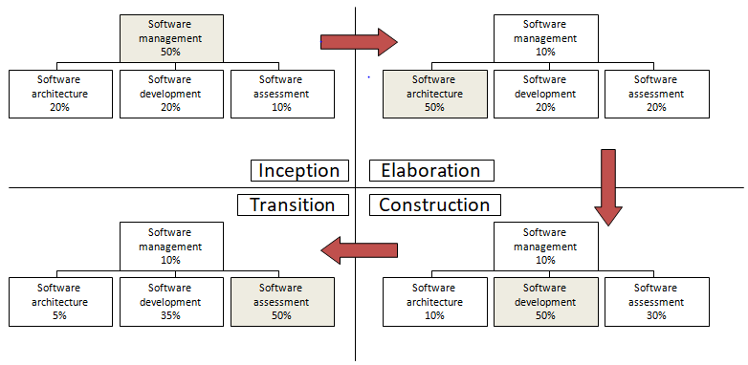
- Inception Team: An organization focused on planning with enough support from the other teams to ensure that the plans represent a consensus of all perspectives
- Elaboration Team: An architecture-focused organization in which the driving forces of the project reside in the software architecture team and are supported by the software development and software assessment team as necessary to achieve a stable architecture baseline.
- Construction Team: a fairly balanced organization in which most of the activity resides in the software development and software assessment teams.
- Transition Team: a customer focused organization in which usage feedback drives the deployment activities.
- what is meant by software architecture
Software architecture refers to the fundamental structures of a software system and the discipline of creating such structures and systems. ... It functions as a blueprint for the system and the developing project, laying out the tasks necessary to be executed by the design teams.
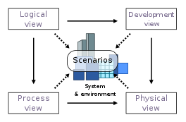
5.Write brief notes on metrics automation.
Many opportunities are available to automate the project control activities of a software project. A Software Project Control Panel (SPCP) is essential for managing against a plan. This panel integrates data from multiple sources to show the current status of some aspect of the project. The panel can support standard features and provide extensive capability for detailed situation analysis. SPCP is one example of metrics automation approach that collects, organizes and reports values and trends extracted directly from the evolving engineering artifacts.
SPCP: To implement a complete SPCP, the following are necessary.
- Metrics primitives : trends, comparisons and progressions
- A graphical user interface.
- Metrics collection agents:
- Metrics data management server
- Metrics definitions: actual metrics presentations for requirements progress, implementation¬ progress, assessment progress, design progress and other progress dimensions.
- Actors monitor and administrator.
- What are the seven core metrics?
- Management Indicators
- Work and Progress
- Budgeted cost and expenditures
- Staffing and team dynamics
- Quality Indicators
4. Change traffic and stability
5. Breakage and modularity
6. Rework and adaptability
7. Mean time between failures (MTBF) and maturity

7. What is meant by management indicators?
Software management indicators are aids to the management of software projects. By collecting data at all stages of development, a manager can learn to detect early warnings of problems and to control the growth of problems.
- There are three fundamental sets of management metrics: technical progress, financial status and staffing progress.
- By examining these perspectives management can generally assess whether a project is on budget and on schedule.
- The management indicators recommended here include standard financial status based on an earned value system, objective technical progress metrics tailored to the primary measurement criteria for each major team of the organization and staffing metrics that provide insight into team dynamics.
- What is meant by work and progress?
Work: The effort to be accomplished to complete a certain set of tasks
Progress: Work completed over time
- What is meant by staffing and Team dynamics?
- This metric measure the personnel changes over time, which involves staffing additions and reductions over time.
- An iterative development should start with a small team until the risks in the requirements and architecture have been suitably resolved.
- Depending on the overlap of iterations and other project specific circumstances, staffing can vary.
- Increase in staff can slow overall project progress as new people consume the productive team of existing people in coming up to speed.
- The default perspectives of this metric are people per month added and people per month leaving.

- What is meant by indicator what are the two types of indicators?
INDICATORS: An indicator is a metric or a group of metrics that provides an understanding of the software process or software product or a software project.
A software engineer assembles measures and produce metrics from which the indicators can be derived. Two types of indicators are:
(i) Management indicators. (ii) Quality indicators.
11. What is meant by breakage and modularity?
- Breakage is defined as the average extent of change, which is the amount of software baseline that needs rework
- Modularity is the average breakage trend over time.
- This indicator provides insight into the benign or malignant character of software change.
- In a mature iterative development process, earlier changes are expected to result in more scrap than later changes.

12. What is meant by change traffic and stability?
- This metric measures the change traffic over time.
- The number of software change orders opened and closed over the life cycle is called change traffic.
- Stability specifies the relationship between opened versus closed software change orders.
- This metric can be collected by change type, by release, across all releases, by term, by components, by subsystems, etc.
13. What is meant by rework and adaptability?
- Rework is defined as the average cost of change which is the effort to analyze, resolve and retest all changes to software baselines.
- Adaptability is defined as the rework trend over time. This metric provides insight into rework measurement.
- All changes are not created equal. Some changes can be made in a staff hour, while others take staff-weeks.This metric provides insight into rework measurement
- What is meant by MTBF and maturity?
- MTBF (Mean Time Between Failures) is the average usage time between software faults.
- It is computed by dividing the test hours by the number of type 0 and type 1 SCOs.
Maturity is defined as the MTBF trend over time
- What is meant by Round-Trip Engineering?
The environment support necessary to automate and synchronize engineering information in different formats (for example, requirements specification, design models, source code, executable code, test cases.

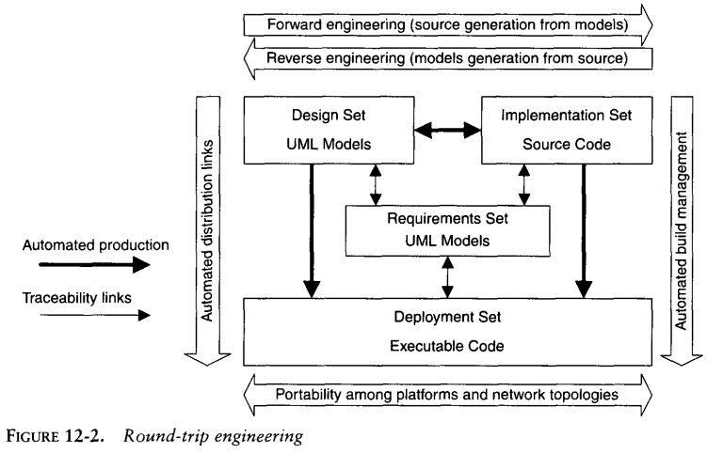

Long Answers :

What are the Activities of software management team and software activities team.
Software management team activities :
The software management team carries the burden of delivering win conditions to all stakeholders. The software management team is responsible for planning the effort and conducting the plan. The software management team takes ownership of all aspects of quality. It is responsible for attaining (reach / achieve) and maintaining balance among these aspects so that the overall solution is adequate for all stakeholders.
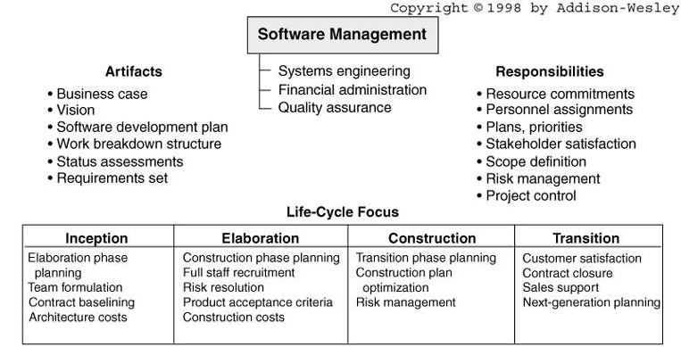
The software architecture team is responsible for the architecture. For any project, the skill of the software architecture team is crucial. With a good architecture team, an average development team can also succeed but if the architecture is weak, even an expert development team of superstar programmers may not succeed. In most projects, the inception and elaboration phases will be dominated by the software management team and the software architecture team.
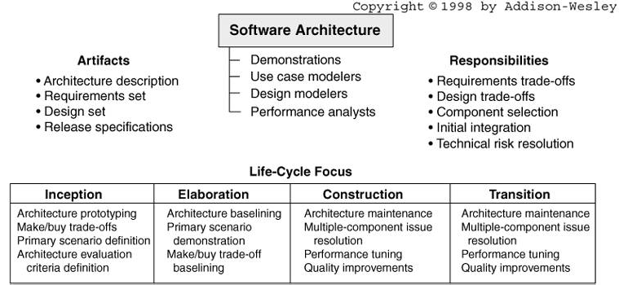
- Write about evolution of organizations.
- Inception Team: An organization focused on planning with enough support from the other teams to ensure that the plans represent a consensus of all perspectives
- Elaboration Team: An architecture-focused organization in which the driving forces of the project reside in the software architecture team and are supported by the software development and software assessment team as necessary to achieve a stable architecture baseline.
- Construction Team: a fairly balanced organization in which most of the activity resides in the software development and software assessment teams.
- Transition Team: a customer focused organization in which usage feedback drives the deployment activities.

Explain about Seven core metrics?
Need for Software Metrics:
- Software metrics are needed for calculating the cost and schedule of a software product with great accuracy.
- Software metrics are required for making an accurate estimation of the progress.
- The metrics are also required for understanding the quality of the software product. Indicators:
An indicator is a metric or a group of metrics that provides an understanding of the software process or software product or a software project. A soft ware engineer assembles measures and produce metrics from which the indicators can be derived. Two types of indicators are:
- Management indicators.
- Quality indicators.

Management Indicators The management indicators i.e., technical progress, financial status and staffing progress are used to determine whether a project is on budget and on schedule. The management indicators that indicate financial status are based on earned value system.
- Work and progress ( work performed over time)
- Budgeted cost and expenditures ( cost incurred over time )
- Staffing and team dynamics ( personnel changes over time )
Quality Indicators The quality indicators are based on the measurement of the changes occurred in software.
- Change traffic and stability ( changes traffic over time)
- Breakage and modularity ( average breakage per change over time)
- Rework and adaptability ( average rework per change over time )
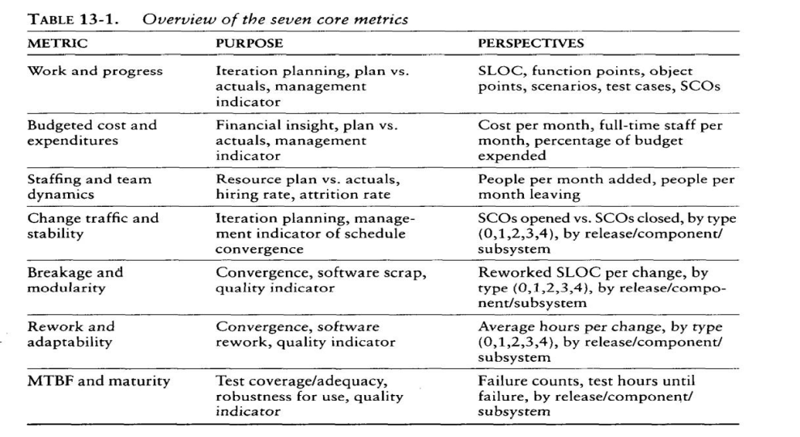
- Mean time between failures ( MTBF) and maturity ( defect rate over time) Seven Core Metrics of Software Project
Software metrics instrument the activities and products of the software development/ integration process. Metrics values provide an important perspective for managing the process. The most useful metrics are extracted directly from the evolving artifacts. There are seven core metrics that are used in managing a modern process.
- Explain about pragmatic software metrics
- Measuring is useful, but it doesn’t do any thinking for the decision makers.
- It only provides data to help them to ask the right questions, understand the context and make objective decisions.
- The basic characteristics of a good metric are as follows:
- It is considered meaningful by the customer, manager and performers. If any of the stakeholders does not see the metric as meaningful, it will not be used.
- It demonstrates quantifiable correlation between process perturbations and business performance. The only real organizational goals and objectives are financial: cost reduction, revenue increase and margin increase.
- It is objective and unambiguously defined.
- It displays trends: understanding the change in a metric’s value with respect to time, subsequent projects, and subsequent releases.
5. It is a natural byproduct of the process: the metric does not introduce new artifacts or overhead activities; it is derived directly from the main stream engineering and management workflows.
6. It is supported by automation. Experience has demonstrated that the most successful metrics are those that are collected and reported by automate tools.
Some of the characteristics of a software by this metrics are:
- A low number of change requests to a software baseline may mean that the software is mature and error free.
- A software change order that has been open for a longtime may mean that the problem was simple to diagnose and the solution required substantial rework.
- A large increase in personnel in a given month may cause progress to increase proportionally if they are trained people who are productive from the outset.
- Explain about Metrics Automation
- Many opportunities are available to automate the project control activities of a software project.
- For managing against a plan, a software project control panel (SPCP) that maintains an on-line version of the status of evolving artifacts provides a key advantage.
- To implement a complete SPCP, it is necessary to define and develop the following:
- Metrics primitives: indicators, trends, comparisons and progressions.
A graphical user interface: GUI support for a software project
- Metrics collection agents: data extraction from the environment tools that maintain the engineering notations for various artifact sets.
- Metrics data management server: data management support for populating the metric displays of the GUI and storing the data extracted by the agent .
- Metrics definitions: Actual metrics presentations for requirements progress, implementation progress, assessment progress, design progress and other progress dimensions.
- Actors: Monitor and administrator.
- Specific monitors called roles include software project managers, software development team leads, software architects and customers.
- Each role performs the same general use cases, but with different focus.
- Monitor: defines panel layouts from existing mechanisms, graphical objects and linkages to project data; queries data to be displayed at different levels of abstraction.
- Administrator: installs the system; defines new mechanisms, graphical objects and linkages etc,.
- The display is called a panel.
- The software project manager role has defined a top level display with four graphical objects.
- Project activity status: The graphical object in the upper left provides an overview of the status of the top level WBS elements
- Technical artifact status: This graphical object provides several examples of indicators: the actual percentage and the current first derivative.
- Milestone progress: The graphical object in the lower left provides a progress assessment of the achievement of milestones against plan and provides indicators of the current values.
- Action item progress: the graphical object in the lower right provides a different perspective of progress, showing the current number of open and closed issues.
- Explain in detail about software change orders?
Software change orders (SCO)
  - The automatic unit of software work that is authorized to create, modify, or obsolesce (out of date) components within a configuration baseline is called SCO.
  - SCO are key mechanisms for partitioning, allocating, and scheduling software work against an established software baseline and for assessing progress and quality.
  - The figure shows a good starting point for describing a set of change primitives. The basic fields of the SCO are
    - Title, b) Description, c) Metrics, d)Resolution, e) Assessment and f) Disposition
a)Title: The Title is suggested by the originator and is finalized upon acceptance by the configuration control board(CCB).This field should should include a reference to an external software problem report if the change was initiated by external person.
b) Description: The Problem description includes the name of the originator, date of organization, CCB-assigned SCO identifier, and relevant version identifiers of related support software
c)Metrics: The metrics collected for each SCO are important for planning, for scheduling, and for assessing quality improvement, change categories are type 0(critical bug),type 1(bug),type 2(enhancement),type 3(new feature),and type 4(other).
- The breakage item quantifies the volume of change.
- The rework item quantifies the complexity of change.
- The analysis item identifies the number of staff hours expended in understanding the required change
- The implement item identifies the staff hours necessary to design and implement the resolution.
- The test item identifies the hours expended in testing the resolution.
- The document item identifies the all effort expended in updating other artifacts such as the user manual or release description.
d)Resolution: This field includes the name of the person responsible for implementing the change, the components changed, the actual metrics,and a description of the change.
e) Assessment: This field describes the assessment technique as either inspection, analysis, demonstration, or test.
f) Disposition: The SCO is assigned one of the following states by the CCB:
Proposed: written, pending CCB review
Accepted: CCB-approved for resolution
Rejected: closed, with rationale, such as not a problem, duplicate, obsolete change, resolves by another SCO.
Archives: accepted but postponed until a later release
In progress: assigned and actively being resolved by the development organization
In assessment: resolved by the development organization; being assessed by a test organization
Closed: completely resolved, with the concurrence of all CCB members
- Configuration baseline: It is a named collection of software components and supporting documentation that is subject to change management and is upgraded, maintained, tested and obsolesced as a unit
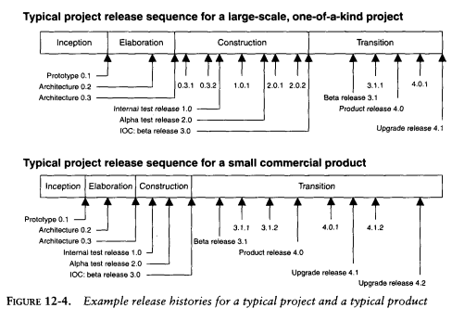
- Once software is placed in controlled baseline, all the changes can be monitored.
- Change categories are as follows.
  - Type-0: Critical failures, are fixed before external product release
  - Type-1: Errors does not produce any negative effect on the usefulness of the product
  - Type-2: Causes performance improvement rather than defect
  - Type-3: Results into update requirements, produce new additional feature
  - Type-4: Changes that are not part of the current version, need to change the version

Configuration Control Board (CCB): A CCB is a team of people that function as the decision authority on the content of configuration baseline.
- It include software manager, software architecture manager, software development manager, software assessment manager, and other stakeholders.
- CCB take action through board meetings, on-line distribution and agreement. It determines the fate of SCO.
- Accepted include change for resolution in the next release; archiving accepts the change but postpones it for resolution in a future release; and rejection judges the without merit, redundant with other proposed changes, or out of scope.
- [in progress]. The responsible person analyzes, implements, and tests a solution to satisfy the SCO. This tasks includes updating documentation ,release notes, and submitting new SCO’s, if necessary.
- [In assessment].The test team checks whether the SCO is completely resolved or not. if they satisfied, the SCO is submitted to the CCB for final disposition and closure.
- [Closed]. When the development organization, independent test organization, and CCB concur that the SCO is resolved ,it is transitioned to a closed status

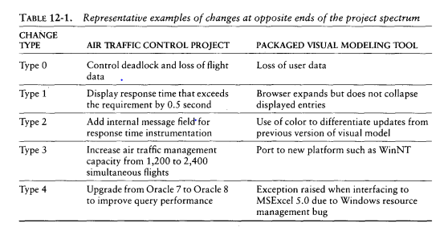
- Discuss about Infrastructures and Stakeholder Environments
Infrastructure
The organization infrastructure provides the organization’s capital assets including two key artifacts - Policy & Environment
I Organization Policy:
A Policy captures the standards for project software development processes
The organization policy is usually packaged as a handbook that defines the life cycles & the
process primitives such as
  - Major milestones
  - Intermediate Artifacts
  - Engineering repositories
  - Metrics
  - Roles & Responsibilities

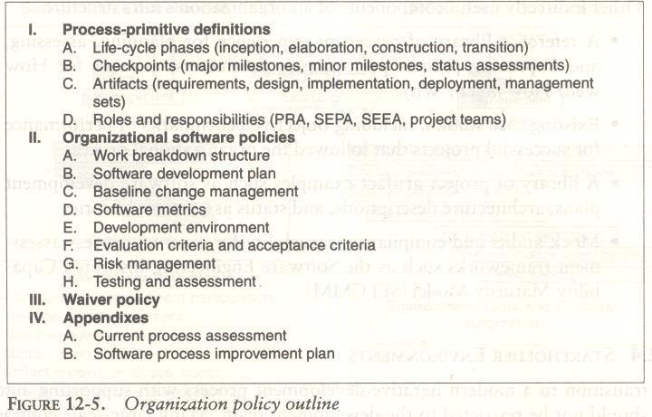

Infrastructure
II Organization Environment
The Environment that captures an inventory of tools which are building blocks from which project environments can be configured efficiently & economically

Stakeholder Environment
Many large scale projects include people in external organizations that represent other stakeholders participating in the development process they might include

- Procurement agency contract monitors
- End-user engineering support personnel
- Third party maintenance contractors
- Independent verification & validation contractors
- Representatives of regulatory agencies & others.

These stakeholder representatives also need to access to development resources so that they can contribute value to overall effort. These stakeholders will be access through on-line
An on-line environment accessible by the external stakeholders allow them to participate in the process a follows
Accept & use executable increments for the hands-on evaluation.
Use the same on-line tools, data & reports that the development organization uses to manage & monitor the project
Avoid excessive travel, paper interchange delays, format translations, paper * shipping costs & other overhead cost

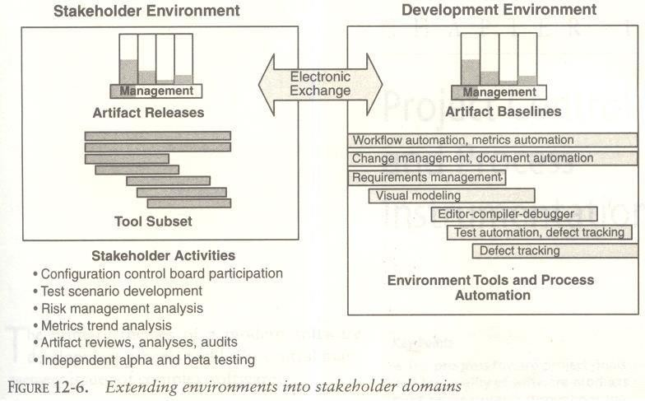

- Discuss about Project Environment:
The Project Environment:
The project environment artifacts evolve through three discrete states.
(1) Prototyping Environment. (2) Development Environment. (3) Maintenance Environment.
The Prototype Environment includes an architecture test bed for prototyping project architecture to evaluate trade-offs during inception & elaboration phase of the life cycle.
The Development environment should include a full suite of development tools needed to support various Process workflows & round-trip engineering to the maximum extent possible.
The Maintenance Environment should typically coincide with the mature version of the development. There are four important environment disciplines that are critical to management context & the success of a modern iterative development process.
- There are four important environment disciplines that are critical to the management context and the success of a modern iterative development process
  - Tools must be integrated to maintain consistency and traceability. Roundtrip engineering is the term used to describe this key requirement for environments that support iterative development
  - Change management must be automated and enforced to manage multiple iterations and to enable change freedom. Change is the fundamental primitives of iterative development
  - Organizational infrastructure enable project environments to be derived from a common base of process and tools. A common infrastructure promotes inter project consistency, reuse of training, reuse of lessons learned and other strategic improvements to the organization's meta process

Extending automation support for stakeholder environments enables to support for paperless exchange of information and more effective review.

UNIT-V

- Explain about evolutionary requirements.
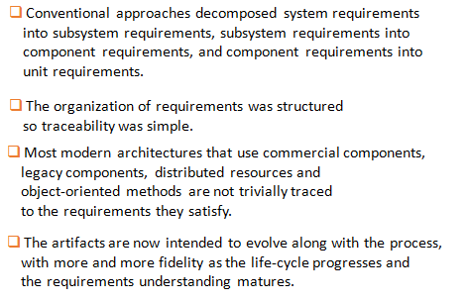
- Describe early risk resolution
- The engineering stage of the life cycle (inception and elaboration phases) focuses on confronting the risks and resolving them before the big resource commitments of the production stage.
- Conventional projects usually do the easy stuff first, thereby demonstrating early progress.
- A modern process attacks the important 20% of the requirements, use cases, components, and risks.
- This is the essence of my most important principle: architecture first.
- 80% of the engineering is consumed by 20% of the requirements.
- 80% of the software cost is utilized by 20% of the components
- .80% of the bugs occur because of 20% of the components
- 80% of the software scrap and rework is due to 20% if the changes
- 80% of the resource consumption is due to 20% of the components
- 80% of the project progress is carried-out by 20% of the people

3. Who are stakeholders? List them
Stakeholders are those with any interest in your project's outcome. They are typically the members of a project team, project managers, executives, project sponsors, customers, and users
Examples of stakeholders in a project
The stakeholders in each particular project will vary depending on the type of project and industry, but here are a few examples of the types of stakeholders in project management you might need to consider:
- Project manager
- Team members
- Managers
- Resource managers
- Executives
- Senior management
- Company owners
- Investors
- Sponsors
- Financiers (the people, not the cakes)
- Suppliers
- Vendors
- Consultants
- Customers
- End users

- Explain in detail about process maturity?

Ans :
The process maturity level of the development organization, as defined by the Software Engineering Institute's Capability Maturity Model is another key driver of management complexity. Managing a mature process (level 3 or higher) is far simpler than managing an immature process (levels 1 and 2). Organizations with a mature process typically have a high level of precedent experience in developing software and a high level of existing process collateral that enables predictable planning and execution of the process. This sort of collateral includes well-defined methods, process automation tools, trained personnel, planning metrics, artifact templates, and workflow templates. Tailoring a mature organization's process for a specific project is generally a straightforward task. Table summarizes key differences in the process primitives for varying levels of process maturity.

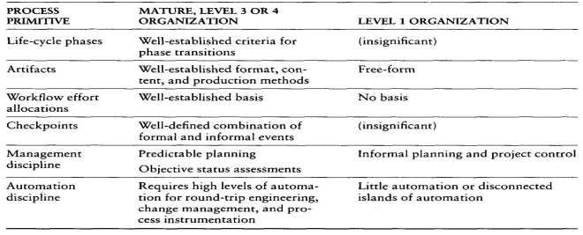

- Explain in detail about architectural risk?

Ans :
The degree of technical feasibility demonstrated before commitment to full-scale production is an important dimension of defining a specific project's process. There are many sources of architectural risk. Some of the most important and recurring sources are system performance (resource utilization, response time, throughput, accuracy), robustness to change (addition of new features, incorporation of new technology, adaptation to dynamic operational conditions), and system reliability (predictable behavior, fault tolerance). The degree to which these risks can be eliminated before construction begins can have dramatic ramifications in the process tailoring, Table summarizes key differences in the process primitives for varying levels of architectural risk.

- Explain the next generation cost models?

Ans :
Next generation software cost models
Software experts hold widely varying opinions about software economics and its manifestation in software cost estimation models: Source lines of code versus function points. Economy of scale versus diseconomy of scale. Productivity measures versus quality measures. Java versus C++. Object-oriented versus functionally oriented. Commercial components versus custom development. All these topics represent industry debates surrounded by high levels of rhetoric. The passionate overhype or under hype, depending on your perspective, makes it difficult to separate facts from exaggeration. Energetic disagreement is an indicator of an industry in flux, in which many competing technologies and techniques are maturing rapidly. One of the results, however, is a continuing inability to predict with precision the resources required for a given software endeavor.
Accurate estimates are possible today, although honest estimates are imprecise. It will be difficult to improve empirical estimation models while the project data going into these models are noisy and highly uncorrelated, and are based on differing process and technology foundations.
Some of today's popular software cost models are not well matched to an iterative software process focused on an architecture-first approach. Despite many advances by some vendors of software cost estimation tools in expanding their repertoire of up-to-date project experience data, many cost estimators are still using a conventional process experience base to estimate a modern project profile. This section provides my perspective on how a software cost model should be structured to best support the estimation of a modern software process. There are cost models and techniques in the industry that can support subsets of this approach. My software cost model is all theory; I have no empirical evidence to demonstrate that this approach will be more accurate than today's cost models. Even though most of the methods and technology necessary for a modern management process are available today, there are not enough relevant, completed projects to back up my assertions with objective evidence.
A next-generation software cost model should explicitly separate architectural engineering from application production, just as an architecture-first process does. The cost of designing, producing, testing, and maintaining the architecture baseline is a function of scale, quality, technology, process, and team skill. There should still be some diseconomy of scale (exponent greater than 1.0) in the architecture cost model because it is inherently driven by research and development-oriented concerns. When an organization achieves a stable architecture, the production costs should be an exponential function of size, quality, and complexity, with a much more stable range of process and personnel influence. The production stage cost model should reflect an economy of scale (exponent less than 1.0) similar to that of conventional economic models for bulk production of commodities. Figure summarizes an hypothesized cost model for an architecture-first development process.

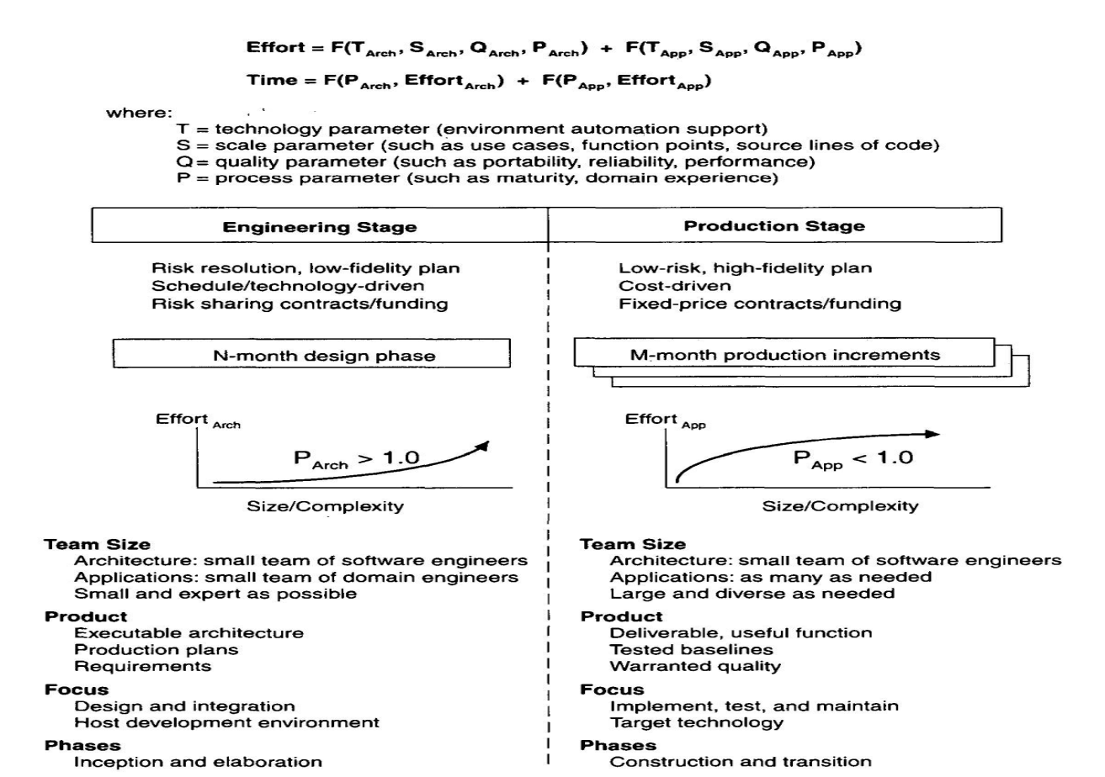

Next-generation software cost models should estimate large-scale architectures with economy of scale. This implies that the process exponent during the production stage will be less than 1.0. My reasoning is that the larger the system, the more opportunity there is to exploit automation and to reuse common processes, components, and architectures.

There are many solutions to any given problem, as illustrated in Figure, each with a different value proposition. Cost is a key discriminator among potential solutions. Cost estimates that are more accurate and more precise can be derived from specific solutions to problems.

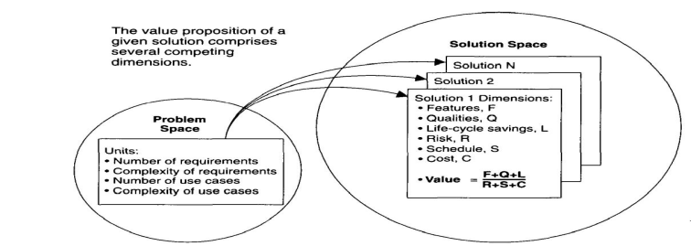

I expect two major improvements in next-generation software cost estimation models:
- Separation of the engineering stage from the production stage will force estimators to differentiate between architectural scale and implementation size. This will permit greater accuracy and more-honest precision in life-cycle estimates.
- Rigorous design notations such as UML will offer an opportunity to define units of measure for scale that are more standardized and therefore can be automated and tracked. These measures can also be traced more straightforwardly into the costs of production.

- Explain the concept of early risk resolution?

Ans :
Early Risk Resolution
The engineering stage of the life cycle (inception and elaboration phases) focuses on confronting the risks and resolving them before the big resource commitments of the production stage. Conventional projects usually do the easy stuff first, thereby demonstrating early progress. A modern process attacks the important 20% of the requirements, use cases, components, and risks. This is the essence of my most important principle: architecture first.

- 80% of the engineering is consumed by 20% of the requirements. Strive to understand the driving requirements completely before committing resources to full-scale development. Do not strive prematurely for high fidelity and full traceability of the requirements.
- 80% of the software cost is consumed by 20% of the components. Elaborate the cost- critical components first so that planning and control of cost drivers are well understood early in the life cycle.
- 80% of the errors are caused by 20% of the components. Elaborate the reliability-critical components first so that assessment activities have enough time to achieve the necessary level of maturity.
- 80% of software scrap and rework is caused by 20% of the changes. Elaborate the change-critical components first so that broad-impact changes occur when the project is nimble.
- 80% of the resource consumption (execution time, disk space, memory) is consumed by 20% of the components. Elaborate the performance-critical components first so that engineering trade-offs with reliability, changeability, and cost-effectiveness can be resolved as early in the life cycle as possible.
- 80% of the progress is made by 20% of the people. Make sure that the initial team for planning the project and designing the architecture is of the highest quality. An adequate plan and adequate architecture can then succeed with an average construction team. An inadequate plan or inadequate architecture will probably not succeed, even with an expert construction team.

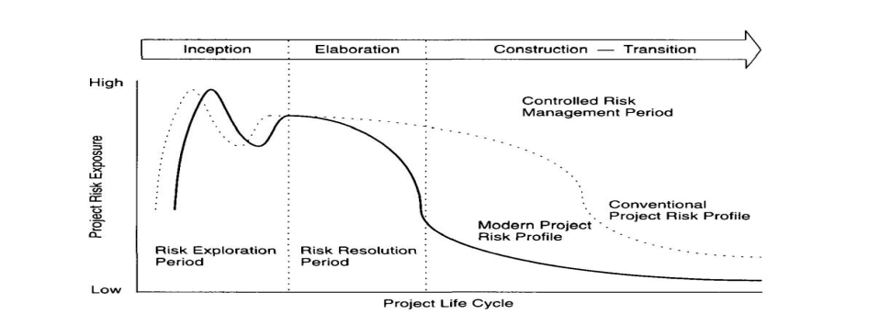

- Explain the software management best practices?

Ans :
The nine best practices are described next, with my commentary on how they resonate with the process framework, management disciplines, and top 10 principles that I have recommended. (Quotations are presented in italics.)
  - Formal risk management.
Using an iterative process that confronts risk is more or less what this is saying.
  - Agreement on interfaces.
While we may use different words, this is exactly the same intent as my architecture-first principle. Getting the architecture baselined forces the project to gain agreement on the various external interfaces and the important internal interfaces, all of which are inherent in the architecture.

3. Formal inspections.
The assessment workflow throughout the life cycle, along with the other engineering workflows, must balance several different defect removal strategies. The least important strategy, in terms of breadth, should be formal inspection, because of its high costs in human resources and its low defect discovery rate for the critical architectural defects that span multiple components and temporal complexity.
  - Metric-based scheduling and management.
This important principle is directly related to my model-based notation and objective quality control principles. Without rigorous notations for artifacts, the measurement of progress and quality degenerates into subjective estimates.
  - Binary quality gates at the inch-pebble level.
This practice is easy to misinterpret. Too many projects have taken exactly this approach early in the life cycle and have laid out a highly detailed plan at great expense. Three months later, when some of the requirements change or the architecture changes, a large percentage of the detailed planning must be rebaselined. A better approach would be to maintain fidelity of the plan commensurate with an understanding of the requirements and the architecture. Rather than inch pebbles, I recommend establishing milestones in the engineering stage followed by inch pebbles in the production stage. This is the primary message behind my evolving levels of ' detail principle.
  - Program wide visibility of progress versus plan.
This practice namely, open communications among project team members is obviously necessary. None of my principles traces directly to this practice. It seems so obvious, I let it go without saying.
  - Defect tracking against quality targets.
This important principle is directly related to my architecture-first and objective quality control principles. The make-or-break defects and quality targets are architectural. Getting a handle on these qualities early and tracking their trends are requirements for success.

Configuration management.
The Airlie Software Council emphasized configuration management as key to controlling complexity and tracking changes to all artifacts. It also recognized that automation is important because of the volume and dynamics of modern; large-scale projects, which make manual methods cost-prohibitive and error-prone. The same reasoning is behind my change management principle.
  - People-aware management accountability.
This is another management principle that seems so obvious, I let it go without saying.
There is significant overlap and commonality of spirit between my top principles and the Airlie Software Council's best practices. However, I think the Council omitted some important principles: configurability and component-based, model-based, demonstration- based development. This omission is surprising, because my rationale for including component-based and model-based principles was to reduce the complexity of development. This is exactly the stated purpose of the Airlie Software Council. The demonstration-based principle is in my top 10 primarily to force integration to occur continuously throughout the life cycle and to promote better stakeholder relationships through a more meaningful medium of communications. Because the Airlie Software Council was focused on a particular domain namely, large-scale, nationally important systems configurability was less important.
The two Airlie Software Council practices I would not have included are inspections and binary quality gates at the inch-pebble level. Although they are useful, they are overemphasized in practice, and there are other important principles that should have been included.

10.Explain about Top 10 Software Management Principles
Principles of Software Management

- Software management basically relies on the following principles, they are,

- Process must be based on architecture-first approach
If the architecture is focused at the initial stage, then there will be a good foundation for almost 20% of the significant stuff that are responsible for the overall success of the project. This stuff include the requirements, components use cases, risks and errors. In other words, if the components that are being involved in the architecture are well known then the expenditure causes by scrap and rework will be comparatively less.
- Develop an iterative life-cycle process that identifies the risks at an early stage
An iterative process supports a dynamic planning framework that facilitates the risk management predictable performance moreover, if the risks are resolved earlier, the predictability will be more and the scrap and rework expenses will be reduced.
- After the design methods in-order to highlight components-based development.
The quantity of the human generated source code and the customized development can be reduced by concentrating on individual components rather than individual lines- of-code. The complexity of software is directly proportional to the number of artifacts it contains that is, if the solution is smaller then the complexity associated with its management is less.
- Create a change management Environment
Highly-controlled baselines are needed to compensate the changes caused by various teams that concurrently work on the shared artifacts.

- Improve change freedom with the help of automated tools that support round-trip engineering.
The roundtrip-engineering is an environment that enables the automation and synchronization of engineering information into various formats. The engineering information usually consists requirement specification, source code, design models test cases and executable code. The automation of this information allows the teams to focus more on engineering rather than dealing with over head involved.
- Design artifacts must be captured in model based notation.
The design artifacts that are modeled using a model based notation like UML, are rich in graphics and texture. These modeled artifacts facilitate the following tasks.

  - Complexity control

Objective fulfillment

  - Performing automated analysis

- Process must be implemented or obtaining objective quality control and estimation of progress.
The progress in the lifecycle as well as the quality of intermediately products must be estimated and incorporated into the process. This can be done with the help of well defined estimation mechanism that are directly derived from the emerging artifacts. These mechanisms provide detailed information about trends and correlation with requirements.
- Implement a Demonstration-based Approach for Estimation of intermediately Artifacts
This approach involves giving demonstration on different scenarios. It facilitates earl integration and better understanding of design trade-offs. Moreover, it eliminates architectural defects earlier in the lifecycle. The intermediately results of this approach are definitive.
- The Points Increments and generations must be made based on the evolving levels of detail
.Here, the ‘levels of detail’ refers to the level of understanding requirements and architecture. The requirements, iteration content, implementations and acceptance testing can be organized using cohesive usage scenarios.
10. Develop a configuration process that should be economically scalable
The process framework applied must be suitable for variety of applications. The process must make use of processing spirit, automation, architectural patterns and components such that it is economical and yield investment benefits.

  - Explain about Modern Process Transitions
- The lower-level managers and the middle level managers should participate in the project development
Any organization which has an employee count less than or equal to 25 does not need to have pure managers. The responsibility of the managers in this type of organization will be similar to that of a project manager. Pure managers are needed when personal resources exceed 25. Firstly, these managers understand the status of the project them, develop the plans and estimate the results. The manager should participate in developing the plans. This transition affects the software project managers.
- Tangible design and requirements
The traditional processes utilize tons of paper in order to generate the documents relevant to the desired project. Even the significant milestones of a project are expressed via documents. Thus, the traditional process spends most of their crucial time on document preparation instead of performing software development activities
- Assertive Demonstrations are prioritized
The design errors are exposed by carrying-out demonstrations in the early stages of the life cycle. The stake holders should not over-react to these design errors because overemphasis of design errors will discourage the development organizations in producing the ambitious future iterating. This does not mean that stakeholders should bare all these errors. Infect, the stakeholders must follow all the significant steps needed for resolving these issues because these errors will sometimes lead to serious down-fall in the project. This transition will unmark all the engineering or process issues so, it is mostly refused by management team, and widely accepted by users, customers and the engineering team.
- The performance of the project can be determined earlier in the life cycle.
The success and failure of any project depends on the planning and architectural phases of life cycle so, these phases must employ high-skilled professionals. However, the remaining phases may work well an average team.
- Earlier increments will be adolescent
The development organizations must ensure that customers and users should not expect to have good or reliable deliveries at the initial stages.
This can be done by demonstration of flexible benefits in successive increments. The demonstration is similar to that of documentation but involves measuring of changes, fixes and upgrades based on the objectives so as to highlight the process quality and future environments
- Artifacts tend to be insignificant at the early stages but prove to be the most significant in the later stages.
- The details of the artifacts should not be considered unless a stable and a useful baseline is obtained. This transition is accepted by the development team while the conventional contract monitors refuse this transition.
- Identifying and Resolving of real issues is done in a systematic order
- The requirements and designs of any successful project arguments along with the continuous negotiations and trade-offs. The difference between real and apparent issued of a successful project can easily be determined. This transition may affect any team of stakeholders
- Everyone should focus on quality assurance
- The software project manager should ensure that quality assurance is integrated in every aspect of project that is it should be integrated into every individuals role, every artifact, and every activity performed etc.
- There are some organizations which maintains a separate group of individuals know as quality assurance team, this team would perform inspections, meeting and checklist in order to measure quality assurance.
- Performance issues crop up earlier in the projects life cycle.
Earlier performance issues are a mature design process but resembles as an immature design. This transition is accepted by development engineers because it enables the evaluation of performance tradeoffs in subsequent releases.
- Automation must be done with appropriate investments
Automation is the key concept of iterative development projects and must be done with sufficient funds. Moreover, the stakeholders must select an environment that supports iterative development. This transition is mainly opposed by organizational managers.
- Good software organizations should have good profit margins.
Most of the contractors for any software contracting firm focus only on obtaining their profit margins beyond the acceptable range of 5% and 15%. They don’t look for the quality of finished product as a result, the customers will be affected.

10.Explain about CCPDS-R Case Study
- Command center processing and display system-replacement [CCPDS-R] project was performed for the U.S. Air force by technical review workgroup (TRW) space and defense in Redondo Beach, California.
- The entire project included system engineering, hardware procurement, and software development, with each of these three major activities consuming about one-third of the total cost.
- CCPDS-R was also a very large software development activity and was one of the first projects to use the Ada Programming Language.
Key Points of CCPDS-R
- An objective case study is a true indicator of a mature organization and a mature project process. The software industry needs more case studies like CCPDS-R.
- CCPDS-R was one of the pioneering projects that practiced many modern management approaches.
- The metrics histories were all derived directly from the Artifacts of the projects process. These data were used to manage the project and were embraced by practitioners ,managers and stakeholders .
- This appendix provides a practical context that is relevant to the techniques to the disciplines and opinions.

- Explain about Common Subsystem Overview
Software acquisitions process:-
- The CCPDS-R acquisition included two distinct phases: a concept definition (CD) phase and a full-scale development (FSD) phase. The CD phase proposal was competed for by five major bidders, and two firm-fixed-price contracts of about $2 million each were awarded.
The winning contractors also invested their own discretionary resources to discriminate themselves with the best-value FSD phase proposal. Figure D-l summarizes the overall acquisition process and the products of each phase

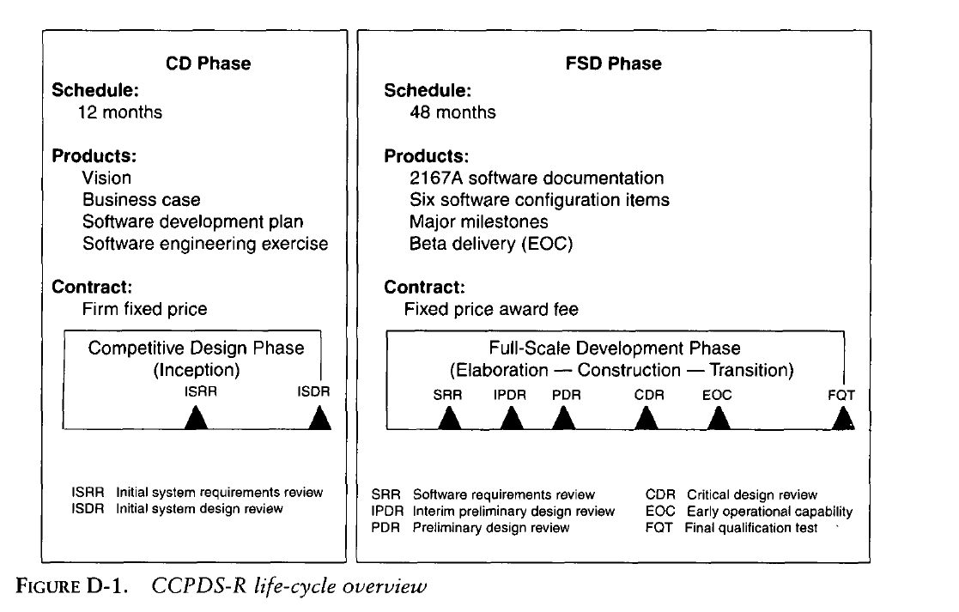
- Competitive Design phase [CD] Phase
- Full-scale Development phase[FSD] Phase
Competitive Design phase [CD] Phase
This Concept Definition Phase included following activities:
- Analyze and specify the project requirements
- Define and develop the top-level architecture
- Plan FSD phase software development activities
- Configure the process and development environment
- Establish trust and win-win relationships among the stakeholder

Full-scale Development phase[FSD] Phase
- Software requirements review (SRR)
-Initial feasibility of the foundation components
-Basic use cases ofInitialization
- Interim preliminary design review (IPDR)
-Feasibility of the architectural infrastructure under riskiest use cases
- Preliminary design review (PDR)
-Adequate achievement of the peak load scenarios
- Critical design review (CDR)
-Update of the architectural baseline for test capability of whole system
Use the proposed software team.
• Use the proposed software development techniques and tools.
• Use the FSD-proposed software development plan.
• Conduct a mock design review with the customer 23 days after receipt of the specification.
- The results produced by TRW's CCPDS-R team were impressive. They demonstrated to the customer that the team was prepared, credible, and competent at conducting the proposed software approach. Approximately 12 staff-months were expended in the effort (12 people full-time for 23 days).
- A detailed plan was established that included an activity network, responsibility assignments, and expected results for tracking progress. The plan included two architecture iterations and all the milestones and artifacts proposed in the software development plan. The exercise produced the following results:
- Four primary use cases were elaborated and demonstrated.
- • A software architecture skeleton was designed, prototyped, and documented, including two executable, distributed processes; five concurrent tasks (separate threads of control); eight components; and 72 component-to-component interfaces.
- • A total of 4,163 source lines of prototype components were developed and executed. Several thousand lines of reusable components were also integrated into the demonstration.
- • Three milestones were conducted and more than 30 action items resolved.
- • Production of 11 documents (corresponding to the proposed artifacts) demonstrated the automation inherent in the documentation tools.
- The Digital Equipment Corporation VAX/VMS tools, Rational R1000 environment, LaTeX documentation templates, and several custom-developed tools were used.
- • Several needed improvements to the process and the tools were identified. The concept of evolving the plan, requirements, process, design, and environment at each major milestone was considered potentially risky but was implemented with rigorous change management.

- Explain about Project Organization
- Project Organization
- In preparing for the CCPDS-R project, TRW placed a strong emphasis on evolving the right team. The CD phase team represented the essence of the architecture team which is responsible for an efficient engineering stage. This team had the following primary responsibilities
- Analyze and specify the project requirements
- Define and develop the top-level architecture
- Plan the FSD phase software development activities
- Configure the process and development environment
- Establish trust and win-win relationships among the stakeholders
Project Organization &Responsibilities
- The CD phase team was small and expert, with little, if any, organizational hierarchy. One of its exceptional attributes was its complement of talent. All necessary skills were covered, and there was very little competition among personnel.
- The FSD phase team was formed by transitioning many of the CD phase team members into leadership positions and expanding the number of personnel to the necessary levels for full-scale development. Figure D-2 illustrates the software organization evolution and FSD software responsibilities.

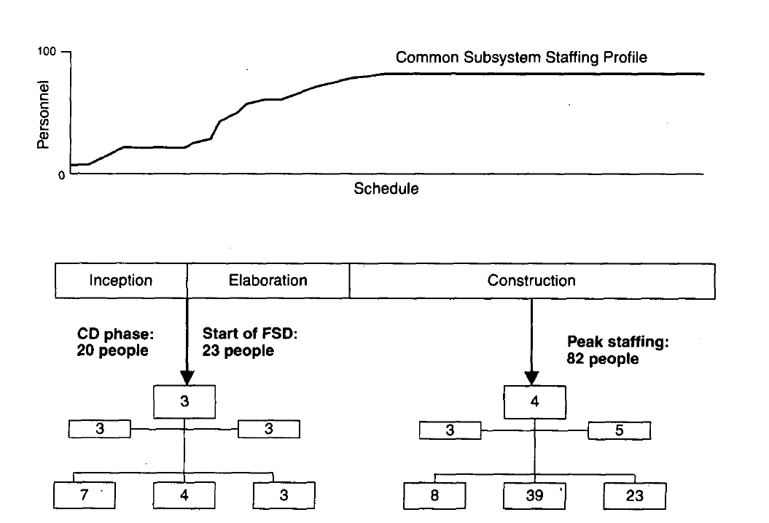

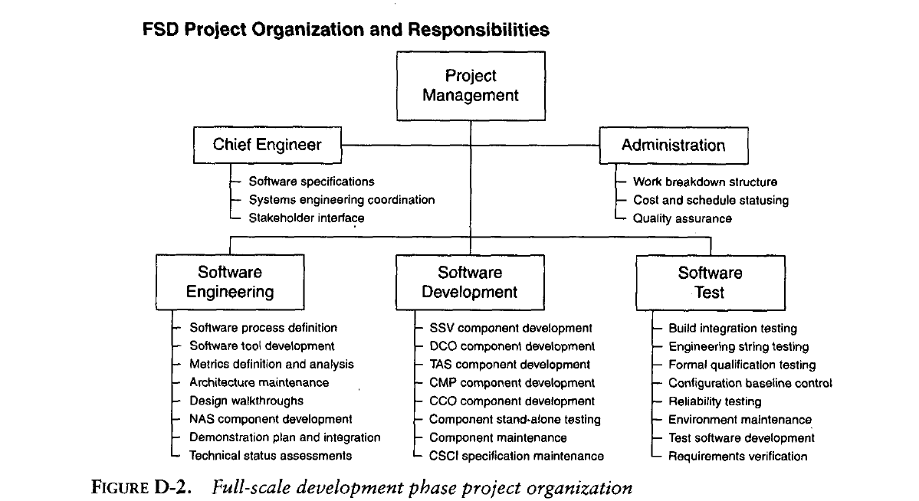

4.Explain about Common Subsystem Product Overview
The Common Subsystem software comprised six computer software configuration items (CSCIs). (CSCI is government jargon for a set of components that is managed, configured, and documented as a unit and allocated to a single team for development.) CSCIs are defined and described in DOD-STD-2167A [DOD, 1988], The CSCIs were identified as follows:
1. Network Architecture Services (NAS). This foundation middleware provided reusable components for network management, interprocess communications, initialization, reconfiguration, anomaly management, and instrumentation of software health, performance, and state. This CSCI was designed to be reused across all three CCPDS-R subsystems.
2. System Services (SSV). This CSCI comprised the software architecture skeleton, real-time data distribution, global data types, and the computer system operator interface.
3. Display Coordination (DCO). This CSCI comprised user interface control, display formats, and display population.
4. Test and Simulation (TAS). This CSCI comprised test scenario generation, test message injection, data recording, and scenario playback.
5. Common Mission Processing (CMP). This CSCI comprised the missile warning algorithms for radar, nuclear detonation, and satellite early warning messages.
6. Common Communications (CCO). This CSCI comprised external interfaces with other systems and message input, output, and protocol management.
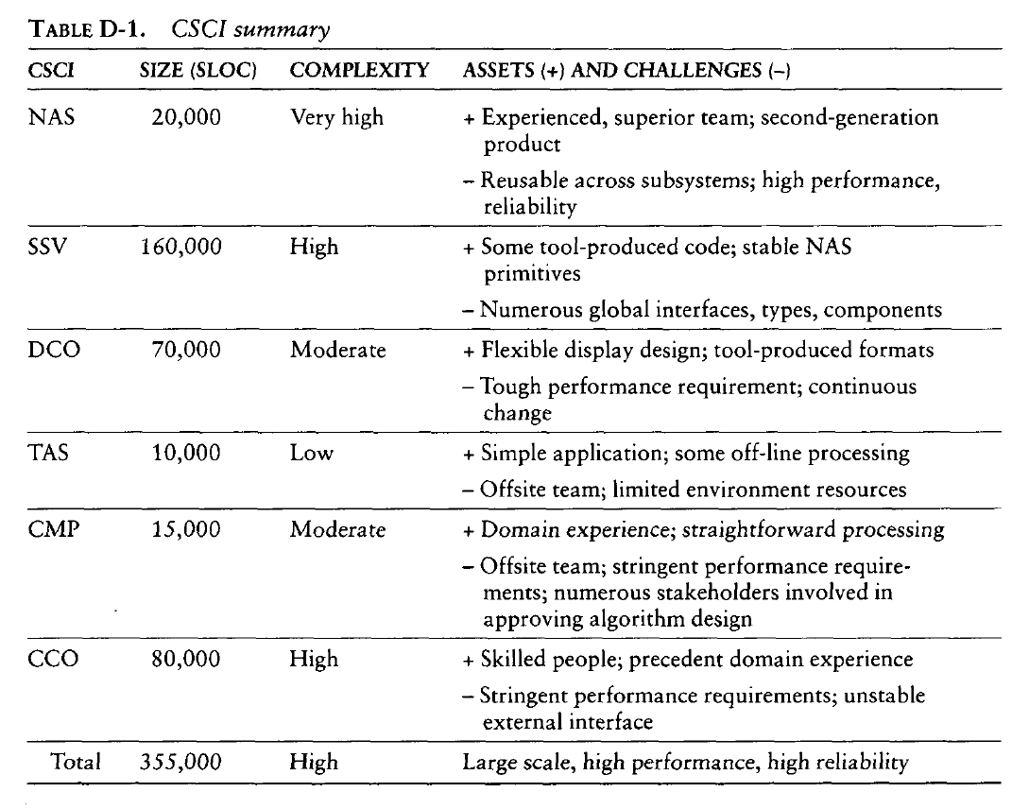

- Explain about Process Overview
- Risk Management : Build Content
- The Incremental Design Process
- Component Evolution
- The Incremental Test Process
- DOD-STD-2167A Artifacts

- CCPDS-R Software development followed a standard Department of Defense life cycle after contract award, With a software requirements review, preliminary design review ,critical design review, and a final qualification test.
- To manage this large software effort, six incremental builds were defined.
- The PDR baseline required three major architecture iterations, the conclusions of which coincided with the milestones for the software requirements review(SRR),interim(IPDR),and PDR .
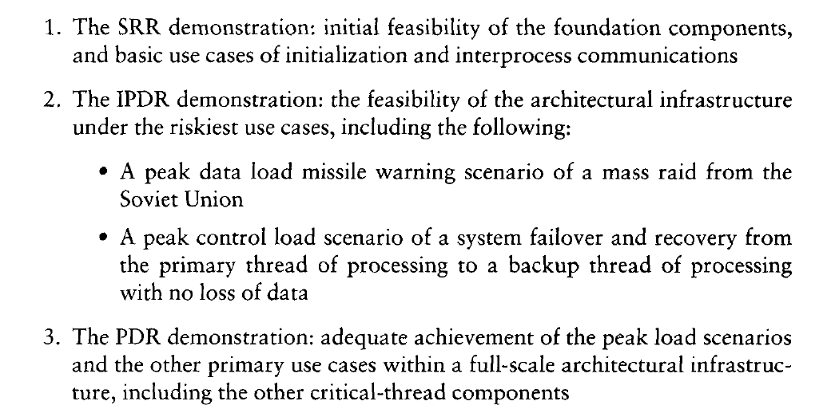
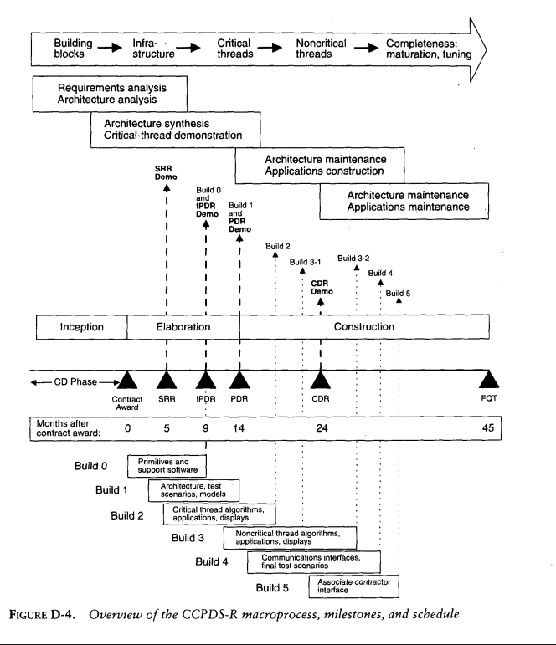

Risk Management : Build Content
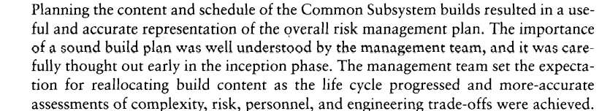
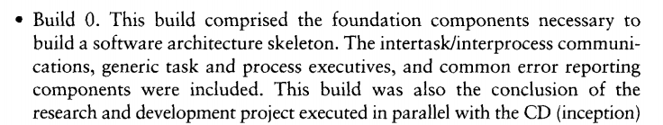
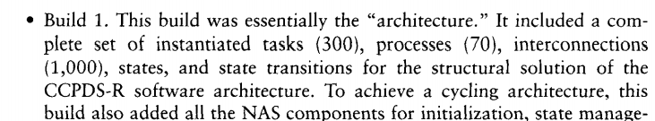
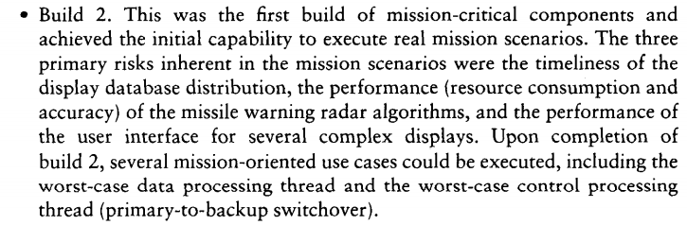
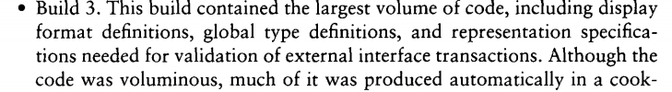
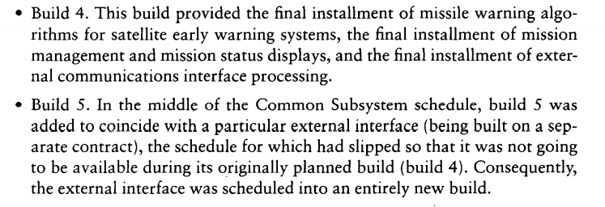
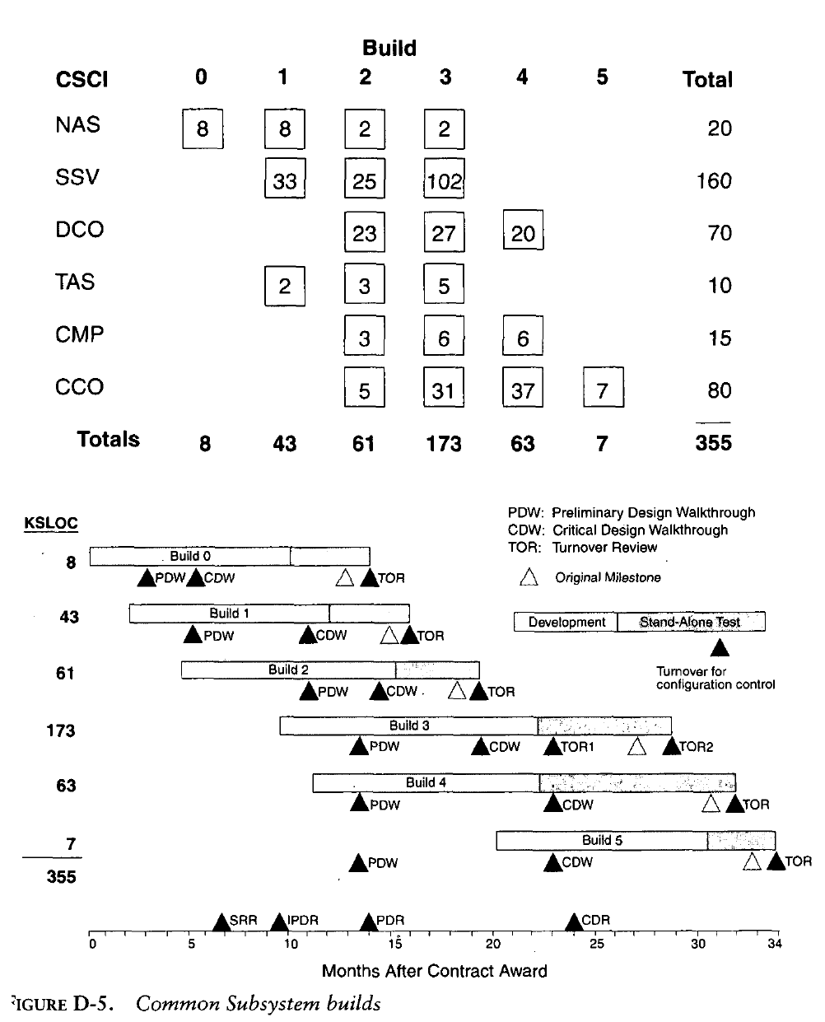
THE INCREMENTAL DESIGN PROCESS
Well Defined sequence of walkthroughs took place:
- Preliminary design walkthrough(PDW)
-Initial Prototyping and Design Work
- Critical design walkthrough(CDW)
- Build’s Design Work
- Code walkthrough(CW)
-Detailed Code Walkthrough
- Turnover review(TR)
-A one month activity including SAT, BIT ,
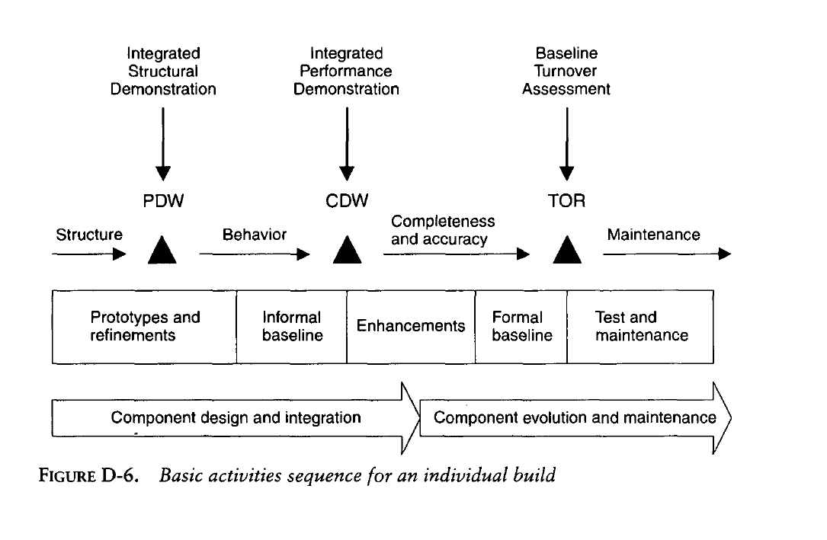
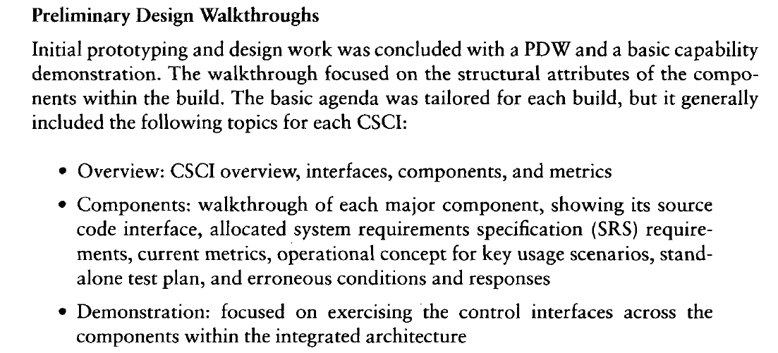
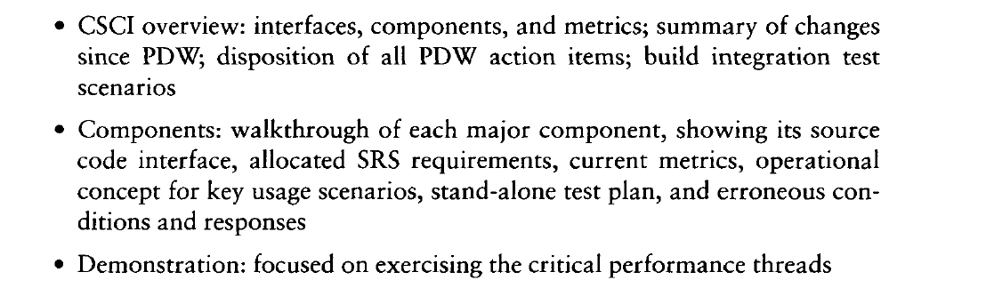

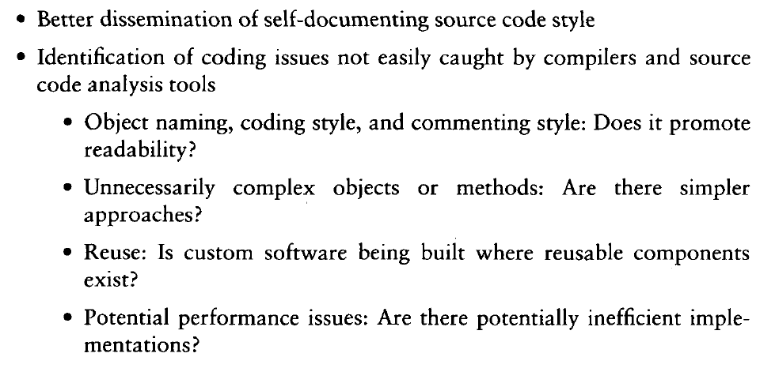
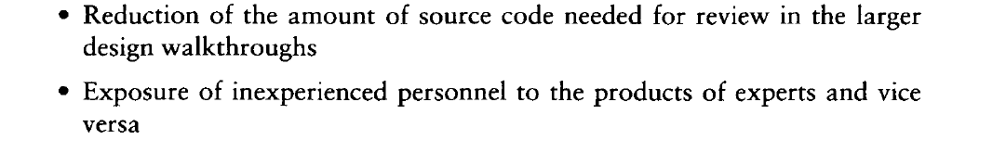
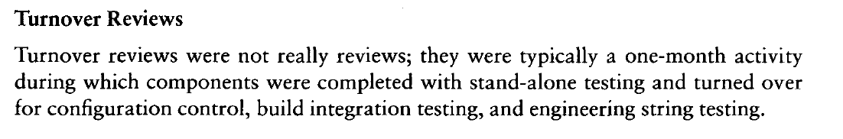
Component Evolution
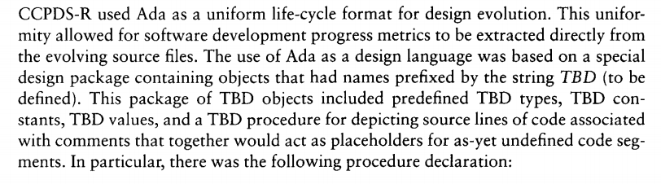

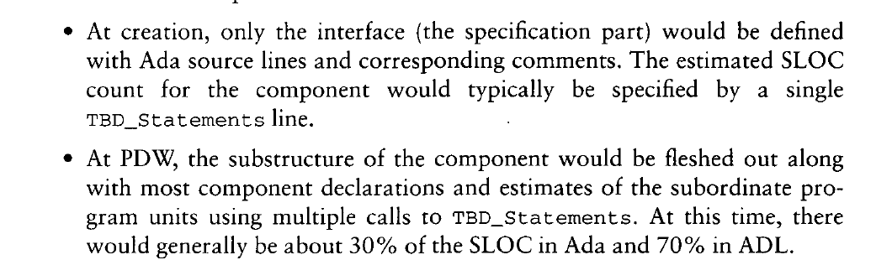
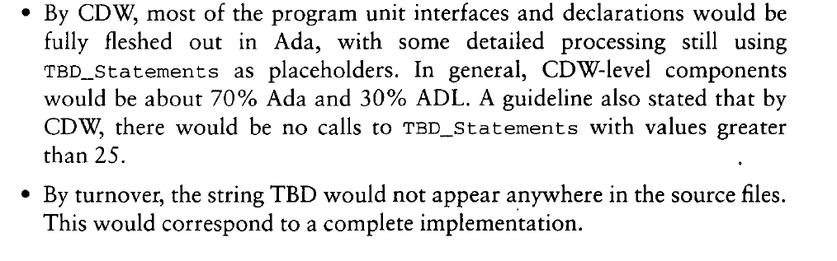
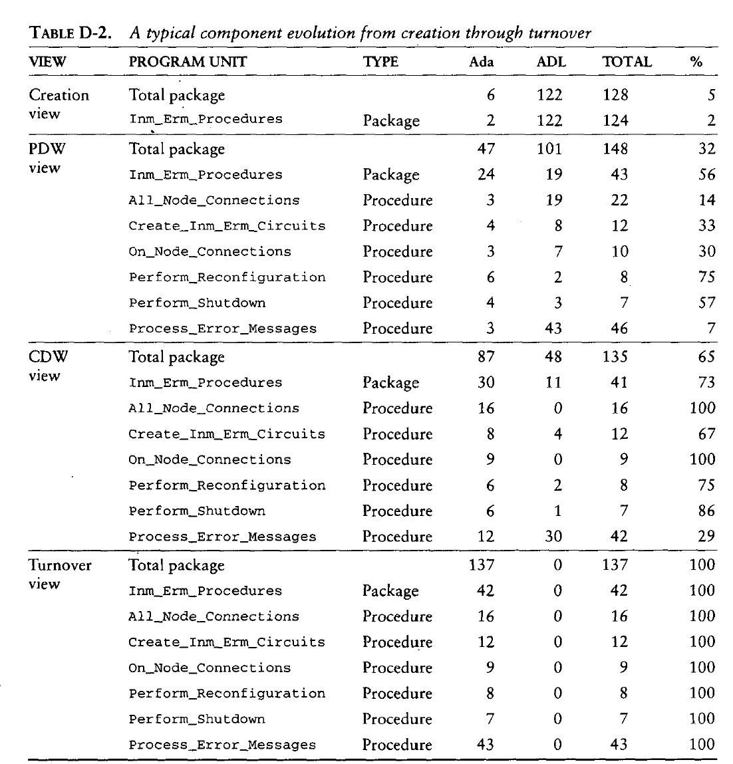
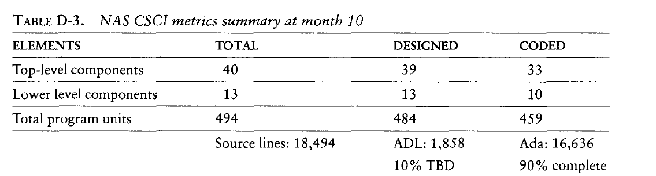
The Incremental Test Process
- Stand-alone test
-Corresponds to completeness and boundary condition tests to the possible extent.
- Build integration test
-To ensure previously demonstrated capabilities still operated as expected.
iii. Reliability test
-Help uncover potentially insipid, transient errors of major design consequence.
- Engineering string test
-Verifying specific subsets of requirements through demonstration .
- Final qualification test
-Represented a set of requirements which could not be verifying until whole system was present Ex: a 50% reserve capacity requirement could not be verified until FQT, when whole system was operational
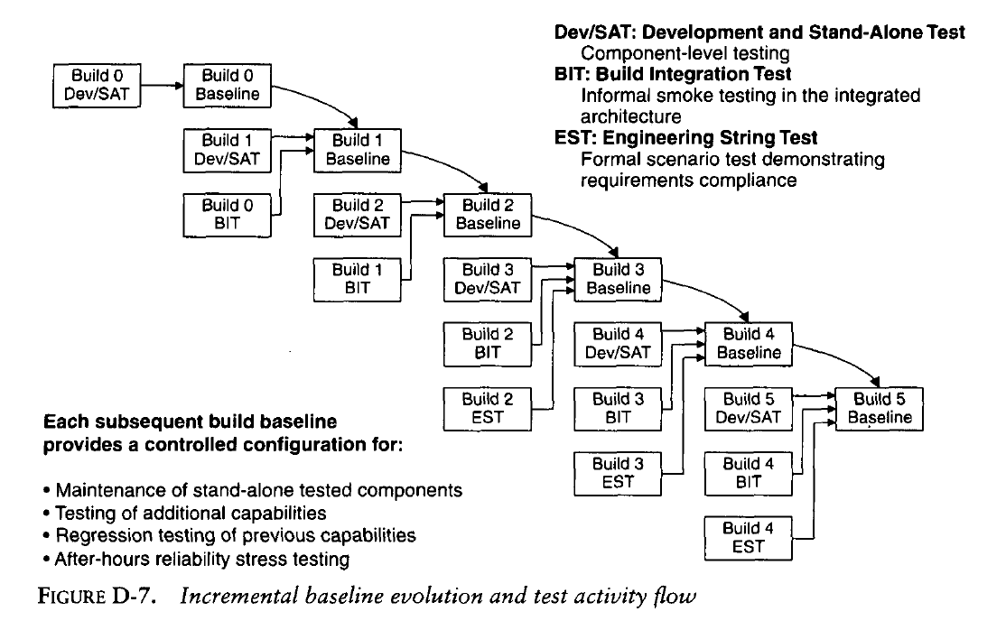
DOD-STD-2167A Artifacts
