STEP material

UNIT-I

Short answer questions:
- What is distributed computing?
“Distributing Computing is a type of computing in which different components and objects comprising an application can be located on different computers connected to a network.”
- Give the advantages of distributed computing compared to a traditional standalone application?

- Higher performance
- Collaboration
- Higher reliability and availability
- Scalability
- Extensibility
- Reuse
- Reduced cost

- Define web service?

Web services is a standardized way or medium to propagate communication between the client and server applications on the World Wide Web.

- What are the different types of web services?
Web services are mainly of two types. These are:
(i) SOAP Web Services
(ii)REST Web Services
- Differentiate between web services and SOA.

Web services are based on the concept of service oriented architecture (SOA). SOA enables software components, including application functions, objects, and processes from different systems, to be exposed as services.

Long answer questions:
- Discuss about Java RMI architectural model. Give its advantages anddisadvantages.

- Java RMI was developed by Sun Microsystems as the standard mechanism to enable distributed Java objects-based application development using the Java environment.
- RMI provides a distributed Java application environment by calling remote Java objects and passing them as arguments or return values.
- It uses Java object serialization that allows the conversion of objects into streams
- Before RMI, the only way to do inter-process communications in the Java platform was to use the standard Java network libraries.
- Java RMI uses Java Remote Method Protocol (JRMP) as the interprocess communication protocol, enabling Java objects living in different Java Virtual Machines (VMs) to transparently invoke one another’s methods. Because these VMs can be running on different computers anywhere on the network,
- The RMI infrastructure based on the JRMP acts as the medium between the RMI clients and remote objects. It intercepts client requests, passes invocation arguments, delegates invocation requests to the RMI skeleton, and finally passes the return values of the method execution to the client stub.
JAVA RMI architectural model

The Java RMI architecture is composed of the following components:
- RMI client: The RMI client, which can be a Java applet or a standalone application, performs the remote method invocations on a server object.
- RMI stub: The RMI stub is the client proxy generated by the rmi compiler (rmic provided along with Java developer kit—JDK) that encapsulates the network information of the server and performs the delegation of the method invocation to the server.
- RMI infrastructure: The RMI infrastructure consists of two layers: the remote reference layer and the transport layer.
- The remote reference layer separates out the specific remote reference behavior from the client stub. It handles certain reference semantics like connection retries, which are unicast/multicast of the invocation requests.
- The transport layer actually provides the networking infrastructure, which facilitates the actual data transfer during method invocations
- RMI server: The server is the Java remote object that implements the exposed interfaces and executes the client requests. It receives incoming remote method invocations from the respective skeleton, which passes the parameters.
- Discuss about CORBA architectural model? Give its advantages anddisadvantages.

- CORBA (Common Object Request Broker Architecture) is a standard that enables an object written in one programming language, running on one platform to interact with objects across the network that are written in other programming languages and running on other platforms.
For example, a client object written in C++ and running under Windows can communicate with an object on a remote machine written in Java running under UNIX.
- The CORBA specification was developed by the Object Management Group (OMG).
- CORBA, as defined by the OMG, is a standard or specification and not a particular piece of software.
- CORBA 3.0 is actually a suite of 10 standards, each defining aspects of a CORBA implementation.

- By adopting CORBA, the applications can be written in any language that has mappings to a neutral interface definition called the Interface Definition Language (IDL).
- CORBA also defines a collection of system-level services for handling low-level application services like life-cycle, persistence, transaction, naming, security.
- CORBA 1.1 was focused on creating component level, portable object applications without interoperability.
- The introduction of CORBA 2.0 added interoperability between different ORB vendors by implementing an 4 Internet Inter-ORB Protocol (IIOP).
- The IIOP defines the ORB backbone, through which other ORBs can bridge and provide interoperation with its associated services.
- In a CORBA based solution, the Object Request Broker (ORB) is an object bus that provides a transparent mechanism for sending requests and receiving responses to and from objects, regardless of the environment and its location.
CORBA architecture is composed of the following components:
- IDL(Interface Definition Language): CORBA uses IDL contracts to specify the application boundaries and to establish interfaces with its clients.
- The IDL provides a mechanism by which the distributed application component’s interfaces, inherited classes, events, attributes, and exceptions can be specified.
- ORB(Object Request Broker): It acts as the object bus or the bridge, providing the communication infrastructure to send and receive request/responses from the client and server.
Advantages of CORBA over a traditional client/server application model
- OS and programming-language independence:-Interfaces between clients and servers are defined in OMG IDL, thus providing the following advantages to Internet programming: Multi-language and multi-platform application environments, which provide a logical separation between interfaces and implementation.
- Legacy and custom application integration:-Using CORBA IDL, developers can encapsulate existing and custom applications as callable client applications and use them as objects on the ORB.
- Rich distributed object infrastructure:-CORBA offers developers a rich set of distributed object services, such as the Lifecycle, Events, Naming, Transactions, and Security services.
- Location transparency :- CORBA provides location transparency: An object reference is independent of the physical location and application level location. This allows developers to create CORBA-based systems where objects can be moved without modifying the underlying applications.

- Discuss about client and server technology with reference to web based applications

- Distributed application architecture were dominated by two-tier business applications.
- In a two-tier architecture model, the first (upper) tier handles the presentation and business logic of the user application (client), and the second/lower tier handles the application organization and its data storage (server). This approach is commonly called client-server applications architecture.
- Client-server in this model handles most of the business processing and provides the graphical user interface of the application.
- It is a very popular design in business applications where the user. interface and business logic are tightly coupled with a database server for handling data retrieval and processing.
- For example, the client-server model has been widely used in enterprise resource planning (ERP), billing, and Inventory application systems where a number of client business applications residing in multiple desktop systems interact with a central database server.
Limitations of the client-server application model are as follows:
- Complex business processing at the client side demands robust client systems.
- Security is more difficult to implement because the algorithms and logic reside on the client side making it more vulnerable to hacking.
- Increased network bandwidth is needed to accommodate many calls to the server, which can impose scalability restrictions.
- Maintenance and upgrades of client applications are extremely difficult because each client has to be maintained separately.
- Client-server architecture suits mostly database-oriented standalone applications and does not target robust reusable component oriented applications.
- Explain about Dcom technology with reference to web based applications?

- The Microsoft Component Object Model (COM) provides a way for Windows-based software components to communicate with each other by defining a binary and network standard in a Windows operating environment.
- COM evolved from OLE (Object Linking and Embedding), which employed a Windows registry-based object organization mechanism
- Microsoft developed the Distributed Common Object Model (DCOM) as its answer to the distributed computing problem in the Microsoft Windows platform.
- DCOM enables COM applications to communicate with each other using an RPC mechanism, which employs a DCOM protocol on the wire.

Fig: Basic architectural model of Microsoft DCOM

- Define web services and explain a scenario for web services? Explain about basic operational model of web services?

- Web services are based on the concept of service oriented architecture (SOA).
- SOA enables software components, including application functions, objects, and processes from different systems, to be exposed as services.
The following are the major technical reasons for choosing Web services over Web applications
- Web services can be invoked through XML-based RPC mechanisms across firewalls.
- Web services provide a cross-platform, cross-language solution based on XML messaging.
- Web services facilitate ease of application integration using a lightweight infrastructure without affecting scalability.
- Web services enable interoperability among heterogeneous applications.
Basic Operational model of Web Services:
- Operations are conceived as involving three distinct roles and relationships that defines the web service providers and users.
- These roles and relationships are:
- Service provider: The service provider is responsible for developing and deploying the web services. The provider also defines services and publishes them with service broker.
- Service Broker: The service broker also called as service registry is responsible for service registration and discovery of web services. The broker lists various services that helps the service requester find and subscribe the required services.
- Service Requester: The service requester is responsible for the service invocation. The requestor locates the web services using service broker, invokes the require service and execute it from the service provider.

Choose the correct answers:

- Web services can bediscoveredusing
  - WSDL B) UDDI C)HTTP D)UDP

- UDDI registry contains howmanyelements
A) 1 B)2 C)3 D) 4

- The basic web services platform is a combination of ___ and ____
  - XML+HTTP B) CSS+JAVA C) XML+HTML D) CSS+HTTP

- The UDDI Business Registry (UBR), alsoknownas
  - PrivateCloud B)Networkcloud C)SimpleCloud D)Public Cloud

- XML stands for
  - Extensible mark-up language B) Extension mark-up language
C) Extend mark-up language D) None of the above
- The following protocol is used to access theweb services
  - SOAP B) HTTP C) FTP D)UDP
- _______ is the basis for web services
  - XML B) PHP C) CSS D) CGI

8.Web Serviceisused to convert your application into web application.

9. Service Oriented Architecture or SOA is a design pattern and it is designed to provide
services to other applications through protocol.

10. Webservices are Application components

UNIT-II
Short answer questions:
- Explain the basic characteristics of web services?
- Web services are based on XML messaging, which means that the data exchanged between the Web service provider and the user are defined in XML.
- Web services provide a cross-platform integration of business applications over the Internet.
- To build Web services, developers can use any common programming language, such as Java, C, C++, Perl, Python, C#, and/or Visual Basic, and its existing application components.

- List out the core building blocks of web service architecture?
(i)Service container /runtime environment
(ii)Service registry
(iii)Service delivery

- Mention the standards and technologies used for implementing web services?
The standard technologies for implementing the SOA patterns with Web services are Web Services Description Language (WSDL), Universal Description, Discovery & Integration (UDDI). and Simple Object Access Protocol (SOAP). WSDL, UDD1, and SOAP are the three core technologies most often used to implement Web services.

- Define WSDL?
- WSDL stands for Web Services Description Language.
- WSDL is used to describe web services
- WSDL is written in XML

- Briefly explain WSDL elements?
- Definition
- Data types
- Message
- Operation
- Port type
- Binding
- Port
- Service

Long answer questions:
- Explain web service architecture and its core building blocks?

Key requirements of web service architecture are as follows:
- To provide universal interface and a consistent solution model to define the application and enabling components for services.
- To define framework with standard based infrastructure model and protocol to support service based applications over internet.
- To enable distributable centralized and decentralized application that supports communication for inter-enterprise and intra-enterprise.
- To enable publishing of services to one or more public or private directories.
- To handle these requirement web service architecture model consist of three logical key components as core building blocks as follows:
- Service container /runtime environment :This act as the web servcies runtime environment and hosts the service provider. It defines the web services runtime environment meant for client communication as a container of web services . It also handles the registration of the service description with service registries.
- Service registry: The service host the published services and acts as a broker providing facility and stores the description of web services registered by the service providers.
- Service delivery: It act as a web service client runtime environment by looking up the services registries to find the required services and invoking the from service provider.

- Explain web service communication?
(i)RPC –based synchronous communication model
(ii)Message based synchronous/asynchronous communication model

RPC- Based Communication model:

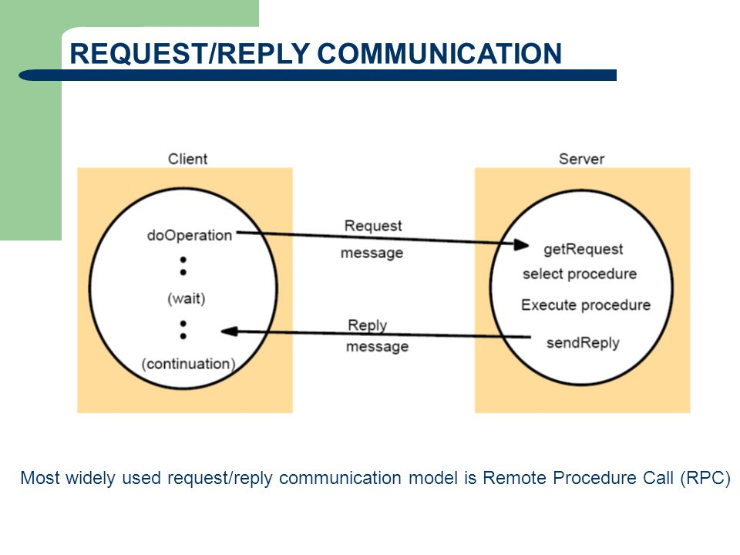
- RPC is a request–response protocol.
- An RPC is initiated by the client, which sends a request message to a known remote server to execute a specified procedure with supplied parameters.
- The remote server sends a response to the client, and the application continues its process.
- While the server is processing the call, the client is blocked (it waits until the server has finished processing before resuming execution), unless the client sends an asynchronous request to the server, such as an XML HttpRequest.
Sequence of events in RPC-Based model:
- The client calls the client stub (piece of code that converts parameters passed between client and server during RPC). The call is a local procedure call, with parameters pushed on to the stack in the normal way.
- The client stub packs the parameters into a message and makes a system call to send the message. Packing the parameters is called marshalling (transforming the memory representation of an object to a data format suitable for storage ).
- The client's local operating system sends the message from the client machine to the server machine.
- The local operating system on the server machine passes the incoming packets to the server stub.
- The server stub unpacks the parameters from the message. Unpacking the parameters is called unmarshalling.
- Finally, the server stub calls the server procedure. The reply traces the same steps in the reverse direction.

- The messaging –based communication model defines a loosely coupled and document-driven communication.
- The service requestor invoking a messaging –based service provider does not wait for a response.
- client service requestor sends an entire document rather than sending a set of parameters.
- The service provider receives the document, processes it, and then may or may not return a message.
- Depending upon the implementation, the client can either send or receive a document asynchronously to and from a messaging-based Web service, but it cannot do both functionalities at an instant.
- In addition, it also is possible to implement messaging with a synchronous communication model where the client makes the service request to the service provider, and then waits and receives the document from the service provider.
- The current version of SOAP 1.2 and ebXML Messaging support these communication models.

- Explain the basic steps involved for implementing web services?

- The service provider creates the Web service typically as SOAP based service interfaces for exposed business applications. The provider then deploys them in a service container or using a SOAP runtime environment, and then makes them available for invocation over a network. The service provider also describes the Web service as a WSDL-based service description, which defines the clients and the service container with a consistent way of identifying the service location, operations, and its communication model.
- The service provider then registers the WSDL-based service description with a service broker, which is typically a UDDI registry.
- The UDDI registry then stores the service description as binding templates and URLs to WSDLs located in the service provider environment.
- The service requestor then locates the required services by querying the UDDI registry. The service requestor obtains the binding information and the URLs to identify the service provider.

5. Using the binding information, the service requestor then invokes the service provider and then retrieves the WSDL Service description for those registered services. Then, the service requestor creates a client proxy application and establishes communication with the service provider using SOAP.
6. Finally, the service requestor communicates with the service provider and exchanges data or messages by invoking the available services in the service container.

- Briefly explain WSDL Document Structure?
A WSDL document has a definitions element that contains the other five elements, types, message, portType, binding and service. The following sections describe the features of the generated client code.
WSDL supports the XML Schemas specification (XSD) as its type system.
definitions:
Contains the definition of one or more services. JDeveloper generates the following attribute declarations for this section:
- name is optional.
- targetNamespace is the logical namespace for information about this service. WSDL documents can import other WSDL documents, and setting targetNamespace to a unique value ensures that the namespaces do not clash.
- xmlns is the default namespace of the WSDL document, and it is set to http://schemas.xmlsoap.org/wsdl/.
- All the WSDL elements, such as <definitions>, <types> and <message> reside in this namespace.
- xmlns:xsd and xmlns:soap are standard namespace definitions that are used for specifying SOAP-specific information as well as data types.
- xmlns:tns stands for this namespace.
- xmlns:ns1 is set to the value of the schema targetNamespace, in the <types> section.
Notice that the default of http://tempuri.org in namespaces to ensure that the namespaces are unique.
types:
Provides information about any complex data types used in the WSDL document. When simple types are used the document does not need to have a types section.
message:
An abstract definition of the data being communicated. In the example, the message contains just one part, response, which is of type string, where string is defined by the XML Schema.
operation:
An abstract description of the action supported by the service.
portType:
An abstract set of operations supported by one or more endpoints.
binding:
Describes how the operation is invoked by specifying concrete protocol and data format specifications for the operations and messages.
port:
Specifies a single endpoint as an address for the binding, thus defining a single communication endpoint.

service:
Specifies the port address(es) of the binding. The service is a collection of network endpoints or ports.

- Discuss about WSDL Binding?

The <binding> element provides specific details on how a portType operation will actually be transmitted over the wire.
- The bindings can be made available via multiple transports including HTTP GET, HTTP POST, or SOAP.
- The bindings provide concrete information on what protocol is being used to transfer portType operations.
- The bindings provide information where the service is located.
- For SOAP protocol, the binding is <soap:binding>, and the transport is SOAP messages on top of HTTP protocol.
- You can specify multiple bindings for a single portType.
- The binding element has two attributes : name and type attribute.
<binding name = "Hello_Binding" type = "tns:Hello_PortType">
The name attribute defines the name of the binding, and the type attribute points to the port for the binding, in this case the "tns:Hello_PortType" port.

SOAP Binding
WSDL 1.1 includes built-in extensions for SOAP 1.1. It allows you to specify SOAP specific details including SOAP headers, SOAP encoding styles, and the SOAPAction HTTP header. The SOAP extension elements include the following −
- soap:binding
- soap:operation
- soap:body

soap:binding
This element indicates that the binding will be made available via SOAP. The style attribute indicates the overall style of the SOAP message format. A style value of rpc specifies an RPC format.
The transport attribute indicates the transport of the SOAP messages. The value http://schemas.xmlsoap.org/soap/http indicates the SOAP HTTP transport, whereas http://schemas.xmlsoap.org/soap/smtp indicates the SOAP SMTP transport.

soap:operation
This element indicates the binding of a specific operation to a specific SOAP implementation. The soapAction attribute specifies that the SOAPAction HTTP header be used for identifying the service.

soap:body
This element enables you to specify the details of the input and output messages. In the case of HelloWorld, the body element specifies the SOAP encoding style and the namespace URN associated with the specified service.
Here is the piece of code from the Example chapter −
<bindingname="Hello_Binding"type="tns:Hello_PortType">
<soap:bindingstyle="rpc"transport="http://schemas.xmlsoap.org/soap/http"/>
<operationname="sayHello">
<soap:operationsoapAction="sayHello"/>

<input>
<soap:body
encodingStyle="http://schemas.xmlsoap.org/soap/encoding/"
namespace="urn:examples:helloservice"use="encoded"/>
</input>

<output>
<soap:body
encodingStyle="http://schemas.xmlsoap.org/soap/encoding/"
namespace="urn:examples:helloservice"use="encoded"/>
</output>
</operation>
</binding>

Choose the correct answers:

1. RPCstandsfor
  - RemoteProtocol B) Remote Position Call C) Remote Procedure CallD)None

2.WSDLacts as a interface between web serviceapplications

3.WSDL standsforWeb Services Description Language.

4.Which of the following is a components of a Web Service architecture?
A) SOAP B) UDDI C) WSDL D) All of these
5.Is XML-RPC is platform-dependent?
A) true B) false

UNIT-III

Short answer questions:

  - What is XML?
- XML stands for eXtensible Markup Language
- XML is a markup language much like HTML
- XML was designed to store and transport data
- XML was designed to be self-descriptive
- XML is a W3C Recommendation
  - Write a short note on xml document structure?
An XML document consists of three parts, in the order given:
- An XML declaration (which is technically optional, but recommended in most normal cases)
- A document type declaration that refers to a DTD (which is optional, but required if you want validation)
- A body or document instance (which is required)

3. Define SOAP?

- SOAP stands for Simple Object Access Protocol
- SOAP is an application communication protocol
- SOAP is a format for sending and receiving messages
- SOAP is platform independent
- SOAP is based on XML
- SOAP is a W3C recommendation

- List the elements in soap message structure?
A SOAP message is an ordinary XML document containing the following elements −
- Envelope
- Header
- Body
- Fault

- Explain the advantages of soap?
The following are some of the many advantages that SOAP provides.
i) Language neutrality :SOAP can be developed using any language.
ii) Interoperability and Platform Independence : SOAP can be implemented in any language and can be executed in any platform.
iii) Simplicity : SOAP messages are in very simple XML format.
iv) Scalability : SOAP uses HTTP protocol for transport due to which it becomes scalable.

Long answer questions:

  - Explain about xml document structure?
An XML document is a basic unit of XML information composed of elements and other markup in an orderly package. An XML document can contains wide variety of data. For example, database of numbers, numbers representing molecular structure or a mathematical equation.

XML Document Example
A simple document is shown in the following example −
<?xml version ="1.0"?>
<contact-info>
<name>Tanmay Patil</name>
<company>TutorialsPoint</company>
<phone>(011) 123-4567</phone>
</contact-info>
The following image depicts the parts of XML document.
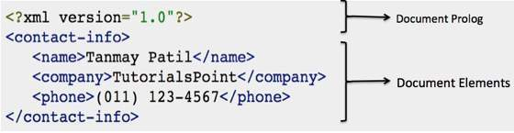

Document Prolog Section
Document Prolog comes at the top of the document, before the root element. This section contains −
- XML declaration
- Document type declaration

Document Elements Section
Document Elements are the building blocks of XML. These divide the document into a hierarchy of sections, each serving a specific purpose. You can separate a document into multiple sections so that they can be rendered differently, or used by a search engine. The elements can be containers, with a combination of text and other elements.
XML declaration contains details that prepare an XML processor to parse the XML document. It is optional, but when used, it must appear in the first line of the XML document.

Syntax
Following syntax shows XML declaration −
<?xml
version ="version_number"
encoding ="encoding_declaration"
standalone ="standalone_status"
?>

Following are few examples of XML declarations −
XML declaration with no parameters −
<?xml >
XML declaration with version definition −
<?xml version = "1.0">
XML declaration with all parameters defined −
<?xml version = "1.0" encoding = "UTF-8" standalone = "no" ?>
XML declaration with all parameters defined in single quotes −
<?xml version = '1.0' encoding = 'iso-8859-1' standalone = 'no' ?>

  - Discuss about xml namespaces?
A Namespace is a set of unique names. Namespace is a mechanisms by which element and attribute name can be assigned to a group. The Namespace is identified by URI(Uniform Resource Identifiers).

Namespace Declaration
A Namespace is declared using reserved attributes. Such an attribute name must either be xmlns or begin with xmlns: shown as below −
<element xmlns:name = "URL">

Syntax
- The Namespace starts with the keyword xmlns.
- The word name is the Namespace prefix.
- The URL is the Namespace identifier.

Example
Namespace affects only a limited area in the document. An element containing the declaration and all of its descendants are in the scope of the Namespace. Following is a simple example of XML Namespace −
<?xml version ="1.0" encoding ="UTF-8"?>
<cont:contactxmlns:cont="www.tutorialspoint.com/profile">
<cont:name>Tanmay Patil</cont:name>
<cont:company>TutorialsPoint</cont:company>
<cont:phone>(011) 123-4567</cont:phone>
</cont:contact>
Here, the Namespace prefix is cont, and the Namespace identifier (URI) as www.tutorialspoint.com/profile. This means, the element names and attribute names with the cont prefix (including the contact element), all belong to the www.tutorialspoint.com/profile namespace

  - Explain about SOA life cycle?

- Service orientation ties together autonomous sources of information bridging a wide range of operating systems, technology and communication process.
- This service orientation process is an iterative and incremental process.
- It consists of creating (exposing new services aggregating(composing ) these services into larger composing applications and making the outputs available for consumption by the business user.
- All these phases are driven by the business processes to meet the business experiments.
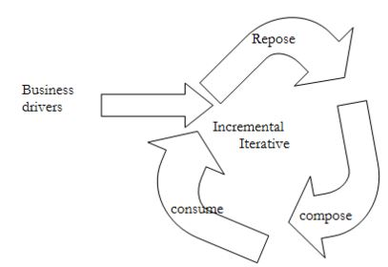

Fig: SOA life cycle

These phases are as follows:
1) Expose:
- This phase focuses on creation/extraction of services from existing application and data.
- service creation can be time grained or course grained.
- As services are loosely coupled, they can be.
- It is also concerned with the implementation of these services.
2) Compose:
- Once services are created, they can be combined into more complex services, applications or business processes.
- As receives are loosely coupled, they can be combined and reused with maximum flexibility.
3) Consume:
- This phase is concerned with the usage of the already created services by other IT systems or end users.
- It delivers new, dynamic applications that enable insight into business performance.

- Explain about SOAP HTTP binding?

The HTTP Protocol:HTTP communicates over TCP/IP. An HTTP client connects to an HTTP server using TCP. After establishing a connection, the client can send an HTTP request message to the server:
POST /item HTTP/1.1
Host: 189.123.345.239
Content-Type: text/plain
Content-Length: 200
- The server then processes the request and sends an HTTP response back to the client. The response contains a status code that indicates the status of the request:

200 OK
Content-Type: text/plain
Content-Length: 200
- In the example above, the server returned a status code of 200. This is the standard success code for HTTP.
- If the server could not decode the request, it could have returned something like this:

400 Bad Request
Content-Length: 0

SOAP HTTP Binding
A SOAP method is an HTTP request/response that complies with the SOAP encoding rules.

HTTP + XML = SOAP
A SOAP request could be an HTTP POST or an HTTP GET request.
The HTTP POST request specifies at least two HTTP headers: Content-Type and Content-Length.

Content-Type

The Content-Type header for a SOAP request and response defines the MIME type for the message and the character encoding (optional) used for the XML body of the request or response.

Syntax
Content-Type: MIMEType; charset=character-encoding

Example
POST /item HTTP/1.1
Content-Type: application/soap+xml; charset=utf-8

Content-Length

The Content-Length header for a SOAP request and response specifies the number of bytes in the body of the request or response.

Syntax
Content-Length: bytes

Example
POST /item HTTP/1.1
Content-Type: application/soap+xml; charset=utf-8
Content-Length: 250

- Discuss about soap as a messaging protocol?

- SOAP is the standard messaging protocol used by Web services.
- SOAP covers the following four main areas:
- A message format for one-way communication describing how a message can be packed into an XML document.
- A description of how a SOAP message should be transported using HTTP (for Web-based interaction) or SMTP (for e-mail-based interaction).
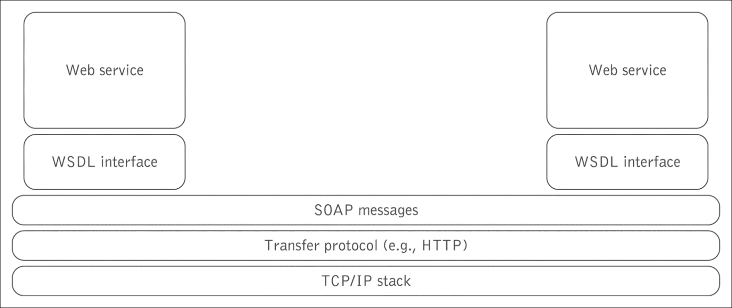

- A set of rules that must be followed when processing a SOAP message and a simple classification of the entities involved in processing a SOAP message.
- A set of conventions on how to turn an RPC call into a SOAP message and back.

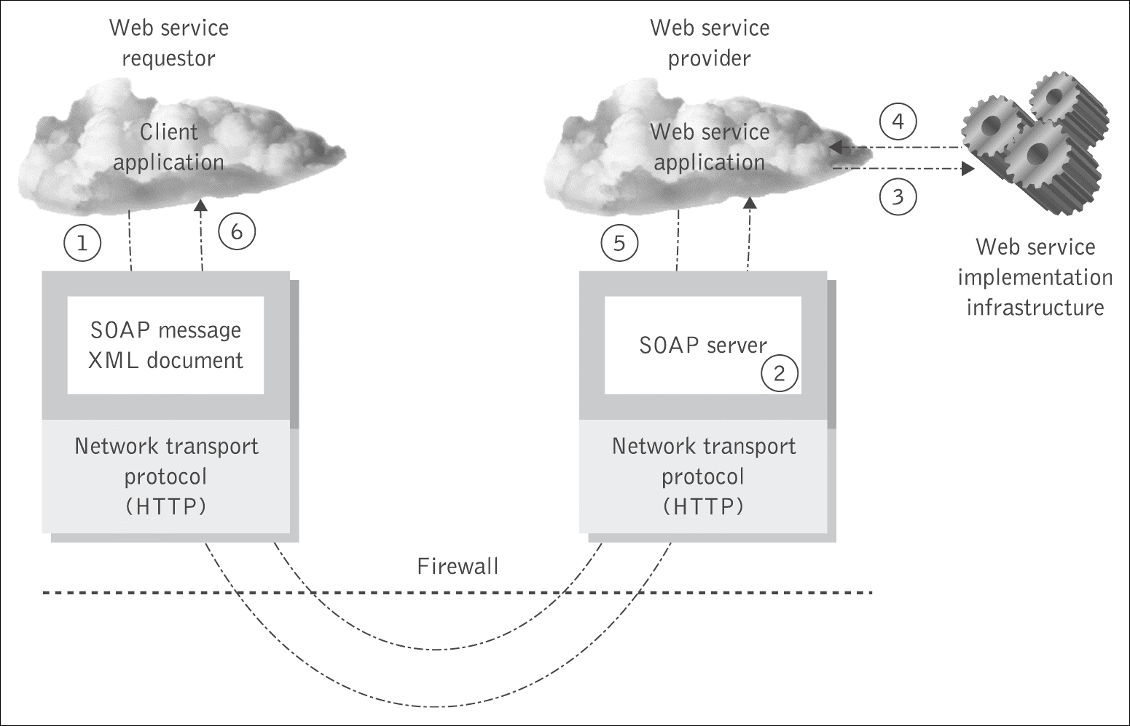

Choose the correct answers:

How many API's defined by Java for developing web service applications since JavaEE 6
- 1 b) 2 c) 3 d) 4

SOAP uses the following format that must be parsed to be read
- XML b) HTML c) DHTML d) WSDL

What is the root element of a SOAP message
- SOAP Header b) SOAP-XML c) SOAP Element d) SOAP Envelope

  - SOAP stands simple object access protocol.

  - UDDIXML based framework for describing, discovering and integrating web services.

UNIT-IV
Short answer questions:
  - What is UDDI?
UDDI stands for Universal Description, Discovery, and Integration. UDDI is an XML-based
standard for describing, publishing, and finding web services.
  - What is UDDI interface?
The UDDI standard version 2.0 specifies two interfaces for service consumers and service providers to interact with the registry.
i) Service consumers use Inquiry Interface to find a service
ii) service providers use Publisher Interface to list a service.
  - What is the role of UDDI registry?
When development teams start to build Web service interfaces into their applications, they face
such issues as code reuse, ongoing maintenance and documentation. The need to manage these
services can increase rapidly.The UDDI registry can help to address these issues and provides
the following benefits:
- It delivers visibility when identifying which services within the organization can be reused to address a business need.
- It promotes reuse and prevents reinvention. It accelerates development time and improves productivity. This ability of UDDI to categorize a growing portfolio of services makes it easier to manage them. It helps you understand relationships between components, supports versioning and manages dependencies.

  - Discuss about the implementation of UDDI?

Java Implementations

Perl Implementation

Ruby Implementation

Python Implementation

  - What is web service notification?
The Web Services Notification (WSN) defines a set of specifications that standardize the way Web Services interact using the notification pattern.

Long answer questions:
- Explain about service discovery?
- Service discovery is the process of automatically detecting devices and services on a network. Service discovery protocol (SDP) is a networking standard that accomplishes detection of networks by identifying resources. Traditionally, service discovery helps reduce configuration efforts by users who are presented with compatible resources, such as a bluetooth-enabled printer or server.
- More recently, the concept has been extended to network or distributed container resources as ‘services’, which are discovered and accessed.

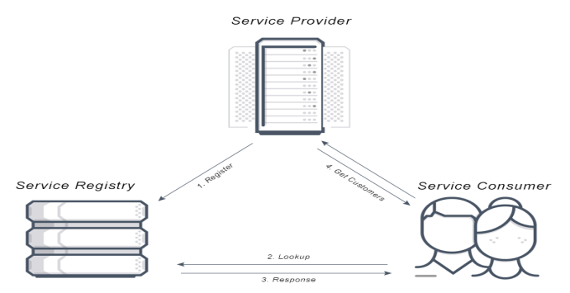

- Service Discovery has the ability to locate a network automatically making it so that there is no need for a long configuration set up process. Service discovery works by devices connecting through a common language on the network allowing devices or services to connect without any manual intervention. (i.e Kubernetes service discovery, AWS service discovery)
- There are two types of service discovery: Server-side and Client-side. Server-side service discovery allows clients applications to find services through a router or a load balancer. Client-side service discovery allows clients applications to find services by looking through or querying a service registry, in which service instances and endpoints are all within the service registry.

How does Service Discovery Work?
There are three components to Service Discovery: the service provider, the serviceconsumer and
the service registry.
- The Service Provider registers itself with the service registry when it enters the system and de-
registers itself when it leaves the system.
- The Service Consumer gets the location of a provider from the service registry, and then connects it to the service provider.
- The Service Registry is a database that contains the network locations of service instances. The service registry needs to be highly available and up to date so clients can go through network locations obtained from the service registry. A service registry consists of a cluster of servers that use a replication protocol to maintain consistency.

Advantages of Service Discovery (Server-side & Client-side):
- The advantage of Server-side service discovery is that it makes the client application lighter as it does not have to deal with the lookup procedure and makes a request for services to the router.
- The advantage of Client-side service discovery is that the client application does not have to traffic through a router or a load balancer and therefore can avoid that extra hop.

- Explain about UDDI Architecture?

The UDDI technical architecture consists of three parts −

UDDI Data Model
UDDI Data Model is an XML Schema for describing businesses and web services. The data model is described in detail in the "UDDI Data Model" chapter.

UDDI API Specification
It is a specification of API for searching and publishing UDDI data.

UDDI Cloud Services
These are operator sites that provide implementations of the UDDI specification and synchronize all data on a scheduled basis.

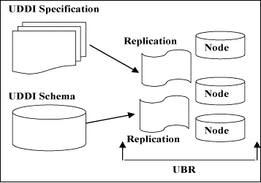

- The UDDI Business Registry (UBR), also known as the Public Cloud, is a conceptually single system built from multiple nodes having their data synchronized through replication.
- The current cloud services provide a logically centralized, but physically distributed, directory. It means the data submitted to one root node will automatically be replicated across all the other root nodes. Currently, data replication occurs every 24 hours.
- UDDI cloud services are currently provided by Microsoft and IBM. Ariba had originally planned to offer an operator as well, but has since backed away from the commitment. Additional operators from other companies, including Hewlett-Packard, are planned for the near future.
- It is also possible to set up private UDDI registries. For example, a large company may set up its own private UDDI registry for registering all internal web services. As these registries are not automatically synchronized with the root UDDI nodes, they are not considered as a part of the UDDI cloud.

- Explain about UDDI specification?

The specifications include the following −
- UDDI Replication,
- UDDI Operators,
- UDDI Programmer's API, and
- UDDI Data Structures

UDDI Replication
This document describes the data replication processes and interfaces to which a registry operator must conform to achieve data replication between sites. This specification is not a programmer's API; it defines the replication mechanism used among UBR nodes.

UDDI Operators
This document outlines the behavior and operational parameters required by the UDDI node operators. This specification defines data management requirements to which operators must adhere.

UDDI Programmer's API
This specification defines a set of functions that all UDDI registries support for inquiring about services hosted in a registry and for publishing information about a business or a service to a registry. This specification defines a series of SOAP messages containing XML documents that a UDDI registry accepts, parses, and responds to. This specification, along with the UDDI XML API schema and the UDDI Data Structure specification, makes up a complete programming interface to a UDDI registry.

UDDI Data Structures
This specification covers the specifics of the XML structures contained within the SOAP messages defined by the UDDI Programmer's API. This specification defines five core data structures and their relationships with one another.
The UDDI XML API schema is not contained in a specification; rather, it is stored as an XML Schema document that defines the structure and datatypes of the UDDI data structures.

- Discuss about UDDI implementation?

A number of UDDI implementations are currently available. These implementations make it easier to search or publish UDDI data, without getting mired in the complexities of the UDDI API. Here is a brief synopsis of the main UDDI implementations available.

Java Implementations
There are two UDDI implementations for Java.
- UDDI4J (UDDI for Java) − UDDI4J was originally created by IBM. In January 2001, IBM turned over the code to its own open source site. UDDI4J is a Java class library that provides an API to interact with a UDDI.
- jUDDI − jUDDI is an open source Java implementation of a UDDI registry and a toolkit for accessing UDDI services.

Perl Implementation
- UDDI::Lite − It provides a basic UDDI client for inquiry and publishing.

Ruby Implementation
- UDDI4r − It provides a basic UDDI client for inquiry and publishing.

Python Implementation
- UDDI4Py − UDDI4Py is a Python package that allows the sending of requests to, and processing of responses from the UDDI Version 2 APIs.

- Briefly discuss about UDDI?

UDDI is an XML-based standard for describing, publishing, and finding web services.

- UDDI stands for Universal Description, Discovery, and Integration.
- UDDI is a specification for a distributed registry of web services.
- UDDI is a platform-independent, open framework.
- UDDI can communicate via SOAP, CORBA, Java RMI Protocol.
- UDDI uses Web Service Definition Language(WSDL) to describe interfaces to web services.
- UDDI is seen with SOAP and WSDL as one of the three foundation standards of web services.
- UDDI is an open industry initiative, enabling businesses to discover each other and define how they interact over the Internet.
UDDI has two sections −
- A registry of all web service's metadata, including a pointer to the WSDL description of a service.
- A set of WSDL port type definitions for manipulating and searching that registry.

History of UDDI
- UDDI 1.0 was originally announced by Microsoft, IBM, and Ariba in September 2000.
- Since the initial announcement, the UDDI initiative has grown to include more than 300 companies including Dell, Fujitsu, HP, Hitachi, IBM, Intel, Microsoft, Oracle, SAP, and Sun.
- In May 2001, Microsoft and IBM launched the first UDDI operator sites and turned the UDDI registry live.
- In June 2001, UDDI announced Version 2.0.
- As the time of writing this tutorial, Microsoft and IBM sites had implemented the 1.0 specification and were planning 2.0 support in the near future.
- Currently UDDI is sponsored by OASIS.

Choose the correct answers:

______________Pages contains basic information about the company and its business in the UDDI registry.
a) White b) Yellow c) Blue d) Green
  - UDDI usesWSDL language to describe interfaces to web services.

  - UDDI stands for Universal Description, Discovery, and Integration.

The UDDI Business Registry (UBR), also known as

a)Private Cloud b) Network cloud c) Simple Cloud d) Public Cloud

  - UDDI is an XMLbased standard for describing, publishing, and finding web services.

UNIT-V

Short answer questions:

  - Write about xml security standards?
The four basics security requirements for web-based communication: authentication, authorization, confidentiality and signature.
  - Define XML encryption?
XML Encryption specifies a process for encrypting data and representing the result in XML. The data may be arbitrary data (including an XML document), an XML element, or XML element content. The result of encrypting data is an XML Encryption element which contains or references the cipher data.

What is XKMS?
The XKMS standard specifies protocols for distributing and registering public keys,
suitable for use with the XML Signature and XML Encryption standards.
  - List XKMS components?
XKMS consists of two parts:
    - X-KISS. XML Key Information Service Specification.
    - X-KRSS.
  - Explain about web services interoperability?

The Web Services Interoperability Organization (WS-I) is a cross-industry project intended

to accelerate the growth and release of interoperable Web services that would work on

various platforms, applications, programming languages and computer system across

the Internet.

Long answer questions:
- Explain about the overview of .NET?
.NET is a software framework which is designed and developed by Microsoft. The first version
of the .Net framework was 1.0 which came in the year 2002. In easy words, it is a virtual
machine for compiling and executing programs written in different languages like C#, VB.Net
etc. It is used to develop Form-based applications, Web-based applications, and Web services.
There is a variety of programming languages available on the .Net platform, VB.Net and C#
being the most common ones. It is used to build applications for Windows, phone, web, etc. It
provides a lot of functionalities and also supports industry standards.NET Framework supports
more than 60 programming languages in which 11 programming languages are designed and
developed by Microsoft. The remaining Non-Microsoft Languages which are supported by
.NET Framework but not designed and developed by Microsoft.

11 Programming Languages which are designed and developed by Microsoft are:

- C#.NET
- VB.NET
- C++.NET
- J#.NET
- F#.NET
- JSCRIPT.NET
- WINDOWS POWERSHELL
- IRON RUBY
- IRON PYTHON
- C OMEGA
- ASML(Abstract State Machine Language)

Main Components of .NET Framework
Common Language Runtime (CLR): CLR is the basic and Virtual Machine component of the .NET Framework. It is the run-time environment in the .NET Framework that runs the codes and helps in making the development process easier by providing the various services such as remoting, thread management, type-safety, memory management, robustness, etc.. Basically, it is responsible for managing the execution of .NET programs regardless of any .NET programming language. It also helps in the management of code, as code that targets the runtime is known as the Managed Code and code doesn’t target to runtime is known as Unmanaged code.
Framework Class Library(FCL): It is the collection of reusable, object-oriented class libraries and methods, etc that can be integrated with CLR. Also called the Assemblies. It is just like the header files in C/C++ and packages in the java. Installing .NET framework basically is the installation of CLR and FCL into the system. Below is the overview of .NET Framework.

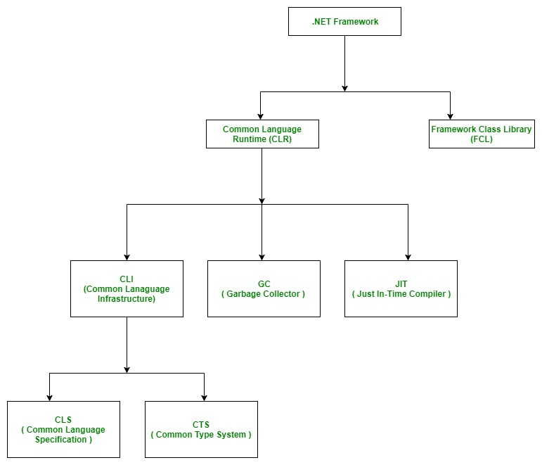

- The combination of Operating System Architecture and CPU Architecture is known as the platform. Platform dependent means the programming language code will run only on particular Operating System. A .NET application is platform dependent because of the .NET framework
which is only able to run on the Windows-based operating system. The .Net application is platform independent also because of Mono framework. Using Mono framework the .Net application can run on any Operating System including windows. Mono framework is a third party software developed by Novell Company which is now a part of Micro Focus Company. It is a paid framework.

- Explain in detail about interoperability?
- The Web Services Interoperability organization (WS-I) is an open industry organization that creates, promotes, and supports generic protocols for the interoperable exchange of messages between Web services. WS-I profiles are guidelines and recommendations for how the standards should be used. These profiles aim to remove ambiguities by adding constraints to the underlying specifications.
- WS-I deliverables are profiles, common or best practices, scenarios, testing software, and testing materials.
- You should design your Web service so that it adheres to WS-I basic profiles. WS-I compliant services agree to clear contracts and have a greater chance of interoperability.
For example, a WS-I basic profile-compliant Web service should use the following features.
- Use HTTP or HTTPS as the transport binding. HTTP 1.1 is preferred over HTTP 1.0.
- Use literal style encoding. Do not use SOAP encoding.
- Use stricter fault message syntax. When a MESSAGE contains a soap:Fault element, its element children must be unqualified.
- Use XML version 1.0.
- The service should not declare array wrapper elements using the convention ArrayOfXXX.

Why is Interoperability Necessary?
The goal of the Web service architecture is to allow heterogeneous business applications to smoothly work together. The architecture is loosely coupled and based on XML standards. Web services are designed to work with each other by defining Web Service Description Language (WSDL) files as service contracts, regardless of which operating system and development technology are behind them. However, because of the complexity involved in service contracts, standards like WSDL and SOAP leave room for ambiguous interpretations. In addition, vendor-specific enhancements and extensions work against universal interoperability.

General Guidelines for Creating Interoperable Web Services
The first general guideline is to create Web services which are WS-I compliant, if possible.
- The WS-I profiles, however, do not solve all interoperability problems. Many Web services were implemented before WS-I profiles existed. Also, the legacy systems that you are enabling as a Web service might have placed restrictions on your designs.
- Thus, good practice in designing Web services should always be adopted from the beginning of the development process, whenever possible. The following sections describe these guidelines.
- Design your Web service top down
- Design data types using XSD first
- Keep data types simple
- Be careful with null values
- Use a compliance testing tool to validate the WSDL
- Understand the differences between platform native types
- Avoid using RPC-encoded message format

Design your Web service top down
- The top down approach enables you to design your Web service from service contracts that are not tied to any platform or language-specific characteristics. Your WSDL is less likely to be affected by existing legacy APIs.

Design data types using XSD first
- If possible, use an XSD schema editor to design your data types with schema types. Resist using platform-specific data types such as the .NET DataSet data type, Java collections, and so on.
Keep data types simple
- Avoid unnecessarily complex schema data types such as xsd:choice. Simple types provide the best interoperability and have the added benefit of improved performance.
Be careful with null values
- Decide what you want to do with null values. For example, should an array be allowed to be null? Should you use a null string or an empty string? If you are sending a null value across the platform, will it cause exceptions on the receiver side?
- Avoid sending null values if possible. If you must use null values in your application, design your schema types to clearly indicate that a null value is allowed.
Use a compliance testing tool to validate the WSDL
- If your Web service is designed to be WS-I compliant, use the WS-I monitor tool to log messages and the analyzer tool to validate for conformance. WS-I tools can be downloaded for free from the following Web site.
http://www.ws-i.org/deliverables/workinggroup.aspx?wg=testingtools
Understand the differences between platform native types
- Some schema types, such as xsd:unsignedshort and xsd:unsignedint, do not always have a direct native type mapping. For example, there are no Java platform equivalent unsigned types. Schema numeric types such as xsd:double, xsd:float, and xsd:decimal might have different precisions once mapped to their platform native types. There are also limitations on the xsd:string type. The strings must not contain illegal XML characters and the \r (carriage return) character will typically be mapped to the \n (line feed) character.
Avoid using RPC-encoded message format
- By itself, the RPC-encoded message format does not imply that you will not be able to interoperate with other platform and clients. In many cases, there are RPC-encoded Web services which are working today. The reason to move away from RPC-encoded message formats is to avoid some of the corner cases where different interpretations of the underlying specification and implementation choices break interoperability. Some examples of these corner cases include the treatment of sparse arrays, multi-dimensional arrays, custom fault code QNames, un-typed payloads, and so on.

- Describe XML encryption by an example?

- XML Encryption is a process for encrypting/decrypting digital content (including XML documents and portions thereof) and an XML syntax used to represent the encrypted content and information that enables an intended recipient to decrypt it.

- XML encryption is a specification that was developed by World Wide Web (WWW) Consortium (W3C) in 2002 and that contains the steps to encrypt data, the steps to decrypt encrypted data, the XML syntax to represent encrypted data, the information to be used to decrypt the data, and a list of encryption algorithms, such as triple DES, AES, and RSA.
- You can apply XML encryption to an XML element, XML element content, and arbitrary data, including an XML document. For example, suppose that you need to encrypt the <CreditCard> element that is shown in example 1.
Example 1: Sample XML document:
<PaymentInfoxmlns='http://example.org/paymentv2'>
<Name>John Smith</Name>
<CreditCard Limit='5,000' Currency='USD'>
<Number>4019 2445 0277 5567</Number>
<Issuer>Example Bank</Issuer>
<Expiration>04/02</Expiration>
</CreditCard>
</PaymentInfo>

Example 2: XML document with a common secret key:
Example 2 shows the XML document after encryption. The <EncryptedData> element represents the encrypted <CreditCard> element. The <EncryptionMethod> element describes the applied encryption algorithm, which is triple DES in this example. The <KeyInfo> element contains the information that is needed to retrieve a decryption key, which is a <KeyName> element in this example. The <CipherValue> element contains the cipher text that is obtained by serializing and encrypting the <CreditCard> element.
<PaymentInfoxmlns='http://example.org/paymentv2'>
<Name>John Smith</Name>
<EncryptedData Type='http://www.w3.org/2001/04/xmlenc#Element'
xmlns='http://www.w3.org/2001/04/xmlenc#'>
<EncryptionMethod
Algorithm='http://www.w3.org/2001/04/xmlenc#tripledes-cbc'/>
<KeyInfoxmlns='http://www.w3.org/2000/09/xmldsig#'>
<KeyName>John Smith</KeyName>
</KeyInfo>
<CipherData>
<CipherValue>ydUNqHkMrD...</CipherValue>
</CipherData>
</EncryptedData>
</PaymentInfo>

Example 3: XML document encrypted with the public key of the recipient:
In example 2, it is assumed that both the sender and recipient have a common secret key. If the recipient has a public and private key pair, which is commonly the case, the <CreditCard> element can be encrypted as shown in example 3. The <EncryptedData> element is the same as the <EncryptedData> element found in Example 2. However, the <KeyInfo> element contains an <EncryptedKey> element.
<PaymentInfoxmlns='http://example.org/paymentv2'>
<Name>John Smith</Name>
<EncryptedData Type='http://www.w3.org/2001/04/xmlenc#Element'
xmlns='http://www.w3.org/2001/04/xmlenc#'>
<EncryptionMethod
Algorithm='http://www.w3.org/2001/04/xmlenc#tripledes-cbc'/>
<KeyInfoxmlns='http://www.w3.org/2000/09/xmldsig#'>
<EncryptedKeyxmlns='http://www.w3.org/2001/04/xmlenc#'>
<EncryptionMethod
Algorithm='http://www.w3.org/2001/04/xmlenc#rsa-1_5'/>
<KeyInfoxmlns='http://www.w3.org/2000/09/xmldsig#'>
<KeyName>Sally Doe</KeyName>
</KeyInfo>
<CipherData>
<CipherValue>yMTEyOTA1M...</CipherValue>
</CipherData>
</EncryptedKey>
</KeyInfo>
<CipherData>
<CipherValue>ydUNqHkMrD...</CipherValue>
</CipherData>
</EncryptedData>
</PaymentInfo>

- Explain in detail about SOA and web service management?

- Service-oriented architecture (SOA) emerged in the early part of this century as an evolution of distributed computing. Before SOA, services were understood as the end result of the application development process. In SOA, the application itself is composed of services. Services can be delivered individually or combined as components in a larger, composite service.
- Services interact over the wire using a protocol such as REST or SOAP (Simple Object Access Protocol). Services are loosely coupled, meaning the service interface is independent of the underlying implementation.

SOA and web services
- SOA and web services are frequently conflated, but they are not the same thing. SOA is an architecture that allows developers to combine multiple application services into a larger, composite service. SOA can be implemented using SOAP-based web services or REST APIs, or sometimes a combination of both. It's important to understand that in SOA, a service is any remotely available resource that can respond to requests. A web service is implemented using specific protocols.

Why service-oriented architecture?
SOA addresses three common enterprise challenges:
- Respond quickly to business changes.
- Leverage existing infrastructure investments.
- Support new channels of interaction with customers, partners, and suppliers.
- Enterprise infrastructure is heterogeneous across operating systems, applications, system software, and application infrastructure. As a result, many enterprise systems are comprised of complex and inconsistent applications delivering a range of interdependent services. Existing applications running current business processes are critical, so starting from scratch or modifying them is a delicate proposition. But enterprises must be able to modify and expand technical infrastructure to meet business demands.

- As an example, consider how an enterprise might use a set of existing applications to create a new, composite supply-chain application. While the existing applications are heterogeneous and
distributed across various systems, their functionality is exposed and accessed using standard interfaces.
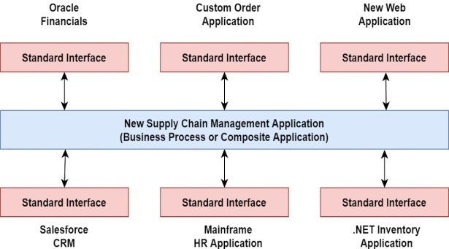

Figure: Supply-chain application in a service-oriented architecture

Key characteristics of SOA
SOA can be as simple as a single component consuming services provided by another component or as sophisticated as a range of components interacting via an enterprise service bus such as MuleSoft's ESB.
- Service providers expose endpoints and describe the available actions at each endpoint.
- Service consumers issues requests and consume responses.
- Service providers generate messages to handle requests.

SOAP-based web services
Web services implemented using SOAP are still more rigid than a RESTful web services or microservices implementation, but far more flexible than the early days of SOA. Here we'll just look at the high-level protocols required for SOAP-based web services.

SOAP, WSDL, and XSD
SOAP, WSDL, and XSD are the fundamental infrastructure of a SOAP-based web service implementation.WSDL is used to describe the service, and SOAP is the transport layer for sending messages between service consumers and providers. Services communicate with messages formally defined using XML Schema (XSD).

Web service security
The WS-I Basic Profile 2.0 specification addresses message security. This specification focuses on credential exchange, message integrity, and message confidentiality.

Web service discovery
Once the cornerstone of web service discovery, UDDI (Universal Description, Definition and Integration)

Building and deploying web services
Java developers have several options for building and deploying SOAP-based web services, including Apache Axis2 and Spring-WS; however, the Java standard is JAX-WS, the Java API for XML Web Services. The core idea behind JAX-WS is to create Java classes and annotate them to create the required artifacts. Under the hood, JAX-WS uses several Java packages, including JAXB, a general purpose library for binding Java classes to XML.
JAX-WS hides the underlying complexity and protocols from the developer, thus streamlining the process of defining and deploying Java-based SOAP services. Modern Java IDEs like Eclipse include full support for developing JAX-WS web services.

What is a J2EE Web Service?
- A Web Service is organized around an architecture containing three main elements: the Service Registry, the Service Provider, and the Service Requester. Figure 1 gives an overview of the relationship between these different elements.
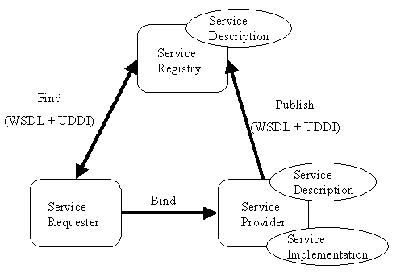
Figure 1: - Web Service architecture
- The Service Provider starts by defining the Service Interface through an abstract Service Description document using the Web Services Description Language (WSDL). This abstract description is associated to transport and encoding bindings, and to an address in a concrete Service Description to define a concrete Service instance also called Service Endpoint or Port. This concrete description can then be published in a Service Registry such as Universal Description, Discovery and Integration (UDDI) to be accessed by any Service Requester. A Service Requester will use it to select and use a concrete Service Implementation for the Web Service.
- A J2EE Web Service consists in a set of such Ports operating within a container. The container mediates access to the service and provides the runtime environment.
- A client of a Web Service can be another Web service, any J2EE component, or an arbitrary Java application. Even non-java or non-Web applications can use Web services.

Web Service Client View
- The Web Service client view is provided by the Port Provider (Service Provider) and by the container. As shown in the Figure 2 below (in gray), the client view comprises a Service Interface and a Service Endpoint Interface.

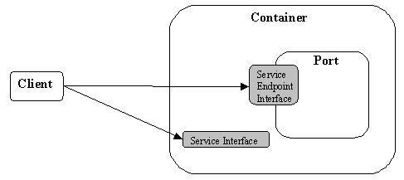
Figure 2: - Web Service client view
- To access a Port of a Web Service, the client starts by locating the Service Interface using the JNDI APIs. Through the Service Interface, the client will discover the methods to use to access a Port and access the Web Service implementation using the Service Endpoint Interface. In the client view a Port is considered as a stateless object.
- The Service and Service Endpoint Interfaces are defined by the JAX-RPC specification; however, the Service Interface behavior is defined by the WSDL Service Description document provided by the Web Service Provider.

Web Service Server View

The server view of a Web Service deals with the implementation of the business logic of the service. As defined in J2EE 1.4, Web Service Endpoint can be implemented using one of the following approaches:
- Using a stateless session bean as specified in the JSR 109 and EJB 2.1 specifications
- Using a servlet as specified in JAX-RPC

Choose the correct answers:

There are two types of web services in total i.e. SOAP and RESTfulweb service.
  - _____________________is a design pattern and It is designed to provide services to other applications through protocol.
    - SOA b) web services c) SOAP d) UDDI
  - XML Encryption specifies a process for encrypting data and representing the result in XML.
  - The ___________is an open industry organization that creates, promotes, and supports generic protocols for the interoperable exchange of messages between Web services.
a)Web Services Interoperability organization (WS-I)b) ISO
c) OSI d) Both
5. J2EE stands for Java 2 Platform, Enterprise Edition

