DESIGN PATTERNS
UNIT-1
INTRODUCTION

Short answer questions

1. Define Design Patterns
Christopher Alexander says, "Each pattern describes a problem which occurs over and over again in our environment, and then describes the core of the solution to that problem, in such a way that you can use this solution a million times over, without ever doing it the same way twice".

2. What are the essential elements of a design pattern
In general, a pattern has four essential elements:
1.The pattern name is a handle we can use to describe a design problem, its solutions, and consequences in a word or two. Naming a pattern immediately increases our design vocabulary.
2.The problem describes when to apply the pattern. It explains the problem and its context. It might describe specific design problems such as how to represent algorithms as objects. It might describe class or object structures that are symptomatic of an inflexible design.
3.The solution describes the elements that make up the design, their relationships, responsibilities, and collaborations. The solution doesn't describe a particular concrete design or implementation, because a pattern is like a template that can be applied in many different situations. Instead, the pattern provides an abstract description of a design problem and how a general arrangement of elements (classes and objects in our case) solves it.
4.The consequences are the results and trade-offs of applying the pattern.. The consequences for software often concern space and time trade-offs. They may address language and implementation issues as well.

3. What is Gang of Four? ( or ) Who is credited with the idea for design patterns?
In 1994, 4 authors Erich Gamma, Richard Helm, Ralph Johnson and John Vlissides published a book titled “Design Patterns –Elements of Reusable Object Oriented Software” which initiated the concept of software development. These 4 authors are collectively called as Gang of Four.

4. What are the Benefits or Advantages of Design Patterns
The Benefits or Advantages of Design Patterns are
Proven: They have a proven track record as they are already widely used and thus reduce the technical risk to the project
Well documented: They aid communication by the very fact that they are well documented and can be researched if that is not the case.
Language neutral: They are language neutral and so can be applied to any language that supports object-orientation
Flexible: They are highly flexible and can be used in practically any type of application or domain
Easy reuse: Design patterns make it easier to reuse successful designs and architecture

5.What are uses of design patterns
Uses of Design Patterns
1.Design patterns can speed up the development process by providing tested, proven development paradigms. Effective software design requires considering issues that may not become visible until later in the implementation. Reusing design patterns helps to prevent subtle issues that can cause major problems and improves code readability for coders and architects familiar with the patterns.
2.Often, people only understand how to apply certain software design techniques to certain problems. These techniques are difficult to apply to a broader range of problems. Design patterns provide general solutions, documented in a format that doesn't require specifics tied to a particular problem.
3.In addition, patterns allow developers to communicate using well-known, well understood names for software interactions. Common design patterns can be improved over time, making them more robust than ad-hoc designs.

6.Define MVC. What are the advantages of MVC
MVC: The Model/View/Controller (MVC) triad of classes is used to build user interfaces in Smalltalk.
The Model is the application object, the View is its screen presentation, and the Controller defines the way the user interface reacts to user input.
Important advantages of MVC Model:
1. Faster development process:
MVC supports rapid and parallel development. If an MVC model is used to develop any particular web application then it is possible that one programmer can work on the view while the another can work on the controller to create business logic of the web application. Hence this way, the application developed using MVC model can be completed three times faster than applications that are developed using other development pattern.
2. Ability to provide multiple views:
In the MVC Model, you can create multiple views for a model. Today, there is an increasing demand for new ways to access your application and for that MVC development is certainly a great solution. Moreover, in this method, Code duplication is very limited because it separates data and business logic from the display.
3. Support for asynchronous technique:
The MVC architecture can also integrate with the JavaScript Framework. This means that MVC applications can be made to work even with PDF files, site-specific browsers, and also with desktop widgets. MVC also supports asynchronous technique, which helps developers to develop an application that loads very fast.
4. Modification does not affect the entire model:
For any web application, user interface tends to change more frequently than even the business rules of the company. It is obvious that you make frequent changes in your web application like changing colors, fonts, screen layouts, and adding new device support for mobile phones or tablets. Moreover, Adding new type of views are very easy in MVC pattern because the Model part does not depend on the views part. Therefore, any changes in the Model will not affect the entire architecture.
5. MVC model returns the data without formatting:
MVC pattern returns data without applying any formatting. Hence, the same components can be used and called for use with any interface. For example, any kind of data can be formatted with HTML, but it could also be formatted with Macromedia Flash or Dream viewer.

7.Describe the basic approach used in functional decomposition.
Functional decomposition is the approach to analysis that breaks down (decomposes) a problem into its functional parts without too much concern for global requirements and future modifications.

8. What are three reasons that cause requirements to change?
The user's understanding of what they need and what is possible grows and changes as they discuss the problem with analysts. The developer's understanding of what is possible and what is needed evolves as they become familiar with the domain and with the software. The technical environment evolves, forcing changes in how to implement.

9. I advocate thinking about responsibilities rather than functions. What is meant by this?
Give an example.
Rather than thinking first about how something is done (functions), the analyst should focus on what the routine is responsible for doing - how it does it does not matter. The control program is much simpler in this case.

10. Define "coupling" and "cohesion". What is "tight" coupling?
Cohesion is how strongly the internal operations of a routine are related to each other. Coupling is how strongly a routine is dependent upon other routines.

Essay Answer Questions

1.Write about Design Patterns in Smalltalk MVC
The Model/View/Controller (MVC) triad of classes is used to build user interfaces in Smalltalk-80. It was originally invented by Small Talk programmer Trygve Reenskaug
MVC consists of three kinds of objects.
Model
It is the application object It represents special knowledge and expertise. They hold application data and define the logic that manipulates that data .MVC application has all its important data encapsulated in model object.
View
It is its screen presentation of an application object. It visualizes data the model contains View obtains data from model .There can be multiple views of the model.
Controller
Defines the way the user interface reacts to user input. It acts as the intermediary between the application view object and model object. These are often in charge of making sure the views have access tom the model objects they need to display and act as the conduit through which views learn about changes to the model.
Before MVC ,user interface designs tend to limp these objects together.MVC decouples to increase4 flexibility and reuse.
Control flow of MVC
The control flow generally works as follows:
1. The user interacts with the user interface in some way (e.g., user presses a button)
2. A controller handles the input event from the user interface, often via a registered handler or callback.
3. The controller accesses the model, possibly updating it in a way appropriate to the user’s action (e.g., controller updates user’s shopping cart). Complex controllers are often structured using the command pattern to encapsulate actions and simplify extension.
4. A view uses the model to generate an appropriate user interface (e.g., view produces a screen listing the shopping cart contents). The view gets its own data from the model. The model has no direct knowledge of the view. (However, the observer pattern can be used to allow the model to indirectly notify interested parties, potentially including views, of a change.)
5. The user interface waits for further user interactions, which begins the cycle anew.
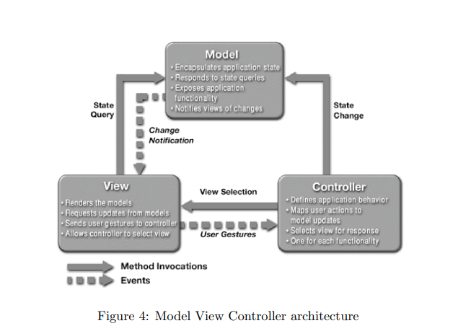
Features
1.Subscribe / Notify
MVC decouples views and models by establishing a subscribe/notify protocol between them.
A view must ensure that its appearance reflects the state of the model. Whenever the model's data changes, the model notifies views that depend on it.
In response, each view gets an opportunity to update itself. This approach lets you attach multiple views to a model to provide different presentations. You can also create new views for a model without rewriting it.
The following diagram shows a model and three views. (We've left out the controllers for simplicity.)
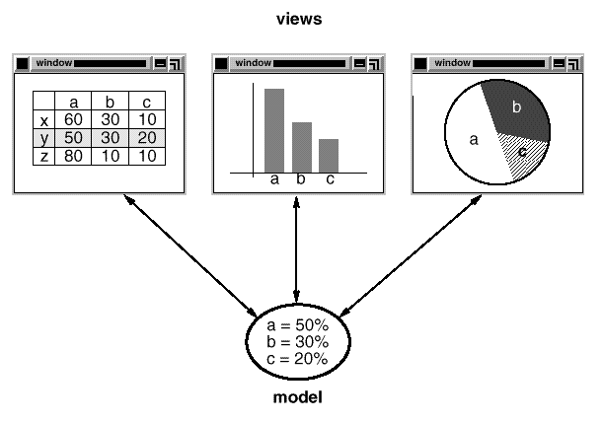

The model contains some data values, and the views defining a spreadsheet, histogram, and pie chart display these data in various ways. The model communicates with its views when its values change, and the views communicate with the model to access these values.
This example reflects a design that decouples views from models. But the design is applicable to a more general problem: decoupling objects so that changes to one can affect any number of others without requiring the changed object to know details of the others.

2. Views can be nested
Another feature of MVC is that views can be nested. For example, a control panel of buttons might be implemented as a complex view containing nested button views.
The user interface for an object inspector can consist of nested views that may be reused in a debugger.
MVC supports nested views with the CompositeView class, a subclass of View. This design is applicable to a more general problem, which occurs whenever we want to group objects and treat the group like an individual object. This more general design is described by Composite Design Pattern. It lets you create a class hierarchy in which some subclasses define primitive objects(e.g. buttons) and other classes define composite objects(composite view) that assemble the primitives into more complex objects.

3.View responds based on user input
MVC also lets you change the way a view responds to user input without changing its visual presentation. for example, or have it use a pop-up menu instead of command keys. MVC encapsulates the response mechanism in a Controller object. There is a class hierarchy of controllers, making it easy to create a new controller as a variation on an existing one.
A view uses an instance of a Controller subclass to implement a particular response strategy; to implement a different strategy, simply replace the instance with a different kind of controller. It's even possible to change a view's controller at run-time to let the view change the way it responds to user input. For example, a view can be disabled so that it doesn't accept input simply by giving it a controller that ignores input events.
The View-Controller relationship is an example of the Strategy design pattern. A Strategy is an object that represents an algorithm. It's useful when you want to replace the algorithm either statically or dynamically, when you have a lot of variants of the algorithm, or when the algorithm has complex data structures that you want to encapsulate.
MVC uses other design patterns, such as Factory Method to specify the default controller class for a view and Decorator to add scrolling to a view. But the main relationships in MVC are given by the Observer, Composite, and Strategy design patterns.

2. Write the process of Describing Design Patterns
Each pattern is divided into sections according to the following template. The template lends a uniform structure to the information, making design patterns easier to learn, compare, and use. These are …
Pattern Name and Classification
The pattern's name conveys the essence of the pattern succinctly. A good name is vital, because it will become part of your design vocabulary. The pattern's classification reflects the scheme.

Intent
A short statement that answers the following questions:
What does the design pattern do?
What is its rationale and intent?
What particular design issue or problem does it address?

Also Known As
Other well-known names for the pattern, if any.

Motivation
A scenario that illustrates a design problem and how the class and objectstructures in the pattern solve the problem. The scenario will help you understand the more abstract description of the pattern that follows.

Applicability
A short statement that answers the following questions:
What are the situations in which the design pattern can be applied?
What are examples of poor designs that the pattern can address?
How can you recognize these situations?

Structure
A graphical representation of the classes in the pattern using a notation based on the Object Modeling Technique (OMT) We also use interaction diagrams to illustrate sequences of requests and collaborations between objects.
Participants
The classes and/or objects participating in the design pattern and their responsibilities.

Collaborations
A short statement that answers the following questions:
How the participants collaborate to carry out their responsibilities.

Consequences
A short statement that answers the following questions:
How does the pattern support its objectives?
What are the trade-offs and results of using the pattern?
What aspect of system structure does it let you vary independently?

Implementation
A short statement that answers the following questions:
What pitfalls, hints, or techniques should you be aware of when implementing the pattern?
Are there language-specific issues?

Sample Code
Code fragments that illustrate how you might implement the pattern in C++ or Smalltalk.

Known Uses
Examples of the pattern found in real systems.

Related Patterns
A short statement that answers the following questions:
What design patterns are closely related to this one?
What are the important differences?
With which other patterns should this one be used?

3.Write the Catalog of Design Patterns

The catalog contain intent of 23 patterns……..
Abstract Factory
Provide an interface for creating families of related or dependent objects without specifying their concrete classes. Convert the interface of a class into another interface clients expect. Adapter lets classes work together that couldn't otherwise because of incompatible interfaces.

Bridge
Decouple an abstraction from its implementation so that the two can vary independently.

Builder
Separate the construction of a complex object from its representation so that the same construction process can create different representations.

Chain of Responsibility
Avoid coupling the sender of a request to its receiver by giving more than one object a chance to handle the request. Chain the receiving objects and pass the request along the chain until an object handles it.

Command
Encapsulate a request as an object, thereby letting you parameterize clients with different requests, queue or log requests, and support undoable operations.

Composite
Compose objects into tree structures to represent part-whole hierarchies. Composite lets clients treat individual objects and compositions of objects uniformly.

Decorator
Attach additional responsibilities to an object dynamically. Decorators provide a flexible alternative to subclassing for extending functionality.

Facade
Provide a unified interface to a set of interfaces in a subsystem. Façade defines a higher-level interface that makes the subsystem easier to use.

Factory Method
Define an interface for creating an object, but let subclasses decide which class to instantiate. Factory Method lets a class defer instantiation to subclasses.

Flyweight
Use sharing to support large numbers of fine-grained objects efficiently.

Interpreter
Given a language, define a represention for its grammar along with an interpreter that uses the representation to interpret sentences in the language.

Iterator
Provide a way to access the elements of an aggregate object sequentially without exposing its underlying representation.

Mediator
Define an object that encapsulates how a set of objects interact. Mediator promotes loose coupling by keeping objects from referring to each other explicitly, and it lets you vary their interaction independently.

Memento
Without violating encapsulation, capture and externalize an object's internal state so that the object can be restored to this state later.

Observer
Define a one-to-many dependency between objects so that when one object changes state, all its dependents are notified and updated automatically.

Prototype
Specify the kinds of objects to create using a prototypical instance, and create new objects by copying this prototype.

Proxy
Provide a surrogate or placeholder for another object to control access to it.

Singleton
Ensure a class only has one instance, and provide a global point of access to it.

State
Allow an object to alter its behavior when its internal state changes. The object will appear to change its class.

Strategy
Define a family of algorithms, encapsulate each one, and make them interchangeable. Strategy lets the algorithm vary independently from clients that use it.

Template Method
Define the skeleton of an algorithm in an operation, deferring some steps to subclasses. Template Method lets subclasses redefine certain steps of an algorithm without changing the algorithm's structure.

Visitor
Represent an operation to be performed on the elements of an object structure. Visitor lets you define a new operation without changing the classes of the elements on which it operates.

4.Describe the process of Organizing the Catalog
Design patterns vary in their granularity and level of abstraction. Because there are many design patterns, we need a way to organize them.

We classify design patterns by two criteria,

a)Purpose: It reflects what a pattern does
Patterns can have either
Creational: concerns the process of object creation.
Structural: deals with the composition of classes or objects
Behavioral:characterizes the ways in which classes or objects interact and distribute responsibility.

b)Scope : specifies whether the pattern applies primarily to classes or to objects.
Class patterns: deal with relationships between classes and their subclasses. These relationships are established through inheritance, so they are static—fixed at compile-time.
Object patterns: deal with object relationships, which can be changed at run-time and are more dynamic. Almost all patterns use inheritance to some extent. So the only patterns labeled "class patterns" are those that focus on class relationships.
Combining above two
The Creational class patterns defer some part of object creation to subclasses, while the Creational object patterns defer it to another object.
The Structural class patterns use inheritance to compose classes, while the Structural object patterns describe ways to assemble objects.
The Behavioral class patterns use inheritance to describe algorithms and flow of control, whereas the Behavioral object patterns describe how a group of objects cooperate to perform a task that no single object can carry out alone.

 |  | Purpose
 |  | Creational | Structural | Behavioral
Scope | Class | Factory Method | Adapter | Interpreter Template Method
Scope | Object | Abstract Factory Builder Prototype Singleton | Adapter Bridge Composite Decorator Facade Flyweight Proxy | Chain of Responsibility Command Iterator Mediator Memento Observer State  Strategy Visitor

5.How Design Patterns Solve Design Problems
Design patterns solve many of the day-to-day problems object-oriented designers face, and in many different ways. Here are several of these problems and how design patterns solve them.

1.Finding Appropriate Objects

Object and its terminology
- Object-oriented programs are made up of objects. An object packages both data and the procedures that operate on that data. The procedures are typically called methods or operations. An object performs an operation when it receives a request (or message) from a client.
- Requests are the only way to get an object to execute an operation. Operations are the only way to change an object's internal data. Because of these restrictions, the object's internal state is said to be encapsulated; it cannot be accessed directly, and its representation is invisible from outside the object. The hard part about object-oriented design is decomposing a system into objects.
- Decomposing a system into Objects
- The hard part about object-oriented design is decomposing a system into objects. The task is difficult because many factors come into play: encapsulation, granularity, dependency, flexibility, performance, evolution, reusability, and on and on. They all influence the decomposition, often in conflicting ways.
- Object-oriented design methodologies favor many different approaches. You can write a problem statement, single out the nouns and verbs, and create corresponding classes and operations. Or you can focus on the collaborations and responsibilities in your system. Or you can model the real world and translate the objects found during analysis into design. There will always be disagreement on which approach is best.
- Analysis model verses Real world
- Many objects in a design come from the analysis model. But object-oriented designs often end up with classes that have no counterparts in the real world. Some of these are low-level classes like arrays. Others are much higher-level.
- Design patterns help you identify less-obvious abstractions and the objects that can capture them. For example, objects that represent a process or algorithm don't occur in nature, yet they are a crucial part of flexible designs. The Strategy pattern describes how to implement interchangeable families of algorithms. The State pattern represents each state of an entity as an object. These objects are seldom found during analysis or even the early stages of design; they're discovered later in the course of making a design more flexible and reusable.

2. Determining Object Granularity

Size of Objects
- Objects can vary tremendously in size and number. They can represent everything down to the hardware or all the way up to entire applications. How do we decide what should be an object?
- Design Pattern Solution
Design patterns that address this issue are,
- The Facade pattern describes how to represent complete subsystems as objects,
- The Flyweight pattern describes how to support huge numbers of objects at the finest
granularities.
- Other design patterns describe specific ways of decomposing an object into smaller objects.
- Abstract Factory and Builder yield objects whose only responsibilities are creating other objects.
- Visitor and Command yield objects whose only responsibilities are to implement a request on another object or group of objects.

3.Specifying Object Interfaces

Defining an Interface
- Every operation declared by an object specifies the operation's name, the objects it takes as parameters, and the operation's return value. This is known as the operation's signature.
- The set of all signatures defined by an object's operations is called the interface to the object. An object's interface characterizes the complete set of requests that can be sent to the object. Any request that matches a signature in the object's interface may be sent to the object.
- Type of an Interface
- A type is a name used to denote a particular interface. We speak of an object as having the type "Window" if it accepts all requests for the operations defined in the interface named "Window."
- An object can have many types.
- Interfaces and Implementation
- Interfaces are fundamental in object-oriented systems. Objects are known only through their interfaces. There is no way to know anything about an object or to ask it to do anything without going through its interface. An object's interface says nothing about its implementation—different objects are free to implement requests differently. That means two objects having completely different implementations can have identical interfaces.
- Dynamic Binding
- When a request is sent to an object, the particular operation that's performed depends on both the request and the receiving object. Different objects that support identical requests may have different implementations of the operations that fulfill these requests. The run-time association of a request to an object and one of its operations is known as dynamic binding.
- Dynamic binding means that issuing a request doesn't commit you to a particular implementation until run-time.
- Polymorphism
- You can write programs that expect an object with a particular interface, knowing that any object that has the correct interface will accept the request.
- Moreover, dynamic binding lets you substitute objects that have identical interfaces for each other at run-time. This substitutability is known as polymorphism, and it's a key concept in object-oriented systems. It lets a client object make few assumptions about other objects beyond supporting a particular interface.
- Polymorphism simplifies the definitions of clients, decouples objects from each other, and lets them vary their relationships to each other at run-time.
- Design Patterns defining Interfaces
Design patterns help you define interfaces by identifying their key elements and the kinds of data that get sent across an interface. A design pattern might also tell you what not to put in the interface.
- The Memento pattern is a good example. It describes how to encapsulate and save the internal state of an object so that the object can be restored to that state later. The pattern stipulates that Memento objects must define two interfaces: a restricted one that lets clients hold and copy mementos, and a privileged one that only the original object can use to store and retrieve state in the memento.
- Design patterns also specify relationships between interfaces. In particular, they often require some classes to have similar interfaces, or they place constraints on the interfaces of some classes.
- For example, both Decorator and Proxy require the interfaces of Decorator and Proxy objects to be identical to the decorated and proxied objects.
- In Visitor , the Visitor interface must reflect all classes of objects that visitors can visit.

4.Specifying Object Implementations

Defining and representing Object and Class
- An object's implementation is defined by its class. The class specifies the object's internal data and representation and defines the operations the object can perform.
- OMT-based notation depicts a class as a rectangle with the class name in bold. Operations appear in normal type below the class name. Any data that the class defines comes after the operations. Lines separate the class name from the operations and the operations from the data:
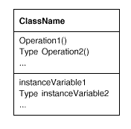
- Instantiating a Class
- Objects are created by instantiating a class. The object is said to be an instance of the class. The process of instantiating a class allocates storage for the object's internal data (made up of instance variables) and associates the operations with these data. Many similar instances of an object can be created by instantiating a class.
- A dashed arrowhead line indicates a class that instantiates objects of another class. The arrow points to the class of the instantiated objects.
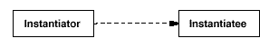
- Inheritance
- New classes can be defined in terms of existing classes using class inheritance.
- When a subclass inherits from a parent class, it includes the definitions of all the data and operations that the parent class defines.
- Objects that are instances of the subclass will contain all data defined by the subclass and its parent classes, and they'll be able to perform all operations defined by this subclass and its parents. We indicate the subclass relationship with a vertical line and a triangle
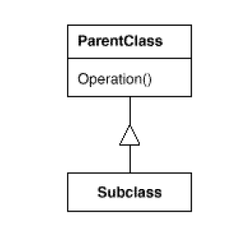
- Abstract Class
- An abstract class is one whose main purpose is to define a common interface for its subclasses.
- An abstract class will defer some or all of its implementation to operations defined in subclasses; hence an abstract class cannot be instantiated.
- The operations that an abstract class declares but doesn't implement are called abstract operations.
- Classes that aren't abstract are called concrete classes.
- A class may override an operation defined by its parent class. Overriding gives subclasses a chance to handle requests instead of their parent classes.
- The names of abstract classes appear in slanted type to distinguish them from concrete classes.
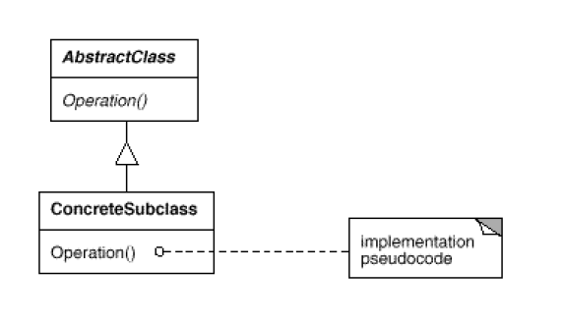
- Mixin Class
- A mixin class is a class that's intended to provide an optional interface or functionality to other classes. It's similar to an abstract class in that it's not intended to be instantiated. Mixin classes require multiple inheritance:
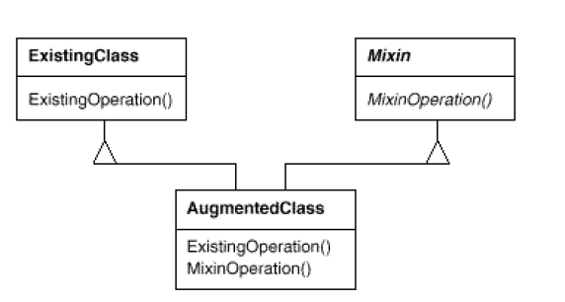

5.Class verses Interface Inheritance
- Difference between an object's class and its type.
- An object's class defines how the object is implemented. The class defines the object's internal state and the implementation of its operations.
- An object's type only refers to its interface—the set of requests to which it can respond.
- An object can have many types, and objects of different classes can have the same type.
- There's a close relationship between class and type. Because a class defines the operations an object can perform, it also defines the object's type.
- When we say that an object is an instance of a class, we imply that the object supports the interface defined by the class.
- Languages like C++ and Eiffel use classes to specify both an object's type and its implementation. Smalltalk programs do not declare the types of variables.
- Difference between class inheritance and interface inheritance (or subtyping).
- Class inheritance defines an object's implementation in terms of another object's implementation. In short, it's a mechanism for code and representation sharing.
- Interface inheritance (or subtyping) describes when an object can be used in place of another.
- Many languages don't make the distinction
- Design Patterns on these distinctions
Many of the design patterns depend on this distinction.
- Objects in a Chain of Responsibility must have a common type, but usually they don't share a common implementation.
- In the Composite pattern, Component defines a common interface, but Composite often defines a common implementation.
- Command , Observer , State , and Strategy are often implemented with abstract classes that are pure interfaces.
6.Programming to an Interface, not an Implementation
- Class Inheritance
- Class inheritance is basically just a mechanism for extending an application's functionality by reusing functionality in parent classes. It lets you get new implementations
- Interface is also important because polymorphism depends on it.
- When inheritance is used carefully (some will say properly), all classes derived from an abstract class will share its interface. This implies that a subclass merely adds or overrides operations and does not hide operations of the parent class. All subclasses can then respond to the requests in the interface of this abstract class, making them all subtypes of the abstract class.
- There are two benefits to manipulating objects solely in terms of the interface defined by abstract classes:
- Clients remain unaware of the specific types of objects they use, as long as the objects adhere to the interface that clients expect.
- Clients remain unaware of the classes that implement these objects. Clients only know about the abstract class(es) defining the interface.
This so greatly reduces implementation dependencies between subsystems that it leads to the following principle of reusable object-oriented design:
Program to an interface, not an implementation.
- Don't declare variables to be instances of particular concrete classes. Instead, commit only to an interface defined by an abstract class.
- Creational patterns ensure that your system is written in terms of interfaces, not implementations by to instantiate concrete classes and abstracting the process of object creation

7.Putting Reuse Mechanisms to Work
- Inheritance verses Composition

- Class inheritance lets you define the implementation of one class in terms of another's. Reuse by subclassing is often referred to as white-box reuse.
- The term "white-box" refers to visibility: With inheritance, the internals of parent classes are often visible to subclasses.
- Object composition is an alternative to class inheritance. Here, new functionality is obtained by assembling or composing objects to get more complex functionality. Object composition requires that the objects being composed have well-defined interfaces.
- This style of reuse is called black- box reuse, because no internal details of objects are visible. Objects appear only as "black boxes."
- Advantages of Class inheritance
- Class inheritance is defined statically at compile-time and is straightforward to use, since it's supported directly by the programming language.
- Class inheritance also makes it easier to modify the implementation being reused.
- Disadvantages of class inheritance
- Can't change the implementations inherited from parent classes at run-time, because inheritance is defined at compile-time.
- Parent classes often define at least part of their subclasses' physical representation. Because inheritance exposes a subclass to details of its parent's implementation, it's often said that "inheritance breaks encapsulation".

- Object composition solution to these problems
- Defined dynamically at run-time through objects acquiring references to other objects
- Because objects are accessed solely through their interfaces, we don't break encapsulation
- Object composition has another effect on system design.
- Favoring object composition over class inheritance helps you keep each class encapsulated and focused on one task. Your classes and class hierarchies will remain small.
- A design based on object composition will have more objects (if fewer classes), and the system's behavior will depend on their interrelationships instead of being defined in one class.
These leads us to our second principle of object-oriented design:
Favor object composition over class inheritance.
You shouldn't have to create new components to achieve reuse. You should be able to get
all the functionality you need just by assembling existing components through object composition.
- But this is rarely the case, because the set of available components is never quite rich enough in practice. Reuse by inheritance makes it easier to make new components that can be composed with old ones. Inheritance and object composition thus work together.
- Delegation
- Definition: Delegation is a way of making composition as powerful for reuse as inheritance. In delegation, two objects are involved in handling a request: a receiving object delegates operations to its delegate
- In inheritance ,inherited operation can always refer to the receiving object through the this member variable in C++ and self in Smalltalk. To achieve the same effect with delegation, the receiver passes itself to the delegate to let the delegated operation refer to the receiver.
- Example: Instead of making class Window a subclass of Rectangle (because windows happen to be rectangular), the Window class might reuse the behavior of Rectangle by keeping a Rectangle instance variable and delegating Rectangle-specific behavior to it. In other words, instead of a Window being a Rectangle, it would have a Rectangle. Window must now forward requests to its Rectangle instance explicitly, whereas before it would have inherited those operations.
- A plain arrowhead line indicates that a class keeps a reference to an instance of another class. The reference has an optional name, "rectangle" in this case.
- Advantage
- Easy to compose behaviors at run-time and to change the way they're composed
Example: Our window can become circular at run-time simply by replacing its Rectangle instance with a Circle instance
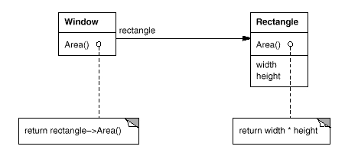

- Disadvantages
- It shares with other techniques that make software more flexible through object composition Dynamic, highly parameterized software is harder to understand than more static software.
- There are also run-time inefficiencies

- Design patterns using Delegation
- In the State pattern, an object delegates requests to a State object that represents its current state.
- In the Strategy pattern, an object delegates a specific request to an object that represents a strategy for carrying out the request
- In Visitor, the operation that gets performed on each element of an object structure is always delegated to the Visitor object
- The Mediator object implements operations simply by forwarding them to the other objects; other times it passes along a reference to itself and thus uses true delegation.
- Chain of Responsibility handles requests by forwarding them from one object to another along a chain of objects.
8.Inheritance versus Parameterized Types
- Definition :Another (not strictly object-oriented) technique for reusing functionality is through parameterized types, also known as generics (Ada, Eiffel) and templates (C++). This technique lets you define a type without specifying all the other types it uses. The unspecified types are supplied as parameters at the point of use.
- For example, a List class can be parameterized by the type of elements it contains. To declare a list of integers, you supply the type "integer" as a parameter to the List parameterized type. To declare a list of String objects, you supply the "String" type as a parameter. The language implementation will create a customized version of the List class template for each type of element.

9.Relating Run-Time and Compile-Time Structures
- The code structure is frozen at compile-time; it consists of classes in fixed inheritance relationships.
- A program's run-time structure consists of rapidly changing networks of communicating objects.
- In fact, the two structures are largely independent.
- Consider the distinction between object aggregation and acquaintance and how differently they manifest themselves at compile- and run-times.
- Aggregation implies that one object owns or is responsible for another object. Generally we speak of an object having or being part of another object. Aggregation implies that an aggregate object and its owner have identical lifetimes. An arrowhead line with a diamond at its base denotes aggregation
- Acquaintance implies that an object merely knows of another object. Sometimes acquaintance is called "association" or the "using" relationship. Acquainted objects may request operations of each other, but they aren't responsible for each other. A plain arrowhead line denotes acquaintance.Acquaintance is a weaker relationship than aggregation and suggests much looser coupling between objects.
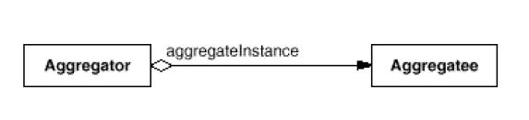
Acquainted object2

Acquainted object1

- In Smalltalk, all variables are references to other objects. There's no distinction in the programming language between aggregation and acquaintance.
- In C++, aggregation can be implemented by defining member variables that are real instances, but it's more common to define them as pointers or references to instances. Acquaintance is implemented with pointers and references as well.
- Ultimately, acquaintance and aggregation are determined more by intent than by explicit language mechanisms. The distinction may be hard to see in the compile-time structure, but it's significant.
- Aggregation relationships tend to be fewer and more permanent than acquaintance. Acquaintances, in contrast, are made and remade more frequently, sometimes existing only for the duration of an operation.
- Acquaintances are more dynamic as well, making them more difficult to discern in the source code.
These are the disparity between a program's run-time and compile-time structures
- Design Patterns in Run-Time and Compile-Time Structures
- Composite and Decorator are especially useful for building complex run-time structures.
- Observer involves run-time structures that are often hard to understand unless you know the pattern.
- Chain of Responsibility also results in communication patterns that inheritance doesn't reveal.

10.Designing for Change
- The key to maximizing reuse lies in anticipating new requirements and change to existing requirements, and in designing your systems so that they can evolve accordingly.
- A design that doesn't take change into account risks major redesign in the future. Those changes might involve class redefinition and reimplementation, client modification, and retesting.
- Design patterns help you avoid this by ensuring that a system can change in specific ways. Each design pattern lets some aspect of system structure vary independently of other aspects, thereby making a system more robust to a particular kind of change.
Here are some common causes of redesign along with the design pattern(s) that address them:
- Creating an object by specifying a class explicitly.
Specifying a class name when you create an object commits you to a particular
implementation instead of a particular interface. This commitment can complicate future
changes. To avoid it, create objects indirectly.
Design patterns: Abstract Factory , Factory Method , Prototype
- Dependence on specific operations.
When you specify a particular operation, you commit to one way of satisfying request.
By avoiding hard-coded requests, you make it easier to change the way a request gets
satisfied both at compile-time and at run-time.
Design patterns: Chain of Responsibility , Command .
- Dependence on hardware and software platform.
External operating system interfaces and application programming interfaces (APIs) are different on different hardware and software platforms. Software that depends on a particular platform will be harder to port to other platforms. It may even be difficult to keep it up to date on its native platform. It's important therefore to design your system to limit its platform dependencies.
Design patterns: Abstract Factory , Bridge .
- Dependence on object representations or implementations.
Clients that know how an object is represented, stored, located, or implemented might
need to be changed when the object changes. Hiding this information from clients keeps changes from cascading.
Design patterns: Abstract Factory , Bridge , Memento , Proxy
- Algorithmic dependencies.
Algorithms are often extended, optimized, and replaced during development and reuse. Objects that depend on an algorithm will have to change when the algorithm changes. Therefore algorithms that are likely to change should be isolated.
Design patterns: Builder , Iterator , Strategy, Template Method , Visitor .
- Tight coupling.
Classes that are tightly coupled are hard to reuse in isolation, since they depend on
each other. Loose coupling increases the probability that a class can be reused by itself and that a system can be learned, ported, modified, and extended more easily. Design patterns use techniques such as abstract coupling and layering to promote loosely coupled systems.
Design patterns: Abstract Factory, Bridge , Chain of Responsibility , Command, Façade, Mediator, Observer.
- Extending functionality by subclassing.
Customizing an object by subclassing often isn't easy. Every new class has a fixed implementation overhead (initialization, finalization, etc.). Defining a subclass also requires an in-depth understanding of the parent class. Object composition in general and delegation in particular provide flexible alternatives to inheritance for combining behavior. Many design patterns produce designs in which you can introduce customized functionality just by defining one subclass and composing its instances
with existing ones.
Design patterns: Bridge , Chain of Responsibility , Composite , Decorator , Observer , Strategy .
- Inability to alter classes conveniently.
Sometimes you have to modify a class that can't be modified conveniently because you don’t have the source code or any change would require modifying lots of existing subclasses. Design patterns offer ways to modify classes in such circumstances.
Design patterns: Adapter , Decorator , Visitor

11. Application Programs
If you're building an application program such as a document editor or spreadsheet, then internal reuse, maintainability, and extension are high priorities.
- Internal reuse ensures that you don't design and implement any more than you have to. Design patterns that reduce dependencies can increase internal reuse.
- Design patterns also make an application more maintainable when they're used to limit platform dependencies
- They enhance extensibility by showing you how to extend class hierarchies and how to exploit object composition. Reduced coupling also enhances extensibility.

12.Toolkits
- Often an application will incorporate classes from one or more libraries of predefined classes called toolkits. A toolkit is a set of related and reusable classes designed to provide useful, general-purpose functionality.
- An example of a toolkit is a set of collection classes for lists, associative tables, stacks, and the like.
- Toolkit design is arguably harder than application design, because toolkits have to work in many applications to be useful. Moreover, the toolkit writer isn't in a position to know what those applications will be or their special needs That makes it all the more important to avoid assumptions and dependencies that can limit the toolkit's flexibility and consequently its applicability and effectiveness.

13. Frameworks
- A framework is a set of cooperating classes that make up a reusable design for a specific class of software. For example, a framework can be geared toward building graphical editors for different domains like artistic drawing, music composition, and mechanical CAD Another framework can help you build compilers for different programming languages and target machines.
- The framework dictates the architecture of your application. It will define the overall structure, its partitioning into classes and objects, the key responsibilities.
- The framework captures the design decisions that are common to its application domain. Frameworks thus emphasize design reuse over code reuse
- When you use a toolkit, you write the main body of the application and call the code you want to reuse. When you use a framework, you reuse the main body and write the code it calls. You'll have to write operations with particular names and calling conventions, but that reduces the design decisions you have to make.
- A framework designer gambles that one architecture will work for all applications in the domain. Any substantive change to the framework's design would reduce its benefits considerably, since the framework's main contribution to an application is the architecture it defines. Therefore it's imperative to design the framework to be as flexible and extensible as possible.
- An added benefit comes when the framework is documented with the design patterns it uses People who know the patterns gain insight into the framework faster.

Because patterns and frameworks have some similarities, people often wonder how or even if they differ. They are different in three major ways:
- Design patterns are more abstract than frameworks.
Frameworks can be embodied in code, but only examples of patterns can be embodied in code. A strength of frameworks is that they can be written down in programming languages and not only studied but executed and reused directly. In contrast, the design patterns have to be implemented each time they're used. Design patterns also explain the intent, trade-offs, and consequences of a design.
- Design patterns are smaller architectural elements than frameworks.
A typical framework contains several design patterns, but the reverse is never true.
- Design patterns are less specialized than frameworks.
Frameworks always have a particular application domain. In contrast, the design patterns
in this catalog can be used in nearly any kind of application.

6. How to Select a Design Pattern
Here are several different approaches to finding the design pattern that's right for your problem:
- Consider how design patterns solve design problems.
How design patterns help you find appropriate objects, determine object granularity, specify object interfaces, and several other ways in which design patterns solve design problems. Referring to these discussions can help guide your search for the right pattern.
- Scan Intent sections.
Read through each pattern's intent to find one or more that sound relevant to your problem. You
- Study how patterns interrelate.
Studying these relationships can help direct you to the right pattern or group of patterns.
- Study patterns of like purpose.
The catalog has three chapters, one for creational patterns, another for structural patterns, and a third for behavioral patterns. Each chapter starts off with introductory comments on the patterns and concludes with a section that compares and contrasts them. These sections give you insight into the similarities and differences between patterns of like purpose.
- Examine a cause of redesign.
Look at the causes of redesign starting on to see if your problem involves one or more of them. Then look at the patterns that help you avoid the causes of redesign.
- Consider what should be variable in your design.
This approach is the opposite of focusing on the causes of redesign. Instead of considering what might force a change to a design, consider what you want to be able to change without redesign. The focus here is on encapsulating the concept that varies, a theme of many design patterns.

7.How to Use a Design Pattern
Once you've picked a design pattern, how do you use it? Here's a step-by-step approach to applying a design pattern effectively:
- Read the pattern once through for an overview.
Pay particular attention to the Applicability and Consequences sections to ensure the pattern is right for your problem.
- Go back and study the Structure, Participants, and Collaborations sections.
Make sure you understand the classes and objects in the pattern and how they relate to one another.
- Look at the Sample Code section to see a concrete example of the pattern in code.
Studying the code helps you learn how to implement the pattern.
- Choose names for pattern participants that are meaningful in the application context.
The names for participants in design patterns are usually too abstract to appear directly in an application. Nevertheless, it's useful to incorporate the participant name into the name that appears in the application. That helps make the pattern more explicit in the implementation. For example, if you use the Strategy pattern for a text compositing algorithm, then you might have classes SimpleLayoutStrategy or TeXLayoutStrategy.
- Define the classes.
Declare their interfaces, establish their inheritance relationships, and define the instance variables that represent data and object references. Identify existing classes in your application that the pattern will affect, and modify them accordingly.
- Define application-specific names for operations in the pattern.
Here again, the names generally depend on the application. Use the responsibilities and collaborations associated with each operation as a guide. Also, be consistent in your naming conventions. For example, you might use the "Create-" prefix consistently to denote a factory method.
- Implement the operations to carry out the responsibilities and collaborations in the pattern.
The Implementation section offers hints to guide you in the implementation. The examples in the Sample Code section can help as well.

UNIT-2
1.A CASE STUDY :DESIGNING A DOCUMENT EDITOR
2.CREATIONAL PATTERNS

Short answer questions

1.Give the meaning of WYSIWYG
What-You-See-Is-What-You-Get

2.Define Lexi
Lexi is a “What-You-See-Is-What-You-Get” (or “WYSIWYG”) document editor. AWYSIWYG representation of the document occupies the large rectangulararea in the center. The document can mix text and graphics freely ina variety of formatting styles. Surrounding the document are the usual pull-down menus and scroll bars, plus a collection of page icons for jumping to a particular page in the document.

3.List the Design problems
- Document structure
- Formatting
- Embellishing the user interface
- Supporting multiple look-and-feel standards
- Supporting multiple window systems
- User operations
- Spelling checking and hyphenation

4.Write the meaning of a document
The document can mix text and graphics freely ina variety of formatting styles. Surrounding the document are the usual pull-down menus and scroll bars, plus a collection of page icons for jumping to a particular page in the document.

5.Differentiate between Compositor and Composition
We’ll define a Compositor class for objects that can encapsulate a formatting algorithm. The interface lets the compositor know what glyphs to format and when to do the formatting. The glyphs it formats are the children of a special Glyph subclass called Composition.
A composition gets an instance of a Compositor subclass when it is created, and it tells the compositor to Compose its glyphs when necessary, for example, when the user changes a document.
6.Define Formatting
After representing document physical structure ,next we need to know how to construct a particular physical structure in to properly formatted document .This includes breaking text into lines, using hyphens , adjusting margins etc.
7.Define Iterator Class
We’ll use an abstract class called Iterator to define a general interface for access and traversal. Concretesubclasses like ArrayIterator and ListIterator implement the interface to provide access to arrays and lists, while PreorderIterator, PostorderIterator, and the like implement different traversals on specific structures.

8.What is Recursive Composition
A common way to represent hierarchically structured information is through a technique called recursive composition, which entails building increasingly complex elements out of simpler ones
9.Define Widget
Style guides have much to say about the look and feel of so-called “widgets,” another term for visible glyphs like buttons, scroll bars, and menus that act as controlling elements in a user interface

10. Differentiate between Glyph and Monoglyph
We’ll define a Glyph abstract class for all objects that can appear in a document structure. Its subclasses define both primitive graphical elements (like characters and images) and structural elements(like rows and columns).
We’ll define a subclass of Glyph called MonoGlyph to serve as an abstract class for “embellishment glyphs,” like Border. MonoGlyph stores a reference to a component and forwards all requests toit. That makes MonoGlyph totally transparent to clients by default.

Essay Answer Questions

1.What are the design problems while designing a document editor?
We will examine seven problems in Lexi’s design:
- Document structure. The choice of internal representation for the document affects nearly every aspect of Lexi’s design. All editing, formatting, displaying, and textual analysis will require traversing the representation.

- Formatting. How does Lexi actually arrange text and graphics into lines and columns? What objects are responsible for carrying out different formatting policies? How do these policies interact with the document’s internal representation?

- Embellishing the user interface. Lexi’s user interface includes scroll bars, borders, and drop shadows that embellish the WYSIWYG document interface. Such embellishments are likely to change as Lexi’s user interface evolves. Hence it’s important to be able to add and remove embellishments easily without affecting the rest of the application.

- Supporting multiple look-and-feel standards. Lexi should adapt easily to different look-and- feel standards such as Motif and Presentation Manager (PM) without major modification.

- Supporting multiple window systems. Different look-and-feel standards are usually implemented on different window systems. Lexi’s design should be as independent of the window system as possible.

- User operations. Users control Lexi through various user interfaces, including buttons and pull- down menus. The functionality behind these interfaces is scattered throughout the objects in the application. The challenge here is to provide a uniform mechanism both for accessing this scattered functionality and for undoing its effects.

- Spelling checking and hyphenation. How does Lexi support analytical operations such as checking for misspelled words and determining hyphenation points? How can we minimize the number of classes we have to modify to add a new analytical operation?
2.Write a short note on Document Structure
A document is ultimately just an arrangement of basic graphical elements such as characters, lines, polygons, and other shapes. These elements capture the total information content of the document.
The structure of the document contains a collection of these elements and each element can inturn be a substructures of other elements so on.
Goals
Lexi’s user interface should let users manipulate these substructures directly. For example, a user should be able to treat a diagram as a unit rather than as a collection of individual graphical primitives. The user should be able to refer to a table as a whole ,not as an unstructured mass of text and graphics. That helps make the interface simple and intuitive. To give Lexi’s implementation similar qualities, we’ll choose an internal representation that matches the document’s physical structure.
In particular, the internal representation should support the following:
- Maintaining the document’s physical structure, that is, the arrangement of text and graphics into lines, columns, tables, etc.
- Generating and presenting the document visually.
- Mapping positions on the display to elements in the internal representation. This lets Lexi determine what the user is referring to when he points to something in the visual representation.
Constraint
- We should treat text and graphics uniformly.
The application’s interface lets the user embed text within graphics freely and vice versa. We should avoid treating graphics as a special case of text or text as a special case of graphics; otherwise we’ll end up with redundant formatting and manipulation mechanisms. One set of mechanisms should suffice for both text and graphics.
- Our implementation shouldn’t have to distinguish between single elements and groups of elements in the internal representation.
Lexi should be able to treat simple and complex elements uniformly, thereby allowing arbitrarily complex documents. The tenth element in line five of column two, for instance, could be a single character or an intricate diagram with many sub elements
- Analyze the text
We need to analyse for such things as spelling errors and potential hyphenation points. Often we don’t care whether the element of a line is a simple or complex object. But sometimes an analysis depends on the objects being analyzed. It makes little sense, for example, to check the spelling of a polygon or to hyphenate it.
Solution
Recursive Composition
A common way to represent hierarchically structured information is through a technique called recursive composition, which entails building increasingly complex elements out of simpler ones.
As a first step, we can tile a set of characters and graphics from left to right to form a line in the document. Then multiple lines can be arranged to form a column ,multiple columns can form a page, and so on.
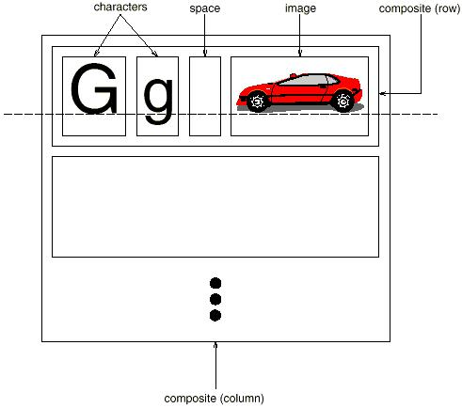

We can represent this physical structure by devoting an object to each important element. That includes not just the visible elements like the characters and graphics but the invisible, structural elements as well—the lines and the column. The result is the object structures.
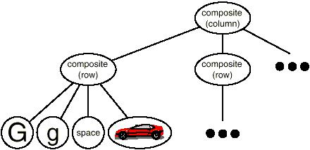

By using an object for each character and graphical element in the document, we promote flexibility at the finest levels of Lexi’s design. We can treat text and graphics uniformly with respect to how they are drawn, formatted, and embedded within each other. We can extend Lexi to support new character sets without disturbing other functionality
This approach has two important implications.
- The objects need corresponding classes.
- These classes must have compatible interfaces
Glyphs
We’ll define a Glyph abstract class for all objects that can appear in a document structure. Its subclasses define both primitive graphical elements (like characters and images) and structural elements(like rows and columns).

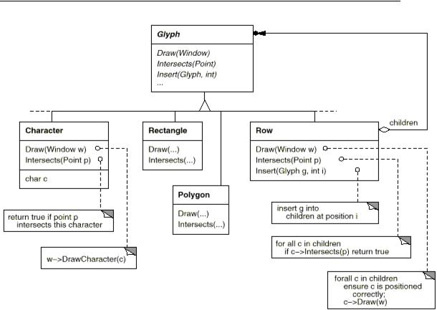

Glyphs have three basic responsibilities.
(1) how to draw themselves,
(2) what space they occupy, and
(3) their children and parent.
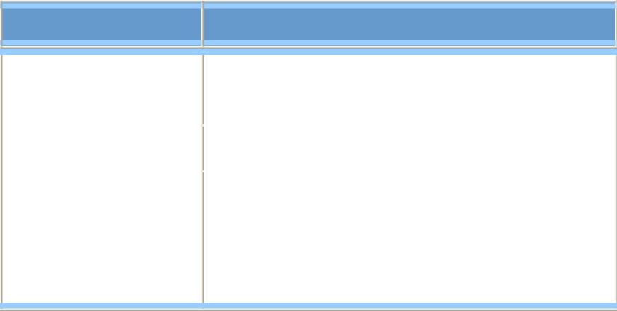

Responsibility Operations

 | appearance |  | virtual void Draw(Window*)
 |  |  | virtual void Bounds(Rect&)
 | hit detection |  | virtual bool Intersects(const Point&)
 | structure |  | virtual void Insert(Glyph*, int)
 |  |  | virtual void Remove(Glyph*)
 |  |  | virtual Glyph* Child(int)
 |  |  | virtual Glyph* Parent()
Draw Operation
Glyph subclasses redefine the Draw operation to render themselves onto a window. They are passed a reference to a Window object in the call to Draw.
The Window class defines graphics operations for rendering text and basic shapes in a window on the screen.
A Rectangle subclass of Glyph might redefine Draw as follows:
void Rectangle::Draw (Window* w)
{
w->DrawRect(_x0, _y0, _x1, _y1);
}
where _x0, _y0, _x1, and _y1are data members of Rectangle that define two opposing corners ofthe rectangle. DrawRect is the Window operation that makesthe rectangle appear on the screen.
Bound Operation
A parent glyph often needs to know how much space a child glyph occupies, for example, to arrange it. The Bounds operation returns the rectangular area that the glyph occupies. It returns the opposite corners of the smallest rectangle that contains the glyph. Glyph subclasses redefine this operation to return the rectangular area in which they draw.
Intersects operation
The Intersects operation returns whether a specified point intersects the glyph. Whenever the user clicks somewhere in the document, Lexi calls this operation to determine which glyph or glyph structure is under the mouse. The Rectangle class redefines this operation to compute the intersection of the rectangle and the given point.
Insert Operation
The Insert operation inserts a glyph at a position specified by an integer index.
Remove Operation
The Remove operation removes a specified glyph if it is indeed a child.
Child Operation
The Child operation returns the child (if any) at the given index.
Parent Operation
Parent provides a standard interface to the glyph’s parent, if any. Glyphs in Lexi store a reference to their parent, and their Parent operation simply returns this reference.
Design Patterns
Composite Pattern
Recursive composition is good for more than just documents. We can use it to represent any potentially complex, hierarchical structure. The Composite pattern captures the essence of recursive composition in object-oriented terms. Now would be a goodtime to turn to that pattern and study it, referring back to this scenario as needed.
3.Write a short note on Formatting
Goals
After representing document physical structure ,next we need to know how to construct a particular physical structure in to properly formatted document .This includes breaking text into lines, using hyphens , adjusting margins etc.
Constraints
Encapsulating the Formatting Algorithm

Lexi is a WYSIWYG editor, an important trade-off to consider is the balance between formatting quality and formatting speed. We want generally good response from the editor without sacrificing how good the document looks. For example, the user might tolerate slightly slower response in exchange for better formatting.
Another, more implementation-driven trade-off balances formatting speed and storage requirements: It may be possible to decrease formatting time by caching more information.
Solutions
Because formatting algorithms tend to be complex, it’s also desirable to keep them well-contained or—better yet—completely independent of the document structure.
We could add a new kind of Glyph subclass without regard to the formatting algorithm. Conversely, adding a new formatting algorithm shouldn’t require modifying existing glyphs.
These characteristics suggest we should design Lexi so that it’s easy to change the formatting algorithm at least at compile-time, if not at run-time as well.
We can isolate the algorithm and make it easily replaceable at the same time by encapsulating it in an object. More specifically, we’ll define a separate class hierarchy for objects that encapsulate formatting algorithms.
The root of the hierarchy will define an interface that supports a wide range of formatting algorithms, and each subclass will implement the interface to carryout a particular algorithm. Then we can introduce a Glyph subclass that will structure its children automatically using a given algorithm object.
Design Patterns
Compositor and Composition
We’ll define a Compositor class for objects that can encapsulate a formatting algorithm. The interface lets the compositor know what glyphs to format and when to do the formatting. The glyphs it formats are the children of a special Glyph subclass called Composition.
A composition gets an instance of a Compositor subclass when it is created, and it tells the compositor to Compose its glyphs when necessary, for example, when the user changes a document.

 | Responsibility |  |  | Operations
 | What | to | format | void SetComposition(Composition*)
 | When | to | format | virtual void Compose()

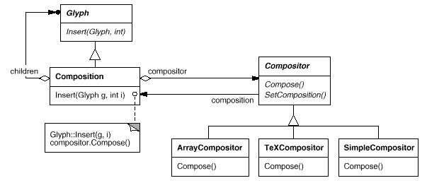

A Compositor has an associated instance of a composition object.When a Compositor runs its Compose(),it iterates through each element of its associated Composition and rearranges the structure by inserting Rows and Columns as needed.

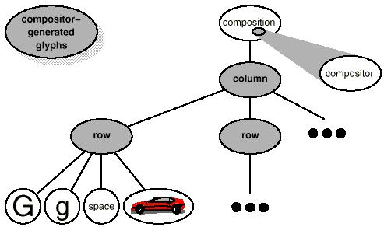

Each Compositor subclass can implement a different line breaking algorithm. For example, a SimpleCompositor might do a quick pass without regard for such mplemen as the document’s “color.” Good color means having an even distribution of text and whitespace. A TeXCompositor would implement the full TeX algorithm , which takes things like color into account in exchange for longer formatting times.
We can add new Compositor subclasses without touching the glyph classes, and vice versa. In fact, we can change the linebreaking algorithm at run-time by adding a single SetCompositor operation to Composition’s basic glyph interface.
Design Pattern
Strategy Pattern
Encapsulating an algorithm in an object is the intent of the Strategy pattern. The key participants in the pattern are Strategy objects (which encapsulate different algorithms)and the context in which they operate. Compositors are strategies; they encapsulate different formatting algorithms. A composition is the context for a compositor strategy.
The key to applying the Strategy pattern is designing interfaces for the strategy and its context that are general enough to support a range of algorithms. You shouldn’t have to change the strategy or context interface to support a new algorithm. In our example, the basic Glyph interface’s support for child access, insertion, and removal is general enough to let Compositor subclasses change the document’s physical structure, regardless of the algorithm they use to do it. Likewise, the Compositor interface gives compositions whatever they need to initiate formatting.
4.Write a short note on Embellishing the User Interface
Problems and Constraints
We consider two embellishments in Lexi’s user interface. The first adds a border around the text editing area to demarcate the page of text. The second adds scroll bars that let the user view different parts of the page.
Unknown to User Interface
User Interface object should not know about the embellishments.
Explosion of Classes
Embellishing the user interface involves extending existing code. Using inheritance to do such extension precludes rearranging embellishments at run-time, but an equally serious problem is the explosion of classes that can result from an inheritance-based approach.
We could add a border to Composition by sub classing it to yield a BorderedComposition class. Or we could add a scrolling interface in the same way to yield a ScrollableComposition. If we want both scrollbars and a border, we might produce a BorderedScrollableComposition, and so forth. In the extreme, we end up with a class for every possible combination of embellishments, a solution that quickly becomes unworkable as the variety of embellishments grows.
Solution
Transparent Enclosure
Object composition offers a potentially more workable and flexible extension mechanism. But what objects do we compose?
Since we know we’re embellishing an existing glyph, we could make the embellishment itself an object (say, an instance of class Border). That gives us two candidates for composition, the glyph and the border.
The next step is to decide who composes whom. We could have the border contain the glyph, which makes sense given that the border will surround the glyph on the screen. Or we could do the opposite—put the border into the glyph—but then we must make modifications to the corresponding Glyph subclass to make it aware of the border. Our first choice, composing the glyph in the border, keeps the border-drawing code entirely in the Border class, leaving other classes alone.
What does the Border class look like? The fact that borders have an appearance suggests they should actually be glyphs; that is, Border should be a subclass of Glyph. But there’s a more compelling reason for doing this: Clients shouldn’t care whether glyphs have borders or not. They should treat glyphs uniformly.
When clients tell a plain, unbordered glyph to draw itself, it should do so without embellishment. If that glyph is composed in a border, clients shouldn’t have to treat the border containing the glyph any differently; they just tell it to draw itself as they told the plain glyph before.
This implies that the Border interface matches the Glyph interface. We subclass Border from Glyph to guarantee this relationship.
All this leads us to the concept of transparent enclosure, which combines the notions of (1) single-child (or single-component) composition and (2) compatible interfaces.
Clients generally can’t tell whether they’re dealing with the component or its enclosure (i.e., the child’s parent),especially if the enclosure simply delegates all its operations to its component. But the enclosure can also augment the component’s mplemen by doing work of its own before and/or after delegating an operation.
Monoglyph
We can apply the concept of transparent enclosure to all glyphs that embellish other glyphs. To make this concept concrete, we’ll define a subclass of Glyph called MonoGlyph to serve as an abstract class for “embellishment glyphs,” like Border. MonoGlyph stores a reference to a component and forwards all requests toit. That makes MonoGlyph totally transparent to clients by default. For example, MonoGlyph implements the Draw operation like this:
void MonoGlyph::Draw (Window* w)
{
_component->Draw(w);
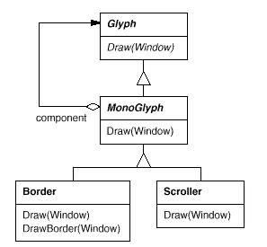
}

MonoGlyph subclasses reimplement at least one of these forwarding operations. Border::Draw, for instance, first invokes the parent class operation MonoGlyph::Draw on the component to let thecomponent do its part—that is, draw everything but the border. ThenBorder::Draw draws the border by calling a private operation called DrawBorder,
void Border::Draw (Window* w)
{
MonoGlyph::Draw(w);
DrawBorder(w);
}
Scroller is a MonoGlyph that draws its component in different locations based on the positions of two scroll bars, which it adds as embellishments.
When Scroller draws its component, it tells the graphics system to clip to its bounds. Clipping parts of the component that are scrolled out of view keeps them from appearing on the screen.
Now we have all the pieces we need to add a border and a scrolling interface to Lexi’s text editing area. We compose the existing Composition instance in a Scroller instance to add the scrolling interface, and we compose that in a Border instance.
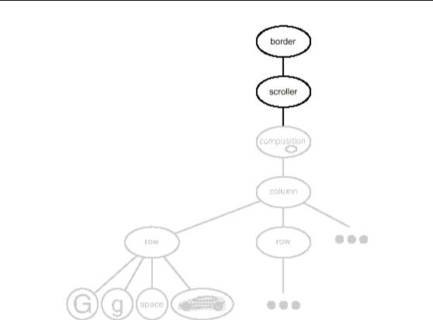
We can reverse the order of composition, putting the bordered composition into the Scroller instance. In that case the border would be scrolled along with the text, which may or may not be desirable. The point is, transparent enclosure makes it easy to experiment with different alternatives, and it keeps clients free of embellishment code.
Design Pattern
Decorator Pattern
The Decorator pattern captures class and object relationships that support embellishment by transparent enclosure. The term “embellishment” actually has broader meaning than what we’ve considered here. In the Decorator pattern, embellishment refers to anything that adds responsibilities to an object without modifying the object itself.

5.Explain about Supporting Multiple Look-and-Feel Standards
Achieving portability across hardware and software platforms is a major problem in system design. Retargeting Lexi to a new platform shouldn’t require a major overhaul, or it wouldn’t be worth retargeting. We should make porting as easy as possible.
Problems and Constraints
One obstacle to portability is the diversity of look-and-feel standards, which are intended to enforce uniformity between applications. These standards define guidelines for how applications appear and react to the user. While existing standards aren’t that different from each other, people certainly won’t confuse one for the other—Motif applications don’t look and feel exactly like their counterparts on other platforms, and vice versa.
Our design goals are to make Lexi conform to multiple existing look-and-feel standards and to make it easy to add support for new standards as they (invariably) emerge. We also want our design to support the ultimate in flexibility: changing Lexi’s look and feel at run-time.
Solution
Abstracting Object Creation
Everything we see and interact with in Lexi’s user interface is a glyph composed in other, invisible glyphs like Row and Column. The invisible glyphs compose visible ones like Button and Character and lay them out properly.
Style guides have much to say about the look and feel of so-called “widgets,” another term for visible glyphs like buttons, scroll bars, and menus that act as controlling elements in a user interface.
We’ll assume we have two sets of widget glyph classes with which to implement multiple look-and-feel standards:
- A set of abstract Glyph subclasses for each category of widget glyph. For example, an abstract class ScrollBar will augment the basic glyph interface to add general scrolling operations; Button is a nabstract class that adds button-oriented operations; and so on.
- A set of concrete subclasses for each abstract subclass that implement different look-and-feel standards. For example, ScrollBar might have MotifScrollBar and PMScrollBar subclasses that implement Motif and Presentation Manager-style scroll bars, respectively.

Lexi must distinguish between widget glyphs for different look-and-feel styles. For example, when Lexi needs to put a button in its interface, it must instantiate a Glyph subclass for the right style of button(MotifButton, PMButton, MacButton, etc.).
Lexi needs a way to determine the look-and-feel standard that’s being targeted in order to create the appropriate widgets. Not only must we avoid making explicit constructor calls; we must also be able to replace an entire widget set easily. We can achieve both by abstracting the process of object creation.
Factories and Product Classes
Normally we might create an instance of a Motif scroll bar glyph with the following C++ code:
ScrollBar* sb = new MotifScrollBar;
This is the kind of code to avoid if you want to minimize Lexi’s look-and-feel dependencies. But suppose we initialize sb as follows:
ScrollBar* sb = guiFactory->CreateScrollBar();
where guiFactory is an instance of a MotifFactory class. CreateScrollBar returns a new instance of the proper ScrollBar subclass for the look and feel desired, Motif in this case. As far as clients are concerned, the effect is the same as calling the MotifScrollBar constructor directly. But there’s a crucial difference: There’s no longer anything in the code that mentions Motif by name.
The guiFactory object abstracts the process of creating not just Motif scroll bars but scroll bars for any look-and-feel standard. And guiFactory isn’t limited to producing scroll bars. It can manufacture a full range of widget glyphs, including scroll bars, buttons, entry fields, menus, and so forth.
All this is possible because MotifFactory is a subclass of GUIFactory, an abstract class that defines a general interface for creating widget glyphs. It includes operations like CreateScrollBar and CreateButtonfor instantiating different kinds of widget glyphs. Subclasses of GUIFactory implement these operations to return glyphs such as MotifScrollBar and PMButton that implement a particular look and feel.
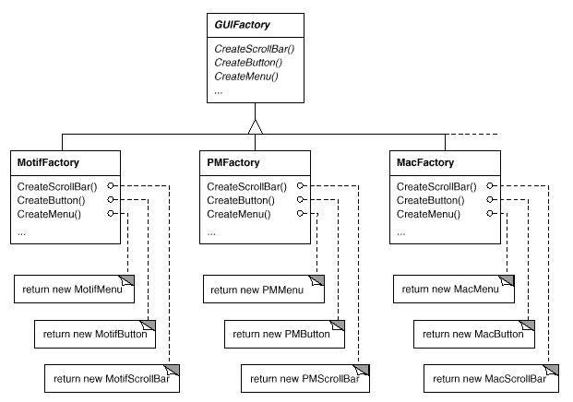

Factories create product objects. Moreover, the products that a factory produces are related to one another; in this case, the products are all widgets for the same look and feel.

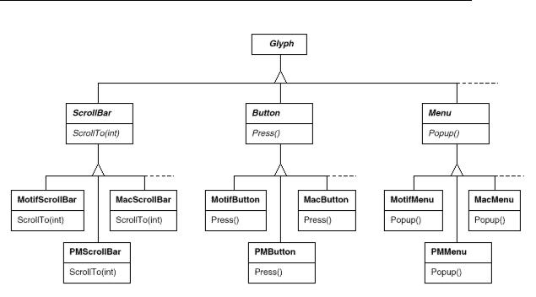
The last question we have to answer is, Where does the GUIFactory instance come from? The answer is, Anywhere that’s convenient. The variable guiFactory could be a global, a static member of a well-known class, or even a local variable if the entire user interface is created within one class or function. There’s even a design pattern, Singleton (144), for managing well-known, one-of-a-kind objects like this. The important thing, though, is to initialize guiFactory at a point in the program before it’s ever used to create widgets but after it’s clear which look and feel is desired.
If the look and feel is known at compile-time, then guiFactory can be initialized with a simple assignment of a new factory instance at the beginning of the program:
GUIFactory* guiFactory = new MotifFactory;
If the user can specify the look and feel with a string name atstartup time, then the code to create the factory might be
GUIFactory* guiFactory;
const char* styleName = getenv(“LOOK_AND_FEEL”);
//user or environment supplies this at startup
if (strcmp(styleName, “Motif”) == 0)
{
guiFactory = new MotifFactory;
}
else if (strcmp(styleName, “Presentation_Manager”) == 0)
{
guiFactory = new PMFactory;
}
else
{
guiFactory = new DefaultGUIFactory;
}
There are more sophisticated ways to select the factory at run-time. For example, you could maintain a registry that maps strings to factory objects. That lets you register instances of new factory subclasses without modifying existing code, as the preceding approach requires. And you don’t have to link all platform-specific factories into the application. That’s important, because it might not be possible to link a MotifFactory on a platform that doesn’t support Motif.
But the point is that once we’ve configured the application with the right factory object, its look and feel is set from then on. If we change our minds, we can reinitialize guiFactory with a factory for a different look and feel and then reconstruct the interface. Regardless of how and when we decide to initialize guiFactory, we know that once we do, the application can create the appropriate look and feel without modification.
Design Pattern
Abstract Factory Pattern
Factories and products are the key participants in the Abstract Factory pattern. This pattern captures how to create families of related product objects without instantiating classes directly. It’s most appropriate when the number and general kinds of product objects stay constant, and there are differences in specific product families. We choose between families by instantiating a particular concrete factory and using it consistently to create products thereafter. We can also swap entire families of products by replacing the concrete factory with an instance of a different one. The Abstract Factory pattern’s emphasis on families of products distinguishes it from other creational patterns, which involve only one kind of product object.
6.Explain about Supporting Multiple Window Systems
Look and feel is just one of many portability issues. Another is the windowing environment in which Lexi runs. A platform’s window system creates the illusion of multiple overlapping windows on a bitmapped display. It manages screen space for windows and routes input to them from the keyboard and mouse. Several important and largely incompatible window systems exist today (e.g., Macintosh, Presentation Manager, Windows, X).We’d like Lexi to run on as many of them as possible for exactly the same reasons we support multiple look-and-feel standards.
Problems and Constraints

Can We Use an Abstract Factory?
At first glance this may look like another opportunity to apply the Abstract Factory pattern. But the constraints for window system portability differ significantly from those for look-and-feel independence.
In applying the Abstract Factory pattern, we assumed we would define the concrete widget glyph classes for each look-and-feel standard. That meant we could derive each concrete product for a particular standard (e.g., MotifScrollBar and MacScrollBar) from an abstract product class (e.g., ScrollBar).
But suppose we already have several class hierarchies from different vendors, one for each look-and-feel standard. Of course, it’s highly unlikely these hierarchies are compatible in any way.
Hence we won’t have a common abstract product class for each kind of widget (ScrollBar, Button, Menu, etc.)—and the Abstract Factory pattern won’t work without those crucial classes. We have to make the different widget hierarchies adhere to a common set of abstract product interfaces. Only then could we declare the Create… operations properly in our abstract factory’s interface.
We solved this problem for widgets by developing our own abstract and concrete product classes. Now we’re faced with a similar problem when we try to make Lexi work on existing window systems; namely, different window systems have incompatible programming interfaces. Things are a bit tougher this time, though, because we can’t afford to implement our own nonstandard window system.

But there’s a saving grace. Like look-and-feel standards, window system interfaces aren’t radically different from one another, because all window systems do generally the same thing. We need a uniform set of windowing abstractions that lets us take different window system implementations and slide any one of them under a common interface.
Solution
Encapsulating Implementation Dependencies
Window class is used for displaying a glyph or glyph structure on the display.. The Window class encapsulates the things windows tend to do across window systems:
- They provide operations for drawing basic geometric shapes.
- They can iconify and de-iconify themselves.
- They can resize themselves.
- They can (re)draw their contents on demand, for example, when they are de-iconified or when an overlapped and obscured portion of their screen space is exposed.

The Window class must span the functionality of windows from different window systems. Let’s consider two extreme philosophies:

Intersection of functionality. The Window class interface provides only functionality that’s common to all window systems. The problem with this approach is that our Window interface winds up being only as powerful as the least capable window system. We can’t take advantage of more advanced features even if most (but not all) window systems support them.
Union of functionality. Create an interface that incorporates the capabilities of all existing systems. The trouble here is that the resulting interface may well be huge and incoherent. Besides, we’ll have to change it (and Lexi, which depends on it) anytime a vendor revises its window system interface.
Neither extreme is a viable solution, so our design will fall some where between the two. The Window class will provide a convenient interface that supports the most popular windowing features. Because Lexi will deal with this class directly, the Window class must also support the things Lexi knows about, namely, glyphs. That means Window’s interface must include a basic set of graphics operations that lets glyphs draw themselves in the window.
Responsibility | Operations
window management | virtual void Redraw()
 | virtual void Raise()
 | virtual void Lower()
 | virtual void Iconify()
 | virtual void Deiconify()
 | …
graphics | virtual void DrawLine(…)
 | virtual void DrawRect(…)
 | virtual void DrawPolygon(…)
 | virtual void DrawText(…)
 | …
Window is an abstract class. Concrete subclasses of Window support the different kinds of windows that users deal with. For example, application windows, icons, and warning dialogs are all windows, but they have somewhat different behaviors. So we can define subclasses like ApplicationWindow, IconWindow, and DialogWindow to capture these differences. The resulting class hierarchy gives applications like Lexi a uniform and intuitive windowing abstraction, one that doesn’t depend on any particular vendor’s window system:
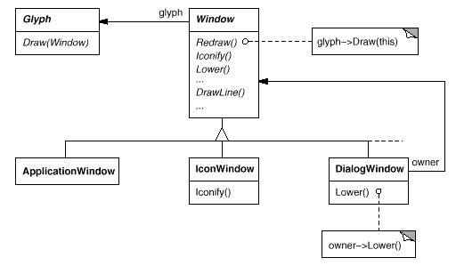

Now that we’ve defined a window interface for Lexi to work with, where does the real platform-specific window come in? If we’re not implementing our own window system, then at some point our window abstraction must be implemented in terms of what the target window system provides. So where does that implementation live?
One approach is to implement multiple versions of the Window class and its subclasses, one version for each windowing platform. We’d have to choose the version to use when we build Lexi for a given platform. But imagine the maintenance headaches we’d have keeping track of multiple classes, all named “Window” but each implemented on a different window system. Alternatively, we could create implementation-specific subclasses of each class in the Window hierarchy—and end up with another subclass explosion problem like the onewe had trying to add embellishments. Both of these alternatives have another drawback: Neither gives us the flexibility to change the window system we use after we’ve compiled the program. So we’ll haveto keep several different executables around as well.
Neither alternative is very appealing, but what else can we do? The same thing we did for formatting and embellishment, namely, encapsulate the concept that varies. What varies in this case is the window system implementation. If we encapsulate a window system’s functionality in an object, then we can implement our Window class and subclasses in terms of that object’s interface. Moreover, if that interface can serve all the window systems we’re interested in, then we won’t have to change Window or any of its subclasses to support different window systems. We can configure window objects to the window system we want simply by passing them the right window system-encapsulating object. We can even configure the window at run-time.
Window and WindowImp
We’ll define a separate WindowImp class hierarchy in which to hide different window system implementations. WindowImp is an abstract class for objects that encapsulate window system-dependent code. To make Lexi work on a particular window system, we configure each window object with an instance of a WindowImp subclass for that system.
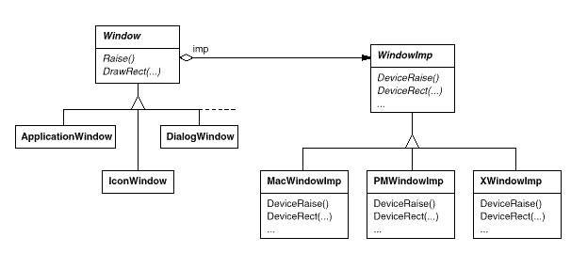

By hiding the implementations in WindowImp classes, we avoid polluting the Window classes with window system dependencies, which keeps the Window class hierarchy comparatively small and stable.
WindowImp Subclasses
Subclasses of WindowImp convert requests into window system-specific operations. We defined the Rectangle::Draw in terms of the DrawRect operation on the Window instance:
void Rectangle::Draw (Window* w)
{
w->DrawRect(_x0, _y0, _x1, _y1);
}
The default implementation of DrawRect uses the abstract operation for drawing rectangles declared by WindowImp:
void Window::DrawRect ( Coord x0, Coord y0, Coord x1, Coord y1 )
{
_imp->DeviceRect(x0, y0, x1, y1);
}
where _imp is a member variable of Window that stores the WindowImp with which the Window is configured. The window implementation is defined by the instance of the WindowImp sub class that _imp points to. For an XwindowImp (that is, a WindowImp subclass for the X Window System), the DeviceRect’s implementation might look like
void XwindowImp::DeviceRect ( Coord x0, Coord y0, Coord x1, Coord y1 )

{
int x = round(min(x0, x1));
int y = round(min(y0, y1));
int w = round(abs(x0 – x1));
int h = round(abs(y0 – y1));
XdrawRectangle(_dpy, _winid, _gc, x, y, w, h);
}
Configuring Windows with WindowImps
A key issue we haven’t addressed is how a window gets configured with the proper WindowImp subclass in the first place. Stated another way, when does _imp get initialized, and who knows what window system (and consequently which WindowImp subclass) is in use?
There are several possibilities, but we’ll focus on one that uses the Abstract Factory pattern. We can define an abstract factory class WindowSystemFactory that provides an interface for creating different kinds of window system-dependent implementation objects:
class WindowSystemFactory
{
public:
virtual WindowImp* CreateWindowImp() = 0;
virtual ColorImp* CreateColorImp() = 0;
virtual FontImp* CreateFontImp() = 0;
// a “Create…” operation for all window system resources
};
Now we can define a concrete factory for each window system:
class PMWindowSystemFactory : public WindowSystemFactory
{
virtual WindowImp* CreateWindowImp()
{
return new PMWindowImp;
}
// …

};
class XwindowSystemFactory : public WindowSystemFactory
{
virtual WindowImp* CreateWindowImp()
{
return new XwindowImp;
}
// …
};
The Window base class constructor can use the WindowSystemFactory interface to initialize the_imp member with the WindowImp that’s right for the window system:
Window::Window ()
{
_imp = windowSystemFactory->CreateWindowImp();
}
Design Pattern
Bridge Pattern
The WindowImp class defines an interface to common window system facilities, but its design is driven by different constraints than Window’s interface. Application programmers won’t deal with WindowImp’s interface directly; they only deal with Window objects. So WindowImp’s interface needn’t match the application programmer’s view of the world, as was our concern in the design of the Window class hierarchy and interface. WindowImp’s interface can more closely reflect what window systems actually provide, warts and all. It can be biased toward either an intersection or a union of functionality approach, whichever suits the target window systems best.
The important thing to realize is that Window’s interface caters to the applications programmer, while WindowImp caters to window systems. Separating windowing functionality into Window and WindowImp hierarchies lets us implement and specialize these interfaces independently. Objects from these hierarchies cooperate to let Lexi work without modification on multiple window systems.
The relationship between Window and WindowImp is an example of the Bridge pattern. The intent behind Bridge is to allow separate class hierarchies to work together even as they evolve independently. Our design criteria led us to create two separate class hierarchies, one that supports the logical notion of windows, and another for capturing different implementations of windows. The Bridge pattern lets us maintain and enhance our logical windowing abstractions without touching window system-dependent code, and vice versa.
7.Write a short note on User Operations
Some of Lexi’s functionality is available through the document’s WYSIWYG representation. You enter and delete text, move the insertion point, and select ranges of text by pointing, clicking, and typing directly in the document. Other functionality is accessed indirectly through user operations in Lexi’s pull-down menus, buttons, and keyboard accelerators. The functionality includes operations for
- creating a new document,
- opening, saving, and printing an existing document,
- cutting selected text out of the document and pasting it back in,
- changing the font and style of selected text,
- changing the formatting of text, such as its alignment and justification,
- quitting the application,
Problems and Constraints
Lexi provides different user interfaces for these operations. But we don’t want to associate a particular user operation with a particular user interface, because we may want multiple user interfaces to the same operation (you can turn the page using either a page button or a menu operation, for example). We may also want to change the interface in the future.
Furthermore, these operations are implemented in many different classes. We as mplementers want to access their functionality without creating a lot of dependencies between implementation and user interface classes. Otherwise we’ll end up with a tightly coupled implementation, which will be harder to understand, extend, and maintain.
To further complicate matters, we want Lexi to support undo andredo⁸ofmost but not all its functionality. Specifically, we want to be able to undo document-modifying operations like delete, with which a user can destroy lots of data inadvertently. But we shouldn’t try to undo an operation like saving a drawing or quitting the application. These operations should have no effect on the undo process. We also don’t want an arbitrary limit on the number of levels of undo and redo.
Solution
Encapsulating a Request
From our perspective as designers, a pull-down menu is just another kind of glyph that contains other glyphs. What distinguishes pull-down menus from other glyphs that have children is that most glyphs in menus do some work in response to an up-click.
We could define a subclass of MenuItem for every user operation and then hard-code each subclass to carry out the request. But that’s not really right; we don’t need a subclass of MenuItem for each request any more than we need a subclass for each text string in a pull-down menu. Moreover, this approach couples the request to a particular user interface, making it hard to fulfill the request through a different user interface.
To illustrate, suppose you could advance to the last page in the document both through a MenuItem in a pull-down menu and by pressing a page icon at the bottom of Lexi’s interface (which might be more convenient for short documents). If we associate the request with a MenuItem through inheritance, then we must do the same for the page icon and any other kind of widget that might issue such a request. That can give rise to a number of classes approaching the product of the number of widget types and the number of requests.
We could parameterize MenuItem with a function to call, but that’s not a complete solution for at least three reasons:
- It doesn’t address the undo/redo problem.
- It’s hard to associate state with a function. For example, a function that changes the font needs to know which font.
- Functions are hard to extend, and it’s hard to reuse parts of them.

These reasons suggest that we should parameterize MenuItems with an object, not a function. Then we can use inheritance to extend and reuse the request’s implementation. We also have a place to store state and implement undo/redo functionality. Here we have another example of encapsulating the concept that varies, in this case a request. We’ll encapsulate each request in a command object.
Command Class and Subclasses
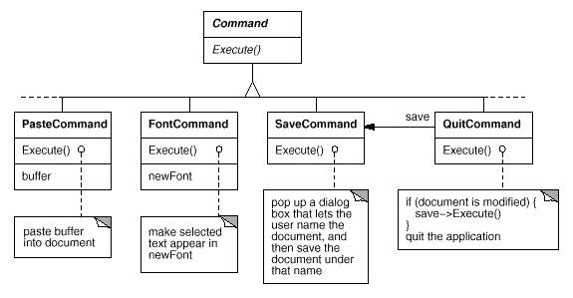
First we define a Command abstract class to provide an interface for issuing a request. The basic interface consists of a single abstract operation called “Execute.” Subclasses of Command implement Execute in different ways to fulfill different requests. Some subclasses may delegate part or all of the work to other objects. Other subclasses may be in a position to fulfil the request entirely on their own. To the requester, however, a Command object is a Command object—they are treated uniformly.

Now MenuItem can store a Command object that encapsulates a request.We give each menu item object an instance of the Command subclass that’s suitable for that menu item, just as we specify the text to appear in the menu item. When a user chooses a particular menu item, the MenuItem simply calls Execute on its Command object to carry out the request.
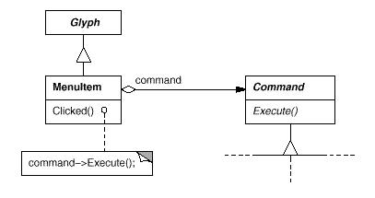

Undoability
Undo/redo is an important capability in interactive applications. To undo and redo commands, we add an Unexecute operation to Command’s interface. Unexecute reverses the effects of a preceding Execute operation using whatever undo information Execute stored. In the case of a Font Command, for example, the Execute operation would store the range of text affected by the font change along with the original font(s). FontCommand’s Unexecute operation would restore the range of text to its original font(s).
Sometimes undoability must be determined at run-time. A request to change the font of a selection does nothing if the text already appears in that font. Suppose the user selects some text and then requests a spurious font change. What should be the result of a subsequent undo request? Should a meaningless change cause the undo request to do something equally meaningless? Probably not. If the user repeats the spurious font change several times, he shouldn’t have to perform exactly the same number of undo operations to get back to the last meaningful operation. If the net effect of executing a command was nothing, then there’s no need for a corresponding undo request.
So to determine if a command is undoable, we add an abstract Reversible operation to the Command interface. Reversible returns a Boolean value. Subclasses can redefine this operation to return true or false based on run-time criteria.
Command History
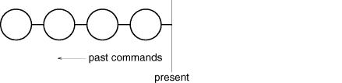
The final step in supporting arbitrary-level undo and redo is to define a command history, or list of commands that have been executed (or unexecuted, if some commands have been undone).Conceptually, the command history looks like this:

Each circle represents a Command object. In this case the user has issued four commands. The leftmost command was issued first, followed by the second-leftmost, and so on until the most recently issued command, which is rightmost. The line marked “present” keeps trackof the most recently executed (and unexecuted) command.
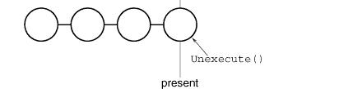
To undo the last command, we simply call Unexecute on the most recent command:

After unexecuting the command, we move the “present” line one command to the left. If the user chooses undo again, the next-most recently issued command will be undone in the same way, and we’re left in the state depicted here:

You can see that by simply repeating this procedure we get multiple levels of undo. The number of levels is limited only by the length of the command history.
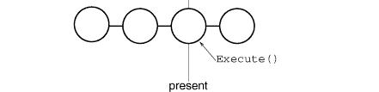
To redo a command that’s just been undone, we do the same thing in reverse. Commands to the right of the present line are commands that may be redone in the future. To redo the last undone command, we call Execute on the command to the right of the present l in

Then we advance the present line so that a subsequent redo will call redo on the following command in the future.
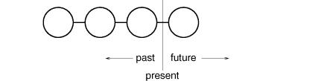

Of course, if the subsequent operation is not another redo but an undo, then the command to the left of the present line will be undone. Thus the user can effectively go back and forth in time as needed to recover from errors.
Design Pattern
Command Pattern
Lexi’s commands are an application of the Command pattern, which describes how to encapsulate a request. The Command pattern prescribes a uniform interface for issuing requests that lets you configure clients to handle different requests. The interface shields clients from the request’s implementation. A command may delegate all, part, or none of the request’s implementation to other objects. This is perfect for applications like Lexi that must provide centralized access to functionality scattered throughout the application. The pattern also discusses undo and redo mechanisms built on the basic Command interface.
8.Write a short note on Spelling Checking and Hyphenation
This design problem involves textual analysis, specifically checking for misspellings and introducing hyphenation points where needed for good formatting.
Problems and Constraints
The constraints here are similar to those we had for the formatting design problem.
- Allow for multiple ways to check spelling and identify places for hyphenation i.e support for multiple algorithms
- Avoid writing this functionality into the document structure i.e we should be able to iterate through a text’s content without access to the text’s actual structure(arrays, list, string)
- Allow expansion of Lexi’s analytical abilities over time. We might add searching, word counting ,a calculation facility for adding up tabular values, grammar checking and so on without changing the class and subclass every time we introduce new functionality of this sort.
- allow for any manner of traversal of document(begin to end, end to begin ,alphabetical order etc)

We will analyse this in two different regards
(1) accessing the information to be analyzed, which we have scattered over the glyphs in the document structure, and
(2) doing the analysis.
Solution
a)Accessing Scattered Information
Accessing the Document Structure

Many kinds of analysis require examining the text character by character. The text we need to analyze is scattered throughout a hierarchical structure of glyph objects. To examine text in such a structure, we need an access mechanism that has knowledge about the data structures in which objects are stored. Some glyphs might store their children in linked lists, others might use arrays, and still others might use more esoteric data structures. Our access mechanism must be able to handle all of these possibilities.
An added complication is that different analyses access information indifferent ways. Most analyses will traverse the text from beginning to end. But some do the opposite—a reverse search, for example, needs to progress through the text backward rather than forward. Evaluating algebraic expressions could require an inorder traversal.
So our access mechanism must accommodate differing data structures, and we must support different kinds of traversals, such as preorder, postorder, and inorder.
Encapsulating Access and Traversal
Problem with integer index of Glyph
Our glyph interface uses an integer index to let clients refer to children. Although that might be reasonable for glyph classes that store their children in an array, it may be inefficient for glyphs that use a linked list.
Solution
An important role of the glyph abstraction is to hide the data structure in which children are stored. That way we can change the data structure a glyph class uses without affecting other classes.
Problem with interface biased towards one data structure
The glyph interface shouldn’t be biased toward one data structure or another. It
shouldn’t be better suited to arrays than to linked lists.
Solution
We can solve this problem and support several different kinds of traversals at the same time. We can put multiple access and traversal capabilities directly in the glyph classes and provide a way to choose among them, perhaps by supplying an enumerated constant as a parameter. The classes pass this parameter around during a traversal to ensure they’re all doing the same kind of traversal. They have to pass around any information they’ve accumulated during traversal.
We might add the following abstract operations to Glyph’s interface to support this approach:
void First(Traversal kind)
void Next()
bool IsDone()
Glyph* GetCurrent()
void Insert(Glyph*)
First initializes the traversal. It takes the kind of traversal as a parameter of type Traversal, an enumerated constant with values such as CHILDREN (to traverse the glyph’s immediate children only),
PREORDER (to traverse the entire structure inpreorder), POSTORDER, and INORDER.Next advances to the next glyph in the traversal.
IsDone reports whether the traversal is over or not.
GetCurrent replaces theChild operation; it accesses the current glyph in thetraversal.
Insert replaces the old operation; it insertsthe given glyph at the current position.
C++ code to do a preorder traversal of a glyph structure rooted at g:
Glyph* g;
for (g->First(PREORDER); !g->IsDone(); g->Next()) {
Glyph* current = g->GetCurrent();
// do some analysis
}
Notice that we’ve banished the integer index from the glyph interface. There’s no longer anything that biases the interface toward one kind of collection or another. We’ve also saved clients from having to implement common kinds of traversals themselves.
Still problem remains
But this approach still has problems. For one thing, it can’t support new traversals without either extending the set of enumerated values or adding new operations. Say we wanted to have a variation on preorder traversal that automatically skips non-textual glyphs. We’d have to change the Traversal enumeration to include something like TEXTUAL_PREORDER.
We’d like to avoid changing existing declarations. Putting the traversal mechanism entirely in the Glyph class hierarchy makes it hard to modify or extend without changing lots of classes. It’s also difficult to reuse the mechanism to traverse other kinds of object structures. And we can’t have more than one traversal in progress on a structure.
Once again, a better solution is to encapsulate the concept that varies, in this case the access and traversal mechanisms. We can introduce a class of objects called iterators whose sole purpose is to define different sets of these mechanisms. We can use inheritance to let us access different data structures uniformly and support new kinds of traversals as well. And we won’t have to change glyph interfaces or disturb existing glyph implementations to do it.
Iterator Class and Subclasses
We’ll use an abstract class called Iterator to define a general interface for access and traversal. Concretesubclasses like ArrayIterator and ListIterator implement the interface to provide access to arrays and lists, while PreorderIterator, PostorderIterator, and the like implement different traversals on specific structures. Each Iterator subclass has are reference to the structure it traverses. Subclass instances are initialized with this reference when they are created. We’ve added a CreateIterator abstract operation to the Glyph class interface to support iterators.
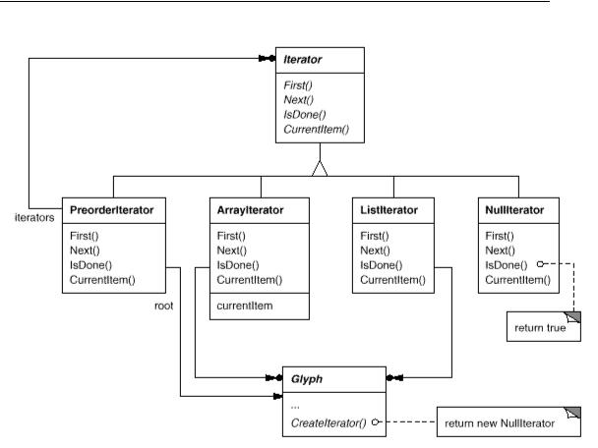

The Iterator interface provides operations First, Next, and IsDone for controlling the traversal. The ListIterator class implements First to point to the first element in the list, and Next advances the iterator to the next item in the list. IsDone returns whether or not the list pointer points beyond the last element in the list. CurrentItem dereferences the iterator to return the glyph it points to. An ArrayIterator class would do similar things but on an array of glyphs.
Now we can access the children of a glyph structure without knowing its representation:
Glyph* g;
Iterator<Glyph*>* i = g->CreateIterator();
for (i->First(); !i->IsDone(); i->Next())
{
Glyph* child = i->CurrentItem();
// do something with current child
}
CreateIterator returns a NullIterator instance by default. AnullIterator is a degenerate iterator for glyphs that have no children, that is, leaf glyphs. NullIterator’s IsDone operation always returns true.
A glyph subclass that has children will override CreateIterator to return an instance of a different Iterator subclass. Which subclass depends on the structure that stores the children. If the Row subclass of Glyph stores its children in a list_children, then its CreateIterator operation would look like this:
Iterator<Glyph*>* Row::CreateIterator () {
return new ListIterator<Glyph*>(_children);
}
Traversal Iterators
Iterators for preorder and inorder traversals implement their traversals in terms of glyph-specific iterators. The iterators for these traversals are supplied the root glyph in the structure they traverse. They call CreateIterator on the glyphs in the structure and use a stack to keep track of the resulting iterators.
For example, class PreorderIterator gets the iterator from the root glyph, initializes it to point to its first element, and then pushes it onto the stack:
void PreorderIterator::First () {
Iterator<Glyph*>* i = _root->CreateIterator();
if (i) {
i->First();
_iterators.RemoveAll();
_iterators.Push(i);
}
}
CurrentItem would simply call CurrentItem on theiterator at the top of the stack:
Glyph* PreorderIterator::CurrentItem () const {
Return _iterators.Size() > 0 ? _iterators.Top()->CurrentItem() : 0;
}
The Next operation gets the top iterator on the stack and asks its current item to create an iterator, in an effort to descend the glyph structure as far as possible (this is a preorder traversal, after all). Next sets the new iterator to the first item in the traversal and pushes it on the stack. Then Next tests the latest iterator; if its IsDone operation returns true, then we’ve finished traversing the current subtree (or leaf) in the traversal. In that case, Next pops the top iterator off the stack and repeats this process until it finds the next incomplete traversal, if there is one; if not, then we have finished traversing the structure.
Void PreorderIterator::Next () {
Iterator<Glyph*>* i = _iterators.Top()->CurrentItem()->CreateIterator();
i->First();
_iterators.Push(i);
while ( _iterators.Size() > 0 && _iterators.Top()->IsDone() ) {
delete _iterators.Pop();
_iterators.Top()->Next();
}
}
Notice how the Iterator class hierarchy lets us add new kinds of traversals without modifying glyph classes—we simply subclass Iterator and add a new traversal as we have with PreorderIterator. Glyph subclasses use the same interface to give clients access to their children without revealing the underlying data structure they use to store them. Because iterators store their own copy of the state of a traversal, we can carry on multiple traversals simultaneously, even on the same structure. And though our traversals have been over glyph structures in this example, there’s no reason we can’t parameterize a class like PreorderIterator by the type of object in the structure. We’d use templates to do that in C++. Then we can reuse the machinery in PreorderIterator to traverse other structures.
Design Pattern
Iterator Pattern
The Iterator pattern captures these techniques for supporting access and traversal over object structures. It’s applicable not only to composite structures but to collections as well. It abstracts the traversal algorithm and shields clients from the internal structure of the objects they traverse. The Iterator pattern illustrates once more how encapsulating the concept that varies helps us gain flexibility and reusability. Even so, the problem of iteration has surprising depth, and the Iterator pattern covers many more nuances and trade-offs than we’ve considered here.
b)Doing the analysis
About the analysis
Now that we have a way of traversing the glyph structure, we need to check the spelling and do the hyphenation. Both analyses involve accumulating information during the traversal.
Placing the analysis
First we have to decide where to put the responsibility for analysis.
- In Iterator class
We could put it in the Iterator classes, thereby making analysis an integral part of traversal. But we get more flexibility and potential for reuse if we distinguish between the traversal and the actions performed during traversal. That’s because different analyses often require the same kind of traversal. Hence we can reuse the same set of iterators for different analyses. For example, preorder traversal is common to many analyses, including spelling checking, hyphenation, forward search, and word count. So analysis and traversal should be separate.
- In Glyph class
We can put the analytical capability into Glyph class themselves. We know there are many kinds of analyses we might want to do. Each analysis will do different things at different points in the traversal. Some glyphs are more significant than others depending on the kind of analysis. If we’re checking spelling or hyphenating, we want to consider character glyphs and not graphical ones like lines and bitmapped images. If we’re making color separations, we’d want to consider visible glyphs and not invisible ones. Inevitably, different analyses will analyze different glyphs.
For each analysis we can add one or more abstract operations to the Glyph class and have subclasses implement them in accordance with the role they play in the analysis.
But the trouble with that approach is that we’ll have to change every glyph class whenever we add a new kind of analysis. We can ease this problem in some cases: If only a few classes participate in the analysis, or if most classes do the analysis the same way, then we can supply a default implementation for the abstract operation in the Glyph class. The default operation would cover the common case. Thus we’d limit changes to just the Glyph class and those subclasses that deviate from the norm.
Yet even if a default implementation reduces the number of changes, an insidious problem remains: Glyph’s interface expands with every new analytical capability. Over time the analytical operations will start to obscure the basic Glyph interface. It becomes hard to see that a glyph’s main purpose is to define and structure objects that have appearance and shape—that interface gets lost in the noise.

Encapsulating the Analysis
From all indications, we need to encapsulate the analysis in a separate object, much like we’ve done many times before. We could put the machinery for a given analysis into its own class. We could use an instance of this class in conjunction with an appropriate iterator.
The iterator would “carry” the instance to each glyph in the structure. The analysis object could then perform a piece of the analysis at each point in the traversal. The analyzer accumulates information of interest (characters in this case) as the traversal proceeds:
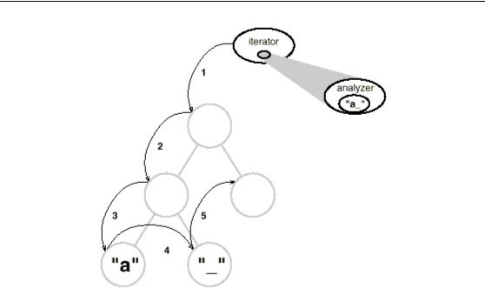

we add the following abstract operation to the Glyph class:
void CheckMe(SpellingChecker&)
We define CheckMe in every Glyph subclass as follows:
void GlyphSubclass::CheckMe (SpellingChecker& checker)
{
checker.CheckGlyphSubclass(this);
}
where GlyphSubclass would be replaced by the name of the glyph subclass. Note that when CheckMe is called, the specific Glyph subclass is known—after all, we’re in one of its operations. In turn, the SpellingChecker class interface includes an operation like CheckGlyph Subclass for every Glyphsubclass:
class SpellingChecker
{

public:
SpellingChecker();
virtual void CheckCharacter(Character*);
virtual void CheckRow(Row*);
virtual void CheckImage(Image*);
- … and so forth List<char*>& GetMisspellings();
protected:
virtual bool IsMisspelled(const char*);
private:
char _currentWord[MAX_WORD_SIZE];
List<char*> _misspellings;
};
SpellingChecker’s checking operation for Character glyphs might look something like this:
void SpellingChecker::CheckCharacter (Character* c)
{
const char ch = c->GetCharCode();
if (isalpha(ch))
{
// append alphabetic character to _currentWord
}
Else
{
- we hit a nonalphabetic character if (IsMisspelled(_currentWord))
- {
- add _currentWord to _misspellings
_misspellings.Append(strdup(_currentWord));
}
_currentWord[0] = ‘\0’;
- reset _currentWord to check next word
}
}
CheckCharacter accumulates alphabetic characters into the _currentWord buffer. When it encounters a non alphabetic character, such as an underscore, it uses the IsMisspelled operation to check the spelling of the word in _currentWord.If the word is misspelled, then CheckCharacter adds the word to the list of misspelled words. Then it must clear out the_currentWord buffer to ready it for the next word. When the traversal is over, you can retrieve the list of misspelled words with the GetMisspellings operation.
Now we can traverse the glyph structure, calling CheckMe on each glyph with the spelling checker as an argument. This effectively identifies each glyph to the SpellingChecker and prompts the checker to do the next increment in the spelling check.
SpellingChecker spellingChecker;
Composition* c;
- …
Glyph* g; PreorderIterator i(c);
for (i.First(); !i.IsDone(); i.Next()) { g = i.CurrentItem(); g->CheckMe(spellingChecker);
}
The following interaction diagram illustrates howCharacter glyphs and the
SpellingChecker objectwork together:

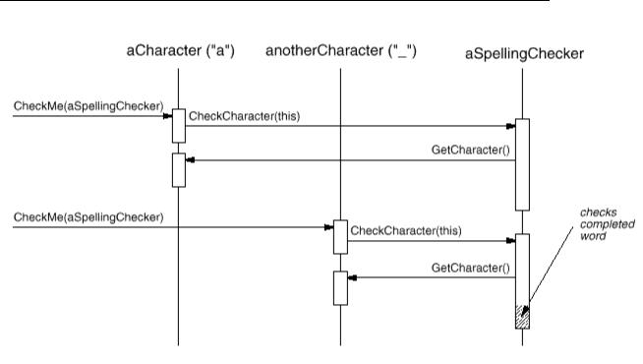

This approach works for finding spelling errors, but how does it help us support multiple kinds of analysis? It looks like we have to add an operation like CheckMe(SpellingChecker&) to Glyph and its subclasses whenever we add a new kind of analysis. That’s true if we insist on an independent class for every analysis. But there’s no reason why we can’t give all analysis classes the same interface. Doing so lets us use them polymorphically. That means we can replace analysis-specific operations like CheckMe(SpellingChecker&) with an analysis-independent operation that takes a more general parameter.
Visitor Class and Subclasses
We’ll use the term visitor to refer generally to classes of objects that “visit” other objects during a traversal and do something appropriate. In this case we can define a Visitor class that defines an abstract interface for visiting glyphs in a structure.
Class Visitor {
public:
virtual void VisitCharacter(Character*) { }
virtual void VisitRow(Row*) { }
virtual void VisitImage(Image*) { }
- .. and so forth
};
Concrete subclasses of Visitor perform different analyses. For example, we could have a SpellingCheckingVisitor subclass for checking spelling, and a HyphenationVisitor subclass for hyphenation. SpellingCheckingVisitor would be implemented exactly as we implemented SpellingChecker above, except the operation names would reflect the more general Visitor interface. For example, CheckCharacter would be called VisitCharacter.
Since CheckMe isn’t appropriate for visitors that don’t check anything, we’ll give it a more general name: Accept. Its argument must also change to take a Visitor&, reflecting the fact that it can accept any visitor.
Now adding a new analysis requires just defining a new subclass of Visitor—we don’t have to touch any of the glyph classes. We support all future analyses by adding this one operation to Glyph and its subclasses.
Checking hyphenation
HyphenationVisitor applies a hyphenation algorithm to determine the potential hyphenation points in the word, if any. Then at each hyphenation point, it inserts a discretionary glyph into the composition. Discretionary glyphs are instances of Discretionary, a subclass of Glyph.

A discretionary glyph has one of two possible appearances depending on whether or not it is the last character on a line. If it’s the last character, then the discretionary looks like a hyphen; if it’s not at the end of a line, then the discretionary has no appearance whatsoever. The discretionary checks its parent (a Row object) to see if it is the last child. The discretionary makes this check whenever it’s called on to draw itself or calculate its boundaries. The formatting strategy treats discretionaries the same as whitespace, making them candidates for ending a line.
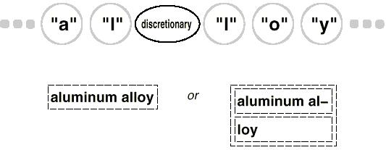

Design Pattern
Visitor Pattern
The Visitor class and its subclasses described earlier are the key participants in the pattern. The Visitor pattern captures the technique we’ve used to allow an open-ended number of analyses of glyph structures without having to change the glyph classes themselves. Another nice feature of visitors is that they can be applied not just to composites like our glyph structures but to any object structure. That includes sets, lists, even directed-acyclic graphs. Furthermore, the classes that a visitor can visit needn’t be related to each other through a common parent class. That means visitors can work across class hierarchies.
The pattern is most suitable when you want to be able to do a variety of different things to objects that have a stable class structure. Adding a new kind of visitor requires no change to that class structure, which is especially important when the class structure is large. But whenever you add a subclass to the structure, you’ll also have to update all your visitor interfaces to include a Visit… operation for that subclass. In our example that means adding a new Glyph subclass called Foo will require changing Visitor and all its subclasses to include a VisitFoo operation. But given our design constraints, we’re much more likely to add a new kind of analysis to Lexi than a new kind of Glyph. So the Visitor pattern is well-suited to our needs.
9.Explain about Abstract Factory
Intent
Provide an interface for creating families of related or dependent objects without specifying their concrete classes.
Also Known As
Kit
Motivation
Consider a user interface toolkit that supports multiple look-and-feel standards, such as Motif and Presentation Manager. Different look-and-feels define different appearances and behaviors for user interface “widgets” like scroll bars, windows, and buttons. To be portable across lookand-feel standards, an application should not hard-code its widgets for a particular look and feel. Instantiating look-and-feel-specific classes of widgets throughout the application makes it hard to change the look and feel later.
We can solve this problem by defining an abstract WidgetFactory class that declares an interface for creating each basic kind of widget. There’s also an abstract class for each kind of widget, and concrete subclasses implement widgets for specific look-and-feel standards.
WidgetFactory’s interface has an operation that returns a new widget object for each abstract widget class. Clients call these operations to obtain widget instances, but clients aren’t aware of the concrete classes they’re using. Thus clients stay independent of the prevailing
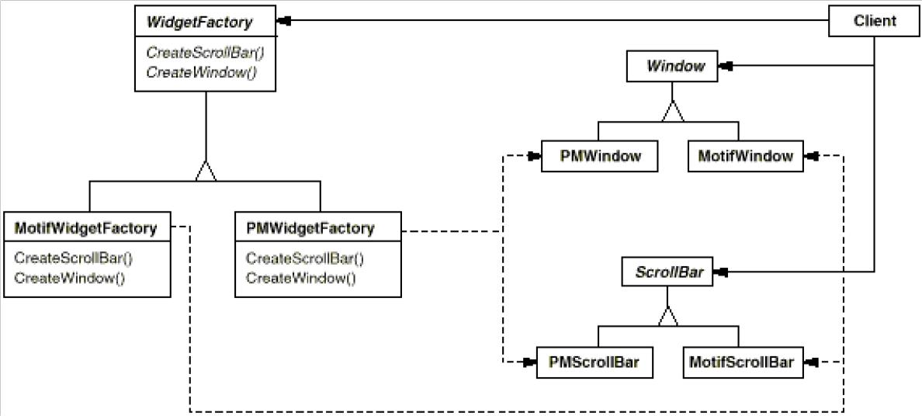

Applicability
Use the Abstract Factory pattern when
- a system should be independent of how its products are created, composed, and represented.
- a system should be configured with one of multiple families of products.
- a family of related product objects is designed to be used together, and you need to enforce this constraint.
- you want to provide a class library of products, and you want to reveal just their interfaces, not their implementations.
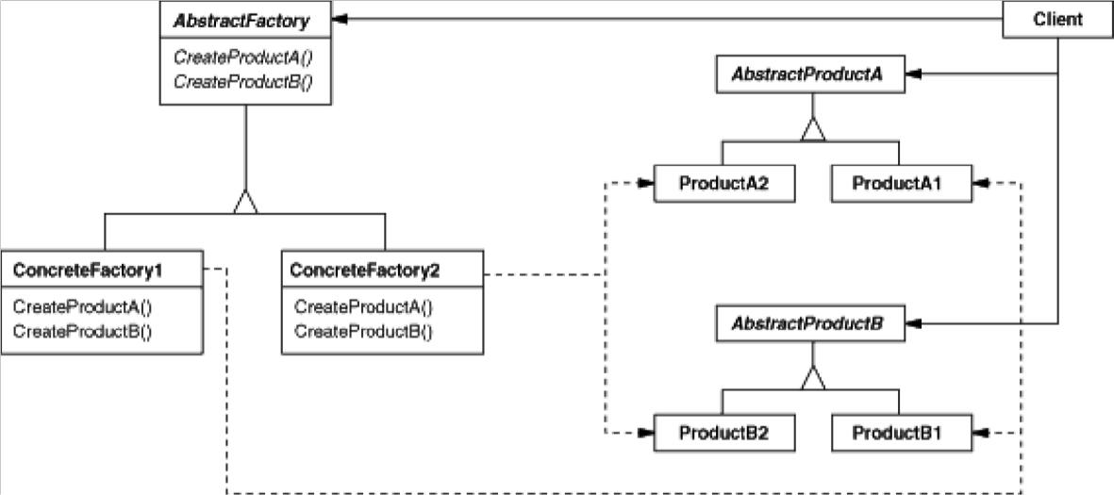
Structure

Participants
· AbstractFactory (WidgetFactory) declares an interface for
operations that create abstract product objects.
· ConcreteFactory (MotifWidgetFactory, PMWidgetFactory)
implements the operations to create concrete product objects.
· AbstractProduct (Window, ScrollBar) declares an interface for a type of
product object. · ConcreteProduct (MotifWindow, MotifScrollBar) defines
a product object to be created by the corresponding concrete factory.
Implements the AbstractProduct interface.
- Client
uses only interfaces declared by AbstractFactory andAbstractProduct classes
Collaborations
· Normally a single instance of a Concrete Factory class is created at run-time.
This concrete factory creates product objects having a particular implementation. To create different product objects, clients should use a different concrete factory. · AbstractFactory defers creation of product objects to its Concrete Factory subclass.
Consequences
The Abstract Factory pattern has the following benefits and liabilities:
- It isolates concrete classes. The Abstract Factory pattern helps you control the classes of objects that an application creates. Because a factory encapsulates the responsibility and the process of creating product objects, it isolates clients from implementation classes. Clients manipulate
- It makes exchanging product families easy. The class of a concrete factory appears only once in an application—that is, where it’s instantiated. This makes it easy to change the concrete factory an application uses. It can use different product configurations simply by changing the concrete factory. Because an abstract factory creates a complete family of products, the whole product family changes at once.
- It promotes consistency among products. When product objects in a family are designed to work together, it’s important that an application use objects from only one family at a time. AbstractFactory makes this easy to enforce.

- Supporting new kinds of products is difficult. Extending abstract factories to produce new kinds of Products isn’t easy. That’s because the
Implementation
Here are some useful techniques for implementing the Abstract Factory pattern.
- Factories as singletons. An application typically needs only one instance of a ConcreteFactory per product family. So it’s usually best implemented as a Singleton .
- Creating the products. AbstractFactory only declares an interface for creating products. It’s up to ConcreteProduct subclasses to actually create them. The most common way to do this is to define a factory method for each product.

Sample Code
Class MazeFactory can create components of mazes. It builds rooms, walls, and doors between rooms. It might be used by a program that reads plans for mazes from a file and builds the corresponding maze. Or it might be used by a program that builds mazes randomly. Programs that build mazes take a MazeFactory as an argument so that the programmer can specify the classes of rooms, walls, and doors to construct.
Class MazeFactory {
public: MazeFactory();
virtual Maze* MakeMaze() const
{ return new Maze; }
virtual Wall* MakeWall() const
{ return new Wall; }
virtual Room* MakeRoom(int n) const
{ return new Room(n); }
virtual Door* MakeDoor(Room* r1, Room* r2) const
{ return new Door(r1, r2); } };
Recall that the member function CreateMaze builds a small maze consisting of two rooms with a door between them. CreateMaze hard-codes the class names, making it difficult to create mazes with different components. Here’s a version of Create Maze that remedies that shortcoming by taking a MazeFactory as a parameter:
Known Uses
InterViews uses the “Kit” suffix [Lin92] to denote AbstractFactory classes. It defines WidgetKit and Dialog Kit abstract factories for generating look-and-feel-specific user interface objects. InterViews also includes a Layout Kit that generates different composition objects depending on the layout desired. For example, a layout that is conceptually horizontal may require different composition objects depending on the document’s orientation (portrait or landscape).
Related Patterns
AbstractFactory classes are often implemented with factory methods Factory Method but they can also be implemented using Prototype A concrete factory is often a singleton
10.Explain about Builder
Intent
Separate the construction of a complex object from its representation so that the same construction process can create different representations.
Motivation
A reader for the RTF (Rich Text Format) document exchange format should be able to convert RTF to many text formats.
The reader might convert RTF documents into plain ASCII text or into a text widget that can be edited interactively. The problem, however, is that the number of possible conversions is openended. So it should be easy to add a new conversion without modifying the reader.
A solution is to configure the RTFReader class with a TextConverter object that converts RTF to another textual representation. As the RTFReader parses the RTF document, it uses the TextConverter to perform the conversion. Whenever the RTFReader recognizes an RTF token (either plain text or an RTF control word), it issues a request to the TextConverter to convert the token.

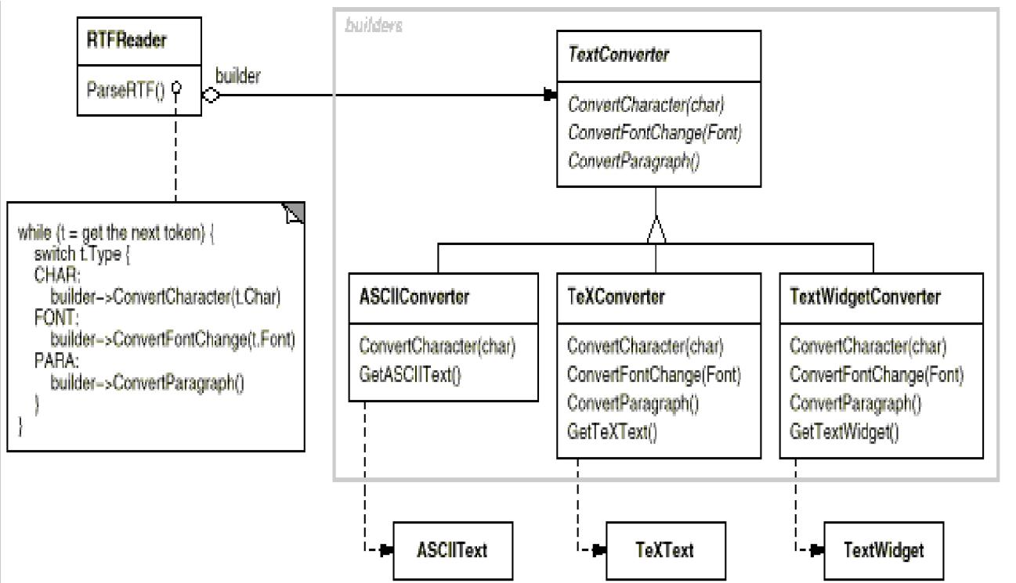
Applicability
Use the Builder pattern when
- the algorithm for creating a complex object should be independent of the parts that make up the object and how they’re assembled.

- the construction process must allow different representations for the object that’s constructed

Structure
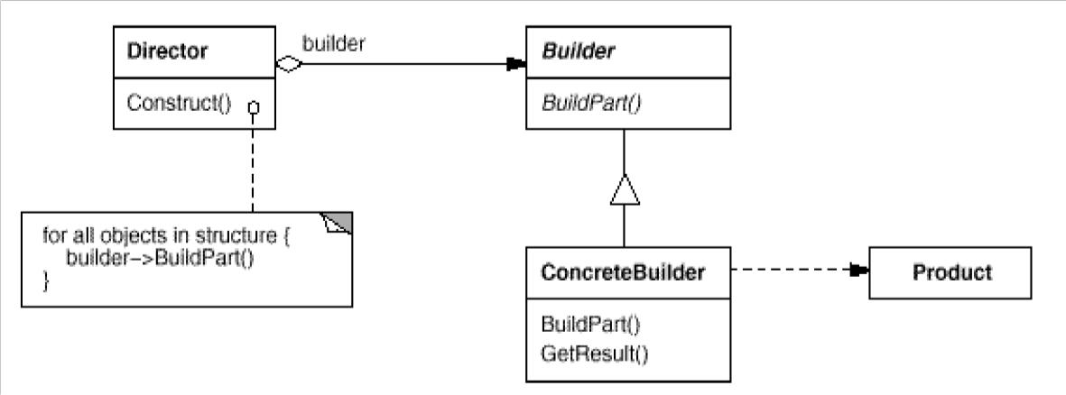

Participants
· Builder (TextConverter) specifies an abstract interface for creating parts of a Product object.
· ConcreteBuilder (ASCIIConverter, TeXConverter, TextWidgetConverter) constructs and assembles parts of the product by implementing the Builder interface.
Defines and keeps track of the representation it creates. Provides an interface for retrieving the product (e.g., GetASCIIText, GetTextWidget).
- Director (RTFReader) constructs an object using the Builder interface.
- Product (ASCIIText, TeXText, TextWidget) Represents the complex object under construction.
ConcreteBuilder builds the product’s internal representation and defines the process by which it’s assembled.
Includes classes that define the constituent parts, including interfaces for assembling the parts into the final result.
Collaborations
- The client creates the Director object and configures it with the desired Builder object.
- Director notifies the builder whenever a part of the product should be built.
- Builder handles requests from the director and adds parts to the product.
- The client retrieves the product from the builder.
The following interaction diagram illustrates how Builder and Director cooperate with a client.
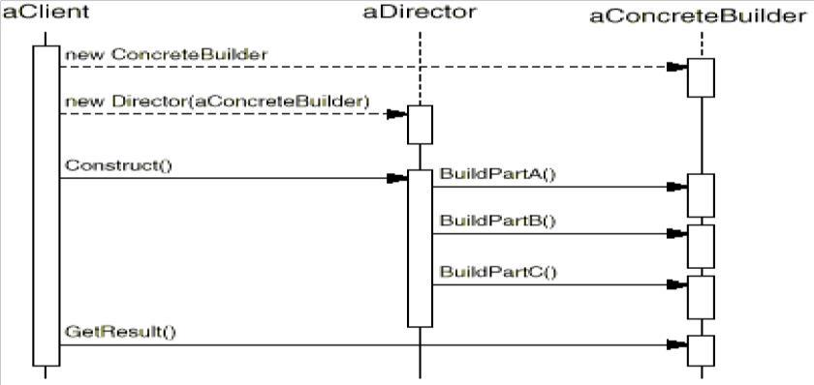

Consequences
Here are key consequences of the Builder pattern:
- It lets you vary a product’s internal representation. The Builder object provides the director with an abstract interface for constructing the product. The interface lets the builder hide the representation and internal structure of the product.
- It isolates code for construction and representation. The Builder pattern improves modularity by encapsulating the way a complex object is constructed and represented. Clients needn’t know anything about the classes that define the product’s internal structure; such classes don’t appear in Builder’s interface.

- It gives you finer control over the construction process. Unlike creational patterns that construct products in one shot, the Builder pattern constructs

Implementation
Typically there’s an abstract Builder class that defines an operation for each component that a director may ask it to create. The operations do nothing by default.
A ConcreteBuilder class overrides operations for components it’s interested in creating.
Here are other implementation issues to consider:
- Assembly and construction interface. Builders construct their products in step-by-step fashion. Therefore the Builder class interface must be general enough to allow the construction of products for all kinds of concrete builders.
- Why no abstract class for products? In the common case, the products produced by the concrete builders differ so greatly in their representation that there is little to gain from giving different products a common parent class.

Sample Code
We’ll define a variant of the CreateMaze member function that takes a builder of class MazeBuilder as an argument.
The MazeBuilder class defines the following interface for building mazes:
class MazeBuilder { public:
virtual void BuildMaze() { } virtual
void BuildRoom(int room) { }
virtual void BuildDoor(int roomFrom, int roomTo) { }
virtual Maze* GetMaze() { return 0; } protected:
MazeBuilder();
};
This interface can create three things: (1) the maze, (2) rooms with a particular room number, and (3) doors between numbered rooms. The Get Maze operation returns the maze to the client. Subclasses of Maze Builder will override this operation to return the maze that they build.
Given the MazeBuilder interface, we can change the CreateMaze member function to take this builder as a parameter.
Maze* MazeGame::CreateMaze (MazeBuilder& builder) { builder.BuildMaze(); builder.BuildRoom(1);
builder.BuildRoom(2);
builder.BuildDoor(1, 2); return
builder.GetMaze();
}
Known Uses
The RTF converter application is from ET++ [WGM88]. Its text building block uses a builder to process text stored in the RTF format.
Builder is a common pattern in Smalltalk-80 [Par90]:
- The Parser class in the compiler subsystem is a Director that takes a ProgramNodeBuilder object as an argument. A Parser object notifies its ProgramNodeBuilder object each time it recognizes a syntactic construct.
When the parser is done, it asks the builder for the parse tree it built and returns it to the client.
Related Patterns
Abstract Factory is similar to Builder in that it too may construct complex objects.
11.Explain about Factory Method
Intent
Define an interface for creating an object, but let subclasses decide which class to instantiate.
Factory Method lets a class defer instantiation to subclasses.
Also Known As
Virtual Constructor
Motivation
Frameworks use abstract classes to define and maintain relationships between objects. A framework is often responsible for creating these objects as well. Consider a framework for applications that can present multiple documents to the user.
Two key abstractions in this framework are the classes Application and Document. Both classes are abstract, and clients have to subclass them to realize their application-specific implementations.
To create a drawing application, for example, we define the classes Drawing Application and DrawingDocument. The Application class is responsible for managing Documents and will create them as required.

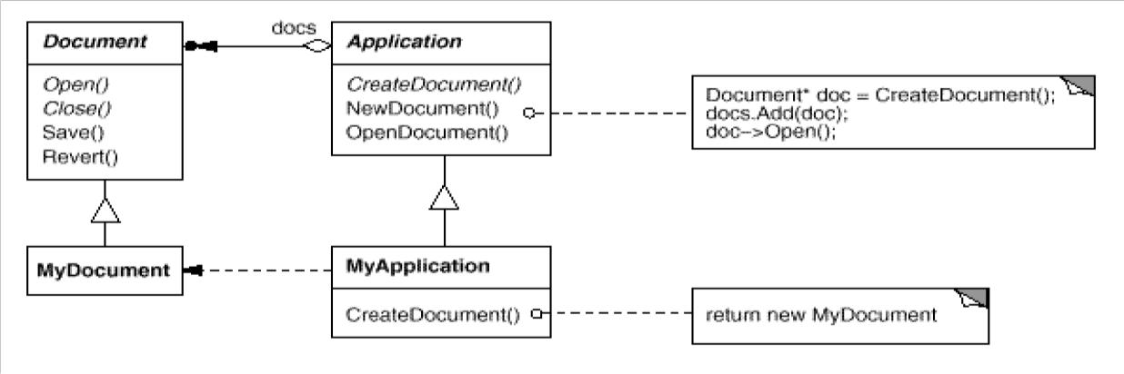

Applicability
Use the Factory Method pattern when
- a class can’t anticipate the class of objects it must create.
- a class wants its subclasses to specify the objects it creates.
- classes delegate responsibility to one of several helper subclasses, and you want to localize the knowledge of which helper subclass is the delegate

Structure
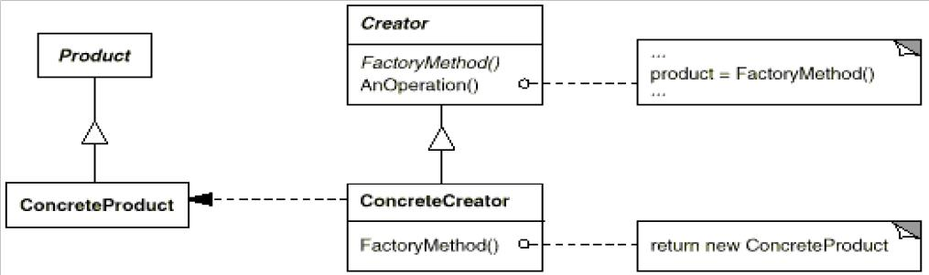

Participants
· Product (Document)
defines the interface of objects the factory method creates.
- ConcreteProduct (MyDocument) implements the Product interface.
· Creator (Application) declares the factory method, which returns an object of type Product. Creator may also define a default implementation of the factory method that returns
a default ConcreteProduct object. May call the factory method to create a Product object.
- ConcreteCreator (MyApplication)
overrides the factory method to return an instance of a ConcreteProduct
Collaborations
- Creator relies on its subclasses to define the factory method so that it returns an instance of the appropriate ConcreteProduct.
Consequences
Factory methods eliminate the need to bind application-specific classes into your code. The code only deals with the Product interface; therefore it can work with any user-defined ConcreteProduct classes.
A potential disadvantage of factory methods is that clients might have to subclass the Creator class just to create a particular ConcreteProduct object. Subclassing is fine when the client has to subclass the Creator class anyway, but otherwise the client now must deal with another point of evolution.
Here are two additional consequences of the Factory Method pattern:
- Provides hooks for subclasses. Creating objects inside a class with a factory method is always more flexible than creating an object directly. Factory Method gives subclasses a hook for providing an extended version of an object.
In the Document example, the Document class could define a factory method called CreateFileDialog that creates a default file dialog object for opening an existing document. A Document subclass can define an application-specific file dialog by overriding this factory method.In this case the factory method is not abstract but provides a reasonable default implementation.
- Connects parallel class hierarchies. In the examples we’ve considered so far, the factory method is only called by Creators. But this doesn’t have to be the case; clients can find factory methods useful, especially in thecase of parallel class hierarchies.
Parallel class hierarchies result when a class delegates some of its responsibilities to a separate class. Consider graphical figures that can be manipulated interactively; that is, they can be stretched, moved, or rotated using the mouse. Figure class hierarchy:
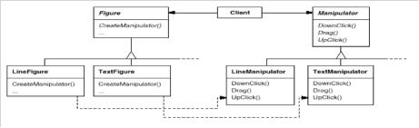
Implementation
Consider the following issues when applying the Factory Method pattern:
- Two major varieties. The two main variations of the Factory Method pattern are (1) the case when the Creator class is an abstract class and does not provide an implementation for the factory method it declares, and (2) the case when the Creator is a concrete class and provides a default implementation for the factory method. It’s also possible to have an abstract class that defines a default implementation, but this is less common.
The first case requires subclasses to define an implementation, because there’s no reasonable default.
. In the second case, the concrete Creator uses the factory method primarily for flexibility. It’s following a rule that says, “Create objects in a separate operation so that subclasses can override the way they’re created.” This rule ensures that designers of subclasses can change the class of objects their parent class instantiates if necessary.
- Parameterized factory methods. Another variation on the pattern lets the factory method create multiple kinds of products. The factory method takes a parameter that identifies the kind of object to create. All objects the factory method creates will share the Product interface. In the Document example, Application might support different kinds of Documents. You pass CreateDocument an extra parameter to specify the kind of document to create.
A parameterized factory method has the following general form, where MyProduct and
YourProduct are subclasses of Product:
class Creator { public:
virtual Product* Create(ProductId);
};
Product* Creator::Create (ProductId id) { if
(id == MINE) return new MyProduct; if (id
- YOURS) return new YourProduct; // repeat for remaining products… return 0;
Overriding a parameterized factory method lets you easily and selectively extend or change the products that a Creator produces. You can introduce new identifiers for new kinds of products, or you can associate existing identifiers with different products.
Sample Code
The function CreateMaze builds and returns a maze. One problem with this function is that it hard-codes the classes of maze, rooms, doors, and walls. We’ll introduce factory methods to let subclasses choose these components.
First we’ll define factory methods in MazeGame for creating the maze, room, wall, and door objects:
class MazeGame { public:
Maze* CreateMaze(); // factory
methods: virtual Maze*
MakeMaze() const
{ return new Maze; }
virtual Room* MakeRoom(int n) const
{ return new Room(n); } virtual Wall* MakeWall() const
{ return new Wall; }
virtual Door* MakeDoor(Room* r1, Room* r2) const
{ return new Door(r1, r2); } };
Each factory method returns a maze component of a given type. MazeGame provides default implementations that return the simplest kinds of maze, rooms, walls, and doors. Now we can rewrite CreateMaze to use these factory methods:
Maze* MazeGame::CreateMaze () { Maze* aMaze = MakeMaze(); Room* r1 = MakeRoom(1); Room* r2 = MakeRoom(2); Door* theDoor = MakeDoor(r1, r2); aMaze->AddRoom(r1); aMaze->AddRoom(r2); r1->SetSide(North, MakeWall()); r1->SetSide(East, theDoor); r1->SetSide(South, MakeWall()); r1->SetSide(West, MakeWall()); r2->SetSide(North, MakeWall()); r2->SetSide(East, MakeWall()); r2->SetSide(South, MakeWall()); r2->SetSide(West, theDoor); return aMaze;
}
Known Uses
Factory methods uses toolkits and frameworks. The preceding document example is a typical use in MacApp and ET++ [WGM88]. The manipulator example is from Unidraw. Class View in the Smalltalk-80 Model/View/Controller framework has a method default Controller that creates a controller, and this might appear to be a factory method But subclasses of View specify the class of their default controller by defining defaultControllerClass,
A more esoteric example in Smalltalk-80 is the factory method parserClass defined by Behavior (a superclass of all objects representing classes). This enables a class to use a customized parser for its source code. For example, a client can define a class SQLParser to analyze the source code of a class with embedded SQL statements.
Related Patterns
Abstract Factory is often implemented with factory methods. The Motivation example in the Abstract Factory pattern illustrates Factory Method as well. Factory methods are usually called within Template Methods ..
12.Explain about Prototype
Intent
Specify the kinds of objects to create using a prototypical instance, and create new objects by copying this prototype.
Motivation
You could build an editor for music scores by customizing a general framework for graphical editors and adding new objects that represent notes, rests, and staves.
The editor framework may have a palette of tools for adding these music objects to the score. The palette would also include tools for selecting, moving, and otherwise manipulating music objects. Users will click on the quarter-note tool and use it to add quarter notes to the score. Or they can use the move tool to move a note up or down on the staff, thereby changing its pitch.
Let’s assume the framework provides an abstract Graphic class for graphical components, like notes and staves.
Moreover, it’ll provide an abstract Tool class for defining tools like those in the palette. The framework also predefines a GraphicTool subclass for tools that create instances of graphical objects and add them to the document.
But GraphicTool presents a problem to the framework designer. The classes for notes and staves are specific to our application, but the GraphicTool class belongs to the framework. GraphicTool doesn’t know how to create instances of our music classes to add to the score.
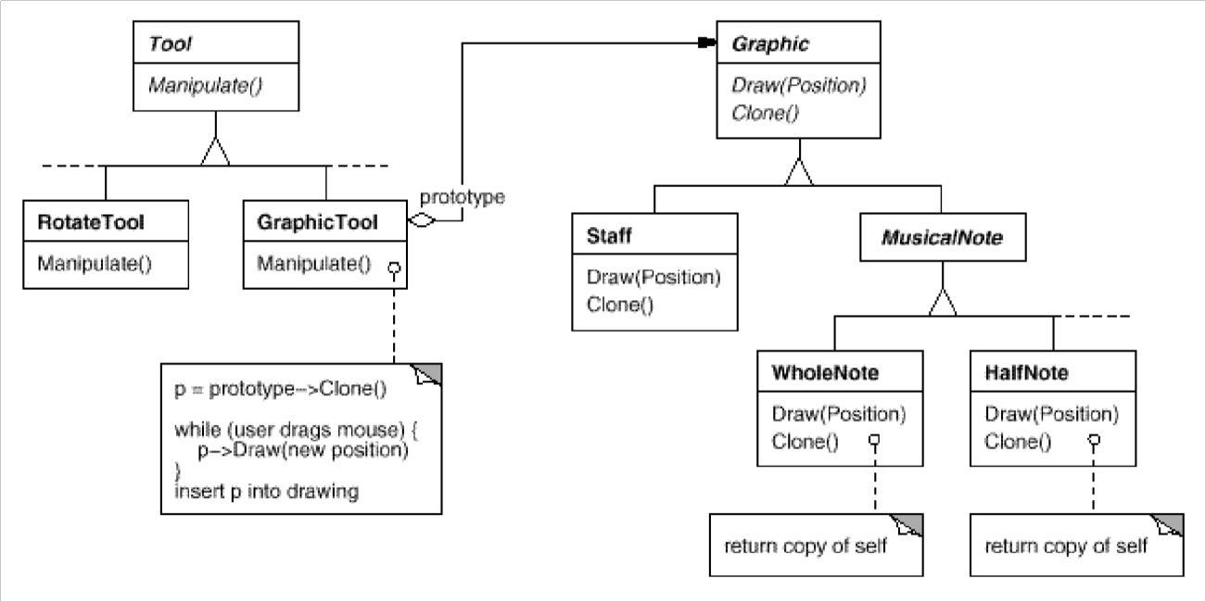
.

The question is, how can the framework use it to parameterize instances of GraphicTool by the class of Graphic they’re supposed to create?
The solution lies in making GraphicTool create a new Graphic by copying or “cloning” an instance of a Graphic subclass. We call this instance a prototype. GraphicTool is parameterized by the prototype it should clone and add to the document. If all Graphic subclasses support a Clone operation, then the GraphicTool can clone any kind of Graphic.
So in our music editor, each tool for creating a music object is an instance of GraphicTool that’s initialized with a different prototype.
Applicability
Use the Prototype pattern when a system should be independent of how its products are created, composed, and represented; and
- when the classes to instantiate are specified at run-time, for example, by dynamic loading; or
- to avoid building a class hierarchy of factories that parallels the class hierarchy of products; or · when instances of a class can have one of only a few different combinations of state. It may be more convenient to install a corresponding number of prototypes and clone them rather than instantiating the class manually, each time with the appropriate state.
Structure
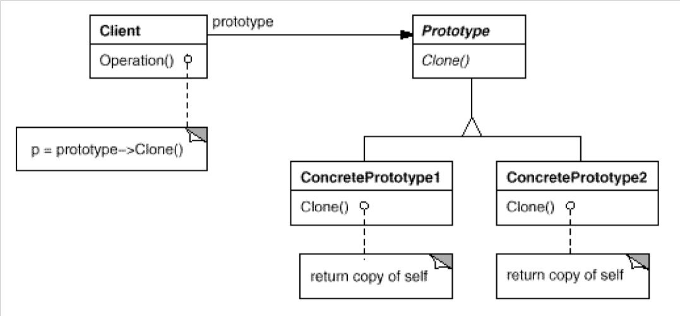

Participants
- Prototype (Graphic) declares an interface for cloning itself.
- ConcretePrototype (Staff, WholeNote, HalfNote) implements an operation for cloning itself.
· Client (GraphicTool) creates a new object by asking a prototype to clone itself.
Collaborations
· A client asks a prototype to clone itself.
Consequences
Additional benefits of the Prototype pattern are listed below.
- Adding and removing products at run-time. Prototypes let you incorporate a new concrete product class into a system simply by registering a prototypical instance with the client. That’s a bit more flexible than other creational patterns, because a client can install and remove prototypes at run-time.
- Specifying new objects by varying values. Highly dynamic systems let you define new behavior through object composition—by specifying values for an object’s variables
.In music editor, one GraphicTool class can create a limitless variety of music objects.
- Specifying new objects by varying structure. Many applications build objects from parts and subparts. Editors for circuit design, for example, build circuits out of subcircuits.1 For convenience, such applications often let you instantiate complex, user-defined structures, say, to use a specific subcircuit again and again.
The Prototype pattern supports this as well. We simply add this subcircuit as a prototype to the palette of available circuit elements. As long as the composite circuit object implements Clone as a deep copy, circuits with different structures can be prototypes.
- Reduced subclassing. Factory Method (121) often produces a hierarchy of Creator classes that parallels the product class hierarchy. The Prototype pattern lets you clone a prototype instead of asking a factory method to make a new object.

Implementation
Prototype is particularly useful with static languages like C++, where classes are not objects, and little or no type information is available at run-time.
It’s less important in languages like Smalltalk or Objective C that provide what amounts to a prototype (i.e., a class object) for creating instances of each class. This pattern is built into prototype-based languages like Self [US87], in which all object creation happens by cloning a prototype.
Consider the following issues when implementing prototypes:
- Using a prototype manager. When the number of prototypes in a system isn’t fixed (that is, they can be created and destroyed dynamically), keep a registry of available prototypes. Clients won’t manage prototypes themselves but will store and retrieve them from the registry. A client will ask the registry for a prototype before cloning it. We call this registry a prototype manager. A prototype manager is an associative store that returns the prototype matching a
given key. It has operations for registering a prototype undera key and for unregistering it. Clients can change or even browse through the registry at run-time. This lets clients extend and take inventory on the system without writing code.
- Implementing the Clone operation. The hardest part of the Prototype pattern is implementing the Clone operation correctly. It’s particularly tricky when object structures contain circular references.
Most languages provide some support for cloning objects. For example, Smalltalk provides an implementation of copy that’s inherited by all subclasses of Object.
C++ provides a copy constructor. But these facilities don’t solve the “shallow copy versus deep copy” problem [GR83].
Sample Code
We’ll define a Maze Prototype Factory subclass of the Maze Factory class.
Maze Prototype Factory will be initialized with prototypes of the objects it will create so that we don’t have to subclass it just to change the classes of walls or rooms it creates.
Maze Prototype Factory augments the Maze Factory interface with a constructor that takes the prototypes as arguments:
class MazePrototypeFactory : public MazeFactory { public: MazePrototypeFactory(Maze*, Wall*, Room*, Door*); virtual Maze* MakeMaze() const; virtual Room* MakeRoom(int) const; virtual Wall* MakeWall() const; virtual Door* MakeDoor(Room*, Room*) const; private:
Maze* _prototypeMaze;
Room* _prototypeRoom;
Wall* _prototypeWall;
Door* _prototypeDoor;
};
The new constructor simply initializes its prototypes: MazePrototypeFactory::MazePrototypeFactory ( Maze* m, Wall* w, Room* r, Door* d ) {
_prototypeMaze = m;
_prototypeWall = w;
_prototypeRoom = r;
_prototypeDoor = d;
}
The member functions for creating walls, rooms, and doors are similar: Each clones a prototype and then initializes it. Here are the definitions of MakeWall and MakeDoor:

Known Uses
The first example of the Prototype pattern was in Ivan Sutherland’s Sketchpad system. An objectoriented language was in ThingLab, where users could form a composite object and then promote it to a prototype by installing it in a library of reusable objects
The “interaction technique library” in Mode Composer stores prototypes of objects that support various interaction techniques . Any interaction technique created by the Mode Composer can be used as a prototype by placing it in this library. The Prototype pattern lets Mode Composer support an unlimited set of interaction techniques.
Related Patterns
Composite and Decorator
13.Explain about Singleton
Intent
Ensure a class only has one instance, and provide a global point of access to it.
Motivation
It’s important for some classes to have exactly one instance. Although there can be many printers in a system, there should be only one printer spooler.
There should be only one file system and one window manager. A digital filter will have one A/D converter. An accounting system will be dedicated to serving one company. How do we ensure that a class has only one instance and that the instance is easily accessible? A global variable makes an object accessible, but it doesn’t keep you from instantiating multiple objects.
A better solution is to make the class itself responsible for keeping track of its sole instance. The class can ensure that no other instance can be created (by intercepting requests to create new objects), and it can provide a way to access the instance. This is the Singleton pattern.
Applicability
Use the Singleton pattern when
· there must be exactly one instance of a class, and it must be accessible to clients from a wellknown access point.
- when the sole instance should be extensible by subclassing, and clients should be able to use an extended instance without modifying their code.
Structure
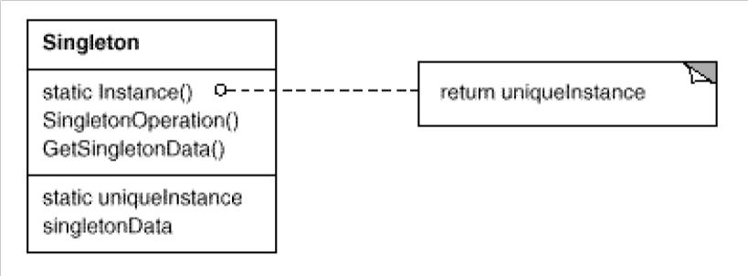

Participants
- Singleton
defines an Instance operation that lets clients access its unique instance. Instance is a class operation (that is, a class method in Smalltalk and a static member function in C++). . may be responsible for creating its own unique instance.
Collaborations
· Clients access a Singleton instance solely through Singleton’s Instance operation.
Consequences
The Singleton pattern has several benefits:
- Controlled access to sole instance. Because the Singleton class encapsulates its sole instance, it can have strict control over how and when clients access it.
- Reduced name space. The Singleton pattern is an improvement over global variables. It avoids polluting the name space with global variables that store sole instances.
- Permits refinement of operations and representation. The Singleton class may be subclassed, and it’s easy to configure an application with an instance of this extended class. You can configure the application with an instance of the class you need at run-time.
- Permits a variable number of instances. The pattern makes it easy to change your mind and allow more than one instance of the Singleton class. Moreover, you can use the same approach to control the number of instances that the application uses.
- More flexible than class operations. Another way to package a singleton’s functionality is to use class operations (that is, static member functions in C++ or class methods in Smalltalk). But both of these language techniques make it hard to change a design to allow more than one instance of a class. Moreover, static member functions in C++ are never virtual, so subclasses can’t override them polymorphically.

Implementation
Here are implementation issues to consider when using the Singleton pattern:
Ensuring a unique instance. The Singleton pattern makes the sole instance a normal instance of a class, but that class is written so that only one instance can ever be created. A common way to do this is to hide the operation that creates the instance behind a class operation (that is, either a static member function or a class method) that guarantees only one instance is created.
Singleton also defines a static member variable _instance that contains a pointer to its unique instance.
The Singleton class is declared as
class Singleton { public:
static Singleton* Instance();
protected: Singleton();
private: static Singleton*
_instance;
};
The corresponding implementation is
Singleton* Singleton::_instance = 0;
Singleton* Singleton::Instance () { if
(_instance == 0) { _instance = new
Singleton;
}
return _instance;
}
Sample Code where the Singleton pattern comes in. By making the MazeFactorya singleton, we make the maze object globally accessible without resorting toglobal variables.
For simplicity, let’s assume we’ll never subclass MazeFactory. (We’ll consider the alternative in a moment.) We make it a Singleton class in C++ by adding a static Instance operation and a static _instance member to hold the one and only instance.
We must also protect the constructor to prevent accidental instantiation, which might lead to more than one instance. Class MazeFactory { public: static MazeFactory* Instance(); // existing interface goes here protected: MazeFactory(); private:
static MazeFactory* _instance;
};

The corresponding implementation is
MazeFactory* MazeFactory::_instance = 0; MazeFactory* MazeFactory::Instance () {
if (_instance == 0) {
_instance = new MazeFactory;
}
return _instance; }
Now let’s consider what happens when there are subclasses of MazeFactory, and the application must decide which one to use. We’ll select the kind of maze through an environment variable and add code that instantiates the proper MazeFactory subclass based on the environment variable’s value. The Instance operation is a good place to put this code, because it already instantiates MazeFactory: MazeFactory* MazeFactory::Instance () {
if (_instance == 0) {
const char* mazeStyle = getenv(“MAZESTYLE”); if (strcmp(mazeStyle, “bombed”) == 0) {
_instance = new BombedMazeFactory;
} else if (strcmp(mazeStyle, “enchanted”) == 0) { _instance = new EnchantedMazeFactory;
// … other possible subclasses } else { // default
_instance = new MazeFactory;
} }
return _instance; }
Known Uses
An example of the Singleton pattern in Smalltalk-80 [Par90] is the set of changes to the code, which is ChangeSet current. A more subtle example is the relationship between classes and their metaclasses. A metaclass is the class of a class, and each metaclass has one instance. Metaclasses do not have names .
The InterViews user interface toolkit [LCI+92] uses the Singleton pattern to access the unique instance of its Session and WidgetKit classes, among others.
Related Patterns
Many patterns can be implemented using the Singleton pattern. See Abstract Factory, Builder , and Prototype .

UNIT-3
STRUCTURAL PATTERNS PART-1

STRUCTURAL PATTERNS PART-11

Short Answer Questions
1.Write the Applicability of Adapter design pattern
Use the Adapter pattern when
- you want to use an existing class, and its interface does not match the one you need.
- you want to create a reusable class that cooperates with unrelated or unforeseen classes, that is, classes that don't necessarily have compatible interfaces.

- (object adapter only) you need to use several existing subclasses, but it's impractical to adapt their interface by sub classing every one. An object adapter can adapt the interface of its parent class.

2.What are the Collaborations of Adapter design pattern
Clients call operations on an Adapter instance. In turn, the adapter calls Adaptee operations that carry out the request.

3.Write the Intent Bridge design pattern
- Decouple an abstraction from its implementation so that the two can vary independently.

4.Draw the Structure of Composite design pattern
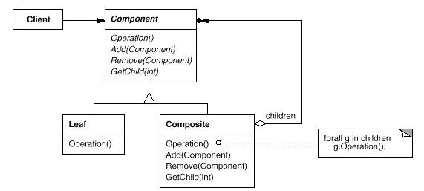

5.What are the Related Patterns of Decorator design patern

- Adapter: A decorator is different from an adapter in that a decorator only changes an object's responsibilities, not its interface; an adapter will give an object a completely new interface.

- Composite: A decorator can be viewed as a degenerate composite with only one component. However, a decorator adds additional responsibilities—it isn't intended for object aggregation.

- Strategy : A decorator lets you change the skin of an object; a strategy lets you change the guts. These are two alternative ways of changing an object.

6.Write the Intent Façade design pattern
- Provide a unified interface to a set of interfaces in a subsystem. Facade defines a higher-level interface that makes the subsystem easier to use.

7.What are Participants in Flyweight design pattern
Flyweight
declares an interface through which flyweights can receive and act on extrinsic state.
ConcreteFlyweight (Character)
implements the Flyweight interface and adds storage for intrinsic state, if any. A ConcreteFlyweight object must be sharable. Any state it stores must be intrinsic; that is, it must be independent of the ConcreteFlyweight object's context.
UnsharedConcreteFlyweight (Row, Column)
not all Flyweight subclasses need to be shared. The Flyweight interface enables sharing; it doesn't enforce it. It's common for UnsharedConcreteFlyweight objects to have ConcreteFlyweight objects as children at some level in the flyweight object structure (as the Row and Column classes have).
FlyweightFactory
creates and manages flyweight objects
ensures that flyweights are shared properly. When a client requests a flyweight, the FlyweightFactory object supplies an existing instance or creates one, if none exists.
Client
maintains a reference to flyweight(s).
computes or stores the extrinsic state of flyweight(s).

8.What are the Known Uses of proxy design pattern
The virtual proxy example in the Motivation section is from the ET++ text building block classes.
NEXTSTEP [Add94] uses proxies (instances of class NXProxy) as local representatives for objects that may be distributed. A server creates proxies for remote objects when clients request them. On receiving a message, the proxy encodes it along with its arguments and then forwards the encoded message to the remote subject. Similarly, the subject encodes any return results and sends them back to the NXProxy object.
McCullough [McC87] discusses using proxies in Smalltalk to access remote objects. Pascoe [Pas86] describes how to provide side-effects on method calls and access control with "Encapsulators."

Essay Answer Questions
1.Write a short note on Structural patterns
In Software Engineering, Structural Design Patterns are Design Patterns that ease the design by identifying a simple way to realize relationships between entities.
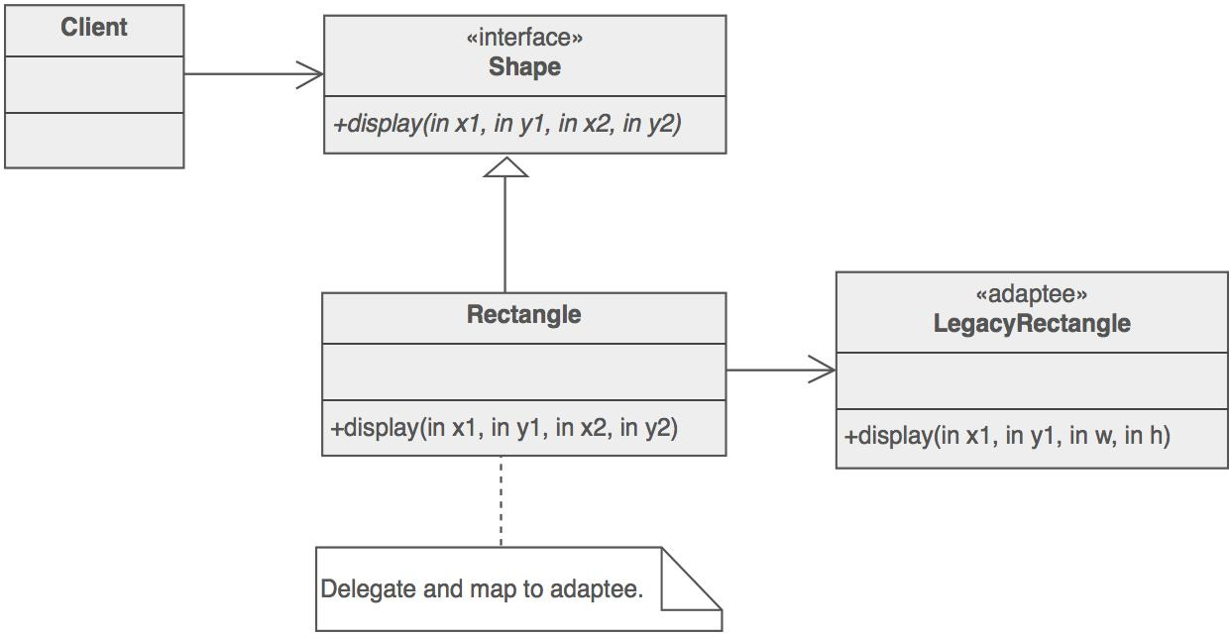

- Adapter
- Bridge
Separates an object’s interface from its implementation
- Composite
A tree structure of simple and composite objects
- Decorator
Add responsibilities to objects dynamically
- Facade
A single class that represents an entire subsystem
- Flyweight
A fine-grained instance used for efficient sharing

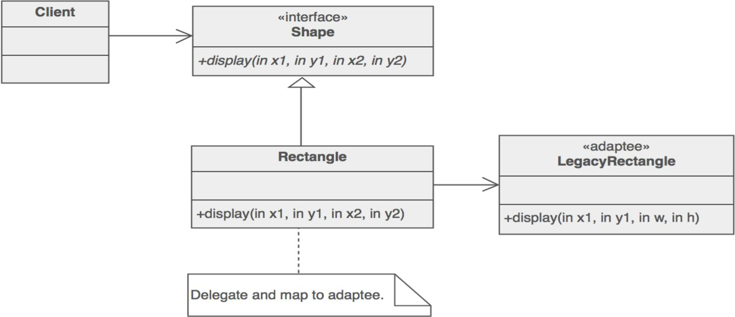

Private Class Data
Restricts accessor/mutator access
Proxy
An object representing another object
Rules of thumb
- Adapter makes things work after they're designed; Bridge makes them work before they are.
- Bridge is designed up-front to let the abstraction and the implementation vary independently. Adapter is retrofitted to make unrelated classes work together.
- Adapter provides a different interface to its subject. Proxy provides the same interface. Decorator provides an enhanced interface.
- Adapter changes an object's interface, Decorator enhances an object's responsibilities. Decorator is thus more transparent to the client. As a consequence, Decorator supports recursive composition, which isn't possible with pure Adapters.
- Composite and Decorator have similar structure diagrams, reflecting the fact that both rely on recursive composition to organize an open-ended number of objects.
- Composite can be traversed with Iterator. Visitor can apply an operation over a Composite. Composite could use Chain of responsibility to let components
access global properties through their parent. It could also use Decorator to override these properties on parts of the composition. It could use Observer to tie one object structure to another and State to let a component change its behavior as its state changes.
- Composite can let you compose a Mediator out of smaller pieces through recursive composition.
- Decorator lets you change the skin of an object. Strategy lets you change the guts.
- Decorator is designed to let you add responsibilities to objects without subclassing. Composite's focus is not on embellishment but on representation. These intents are distinct but complementary. Consequently, Composite and Decorator are often used in concert.
- Decorator and Proxy have different purposes but similar structures. Both describe how to provide a level of indirection to another object, and the implementations keep a reference to the object to which they forward requests.
- Facade defines a new interface, whereas Adapter reuses an old interface. Remember that Adapter makes two existing interfaces work together as opposed to defining an entirely new one.
- Facade objects are often Singleton because only one Facade object is required.
- Mediator is similar to Facade in that it abstracts functionality of existing classes. Mediator abstracts/centralizes arbitrary communication between colleague objects, it routinely "adds value", and it is known/referenced by the colleague objects. In contrast, Facade defines a simpler interface to a subsystem, it doesn't add new functionality, and it is not known by the subsystem classes.
- Abstract Factory can be used as an alternative to Facade to hide platform-specific classes.
- Whereas Flyweight shows how to make lots of little objects, Facade shows how to make a single object represent an entire subsystem.
- Flyweight is often combined with Composite to implement shared leaf nodes.
- Flyweight explains when and how State objects can be shared.

2.Write about Adapter Design Patterns
Intent
- Convert the interface of a class into another interface clients expect. Adapter lets classes work together that couldn't otherwise because of incompatible interfaces.
- Wrap an existing class with a new interface.
- Impedance match an old component to a new system
Problem
An "off the shelf" component offers compelling functionality that you would like to reuse, but its "view of the world" is not compatible with the philosophy and architecture of the system currently being developed.
Discussion
Reuse has always been painful and elusive. One reason has been the tribulation of designing something new, while reusing something old. There is always something not quite right between the old and the new. It may be physical dimensions or misalignment. It may be timing or synchronization. It may be unfortunate assumptions or competing standards.
It is like the problem of inserting a new three-prong electrical plug in an old two-prong wall outlet – some kind of adapter or intermediary is necessary.
Adapter is about creating an intermediary abstraction that translates, or maps, the old component to the new system. Clients call methods on the Adapter object which redirects them into calls to the legacy component. This strategy can be implemented either with inheritance or with aggregation.
Adapter functions as a wrapper or modifier of an existing class. It provides a different or translated view of that class.
Structure
Below, a legacy Rectangle component's display() method expects to receive "x, y, w, h" parameters. But the client wants to pass "upper left x and y" and "lower right x and y". This incongruity can be reconciled by adding an additional level of indirection – i.e. an Adapter object.
The Adapter could also be thought of as a "wrapper".
Example
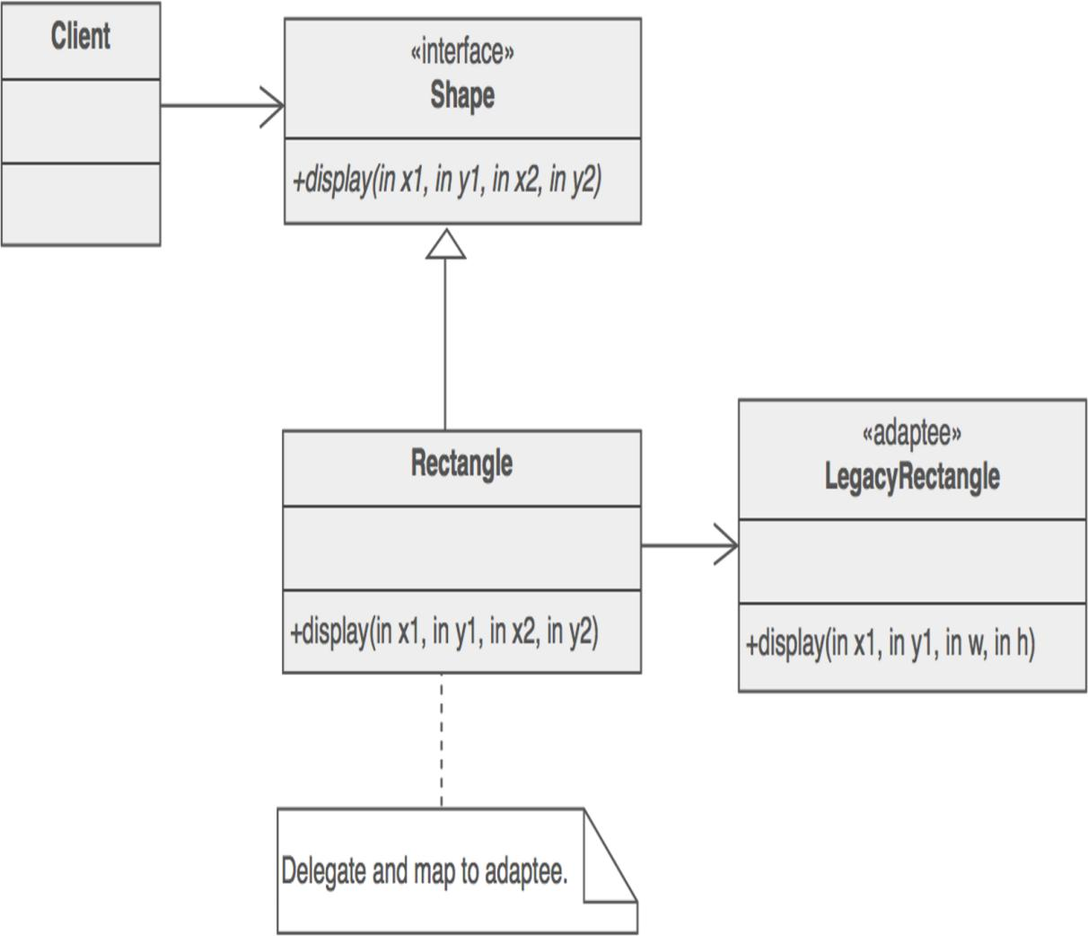

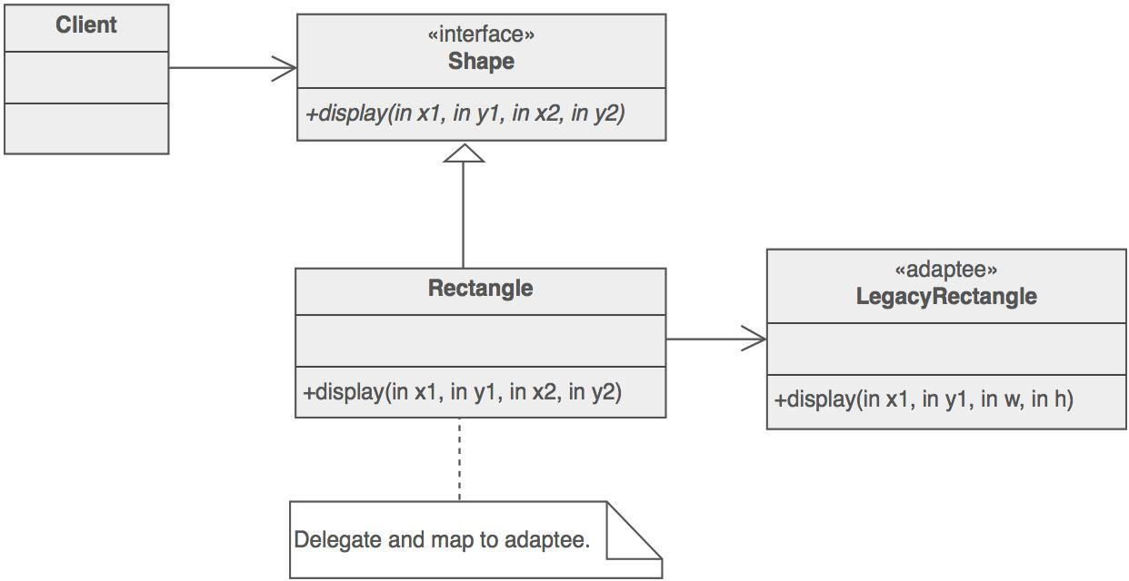
The Adapter pattern allows otherwise incompatible classes to work together by converting the interface of one class into an interface expected by the clients. Socket wrenches provide an example of the Adapter. A socket attaches to a ratchet, provided that the size of the drive is the same. Typical drive sizes in the United States are 1/2" and 1/4". Obviously, a 1/2" drive ratchet will not fit into a 1/4" drive socket unless an adapter is used. A 1/2" to 1/4" adapter has a 1/2" female connection to fit on the 1/2" drive ratchet, and a 1/4" male connection to fit in the 1/4" drive socket.

Check list
- Identify the players: the component(s) that want to be accommodated (i.e. the client), and the component that needs to adapt (i.e. the adaptee).
- Identify the interface that the client requires.
- Design a "wrapper" class that can "impedance match" the adaptee to the client.
- The adapter/wrapper class "has a" instance of the adaptee class.
- The adapter/wrapper class "maps" the client interface to the adaptee interface. 6. The client uses (is coupled to) the new interface
Rules of thumb
- Adapter makes things work after they're designed; Bridge makes them work before they are.
- Bridge is designed up-front to let the abstraction and the implementation vary independently. Adapter is retrofitted to make unrelated classes work together.
- Adapter provides a different interface to its subject. Proxy provides the same interface. Decorator provides an enhanced interface.
- Adapter is meant to change the interface of an existing object. Decorator enhances another object without changing its interface. Decorator is thus more transparent to the application than an adapter is. As a consequence, Decorator supports recursive composition, which isn't possible with pure Adapters.
- Facade defines a new interface, whereas Adapter reuses an old interface. Remember that Adapter makes two existing interfaces work together as opposed to defining an entirely new one.

3.Explain Bridge Design Pattern
Intent
- Decouple an abstraction from its implementation so that the two can vary independently.
- Publish interface in an inheritance hierarchy, and bury implementation in its own inheritance hierarchy.
- Beyond encapsulation, to insulation
Problem
"Hardening of the software arteries" has occurred by using subclassing of an abstract base class to provide alternative implementations. This locks in compile-time binding between interface and implementation. The abstraction and implementation cannot be independently extended or composed.
Motivation
Consider the domain of "thread scheduling".
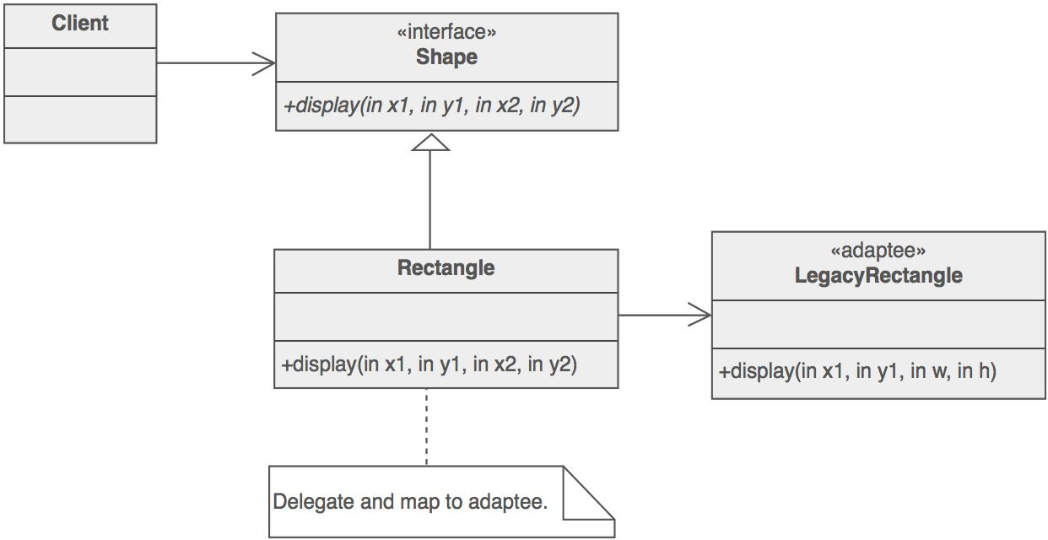

There are two types of thread schedulers, and two types of operating systems or "platforms". Given this approach to specialization, we have to define a class for each permutation of these two dimensions. If we add a new platform (say ... Java's Virtual Machine), what would our hierarchy look like?

What if we had three kinds of thread schedulers, and four kinds of platforms? What if we had five kinds of thread schedulers, and ten kinds of platforms? The number of classes we would have to define is the product of the number of scheduling schemes and the number of platforms.
The Bridge design pattern proposes refactoring this exponentially explosive inheritance hierarchy into two orthogonal hierarchies – one for platform-independent abstractions, and the other for platform-dependent implementations.

Discussion
Decompose the component's interface and implementation into orthogonal class hierarchies. The interface class contains a pointer to the abstract implementation class. This pointer is initialized with an instance of a concrete implementation class, but all subsequent interaction from the interface class to the implementation class is limited to the abstraction maintained in the implementation base class. The client interacts with the interface class, and it in turn "delegates" all requests to the implementation class.
The interface object is the "handle" known and used by the client; while the implementation object, or "body", is safely encapsulated to ensure that it may continue to evolve, or be entirely replaced (or shared at run-time. Use the Bridge pattern when:
- you want run-time binding of the implementation,
- you have a proliferation of classes resulting from a coupled interface and numerous implementations,
- you want to share an implementation among multiple objects,
- you need to map orthogonal class hierarchies.
Consequences include:
- decoupling the object's interface,
- improved extensibility (you can extend (i.e. subclass) the abstraction and implementation hierarchies independently),
- hiding details from clients.
Bridge is a synonym for the "handle/body" idiom. This is a design mechanism that encapsulates an implementation class inside of an interface class. The former is the body, and the latter is the handle. The handle is viewed by the user as the actual class, but the work is done in the body. "The handle/body class idiom may be used to decompose a complex abstraction into smaller, more manageable classes. The idiom may reflect the sharing of a single resource by multiple classes that control access to it (e.g. reference counting)."
Structure
The Client doesn’t want to deal with platform-dependent details. The Bridge pattern encapsulates this complexity behind an abstraction "wrapper".
Bridge emphasizes identifying and decoupling "interface" abstraction from "implementation" abstraction.

Example
The Bridge pattern decouples an abstraction from its implementation, so that the two can vary independently. A household switch controlling lights, ceiling fans, etc. is an example of the Bridge. The purpose of the switch is to turn a device on or off. The actual switch can be implemented as a pull chain, simple two position switch, or a variety of dimmer switches.
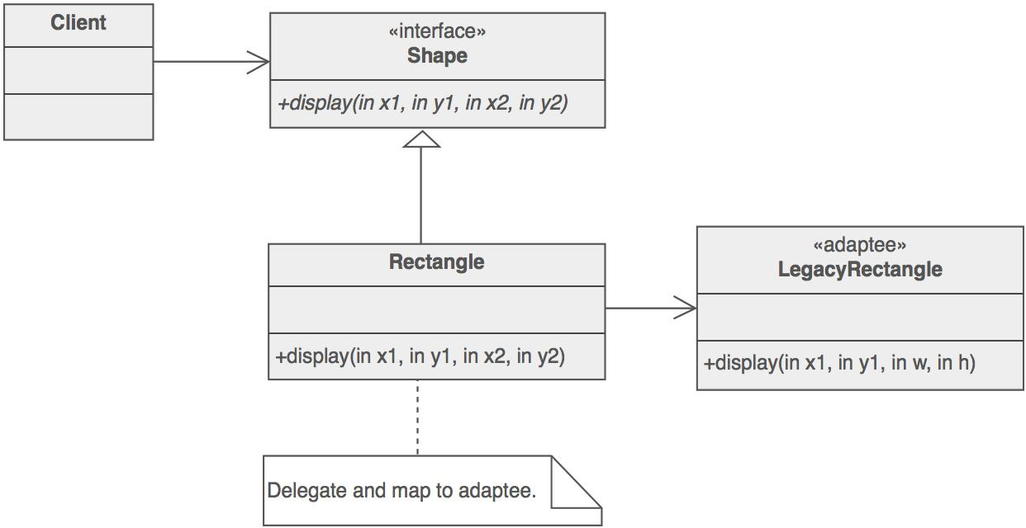

Check list
- Decide if two orthogonal dimensions exist in the domain. These independent concepts could be: abstraction/platform, or domain/infrastructure, or front-end/back-end, or interface/implementation.
- Design the separation of concerns: what does the client want, and what do the platforms provide.
- Design a platform-oriented interface that is minimal, necessary, and sufficient. Its goal is to decouple the abstraction from the platform.
- Define a derived class of that interface for each platform.
- Create the abstraction base class that "has a" platform object and delegates the platform-oriented functionality to it.
- Define specializations of the abstraction class if desired.
Rules of thumb
- Adapter makes things work after they're designed; Bridge makes them work before they are.
- Bridge is designed up-front to let the abstraction and the implementation vary independently. Adapter is retrofitted to make unrelated classes work together.
- State, Strategy, Bridge (and to some degree Adapter) have similar solution structures. They all share elements of the "handle/body" idiom. They differ in intent - that is, they solve different problems.
- The structure of State and Bridge are identical (except that Bridge admits hierarchies of envelope classes, whereas State allows only one). The two patterns use the same structure to solve different problems: State allows an object's behavior to change along with its state, while Bridge's intent is to decouple an abstraction from its implementation so that the two can vary independently.
- If interface classes delegate the creation of their implementation classes (instead of creating/coupling themselves directly), then the design usually uses the Abstract Factory pattern to create the implementation objects.

4.Write about Composite Design Pattern
Intent
- Compose objects into tree structures to represent whole-part hierarchies. Composite lets clients treat individual objects and compositions of objects uniformly.
- Recursive composition
- "Directories contain entries, each of which could be a directory."
- 1-to-many "has a" up the "is a" hierarchy
Problem
Application needs to manipulate a hierarchical collection of "primitive" and "composite" objects. Processing of a primitive object is handled one way, and processing of a composite object is handled differently. Having to query the "type" of each object before attempting to process it is not desirable.
Discussion
Define an abstract base class (Component) that specifies the behavior that needs to be exercised uniformly across all primitive and composite objects. Subclass the Primitive and Composite classes off of the Component class. Each Composite object "couples" itself only to the abstract type Component as it manages its "children".
Use this pattern whenever you have "composites that contain components, each of which could be a composite".
Child management methods [e.g. addChild(), removeChild()] should normally be defined in the Composite class. Unfortunately, the desire to treat Primitives and Composites uniformly requires that these methods be moved to the abstract Component class. See the "Opinions" section below for a discussion of "safety" versus "transparency" issues.
Structure
Composites that contain Components, each of which could be a Composite.

Menus that contain menu items, each of which could be a menu.
Row-column GUI layout managers that contain widgets, each of which could be a rowcolumn GUI layout manager.
Directories that contain files, each of which could be a directory.
Containers that contain Elements, each of which could be a Container.
Example
The Composite composes objects into tree structures and lets clients treat individual objects and compositions uniformly. Although the example is abstract, arithmetic expressions are Composites. An arithmetic expression consists of an operand, ann operator (+ - * /), and another operand. The operand can be a number, or another arithmetic expresssion. Thus, 2 + 3 and (2 + 3) + (4 * 6) are both valid expressions.
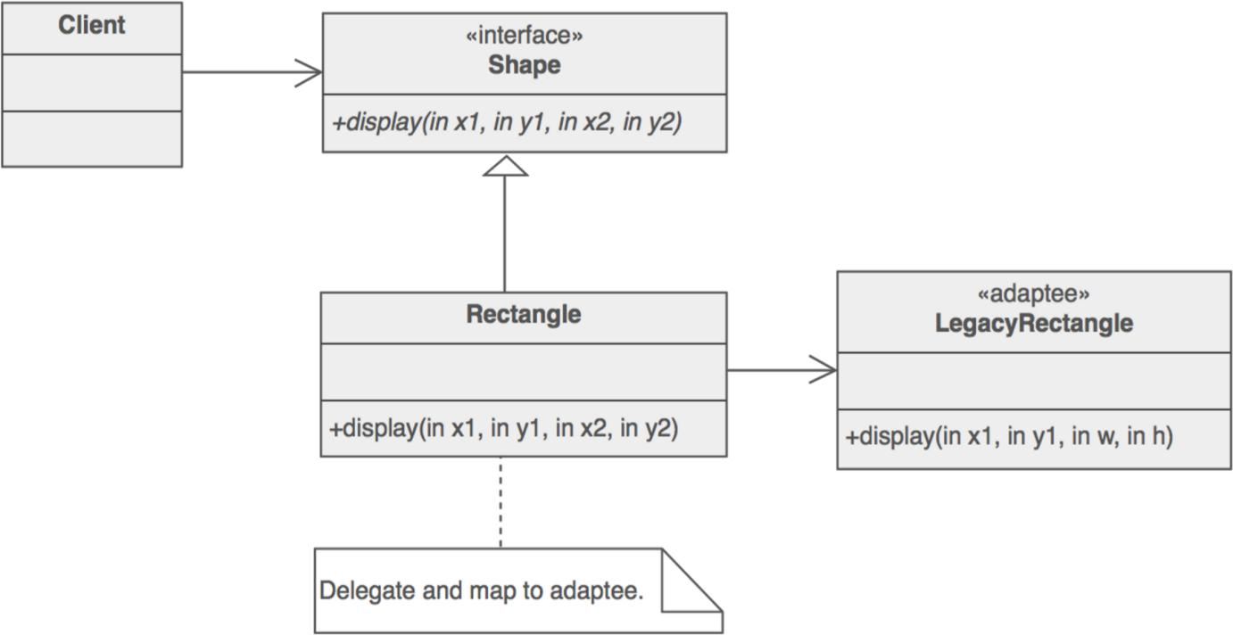

Check list
- Ensure that your problem is about representing "whole-part" hierarchical relationships.
- Consider the heuristic, "Containers that contain containees, each of which could be a container." For example, "Assemblies that contain components, each of which could be an assembly." Divide your domain concepts into container classes, and containee classes.
- Create a "lowest common denominator" interface that makes your containers and containees interchangeable. It should specify the behavior that needs to be exercised uniformly across all containee and container objects.
- All container and containee classes declare an "is a" relationship to the interface.
- All container classes declare a one-to-many "has a" relationship to the interface.
- Container classes leverage polymorphism to delegate to their containee objects.
- Child management methods [e.g. addChild(), removeChild()] should normally be defined in the Composite class. Unfortunately, the desire to treat Leaf and Composite objects uniformly may require that these methods be promoted to the abstract Component class. See the Gang of Four for a discussion of these "safety" versus "transparency" trade-offs.
Rules of thumb
- Composite and Decorator have similar structure diagrams, reflecting the fact
that both rely on recursive composition to organize an open-ended number of objects.
- Composite can be traversed with Iterator. Visitor can apply an operation over a Composite. Composite could use Chain of Responsibility to let components access global properties through their parent. It could also use Decorator to override these properties on parts of the composition. It could use Observer to tie one object structure to another and State to let a component change its behavior as its state changes.  Composite can let you compose a Mediator out of smaller pieces through recursive composition.
- Decorator is designed to let you add responsibilities to objects without subclassing. Composite's focus is not on embellishment but on representation. These intents are distinct but complementary. Consequently, Composite and Decorator are often used in concert.
- Flyweight is often combined with Composite to implement shared leaf nodes.
Opinions
The whole point of the Composite pattern is that the Composite can be treated atomically, just like a leaf. If you want to provide an Iterator protocol, fine, but I think that is outside the pattern itself. At the heart of this pattern is the ability for a client to perform operations on an object without needing to know that there are many objects inside.
Being able to treat a heterogeneous collection of objects atomically (or transparently) requires that the "child management" interface be defined at the root of the Composite class hierarchy (the abstract Component class). However, this choice costs you safety, because clients may try to do meaningless things like add and remove objects from leaf objects. On the other hand, if you "design for safety", the child management interface is declared in the Composite class, and you lose transparency because leaves and Composites now have different interfaces.

Smalltalk implementations of the Composite pattern usually do not have the interface for managing the components in the Component interface, but in the Composite interface. C++ implementations tend to put it in the Component interface. This is an extremely interesting fact, and one that I often ponder. I can offer theories to explain it, but nobody knows for sure why it is true.
My Component classes do not know that Composites exist. They provide no help for navigating Composites, nor any help for altering the contents of a Composite. This is because I would like the base class (and all its derivatives) to be reusable in contexts that do not require Composites. When given a base class pointer, if I absolutely need to know whether or not it is a Composite, I will use dynamic_cast to figure this out. In those cases where dynamic_cast is too expensive, I will use a Visitor.
Common complaint: "if I push the Composite interface down into the Composite class, how am I going to enumerate (i.e. traverse) a complex structure?" My answer is that when I have behaviors which apply to hierarchies like the one presented in the
Composite pattern, I typically use Visitor, so enumeration isn't a problem - the Visitor knows in each case, exactly what kind of object it's dealing with. The Visitor doesn't need every object to provide an enumeration interface.
Composite doesn't force you to treat all Components as Composites. It merely tells you to put all operations that you want to treat "uniformly" in the Component class. If add, remove, and similar operations cannot, or must not, be treated uniformly, then do not put them in the Component base class. Remember, by the way, that each pattern's structure diagram doesn't define the pattern; it merely depicts what in our experience is a common realization thereof.
5.Explain Decorator Design Pattern
Intent
- Attach additional responsibilities to an object dynamically. Decorators provide a flexible alternative to subclassing for extending functionality.
- Client-specified embellishment of a core object by recursively wrapping it.
- Wrapping a gift, putting it in a box, and wrapping the box.
Problem
You want to add behavior or state to individual objects at run-time. Inheritance is not feasible because it is static and applies to an entire class.
Discussion
Suppose you are working on a user interface toolkit and you wish to support adding borders and scroll bars to windows. You could define an inheritance hierarchy like ...

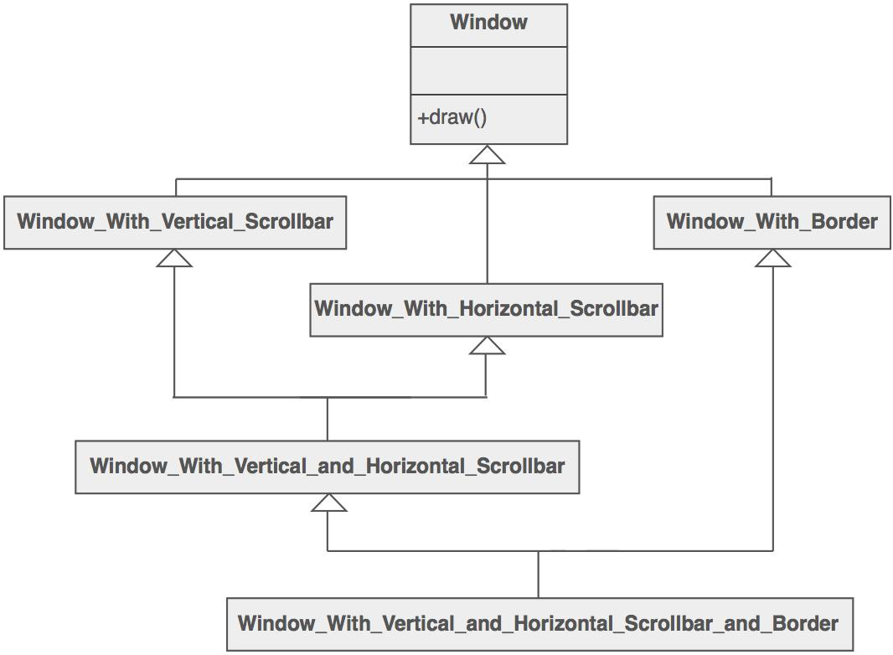

But the Decorator pattern suggests giving the client the ability to specify whatever combination of "features" is desired.
Widget* aWidget = new
BorderDecorator( new
HorizontalScrollBarDecorator(
new
VerticalScrollBarDecorator(
new Window( 80, 24 ))));
aWidget->draw();
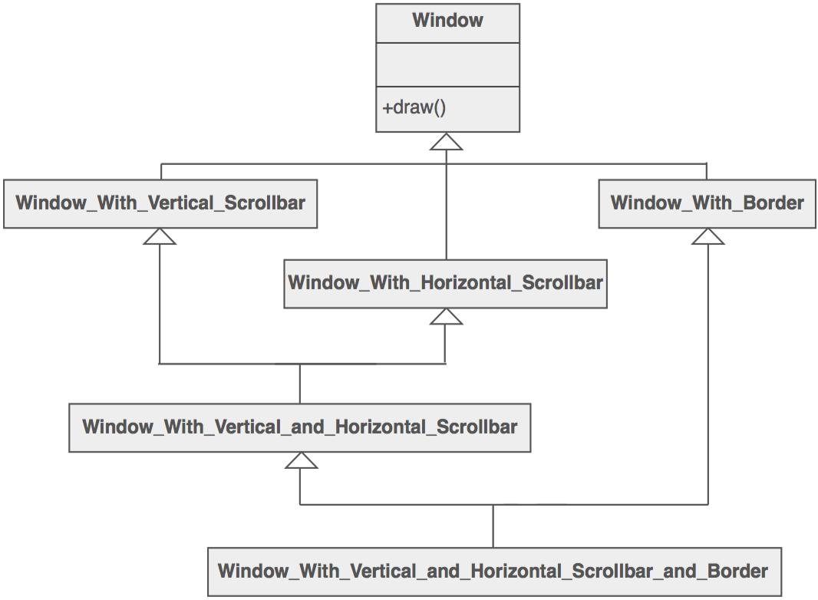
This flexibility can be achieved with the following design

Another example of cascading (or chaining) features together to produce a custom object might look like ...
Stream* aStream = new CompressingStream( new

ASCII7Stream(
new FileStream("fileName.dat"))); aStream->putString( "Hello world" );
The solution to this class of problems involves encapsulating the original object inside an abstract wrapper interface. Both the decorator objects and the core object inherit from this abstract interface. The interface uses recursive composition to allow an unlimited number of decorator "layers" to be added to each core object.
Note that this pattern allows responsibilities to be added to an object, not methods to an object's interface. The interface presented to the client must remain constant as successive layers are specified.
Also note that the core object's identity has now been "hidden" inside of a decorator object.
Trying to access the core object directly is now a problem.
Structure
The client is always interested in CoreFunctionality.doThis(). The client may, or may not, be interested in OptionalOne.doThis() and OptionalTwo.doThis(). Each of these classes always delegate to the Decorator base class, and that class always delegates to the contained "wrappee" object.

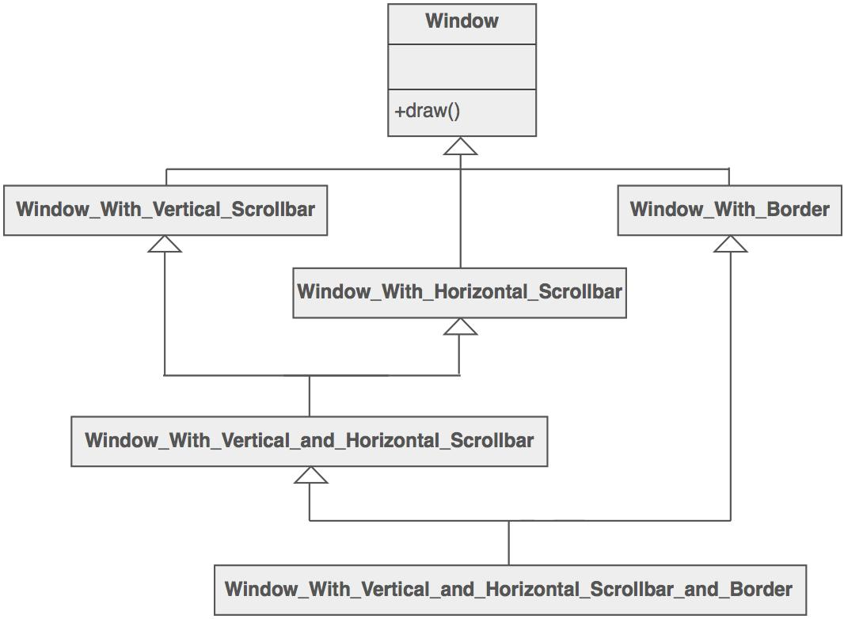

Example
The Decorator attaches additional responsibilities to an object dynamically. The ornaments that are added to pine or fir trees are examples of Decorators. Lights, garland, candy canes, glass ornaments, etc., can be added to a tree to give it a festive look. The ornaments do not change the tree itself which is recognizable as a Christmas tree regardless of particular ornaments used. As an example of additional functionality, the addition of lights allows one to "light up" a Christmas tree.
Another example: assault gun is a deadly weapon on it's own. But you can apply certain "decorations" to make it more accurate, silent and devastating.

Check list
- Ensure the context is: a single core (or non-optional) component, several optional embellishments or wrappers, and an interface that is common to all.
- Create a "Lowest Common Denominator" interface that makes all classes interchangeable.
- Create a second level base class (Decorator) to support the optional wrapper classes.
- The Core class and Decorator class inherit from the LCD interface.
- The Decorator class declares a composition relationship to the LCD interface, and this data member is initialized in its constructor.
- The Decorator class delegates to the LCD object.
- Define a Decorator derived class for each optional embellishment.
- Decorator derived classes implement their wrapper functionality - and - delegate to the Decorator base class.
- The client configures the type and ordering of Core and Decorator objects.
Rules of thumb
- Adapter provides a different interface to its subject. Proxy provides the same interface. Decorator provides an enhanced interface.
- Adapter changes an object's interface, Decorator enhances an object's responsibilities. Decorator is thus more transparent to the client. As a consequence, Decorator supports recursive composition, which isn't possible with pure Adapters.
- Composite and Decorator have similar structure diagrams, reflecting the fact that both rely on recursive composition to organize an open-ended number of
objects.
A Decorator can be viewed as a degenerate Composite with only one component. However, a Decorator adds additional responsibilities - it isn't intended for object aggregation. Decorator is designed to let you add responsibilities to objects without subclassing. Composite's focus is not on embellishment but on representation. These intents are distinct but complementary. Consequently, Composite and Decorator are often used in concert.
- Composite could use Chain of Responsibility to let components access global properties through their parent. It could also use Decorator to override these properties on parts of the composition.
- Decorator and Proxy have different purposes but similar structures. Both describe how to provide a level of indirection to another object, and the implementations keep a reference to the object to which they forward requests.
- Decorator lets you change the skin of an object. Strategy lets you change the guts.

6.Explain Facade Design Pattern
Intent
- Provide a unified interface to a set of interfaces in a subsystem. Facade defines a higher-level interface that makes the subsystem easier to use.
- Wrap a complicated subsystem with a simpler interface.
Problem
A segment of the client community needs a simplified interface to the overall functionality of a complex subsystem.
Discussion
Facade discusses encapsulating a complex subsystem within a single interface object. This reduces the learning curve necessary to successfully leverage the subsystem. It also promotes decoupling the subsystem from its potentially many clients. On the other hand, if the Facade is the only access point for the subsystem, it will limit the features and flexibility that "power users" may need.
The Facade object should be a fairly simple advocate or facilitator. It should not become an all-knowing oracle or "god" object.
Structure
Facade takes a "riddle wrapped in an enigma shrouded in mystery", and interjects a wrapper that tames the amorphous and inscrutable mass of software.

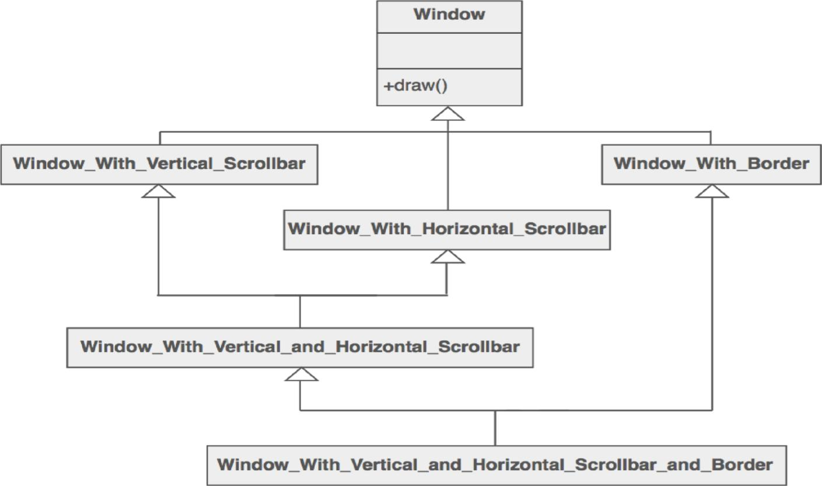
SubsystemOne and SubsystemThree do not interact with the internal components of SubsystemTwo. They use the SubsystemTwoWrapper "facade" (i.e. the higher level abstraction).

Example
The Facade defines a unified, higher level interface to a subsystem that makes it easier to use. Consumers encounter a Facade when ordering from a catalog. The consumer calls one number and speaks with a customer service representative. The customer service representative acts as a Facade, providing an interface to the order fulfillment department, the billing department, and the shipping department.
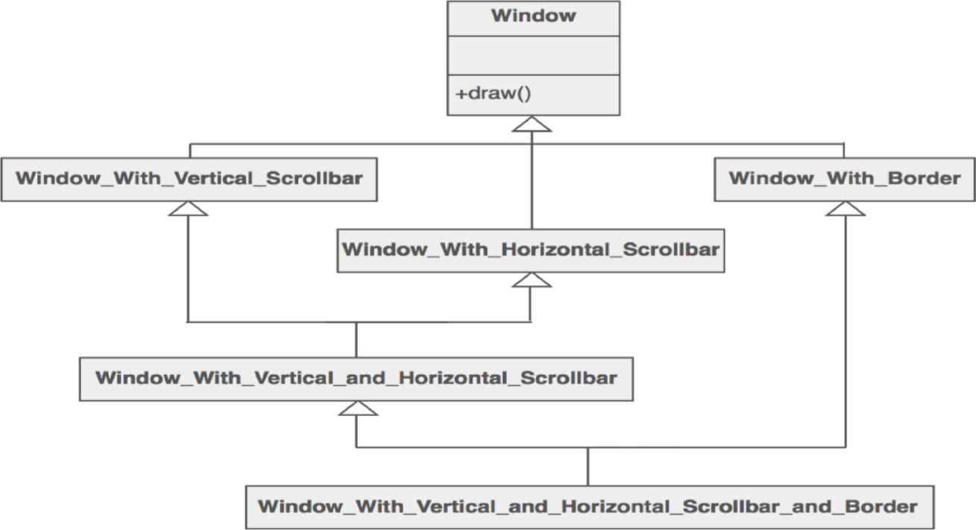

Check list
- Identify a simpler, unified interface for the subsystem or component.
- Design a 'wrapper' class that encapsulates the subsystem.
- The facade/wrapper captures the complexity and collaborations of the component, and delegates to the appropriate methods.
- The client uses (is coupled to) the Facade only.
- Consider whether additional Facades would add value.
Rules of thumb
- Facade defines a new interface, whereas Adapter uses an old interface. Remember that Adapter makes two existing interfaces work together as opposed to defining an entirely new one.
- Whereas Flyweight shows how to make lots of little objects, Facade shows how to make a single object represent an entire subsystem. Mediator is similar to Facade in that it abstracts functionality of existing classes. Mediator abstracts/centralizes arbitrary communications between colleague objects. It routinely "adds value", and it is known/referenced by the colleague objects. In contrast, Facade defines a simpler interface to a subsystem, it doesn't add new functionality, and it is not known by the subsystem classes.

- Abstract Factory can be used as an alternative to Facade to hide platform-specific classes.
- Facade objects are often Singletons because only one Facade object is required.
Adapter and Facade are both wrappers; but they are different kinds of wrappers. The intent of Facade is to produce a simpler interface, and the intent of Adapter is to design to an existing interface. While Facade routinely wraps multiple objects and Adapter wraps a single object; Facade could front-end a single complex object and Adapter could wrap several legacy objects.

Question: So the way to tell the difference between the Adapter pattern and the Facade pattern is that the Adapter wraps one class and the Facade may represent many classes?
Answer: No! Remember, the Adapter pattern changes the interface of one or more classes into one interface that a client is expecting. While most textbook examples show the adapter adapting one class, you may need to adapt many classes to provide the interface a client is coded to. Likewise, a Facade may provide a simplified interface to a single class with a very complex interface. The difference between the two is not in terms of how many classes they "wrap", it is in their intent.
7.Write about Flyweight Design Pattern
Intent
- Use sharing to support large numbers of fine-grained objects efficiently.
- The Motif GUI strategy of replacing heavy-weight widgets with light-weight gadgets.
Problem
Designing objects down to the lowest levels of system "granularity" provides optimal flexibility, but can be unacceptably expensive in terms of performance and memory usage.
Discussion
The Flyweight pattern describes how to share objects to allow their use at fine granularities without prohibitive cost. Each "flyweight" object is divided into two pieces: the statedependent (extrinsic) part, and the state-independent (intrinsic) part. Intrinsic state is stored (shared) in the Flyweight object. Extrinsic state is stored or computed by client objects, and passed to the Flyweight when its operations are invoked.
An illustration of this approach would be Motif widgets that have been re-engineered as lightweight gadgets. Whereas widgets are "intelligent" enough to stand on their own; gadgets exist in a dependent relationship with their parent layout manager widget. Each layout manager provides context-dependent event handling, real estate management, and resource services to its flyweight gadgets, and each gadget is only responsible for context-independent state and behavior.
Structure
Flyweights are stored in a Factory's repository. The client restrains herself from creating Flyweights directly, and requests them from the Factory. Each Flyweight cannot stand on its own. Any attributes that would make sharing impossible must be supplied by the client whenever a request is made of the Flyweight. If the context lends itself to "economy of scale" (i.e. the client can easily compute or look-up the necessary attributes), then the Flyweight pattern offers appropriate leverage.

he Ant, Locust, and Cockroach classes can be "light-weight" because their instance-specific state has been de-encapsulated, or externalized, and must be supplied by the client.
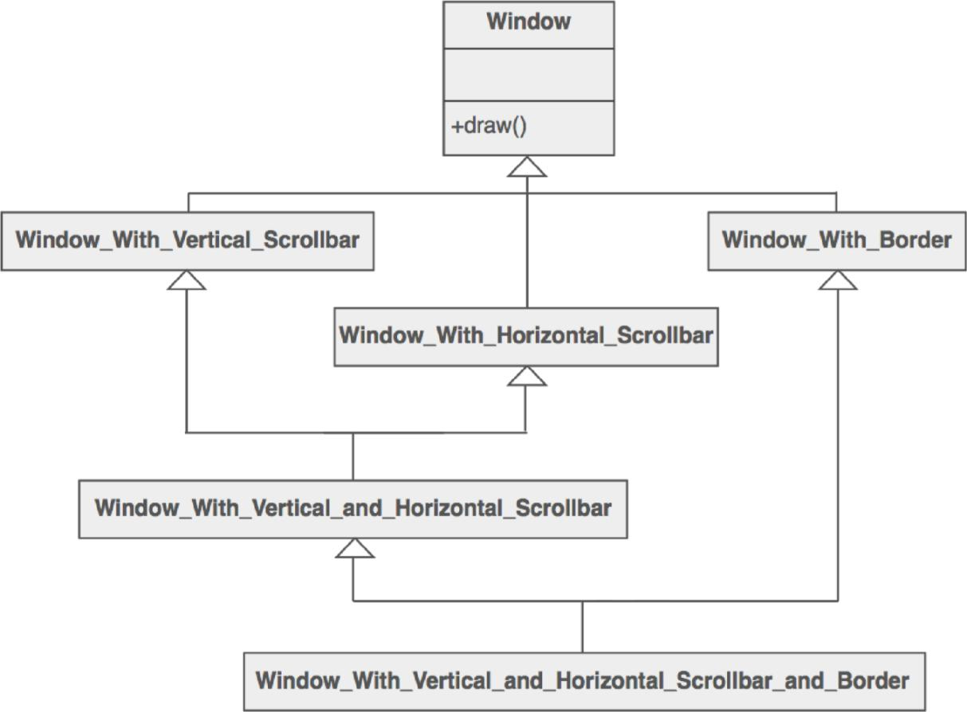

Example
The Flyweight uses sharing to support large numbers of objects efficiently. Modern web browsers use this technique to prevent loading same images twice. When browser loads a web page, it traverse through all images on that page. Browser loads all new images from Internet and places them the internal cache. For already loaded images, a flyweight object is created, which has some unique data like position within the page, but everything else is referenced to the cached one.

Check list
- Ensure that object overhead is an issue needing attention, and, the client of the class is able and willing to absorb responsibility realignment.
- Divide the target class's state into: shareable (intrinsic) state, and non-shareable (extrinsic) state.
- Remove the non-shareable state from the class attributes, and add it the calling argument list of affected methods.
- Create a Factory that can cache and reuse existing class instances.
- The client must use the Factory instead of the new operator to request objects.
- The client (or a third party) must look-up or compute the non-shareable state, and supply that state to class methods.
Rules of thumb
- Whereas Flyweight shows how to make lots of little objects, Facade shows how to make a single object represent an entire subsystem.
- Flyweight is often combined with Composite to implement shared leaf nodes.  Terminal symbols within Interpreter's abstract syntax tree can be shared with Flyweight.
- Flyweight explains when and how State objects can be shared.

8.Explain about Proxy Design Pattern:-
Intent
- Provide a surrogate or placeholder for another object to control access to it. Use an extra level of indirection to support distributed, controlled, or intelligent access.
- Add a wrapper and delegation to protect the real component from undue complexity.
Problem
You need to support resource-hungry objects, and you do not want to instantiate such objects unless and until they are actually requested by the client.
Discussion
Design a surrogate, or proxy, object that: instantiates the real object the first time the client makes a request of the proxy, remembers the identity of this real object, and forwards the instigating request to this real object. Then all subsequent requests are simply forwarded directly to the encapsulated real object.
There are four common situations in which the Proxy pattern is applicable.
- A virtual proxy is a placeholder for "expensive to create" objects. The real object is only created when a client first requests/accesses the object.
- A remote proxy provides a local representative for an object that resides in a different address space. This is what the "stub" code in RPC and CORBA provides.
- A protective proxy controls access to a sensitive master object. The "surrogate" object checks that the caller has the access permissions required prior to forwarding the request.
- A smart proxy interposes additional actions when an object is accessed. Typical uses include: Counting the number of references to the real object so that it can be freed automatically when there are no more references (aka smart pointer), Loading a persistent object into memory when it's first referenced, Checking that the real object is locked before it is accessed to ensure that no other object can change it.
Structure
By defining a Subject interface, the presence of the Proxy object standing in place of the RealSubject is transparent to the client.
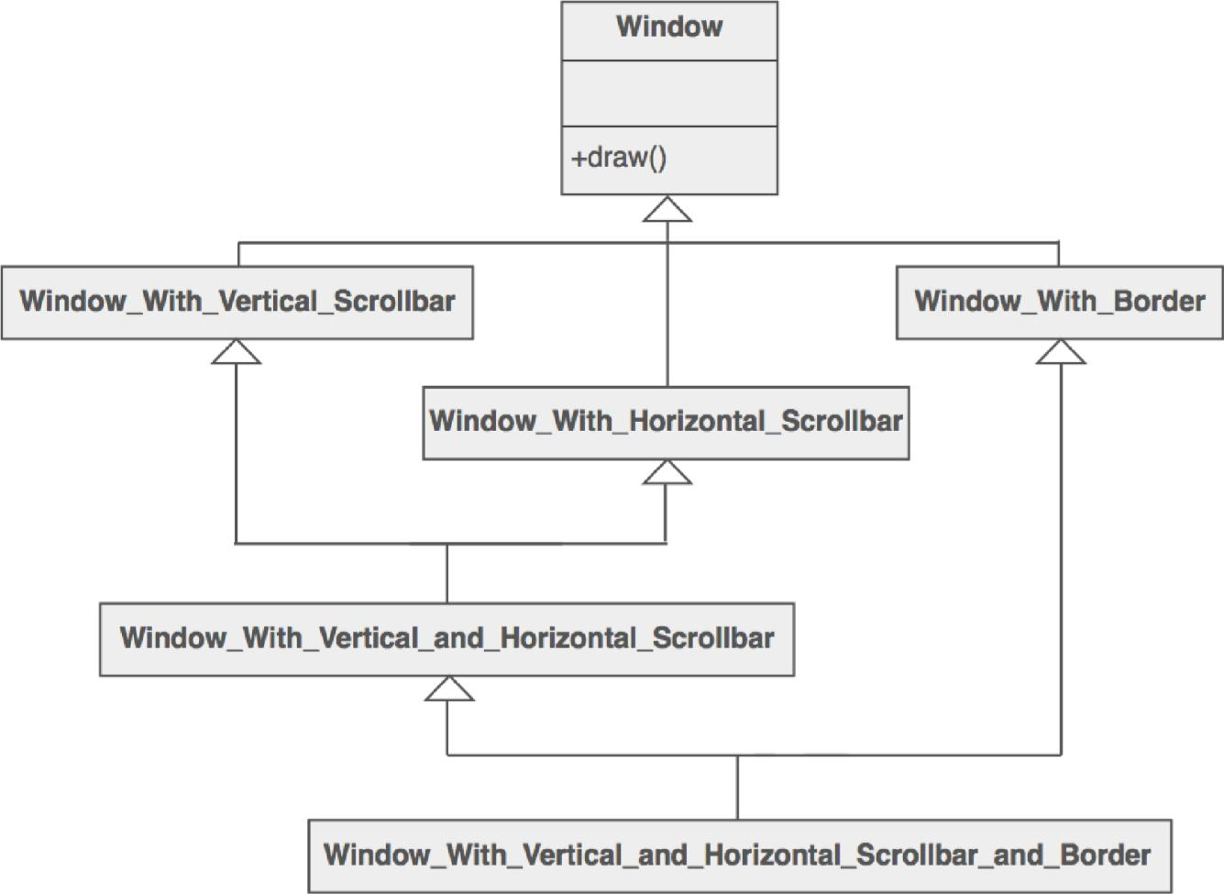

Example
The Proxy provides a surrogate or place holder to provide access to an object. A check or bank draft is a proxy for funds in an account. A check can be used in place of cash for making purchases and ultimately controls access to cash in the issuer's account.

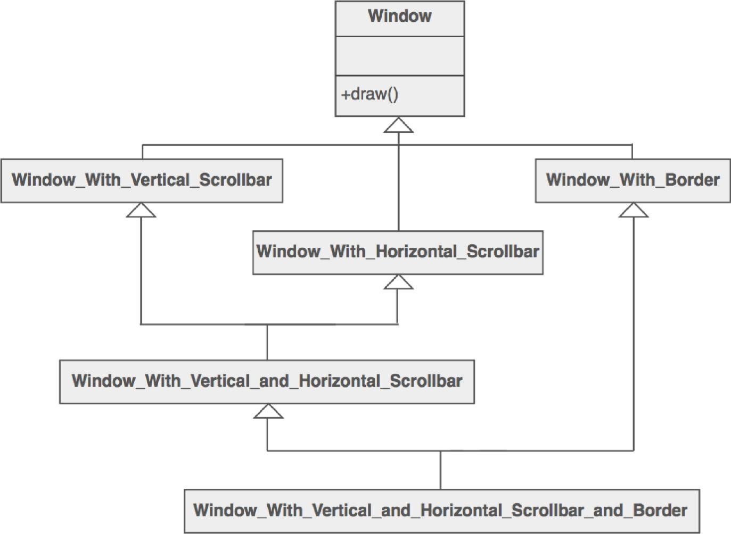

Check list
- Identify the leverage or "aspect" that is best implemented as a wrapper or surrogate.
- Define an interface that will make the proxy and the original component interchangeable.
- Consider defining a Factory that can encapsulate the decision of whether a proxy or original object is desirable.
- The wrapper class holds a pointer to the real class and implements the interface.
- The pointer may be initialized at construction, or on first use.
- Each wrapper method contributes its leverage, and delegates to the wrappee object.
Rules of thumb
- Adapter provides a different interface to its subject. Proxy provides the same interface. Decorator provides an enhanced interface.
- Decorator and Proxy have different purposes but similar structures. Both describe how to provide a level of indirection to another object, and the implementations keep a reference to the object to which they forward requests.

UNIT-IV
BEHAVIORAL PATTERNS PART-1
BEHAVIORAL PATTERNS PART-1I
Short Answer Questions
1.Write a short note on Behavioral Patterns
- Deal with the way objects interact and distribute responsibility.
- Chain of Responsibility: Avoid coupling the sender of a request to its receiver by giving more than one object a chance to handle the request. Chain the receiving. objects an dpass the request along the chain until an object handles it.
- Command: Encapsulate a request as an object, thereby letting you paramaterize clients with different requests, queue or log requests, and support undoable operations.
- Interpreter: Given a language, define a representation for its grammar along with an interpreter that uses the representation to interpret sentences in the language.

2.Write the Intent of Chain of responsibility
Avoid coupling the sender of a request to its receiver by giving more than one object a chance to handle the request. Chain the receiving objects and pass the request along the chain until an object handles it.
3.What are the Participants of Command Design pattern
Command
  - declares an interface for executing an operation.
ConcreteCommand (PasteCommand, OpenCommand)
defines a binding between a Receiver object and an action.
  - implements Execute by invoking the corresponding operation(s) on Receiver.
Client (Application)
  - creates a ConcreteCommand object and sets its receiver.
Invoker (MenuItem)
  - asks the command to carry out the request.
Receiver (Document, Application)
  - knows how to perform the operations associated with carrying out a request. Any class may serve as a Receiver.

4.Draw the Structure of Interpreter design pattern
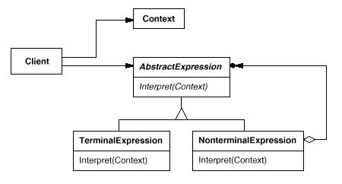

5.What is the Applicability of Iterator design pattern
Use the Iterator pattern
to access an aggregate object's contents without exposing its internal representation.
to support multiple traversals of aggregate objects.
to provide a uniform interface for traversing different aggregate structures (that is, to support polymorphic iteration).

6.What is the Intent Mediator design pattern

Define an object that encapsulates how a set of objects interact. Mediator promotes loose coupling by keeping objects from referring to each other explicitly, and it lets you vary their interaction independently.

7.What are the Collaborations Mediator design pattern
Colleagues send and receive requests from a Mediator object. The mediator implements the cooperative behavior by routing requests between the appropriate colleague(s).

8.What are the Related Patterns of Memento design pattern

Command : Commands can use mementos to maintain state for undoable operations.

Iterator: Memento scan be used for iteration as described earlier.

9.What are the Known Uses of Observer design pattern
The first and perhaps best-known example of the Observer pattern appears in Smalltalk Model/View/Controller (MVC), the user interface framework in the Smalltalk environment [KP88]. MVC's Model class plays the role of Subject, while View is the base class for observers. Smalltalk, ET++ [WGM88], and the THINK class library [Sym93b] provide a general dependency mechanism by putting Subject and Observer interfaces in the parent class for all other classes in the system.
Other user interface toolkits that employ this pattern are InterViews [LVC89], the AndrewToolkit [P+88], and Unidraw [VL90]. InterViews defines Observer and Observable (for subjects) classes explicitly. Andrew calls them "view" and "data object," respectively. Unidraw splits graphical editor objects into View (for observers) and Subject parts.

Essay Answer Questions
1.Write about Chain of Responsibility
- Decouple sender of a request from receiver.
- Give more than one object a chance to handle.
- Flexibility in assigning responsibility.
- Often applied with Composite.
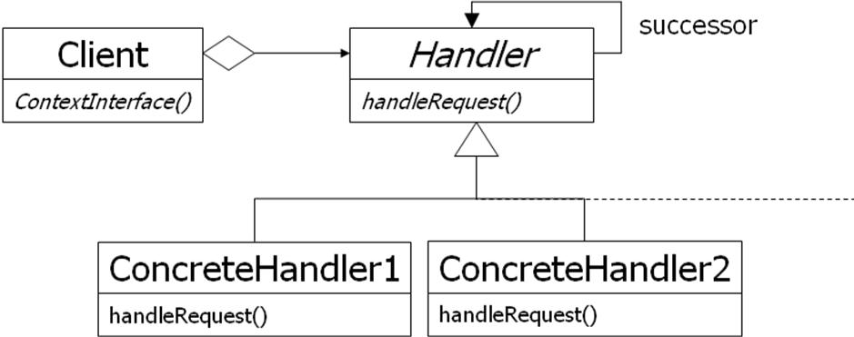

Chain of Responsibility (2)
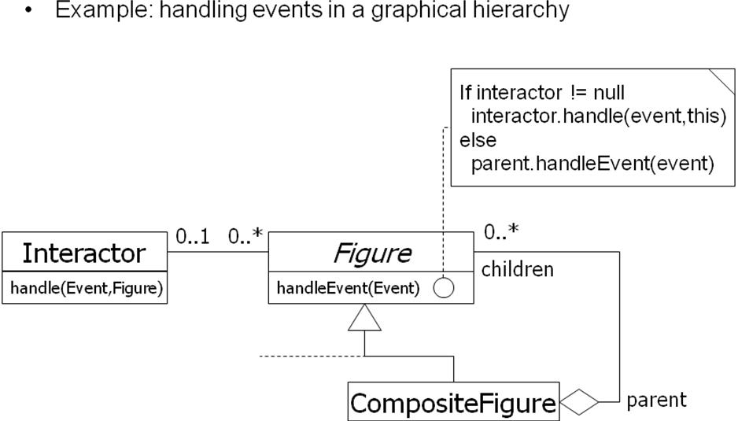

2.Write about Command design pattern
Problem description:
Encapsulates requests so that they can be executed, undone, or queued independently
of the request.
Solution:
A Command abstract class declares the interface supported by all
ConcreteCommands. ConcreteCommands encapsulate a service to be applied to a Receiver. The Client creates ConcreteCommands and binds them to specific Receivers. The Invoker actually executes a command.
Command: Class Diagram
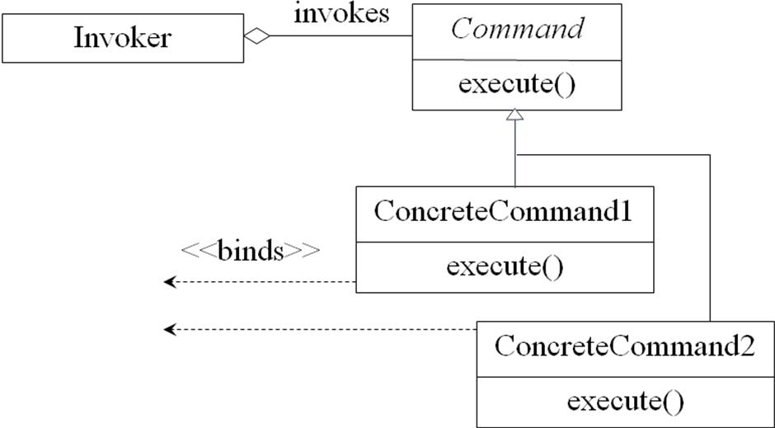

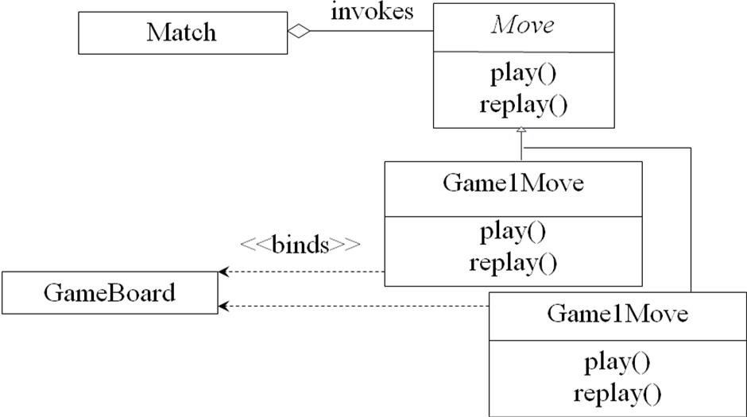
Command: Class Diagram for Match

Command: Consequences
Consequences:
The object of the command (Receiver) and the algorithm of the command.
(ConcreteCommand) are decoupled.
Invoker is shielded from specific commands.
ConcreteCommands are objects. They can be created and stored.
New ConcreteCommands can be added without changing existing code.
Command:
- You have commands that need to be
– executed,
– undone, or
– queued
- Command design pattern separates
–Receiver from Invoker from Commands
- All commands derive from Command and implement do(), undo(), and redo().
Command Design Pattern :
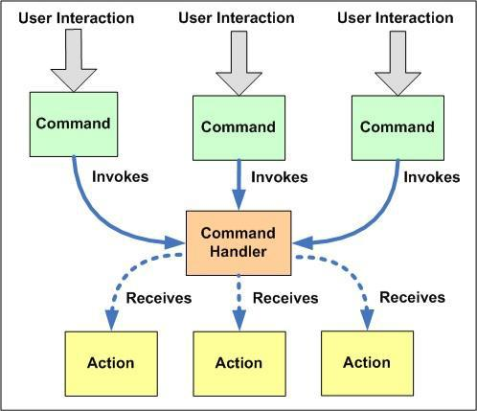

- Separates command invoker and receiver.
Pattern: Interpreter:
- Intent: Given a language, interpret sentences.
- Participants: Expressions, Context, Client.
- Implementation: A class for each expression type
An Interpret method on each class
A class and object to store the global state (context)
- No support for the parsing process
(Assumes strings have been parsed into exp trees)
Pattern: Interpreter with Macros:
- Example: Definite Clause Grammars.
- A language for writing parsers/interpreters.
- Macros make it look like (almost) standard BNF. Command(move(D)) -> “go”, Direction(D).
- Built-in to Prolog; easy to implement in Dylan, Lisp.
- Does parsing as well as interpretation.
- Builds tree structure only as needed.
(Or, can automatically build complete trees)
- May or may not use expression classes.
Method Combination:
- Build a method from components in different classes
- Primary methods: the “normal” methods; choose the most specific one
- Before/After methods: guaranteed to run; No possibility of forgetting to call super
Can be used to implement Active Value pattern
- Around methods: wrap around everything; Used to add tracing information, etc.
- Is added complexity worth it?
Common Lisp: Yes; Most languages: No
Iterator pattern :
- iterator: an object that provides a standard way to examine all elements of any collection.
- uniform interface for traversing many different data structures without exposing their implementations.
- supports concurrent iteration and element removal.
- removes need to know about internal structure of collection or different methods to access data from different collections. Pattern: Iterator objects that traverse
collections

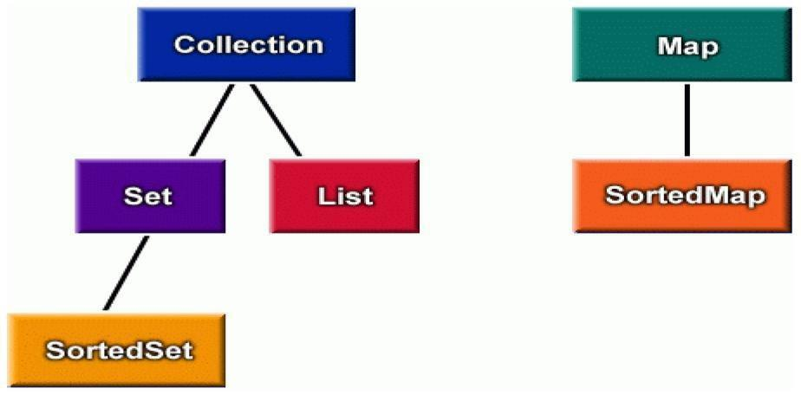

Iterator interfaces in
Java:public interface
java.util.Iterator { public
boolean hasNext(); public
Object next(); public void
remove();
}
public interface
java.util.Collection { ... //
List, Set extend Collection
public Iterator iterator();
}
public interface java.util.Map {
...
public Set keySet(); // keys,values are Collections public Collection values(); // (can call iterator() on them)
}
Iterators in Java:
- all Java collections have a method iterator that returns an iterator for the elements of the collection.
- can be used to look through the elements of any kind of collection (an alternative to for loop).
List list = new
ArrayList(); ... add
some elements ...
for (Iterator itr = list.iterator(); itr.hasNext()) {
BankAccount ba = (BankAccount)itr.next();
System.out.println(ba);
}
Adding your own Iterators :
- when implementing your own collections, it can be very convenient to use
Iterators –discouraged (has nonstandard interface): |  | public class
PlayerList { | public int getNumPlayers() { ... } | public boolean
empty() { ... } | public Player getPlayer(int n) { ... | }
}
–preferred:
public class PlayerList {
public Iterator iterator() { ...

} public int size() { ... }
public boolean isEmpty() { ...
}
}
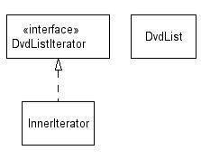

3.Write about Mediator Pattern
- The Mediator pattern reduces coupling and simplifies code when several objects must negotiate a complex interaction.
- Classes interact only with a mediator class rather than with each other.
- Classes are coupled only to the mediator where interaction control code resides.
- Mediator is like a multi-way Façade pattern.
Analogy: a meeting scheduler.
Unmediated
Collaboration
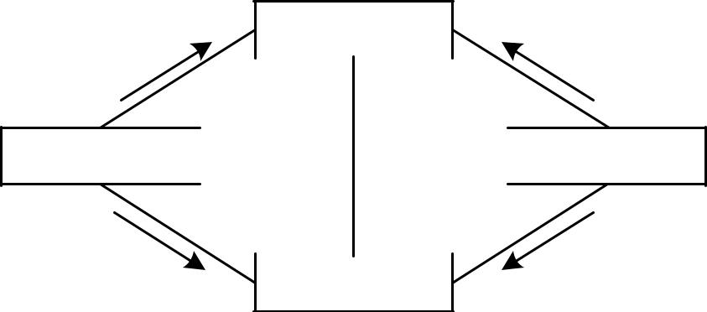

collaboratorB
1: op1() |  | 2.1: op2()

2: op2()
collaboratorA 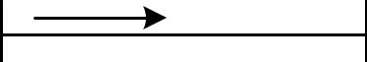 collaboratorC

3: op4() |  | 2.2: op3()
collaboratorD

^{Mediated} collaboratorB
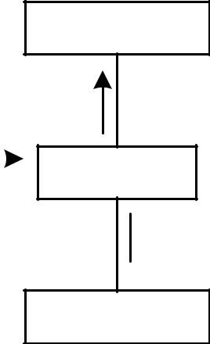

Collaboration

1.1: op1()
1.5: op2()
1: op() | 1.2: op2()
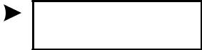

collaboratorA mediator collaboratorC

1.3: op 3()
1.4: op4()
collaboratorD

Mediator Pattern Structure:
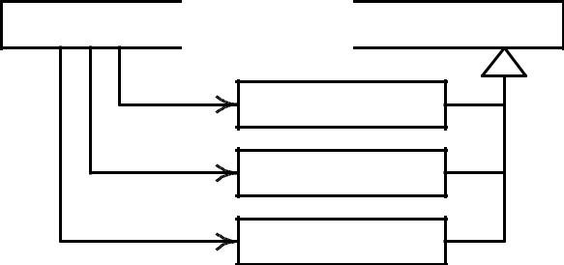
Mediator 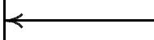 Collaborator

ColleagueA

ColleagueB

ColleagueC

Mediator as a Broker:
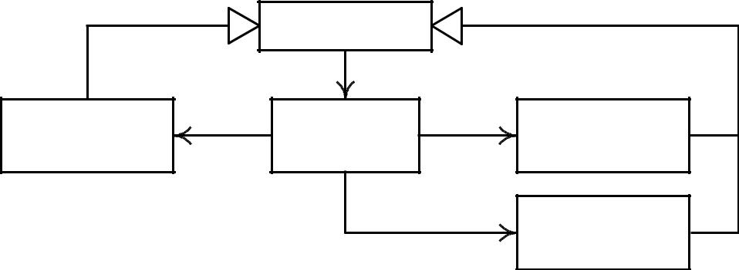

 | Collaborator
«client» | «broker» | «supplier»
ColleagueA | Mediator | ColleagueB
 |  | «supplier»
 |  | ColleagueC

Mediator Behavior:
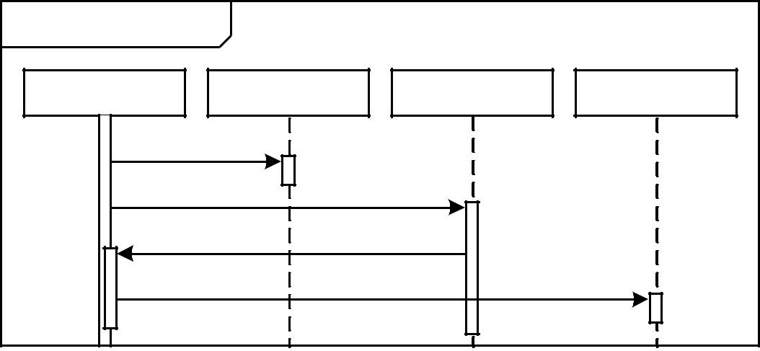
sd requestService ()
self:Mediator | :ColleagueA | :ColleagueB | : ColleagueC
consult ()
consult ()
 | notify ()
consult ()

When to Use a Mediator:
- Use the Mediator pattern when a complex interaction between collaborators must be encapsulated to
– Decouple collaborators,
– Centralize control of an interaction, and –Simplify the collaborators.
- Using a mediator may compromise performance.

Mediators, Façades, and Control Styles:
- The Façade and Mediator patterns provide means to make control more centralized.
- The Façade and Mediator patterns should be used to move from a dispersed to a delegated style, but not from a delegated to a centralized style.
Summary :

- Broker patterns use a Broker class to facilitate the interaction between a Client and a Supplier.
- The Façade pattern uses a broker (the façade) to provide a simplified interface to a complex sub-system.
- The Mediator pattern uses a broker to encapsulate and control a complex interaction among several suppliers.

4..Explain about Memento Pattern
Intent:
- Capture and externalize an object’s state without violating encapsulation.
- Restore the object’s state at some later time.
– Useful when implementing checkpoints and undo mechanisms that let users back out of tentative operations or recover from errors.
– Entrusts other objects with the information it needs to revert to a previous state without exposing its internal structure and representations.
Forces:
- Application needs to capture states at certain times or at user discretion. May be used for:
– Undue / redo
– Log errors or events
– Backtracking
- Need to preserve encapsulation
– Don’t share knowledge of state with other objects
- Object owning state may not know when to take state snapshot.
Motivation:
- Many technical processes involve the exploration of some complex data structure.
- Often we need to backtrack when a particular path proves unproductive.
Examples are graph algorithms, searching knowledge bases, and text navigation.
Memento stores a snapshot of another object’s internal state, exposure of which would violate encapsulation and compromise the application’s reliability and extensibility.
A graphical editor may encapsulate the connectivity relationships between objects in a class, whose public interface might be insufficient to allow precise reversal of a move operation.
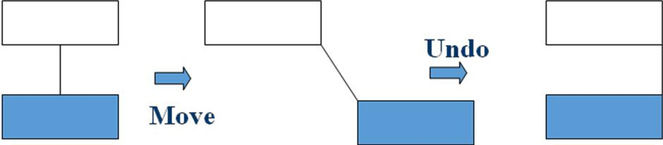

Memento pattern solves this problem as follows:
- The editor requests a memento from the object before executing move operation.
- Originator creates and returns a memento.
- During undo operation, the editor gives the memento back to the originator.
- Based on the information in the memento, the originator restores itself to its previous state.
Applicability:
- Use the Memento pattern when:
– A snapshot of an object’s state must be saved so that it can be restored later, and direct access to the state would expose implementation details and break encapsulation.
Structure:
Originator |  |  | Memento
 |  |  | Memento |  |  | caretaker
Attribute: |  |  | Attribute: |  |  | caretaker
State |  |  | state
Operation: |  |  | Operation:
SetMemento(Memento m) |  |  | GetState( )
CreateMemento( ) |  |  | SetState( )
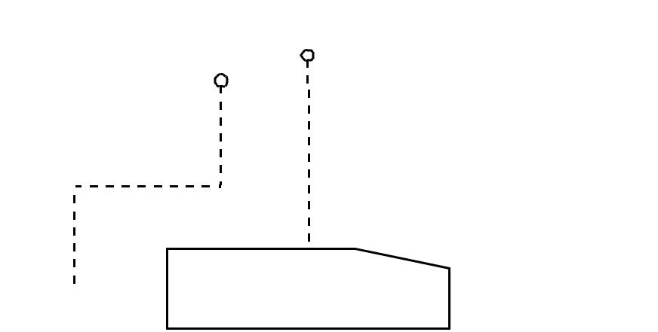
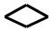

state = m->GetState( )
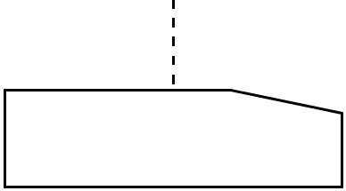
return new Memento(state)

Participants:
- Memento
– Stores internal state of the Originator object. Originator decides how much.
– Protects against access by objects other than the originator.
– Mementos have two interfaces:
    - Caretaker sees a narrow interface.
    - Originator sees a wide interface.
    - Originator
– Creates a memento containing a snapshot of its current internal state.
– Uses the memento to restore its internal state.
Caretaker:
- Is responsible for the memento’s safekeeping.
- Never operates on or examines the contents of a memento.
Event Trace:
Collaborations:
- A caretaker requests a memento from an originator, holds it for a time, and passes it back to the originator.
- Mementos are passive. Only the originator that created a memento will assign or retrieve its state.
Consequences:
Memento has several consequences:
– Memento avoids exposing information that only an originator should manage, but for simplicity should be stored outside the originator.
– Having clients manage the state they ask for simplifies the originator.
- Using mementos may be expensive, due to copying of large amounts of state or frequent creation of mementos.
- A caretaker is responsible for deleting the mementos it cares for.
A caretaker may incur large storage costs when it stores mementos.
Implementation:
When mementos get created and passed back to their originator in a predictable sequence, then Memento can save just incremental changes to originator’s state.
Known Uses:
Memento is a 2000 film about Leonard Shelby and his quest to revenge the brutal murder of his wife. Though Leonard is hampered with short-term memory loss, he uses notes and tatoos to compile the information into a suspect.
Known Use of Pattern
- Dylan language uses memento to provide iterators for its collection facility.
– Dylan is a dynamic object oriented language using the functional style.
– Development started by Apple, but subsequently moved to open source.
Related Patterns
- Command
Commands can use mementos to maintain state for undo mechanisms.
- Iterator
Mementos can be used for iteration.
5.Explain about Observer Pattern
- Define a one-to-many dependency, all the dependents are notified and updated automatically
- The interaction is known as publish-subscribe or subscribe-notify
- Avoiding observer-specific update protocol: pull model vs. push model
- Other consequences and open issues

Intent:
- Define a one-to-many dependency between objects so that when one object changes state, all its dependents are notified and updated automatically
- Key forces:
- There may be many observers
- Each observer may react differently to the same notification
- The subject should be as decoupled as possible from the observers to allow observers to change independently of the subject
Observer
- Many-to-one dependency between objects
- Use when there are two or more views on the same “data”
- aka “Publish and subscribe” mechanism
- Choice of “push” or “pull” notification styles

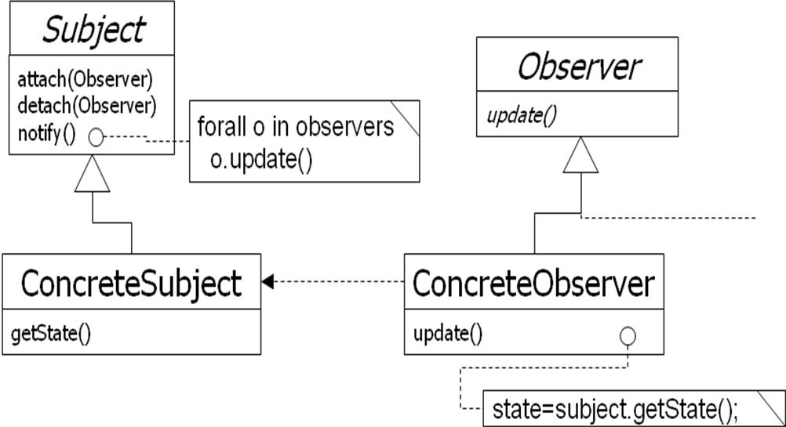

Observer: Encapsulating Control Flow
Name: Observer design pattern
Problem description:
Maintains consistency across state of one Subject and many Observers.
Solution:
A Subject has a primary function to maintain some state (e.g., a data structure). One or more Observers use this state, which introduces redundancy between the states of Subject and Observer.
Observer invokes the subscribe() method to synchronize the state. Whenever the state changes, Subject invokes its notify() method to iteratively invoke each Observer.update() method.
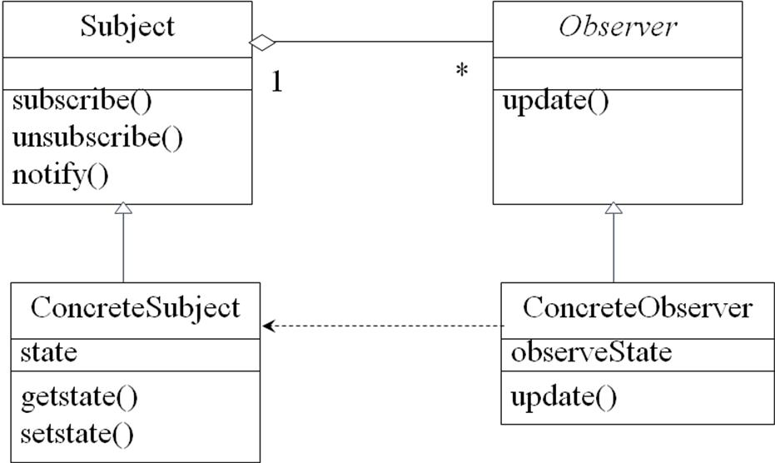
Observer: Class Diagram

Observer: Consequences
Consequences:
Decouples Subject, which maintains state, from Observers, who make use of the state.
Can result in many spurious broadcasts when the state of Subject changes.
Collaborations in Observer Pattern
Observer Pattern [1]
- Need to separate presentational aspects with the data, i.e. separate views and data.
- Classes defining application data and presentation can be reused.
- Change in one view automatically reflected in other views. Also, change in the application data is reflected in all views.
- Defines one-to-many dependency amongst objects so that when one object changes its state, all its dependents are notified.
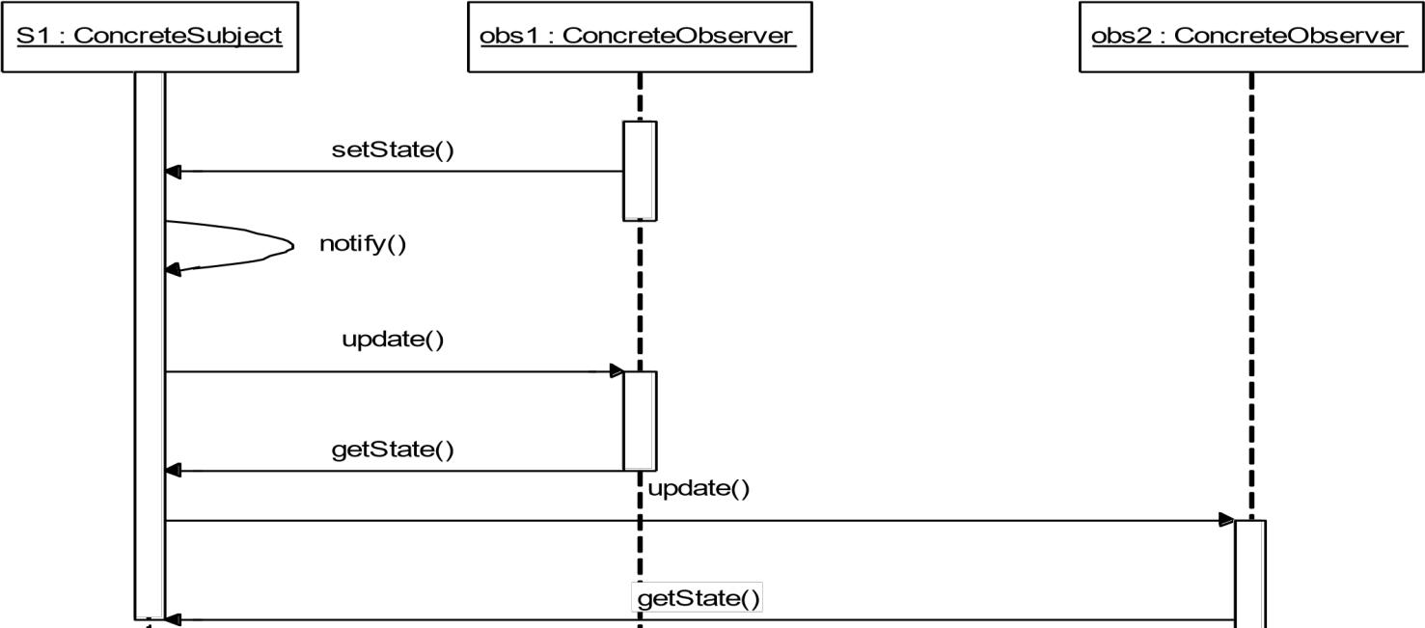
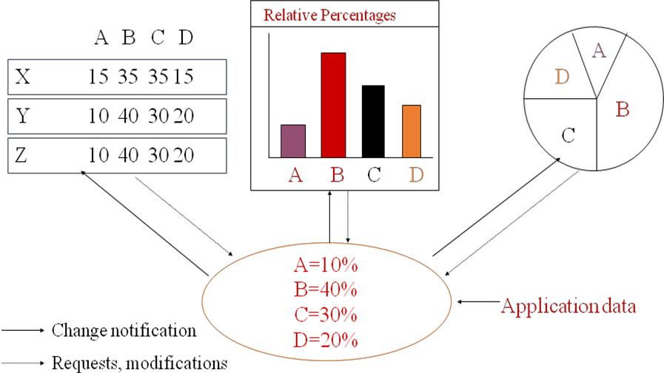

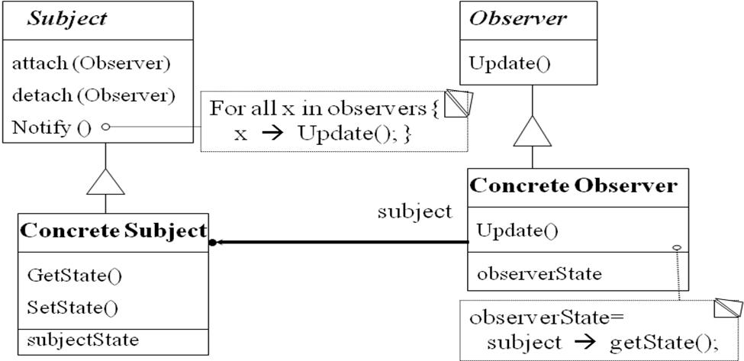

Class collaboration in Observer
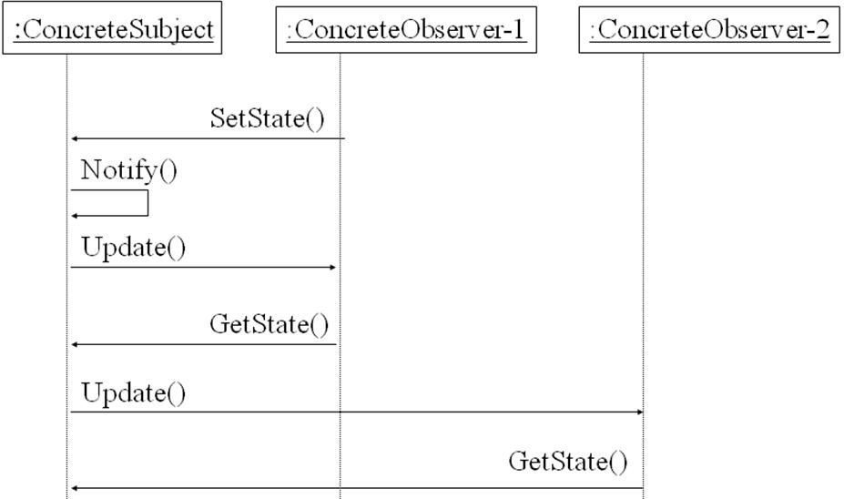
Observer Pattern: Observer code
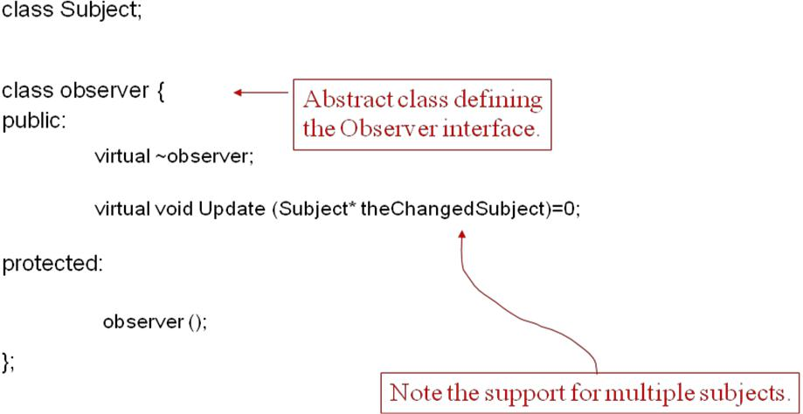

Observer Pattern: Subject Code
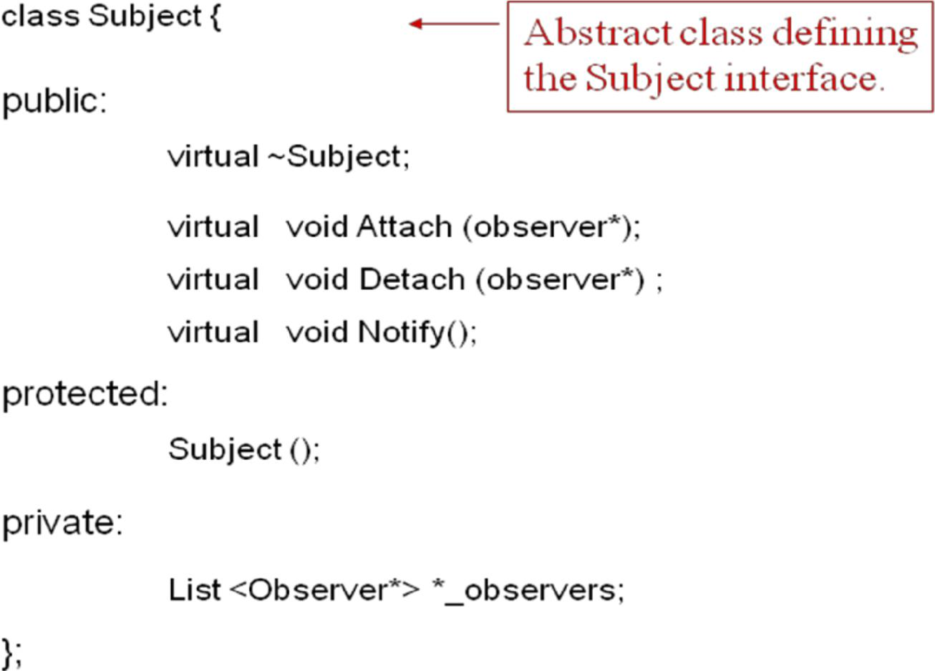

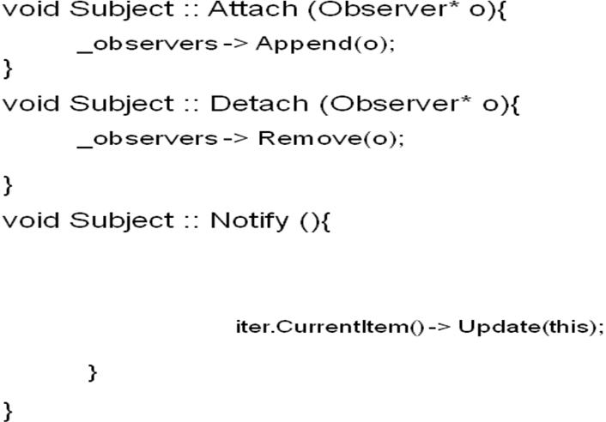

Observer Pattern: A Concrete Subject [1]
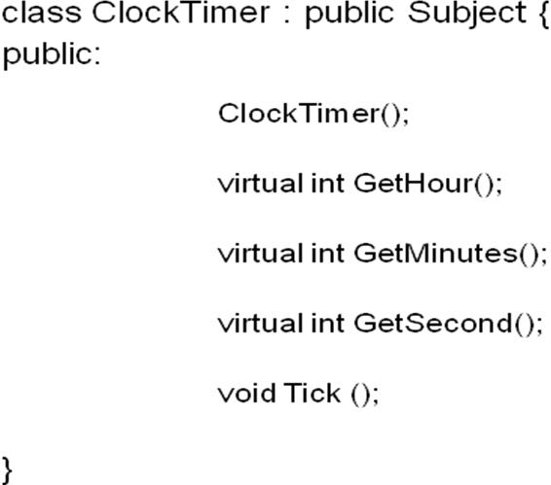

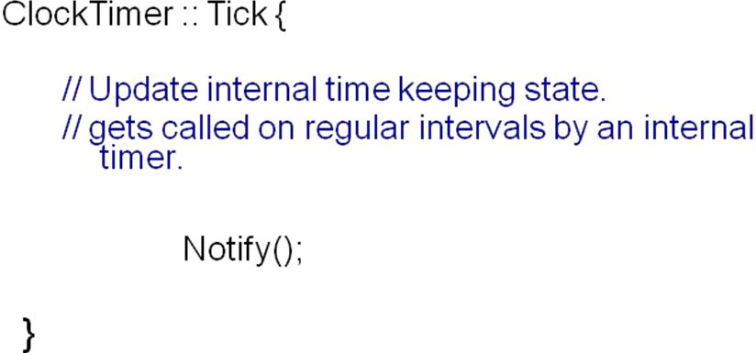

Observer Pattern: A Concrete Observer [1]
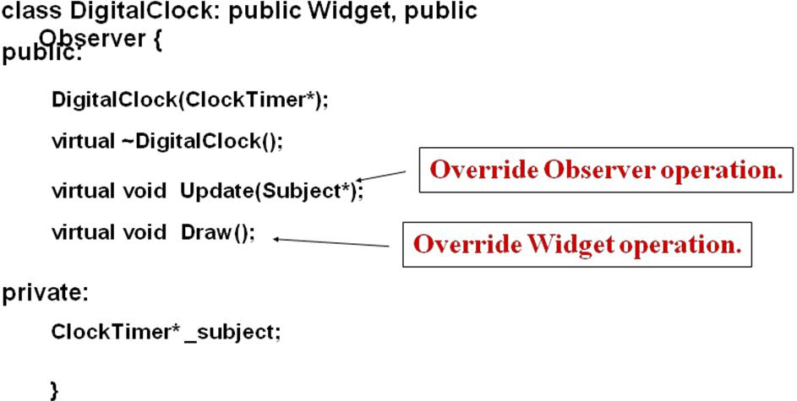

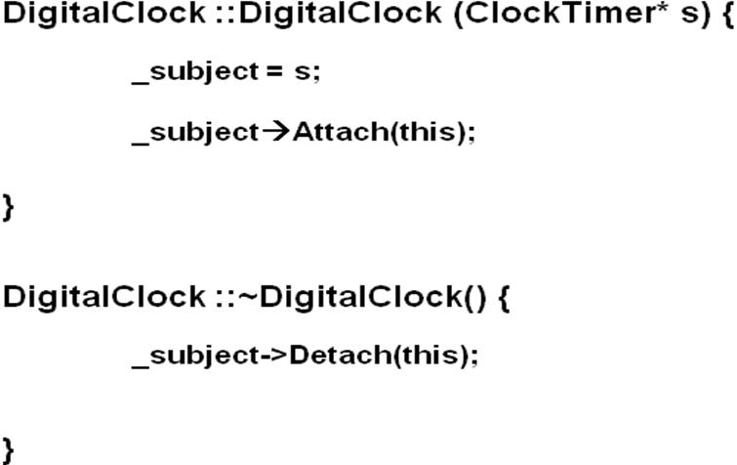
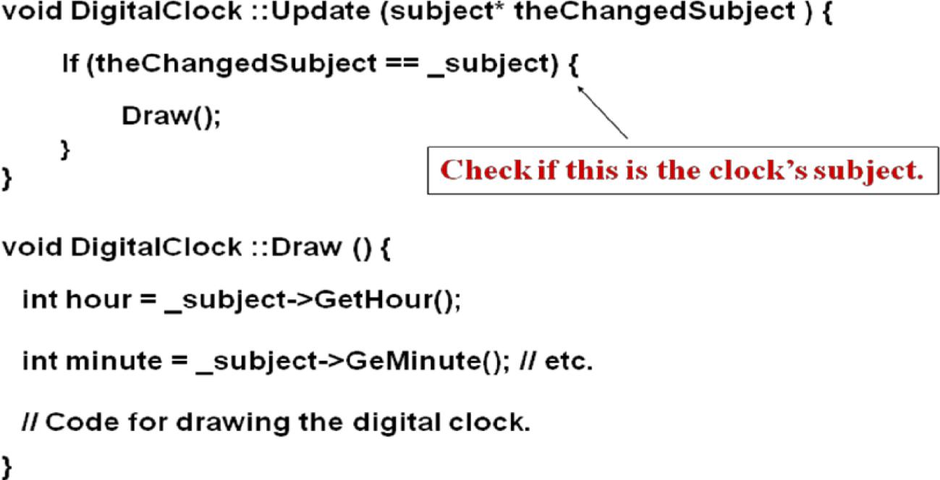

Observer Pattern: Main (skeleton)
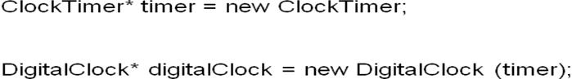

Observer Pattern: Consequences
- Abstract coupling between subject and observer. Subject has no knowledge of concrete observer classes. (What design principle is used?)
- Support for broadcast communication. A subject need not specify the receivers; all interested objects receive the notification.
- Unexpected updates: Observers need not be concerned about when then updates are to occur. They are not concerned about each other’s presence. In some cases this may lead to unwanted updates.
When to use the Observer Pattern?
- When an abstraction has two aspects: one dependent on the other. Encapsulating these aspects in separate objects allows one to vary and reuse them independently.
- When a change to one object requires changing others and the number of objects to be changed is not known.
- When an object should be able to notify others without knowing who they are. Avoid tight coupling between objects.

UNIT-5
Behavioral patterns part-II
What to expect from design patterns
Short Answer Questions
1.Write the intent of State design pattern
Allow an object to alter its behavior when its internal state changes.The object will appear to change its class.
2.Draw the Structure State design pattern
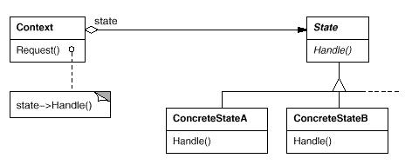

3.What are Participants of strategy design pattern
Strategy (Compositor)
  - declares an interface common to all supported algorithms. Context uses this interface to call the algorithm defined by a ConcreteStrategy.
ConcreteStrategy (SimpleCompositor, TeXCompositor,ArrayCompositor)
  - implements the algorithm using the Strategy interface.
Context (Composition)
  - is configured with a ConcreteStrategy object.
maintains a reference to a Strategy object.
may define an interface that lets Strategy access its data.

4.What are Related Patterns of strategy design pattern
Flyweight Strategy objects often make good flyweights.
5.Write the Intent of Template method design pattern
Define the skeleton of an algorithm in an operation, deferring some steps to subclasses. Template Method lets subclasses redefine certain steps of an algorithm without changing the algorithm's structure.

6.What are Known Uses of Template method design pattern
Template methods are so fundamental that they can be found in almost every abstract class. Wirfs-Brock et al. [WBWW90, WBJ90] provide a good overview and discussion of template methods.
7.Write a short note A Parting Thought
The best designs will use many design patterns that dovetail and intertwine to produce a greater whole. As Christopher Alexander says: It is possible to make buildings by stringing together patterns, in a rather loose way. A building made like this, is an assembly of patterns. It is not dense. It is not profound. But it is also possible to put patterns together in such a way that many patterns overlap in the same physical space: the building is very dense; it has many meanings captured in a small space; and through this density, it becomes profound.
8. Write a short note on Behavioral Patterns
- Deal with the way objects interact and distribute responsibility.
- Chain of Responsibility: Avoid coupling the sender of a request to its receiver by giving more than one object a chance to handle the request. Chain the receiving. objects an dpass the request along the chain until an object handles it.
- Command: Encapsulate a request as an object, thereby letting you paramaterize clients with different requests, queue or log requests, and support undoable operations.
- Interpreter: Given a language, define a representation for its grammar along with an interpreter that uses the representation to interpret sentences in the language.

Essay Answer Questions
1.How to use STATE pattern ?
- State pattern is useful when there is an object that can be in one of several states, with different behavior in each state.
- To simplify operations that have large conditional statements that depend on the object’s state.
if (myself = happy) then
{

eatIceCream();
…. }else (myself = sad) then

if

{
goToPub();
….
}
else if (myself

=

ecstatic) then{
….
Example I
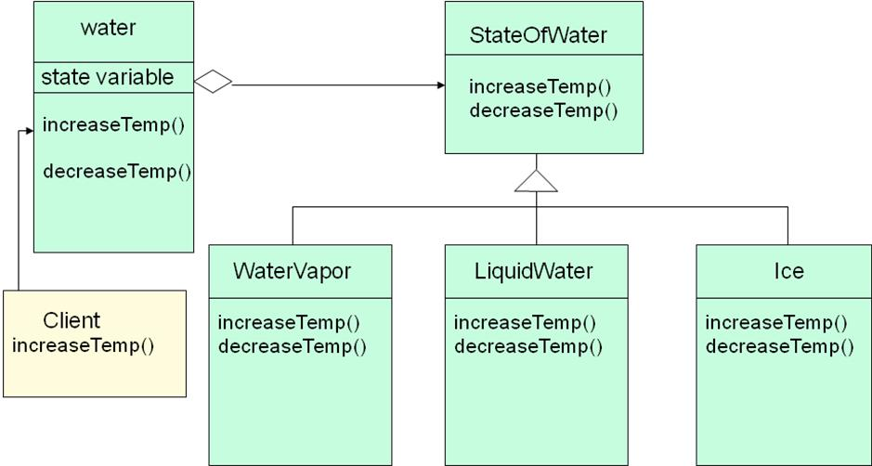

How is STATE pattern implemented ?
- “Context” class:
Represents the interface to the outside world.
- “State” abstract class:

Base class which defines the different states of the “state machine”.
- “Derived” classes from the State class:
Defines the true nature of the state that the state machine can be in.
Context class maintains a pointer to the current state. To change the state of the state machine, the pointer needs to be changed.
Example II
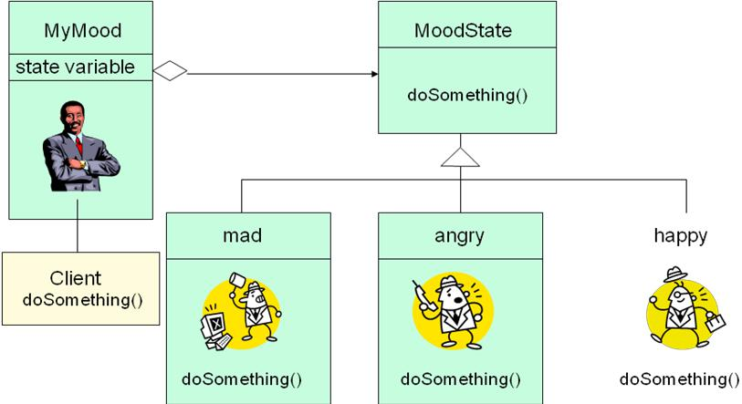

Benefits of using STATE pattern
- Localizes all behavior associated with a particular state into one object.
  - New state and transitions can be added easily by defining new subclasses.
  - Simplifies maintenance.
- It makes state transitions explicit.
  - Separate objects for separate states makes transition explicit rather than using internal data values to define transitions in one combined object.
  - State objects can be shared.
  - Context can share State objects if there are no instance variables.
Food for thought…
- To have a monolithic single class or many subclasses ?
- Increases the number of classes and is less compact.
- Avoids large conditional statements.
- Where to define the state transitions ?
- If criteria is fixed, transition can be defined in the context.
- More flexible if transition is specified in the State subclass.
- Introduces dependencies between subclasses.
- Whether to create State objects as and when required or to create-themonce-and-use-many-times ?
- First is desirable if the context changes state infrequently.
- Later is desirable if the context changes state frequently.
Pattern: Strategy objects that hold alternate algorithms to solve a problem
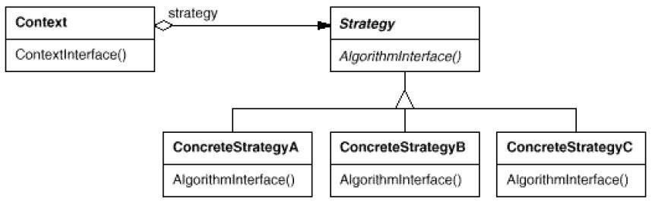

2.Explain Strategy pattern
- pulling an algorithm out from the object that contains it, and encapsulating the algorithm (the "strategy") as an object
- each strategy implements one behavior, one implementation of how to solve the same problem
–how is this different from Command pattern?
- separates algorithm for behavior from object that wants to act
- allows changing an object's behavior dynamically without extending / changing the object itself
- examples:
– file saving/compression
– layout managers on GUI containers
– AI algorithms for computer game players
Strategy example: Card player
- Strategy hierarchy parent // (an interface or abstract class) public interface Strategy { public Card getMove();
}
  - setting a strategy player1.setStrategy(new SmartStrategy());
  - using a strategy
Card p1move = player1.move(); // uses strategy
Strategy: Encapsulating Algorithms
Name: Strategy design pattern
Problem description:
Decouple a policy-deciding class from a set of mechanisms, so that different mechanisms can be changed transparently.
Example:
A mobile computer can be used with a wireless network, or
connected to an Ethernet, with dynamic switching between networks based on location and network costs.
Solution:
A Client accesses services provided by a Context.
The Context services are realized using one of several mechanisms, as decided by a Policy object.
The abstract class Strategy describes the interface that is common to all mechanisms that Context can use. Policy class creates a ConcreteStrategy object and configures Context to use it.
Strategy Example: Class Diagram for Mobile Computer
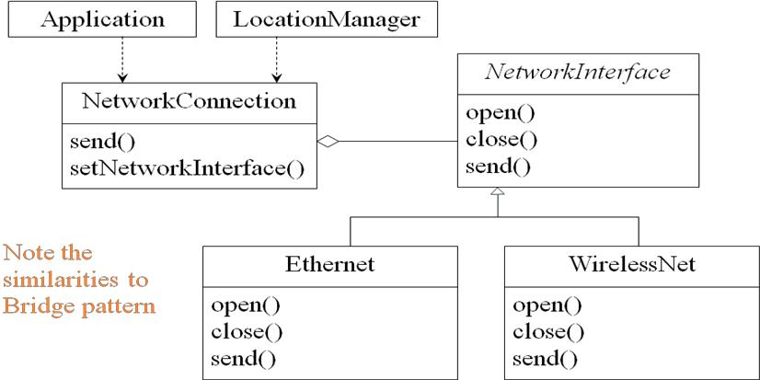

Strategy: Class Diagram
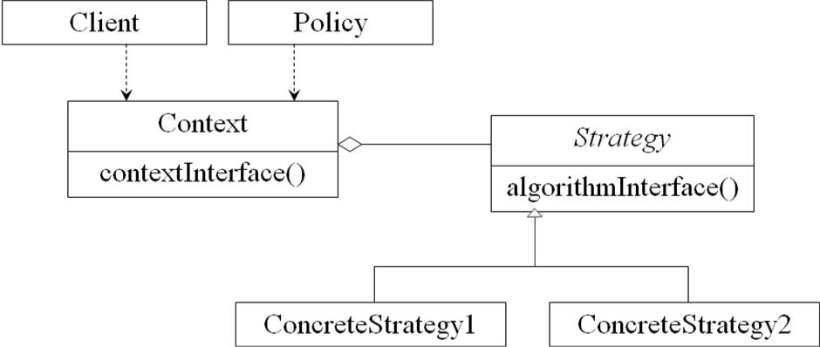

Strategy: Consequences
Consequences:
ConcreteStrategies can be substituted transparently from Context.
Policy decides which Strategy is best, given the current circumstances.
New policy algorithms can be added without modifying Context or Client.
Strategy
- You want to
– use different algorithms depending upon the context
– avoid having to change the context or client
- Strategy
– decouples interface from implementation
– shields client from implementations
– Context is not aware which strategy is being used; Client configures the Context
– strategies can be substituted at runtime
– example: interface to wired and wireless networks
- Make algorithms interchangeable---”changing the guts”
- Alternative to subclassing
- Choice of implementation at run-time
- Increases run-time complexity

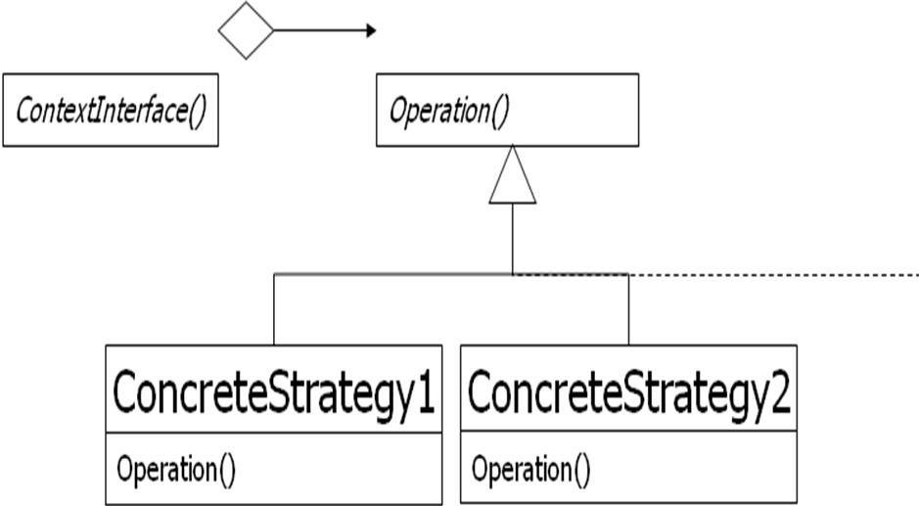

3.Write about Template Method
Conducted By Raghavendar Japala

• Introduction to Template Method Design Pattern
- Structure of Template Method
- Generic Class and Concrete Class
- Plotter class and Plotter Function Class
Introduction
The DBAnimationApplet illustrates the use of an abstract class that serves as a template for classes with shared functionality.
An abstract class contains behavior that is common to all its subclasses. This behavior is encapsulated in nonabstract methods, which may even be declared final to prevent any modification. This action ensures that all subclasses will inherit the same common behavior and its implementation.
The abstract methods in such templates ensure the interface of the subclasses and require that context specific behavior be implemented for each concrete subclass.
Hook Method and Template Method
The abstract method paintFrame() acts as a placeholder for the behavior that is implemented differently for each specific context.
We call such methods, hook methods, upon which context specific behavior may be hung, or implemented.
The paintFrame() hook is placed within the method update(), which is common to all concrete animation applets. Methods containing hooks are called template methods.
Hook Method and Template Method (Con’t)
The abstract method paintFrame() represents the behavior that is changeable, and its implementation is deferred to the concrete animation applets.
We call paintFrame() a hook method. Using the hook method, we are able to define the update() method, which represents a behavior common to all the concrete animation applets.
Frozen Spots and Hot Spots
A template method uses hook methods to define a common behavior.
Template method describes the fixed behaviors of a generic class, which are sometimes called frozen spots.
Hook methods indicate the changeable behaviors of a generic class, which are sometimes called hot spots.
Hook Method and Template Method (Con’t)
The abstract method paintFrame() represents the behavior that is changeable, and its implementation is deferred to the concrete animation applets

We call paintFrame() a hook method. Using the hook method, we are able to define the update() method, which represents a behavior common to all the concrete animation applets.
Structure of the Template Method Design Pattern
