BLOCKCHAIN TECHNOLOGY LECTURE NOTES
UNIT-1
1..List Out Types Of Block Chain Networks?
There Are Four Main Types Of Blockchain Networks:
Public Blockchains,
Private Blockchains,
Consortium Blockchains
Hybrid Blockchains

2.Define Cryptocurrency With Examples And Justify Its Cryptocurrency Is Safe?
Cryptocurrency, Sometimes Called Crypto-Currency Or Crypto, Is Any
. Form Of Currency That Exists Digitally Or Virtually And Uses Cryptography To Secure
Transactions. Cryptocurrencies Don't Have A Central Issuing Or Regulating Authority, Instead
Using A Decentralized System To Record Transactions And Issue New Units.

3.How Did Block Chain Technology Developed Over Years?
The Evolution Of Blockchain Technology Started In 1991. When Research Scientists Stuart
Haber And W. Scott Stornetta Were Working On A Practical Solution To Keep The Backup
Of Digital Documents. Afterward, They Aim To Make The Timestamps Of Those Documents
More Secure.

4.What Are The Problems In Crypto Currency?
Critics, However, See Crypto Assets As Not Merely Inherently Worthless But A Front For Crime, Scams, And Gambling. They Also Point To Their Dizzying Volatility. Bitcoin, For Instance, Soared From $200 A Decade Ago To Nearly $70,000 In 2021 Before Plunging To Critics, however, see crypto assets as not merely inherently worthless but a front for crime, No Legal Tender: Cryptocurrencies, including Bitcoin, are not recognized as legal tender in India. The Reserve Bank of India (RBI), the country's central bank, has clarified that virtual currencies do not have any official backing and are not regulated by any governmental authority.scams, and gambling. They also point to their dizzying volatility. Bitcoin, for instance, soared from $200 a decade ago to nearly $70,000 in 2021 before plunging to around $29,000 today.

5.How Did Block Chain Technology Developed Over Years?
Blockchain Began With A Man Named Satoshi Nakamoto, Who Invented Bitcoin And Brought
Blockchain Technology To The World Back In 2009. Bitcoin Aimed To Be A Viable Alternative
To Fiat Currency. A Secure, Decentralised, Global Currency That Could Be Used As A Medium
Of Exchange. However, Experts Believe Blockchain Will Be Used For Many Other Important
Applications By 2024 And Beyond. More And More Governments And Large Companies Are
Expected To Use Blockchain For Record-Keeping. This Can Help Make Record-Keeping
More Secure And Accurate.

10 MARKS QUESTIONS
1.BLOCKCHAIN OR DISTRIBUTED TRUST:
Blockchain is a shared, immutable ledger that facilitates the process of recording transactions and tracking assets in a business network. An asset can be tangible (a house, car, cash, land) or intangible (intellectual property, patents, copyrights, branding). Virtually anything of value can be tracked and traded on a blockchain network, reducing risk and cutting costs for all involved.
Why blockchain is important: Business runs on information. The faster it’s received and the more accurate it is, the better. Blockchain is ideal for delivering that information because it provides immediate, shared and completely transparent information stored on an immutable ledger that can be accessed only by permissioned network members. A blockchain network can track orders, payments, accounts, production and much more. And because members share a single view of the truth, you can see all details of a transaction end to end, giving you greater confidence, as well as new efficiencies and opportunities.

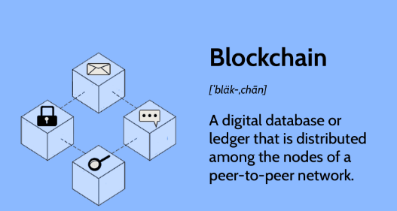
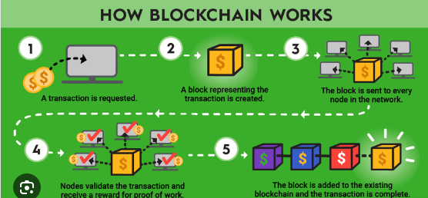

Key elements of a blockchain
Distributed ledger technology
All network participants have access to the distributed ledger and its immutable record of transactions. With this shared ledger, transactions are recorded only once, eliminating the duplication of effort that’s typical of traditional business networks.
Immutable records
No participant can change or tamper with a transaction after it’s been recorded to the shared ledger. If a transaction record includes an error, a new transaction must be added to reverse the error, and both transactions are then visible.
Smart contracts
To speed transactions, a set of rules — called a smart contract — is stored on the blockchain and executed automatically. A smart contract can define conditions for corporate bond transfers, include terms for travel insurance to be paid and much more.
How blockchain works
As each transaction occurs, it is recorded as a “block” of data
Those transactions show the movement of an asset that can be tangible (a product) or intangible (intellectual). The data block can record the information of your choice: who, what, when, where, how much and even the condition — such as the temperature of a food shipment.
Each block is connected to the ones before and after it
These blocks form a chain of data as an asset moves from place to place or ownership changes hands. The blocks confirm the exact time and sequence of transactions, and the blocks link securely together to prevent any block from being altered or a block being inserted between two existing blocks.
Transactions are blocked together in an irreversible chain: a blockchain
Each additional block strengthens the verification of the previous block and hence the entire blockchain. This renders the blockchain tamper-evident, delivering the key strength of immutability. This removes the possibility of tampering by a malicious actor — and builds a ledger of transactions you and other network members can trust.
Benefits of blockchain
What needs to change: Operations often waste effort on duplicate record keeping and third-party validations. Record-keeping systems can be vulnerable to fraud and cyberattacks. Limited transparency can slow data verification. And with the arrival of IoT, transaction volumes have exploded. All of this slows business, drains the bottom line — and means we need a better way. Enter blockchain.
Greater trust
With blockchain, as a member of a members-only network, you can rest assured that you are receiving accurate and timely data, and that your confidential blockchain records will be shared only with network members to whom you have specifically granted access.
Greater security
Consensus on data accuracy is required from all network members, and all validated transactions are immutable because they are recorded permanently. No one, not even a system administrator, can delete a transaction.
More efficiencies
With a distributed ledger that is shared among members of a network, time-wasting record reconciliations are eliminated. And to speed transactions, a set of rules — called a smart contract — can be stored on the blockchain and executed automatically.

Types of blockchain networks
There are several ways to build a blockchain network. They can be public, private, permissioned or built by a consortium.
Public blockchain networks
A public blockchain is one that anyone can join and participate in, such as Bitcoin. Drawbacks might include substantial computational power required, little or no privacy for transactions, and weak security. These are important considerations for enterprise use cases of blockchain.
Private blockchain networks
A private blockchain network, similar to a public blockchain network, is a decentralized peer-to-peer network. However, one organization governs the network, controlling who is allowed to participate, execute a consensus protocol and maintain the shared ledger. Depending on the use case, this can significantly boost trust and confidence between participants. A private blockchain can be run behind a corporate firewall and even be hosted on premises.
Permissioned blockchain networks
Businesses who set up a private blockchain will generally set up a permissioned blockchain network. It is important to note that public blockchain networks can also be permissioned. This places restrictions on who is allowed to participate in the network and in what transactions. Participants need to obtain an invitation or permission to join.
Consortium blockchains
Multiple organizations can share the responsibilities of maintaining a blockchain. These pre-selected organizations determine who may submit transactions or access the data. A consortium blockchain is ideal for business when all participants need to be permissioned and have a shared responsibility for the blockchain.
Blockchain security
Risk management systems for blockchain networks When building an enterprise blockchain application, it’s important to have a comprehensive security strategy that uses cybersecurity frameworks, assurance services and best practices to reduce risks against attacks and fraud.

2.DISTRIBUTED TRUST:
Trust is an unstable equilibrium. When two people trust each other, it only takes one of them to have doubts for the other to also start doubting. The result is that the parties descend into a state of mutual mistrust, a sentiment that is much less precariously balanced. It therefore takes energy to retain trust; yet it takes information to facilitate this energy. One of our era’s most violent breaks with established models concerns the source of this energy. France follows a model whereby energy is externalised: it is the nation’s judges, teachers, managers, parents, and so on, who are responsible for driving this energy. In the Anglo-Saxon model, the energy comes from both parties (or from the community, when there are several people involved). When eBay was created, it was not the only online auction and shopping website, but it invented the concept of buyers and sellers rating each other, a scoring feature that can now be found on all community sites such as Airbnb, BlaBlaCar, and so. What eBay understood is that trust could only be created by the community itself and not by the presence of third parties, which in its case would have meant expert auctioneers.
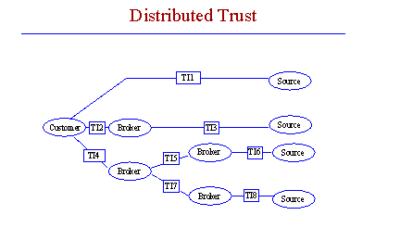

2.CURRENCY:
Currency serves as a means of exchanging commodities and services. Money in the form of paper or coins, issued by a government and accepted at face value, isknownascurrency.
In bartering, goods and services were exchanged directly for other goods and services . Currency has replaced bartering as the primary means of exchanging goods and services in themodernworld.



3.CRYPTOCURRENCY:
Cryptocurrency is a digital payment system that doesn't rely on banks to verify transactions. It’s a peer-to-peer system that can enable anyone anywhere to send and receive payments. Instead of being physical money carried around and exchanged in the real world, cryptocurrency payments exist purely as digital entries to an online database describing specific transactions. When you transfer cryptocurrency funds, the transactions are recorded in a public ledger. Cryptocurrency is stored in digital wallets.
Cryptocurrency received its name because it uses encryption to verify transactions. This means advanced coding is involved in storing and transmitting cryptocurrency data between wallets and to public ledgers. The aim of encryption is to provide security and safety.
The first cryptocurrency was Bitcoin, which was founded in 2009 and remains the best known today. Much of the interest in cryptocurrencies is to trade for profit, with speculators at times driving prices skyward.

4.How does cryptocurrency work?
Cryptocurrencies run on a distributed public ledger called blockchain, a record of all transactions updated and held by currency holders.
Units of cryptocurrency are created through a process called mining, which involves using computer power to solve complicated mathematical problems that generate coins. Users can also buy the currencies from brokers, then store and spend them using cryptographic wallets.
If you own cryptocurrency, you don’t own anything tangible. What you own is a key that allows you to move a record or a unit of measure from one person to another without a trusted third party.

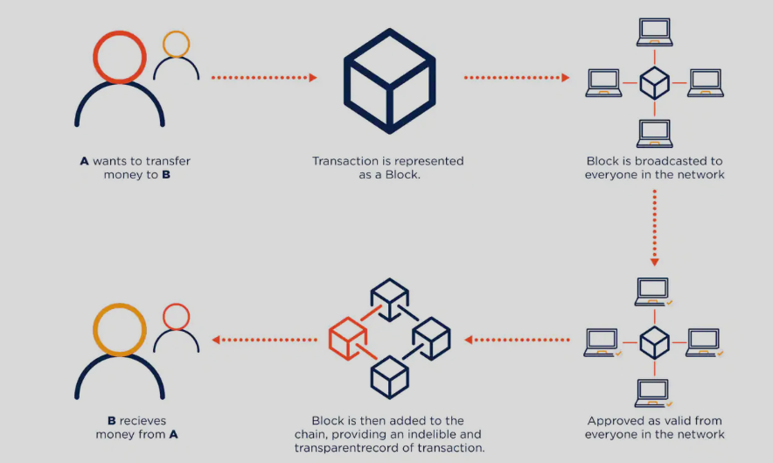

WORKING PROCEDUREOF CRYPTO CURRENCY
Although Bitcoin has been around since 2009, cryptocurrencies and applications of blockchain technology are still emerging in financial terms, and more uses are expected in the future. Transactions including bonds, stocks, and other financial assets could eventually be traded using the technology.

Cryptocurrency examples
There are thousands of cryptocurrencies. Some of the best known include:
Bitcoin:
Founded in 2009, Bitcoin was the first cryptocurrency and is still the most commonly traded. The currency was developed by Satoshi Nakamoto – widely believed to be a pseudonym for an individual or group of people whose precise identity remains unknown.
Ethereum:
Developed in 2015, Ethereum is a blockchain platform with its own cryptocurrency, called Ether (ETH) or Ethereum. It is the most popular cryptocurrency after Bitcoin.
Litecoin:
This currency is most similar to bitcoin but has moved more quickly to develop new innovations, including faster payments and processes to allow more transactions.
Ripple:
Ripple is a distributed ledger system that was founded in 2012. Ripple can be used to track different kinds of transactions, not just cryptocurrency. The company behind it has worked with various banks and financial institutions.
Non-Bitcoin cryptocurrencies are collectively known as “altcoins” to distinguish them from the original.

How to buy cryptocurrency
You may be wondering how to buy cryptocurrency safely. There are typically three steps involved. These are:
Step 1: Choosing a platform
The first step is deciding which platform to use. Generally, you can choose between a traditional broker or dedicated cryptocurrency exchange:
- Traditional brokers. These are online brokers who offer ways to buy and sell cryptocurrency, as well as other financial assets like stocks, bonds, and ETFs. These platforms tend to offer lower trading costs but fewer crypto features.
- Cryptocurrency exchanges. There are many cryptocurrency exchanges to choose from, each offering different cryptocurrencies, wallet storage, interest-bearing account options, and more. Many exchanges charge asset-based fees.
When comparing different platforms, consider which cryptocurrencies are on offer, what fees they charge, their security features, storage and withdrawal options, and any educational resources.
Step 2: Funding your account
Once you have chosen your platform, the next step is to fund your account so you can begin trading. Most crypto exchanges allow users to purchase crypto using fiat (i.e., government-issued) currencies such as the US Dollar, the British Pound, or the Euro using their debit or credit cards – although this varies by platform.
Crypto purchases with credit cards are considered risky, and some exchanges don't support them. Some credit card companies don't allow crypto transactions either. This is because cryptocurrencies are highly volatile, and it is not advisable to risk going into debt — or potentially paying high credit card transaction fees — for certain assets.
Some platforms will also accept ACH transfers and wire transfers. The accepted payment methods and time taken for deposits or withdrawals differ per platform. Equally, the time taken for deposits to clear varies by payment method.
An important factor to consider is fees. These include potential deposit and withdrawal transaction fees plus trading fees. Fees will vary by payment method and platform, which is something to research at the outset.
Step 3: Placing an order
You can place an order via your broker's or exchange's web or mobile platform. If you are planning to buy cryptocurrencies, you can do so by selecting "buy," choosing the order type, entering the amount of cryptocurrencies you want to purchase, and confirming the order. The same process applies to "sell" orders.
There are also other ways to invest in crypto. These include payment services like PayPal, Cash App, and Venmo, which allow users to buy, sell, or hold cryptocurrencies. In addition, there are the following investment vehicles:
- Bitcoin trusts: You can buy shares of Bitcoin trusts with a regular brokerage account. These vehicles give retail investors exposure to crypto through the stock market.
- Bitcoin mutual funds: There are Bitcoin ETFs and Bitcoin mutual funds to choose from.
- Blockchain stocks or ETFs: You can also indirectly invest in crypto through blockchain companies that specialize in the technology behind crypto and crypto transactions. Alternatively, you can buy stocks or ETFs of companies that use blockchain technology.
The best option for you will depend on your investment goals and risk appetite.

How to store cryptocurrency
Once you have purchased cryptocurrency, you need to store it safely to protect it from hacks or theft. Usually, cryptocurrency is stored in crypto wallets, which are physical devices or online software used to store the private keys to your cryptocurrencies securely. Some exchanges provide wallet services, making it easy for you to store directly through the platform. However, not all exchanges or brokers automatically provide wallet services for you.
There are different wallet providers to choose from. The terms “hot wallet” and “cold wallet” are used:
- Hot wallet storage: "hot wallets" refer to crypto storage that uses online software to protect the private keys to your assets.
- Cold wallet storage: Unlike hot wallets, cold wallets (also known as hardware wallets) rely on offline electronic devices to securely store your private keys.
Typically, cold wallets tend to charge fees, while hot wallets don't.

What can you buy with cryptocurrency?
When it was first launched, Bitcoin was intended to be a medium for daily transactions, making it possible to buy everything from a cup of coffee to a computer or even big-ticket items like real estate. That hasn’t quite materialized and, while the number of institutions accepting cryptocurrencies is growing, large transactions involving it are rare. Even so, it is possible to buy a wide variety of products from e-commerce websites using crypto. Here are some examples:
Technology and e-commerce sites:
Several companies that sell tech products accept crypto on their websites, such as newegg.com, AT&T, and Microsoft. Overstock, an e-commerce platform, was among the first sites to accept Bitcoin. Shopify, Rakuten, and Home Depot also accept it.
Luxury goods:
Some luxury retailers accept crypto as a form of payment. For example, online luxury retailer Bitdials offers Rolex, Patek Philippe, and other high-end watches in return for Bitcoin.
Cars:
Some car dealers – from mass-market brands to high-end luxury dealers – already accept cryptocurrency as payment.
Insurance:
In April 2021, Swiss insurer AXA announced that it had begun accepting Bitcoin as a mode of payment for all its lines of insurance except life insurance (due to regulatory issues). Premier Shield Insurance, which sells home and auto insurance policies in the US, also accepts Bitcoin for premium payments.
If you want to spend cryptocurrency at a retailer that doesn’t accept it directly, you can use a cryptocurrency debit card, such as BitPay in the US.

Cryptocurrency fraud and cryptocurrency scams
Unfortunately, cryptocurrency crime is on the rise. Cryptocurrency scams include:
Fake websites: Bogus sites which feature fake testimonials and crypto jargon promising massive, guaranteed returns, provided you keep investing.
Virtual Ponzi schemes: Cryptocurrency criminals promote non-existent opportunities to invest in digital currencies and create the illusion of huge returns by paying off old investors with new investors’ money. One scam operation, BitClub Network, raised more than $700 million before its perpetrators were indicted in December 2019.
"Celebrity" endorsements: Scammers pose online as billionaires or well-known names who promise to multiply your investment in a virtual currency but instead steal what you send. They may also use messaging apps or chat rooms to start rumours that a famous businessperson is backing a specific cryptocurrency. Once they have encouraged investors to buy and driven up the price, the scammers sell their stake, and the currency reduces in value.
Romance scams: The FBI warns of a trend in online dating scams, where tricksters persuade people they meet on dating apps or social media to invest or trade in virtual currencies. The FBI’s Internet Crime Complaint Centre fielded more than 1,800 reports of crypto-focused romance scams in the first seven months of 2021, with losses reaching $133 million.
Otherwise, fraudsters may pose as legitimate virtual currency traders or set up bogus exchanges to trick people into giving them money. Another crypto scam involves fraudulent sales pitches for individual retirement accounts in cryptocurrencies. Then there is straightforward cryptocurrency hacking, where criminals break into the digital wallets where people store their virtual currency to steal it.

Is cryptocurrency safe?
Cryptocurrencies are usually built using blockchain technology. Blockchain describes the way transactions are recorded into "blocks" and time stamped. It's a fairly complex, technical process, but the result is a digital ledger of cryptocurrency transactions that's hard for hackers to tamper with.
In addition, transactions require a two-factor authentication process. For instance, you might be asked to enter a username and password to start a transaction. Then, you might have to enter an authentication code sent via text to your personal cell phone.
While securities are in place, that does not mean cryptocurrencies are un-hackable. Several high-dollar hacks have cost cryptocurrency start-ups heavily. Hackers hit Coincheck to the tune of $534 million and BitGrail for $195 million, making them two of the biggest cryptocurrency hacks of 2018.
Unlike government-backed money, the value of virtual currencies is driven entirely by supply and demand. This can create wild swings that produce significant gains for investors or big losses. And cryptocurrency investments are subject to far less regulatory protection than traditional financial products like stocks, bonds, and mutual funds.

Four tips to invest in cryptocurrency safely
According to Consumer Reports, all investments carry risk, but some experts consider cryptocurrency to be one of the riskier investment choices out there. If you are planning to invest in cryptocurrencies, these tips can help you make educated choices.
Research exchanges:
Before you invest, learn about cryptocurrency exchanges. It’s estimated that there are over 500 exchanges to choose from. Do your research, read reviews, and talk with more experienced investors before moving forward.
Know how to store your digital currency:
If you buy cryptocurrency, you have to store it. You can keep it on an exchange or in a digital wallet. While there are different kinds of wallets, each has its benefits, technical requirements, and security. As with exchanges, you should investigate your storage choices before investing.
Diversify your investments:
Diversification is key to any good investment strategy, and this holds true when you are investing in cryptocurrency. Don't put all your money in Bitcoin, for example, just because that's the name you know. There are thousands of options, and it's better to spread your investment across several currencies.
Prepare for volatility:
The cryptocurrency market is highly volatile, so be prepared for ups and downs. You will see dramatic swings in prices. If your investment portfolio or mental wellbeing can't handle that, cryptocurrency might not be a wise choice for you.
Cryptocurrency is all the rage right now, but remember, it is still in its relative infancy and is considered highly speculative. Investing in something new comes with challenges, so be prepared. If you plan to participate, do your research, and invest conservatively to start.
5.CROWDFUNDING:
The Crowdfunding platform in block-chain makes different possibilities for the startups by raising the funds to create their own digital currency and it is peer-to-peer fund raising model some of the famous crowdfunding cryptocurrencies are coinspace, swarm, judobaby etc. Crowdfunding has offers for creators and other consumers. Anyone can participate in this crowdfunding if they have invented any new cryptocurrency (e.g., Ethereum) and also can contribute as much as they want.
How does BlockChain support Crowdfunding ?
There are several areas where block-chain supports and improves crowdfunding, crowdfunding platforms powered by blockchain technology removes the need for intermediate third party.
- Decentralization: Since block-chain is decentralized it doesn’t rely on any other platforms to create funds. for starters, no longer to be obliged to any rules and any project can get visibility and funded if the investors think to invest, eliminates fees which makes crowdfunding less expensive for the creators.
- Access Equity: To provide investors equity or ownership block-chain relies on asset tokenization. For example, a person who plans to create multiple new products with the incoming funds and grant small ownerships stake in the company.This could potentially open whole new world of opportunity.
- Universal Opportunity: Any project using a block-chain-based crowdfunding model can get funded. Any person with an internet connection can contribute projects.
- Flexible Options: Using block-chain as asset tokenization grants creators and entrepreneurs more liberties.usually asset tokens have their own currency to enable organizations to hire professionals and advertisers.
- Peer-to-Peer: The cryptocurrencies are exchangeable on a peer to peer network.This usually help the people for their investment which even generates more interest in the entire process.
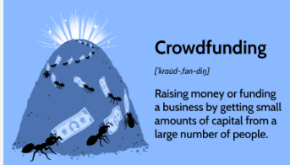



UNIT-II
2 MARKS QUESTIONS
1.Explain about Digital art?

Digital art is any artwork that draws upon digital technology as an essential part of its creative process.
It encompasses a wide range of techniques, from digital drawings, paintings, and illustration, to photos,
videos, and even sculpture.
2.Explain about crypto currency? What is the main Problem in crypto currency?
Cryptocurrencies have the following disadvantages. There is concern that cryptocurrencies like
Bitcoin are not rooted in any material goods. Some research, however, has identified that the cost
of producing a Bitcoin, which requires an increasingly large amount of energy, is directly related
to its market price.

3.What is encryption? What is its role in Block chain?

Encryption converts plaintext into ciphertext, or encrypted data that is unreadable, with the use of
an encryption algorithm or cipher. Only authorized users can access the data and are able to
decode the ciphertext back into readable plaintext. Encryption is - Scramble the data in a form
that it not readable by human being or it will take time to decrypt by the computer as well.
Block chain use Public/Private (RSA Security) key encryption.
Blockchain use this encryption to safe the data in the block, So it can be decrypt only by the
users having the valid private key.
.4. Proof of Elapsed Time(PoET)?
PoET is a consensus algorithm used in a permissioned blockchain network to decide on mining
rights and the next block miner. FYI, a permissioned blockchain network requires participants
to prove their identity and whether they are allowed to join.

5..list out some of the blockchain development tools?
A blockchain is “a distributed database that maintains a continuously growing list of ordered
records, called blocks.” These blocks “are linked using cryptography. Each block contains a
cryptographic hash of the previous block, a timestamp, and transaction data.
- Top 10 Blockchain Tools
  - Solidity
  - Hyperledger Fabric
  - Ethereum
  - Solc
  - Truffle
  - Ganache
  - Metamask
  - Remix
  - Geth
  - Web3.js
6.What is Digital identity verification?
Digital identity verification is the process of confirming an online identity. It confirms the people with digital identities exist, authenticates they are who they say they are, and investigates their reputation to help prevent fraud, mitigate risk and ensure compliance.

10 MARKS QUESTIONS
1.Extensibility of Blockchain concepts:
Blockchain technology was introduced to disrupt the financial sector. Many financial institutes and banks have leveraged blockchain to make transactions secure and remove intermediaries.
But blockchain technology is not only restricted to the finance sector. From automobile to retail, healthcare, manufacturing, and travel, every industry is investing in blockchain to avail its benefits.
The technical concept behind the blockchain is similar to that of a database, but the interaction with that database is entirely different.
For developers willing to learn blockchain development, it is essential to understand how they will write software applications in the future and how different blockchain concepts like consensus, trusted computing, smart contracts, and file storage systems interact with one another in a decentralized environment.
To make you learn how to develop blockchain applications or to implement
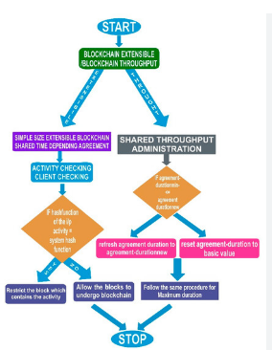

blockchain development in businesses, we have covered the following ground:

Understanding the basics of Blockchain Development
If you are a beginner, you should be familiar with the following terms:
- Blockchain
The blockchain is an incorruptible chain of blocks where each block contains data of value which is validated by all nodes in the network, not by any central authority. Each block in the chain includes its hash value and that of the previous block which acts as a unique fingerprint so that no one can tamper with data stored in it.The information stored on the blockchain can never be deleted or altered. Instead, a new block needs to be added to the chain to update the information.
- Decentralized
A blockchain is said to be decentralized as it is not stored in one place and does not have a center. Instead, the data saved in blockchain is distributed across many different computers, called as nodes.Since no single entity has control over the data, users interact with each other directly without the involvement of a third party.
- DecentralizedConsensus
A blockchain is a decentralized peer-to-peer system which has no central authority to control the exchange of information. Though no involvement of a central administrator keeps the system devoid of corruption, it raises the following questions:
  - How is a decision made in the blockchain?
  - How is a transaction added to the chain of blocks?
In a normal centralized model, a central authority or a board of decision-makers take all the required decisions. But it is not possible in the case of blockchain as it has no leader.
The members of a blockchain network need to come to a consensus via “consensus mechanisms” to make decisions. We shall discuss some of the significant consensus algorithms in detail.
- Smart Contracts
Smart contracts are the building blocks for blockchain-based applications. The concept behind smart contracts is the contractual governance of transactions between two or more participants. It can be verified programmatically with the blockchain, instead of a central authority.Also, smart contracts allow users to control ownership by offering controlled data disclosure.
- Mining
Mining is defined as the process of adding or validating transactions to the distributed ledger. It mainly involves creating a hash of a block that cannot be forged. As a result, it protects the integrity of the entire system without needing a central system. Miners are the users who utilize the computational power to mine for blocks.
Learning the basics of decentralized technology is not enough, there’s a lot to understand before moving to blockchain development. Let’s discuss some of the concepts which are common yet important for every blockchain enthusiast.

Following are some of the important concepts that are prerequisite for the blockchain development
- Programming Language- C, C++, Java, JavaScript, Python and Solidity.
- Data Structures- Linked List, Hyperledger, Acyclic Graph, HashTable and Associative Array.
- Security and Encryption- Secure Hashing Algorithm, Private Key and Public Key Pair.
- Networking Concepts- Multi-Threading and Socket Programming.
Whether you are a learner, innovator or entrepreneur, you should also know about the different blockchain consensus algorithms on the basis of which a blockchain platform can be chosen to build a dApp (decentralized application).

Mentioned below are some of the blockchain consensus algorithms which can be used for blockchain development
- ProofofWork
Proof of Work is the first consensus algorithm introduced in the blockchain network. It is used by various blockchain technologies to validate the transactions and add relevant blocks to the chain of a network. As a decentralized ledger contains all information related to the blocks, it is essential to take care of all transactional blocks.
It is the responsibility of miners to manage the transactions blocks which can be done with the process of mining. The concept behind this technique is to solve complicated mathematical problems and provide a solution. Since it requires a lot of computational power to solve a mathematical problem, proof of work has certain limitations. More a network grows, more the power is required.
Firstly, miners have to solve the puzzles to create new blocks and confirm the transactions. The complexity of a puzzle depends on the maximum number of users, overall load and the minimum current power of the network.
Bitcoin is the most common platform where proof of work algorithm is implemented. Ethereum also used the same consensus in 3-4 big projects, but now it has moved on to Proof of Stake.
- ProofofStake
Proof of stake is a blockchain consensus algorithm, designed to overcome the drawbacks of the proof of work algorithm.
In Proof of Stake algorithm, each block gets validated before another block is added to the ledger. Miners can participate in the mining process with their coins to stake.
The algorithm has introduced a new type of concept where everyone can mine or validate new blocks based on the coins they hold. So, the more coins an individual has, the more are the chances to become a miner.
The miners of the network are chosen randomly. If an individual has a specific amount of coins stored in the wallet, then he is qualified to act as a node on the network.
After becoming a node, an individual needs to deposit a specific amount of coins to be qualified as a miner. Voting is done to choose the validators.
Then, the miners can stake the minimum amount needed for the special wallet staking.
New blocks get created which are proportional to the number of coins in the wallet. For instance, if a person owns 10% of all the coins, he can only mine 10% of the new blocks.
- ProofofElapsedTime(PoET)
PoET is one of the best consensus algorithms, designed for permissioned blockchain network where you require permission to access the network.
The mining rights or voting principles are decided by the permissions networks.
Since the network requires identification of the miners, the consensus algorithm ensures a secure login into the system.
Therefore, PoET gives a chance to choose the winners via a fair means only.
The algorithm relies on a special CPU requirement, called “Intel Software Guard Extension”. The Software Guard Extension helps to execute unique codes within the network. Using this system, it ensures that the winning is purely fair.
- PracticalByzantineFaultTolerance(PBFT)
PBFT focuses on the state machine. It replicates the system but avoids the main Byzantine general problem.
Now, the question is how PBFT consensus works?
The algorithm assumes from the start that the network could have possible failures and independent nodes might not work properly at certain times.
So, PBFT is designed for asynchronous consensus systems and optimized in an efficient way to deal with the above issues.
Moreover, all the nodes in the system are arranged in a particular order.
Out of all the nodes, one node acts as the primary node while others work as the backup plan. However, all the nodes in the system perform their functions in harmony and interact with one another.
Once you understand the basics of blockchain development, it is the time to understand the various tools that contribute to the blockchain development.

Following are some of the blockchain development tools which can help ease the development process
- Geth
Geth is a command line interface, used to run a full Ethereum node in Go. The tool is designed to implement an Ethereum node in the Go programming language.By installing and executing Geth, a user can perform the following tasks

  - Mine Ether tokens.
  - Create smart contracts and send transactions on the Ethereum Virtual Machine.
  - Transfer funds between addresses.
  - Track the block history.
Operating systems such as Linux, Mac, and Windows support the installation of Geth. Also, this command line interface supports two types of installations, i.e., Binary and Scripted.
Using Geth, it can be possible to connect to the existing live blockchain and create its blockchain on the basis of provided settings.
- Mist
Before the development is started using Ethereum, it is essential to have a place where Ether tokens can be stored and smart contracts can be executed. Mist is a program which is connected to Geth in the background and acts as an interface for the wallet.

Though Mist is widely used for smart contract deployment, you must remember one thing. It is a full node wallet, i.e., one has to download the entire Ethereum blockchain, which is >1Tera Bytes (TB).Mist is supportable on Windows (both 32- and 64-bit), Linux (32- and 64-bit) and Mac. After the node gets fully synced, you will have an option to operate on the testnet or the mainnet.
- Remix
Remix is a suite of tools which has been designed to communicate with the Ethereum platform. It is used to debug transactions saved in the Git repository.

A developer needs to connect with an Ethereum node to use tools hosted by Remix.
Remix is comprised of the following tools
  - remix analyzer
  - remix-lib
  - remix-debug
  - remix-tests
  - remixd
  - remix-solidity
Remix IDE is a browser based compiler that allows users to develop Ethereum smart contracts with Solidity language. It also supports testing, deploying and debugging of smart contracts.
- Solc(SolidityCompiler)
Solidity is a loosely-typed language which has a syntax similar to that of ECMAScript used for creating the smart contracts on Ethereum blockchain. The role of Solc is to convert the solidity script into a format readable by the Ethereum Virtual Machine.

Solidity Compilers are of two types
  - solc : Coded in C++
  - solc-js : Uses Emscripten to cross-compile from solc C++ to JavaScript
Though both of the above compilers are built from the same source code, they come up with the different results.
- BlockchainTestnet
While writing any program for Ethereum Virtual Machine (EVM), it is important to consider the following things:

First, a user has to pay for gas usage and the launch of an application. So, no one would like to pay money for a project that has not been tested.
Secondly, an untested code can have some bugs which can create havoc to the Ethereum blockchain. Also, the information stored on Ethereum blockchain is immutable which cannot be undone.
Therefore, it is good to test a dApp before deploying it on the mainnet. Testnet is quite similar to the Ethereum blockchain which allows developers or users to test the application before deployment.

Here are the top blockchain platforms that support blockchain development
- Ethereum
Ethereum is an open-source blockchain based distributed computing platform founded by VitalkButerin in late 2013. Known for executing smart contracts on the custom-built blockchain, Ethereum uses EVM (Ethereum Virtual Machine) to offer the run-time environment.

No doubt that Ethereum a permissionless (public) blockchain platform, it is built for mass consumption versus restricted access. It has a native cryptocurrency called Ether, which is used to fuel the Ethereum ecosystem. A developer who builds the app on the top of the Ethereum platform has to pay in Ethers to execute transactions and run nodes.
Since Ethereum uses PoW(Proof of Work) consensus algorithm, its speed is comparatively slower as compared to other platforms.
- HyperledgerSawtooth
Hyperledger Sawtooth is a modular and enterprise-grade blockchain development platform which can be used to create, execute and deploy distributed ledgers to maintain digital records in a decentralized way.

PoET (Proof of Elapsed Time) consensus algorithm allows Hyperledger Sawtooth platform to integrate with hardware security solutions. Offering a solution to the Byzantine Generals Problem, PoET utilizes the trusted execution environment which enhances the efficiency of existing algorithms like Proof of Work.
Its modular architecture enables applications to select the transaction rules, consensus algorithms, and permissions as per the business needs.
- HyperledgerFabric
Intended to build blockchain based applications with a modular architecture, Hyperledger Fabric is another project of Hyperledger designed for permissioned networks. It only enables authorized identities to participate in a blockchain ecosystem.

The architecture of Hyperledger Fabric allows the team of network designers to plug in the preferred components such as consensus and membership services, separating it from other blockchain platforms.
- EOS
Designed and developed by a private company, Block.one, EOS is a blockchain platform that supports the development of decentralized applications (dApps).

EOS blockchain solution solves the issues of scalability with Ethereum and Bitcoin by offering smart contract capability, decentralized storage of enterprise solutions and hosting services. Transactions to be added to the EOS network accomplish consensus with a delegated proof-of-stake algorithm and multi-threading.
- HederaHashgraph
Based on Directed Acyclic Graph, Hedera Hashgraph is a fast, secure and fair Distributed Ledger Platform that does not require computing a heavy proof of work algorithm.

The transactions to be added to the network are validated via Gossip about Gossip and Virtual Voting consensus algorithm.
2.DIGITAL IDENTITY VERIFICATION :
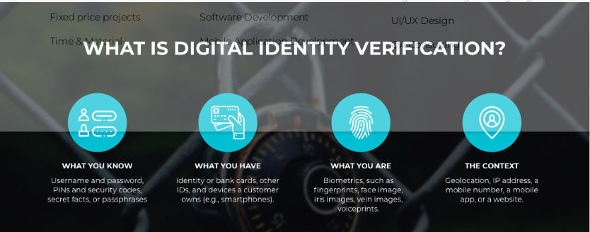

Blockchain identity systems enable users to monetize their own data, track how it’s used, and easily share and secure it.
In the off-chain world, “Digital Identity” (D-ID) refers to the aggregated information that is collected by various parties and platforms when a user spends time and conducts activities online. Data such as a user’s search history, social media activity, transaction history, usernames and passwords, call records, SSN, date of birth, credit history, medical history, and other important information routinely finds its way and is stored online, ultimately building a unique profile spread across multiple databases—each user’s Digital Identity.
Users have at their disposal a range of authentication and security tools to protect their data, but even the most secure online platforms can be hacked, leading to exposure of sensitive aspects of a user’s D-ID and putting them and the platforms at risk of identity theft and fraud. In fact, multiple studies have shown that hacked or leaked personal information is among the most frequently traded products on the dark web.
The way D-ID functions on a blockchain, by contrast, is at once more public and more private. Blockchains are decentralized, immutable ledgers (or databases), allowing for individuals to transact peer-to-peer while maintaining consensus concerning the ledger/data, ultimately creating a source of shared truth. Blockchains are public in the sense that any participant or even outsider can audit every transaction and address, and they’re private in the sense that, unless they’re explicitly permissioned, blockchains require no KYC (Know Your Customer) and users can participate anonymously with their blockchain addresses possessing little or no link to their off-chain identities.
One especially promising use case for blockchain technology is to improve the D-ID experience by applying the best features of blockchain technology to legacy D-ID systems. Though the architectural details vary, a blockchain-based D-ID solution would ideally allow users to selectively choose with whom and when they share their information, keep user information off of databases vulnerable to attack, allow users to better monetize their data, and better preserve user privacy. While this use case might seem trifling at first blush, it offers more than convenience and data security—by some estimates, digital identity and related industries could reach 3% of GDP by 2030.
This article will examine the risks and challenges associated with legacy D-ID implementations, break down how blockchain D-ID might solve them, and analyze four specific implementations relying on Chainlink oracles to connect personal information with the blockchain.

Current Flaws in D-ID
Though they can often go unnoticed to users who have come to accept them, the flaws of legacy D-ID systems are both systemic and pernicious. D-ID is a crucial element to making many of the online systems people rely on for everyday life work, but at nearly every step—from the collection, storage, and sale of data—D-ID is rife with security, privacy, and even ethical concerns. Ultimately, these problems can roughly be grouped into three categories: data monetization, data access, and data storage.

Data Monetization
An important part of D-ID is the data surreptitiously gathered by major internet platforms on a user’s behavior, habits, and biographical information. A search engine, for instance, might gather data about a user’s interests to tailor ads for them, or a social media site might sell information natively created by users to interested parties such as political campaigns. Because the details of these activities are often buried in terms-of-use agreements, users of these platforms ubiquitously and unwittingly enrich platforms with time spent ostensibly in leisure.
This process where users, by engaging in normal habits, unknowingly provide platforms with information that is then subsequently monetized is frequently referred to “free labor.” Proponents of free labor argue that this data monetization is a natural trade-off for access to what are often free services/platforms, and that they eventually benefit the user by allowing the platforms to grow faster and provide better user experiences.
However, free labor presents a host of ethical and privacy issues, often revolving around users being unclear about what data is being gathered, to whom it’s being sold, or where it’s being stored. Though some countries have attempted to place regulations on the data that can be collected by major platforms, free labor remains a rampant issue, with users all across the Internet unsure of what data is being gathered and what’s being done with it.

Data Access
Certain Internet platforms and services require a more complete D-ID profile to access than others. Social media sites may require just an email address (though they’ll subsequently build a profile on a user), while a lending service or a government agency might want a full financial or personal history before providing access and services through their portal. As a result, users are often forced to provide the same information about themselves over and over across different platforms. While the separation of databases may prevent a more catastrophic breach by isolating an attack, each database storing important user information ultimately increases the attack surface of a user’s data.
This puts users in a difficult position, having to choose between time-consuming processes and bureaucracy or storing their information for repeated use on databases that might potentially be vulnerable to attack. Additionally, this system also creates headaches for the platforms as well: government agencies might store redundant information across multiple servers, which leads to cost inefficiency, and other platforms might become more vulnerable to scams or theft as a result of user data leaks. In many instances, the platforms are ultimately the responsible parties for any financial losses associated with identity theft.

Data Security
As mentioned above, users frequently propagate information about themselves online, including financial information in order to make purchases or gain access to services. Access and security rarely go hand-in-hand, and the same holds true for D-ID—each website that stores information about a user presents a new attack vector through which their information might be stolen.
Given the level of the threat, one would expect that platforms would invest in superior security and privacy infrastructure. However, in spite of security efforts statistics indicate that data protection problems are getting worse, not better: upwards of 10% of the population is affected by identity theft every year, and that number is on the rise during the pandemic.

Blockchain-Based D-ID Solutions
Because of these flaws, D-ID is a space ripe for disruption from blockchain technology. By using blockchains to architect superior D-ID systems, many of the most glaring problems with D-ID can be solved and whole new use cases can be enabled.
The key features of a blockchain-based D-ID system would include: the ability for users to monetize the information they natively create and track how their information is being used; the ability to readily and easily share D-ID information; and the ability to keep that data secure. There are a range of unique approaches towards achieving these goals—including the potential of doing away with off-chain identities entirely—and each leverage blockchain in different ways.

DECO
One blockchain-based D-ID system is Chainlink’s privacy preserving oracle technology DECO—developed by Chainlink Labs Chief Scientist Ari Juels, researcher Fan Zhang, and others. While new D-ID storage solutions may alter how data is stored, the reality is that a lot of data is still stored in trusted databases. Many users/institutions may prefer the security of entrusting a high-security custodian to protect that data, especially governments and large enterprises.
DECO allows oracles to attest to the validity of information in trusted databases/systems without exposing it to the public or even the oracle itself using a cryptographic technique known as Zero Knowledge Proofs. Essentially, the oracle can join a user-initiated web session to attest to some requested information— possibly to verify someone’s identity, approve their financial information, or check key government records. Importantly, that data never leaves the secure, user-selected database, allowing a user to store their D-ID information in certain locations they trust and set up selective access, as opposed to propagating it to a variety of systems with weak guarantees on access control. This allows for a privacy-preserving plug-and-play option that combines the usability of legacy systems with the security of blockchain.
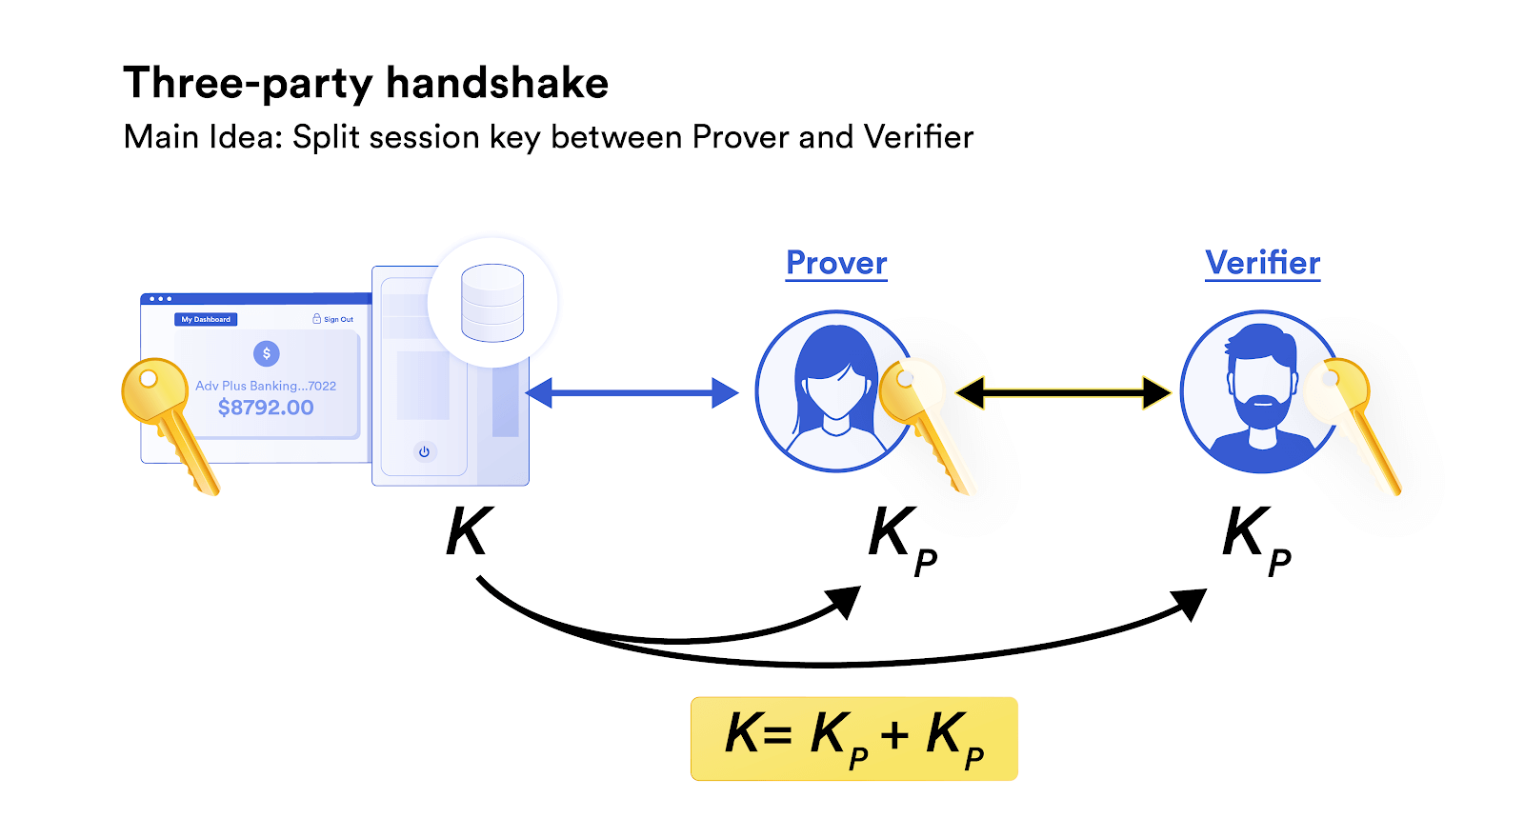
One of DECO’s main techniques involves a three-party handshake – a method in which the Prover (user) and Verifier (oracle) can combine their public TLS keys and form a combined request for data, without the Verifier ever receiving said data.
DECO’s privacy-preserving technology also allows for use cases that would otherwise have been impossible, such as big data medical studies. For years researchers have been excited about the potential of applying machine learning and computational analysis to large medical datasets, hoping to use these tools to make discoveries and breakthroughs that human analysis wouldn’t be able to find. However, the privacy and security concerns of patient data have long been a roadblock. DECO would allow researchers selective access to the data they need while complying with HIPA regulations and without putting that data at risk, potentially enabling a new era of medical research.

Bloom
Another example of a project using blockchain technology to enhance D-ID is Bloom, a decentralized identity protocol that allows users to claim, control, and selectively share their financial data while retaining full ownership via a decentralized architecture.
Bloom works by taking user-provided data and verifying each user’s identity, and then subsequently writing that data to the blockchain as an encrypted hash. This allows user information to be stored on a public ledger/source of truth while simultaneously maintaining privacy of it. It’s especially useful for financial information, which is one of Bloom’s core areas of focus—a recent blog post from Bloom laid out how Chainlink oracles help connect credit scores to DeFi protocols.
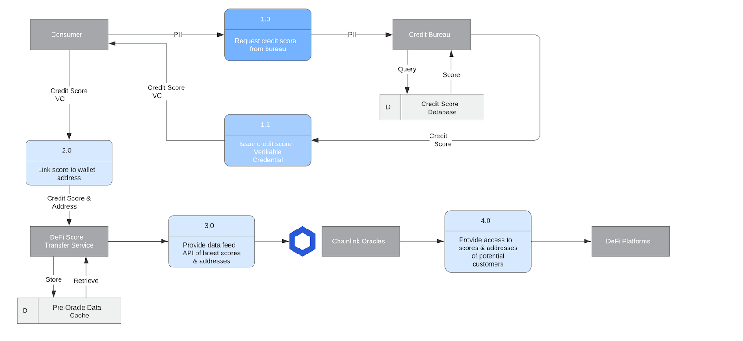
How Chainlink decentralized oracles connect credit scores to DeFi protocols.
“Bloom started as a protocol using smart contracts and Ethereum addresses to uniquely identify individuals and enable them to claim, store, and share verified identity attributes, with the goal of decentralizing the credit bureau model,” says Isaac Patka, CTO of Bloom. “As the technology evolved we joined forces with the larger decentralized/self-sovereign identity community to develop open and interoperable standards for identifying users, issuing credentials, and exchanging information. The identity standards have now matured to the point that we can take this technology to market and drive global impact. We are excited to realize our original vision of extending financial inclusion, and using platforms like Chainlink to bridge the gap between the traditional and decentralized worlds.”

Unstoppable Domains
Unstoppable Domains is decentralized blockchain-based protocol for registering and hosting Internet domain names as non-fungible ERC721 tokens on the Ethereum blockchain. Unstoppable Domains recently announced a new feature that uses Chainlink oracles to link Twitter users to specific domains, making it easy to identify and confirm a user’s public address based on their social media account. Additionally, users can send payments directly to the domains, bypassing often confusing Ethereum addresses for a superior UI/UX experience.
What makes this solution unique is that it can potentially bypass real-world information entirely. Twitter users can remain anonymous, but still have a named Internet domain linked to them that can send and receive blockchain-based payments. This allows for secure, highly intuitive transfer of value between parties whose identities are potentially entirely digital and don’t have to be stored in any centralized database.

Decentr
Decentr is a project that aims to provide a Web3 version of credit scores—what they call a “Personal Data Value” (PDV). Each user’s PDV would be sourced from a potential combination of social media activity, on-chain activity such as their total owned assets and history of repaying loans, and real-world data such as KYC/AML information. As discussed Decentr’s blog post, Chainlink oracles can supply this data to DeFi protocols across any blockchain, and users with high PDV values could potentially receive less collateralized or even collateral-free loans.
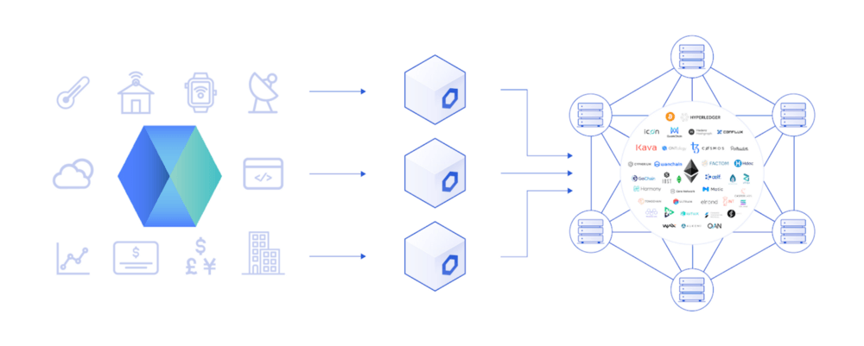
Decentr integrates with Chainlink to provide user-centric social reputation scores to DeFi.
Like Unstoppable Domains, this approach not only finds a way to securely connect off-chain data to D-ID using blockchain, but also bolsters the blockchain identity experience by taking valuable on-chain data and using it to create a D-ID profile of users. Privacy-focused users could potentially bypass using real-world information all together, and instead build their PDV value solely from their on-chain metrics.
2.BLOCKCHAIN NEUTRALITY:
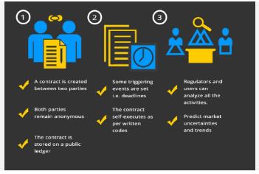

Blockchain technology is transforming how markets work.Blockchains eliminate the need for trusted gatekeepers likebanks to execute, verify, and recordtransactions.Inthefinancial markets, their disruptive potential threatens bothWall Street banks and Silicon Valley venture capitalists. Howblockchain technology is regulated will determine whether it
encourages or inhibits competition. Some blockchainapplications present serious fraud and systemic risks,complicating regulation. This Article explores the antitrust andcompetition policy challenges blockchain presents and proposesa regulatory strategy, modeled on Internet regulation and netneutrality principles, to unlock blockchain’s competitivepotential. It contends that financial regulators should promoteblockchain competition—and the resulting marketdecentralization—except in cases where specific applicationsare shown to harm consumers or threaten systemic safety.Regulators also should ensure openaccessandnon-discrimination on dominant blockchain networks. Thisapproach will not only serve traditional antitrust goals oflowering prices andpromotinginnovation,butitalsomightachieve broader economic and social reform by reducing the power and influence of the biggest financial institutions.

3.DIGITAL ART:
Crypto art is a blanket term coined to represent the fusion of art and blockchain technology. As a sub ecosystem within the world of cryptocurrencies, crypto art intends to preserve immutable versions of digital art such as music albums, paintings, awards and a wide range of memorabilia.

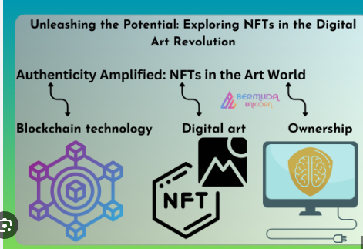

Crypto art is preserved on the blockchain in the form of nonfungible tokens, or NFTs, and are usually tied up with a monetary value. Just like traditional art forms, the value of crypto art or NFTs is heavily influenced by the credibility of the creator, the rarity of the art and its demand in the collector’s market.
As a collectible, NFTs and similar forms of digital art are capable of being publicly verified for authenticity and change of ownership. This allows every piece of art to be verifiably unique and hold a corresponding monetary value. Let’s dive deeper into the world of crypto art.

Who are the crypto artists?
The biggest drivers of the crypto art landscape are the artists that create/recreate pieces to be stored over the blockchain. Although NFTs can represent numerous aspects of the digital world, the first step begins with the creation of digital artwork. Digital art can be created by using readily-available software and a personal computer in the form of GIF, JPEG, videos, 3D images and similar art forms.
While the aforementioned digital art can be easily replicated and distributed over the internet, crypto artists need to certify and mint a nonfungible token that is linked to the authenticity of the art created. Once certified, the art can then be uploaded to various marketplaces and marketed to potential buyers.
It is important to note that crypto art is also subject to copyright laws and artists are expected to create, mint and sell unique NFTs while respecting the ownership of other artworks.

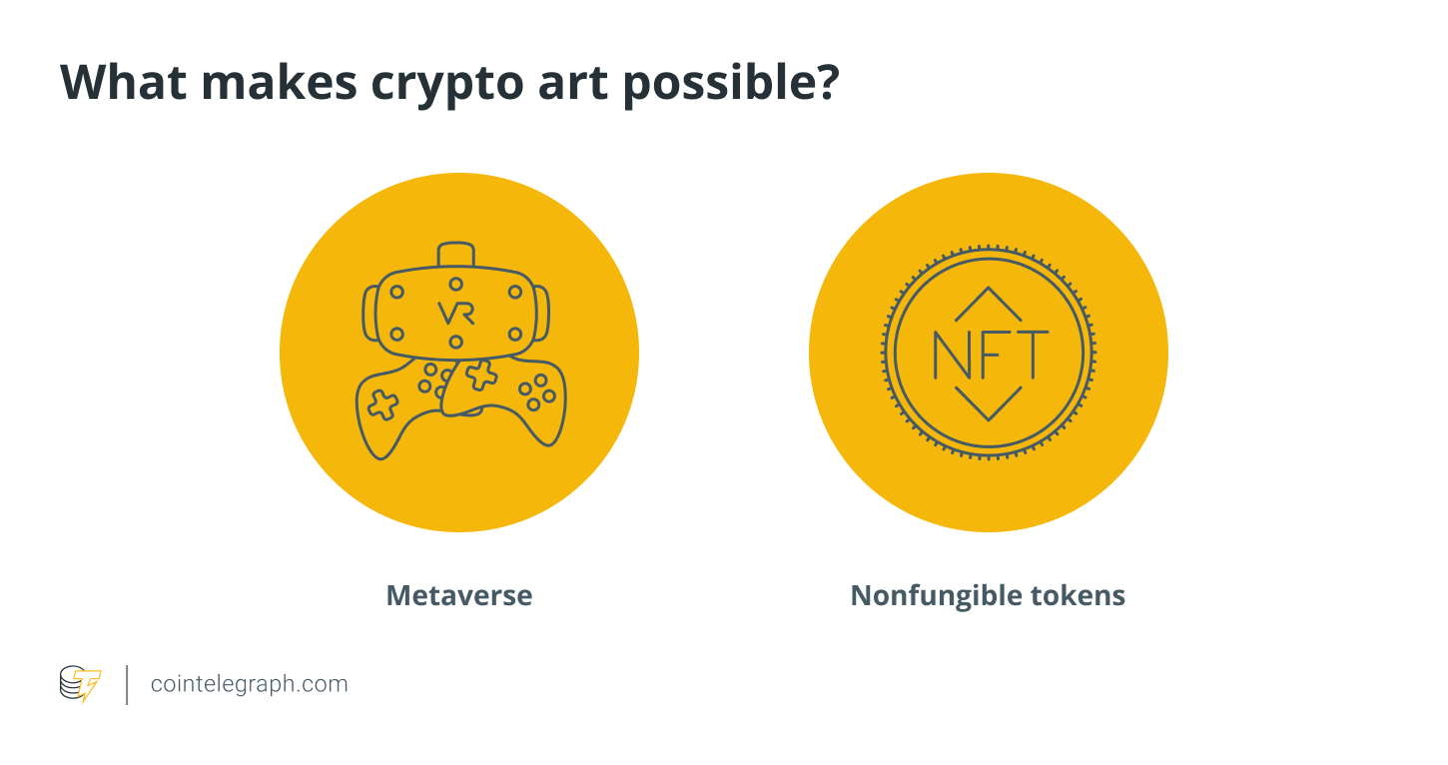

Metaverse
The term metaverse was coined in 1992 by Neal Stephenson, the author of the science fiction novel Snow Crash. This was the first time someone envisioned a full-interactable virtual world consisting of human avatars and 3D digital objects.
Metaverse is the most popular implementation of crypto art or NFTs, which makes use of digital art to represent objects in a fully-functional virtual world. The Metaverse allows users to create, own, create, purchase and sell virtual versions of shoes, clothes, property and other belongings.
A metaverse can also represent social communities where people from all over the world can participate in online meetups for conferences, meetings and parties. In a typical metaverse setting, users can interact with each other and co-participate in virtual reality (VR) events such as dancing to music or attending yoga classes in groups.
Metaverses has also found use cases in the gaming industry as developers create open-world games around the rising digital ecosystem. By infusing gamification, metaverses can be modified to depict interactive virtual worlds explorable through user-created avatars.
Given the untapped potential of possibilities within metaverses, major social media and tech corporations continue to explore various use cases primarily aimed at improving customer engagement. For example, social media giant Facebook renamed itself “Meta” to be more aligned with the development of a metaverse. Following suit, numerous tech giants are also exploring metaverse capabilities to identify the various revenue streams and customer engagement services.

Nonfungible tokens (NFT)
Nonfungible tokens are what make crypto art possible. While comparable to any other form of digital images including JPEG, GIF and 3D images, NFTs contain metadata that can help prove its value and ownership over a public blockchain.
Given the endless possibilities offered by digitalization, NFTs have evolved into representing real-world objects in metaverses and other virtual worlds. Online virtual stores facilitate retail purchases of digital clothes, shoes, property and other assets and merchandise.
Moreover, the true market value of NFTs is dictated by the rarity and the public demand for a particular collection or entity. Some of the mainstream examples of NFT adoption include the launch of music albums and the issuance of awards and fan tokens in various sport events.
In addition to representing aspects of the real world, artists make the most of this budding landscape to create art and market it to potential buyers across the globe. This also brings the opportunity for enthusiasts to recreate popular paintings and offer collectors a piece of priceless history.

How much does it cost to hang the crypto art on your wall?
While crypto art can be replicated and copied by simply downloading the image or taking a screenshot, the process leaves out the most important feature of the art, i.e., the metadata or the proof of its uniqueness.
Every digital art needs to be assigned a unique ID before it can be called NFT and possess a monetary value. As a result, the unique ID of the NFTs is what makes the arts one-of-a-kind, confirming the legitimacy of the art’s value and ownership. The typical prices of minting an NFT can range from as low as $1.00 to an average of $900, depending on the service provider and the blockchain host. However, unrealistic gas prices can drive up the NFT minting costs even higher.
The unique ID of an NFT artwork can be cross-checked across a network of public blockchains. When crypto art gets sold or transferred to a different user, the metadata gets timestamped over the blockchain network. Depending on the rarity and collector’s demand of the piece, an NFT can range anywhere from a few dollars to millions.
NFT marketplaces help the creator mint digital art into a nonfunglible token. The process typically involves the use of a native blockchain cryptocurrency wallet and cryptocurrency payment. Minting requires the creator to pay transaction fees or gas fees for updating the blockchain with the metadata about the crypto art in question, determined by the blockchain network and the stress or the current transactional capacity of the blockchain.

Weighing in the risks and rewards
The NFT marketplace, while rewarding, has opened new potential avenues for scammers and bad actors that target unsuspecting investors and collectors. Just like any other ecosystem that involves cryptocurrency and blockchain technology, investors and enthusiasts are advised to research heavily on the NFTs before making any commitments or purchases.
It is equally important for investors to confirm the metadata of the NFTs on their corresponding blockchains. Metadata is a term used to describe additional information about a particular object or an instance which, in the case of NFTs, involves information about minting, blockchain host, ownership and the creator details. The information available on the blockchain can be regarded as the only way to confirm the legitimacy of a crypto art offering.
As discussed, the credibility and the value of NFTs are directly linked to their creators and the demand in the resale market. That being said, even though the NFTs may check out in terms of authenticity, it does not guarantee high (or any) resale value. The resale value of NFTs is purely determined by the investor sentiment attached to the art.

Can crypto art be copied?
Contrasting to the popular belief that replicating crypto art is as simple as saving a copy of the image or video locally on a computing device, copying crypto art is technically impossible. For example, when a user attempts to “save” a crypto art, the person ends up saving an identical copy of the image but misses out on capturing the information that makes the NFT component of any digital art.
In many cases, the artist may choose to retain the copyright ownership of an NFT, which allows the artist to create and sell multiple copies of the same art. However, the metadata helps differentiate the ownership of similar-looking NFTs and ensures the credibility of the creator.
As discussed earlier, crypto art (just like any other form of art) is subject to copyright and wrongly claiming to be the creator can have negative consequences depending on the law of the land.

A peek into the future of NFTs, metaverse and crypto art
The future of crypto art will be determined by the people that believe in the ecosystem and its extent of mainstream adoption. Given the involvement of popular artists, musicians, sports persons and celebrities, crypto art has fortunately attracted a large number of people willing to buy, sell and collect art in the form of NFTs.
The existing use cases of the crypto art ecosystem involve art and interactive virtual worlds. With increased adoption, NFTs are slowly bleeding into the world of virtual asset purchases such as purchasing online versions of limited edition clothes, property and so on.
While the world of cryptocurrencies, especially crypto art, is yet to be tested for its full potential, the budding technology has already altered the way we look at precious collectibles and art in a virtual setup. As for its future, crypto art is well-positioned to be treated as an instrument of a virtual representation of every aspect of our day-to-day lives.
4.BLOCKCHAIN ENVIRONMENT:
Blockchain, a digital ledger technology, is widely known for its application to cryptocurrencies. Introduced in 2008 to serve as a public transaction ledger for Bitcoin, the technology has given rise to hundreds of cryptocurrencies (e.g. Ethereum, Ripple, NEO, Litecoin), as well as having other emerging applications in diverse fields, including supply chains, digital content, patents, smart contracts, governance and e-voting (EPRS, 2017).

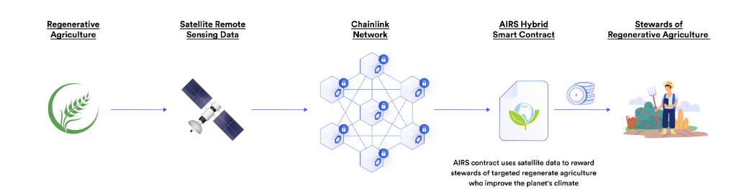
Understanding the basics of blockchain technology is essential to assess its implications, which are potentially huge and transformative for society, the economy and the environment. The European Union Agency for Network and Information Security (ENISA) defines blockchain as:
… a public ledger consisting of all transactions taking place across a peer-to-peer network. It is a data structure consisting of linked blocks of data … This decentralised technology enables the participants of a peer-to-peer network to make transactions without the need of a trusted central authority and at the same time relying on cryptography to ensure the integrity of transactions.
In contrast to the traditional ledgers used by banks and governments for centuries, which are centralised and inaccessible, blockchain ledgers are decentralised and transparent . There is no central authority acting as the exclusive manager of the ledger, with sole responsibility for storage, updates and verification of transactions. On the contrary, all participants of the blockchain network hold a copy of the ledger, and transactions — although encrypted — are visible to all.
Although participants may not know each other, such a decentralised ledger system is viable because it is made trustworthy and secure by design. Blockchain stores, shares and synchronises data as ‘chains of blocks’ using cryptographic techniques. Blocks represent recorded transactions, and each new block of transactions is linked to the previous ones, thus creating an ever growing chain . The creation of each new block must be approved by all network participants. This is achieved thanks to a predefined ‘consensus mechanism’ that sets the rules for the verification, validation and addition of transactions to the ledger .
The most common approach is ‘mining’, which relies on the ‘proof-of-work’ mechanism. To add a block of transactions to a blockchain, participants compete to find a solution to a difficult mathematical problem based on a cryptographic algorithm. When a ‘miner’ finds the solution, and after verification from other participants, the block is added to the blockchain. All copies of the ledger are updated, making the new changes permanent.
Furthermore, each block has a timestamp as well as a unique hash value
referring to previous blocks. The authenticity and integriy of transactions themselves are ensured by standard public-private key cryptography. With constant updates and validation made to the blockchain, as well as inspection of the complete history of transactions open (at least potentially) to everyone, make the ledger unique and immutable, ensuring trust among participants to operate their transactions. In addition, these transactions can be executed automatically, without the need for human intervention, thanks to self-executing computer codes — named ‘smart contracts’ — that contain the terms of contracts and are stored in the blockchain.
‘Permissionless’ blockchains, of the sort just described, allow anyone to access, verify and add transitions. But it is also possible to set up a ‘permissioned’ blockchain where access to and the validation or addition of transactions are restricted to a more limited group of people

How block chain change environment(Agriculture)

UNIT-III

- MARKS
1.How block chain is use in science?
1: Making Research Transparent
2: Making Data Storage Safer
3: Making Science Transparent
2.How does Block chain support crowd funding?
Using cryptocurrency or digital tokens, crowdfunding with blockchain technology entails raising money via a decentralized network. A distributed ledger using blockchain technology tracks each transaction and confirms it across several network nodes.
3.What is Blockchain currency? How many currencies are in Blockchain ?
cryptocurrency is a digital payment system that doesn't rely on banks to verify transactions. It’s a peer-to-peer system that can enable anyone anywhere to send and receive payments. Instead of being physical money carried around and exchanged in the real world, cryptocurrency payments exist purely as digital entries to an online database describing specific transactions. As of March 2024, there are 13,217 cryptocurrencies in existence. However, not all cryptocurrencies are active or valuable.
4.What is the use of Block chain in Genomics ?
Blockchain provides immutability such that the data cannot be altered, whether intentionally or accidentally. This is an important aspect of the system not only for personal, private data but also for large-scale open genomic data
5.Define Bit coin MOOCs?
This Massive Open Online Course (MOOC) is a basic introduction to Bitcoin (its system, network, protocol, blockchain and digital currency) for decision makers of enterprises, developers and students. Quasi MOOCs can be content-based (xMOOCs), task-based, network- based (cMOOCs). 4. hMOOC is the hybrid MOOC or MOOC 3.0. This concept supports hybrid or flipped classes (blended learning), integrates and combines on- line and face-to-face teaching/learning.
10 marks questions
1.what is the main purpose of Blockchain?

The main purpose of blockchain is to create a decentralized and transparent system for recording and verifying transactions. Unlike traditional systems, which rely on central authorities such as banks or governments to validate transactions and maintain records, blockchain technology allows for peer-to-peer transactions and eliminates the need for intermediaries.
Blockchain achieves this through the use of a distributed ledger, which is a decentralized database that is maintained by a network of nodes. Each node on the network has a copy of the ledger, and transactions are validated through a consensus mechanism that ensures that all nodes agree on the state of the ledger.
The key benefits of this decentralized and transparent system are increased security, privacy, and efficiency. Transactions on the blockchain are secure and tamper-proof, as they are validated and recorded using cryptographic techniques. Additionally, the decentralized nature of the system makes it more resistant to fraud or hacking attempts, as there is no single point of failure.
Blockchain technology has many potential applications, from financial services and supply chain management to voting systems and digital identity verification. Its ability to create trust and transparency in a decentralized environment makes it a promising solution for many industries and use cases.

2.what is Blockchain in Science?

Blockchain technology has many potential applications in science, particularly in the areas of data management and collaboration. Some of the ways that blockchain is being explored in science include:

1. Data management: Blockchain can be used to create secure and tamper-proof records of scientific data, such as experimental results, genomic data, or climate data. This can help to ensure the integrity and accuracy of the data, as well as make it easier to share and collaborate with other researchers.
2. Intellectual property: Blockchain can be used to create a decentralized and transparent system for managing intellectual property, such as patents or copyrights. This could help to reduce disputes over ownership and attribution, and make it easier for researchers to license and commercialize their work.
3. Collaboration: Blockchain can facilitate collaboration among scientists by creating a secure and transparent platform for sharing data and resources. For example, researchers could use blockchain-based systems to share research tools or datasets, or to collaborate on projects in real-time.
4. Funding: Blockchain can be used to create new models for funding scientific research, such as crowdfunding or tokenized investment. This could help to democratize access to funding and reduce reliance on traditional funding models.

Overall, blockchain technology has the potential to transform many aspects of scientific research, from data management and collaboration to funding and intellectual property. While there are still many challenges to be addressed, such as scalability and interoperability, the growing interest in blockchain among scientists and researchers suggests that it could play an increasingly important role in the future of science.

EXAMPLE-BIOMEDICAL RESEARCH

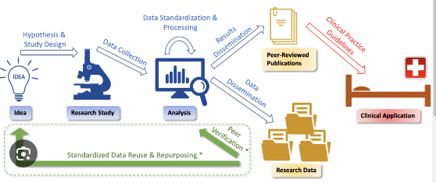

- This is a research project to develop a trustworthy, accountable, data sharing eco-system for biomedical research that utilizes knowledge representation and blockchain technologies to address the challenge of the costly and time-consuming effort needed to bring a biomedical innovation from the bench (basic research) to bedside (clinical level).
- An expressive, provenance-centric language, called SCIENCE Capability-based, Intention-centric, Experiment-oriented, Networked Collaborative Expression (SCIENCE) language will capture “science-capability” of the biomedical research datasets.
- A methodology for smart contracts will encode data use agreements and shared governance of data to create computational data use agreements supporting the automatic evaluation of compliance.
- Novel consensus mechanisms will enable reporting the impact of scientific data and the reproducibility of the research methods, thus providing incentives to scientists in supplying well-annotated, highly reusable data and reproducible research methods.

3.what is Gridcoin in Blockchain? Explain its role in Blockchain Science projects? How much is Grid coin worth today?

Gridcoin is a cryptocurrency that is designed to incentivize scientific research by rewarding users who contribute computing power to scientific projects. Unlike traditional cryptocurrencies, which rely on proof-of-work algorithms that require significant computational power, Gridcoin uses a proof-of-stake algorithm that rewards users for holding and staking coins, as well as for contributing computing power to scientific research projects.
The role of Gridcoin in blockchain science projects is to provide a financial incentive for users to contribute their computing power to scientific research. By contributing computing power to scientific projects, users can earn Gridcoin rewards, which can then be exchanged for other cryptocurrencies or used to support further scientific research.
Gridcoin's value is determined by market demand and supply, and is subject to fluctuations like any other cryptocurrency. As of May 5, 2023, the value of Gridcoin is approximately $0.020 USD per coin, according to CoinGecko. However, it is important to note that cryptocurrency prices can be highly volatile and subject to rapid fluctuations.

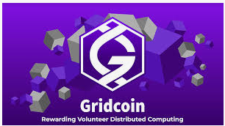

4.what is folding coin ? what are the Applications of folding coin?

FoldingCoin is a cryptocurrency that is designed to incentivize the folding of proteins for medical research. The Folding@home project is a distributed computing project that aims to simulate the folding of proteins in order to better understand diseases such as Alzheimer's, Parkinson's, and cancer. FoldingCoin rewards users for contributing their computer's processing power to the Folding@home project.
Some of the applications of FoldingCoin include:

1. Medical research: FoldingCoin supports the Folding@home project, which is focused on researching and understanding diseases that are caused by protein misfolding. By contributing computing power to the project, users can help accelerate medical research and potentially lead to new treatments for diseases.
2. Cryptocurrency mining: FoldingCoin can be mined using a computer's processing power, similar to other cryptocurrencies. However, instead of solving complex mathematical problems, FoldingCoin mining involves running protein folding simulations for the Folding@home project.
3. Charitable donations: FoldingCoin can be donated to charitable organizations that are focused on medical research or other causes. By donating FoldingCoin, users can support important causes while also earning rewards for their contributions to the Folding@home project.
Overall, FoldingCoin is an innovative cryptocurrency that combines the benefits of cryptocurrency mining with the potential to contribute to important scientific research. By providing an incentive for users to contribute their computing power to the Folding@home project, FoldingCoin has the potential to accelerate medical research and potentially lead to new treatments for diseases.

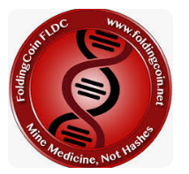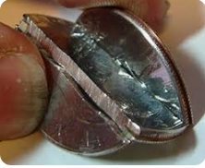

5. Explain about blockchain Genomics? What is The use of Blockchain in genomics?

Blockchain Genomics refers to the use of blockchain technology in genomics, which is the study of an organism's DNA sequence and structure. The use of blockchain technology in genomics has the potential to revolutionize the way genetic data is collected, stored, and shared.
The main use of blockchain in genomics is to create a decentralized and secure system for storing and sharing genetic data. With blockchain technology, genetic data can be stored in a distributed ledger that is encrypted and tamper-proof, which ensures that the data is secure and cannot be altered without authorization. This allows researchers to securely share and collaborate on genetic data, which can lead to new discoveries and treatments for genetic diseases.
Another use of blockchain in genomics is to create a system of incentives for individuals to contribute their genetic data to research projects. By providing individuals with ownership and control over their genetic data, and by incentivizing the sharing of that data through cryptocurrency rewards, blockchain technology can help overcome some of the privacy concerns that have historically limited the sharing of genetic data.
Overall, the use of blockchain in genomics has the potential to revolutionize the field of genetics and lead to new discoveries and treatments for genetic diseases. By providing a secure and decentralized system for storing and sharing genetic data, and by creating incentives for individuals to contribute their data to research projects, blockchain technology can help accelerate medical research and improve human health.

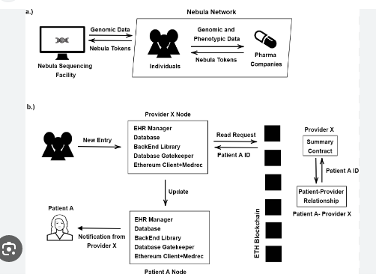

6.Explain about Blockchain MOOCS?

Blockchain MOOCs (Massive Open Online Courses) are online courses that teach blockchain technology and related topics to a large audience. These courses are designed to be accessible to anyone with an internet connection, and they typically use a combination of video lectures, interactive exercises, and discussion forums to help students learn about blockchain.
Blockchain MOOCs cover a wide range of topics, including the basics of blockchain technology, smart contracts, decentralized applications (DApps), and cryptocurrencies. Some MOOCs also cover more advanced topics, such as blockchain governance, consensus algorithms, and scalability.
The benefits of blockchain MOOCs are that they are often free or low-cost, flexible, and accessible. They can be accessed from anywhere in the world and at any time, allowing students to learn at their own pace. Additionally, many blockchain MOOCs offer a certificate upon completion, which can be useful for demonstrating knowledge and skills to employers.
There are several platforms that offer blockchain MOOCs, including Coursera, edX, Udacity, and Blockchain at Berkeley. These platforms offer courses from top universities and industry experts, and they are a great way for individuals to learn about blockchain technology and related topics.

Ex: Blockchain MOOCS credit transfer system
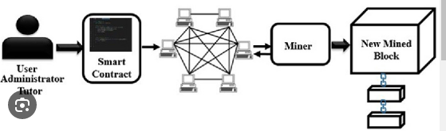

Transferring credits between universities worldwide is challenging and time consuming, and usually follows strict and complicated administrative guidelines. Students may encounter severe difficulties during such a process, primarily if they rely on those credits to transfer to another school or graduate on time. Universities may also find it challenging to compare massive online open courses (MOOCs) to courses offered in their traditional programs due to the need for more uniformity in course content and academic rigor. Administrators and professors may struggle to determine whether students have acquired the knowledge and skills necessary for credit transfer through the MOOC. The power of ChatGPT (Generative Pre-trained Transformer) may be employed in identifying and matching courses to MOOCs. At the same time, blockchain technology may provide a speedy and smooth process for credit transfer. A pilot structure that enables students to sign up for an MOOC and determine course equivalency without the challenges typically connected with credit-transfer issues or the recognition of courses taught outside their university is presented, piloted, and tested, significantly impacting the entire credit-transfer process.

UNIT-IV
1.Explain about Tokenizing ?
Digital asset tokenization is the process whereby ownership rights of an asset are represented as digital tokens and stored on a blockchain. In such cases, tokens can act
like digital certificates of ownership that can represent almost any object of value, including physical, digital, fungible,
and non-fungible assets.

2.Explain about Campus coin?
As a cryptocurrency, CampusCoin offers many advantages over conventional fiat money for members of the campus community: students, their parents, the school administration and, by extension, nearby retailers.
3.How can u make use of currency multiplicity?
Cryptocoin multiplicity is just one kind of currency multiplicity in the modern world. More broadly, we are living in an increasingly multi-currency society with all kinds of monetary and non-monetary currencies. First, there is currency multiplicity in the sense of monetary currency in that there are many different fiat currencies (USD, CNY, EUR, GBP, etc.). Second, there are many other non-fiat, non-cryptocurrencies like loyalty points and airline miles; one estimate is that there are 4,000 such altcurrencies [1]. Now there is also a multiplicity of blockchain-based cryptocurrencies like Bitcoin, Litecoin, and Dogecoin. Fourth, beyond monetary currencies, there is currency multiplicity in non-monetary currencies too like reputation, intention, and attention as discussed above.
4.What role do block chain technologies play in the development and management demurrage currency?
These currencies are based on blockchain networks and use smart contracts to function. Smart contracts are preprogrammed to automatically carry out the conditions of the parties' agreement. Smart contracts are employed in the case of demurrage currencies to control the currency's expiration date.
5.How can proactive government regulations promote innovation while protecting consumers
and public interests?
Regulatory innovation requires experimenting with new approachesc, such as sandboxes, and a shifting mindset that calls for protecting the public while ensuring sustainable market growth. Adopting regtech technologies that improve oversight and enforcement can promote regulatory innovation.

10 marks

1.What Is Currency?
Currency is a medium of exchange for goods and services. In short, it's money, in the form of paper and coins, usually issued by a government and generally accepted at its face value as a method of payment.
Currency is the primary medium of exchange in the modern world, having long ago replaced bartering as a means of trading goods and services.
In the 21st century, a new form of currency has entered the vocabulary and realm of exchange: the virtual currency, also known as cryptocurrency. Virtual currencies, such as Bitcoin and Ethereum, have no physical form or government backing in the United States. They are traded and stored electronically.

Understanding Currency
Currency in some form has been in use for at least 3,000 years. At one time only in the form of coins, currency proved to be crucial to facilitating trade across continents.1
A key characteristic of modern currency is that it is worthless in itself. That is, bills are pieces of paper rather than coins made of gold, silver, or bronze.
The concept of using paper as a currency may have been developed in China as early as 1000 BC, but the acceptance of a piece of paper in return for something of real value took a long time to catch on.2 Modern currencies are issued on paper in various denominations, with fractional issues in the form of coins.

Money vs. Currency
The terms money and currency are often thought to mean the same thing. However, while related, they have different meanings.
Money is a broader term that refers to an intangible system of value that makes the exchange of goods and services possible, now and in the future. Currency is simply one, tangible form of money.
Money is used in a variety of ways, all related to its future use in some kind of transaction. For example, money is a store of value. This means that it has and maintains a certain value that supports ongoing exchanges. People know that the money they received today essentially will have the same value next week when they need to make a purchase or pay a bill.
Money is also referred to as a unit of account. That means it can be used to account for changes in the value of items over time. Businesses use money as a unit of account when they prepare a budget or give assets a value. Profits and losses are established and relied upon using money as a unit of account.
Money also has certain properties that allow for the smooth exchange of goods:
- It is fungible, or, exchangeable, so that it doesn't need to be re-valued for every transaction.
- It is durable so that it lasts for many exchanges over time.
- It is convenient to carry and divide.
- It is recognizable so that people can trust it and confidently complete their exchanges of goods and services.
- The supply of money should be stable so that its value is reliable.
Understanding what money is clarifies the meaning of currency. It's a form of money used every day by people all over the world. Checks are another form of money (known as money substitutes). Cigarettes have even been a form of money, as they were for soldiers during the Second World War.3
The Bureau of Engraving and Printing is responsible for printing America's paper currency. Its parent agency is the U.S. Dept. of the Treasury.4 The U.S. Mint, founded in 1792, is "the nation’s sole manufacturer of legal tender coinage and is responsible for producing circulating coinage for the nation to conduct its trade and commerce."5

Types of Currency
The United States Mint defines currency as money in the form of paper and coins that's used as a medium of exchange.6 Currencies are created and distributed by individual countries around the world.
U.S. currency in paper form is issued by the Bureau of Engraving and Printing as $1, $2, $5, $10, $20, $50, and $100 bills. The $500, $1,000, $5,000, and $10,000 bills are no longer issued but those still in circulation are redeemable at full face value. Currency issued in 1861 or earlier is no longer valid and would not be redeemable at full face value.7
U.S. currency in the form of coins is issued by the Mint in denominations of 1¢, 5¢, 10¢, 25¢, 50¢, and $1.7
There are over 200 national currencies currently in circulation.8 Including the U.S., 42 countries either use the U.S. dollar or peg their currencies directly to the dollar.9
OANDA. "US Dollar Currency."
According to the International Monetary Fund (IMF) the dollar makes up 58.8% of the foreign exchange reserves.10
Most countries issue their own currencies. For example, Switzerland's official currency is the Swiss franc, and Japan's is the yen.1112 An exception is the euro, which has been adopted by most countries that are members of the European Union.13
Some countries accept the U.S. dollar as legal tender in addition to their own currencies, like the Bahamas, Zimbabwe, and Panama.8 For some time after the founding of the U.S. Mint in 1792, Americans continued to use Spanish coins because they were heavier and presumably felt more valuable.9
There are also branded currencies, like airline and credit card points and Disney Dollars. These are issued by companies and are used only to pay for the products and services to which they are tied.

Currency Trading
The exchange rate is the current value of any currency relative to another currency. As a result, rates are quoted for currency pairs, such as the EUR/USD (euro to U.S. dollar). Exchange rates fluctuate constantly in response to economic and political events.14
These fluctuations create the market for currency trading. The foreign exchange market where these trades are conducted is one of the world's largest markets, based on sheer volume. All trades are in large volumes, with a standard minimum lot of 100,000.15 Most currency traders are professionals investing for themselves or for institutional clients that include banks and large corporations.
The foreign exchange market has no physical address. Trading is entirely electronic and goes on 24 hours a day to accommodate traders in every time zone.16
For the rest of us, currency exchange typically is done at an airport kiosk or a bank before we go on a trip or while traveling.
Consumer advocates say that travelers get the best value by exchanging cash at a bank or at an in-network ATM. Other options may have higher fees and unattractive exchange rates.

What Does Currency Mean?
The term currency refers to the tangible form of money that is paper bills and coins. It's used as a medium of exchange that's accepted at face value for products and services as well as for savings and the payment of debt.

What's an Example of Currency?
One example of currency is any of the U.S. paper bills you may have on hand. It is any of the coins the U.S. issues, such as the penny, nickel, and quarter. Currency can also be the paper bills and coins issued by the governments of other countries across the globe.

What's the Difference Between Money and Currency?
Money is an intangible system of value that provides the means for the ongoing exchange of goods and services in a society. Money has taken many forms since it overtook the system of bartering. Currency is a tangible form of it. So, instead of, say, bartering agricultural produce for the clothing you may need, you can use currency (paper notes and coins) to obtain it.

What is a blockchain token?
A token represents a set of rules encoded in a smart contract. Each token belongs to a blockchain address. It’s essentially a digital asset that is stored securely on the blockchain.
Tokens are most often known to be cryptocurrencies such as Bitcoin or Ether tokens.
However, they can be anything from votes to licenses to ownership of a song.
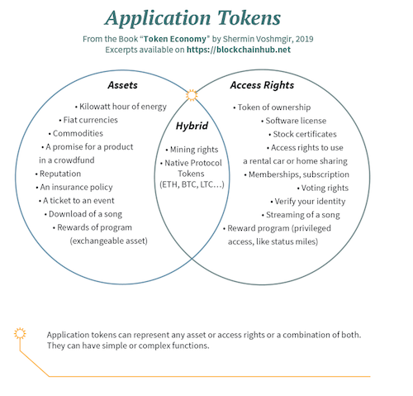
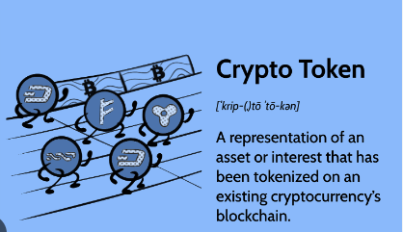

Tokens, as in the image above, are merely assets or access rights (or both). They grant permission and/or ownership to a user. They are a key part of how blockchain technology works.
Another distinction is that tokens are always created on existing blockchains.

So, tokens aren’t cryptocurrencies?
Tokens can be forms of cryptocurrency, such as Bitcoin or Ethereum. There are also stablecoin tokens, which are ‘cryptocurrencies’ that are backed by a real-world asset.
However, tokens often have nothing to do with crypto. A cryptocurrency unit is a token that is secured by cryptography – a token is not a cryptocurrency. A token merely means an asset that can be utilised by the user.
This means that the word ‘blockchain token’ doesn’t need to fill you with fear. It probably has nothing to do with crypto at all. Blockchain has spent many years trying to shed its Bitcoin reputation, yet it is a very valuable asset even outside of crypto.
A cryptocurrency coin is merely a coin and a form of currency. A token has much wider functionality.
To put it simply: look at Bitcoin. Bitcoin tokens can only be used as coins. They are a form of monetary value. Bitcoins have no value outside of finance.
Ether, on the other hand, can be used as a coin but also has other uses. Many blockchain companies use Ethereum for other uses outside of cryptocurrency. ERC-20 tokens can serve different purposes.
So, next time you hear the word ‘token’, don’t immediately shoot it down because you don’t want to be involved with crypto – it might have nothing to do with cryptocurrency at all.
Blockhead Technologies is creating blockchain-enabled tracking solutions, especially suited to the mining sector.

What is Tokenization?
Tokenization is the process of transforming ownerships and rights of particular assets into a digital form. By tokenization, you can transform indivisible assets into token forms.
For example, if you want to sell the famous painting Mona Lisa. You would need to find a seller who wants to shell out millions of dollars for it. Clearly, this reduces the number of people who have enough liquid cash worthy of buying it. But if we tokenize the painting. Then we can have multiple people with whom the ownership of that painting be shared.
Specifically, fractional ownership is possible. Say someone can be 1/25 owner of a painting or asset. It is only possible with tokenization, which provides an adequate solution over traditional solutions. Therefore, most cryptocurrency experts will bet on its usage and future prospects. That is why most experts suggest upskilling with a cryptocurrency course.
Tokenization in blockchain opens up multiple new possibilities for businesses and individuals. IDC, the global market intelligence firm, puts the tokenized asset market on the blockchain to be around $500 billion. The number is mind-blowing, but the concept of tokenization is not new and has been around for some decades.
Before the introduction of blockchain technology, we have used tokenization, especially in financial institutions from the 1960s, to safeguard our credit card details and transaction statements. Even hospitals use them to keep sensitive patient information, and governments use them to keep track of voter registration.
Traditional tokens save the information as alphanumeric tokens and later pass through a cryptographic function. This process makes sure that each token is unique. Blockchain tokenization is like this process.
But blockchain tokenization provides some additional benefits.
- Flexible tokenization of assets
- It comes with security similar to that of a cryptocurrency security
- Potential for broad application of tokens

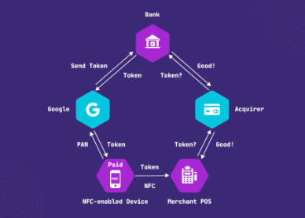

The technology behind blockchain tokens
We implement tokens using smart contracts in the blockchain, also known as token contracts. These contracts are computer programs that help verify the business rules and help transfer values from one user’s wallet to the next.
There are two basic ways to transfer values using a smart contract.
- First is the UTXO model. They introduced it by implementing the bitcoin technology, and many cryptocurrencies use this model. UTXO works by determining the amount of digital currency left in a user’s account after a successful cryptocurrency transaction.
- Then we have the Account-based model, which is used by Ethereum and Hyperledger fabric. When an order takes place, the nodes that are the network’s validators debit the amount from the sender’s account and credit it to the receiver’s account.

Types of Tokens

Security tokens
They are tokens that help validate the ownership of a particular asset or rights. They are the digital representation of an underlying asset. Along with that, they have all the benefits of traditional securities. Moreover, in security tokens, we can program it with the help of a cryptocurrency developer to have unique characteristics and features that suit our needs.
For example, you can trade real estate tokens and pay using the cryptocurrency of that chain.
Then there are some tokens whose value is determined by the underlying asset, such as those with off-chain assets like real estate, invoices—the more valuable the asset, the costlier the token.

Platform tokens
Platform tokens are used in the blockchain to help deliver decentralized applications. For example, you can interact with the Daaps built on the Ethereum network with token Dai. Along with that, as a platform token as we widely use it in the Ethereum network.

Utility tokens
Utility tokens are the most basic token on a blockchain network. They are used to access the services, power the consensus program, pay transaction fees, and even vote for new blockchain developments. Yes, they also work as governance tokens and are utilized in the decision-making process of DAOs.
Suppose, you want to learn more about DAO and ways to set up a DAO to take the pain out of managing your business. Then check out our cryptocurrency course, where we explain cryptocurrency in an easy and fun way.
While security tokens are used to establish ownership rights, utility tokens have more practical usage. This makes utility tokens much more valuable in terms of providing liquidity to a platform.
Note: Crypto tokens developed for a specific purpose can also be used for other purposes. For example, many people buy utility tokens hoping that the blockchain services and product range will grow. The token will see an increase in value.
Along with the above classification, we also have different types of assets that we can convert into tokens.

Fungible Tokens
Fungible tokens mean they can be replicated or replaced. They are not unique.
Converting fungible assets into tokens is easier as you can divide them into fractional units. The most common type of fungible token is gold. Fungible token converters have an inbuilt abstraction layer that helps to facilitate interoperability and provide platform independence.

Non-Fungible Tokens
Non-fungible assets like a diamond, a baseball, or the painting of the Mona Lisa, which we mentioned above, cannot be broken into fractions. But when we convert them into non-fungible tokens, we can have full or partial ownership of them.
Non-fungible tokens are unique, and we can track the history of ownership on the blockchain. This makes sure that no one can replicate the token. Moreover, when a non-fungible asset is converted into a token. They start the process by providing an immutable digital signature. It will help to determine the uniqueness of the underlying asset.
If you have been watching blockchain and crypto-related news, you might have heard how NFT’s are the latest trend, with some of them selling for millions of dollars. The prospect of NFT opens a lot of real-life usage for tokenization. Even fortune 500 companies are racing to have NFT of their products.

Advantages of Tokenization
We have seen what tokenization is and the underlying technology. But it is crucial to understand its advantages as it will help us realize the reasons for its growth. So, here are its advantages in simple terms.

Assets Divisibility and More Liquidity
One of the significant benefits of tokenization in the blockchain is that it opens up the underlying assets to a broad audience. The divisibility of assets helps to achieve it. We can now take part in investments that have a high investment threshold. Thus, removing the liquid premium of hard-to-sell assets like prime real estate and artworks.
Tokenization also provides a broader geographic reach as blockchain is inherently global in nature. Anyone with a computer web browser can interact and keep track of the asset from any part of the world.
Asset divisibility also comes with the benefit of shared ownership. You can have a vacation home with 15 other people and agree on who will use the house during a specific time. This is just one example. There can be many more use cases.

Faster and Cheaper transactions
We can bypass all the intermediaries involved in a transaction with cryptocurrency tokens. Let us understand it with an example if we tokenize the deed of a house and put it on the blockchain. Then interested parties can directly buy the deed with cryptocurrency, and the smart contract will transfer the deed to the new owner after a successful transaction.
The process eliminates the need for a lawyer, banks, an escrow account, and even brokerage commissions. The process is simply cheap and efficient. Moreover, crypto tokens are on the blockchain network that means we can trade them 24/7 all around the globe.

Transparency
In a blockchain, all of the transactions are transparent and available to any computer interacting with the chain. That means you can dig up the previous owner history of an asset, thus increasing trust among potential buyers. Moreover, blockchain tokens also benefit from being immutable as all of the transactions are verified by the nodes.
All of this provides a level of trust that most traditional solutions cannot match.

How blockchain tokenization can help in enterprise systems
For a long time, we have propagated blockchain technology for enterprises. Blockchain provides businesses the flexibility, security, and transparency that most business solutions cannot offer.
On top of that, let us see in detail the benefits of implementing blockchain-based tokenization in businesses.
- Considerable reduction in transaction time between payment and settlement.
- Intangible assets like copyright and patents can be tokenized to increase shareholding. Tokenization will also help to understand the actual value of the assets.
- Asset-backed tokens like stable coins can be used for transactions. This reduces the dependency of enterprises on banks and other intermediaries.
- Loyalty-based tokens can be used to incentivize users to use a company’s products. Additionally, loyalty tokens bring transparency and efficiency as users interact and use loyalty rewards across different platforms.
- Renewable energy projects are costly. So, tokens issued against them will expand the investor pool while building trust.

Challenges to tokenization
As the world slowly adapts to blockchain technology, projects involved with blockchains like tokenization will require increased regulations. However, the tokenization of assets functions similarly to financial securities. But tokenized assets may not be subjected to such rules.
While most countries are implementing laws to encourage the growth of blockchain-based projects. However, some countries are taking strict actions against them, for example. The Securities and Exchange Commission (SEC) can classify certain tokens as securities in the USA. Without a doubt, it will invite a large amount of external scrutiny.
Another major concern is how security tokens-backed assets will be managed. For example, maybe thousands of foreign investors collectively own a tokenized hotel. There remains a big question on who will manage the hotel.
Again, if the underlying assets behind a token go missing. Like tokens backed by gold.
Then there is the issue of lack of undefined rules when the real world and blockchain environment overlaps. So, to summarize it, blockchain, a decentralized system, will still need some kind of third party or a centralized system.

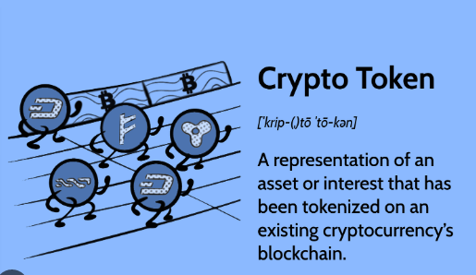

Coin Drop as a strategy for public adoption :
The world has moved to a higher sphere due to current technological innovations and advancements in computer science by introducing virtual currency, also known as Cryptocurrency. The Cryptocurrency that has captivated the world of computer science and economics is a digital currency first mentioned by Wei Dai in 1998. Wei Dai expressed the creation of a digital currency using cryptography as a control . In the white paper titled “Bitcoin: A Peer-to-Peer Electronic Cash System” in 2008, an anonymous person or group of programmers known as Satoshi Nakamoto introduced bitcoin, which operates on a digital ledger technology known as Blockchain . Blockchain is a record of digital transactions within a distributed database in which participants share data subject to verification by most network participants, eliminating the need for a central authority Aside from bitcoin, numerous cryptocurrencies exist, including Auroracoin, Dogecoin, Litecoin, Peercoin, and Ripplecoin [. Reference identified Bitcoin as the most popular, with a capital market value of one billion US dollars in 2016. Cryptocurrency is a peer-to-peer (P2P) digital currency system that allows electronic payments from one individual or entity to another while avoiding all forms of financial institutions. Unlike fiat currency, it is highly divisible, virtual, and independent of any higher authority.
The advent of this digital currency has affected several countries in different ways. For example, Nigeria, which is regarded as the most populous country in Africa, is estimated to have over 200 million people and is characterized by a high unemployment rate and a limited enabling environment for entrepreneurship and business ventures. The Nigerian Bureau of Statistics (NBS) published an unemployment rate of 33.3% in the fourth quarter of 2020, of which 42.5% are youths. As a sequel to this, many had to resort to blockchain and cryptocurrency to improve their economic status. Thus, within a short time, Nigeria generated the second-largest volume of traded bitcoin worldwide . According to , Nigeria took the world by surprise when it published a P2P bitcoin trading volume worth $1.5 billion in the first quarter of 2021. Similarly, a leading financial information media in Nigeria known as Nairametrics disclosed that in the third quarter, Nigeria published an all-time high trading volume worth $1.5 billion on Paxful (an online marketplace for bitcoin trading). Abiodun further reiterated that Nigeria is in the same ranking as China, the US, and India in Paxful’s P2P ranking.
The number of exchanges in operation and the volume of transactions in Nigeria show that the younger generations are fascinated and enthralled by this digital financial innovation. According to ,there are approximately twenty cryptocurrency exchanges in Nigeria run by young Nigerians. He also claimed that between 2018 and 2019, an Austin-based job search site saw a 90% increase in job postings for bitcoin, other cryptocurrencies, and blockchain in Nigeria. Despite the economic boost, the government continues to outlaw the use of cryptocurrency, citing illegality and criminality. Regardless of the ban, Nigeria remains the African P2P bitcoin trading leader. Given the sizeable financial yield in bitcoin trading in Nigeria and the ardent benefits of virtual currency, can this financial technology be embraced and continuously maintained?
This research aims at strengthening the investigation into how digital currency is disrupting the financial sector, the relationship between the advantages of cryptocurrency and factors critical for its adoption and sustainability. This study contributes in the following ways:i.
Highlights on the factors that are considered advantages of cryptocurrency and the factors that are more critical for the adoption of cryptocurrency..
Empirically substantiating the critical industry areas operators engage in and how it has changed the funding and employment narratives.
3.Campus coin?
CampusCoin is a peer-to-peer network utilizing a cryptocurrency to revolutionize the ecosystem at schools worldwide. Simplifying this ecosystem using cryptocurrency can potentially solve a multitude of problems currently prevalent within schools today. The CampusCoin team recognizes two of the largest complications with implementing cryptocurrency on a global level are educating the masses on how to correctly use these cryptocurrencies, as well as the large barrier to entry that they currently face. Specifically targeting students will allow for the education of the ones who will be most greatly affected by the growing transition from fiat currency to digital currency.
An easy to use CampusCoin mobile app built for students, schools, and businesses near schools will serve different, unique purposes for each of these parties. Technological advancements such as a sub-ledger system for schools and businesses, a proprietary payment network termed the Cryptocurrency Payment NetworkTM, ATMs for students, and smart contracts capable of securely storing academic achievement will be implemented to serve unique needs for each. The Campus Ambassador Program as well as CampusCoin sponsored events at schools will be the primary educational marketing tools allowing CampusCoin to spread rapidly.
The CampusCoin Project is being finalized as a non-profit foundation used to give scholarships, loans and provide educational tools and resources to the students who need it most. The CampusCoin team is developing relationships with institutions to encourage their students and faculty to engage in the research and development of the new ecosystem, as they will be direct beneficiaries of this blockchain powered ecosystem. The potential improvements from utilizing a cryptocurrency within the school ecosystem are abundant.



The CampusCoin Project aims to facilitate the economic transition to the blockchain with user-friendly applications and crypto-education.
As blockchain technology sweeps the global economy, the CampusCoin Project is at the forefront of the crypto revolution. As part of our mission, we are spreading awareness of the benefits and uses of digital money and educating people about the blockchain and how to use the technology.
Blockchain technology is simplifying payments and changing how business is conducted. The CampusCoin Project aims to bring the benefits of crypto to college and university campuses.
As a cryptocurrency, CampusCoin offers many advantages over conventional fiat money for members of the campus community: students, their parents, the school administration and, by extension, nearby retailers.
Students:
- Quick and easy payments from a mobile device
- Secure storage of funds
- Great benefits when joining the Campus Ambassador Program
Schools:
- Rapid transaction settlement
- Financial tracking/data analysis using the blockchain
- Reduced processing costs
Businesses:
- Fast payment processing and lower costs
- Simplified transaction data tabulation for sales analysis
- Attract student customers who have CC
- Reduction of employee theft
Parents:
- Send money instantly to your children no matter where they are
- Save money toward your children’s educational future
- CampusCoin is a wonderful gift for any occasion. Watch for prepaid CampusCoin cards!
The Campus Ambassador Program will also facilitate university participation in the blockchain to simplify payments and provide an avenue of communication so the CampusCoin Project can build solutions to meet university needs.
Other Bounties:
Other CC bounties are also offered to promote the CampusCoin Project. Join the Discord group to participate and win free coins!
Crypto-education:
As cryptocurrency spreads around the world, the CampusCoin Project is focused on bringing the advantages of the blockchain to colleges and universities around the world. Our mission is to introduce students, parents, schools and merchants to the advantages of cryptocurrency and the blockchain so that they can learn how to safely use this technology of the future.
4. ) Coin drop as a strategy for Public adoption?
Coin drop as a strategy for Public adoption technology, a strong community, partnerships, and ongoing development. criteria, to create awareness, reward existing users, and encourage broader adoption. audience, as part of a marketing strategy to attract new users and create interest in the project.
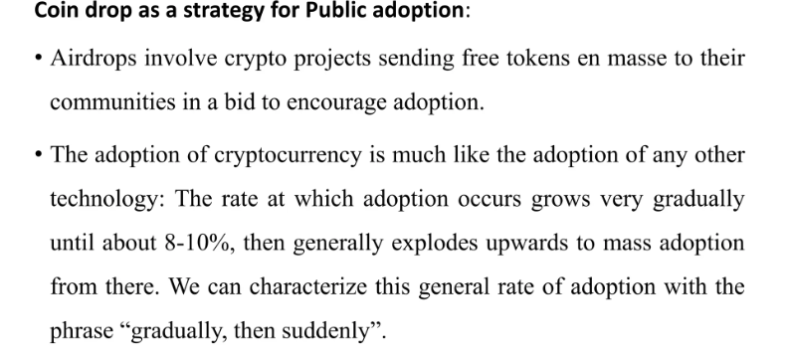
Currency multiplicity:
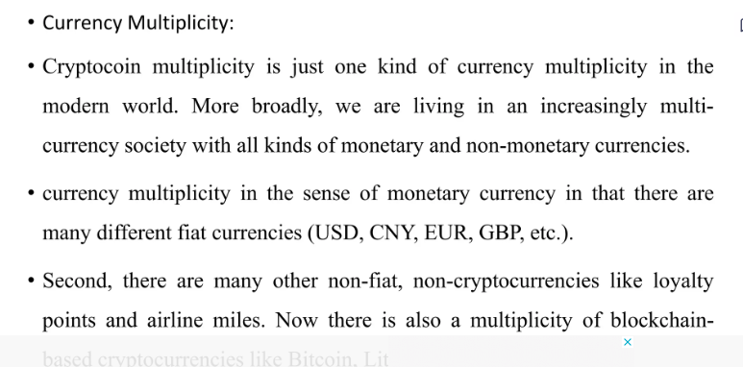
5.Demurrage Currency:
Demur-rage currencies in Blockchain
The way we do financial transactions has been completely transformed by blockchain technology. It has produced an unchangeable, decentralized system that guarantees security and transparency. However, the use of demurrage currencies in blockchain technology has been underutilized. Alternatives to conventional currencies, demurrage currencies offer distinctive qualities that draw people in. In this post, we'll look into blockchain-based demurrage currencies and their possible advantages.
What are Demurrage Currencies?
Demurrage currencies are those whose value depreciates over time. Demurrage currencies aim to increase consumption by discouraging hoarding. Demurrage currencies are not a novel idea; they have been applied in the past, notably during periods of economic unrest. The Wörgl money, which was used in Austria during the Great Depression, is the most well-known illustration of a demurrage currency. The local government utilized the Wörgl money to pay for public works projects, although it depreciated at a rate of 1% each month.
Currency issued under a demurrage has an expiration date, which sets it apart from conventional currencies. To accommodate the demands of the currency's users, this expiration date can be changed. A currency may, for instance, lose value at a rate of 1% per week or 1% per day. To promote spending and discourage hoarding, the expiration date was created.
How do Demurrage Currencies Work in Blockchain?
Demurrage currencies may now be created that are safe and transparent thanks to blockchain technology. These currencies are based on blockchain networks and use smart contracts to function. Smart contracts are preprogrammed to automatically carry out the conditions of the parties' agreement. Smart contracts are employed in the case of demurrage currencies to control the currency's expiration date.
The smart contract includes a provision for the currency's expiry date. The smart contract subtracts a specific percentage from the value of the currency at predetermined intervals when a user gets demurrage cash. Depending on the demands of the currency's users, this deduction can be programmed to happen daily, weekly, or monthly. It is impossible to halt or change the automatic deduction.
Benefits of Demurrage Currencies in Blockchain
There are several benefits to using demurrage currencies in blockchain, including:

Encouraging Spending: Demurrage currencies discourage hoarding and promote spending. This is because the currency loses value over time, so users are incentivized to spend it before it expires.
Stability: Demurrage currencies can provide stability in times of economic uncertainty. They can help prevent inflation and stabilize the value of a currency.
Sustainability: Demurrage currencies can promote sustainable practices by encouraging users to spend their currency on environmentally-friendly products and services.
Decentralization: Demurrage currencies are decentralized, meaning they are not controlled by a central authority. This makes them more resistant to manipulation and corruption.
Community Building: Demurrage currencies can be used to build communities around a shared set of values. For example, a demurrage currency could be used to fund local public works projects or support local businesses.

Specific Examples of Demurrage Currencies in Blockchain
There are several demurrage currencies that are currently being developed or are already in use in blockchain. Some examples include:
Freicoin: Freicoin is a cryptocurrency that was launched in 2013. It is a demurrage currency that loses value at a rate of 5% per year. The purpose of Freicoin is to encourage spending and prevent hoarding. Freicoin operates on the Bitcoin blockchain.
Circles: Circles is a blockchain-based social currency that was launched in 2020. It is a demurrage currency that loses value at a rate of 5% per month. The purpose of Circles is to promote community building and social interactions. Circles operates on the xDai blockchain.
Earth Dollar: Earth Dollar is a blockchain-based currency that was launched in 2018. It is a demurrage currency that loses value at a rate of 3.5% per year. The purpose of Earth Dollar is to promote sustainable practices and fund environmental projects. Earth Dollar operates on the Ethereum blockchain.
Mutual Credit: Mutual Credit is a blockchain-based currency that was launched in 2016. It is a demurrage currency that loses value at a rate of 5% per month. The purpose of Mutual Credit is to promote community building and local economic development. Mutual Credit operates on the Open Credit Network blockchain.
Challenges of Demurrage Currencies in Blockchain
Although demurrage currencies provide a number of advantages, they are not without drawbacks. The biggest obstacle is user acceptability. Users could be cautious to use demurrage currencies since they differ from conventional currencies. The difficulty of deploying demurrage currency on a big scale presents another difficulty. Governments and corporations must provide major technical infrastructure in order for this to be possible.

UNIT-V
1.Scandals and public perception of Blockchain?
Public Perception- The biggest drawback in the way of the success of Blockchain is the perception it holds in the eyes of people. Firstly, people don't see it be a part of mainstream functioning. Secondly, most of the people believe that this technology will not last long.

2.How can proactive government regulations promote innovation while protecting consumers and public interests?
Regulatory innovation requires experimenting with new approachesc, such as sandboxes, and a shifting mindset that calls for protecting the public while ensuring sustainable market growth. Adopting regtech technologies that improve oversight and enforcement can promote regulatory innovation.

3.In the content of business model what is the term subscription economy refer to, and how is changing trational business model?
The subscription economy refers to a business model where customers pay a recurring fee to access a product or service. This model has reshaped industries ranging from entertainment and software to fashion and food delivery
4.How Government Regulations are work in Bitcoin?

A cryptocurrency is a form of virtual or digital asset distributed across a huge number of computers based on a network. It is typically a decentralized digital fund designed to be over the net. It is not governed or regulated by any central authority or government

5.Write the Business Model Challrnges?
The first challenge is developing a product that meets the needs of the market. This can be difficult because it requires a deep understanding of the market and the needs of potential customers. The second challenge is creating a sales and marketing strategy that will generate demand for the product.

10 marks questions
1.what are The Technical challenges of blockchain ?

The technical challenges of blockchain include:

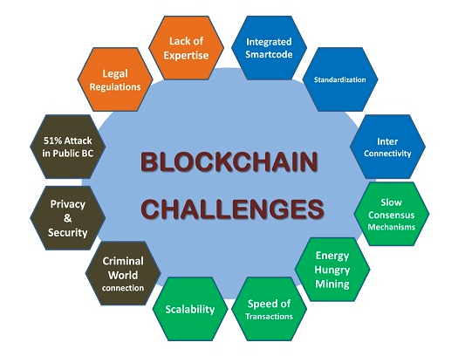

Mining is process intensive requiring ultra-powerful hardware and hence the total cost of the Blockchain network is high both in terms of capital investment and running costs. The return on investments on individual processing nodes may be a factor in an organizational decision-making process while adopting BCT.
Blockchain operations are slow compared to traditional transaction processing. This is because of the consensus mechanism, additional layers of obfuscation and encryption. The delay is worse in public BC. The delay is affordable to a large extent in private BC enterprise solutions. These enterprise solutions also look at selective consensus mechanisms to improve performance.
Interconnectivity across applications and organizations is of prime importance for enterprises while considering BCT. Blockchain architectures are almost standardized with large solution providers like Ethereum, Hyperledger, R3, Ripple, Stellar, etc., and address this interconnectivity. However, the fact that Github is listed with 6500+ BC open-source projects shows that the technology is yet maturing and nonstandard solutions do prevail for various reasons.
Scalability is a major issue in terms of performance considerations and cost implications.
Security is a bit concern with 51% attack in public Blockchain eco structure i.e. if 51% of the nodes vote in favour in a consensus protocol, these nodes gain control of the full network, even wrong could become right. This is a rare scenario but is a threat from powerful hijackers.
In the case of Supply chain BCT adoption, the integration of ERP tools of the manufacturing unit into the BC is the hurdle. ERP is important for manufacturing. Traceability is important in Supply chain. Interconnectivity is falling short because of the lack of ERP tools operating over BCT. The next hurdle is the efforts required to convince the suppliers in on-boarding to the BC Network.

Overall, these technical challenges must be addressed in order for blockchain technology to reach its full potential and become a widely adopted technology.

2.What are the business model challenge in Blockchain?

Blockchain technology presents several challenges to traditional business models. Here are some of the main challenges:

1. Disintermediation: Blockchain technology enables direct peer-to-peer transactions, which reduces the need for intermediaries such as banks, brokers, and other financial institutions. This can disrupt existing business models that rely on intermediaries for revenue.
2. Tokenization: Tokens are digital assets that can represent ownership or value in a particular asset or network. Tokenization can create new revenue streams, but it also requires new business models to be developed.
3. Governance: Blockchain networks are typically decentralized and have no central authority. This can make it difficult to govern and make decisions about changes to the network, which can impact the sustainability of the business model.
4. Regulatory compliance: Blockchain technology presents challenges to traditional regulatory frameworks, particularly in areas such as data privacy, consumer protection, and financial regulation. Companies must navigate these challenges in order to comply with existing regulations and ensure legal compliance.
5. Talent acquisition: As blockchain technology is still relatively new, there is a shortage of skilled professionals who understand the technology and can implement it effectively.
This can make it difficult for companies to build and maintain blockchain-based systems.

Overall, businesses must navigate these challenges in order to successfully adopt blockchain technology and create sustainable business models that leverage the benefits of the technology.

Example:
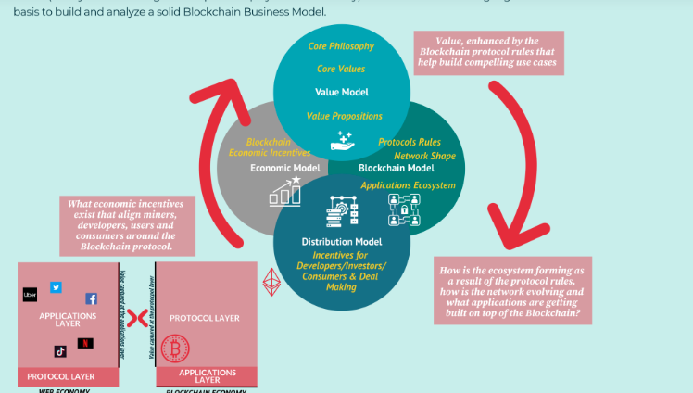

A Blockchain Business Model is made of four main components: Value Model (Core Philosophy, Core Value and Value Propositions for the key stakeholders), Blockchain Model (Protocol Rules, Network Shape and Applications Layer/Ecosystem), Distribution Model (the key channels amplifying the protocol and its communities), and the Economic Model (the dynamics through which protocol players make money). Those elements coming together can serve as the basis to build and analyze a solid Blockchain Business Model.

3.Explain about Scandals and public perception in Blockchain technology anc crypto currency?

Blockchain technology and cryptocurrencies have been surrounded by scandals and controversies that have affected public perception of the technology. Here are some examples:

1. Cryptocurrency scams: There have been numerous instances of cryptocurrency scams, where people have lost significant amounts of money due to fraudulent ICOs (initial coin offerings), Ponzi schemes, and other scams. These incidents have led to skepticism and distrust among the public.
2. Cybersecurity breaches: Cryptocurrency exchanges and wallets have been targets of cyber-attacks, resulting in the theft of millions of dollars worth of digital assets. These incidents have raised concerns about the security of blockchain technology and the vulnerability of digital assets.
3. Illegal activities: Cryptocurrencies have been associated with illegal activities such as money laundering, drug trafficking, and other illegal transactions. This has led to negative public perception of cryptocurrencies as being associated with criminal activities.
4. Lack of regulation: The lack of clear regulation and oversight in the cryptocurrency industry has contributed to negative public perception, as it is perceived as a risky and unregulated industry.

Overall, these scandals and controversies have contributed to a negative public perception of blockchain technology and cryptocurrencies. However, as the technology matures and more regulation is introduced, it is expected that the public perception will improve over time.

4.Explain about Government Regulations of Blockchain?

A blockchain technology and cryptocurrencies become more mainstream, governments around
the world are starting to take notice and regulate the industry. Here are some examples of
government regulations of blockchain:

1. Anti-Money Laundering (AML) and Know-Your-Customer (KYC) regulations:
Governments require companies dealing with cryptocurrencies to comply with AML and KYC regulations to prevent money laundering and terrorist financing.
2. Tax regulations: Governments require individuals and companies to report their cryptocurrency transactions and pay taxes on any profits earned from those transactions.
3. Securities regulations: Some countries consider cryptocurrencies to be securities and require them to be registered and regulated as such.
4. ICO regulations: Governments are starting to regulate ICOs to protect investors from fraud and ensure that they comply with securities regulations.
5. Data protection regulations: Governments are introducing regulations to protect user data on blockchain networks, particularly with regard to personal information and privacy.

Overall, government regulations of blockchain aim to protect consumers, prevent criminal activities, and ensure that the technology is used in a safe and responsible manner. As blockchain technology continues to evolve, it is expected that governments will introduce more regulations to keep up with the changing landscape.


