

Department of Computer Science and Engineering

Step Material

Subject: DESIGN AND ANALYSIS OF ALGORITHMS

Year: III Year/I SEM (R20)

Academic Year: 2023-2024

INSTITUTE VISION AND MISSION

_{Vision:}
To produce globally competent and industry-ready graduates in Computer Science & Engineering by imparting quality education with the know-how of cutting-edge technology and holistic personality.

_{Mission:}

1. To offer high-quality education in Computer Science & Engineering in order to build core competence for the graduates by laying a solid foundation in Applied Mathematics and program framework with a focus on concept building.
2. The department promotes excellence in teaching, research, and collaborative activities to prepare graduates for a professional career or higher studies.
3. Creating an intellectual environment for developing logical skills and problem-solving strategies, thus developing, an able and proficient computer engineer to compete in the current global scenario.

UNIT I DIVIDE AND CONQUER
SHORT ANSWERS
1. What is an algorithm?
An algorithm is a sequence of unambiguous instructions for solving a problem.
i.e., for obtaining a required output for any legitimate input in a finite amount of time.
2. What do you mean by Amortized Analysis?
Amortized analysis finds the average running time per operation over a worst case
sequence of operations. Amortized analysis differs from average-case performance in that
probability is not involved; amortized analysis guarantees the time per operation over
worst-case performance.
3. What are important problem types? (or) Enumerate some important types of
problems.
1. Sorting
2. Searching
3. Numerical problems
4. Geometric problems
5. Combinatorial Problems
6. Graph Problems
7. String processing Problems
Name some basic Efficiency classes
1. Constant 2. Logarithmic 3. Linear 4. nlogn
5. Quadratic 6. Cubic 7. Exponential 8. Factorial
5. What are algorithm design techniques?
Algorithm design techniques ( or strategies or paradigms) are general approaches
to solving problems algorithmatically, applicable to a variety of problems from different
areas of computing. General design techniques are:
(i) Brute force (ii) divide and conquer
(iii) decrease and conquer (iv) transform and conquer
(v) greedy technique (vi) dynamic programming
(vii) backtracking (viii) branch and bound
6. How is an algorithm’s time efficiency measured?
Time efficiency indicates how fast the algorithm runs. An algorithm’s time
efficiency is measured as a function of its input size by counting the number of times its
basic operation (running time) is executed. Basic operation is the most time consuming
operation in the algorithm’s innermost loop.
7. What is Big ‘Oh’ notation?
A function t(n) is said to be in O(g(n)), denoted t(n) O(g(n)) , if t(n) is bounded above
by some constant multiple of g(n) for all large n, i.e., if there exist some positive constant
c and some nonnegative integers n0 such that
t(n) ≤ cg(n) for all n≥ n0
9. Define order of an algorithm
Measuring the performance of an algorithm in relation with the input size n is
known as order of growth.
10. What is recursive call?
Recursive algorithm makes more than a single call to itself is known as recursive
call. An algorithm that calls itself is direct recursive.An algorithm”A” is said to be
indirect recursive if it calls another algorithm which in turn calls “A”.
11. What do you mean by stepwise refinement?
In top down design methodology the problem is solved in sequence (step by step)
is known as stepwise refinement.
12. How is the efficiency of the algorithm defined?
The efficiency of an algorithm is defined with the components.
(i) Time efficiency -indicates how fast the algorithm runs
(ii) Space efficiency -indicates how much extra memory the algorithm needs
13. Define direct recursive and indirect recursive algorithms.
Recursion occurs where the definition of an entity refers to the entity itself.
Recursion can be direct when an entity refers to itself directly or indirect when it refers to
other entities which refers to it. A (Directly) recursive routine calls itself. Mutually
recursive routines are an example of indirect recursion. A (Directly) recursive data type
contains pointers to instances of the data type.
14. What are the characteristics of an algorithm?
Every algorithm should have the following five characteristics
(i) Input
(ii) Output
(iii) Definiteness
(iv) Effectiveness
(v) Termination
Therefore, an algorithm can be defined as a sequence of definite and effective
instructions, which terminates with the production of correct output from the given input.
In other words, viewed little more formally, an algorithm is a step by step formalization
of a mapping function to map input set onto an output set.
15. What do you mean by time complexity and space complexity of an algorithm?
Time complexity indicates how fast the algorithm runs. Space complexity deals with
extra memory it require. Time efficiency is analyzed by determining the number of
repetitions of the basic operation as a function of input size. Basic operation: the
operation that contributes most towards the running time of the algorithm The running
time of an algorithm is the function defined by the number of steps (or amount of
memory) required to solve input instances of size n.
16. Define Big Omega Notations
A function t(n) is said to be in Ω(g(n)) , denoted t(n) Є Ω((g(n)) , if t(n) is bounded below
by some positive constant multiple of g(n) for all large n, i.e., if there exist some positive
constant c and some nonnegative integer n0 such that
t(n) ≥cg(n) for all for all n ≥ n0
17. What are the different criteria used to improve the effectiveness of algorithm?
(i) The effectiveness of algorithm is improved, when the design, satisfies the following
constraints to be minimum.
Time efficiency - how fast an algorithm in question runs.
Space efficiency – an extra space the algorithm requires
(ii) The algorithm has to provide result for all valid inputs.
18. Analyze the time complexity of the following segment:
for(i=0;i<N;i++)
for(j=N/2;j>0;j--)
sum++;
Time Complexity= N * N/2
= N2 /2
Є O(N2)
19. write general plan for analyzing non-recursive algorithms.
i. Decide on parameter indicating an input’s size.
ii. Identify the algorithm’s basic operation
iii. Checking the no.of times basic operation executed depends on size of input.if it
depends on some additional property,then best,worst,avg.cases need to be
investigated
iv. Set up sum expressing the no.of times the basic operation is executed.
(establishing order of growth)
20. How will you measure input size of algorithms?
The time taken by an algorithm grows with the size of the input. So the running
time of the program depends on the size of its input. The input size is measured as the
number of items in the input that is a parameter n is indicating the algorithm’s input size.
21. Define the terms: pseudo code, flow chart
A pseudocode is a mixture of a natural language and programming language like
constructs. A pseudocode is usually more precise than natural language. A flowchart is a
method of expressing an algorithm by a collection of connected geometric shapes
containing descriptions of the algorithm’s steps.
22. write general plan for analyzing recursive algorithms.
i. Decide on parameter indicating an input’s size.
ii. Identify the algorithm’s basic operation
iii. Checking the no.of times basic operation executed depends on size of input.if it
depends on some additional property,then best,worst,avg.cases need to be
investigated
iv. Set up the recurrence relation,with an appropriate initial condition,for the number
of times the basic operation is executed
v. Solve recurrence (establishing order of growth)
23. What do you mean by Combinatorial Problem?
Combinatorial Problems are problems that ask to find a combinatorial object-such
as permutation, a combination, or a subset--that satisfies certain constraints and has some
desired property.
24. Define Big Theta Notations
A function t(n) is said to be in Θ(g(n)) , denoted t(n) Є Θ (g(n)) , if t(n) is bounded both
above and below by some positive constant multiple of g(n) for all large n, i.e., if there
exist some positive constants c1 and c2 and some nonnegative integer n0 such that
c1 g(n) ≤t(n) ≤ c2g(n) for all n ≥ n0
25. What is performance measurement?
Performance measurement is concerned with obtaining the space and the time
requirements of a particular algorithm.
26. What is an algorithm?
An algorithm is a finite set of instructions that, if followed, accomplishes a
particular task. In addition, all algorithms must satisfy the following criteria:
1) input
2) Output
3) Definiteness
4) Finiteness
5) Effectiveness.
27. Define Program.
A program is the expression of an algorithm in a programming language.
Sometimes works such as procedure, function and subroutine are used synonymously
program.
28. What is recursive algorithm?
An algorithm is said to be recursive if the same algorithm is invoked in the body.
29. What is space complexity and time complexity ?
The space complexity of an algorithm is the amount of memory it needs to run to
completion. The time complexity of an algorithm is the amount of computer time it needs
to run to completion.
30. Give the two major phases of performance evaluation
Performance evaluation can be loosely divided into two major phases:
(i) a prior estimates (performance analysis)
(ii) a Posterior testing(performance measurement)
31. Define input size.
The input size of any instance of a problem is defined to be the number of
words(or the number of elements) needed to describe that instance.
32. Define best-case step count.
The best-case step count is the minimum number of steps that can be executed for
the given parameters.
33. Define worst-case step count.
The worst-case step count is the maximum number of steps that can be executed
for the given parameters.
34. Define average step count.
The average step count is the average number of steps executed an instances with
the given parameters.
35. Define Little “oh”.
The function f(n) = 0(g(n)) iff
Lim f(n) =0
n →∞ g(n)
36. Define Little Omega.
The function f(n) = ω (g(n)) iff
Lim f(n) =0
n →∞ g(n)
37. Write algorithm using iterative function to fine sum of n numbers.
Algorithm sum(a,n)
{ S : = 0.0
For i=1 to n do
S : - S + a[i];
Return S;
}
38. Write an algorithm using Recursive function to fine sum of n numbers,
Algorithm Rsum (a,n)
{
If(n≤0) then
Return 0.0;
Else Return Rsum(a, n- 1) + a(n);
39. Define the divide an conquer method.
Given a function to compute on ‘n’ inputs the divide-and-comquer strategy
suggests splitting the inputs in to’k’ distinct susbsets, 1<k <n, yielding ‘k’ subproblems.
The subproblems must be solved, and then a method must be found to combine
subsolutions into a solution of the whole. If the subproblems are still relatively large, then
the divide-and conquer strategy can possibly be reapplied.
40. Define control abstraction.
A control abstraction we mean a procedure whose flow of control is clear but
whose primary operations are by other procedures whose precise meanings are left
undefined.
Write the Control abstraction for Divide-and conquer.
Algorithm DAndC(P)
{
if small(p) then return S(P);
else
{
divide P into smaller instance p1,p2,…pk, k ≥1;
Apply DAndC to each of these subproblems
Return combine (DAnd C(p1) DAnd C(p2),----, DAnd (pk));
}
}
41.What is the substitution method?
One of the methods for solving any such recurrence relation is called the
substitution method.
42. What is the binary search?
If ‘q’ is always chosen such that ‘aq’ is the middle element(that is, q=[(n+1)/2),
then the resulting search algorithm is known as binary search.
43. Give computing time for Binary search?
In conclusion we are now able completely describe the computing time of binary
search by giving formulas that describe the best, average and worst cases.
Successful searches
Θ(1) Θ (logn) Θ (Logn)
best average worst
Unsuccessful searches
Θ (logn)
best, average, worst
45. Define external path length?
The external path length E, is defines analogously as sum of the distance of all
external nodes from the root.
46. Define internal path length.
The internal path length ‘I’ is the sum of the distances of all internal nodes from the root.
47. What is the maximum and minimum problem?
The problem is to find the maximum and minimum items in a set of ‘n’ elements. Though
this problem may look so simple as to be contrived, it allows us to demonstrate
divide and-conquer in simple setting.
48. What is the Quick sort?
Quicksort is divide and conquer strategy that works by partitioning it’s input
elements according to their value relative to some preselected element(pivot). it uses
recursion and the method is also called partition –exchange sort.
49. Write the Analysis for the Quick sort.
O(nlogn) in average and best cases
O(n2) in worst case
50. what is Merge sort? and Is insertion sort better than the merge sort?
Merge sort is divide and conquer strategy that works by dividing an input array in to
two halves,sorting them recursively and then merging the two sorted halves to get the
original array sorted
Insertion sort works exceedingly fast on arrays of less then 16 elements, though for large
‘n’ its computing time is O(n2).
51. Write a algorithm for straightforward maximum and minimum?
Algorithm straight MaxMin(a,n,max,min)
//set max to the maximum and min to the minimum of a[1:n]
{
max := min: = a[i];
for i = 2 to n do
{
if(a[i] >max) then max: = a[i];
if(a[i] >min) then min: = a[i];
}
}
52. what is general divide and conquer recurrence?
Time efficiency T(n)of many divide and conquer algorithms satisfies the equation
T(n)=a.T(n/b)+f(n).This is the general recurrence relation.
53. Write the algorithm for Iterative binary search?
Algorithm BinSearch(a,n,x)
//Given an array a[1:n] of elements in non decreasing
// order, n>0, determine whether x is present
{
low : = 1;
high : = n;
while (low < high) do
{
mid : = [(low+high)/2];
if(x < a[mid]) then high:= mid-1;
else if (x >a[mid]) then low:=mid + 1;
else return mid;
}
return 0;
}
54. Describe the recurrence relation for merge sort?
If the time for the merging operation is proportional to n, then the computing time of
merge sort is described by the recurrence relation
T(n) = a n = 1, a a constant
2T (n/2) + n n >1, c a constant

UNIT-I

Long Answer Questions:

1.What do you mean by algorithm? Write the characteristics of an algorithm?
Ans: Algorithm is a set of steps to complete a task.

For example,

Task: to make a cup of tea.
Algorithm:
- add water and milk to the kettle,
- boil it, add tea leaves,
- Add sugar, and then serve it in cup.

‘’a set of steps to accomplish or complete a task that is described precisely enough that a computer can run it’’.
An algorithm is a ﬁnite set of instructions that, if followed, accomplishes a particular task. In addition, all algorithms must satisfy the following criteria:
    - Input. Zero or more quantities are externally supplied.
    - Output. At least one quantity is produced.
    - Deﬁniteness. Each instruction is clear and unambiguous.
    - Finiteness. The algorithm terminates after a ﬁnite number of steps.
    - Effectiveness. Every instruction must be very basic enough and must be feasible.

  - Algorithms that are definite and effective are also called computational procedures.
  - A program is the expression of an algorithm in a programming language

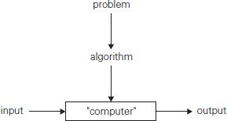

An algorithm has the following characteristics:

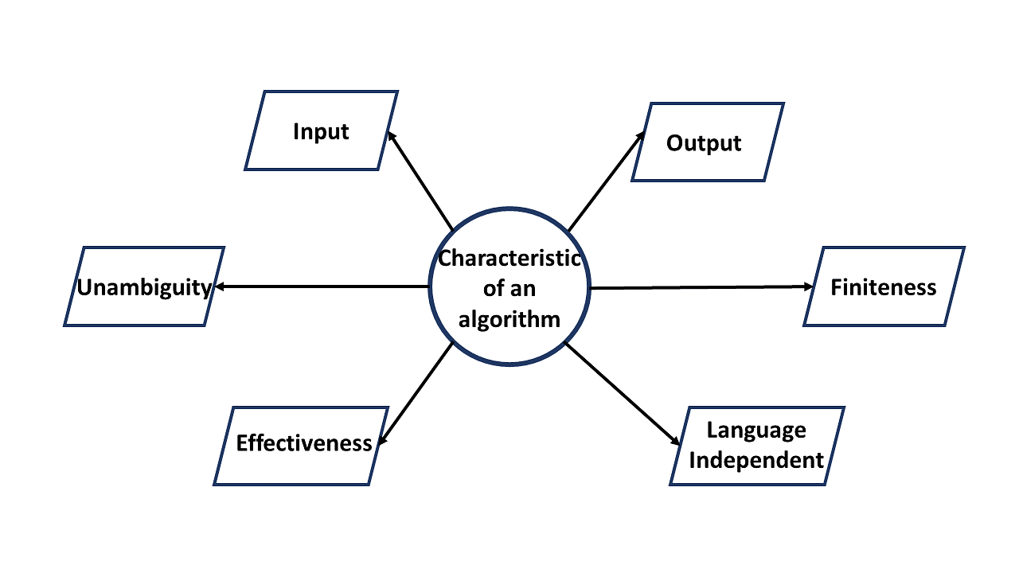
Input: An algorithm requires some input values. An algorithm can be given a value other than 0 as input.
Output: At the end of an algorithm, you will have one or more outcomes.
Unambiguity: A perfect algorithm is defined as unambiguous, which means that its instructions should be
clear and straightforward.
Finiteness: An algorithm must be finite. Finiteness in this context means that the algorithm should have a
limited number of instructions, i.e., the instructions should be countable.
Effectiveness: Because each instruction in an algorithm affects the overall process, it should be adequate.
Language independence: An algorithm must be language-independent, which means that its instructions
Can be implemented in any language and produce the same results.
2. What do you understand by Asymptotic Notations? Describe the type of Asymptotic Notations in brief?
Ans: ASYMPTOTIC NOTATION
ASYMPTOTIC NOTATION
Formal way notation to speak about functions and classify them
The following notations are commonly use notations in performance analysis and used to characterize the
complexity of an algorithm:
1. Big–OH (O) ,
2. Big–OMEGA (Ω),
3. Big–THETA (Θ) and
4. Little–OH (o)
Asymptotic Analysis of Algorithms:
Our approach is based on the asymptotic complexity measure. This means that we don’t try to count the
exact number of steps of a program, but how that number grows with the size of the input to the program.
That gives us a measure that will work for different operating systems, compilers and CPUs.
The asymptotic complexity is written using big-O notation.
• It is a way to describe the characteristics of a function in the limit.
• It describes the rate of growth of functions.
• Focus on what’s important by abstracting away low-order terms and constant factors.

Time complexity | Name | Example
O(1) | Constant | Adding an element to the front of a linked list
O(logn) | Logarithmic | Finding an element in a sorted array
O (n) | Linear | Finding an element in an unsorted array
O(nlog n) | Linear | Logarithmic Sorting n items by ‘divide-and-conquer’- Merge sort
O(n²) | Quadratic | Shortest path between two nodes in a graph
O(n³) | Cubic | Matrix Multiplication
O(2^{n}) | Exponential | The Towers of Hanoi problem

Big ‘oh’: the function f(n)=O(g(n)) iff there exist positive constants c and no such that f(n)<=c*g(n)
for all n, n>= no.
Omega: the function f(n)=(g(n)) iff there exist positive constants c and no such that f(n) >= c*g(n)
for all n, n >= no.
Theta: the function f(n)=(g(n)) iff there exist positive constants c1,c2 and no such that c1 g(n) <= f(n) <= c2 g(n)
for all n, n >= no

Big-O Notation
This notation gives the tight upper bound of the given function. Generally we represent it as f(n) = O(g (11)).
That means, at larger values of n, the upper bound off(n) is g(n). For example, if f(n) = n⁴ + 100n² + 10n + 50
is the given algorithm, then n⁴ is g(n). That means g(n) gives the maximum rate of growth for f(n) at larger
values of n.
O —notation deﬁned as O(g(n)) = {f(n): there exist positive constants c and no such that 0 <= f(n) <= cg(n)
for all n >= no}. g(n) is an asymptotic tight upper bound for f(n). Our objective is to give some rate of growth
g(n) which is greater than given algorithms rate of growth f(n).
In general, we do not consider lower values of n. That means the rate of growth at lower values of n is not important. In the below ﬁgure, no is the point from which we consider the rate of growths for a given algorithm. Below no the rate of growths may be different.

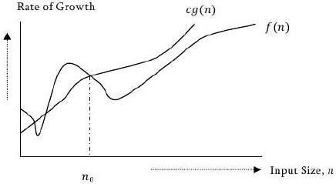
Note Analyze the algorithms at larger values of n only What this means is, below no we do not care for rates of growth.

Omega— Ω notation

Similar to above discussion, this notation gives the tighter lower bound of the given algorithm and we represent it as f(n) = Ω (g(n)). That means, at larger values of n, the tighter lower bound of f(n) is g
For example, if f(n) = 100n² + 10n + 50, g(n) is Ω (n²).
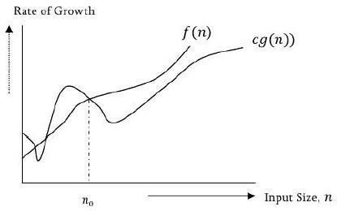
i.e. notation as be defined as Ω (g (n)) = {f(n): there exist positive constants c and no such that
0 <= cg (n) <=
f(n) for all n >= no}. g(n) is an asymptotic lower bound for f(n). Ω (g (n)) is the set of functions with smaller or same order of growth as f(n).

Theta- Θ notation
This notation decides whether the upper and lower bounds of a given function are same or not.
The average running time of algorithm is always between lower bound and upper bound.
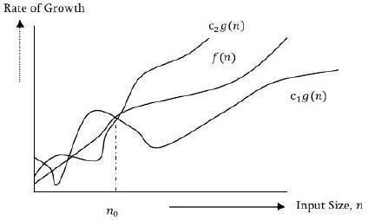
If the upper bound (O) and lower bound (Ω) gives the same result then Θ notation will also have the same rate of growth. As an example, let us assume that f(n) = 10n + n is the expression. Then, its tight upper bound g(n) is O(n). The rate of growth in best case is g (n) = 0(n). In this case, rate of growths in best case and worst are same. As a result, the average case will also be same.
None: For a given function (algorithm), if the rate of growths (bounds) for O and Ω are not same then the rate of growth Θ case may not be same.

Now consider the deﬁnition of Θ notation It is deﬁned as Θ (g(n)) = {f(71):
there exist positive constants C1, C2 and no such that O<=5 c1g(n) <= f(n) <= 2g(n) for all n >= no}. g(n) is an asymptotic tight bound for f(n). Θ (g(n)) is the set of functions with the same order of growth

Important Notes:
For analysis (best case, worst case and average) we try to give upper bound (O) and lower bound (Ω) and average running time (Θ). From the above examples, it should also be clear that, for a given function (algorithm) getting upper bound (O) and lower bound (Ω) and average running time (Θ) may not be possible always.
For example, if we are discussing the best case of an algorithm, then we try to give upper bound (O)
and lower bound (Ω) and average running time (Θ).In the remaining chapters we generally concentrate on upper bound (O) because knowing lower bound (Ω) of an algorithm is of no practical importance and we use 9 notation if upper bound (O) and lower bound (Ω) are same.

Little Oh Notation

The little Oh is denoted as o. It is defined as : Let, f(n} and g(n} be the non negative functions then
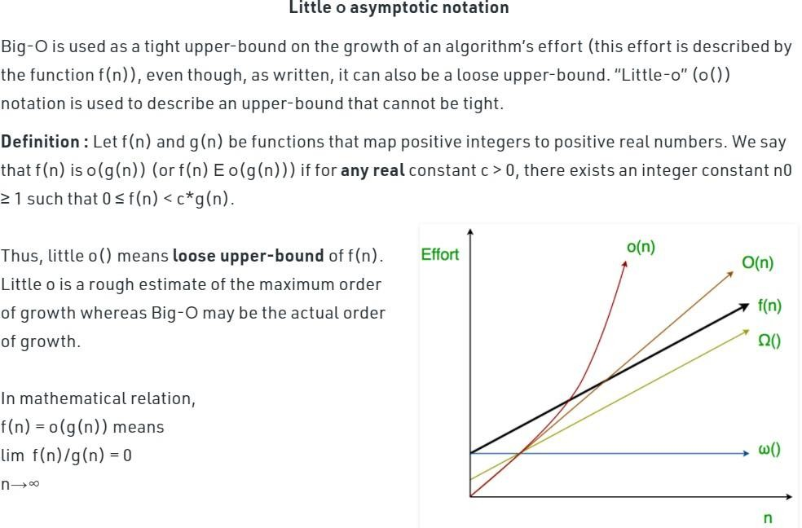

3. Explain the concept of DIVIDE AND CONQUER Method with suitable example?
Ans: General Method

In divide and conquer method, a given problem is,
- Divided into smaller subproblems.
- These subproblems are solved independently.
- Combining all the solutions of subproblems into a solution of the whole.

If the subproblems are large enough then divide and conquer is reapplied. The generated subproblems are usually of some type as the original problem.Hence recurssive algorithms are used in divide and conquer strategy.
Algorithm DAndC(P)
{
if small(P) then return S(P) else{
divide P into smaller instances P1,P2,P3…Pk;
apply DAndC to each of these subprograms; // means DAndC(P1), DAndC(P2)….. DAndC(Pk)
return combine(DAndC(P1), DAndC(P2)….. DAndC(Pk));
}
}
//P➔Problem
//Here small(P)→ Boolean value function. If it is true, then the function S is

//invoked

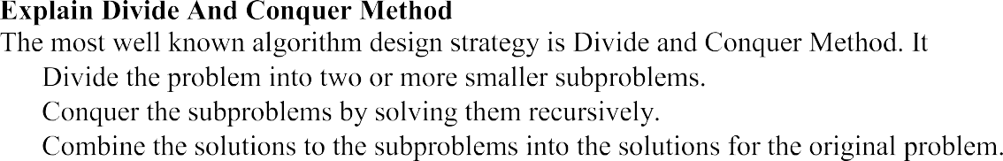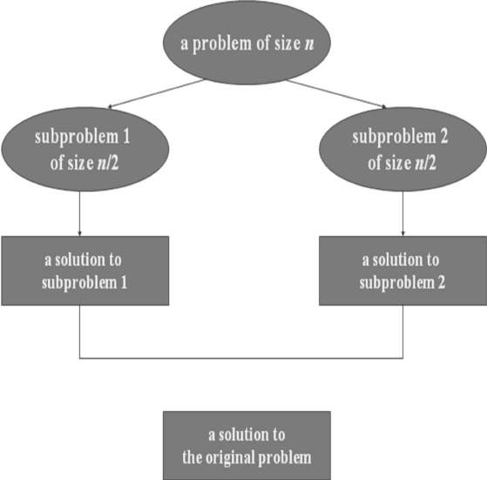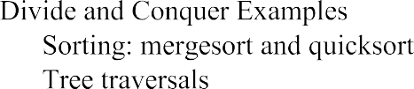

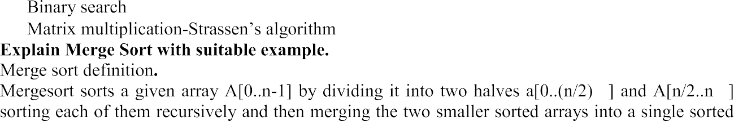

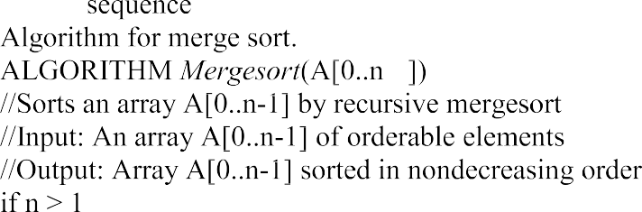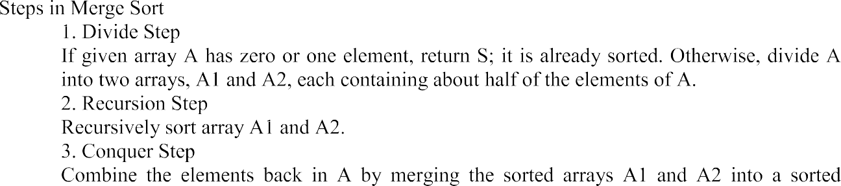
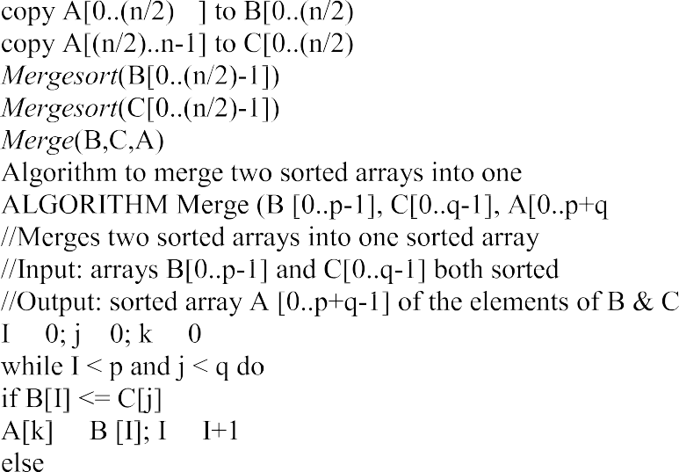
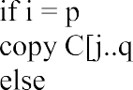
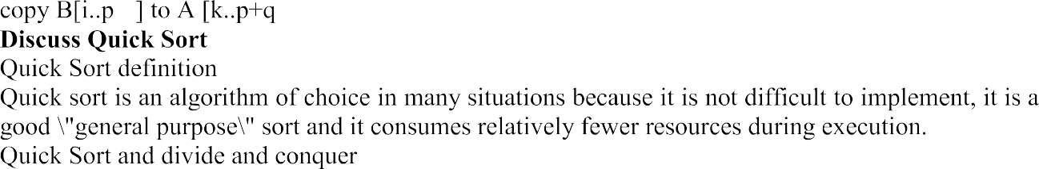

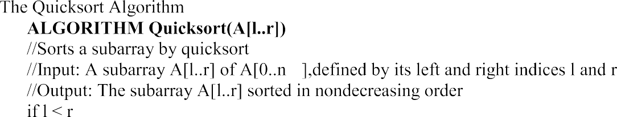

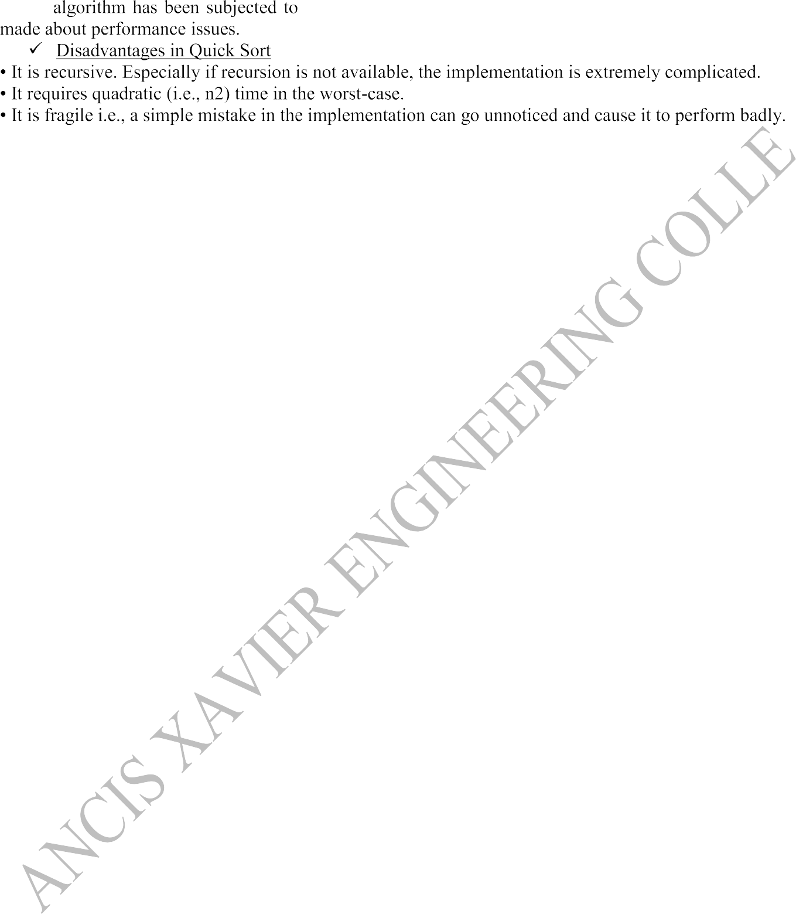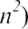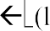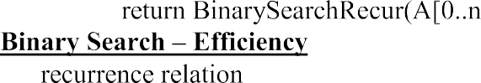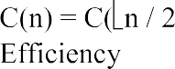

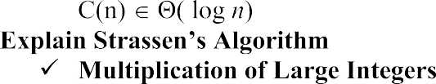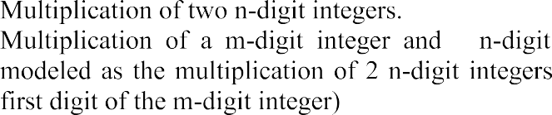

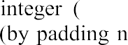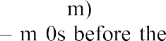
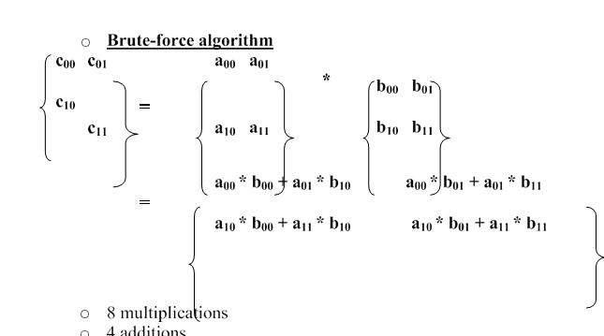

UNIT II

DISJOINT SETS AND BACKTRACKING

SHORT ANSWERS

- Explainthe concept of Disjoints?

Ans: Disjoint Sets: If Si and Sj, i≠j are two sets, then there is no element that is in both Si and Sj..
For example: n=10 elements can be partitioned into three disjoint sets,
S1= {1, 7, 8, 9}
S2= {2, 5, 10}
S3= {3, 4, 6}

Tree representation of sets:
1
5
3
7
8
9
2
10
4
6
S1 S2 S3

Disjoint set Union: Means Combination of two disjoint sets elements. Form above example S1 U S2 ={1,7,8,9,5,2,10 }For S1 U S2 tree representation, simply make one of the tree is a sub tree of the other.
1
1
7
8
9
5
5
7
8
9
2
10
2
10
S1 U S2 S2 U S1

Find: Given element i, find the set containing i.
S1 U S2
Form above example:
Find(4) S3
Find(1) S1 Find(10) S2 Data representation of sets:
Tress can be accomplished easily if, with each set name, we keep a pointer to the root of the tree representing that set.

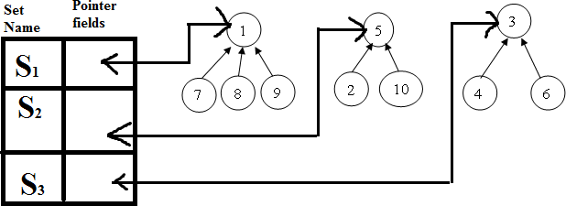

For presenting the union and find algorithms, we ignore the set names and identify sets just by the roots of the trees representing them.
For example: if we determine that element ‘i’ is in a tree with root ‘j’ has a pointer to entry ‘k’ in the set name table, then the set name is just name[k]

For unite (adding or combine) to a particular set we use FindPointer function.
Example: If you wish to unite to Si and Sj then we wish to unite the tree with roots FindPointer (Si) and FindPointer (Sj)
FindPointer is a function that takes a set name and determines the root of the tree that represents it.
For determining operations:
Find(i) 1St determine the root of the tree and find its pointer to entry in setname table. Union(i, j) Means union of two trees whose roots are i and j.

If set contains numbers 1 through n, we represents tree node

P[1:n].
n Maximum number of elements

Each node represent in array
i P
1
-1
2
5
3
-1
4
3
5
-1
6
3
7
1
8
1
9
1
10
5

find(i) by following the indices, starting at i until we reach a node with parent
Example: Find(6) start at 6 and then moves to 6’s parent. Since P[3] is negative, we reached the root.

Algorithm for finding Union(i, j): | Algorithm for find(i)
Algorithm Simple union(i, j)  {  P[i]:=j; // Accomplishes the union  } | Algorithm SimpleFind(i)  {  While(P[i]≥0) do i:=P[i]; return i;  }

If n numbers of roots are there then the above algorithms are not useful for union and find. For union of n trees Union(1,2), Union(2,3), Union(3,4),…..Union(n-1,n).
For Find i in n trees Find(1), Find(2),….Find(n).

Time taken for the union (simple union) is O(1) (constant).
For the n-1 unions O(n).

Time taken for the find for an element at level i of a tree is O(i).
For n finds O(n²).

To improve the performance of our union and find algorithms by avoiding the creation of degenerate trees. For this we use a weighting rule for union(i, j)

Weighting rule for Union(i, j):
If the number of nodes in the tree with root ‘i’ is less than the tree with root ‘j’, then make ‘j’ the parent of ‘i’; otherwise make ‘i’ the parent of ‘j’.

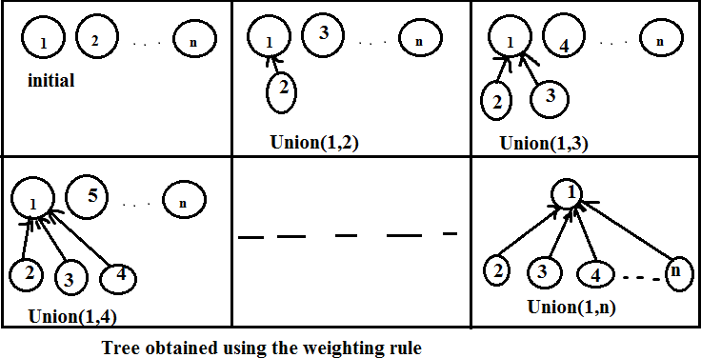

Algorithm for weightedUnion(i, j)
Algorithm WeightedUnion(i,j)
//Union sets with roots i and j, i≠j
// The weighting rule, p[i]= -count[i] and p[j]= -count[j].
{
temp := p[i]+p[j];
if (p[i]>p[j]) then
{ // i has fewer nodes. P[i]:=j;
P[j]:=temp;
}
else
{ // j has fewer or equal nodes. P[j] := i;
P[i] := temp;
}
}

For implementing the weighting rule, we need to know how many nodes there are in every tree.
For this we maintain a count field in the root of every tree.i root node
count[i] number of nodes in the tree.
Time required for this above algorithm is O(1) + time for remaining unchanged is determined by using Lemma.

Lemma:-Let T be a tree with m nodes created as a result of a sequence of unions each performed using WeightedUnion.The height of T is no greater than

|log₂ m|+1.

Collapsing find algorithm is used to perform find operation on the tree reated by Weighted Union.

For example: Tree created by using Weighted Union
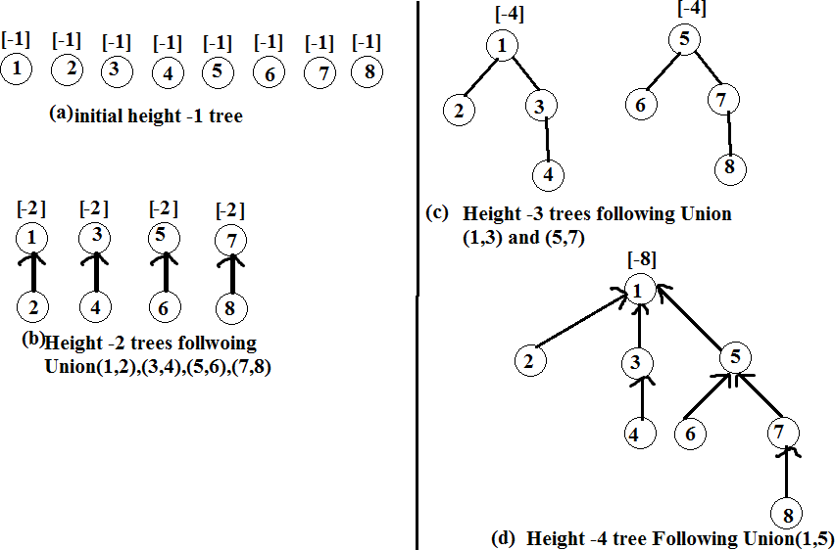
LONG ANSWERS

- Explain Depth First Search algorithm with Example?

Ans: DFST(Dept first search and traversal).:

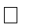Dfs different from bfs The exploration of a vertex v is suspended (stopped) as soon as a new vertex is reached.In this the exploration of the new vertex (example v) begins; this new vertex has been explored, the exploration of v continues.

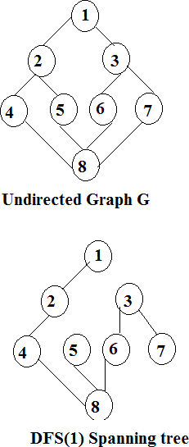
Note: exploration start at the new vertex which is not visited in other vertex exploring and choose nearest path for exploring next or adjacent vertex.

Algorithm for DFS to convert undirected graph G to Connected component or spanning tree.
Algorithm dFS(v)
// a Dfs of G is begin at vertex v
// initially an array visited[] is set to zero.
//this algorithm visits all vertices reachable from v.
// the graph G, and array visited[] are global
{
Visited[v]:=1;
For each vertex w adjacent from v do
{
If (visited[w]=0) then DFS(w);
{
Add w to q; // w is unexplored Visited[w]:=1;
}
}

Maximum Time complexity and space complexity of G(n,e), nodes are in adjacency list. T(n, e)=θ(n+e)
S(n, e)=θ(n)

If nodes are in adjacency matrix then T(n, e)=θ(n²)
S(n, e)=θ(n)

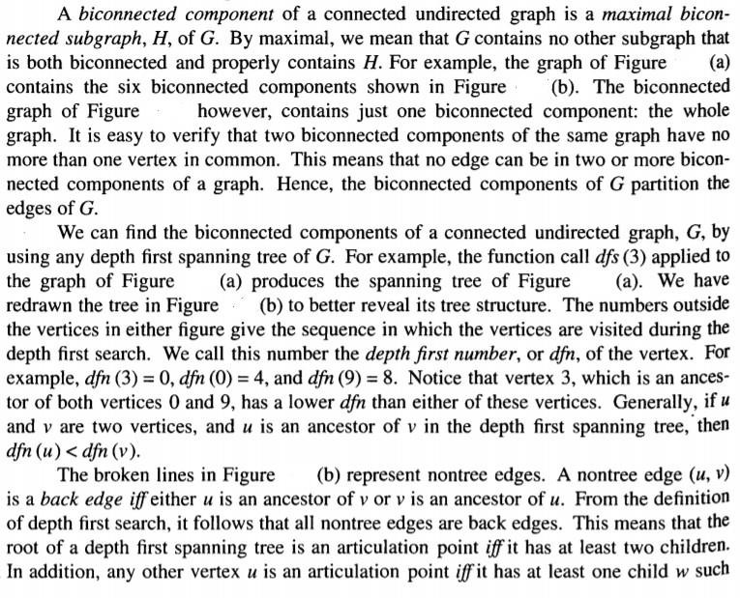
A biconnected component of G is a maximal set of edges such that any two edges in the set lie on a common simple cycle

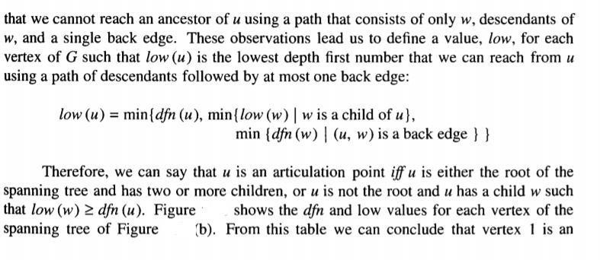
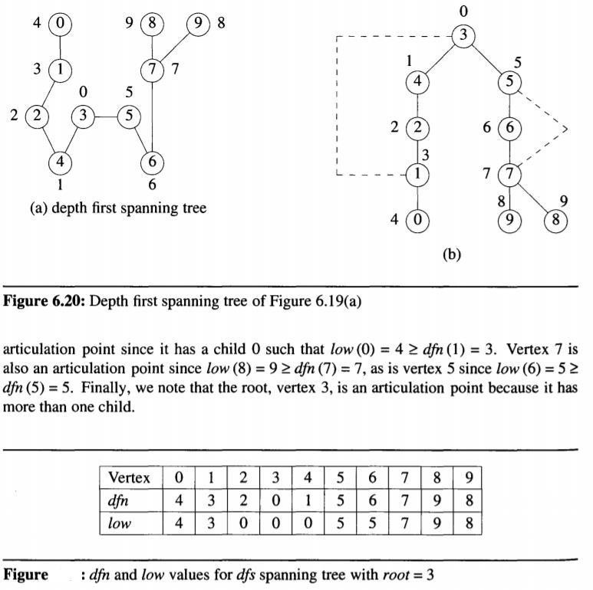

3.. Explain the concept of Backtracking using General Method?
Ans: In back tracking technique, we will solve problems in an efficient way, when compared to other methods like greedy method and dynamic programming.

General Method:

• The basic idea of backtracking is to build up a vector, one component at a time and to test whether the vector being formed has any chance of success.
• The major advantage of this algorithm is that we can realize the fact that the partial vector generated does not lead to an optimal solution. In such a situation that vector can be ignored.
Backtracking algorithm determines the solution by systematically searching the solution space (i.,e set of all feasible solutions) for the given problem.
Backtracking is a depth first search with some bounding function. All solutions using backtracking are
required to satisfy a complex set of constraints. The constraints may be explicit or implicit.

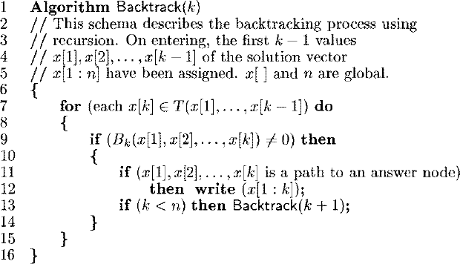

4.Explain the concept of Nqueen problem using Back tracking Method?
Ans: Backtracking is an algorithm design technique that can effectively solve the larger instances
of combinational problems. It follows a systematic approach for obtaining solution to a problem. The applications of backtracking include,
- N-Queens Problem: This is generalization problem. If we take n=8 then the problem is called a 8queens problem. If we take n=4then the problem is called 4 queens problem. A classic combinational problem is to place n queens on a n*n chess board so that no two attack, i.e. no two queens are on the same row, column or diagonal. Algorithm of n-queens problem is given below: Algorithm: All solutions to the n-queens problem

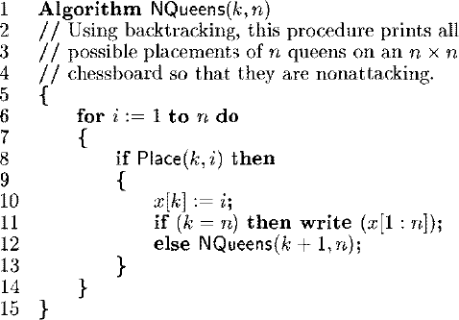
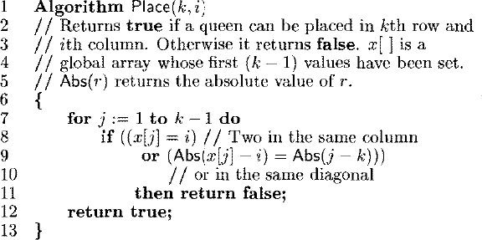
Algorithm: Can a new queen be placed?
5. RECURSIVE BACKTRACKING
Recursive functions are those that calls itself more than once. Consider an example of Palindrome:
Initially, the function isPalindrome(S, 0, 8) is called once with the parameters isPalindrome(S, 1, 7). The recursive call isPalindrome(S, 1, 7) is called once with the parameters isPalindrome(S, 2, 6).
Backtracking is one of the techniques that can be used to solve the problem. We can write the algorithm using this strategy. It uses the Brute force search to solve the problem, and the brute force search says that for the given problem, we try to ma ke all the possible solutions and pick out the best solution from all the desired solutions. This rule is also followed in dynamic programming, but dynamic programming is used for solving optimization problems. In contrast, backtracking is not used in solving optimization problems. Backtracking is used when we have multiple solutions, and we require all those solutions.
Backtracking name itself suggests that we are going back and coming forward; if it satisfies the condition, then return success, else we go back again. It is used to solve a problem in which a sequence of objects is chosen from a specified set so that the sequence satisfies some criteria.
When we have multiple choices, then we make the decisions from the available choices. In the following cases, we need to use the backtracking algorithm:
- A piece of sufficient information is not available to make the best choice, so we use the backtracking strategy to try out all the possible solutions.
- Each decision leads to a new set of choices. Then again, we backtrack to make new decisions. In this case, we need to use the backtracking strategy.
Backtracking is a systematic method of trying out various sequences of decisions until you find out that works. Let's understand through an example.
We start with a start node. First, we move to node A. Since it is not a feasible solution so we move to the next node, i.e., B. B is also not a feasible solution, and it is a dead-end so we backtrack from node B to node A.
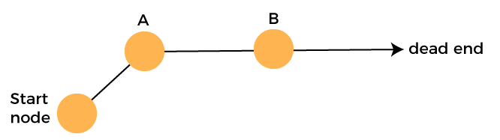
Suppose another path exists from node A to node C. So, we move from node A to node C. It is also a dead-end, so again backtrack from node C to node A. We move from node A to the starting node.
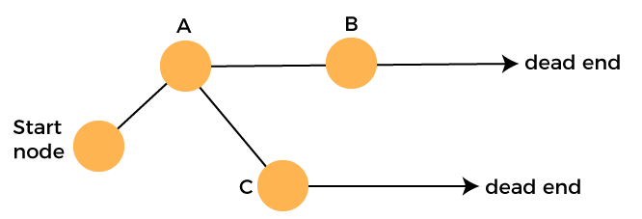
Now we will check any other path exists from the starting node. So, we move from start node to the node D. Since it is not a feasible solution so we move from node D to node E. The node E is also not a feasible solution. It is a dead end so we backtrack from node E to node D.
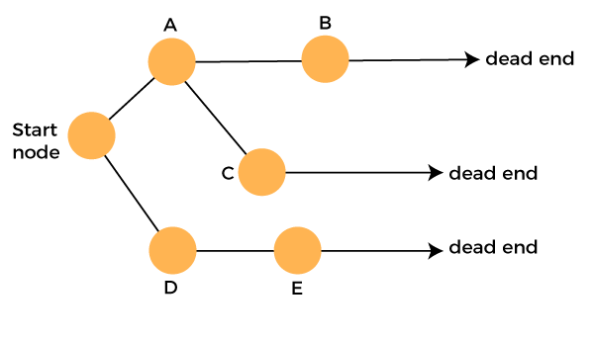
Suppose another path exists from node D to node F. So, we move from node D to node F. Since it is not a feasible solution and it's a dead-end, we check for another path from node F.
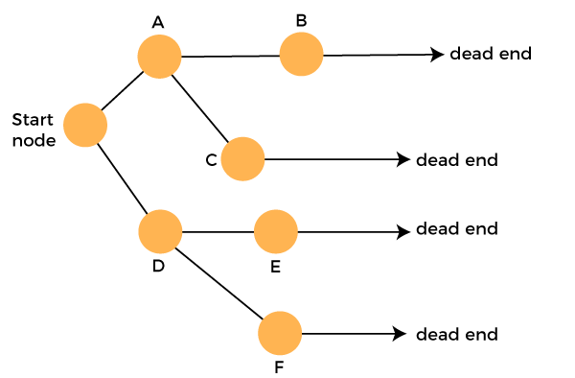
Suppose there is another path exists from the node F to node G so move from node F to node G. The node G is a success node.
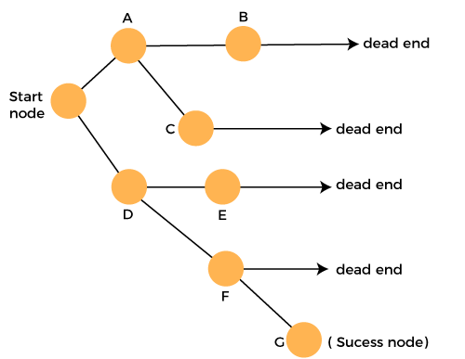
The terms related to the backtracking are:
- Live node: The nodes that can be further generated are known as live nodes.
- E node: The nodes whose children are being generated and become a success node.
- Success node: The node is said to be a success node if it provides a feasible solution.
- Dead node: The node which cannot be further generated and also does not provide a feasible solution is known as a dead node.
Many problems can be solved by backtracking strategy, and that problems satisfy complex set of constraints, and these constraints are of two types:
- Implicit constraint: It is a rule in which how each element in a tuple is related.
- Explicit constraint: The rules that restrict each element to be chosen from the given set.

Applications of Backtracking
- N-queen problem
- Sum of subset problem
- Graph coloring
- Hamiliton cycle
5.Explain sum of subsets problem with an example?

Let, S = {S1 …. Sn} be a set of n positive integers, then we have to find a subset whose sum is equal to given positive integer d.It is always convenient to sort the set’s elements in ascending order. That is, S1 ≤ S2 ≤…. ≤ Sn
Algorithm:
Let, S is a set of elements and m is the expected sum of subsets. Then:
- Start with an empty set.
- Add to the subset, the next element from the list.
- If the subset is having sum m then stop with that subset as solution.
- If the subset is not feasible or if we have reached the end of the set then backtrack through the subset until we find the most suitable value.
- If the subset is feasible then repeat step 2.
- If we have visited all the elements without finding a suitable subset and if no backtracking is possible then stop without solution.
Example: Solve following problem and draw portion of state space tree M=30,W ={5, 10, 12, 13, 15, 18}
Solution:
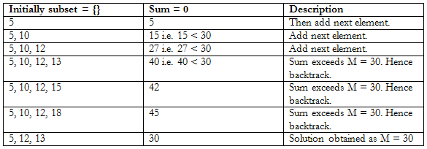
The state space tree is shown as below in figure. {5, 10, 12, 13, 15, 18}
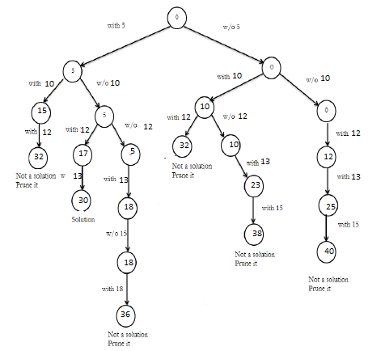

UNIT III
DYNAMIC PROGRAMMING

SHORT ANSWERS
1. Write the difference between the Greedy method and Dynamic programming.
Greedy method Dynamic programming
1.Only one sequence of decision is
generated.
1.Many number of decisions are generated.
2.It does not guarantee to give an optimal
solution always.
2.It definitely gives an optimal solution
always.
2. Define dynamic programming.
Dynamic programming is an algorithm design method that can be used when a
solution to the problem is viewed as the result of sequence of decisions. It is technique
for solving problems with overlapping subproblems.
3. What are the features of dynamic programming?
• Optimal solutions to sub problems are retained so as to avoid recomputing of their
values.
• Decision sequences containing subsequences that are sub optimal are not
considered.
• It definitely gives the optimal solution always.

4. What are the drawbacks of dynamic programming?
• Time and space requirements are high, since storage is needed for all level.
• Optimality should be checked at all levels.

5. Write the general procedure of dynamic programming.
The development of dynamic programming algorithm can be broken into a
sequence of 4 steps.
1. Characterize the structure of an optimal solution.
2. Recursively define the value of the optimal solution.
3. Compute the value of an optimal solution in the bottom-up fashion.
4. Construct an optimal solution from the computed information.
6. Define principle of optimality.
It states that an optimal solution to any of its instances must be made up of
optimal solutions to its subinstances.
7. Define multistage graph
A multistage graph G =(V,E) is a directed graph in which the vertices are partitioned
in to K>=2 disjoint sets Vi,1<=i<=k.The multi stage graph problem is to find a minimum
cost paths from s(source ) to t(sink)
Two approach(forward and backward)
8. Define All pair shortest path problem
Given a weighted connected graph, all pair shortest path problem asks to find the
lengths of shortest paths from each vertex to all other vertices.
9.Define Distance matrix
Recording the lengths of shortest path in n x n matrix is called Distance matrix(D)
10.Define floyd’s algorithm
􀃖 To find all pair shortest path
􀃖 The algorithm computes the distance matrix of a weighted graph with n vertices
through series of n by n matrices :D(0)…D(k-1),D(k)…..D(n)
11. State the time efficiency of floyd’s algorithm
O(n3)
It is cubic
12. Define OBST
􀃖 Dynammic Programming Used
􀃖 If probabilities of searching for elements of a set are known then finding optimal
BST for which the average number of comparisons in a search is smallest
possible.

LONG ANSWERS:

The fractional knapsack problem means that we can divide the item. For example, we have an item of 3 kg then we can pick the item of 2 kg and leave the item of 1 kg. The fractional knapsack problem is solved by the Greedy approach.

Example of 0/1 knapsack problem.
Consider the problem having weights and profits are:
Weights: {3, 4, 6, 5}
Profits: {2, 3, 1, 4}
The weight of the knapsack is 8 kg
The number of items is 4
The above problem can be solved by using the following method:
x_{i} = {1, 0, 0, 1}
= {0, 0, 0, 1}
= {0, 1, 0, 1}
The above are the possible combinations. 1 denotes that the item is completely picked and 0 means that no item is picked. Since there are 4 items so possible combinations will be:
2⁴ = 16; So. There are 16 possible combinations that can be made by using the above problem. Once all the combinations are made, we have to select the combination that provides the maximum profit.
Another approach to solve the problem is dynamic programming approach. In dynamic programming approach, the complicated problem is divided into sub-problems, then we find the solution of a sub-problem and the solution of the sub-problem will be used to find the solution of a complex problem.

How this problem can be solved by using the Dynamic programming approach?
First,
we create a matrix shown as below:
 | 0 | 1 | 2 | 3 | 4 | 5 | 6 | 7 | 8
0
1
2
3
4
In the above matrix, columns represent the weight, i.e., 8. The rows represent the profits and weights of items. Here we have not taken the weight 8 directly, problem is divided into sub-problems, i.e., 0, 1, 2, 3, 4, 5, 6, 7, 8. The solution of the sub-problems would be saved in the cells and answer to the problem would be stored in the final cell. First, we write the weights in the ascending order and profits according to their weights shown as below:
w_{i} = {3, 4, 5, 6}
p_{i} = {2, 3, 4, 1}
The first row and the first column would be 0 as there is no item for w=0
 | 0 | 1 | 2 | 3 | 4 | 5 | 6 | 7 | 8
0 | 0 | 0 | 0 | 0 | 0 | 0 | 0 | 0 | 0
1 | 0
2 | 0
3 | 0
4 | 0
When i=1, W=1
w₁ = 3; since we have only one item in the set having weight 3, but the capacity of the knapsack is 1. We cannot fill the item of 3kg in the knapsack of capacity 1 kg so add 0 at M[1][1] shown as below:
 | 0 | 1 | 2 | 3 | 4 | 5 | 6 | 7 | 8
0 | 0 | 0 | 0 | 0 | 0 | 0 | 0 | 0 | 0
1 | 0 | 0
2 | 0
3 | 0
4 | 0

When i = 1, W = 2
w₁ = 3; Since we have only one item in the set having weight 3, but the capacity of the knapsack is 2. We cannot fill the item of 3kg in the knapsack of capacity 2 kg so add 0 at M[1][2] shown as below:
 | 0 | 1 | 2 | 3 | 4 | 5 | 6 | 7 | 8
0 | 0 | 0 | 0 | 0 | 0 | 0 | 0 | 0 | 0
1 | 0 | 0 | 0
2 | 0
3 | 0
4 | 0
When i=1, W=3
w₁ = 3; Since we have only one item in the set having weight equal to 3, and weight of the knapsack is also 3; therefore, we can fill the knapsack with an item of weight equal to 3. We put profit corresponding to the weight 3, i.e., 2 at M[1][3] shown as below:
 | 0 | 1 | 2 | 3 | 4 | 5 | 6 | 7 | 8
0 | 0 | 0 | 0 | 0 | 0 | 0 | 0 | 0 | 0
1 | 0 | 0 | 0 | 2
2 | 0
3 | 0
4 | 0
When i=1, W = 4
_{W1} = 3; Since we have only one item in the set having weight equal to 3, and weight of the knapsack is 4; therefore, we can fill the knapsack with an item of weight equal to 3. We put profit corresponding to the weight 3, i.e., 2 at M[1][4] shown as below:
 | 0 | 1 | 2 | 3 | 4 | 5 | 6 | 7 | 8
0 | 0 | 0 | 0 | 0 | 0 | 0 | 0 | 0 | 0
1 | 0 | 0 | 0 | 2 | 2
2 | 0
3 | 0
4 | 0
When i=1, W = 5
_{W1} = 3; Since we have only one item in the set having weight equal to 3, and weight of the knapsack is 5; therefore, we can fill the knapsack with an item of weight equal to 3. We put profit corresponding to the weight 3, i.e., 2 at M[1][5] shown as below:
 | 0 | 1 | 2 | 3 | 4 | 5 | 6 | 7 | 8
0 | 0 | 0 | 0 | 0 | 0 | 0 | 0 | 0 | 0
1 | 0 | 0 | 0 | 2 | 2 | 2
2 | 0
3 | 0
4 | 0
When i =1, W=6
_{W1} = 3; Since we have only one item in the set having weight equal to 3, and weight of the knapsack is 6; therefore, we can fill the knapsack with an item of weight equal to 3. We put profit corresponding to the weight 3, i.e., 2 at M[1][6] shown as below:
 | 0 | 1 | 2 | 3 | 4 | 5 | 6 | 7 | 8
0 | 0 | 0 | 0 | 0 | 0 | 0 | 0 | 0 | 0
1 | 0 | 0 | 0 | 2 | 2 | 2 | 2
2 | 0
3 | 0
4 | 0
When i=1, W = 7
_{W1} = 3; Since we have only one item in the set having weight equal to 3, and weight of the knapsack is 7; therefore, we can fill the knapsack with an item of weight equal to 3. We put profit corresponding to the weight 3, i.e., 2 at M[1][7] shown as below:
 | 0 | 1 | 2 | 3 | 4 | 5 | 6 | 7 | 8
0 | 0 | 0 | 0 | 0 | 0 | 0 | 0 | 0 | 0
1 | 0 | 0 | 0 | 2 | 2 | 2 | 2 | 2
2 | 0
3 | 0
4 | 0
When i =1, W =8
_{W1} = 3; Since we have only one item in the set having weight equal to 3, and weight of the knapsack is 8; therefore, we can fill the knapsack with an item of weight equal to 3. We put profit corresponding to the weight 3, i.e., 2 at M[1][8] shown as below:
 | 0 | 1 | 2 | 3 | 4 | 5 | 6 | 7 | 8
0 | 0 | 0 | 0 | 0 | 0 | 0 | 0 | 0 | 0
1 | 0 | 0 | 0 | 2 | 2 | 2 | 2 | 2 | 2
2 | 0
3 | 0
4 | 0
Now the value of 'i' gets incremented, and becomes 2.
When i =2, W = 1
The weight corresponding to the value 2 is 4, i.e., w₂ = 4. Since we have only one item in the set having weight equal to 4, and the weight of the knapsack is 1. We cannot put the item of weight 4 in a knapsack, so we add 0 at M[2][1] shown as below:
 | 0 | 1 | 2 | 3 | 4 | 5 | 6 | 7 | 8
0 | 0 | 0 | 0 | 0 | 0 | 0 | 0 | 0 | 0
1 | 0 | 0 | 0 | 2 | 2 | 2 | 2 | 2 | 2
2 | 0 | 0
3 | 0
4 | 0
When i =2, W = 2
The weight corresponding to the value 2 is 4, i.e., w₂ = 4. Since we have only one item in the set having weight equal to 4, and the weight of the knapsack is 2. We cannot put the item of weight 4 in a knapsack, so we add 0 at M[2][2] shown as below:
 | 0 | 1 | 2 | 3 | 4 | 5 | 6 | 7 | 8
0 | 0 | 0 | 0 | 0 | 0 | 0 | 0 | 0 | 0
1 | 0 | 0 | 0 | 2 | 2 | 2 | 2 | 2 | 2
2 | 0 | 0 | 0
3 | 0
4 | 0
When i =2, W = 3
The weight corresponding to the value 2 is 4, i.e., w₂ = 4. Since we have two items in the set having weights 3 and 4, and the weight of the knapsack is 3. We can put the item of weight 3 in a knapsack, so we add 2 at M[2][3] shown as below:
 | 0 | 1 | 2 | 3 | 4 | 5 | 6 | 7 | 8
0 | 0 | 0 | 0 | 0 | 0 | 0 | 0 | 0 | 0
1 | 0 | 0 | 0 | 2 | 2 | 2 | 2 | 2 | 2
2 | 0 | 0 | 0 | 2
3 | 0
4 | 0
When i =2, W = 4
The weight corresponding to the value 2 is 4, i.e., w₂ = 4. Since we have two items in the set having weights 3 and 4, and the weight of the knapsack is 4. We can put item of weight 4 in a knapsack as the profit corresponding to weight 4 is more than the item having weight 3, so we add 3 at M[2][4] shown as below:
 | 0 | 1 | 2 | 3 | 4 | 5 | 6 | 7 | 8
0 | 0 | 0 | 0 | 0 | 0 | 0 | 0 | 0 | 0
1 | 0 | 0 | 0 | 2 | 2 | 2 | 2 | 2 | 2
2 | 0 | 0 | 0 | 2 | 3
3 | 0
4 | 0
When i = 2, W = 5
The weight corresponding to the value 2 is 4, i.e., w₂ = 4. Since we have two items in the set having weights 3 and 4, and the weight of the knapsack is 5. We can put item of weight 4 in a knapsack and the profit corresponding to weight is 3, so we add 3 at M[2][5] shown as below:
 | 0 | 1 | 2 | 3 | 4 | 5 | 6 | 7 | 8
0 | 0 | 0 | 0 | 0 | 0 | 0 | 0 | 0 | 0
1 | 0 | 0 | 0 | 2 | 2 | 2 | 2 | 2 | 2
2 | 0 | 0 | 0 | 2 | 3 | 3
3 | 0
4 | 0
When i = 2, W = 6
The weight corresponding to the value 2 is 4, i.e., w₂ = 4. Since we have two items in the set having weights 3 and 4, and the weight of the knapsack is 6. We can put item of weight 4 in a knapsack and the profit corresponding to weight is 3, so we add 3 at M[2][6] shown as below:
 | 0 | 1 | 2 | 3 | 4 | 5 | 6 | 7 | 8
0 | 0 | 0 | 0 | 0 | 0 | 0 | 0 | 0 | 0
1 | 0 | 0 | 0 | 2 | 2 | 2 | 2 | 2 | 2
2 | 0 | 0 | 0 | 2 | 3 | 3 | 3
3 | 0
4 | 0
When i = 2, W = 7
The weight corresponding to the value 2 is 4, i.e., w₂ = 4. Since we have two items in the set having weights 3 and 4, and the weight of the knapsack is 7. We can put item of weight 4 and 3 in a knapsack and the profits corresponding to weights are 2 and 3; therefore, the total profit is 5, so we add 5 at M[2][7] shown as below:
 | 0 | 1 | 2 | 3 | 4 | 5 | 6 | 7 | 8
0 | 0 | 0 | 0 | 0 | 0 | 0 | 0 | 0 | 0
1 | 0 | 0 | 0 | 2 | 2 | 2 | 2 | 2 | 2
2 | 0 | 0 | 0 | 0 | 3 | 3 | 3 | 5
3 | 0
4 | 0
When i = 2, W = 8
The weight corresponding to the value 2 is 4, i.e., w₂ = 4. Since we have two items in the set having weights 3 and 4, and the weight of the knapsack is 7. We can put item of weight 4 and 3 in a knapsack and the profits corresponding to weights are 2 and 3; therefore, the total profit is 5, so we add 5 at M[2][7] shown as below:
 | 0 | 1 | 2 | 3 | 4 | 5 | 6 | 7 | 8
0 | 0 | 0 | 0 | 0 | 0 | 0 | 0 | 0 | 0
1 | 0 | 0 | 0 | 2 | 2 | 2 | 2 | 2 | 2
2 | 0 | 0 | 0 | 2 | 3 | 3 | 3 | 5 | 5
3 | 0
4 | 0
Now the value of 'i' gets incremented, and becomes 3.
When i = 3, W = 1
The weight corresponding to the value 3 is 5, i.e., w₃ = 5. Since we have three items in the set having weights 3, 4, and 5, and the weight of the knapsack is 1. We cannot put neither of the items in a knapsack, so we add 0 at M[3][1] shown as below:
 | 0 | 1 | 2 | 3 | 4 | 5 | 6 | 7 | 8
0 | 0 | 0 | 0 | 0 | 0 | 0 | 0 | 0 | 0
1 | 0 | 0 | 0 | 2 | 2 | 2 | 2 | 2 | 2
2 | 0 | 0 | 0 | 2 | 3 | 3 | 3 | 5 | 5
3 | 0 | 0
4 | 0
When i = 3, W = 2
The weight corresponding to the value 3 is 5, i.e., w₃ = 5. Since we have three items in the set having weight 3, 4, and 5, and the weight of the knapsack is 1. We cannot put neither of the items in a knapsack, so we add 0 at M[3][2] shown as below:
 | 0 | 1 | 2 | 3 | 4 | 5 | 6 | 7 | 8
0 | 0 | 0 | 0 | 0 | 0 | 0 | 0 | 0 | 0
1 | 0 | 0 | 0 | 2 | 2 | 2 | 2 | 2 | 2
2 | 0 | 0 | 0 | 2 | 3 | 3 | 3 | 5 | 5
3 | 0 | 0 | 0
4 | 0
When i = 3, W = 3
The weight corresponding to the value 3 is 5, i.e., w₃ = 5. Since we have three items in the set of weight 3, 4, and 5 respectively and weight of the knapsack is 3. The item with a weight 3 can be put in the knapsack and the profit corresponding to the item is 2, so we add 2 at M[3][3] shown as below:
 | 0 | 1 | 2 | 3 | 4 | 5 | 6 | 7 | 8
0 | 0 | 0 | 0 | 0 | 0 | 0 | 0 | 0 | 0
1 | 0 | 0 | 0 | 2 | 2 | 2 | 2 | 2 | 2
2 | 0 | 0 | 0 | 2 | 3 | 3 | 3 | 5 | 5
3 | 0 | 0 | 0 | 2
4 | 0
When i = 3, W = 4
The weight corresponding to the value 3 is 5, i.e., w₃ = 5. Since we have three items in the set of weight 3, 4, and 5 respectively, and weight of the knapsack is 4. We can keep the item of either weight 3 or 4; the profit (3) corresponding to the weight 4 is more than the profit corresponding to the weight 3 so we add 3 at M[3][4] shown as below:
 | 0 | 1 | 2 | 3 | 4 | 5 | 6 | 7 | 8
0 | 0 | 0 | 0 | 0 | 0 | 0 | 0 | 0 | 0
1 | 0 | 0 | 0 | 2 | 2 | 2 | 2 | 2 | 2
2 | 0 | 0 | 0 | 2 | 3 | 3 | 3 | 5 | 5
3 | 0 | 0 | 0 | 1 | 3
4 | 0
When i = 3, W = 5
The weight corresponding to the value 3 is 5, i.e., w₃ = 5. Since we have three items in the set of weight 3, 4, and 5 respectively, and weight of the knapsack is 5. We can keep the item of either weight 3, 4 or 5; the profit (3) corresponding to the weight 4 is more than the profits corresponding to the weight 3 and 5 so we add 3 at M[3][5] shown as below:
 | 0 | 1 | 2 | 3 | 4 | 5 | 6 | 7 | 8
0 | 0 | 0 | 0 | 0 | 0 | 0 | 0 | 0 | 0
1 | 0 | 0 | 0 | 2 | 2 | 2 | 2 | 2 | 2
2 | 0 | 0 | 0 | 2 | 3 | 3 | 3 | 5 | 5
3 | 0 | 0 | 0 | 1 | 3 | 3
4 | 0
When i =3, W = 6
The weight corresponding to the value 3 is 5, i.e., w₃ = 5. Since we have three items in the set of weight 3, 4, and 5 respectively, and weight of the knapsack is 6. We can keep the item of either weight 3, 4 or 5; the profit (3) corresponding to the weight 4 is more than the profits corresponding to the weight 3 and 5 so we add 3 at M[3][6] shown as below:
 | 0 | 1 | 2 | 3 | 4 | 5 | 6 | 7 | 8
0 | 0 | 0 | 0 | 0 | 0 | 0 | 0 | 0 | 0
1 | 0 | 0 | 0 | 2 | 2 | 2 | 2 | 2 | 2
2 | 0 | 0 | 0 | 2 | 3 | 3 | 3 | 5 | 5
3 | 0 | 0 | 0 | 1 | 3 | 3 | 3
4 | 0
When i =3, W = 7
The weight corresponding to the value 3 is 5, i.e., w₃ = 5. Since we have three items in the set of weight 3, 4, and 5 respectively, and weight of the knapsack is 7. In this case, we can keep both the items of weight 3 and 4, the sum of the profit would be equal to (2 + 3), i.e., 5, so we add 5 at M[3][7] shown as below:
 | 0 | 1 | 2 | 3 | 4 | 5 | 6 | 7 | 8
0 | 0 | 0 | 0 | 0 | 0 | 0 | 0 | 0 | 0
1 | 0 | 0 | 0 | 2 | 2 | 2 | 2 | 2 | 2
2 | 0 | 0 | 0 | 2 | 3 | 3 | 3 | 5 | 5
3 | 0 | 0 | 0 | 1 | 3 | 3 | 3 | 5
4 | 0
When i = 3, W = 8
The weight corresponding to the value 3 is 5, i.e., w₃ = 5. Since we have three items in the set of weight 3, 4, and 5 respectively, and the weight of the knapsack is 8. In this case, we can keep both the items of weight 3 and 4, the sum of the profit would be equal to (2 + 3), i.e., 5, so we add 5 at M[3][8] shown as below:
 | 0 | 1 | 2 | 3 | 4 | 5 | 6 | 7 | 8
0 | 0 | 0 | 0 | 0 | 0 | 0 | 0 | 0 | 0
1 | 0 | 0 | 0 | 2 | 2 | 2 | 2 | 2 | 2
2 | 0 | 0 | 0 | 2 | 3 | 3 | 3 | 5 | 5
3 | 0 | 0 | 0 | 1 | 3 | 3 | 3 | 5 | 5
4 | 0
Now the value of 'i' gets incremented and becomes 4.
When i = 4, W = 1
The weight corresponding to the value 4 is 6, i.e., w₄ = 6. Since we have four items in the set of weights 3, 4, 5, and 6 respectively, and the weight of the knapsack is 1. The weight of all the items is more than the weight of the knapsack, so we cannot add any item in the knapsack; Therefore, we add 0 at M[4][1] shown as below:
 | 0 | 1 | 2 | 3 | 4 | 5 | 6 | 7 | 8
0 | 0 | 0 | 0 | 0 | 0 | 0 | 0 | 0 | 0
1 | 0 | 0 | 0 | 2 | 2 | 2 | 2 | 2 | 2
2 | 0 | 0 | 0 | 2 | 3 | 3 | 3 | 5 | 5
3 | 0 | 0 | 0 | 1 | 3 | 3 | 3 | 5 | 5
4 | 0 | 0
When i = 4, W = 2
The weight corresponding to the value 4 is 6, i.e., w₄ = 6. Since we have four items in the set of weights 3, 4, 5, and 6 respectively, and the weight of the knapsack is 2. The weight of all the items is more than the weight of the knapsack, so we cannot add any item in the knapsack; Therefore, we add 0 at M[4][2] shown as below:
 | 0 | 1 | 2 | 3 | 4 | 5 | 6 | 7 | 8
0 | 0 | 0 | 0 | 0 | 0 | 0 | 0 | 0 | 0
1 | 0 | 0 | 0 | 2 | 2 | 2 | 2 | 2 | 2
2 | 0 | 0 | 0 | 2 | 3 | 3 | 3 | 5 | 5
3 | 0 | 0 | 0 | 1 | 3 | 3 | 3 | 5 | 5
4 | 0 | 0 | 0
When i = 4, W = 3
The weight corresponding to the value 4 is 6, i.e., w₄ = 6. Since we have four items in the set of weights 3, 4, 5, and 6 respectively, and the weight of the knapsack is 3. The item with a weight 3 can be put in the knapsack and the profit corresponding to the weight 4 is 2, so we will add 2 at M[4][3] shown as below:
 | 0 | 1 | 2 | 3 | 4 | 5 | 6 | 7 | 8
0 | 0 | 0 | 0 | 0 | 0 | 0 | 0 | 0 | 0
1 | 0 | 0 | 0 | 2 | 2 | 2 | 2 | 2 | 2
2 | 0 | 0 | 0 | 2 | 3 | 3 | 3 | 5 | 5
3 | 0 | 0 | 0 | 1 | 3 | 3 | 3 | 5 | 5
4 | 0 | 0 | 0 | 2
When i = 4, W = 4
The weight corresponding to the value 4 is 6, i.e., w₄ = 6. Since we have four items in the set of weights 3, 4, 5, and 6 respectively, and the weight of the knapsack is 4. The item with a weight 4 can be put in the knapsack and the profit corresponding to the weight 4 is 3, so we will add 3 at M[4][4] shown as below:
 | 0 | 1 | 2 | 3 | 4 | 5 | 6 | 7 | 8
0 | 0 | 0 | 0 | 0 | 0 | 0 | 0 | 0 | 0
1 | 0 | 0 | 0 | 2 | 2 | 2 | 2 | 2 | 2
2 | 0 | 0 | 0 | 2 | 3 | 3 | 3 | 5 | 5
3 | 0 | 0 | 0 | 1 | 3 | 3 | 3 | 5 | 5
4 | 0 | 0 | 0 | 2 | 3
When i = 4, W = 5
The weight corresponding to the value 4 is 6, i.e., w₄ = 6. Since we have four items in the set of weights 3, 4, 5, and 6 respectively, and the weight of the knapsack is 5. The item with a weight 4 can be put in the knapsack and the profit corresponding to the weight 4 is 3, so we will add 3 at M[4][5] shown as below:
 | 0 | 1 | 2 | 3 | 4 | 5 | 6 | 7 | 8
0 | 0 | 0 | 0 | 0 | 0 | 0 | 0 | 0 | 0
1 | 0 | 0 | 0 | 2 | 2 | 2 | 2 | 2 | 2
2 | 0 | 0 | 0 | 2 | 3 | 3 | 3 | 5 | 5
3 | 0 | 0 | 0 | 1 | 3 | 3 | 3 | 5 | 5
4 | 0 | 0 | 0 | 2 | 3 | 3
When i = 4, W = 6
The weight corresponding to the value 4 is 6, i.e., w₄ = 6. Since we have four items in the set of weights 3, 4, 5, and 6 respectively, and the weight of the knapsack is 6. In this case, we can put the items in the knapsack either of weight 3, 4, 5 or 6 but the profit, i.e., 4 corresponding to the weight 6 is highest among all the items; therefore, we add 4 at M[4][6] shown as below:
 | 0 | 1 | 2 | 3 | 4 | 5 | 6 | 7 | 8
0 | 0 | 0 | 0 | 0 | 0 | 0 | 0 | 0 | 0
1 | 0 | 0 | 0 | 2 | 2 | 2 | 2 | 2 | 2
2 | 0 | 0 | 0 | 2 | 3 | 3 | 3 | 5 | 5
3 | 0 | 0 | 0 | 1 | 3 | 3 | 3 | 5 | 5
4 | 0 | 0 | 0 | 2 | 3 | 3 | 4
When i = 4, W = 7
The weight corresponding to the value 4 is 6, i.e., w₄ = 6. Since we have four items in the set of weights 3, 4, 5, and 6 respectively, and the weight of the knapsack is 7. Here, if we add two items of weights 3 and 4 then it will produce the maximum profit, i.e., (2 + 3) equals to 5, so we add 5 at M[4][7] shown as below:
 | 0 | 1 | 2 | 3 | 4 | 5 | 6 | 7 | 8
0 | 0 | 0 | 0 | 0 | 0 | 0 | 0 | 0 | 0
1 | 0 | 0 | 0 | 2 | 2 | 2 | 2 | 2 | 2
2 | 0 | 0 | 0 | 2 | 3 | 3 | 3 | 5 | 5
3 | 0 | 0 | 0 | 2 | 3 | 3 | 3 | 5 | 5
4 | 0 | 0 | 0 | 2 | 3 | 3 | 4 | 5
When i = 4, W = 8
The weight corresponding to the value 4 is 6, i.e., w₄ = 6. Since we have four items in the set of weights 3, 4, 5, and 6 respectively, and the weight of the knapsack is 8. Here, if we add two items of weights 3 and 4 then it will produce the maximum profit, i.e., (2 + 3) equals to 5, so we add 5 at M[4][8] shown as below:
 | 0 | 1 | 2 | 3 | 4 | 5 | 6 | 7 | 8
0 | 0 | 0 | 0 | 0 | 0 | 0 | 0 | 0 | 0
1 | 0 | 0 | 0 | 2 | 2 | 2 | 2 | 2 | 2
2 | 0 | 0 | 0 | 2 | 3 | 3 | 3 | 5 | 5
3 | 0 | 0 | 0 | 2 | 3 | 3 | 3 | 5 | 5
4 | 0 | 0 | 0 | 2 | 3 | 3 | 4 | 5 | 5
As we can observe in the above table that 5 is the maximum profit among all the entries. The pointer points to the last row and the last column having 5 value. Now we will compare 5 value with the previous row; if the previous row, i.e., i = 3 contains the same value 5 then the pointer will shift upwards. Since the previous row contains the value 5 so the pointer will be shifted upwards as shown in the below table:
 | 0 | 1 | 2 | 3 | 4 | 5 | 6 | 7 | 8
0 | 0 | 0 | 0 | 0 | 0 | 0 | 0 | 0 | 0
1 | 0 | 0 | 0 | 2 | 2 | 2 | 2 | 2 | 2
2 | 0 | 0 | 0 | 2 | 3 | 3 | 3 | 5 | 5
3 | 0 | 0 | 0 | 2 | 3 | 3 | 3 | 5 | 5
4 | 0 | 0 | 0 | 2 | 3 | 3 | 4 | 5 | 5
Again, we will compare the value 5 from the above row, i.e., i = 2. Since the above row contains the value 5 so the pointer will again be shifted upwards as shown in the below table:
 | 0 | 1 | 2 | 3 | 4 | 5 | 6 | 7 | 8
0 | 0 | 0 | 0 | 0 | 0 | 0 | 0 | 0 | 0
1 | 0 | 0 | 0 | 2 | 2 | 2 | 2 | 2 | 2
2 | 0 | 0 | 0 | 2 | 3 | 3 | 3 | 5 | 5
3 | 0 | 0 | 0 | 2 | 3 | 3 | 3 | 5 | 5
4 | 0 | 0 | 0 | 2 | 3 | 3 | 4 | 5 | 5
Again, we will compare the value 5 from the above row, i.e., i = 1. Since the above row does not contain the same value so we will consider the row i=1, and the weight corresponding to the row is 4. Therefore, we have selected the weight 4 and we have rejected the weights 5 and 6 shown below:
x = { 1, 0, 0}
The profit corresponding to the weight is 3. Therefore, the remaining profit is (5 - 3) equals to 2. Now we will compare this value 2 with the row i = 2. Since the row (i = 1) contains the value 2; therefore, the pointer shifted upwards shown below:
 | 0 | 1 | 2 | 3 | 4 | 5 | 6 | 7 | 8
0 | 0 | 0 | 0 | 0 | 0 | 0 | 0 | 0 | 0
1 | 0 | 0 | 0 | 2 | 2 | 2 | 2 | 2 | 2
2 | 0 | 0 | 0 | 2 | 3 | 3 | 3 | 5 | 5
3 | 0 | 0 | 0 | 2 | 3 | 3 | 3 | 5 | 5
4 | 0 | 0 | 0 | 2 | 3 | 3 | 4 | 5 | 5
Again we compare the value 2 with a above row, i.e., i = 1. Since the row i =0 does not contain the value 2, so row i = 1 will be selected and the weight corresponding to the i = 1 is 3 shown below:
X = {1, 1, 0, 0}
The profit corresponding to the weight is 2. Therefore, the remaining profit is 0. We compare 0 value with the above row. Since the above row contains a 0 value but the profit corresponding to this row is 0. In this problem, two weights are selected, i.e., 3 and 4 to maximize the profit.

he all pair shortest path algorithm is also known as Floyd-Warshall algorithm is used to find all pair shortest path problem from a given weighted graph. As a result of this algorithm, it will generate a matrix, which will represent the minimum distance from any node to all other nodes in the graph.
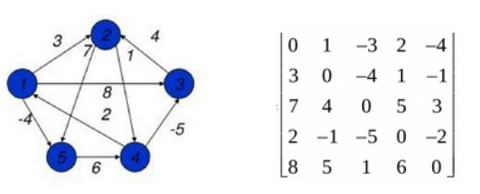
At first the output matrix is same as given cost matrix of the graph. After that the output matrix will be updated with all vertices k as the intermediate vertex.
The time complexity of this algorithm is O(V3), here V is the number of vertices in the graph.
Input − The cost matrix of the graph.
0 3 6 ∞ ∞ ∞ ∞
3 0 2 1 ∞ ∞ ∞
6 2 0 1 4 2 ∞
∞ 1 1 0 2 ∞ 4
∞ ∞ 4 2 0 2 1
∞ ∞ 2 ∞ 2 0 1
∞ ∞ ∞ 4 1 1 0
Output − Matrix of all pair shortest path.
0 3 4 5 6 7 7
3 0 2 1 3 4 4
4 2 0 1 3 2 3
5 1 1 0 2 3 3
6 3 3 2 0 2 1
7 4 2 3 2 0 1
7 4 3 3 1 1 0

Algorithm

floydWarshal(cost)
Input − The cost matrix of given Graph.
Output − Matrix to for shortest path between any vertex to any vertex.
Begin
for k := 0 to n, do
for i := 0 to n, do
for j := 0 to n, do
if cost[i,k] + cost[k,j] < cost[i,j], then
cost[i,j] := cost[i,k] + cost[k,j]
done
done
done
display the current cost matrix
End

Let us understand this problem with the help of a graph. Consider the graph given below. It consists of four vertices (named as 1, 2, 3, 4 inside circles) and there are 5 directed edges with their edge weights as shown in the graph.
Intuitively, we can tell the shortest path from each vertex to every other vertex in this graph.

All pair shortest paths
Node 1:
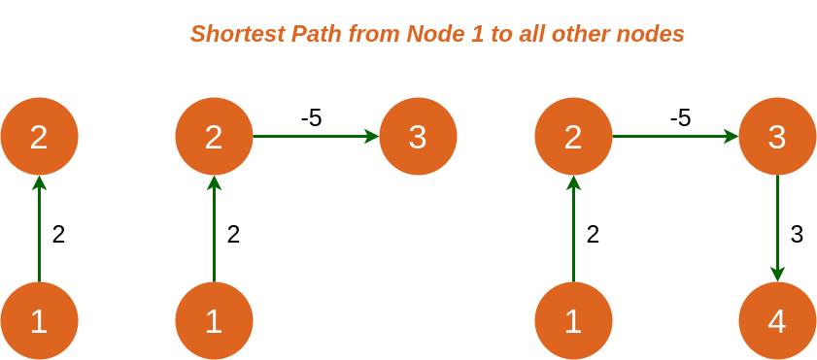

Node 2:
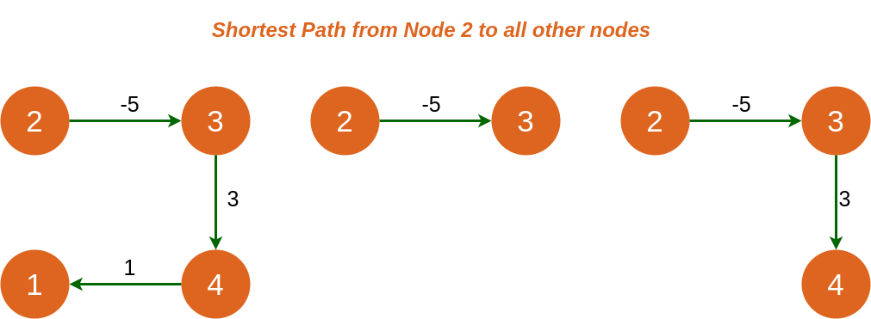

Node 3:
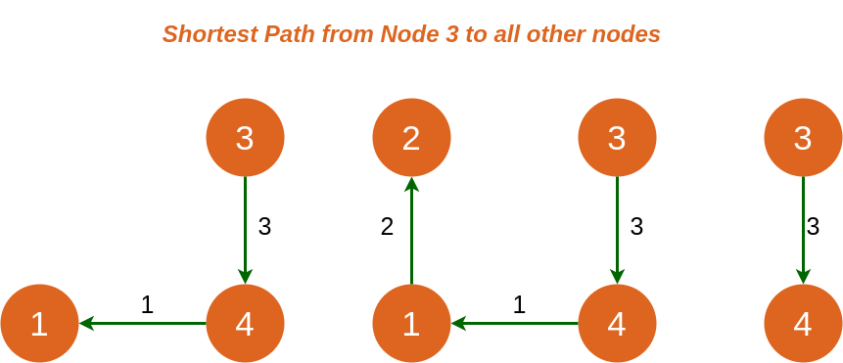

Node 4:
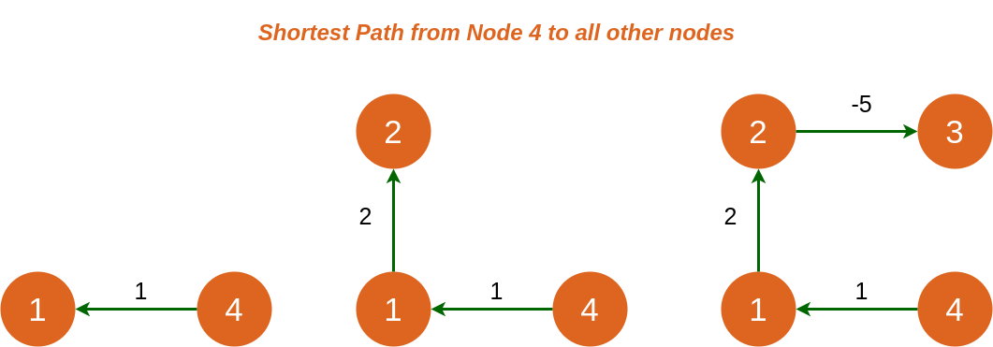

solve the travelling salesman problem using dynamic programming
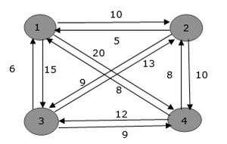
From the above graph, the following table is prepared.
 | 1 | 2 | 3 | 4
1 | 0 | 10 | 15 | 20
2 | 5 | 0 | 9 | 10
3 | 6 | 13 | 0 | 12
4 | 8 | 8 | 9 | 0

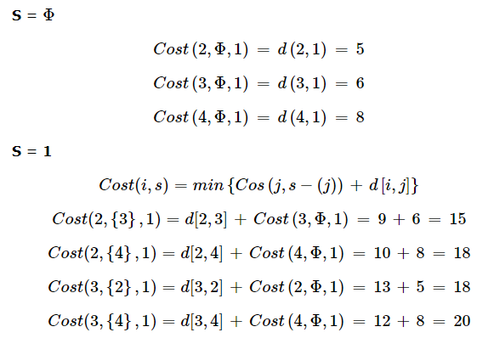
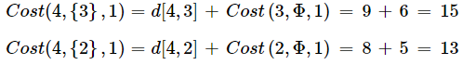
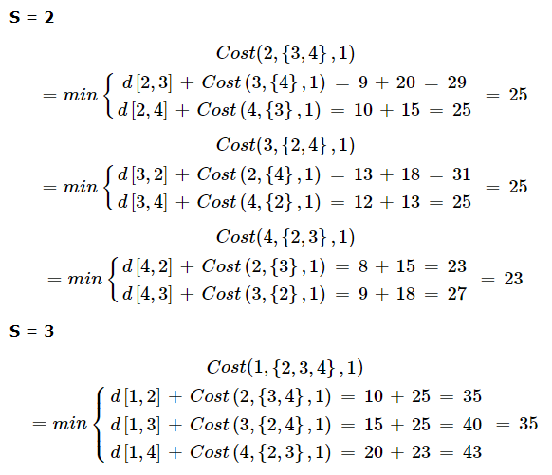
The minimum cost path is 35.
Start from cost {1, {2, 3, 4}, 1}, we get the minimum value for d [1, 2]. When s = 3, select the path from 1 to 2 (cost is 10) then go backwards. When s = 2, we get the minimum value for d [4, 2]. Select the path from 2 to 4 (cost is 10) then go backwards.
When s = 1, we get the minimum value for d [4, 2] but 2 and 4 is already selected. Therefore, we select d [4, 3] (two possible values are 15 for d [2, 3] and d [4, 3], but our last node of the path is 4). Select path 4 to 3 (cost is 9), then go to s = ϕ step. We get the minimum value for d [3, 1] (cost is 6).
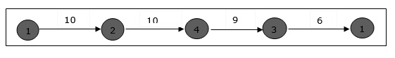
UNIT IV GREEDY METHOD
1. Explain the greedy method.
Greedy method is the most important design technique, which makes a choice that
looks best at that moment. A given ‘n’ inputs are required us to obtain a subset that
satisfies some constraints that is the feasible solution. A greedy method suggests that
one can device an algorithm that works in stages considering one input at a time.
2. Define feasible and optimal solution.
Given n inputs and we are required to form a subset such that it satisfies some
given constraints then such a subset is called feasible solution. A feasible solution
either maximizes or minimizes the given objective function is called as optimal
solution
3. Write the control abstraction for greedy method.
Algorithm Greedy (a, n)
{
solution=0;
for i=1 to n do
{
x= select(a);
if feasible(solution ,x) then
solution=Union(solution ,x);
}
return solution;
}
4. What are the constraints of knapsack problem?
To maximize Σpixi
1≤i≤n
The constraint is : Σwixi ≥ m and 0 ≤ xi ≤ 1 1≤ i ≤ n
1≤i≤n
where m is the bag capacity, n is the number of objects and for each object i wi
and pi are the weight and profit of object respectively.
5. What is a minimum cost spanning tree?
A spanning tree of a connected graph is its connected acyclic subgraph that
contains all vertices of a graph. A minimum spanning tree of a weighted
connected graph is its spanning tree of the smallest weight where bweight of the
tree is the sum of weights on all its edges.
A minimum spanning subtree of a weighted graph (G,w) is a spanning subtree of
G of minimum weight w(T )= Σ w(e )
e€ T
Minimum Spanning Subtree Problem: Given a weighted connected undirected graph
(G,w), find a minimum spanning subtree
6. Specify the algorithms used for constructing Minimum cost spanning tree.
a) Prim’s Algorithm
b) Kruskal’s Algorithm
7. State single source shortest path algorithm (Dijkstra’s algorithm).
For a given vertex called the source in a weigted connected
graph,find shotrtest paths to all its other vertices.Dijikstra’s algorithm applies to
graph with non-negative weights only.
8. What is Knapsack problem?
A bag or sack is given capacity and n objects are given. Each object has weight
wi and
profit pi .Fraction of object is considered as xi (i.e) 0<=xi<=1 .If fraction is 1 then
entire object is put into sack. When we place this fraction into the sack we get wixi
and pixi.
9. Write any two characteristics of Greedy Algorithm?
* To solve a problem in an optimal way construct the solution from given set of
candidates.
* As the algorithm proceeds, two other sets get accumulated among this one set
contains
the candidates that have been already considered and chosen while the other set
contains
the candidates that have been considered but rejected.
10. What is the Greedy approach?
The method suggests constructing solution through sequence of steps,each
expanding partially constructed solution obtained so far,until a complete solution is
reached. On each step,the choice must be
• Feasible(satisfy problem constraints)
• Locally optimal(best local choice among all feasible choices available on that
step)
• Irrevocable(once made,it cant be changed)
11. What are the steps required to develop a greedy algorithm?
* Determine the optimal substructure of the problem.
* Develop a recursive solution.
* Prove that at any stage of recursion one of the optimal choices is greedy choice.
Thus it is always safe to make greedy choice.
* Show that all but one of the sub problems induced by having made the greedy
choice are empty.
* Develop a recursive algorithm and convert into iterative algorithm.
12.state the requirement in optimal storage problem in tapes.
Finding a permutation for the n programs so that when they are stored on the tape in
this order the MRT is minimized.This problem fits the ordering paradigm.
13. state efficiency of prim’s algorithm.
O(|v|2) (WEIGHT MATRIX AND PRIORITY QUEUE AS UNORDERED ARRAY)
O(|E| LOG|V|) (ADJACENCY LIST AND PRIORITY QUEUE AS MIN-HEAP)
14 State Kruskal Algorithm.
The algorithm looks at a MST for a weighted connected graph as an acyclic sub graph
with |v|-1 edges for which the sum of edge weights is the smallest.
15. state efficiency of Dijkstra’s algorithm.
O(|v|2) (WEIGHT MATRIX AND PRIORITY QUEUE AS UNORDERED ARRAY)
O(|E| LOG|V|) (ADJACENCY LIST AND PRIORITY QUEUE AS MIN-HEAP)
16. Differentiate subset paradigm and ordering paradigm
subset paradigm ordering paradigm At each stage a decision is made
regarding whether a particular input is in an optimal solution (generating sub
optimal solutions) For problems that do not call for selection of optimal subset, in the greedy manner we make decisions by considering inputs insome order
Example kNAPSACK, MST Optimal storage on tapes

LONG ANSWERS
1.Explain the optimal solution using Greedy Method?
Ans: Greedy Method:
The greedy method is perhaps (maybe or possible) the most straight forward design technique, used to determine a feasible solution that may or may not be optimal.

Feasible solution:- Most problems have n inputs and its solution contains a subset of inputs that satisfies a given constraint(condition). Any subset that satisfies the constraint is called feasible solution.

Optimal solution: To find a feasible solution that either maximizes or minimizes a given objective function. A feasible solution that does this is called optimal solution.The greedy method suggests that an algorithm works in stages, considering one input at a time. At each stage, a decision is made regarding whether a particular input is in an optimal solution.
Greedy algorithms neither postpone nor revise the decisions (ie., no back tracking).
Example: Kruskal’s minimal spanning tree. Select an edge from a sorted
Single source shortest path problem.

Algorithm for Greedy method
Algorithm Greedy(a,n)
//a[1:n] contains the n inputs.
{
Solution :=0; For i=1 to n do
{
X:=select(a);
If Feasible(solution, x) then Solution :=Union(solution,x);
}
Return solution;
}
Selection Function, that selects an input from a[] and removes it. The selected input’s value is assigned to x.
Feasible Boolean-valued function that determines whether x can be included into the solution vector.
Union function that combines x with solution and updates the objective function.

2. Explain Prim’s Algorithm?
Ans: PRIM’S ALGORITHM: -
- Select an edge with minimum cost and include in to the spanning tree.
- Among all the edges which are adjacent with the selected edge, select the onewith minimum cost.
- Repeat step 2 until ‘n’ vertices and (n-1) edges are been included. And the subgraph obtained does not contain any cycles.

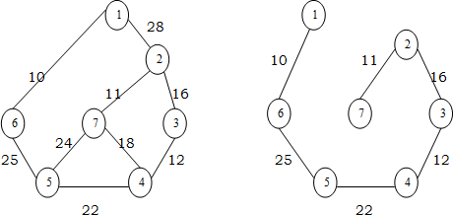

Prim's minimum spanning tree algorithm
Algorithm Prim (E, cost, n,t)
// E is the set of edges in G. Cost (1:n, 1:n) is the
// Cost adjacency matrix of an n vertex graph such that
// Cost (i,j) is either a positive real no. or ∞ if no edge (i,j) exists.
//A minimum spanning tree is computed and
//Stored in the array T(1:n-1, 2).
//(t (i, 1), + t(i,2)) is an edge in the minimum cost spanning tree. The final cost is returned
{
Let (k, l) be an edge with min cost in E Min cost: = Cost (x,l);
T(1,1):= k; + (1,2):= l;
for i:= 1 to n do//initialize near
if (cost (i,l)<cost (i,k) then n east (i): l; else near (i): = k;
near (k): = near (l): = 0; for i: = 2 to n-1 do
{//find n-2 additional edges for t
let j be an index such that near (i) 0 & cost (j, near (i)) is minimum;t (i,1): = j + (i,2): = near (j);
min cost: = Min cost + cost (j, near (j)); near (j): = 0;
for k:=1 to n do // update near ()
if ((near (k) 0) and (cost {k, near (k)) > cost (k,j))) then near Z(k): = ji
}
return mincost;
}

The algorithm takes four arguments E: set of edges, cost is nxn adjacency matrix cost of (i,j)=
+ve integer, if an edge exists between i&j otherwise infinity. ‘n’ is no/: of vertices. ‘t’ is a (n- 1):2matrix which consists of the edges of spanning tree.
E = { (1,2), (1,6), (2,3), (3,4), (4,5), (4,7), (5,6), (5,7), (2,7) }
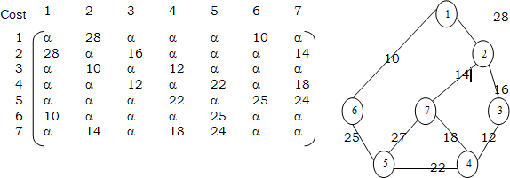
n = {1,2,3,4,5,6,7)
  - The algorithm will start with a tree that includes only minimum cost edge of

Kruskal minimum spanning tree algorithm
Algorithm Kruskal (E, cost, n,t)
//E is the set of edges in G. ‘G’ has ‘n’ vertices
//Cost {u,v} is the cost of edge (u,v) t is the set
//of edges in the minimum cost spanning tree
//The final cost is returned
{ construct a heap out of the edge costs using heapify;
for i:= 1 to n do parent (i):= -1 // place in different sets
//each vertex is in different set {1} {1} {3} i: = 0; min cost: = 0.0;
While (i<n-1) and (heap not empty))do
{
Delete a minimum cost edge (u,v) from the heaps; and reheapify using adjust; j:= find (u); k:=find (v);
if (j k) then
{ i: = 1+1;
+ (i,1)=u; + (i, 2)=v;
mincost: = mincost+cost(u,v); Union (j,k);
}
}
if (i n-1) then write (“No spanning tree”);else return mincost;
}
G. Then edges are added to this tree one by one.

  - The next edge (i,j) to be added is such that i is a vertex which is already included in the treed and j is a vertex not yet included in the tree and cost of i,j is minimum among all edges adjacent to ‘i’.

With each vertex ‘j’ next yet included in the tree, we assign a value near ‘j’. The value near ‘j’ represents a vertex in the tree such that cost (j, near (j)) is minimum among all choices for near.We define near (j):= 0 for all the vertices ‘j’ that are already in the tree. The next edge to include is defined by the vertex ‘j’ such that (near (j)) 0 and cost of (j, near (j)) is minimum.
Analysis: -
The time required by the prince algorithm is directly proportional to the no/: of vertices. If a graph ‘G’ has ‘n’ vertices then the time required by prim’s algorithm is 0(n2)

3. Explain Kruskal’s Algorithm?

Ans: Kruskal’s Algorithm: Start with no nodes or edges in the spanning tree, and repeatedly add the cheapest edge that does not create a cycle.
In Kruskals algorithm for determining the spanning tree we arrange the edges in the increasing order of cost.All the edges are considered one by one in that order and deleted from the graph and are included in to the spanning tree.At every stage an edge is included; the sub-graph at a stage need not be a tree. Infect it is a forest.At the end if we include ‘n’ vertices and n-1 edges without forming cycles then we get a single connected component without any cycles i.e. a tree with minimum cost.
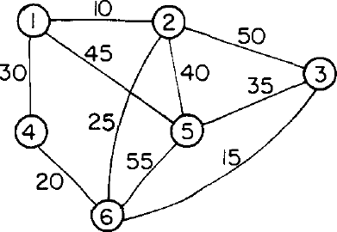
At every stage, as we include an edge in to the spanning tree, we get disconnected trees represented by various sets. While including an edge in to the spanning tree we need to check it does not form cycle. Inclusion of an edge (i,j) will form a cycle if i,j both are in same set. Otherwise the edge can be included into the spanning tree.
UNIT V BRANCH AND BOUND
1. What are the requirements that are needed for performing Backtracking?
To solve any problem using backtracking, it requires that all the solutions satisfy a
complex set of constraints. They are:
i. Explicit constraints.
ii. Implicit constraints.
2.Define explicit constraint.
They are rules that restrict each x to take on values only from a give set. They i
depend on the particular instance I of the problem being solved. All tuples that satisfy the
explicit constraints define a possible solution space.
3. Define implicit constraint.
They are rules that determine which of the tuples in the solution space of I satisfy the
criteria function. It describes the way in which the x must relate to each other. i
4.Define state space tree.
The tree organization of the solution space is referred to as state space tree.
5.Define state space of the problem.
All the paths from the root of the organization tree to all the nodes is called as state
space of the problem
6.Define answer states.
Answer states are those solution states s for which the path from the root to s
defines a tuple that is a member of the set of solutions of the problem.
7. What are static trees?
The tree organizations that are independent of the problem instance being solved
are called as static tree.
8. What are dynamic trees?
The tree organizations those are independent of the problem instance being solved
are called as static tree.
9.Define a live node.
A node which has been generated and all of whose children have not yet been
generated is called as a live node.
10. Define a E – node.
E – node (or) node being expanded. Any live node whose children are currently
being generated is called as a E – node.
11.Define a dead node.
Dead node is defined as a generated node, which is to be expanded further all of
whose children have been generated.
12.,What are the factors that influence the efficiency of the backtracking algorithm?
The efficiency of the backtracking algorithm depends on the following four
factors. They are:
The ti i. me needed to generate the next x k
ii. The number of x satisfying the explicit constraints. k
iii. The time for the bounding functions B
iv. The number of x satisfying the B
13.Define Branch-and-Bound method.
The term Branch-and-Bound refers to all the state space methods in which all
children of the E-node are generated before any other live node can become the E- node.
14.What are the searching techniques that are commonly used in Branch-and-Bound
method.
The searching techniques that are commonly used in Branch-and-Bound method
are:
i. FIFO
ii. LIFO
iii. LC
iv. Heuristic search
15.State 8 – Queens problem.
The problem is to place eight queens on a 8 x 8 chessboard so that no two queen
“attack” that is, so that no two of them are on the same row, column or on the diagonal.
16.State Sum of Subsets problem.
Given n distinct positive numbers usually called as weights , the problem calls for finding
all the combinations of these numbers whose sums are m.
17. State m – colorability decision problem.
Let G be a graph and m be a given positive integer. We want to discover whether the
nodes of G can be colored in such a way that no two adjacent nodes have the same color yet only
m colors are used.
18.Define chromatic number of the graph.
The m – colorability optimization problem asks for the smallest integer m for which the
19. What is a decision problem?
Any problem for which the answer is either zero or one is called decision problem.
20. what is approximate solution?
A feasible solution with value close to the value of an optimal solution is called
approximate solution.
21. what is promising and non-promising nodes?
a node in a state space tree is said to be promising if it corresponds to a
partially constructed solution from which a complete solution can be obtained.
The nodes which are not promising for solution in a state space tree are called
non-promising nodes.
22.Write formula for bounding function in Knapsack problem
In knapsack problem upper bound value is computed by the formula
UB = v + (W-w) * (vi+1/wi+1)
23. Write about traveling salesperson problem.
Let g = (V, E) be a directed. The tour of G is a directed simple cycle that includes every vertex in V. The cost of a tour is
the sum of the cost of the edges on the tour. The traveling salesperson problem is to find a tour of minimum cost.
In branch and bound technique of TSP problem Lower bound lb= s/2
24. Write some applications of traveling salesperson problem.
-> Routing a postal van to pick up mail from boxes located at n different sites.
-> Using a robot arm to tighten the nuts on some piece of machinery on an assembly line.
-> Production environment in which several commodities are manufactured on the same set of machines.
25. Give the time complexity and space complexity of traveling salesperson problem.
Time complexity is O (n2 2n). Space complexity is O (n 2n).
26. Differentiate decision problem and optimization problem
Any problem for which the answer is either zero or one is called decision problem
Any problem that involves the identification of an optimal (maximum or minimum) value of a given cost function is
called optimization problem
27. what is class P and NP?
P is set of all decision problems solvable by deterministic algorithms in polynomial time.
NP is set of all decision problems solvable by non deterministic algorithms in polynomial time.
28. Define NP-Hard and NP-Complete problems
Problem L is NP-Hard if and only if satisfiability reduces to L.
A Problem L is NP-Complete if and only if L is NP-Hard and L belongs to NP.n))

