Unit-1
Short answer questions
1) What is meant by Object Oriented Programming?
OOP is a method of programming in which programs are organised as cooperative collections of objects. Each object is an instance of a class and each class belong to a hierarchy.
2) What is a Class?
Class is a template for a set of objects that share a common structure and a common behaviour.
3) What is an Object?
Object is an instance of a class. It has state, behavior and identity. It is also called as an instance of a class.
4) What is an Instance?
An instance has state, behavior and identity. The structure and behavior of similar classes are defined in their common class. An instance is also called as an object.
5) What are the core OOP’s concepts?
Abstraction, Encapsulation, Inheritance and Polymorphism are the core OOP’s concepts.
6) What is meant by abstraction?
Abstraction defines the essential characteristics of an object that distinguish it from all other kinds of objects. Abstraction provides crisply-defined conceptual boundaries relative to the perspective of the viewer. Its the process of focusing on the essential characteristics of an object. Abstraction is one of the fundamental elements of the object model.
7) What is meant by Encapsulation?
Encapsulation is the process of compartmentalizing the elements of an abstraction that defines the structure and behavior. Encapsulation helps to separate the contractual interface of an abstraction and implementation.
8) What are Encapsulation, Inheritance and Polymorphism?
Encapsulation is the mechanism that binds together code and data it manipulates and keeps both safe from outside interference and misuse. Inheritance is the process by which one object acquires the properties of another object. Polymorphism is the feature that allows one interface to be used for general class actions.
9) What are methods and how are they defined?
Methods are functions that operate on instances of classes in which they are defined. Objects can communicate with each other using methods and can call methods in other classes. Method definition has four parts. They are name of the method, type of object or primitive type the method returns, a list of parameters and the body of the method. A method’s signature is a combination of the first three parts mentioned above.
10) What are different types of access modifiers (Access specifiers)?
Access specifiers are keywords that determine the type of access to the member of a class. These keywords are for allowing privileges to parts of a program such as functions and variables. These are: public: Anything declared as public can be accessed from anywhere.
private: Anything declared as private can’t be seen outside of its class.
protected: Anything declared as protected can be accessed by classes in the same package and subclasses in the other packages.
default modifier : Can be accessed only to classes in the same package.
11) What is an Object and how do you allocate memory to it?
Object is an instance of a class and it is a software unit that combines a structured set of data with a set of operations for inspecting and manipulating that data. When an object is created using new operator, memory is allocated to it.
12) What gives java it’s “write once and run anywhere” nature?
All Java programs are compiled into class files that contain bytecodes. These byte codes can be run in any platform and hence java is said to be platform independent.
13) What is a constructor?
What is a destructor? Constructor is an operation that creates an object and/or initialises its state. Destructor is an operation that frees the state of an object and/or destroys the object itself. In Java, there is no concept of destructors. Its taken care by the JVM.
14) What is the difference between constructor and method?
Constructor will be automatically invoked when an object is created whereas method has to be called explicitly
15) What is Garbage Collection and how to call it explicitly?
When an object is no longer referred to by any variable, java automatically reclaims memory used by that object. This is known as garbage collection. System. gc() method may be used to call it explicitly
16) In Java, How to make an object completely encapsulated?
All the instance variables should be declared as private and public getter and setter methods should be provided for accessing the instance variables.
17) What is static variable and static method?
static variable is a class variable which value remains constant for the entire class. static method is the one which can be called with the class itself and can hold only the staic variables
18) What is finalize() method?
finalize () method is used just before an object is destroyed and can be called just prior to garbage collection.
19) What is the difference between String and String Buffer?
a) String objects are constants and immutable whereas StringBuffer objects are not.
b) String class supports constant strings whereas StringBuffer class supports growable and modifiable strings.
20) What is the difference between this() and super()?
this() can be used to invoke a constructor of the same class whereas super() can be used to invoke a super class constructor.
21) Explain working of Java Virtual Machine (JVM)?
JVM is an abstract computing machine like any other real computing machine which first converts .java file into .class file by using Compiler (.class is nothing but byte code file.) and Interpreter reads byte codes.
22) How can you minimize the need of garbage collection and make the memory use more effective?
Use object pooling and weak object references.
23) What is mutable object and immutable object?
If a object value is changeable then we can call it as Mutable object. (Ex., StringBuffer, …) If you are not allowed to change the value of an object, it is immutable object. (Ex., String, Integer, Float, …)
24) What are the methods provided by the object class?
The Object class provides five methods that are critical when writing multithreaded Java programs: notify()
notifyAll()
wait ()(three versions)
25) What is object cloning?
It is the process of duplicating an object so that two identical objects will exist in the memory at the same time.

26) Difference between constructor and method in java
There are many differences between constructors and methods. They are given below.
Java Constructor | Java Method
Constructor is used to initialize the state of an object. | Method is used to expose behaviour of an object.
Constructor must not have return type. | Method must have return type.
Constructor is invoked implicitly. | Method is invoked explicitly.
The java compiler provides a default constructor if you don't have any constructor. | Method is not provided by compiler in any case.
Constructor name must be same as the class name. | Method name may or may not be same as class name.

Long answer questions
- What are the features of java

Features of Java
- Features of Java
  - Simple
  - Object-Oriented
  - Platform Independent
  - secured
  - Robust
  - Architecture Neutral
  - Portable
  - High Performance
  - Distributed
  - Multi-threaded
There is given many features of java. They are also known as java buzzwords. The Java Features given below are simple and easy to understand.
- Simple
- Object-Oriented
- Platform independent
- Secured
- Robust
- Architecture neutral
- Portable
- Dynamic
- Interpreted
- High Performance
- Multithreaded
- Distributed

Simple
According to Sun, Java language is simple because:
syntax is based on C++ (so easier for programmers to learn it after C++).
removed many confusing and/or rarely-used features e.g., explicit pointers, operator overloading etc.
No need to remove unreferenced objects because there is Automatic Garbage Collection in java.

Object-oriented
Object-oriented means we organize our software as a combination of different types of objects that incorporates both data and behaviour.
Object-oriented programming(OOPs) is a methodology that simplify software development and maintenance by providing some rules.
Basic concepts of OOPs are:
- Object
- Class
- Inheritance
- Polymorphism
- Abstraction
- Encapsulation

Platform Independent
A platform is the hardware or software environment in which a program runs. There are two types of platforms software-based and hardware-based. Java provides software-based platform. The Java platform differs from most other platforms in the sense that it's a software-based platform that runs on top of other hardware-based platforms.It has two components:
- Runtime Environment
- API(Application Programming Interface)

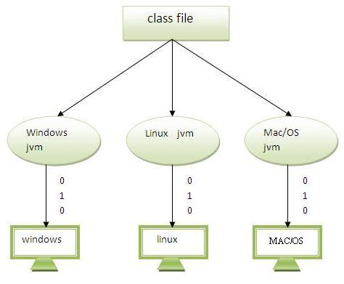Java code can be run on multiple platforms e.g.Windows,Linux,Sun Solaris,Mac/OS etc. Java code is compiled by the compiler and converted into bytecode.This bytecode is a platform independent code because it can be run on multiple platforms i.e. Write Once and Run Anywhere(WORA).

Secured
Java is secured because:
- No explicit pointer
- Programs run inside virtual machine sandbox.

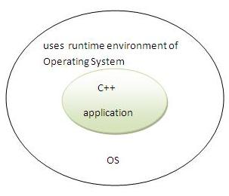 | 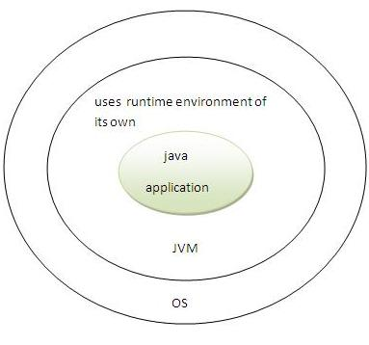

- Classloader- adds security by separating the package for the classes of the local file system from those that are imported from network sources.
- Bytecode Verifier- checks the code fragments for illegal code that can violate access right to objects.
- Security Manager- determines what resources a class can access such as reading and writing to the local disk.
These security are provided by java language. Some security can also be provided by application developer through SSL,JAAS,cryptography etc.

Robust
Robust simply means strong. Java uses strong memory management. There are lack of pointers that avoids security problem. There is automatic garbage collection in java. There is exception handling and type checking mechanism in java. All these points makes java robust.

Architecture-neutral
There is no implementation dependent features e.g. size of primitive types is set.

Portable
We may carry the java bytecode to any platform.

High-performance
Java is faster than traditional interpretation since byte code is "close" to native code still somewhat slower than a compiled language (e.g., C++)

Distributed
We can create distributed applications in java. RMI and EJB are used for creating distributed applications. We may access files by calling the methods from any machine on the internet.

Multi-threaded
A thread is like a separate program, executing concurrently. We can write Java programs that deal with many tasks at once by defining multiple threads. The main advantage of multi-threading is that it shares the same memory. Threads are important for multi-media, Web applications etc.

2) Explain Constructor Overloading in Java
Constructor overloading is a technique in Java in which a class can have any number of constructors that differ in parameter lists.The compiler differentiates these constructors by taking into account the number of parameters in the list and their type.

Example of Constructor Overloading
class Student
{
int id;
String name;
int age;
Student(int i,String n)
{
id = i;
name = n;
}
Student(int i,String n,int a)
{
id = i;
name = n;
age=a;
}
void display()
{
System.out.println(id+" "+name+" "+age);
}

public static void main(String args[])
{
Student s1 = new Student5(111,"Karan");
Student s2 = new Student5(222,"Aryan",25);
s1.display();
s2.display();
}
}

3) Explain Java static keyword
The static keyword in java is used for memory management mainly. The static keyword belongs to the class than instance of the class.
The static can be:
- variable (also known as class variable)
- method (also known as class method)
- block
- nested class

1) static variable
If you declare any variable as static, it is known static variable.
- The static variable can be used to refer the common property of all objects (that is not unique for each object) e.g. company name of employees,college name of students etc.
- The static variable gets memory only once in class area at the time of class loading.

Advantage of static variable
It makes your program memory efficient (i.e it saves memory).

Example of static variable:

static String college ="CMR";

Program of counter by static variable
As we have mentioned above, static variable will get the memory only once, if any object changes the value of the static variable, it will retain its value.
class Counter
{
static int count=0;//will get memory only once and retain its value

Counter()
{
count++;
System.out.println(count);
}

public static void main(String args[])
{

Counter c1=new Counter();
Counter c2=new Counter();
Counter c3=new Counter();

}
}
Output:1
2
3

2) static method
If you apply static keyword with any method, it is known as static method.
- A static method belongs to the class rather than object of a class.
- A static method can be invoked without the need for creating an instance of a class.
- static method can access static data member and can change the value of it.

Example of static method

class Student
{
int rollno;
String name;
static String college = "CMR";

static void change()
{
college = "CMREC";
}

Student (int r, String n)
{
rollno = r;
name = n;
}

void display ()
{
System.out.println(rollno+" "+name+" "+college);
}

public static void main(String args[])
{
Student.change();

Student s1 = new Student (111,"Karan");
Student s2 = new Student (222,"Aryan");
Student s3 = new Student (333,"Sonoo");

s1.display();
s2.display();
s3.display();
}
}

Restrictions for static method
There are two main restrictions for the static method. They are:

- The static method can not use non static data member or call non-static method directly.
- this and super cannot be used in static context.

3) static block
- Is used to initialize the static data member.
- It is executed before main method at the time of classloading.

Example of static block
class A2
{
Static
{
System.out.println("static block is invoked");
}
public static void main(String args[])
{
System.out.println("Hello main");
}
}

4)static inner class
A static class i.e. created inside a class is called static nested class in java. It cannot access non-static data members and methods. It can be accessed by outer class name.

Java static inner class example
class TestOuter1
{
static int data=30;
static class Inner
{
void msg()
{
System.out.println("data is "+data);
}
}
public static void main(String args[])
{
TestOuter1.Inner obj=new TestOuter1.Inner();
obj.msg();
}
}
4) Explain some of the methods of String class

SN | Methods with Description
1 | char charAt(int index)  Returns the character at the specified index.
2 | int compareTo(Object o)  Compares this String to another Object.
3 | int compareTo(String anotherString)  Compares two strings lexicographically.
4 | int compareToIgnoreCase(String str)  Compares two strings lexicographically, ignoring case differences.
5 | String concat(String str)  Concatenates the specified string to the end of this string.
6 | boolean contentEquals(StringBuffer sb)  Returns true if and only if this String represents the same sequence of characters as the specified StringBuffer.
7 | static String copyValueOf(char[] data)  Returns a String that represents the character sequence in the array specified.
8 | static String copyValueOf(char[] data, int offset, int count)  Returns a String that represents the character sequence in the array specified.
9 | boolean endsWith(String suffix)  Tests if this string ends with the specified suffix.
10 | boolean equals(Object anObject)  Compares this string to the specified object.
11 | boolean equalsIgnoreCase(String anotherString)  Compares this String to another String, ignoring case considerations.
12 | int indexOf(int ch)  Returns the index within this string of the first occurrence of the specified character.
13 | int indexOf(int ch, int fromIndex)  Returns the index within this string of the first occurrence of the specified character, starting the search at the specified index.
14 | int indexOf(String str)  Returns the index within this string of the first occurrence of the specified substring.
15 | int indexOf(String str, int fromIndex)  Returns the index within this string of the first occurrence of the specified substring, starting at the specified index

5) Explain Final Keyword In Java
The final keyword in java is used to restrict the user. The java final keyword can be used in many context. Final can be:
- variable
- method
- class

1) final variable
If you make any variable as final, you cannot change the value of final variable(It will be constant).
Example:
final int speedlimit=90;//final variable

2) final method
If you make any method as final, you cannot override it.

Example of final method
class Bike
{
final void run()
{
System.out.println("running");
}
}

class Honda extends Bike
{
void run() // error cannot override final method
{
System.out.println("running safely with 100kmph");
}

public static void main(String args[])
{
Honda honda= new Honda();
honda.run();
}
}
Test it Now
Output:Compile Time Error

3) final class
If you make any class as final, you cannot extend it.

Example of final class
final class Bike
{
}

class Honda1 extends Bike //error cannot inherit final class
{
void run()
{
System.out.println("running safely with 100kmph");
}

public static void main(String args[])
{
Honda1 honda= new Honda();
honda.run();
}
}
Test it Now
Output:Compile Time Error

Unit-2
1) What's the difference between an interface and an abstract class?
An abstract class may contain code in method bodies, which is not allowed in an interface. With abstract classes, you have to inherit your class from it and Java does not allow multiple inheritance. On the other hand, you can implement multiple interfaces in your class.
2) Explain the usage of Java packages.
This is a way to organize files when a project consists of multiple modules. It also helps resolve naming conflicts when different packages have classes with the same names. Packages access level also allows you to protect data from being used by the non-authorized classes.
3) What is method overloading and method overriding?
Method overloading: When a method in a class having the same method name with different arguments is said to be method overloading.
Method overriding : When a method in a class having the same method name with same arguments is said to be method overriding.
4) What is Static member classes?
A static member class is a static member of a class. Like any other static method, a static member class has access to all static methods of the parent, or top-level, class.
5) What is finalize() method?
finalize () method is used just before an object is destroyed and can be called just prior to garbage collection.
6) What is an Abstract Class?
Abstract class is a class that has no instances. An abstract class is written with the expectation that its concrete subclasses will add to its structure and behaviour, typically by implementing its abstract operations.
7) What are inner class and anonymous class?
Inner class: classes defined in other classes, including those defined in methods are called inner classes. An inner class can have any accessibility including private. Anonymous class: Anonymous class is a class defined inside a method without a name and is instantiated and declared in the same place and cannot have explicit constructors
8) What is an Interface?
Interface is an outside view of a class or object which emphaizes its abstraction while hiding its structure and secrets of its behaviour.
9) What is a base class?
Base class is the most generalised class in a class structure. Most applications have such root classes. In Java, Object is the base class for all classes.
10) What is the difference between a static and a non-static inner class?
A non-static inner class may have object instances that are associated with instances of the class's outer class. A static inner class does not have any object instances.
11) What is the difference between abstract class and interface?
a) All the methods declared inside an interface are abstract whereas abstract class must have at least one abstract method and others may be concrete or abstract.
b) In abstract class, key word abstract must be used for the methods whereas interface we need not use that keyword for the methods.
c) Abstract class must have subclasses whereas interface can’t have subclasses.
12) Can you have an inner class inside a method and what variables can you access?
Yes, we can have an inner class inside a method and final variables can be accessed.
13) What is interface and its use?
Interface is similar to a class which may contain method’s signature only but not bodies and it is a formal set of method and constant declarations that must be defined by the class that implements it.
Interfaces are useful for:
a) Declaring methods that one or more classes are expected to implement
b) Capturing similarities between unrelated classes without forcing a class relationship.
c) Determining an object’s programming interface without revealing the actual body of the class.

Long answer questions

1) What is Method Overloading in Java
If a class have multiple methods by same name but different parameters, it is known as Method Overloading.
If we have to perform only one operation, having same name of the methods increases the readability of the program.

Advantage of method overloading: Method overloading increases the readability of the program.

Example of Method Overloading
In this example, we have created two overloaded methods, first sum method performs addition of two numbers and second sum method performs addition of three numbers.
class Calculation
{
void sum(int a,int b)
{
System.out.println(a+b);
}
void sum(int a,int b,int c)
{
System.out.println(a+b+c);
}

public static void main(String args[])
{
Calculation obj=new Calculation();
obj.sum(10,10,10);
obj.sum(20,20);
}
}

2)What is method overriding explain with example

If subclass (child class) has the same method as declared in the parent class, it is known as method overriding in java.
- Method overriding is used for runtime polymorphism

Rules for Java Method Overriding
- method must have same name as in the parent class
- method must have same parameter as in the parent class.
- must be IS-A relationship (inheritance).
Example program
class Vehicle
{
void run()
{
System.out.println("Vehicle is running");
}
}
class Bike2 extends Vehicle
{
void run()
{
System.out.println("Bike is running safely");
}

public static void main(String args[])
{
Bike2 obj = new Bike2();
obj.run();
}

}
Output: Bike is running safely

3) Explain Access Modifiers in java
The access modifiers in java specifies accessibility (scope) of a data member, method, constructor or class.
There are 4 types of java access modifiers:
- private
- default
- protected
- public

Understanding all java access modifiers
Access Modifier | within class | within package | outside package by subclass only | outside package
Private | Y | N | N | N
Default | Y | Y | N | N
Protected | Y | Y | Y | N
Public | Y | Y | Y | Y

Example Program:
package p1;
class AccessDemo
{
int d=10 //default variable
private int a=20;
public int b = 30;
protected int c =40;
}

package p1;
class AccessDemo1
{
Public static void main(String args[])
{
System.out.println(p1.a); //prints 10
//System.out.println(p1.b); //error cant access private variable in other class
System.out.println(p1.c); //prints 30
System.out.println(p1.d); //prints 40
}
}

package p2;
import p1.*;
class AccessDemo2
{
Public static void main(String args[])
{
//System.out.println(p1.a); //error cannot access default variable in other package
//System.out.println(p1.b); //error cannot access private variable in other class
System.out.println(p1.c); //prints 30
System.out.println(p1.d); //error
}
}

4) Explain Types of inheritance in java
On the basis of class, there can be three types of inheritance in java: single, multilevel and hierarchical.
In java programming, multiple and hybrid inheritance is supported through interface only. We will learn about interfaces later.
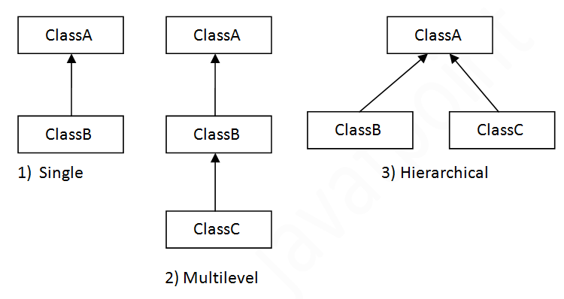

1. Single Inheritance in Java
Single Inheritance is the simple inheritance of all, When a class extends another class(Only one class) then we call it as Single inheritance. The below diagram represents the singleinheritance in java where Class B extends only one class Class A. Here Class B will be theSub class and Class A will be one and only Super class.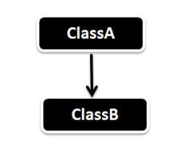
Single Inheritance Example
public class ClassA
{
public void dispA()
{
System.out.println("disp() method of ClassA");
}
}
public class ClassB extends ClassA
{
public void dispB()
{
System.out.println("disp() method of ClassB");
}
public static void main(String args[])
{
//Assigning ClassB object to ClassB reference
ClassB b = new ClassB();
//call dispA() method of ClassA
b.dispA();
//call dispB() method of ClassB
b.dispB();
}
}
Output :
disp() method of ClassA
disp() method of ClassB

2. Multilevel Inheritance in Java
In Multilevel Inheritance a derived class will be inheriting a parent class and as well as the derived class act as the parent class to other class. As seen in the below diagram. ClassBinherits the property of ClassA and again ClassB act as a parent for ClassC. In Short ClassA parent for ClassB and ClassB parent for ClassC.
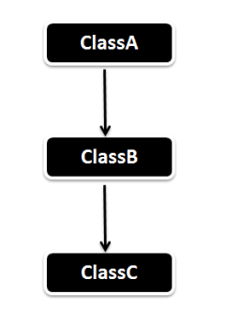
MultiLevel Inheritance Example
public class ClassA
{
public void dispA()
{
System.out.println("disp() method of ClassA");
}
}
public class ClassB extends ClassA
{
public void dispB()
{
System.out.println("disp() method of ClassB");
}
}
public class ClassC extends ClassB
{
public void dispC()
{
System.out.println("disp() method of ClassC");
}
public static void main(String args[])
{
//Assigning ClassC object to ClassC reference
ClassC c = new ClassC();
//call dispA() method of ClassA
c.dispA();
//call dispB() method of ClassB
c.dispB();
//call dispC() method of ClassC
c.dispC();
}
}
Output :
disp() method of ClassA
disp() method of ClassB
disp() method of ClassC

3.Hierarchical Inheritance in Java
In Hierarchical inheritance one parent class will be inherited by many sub classes. As per the below example ClassA will be inherited by ClassB, ClassC and ClassD. ClassA will be acting as a parent class for ClassB, ClassC and ClassD.

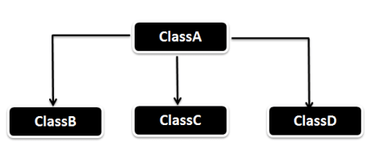
Hierarchical Inheritance Example
public class ClassA
{
public void dispA()
{
System.out.println("disp() method of ClassA");
}
}
public class ClassB extends ClassA
{
public void dispB()
{
System.out.println("disp() method of ClassB");
}
}
public class ClassC extends ClassA
{
public void dispC()
{
System.out.println("disp() method of ClassC");
}
}
public class HierarchicalInheritanceTest
{
public static void main(String args[])
{
ClassB b = new ClassB();
b.dispB();
b.dispA();

ClassC c = new ClassC();

c.dispA();
c.dispB();
c.dispC();

}
}

5) What is dynamic binding explain with example

Dynamic binding:

When type of the object is determined at run-time, it is known as dynamic binding.

Example of dynamic binding
class Animal
{
void eat()
{
System.out.println("animal is eating...");
}
}

class Dog extends Animal
{
void eat()
{
System.out.println("dog is eating...");
}

public static void main(String args[])
{
Animal a=new Dog();
a.eat();
}
}
Test it Now
Output:dog is eating...
6) Write a java program to create an abstract class named Shape that contains two integers and an empty method named printArea(). Provide three classes named Rectangle, Triangle, and Cirlce such that each one of the classes extends the class Shape. Each one of the classes contains only the method printArea() that prints the area of the given shape.
Java Code
abstract class Shape
{
int len,bre;
abstract void printArea();
}
class Rectangle extends Shape
{
int hei;
Rectangle(int l,int b,int h)
{
len=l;
bre=b;
hei=h;
}
void printArea()
{
System.out.println("area of rectangle"+len*bre*hei);
}
}
class Triangle extends Shape
{
Triangle(int l,int b)
{
len=l;
bre=b;
}
void printArea()
{
System.out.println("area of triangle"+0.5*len*bre);
}
}
class Circle extends Shape
{
Circle(int r)
{
len=r;
}
void printArea()
{
System.out.println("area of circle"+3.14*len*len);
}
}
class ShapeDemo
{
public static void main(String args[])
{
Rectangle r=new Rectangle(2,3,6);
Triangle t=new Triangle(4,6);
Circle c=new Circle(2);
Shape d;
d=r;
d.printArea();
d=t;
d.printArea();
d=c;
d.printArea();
}
}
Output:
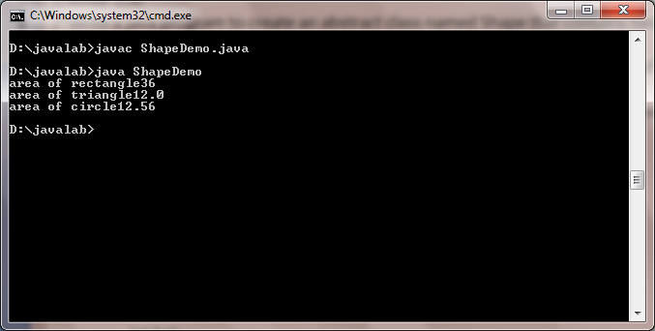

Unit-3
1)What is error?
An Error indicates that a non-recoverable condition has occurred that should not be caught. Error, a subclass of Throwable, is intended for drastic problems, such as OutOfMemoryError, which would be reported by the JVM itself.
2) Which is superclass of Exception?
"Throwable", the parent class of all exception related classes.
3)What are the advantages of using exception handling?
Exception handling provides the following advantages over "traditional" error management techniques: Separating Error Handling Code from "Regular" Code
- Propagating Errors Up the Call Stack.
- Grouping Error Types and Error Differentiation
4) What are the types of Exceptions in Java
There are two types of exceptions in Java, unchecked exceptions and checked exceptions.
Checked exceptions: A checked exception is some subclass of Exception (or Exception itself), excluding class RuntimeException and its subclasses. Each method must either handle all checked exceptions by supplying a catch clause or list each unhandled checked exception as a thrown exception.
Unchecked exceptions: All Exceptions that extend the RuntimeException class are unchecked exceptions. Class Error and its subclasses also are unchecked.
5) Why Errors are Not Checked?
A unchecked exception classes which are the error classes (Error and its subclasses) are exempted from compile-time checking because they can occur at many points in the program and recovery from them is difficult or impossible. A program declaring such exceptions would be pointlessly.
6)How does a try statement determine which catch clause should be used to handle an exception? When an exception is thrown within the body of a try statement, the catch clauses of the try statement are examined in the order in which they appear. The first catch clause that is capable of handling the exception is executed. The remaining catch clauses are ignored.
7) What is the purpose of the finally clause of a try-catch-finally statement?
The finally clause is used to provide the capability to execute code no matter whether or not an exception is thrown or caught.
8) What is the difference between checked and Unchecked Exceptions in Java?
All predefined exceptions in Java are either a checked exception or an unchecked exception. Checked exceptions must be caught using try.. catch () block or we should throw the exception using throws clause. If you dont, compilation of program will fail.
9)What is the difference between exception and error?
The exception class defines mild error conditions that your program encounters. Exceptions can occur when trying to open the file, which does not exist, the network connection is disrupted, operands being manipulated are out of prescribed ranges, the class file you are interested in loading is missing. The error class defines serious error conditions that you should not attempt to recover from. In most cases it is advisable to let the program terminate when such an error is encountered.
10) When is the finally clause of a try-catch-finally statement executed?
The finally clause of the try-catch-finally statement is always executed unless the thread of execution terminates or an exception occurs within the execution of the finally clause.
11) What are the different ways to handle exceptions?
There are two ways to handle exceptions:
- Wrapping the desired code in a try block followed by a catch block to catch the exceptions.
- List the desired exceptions in the throws clause of the method and let the caller of the¬ method handle those exceptions.
12) What is the difference between throw and throws clause?
throw is used to throw an exception manually, where as throws is used in the case of checked exceptions, to tell the compiler that we haven't handled the exception, so that the exception will be handled by the calling function.
13) What are the different ways to generate and Exception?
There are two different ways to generate an Exception.
- Exceptions can be generated by the Java run-time system.
- Exceptions thrown by Java relate to fundamental errors that violate the rules of the Java¬ language or the constraints of the Java execution environment.
14) Where does Exception stand in the Java tree hierarchy?
java.lang.Object->java.lang.Throwable->java.lang.Exception
15) Explain the exception hierarchy in java.
The hierarchy is as follows: Throwable is a parent class off all Exception classes. They are two types of Exceptions: Checked exceptions and UncheckedExceptions. Both type of exceptions extends Exception class
16)How do you get the descriptive information about the Exception occurred during the program execution?
All the exceptions inherit a method printStackTrace() from the Throwable class. This method prints the stack trace from where the exception occurred. It prints the most recently entered method first and continues down, printing the name of each method as it works its way down the call stack from the top.
17) Can we have the try block without catch block?
Yes, we can have the try block without catch block, but finally block should follow the try block. Note: It is not valid to use a try clause without either a catch clause or a finally clause.
UNIT – IV

The Collections Framework (java.util)- Collections overview, Collection Interfaces, The Collection classes- Array List, Linked List, Hash Set, Tree Set, Priority Queue, Array Deque. Accessing a Collection via an Iterator, Using an Iterator, The For-Each alternative, Map Interfaces and Classes, Comparators, Collection algorithms, Arrays, The Legacy Classes and Interfaces- Dictionary, Hashtable ,Properties, Stack, Vector More Utility classes, String Tokenizer, Bit Set, Date, Calendar, Random, Formatter, Scanner

SHORT ANSWER QUESTIONS
1. Define collections?
Collections in java is a framework that provides an architecture to store and manipulate the group of objects.
All the operations that you perform on a data such as searching, sorting, insertion, manipulation, deletion etc. can be performed by Java Collections.
2. What is Java collection framework?
Collection framework represents a unified architecture for storing and manipulating group of objects.
It has:
1. Interfaces and its implementations i.e. classes
2. Algorithm
3. Define ArrayList with syntax?
Java ArrayList class uses a dynamic array for storing the elements. It inherits AbstractList class and implements List interface.
Syntax
public class ArrayList<E> extends AbstractList<E> implements List<E>, RandomAccess, Cloneable, Serializable
4. Define HashTable with syntax?
Java Hashtable class implements a hashtable, which maps keys to values. It inherits Dictionary class and implements the Map interface.
Syntax:
public class Hashtable<K,V> extends Dictionary<K,V> implements Map<K,V>, Cloneable, Serializable
5. What is an iterator interface in java ?
Iterator interface provides the facility of iterating the elements in forward direction only.
There are three methods in the Iterator interface.
public boolean hasNext(),
public object next(),
public void remove()
6. Define properties class in java?
The properties object contains key and value pair both as a string. The java.util.Properties class is the subclass of Hashtable.
It can be used to get property value based on the property key. The Properties class provides methods to get data from properties file and store data into properties file. Moreover, it can be used to get properties of system.
7. Define Random class in java?
The java.util.Random class instance is used to generate a stream of pseudorandom numbers.
Syntax:
public class Random
extends Object
implements Serializable
8. Define Scanner class in java?
The Java Scanner class breaks the input into tokens using a delimiter that is whitespace bydefault. It provides many methods to read and parse various primitive values. Java Scanner class is widely used to parse text for string and primitive types using regular expression.
Java Scanner class extends Object class and implements Iterator and Closeable interfaces.
9. Define stream?
A stream can be defined as a sequence of data. There are two kinds of Streams.
- InPutStream − The InputStream is used to read data from a source.
- OutPutStream − The OutputStream is used for writing data to a destination.
10. Define byte stream?
Java byte streams are used to perform input and output of 8-bit bytes. Though there are many classes related to byte streams but the most frequently used classes are, FileInputStream and FileOutputStream.
11. Define character stream?
Java Character streams are used to perform input and output for 16-bit unicode. Though there are many classes related to byte streams but the most frequently used classes are, FileInputStream and FileOutputStream.

Long Answer Questions.
1. Write about Vector with an explain its working with an example program?
Vector implements a dynamic array. It is similar to ArrayList, but with two differences −
- Vector is synchronized.
- Vector contains many legacy methods that are not part of the collections framework.
- Vector proves to be very useful if you don't know the size of the array in advance or you just need one that can change sizes over the lifetime of a program.

Code for Vector implementation.
import java.util.*;
public class VectorDemo {
public static void main(String args[]) {
// initial size is 3, increment is 2
Vector v = new Vector(3, 2);
System.out.println("Initial size: " + v.size());
System.out.println("Initial capacity: " + v.capacity());
v.addElement(new Integer(1));
v.addElement(new Integer(2));
v.addElement(new Integer(3));
v.addElement(new Integer(4));
System.out.println("Capacity after four additions: " + v.capacity());
v.addElement(new Double(5.45));
System.out.println("Current capacity: " + v.capacity());
v.addElement(new Double(6.08));
v.addElement(new Integer(7));
System.out.println("Current capacity: " + v.capacity());
v.addElement(new Float(9.4));
v.addElement(new Integer(10));
System.out.println("Current capacity: " + v.capacity());
v.addElement(new Integer(11));
v.addElement(new Integer(12));
System.out.println("First element: " + (Integer)v.firstElement());
System.out.println("Last element: " + (Integer)v.lastElement());
if(v.contains(new Integer(3)))
System.out.println("Vector contains 3.");
// enumerate the elements in the vector.
Enumeration vEnum = v.elements();
System.out.println("\nElements in vector:");
while(vEnum.hasMoreElements())
System.out.print(vEnum.nextElement() + " ");
System.out.println();
}
}
This will produce the following result −
Output:
Initial size: 0
Initial capacity: 3
Capacity after four additions: 5
Current capacity: 5
Current capacity: 7
Current capacity: 9
First element: 1
Last element: 12
Vector contains 3.
Elements in vector:
1 2 3 4 5.45 6.08 7 9.4 10 11 12

2. Explain HashTable class in java with an example program?
Java Hashtable class implements a hashtable, which maps keys to values. It inherits Dictionary class and implements the Map interface.
The important points about Java Hashtable class are:
- A Hashtable is an array of list. Each list is known as a bucket. The position of bucket is identified by calling the hashcode() method. A Hashtable contains values based on the key.
- It contains only unique elements.
- It may have not have any null key or value.
- It is synchronized.
Hashtable class Parameters
The Parameters for java.util.Hashtable class are:
- K: It is the type of keys maintained by this map.
- V: It is the type of mapped values.

Example program (HashTable):
import java.util.*;
class TestCollection16{
public static void main(String args[]){
Hashtable<Integer,String> hm=new Hashtable<Integer,String>();
hm.put(100,"Amit");
hm.put(102,"Ravi");
hm.put(101,"Vijay");
hm.put(103,"Rahul");
for(Map.Entry m:hm.entrySet()){
System.out.println(m.getKey()+" "+m.getValue());
}
}
}
OUTPUT:
103 Rahul
102 Ravi
101 Vijay
100 Amit
3. Explain the features of ArrayList with an example Program?
Java ArrayList class uses a dynamic array for storing the elements. It inherits
AbstractList class and implements List interface.
The important features Java ArrayList class are:
- Java ArrayList class can contain duplicate elements.
- Java ArrayList class maintains insertion order.
- Java ArrayList class is non synchronized.
- Java ArrayList allows random access because array works at the index basis.
- In Java ArrayList class, manipulation is slow because a lot of shifting needs to be occurred if any element is removed from the array list.

Fig: Hierarchy of ArrayList

Example Program:
import java.util.*;
class TestCollection1{
public static void main(String args[]){
ArrayList<String> list=new ArrayList<String>();//Creating arraylist
list.add("Ravi");//Adding object in arraylist
list.add("Vijay");
list.add("Ravi");
list.add("Ajay");
//Traversing list through Iterator
Iterator itr=list.iterator();
while(itr.hasNext()){
System.out.println(itr.next());
}
}
}
Output: Ravi
Vijay
Ravi
Ajay

4. What is stack? Perform stack operations push and pop in java?
Stack is a subclass of Vector that implements a standard last-in, first-out stack.
Stack only defines the default constructor, which creates an empty stack. Stack includes all the methods defined by Vector, and adds several of its own.
Syntax: Stack()

import java.util.*;
public class StackDemo {
static void showpush(Stack st, int a) {
st.push(new Integer(a));
System.out.println("push(" + a + ")");
System.out.println("stack: " + st);
}
static void showpop(Stack st) {
System.out.print("pop -> ");
Integer a = (Integer) st.pop();
System.out.println(a);
System.out.println("stack: " + st);
}
public static void main(String args[]) {
Stack st = new Stack();
System.out.println("stack: " + st);
showpush(st, 42);
showpush(st, 66);
showpush(st, 99);
showpop(st);
showpop(st);
showpop(st);
try {
showpop(st);
}catch (EmptyStackException e) {
System.out.println("empty stack");
}
}
}
OUTPUT:
stack: [ ]
push(42)
stack: [42]
push(66)
stack: [42, 66]
push(99)
stack: [42, 66, 99]
pop -> 99
stack: [42, 66]
pop -> 66
stack: [42]
pop -> 42
stack: [ ]
pop -> empty stack

5. Explain the differences between iterator and enumeration in java?

6. What is Enumeration interface in java collections? Explain with an example program program.
It is used to navigate through legacy collection classes. It is a legacy collection interface, which
is used to iterate through legacy collections.
The Enumeration interface defines the methods by which can be enumerated (obtain one at a
time) the elements in a collection of objects.
This legacy interface has been superceded by Iterator. Although not deprecated, Enumeration is
considered obsolete for new code. However, it is used by several methods defined by the legacy
classes such as Vector and Properties, is used by several other API classes.
The methods declared by Enumeration are summarized in the following table:
SN Methods with Description
1
boolean hasMoreElements( )
When implemented, it must return true while there are still more
elements to extract, and false when all the elements have been
enumerated.
2
Object nextElement( )
This returns the next object in the enumeration as a generic Object
reference.
EXAMPLE:
Following is the example showing usage of Enumeration.
import java.util.Vector;
import java.util.Enumeration;
public class EnumerationTester {
public static void main(String args[]) {
Enumeration days;
Vector dayNames = new Vector();
dayNames.add("Sunday");
dayNames.add("Monday");
dayNames.add("Tuesday");
dayNames.add("Wednesday");
dayNames.add("Thursday");
dayNames.add("Friday");
dayNames.add("Saturday");
days = dayNames.elements();
while (days.hasMoreElements()){
System.out.println(days.nextElement());
}
}
}
This would produce the following result:
14
Sunday
Monday
Tuesday
Wednesday
Thursday
Friday
Saturday
7. Explain the LinkedList collection class in java along with methods and an example program.
Java LinkedList class is used to store the elements. It provides a linked-list data structure. It inherits the AbstractList class and implements List and Deque interfaces.
The important points about Java LinkedList are:
- Java LinkedList class can contain duplicate elements.
- Java LinkedList class maintains insertion order.
- Java LinkedList class is non synchronized.
- In Java LinkedList class, manipulation is fast because no shifting needs to be occurred.
- Java LinkedList class can be used as list, stack or queue.
 | Methods of Linked List
1 | void add(int index, Object element) | It is used to insert the specified element at the specified position index in a list.
2 | void addFirst(Object o) | It is used to insert the given element at the beginning of a list.
3 | void addLast(Object o) | It is used to append the given element to the end of a list.
4 | int size() | It is used to return the number of elements in a list
5 | boolean add(Object o) | It is used to append the specified element to the end of a list.
6 | boolean remove(Object o) | It is used to remove the first occurence of the specified element in a list.
7 | Object getFirst() | It is used to return the first element in a list.
8 | Object getLast() | It is used to return the last element in a list.
9 | int indexOf(Object o) | It is used to return the index in a list of the first occurrence of the specified element, or -1 if the list does not contain any element.
10 | int lastIndexOf(Object o) | It is used to return the index in a list of the last occurrence of the specified element, or -1 if the list does not contain any element.

8. Explain the working of TreeSet with an example program.
Java TreeSet class implements the Set interface that uses a tree for storage.

A TreeSet
- Contains unique elements only like HashSet.
- Access and retrieval times are quiet fast.
- Maintains ascending order.
Methods used with TreeSet
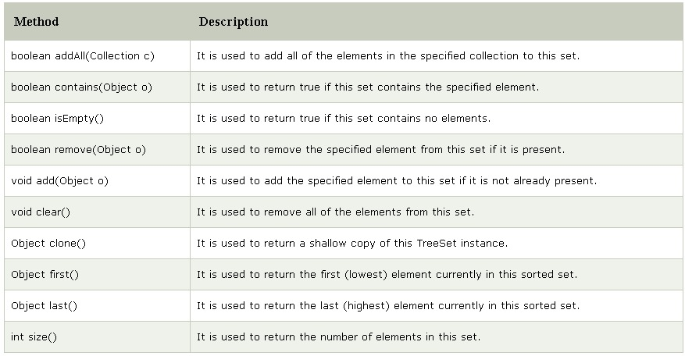

Java program to demonstrate the working of TreeSet
import java.util.*;
class TestCollection11{
public static void main(String args[]){
//Creating and adding elements
TreeSet<String> al=new TreeSet<String>();
al.add("Ravi");
al.add("Vijay");
al.add("Ravi");
al.add("Ajay");
//Traversing elements
Iterator<String> itr=al.iterator();
while(itr.hasNext()){
System.out.println(itr.next());
}
}
}
OUTPUT:

Ajay
Ravi
Vijay
9. What is PriorityQueue in java? Demonstrate its working with a java program.
Priority Queue
The PriorityQueue class provides the facility of using queue. But it does not orders the elements in FIFO manner.

- PriorityQueue doesn’t allow null
- The elements of the priority queue are ordered according to their natural ordering
- The queue retrieval operations poll, remove, peek, and element access the element at the head of the queue.
- It inherits methods from AbstractQueue, AbstractCollection, Collection and Object class.

Methods with PriorityQueue

Sl no. | Method | Description
1 | booleanadd(E element) | This method inserts the specified element into this priority queue.
2 | public remove() | This method removes a single instance of the specified element from this queue, if it is present
3 | public poll() | This method retrieves and removes the head of this queue, or returns null if this queue is empty.
4 | public peek() | This method retrieves, but does not remove, the head of this queue, or returns null if this queue is empty.
5 | iterator() | Returns an iterator over the elements in this queue.
6 | booleancontains(Object o) | This method returns true if this queue contains the specified element

Java program to demonstrate the working of PriorityQueue

import java.util.*;
class PriorityQueueDemo{
public static void main(String args[]){
PriorityQueue<String> queue=new PriorityQueue<String>();
queue.add("Amit");
queue.add("Vijay");
queue.add("Karan");
queue.add("Jai");
queue.add("Rahul");
System.out.println("head:"+queue.element());
System.out.println("head:"+queue.peek());
System.out.println("iterating the queue elements:");
Iterator itr=queue.iterator();
while(itr.hasNext()){
System.out.println(itr.next());
}
queue.remove();
queue.poll();
System.out.println("after removing two elements:");
Iterator<String> itr2=queue.iterator();
while(itr2.hasNext()){
System.out.println(itr2.next());
}
}
}
Output:head:Amit
head:Amit
iterating the queue elements:
Amit
Jai
Karan
Vijay
Rahul
after removing two elements:
Karan
Rahul
Vijay

10. Write a java program to perform and, or and xor operation using BitSet collection class.
The BitSet class creates a special type of array that holds bit values. The BitSet array can increase in size as needed. This makes it similar to a vector of bits. This is a legacy class
Source Code:
import java.util.BitSet;
public class BitSetDemo {

public static void main(String args[]) {
BitSet bits1 = new BitSet(16);
BitSet bits2 = new BitSet(16);

// set some bits
for(int i = 0; i < 16; i++) {
if((i % 2) == 0) bits1.set(i);
if((i % 5) != 0) bits2.set(i);
}

System.out.println("Initial pattern in bits1: ");
System.out.println(bits1);
System.out.println("\nInitial pattern in bits2: ");
System.out.println(bits2);

// AND bits
bits2.and(bits1);
System.out.println("\nbits2 AND bits1: ");
System.out.println(bits2);

// OR bits
bits2.or(bits1);
System.out.println("\nbits2 OR bits1: ");
System.out.println(bits2);

// XOR bits
bits2.xor(bits1);
System.out.println("\nbits2 XOR bits1: ");
System.out.println(bits2);
}
}

