1.Explain the differences between Supervised and Unsupervised Learning with example (5 marks)
Supervised learning
Supervised learning, as the name indicates, has the presence of a supervisor as a teacher. Basically supervised learning is when we teach or train the machine using data that is well labeled. Which means some data is already tagged with the correct answer. After that, the machine is provided with a new set of examples(data) so that the supervised learning algorithm analyses the training data(set of training examples) and produces a correct outcome from labeled data.
For instance, suppose you are given a basket filled with different kinds of fruits. Now the first step is to train the machine with all different fruits one by one like this:
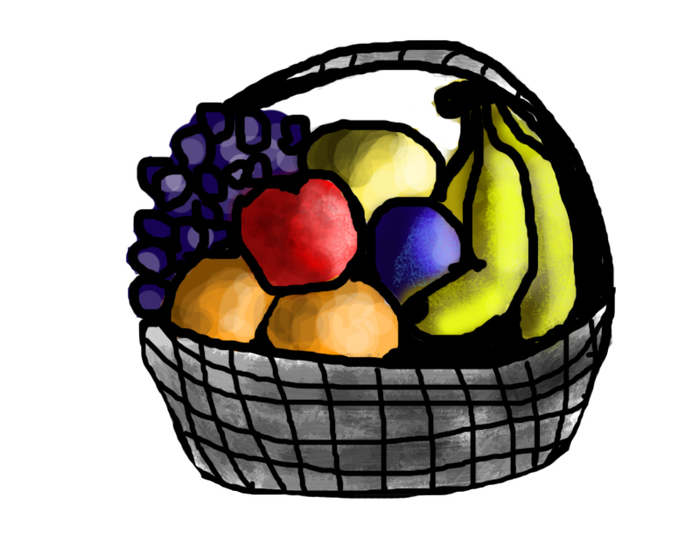
- If the shape of the object is rounded and has a depression at the top, is red in color, then it will be labeled as –Apple.
- If the shape of the object is a long curving cylinder having Green-Yellow color, then it will be labeled as –Banana.
Now suppose after training the data, you have given a new separate fruit, say Banana from the basket, and asked to identify it.

Since the machine has already learned the things from previous data and this time has to use it wisely. It will first classify the fruit with its shape and color and would confirm the fruit name as BANANA and put it in the Banana category. Thus the machine learns the things from training data(basket containing fruits) and then applies the knowledge to test data(new fruit).
Supervised learning is classified into two categories of algorithms:
- Classification: A classification problem is when the output variable is a category, such as “Red” or “blue” , “disease” or “no disease”.
- Regression: A regression problem is when the output variable is a real value, such as “dollars” or “weight”.
Supervised learning deals with or learns with “labeled” data. This implies that some data is already tagged with the correct answer.
Types:-
- Regression
- Logistic Regression
- Classification
- Naive Bayes Classifiers
- K-NN (k nearest neighbors)
- Decision Trees
- Support Vector Machine
Advantages:-
- Supervised learning allows collecting data and produces data output from previous experiences.
- Helps to optimize performance criteria with the help of experience.
- Supervised machine learning helps to solve various types of real-world computation problems.
Disadvantages:-
- Classifying big data can be challenging.
- Training for supervised learning needs a lot of computation time. So, it requires a lot of time.
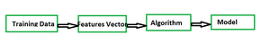
Steps

Unsupervised learning
Unsupervised learning is the training of a machine using information that is neither classified nor labeled and allowing the algorithm to act on that information without guidance. Here the task of the machine is to group unsorted information according to similarities, patterns, and differences without any prior training of data.
Unlike supervised learning, no teacher is provided that means no training will be given to the machine. Therefore the machine is restricted to find the hidden structure in unlabeled data by itself.
For instance, suppose it is given an image having both dogs and cats which it has never seen.
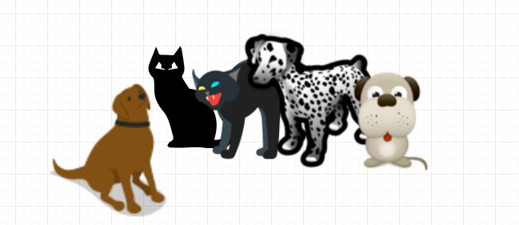
Thus the machine has no idea about the features of dogs and cats so we can’t categorize it as ‘dogs and cats ‘. But it can categorize them according to their similarities, patterns, and differences, i.e., we can easily categorize the above picture into two parts. The first may contain all pics having dogs in them and the second part may contain all pics having cats in them. Here you didn’t learn anything before, which means no training data or examples.
It allows the model to work on its own to discover patterns and information that was previously undetected. It mainly deals with unlabelled data.
Unsupervised learning is classified into two categories of algorithms:
- Clustering: A clustering problem is where you want to discover the inherent groupings in the data, such as grouping customers by purchasing behavior.
- Association: An association rule learning problem is where you want to discover rules that describe large portions of your data, such as people that buy X also tend to buy Y.

Types of Unsupervised Learning:-
Clustering
- Exclusive (partitioning)
- Agglomerative
- Overlapping
- Probabilistic
Clustering Types:-
- Hierarchical clustering
- K-means clustering
- Principal Component Analysis
- Singular Value Decomposition
- Independent Component Analysis

Supervised vs. Unsupervised Machine Learning
Parameters | Supervised machine learning | Unsupervised machine learning
Input Data | Algorithms are trained using labeled data. | Algorithms are used against data that is not labelled
Computational Complexity | Simpler method | Computationally complex
Accuracy | Highly accurate | Less accurate
2. Explain about supervised learning and its types with examples.
Machine Learning is the process of creating models that can perform a certain task without the need for a human explicitly programming it to do something.
There are 3 types of Machine Learning which are based on the way the algorithms are created. They are:
- Supervised Learning – You supervise the learning process, meaning the data that you have collected here is labelled and so you know what input needs to be mapped to what output. This helps you correct your algorithm if it makes a mistake in giving you the answer.
- Unsupervised Learning – The data collected here has no labels and you are unsure about the outputs. So you model your algorithm such that it can understand patterns from the data and output the required answer. You do not interfere when the algorithm learns.
- Reinforcement Learning – There is no data in this kind of learning, nor do you teach the algorithm anything. You model the algorithm such that it interacts with the environment and if the algorithm does a good job, you reward it, else you punish the algorithm. With continuous interactions and learning, it goes from being bad to being the best that it can for the problem assigned to it.

What is Supervised Learning?
Supervised Learning is the process of making an algorithm to learn to map an input to a particular output. This is achieved using the labelled datasets that you have collected. If the mapping is correct, the algorithm has successfully learned. Else, you make the necessary changes to the algorithm so that it can learn correctly. Supervised Learning algorithms can help make predictions for new unseen data that we obtain later in the future.
This is similar to a teacher-student scenario. There is a teacher who guides the student to learn from books and other materials. The student is then tested and if correct, the student passes. Else, the teacher tunes the student and makes the student learn from the mistakes that he or she had made in the past. That is the basic principle of Supervised Learning.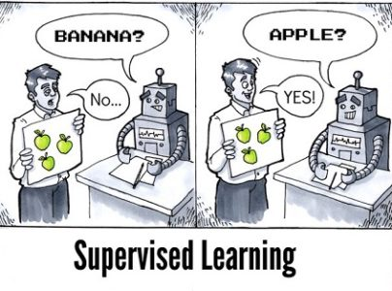Let me give another real-life example that can help you understand what exactly is Supervised Learning.
Example of Supervised Learning
Suppose you have a niece who has just turned 2 years old and is learning to speak. She knows the words, Papa and Mumma, as her parents have taught her how she needs to call them. You want to teach her what a dog and a cat is. So what do you do? You either show her videos of dogs and cats or you bring a dog and a cat and show them to her in real-life so that she can understand how they are different.
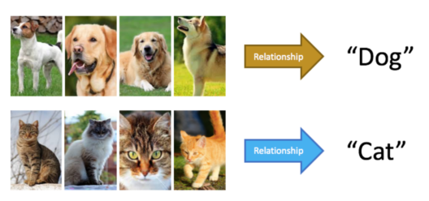Now there are certain things you tell her so that she understands the differences between the 2 animals.
- Dogs and cats both have 4 legs and a tail.
- Dogs come in small to large sizes. Cats, on the other hand, are always small.
- Dogs have a long mouth while cats have smaller mouths.
- Dogs bark while cats meow.
- Different dogs have different ears while cats have almost the same kind of ears.
Now you take your niece back home and show her pictures of different dogs and cats. If she is able to differentiate between the dog and cat, you have successfully taught her.
So what happened here? You were there to guide her to the goal of differentiating between a dog and a cat. You taught her every difference there is between a dog and a cat. You then tested her if she was able to learn. If she was able to learn, she called the dog as a dog and a cat as a cat. If not, you taught her more and were able to teach her. You acted as the supervisor and your niece acted as the algorithm that had to learn. You even knew what was a dog and what was a cat. Making sure that she was learning the correct thing. That is the principle that Supervised Learning follows.
Now with having a basic understanding of what Supervised Learning is, let’s also understand what makes this kind of learning important.

Why is it Important?
- Learning gives the algorithm experience which can be used to output the predictions for new unseen data
- Experience also helps in optimizing the performance of the algorithm
- Real-world computations can also be taken care of by the Supervised Learning algorithms
With the importance of Supervised Learning understood, let’s take a look at the types of Supervised Learning along with the algorithms!

Types of Supervised Learning
Supervised Learning has been broadly classified into 2 types.
- Regression
- Classification
Regression is the kind of Supervised Learning that learns from the Labelled Datasets and is then able to predict a continuous-valued output for the new data given to the algorithm. It is used whenever the output required is a number such as money or height etc. Some popular Supervised Learning algorithms are discussed below:
- Linear Regression – This algorithm assumes that there is a linear relationship between the 2 variables, Input (X) and Output (Y), of the data it has learnt from. The Input variable is called the Independent Variable and the Output variable is called the Dependent Variable. When unseen data is passed to the algorithm, it uses the function, calculates and maps the input to a continuous value for the output.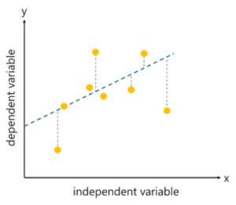
- Logistic Regression – This algorithm predicts discrete values for the set of Independent variables that have been passed to it. It does the prediction by mapping the unseen data to the logit function that has been programmed into it. The algorithm predicts the probability of the new data and so it’s output lies between the range of 0 and 1.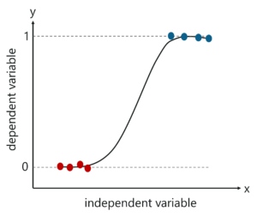
Classification, on the other hand, is the kind of learning where the algorithm needs to map the new data that is obtained to any one of the 2 classes that we have in our dataset. The classes need to be mapped to either 1 or 0 which in real-life translated to ‘Yes’ or ‘No’, ‘Rains’ or ‘Does Not Rain’ and so forth. The output will be either one of the classes and not a number as it was in Regression. Some of the most well-known algorithms are discussed below:
- Decision Tree – Decision Trees classify based on the feature values. They use the method of Information Gain and find out which feature of the dataset gives the best of information, make that as the root node and so on till they are able to classify each instance of the dataset. Every branch in the Decision Tree represents a feature of the dataset. They are one of the most widely used algorithms for classification.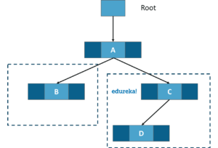
- Naive Bayes Classifier – Naive Bayes algorithms assume that the features of the dataset are all independent of each other. They work great on large datasets. Directed Acyclic Graphs (DAG) is used for the purpose of classification.
- Support Vector Machines (SVM) – SVM algorithms are based on the statistical learning theory of Vap Nik. They use Kernal functions which are a central concept for most of the learning tasks. These algorithms create a hyper-plane that is used to classify the two classes from each other.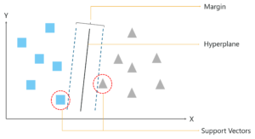
So, I hope you have a clear understanding of the 2 types of Supervised Learning and a few of the most popular algorithms in them. Let’s move over to its applications.
Applications of Supervised Learning
Supervised Learning Algorithms are used in a variety of applications. Let’s go through some of the most well-known applications.
- BioInformatics – This is one of the most well-known applications of Supervised Learning because most of us use it in our day-to-day lives. BioInformatics is the storage of Biological Information of us humans such as fingerprints, iris texture, earlobe and so on. Cellphones of today are capable of learning our biological information and are then able to authenticate us bringing up the security of the system. Smartphones such as iPhones, Google Pixel are capable of facial recognition while OnePlus, Samsung is capable of In-display finger recognition.
- Speech Recognition – This is the kind of application where you teach the algorithm about your voice and it will be able to recognize you. The most well-known real-world applications are virtual assistants such as Google Assistant and Siri, which will wake up to the keyword with your voice only.
- Spam Detection – This application is used where the unreal or computer-based messages and E-Mails are to be blocked. G-Mail has an algorithm that learns the different keywords which could be fake such as “You are the winner of something” and so forth and blocks those messages directly. OnePlus Messages App gives the user the task of making the application learn which keywords need to be blocked and the app will block those messages with the keyword.
- Object-Recognition for Vision – This kind of application is used when you need to identify something. You have a huge dataset which you use to teach your algorithm and this can be used to recognize a new instance. Raspberry Pi algorithms which detect objects are the most well-known example.
Those were some of the places where Supervised Learning has shined and shown its grit in the real world of today. With that, let us move over to the differences between Supervised and Unsupervised learning.

Supervised vs. Unsupervised Learning
Parameter | Supervised Learning | Unsupervised Learning
Dataset | Labelled | Unlabelled
Method of Learning | Guided learning | The algorithm learns by itself using dataset
Complexity | Simpler method | Computationally complex
Accuracy | More Accurate | Less Accurate

Disadvantages of Supervised Learning
Supervised Learning has a lot of challenges and disadvantages that you could face while working with these algorithms. Let’s take a look at these.
- You could overfit your algorithm easily
- Good examples need to be used to train the data
- Computation time is very large for Supervised Learning
- Unwanted data could reduce the accuracy
- Pre-Processing of data is always a challenge
- If the dataset is incorrect, you make your algorithm learn incorrectly which can bring losses

3. Explain Classification and types of classification algorithms with example. (10 marks)

The idea of Classification Algorithms is pretty simple. You predict the target class by analyzing the training dataset.

What is Classification?
We use the training dataset to get better boundary conditions which could be used to determine each target class. Once the boundary conditions are determined, the next task is to predict the target class. The whole process is known as classification.
Target class examples:
- Analysis of the customer data to predict whether he will buy computer accessories (Target class: Yes or No)
- Classifying fruits from features like color, taste, size, weight (Target classes: Apple, Orange, Cherry, Banana)
- Gender classification from hair length (Target classes: Male or Female)
Let’s understand the concept of classification algorithms with gender classification using hair length (by no means am I trying to stereotype by gender, this is only an example). To classify gender (target class) using hair length as feature parameter we could train a model using any classification algorithms to come up with some set of boundary conditions which can be used to differentiate the male and female genders using hair length as the training feature. In gender classification case the boundary condition could the proper hair length value. Suppose the differentiated boundary hair length value is 15.0 cm then we can say that if hair length is less than 15.0 cm then gender could be male or else female.

Classification Algorithms vs Clustering Algorithms
In clustering, the idea is not to predict the target class as in classification, it’s more ever trying to group the similar kind of things by considering the most satisfied condition, all the items in the same group should be similar and no two different group items should not be similar.
Group items Examples:
- While grouping similar language type documents (Same language documents are one group.)
- While categorizing the news articles (Same news category(Sport) articles are one group )
Let’s understand the concept with clustering genders based on hair length example. To determine gender, different similarity measure could be used to categorize male and female genders. This could be done by finding the similarity between two hair lengths and keep them in the same group if the similarity is less (Difference of hair length is less). The same process could continue until all the hair length properly grouped into two categories.

Basic Terminology in Classification Algorithms
- Classifier: An algorithm that maps the input data to a specific category.
- Classification model: A classification model tries to draw some conclusion from the input values given for training. It will predict the class labels/categories for the new data.
- Feature: A feature is an individual measurable property of a phenomenon being observed.
- Binary Classification: Classification task with two possible outcomes. Eg: Gender classification (Male / Female)
- Multi-class classification: Classification with more than two classes. In multi-class classification, each sample is assigned to one and only one target label. Eg: An animal can be a cat or dog but not both at the same time.
- Multi-label classification: Classification task where each sample is mapped to a set of target labels (more than one class). Eg: A news article can be about sports, a person, and location at the same time.

Applications of Classification Algorithms
- Email spam classification
- Bank customers loan pay willingness prediction.
- Cancer tumor cells identification.
- Sentiment analysis
- Drugs classification
- Facial key points detection
- Pedestrians detection in an automotive car driving.

Types of Classification Algorithms
Classification Algorithms could be broadly classified as the following:
- Linear Classifiers
  - Logistic regression
  - Naive Bayes classifier
  - Fisher’s linear discriminant
- Support vector machines
  - Least squares support vector machines
- Quadratic classifiers
- Kernel estimation
  - k-nearest neighbor
- Decision trees
  - Random forests
- Neural networks
- Learning vector quantization
Examples of a few popular Classification Algorithms are given below.

Logistic Regression
As confusing as the name might be, you can rest assured. Logistic Regression is a classification and not a regression algorithm. It estimates discrete values (Binary values like 0/1, yes/no, true/false) based on a given set of independent variable(s). Simply put, it basically, predicts the probability of occurrence of an event by fitting data to a logit function. Hence, it is also known as logit regression. The values obtained would always lie within 0 and 1 since it predicts the probability.
Let us try and understand this through another example.
Let’s say there’s a sum on your math test. It can only have 2 outcomes, right? Either you solve it or you don’t (and let’s not assume points for method here). Now imagine, that you are being given a wide range of sums in an attempt to understand which chapters have you understood well. The outcome of this study would be something like this – if you are given a trigonometry based problem, you are 70% likely to solve it. On the other hand, if it is an arithmetic problem, th probability of you getting an answer is only 30%. This is what Logistic Regression provides you.
If I had to do the math, I would model the log odds of the outcome as a linear combination of the predictor variables.

ta Science with R Programming Certification Training Course
- Instructor-led Sessions
- Real-life Case Studies
- Assignments
- Lifetime Access
Explore Curriculum

odds= p/ (1-p) = probability of event occurrence / probability of event not occurring
ln(odds) = ln(p/(1-p))
logit(p) = ln(p/(1-p)) = b0+b1X1+b2X2+b3X3....+bkXk
In the equation given above, p is the probability of the presence of the characteristic of interest. It chooses parameters that maximize the likelihood of observing the sample values rather than that minimize the sum of squared errors (like in ordinary regression).
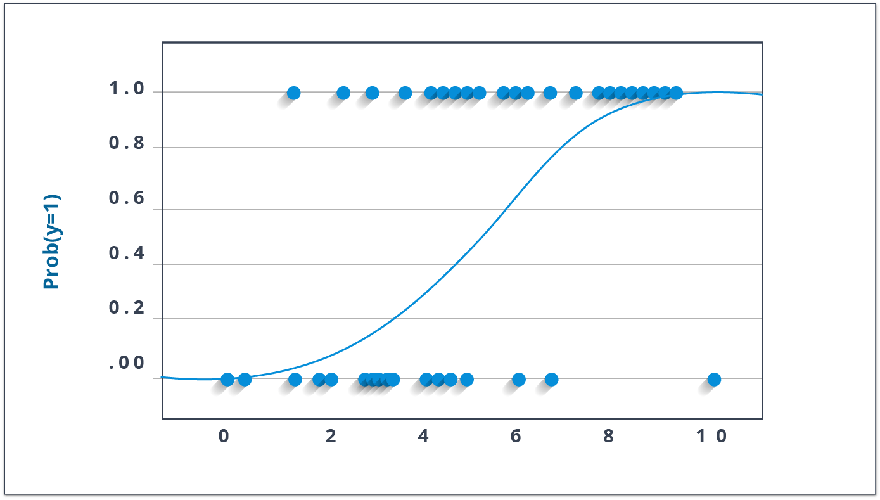Now, a lot of you might wonder, why take a log? For the sake of simplicity, let’s just say that this is one of the best mathematical ways to replicate a step function. I can go way more in-depth with this, but that will beat the purpose of this blog.
There are many different steps that could be tried in order to improve the model:
- include interaction terms
- remove features
- regularize techniques
- use a non-linear model

Decision Trees
Now, the decision tree is by far, one of my favorite algorithms. With versatile features helping actualize both categorical and continuous dependent variables, it is a type of supervised learning algorithm mostly used for classification problems. What this algorithm does is, it splits the population into two or more homogeneous sets based on the most significant attributes making the groups as distinct as possible.
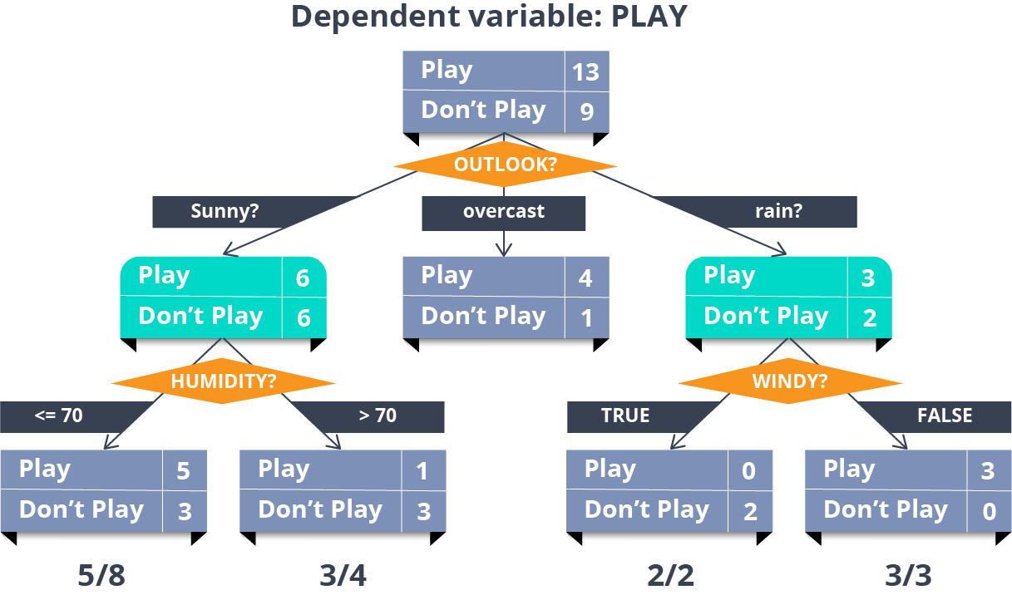
In the image above, you can see that population is classified into four different groups based on multiple attributes to identify ‘if they will play or not’.

Naive Bayes Classifier
This is a classification technique based on an assumption of independence between predictors or what’s known as Bayes’ theorem. In simple terms, a Naive Bayes classifier assumes that the presence of a particular feature in a class is unrelated to the presence of any other feature.
For example, a fruit may be considered to be an apple if it is red, round, and about 3 inches in diameter. Even if these features depend on each other or upon the existence of the other features, a Naive Bayes Classifier would consider all of these properties to independently contribute to the probability that this fruit is an apple.
To build a Bayesian model is simple and particularly functional in case of enormous data sets. Along with simplicity, Naive Bayes is known to outperform sophisticated classification methods as well.
Bayes theorem provides a way of calculating posterior probability P(c|x) from P(c), P(x) and P(x|c). The expression for Posterior Probability is as follows.
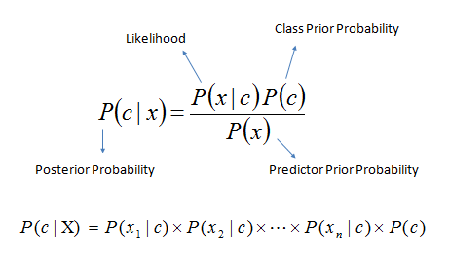Here,
- P(c|x) is the posterior probability of class (target) given predictor (attribute).
- P(c) is the prior probability of class.
- P(x|c) is the likelihood which is the probability of predictor given class.
- P(x) is the prior probability of predictor.
Example: Let’s work through an example to understand this better. So, here I have a training data set of weather namely, sunny, overcast and rainy, and corresponding binary variable ‘Play’. Now, we need to classify whether players will play or not based on weather condition. Let’s follow the below steps to perform it.
Step 1: Convert the data set to the frequency table
Step 2: Create a Likelihood table by finding the probabilities like Overcast probability = 0.29 and probability of playing is 0.64.
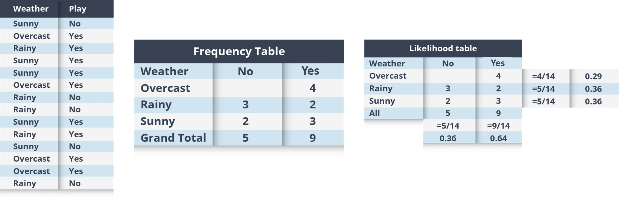Step 3: Now, use the Naive Bayesian equation to calculate the posterior probability for each class. The class with the highest posterior probability is the outcome of prediction.
Problem: Players will play if the weather is sunny, is this statement correct?
We can solve it using above discussed method, so P(Yes | Sunny) = P( Sunny | Yes) * P(Yes) / P (Sunny)
Here we have P (Sunny |Yes) = 3/9 = 0.33, P(Sunny) = 5/14 = 0.36, P( Yes)= 9/14 = 0.64
Now, P (Yes | Sunny) = 0.33 * 0.64 / 0.36 = 0.60, which has higher probability.
Naive Bayes uses a similar method to predict the probability of different class based on various attributes. This algorithm is mostly used in text classification and with problems having multiple classes.

KNN (k- Nearest Neighbors)
K nearest neighbors is a simple algorithm used for both classification and regression problems. It basically stores all available cases to classify the new cases by a majority vote of its k neighbors. The case assigned to the class is most common amongst its K nearest neighbors measured by a distance function (Euclidean, Manhattan, Minkowski, and Hamming).
While the three former distance functions are used for continuous variables, Hamming distance function is used for categorical variables. If K = 1, then the case is simply assigned to the class of its nearest neighbor. At times, choosing K turns out to be a challenge while performing kNN modeling.
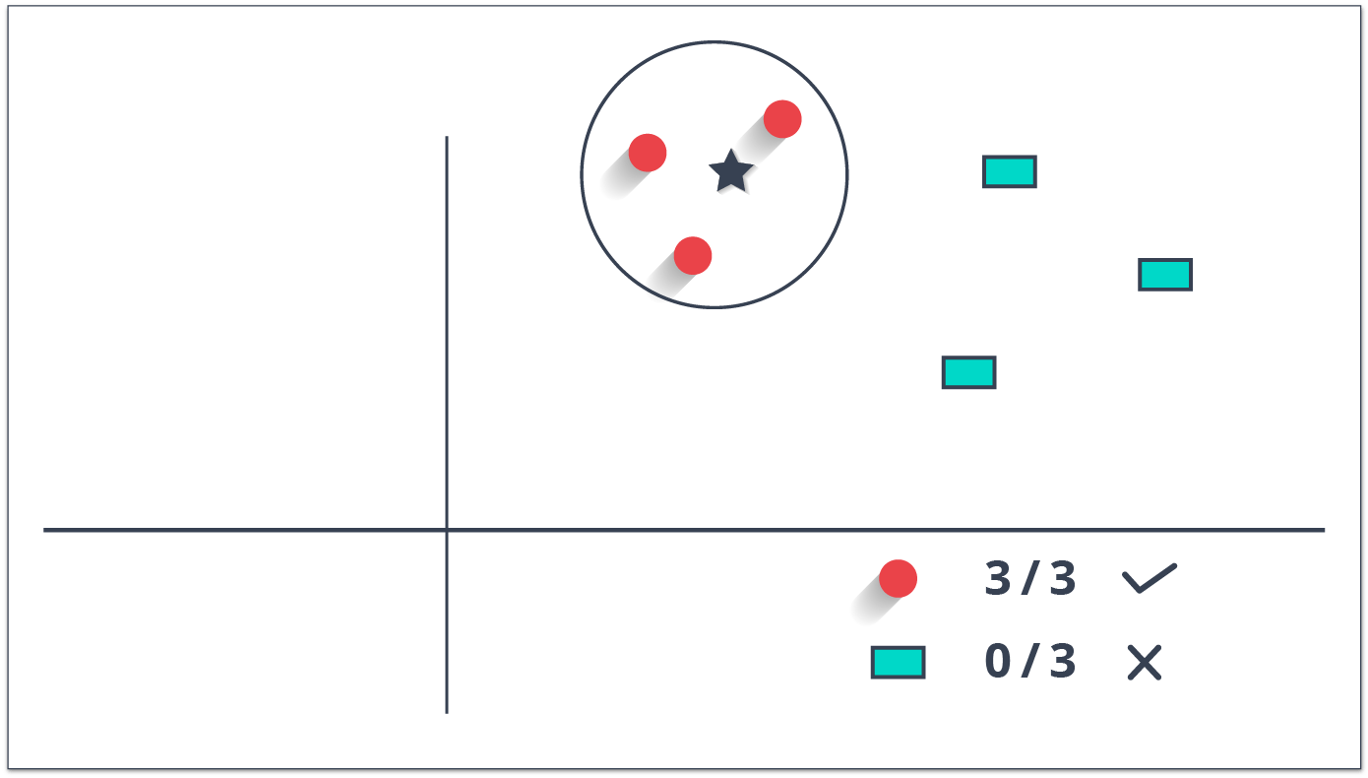
You can understand KNN easily by taking an example of our real lives. If you have a crush on a girl/boy in class, of whom you have no information, you might want to talk to their friends and social circles to gain access to their information!
Things to consider before selecting KNN:
- KNN is computationally expensive
- Variables should be normalized else higher range variables can bias it
- Works on pre-processing stage more before going for kNN like an outlier, noise removal

SVM(Support Vector Machine)
In this algorithm, we plot each data item as a point in n-dimensional space (where n is a number of features you have) with the value of each feature being the value of a particular coordinate.
For example, if we only had two features like Height and Hair length of an individual, we would first plot these two variables in two-dimensional space where each point has two coordinates (these coordinates are known as Support Vectors)
Now, we will find some line that splits the data between the two differently classified groups of data. This will be the line such that the distances from the closest point in each of the two groups will be farthest away.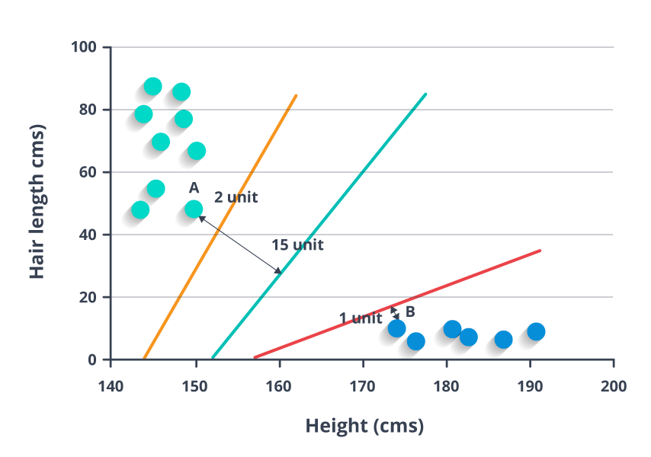
In the example shown above, the line which splits the data into two differently classified groups is the blue line, since the two closest points are the farthest apart from the line. This line is our classifier. Then, depending on where the testing data lands on either side of the line, that’s what class we can classify the new data as.
4.What is Unsupervised learning. Explain in detail.( 10 marks)

An Overview of Machine Learning
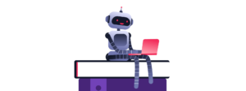Machine Learning, in the simplest of terms, is teaching your machine about something. You collect and clean data, create algorithms, teach the algorithm essential patterns from the data and then expect the algorithm to give you a helpful answer. If the algorithm lives up to your expectations, you have successfully taught your algorithm. If not, just scrap everyt4hing and start from scratch. That is how it works here. And if you are looking for a formal definition, Machine Learning is the process of creating models that can perform a certain task without the need for a human explicitly programming it to do something.
There are 3 types of Machine Learning which are based on the way the algorithms are created. They are:
- Supervised Learning – You supervise the learning process, meaning the data that you have collected here is labelled and so you know what inpu

- t needs to be mapped to what output. This helps you correct your algorithm if it makes a mistake in giving you the answer.
- Unsupervised Learning – The data collected here has no labels and you are unsure about the outputs. So you model your algorithm such that it can understand patterns from the data and output the required answer. You do not interfere when the algorithm learns.
- Reinforcement Learning – There is no data in this kind of learning, nor do you teach the algorithm anything. You model the algorithm such that it interacts with the environment and if the algorithm does a good job, you reward it, else you punish the algorithm. With continuous interactions and learning, it goes from being bad to being the best that it can for the problem assigned to it.
Now that we know what is Machine Learning and the different types of Machine Learning, let us dwell into the actual topic for discussion here and answer What is Unsupervised Learning? Where is Unsupervised Learning used? Unsupervised Learning Algorithms and much more.

What is Unsupervised Learning?

Unsupervised Learning, as discussed earlier, can be thought of as self-learning where the algorithm can find previously unknown patterns in datasets that do not have any sort of labels. It helps in modelling probability density functions, finding anomalies in the data, and much more. To give you a simple example, think of a student who has textbooks and all the required material to study but has no teacher to guide. Ultimately, the student will have to learn by himself or herself to pass the exams. This sort of self-learning is what we have scaled into Unsupervised Learning for machines.
Let me give you a real-life example of where Unsupervised Learning may have been used you to learn about something.
Example of Unsupervised Learning
Suppose you have never watched a cricket match in your entire life and you have been invited by your friends to hang out at their house for a match between India and Australia. You have no idea about what cricket is but just for your friends, you say yes and head over with them. The match starts and you just sit there, blank. Your friends are enjoying the way Virat Kohli plays and want to join in the fun. Here is when you start learning about the game. You analyse the screen and come up with certain conclusions that you can use to understand the game better.

- There are 2 teams with jerseys of colour Blue and Yellow. Since Virat Kohli belongs to India and you see the score of India on the screen, you conclude that India has the jersey of Blue which makes Australia have yellow Jersey.
- There are different types of players on the field. 2 which belong to India have bats in their hand meaning that they are batting. There is someone who runs up and bowls the ball, making him a bowler. There are around 9 players around the field who try to stop the ball from reaching the boundary of the stadium. There is someone behind the wickets and 2 umpires to manage the match.
- If the ball hits the wickets or if the ball is caught by the fielders, the batsman is out and has to walk back.
- Virat Kohli has the number 18 and his name on the back of his jersey and if this player scores a 4 or a 6, you need to cheer.
You make these observations one-by-one and now know when to cheer or boo when the wickets fall. From knowing nothing to knowing the basics of cricket, you can now enjoy the match with your friends.
What happened here? You had every material that you needed to learn about the basics of cricket. The TV, when and who your friends cheer for. This made you learn about cricket by yourself without someone guiding you about anything. This is the principle that unsupervised learning follows. So having understood what Unsupervised Learning is, let us move over and understand what makes it so important in the field of Machine Learning.

Why is it important?
So what does Unsupervised Learning help us obtain? Let me tell you all about it.
- Unsupervised Learning algorithms work on datasets that are unlabelled and find patterns which would previously not be known to us.
- These patterns obtained are helpful if we need to categorize the elements or find an association between them.
- They can also help detect anomalies and defects in the data which can be taken care of by us.
Lastly and most importantly, data which we collect is usually unlabelled which makes work easier for us when we use these algorithms.
Now that we know the importance, let us move ahead and understand the different types of Unsupervised Learning.

Types of Unsupervised Learning
Unsupervised Learning has been split up majorly into 2 types:
- Clustering
- Association
Clustering is the type of Unsupervised Learning where you find patterns in the data that you are working on. It may be the shape, size, colour etc. which can be used to group data items or create clusters. Some popular algorithms in Clustering are discussed below:
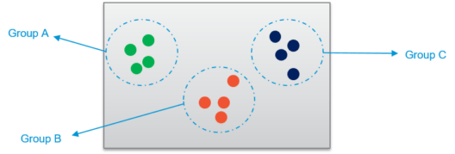
- Hierarchical Clustering – This algorithm builds clusters based on the similarity between different data points in the dataset. It goes over the various features of the data points and looks for the similarity between them. If the data points are found to be similar, they are grouped together. This continues until the dataset has been grouped which creates a hierarchy for each of these clusters.
- K-Means Clustering – This algorithm works step-by-step where the main goal is to achieve clusters which have labels to identify them. The algorithm creates clusters of different data points which are as homogenous as possible by calculating the centroid of the cluster and making sure that the distance between this centroid and the new data point is as less as possible. The smallest distance between the data point and the centroid determines which cluster it belongs to while making sure the clusters do not interlay with each other. The centroid acts like the heart of the cluster. This ultimately gives us the cluster which can be labelled as needed.
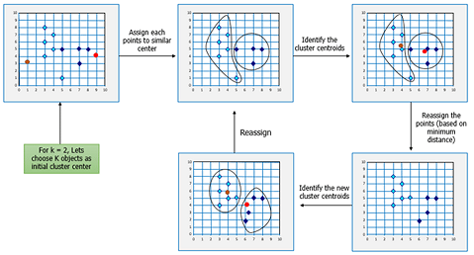
- K-NN Clustering – This is probably the most simple of the Machine Learning algorithms as the algorithm does not really learn but rather classifies the new data point based on the datasets that have been stored by it. This algorithm is also called as a lazy learner because it learns only when the algorithm is given a new data point. It works well with smaller datasets as huge datasets take time to learn.

Association is the kind of Unsupervised Learning where you find the dependencies of one data item to another data item and map them such that they help you profit better. Some popular algorithms in Association Rule Mining are discussed below:
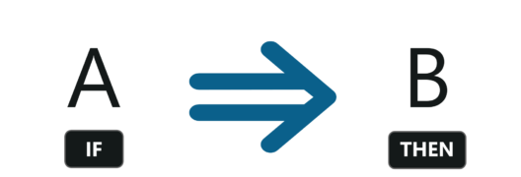
- Apriori algorithm – The Apriori Algorithm is a breadth-first search based which calculates the support between items. This support basically maps the dependency of one data item with another which can help us understand what data item influences the possibility of something happening to the other data item. For example, bread influences the buyer to buy milk and eggs. So that mapping helps increase profits for the store. That sort of mapping can be learnt using this algorithm which yields rules as for its output.
- FP-Growth Algorithm – The Frequency Pattern (FP) algorithm finds the count of the pattern that has been repeated, adds that to a table and then finds the most plausible item and sets that as the root of the tree. Other data items are then added into the tree and the support is calculated. If that particular branch fails to meet the threshold of the support, it is pruned. Once all the iterations are completed, a tree with the root to the item will be created which are then used to make the rules of the association. This algorithm is faster than Apriori as the support is calculated and checked for increasing iterations rather than creating a rule and checking the support from the dataset.

Now that you have a clear understanding between the two kinds of Unsupervised Learning, let us now learn about some of the applications of Unsupervised Learning.

Applications of Unsupervised Learning
Unsupervised Learning helps in a variety of ways which can be used to solve various real-world problems.
- They help us in understanding patterns which can be used to cluster the data points based on various features.
- Understanding various defects in the dataset which we would not be able to detect initially.
- They help in mapping the various items based on the dependencies of each other.
- Cleansing the datasets by removing features which are not really required for the machine to learn from.
This ultimately leads to applications which are helpful to us. Certain examples of where Unsupervised Learning algorithms are used are discussed below:
- AirBnB – This is a great application which helps host stays and experiences connecting people all over the world. This application uses Unsupervised Learning where the user queries his or her requirements and Airbnb learns these patterns and recommends stays and experiences which fall under the same group or cluster.
- Amazon – Amazon also uses unsupervised learning to learn the customer’s purchase and recommend the products which are most frequently bought together which is an example of association rule mining.
- Credit-Card Fraud Detection – Unsupervised Learning algorithms learn about various patterns of the user and their usage of the credit card. If the card is used in parts that do not match the behaviour, an alarm is generated which could possibly be marked fraud and calls are given to you to confirm whether it was you using the card or not.
Those were some of the applications where Unsupervised Learning algorithms have shined and shown their grit. Now that we have finished the applications of Unsupervised Learning, let’s move ahead to the differences between Supervised and Unsupervised Learning.

Supervised Learning vs. Unsupervised Learning
Parameter | Supervised Learning | Unsupervised Learning
Dataset | Labelled Dataset | Unlabelled Dataset
Method of Learning | Guided learning | The algorithm learns by itself using dataset
Complexity | Simpler method | Computationally complex
Accuracy | More Accurate | Less Accurate

Disadvantages of Unsupervised Learning
Even though Unsupervised Learning is used in many well-known applications and works brilliantly, there are still many disadvantages to it.
- There is no way of obtaining the way or method the data is sorted as the dataset is unlabelled.
- They may be less accurate as the input data is not known and labelled by the humans making the machine do it.
- The information obtained by the algorithm may not always correspond to the output class that we required.
- The user has to understand and map the output obtained with the corresponding labels.
- What is Decision tree? Explain Tree Building with example.

Introduction
Till now we have learned about linear regression, logistic regression, and they were pretty hard to understand. Let’s now start with Decision tree’s and I assure you this is probably the easiest algorithm in Machine Learning. There’s not much mathematics involved here. Since it is very easy to use and interpret it is one of the most widely used and practical methods used in Machine Learning.

Contents
1. What is a Decision Tree?
2. Example of a Decision Tree
3. Entropy
4. Information Gain

5. When to stop Splitting?
6. How to stop overfitting?
- max_depth
- min_samples_split
- min_samples_leaf
- max_features
7. Pruning
- Post-pruning
- Pre-pruning

What is a Decision Tree?
It is a tool that has applications spanning several different areas. Decision trees can be used for classification as well as regression problems.

The name itself suggests that it uses a flowchart like a tree structure to show the predictions that result from a series of feature-based splits.
It starts with a root node and ends with a decision made by leaves.

The terminologies.
Root Nodes – It is the node present at the beginning of a decision tree from this node the population starts dividing according to various features.
Decision Nodes – the nodes we get after splitting the root nodes are called Decision Node
Leaf Nodes – the nodes where further splitting is not possible are called leaf nodes or terminal nodes
Sub-tree – a sub-section of this decision tree is called sub-tree.
Pruning – is nothing but cutting down some nodes to stop overfitting.
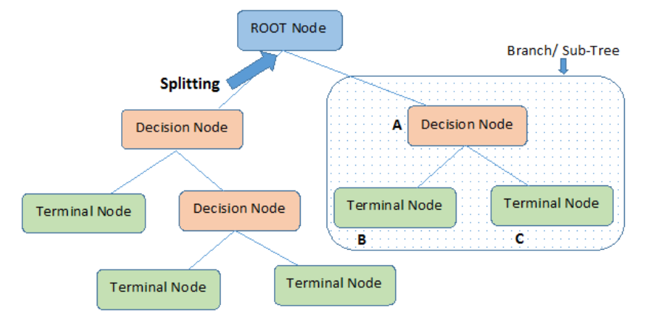
Image 2

Example of a decision tree
Let’s understand decision trees with the help of an example.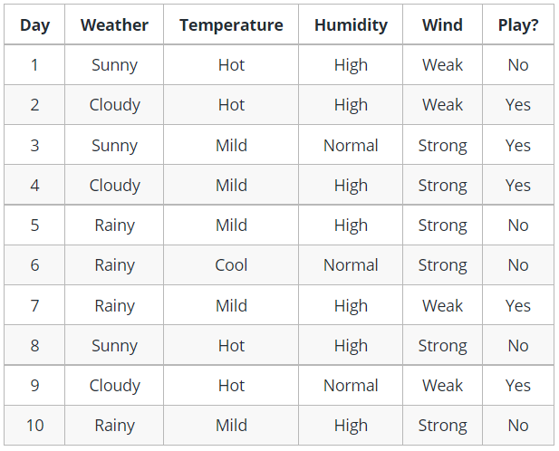
Image 3
Decision trees are upside down which means the root is at the top and then this root is split into various several nodes. Decision trees are nothing but a bunch of if-else statements in layman terms. It checks if the condition is true and if it is then it goes to the next node attached to that decision.
In the below diagram the tree will first ask what is the weather? Is it sunny, cloudy, or rainy? If yes then it will go to the next feature which is humidity and wind. It will again check if there is a strong wind or weak, if it’s a weak wind and it’s rainy then the person may go and play.
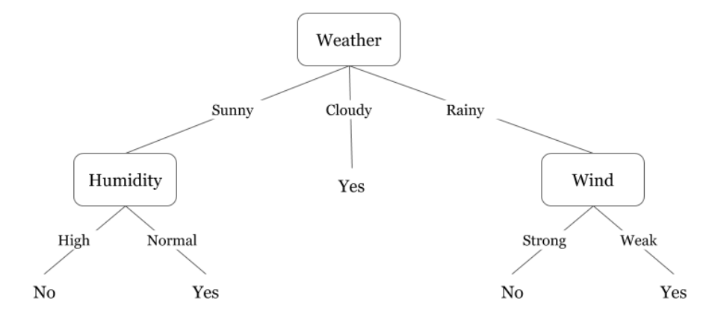
Image 4
Did you notice anything in the above flowchart? We see that if the weather is cloudy then we must go to play. Why didn’t it split more? Why did it stop there?
To answer this question, we need to know about few more concepts like entropy, information gain, and Gini index.
But in simple terms, the output for the training dataset is always yes for cloudy weather, since there is no disorderliness, so here we don’t need to split the node further.
The goal of machine learning is to decrease uncertainty or disorders from the dataset and for this, we use decision trees.
Now you must be thinking how do I know what should be the root node? what should be the decision node? when should I stop splitting? To decide this, there is a metric called “Entropy” which is the amount of uncertainty in the dataset.

Entropy
Entropy is nothing but the uncertainty in our dataset or measure of disorder.
Let me try to explain this with the help of an example.
Suppose you have a group of friends who decides which movie they can watch together on Sunday. There are 2 choices for movies, one is “Lucy” and the second is “Titanic” and now everyone has to tell their choice. After everyone gives their answer we see that “Lucy” gets 4 votes and “Titanic” gets 5 votes. Which movie do we watch now? Isn’t it hard to choose 1 movie now because the votes for both the movies are somewhat equal.
This is exactly what we call disorderness, there is an equal number of votes for both the movies, and we can’t really decide which movie we should watch. It would have been much easier if the votes for “Lucy” were 8 and for “Titanic” it was 2. Here we could easily say that the majority of votes are for “Lucy” hence everyone will be watching this movie.
In a decision tree, the output is mostly “yes” or “no”
The formula for Entropy is shown below:
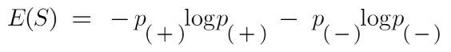
Here p₊ is the probability of positive class
p– is the probability of negative class
S is the subset of the training example

How do Decision Trees use Entropy?
Entropy basically measures the impurity of a node. Impurity is the degree of randomness; it tells how random our data is.
A pure sub-split means that either you should be getting “yes”, or you should be getting “no”.
Suppose a feature has 8 “yes” and 4 “no” initially, after the first split the left node gets 5 ‘yes’ and 2 ‘no’ whereas right node gets 3 ‘yes’ and 2 ‘no’.
We see here the split is not pure, why? Because we can still see some negative classes in both the nodes. In order to make a decision tree, we need to calculate the impurity of each split, and when the purity is 100%, we make it as a leaf node.
To check the impurity of feature 2 and feature 3 we will take the help for Entropy formula.
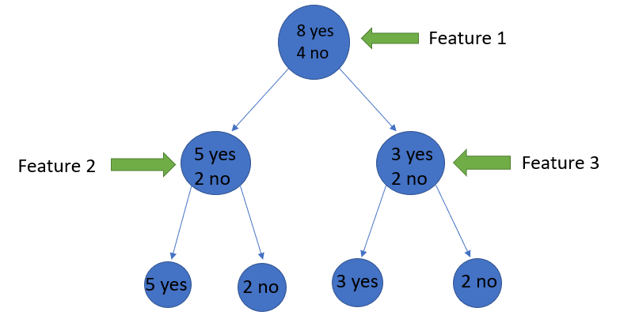
Image Source: Author
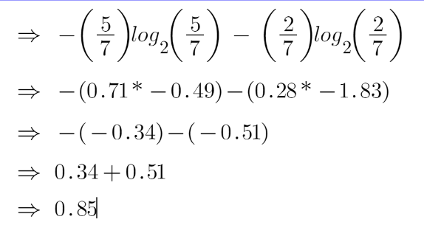
For feature 3,
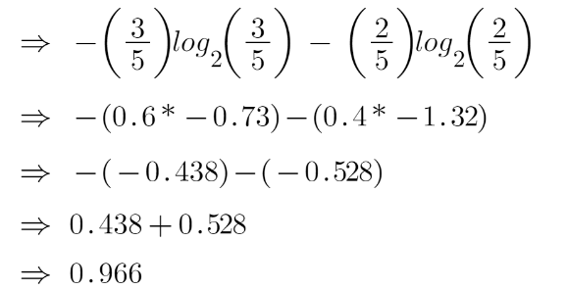
We can clearly see from the tree itself that left node has low entropy or more purity than right node since left node has a greater number of “yes” and it is easy to decide here.
Always remember that the higher the Entropy, the lower will be the purity and the higher will be the impurity.
As mentioned earlier the goal of machine learning is to decrease the uncertainty or impurity in the dataset, here by using the entropy we are getting the impurity of a particular node, we don’t know if the parent entropy or the entropy of a particular node has decreased or not.
For this, we bring a new metric called “Information gain” which tells us how much the parent entropy has decreased after splitting it with some feature.

Information Gain
Information gain measures the reduction of uncertainty given some feature and it is also a deciding factor for which attribute should be selected as a decision node or root node.
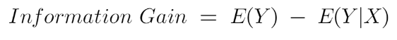
i.e. Information gain= entropy of the full dataset – entropy of the dataset given some feature.
To understand this better let’s consider an example:
Suppose our entire population has a total of 30 instances. The dataset is to predict whether the person will go to the gym or not. Let’s say 16 people go to the gym and 14 people don’t
Now we have two features to predict whether he/she will go to the gym or not.
Feature 1 is “Energy” which takes two values “high” and “low”
Feature 2 is “Motivation” which takes 3 values “No motivation”, “Neutral” and “Highly motivated”.
Let’s see how our decision tree will be made using these 2 features. We’ll use information gain to decide which feature should be the root node and which feature should be placed after the split.
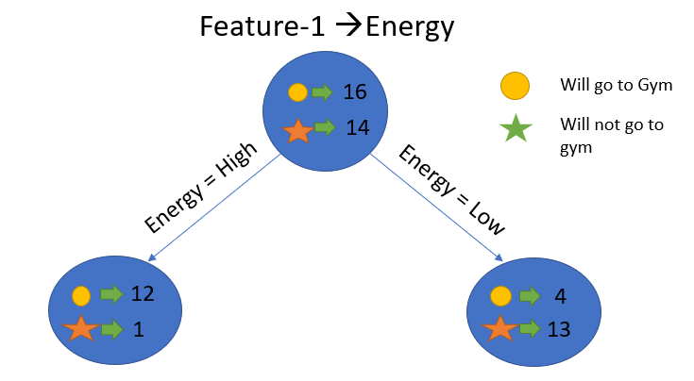
Image Source: Author
Let’s calculate the entropy:
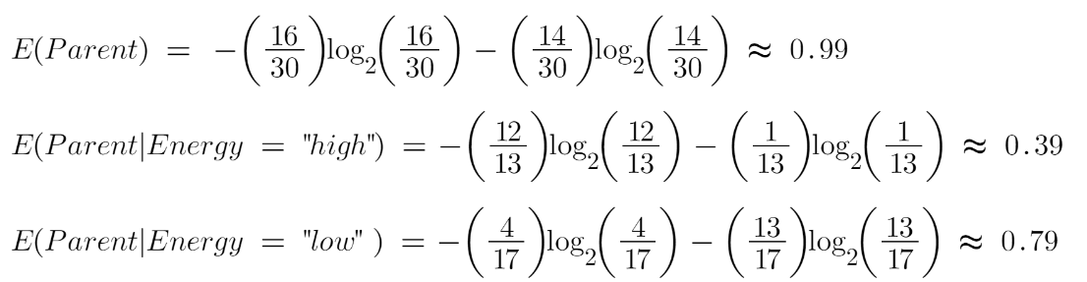
To see the weighted average of entropy of each node we will do as follows:
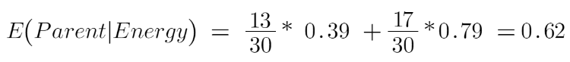
Now we have the value of E(Parent) and E(Parent|Energy), information gain will be:
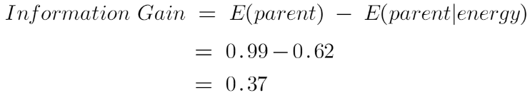
Our parent entropy was near 0.99 and after looking at this value of information gain, we can say that the entropy of the dataset will decrease by 0.37 if we make “Energy” as our root node.
Similarly, we will do this with the other feature “Motivation” and calculate its information gain.
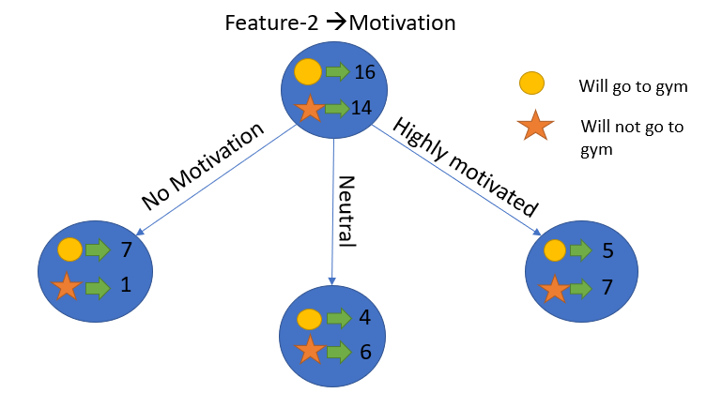
Image Source: Author
Let’s calculate the entropy here:
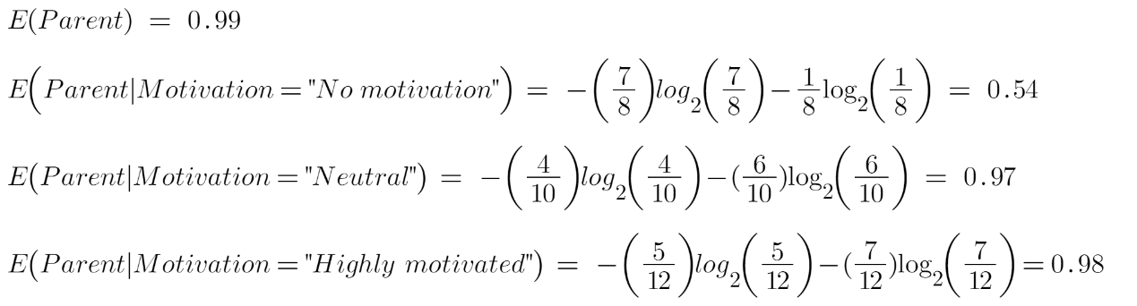
To see the weighted average of entropy of each node we will do as follows:
Now we have the value of E(Parent) and E(Parent|Motivation), information gain will be:
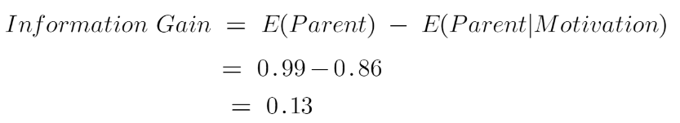
We now see that the “Energy” feature gives more reduction which is 0.37 than the “Motivation” feature. Hence we will select the feature which has the highest information gain and then split the node based on that feature.
Image Source: Author
In this example “Energy” will be our root node and we’ll do the same for sub-nodes. Here we can see that when the energy is “high” the entropy is low and hence we can say a person will definitely go to the gym if he has high energy, but what if the energy is low? We will again split the node based on the new feature which is “Motivation”.

When to stop splitting?
The real-world datasets have a large number of features, which will result in a large number of splits, which in turn gives a huge tree. Such trees take time to build and can lead to overfitting. That means the tree will give very good accuracy on the training dataset but will give bad accuracy in test data.

So the splitting can be stopped ,
- When all the leaf nodes are pure ( leaf nodes have data that belong to one class )
- When all the features are used.
- When a certain criteria like hyperparameter tuning is met.

Hyperparameter Tuning:
- max_depth:. The more the value of max_depth, the more complex your tree will be. The training error will off-course decrease if we increase the max_depth value but when our test data comes into the picture, we will get a very bad accuracy. Hence need a value that will not overfit as well as underfit the data and for this, GridSearchCV can be used.
- min_samples_split. Here we specify the minimum number of samples required to do a spilt. For example, we can use a minimum of 10 samples to reach a decision. That means if a node has less than 10 samples then using this parameter, we can stop the further splitting of this node and make it a leaf node.
- min_samples_leaf – represents the minimum number of samples required to be in the leaf node. The more you increase the number, the more is the possibility of overfitting.
- max_features – it helps us decide what number of features to consider when looking for the best split.
.

Pruning
It is another method that can help us avoid overfitting. It helps in improving the performance of the tree by cutting the nodes or sub-nodes which are not significant. It removes the branches which have very low importance.
There are mainly 2 ways for pruning:
(i) Pre-pruning – we can stop growing the tree earlier, which means we can prune/remove/cut a node if it has low importance while growing the tree.
(ii) Post-pruning – once our tree is built to its depth, we can start pruning the nodes based on their significance.

Some of the regularization parameters

What are the Advantages and Disadvantages of Decision Trees?

Advantages

- Decision tree algorithm is effective and is very simple.
- Decision tree algorithms can be used while dealing with the missing values in the dataset.
- Decision tree algorithms can take care of numeric as well as categorical features.
- Results that are generated from the Decision tree algorithm does not require any statistical or mathematics knowledge to be explained.

Disadvantages

- Logics get transformed if there are even small changes in training data.
- Larger trees get difficult to interpret.
- Biased towards three having more levels.

Explain Regression tree with example.

Regression Trees

| Decision Tree for Regression |

What Are Regression Trees ?
A regression tree is a decision tree that is used for the task of regression which can be used to predict continuous valued outputs.

Mean Square Error

Since the predictions are continuous variables, we need a different measure that tells how much our predictions deviate from the original target and that’s the entry-point of mean square error.
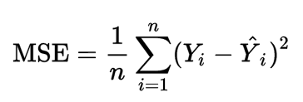
fig 1.1: Mean Square Value
Y is the actual value and Y_hat is the prediction , we only care about how much the prediction varies from the target. Not in which direction. So, we square the difference and divide the entire sum by the total number of records.
In the Regression Tree algorithm, we do the same thing as the Classification trees. But, we try to reduce the Mean Square Error at each child rather than the entropy.

Building a Regression Tree
Let’s consider a dataset where we have 2 variables, as shown below
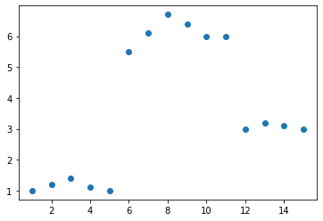
fig 2.1: Dataset, X is a continuous variable and Y is another continuous variable
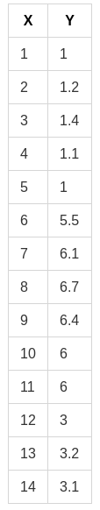
fig 2.2: The actual dataset Table
we need to build a Regression tree that best predicts the Y given the X.

Step 1
The first step is to sort the data based on X ( In this case, it is already sorted ). Then, take the average of the first 2 rows in variable X ( which is (1+2)/2 = 1.5 according to the given dataset ). Divide the dataset into 2 parts ( Part A and Part B ) , separated by x < 1.5 and X ≥ 1.5.
Now, Part A consist only of one point, which is the first row (1,1) and all the other points are in Part — B. Now, take the average of all the Y values in Part A and average of all Y values in Part B separately. These 2 values are the predicted output of the decision tree for x < 1.5 and x ≥ 1.5 respectively. Using the predicted and original values, calculate the mean square error and note it down.

Step 2
In step 1, we calculated the average for the first 2 numbers of sorted X and split the dataset based on that and calculated the predictions. Then, we do the same process again but this time, we calculate the average for the second 2 numbers of sorted X ( (2+3)/2 = 2.5 ). Then, we split the dataset again based on X < 2.5 and X ≥ 2.5 into Part A and Part B again and predict outputs, find mean square error as shown in step 1. This process is repeated for the third 2 numbers, the fourth 2 numbers, the 5th, 6th, 7th till n-1th 2 numbers ( where n is the number of records or rows in the dataset ).

Step 3
Now that we have n-1 mean squared errors calculated , choose the point at which we are going to split the dataset and that point is the point, which resulted in the lowest mean squared error on splitting at it. In this case, the point is x=5.5. Hence the tree will be split into 2 parts. x<5.5 and x≥ 5.5. The Root node is selected this way and the data points that go towards the left child and right child of the root node are further recursively exposed to the same algorithm for further splitting.

Brief Explanation of What the algorithm is doing
The basic idea behind the algorithm is to find the point in the independent variable to split the data-set into 2 parts, so that the mean squared error is the minimised at that point. The algorithm does this in a repetitive fashion and forms a tree-like structure.
A regression tree for the above shown dataset would look like this
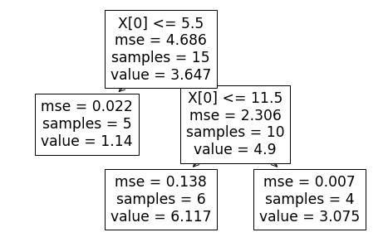
fig 3.1: The resultant Decision Tree
and the resultant prediction visualisation would be this
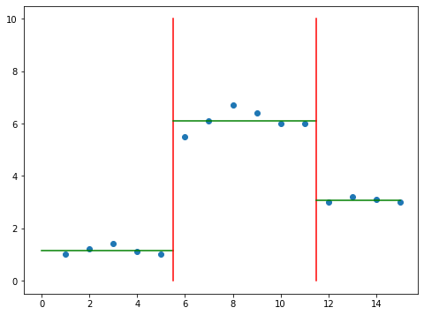
fig 3.2: The Decision Boundary
well, The logic behind the algorithm is splitting the data-set by selecting certain points that best splits the data-set and minimises the mean square error.
And the way we are selecting these points is by going through an iterative process of calculating mean square error for all the splits and choosing the split that has the least value for the mse..

What happens when there are multiple independent variables ?
Let us consider that there are 3 variables similar to the independent variable X from fig 2.2.
At each node, All the 3 variables would go through the same process as what X went through in the above example. The data would be sorted based on the 3 variables separately.
The points that minimises the mse are calculated for all the 3 variables. Out of the 3 variables and the points calculated for them, the one that has the least mse would be chosen.

How are categorical variables handled ?
When we use the continuous variables as independent variables , we select the point with the least mse using an iterative algorithm as mentioned above. When given a categorical variable , we simply split it by asking a binary question ( usually ). For example, let’s say we have a column specifying the size of the tumor in categorical terms. say Small, Medium and Large.
The tree would split the data-set based on whether tumor size = small or tumor size = large or tumor size = Medium or it can also combine multiple values in some cases, based on whichever question reduces the mse the most. and that becomes the top contender for this variable (Tumor Size). The Top contenders of the other variables are compared with this and the selection process is similar to the situation mentioned in “What happens when there are multiple independent variables ?”

Dealing with Over-Fitting and When to stop building the Tree ?
On reading the previous blogs, one might understand the problem of overfitting and how it affects machine learning models. Regression Trees are prone to this problem.
When we want to reduce the mean square error, the decision tree can recursively split the data-set into a large number of subsets to the the point where a set contains only one row or record. Even though this might reduce the mse to zero, this is obviously not a good thing.
This is the famous problem of overfitting and it is a topic of it’s own. The basic takeaway is that the models fit to the existing data too perfectly that it fails to generalise with new data. We can use cross validation methods to avoid this.
One way to prevent this, with respect to Regression trees, is to specify the minimum number of records or rows, Aleaf node can have, In advance.
And the exact number is not easily known when it comes to large data-sets. But, cross-validation could be used for this purpose.

Conclusion
To conclude, Regression Trees are another way of calling Decision Trees that are used for regression and it can be useful in a lot of areas where the relationship between the variables are found to be non-linear.
One thing to remember is that the algorithm is prone to overfitting. So, It is better to always specify the minimum number of children per leaf node in advance and use cross-validation to find this Value.

Explain Classification tree with example.

CLASSIFICATION TREE

Building a Decision Tree For Better Understanding
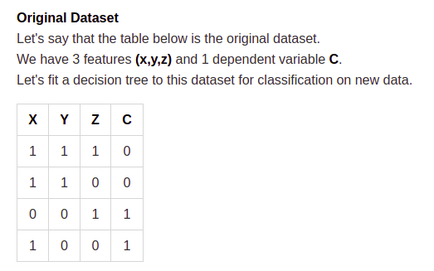
fig : dataset
Now that the data-set is prepared, Let’s build the tree. As the first step , we need to choose the root node. So, The Information Gain for X, Y and Z need to be calculated.

Splitting On X
When we use X as the root node, This is what we get.
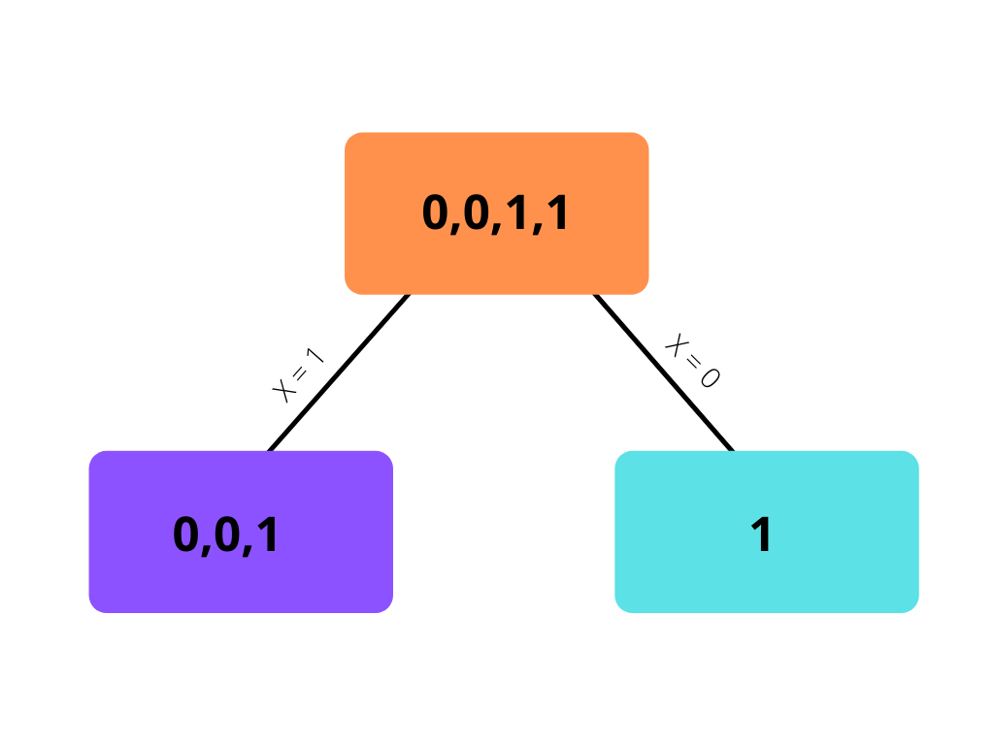
fig : splitting on X
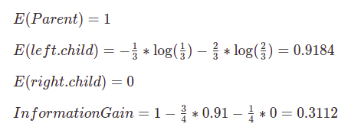

Splitting on Y
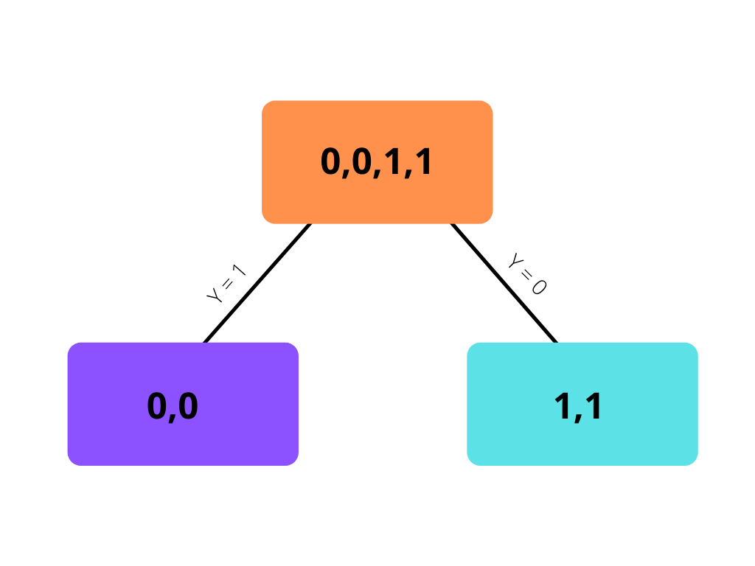
fig 3.3 : Splitting on Y
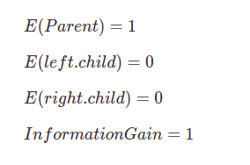

Splitting on Z
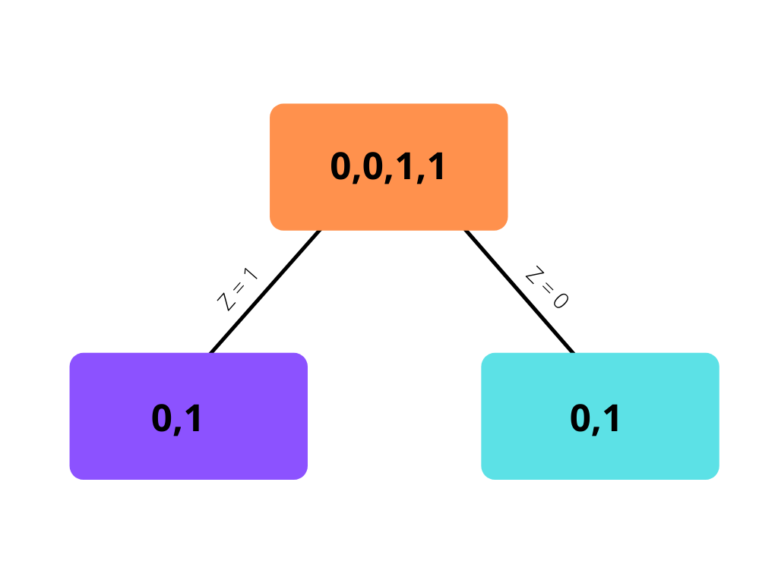
fig : Splitting on Z
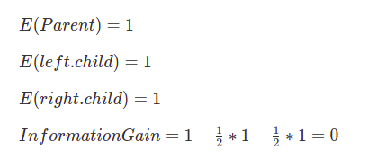
From all the above 3 splits , We can see that the information gain is maximum when we split the dataset using the feature Y. So, We can use Y at the root node. But, When we use Y at the root node, We can also see that both the leaf nodes have become pure leaf nodes (Only containing objects of one class. Either 0 or 1) . So, we can stop building the tree at this stage. The other features have become redundant as Y itself is able to classify the all the data perfectly.
Hence, The resultant Decision tree is the tree that is shown in fig 3.3. On Giving new data, This tree will check if the attribute Y is 0 or 1 for that data and will classify the new data according to it.
In case Y was not able to perfectly classify the data and one of the leaf nodes was impure, we can continue using the other 2 features on that node to further build the decision tree until we get pure leaf nodes.

Continuous Variables
So far, we have seen how decision trees can use entropy and information gain on categorical features in order to choose the best split. But, How does this work on continuous variables ?
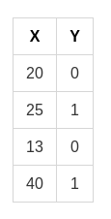
fig : Sample Dataset
Let’s consider the data-set in fig 4.1 where X is a continuous variable and Y is the dependant variable.Here, certain points are chosen by decision trees to ask questions at it’s nodes.
Before choosing the points, the algorithm would order the data-set by X.
The points for the above example would be : (13+20)/2, (20+25)/2,(25+40)/2.
=> 16.5, 22.5, 32.5.
and In the root node , we evaluate which point should be used to split the data-set on, similar to how we use categorical features to split on.
For Example, should the data be split on (x≤16.5) or (x≤22.5) or (x≤32.5) or (x > 32.5) is chosen based on which split provides the highest information gain. In this example, It is not difficult to see that x≤22.5 would be chosen as it splits the dependant variable best
As we split the data based on all these intervals and calculate the information gain for all, this process becomes computationally costly when the data-set is huge.
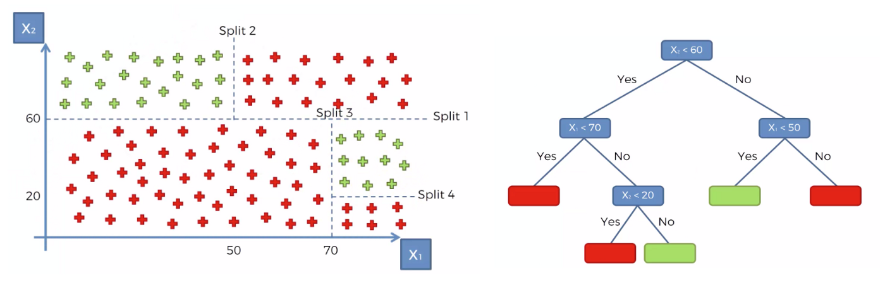
fig 5.1: Decision Tree Example
In all the above examples, I have used custom datasets (from multiple sources) such that short decision tree could be made. This is for calculation purposes. So, Here’s an example of decision tree and it’s classification shown in 2-dimensional space.

When To Stop Building the Tree
- When all the leaf nodes are pure ( leaf nodes have data that belong to one class )
- When a certain criteria is met ( Such as the height of the tree exceeds certain limit, In which case the leaf nodes might not be pure but might output probability of a class instead of the class itself)
- When all the features are used.

Conclusion
In this blog, we saw what is a decision tree and some other basic terminologies and how to build one, given the data-set and when to stop building the tree. Even though Decision Trees are powerful, They are prone to over-fitting, discussing which is a separate topic by itself.
Decision Tree is a powerful algorithm that can be used for classification and can be used for data with non-linear relationships. It is also an algorithm from which the getting the inference and the relationship between the variables is simpler compared to some other algorithms. Decision Trees also kinda does automatic feature selection ( provided some other conditions are satisfied ) as it uses information gain. Overall, It’s a great algorithm.

What is pruning? Explain with example.

