What is Data Visualizatio. Explain different visualization Techniques.
Data Visualization
Data visualization is the art and practice of gathering, analyzing, and graphically representing empirical information. They are sometimes called information graphics, or even just charts and graphs.The goal of visualizing data is to tell the story in the data.Telling the story is predicated on understanding the data at a very deep level, and gathering insight from comparisons of data points in the numbers
- Data visualization aims to communicate data clearly and effectively through graphical representation.
- Data visualization has been used extensively in many applications for Eg. At work for reporting managing business operations and tracking progress of tasks.
- More popularly, we can take advantage of visualization techniques to discover data relationships that are otherwise not easily observable by looking at the raw data.
Why data visualization?
Gain insight into an information space by mapping data onto graphical primitives provide qualitative overview of large data sets,
Search for patterns, trends, structure, irregularities, relationships among data
Help find interesting regions and suitable parameters for further quantitative analysis Provide a visual proof of computer representations derived.
Categorization of visualization methods
- Pixel-oriented visualization techniques
- Geometric projection visualization techniques
- Icon-based visualization techniques
- Hierarchical visualization techniques
- Visualizing complex data and relations

1.Pixel-Oriented Visualization Techniques

- A simple way to visualize the value of a dimension is to use a pixel where the color of the pixel reflects the dimension’s value.
- For a data set of m dimensions pixel oriented techniques create m windows on the screen, one for each dimension.
- The m dimension values of a record are mapped to m pixels at the corresponding position in the windows.
- The color of the pixel reflects other corresponding values.
- Inside a window, the data values are arranged in some global order shared by all windows
- Eg: All Electronics maintains a customer information table, which consists of 4 dimensions: income, credit_limit, transaction_volume and age. We analyze the correlation between income and other attributes by visualization.
- We sort all customers in income in ascending order and use this order to layout the customer data in the 4 visualization windows as shown in fig.
- The pixel colors are chosen so that the smaller the value, the lighter the shading.
- Using pixel based visualization we can easily observe that credit_limit increases as income increases customer whose income is in the middle range are more likely to purchase more from All Electronics, these is no clear correlation between income and age.
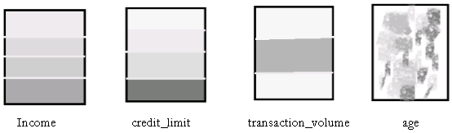
Fig: Pixel oriented visualization of 4 attributes by sorting all customers in income Ascending order.

Laying Out Pixels in Circle Segments
To save space and show the connections among multiple dimensions, space filling
is often done in a circle segment.
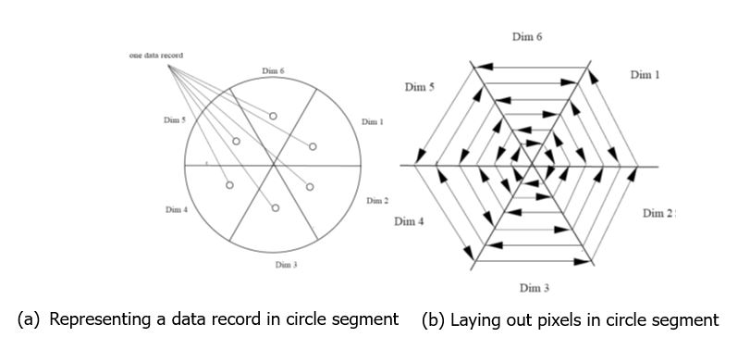

2 .Geometric Projection visualization techniques
- A drawback of pixel-oriented visualization techniques is that they cannot help us much in understanding the distribution of data in a multidimensional space.
- Geometric projection techniques help users find interesting projections of multidimensional data sets.
- A scatter plot displays 2-D data point using Cartesian co-ordinates. A third dimension can be added using different colors of shapes to represent different data points.
- Eg. Where x and y are two spatial attributes and the third dimension is represented by different shapes
- Through this visualization, we can see that points of types “+” &”X” tend to be collocated.
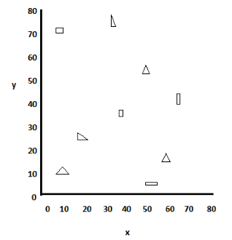
Fig: visualization of 2D data set using scatter plot
Methods
Direct visualization
Scatterplot and scatterplot matrices
Landscapes
Projection pursuit technique: Help users find meaningful projections of multidimensional data
Prosection views
Hyperslice
Parallelcoordinates

Scatter Plots
- A scatter plot displays 2-D data points using Cartesian coordinates.
- A third dimension can be added using different colors or shapes to represent different data points .

Scatterplot Matrices
- The scatter-plot matrix is an extension to the scatter plot.
- For k-dimensional data a minimum of (k2-k)/2 scatterplots of 2D will be required.
- There can be maximum of k2 plots of 2D
- In the adjoining figure , there are k2 plots. Out of these, k are X-X plots, and all X-Y plots (where X, Y are distinct dimensions) are given in 2 orientations (X vs Y and Y vs, X)

Parallel Coordinates
- The scatter-plot matrix becomes less effective as the dimensionality increases.

- Another technique, called parallel coordinates, can handle higher dimensionality.

- n equidistant axes which are parallel to one of the screen axes and correspond to the attributes (i.e. n dimensions).

- The axes are scaled to the [minimum, maximum]: range of the corresponding attribute.

- Every data item corresponds to a polygonal line which intersects each of the axes at the point which corresponds to the value for the attribute.

3. Icon based visualization techniques:-
Visualization of the data values as features of icons
Typical visualization methods
Chernoff Faces
Stick Figures
General techniques
- Shape coding: Use shape to represent certain information encoding
- Color icons: Use color icons to encode more information
- Tile bars: Use small icons to represent the relevant feature vectors in document retrieval
2 popular icon based techniques:-
Chern off faces: - They display multidimensional data of up to 18 variables as a cartoon human face.
A way to display variables on a two-dimensional surface, e.g., let x be eyebrow slant, y be eye size, z be nose length, etc.
The figure shows faces produced using 10 characteristics–
head eccentricity,
eye size,
eye spacing,
eye eccentricity,
pupil size,
eyebrow slant,
nose size,
mouth shape,
mouth size, and
mouth opening):
Each assigned one of 10 possible values.
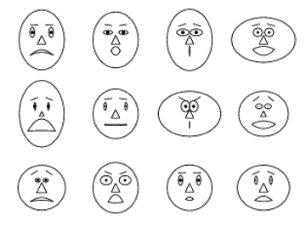

Fig: chern off faces each face represents an ‘n’ dimensional data points (n<18)

Stick figures: It maps multidimensional data to five –piece stick figure, where each figure has 4 limbs and a body.
2 dimensions are mapped to the display axes and the remaining dimensions are mapped to the angle and/ or length of the limbs.

A census data figure showing age, income, gender, education
A 5-piece stick figure (1 body and 4 limbs w. different angle/length)
Age, income are indicated by position of the figure.
Gender, education are indicated by angle/length.
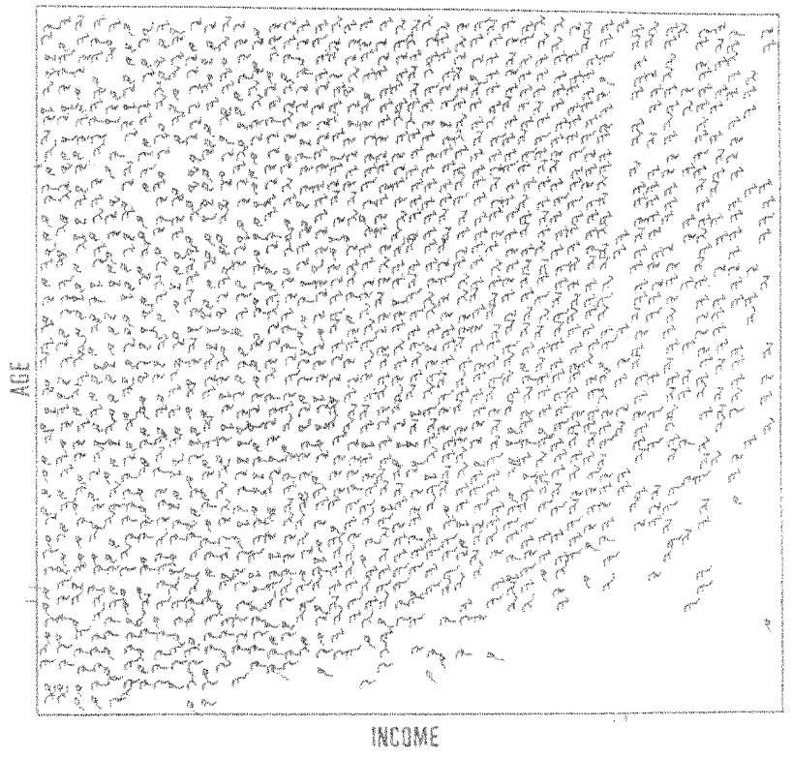
Visualizationcanshowatexturepattern

4.Hierarchical Visualization
- For a large data set of high dimensionality, it would be difficult to visualize all dimensions at the same time.
- Hierarchical visualization techniques partition all dimensions into subsets (i.e., subspaces). The subspaces are visualized in a hierarchical manner
- “Worlds-within-Worlds,” also known as n-Vision, is a representative hierarchical visualization method.
- To visualize a 6-D data set, where the dimensions are F,X1,X2,X3,X4,X5. We want to observe how F changes w.r.t. other dimensions.
We can fix X3,X4,X5 dimensions to selected values and visualize changes to F w.r.t. X1, X2
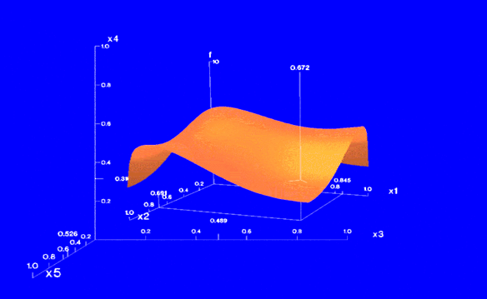

Visualizing Complex Data and Relations
- Most visualization techniques were mainly for numeric data. Recently, more and more non-numeric data, such as text and social networks, have become available.
- Many people on the Web tag various objects such as pictures, blog entries, and product reviews.
- A tag cloud is a visualization of statistics of user-generated tags. Often, in a tag cloud, tags are listed alphabetically or in a user-preferred order.
- The importance of a tag is indicated by font size or color.
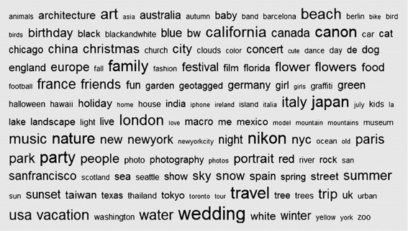
VisualizingComplexDataandRelations
Explain in detail about Data Visualization Tools.

What Are Data Visualization Tools?
Data visualization tools provide data visualization designers with an easier way to create visual representations of large data sets. When dealing with data sets that include hundreds of thousands or millions of data points, automating the process of creating a visualization, at least in part, makes a designer’s job significantly easier.
These data visualizations can then be used for a variety of purposes: dashboards, annual reports, sales and marketing materials, investor slide decks, and virtually anywhere else information needs to be interpreted immediately.

What Do the Best Data Visualization Tools Have in Common?
The best data visualization tools on the market have a few things in common. First is their ease of use. There are some incredibly complicated apps available for visualizing data. Some have excellent documentation and tutorials and are designed in ways that feel intuitive to the user. Others are lacking in those areas, eliminating them from any list of “best” tools, regardless of their other capabilities.
The best tools can also handle huge sets of data. In fact, the very best can even handle multiple sets of data in a single visualization.
The best tools also can output an array of different chart, graph, and map types. Most of the tools below can output both images and interactive graphs. There are exceptions to the variety of output criteria, though. Some data visualization tools focus on a specific type of chart or map and do it very well. Those tools also have a place among the “best” tools out there.
Finally, there are cost considerations. While a higher price tag doesn’t necessarily disqualify a tool, the higher price tag has to be justified in terms of better support, better features, and better overall value.

Data Visualization Tools Comparison
There are dozens, if not hundreds, of applications, tools, and scripts available to create visualizations of large data sets. Many are very basic and have a lot of overlapping features.
But there are standouts that either have more capability for the types of visualizations they can create or are significantly easier to use than the other options out there.

Tableau (and Tableau Public)
Tableau has a variety of options available, including a desktop app, server and hosted online versions, and a free public option. There are hundreds of data import options available, from CSV files to Google Ads and Analytics data to Salesforce data.
Output options include multiple chart formats as well as mapping capability. That means designers can create color-coded maps that showcase geographically important data in a format that’s much easier to digest than a table or chart could ever be.
The public version of Tableau is free to use for anyone looking for a powerful way to create data visualizations that can be used in a variety of settings. From journalists to political junkies to those who just want to quantify the data of their own lives, there are tons of potential uses for Tableau Public. They have an extensive gallery of infographics and visualizations that have been created with the public version to serve as inspiration for those who are interested in creating their own.
Pros
- Hundreds of data import options
- Mapping capability
- Free public version available
- Lots of video tutorials to walk you through how to use Tableau
Cons
- Non-free versions are expensive ($70/month/user for the Tableau Creator software)
- Public version doesn’t allow you to keep data analyses private
Data Visualization Examples
Data visualizations can make public safety data easier to digest.
An interactive visualization of the highest-grossing actors of all time.
Bottom Line
Tableau is a great option for those who need to create maps in addition to other types of charts. Tableau Public is also a great option for anyone who wants to create public-facing visualizations.

Infogram
Infogram is a fully-featured drag-and-drop visualization tool that allows even non-designers to create effective visualizations of data for marketing reports, infographics, social media posts, maps, dashboards, and more.
Finished visualizations can be exported into a number of formats: .PNG, .JPG, .GIF, .PDF, and .HTML. Interactive visualizations are also possible, perfect for embedding into websites or apps. Infogram also offers a WordPress plugin that makes embedding visualizations even easier for WordPress users.
Pros
- Tiered pricing, including a free plan with basic features
- Includes 35+ chart types and 550+ map types
- Drag and drop editor
- API for importing additional data sources
Cons
- Significantly fewer built-in data sources than some other apps

Visualizations can make complex topics easy to understand.
Charts make data easier to compare, year-to-year.
Maps are an excellent way to give a snapshot of worldwide data.
Bottom Line
Infogram is a great option for non-designers as well as designers. The drag-and-drop editor makes it easy to create professional-looking designs without a lot of visual design skill.

ChartBlocks
ChartBlocks claims that data can be imported from “anywhere” using their API, including from live feeds. While they say that importing data from any source can be done in “just a few clicks,” it’s bound to be more complex than other apps that have automated modules or extensions for specific data sources.
The app allows for extensive customization of the final visualization created, and the chart building wizard helps users pick exactly the right data for their charts before importing the data.
Designers can create virtually any kind of chart, and the output is responsive—a big advantage for data visualization designers who want to embed charts into websites that are likely to be viewed on a variety of devices.
Pros
- Free and reasonably priced paid plans are available
- Easy to use wizard for importing the necessary data
Cons
- Unclear how robust their API is
- Doesn’t appear to have any mapping capability

Stacked graph charts are an effective way to compare and contrast data.
Scatter plots are a simple way to represent data trends.
Line charts are effective at showing trends and comparisons.
Bottom Line
ChartBlocks has an excellent free plan, which is a big plus. The ease of use for creating basic charts and graphs is also

Datawrapper
Datawrapper was created specifically for adding charts and maps to news stories. The charts and maps created are interactive and made for embedding on news websites. Their data sources are limited, though, with the primary method being copying and pasting data into the tool.
Once data is imported, charts can be created with a single click. Their visualization types include column, line, and bar charts, election donuts, area charts, scatter plots, choropleth and symbol maps, and locator maps, among others. The finished visualizations are reminiscent of those seen on sites like the New York Times or Boston Globe. In fact, their charts are used by publications like Mother Jones, Fortune, and The Times.
The free plan is perfect for embedding graphics on smaller sites with limited traffic, but paid plans are on the expensive side, starting at $39/month.
Pros
- Specifically designed for newsroom data visualization
- Free plan is a good fit for smaller sites
- Tool includes a built-in color blindness checker
Cons
- Limited data sources
- Paid plans are on the expensive side

Scatter plots can show a multitude of data, especially when color-coded to show more points.
Bottom Line
Datawrapper is an excellent choice for data visualizations for news sites. Despite the price tag, the features Datawrapper includes for news-specific visualization make it worth it.

D3.js
D3.js is a JavaScript library for manipulating documents using data. D3.js requires at least some JS knowledge, though there are apps out there that allow non-programming users to utilize the library.
Those apps include NVD3, which offers reusable charts for D3.js; Plotly’s Chart Studio, which also allows designers to create WebGL and other charts; and Ember Charts, which also uses the Ember.js framework.
Pros
- Very powerful and customizable
- Huge number of chart types possible
- A focus on web standards
- Tools available to let non-programmers create visualizations
- Free and open source
Cons
- Requires programming knowledge to use alone
- Less support available than with paid tools

Chord diagrams show relationships between groups of entries.
Showing geographic data is best done with data maps.
Voronoi maps are an interesting way to show geographic data.
Bottom Line
D3.js is only suitable for those designers who either have access to a programmer for help or have programming knowledge themselves.

Google Charts
Google Charts is a powerful, free data visualization tool that is specifically for creating interactive charts for embedding online. It works with dynamic data and the outputs are based purely on HTML5 and SVG, so they work in browsers without the use of additional plugins. Data sources include Google Spreadsheets, Google Fusion Tables, Salesforce, and other SQL databases.
There are a variety of chart types, including maps, scatter charts, column and bar charts, histograms, area charts, pie charts, treemaps, timelines, gauges, and many others. These charts can be customized completely, via simple CSS editing.
Pros
- Free
- Wide variety of chart formats available
- Cross-browser compatible since it uses HTML5/SVG
- Works with dynamic data
Cons
- Beyond the tutorials and forum available, there’s limited support

Combo charts show trends and comparisons.
GeoCharts are just one method of visualizing data with Google Charts.
Annotations make charts and graphs easier to understand.
Bottom Line
Google Charts is a great option if a designer is somewhat comfortable with coding and wants a powerful, free solution. Being able to use any SQL database as a data source makes it a good option for large data sets, too.

FusionCharts
FusionCharts is another JavaScript-based option for creating web and mobile dashboards. It includes over 150 chart types and 1,000 map types. It can integrate with popular JS frameworks (including React, jQuery, React, Ember, and Angular) as well as with server-side programming languages (including PHP, Java, Django, and Ruby on Rails).
FusionCharts gives ready-to-use code for all of the chart and map variations, making it easier to embed in websites even for those designers with limited programming knowledge. Because FusionCharts is aimed at creating dashboards rather than just straightforward data visualizations it’s one of the most expensive options included in this article. But it’s also one of the most powerful.
Pros
- Huge number of chart and map format options
- More features than most other visualization tools
- Integrates with a number of different frameworks and programming languages
Cons
- Expensive (starts at almost $500 for one developer license)
- Overkill for simple visualizations outside of a dashboard environment
- FusionCharts is designed for creating data visualization dashboards.
Dashboards can showcase numerous data visualizations side by side.
Managing business operations is done best with data visualization dashboards.
Bottom Line
For creating dashboards, nothing else really compares to FusionCharts. If that’s the project at hand, this is undoubtedly the most powerful choice.

Chart.js
Chart.js is a simple but flexible JavaScript charting library. It’s open source, provides a good variety of chart types (eight total), and allows for animation and interaction.
Chart.js uses HTML5 Canvas for output, so it renders charts well across all modern browsers. Charts created are also responsive, so it’s great for creating visualizations that are mobile-friendly.
Pros
- Free and open source
- Responsive and cross-browser compatible output
Cons
- Very limited chart types compared to other tools
- Limited support outside of the official documentation

Bubble charts can showcase numerous data points simultaneously.

Multi-axis line charts are better when they’re annotated (this one uses tooltips when hovering over points on the lines).

Stacked area line charts are visually striking visualizations.
Bottom Line
Chart.js is a good option for designers who need a simple, customizable, interactive visualization option. Its biggest selling points are that it’s free and open source.

Grafana
Grafana is open-source visualization software that lets users create dynamic dashboards and other visualizations. It supports mixed data sources, annotations, and customizable alert functions, and it can be extended via hundreds of available plugins. That makes it one of the most powerful visualization tools available.
Export functions allow designers to share snapshots of dashboards as well as invite other users to collaborate. Grafana supports over 50 data sources via plugins. It’s free to download, or there’s a cloud-hosted version for $49/month. (There’s also a very limited free hosted version.) The downloadable version also has support plans available, something a lot of other open-source tools don’t offer.
Pros
- Open source, with free and paid options available
- Large selection of data sources available
- Variety of chart types available
- Makes creating dynamic dashboards simple
- Can work with mixed data feeds
Cons
- Overkill for creating simple visualizations
- Doesn’t offer as many visual customization options as some other tools
- Not the best option for creating visualization images
- Not able to embed dashboards in websites, though possible for individual panels
Grafana is a powerful data visualization dashboard tool.

Bottom Line
Grafana is one of the best options for creating dashboards for internal use, especially for mixed or large data sources.

Chartist.js
Chartist.js is a free, open-source JavaScript library that allows for creating simple responsive charts that are highly customizable and cross-browser compatible. The entire JavaScript library is only 10KB when GZIPped. Charts created with Chartist.js can also be animated, and plugins allow it to be extended.
Pros
- Free and open source
- Tiny file size
- Charts can be animated
Cons
- Not the widest selection of chart types available
- No mapping capabilities
- Limited support outside of developer community

Chartist.js offers a number of basic graph types.
Bottom Line
Chartist.js is a good option for designers who want simple, embeddable, responsive charts with a small file size.

Sigmajs
Sigmajs is a single-purpose visualization tool for creating network graphs. It’s highly customizable but does require some basic JavaScript knowledge in order to use. Graphs created are embeddable, interactive, and responsive.
Pros
- Highly customizable and extensible
- Free and open source
- Easy to embed graphs in websites and apps
Cons
- Only creates one type of visualization: network graphs
- Requires JS knowledge to customize and implement

Sigmajs creates network graphs exclusively.
- Bottom Line
- Because of its single focus, Sigmajs is a great option for creating network graphs as long as the designer is comfortable with JavaScript.

Polymaps
Polymaps is a dedicated JavaScript library for mapping. The outputs are dynamic, responsive maps in a variety of styles, from image overlays to symbol maps to density maps. It uses SVG to create the images, so designers can use CSS to customize the visuals of their maps.
Pros
- Free and open source
- Built specifically for mapping
- Easy to embed maps in websites and apps
Cons
- Only creates one type of visualization
- Requires some coding knowledge to customize and implement
Bottom Line
Polymaps is a good option if maps are the only type of visualization required, as long as the designer is comfortable with some basic coding.
Power BI

Related products: Power BI Desktop, Power BI Report Server
Description: Microsoft is a major players in enterprise BI and analytics. The company’s flagship platform, Power BI, is cloud-based and delivered on the Azure Cloud. On-prem capabilities also exist for individual users or when power users are authoring complex data mashups using in-house data sources. Power BI is unique because it enables users to do data preparation, data discovery, and dashboards with the same design tool. The platform integrates with Excel and Office 365, and has a very active user community that extends the tool’s capabilities.

