**STEP MATERIAL**

**OF**

**DISCRETE MATHEMATICS**

**By**

**Mr. V. Kiran Kumar**

**Assistant Professor**

**Department of CSE (Data Science)**

**UNIT - I**

The Foundations: Logic and Proofs: Propositional Logic, Applications of Propositional Logic, Propositional Equivalence, Predicates and Quantifiers, Nested Quantifiers, Rules of Inference, Introduction to Proofs, Proof Methods and Strategy.

**Propositional Logic**

**Truth Tables**

Here's a question about playing Monopoly:

If you get more doubles than any other player then you will lose, or if you lose then you must have bought the most properties.

True or false? We will answer this question, and won't need to know anything about Monopoly. Instead we will look at the logical *form* of the statement.

We need to decide when the statement (P→Q)∨(Q→R)(P→Q)∨(Q→R) is true. Using the definitions of the connectives in [Section 0.2](http://discrete.openmathbooks.org/dmoi2/sec_intro-statements.html), we see that for this to be true, either P→QP→Q must be true or Q→RQ→R must be true (or both). Those are true if either PP is false or QQ is true (in the first case) and QQ is false or RR is true (in the second case). So—yeah, it gets kind of messy. Luckily, we can make a chart to keep track of all the possibilities. Enter ***truth tables***. The idea is this: on each row, we list a possible combination of T's and F's (for true and false) for each of the sentential variables, and then mark down whether the statement in question is true or false in that case. We do this for every possible combination of T's and F's. Then we can clearly see in which cases the statement is true or false. For complicated statements, we will first fill in values for each part of the statement, as a way of breaking up our task into smaller, more manageable pieces.

Since the truth value of a statement is completely determined by the truth values of its parts and how they are connected, all you really need to know is the truth tables for each of the logical connectives. Here they are:

|  |  |  |
| --- | --- | --- |
| PP | QQ | P∧QP∧Q |
| T | T | T |
| T | F | F |
| F | T | F |
| F | F | F |
| PP | QQ | P∨QP∨Q |
| T | T | T |
| T | F | T |
| F | T | T |
| F | F | F |
|  |  |  |

|  |  |  |
| --- | --- | --- |
| PP | QQ | P→QP→Q |
| T | T | T |
| T | F | F |
| F | T | T |
| F | F | T |
| PP | QQ | P↔QP↔Q |
| T | T | T |
| T | F | F |
| F | T | F |
| F | F | T |

The truth table for negation looks like this:

|  |  |
| --- | --- |
| PP | ¬P¬P |
| T | F |
| F | T |
|  |  |

None of these truth tables should come as a surprise; they are all just restating the definitions of the connectives. Let's try another one.

###### Example:

Make a truth table for the statement ¬P∨Q.¬P∨Q.

[Solution](http://discrete.openmathbooks.org/dmoi2/sec_propositional.html)

Note that this statement is not ¬(P∨Q),¬(P∨Q), the negation belongs to PP alone. Here is the truth table:

|  |  |  |  |
| --- | --- | --- | --- |
| PP | QQ | ¬P¬P | ¬P∨Q¬P∨Q |
| T | T | F | T |
| T | F | F | F |
| F | T | T | T |
| F | F | T | T |

We added a column for ¬P¬P to make filling out the last column easier. The entries in the ¬P¬P column were determined by the entries in the PP column. Then to fill in the final column, look only at the column for QQ and the column for ¬P¬P and use the rule for ∨.

###### Example

Analyze the statement, “if you get more doubles than any other player you will lose, or that if you lose you must have bought the most properties,” using truth tables.

[Solution](http://discrete.openmathbooks.org/dmoi2/sec_propositional.html)

Represent the statement in symbols as (P→Q)∨(Q→R),(P→Q)∨(Q→R), where PP is the statement “you get more doubles than any other player,” QQ is the statement “you will lose,” and RR is the statement “you must have bought the most properties.” Now make a truth table.

The truth table needs to contain 8 rows in order to account for every possible combination of truth and falsity among the three statements. Here is the full truth table:

|  |  |  |  |  |  |
| --- | --- | --- | --- | --- | --- |
| PP | QQ | RR | P→QP→Q | Q→RQ→R | (P→Q)∨(Q→R)(P→Q)∨(Q→R) |
| T | T | T | T | T | T |
| T | T | F | T | F | T |
| T | F | T | F | T | T |
| T | F | F | F | T | T |
| F | T | T | T | T | T |
| F | T | F | T | F | T |
| F | F | T | T | T | T |
| F | F | F | T | T | T |

The first three columns are simply a systematic listing of all possible combinations of T and F for the three statements (do you see how you would list the 16 possible combinations for four statements?). The next two columns are determined by the values of P,P, Q,Q, and RR and the definition of implication. Then, the last column is determined by the values in the previous two columns and the definition of ∨.∨. It is this final column we care about.

Notice that in each of the eight possible cases, the statement in question is true. So our statement about monopoly is true (regardless of how many properties you own, how many doubles you roll, or whether you win or lose).

The statement about monopoly is an example of a **tautology**, a statement which is true on the basis of its logical form alone. Tautologies are always true but they don't tell us much about the world. No knowledge about monopoly was required to determine that the statement was true. In fact, it is equally true that “If the moon is made of cheese, then Elvis is still alive, or if Elvis is still alive, then unicorns have 5 legs.”

###### Example

Are the statements, “it will not rain or snow” and “it will not rain and it will not snow” logically equivalent?

[Solution](http://discrete.openmathbooks.org/dmoi2/sec_propositional.html)

We want to know whether ¬(P∨Q)¬(P∨Q) is logically equivalent to ¬P∧¬Q.¬P∧¬Q. Make a truth table which includes both statements:

|  |  |  |  |
| --- | --- | --- | --- |
| PP | QQ | ¬(P∨Q)¬(P∨Q) | ¬P∧¬Q¬P∧¬Q |
| T | T | F | F |
| T | F | F | F |
| F | T | F | F |
| F | F | T | T |

Since in every row the truth values for the two statements are equal, the two statements are logically equivalent.

### Direct Proof

The simplest (from a logic perspective) style of proof is a **direct proof**. Often all that is required to prove something is a systematic explanation of what everything means. Direct proofs are especially useful when proving implications. The general format to prove P→Q is this:

Assume P. Explain, explain, …, explain. Therefore Q.

Often we want to prove universal statements, perhaps of the form

∀x(P(x)→Q(x)).

Again, we will want to assume P(x) is true and deduce Q(x).

But what about the x?x? We want this to work for all x.x. We accomplish this by fixing xx to be an arbitrary element (of the sort we are interested in).

Here are a few examples. First, we will set up the proof structure for a direct proof, then fill in the details.

###### Example

Prove: For all integers n, if nn is even, then n2 is even.

[Solution](http://discrete.openmathbooks.org/dmoi2/sec_logic-proofs.html)

The format of the proof with be this: Let nn be an arbitrary integer. Assume that nn is even. Explain explain explain. Therefore n2n2 is even.

To fill in the details, we will basically just explain what it means for nn to be even, and then see what that means for n2.n2. Here is a complete proof.

###### **Proof**

Let n be an arbitrary integer. Suppose nn is even. Then n=2k for some integer k.

 Now n2=(2k)2=4k2=2(2k2).

Since 2k2 is an integer, n2 is even.

###### Example.

Prove: For all integers a, b, and c, if a|b and b|c then a|c. Here x|y, read “x divides y” means that y is a multiple of x (so x will divide into y without remainder).

[Solution](http://discrete.openmathbooks.org/dmoi2/sec_logic-proofs.html)

Even before we know what the divides symbol means, we can set up a direct proof for this statement. It will go something like this: Let a,a, b,b, and cc be arbitrary integers. Assume that a|b and b|c. Dot dot dot. Therefore a|c.

How do we connect the dots? We say what our hypothesis (a|b and b|c) really means and why this gives us what the conclusion (a|c) really means. Another way to say that a|b is to say that b=ka for some integer k (that is, that b is a multiple of a). What are we going for? That c=la, for some integer l (because we want c to be a multiple of a). Here is the complete proof.

###### **Proof**

Let a, b, and c be integers. Assume that a|b and b|c. In other words, b is a multiple of a and c is a multiple of b.

So there are integers k and j such that b=ka and c=jb.

 Combining these (through substitution) we get that c=jka.

But jkjk is an integer, so this says that c is a multiple of a.

Therefore a|c.

### Proof by Contrapositive

[**¶**](http://discrete.openmathbooks.org/dmoi2/sec_logic-proofs.html#subsection-32)

Recall that an implication P→QP→Q is logically equivalent to its contrapositive ¬Q→¬P.¬Q→¬P. There are plenty of examples of statements which are hard to prove directly, but whose contrapositive can easily be proved directly. This is all that **proof by contrapositive** does. It gives a direct proof of the contrapositive of the implication. This is enough because the contrapositive is logically equivalent to the original implication.

The skeleton of the proof of P→QP→Q by contrapositive will always look roughly like this:

Assume ¬Q. Explain, explain, … explain. Therefore ¬P.

As before, if there are variables and quantifiers, we set them to be arbitrary elements of our domain. Here are a couple examples:

###### Example

Is the statement “for all integers n, if n2 is even, then n is even” true?

[Solution](http://discrete.openmathbooks.org/dmoi2/sec_logic-proofs.html)

This is the converse of the statement we proved above using a direct proof. From trying a few examples, this statement definitely appears this is true. So let's prove it.

A direct proof of this statement would require fixing an arbitrary nn and assuming that n2n2 is even. But it is not at all clear how this would allow us to conclude anything about n. Just because n2=2k does not in itself suggest how we could write n as a multiple of 2.

Try something else: write the contrapositive of the statement. We get, for all integers n, if n is odd then n2 is odd. This looks much more promising. Our proof will look something like this:

Let n be an arbitrary integer. Suppose that n is not even. This means that …. In other words …. But this is the same as saying …. Therefore n2n2 is not even.

Now we fill in the details:

###### **Proof**

We will prove the contrapositive. Let nn be an arbitrary integer. Suppose that nn is not even, and thus odd. Then n=2k+1 for some integer k.k. Now n2=(2k+1)2=4k2+4k+1=2(2k2+2k)+1.n2=(2k+1)2=4k2+4k+1=2(2k2+2k)+1.

Since 2k2+2k2k2+2k is an integer, we see that n2 is odd and therefore not even.

###### Example

Prove: for all integers a and b, if a+b is odd, then a is odd or bb is odd.

[Solution](http://discrete.openmathbooks.org/dmoi2/sec_logic-proofs.html)

The problem with trying a direct proof is that it will be hard to separate aa and bb from knowing something about a+b.a+b. On the other hand, if we know something about aa and bb separately, then combining them might give us information about a+b. The contrapositive of the statement we are trying to prove is: for all integers a and b, if a and b are even, then a+b is even. Thus our proof will have the following format:

Let a and b be integers. Assume that a and b are both even. la Therefore a+b is even.

Here is a complete proof:

###### **Proof**

Let aa and bb be integers. Assume that aa and bb are even. Then a=2ka=2k and b=2lb=2l for some integers k and l. Now a+b=2k+2l=2(k+1). Since k+l is an integer, we see that a+b is even, completing the proof.

Note that our assumption that a and b are even is really the negation of a or b is odd. We used De Morgan's law here.

We have seen how to prove some statements in the form of implications: either directly or by contrapositive. Some statements are not written as implications to begin with.

###### Example

Consider the statement, for every prime number p,p, either p=2p=2 or pp is odd. We can rephrase this: for every prime number p,p, if p≠2,p≠2, then pp is odd. Now try to prove it.

[Solution](http://discrete.openmathbooks.org/dmoi2/sec_logic-proofs.html)

###### **Proof**

Let p be an arbitrary prime number. Assume pp is not odd. So pp is divisible by 2. Since pp is prime, it must have exactly two divisors, and it has 2 as a divisor, so pp must be divisible by only 1 and 2. Therefore p=2.p=2. This completes the proof (by contrapositive).

### Proof by Contradiction

[**¶**](http://discrete.openmathbooks.org/dmoi2/sec_logic-proofs.html#subsection-33)

There might be statements which really cannot be rephrased as implications. For example, “√2 is irrational.” In this case, it is hard to know where to start. What can we assume? Well, say we want to prove the statement P. What if we could prove that ¬P→Q where Q was false? If this implication is true, and Q is false, what can we say about ¬P? It must be false as well, which makes P true!

This is why **proof by contradiction** works. If we can prove that ¬P leads to a contradiction, then the only conclusion is that ¬P is false, so P is true. That's what we wanted to prove. In other words, if it is impossible for PP to be false, PP must be true.

Here are a couple examples of proofs by contradiction:

###### Example

Prove that √2 is irrational.

[Solution](http://discrete.openmathbooks.org/dmoi2/sec_logic-proofs.html)

###### **Proof**

Suppose not. Then √2 is equal to a fraction ab. Without loss of generality, assume abab is in lowest terms (otherwise reduce the fraction). So,

2=a2b22=a2b22b2=a22b2=a2

Thus a2 is even, and as such aa is even. So a=2k for some integer k,k, and a2=4k2. We then have,

2b2=4k2

b2=2k2

Thus b2 is even, and as such b is even. Since aa is also even, we see that ab is not in lowest terms, a contradiction. Thus √2 is irrational.

###### Example

Prove: There are no integers x and y such that x2=4y+2.

[Solution](http://discrete.openmathbooks.org/dmoi2/sec_logic-proofs.html)

###### **Proof**

We proceed by contradiction. So suppose there are integers xx and yy such that x2=4y+2=2(2y+1). So x2 is even. We have seen that this implies that xx is even. So x=2kx=2k for some integer k. Then x2=4k2. This in turn gives 2k2=(2y+1). But 2k2 is even, and 2y+1 is odd, so these cannot be equal. Thus we have a contradiction, so there must not be any integers x and y such that x2=4y+2.

###### Example

The Pigeonhole Principle: If more than nn pigeons fly into nn pigeon holes, then at least one pigeon hole will contain at least two pigeons. Prove this!

[Solution](http://discrete.openmathbooks.org/dmoi2/sec_logic-proofs.html)

###### **Proof**

Suppose, contrary to stipulation, that each of the pigeon holes contain at most one pigeon. Then at most, there will be nn pigeons. But we assumed that there are more than nn pigeons, so this is impossible. Thus there must be a pigeonhole with more than one pigeon.

While we phrased this proof as a proof by contradiction, we could have also used a proof by contrapositive since our contradiction was simply the negation of the hypothesis. Sometimes this will happen, in which case you can use either style of proof. There are examples however where the contradiction occurs “far away” from the original statement.

### Proof by (counter) Example

It is almost NEVER okay to prove a statement with just an example. Certainly none of the statements proved above can be proved through an example. This is because in each of those cases we are trying to prove that something holds of all integers. We claim that n2n2 being even implies that nn is even, no matter what integer nn we pick. Showing that this works for n=4n=4 is not even close to enough.

This cannot be stressed enough. If you are trying to prove a statement of the form ∀xP(x),∀xP(x), you absolutely CANNOT prove this with an example.[1](http://discrete.openmathbooks.org/dmoi2/sec_logic-proofs.html)

However, existential statements can be proven this way. If we want to prove that there is an integer nn such that n2−n+41n2−n+41 is not prime, all we need to do is find one. This might seem like a silly thing to want to prove until you try a few values for n.n.

|  |  |  |  |  |  |  |  |
| --- | --- | --- | --- | --- | --- | --- | --- |
| n | 1 | 2 | 3 | 4 | 5 | 6 | 7 |
| n2−n+41 | 41 | 43 | 47 | 53 | 61 | 71 | 83 |

So far we have gotten only primes. You might be tempted to conjecture, “For all positive integers n, the number n2−n+41 is prime.” If you wanted to prove this, you would need to use a direct proof, a proof by contra positive, or another style of proof, but certainly it is not enough to give even 7 examples. In fact, we can prove this conjecture is false by proving its negation: “There is a positive integer nn such that n2−n+41 is not prime.” Since this is an existential statement, it suffices to show that there does indeed exist such a number.

In fact, we can quickly see that n=41 will give 412 which is certainly not prime. You might say that this is a counterexample to the conjecture that n2−n+41 is always prime.

Since so many statements in mathematics are universal, making their negations existential, we can often prove that a statement is false (if it is) by providing a counterexample.

###### Example

Above we proved, “for all integers a and b, if a+b is odd, then a is odd or bb is odd.” Is the converse true?

[Solution](http://discrete.openmathbooks.org/dmoi2/sec_logic-proofs.html)

The converse is the statement, “for all integers aa and b,b, if aa is odd or bb is odd, then a+ba+b is odd.” This is false! How do we prove it is false? We need to prove the negation of the converse. Let's look at the symbols. The converse is

∀a∀b((O(a)∨O(b))→O(a+b)).∀a∀b((O(a)∨O(b))→O(a+b)).

We want to prove the negation:

¬∀a∀b((O(a)∨O(b))→O(a+b)).¬∀a∀b((O(a)∨O(b))→O(a+b)).

Simplify using the rules from the previous sections:

∃a∃b((O(a)∨O(b))∧¬O(a+b)).∃a∃b((O(a)∨O(b))∧¬O(a+b)).

As the negation passed by the quantifiers, they changed from ∀∀ to ∃.∃. We then needed to take the negation of an implication, which is equivalent to asserting the if part and not the then part.

Now we know what to do. To prove that the converse is false we need to find two integers aa and bb so that aa is odd or bb is odd, but a+ba+b is not odd (so even). That's easy: 1 and 3. (remember, “or” means one or the other or both). Both of these are odd, but 1+3=41+3=4 is not odd.

###### Example3.2.11

Prove: For any integer n,n, the number (n3−n)(n3−n) is even.

[Solution](http://discrete.openmathbooks.org/dmoi2/sec_logic-proofs.html)

It is hard to know where to start this, because we don't know much of anything about n.n. We might be able to prove that n3−nn3−n is even if we knew that nn was even. In fact, we could probably prove that n3−nn3−n was even if nn was odd. But since nn must either be even or odd, this will be enough. Here's the proof.

###### **Proof**

 We consider two cases: if n is even or if n is odd.

Case 1: n is even. Then n=2k for some integer k. This give

n3−n=8k3−2k=2(4k2−k),

n3−n=8k3−2k=2(4k2−k),

and since 4k2−k4k2−k is an integer,

this says that n3−nn3−n is even.

Case 2: nn is odd. Then n=2k+1n=2k+1 for some integer k.k.

This gives

n3−n=(2k+1)3−(2k+1)

=8k3+6k2+6k+1−2k−1

=2(4k3+3k2+2k),n3−n

=(2k+1)3−(2k+1)

=8k3+6k2+6k+1−2k−1

=2(4k3+3k2+2k),

and since 4k3+3k2+2k4k3+3k2+2k is an integer, we see that n3−nn3−n is even again.

Since n3−nn3−n is even in both exhaustive cases, we see that n3−nn3−n is indeed always even.

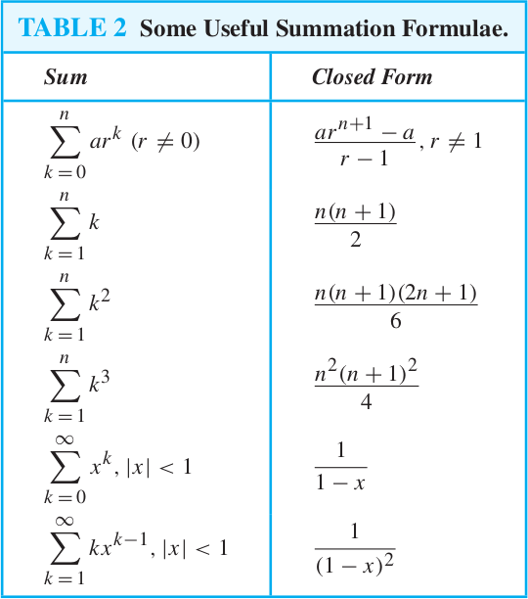

**UNIT – II**

Basic Structures, Sets, Functions, Sequences, Sums, Matrices and Relations Sets, Functions, Sequences & Summations, Cardinality of Sets and Matrices Relations, Relations and Their Properties, n-ary Relations and Their Applications, Representing Relations, Closures of Relations, Equivalence Relations, Partial Orderings.

*Example: Show A B = A B*

De Morgan’s Law for Sets: proof below uses De Morgan’s Law for logi

1 *A* ∩ *B* = {*x*|*x* ̸∈ *A* ∩ *B*} Def of Complement

2 = {*x*|¬(*x* ∈ *A* ∩ *B*)} Def of ”Not In”

3 = {*x*|¬(*x* ∈ *A* ∧ *x* ∈ *B*)} Def of Intersection

4 = {*x*|¬(*x* ∈ *A*) ∨ ¬(*x* ∈ *B*)} **De Morgan’s Law**

5 = {*x*|(*x* ̸∈ *A*) ∨ (*x* ̸∈ *B*)} Def of ̸∈

6 = {*x*|(*x* ∈ *A*) ∨ (*x* ∈ *B*)} Def of Complement

7 = {*x*|*x* ∈ (*A* ∪ *B*)} Def of Union

8 = *A* ∪ *B* Simplify ■

Show that IF *A* ∪ *B* = *A* THEN *B* ⊂ *A*

* + Use set builder notation starting
  + Start with known facts
  + Derive definition of subset

1. *A* ∪ *B* = *A* Fact
2. *A* ∪ *B* = {*x*|*x* ∈ *A* ∨ *x* ∈ *B*} Def of Union
3. *A* = {*x*|*x* ∈ *A*} Set Builder Notation
4. {*x*|*x* ∈ *A*} = {*x*|*x* ∈ *A* ∨ *x* ∈ *B*} Equiv of 2/3 by 1
5. ∀*x*(*x* ∈ *B* → *x* ∈ *A*) Meaning of 4

*B* ⊂ *A* Def of Subset from 4

Solve the recurrence relation an=an−1+n with initial term a0=4.

[Solution](http://discrete.openmathbooks.org/dmoi2/sec_recurrence.html)

To get a feel for the recurrence relation, write out the first few terms of the sequence: 4,5,7,10,14,19,…. Look at the difference between terms. a1−a0=1 and a2−a1=2 and so on. The key thing here is that the difference between terms is n.n. We can write this explicitly: an−an−1=n. Of course, we could have arrived at this conclusion directly from the recurrence relation by subtracting an−1 from both sides.

Now use this equation over and over again, changing n each time:

a1−a0=1a2−a1=2a3−a2=3⋮⋮an−an−1=n.

Add all these equations together. On the right-hand side,

we get the sum 1+2+3+⋯+n.1+2+3+⋯+n.

We already know this can be simplified to n(n+1)2.

What happens on the left-hand side? We get

(a1−a0)+(a2−a1)+(a3−a2)+⋯(an−1−an−2)+(an−an−1).

This sum telescopes.

We are left with only the −a0 from the first equation and the anan from the last equation.

Putting this all together we have −a0+an=n(n+1)2or an=n(n+1)2+a0. But we know that a0=4. So the solution to the recurrence relation, subject to the initial condition is

an = n(n+1)2+4.

(Now that we know that, we should notice that the sequence is the result of adding 4 to each of the triangular numbers.)

###### Example

Use iteration to solve the recurrence relation an=an−1+n with a0=4.

[Solution](http://discrete.openmathbooks.org/dmoi2/sec_recurrence.html)

Again, start by writing down the recurrence relation when n=1. This time, don't subtract the an−1 terms to the other side:

a1=a0+1.

Now a2=a1+2, but we know what a1is. By substitution, we get

a2=(a0+1)+2.

Now go to a3=a2+3, using our known value of a2:

a3=((a0+1)+2)+3.

We notice a pattern. Each time, we take the previous term and add the current index.

So

an=((((a0+1)+2)+3)+⋯+n−1)+n.

Regrouping terms, we notice that an is just a0 plus the sum of the integers from 11 to n.

So, since a0=4,

an=4+n(n+1)2.

**UNIT – III**

Algorithms, Induction and Recursion: Algorithms, The Growth of Functions, Complexity of Algorithms Induction and Recursion: Mathematical Induction, Strong Induction and Well-Ordering, Recursive Definitions and Structural Induction, Recursive Algorithms, Program Correctness.

### Problems on Principle of Mathematical Induction

**1. Using the principle of mathematical induction, prove that   
  
1² + 2² + 3² + ..... + n² = (1/6){n(n + 1)(2n + 1} for all n ∈ N.**   
  
**Solution:**  
  
Let the given statement be P(n). Then,   
  
P(n): 1² + 2² + 3² + ..... +n² = (1/6){n(n + 1)(2n + 1)}.   
  
Putting n =1 in the given statement, we get   
  
LHS = 1² = 1 and RHS = (1/6) × 1 × 2 × (2 × 1 + 1) = 1.   
  
Therefore LHS = RHS.   
  
Thus, P(1) is true.

Let P(k) be true. Then,  
  
P(k): 1² + 2² + 3² + ..... + k² = (1/6){k(k + 1)(2k + 1)}.  
  
Now, 1² + 2² + 3² + ......... + k² + (k + 1)²  
  
                    = (1/6) {k(k + 1)(2k + 1) + (k + 1)²  
  
                    = (1/6){(k + 1).(k(2k + 1)+6(k + 1))}  
  
                    = (1/6){(k + 1)(2k² + 7k + 6})  
  
                    = (1/6){(k + 1)(k + 2)(2k + 3)}  
  
                    = 1/6{(k + 1)(k + 1 + 1)[2(k + 1) + 1]}  
  
⇒ P(k + 1): 1² + 2² + 3² + ….. + k² + (k+1)²  
  
                    = (1/6){(k + 1)(k + 1 + 1)[2(k + 1) + 1]}  
  
⇒ P(k + 1) is true, whenever P(k) is true.  
  
Thus, P(1) is true and P(k + 1) is true, whenever P(k) is true.  
  
Hence, by the principle of mathematical induction, P(n) is true for all n ∈ N.

2. By using math**ematical induction prove that the given equation is true for all positive integers.**

**. By using mathematical induction prove that the given equation is true for all positive integers.**

**1 x 2 + 3 x 4 + 5 x 6 + …. + (2n - 1) x 2n =**n(n+1)(4n−1)3n(n+1)(4n−1)3

**Solution:**

From the statement formula

When n = 1,

LHS =1 x 2 = 2

RHS = 1(1+1)(4x1−1)31(1+1)(4x1−1)3 = 6363 = 2

Hence it is proved that P (1) is true for the equation.

Now we assume that P (k) is true or 1 x 2 + 3 x 4 + 5 x 6 + …. + (2k - 1) x 2k = k(k+1)(4k−1)3k(k+1)(4k−1)3.

For P(k + 1)

LHS = 1 x 2 + 3 x 4 + 5 x 6 + …. + (2k - 1) x 2k + (2(k + 1) - 1) x 2(k + 1)

= k(k+1)(4k−1)3k(k+1)(4k−1)3 + (2(k + 1) - 1) x 2(k + 1)

= (k+1)3(k+1)3(4k2 - k + 12 k + 6)

= (k+1)(4k2+8k+3k+6)3(k+1)(4k2+8k+3k+6)3

= (k+1)(k+2)(4k+3)3(k+1)(k+2)(4k+3)3

= (k+1)((k+1)+1)(4(k+1)−1)3(k+1)((k+1)+1)(4(k+1)−1)3 = RHS for P (k+1)

Now it is proved that P (k + 1) is also true for the equation.

So the given statement is true for all positive integers

Problems on Principle of Mathematical Induction  
  
**3. Using the principle of mathematical induction, prove that  
  
1 ∙ 2 + 2 ∙ 3 + 3 ∙ 4 + ..... + n(n + 1) = (1/3){n(n + 1)(n + 2)}.**  
  
**Solution:**  
  
Let the given statement be P(n). Then,  
  
P(n): 1 ∙ 2 + 2 ∙ 3 + 3 ∙ 4 + ..... + n(n + 1) = (1/3){n(n + 1)(n + 2)}.  
  
Thus, the given statement is true for n = 1, i.e., P(1) is true.  
  
Let P(k) be true. Then,  
  
P(k): 1 ∙ 2 + 2 ∙ 3 + 3 ∙ 4 + ..... + k(k + 1) = (1/3){k(k + 1)(k + 2)}.  
  
Now, 1 ∙ 2 + 2 ∙ 3 + 3 ∙ 4 +...+ k(k + 1) + (k + 1)(k + 2)  
  
          = (1 ∙ 2 + 2 ∙ 3 + 3 ∙ 4 + ....... + k(k + 1)) + (k + 1)(k + 2)  
  
          = (1/3) k(k + 1)(k + 2) + (k + 1)(k + 2) [using (i)]  
  
          = (1/3) [k(k + 1)(k + 2) + 3(k + 1)(k + 2)  
  
          = (1/3){(k + 1)(k + 2)(k + 3)}  
  
⇒ P(k + 1): 1 ∙ 2 + 2 ∙ 3 + 3 ∙ 4 +......+ (k + 1)(k + 2)  
  
                     = (1/3){k + 1 )(k + 2)(k +3)}  
  
⇒ P(k + 1) is true, whenever P(k) is true.  
  
Thus, P(1) is true and P(k + 1)is true, whenever P(k) is true.  
  
Hence, by the principle of mathematical induction, P(n) is true for all values of ∈ N.  
  
  
  
Problems on Principle of Mathematical Induction

**4. By using mathematical induction prove that the given equation is true for all positive integers.**

**2 + 4 + 6 + …. + 2n = n(n+1)**

**Solution:**

From the statement formula

When n = 1 or P (1),

LHS = 2

RHS =1 × 2 = 2

So P (1) is true.

Now we assume that P (k) is true or 2 + 4 + 6 + …. + 2k = k(k + 1).

For P(k + 1),

LHS = 2 + 4 + 6 + …. + 2k + 2(k + 1)

= k(k + 1) + 2(k + 1)

= (k + 1) (k + 2)

= (k + 1) ((k + 1) + 1) = RHS for P(k+1)

Now it is proved that P(k+1) is also true for the equation.

So the given statement is true for all positive integers.

**5. Using the principle of mathematical induction, prove that  
  
1 ∙ 3 + 3 ∙ 5 + 5 ∙ 7 +.....+ (2n - 1)(2n + 1) = (1/3){n(4n² + 6n - 1).**  
  
**Solution:**  
  
Let the given statement be P(n). Then,  
  
P(n): 1 ∙ 3 + 3 ∙ 5 + 5 ∙ 7 +...... + (2n - 1)(2n + 1)= (1/3)n(4n² + 6n - 1).  
  
When n = 1, LHS = 1 ∙ 3 = 3 and RHS = (1/3) × 1 × (4 × 1² + 6 × 1 - 1)  
  
                                                   = {(1/3) × 1 × 9} = 3.  
  
LHS = RHS.  
  
Thus, P(1) is true.  
  
Let P(k) be true. Then,  
  
P(k): 1 ∙ 3 + 3 ∙ 5 + 5 ∙ 7 + ….. + (2k - 1)(2k + 1) = (1/3){k(4k² + 6k - 1) ......(i)  
  
Now,  
  
1 ∙ 3 + 3 ∙ 5 + 5 ∙ 7 + …….. + (2k - 1)(2k + 1) + {2k(k + 1) - 1}{2(k + 1) + 1}  
  
          = {1 ∙ 3 + 3 ∙ 5 + 5 ∙ 7 + ………… + (2k - 1)(2k + 1)} + (2k + 1)(2k + 3)  
  
          = (1/3) k(4k² + 6k - 1) + (2k + 1)(2k + 3) [using (i)]  
  
          = (1/3) [(4k³ + 6k² - k) + 3(4k² + 8k + 3)]  
  
          = (1/3)(4k³ + 18k² + 23k + 9)  
  
          = (1/3){(k + 1)(4k² + 14k + 9)}  
  
          = (1/3)[k + 1){4k(k + 1) ² + 6(k + 1) - 1}]  
  
⇒ P(k + 1): 1 ∙ 3 + 3 ∙ 5 + 5 ∙ 7 + ..... + (2k + 1)(2k + 3)  
  
           = (1/3)[(k + 1){4(k + 1)² + 6(k + 1) - 1)}]  
  
⇒ P(k + 1) is true, whenever P(k) is true.  
  
Thus, P(1) is true and P(k + 1) is true, whenever P(k) is true.  
  
Hence, by the principle of mathematical induction, P(n) is true for all n ∈ N.  
  
  
  
More Problems on Principle of Mathematical Induction

**6. By using mathematical induction prove that the given equation is true for all positive integers.**

**2 + 6 + 10 + ….. + (4n - 2) = 2n2**

**Solution:**

From the statement formula

When n = 1 or P(1),

LHS = 2

RHS = 2 × 12 = 2

So P(1) is true.

Now we assume that P (k) is true or 2 + 6 + 10 + ….. + (4k - 2) = 2k2

For P (k + 1),

LHS = 2 + 6 + 10 + ….. + (4k - 2) + (4(k + 1) - 2)

= 2k2 + (4k + 4 - 2)

= 2k2+ 4k + 2

= (k+1)2

= RHS for P(k+1)

Now it is proved that P(k+1) is also true for the equation.

So the given statement is true for all positive integers.

**7. Using the principle of mathematical induction, prove that  
  
1/(1 ∙ 2) + 1/(2 ∙ 3) + 1/(3 ∙ 4) + ..... + 1/{n(n + 1)} = n/(n + 1)**  
  
**Solution:**  
  
Let the given statement be P(n). Then,  
  
P(n): 1/(1 ∙ 2) + 1/(2 ∙ 3) + 1/(3 ∙ 4) + ..... + 1/{n(n + 1)} = n/(n + 1).  
  
Putting n = 1 in the given statement, we get  
  
LHS= 1/(1 ∙ 2) = and RHS = 1/(1 + 1) = 1/2.  
  
LHS = RHS.  
  
Thus, P(1) is true.  
  
Let P(k) be true. Then,  
  
P(k): 1/(1 ∙ 2) + 1/(2 ∙ 3) + 1/(3 ∙ 4) + ..... + 1/{k(k + 1)} = k/(k + 1) ..…(i)  
  
Now 1/(1 ∙ 2) + 1/(2 ∙ 3) + 1/(3 ∙ 4) + ..... + 1/{k(k + 1)} + 1/{(k + 1)(k + 2)}  
  
[1/(1 ∙ 2) + 1/(2 ∙ 3) + 1/(3 ∙ 4) + ..... + 1/{k(k + 1)}] + 1/{(k + 1)(k + 2)}  
  
= k/(k + 1)+1/{ (k + 1)(k + 2)}.  
  
{k(k + 2) + 1}/{(k + 1)²/[(k + 1)k + 2)] using …(ii)  
  
= {k(k + 2) + 1}/{(k + 1)(k + 2}  
  
= {(k + 1)² }/{(k + 1)(k + 2)}  
  
= (k + 1)/(k + 2) = (k + 1)/(k + 1 + 1)  
  
⇒ P(k + 1): 1/(1 ∙ 2) + 1/(2 ∙ 3) + 1/(3 ∙ 4) + ……… + 1/{ k(k + 1)} + 1/{(k + 1)(k + 2)}  
  
                    = (k + 1)/(k + 1 + 1)  
  
⇒ P(k + 1) is true, whenever P(k) is true.  
  
Thus, P(1) is true and P(k + 1)is true, whenever P(k) is true.  
  
Hence, by the principle of mathematical induction, P(n) is true for all n ∈ N.  
  
Problems on Principle of Mathematical Induction

**8. Using the principle of mathematical induction, prove that  
  
{1/(3 ∙ 5)} + {1/(5 ∙ 7)} + {1/(7 ∙ 9)} + ….... + 1/{(2n + 1)(2n + 3)} = n/{3(2n + 3)}.**  
  
**Solution:**  
  
Let the given statement be P(n). Then,  
  
P(n): {1/(3 ∙ 5) + 1/(5 ∙ 7) + 1/(7 ∙ 9) + ……. + 1/{(2n + 1)(2n + 3)} = n/{3(2n + 3).  
  
Putting n = 1 in the given statement, we get  
  
and LHS = 1/(3 ∙ 5) = 1/15 and RHS = 1/{3(2 × 1 + 3)} = 1/15.  
  
LHS = RHS  
  
Thus , P(1) is true.  
  
Let P(k) be true. Then,  
  
P(k): {1/(3 ∙ 5) + 1/(5 ∙ 7) + 1/(7 ∙ 9) + …….. + 1/{(2k + 1)(2k + 3)} = k/{3(2k + 3)} ….. (i)  
  
Now, 1/(3 ∙ 5) + 1/(5 ∙ 7) + ..…… + 1/[(2k + 1)(2k + 3)] + 1/[{2(k + 1) + 1}2(k + 1) + 3  
  
          = {1/(3 ∙ 5) + 1/(5 ∙ 7) + ……. + [1/(2k + 1)(2k + 3)]} + 1/{(2k + 3)(2k + 5)}  
  
          = k/[3(2k + 3)] + 1/[2k + 3)(2k + 5)] [using (i)]  
  
           = {k(2k + 5) + 3}/{3(2k + 3)(2k + 5)}  
  
          = (2k² + 5k + 3)/[3(2k + 3)(2k + 5)]  
  
          = {(k + 1)(2k + 3)}/{3(2k + 3)(2k + 5)}  
  
           = (k + 1)/{3(2k + 5)}  
  
          = (k + 1)/[3{2(k + 1) + 3}]  
  
= P(k + 1): 1/(3 ∙ 5) + 1/(5 ∙ 7) + …….. + 1/[2k + 1)(2k + 3)] + 1/[{2(k + 1) + 1}{2(k + 1) + 3}]  
  
                    = (k + 1)/{3{2(k + 1) + 3}]  
  
⇒ P(k + 1) is true, whenever P(k) is true.  
  
Thus, P(1) is true and P(k + 1) is true, whenever P(k) is true.  
  
Hence, by the principle of mathematical induction, P(n) is true for n ∈ N.  
  
  
  
Problems on Principle of Mathematical Induction  
**9. By induction prove that 3n- 1 is divisible by 2 is true for all positive integers.**

**Solution:**

When n = 1, P(1) = 31 - 1 = 2 which is divisible by 2.

So P(1) is true.

Now we assume that P(k) is true or 3k - 1 is divisible by 2.

When P(k + 1),

3k + 1 - 1= 3k x 3 - 1 = 3k x 3 - 3 + 2 = 3(3k - 1) + 2

As (3k - 1) and 2 both are divisible by 2, it is proved that divisible by 2 is true for all positive integers.

**10. Using the principle of mathematical induction, prove that  
  
1/(1 ∙ 2 ∙ 3) + 1/(2 ∙ 3 ∙ 4) + …….. + 1/{n(n + 1)(n + 2)} = {n(n + 3)}/{4(n + 1)(n + 2)} for all n ∈ N.**  
  
**Solution:**  
  
Let P (n): 1/(1 ∙ 2 ∙ 3) + 1/(2 ∙ 3 ∙ 4) + ……. + 1/{n(n + 1)(n + 2)} = {n(n + 3)}/{4(n + 1)(n + 2)} .  
  
Putting n = 1 in the given statement, we get  
  
LHS = 1/(1 ∙ 2 ∙ 3) = 1/6 and RHS = {1 × (1 + 3)}/[4 × (1 + 1)(1 + 2)] = ( 1 × 4)/(4 × 2 × 3) = 1/6.  
  
Therefore LHS = RHS.  
  
Thus, the given statement is true for n = 1, i.e., P(1) is true.  
  
Let P(k) be true. Then,  
  
P(k): 1/(1 ∙ 2 ∙ 3) + 1/(2 ∙ 3 ∙ 4) + ……... + 1/{k(k + 1)(k + 2)} = {k(k + 3)}/{4(k + 1)(k + 2)}. …….(i)  
  
Now, 1/(1 ∙ 2 ∙ 3) + 1/(2 ∙ 3 ∙ 4) + ………….. + 1/{k(k + 1)(k + 2)} + 1/{(k + 1)(k + 2)(k + 3)}  
  
           = [1/(1 ∙ 2 ∙ 3) + 1/(2 ∙ 3 ∙ 4) + ………..…. + 1/{ k(k + 1)(k + 2}] + 1/{(k + 1)(k + 2)(k + 3)}  
  
           = [{k(k + 3)}/{4(k + 1)(k + 2)} + 1/{(k + 1)(k + 2)(k + 3)}]  
                                                            [using(i)]  
  
           = {k(k + 3)² + 4}/{4(k + 1)(k + 2)(k + 3)}  
  
           = (k³ + 6k² + 9k + 4)/{4(k + 1)(k + 2)(k + 3)}  
  
           = {(k + 1)(k + 1)(k + 4)}/{4 (k + 1)(k + 2)(k + 3)}  
  
           = {(k + 1)(k + 4)}/{4(k + 2)(k + 3)  
  
⇒ P(k + 1): 1/(1 ∙ 2 ∙ 3) + 1/(2 ∙ 3 ∙ 4) + ……….….. + 1/{(k + 1)(k + 2)(k + 3)}  
  
                    = {(k + 1)(k + 2)}/{4(k + 2)(k + 3)}  
  
⇒ P(k + 1) is true, whenever P(k) is true.  
  
Thus, P(1) is true and P(k + 1) is true, whenever P(k) is true.  
  
Hence, by the principle of mathematical induction, P(n) is true for all n ∈ N.  
  
  
  
Problems on Principle of Mathematical Induction

**11. By induction prove that n2- 3n + 4 is even and it is true for all positive integers.**

**Solution:**

When n = 1, P (1) = 1 - 3 + 4 = 2 which is an even number.

So P (1) is true.

Now we assume that P (k) is true or k2- 3k + 4 is an even number.

When P (k + 1),

(k + 1)2- 3(k + 1) + 4

= k2+ 2k + 1 - 3k + 3 + 4

= k2- 3k + 4 + 2(k + 2)

As k2- 3k + 4 and 2(k + 2) both are even, there sum also will be an even number.

So it is proved that n2- 3n + 4 is even is true for all positive integers.

**12. Using the Principle of mathematical induction, prove that  
  
{1 - (1/2)}{1 - (1/3)}{1 - (1/4)} ….... {1 - 1/(n + 1)} = 1/(n + 1) for all n ∈ N.**  
  
**Solution:**  
  
Let the given statement be P(n). Then,  
  
P(n): {1 - (1/2)}{1 - (1/3)}{1 - (1/4)} ….... {1 - 1/(n + 1)} = 1/(n + 1).  
  
When n = 1, LHS = {1 – (1/2)} = ½ and RHS = 1/(1 + 1) = ½.  
  
Therefore LHS = RHS.  
  
Thus, P(1) is true.  
  
Let P(k) be true. Then,  
  
P(k): {1 - (1/2)}{1 - (1/3)}{1 - (1/4)} ….... [1 - {1/(k + 1)}] = 1/(k + 1)  
  
Now, [{1 - (1/2)}{1 - (1/3)}{1 - (1/4)} ….... [1 - {1/(k + 1)}] ∙ [1 – {1/(k + 2)}]  
  
           = [1/(k + 1)] ∙ [{(k + 2 ) - 1}/(k + 2)}]  
  
           = [1/(k + 1)] ∙ [(k + 1)/(k + 2)]  
  
           = 1/(k + 2)  
  
Therefore p(k + 1): [{1 - (1/2)}{1 - (1/3)}{1 - (1/4)} ….... [1 - {1/(k + 1)}] = 1/(k + 2)  
  
⇒ P(k + 1) is true, whenever P(k) is true.  
  
Thus, P(1) is true and P(k + 1) is true, whenever P(k) is true.  
  
Hence, by the principle of mathematical induction, P(n) is true for all n ∈ N.

**UNIT - IV**

Discrete Probability and Advanced Counting Techniques: An Introduction to Discrete Probability, Probability Theory, Bayes’Theorem, Expected Value and Variance Advanced Counting Techniques: Recurrence Relations, Solving Linear Recurrence Relations, Divide-and-Conquer Algorithms and Recurrence Relations, Generating Functions, Inclusion- Exclusion, Applications of Inclusion-Exclusion

**1.**A dice is thrown 65 times and 4 appeared 2 1 times. Now, in a random throw of a dice, what is the probability of getting a 4?  
  
**Solution:**  
  
Total number of tria1s = 65.  
  
Number of times 4 appeared = 21.

Probability of getting a 4 = Number of times 4 appeared/Total number of trials  
  
                                  = 21/65

**2.**A survey of 200families shows the results given below:

|  |  |  |  |
| --- | --- | --- | --- |
| **No. of girls in the family** | 2 | 1 | 0 |
| **No. of Families** | 32 | 154 | 14 |

Out of these families, one is chosen at random. What is the probability that the chosen family has 1 girl?  
  
**Solution:**  
  
Total number of families = 200.  
  
Number of families having 1 girl = 154.

Probability of getting a family having 1 girl  
  
                               = Number of families having 1 girl/Total number of families  
  
                               = 154/200  
  
                               = 77/100

Worksheet Probability:

**1.** The tree diagram above represents three events. In the first event either a Red, White, or Blue circle is chosen. In the second event either a Red, White, or Blue circle is chosen. In the third event either a Red, White, or Blue circle is chosen.

**Match the following events with the corresponding probabilities:**

(a) The second circle is white (a) 10/15

(b) All three circles are red (b) 4/15

(c) Exactly two circles are the same (c) 5/15

(d) At least two circles are the same (d) 3/15

(e) The first circle is not red (e) 1/15

(f) The first two circles are blue (f) 12/15

(g) The third circle is blue (g) 15/15

**2.**The tree diagram above represents three events. In the first event either an A, B, or C is chosen. In the second event either an A, B, or C is chosen. In the third event either a D, E, or F is chosen.

**Match the outcome with its probability:**

(a) The second letter is a C (a) 6/12

(b) The first or second letter is an A (b) 0/12

(c) The last letter chosen is a D (c) 5/15

(d) The first two letters chosen are both A (d) 3/15

(e) All three letters are the same (e) 1/15

(f) The first letter is not an A (f) 12/15

(g) ADD (g) 15/15

**Example of Bayes’ Theorem**

Imagine you are a financial analyst at an investment bank. According to your research of [publicly-traded companies](https://corporatefinanceinstitute.com/resources/knowledge/finance/private-vs-public-company/), 60% of the companies that increased their share price by more than 5% in the last three years replaced their [CEOs](https://corporatefinanceinstitute.com/resources/careers/jobs/what-is-a-ceo-chief-executive-officer/) during the period.

At the same time, only 35% of the companies that did not increase their share price by more than 5% in the same period replaced their CEOs. Knowing that the probability that the stock prices grow by more than 5% is 4%, find the probability that the shares of a company that fires its CEO will increase by more than 5%.

Before finding the probabilities, you must first define the notation of the probabilities.

* P(A) – the probability that the stock price increases by 5%
* P(B) – the probability that the CEO is replaced
* P(A|B) – the probability of the stock price increases by 5% given that the CEO has been replaced
* P(B|A) – the probability of the CEO replacement given the stock price has increased by 5%.

Using the Bayes’ theorem, we can find the required probability:

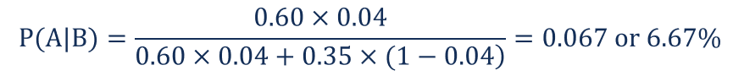

Thus, the probability that the shares of a company that replaces its CEO will grow by more than 5% is 6.67%.

**Que-1.** Solve the following recurrence relation?  
T(n) = 7T(n/2) + 3n^2 + 2  
(a) O(n^2.8)  
(b) O(n^3)  
(c) θ(n^2.8)  
(d) θ(n^3)

**Explanation –**  
T(n) = 7T(n/2) + 3n^2 + 2  
As one can see from the formula above:  
a = 7, b = 2, and f(n) = 3n^2 + 2  
So, f(n) = O(n^c), where c = 2.  
It falls in [master’s theorem](https://www.geeksforgeeks.org/analysis-algorithm-set-4-master-method-solving-recurrences/)case 1:  
logb(a) = log2(7) = 2.81 > 2  
It follows from the first case of the master theorem that T(n) = θ(n^2.8) and implies O(n^2.8) as well as O(n^3).  
Therefore, option (a), (b), and (c) are correct options.

**Que-2.** Sort the following functions in the decreasing order of their asymptotic (big-O) complexity:  
f1(n) = n^√n , f2(n) = 2^n, f3(n) = (1.000001)^n , f4(n) = n^(10)*2^(n/2)  
(a) f2> f4> f1> f3  
(b) f2> f4> f3> f1  
(c) f1> f2> f3> f4  
(d) f2> f1> f4> f3

**Explanation –**  
f2 > f4 because we can write f2(n) = 2^(n/2)*2^(n/2), f4(n) = n^(10)*2^(n/2) which clearly shows that f2 > f4  
f4 > f3 because we can write f4(n) = n^10.〖√2〗^n = n10.(1.414)n , which clearly shows f4> f3  
f3> f1:  
f1 (n) = n^√n take log both side log f1 = √n log n  
f3 (n) = (1.000001)^n take log both side log f3 = n log(1.000001), we can write as log f3 = √n*√n log(1.000001) and √n > log(1.000001).  
So, correct order is f2> f4> f3> f1. Option (b) is correct.

**Que-3.** f(n) = 2^(2n)  
Which of the following correctly represents the above function?  
(a) O(2^n)  
(b) Ω(2^n)  
(c) Θ(2^n)  
(d) None of these

**Explanation –** f(n) = 2^(2n) = 2^n*2^n  
Option (a) says f(n)<= c*2n, which is not true. Option (c) says c1*2n <= f(n) <= c2*2n, lower bound is satisfied but upper bound is not satisfied. Option (b) says c*2n <= f(n) this condition is satisfied hence option (b) is correct.

**Que-4.** Master’s theorem can be applied on which of the following recurrence relation?  
(a) T (n) = 2T (n/2) + 2^n  
(b) T (n) = 2T (n/3) + sin(n)  
(c) T (n) = T (n-2) + 2n^2 + 1  
(d) None of these

**Explanation –** Master theorem can be applied to the recurrence relation of the following type  
T (n) = aT(n/b) + f (n) (Dividing Function) & T(n)=aT(n-b)+f(n) (Decreasing function)  
Option (a) is wrong because to apply [master’s theorem,](https://www.geeksforgeeks.org/analysis-algorithm-set-4-master-method-solving-recurrences/) function f(n) should be polynomial.  
Option (b) is wrong because in order to apply master theorem f(n) should be monotonically increasing function.  
Option (d) is not the above mentioned type, therefore correct answer is (c) because T (n) = T (n-2) + 2n^2 + 1 will be considered as T (n) = T (n-2) + 2n^2 that is in the form of decreasing function.

**Que-5.** T(n) = 3T(n/2+ 47) + 2n^2 + 10*n – 1/2. T(n) will be

(a) O(n^2)  
(b) O(n^(3/2))  
(c) O(n log n)  
(d) None of these

**Explanation –** For higher values of n, n/2 >> 47, so we can ignore 47, now T(n) will be  
T(n) = 3T(n/2)+ 2*n^2 + 10*n – 1/2 = 3T(n/2)+ O(n^2)  
Apply master theorem, it is case 3 of master theorem T(n) = O(n^2).  
Option (a) is correct.

## Inclusion-Exclusion Principle: Example One (Two Sets)

### Question:

**Among 50 patients admitted to a hospital, 25 are diagnosed with pneumonia, 30 with bronchitis, and 10 with both pneumonia and bronchitis. Determine:**

**(a) The number of patients diagnosed with pneumonia or bronchitis (or both).**

**(b) The number of patients not diagnosed with pneumonia or bronchitis.**

### Solution:

The first step is to formally identify the sets and indicate the number of elements in each. This can be done purely with the given information; No calculation is necessary. With this inclusion-exclusion principle question, the three sets can be defined as follows:

**Let U denote the entire set of patients. Let P and B denote the set of patients diagnosed with pneumonia and bronchitis respectively. Thus:**

**|U| = 50**

**|P| = 25**

**|B| = 30**

**|P ∩ B| = 10**

We may now create a Venn diagram. There are two sets and therefore two circles. Since we know the number of elements in the intersection of P and B ( |P ∩ B| ) we can fill this in first:

[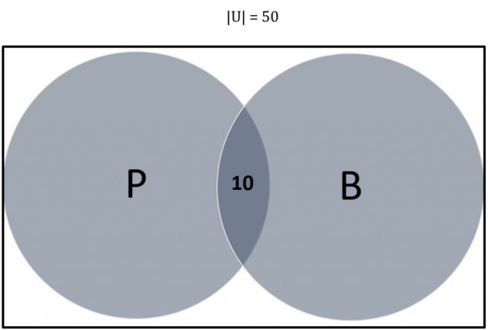](https://compscistation.com/wp-content/uploads/2018/11/venn-two-sets.jpg)

Now we can calculate how many elements live only in P but not |P ∩ B|:

**Since |P| = 25 and |P ∩ B| = 10, there are 15 (25-10 = 15) elements exclusive to P.**

Follow the same method to calculate the number of elements living only in B but not |P ∩ B|:

**Since |B| = 30 and |P ∩ B| = 10, there are 20 (30-10 = 20) elements exclusive to B.**

This new information should be added to our Venn diagram as follows:

[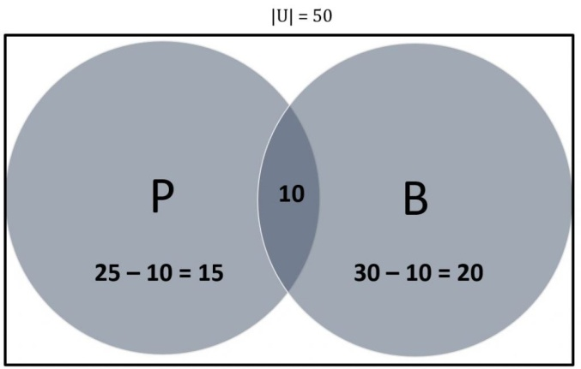](https://compscistation.com/wp-content/uploads/2018/11/venn-two-sets-final.jpg)

The preliminary work is complete and we have enough information to answer the questions directly:

***(a)*Determine the number of patients diagnosed with pneumonia or bronchitis (or both).**

This is the same as asking to determine |P ∪ B|. Looking at the Venn diagram, formulate the answer as follows:

**|P ∪ B| = 15 + 10 + 20**

**= 45**

**Thus 45 patients are diagnosed with pneumonia or bronchitis.**

The same answer can also be reached by using the inclusion-exclusion principle directly without referring to the Venn diagram:

**|P ∪ B| = |P| + |B| – |P ∪ B|**

**= (25 + 30) – (10)**

**= 45**

**Thus 45 patients are diagnosed with pneumonia or bronchitis.**

**(b) Determine the number of patients not diagnosed with pneumonia or bronchitis.**

This is the same as asking to determine |(P ∪ B)’|. We know that there are 50 patients altogether – of which 45 are diagnosed with pneumonia or bronchitis. Use this to solve the question:

**|U| = 50.**

**|P ∪ B| = 45**

**Therefore,**

**|(P ∪ B)’|**

**= 50 – 45 = 5**

**5 patients are not diagnosed with pneumonia or bronchitis.**

## Inclusion-Exclusion Principle: Example Two (Three Sets)

### ****Question:****

**A large software development company employs 100 computer programmers. Of them, 45 are proficient in Java, 30 in C#, 20 in Python, six in C# and Java, one in Java and Python, five in C# and Python, and just one programmer  is proficient in all three languages above.**

**Determine the number of computer programmers that are not proficient in any of these three languages.**

### ****Solution:****

As done in the first inclusion-principle exercise problem above, start with defining the given information:

**Let U denote the set of all employed computer programmers and let J, C and P denote the set of programmers proficient in Java, C# and Python, respectively. Thus:**

**|U| = 100**

**|J| = 45**

**|C| = 30**

**|P| = 20**

**|J ∩ C| = 6**

**|J ∩ P| = 1**

**|C ∩ P| = 5**

**|J ∩ C ∩ P| = 1**

We may now use a Venn diagram. It requires three circles since three sets are involved. Begin by populating the central intersection of all the three circles first:  J **∩** C **∩** P. Then use subtraction to determine the cardinality of the remaining sections.

[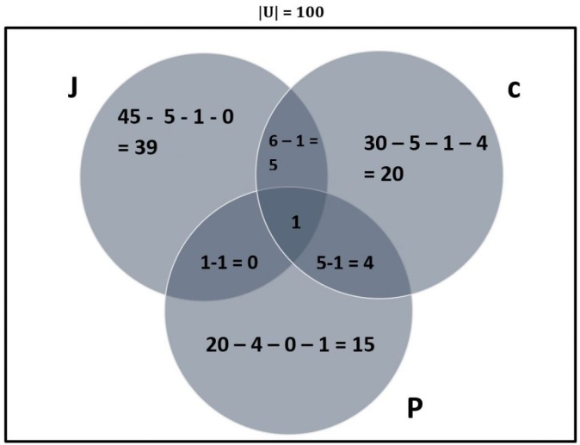](https://compscistation.com/wp-content/uploads/2018/11/inclusion-exclusion-set-theory-3.jpg)

We now have sufficient information in order to answer the question:

***Determine the number of computer programmers that are not proficient in any of these three languages.***

In other words, we need to determine the cardinality of the complement of the set J ∪ C ∪ P. (This is denoted as |(J ∪ C ∪ P)’|). Calculate |J ∪ C ∪ P| first before determining the complement value:

**|J ∪ C ∪ P|**

**= 39 + 5 +20 +4 +15 + 1**

**= 84**

Now calculate the complement:

**|(J ∪ C ∪ P)’ | = |U| – |J ∪ C ∪ P|**

**= 100 – 84**

**= 16**

**16 programmers are not proficient in any of the three languages.**

## Inclusion-Exclusion Principle: Example Three (Three Sets)

This inclusion-exclusion principle question example can be solved algebraically.

### ****Question:****

**There are 350 farmers in a large region. 260 farm beetroot, 100 farm yams, 70 farm radish, 40 farm beetroot and radish, 40 farm yams and radish, and 30 farm beetroot and yams. Let B, Y, and R denote the set of farms that farm beetroot, yams and radish respectively.**

**Determine the number of farmers that farm beetroot, yams, and radish.**

### ****Solution:****

The letters for denoting the sets have already been provided in the question itself (unlike the above example). We may therefore note the cardinality straight away:

**|U| = 350**

**|B| = 260**

**|Y| = 100**

**|R| = 70**

**|B ∩ R| = 40**

**|Y ∩ R| = 40**

**|B ∩ Y| = 30**

We need to determine the cardinality of the intersection of all three sets, which is |B ∩ Y ∩ R|. This is the unknown which we can assign determine algebraically.. Populate a Venn diagram with the given information. Use x to represent |B **∩**Y **∩**R|.

**Let x farmers farm beetroot, yams, and radish. That is, let |B ∩ Y ∩ R| = x**

[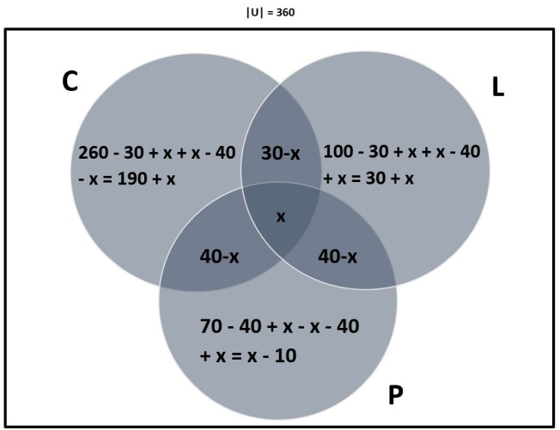](https://compscistation.com/wp-content/uploads/2018/11/venn-three-set-problem-exercise.jpg)

Now solve for x algebraically:

**|U|= 350 = 190 + x + (30 – x) + x + (40 – x) + (40 – x) + 30 + x + x – 10**

**350 = 320 + x**

**x = 30**

**Therefore, 30 farmers farm beetroot, yams, and radish.**

**UNIT – V**

Graphs: Graphs and Graph Models, Graph Terminology and Special Types of Graphs, Representing Graphs and Graph Isomorphism, Connectivity, Euler and Hamilton Paths, Shortest-Path Problems, Planar Graphs, Graph Coloring. Trees: Introduction to Trees, Applications of Trees, Tree Traversal, Spanning Trees, Minimum Spanning Trees.

**Problem 1 –** There are 25 telephones in Geeksland. Is it possible to connect them with wires so that each telephone is connected with exactly 7 others.  
**Solution –** Let us suppose that such an arrangement is possible. This can be viewed as a graph in which telephones are represented using vertices and wires using the edges. Now we have 25 vertices in this graph. The degree of each vertex in the graph is 7.

From [handshaking lemma](https://www.geeksforgeeks.org/handshaking-lemma-and-interesting-tree-properties/), we know.

sum of degrees of all vertices = 2*(number of edges)

number of edges = (sum of degrees of all vertices) / 2

We need to understand that an edge connects two vertices. So the sum of degrees of all the vertices is equal to twice the number of edges.  
Therefore,

25*7 = 2*(number of edges)

number of edges = 25*7 / 2 = 87.5

This is not an integer. As a result we can conclude that our supposition is wrong and such an arrangement is not possible.

**Problem 2 –** The figure below shows an arrangement of knights on a 3*3 grid.  
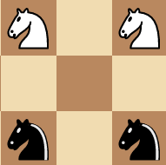  
**Figure –** initial state

Is it possible to reach the final state as shown below using valid knight’s moves ?

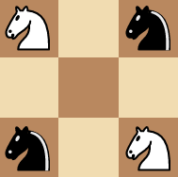  
**Figure –** final state

**Solution –** NO. You might think you need to be a good chess player in order to crack the above question. However the above question can be solved using graphs. But what kind of a graph should we draw? Let each of the 9 vertices be represented by a number as shown below.

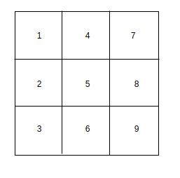

Now we consider each square of the grid as a vertex in our graph. There exists a edge between two vertices in our graph if a valid knight’s move is possible between the corresponding squares in the graph. For example – If we consider square 1. The reachable squares with valid knight’s moves are 6 and 8. We can say that vertex 1 is connected to vertices 6 and 8 in our graph.

Similarly we can draw the entire graph as shown below. Clearly vertex 5 can’t be reached from any of the squares. Hence none of the edges connect to vertex 5.

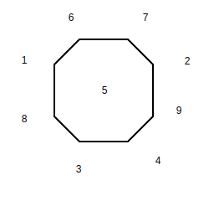

We use a hollow circle to depict a white knight in our graph and a filled circle to depict a black knight. Hence the initial state of the graph can be represented as :

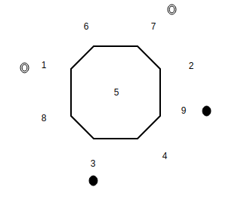  
**Figure –** initial state

The final state is represented as :

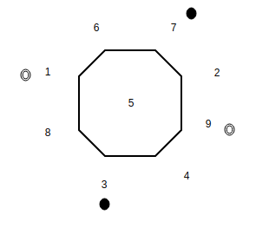  
**Figure –** final state

Note that in order to achieve the final state there needs to exist a path where two knights (a black knight and a white knight cross-over). We can only move the knights in a clockwise or counter-clockwise manner on the graph (If two vertices are connected on the graph: it means that a corresponding knight’s move exists on the grid). However the order in which knights appear on the graph cannot be changed. There is no possible way for a knight to cross over (Two knights cannot exist on one vertex) the other in order to achieve the final state. Hence, we can conclude that no matter what the final arrangement is not possible.

**Problem 3:** There are 9 line segments drawn in a plane. Is it possible that each line segment intersects exactly 3 others?  
**Solution:** This problem seems very difficult initially. We could think of solving it using graphs. But how do we do draw the graph. If we try to approach this problem by using line segments as edges of a graph,we seem to reach nowhere (This sounds confusing initially). Here we need to consider a graph where each line segment is represented as a vertex. Now two vertices of this graph are connected if the corresponding line segments intersect.

Now this graph has 9 vertices. The degree of each vertex is 3.

We know that for a graph  
**Sum of degrees of all vertices = 2* Number of Edges in the graph**  
Since the sum of degrees of vertices in the above problem is 9*3 = 27 i.e odd, such an arrangement is not possible.

## Euler’s Path

An Euler’s path contains each edge of ‘G’ exactly once and each vertex of ‘G’ at least once. A connected graph G is said to be traversable if it contains an Euler’s path.

## Example

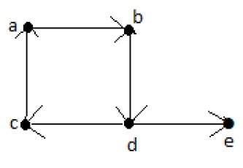

**Euler’s Path** = d-c-a-b-d-e.

## Euler’s Circuit

In an Euler’s path, if the starting vertex is same as its ending vertex, then it is called an Euler’s circuit.

## Example

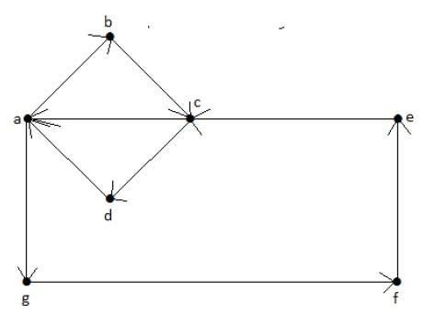

**Euler’s Path** = a-b-c-d-a-g-f-e-c-a.

## Euler’s Circuit Theorem

A connected graph ‘G’ is traversable if and only if the number of vertices with odd degree in G is exactly 2 or 0. A connected graph G can contain an Euler’s path, but not an Euler’s circuit, if it has exactly two vertices with an odd degree.

**Note** − This Euler path begins with a vertex of odd degree and ends with the other vertex of odd degree.

## Example

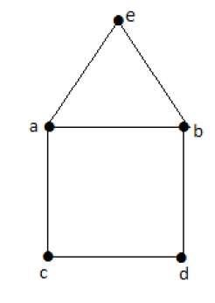

**Euler’s Path** − b-e-a-b-d-c-a is not an Euler’s circuit, but it is an Euler’s path. Clearly it has exactly 2 odd degree vertices.

**Note** − In a connected graph G, if the number of vertices with odd degree = 0, then Euler’s circuit exists.

## Hamiltonian Path

A connected graph is said to be Hamiltonian if it contains each vertex of G exactly once. Such a path is called a **Hamiltonian path**.

## Example

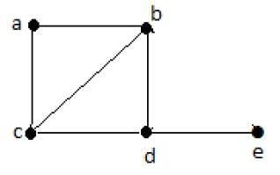

**Hamiltonian Path** − e-d-b-a-c.

**Note** −

* Euler’s circuit contains each edge of the graph exactly once.
* In a Hamiltonian cycle, some edges of the graph can be skipped.

## Example

Take a look at the following graph −

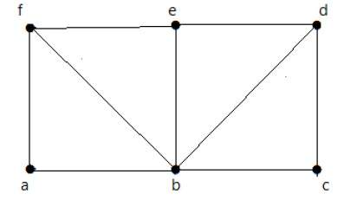

For the graph shown above −

* Euler path exists – false
* Euler circuit exists – false
* Hamiltonian cycle exists – true
* Hamiltonian path exists – true

G has four vertices with odd degree, hence it is not traversable. By skipping the internal edges, the graph has a Hamiltonian cycle passing through all the vertices.

A spanning tree of a connected undirected graph GG is a tree that minimally includes all of the vertices of GG. A graph may have many spanning trees.

### Example

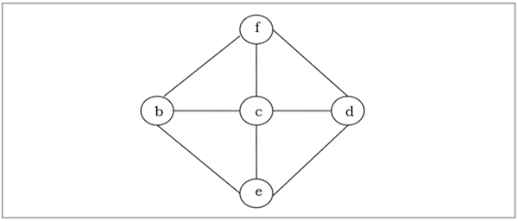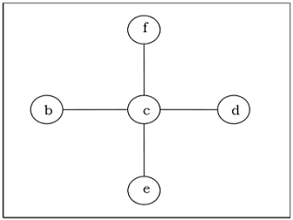

## Minimum Spanning Tree

A spanning tree with assigned weight less than or equal to the weight of every possible spanning tree of a weighted, connected and undirected graph GG, it is called minimum spanning tree (MST). The weight of a spanning tree is the sum of all the weights assigned to each edge of the spanning tree.

### Example

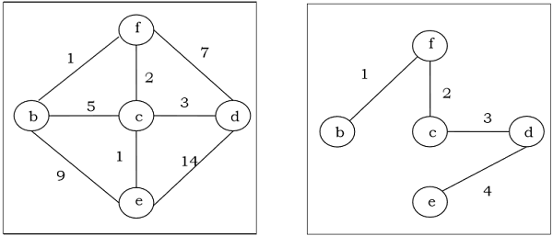

## Kruskal's Algorithm

Kruskal's algorithm is a greedy algorithm that finds a minimum spanning tree for a connected weighted graph. It finds a tree of that graph which includes every vertex and the total weight of all the edges in the tree is less than or equal to every possible spanning tree.

### Algorithm

**Step 1** − Arrange all the edges of the given graph G(V,E)G(V,E) in ascending order as per their edge weight.

**Step 2** − Choose the smallest weighted edge from the graph and check if it forms a cycle with the spanning tree formed so far.

**Step 3** − If there is no cycle, include this edge to the spanning tree else discard it.

**Step 4** − Repeat Step 2 and Step 3 until (V−1)(V−1) number of edges are left in the spanning tree.

**Problem**

Suppose we want to find minimum spanning tree for the following graph G using Kruskal’s algorithm.

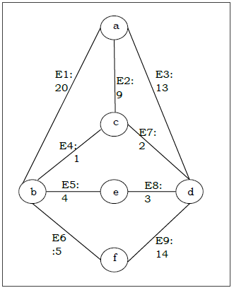

**Solution**

From the above graph we construct the following table −

|  |  |  |
| --- | --- | --- |
| **Edge No.** | **Vertex Pair** | **Edge Weight** |
| E1 | (a, b) | 20 |
| E2 | (a, c) | 9 |
| E3 | (a, d) | 13 |
| E4 | (b, c) | 1 |
| E5 | (b, e) | 4 |
| E6 | (b, f) | 5 |
| E7 | (c, d) | 2 |
| E8 | (d, e) | 3 |
| E9 | (d, f) | 14 |

Now we will rearrange the table in ascending order with respect to Edge weight −

|  |  |  |
| --- | --- | --- |
| **Edge No.** | **Vertex Pair** | **Edge Weight** |
| E4 | (b, c) | 1 |
| E7 | (c, d) | 2 |
| E8 | (d, e) | 3 |
| E5 | (b, e) | 4 |
| E6 | (b, f) | 5 |
| E2 | (a, c) | 9 |
| E3 | (a, d) | 13 |
| E9 | (d, f) | 14 |
| E1 | (a, b) | 20 |

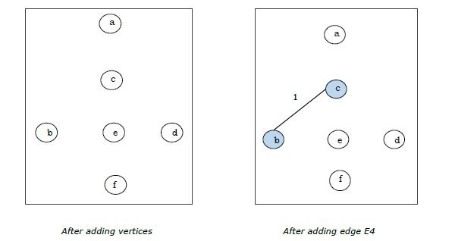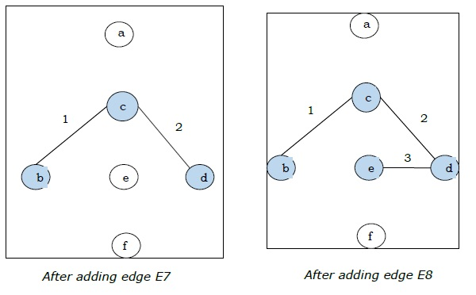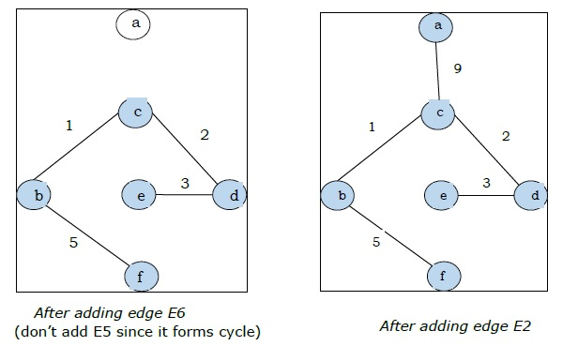

Since we got all the 5 edges in the last figure, we stop the algorithm and this is the minimal spanning tree and its total weight is (1+2+3+5+9)=20(1+2+3+5+9)=20.

## Prim's Algorithm

Prim's algorithm, discovered in 1930 by mathematicians, Vojtech Jarnik and Robert C. Prim, is a greedy algorithm that finds a minimum spanning tree for a connected weighted graph. It finds a tree of that graph which includes every vertex and the total weight of all the edges in the tree is less than or equal to every possible spanning tree. Prim’s algorithm is faster on dense graphs.

### Algorithm

* Initialize the minimal spanning tree with a single vertex, randomly chosen from the graph.
* Repeat steps 3 and 4 until all the vertices are included in the tree.
* Select an edge that connects the tree with a vertex not yet in the tree, so that the weight of the edge is minimal and inclusion of the edge does not form a cycle.
* Add the selected edge and the vertex that it connects to the tree.

**Problem**

Suppose we want to find minimum spanning tree for the following graph G using Prim’s algorithm.

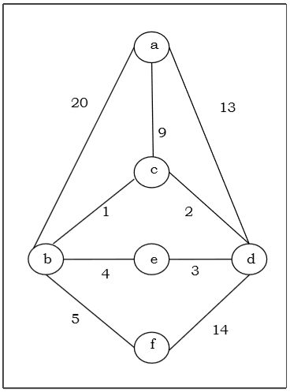

**Solution**

Here we start with the vertex ‘a’ and proceed.

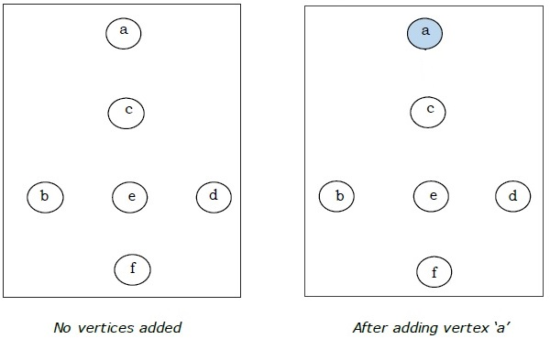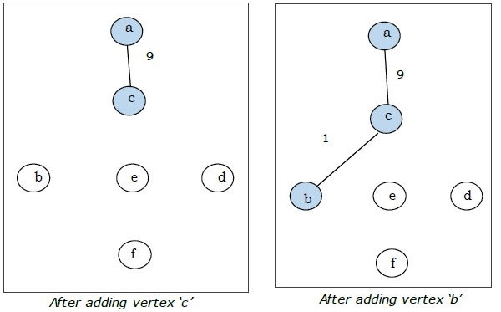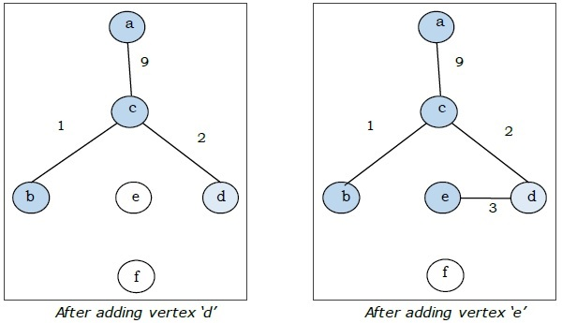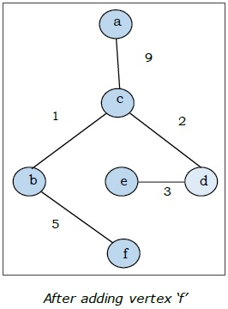

This is the minimal spanning tree and its total weight is (1+2+3+5+9)=20(1+2+3+5+9)=20.