STEP MATERIAL
Business Economics and Financial Analysis
UNIT – 1:
INTRODUCTION TO BUSINESS AND ECONOMICS:
SHORT QUESTIONS AND ANSWERS:
- What is business?
Business is an economic activity carried on with the intention of to earn profit. The main aim of business is to earn profit. Business includes Industry and Commerce.
- What is Economics and types?

Economics is a social science concerned with the production, distribution and consumption of goods and services. It studies how individuals, businesses, governments and nations make choices on allocating resources to satisfy their wants and needs, and tries to determine how these groups should organize and coordinate efforts to achieve maximum output.
- Types of Business entities explain briefly?

- Sole trader business:
The sole trader is the simplest, oldest and natural form of business organization. It is also called sole proprietorship. ‘Sole’ means one. ‘Sole trader’ implies that there is only one trader who is the owner of the business.
- Partnership business:
Partnership is an improved from of sole trader in certain respects. Where there are like-minded persons with resources, they can come together to do the business and share the profits/losses of the business in an agreed ratio. Persons who have entered into such an agreement are individually called ‘partners’ and collectively called ‘firm’. The relationship among partners is called a partnership.
Indian Partnership Act, 1932 defines partnership as the relationship between two or more persons who agree to share the profits of the business carried on by all or any one of them acting for all.
- Joint stock company :
The joint stock company emerges from the limitations of partnership such as joint and several liability, unlimited liability, limited resources and uncertain duration and so on. Normally, to take part in a business, it may need large money and we cannot foretell the fate of business. It is not literally possible to get into business with little money. Against this background, it is interesting to study the functioning of a joint stock company.
The main principle of the joint stock company from is to provide opportunity to take part in business with a low investment as possible say Rs.1000. Joint Stock Company has been a boon for investors with moderate funds to invest.
The word ‘ company’ has a Latin origin, com means ‘ come together’, pany means ‘ bread’, joint stock company means, people come together to earn their livelihood by investing in the stock of company jointly.
- What is micro and macro economics?

Micro economics:
Study of small economic units such as individuals, firms, and industries (competitive markets, labor markets, personal decision making, etc.)
Macro economics:
Study of the large economy as a whole or in its basic subdivisions (National Economic Growth, Government Spending, Inflation, Unemployment, etc.)
- What is national income and concept?
National income measures the total value of goods and services produced within the economy over a period of time.
Concepts:
Gross domestic product (GDP): is defined as "an aggregate measure of production equal to the sum of the gross values adde Per Capita Income (PCI)
Per Capita Income: of a country is derived by dividing the national income of the country by the total population of a countryd of all resident institutional units engaged in production
Gross national product (GNP): is the market value of all the productsand services produced in one year by labor and property supplied by the citizens of a country.
Personal Income (PI):
Personal Income i s the total money income received by individuals and households of a country from all possible sources before direct taxes.

- What is Business cycle and phases?

The business cycle occurs when economic activity speeds up or slows down. A business cycle is a swing in total national output, income and employment, usually lasting for a period of 2 to 10 years, marked by widespread expansion or contraction in many sectors of the economy

Phases:
- Boom stage
- Growth stage
- Maturity stage
- Decline stage

- What is business economics and nature of Business economics?

Business Economics refers to the firm’s decision making process. It could be also interpreted as “Economics of Management” or “Economics of Management”. Business Economics is also called as “Industrial Economics” or “Managerial Economics”.
Nature of Business Economics:
Close to microeconomics:
Business economics is concerned with finding the solutions for different Business problems of a particular firm. Thus, it is more close to microeconomics. The study of an individual consumer or a firm is called microeconomics (also called the Theory of Firm). Microeconomics deals with behavior and problems of single individual and of micro organization. Business economics has its roots in microeconomics and it deals with the micro or individual enterprises.
Macroeconomics:
The study of ‘aggregate’ or total level of economic activity in a country is called macroeconomics. It studies the flow of economics resources or factors of production (such as land, labour, capital, organization and technology) from the resource owner to the business firms and then from the business firms to the households. It deals with total aggregates, for instance, total national income total employment, output and total investment. It studies the interrelations among various aggregates and examines their nature and behaviour, their determination and causes of fluctuations in the.
Normative statements:
A normative statement usually includes or implies the words ‘ought’ or ‘should’. They reflect people’s moral attitudes and are expressions of what a team of people ought to do. For instance, it deals with statements such as ‘Government of India should open up the economy. Such statement are based on value judgments and express views of what is ‘good’ or ‘bad’, ‘right’ or ‘ wrong’. One problem with normative statements is that they cannot to verify by looking at the facts, because they mostly deal with the future. Disagreements about such statements are usually settled by voting on them.
Prescriptive actions:
Prescriptive action is goal oriented. Given a problem and the objectives of the firm, it suggests the course of action from the available alternatives for optimal solution. If does not merely mention the concept, it also explains whether the concept can be applied in a given context on not...
Offers scope to evaluate each alternative:
Business economics provides an opportunity to evaluate each alternative in terms of its costs and revenue. The Business economist can decide which is the better alternative to maximize the profits for the firm.
Interdisciplinary:
The contents, tools and techniques of managerial economics are drawn from different subjects such as economics, management, mathematics, finance, marketing statistics, accountancy, psychology, organizational behavior, sociology and etc.
Managerial economic is descriptive:
It is provides explanation description for the concepts of sales, profit ect… Business economic provides brief description for the questions like how will be our sales, when can we reach breakeven and from what time we can get profits ect...
Managerial economic is application oriented:
It is helps the managers in solving problems of different application areas like production. Pricing, promotion demand analysis ect.
- What is the role of Business economist?
Business economist taking the decision about
  - Production
  - Capital Management Decisions
  - Pricing Decisions
  - Promotion Strategies
  - Demand Analyses and Forecasting
  - Resource Allocation
  - Profit analysis

LONG QUESTIONS AND ANSWERS:
1. Define Business and Structure of business?
Business Definition:
An organization or Economic system where goods and services are exchanged for one another or for money. Every business requires some from of investment and enough customers to whom its output can be sold an a consistent basis in order to make profit.
Business is an economic activity carried on with the intention of to earn profit. The main aim of business is to earn profit. Business includes Industry and Commerce.

Objectives Of Business:
(i) Economic objective and
(ii) Social objective
Economic Objectives:
Economic objectives of business include earning adequate profit or satisfactory
Return on capital invested, survival in the case of competition and growth to Maintain progress.
Social Objectives:
Social objectives include providing employment opportunities, supply of quality Goods and services at reasonable price, improving the standard of living and contributing to environmental protection. It also includes justice to workers in terms of wages, welfare amenities, improved service conditions and Professional growth.
Nature Of Business:
- Business is an economic activity
- It includes the activities of production or purchase and distribution.
- It deals in goods and services.
- It implies regularity of transactions.
- It aims at earning profits through the satisfaction of human wants.

Business Structure:
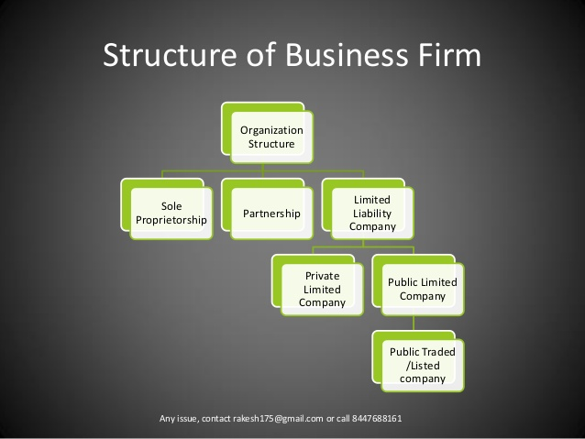
2. Explain theory of firm?
The of firm is the micro economic concept founded in neoclassical economics that state that firms (including business and corporations) exist and make decisions to maximize profits.
Theory of firm deals with optimum level of profit. It is used to identify level of output, prices to sell and prices to breakeven.
Purpose of the theories:
To provide models for the analysis of the decision making in the firm in various market structures. The validity of the theories is judged on the basis of several criteria (like, ,production, cost, revenue, profit maximization)
To provide explanation on the entire range of price- output decision – how the firms set their price, decision their product line, advertisement expenses, sales promotion efforts, research and development expenses, etc.

Production Theory

Cost Theory

Theories about a firm’s behavior in the market place, the nature of that market place and how they produce and price their goods

Revenue Theory

Profit Theory

THEORY OF PRODUCTION:
In economics, production theory explains the principles in which the business has to take decisions on how much of each commodity it sells and how much it produces and also how much of raw material ie., fixed capital and labor it employs and how much it will use. It defines the relationships between the prices of the commodities and productive factors on one hand and the quantities of these commodities and productive factors that are produced on the other hand.
Concept:
Production is a process of combining various inputs to produce an output for consumption. It is the act of creating output in the form of a commodity or a service which contributes to the utility of individuals. In other words, it is a process in which the inputs are converted into outputs.
Production Definition:
The production function shows the relation between input changes and output changes. It also shows the maximum amount of output that can be obtained by the firm from a fixed quantity of resources. It is the process in which the inputs (The factors of production such as land, labour, capital, technology, etc) are converted into outputs (The goods and service).
Production Fuction:
The production function shows the relation between input changes and output changes. It also shows the maximum amount of output that can be obtained by the firm from a fixed quantity of resources.
A tool of analysis used in explaining the input-output relationship. It describes the technical relationship between inputs and output in physical terms. In its general form, it holds that production of a given commodity depends on certain specific inputs.
In its specific form, it presents the quantitative relationships between inputs and outputs. A production function may take the form of a schedule, a graph line or a curve, an algebraic equation or a mathematical model. The production function represents the technology of a firm.
An empirical production function is generally so complex to include a wide range of inputs: land, labour, capital, raw materials, time, and technology. These variables form the independent variables in a firm’s actual production function. A firm’s long-run production function is of the form:
Q=F (L, L, k, O, T)
Where q= Quantity of output
L= land
L= labour
K= capital
O= Oraganization
T= Technology
Total product:
It refers to the total amount of commodity produced by the combination of all inputs in a given period of time.

Total product graph :-
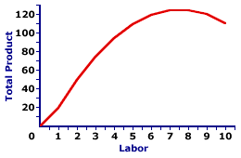
Average product:
An average product is the outcome of the total product divided by the total units of the input employed. It refers to the output per unit of the input.
AP= TP/N
where,
AP= Average Product
TP= Total Product
N= Total units of inputs employed
Marginal product:
It is the addition made to the total product by employing one more unit of the input. In other words, it is the ratio of the change in the total product with the change in the units of the input.
MP = TP (n) – TP (n-1)
TP (n) = Total product after employing one more unit (nth unit)
TP (n-1) = Total product before employing one more unit
THEORY OF COST:
Costs of a firm is incurred to establish the production unit and to purchase different factors of production.
Cost of firm (TC) is classified into two broad categories – Fixed cost (TFC) and Variable cost (TVC).
I.e TC= TFC+TVC
Total Cost:-
Fixed costs (FC) are costs that don't change from month to month and don't vary based on activities or the number of goods used. The formula to calculate total cost is the following:
TC (total cost) = TFC (total fixed cost) + TVC (total variable cost) 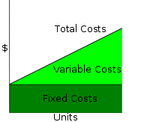

Fixed Cost:-
A fixed cost is a cost that does not change with an increase or decrease in the amount of goods or services produced or sold. Fixed costs are expenses that have to be paid by a company, independent of any business activity.
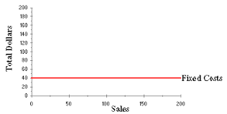
Ex:- Rent, insurance and interest
Variable cost :-
Variable costs are corporate expenses that vary in direct proportion to the quantity of output. Unlike fixed costs, which remain constant regardless of output, variable costs are a direct function of production volume, rising whenever production expands and falling whenever it contracts. Examples of common variable costs include raw materials, packaging, and labor directly involved in a company's manufacturing process.
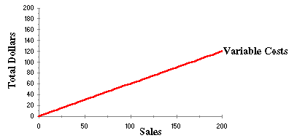

Average Cost:-
average cost and/or unit cost is equal to total cost divided by the number of goods produced (the output quantity, Q). It is also equal to the sum of average variable costs (total variable costs divided by Q) plus average fixed costs (total fixed costs divided by Q). Average costs may be dependent on the time period considered (increasing production may be expensive or impossible in the short term, for example). Average costs affect the supply curve and are a fundamental component of supply and demand.
Marginal cost:-
Marginal cost is the variable costs incurred when producing additional units of a goods or services.
Formula:-
MC= TPn-TPn-1
THEORY OF REVENUE:
Revenue Theory explains the revenue is the amount of income a firm receives from selling its goods or services over a certain period of time.
Average revenue (AR) = TR / Q = (P x Q) / Q = P,
Total revenue:
Total revenue in economics refers to the total receipts from sales of a given quantity of goods or services. It is the total income of a business and is calculated by multiplying the quantity of goods sold by the price of the goods.
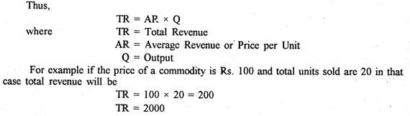
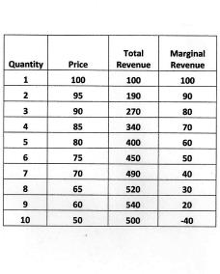
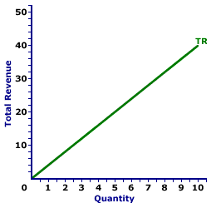
Average revenue:
Average revenue is the revenue generated per unit of output sold. It plays a role in the determination of a firm's profit. Per unit profit is average revenue minus average (total) cost. A firm generally seeks toproduce the quantity of output that maximizes profit.
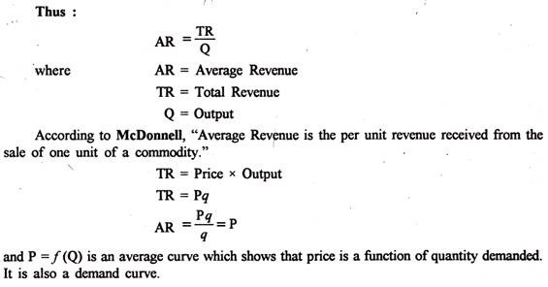
Marginal revenue:
In microeconomics, marginal revenue (R') is the additional revenue that will be generated by increasing product sales by one unit. It can also be described as the unit revenue the last item sold has generated for the firm. ... As a result, it will have to lower the price of all units sold to increase sales by 1 unit.
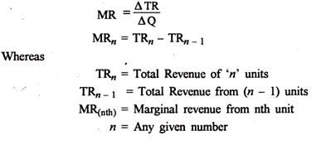

The relationship between TR, AR and MR can be expressed with the help of a table 1.
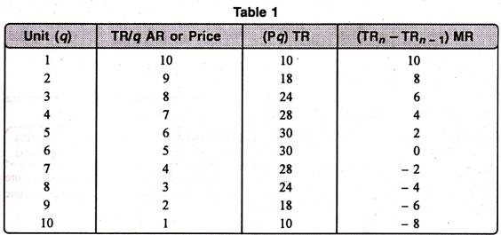
PROFIT MAXIMIZATION THEORY:
In the neoclassical theory of the firm, the main objective of a business firm is profit maximization. The firm maximizes its profits when it satisfies the two rules.
MC = MR and
MC curve cuts the MR curve from below.
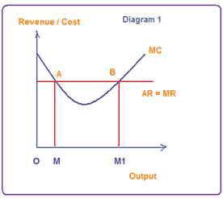
Maximum profits refer to pure profits which are a surplus above the average cost of production. It is the amount left with the entrepreneur after he has made payments to all factors of production, including his wages of management. In other words, it is a residual income over and above his normal profits.
3. Explain types of Business entities?
Sole Trader:
The sole trader is the simplest, oldest and natural form of business organization. It is also called sole proprietorship. ‘Sole’ means one. ‘Sole trader’ implies that there is only one trader who is the owner of the business.
It is a one-man form of organization wherein the trader assumes all the risk of ownership carrying out the business with his own capital, skill and intelligence. He is the boss for himself. He has total operational freedom. He is the owner, Manager and controller. He has total freedom and flexibility. Full control lies with him. He can take his own decisions. He can choose or drop a particular product or business based on its merits. He need not discuss this with anybody. He is responsible for himself. Restaurants, Supermarkets, pan shops, medical shops, hosiery shops etc.
Features of sole trader:
- It is easy to start a business under this form and also easy to close.
- He introduces his own capital. Sometimes, he may borrow, if necessary
- He enjoys all the profits and in case of loss, he lone suffers.
- He has a high degree of flexibility to shift from one business to the other.
- Business secretes can be guarded well
Advantages of sole trader:
- The following are the advantages of the sole trader from of business organization:
- Easy to start and easy to close: Formation of a sole trader form of organization is relatively easy even closing the business is easy.
- Personal contact with customers directly: Based on the tastes and preferences of the customers the stocks can be maintained.
- Prompt decision-making: To improve the quality of services to the customers, he can take any decision and implement the same promptly.
- He is the boss and he is responsible for his business Decisions relating to growth or expansion can be made promptly.
- High degree of flexibility: Based on the profitability, the trader can decide to continue or change the business, if need be.
Disadvantages of sole trader:
- Unlimited liability:
The liability of the sole trader is unlimited. It means that the sole trader has to bring his personal property to clear off the loans of his business. From the legal point of view, he is not different from his business.
- Limited amounts of capital:
The resources a sole trader can mobilize cannot be very large and hence this naturally sets a limit for the scale of operations.
- No division of labour:
All the work related to different functions such as marketing, production, finance, labour and so on has to be taken care of by the sole trader himself. There is nobody else to take his burden. Family members and relatives cannot show as much interest as the trader takes.
- Uncertainty:
There is no continuity in the duration of the business. On the death, insanity of insolvency the business may be come to an end.
- Inadequate for growth and expansion:
This from is suitable for only small size, one-man-show type of organizations. This may not really work out for growing and expanding organizations.
- Lack of specialization:
The services of specialists such as accountants, market researchers, consultants and so on, are not within the reach of most of the sole traders
Partnership:
Partnership is an improved from of sole trader in certain respects. Where there are like-minded persons with resources, they can come together to do the business and share the profits/losses of the business in an agreed ratio. Persons who have entered into such an agreement are individually called ‘partners’ and collectively called ‘firm’. The relationship among partners is called a partnership.
Indian Partnership Act, 1932 defines partnership as the relationship between two or more persons who agree to share the profits of the business carried on by all or any one of them acting for all.
Features of partnership:
- Relationship: Partnership is a relationship among persons. It is relationship resulting out of an agreement.
- Two or more persons: There should be two or more number of persons.
- There should be a business: Business should be conducted.
- Agreement: Persons should agree to share the profits/losses of the business
Partnership Deed
The written agreement among the partners is called ‘the partnership deed’. It contains the terms and conditions governing the working of partnership. The following are contents of the partnership deed.
- Names and addresses of the firm and partners
- Nature of the business proposed
- Duration
- Amount of capital of the partnership and the ratio for contribution by each of the partners.
- Their profit sharing ration (this is used for sharing losses also)
- Rate of interest charged on capital contributed, loans taken from the partnership and the amounts drawn, if any, by the partners from their respective capital balances.
- The amount of salary or commission payable to any partner
- Procedure to value good will of the firm at the time of admission of a new partner, retirement of death of a partner
Kind of partners:
The following are the different kinds of partners:
Active Partner:
Active partner takes active part in the affairs of the partnership. He is also called working partner.

Sleeping Partner:
Sleeping partner contributes to capital but does not take part in the affairs of the partnership.
Nominal Partner:
Nominal partner is partner just for namesake. He neither contributes to capital nor takes part in the affairs of business. Normally, the nominal partners are those who have good business connections, and are well places in the society.
Partner by Estoppels:
Estoppels means behavior or conduct. Partner by estoppels gives an impression to outsiders that he is the partner in the firm. In fact is neither contributes to capital, nor takes any role in the affairs of the partnership.
Partner by holding out:
If partners declare a particular person (having social status) as partner and this person does not contradict even after he comes to know such declaration, he is called a partner by holding out and he is liable for the claims of third parties. However, the third parties should prove they entered into contract with the firm in the belief that he is the partner of the firm. Such a person is called partner by holding out.
Advantages of partnership:
- Easy to form: Once there is a group of like-minded persons and good business proposal, it is easy to start and register a partnership.
- Availability of larger amount of capital: More amount of capital can be raised from more number of partners.
- Division of labour: The different partners come with varied backgrounds and skills. This facilities division of labour.
- Flexibility: The partners are free to change their decisions, add or drop a particular product or start a new business or close the present one and so on.
- Personal contact with customers: There is scope to keep close monitoring with customers requirements by keeping one of the partners in charge of sales and marketing. Necessary changes can be initiated based on the merits of the proposals from the customers.
- Quick decisions and prompt action: If there is consensus among partners, it is enough to implement any decision and initiate prompt action. Sometimes, it may more time for the partners on strategic issues to reach consensus.

Disadvantagesof partnership:
- Formation of partnership is difficult: Only like-minded persons can start a partnership. It is sarcastically said,’ it is easy to find a life partner, but not a business partner’.
- Liability: The partners have joint and several liabilities beside unlimited liability. Joint and several liability puts additional burden on the partners, which means that even the personal properties of the partner or partners can be attached. Even when all but one partner become insolvent, the solvent partner has to bear the entire burden of business loss.
- Lack of harmony or cohesiveness: It is likely that partners may not, most often work as a group with cohesiveness. This result in mutual conflicts, an attitude of suspicion and crisis of confidence. Lack of harmony results in delay in decisions and paralyses the entire operations
- Limited growth: The resources when compared to sole trader, a partnership may raise little more. But when compare to the other forms such as a company, resources raised in this form of organization are limited. Added to this, there is a restriction on the maximum number of partners
Joint stock company:
The joint stock company emerges from the limitations of partnership such as joint and several liability, unlimited liability, limited resources and uncertain duration and so on. Normally, to take part in a business, it may need large money and we cannot foretell the fate of business. It is not literally possible to get into business with little money. Against this background, it is interesting to study the functioning of a joint stock company.
The main principle of the joint stock company from is to provide opportunity to take part in business with a low investment as possible say Rs.1000. Joint Stock Company has been a boon for investors with moderate funds to invest.
The word ‘ company’ has a Latin origin, com means ‘ come together’, pany means ‘ bread’, joint stock company means, people come together to earn their livelihood by investing in the stock of company jointly.
Company Defined
Lord Justice Lindley explained the concept of the joint stock company from of organization as ‘an association of many persons who contribute money or money’s worth to a common stock and employ it for a common purpose.
Features of Joint Stock Company:
- Artificial person: The Company has no form or shape. It is an artificial person created by law. It is intangible, invisible and existing only, in the eyes of law.
- Separate legal existence: it has an independence existence, it separate from its members. It can acquire the assets. It can borrow for the company. It can sue other if they are in default in payment of dues, breach of contract with it, if any. Similarly, outsiders for any claim can sue it. A shareholder is not liable for the acts of the company. Similarly, the shareholders cannot bind the company by their acts.
- Voluntary association of persons: The Company is an association of voluntary association of persons who want to carry on business for profit. To carry on business, they need capital. So they invest in the share capital of the company.
- Limited Liability: The shareholders have limited liability i.e., liability limited to the face value of the shares held by him. In other words, the liability of a shareholder is restricted to the extent of his contribution to the share capital of the company. The shareholder need not pay anything, even in times of loss for the company, other than his contribution to the share capital.
- Capital is divided into shares: The total capital is divided into a certain number of units. Each unit is called a share. The price of each share is priced so low that every investor would like to invest in the company. The companies promoted by promoters of good standing (i.e., known for their reputation in terms of reliability character and dynamism) are likely to attract huge resources

Advantages of Joint Stock Company:

- Mobilization of larger resources: A joint stock company provides opportunity for the investors to invest, even small sums, in the capital of large companies. The facilities rising of larger resources.
- Separate legal entity: The Company has separate legal entity. It is registered under Indian Companies Act, 1956.
- Limited liability: The shareholder has limited liability in respect of the shares held by him. In no case, does his liability exceed more than the face value of the shares allotted to him.
- Transferability of shares: The shares can be transferred to others. However, the private company shares cannot be transferred.
- Liquidity of investments: By providing the transferability of shares, shares can be converted into cash.
- Inculcates the habit of savings and investments: Because the share face value is very low, this promotes the habit of saving among the common man and mobilizes the same towards investments in the company.
- Democracy in management: the shareholders elect the directors in a democratic way in the general body meetings. The shareholders are free to make any proposals, question the practice of the management, suggest the possible remedial measures, as they perceive, the directors respond to the issue raised by the shareholders and have to justify their actions.
- Economics of large scale production: Since the production is in the scale with large funds at
- Continued existence: The Company has perpetual succession. It has no natural end. It continues forever and ever unless law put an end to it.

Disadvantages of Joint Stock Company:

- Formation of company is a long drawn procedure: Promoting a joint stock company involves a long drawn procedure. It is expensive and involves large number of legal formalities.
- High degree of government interference: The government brings out a number of rules and regulations governing the internal conduct of the operations of a company such as meetings, voting, audit and so on, and any violation of these rules results into statutory lapses, punishable under the companies act.
- Inordinate delays in decision-making: As the size of the organization grows, the number of levels in organization also increases in the name of specialization. The more the number of levels, the more is the delay in decision-making. Sometimes, so-called professionals do not respond to the urgencies as required. It promotes delay in administration, which is referred to ‘red tape and bureaucracy’.
- Lack or initiative: In most of the cases, the employees of the company at different levels show slack in their personal initiative with the result, the opportunities once missed do not recur and the company loses the revenue.
- Lack of responsibility and commitment: In some cases, the managers at different levels are afraid to take risk and more worried about their jobs rather than the huge funds invested in the capital of the company lose the revenue.
- Lack of responsibility and commitment: In some cases, the managers at different levels are afraid to take risk and more worried about their jobs rather than the huge funds invested in the capital of the company. Where managers do not show up willingness to take responsibility, they cannot be considered as committed. They will not be able to handle the business risks.
4. What are sources of capital for a company?
Method of Finance is the type of finance used-such as a loan or a mortgage. The source of finance would be where the money was obtained from-a loan may be obtained from a bank while the mortgage may be obtained from a credit society. From a financial statement, we can read in what form the capital is tied up (fixed assets or current assets) and how these are financed (from own capital or borrowed funds).
It is necessary to notice the difference between methods and sources of finance to identify which type of asset can be bought from what source of funds. For example, fixed asset can be bought only from long-term source of funds. If you buy a long-term asset utilizing funds from short-term sources, the asset has to be sold off to repay the short-term loan, in the event of pressure to repay the loan.
METHODS OF FINANCE:
The following are the common methods of finance:
Long –term finance
Medium-term fiancé
Short-term fiancé
LONG-TERM FINANCE:
Long-term finance refers to that finance available for a long period say three years and above. The long-term methods outlined below are used to purchase fixed assets such as land and buildings, plant and so on.
Own Capital:
Irrespective of the form of organization such as soletrader, partnership or a company, the owners of the business have to invest their own finances to start with. Money invested by the owners, partners or promoters is permanent and will stay with the business throughout the life of the business.
Share Capital:
Normally in the case of a company, the capital is raised by issue of shares. The capital so raised is called share capital. The liability of the shareholder is limited to the extent of his contribution to the share capital of the company. The shareholder is entitled to dividend in case the company makes profits and the directors announce dividend formally in the general body meetings. The share capital can be of two types: Preference share capital and equity share capital. The salient features of preference share capital and ordinary share capital are discussed below:
- Preference Share Capital:
Capital raised through issue of preference shares is called preference share capital. A preference shareholder enjoys two rights over equity shareholders: (a) right to receive fixed rate of dividend and (b) right to return of capital. After setting the claims of outsiders, preference shareholders are the first to get their dividend and then the balance will go to the equity shareholders. However, the preference shareholders do not have any voting rights in the annual general body meetings of the company. This deprives them of the right to participate in the management of the affairs of the company.
Types of preference shares:
Cumulative preference share:
A cumulative preference share gets his right to the arrears of dividend cumulated over a period of time. If the company is not in a position to pay dividends during a particular year due to paucity of profits, it has to pay the same to the cumulative preference shareholders when it makes profits. In other words, the holders of cumulative preference shares enjoy the right to receive, when profits permit, the dividend missed in the years when the profits were nil or inadequate.
Non-cumulative preference shares:
The holders of these shares do not enjoy any right over the arrears of dividend. Hence the unpaid dividend in arrears cannot be claimed in future.
Participating preference shares:
The holder of these shares enjoys the dividend two times. They get their normal fixed rate of dividend as per their entitlement. They participate again along with the equity shareholders in the distribution of profits.
Redeemable preference shares:
These shares are repaid at the end of a given period. The period of repayment is stipulated on each share.
Non-redeemable preference shares :
These shares continue as long as the company continues. They are repaid only at the end of the lifetime of the company.
2. Equity Share Capital:
Capital raised through issue of equity share is called equity share capital. An equity share is also called ordinary share. An equity shareholder does not enjoy any priorities such as those enjoyed by a preference shareholder. But an equity shareholder is entitled to voting rights as many as the number of shares he holds. The profits after praying all the claims belong to the equity shareholders. In case of loss, they are the first to suffer the losses. Equity shareholders are the real risk bearers of the company. But at the same time, they are entitled for the whole surplus of the profits after payment of dividends to preference shareholders. Therefore, the rate of dividend on equity shares is not fixed.
Retained Profits:
The retained profits are the profits remaining after all the claims. They form a very significant source of finance. Retained profits form good source of working capital. Particularly in times of growth and expansion, retained profits can be advantageously utilized.
Long-term Loans:
There are specialized financial institutions offering long-term loans, provided the business proposal is feasible. The promoter should be offer asset of the business as security to avail of this source.
3. Debentures:
Debentures are the loans taken by the company. It is a certificate or letter issued by the company under its common seal acknowledging the receipt of loan. A debenture holder is the creditor of the company. A debenture holder is entitled to a fixed rate of interest on the debenture amount. Payment of interest on debenture is the first charge against profit.
- Convertible Debentures:
These debentures are converted into equity shares after the period mentioned in the terms and conditions of issue. In terms of cost, debentures are cheaper than the equity shares. Where the company is not sure of good profits to sustain the size of equity, it prefers to issue convertible debentures. These debentures continue as loan for the defined period. These are converted into equity shares on the specified date. Then onwards, these shareholders will be entitled to dividend, which will be normally higher than the rate of interest on debentures.
- Partly Convertible Debentures:
A portion of debentures is to be converted into equity shares. They continue as loan till the date of payment.
- Non-convertible Debentures:
These debentures will not be converted into equity shares. They continue as loan till the date of payment.

- Secured Debentures:
These debentures are safe because the assets of the company are offered as security towards the payment of the debentures. Newly promoted companies issue secured debentures to create confidence among the investors.
- Partly Secured Debentures:
These debentures are partly covered by the security. In other words, the security value is lesser than the face value of the debentures issued.
- Unsecured Debentures:
There is no security for these debentures. Normally, the companies having a good financial records issue unsecured debentures.
- Redeemable Debentures:
These debentures are repaid on a specified date.
- Non-redeemable Debentures:
These are repaid only at the end of the lifetime of the company.

II. MEDIUM-TERM FINANCE:
Medium-term finance refers to such sources of finance where the repayment is normally over one year and less than three years. This is normally utilized to buy or lease motor-vehicles, computer equipment, or machinery whose life is less than three years. The sources of medium-term finance are as given below:
Bank Loans:
Bank loans are extended at a fixed rate interest. Repayment of the loan and interest are scheduled at the beginning and are usually directly debited to the current account of the borrower. These are secured loans.
Hire-purchase:
It is a facility to buy a fixed asset while paying the price over a long period of time. In other words, the possession of the asset can be taken by making a down payment of a part of the price and the balance will be repaid with a fixed rate of interest in agreed number of installments. The buyer becomes the owner of the asset only on payment of the last installment.
Leasing of Renting:
Where there is a need for fixed assets, the asset need not be purchased. It can be taken on lease or rent for specified number of years. The company who owns the asset is called lessor and the company which takes the asset on lease is called lessee. The agreement between the lessor and lessee is called a lease agreement. On the expiry of the lease agreement, the owner takes the asset back into his custody. Under lease agreement, ownership to the asset never passes.

Venture Capital:
This form of finance is available only for limited companies. Venture capital is normally provided in such projects where there is relatively a higher degree of risk. For such projects, finance through the conventional sources may not be available. Many banks offer such finance through their merchant banking divisions, of specialist banks which offers advice un-financial assistance.
SHORT-TERM FIANCÉ:
Short term finance is that finance which is available for a period of less than one year. The following are the sources of short term finance.

Commercial Paper (CP):
CPs are issued usually in large denominations by the leading, nationally reputed, highly rated and credit worthy, large manufacturing and finance companies in the public and private sectors.
Bank overdraft:
This is a special arrangement with the banker where the customer can draw more than what he has any savings/current account subject to a maximum limit interest is charged on a day to day basis on the actual amount overdrawn. This source is utilized to meet the temporary shortage of funds.
This is a special arrangement with the banker where the customer can draw more than what he has any savings/current account subject to a maximum limit interest is charged on a day to day basis on the actual amount overdrawn. This source is utilized to meet the temporary shortage of funds.
Trade Credit:
This is a short term credit facility extended by the creditor to the debtor. Normally, it is common for the trader to by the material and other supplies from the suppliers on the credit basis. After selling the stocks the trader pays the cash and buys fresh stocks again on credit. Sometimes, the suppliers may insist on the buyer to sign on bill (bill of exchange). This bill is called bills payable.
Debit factoring or Credit factoring:
Debit factoring is an arrangement with factor where the trader agrees to sell its accounts receivable or debtor at discount to the specialized dealer called factors. In the case of Credit factoring the trader agrees to sell his accounts payables (at premium)
5. Define Economics and importance of Economics and concepts of economics?
Economics is a social science concerned with the production, distribution and consumption of goods and services. It studies how individuals, businesses, governments and nations make choices on allocating resources to satisfy their wants and needs, and tries to determine how these groups should organize and coordinate efforts to achieve maximum output.
Importance:
- Useful For The Producer :-
Economics is very useful for the producer. It guides him that how he should combine the four factors of production and minimize the cost of production.
- Useful For The Consumer :-
The consumer can adjust his expenditure of various goods in better way if he knows the principles of economics. He will spend his income according the law of Equi-Marginal utility in order to get maximum satisfaction.
- Poverty And Development :-
It helps in removing the poverty from the country. Under developed countries are facing many problems like unemployment , over population low per capita income and low production. Economics is very useful in solving these problems.
- Useful For The Leader :-
Its study is helpful for the leader5s to understand the economic problems if they have a knowledge of Economics.
- Useful For The Finance Minister :-
Finance minister prepares the yearly budget of the country. Economics guides him that how he should frame the tax policy and monetary policy.
- Useful For The Distribution Of National Income :-
From the study of economics one can easily judge that how the income should be distributed among the four factors of production. For this purpose Marginal productivity theory is suggested by economics.
- Cultural Value :-
A person's education can not be considered complete unless he has some knowledge of economics. The thing which happen daily around us have an important economic bearing. So there is also the cultural value of the study of economics.
- Importance For A Common Man :-
The study of economics is very useful for every citizen. It enables him to understand and criticize the economic policies of the government. He can also guide the government.
- Economic Planning :-
In the modern age the importance of economic planning can not be ignored. Through planning we can utilize our natural resources in better way and can improve our economic condition.
- Importance For Labour :-
It guides the workers that how they can get maximum wages from the employer. It enables them to get the right of trade union , collective bargaining and fixation of working hours.
CONCEPTS:
- Micro concept
- Macro concept
MICRO ECONOMICS:
Study of small economic units such as individuals, firms, and industries (competitive markets, labor markets, personal decision making, etc.)
MACRO ECONOMICS:
Study of the large economy as a whole or in its basic subdivisions (National Economic Growth, Government Spending, Inflation, Unemployment, etc.)
Macroeconomics is a branch of economics that deals with the economy as a whole. It takes into consideration the performance, behavior and structure of the economy as a whole rather than the individual components or firms (Microeconomics). Thus, Macroeconomics contains the study of the aggregated concepts like National Income, GDP, Unemployment, Aggregate Demand, Aggregate Supply etc. Macroeconomics plays a major role in helping the government to formulate the economic policy for the nation.
What are the basic objectives of Macroeconomics?
The basic objective of Macroeconomics is the Economic Growth of the nation, This Growth can
be achieved by achieving the following goals:
1. Reduction in the Unemployment Rate
2. Stabilization of the prices in the economy
3. Maintaining the Balance of Payments
4. Stabilizing the Economic Growth Rate
Components:
1. Aggregate Demand
2. Aggregate Supply
Aggregate Demand:
Aggregate Demand refers to the total demand in the economy for the final
goods and services at a given period of time at a particular price. This is also called Domestic
Final Demand or Domestic GDP. The Aggregate Demand shows the different quantities that can
be purchased at different possible prices. The main components that form Aggregate Demand are:
Consumption:
Consumption refers to the final goods and services consumed by the Households in the economy. This forms the largest proportion in the Aggregate Demand of the Economy.
Investment:
Investment is considered to be the most volatile component in the Aggregate Demand’s composition. It is the spending by the firms in their capital.
Government Spending:
The government Spending involves the expenditure made by the Government. This includes Transfer Payments, Capital Spending etc.
Net Exports (X-M):
Net Exports refer to the excess of the exports over imports. The increase in the Exports will increase the consumption of the domestic product so as to be exported. “X” refers to Exports and “M” refers to Imports.
Thus, we have, AD = C+I+G+(X-M)
where,
AD- Aggregate Demand
C- Consumption
I- Investment
X- Exports
M- Imports

Aggregate Supply:
Aggregate Supply refers to the total supply of the final goods and services in the economy by the suppliers. It is the quantity that the suppliers or the firms are ready to supply
in the economy at a given period of time at a particular price. The supply by all the firms in the
economy is summed up while determining the aggregate supply. The main components that form Aggregate supply are:
Consumption:
Consumption refers to the goods and services that are consumed by the households. This is the basic part of Aggregate supply.
Savings:
Savings refer to the part of income that is saved by the households or the firms and which is not put into the investment sector.
Thus, we have, AS = C+S
Where,
AS- Aggregate Supply
C- Consumption
S- Savings
Concepts of Macroeconomics:
Macroeconomics is a wide subject and can be correlated to several ideologies and concepts. But
usually it is linked up and studied with relation to the following three concepts:
1. Gross Domestic Product (GDP)
2. Unemployment Rate
3. Inflation Rate
4. International Trade.
Output or Income:
Both Output and income are interchangeably used in macroeconomics. Both correlated to each other, Income is generally directly proportional to the level of output an economy produces. The level of output determines the level of Gross Domestic Product. This GDP is used in the measurement of the efficiency of the economy’s functions. Thus, it serves as one of the vital concepts of Macroeconomics.
Unemployment:
Unemployment is one of the major issues that macroeconomics deal with. Unemployment refers to the number of people who are willing to work but do not have any job. Macroeconomics aims at full employment of the resources and the people present in the economy to achieve maximum production.
There are two approaches to the study of employment:
- Keynesian Approach:
According to the Keynesian approach; the resources are not fully employed in the economy and the supply can be fully elastic till the point the resources are completely employed. Once the resources are fully employed; the production can no more be increased.
- Classical Approach:
According to the Classical Approach, there is full employment in the economy at any point of time. Thus, there can be no increase in the supply or production in the economy, any increase in the aggregate demand will render a rise in the prices.
Inflation or Deflation:
Inflation refers to the rise in the prices of the goods and services in the economy and Deflation refers to the decline in the prices of the goods and services in the economy. Usually the rise in the prices i.e. inflation leads to the growth in the economy where as the deflation leads to a downfall in the growth of the economy. The economists generally try to maintain the level of prices in the economy so as to maintain a balance. This is being done by using various monetary and fiscal policies.
UNIT – II DEMAND AND SUPPLY ANALYSIS:
Short question and answers:
- What is demand?

Thus demand in economics means the desire backed by the willingness to buy a commodity and the purchasing power to pay. In the words of “Benham” “The demand for anything at a given price is the amount of it which will be bought per unit of time at that Price”. (Thus demand is always at a price for a definite quantity at a specified time.) Thus demand has three essentials – price, quantity demanded and time. Without these, demand has to significance in economics.
A product or services is said to have demand when tree conditions are satisfied:
Desire + Ability to pay + Willingness to pay for it

- Explain law of demand and assumptions?

Law of demand shows the relation between price and quantity demanded of a commodity in the market. In the words of Marshall, “the amount demand increases with a fall in price and diminishes with a rise in price”.
Generally, a person demands more at a lower price and less at a higher price. The relation of price to demand or sales is known in Economics as the Law of Demand.
The Law of Demand states that “higher the price, lower the demand and vice versa, other things remaining the same”.
Assumption:
- Law is demand is based on certain assumptions:
- This is no change in consumers taste and preferences.
- Income should remain constant.
- Prices of other goods should not change
- What are the factors affecting demand?
There are factors on which the demand for a commodity depends. These factors are economic, social as well as political factors. The effect of all the factors on the amount demanded for the commodity is called Demand Function.
These factors are as follows:
Price of the Commodity:
The most important factor-affecting amount demanded is the price of the commodity. The amount of a commodity demanded at a particular price is more properly called price demand. The relation between price and demand is called the Law of Demand. It is not only the existing price but also the expected changes in price, which affect demand
Income of the Consumer:
The second most important factor influencing demand is consumer income. In fact, we can establish a relation between the consumer income and the demand at different levels of income, price and other things remaining the same. The demand for a normal commodity goes up when income rises and falls down when income falls. But in case of Giffen goods the relationship is the opposite.
Prices of related goods:
The demand for a commodity is also affected by the changes in prices of the related goods also. Related goods can be of two types:
(I). Substitutes which can replace each other in use; for example, tea and coffee are substitutes. The change in price of a substitute has effect on a commodity’s demand in the same direction in which price changes. The rise in price of coffee shall raise the demand for tea;
(ii). Complementary foods are those which are jointly demanded, such as pen and ink. In such cases complementary goods have opposite relationship between price of one commodity and the amount demanded for the other. If the price of pens goes up, their demand is less as a result of which the demand for ink is also less.
The price anddemand go in opposite direction. The effect of changes in price of a commodity on amounts demanded of related commodities is called Cross Demand.
Tastes of the Consumers:
The amount demanded also depends on consumer’s taste. Tastes include fashion, habit, customs, etc. A consumer’s taste is also affected by advertisement. If the taste for a commodity goes up, its amount demanded is more even at the same price. This is called increase in demand. The opposite is called decrease in demand.
Population:
Increase in population increases demand for necessaries of life. The composition of population also affects demand. Composition of population means the proportion of young and old and children as well as the ratio of men to women. A change in composition of population has an effect on the nature of demand for different commodities.
Expectations regarding the future:
If consumers expect changes in price of commodity in future, they will change the demand at present even when the present price remains the same. Similarly, if consumers expect their incomes to rise in the near future they may increase the demand for a commodity just now.
Advertisement expenditure:
Advertisement promotes sales. Other factors remaining same, with every increase in the advertisement expense there will be an increase in sales.
Demonstration effect:
Demand for luxury item is always great among the rich. This naturally influences the less affluent or the lower income group in the neighborhood. They also begin to buy luxury item to imitate their rich neighbors even when they do not have any genuine need for them
Climate and weather:
The climate of an area and the weather prevailing there has a decisive effect on consumer’s demand. In cold areas woolen cloth is demanded. During hot summer days, ice is very much in demand. On a rainy day, ice cream is not so much demanded.

- What is perfect elasticity of demand?

When small change in price leads to an infinitely large change is quantity demand, it is called perfectly or infinitely elastic demand. In this case E=∞

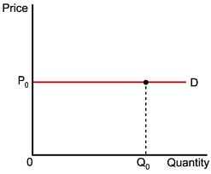

- What is unitary elasticity of demand?

The change in demand is exactly equal to the change in price. When both are equal E=1 and elasticity if said to be unitary.

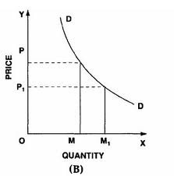
When price falls from ‘OP’ to ‘OP1’ quantity demanded increases from ‘OP’ to ‘OP1’, quantity demanded increases from ‘OM’ to ‘OM1’. Thus a change in price has resulted in an equal change in quantity demanded so price elasticity of demand is equal to unity.
LONG QUESTION AND ANSWERS:

- Define elasticity of demand and measurement types of elasticity of demand?

Demand:
Thus demand in economics means the desire backed by the willingness to buy a commodity and the purchasing power to pay. In the words of “Benham” “The demand for anything at a given price is the amount of it which will be bought per unit of time at that Price”. (Thus demand is always at a price for a definite quantity at a specified time.) Thus demand has three essentials – price, quantity demanded and time. Without these, demand has to significance in economics.
A product or services is said to have demand when tree conditions are satisfied:
Desire + Ability to pay + Willingness to pay for it

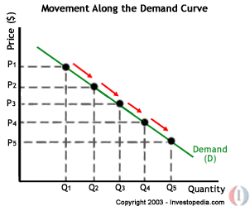
Price of Apple (In. Rs.) | Quantity Demanded
10 | 1
8 | 2
6 | 3
4 | 4

LAW OF DEMAND
Law of demand shows the relation between price and quantity demanded of a commodity in the market. In the words of Marshall, “the amount demand increases with a fall in price and diminishes with a rise in price”.
Generally, a person demands more at a lower price and less at a higher price. The relation of price to demand or sales is known in Economics as the Law of Demand.
The Law of Demand states that “higher the price, lower the demand and vice versa, other things remaining the same”.
The demand curve slopes downward from left to rights showing that more quantities are demanded at lower prices. That is, demand responds to price in the reverse direction. The reasons for the inverse relation between price and quantity demanded are the following:
Price of Apple (In. Rs.) | Quantity Demanded
10 | 1
8 | 2
6 | 3
4 | 4
2 | 5
Demand schedule:
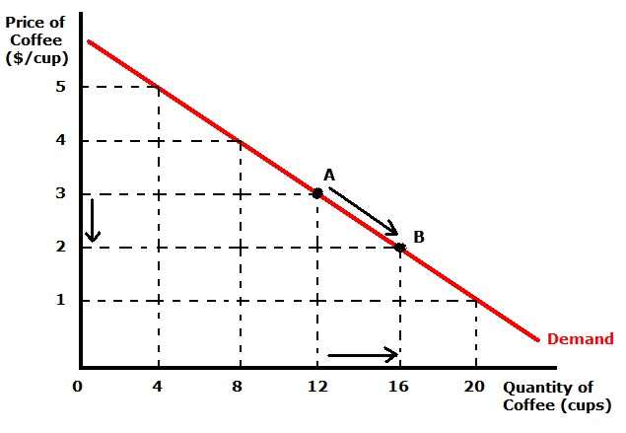
When the price falls from Rs. 10 to 8 quantity demand increases from 1 to 2. In the same way as price falls, quantity demand increases on the basis of the demand schedule we can draw the demand curve The demand curve DD shows the inverse relation between price and quantity demand of apple. It is downward sloping.
ELASTICITY OF DEMAND
Elasticity of demand explains the relationship between a change in price and consequent change in amount demanded. “Marshall” introduced the concept of elasticity of demand. Elasticity of demand shows the extent of change in quantity demanded to a change in price.
In the words of “Marshall”, “The elasticity of demand in a market is great or small according as the amount demanded increases much or little for a given fall in the price and diminishes much or little for a given rise in Price”
Elastic demand: A small change in price may lead to a great change in quantity demanded. In this case, demand is elastic.
In-elastic demand: If a big change in price is followed by a small change in demanded then the demand in “inelastic”.

Proportionate change in the quantity demand of commodity
Elasticity = ------------------------------------------------------------------
Proportionate change in the factors of commodity
MEASUREMENT OF ELASTICITY OF DEMAND
- Perfectly elastic demand
- Perfectly Inelastic Demand
- Relatively elastic demand
- Relatively in-elastic demand
- Unit elasticity of demand

A. PERFECTLY ELASTIC DEMAND:
When small change in price leads to an infinitely large change is quantity demand, it is called perfectly or infinitely elastic demand. In this case E=∞

The demand curve DD1 is horizontal straight line. It shows the at “OP” price any amount is demand and if price increases, the consumer will not purchase the commodity.
B. PERFECTLY INELASTIC DEMAND
In this case, even a large change in price fails to bring about a change in quantity demanded.

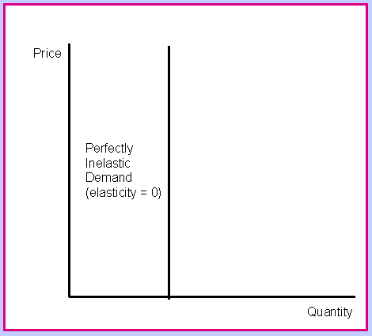

when price increases from ‘op’ to ‘op’, the quantity demanded remains the same. in other words the response of demand to a change in price is nil. in this case ‘e’=0.
C. RELATIVELY ELASTIC DEMAND:
Demand changes more than proportionately to a change in price. i.e. a small change in price loads to a very big change in the quantity demanded. In this caseE > 1. This demand curve will be flatter.

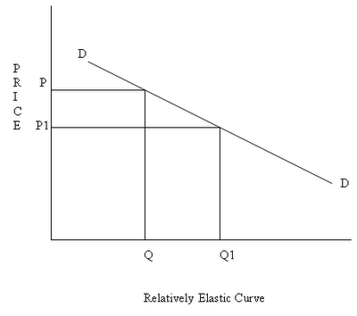
When price falls from ‘OP’ to ‘OP1’, amount demanded increase from “OQ’ to “OQ1’ which is larger than the change in price.
D. RELATIVELY IN-ELASTIC DEMAND.
Quantity demanded changes less than proportional to a change in price. A large change in price leads to small change in amount demanded. Here E < 1. Demanded carve will be steeper.

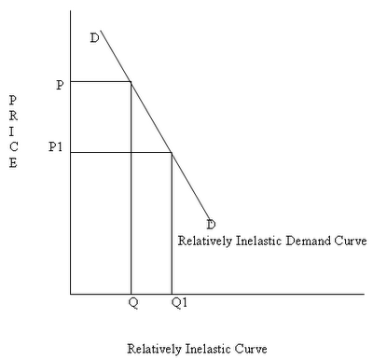

When price falls from “OP’ to ‘OP1 amount demanded increases from OQ to OQ1, which is smaller than the change in price.
E. UNIT ELASTICITY OF DEMAND:
The change in demand is exactly equal to the change in price. When both are equal E=1 and elasticity if said to be unitary.
When price falls from ‘OP’ to ‘OP1’ quantity demanded increases from ‘OP’ to ‘OP1’, quantity demanded increases from ‘OM’ to ‘OM1’. Thus a change in price has resulted in an equal change in quantity demanded so price elasticity of demand is equal to unity.

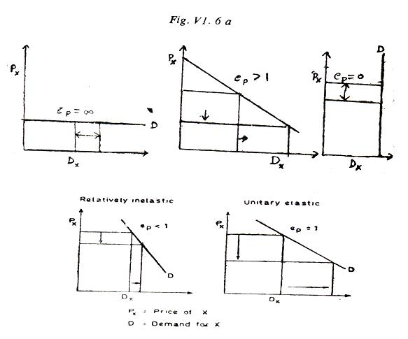

TYPES OF ELASTICITY OF DEMAND:
There are three types of elasticity of demand:
- Price elasticity of demand
- Income elasticity of demand
- Cross elasticity of demand
- advertising elasticity of demand
1. PRICE ELASTICITY OF DEMAND:
Marshall was the first economist to define price elasticity of demand. Price elasticity of demand measures changes in quantity demand to a change in Price. It is the ratio of percentage change in quantity demanded to a percentage change in price.

Proportionate change in the quantity demand of commodity
Price elasticity = ------------------------------------------------------------------
Proportionate change in the price of commodity
There are three cases of price elasticity of demand
- Price elasticity greater than unity
- Price elasticity leas than unity
- Unit price elasticity

- Price elasticity greater than unity:
Demand changes more than proportionately to a change in price. i.e. a small change in price loads to a very big change in the quantity demanded. In this caseE > 1. This demand curve will be flatter.

When price falls from ‘OP’ to ‘OP1’, amount demanded increase from “OQ’ to “OQ1’ which is larger than the change in price.
- Price elasticity leas than unity:
Quantity demanded changes less than proportional to a change in price. A large change in price leads to small change in amount demanded. Here E < 1. Demanded carve will be steeper.

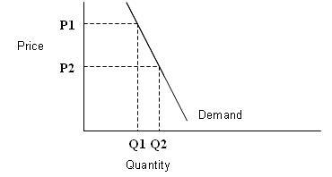
When price falls from “OP1’ to ‘OP2 amount demanded increases from OQ1 to OQ2, which is smaller than the change in price.
- unit price elasticity:
The change in demand is exactly equal to the change in price. When both are equal E=1 and elasticity if said to be unitary.

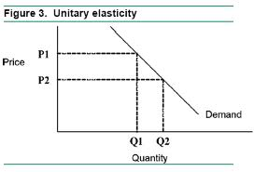

2. INCOME ELASTICITY OF DEMAND:
Income elasticity of demand shows the change in quantity demanded as a result of a change in income. Income elasticity of demand may be slated in the form of a formula.

Proportionate change in the quantity demand of commodity
Income Elasticity = ------------------------------------------------------------------
Proportionate change in the income of the people

Income elasticity of demand can be classified in to five types.
A. Zero income elasticity:
Quantity demanded remains the same, even though money income increases. Symbolically, it can be expressed as Ey=0. It can be depicted in the following way:

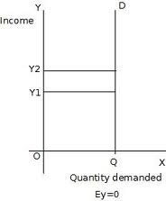

As income increases from OY to OY1, quantity demanded never changes.
B. Negative Income elasticity:
When income increases, quantity demanded falls. In this case, income elasticity of demand is negative. i.e., Ey< 0

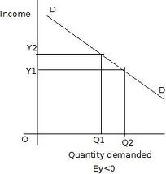

When income increases from OY1 to OY2, demand falls from OQ1 to OQ2.
c. Unit income elasticity:
When an increase in income brings about a proportionate increase in quantity demanded, and then income elasticity of demand is equal to one. Ey = 1

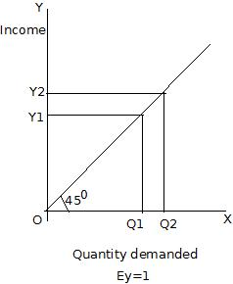
When income increases from OY1 to OY2, Quantity demanded also increases from OQ1 to OQ2.
d. Income elasticitylees than unity:
In this case, an increase in come brings about a more than proportionate increase in quantity demanded. Symbolically it can be written as Ey< 1.

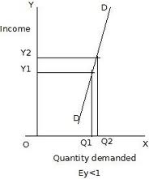

It shows high-income elasticity of demand. When income increases from OY to OY1, Quantity demanded increases from OQ to OQ1.
E. Income elasticity greater than unity:
When income increases quantity demanded also increases but less than proportionately. In this case E < 1.

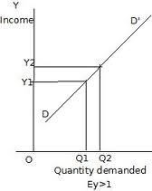

An increase in income from OY1 to OY2, brings what an increase in quantity demanded from OQ1 to OQ2, But the increase in quantity demanded is smaller than the increase in income. Hence, income elasticity of demand is less than one.
3. CROSS ELASTICITY OF DEMAND:
A change in the price of one commodity leads to a change in the quantity demanded of another commodity. This is called a cross elasticity of demand. The formula for cross elasticity of demand is:

Proportionate change in the quantity demand of commodity “X”
Cross elasticity = -----------------------------------------------------------------------
Proportionate change in the price of commodity “Y”
A.In case of substitutes, cross elasticity of demand is positive. Eg: Coffee and Tea. When the price of coffee increases, Quantity demanded of tea increases. Both are substitutes.

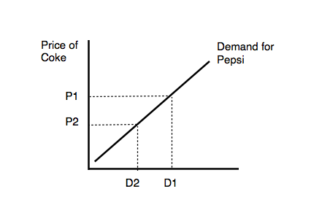
B.In case of compliments, cross elasticity is negative. If increase in the price of one commodity leads to a decrease in the quantity demanded of another and vice versa.

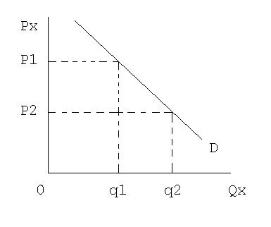
When price of car goes up from OP to OP! the quantity demanded of petrol decreases from OQ1 to OQ2. The cross-demanded curve has negative slope.
4 ADVERTISING ELASTICITY OF DEMAND
It refers to increase in the sale revenue because of changes in the advertising expenditure. In other words there is a direct relationship between the amount of money spent on advertising and its impact on sales. It is always positive
Proportionate change in the quantity demand of product “X”
Advertising elasticity = -----------------------------------------------------------------------
Proportionate change in the advertising cost
Advertising elasticity greater than unity:
In this case, an increase in come brings about a more than proportionate increase in quantity demanded. Symbolically it can be written as Ey> 1.
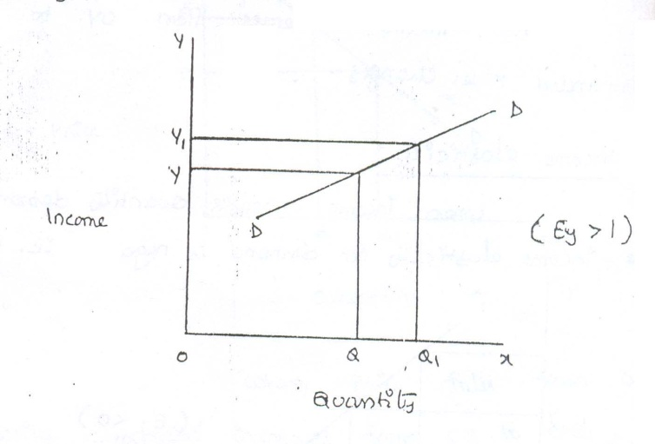

It shows high-income elasticity of demand. When income increases from OY to OY1, Quantity demanded increases from OQ to OQ1.
Advertising elasticity leas than unity:
When income increases quantity demanded also increases but less than proportionately. In this case E < 1.
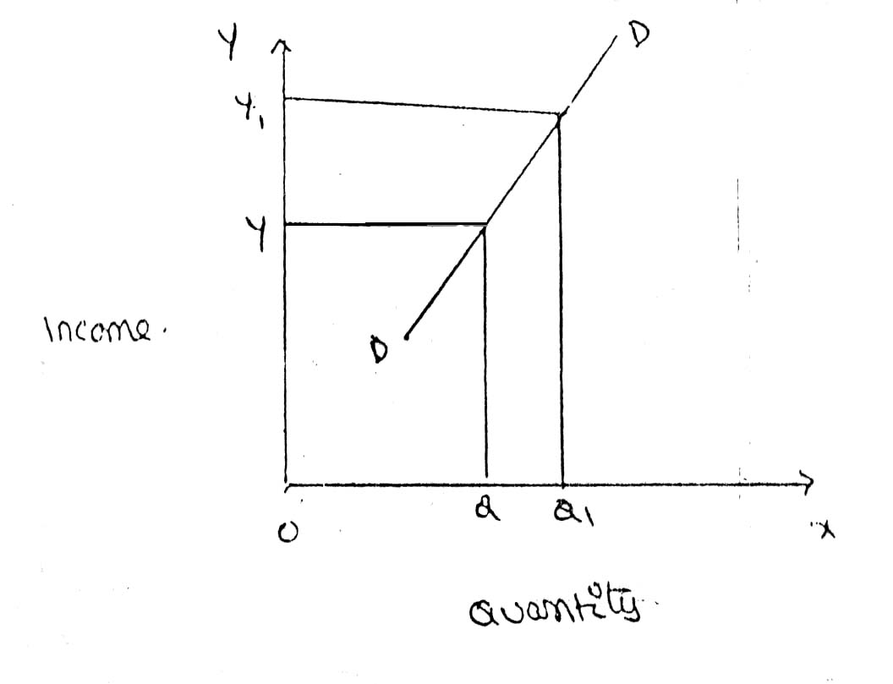

Unit advertising elasticity:
When an increase in income brings about a proportionate increase in quantity demanded, and then income elasticity of demand is equal to one. Eye = 1

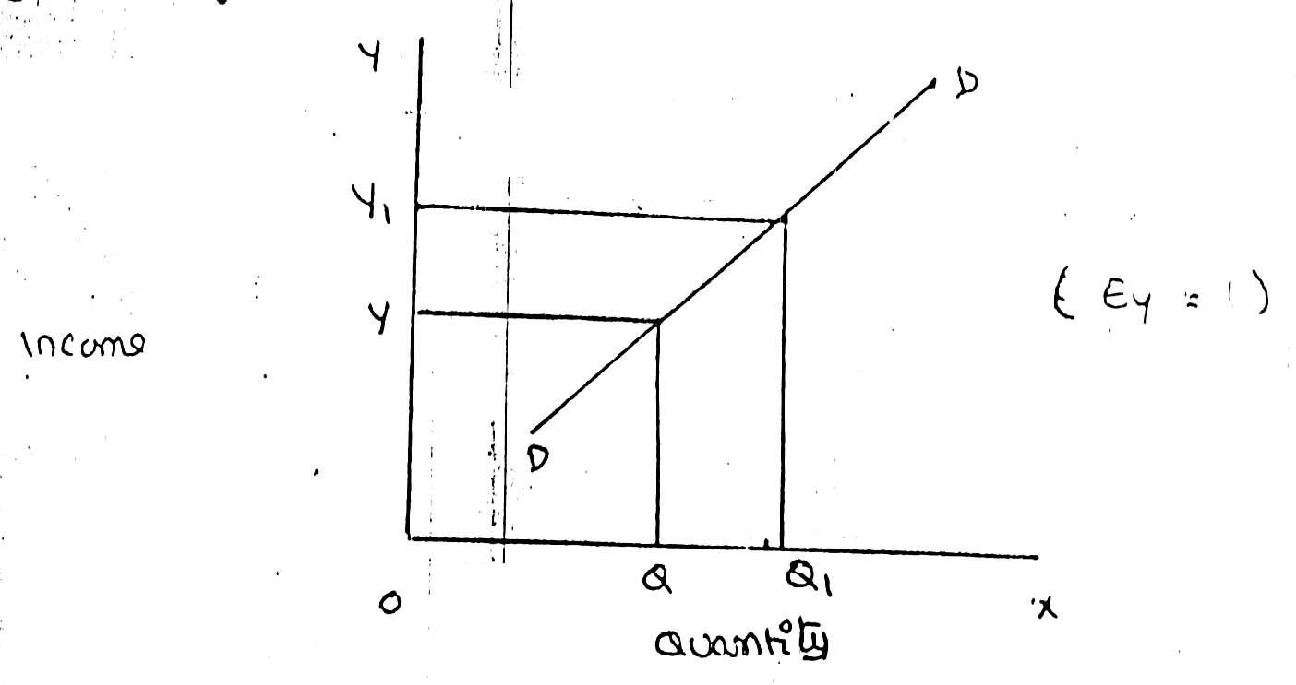

2. Demand Forecasting? Explain the various steps involved in demand forecasting.
DEMAND FORECASTING
INTRODUCTION:
The information about the future is essential for both new firms and those planning to expand the scale of their production. Demand forecasting refers to an estimate of future demand for the product. Forecasting helps to assess the likely demand for products and services and to plan production accordingly
In recent times, forecasting plays an important role in business decision-making. Demand forecasting has an important influence on production planning. It is essential for a firm to produce the required quantities at the right time.
It is essential to distinguish between forecasts of demand and forecasts of sales. Sales forecast is important for estimating revenue cash requirements and expenses. Demand forecasts relate to production, inventory control, timing, reliability of forecast etc. However, there is not much difference between these two terms.
THE NEED FOR DEMAND FORECASTING
The importance of demand forecasting is paramount when either production or demand is uncertain. Where the supply is not in accordance with the demand, it results in the development of a black market or excessive prices.
Where there is a lot of competition, the entrepreneur has to estimate the demand for his production and services so that he can plan his material inputs, such as manpower, finances, advertising and other overheads.
TYPES OF DEMAND FORECASTING:
Based on the time span and planning requirements of business firms, demand forecasting can be classified in to
1. Short-term demand forecasting and
2. Long – term demand forecasting.
1. Short-term demand forecasting: Short-term demand forecasting is limited to short periods, usually for one year. It relates to policies regarding sales, purchase, price and finances. It refers to existing production capacity of the firm. Short-term forecasting is essential for formulating is essential for formulating a suitable price policy. If the business people expect of rise in the prices of raw materials of shortages, they may buy early... Production may be undertaken based on expected sales and not on actual sales.
2. Long – term forecasting: In long-term forecasting, the businessmen should now about the long-term demand for the product. Planning of a new plant or expansion of an existing unit depends on long-term demand. Similarly a multi product firm must take into account the demand for different items. When forecast are mode covering long periods, the probability of error is high. It is very difficult to forecast the production, the trend of prices and the nature of competition.

FORECASTING LEVELS

INDUSTRY LEVEL
FIRM LEVEL
ECONOMIC LEVEL
Economic forecasting is concerned with the economics, its covers whole economy. It based on levels of income saving of the customers.
Industrial level forecasting is used for inter-industry comparisons and is being supplied by trade association or chamber of commerce.
Firm level forecasting relates to individual firm. Estimate the demand for product and services offered by a single firm
Functional nature o demand
Higher volumes of sales can be realized with higher level of advertisements. However there could be some minimum value sales even when there are no advertisements on a large scale.
Degree of orientation
The fore casting is terms of total sales can be viewed as general forecasting where as product and service wise forecasting is a refers to specific forecasting.
METHODS OF DEMANDFORECASTING
- SURVEY METHOD
(a) Census methods
(b) Sample method
2. STATISTICAL METHODS
1. Trend Projection Methods
A) Moving Average Method
B) Exponential Smoothing
2. Barometric Techniques
3. Correlation and Regression Methods
3.OTHERS METHODS
(a)Expert Opinion
(B)Test Marketing
(C)Controlled Experiments
(D)Judgmental Approach
- Survey method :
It is the most useful source of information would be the buyers themselves. It is better to draw list of all potential buyers, approach each buyers to ask how much he plans to buy of the given product at a given point of time. The survey of buyers can be conducted either by covering the whole populations or by selecting a sample group of buyers. Suppose there are 10000 buyers for a particular product.

If the company wishes to elicit the opinion of all the buyers, this method is called census or total enumeration methods. This methods is not only time consuming but also costly. The firm can select a group of buyers who can represent the whole populations this methods is called the sample method.
The survey method is considered more advantages in the following situations.
(1) Where the product is new on the market for which no data previously exists
(2) When the buyers are few and they are accessible
(3) When the cost of reaching them is not significant
(4) When the consumers stick to their intentions
(5) When they are willing to disclose what they intend to do.
This method has certain disadvantages also. They are:
(1) SURVEYS MAY BE EXPENSIVE;-Quite often the value of information supplied by the customer is not worth the cost of gathering it.
(2) SAMPLE SIZE AND TIMING OF SURVEY;-Sample size should be large enough to yield meaningful results on the desired aspects of study. Also the sample should be selected in such a way that it represents the whole population under the study. This increase the cost and also the time needed to undertake the analysis. The forecast results can deeply be influenced by the timing of the survey. For example, the number of residents preferring to stay in multi-stored apartments soon after the news about an earthquake may drastically come down when compared to the normal times.
Where the surveys are conducted by a group of firms, these costs can be shared.
(3) METHODS OF SAMPLING;-The survey should be based on appropriate method of sampling. The method so selected should be capable of providing result with no bays. For instance, the surveys conducted on the internet will have a built-in bias towards those in the higher socio-economic groups who have access to interment.
(4) INCONSISTENT BUYING BEHAVIOUR;-The buyers also may not express their intentions freely. Even the buyers do no act upon the way they express. Most of the buyers are susceptible to the advertisement strategies and are emotional when it really comes to the question of buying the product or services.
STATISTICAL METHODS
For forecasting the demand for goods and services in the long-run, statistical and mathematical methods are used considering the past data.
1. TREND PROJECTION METHODS;-These are generally based on analysis of past sales patterns. These methods dispense with the need for costly market research because the necessary information is often already available in company files in terms of different time periods, that is, a time series data.
(b)MOVING AVERAGE METHOD;-This method considers that the average of past events determine the future events. In other words, this method provides consistent results when the past events are consistent and unaffected by wide changes. As the name itself suggest, under this method, the average keeps on moving depending up on the number of years selected. Selection of the number of years is the decisive factor in this method. Moving averages get updated as new information flows in.
(c)EXPONENTIAL SMOOTIHING;-This is a more popular technique used for short forecasts. This method is an improvement over moving averages method. Unlike in moving averages method, all time periods (ranging from the immediate past) here are given varying weights, that is, the values of the given variable in the recent time are given higher weights and the values of the given variable in the distant past are given relatively lower weights for further processing.
2. BAROMETRIC TECHNIQUES;-In other words, to forecast demand for a particular product or service, use some other relevant indicator (Which is known as a barometer) of future demand. How the statistical data relating to the economy comes handy for this purpose is explained in the following examples.
3. CORRELATION AND REGRESSION METHODS;-Correlation and regression methods are statistical techniques. When the two variables tend to change together, then they are said to be correlated. The extent to which they are correlated is measured by correlation coefficient. Of these two variables, one is a dependent variable and the other is an independent. If the high values of one variable are associated with the high values of another, they are said to be positively correlated. For example, if the advertisement are positively correlated. Similarly, if the high values of one variable are associated with the low values of another, then they are said to be negatively correlated. For example, if the price of a product has come down; and as result, there is increase in its demand; the demand and the price are negatively correlated.
OTHERS METHODS
(a)EXPERT OPINION: Well informed person are called experts. Experts constitute another source of information. These people are generally the outside experts and they do not have any vested in the result of particular survey
An expert is good at forecasting and analyzing the future trends in a given product or service at a given level of technology. The service of an expert could be advantageously used when a firm uses general economic forecast or special industry forecast prepared outside the firm. It may be easy to administer this method where there are parameters clearly defined to make forecast. This act as guidelines
This method has certain advantages and disadvantages.
- Result of this method would be more reliable as the expert is unbiased, has no direct involvement in its primary activities
- Independent demand forecast can be made relatively quickly and cheaply
- Where there is different point of view among different experts, consensus can be arrived through an objective analysis. These experts can be asked to explain the reasons why the forecasts are out of line with consensus. These can be taken into account before taking the final decisions. Sorting out difference in estimates in this way is called DELPHI TECNIQUE
(b)TEST MAREKETING: It is likely that opinions given by buyers, sales man or other experts may be, at times, misleading. This is the reason why of the manufacturers favor to test their product or service in a limited market as test –run before they launch their product nationwide. Based on the result of test marketing, valuable lessons can be learnt in how customer reacts to the given product and necessary changes can be introduced to gain wider acceptability. To forecast the sales of a new product or the likely sales of an established product in a new channel of distribution or territory, it is customary to find test marketing in practice.
Automobiles companies maintain a panel of consumers who give feedback on style and design and specification of the new models. Accordingly these companies make changes, if any, and launch the product in the wider markets
The advantages of test marketing are:
- The acceptability of the product can be judged in a limited market
- Before this is too late, the correction can be made to the product design, if necessary. Thus, major atrophy, in term of failure, can be avoided.
- The customer psychology is more focused in this method and the product and service are aligned or redesigned accordingly to gain more customer acceptance
The following are the disadvantages of this method:
- It reveals the quality of product to the competitors before it is launched in the wider markets. The competitors may bring about the similar product or often misuse the result of test marketing against the given company.
- It is not always easy to select a representative audience or market.
- It may also be difficult to extrapolate the feedback received from such a test market, particularly where the chosen market is not fully representative.
(c)CONTROLLED EXPERIMENTS: It refers to such exercises of the major determinants of demand are manipulated to suit to the customer with taste and preferences, income groups, and such other. It is further factors remain same in this method in this method the product is introduced in different packages, different prices in different markets or same markets.
This method is still in the infancy stage and not much tried because of the following reasons:
- It is costly and consuming
- It involves elaborate model of studying different markets and different permutations and combinations that can push the product aggressively
- It fails in one market, it may affect other market also
(d)JUDGEMENTAL APPROACH: When none of the above methods are directly related to the given product or service, the management has no alternative other than using its own judgment. Even when the above methods are used, the forecasting process is supplemented with the factor of judgment for the following reasons:
- Historical data for significantly long period is not available
- Turning points in terms of polices or procedure
- Explain the various factors influencing elasticity of demand?

1. Nature of commodity:
Elasticity or in-elasticity of demand depends on the nature of the commodity i.e. whether a commodity is a necessity, comfort or luxury, normally; the demand for Necessaries like salt, rice etc is inelastic. On the other band, the demand for comforts and luxuries is elastic.
2. Availability of substitutes:
Elasticity of demand depends on availability or non-availability of substitutes. In case of commodities, which have substitutes, demand is elastic, but in case of commodities, which have no substitutes, demand is in elastic.
3. Variety of uses:
If a commodity can be used for several purposes, than it will have elastic demand. i.e. electricity. On the other hand, demanded is inelastic for commodities, which can be put to only one use.
4. Postponement of demand:
If the consumption of a commodity can be postponed, than it will have elastic demand. On the contrary, if the demand for a commodity cannot be postpones, than demand is in elastic. The demand for rice or medicine cannot be postponed, while the demand for Cycle or umbrella can be postponed.
5. Amount of money spent:
Elasticity of demand depends on the amount of money spent on the commodity. If the consumer spends a smaller for example a consumer spends a little amount on salt and matchboxes. Even when price of salt or matchbox goes up, demanded will not fall. Therefore, demand is in case of clothing a consumer spends a large proportion of his income and an increase in price will reduce his demand for clothing. So the demand is elastic.
6. Time:
Elasticity of demand varies with time. Generally, demand is inelastic during short period and elastic during the long period. Demand is inelastic during short period because the consumers do not have enough time to know about the change is price. Even if they are aware of the price change, they may not immediately switch over to a new commodity, as they are accustomed to the old commodity.
7. Range of Prices:
Range of prices exerts an important influence on elasticity of demand. At a very high price, demand is inelastic because a slight fall in price will not induce the people buy more. Similarly at a low price also demand is inelastic. This is because at a low price all those who want to buy the commodity would have bought it and a further fall in price will not increase the demand. Therefore, elasticity is low at very him and very low prices.
- Explain law of demand and expectations of law demand with curve?

EXCEPTIONAL DEMAND CURVE
Sometimes the demand curve slopes upwards from left to right. In this case the demand curve has a positive slope.
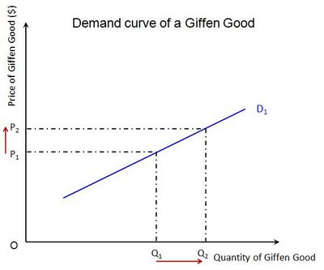
When price increases from OP to Op1 quantity demanded also increases from to OQ1 and vice versa. The reasons for exceptional demand curve are as follows.

- Giffen paradox:

Robert giffen has observed an effect of goods which has increase in demand even if price raised and goods demand decreases even if price decreased. He named above the goods as
Superior goods
Inferior goods
Ex: if a person buy bread and meat daily, If the price of bread is decreased, he will not purchases more breads, for the balance of money he will purchases meat . Decrease in the price of an inferior goods does not increases its demand, dut increase the demand for superior goods
The Giffen good or inferior good is an exception to the law of demand. When the price of an inferior good falls, the poor will buy less and vice versa. For example, when the price of maize falls, the poor are willing to spend more on superior goods than on maize if the price of maize increases, he has to increase the quantity of money spent on it. Otherwise he will have to face starvation. Thus a fall in price is followed by reduction in quantity demanded and vice versa. “Giffen” first explained this and therefore it is called as Giffen’s paradox.

3. Ignorance:

Sometimes, the quality of the commodity is Judge by its price. Consumers think that the product is superior if the price is high. As such they buy more at a higher price.
4. Speculative effect:

If the price of the commodity is increasing the consumers will buy more of it because of the fear that it increase still further, Thus, an increase in price may not be accomplished by a decrease in demand.
5. Fear of shortage:

During the times of emergency of war People may expect shortage of a commodity. At that time, they may buy more at a higher price to keep stocks for the future.

6. Necessaries:

In the case of necessaries like rice, vegetables etc. people buy more even at a higher price.
7. Goods don’t have substitutes:

As a general tendency, demand has to be decrease with increase in price, but if any goods don’t have substitutes, like salt and medicines, the demand will not get decreases. People will definitely buy as they don’t have other alternative

8. Insignificant income spent on goods:

If consumers spend a small amount for any goods the price changes will not influence the demand for that sort of goods, as they spent insignificant income or match boxes they might not reduce buying even if price rises
9. Conspicuous consumption:

Goods like diamonds, pearls ect ,are purchased by rich and wealthy section of the society because the price of such goods are so high that they are beyond the reach of a common man .most of these goods are demand when their price go up very high

UNIT- III Production, Cost, Market Structures & Pricing:

SHORT QUESTION AND ANSWERS:

- What is production?

Samuelson defines the production function as "the technical relationship which reveals the maximum amount of output capable of being produced by each set of inputs". It is defined for a given state of technical knowledge.

- Explain production function?
The inputs for any product or service are land, labour, capital, organization and technology. In other words, the production here is the function here of these five variable inputs. Mathematically, this is expressed as
Q=F (L1, L2, C, O, T)

L1 =land
L2 =labour
C = capital
O = organization
T = technology
Where Q is the quantity of production, f explains the function, that is, the type of relation between inputs and outputs these inputs have been taken in conventional terms. In reality, materials also can be included in a set of inputs.
- Production functions with one viable?
Assume that a firms production function consists of fixed quantities of all inputs (land, equipment, etc.) except labour which is a variable input when the firm expands output by employing more and more labour it alters the proportion between fixed and the variable inputs. The law can be stated as follows:
“When total output or production of a commodity is increased by adding units of a variable input while the quantities of other inputs are held constant, the increase in total production becomes after some point, smaller and smaller”.
Three stages of law:
The behaviors of the Output when the varying quantity of one factor is combines with a fixed quantity of the other can be divided in to three district stages. The three stages can be better understood by following the table.
Fixed factor | Variable factor (Labour) | Total product | Average Product | Marginal Product
1 | 1 | 100 | 100 | - | Stage I
1 | 2 | 220 | 120 | 120 | Stage I
1 | 3 | 270 | 90 | 50 | Stage I
1 | 4 | 300 | 75 | 30 | Stage II
1 | 5 | 320 | 64 | 20 | Stage II
1 | 6 | 330 | 55 | 10 | Stage II
1 | 7 | 330 | 47 | 0 | Stage III
1 | 8 | 320 | 40 | -10 | Stage III

Above table reveals that both average product and marginal product increase in the beginning and then decline of the two marginal products drops of faster than average product.
Total product is maximum when the farmer employs 6th worker, nothing is produced by the 7th worker and its marginal productivity is zero, whereas marginal product of 8th worker is ‘-10’, by just creating credits 8th worker not only fails to make a positive contribution but leads to a fall in the total output. Production function with one variable input and the remaining fixed inputs is illustrated as below
- Explain returns to scale?
Another important attribute of production function is how output responds in the long run to changes in the scale of the firm i.e. when all inputs are increased in the same proportion (by say 10%), how does output change. Clearly, there are 3 possibilities. If output increases by more than an increase in inputs (i.e.by more than 10%), then the situation is one of increasing returns to scale (IRS).
If output increases by less than the increase in inputs, then it is a case of decreasing returns to scale (DRS).Lastly, output may increase by exactly the same proportion as inputs. For example a doubling of inputs may Lead to a doubling of output. This is a case of constant returns to scale (CRS).

Capital (Units) | Labour (units) | % increase in both inputs | Output (quintals) | % increase in both output | Law applications
1 | 3 |  | 50
2 | 6 | 100 | 120 | 140 | increase
4 | 12 | 100 | 240 | 100 | constant
8 | 24 | 100 | 360 | 50 | decrease

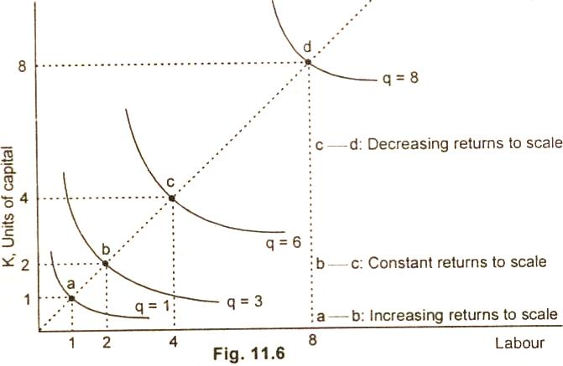

ECONOMIES OF SCALE
The economics of scale result because of increase in the scale of production. Marshal divides the economies of scale into two groups:
Internal economies
External; economies
Internal economies:
It refers to the economies in production cost which accrue to the firm alone whenit expands it output. the internal economies occur as results of increase in the scale of production.
The internal economies divide into following type:
- Managerial economies :
As the firm expands the firm need qualified managerial personnel to handle each of its functions such as marketing, finace, ect functional specilisational ensure minimum wastage and lower the cost of productions in the long run.
- Commercial economies
The transactions of buying and selling raw material and other operating supplies such as spares and so on. There could be cheaper saving in the procurement, transportation and storage costs. This will leads to lower cost and increase profits.
- Financial economies
There could be cheaper credit facility from the financial institution to meet the capital expenditure or working capital requirement .a large firm to give security to financial institution
- Technical economies
Increase in the scale of production follows when there is sophisticated technology available and the firm is in a position to hire qualified technology manpower to make use of it.
- Marketing economies
As the firm grow lager and lager it can afford to maintain a full fledged marketing departmentindependently to handle the issues related to design of customer ,promotion ,marketing staff.

- Risk bearing economies
As there is growth in size of firm there is increase in the risk also. Sharing in the risk with the insurance companies is the first priority for any firm. The firm insureit machinery and other assets against the fire theft ect.the lager firm can spread their risk so that they do not keep all their eggs in one basket.
- Economies of research and development
Large organizations such as dr.reddy labs,HCL, ect bring out several innovative products.
External economies
It refers to the entire firm in the industry, because of growth of the on industry as a whole or because of growth of industry.
- Economies concentration
Because all firm are located at one place ,it is likely that there is better infrastructure in term of approach roads, tans potation ect
- Economies of R&D
The entire firm can pool resource together to finance research and development activity and thus shares benefits of research.
- Economies of welfare
There could be common facility such as canteen, industryhousing, community halls,ect which can be used in common by the employee in the whole industry.Production may be carried on a small scale or o a large scale by a firm. When a firm expands its size of production by increasing all the factors, it secures certain advantages known as economies of production. Marshall has classified these economies of large-scale production into internal economies and external economies. Internal economies are those, which are opened to a single factory or a single firm independently of the action of other firms. They result from an increase in the scale of output of a firm and cannot be achieved unless output increases.

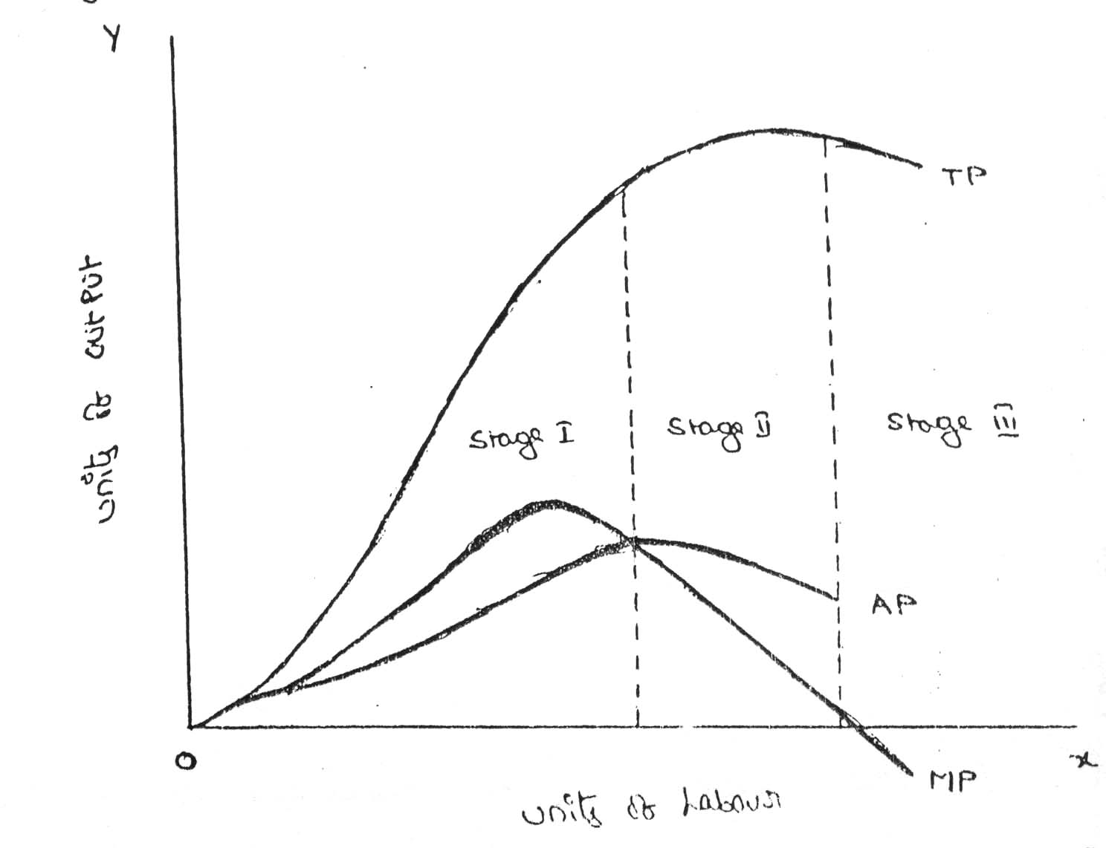

From the above graph the law of variable proportions operates in three stages. In the first stage, total product increases at an increasing rate. The marginal product in this stage increases at an increasing rate resulting in a greater increase in total product. The average product also increases. This stage continues up to the point where average product is equal to marginal product. The law of increasing returns is in operation at this stage.
The law of diminishing returns starts operating from the second stage awards. At the second stage total product increases only at a diminishing rate. The average product also declines. The second stage comes to an end where total product becomes maximum and marginal product becomes zero. The marginal product becomes negative in the third stage. So the total product also declines. The average product continues to decline
- What is cost and explain types of cost analysis?

Actual cost is defined as the cost or expenditure which a firm incurs for producing or acquiring a good or service. The actual costs or expenditures are recorded in the books of accounts of a business unit. Actual costs are also called as "Outlay Costs" or "AbsoluteCosts"or"AcquisitionCosts".

- Fixed Costs,
- Variable Costs, and
- Total Costs

- What is fixed and variable cost?
Fixed costs are those that are spent and cannot be changed in the period of time under consideration. In the long run there are no fixed costs since all costs are variable. In the short run, a number of costs will be fixed.
Workers represent variable costs – those that change as output changes
- What is market structure?

market structure describes the competitive environment in the market for any good or service. a market consists of all firms and individuals who are willing and able to buy or sell a particular product. this includes firms and individuals currently engaged in buying and selling a particular product, as well as potential entrants.

- What is pricing ?

Price denotes the exchange value of a unit of good expressed in terms of money. thus the current price of a maruti car around rs. 2,00,000, the price of a hair cut is rs. 25 the price of a economics book is rs. 150 and so on. nevertheless, if one gives a little, if one gives a little thought to this subject, one would realize that there is nothing like a unique price for any good. instead, there are multiple prices.

price concepts

price of a well-defined product varies over the types of the buyers, place it is received, credit sale or cash sale, time taken between final production and sale, etc.

the multiple prices is more serious in the case of items like cars refrigerators, coal, furniture and bricks and is of little significance for items like shaving blade, soaps, tooth pastes, creams and stationeries. differences in various prices of any good are due to differences in transport cost, storage cost accessories, interest cost, intermediaries’ profits etc.

Long question and answers:
- Define production function with one variable input with example?
Introduction:
The production function expresses a functional relationship between physical inputs and physical outputs of a firm at any particular time period. The output is thus a function of inputs
Definition:
Samuelson defines the production function as "the technical relationship which reveals the maximum amount of output capable of being produced by each set of inputs". It is defined for a given state of technical knowledge.
Input-OutputRelationship or Production Function
The inputs for any product or service are land, labour, capital, organization and technology. In other words, the production here is the function here of these five variable inputs. Mathematically, this is expressed as
Q=F (L1, L2, C, O, T)
L1 =land
L2 =labour
C = capital
O = organization
T = technology

Where Q is the quantity of production, f explains the function, that is, the type of relation between inputs and outputs these inputs have been taken in conventional terms. In reality, materials also can be included in a set of inputs.
In a specific situation, some factors of production may be important and the relative importance of the factors depends upon the final product to be manufactured. For example, in the case of the software industry, land is not an input factor as significant as that in case of an agricultural product.
In the case of an agricultural product, increasing the other factors of production can increase the production; but beyond a point, increased output can be had only with increased use of agricultural land. Investment in land forms a significant portion of the total cost of production for output. With change in industry and the requirements, the production function also needs to be modified to suit to the situation.
Assumptions:
Production function has the following assumptions.
- The production function is related to a particular period of time.
- There is no change in technology.
- The producer is using the best techniques available.
- The factors of production are divisible.
- Production function can be fitted to a short run or to long run.

ProductionFunction with One Variable Inputs and Laws Of Returns
Assume that a firms production function consists of fixed quantities of all inputs (land, equipment, etc.) except labour which is a variable input when the firm expands output by employing more and more labour it alters the proportion between fixed and the variable inputs. The law can be stated as follows:
“When total output or production of a commodity is increased by adding units of a variable input while the quantities of other inputs are held constant, the increase in total production becomes after some point, smaller and smaller”.
Three stages of law:
The behaviors of the Output when the varying quantity of one factor is combines with a fixed quantity of the other can be divided in to three district stages. The three stages can be better understood by following the table.
Fixed factor | Variable factor (Labour) | Total product | Average Product | Marginal Product
1 | 1 | 100 | 100 | - | Stage I
1 | 2 | 220 | 120 | 120 | Stage I
1 | 3 | 270 | 90 | 50 | Stage I
1 | 4 | 300 | 75 | 30 | Stage II
1 | 5 | 320 | 64 | 20 | Stage II
1 | 6 | 330 | 55 | 10 | Stage II
1 | 7 | 330 | 47 | 0 | Stage III
1 | 8 | 320 | 40 | -10 | Stage III

Above table reveals that both average product and marginal product increase in the beginning and then decline of the two marginal products drops of faster than average product.
Total product is maximum when the farmer employs 6th worker, nothing is produced by the 7th worker and its marginal productivity is zero, whereas marginal product of 8th worker is ‘-10’, by just creating credits 8th worker not only fails to make a positive contribution but leads to a fall in the total output. Production function with one variable input and the remaining fixed inputs is illustrated as below

From the above graph the law of variable proportions operates in three stages. In the first stage, total product increases at an increasing rate. The marginal product in this stage increases at an increasing rate resulting in a greater increase in total product. The average product also increases. This stage continues up to the point where average product is equal to marginal product. The law of increasing returns is in operation at this stage.
The law of diminishing returns starts operating from the second stage awards. At the second stage total product increases only at a diminishing rate. The average product also declines. The second stage comes to an end where total product becomes maximum and marginal product becomes zero. The marginal product becomes negative in the third stage. So the total product also declines. The average product continues to decline

STAGES | TP | MP | AP
1 | Increase at an increasing rate | Increase reach  the maximum | Increase and reach  the maximum
2 | Increase atDiminishing rate Till it reaches Maximum | Diminish equal to zero | Starts Diminish
3 | Start declining | Because negative | Continues to decline

ProductionFunction with Two Variable Inputs and Laws of Returns
Let us consider a production process that requires two inputs, capital(c) and labour (L) to produce a given output (Q). There could be more than two inputs in a real life situation, but for a simple analysis, we restrict the number of inputs to two only. In other words, the production function based on two inputs can be expressed as:
Q=f(C,L)
Normally, both capital and labour are required to produce a product. To some extent, these two inputs can be substituted for each other. Hence the product may choose any combination of labour and capital that gives him the required number of units of output. For any given level of output, a producer may hire both capital and labour, but he is free to choose any one combination of labour and capital out of several such combinations. The alternative combinations of labour and capital yielding a given level of output are such that if the use of one factor input is increased, that of another will decrease and vice versa.
ISOQUANTS:

The term Isoquants is derived from the words ‘iso’ and ‘quant’ – ‘Iso’ means equal and ‘quent’ implies quantity. Isoquant therefore, means equal quantity. A family of iso-product curves or isoquants or production difference curves can represent a production function with two variable inputs, which are substitutable for one another within limits.
Isoquants are the curves, which represent the different combinations of inputs producing a particular quantity of output. Any combination on the isoquant represents the some level of output.
Q= f (L, K)
Where ‘Q’, the units of output is a function of the quantity of two inputs ‘L’ and ‘K’.
Thus an isoquant shows all possible combinations of two inputs, which are capable of producing equal or a given level of output. Since each combination yields same output, the producer becomes indifferent towards these combinations.

Combinations | Labour (units) | Capital (Units) | Output (quintals)
A | 1 | 10 | 50
B | 2 | 7 | 50
C | 3 | 4 | 50
D | 4 | 4 | 50
E | 5 | 1 | 50
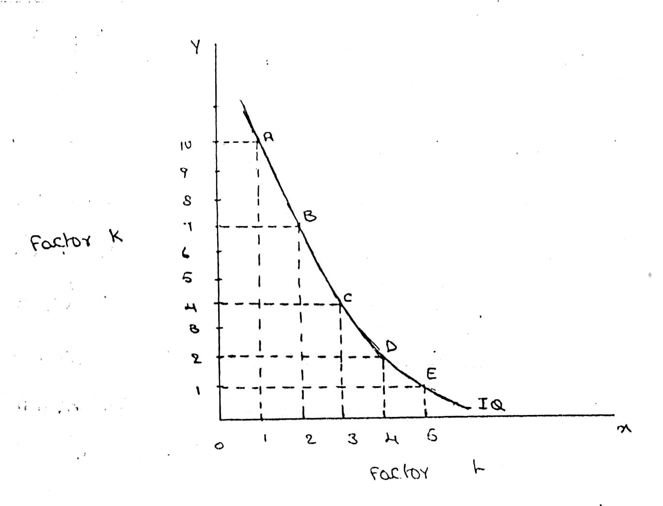

FEATURES OF AN ISOQUANT

(1).DOWNWARD SLOPING:-Isoquants are downward sloping curves because, if one input increases, the other one reduces. There is no question of increase in both the inputs to yield a given output.
A degree of substitution is assumed between the factors of production. In other words, an isoquant cannot be increasing, as increase in both the inputs does not yield same level of output. If it is constant, it means that the output remains constant though the use of one of the factors is increasing, which is not true, isoquants slope from left to right.
(2).CONVEX TO ORIGIN:-Isoquants are convex to the origin. It is because the input factors are not perfect substitutes. One input factors were perfect substituted by other input factor in a 'diminishing marginal rate'. If the input factors were perfect substitutes, the isoquant would be a falling straight line. When the inputs are used in fixed proportion, and substitution of one input for the other cannot take place, the isoquant will be L shaped.
(3).DO NOT INTERSECT:-Two isoproducts do not intersect with each other. It is because, each of these denote a particular level of output. If the manufacturer wants to operate at a higher level of output, he has to switch over to another isoquant with a higher level of output and vice versa.
(4).DO NOT TOUCH AXES:-The isoquant touches neither x-axis nor y-axis, as both inputs are required to produce a given product.
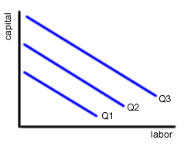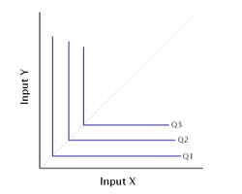
isoquant perfect substitute isoquant not perfect substitute
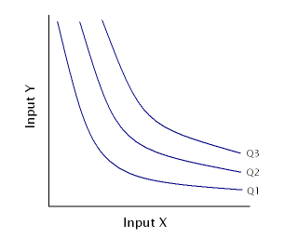
It showing different volume of output

ISO COST

Definition:
A firm can produce a given level of output using efficiently different combinations of two inputs. For choosing efficient combination of the inputs, the producer selects that combination of factors which has the lower cost of production. The information about the cost can be obtained from theisocost lines.
Explanation:
An isocost line is also called outlay line or price line or factor cost line. An isocost line shows all the combinations of labor and capital that are available for a given total cost to-the producer..
In economics, the isocost is the set of combinations of goods that have the same total cost; this can be represented by a curve on a graph.
In economics an `isocost` line shows all combinations of inputs which cost the same total amount

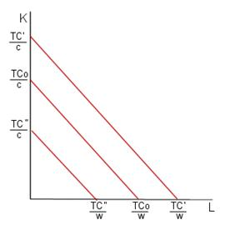

Isoquant and Isocost

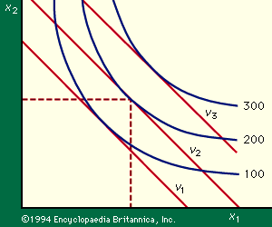

Marginal rate of technical substitution

In economic theory, the Marginal Rate of Technical Substitution (MRTS) - or Technical Rate of Substitution (TRS) - is the amount by which the quantity of one input has to be reduced ( − Δx₂) when one extra unit of another input is used (Δx₁ = 1), so that output remains constant ().
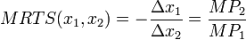
where MP₁ and MP₂ are the marginal products of input 1 and input 2, respectively, and MRTS(x₁,x₂) is Marginal Rate of Technical Substitution of the input x₁ for x₂.Along an isoquant, the MRTS shows the rate at which one input (e.g. capital or labor) may be substituted for another, while maintaining the same level of output. The MRTS can also be seen as the slope of an isoquant at the point in question.
Combinations | Labour (units) | Capital (Units) | Output (quintals) | MRTS
A | 20 | 1 | 50
B | 15 | 2 | 50 | 5:1
C | 11 | 3 | 50 | 4:1
D | 8 | 4 | 50 | 3:1
E | 6 | 5 | 50 | 2:1
F | 5 | 6 | 50 | 1:1

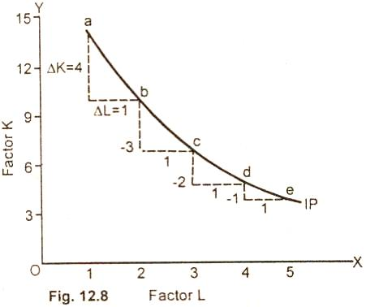

Least cost combination of inputs

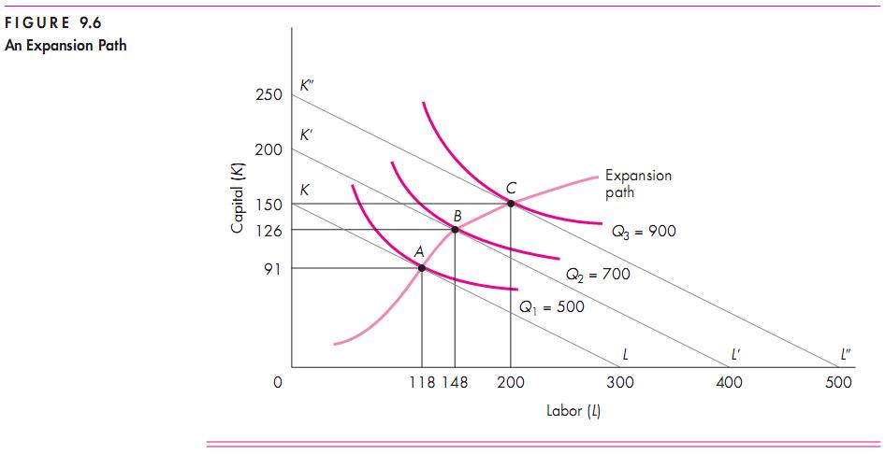

Cobb-Douglas production function:
Production function of the linear homogenous type is invested by and first tested by C. W. Cobb and P. H. Dougles in 1899 to1922. This famous statistical production function is known as Cobb-Douglas production function. Originally the function is applied on the empirical study of the American manufacturing industry. Cabb – Douglas production function takes the following mathematical form.
Y= (bK^{X} L^{1-x})
Where Y=output k=Capital L=Labour
The production function shows that one percent change in labour, capital reaming the same is associated with a 0.75 %change in output. One percent change in capital, labour reaming the same, is associated with a 0.25 %change in output.
Assumptions:
It has the following assumptions
- The function assumes that output is the function of two factors viz. capital and labour.
- It is a linear homogenous production function of the first degree
- The function assumes that the logarithm of the total output of the economy is a linear function of the logarithms of the labour force and capital stock.
- There are constant returns to scale
- All inputs are homogenous(same)

- State and explain Break-Even analysis and explain its importance?
The study of cost-volume-profit relationship is often referred as BEA. The term BEA is interpreted in two senses. In its narrow sense, it is concerned with finding out BEP; BEP is the point at which total revenue is equal to total cost. It is the point of no profit, no loss. In its broad determine the probable profit at any level of production

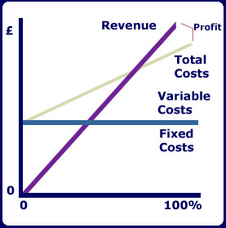

- Fixed cost: Expenses that do not vary with the volume of production are known as fixed expenses. Eg. Manager’s salary, rent and taxes, insurance etc. It should be noted that fixed changes are fixed only within a certain range of plant capacity. The concept of fixed overhead is most useful in formulating a price fixing policy. Fixed cost per unit is not fixed.
- Variable Cost: Expenses that vary almost in direct proportion to the volume of production of sales are called variable expenses. Eg. Electric power and fuel, packing materials consumable stores. It should be noted that variable cost per unit is fixed.
- Contribution: Contribution is the difference between sales and variable costs and it contributed towards fixed costs and profit. It helps in sales and pricing policies and measuring the profitability of different proposals. Contribution is a sure test to decide whether a product is worthwhile to be continued among different products.

Contribution = Sales – Variable cost
Contribution = Fixed Cost + Profit.
- Margin of safety: Margin of safety is the excess of sales over the break even sales. It can be expressed in absolute sales amount or in percentage. It indicates the extent to which the sales can be reduced without resulting in loss. A large margin of safety indicates the soundness of the business. The formula for the margin of safety is:
Present sales – Break even sales or
- Break – Even- Point: If we divide the term into three words, then it does not require further explanation.
Break-divide
Even-equal
Point-place or position
Break Even Point refers to the point where total cost is equal to total revenue. It is a point of no profit, no loss. This is also a minimum point of no profit, no loss. This is also a minimum point of production where total costs are recovered. If sales go up beyond the Break Even Point, organization makes a profit. If they come down, a loss is incurred.

- Break Even point (Units) =
- Break Even point (In Rupees) =

Merits:
- Information provided by the Break Even Chart can be understood more easily then those contained in the profit and Loss Account and the cost statement.
- Break Even Chart discloses the relationship between cost, volume and profit. It reveals how changes in profit. So, it helps management in decision-making.
- It is very useful for forecasting costs and profits long term planning and growth
- The chart discloses profits at various levels of production.
- It serves as a useful tool for cost control.
- It can also be used to study the comparative plant efficiencies of the industry.
- Analytical Break-even chart present the different elements, in the costs – direct material, direct labour, fixed and variable overheads.
Demerits:
- Break-even chart presents only cost volume profits. It ignores other considerations such as capital amount, marketing aspects and effect of government policy etc., which are necessary in decision making.
- It is assumed that sales, total cost and fixed cost can be represented as straight lines. In actual practice, this may not be so.
- It assumes that profit is a function of output. This is not always true. The firm may increase the profit without increasing its output.
- A major draw back of BEC is its inability to handle production and sale of multiple products.
- It is difficult to handle selling costs such as advertisement and sale promotion in BEC.
- It ignores economics of scale in production.
- Fixed costs do not remain constant in the long run.
- Semi-variable costs are completely ignored.
- It assumes production is equal to sale. It is not always true because generally there may be opening stock.
- When production increases variable cost per unit may not remain constant but may reduce on account of bulk buying etc.

- Define Market and explain how markets are classified?

A market is a place where sellers sell and buyers buy a commodity. According to robert dorfman, a market is a group of people and firm who are in contact with one another for the purpose of buying and selling some commodity. it is not necessary that every member of the market be in contact with every other one; the contacts may be indirect.

Market structure describes the competitive environment in the market for any good or service. a market consists of all firms and individuals who are willing and able to buy or sell a particular product. This includes firms and individuals currently engaged in buying and selling a particular product, as well as potential entrants.

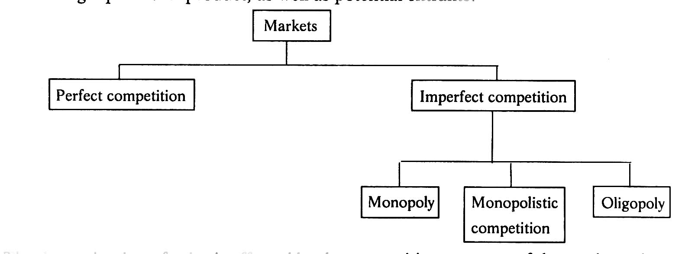

Perfect competition:

Iit refers to a market structure where competition among the sellers and buyers prevails in its most perfect form. in a perfectly competitive market, a single market price prevails for the commodity, which is determined by the forces of total demand and total supply in the market.

Monopoly:-

If there is only one seller, monopoly market is said to exist. an extreme version of imperfect market is monopoly. here a single seller completely controls the entire industry. it is only firm producing the given product in its industry. in case of monopoly, there is very little difference between the firm and industry. the firm is called monopolist or monopoly firm. maruti-suzuki enjoyed all the government protection for a long time when it enjoyed monopoly in respect of small cars.

Monopolistic Competition:-

when large number of sellers produces differentiated products, monopolistic competition is said to exist. a product is said to be differentiated when its important features vary. it may be differentiated based on real or perceived differences. for cameras, the important features include zoom lenses, focal length, memory, size of camera, aperture and exposure controls, flash, safety, digital day and date display, and the overall picture quality and so on.

Duopoly:-

if there are two sellers, duopoly is said to exist. if pepsi and coke are the two companies in soft drinks, this market is called duopoly. basic facilities for satellite communication are presently provided by mahan agar telephone nigam limited (mntl) and videsh sanchar nigam limited (vsnl). this market for satellite communication can be referred to as duopoly.

Oligopoly:-

another variety of imperfect competition is oligopoly. if there is competition among a few sellers, oligopoly is said to exist. the examples are the car manufacturing companies (such as maruti suzuki, hindustan motors, daewoo, toyota and so on), newspapers (such as the hindu, indian express, times of india, economic times, eenadu and so on). in oligopoly, each individual seller or firm can affect the market price

characteristics of perfect competition

The following features characterize a perfectly competitive market:

A large number of buyers and sellers: the number of buyers and sellers is large and the share of each one of them in the market is so small that none has any influence on the market price.

Homogeneous product: the product of each seller is totally undifferentiated from those of the others. Under perfect competition, the product offered for sale by all the seller must be identical in every respect. the goods offered for sale are perfect substitutes of one another. buyers have no special preference for the product of a particular seller. no seller can raise the price above the prevailing price or lower the price below the prevailing price.

free entry and exit: any buyer and seller is free to enter or leave the market of the commodity. under perfect competition, there will be no restriction on the entry and exit of both buyers and sellers. if the existing sellers start making abnormal profits, new sellers should be able to enter the market freely. this will bring down the abnormal profits to the normal level. similarly, when losses will occur existing sellers may leave the market. however, such free entry or free exit is possible only in the long run, but not in the short-run.

perfect knowledge: all buyers and sellers have perfect knowledge about the market for the commodity. perfect competition implies perfect knowledge on the part of buyers and sellers regarding the market conditions. as a results, no buyer will be prepared to pay a price higher than the prevailing price. sellers will not charge a price higher or lower than the prevailing price. in this market, advertisement has no scope.

Monopoly

the word monopoly is made up of two syllables, mono and poly. mono means single while poly implies selling. thus monopoly is a form of market organization in which there is only one seller of the commodity. there are no close substitutes for the commodity sold by the seller. pure monopoly is a market situation in which a single firm sells a product for which there is no good substitute.

features of monopoly:

the following are the features of monopoly.

single person or a firm: a single person or a firm controls the total supply of the commodity. there will be no competition for monopoly firm. the monopolist firm is the only firm in the whole industry.

no close substitute: the goods sold by the monopolist shall not have closely competition substitutes.even if price of monopoly product increase people will not go in far substitute. for example: if the price of electric bulb increase slightly, consumer will not go in for kerosene lamp.

large number of buyers: under monopoly, there may be a large number of buyers in the market who compete among themselves.

price maker: since the monopolist controls the whole supply of a commodity, he is a price-maker, and then he can alter the price.

supply and price: the monopolist can fix either the supply or the price. he cannot fix both. if he charges a very high price, he can sell a small amount. if he wants to sell more, he has to charge a low price. he cannot sell as much as he wishes for any price he pleases.

downward sloping demand curve: the demand curve (average revenue curve) of monopolist slopes downward from left to right. it means that he can sell more only by lowering price.

Monopolistic Competition

perfect competition and pure monopoly are rate phenomena in the real world. instead, almost every market seems to exhibit characteristics of both perfect competition and monopoly. hence in the real world it is the state of imperfect competition lying between these two extreme limits that work. edward. h. chamberlain developed the theory of monopolistic competition, which presents a more realistic picture of the actual market structure and the nature of competition.

characteristics of monopolistic competitionthe important characteristics of monopolistic competition are:

existence of many firms: industry consists of a large number of sellers, each one of whom does not feel dependent upon others. every firm acts independently without bothering about the reactions of its rivals. the size is so large that an individual firm has only a relatively small part in the total market, so that each firm has very limited control over the price of the product. as the number is relatively large it is difficult for these firms to determine its price- output policies without considering the possible reactions of the rival forms. a monopolistically competitive firm follows an independent price policy.

product differentiation: product differentiation means that products are different in some ways, but not altogether so. the products are not identical but the same time they will not be entirely different from each other. it really means that there are various monopolist firms competing with each other. an example of monopolistic competition and product differentiation is the toothpaste produced by various firms. the product of each firm is different from that of its rivals in one or more respects. different toothpastes like colgate, close-up, forehans, cibaca, etc., provide an example of monopolistic competition. these products are relatively close substitute for each other but not perfect substitutes. consumers have definite preferences for the particular verities or brands of products offered for sale by various sellers. advertisement, packing, trademarks, brand names etc. help differentiation of products even if they are physically identical.

large number of buyers: there are large number buyers in the market. but the buyers have their own brand preferences. so the sellers are able to exercise a certain degree of monopoly over them. each seller has to plan various incentive schemes to retain the customers who patronize his products.

free entry and exist of firms: as in the perfect competition, in the monopolistic competition too, there is freedom of entry and exit. that is, there is no barrier as found under monopoly.

selling costs: since the products are close substitute much effort is needed to retain the existing consumers and to create new demand. so each firm has to spend a lot on selling cost, which includes cost on advertising and other sale promotion activities.

imperfect knowledge: imperfect knowledge about the product leads to monopolistic competition. if the buyers are fully aware of the quality of the product they cannot be influenced much by advertisement or other sales promotion techniques. but in the business world we can see that thought the quality of certain products is the same, effective advertisement and sales promotion techniques make certain brands monopolistic. for examples, effective dealer service backed by advertisement-helped popularization of some brands through the quality of almost all the cement available in the market remains the same.

- Define pricing and explain pricing methods:
Pricing Methods
Pricing is not an exact science. Pricing decisions, more often, are done by trial and error. Most often we see discounts and concessions offered at the time of purchase. Sometimes, certain shames are introduced wherein if you by a packet of Tea powder, a dining still table spoon if free! Why are all these provided? While the main objective of such shames is to increase sales, one of the other objectives is also to correct the pricing strategy, if at all it has gone wrong earlier.
Pricing is an important exercise. Under-pricing will result in losses and over-pricing will make the customers run away. To determine pricing in a scientific manner, it is necessary to understand the pricing objectives, pricing methods, pricing policies, and pricing procedures.
Pricing Objectives
Pricing objectives refer to the general and specific objectives, which a firm sets for itself in establishing the price of its products and/or services and these are not much different from the marketing objectives or firm's overall business objectives.
Generally, the following are the objectives of pricing.
(a) To maximize profits,
(b) To increase sales
(c) To increase the market share,
(d) To satisfy customers, and
(e) To meet the competition.
Prcing Policy
The firm has to formulate its pricing policies, particularly when it deals in multiple products. The pricing policies are intended to bring consistency in the pricing pattern. For instance, to maintain price differentials between the deluxe models and basic models and so on. Pricing policy defines how to handle complex issues such as price discrimination and so forth.
Pricing Methods
1. COST-BASED PRICING METHODS
(a) COST PULS PRICING;- This is also called 'full cost or mark up' pricing. Here the average cost at normal capacity of output is ascertained and then a conventional margin of profit is added to the cost to arrive at the price. In other words, find out the product unit's total cost and add a percentage of profit to arrive at the selling price.
(b) MARGINAL COST PRICING;- In marginal cost pricing, selling price is fixed in such a way that it covers fully the variable or marginal cost and contributes towards recovery of fixed costs fully or partly, depending upon the market situations. In times of stiff competition, marginal cost offers a guide-line as to how far the selling price can be lowered.
COMPETITION-ORIENTED PRICING
Here the pricing is a very complex task. Here the price of a product is set based on what the competitor charges for similar products. In other words, a reduction in the price of products by the competitor will force us also to follow suit. In such a case, how far we can go on reducing the price? Here the marginal cost concept comes handy. As long as the price covers the marginal cost, continue to sell. If not, better stop selling. It is because, every unit sold at less than marginal cost results in loss.
SEALED BID PRICING;- This method popular in tenders and contracts. Each contracting firm quotes its price in a sealed cover called 'tender'. All the tenders are opened on a scheduled date and the person, who quotes the lowest price, other things remaining the same, is awarded the contract. The objective of the bidding firm is to bag the contract and hence it will quote lower than others. Marginal cost concept continues to be the guiding principle here also. Any price quoted less than the marginal price results in loss. Any price quoted ambitiously, no doubt, results in profit but suffers from the danger of losing the contract.
GOING RATE PRICING;-Here the price charged by the firm is in tune with price charged in the industry as a whole. In other words, the prevailing market price at a given point of time is the guiding factor. When one wants to buy determine the price. Normally the market leaders keep announcing the prevailing prices at a given point of time based on demand and supply positions.
DEMAND-ORIENTED PRICING
The higher the demand, the higher can be the price. Cost is not the consideration here. The key to pricing here is the value as perceived by the consumer. This is a relatively modern marketing concept. Today most of the organizations consider favorably such proposals where there is possibility to charge higher prices on their products and services, even though they call for higher investments and latest technology. Demand-oriented pricing can take two forms: (a) Differential pricing also called price discrimination, (b) perceived value pricing.
PRICE DISCRIMINATION;-
Price discrimination refers to the practice of charging different prices to customers for the same good. The firm uses its desecration to charge differently the different customers. It is also called differential pricing. customers of different profiles can be separated in various ways, such as by different consumer requirements (for example bulk and low gas supply to industrial and household consumers), by nature of product itself (for example original and replacement components of pressure cookers), by geographical areas (domestic and international markets), by income group (in a government hospital the patients are charged a fee based on their income groups) and so on.
The objects of price discrimination are to
* develop a new market including for export,
* utilize the maximum capacity,
* share consumer's surplus along with consumer, not leaving it totally to him,
* meet competition,
* increase market share.
PERCEIVED VALUE PRICING;- Perceived value pricing refers to where the price is fixed on the basis of the perception of the buyer of the value of the products.
STRATEGY-BASED PRICING
MARKET SKIMMING;-
When the product is introduced for the first time in the market, the company follows this method. Under this method, the company fixes a very high price for the product. The main idea is to charge the customer maximum possible. This strategy is mostly found in case of technology products. When Sony introduces a particular TV model, it fixes a very high price. When new series of Pentium is released into market, it is priced very high. Initially, all cannot afford except a very few. As the time passes by, the price comes down and more people can afford to buy except a very few. This method can be followed only when (i) the demand for the product is inelastic,(ii) there is no threat from competitors,(iii) a high price is coupled with high technology or quality.
MARKET PENETRATION;-
This is exactly opposite to the market skimming method. Here the price of the product is fixed so low that the company can increase its market share. The company attains profits with increasing volumes and increase in the market share. More often, the companies believe that it is necessary to dominate the market in the long-run than making profits in the short-run. This method is more suitable where market is highly price-sensitive. In such a case, a low price stimulates more rapid growth. It will be more appropriate in cases where the costs are likely to fall with increase in output. A low price may not attract significant degree of competition also.
TWO-PART PRICING;-
The firms with market power can enhance profits by the strategy of two-part pricing. Under this strategy, a firm charges a fixed fee for the right to purchase its goods, plus a per unit charges for each unit purchased. Entertainment house such as country clubs. Golf courses and health clubs usually adopt this strategy. Then charge a fixed initiation fee plus a charge per month or per visit, to use the facilities. There are also organizations that charge membership fee (equivalent to the consumer surplus) and offer their products and services cost-to-cost basis.
BLOCK PRICING;-
Block pricing is another way a firm with market power can enhance its profits. We see block pricing in our day-to-day life very frequently. Six Lux soaps in a single packed or five Magi noodles in a single pack illustrate this pricing method. By selling certain number of units of a product as one package, the firm earns more than by selling unit wise. The block pricing is a profit maximization price on each package. It is generally the total value the consumer receives for the package, including consumer surplus.
COMMODITY BUNDLING;-
Commodity bundling refers to the practice of bundling two or more different products together and selling them at a single 'bundle price'. The package includes the airfare, hotel, meals, sightseeing and so on at a bundled price instead of pricing each of these services separately. Computer firms offer PCs, assembling as per the customer specifications and offer them at a bundled price. The car companies provide cars with air-conditioning, Power steering, automatic transmission, auto gear and so forth, and sell them at a special price.
PEAK LOAD PRICING;-
During seasonal period when demand is likely to be higher, a firm may enhance profits by peak load pricing. The firm's philosophy is to charge a higher price during peak times than is charged during off-peak times. The pricing is done in such a way that the business is not lost to the competitors. The firm following such a strategy covers the likely losses during the off-peak times form the likely profits from the peak times.
CROSS SUBSIDISATION;-
In cases where demand for two products produced by a firm is interrelated through demand or costs, the firm may enhance the profitability of its operations through cross subsidization. Using the profits generated by established products, a firm may expand its activates by financing new product development and diversification into new product markets.
TRANSFER PRICING;-
Transfer pricing is an internal pricing technique. It refers to a price at which inputs of one department are transferred to another, in order to maximize the overall profits of the company.

UNIT-IV Financial Accounting:
SHORT QUESTION AND ANSWERS:
- What is accounting?

Smith and Ashburne: “Accounting is a means of measuring and reporting the results of economic activities.”
The art of recording, classifying and summarizing in a significant manner and in terms of money transactions and events, which are in part at least, of a financial character and interpreting the results thereof.”
Thus, accounting is an art of identifying, recording, summarizing and interpreting business transactions of financial nature. Hence accounting is the Language of Business.
- What are the branches of accounting?

The important branches of accounting are:
- Financial Accounting: The purpose of Accounting is to ascertain the financial results i.e. profit or loss in the operations during a specific period. It is also aimed at knowing the financial position, i.e. assets, liabilities and equity position at the end of the period. It also provides other relevant information to the management as a basic for decision-making for planning and controlling the operations of the business.
- Cost Accounting: The purpose of this branch of accounting is to ascertain the cost of a product / operation / project and the costs incurred for carrying out various activities. It also assists the management in controlling the costs. The necessary data and information are gatherr4ed form financial and other sources.
- Management Accounting: Its aim to assist the management in taking correct policy decision and to evaluate the impact of its decisions and actions. The data required for this purpose are drawn accounting and cost-accounting.

- Explain accounting function and cycle?

The job of an accountant involves the following types of accounting works
- Designing Work: It includes the designing of the accounting system, basis for identification and classification of financial transactions and events, forms, methods, procedures, etc.
- Recording Work: The financial transactions are identified, classified and recorded in appropriate books of accounts according to principles. This is “Book Keeping”. The recording of transactions tends to be mechanical and repetitive.
- Summarizing Work: The recorded transactions are summarized into significant form according to generally accepted accounting principles. The work includes the preparation of profit and loss account, balance sheet. This phase is called ‘preparation of final accounts’
- Analysis and Interpretation Work: The financial statements are analysed by using ratio analysis, break-even analysis, funds flow and cash flow analysis.
- Reporting Work: The summarized statements along with analysis and interpretation are communicated to the interested parties or whoever has the right to receive them.
For Ex. Share holders. In addition, the accou8nting departments have to prepare and send regular reports so as to assist the management in decision making. This is ‘Reporting’.
- Preparation of Budget: The management must be able to reasonably estimate the future requirements and opportunities. As an aid to this process, the accountant has to prepare budgets, like cash budget, capital budget, purchase budget, sales budget etc. this is ‘Budgeting’.
- Taxation Work: The accountant has to prepare various statements and returns pertaining to income-tax, sales-tax, excise or customs duties etc., and file the returns with the authorities concerned.
- Auditing: It involves a critical review and verification of the books of accounts statements and reports with a view to verifying their accuracy. This is ‘Auditing’

- Explain concepts and conventions of accounting?

BUSINESS ENTITY CONEPT: In this concept “Business is treated as separate from the proprietor”. All the Transactions recorded in the book of Business and not in the books of proprietor. The proprietor is also treated as a creditor for the Business.
2. GOING CONCERN CONCEPT: This concept relates with the long life of Business. The assumption is that business will continue to exist for unlimited period unless it is dissolved due to some reasons or the other.
3. MONEY MEASUREMENT CONCEPT: In this concept “Only those transactions are recorded in accounting which can be expressed in terms of money, those transactions which can not be expressed in terms of money are not recorded in the books of accounting”.
4. COST CONCEPT: Accounting to this concept, can asset is recorded at its cost in the books of account. i.e., the price, which is paid at the time of acquiring it. In balance sheet, these assets appear not at cost price every year, but depreciation is deducted and they appear at the amount, which is cost, less classification.
5. ACCOUNTING PERIOD CONCEPT: every Businessman wants to know the result of his investment and efforts after a certain period. Usually one-year period is regarded as an ideal for this purpose. This period is called Accounting Period. It depends on the nature of the business and object of the proprietor of business.
6. DUAL ASCEPT CONCEPT: According to this concept “Every business transactions has two aspects”, one is the receiving benefit aspect another one is giving benefit aspect. The receiving benefit aspect is termed as
“DEBIT”, where as the giving benefit aspect is termed as “CREDIT”. Therefore, for every debit, there will be corresponding credit.
7. MATCHING COST CONCEPT: According to this concept “The expenses incurred during an accounting period, e.g., if revenue is recognized on all goods sold during a period, cost of those good sole should alsoBe charged to that period.
8. REALISATION CONCEPT: According to this concept revenue is recognized when a sale is made. Sale is Considered to be made at the point when the property in goods posses to the buyer and he becomes legally liable to pay.
ACCOUNTING CONVENTIONS
Accounting is based on some customs or usages. Naturally accountants here to adopt that usage or custom.They are termed as convert conventions in accounting. The following are some of the important accounting conventions.
1. FULL DISCLOSURE: According to this convention accounting reports should disclose fully and fairly the information. They purport to represent. They should be prepared honestly and sufficiently disclose information which is if material interest to proprietors, present and potential creditors and investors. The companies ACT, 1956 makes it compulsory to provide all the information in the prescribed form.
2. MATERIALITY: Under this convention the trader records important factor about the commercial activities. In the form of financial statements if any unimportant information is to be given for the sake of clarity it will be given as footnotes.
3. CONSISTENCY:It means that accounting method adopted should not be changed from year to year. It means that there should be consistent in the methods or principles followed. Or else the results of a year cannot be conveniently compared with that of another.
4. CONSERVATISM: This convention warns the trader not to take unrealized income in to account. That is why the practice of valuing stock at cost or market price, which ever is lower is in vague. This is the policy of “playing safe”; it takes in to consideration all prospective losses but leaves all prospective profits.
5. Explain golden role of accounting?
1.Personal accounts
2. Real accounts
3. Nominal accounts
1. Personal Accounts: Accounts which are transactions with persons are called “Personal Accounts”.
A separate account is kept on the name of each person for recording the benefits received from, or given to the person in the course of dealings with him.
E.g.: Krishna’s A/C, Gopal’s A/C, SBI A/C, NagarjunaFinanaceLtd.A/C, ObulReddy& Sons A/C , HMT Ltd. A/C, Capital A/C, Drawings A/C etc.
2. Real Accounts: The accounts relating to properties or assets are known as “Real Accounts” .Every business needs assets such as machinery, furniture etc, for running its activities .A separate account is maintained for each asset owned by the business.
E.g.: cash A/C, furniture A/C, building A/C, machinery A/C etc.
3.NominalAccounts: Accounts relating to expenses, losses, incomes and gains are known as “Nominal Accounts”. A separate account is maintained for each item of expenses, losses, income or gain.
E.g.: Salaries A/C, stationery A/C, wages A/C, postage A/C, commission A/C, interest A/C, purchases A/C, rent A/C, discount A/C, commission received A/C, interest received A/C, rent received A/C, discount received A/C.
Before recording a transaction, it is necessary to find out which of the accounts is to be debited and which is to be credited. The following three different rules have been laid down for the three classes of accounts….
1. Personal Accounts: The account of the person receiving benefit (receiver) is to be debited and the account of the person giving the benefit (given) is to be credited.
Rule: “Debit----The Receiver
Credit---The Giver”

2. Real Accounts: When an asset is coming into the business, account of that asset is to be debited .When an asset is going out of the business; the account of that asset is to be credited.
Rule: “Debit----What comes in
Credit---What goes out”

3. Nominal Accounts: When an expense is incurred or loss encountered, the account representing the expense or loss is to be debited. When any income is earned or gain made, the account representing the income of gain is to be credited.
Rule: “Debit----All expenses and losses
Credit---All incomes and gains”

- Briefly explain about journal , ledger, trial balance and profit and loss a/c , balance sheet?

Journal:

The word Journal is derived from the Latin word ‘journ’ which means a day. Therefore, journal means a ‘day Book’ in day-to-day business transactions are recorded in chronological order.
Ledger:
All the transactions in a journal are recorded in a chronological order. After a certain period, if we want to know whether a particular account is showing a debit or credit balance it becomes very difficult. So, the ledger is designed to accommodate the various accounts maintained the trader. It contains the final or permanent record of all the transactions in duly classified form. “A ledger is a book which contains various accounts.” The process of transferring entries from journal to ledger is called “POSTING”.
trial balance:
The first step in the preparation of final accounts is the preparation of trail balance. In the double entry system of book keeping, there will be credit for every debit and there will not be any debit without credit. When this principle is followed in writing journal entries, the total amount of all debits is equal to the total amount all credits.
A trail balance is a statement of debit and credit balances. It is prepared on a particular date with the object of checking the accuracy of the books of accounts. It indicates that all the transactions for a particular period have been duly entered in the book, properly posted and balanced. The trail balance doesn’t include stock in hand at the end of the period. All adjustments required to be done at the end of the period including closing stock are generally given under the trail balance.
Profit and loss a/c:
The business man is always interested in knowing his net income or net profit.Net profit represents the excess of gross profit plus the other revenue incomes over administrative, sales, Financial and other expenses. The debit side of profit and loss account shows the expenses and the credit side the incomes. If the total of the credit side is more, it will be the net profit. And if the debit side is more, it will be net loss.
Balance sheet:
The second point of final accounts is the preparation of balance sheet. It is prepared often in the trading and profit; loss accounts have been compiled and closed. A balance sheet may be considered as a statement of the financial position of the concern at a given date.

- Explain ledger and trial balance proforma?

Ledger proforma:

Date | Particulars | Lfno | Amount | Date | Particulars | Lfno | amount

Trial balance proforma:
Trail balance for MR…………………………………… as on …………
NO | NAME OF ACCOUNT  (PARTICULARS) | DEBIT  AMOUNT (RS.) | CREDIT  AMOUNT (RS.)

LONG QUESTION AND ANSWERS:
- Give a brief account on the important records of Accounting under Double Entry System and discuss briefly ?

Definition of Accounting:
Smith and Ashburne: “Accounting is a means of measuring and reporting the results of economic activities.”
American Institute of Certified Public Accountants (AICPA):
“The art of recording, classifying and summarizing in a significant manner and in terms of money transactions and events, which are in part at least, of a financial character and interpreting the results thereof.”
Thus, accounting is an art of identifying, recording, summarizing and interpreting business transactions of financial nature. Hence accounting is the Language of Business.
BRANCHES OF ACCOUNTING:
The important branches of accounting are:
- Financial Accounting: The purpose of Accounting is to ascertain the financial results i.e. profit or loss in the operations during a specific period. It is also aimed at knowing the financial position, i.e. assets, liabilities and equity position at the end of the period. It also provides other relevant information to the management as a basic for decision-making for planning and controlling the operations of the business.
- Cost Accounting: The purpose of this branch of accounting is to ascertain the cost of a product / operation / project and the costs incurred for carrying out various activities. It also assists the management in controlling the costs. The necessary data and information are gatherr4ed form financial and other sources.
- Management Accounting: Its aim to assist the management in taking correct policy decision and to evaluate the impact of its decisions and actions. The data required for this purpose are drawn accounting and cost-accounting.
FUNCTIONS OF AN ACCOUNTANT
The job of an accountant involves the following types of accounting works
- Designing Work: It includes the designing of the accounting system, basis for identification and classification of financial transactions and events, forms, methods, procedures, etc.
- Recording Work: The financial transactions are identified, classified and recorded in appropriate books of accounts according to principles. This is “Book Keeping”. The recording of transactions tends to be mechanical and repetitive.
- Summarizing Work: The recorded transactions are summarized into significant form according to generally accepted accounting principles. The work includes the preparation of profit and loss account, balance sheet. This phase is called ‘preparation of final accounts’
- Analysis and Interpretation Work: The financial statements are analysed by using ratio analysis, break-even analysis, funds flow and cash flow analysis.
- Reporting Work: The summarized statements along with analysis and interpretation are communicated to the interested parties or whoever has the right to receive them.
For Ex. Share holders. In addition, the accou8nting departments have to prepare and send regular reports so as to assist the management in decision making. This is ‘Reporting’.
- Preparation of Budget: The management must be able to reasonably estimate the future requirements and opportunities. As an aid to this process, the accountant has to prepare budgets, like cash budget, capital budget, purchase budget, sales budget etc. this is ‘Budgeting’.
- Taxation Work: The accountant has to prepare various statements and returns pertaining to income-tax, sales-tax, excise or customs duties etc., and file the returns with the authorities concerned.
- Auditing: It involves a critical review and verification of the books of accounts statements and reports with a view to verifying their accuracy. This is ‘Auditing’

USERS OF ACCOUNTING INFORMATION
Different categories of users need different kinds of information for making decisions. The users of accounting can be divided in two board groups
(1). Internal users and
(2). External users.
- Internal Users:
Managers: These are the persons who manage the business, i.e. management at him top, middle and lower levels. Their requirements of information are different because they make different types of decisions.
Accounting reports are important to managers for evaluating the results of their decisions. In additions to external financial statements, managers need detailed internal reports either branch division or department or product-wise. Accounting reports for managers are prepared much more frequently than external reports.
Accounting information also helps the managers in appraising the performance of subordinates. As such Accounting is termed as “the eyes and ears of management.”
2. External Users:
1. Investors: Those who are interested in buying the shares of company are naturally interested in the financial statements to know how safe the investment already made is and how safe the proposed investments will be.
2. Creditors: Lenders are interested to know whether their load, principal and interest, will be paid when due. Suppliers and other creditors are also interested to know the ability of the firm to pay their dues in time.
3. Workers: In our country, workers are entitled to payment of bonus which depends on the size of profit earned. Hence, they would like to be satisfied that he bonus being paid to them is correct. This knowledge also helps them in conducting negotiations for wages.
4. Customers: They are also concerned with the stability and profitability of the enterprise. They may be interested in knowing the financial strength of the company to rent it for further decisions relating to purchase of goods.
5. Government: Governments all over the world are using financial statements for compiling statistics concerning business which, in turn, helps in compiling national accounts. The financial statements are useful for tax authorities for calculating taxes.
6. Public :The public at large interested in the functioning of the enterprises because it may make a substantial contribution to the local economy in many ways including the number of people employed and their patronage to local suppliers.
7. Researchers:The financial statements’, being a mirror of business conditions, is of great interest to scholars undertaking research in accounting theory as well as business affairs and practices.
ADVANTAGES FROM ACCOUNTING
The role of accounting has changed from that of a mere record keeping during the 1st decade of 20th century of the present stage, which it is accepted as information system and decision making activity. The following are the advantages of accounting.
- Provides for systematic records: Since all the financial transactions are recorded in the books, one need not rely on memory. Any information required is readily available from these records.
- Facilitates the preparation of financial statements: Profit and loss accountant and balance sheet can be easily prepared with the help of the information in the records. This enables the trader to know the net result of business operations (i.e. profit / loss) during the accounting period and the financial position of the business at the end of the accounting period.
- Provides control over assets:Book-keeping provides information regarding cash in had, cash at bank, stock of goods, accounts receivables from various parties and the amounts invested in various other assets. As the trader knows the values of the assets he will have control over them.
- Provides the required information: Interested parties such as owners, lenders, creditors etc., get necessary information at frequent intervals.
- Comparative study: One can compare the present performance of the organization with that of its past. This enables the managers to draw useful conclusion and make proper decisions.
- Less Scope for fraud or theft: It is difficult to conceal fraud or theft etc., because of the balancing of the books of accounts periodically. As the work is divided among many persons, there will be check and counter check.
- Tax matters: Properly maintained book-keeping records will help in the settlement of all tax matters with the tax authorities.
- Ascertaining Value of Business: The accounting records will help in ascertaining the correct value of the business. This helps in the event of sale or purchase of a business.
- Documentary evidence: Accounting records can also be used as evidence in the court to substantiate the claim of the business. These records are based on documentary proof. Every entry is supported by authentic vouchers. As such, Courts accept these records as evidence.
- Helpful to management: Accounting is useful to the management in various ways. It enables the management to asses the achievement of its performance. The weakness of the business can be identified and corrective measures can be applied to remove them with the helps accounting.

LIMITATIONS OF ACCOUNTING .
- Does not record all events: Only the transactions of a financial character will be recorded under book-keeping. So it does not reveal a complete picture about the quality of human resources, locational advantage, business contacts etc.
- Does not reflect current values: The data available under book-keeping is historical in nature. So they do not reflect current values. For instance, we record the value of stock at cost price or market price, which ever is less. In case of, building, machinery etc., we adopt historical cost as the basis. Infact, the current values of buildings, plant and machinery may be much more than what is recorded in the balance sheet.
- Estimates based on Personal Judgment: The estimate used for determining the values of various items may not be correct. For example, debtors are estimated in terms of collectibility, inventories are based on marketability, and fixed assets are based on useful working life. These estimates are based on personal judgment and hence sometimes may not be correct.
- Inadequate information on costs and Profits: Book-keeping only provides information about the overall profitability of the business. No information is given about the cost and profitability of different activities of products or divisions.

- What are the different Concepts and Conventions of Financial Accounting?

Basic Accounting Concepts

Accounting is a system evolved to achieve a set of objectives. In order to achieve the goals, we need a set of rules or guidelines. These guidelines are termed here as “BASIC ACCOUNTING CONCEPTS”. The term concept means an idea or thought. Basic accounting concepts are the fundamental ideas or basic assumptions underlying the theory and profit of FINANCIAL ACCOUNTING. These concepts help in bringing about uniformity in the practice of accounting. In accountancy following concepts are quite popular.
1. BUSINESS ENTITY CONEPT: In this concept “Business is treated as separate from the proprietor”. All the Transactions recorded in the book of Business and not in the books of proprietor. The proprietor is also treated as a creditor for the Business.
2. GOING CONCERN CONCEPT: This concept relates with the long life of Business. The assumption is that business will continue to exist for unlimited period unless it is dissolved due to some reasons or the other.
3. MONEY MEASUREMENT CONCEPT: In this concept “Only those transactions are recorded in accounting which can be expressed in terms of money, those transactions which can not be expressed in terms of money are not recorded in the books of accounting”.
4. COST CONCEPT: Accounting to this concept, can asset is recorded at its cost in the books of account. i.e., the price, which is paid at the time of acquiring it. In balance sheet, these assets appear not at cost price every year, but depreciation is deducted and they appear at the amount, which is cost, less classification.
5. ACCOUNTING PERIOD CONCEPT: every Businessman wants to know the result of his investment and efforts after a certain period. Usually one-year period is regarded as an ideal for this purpose. This period is called Accounting Period. It depends on the nature of the business and object of the proprietor of business.
6. DUAL ASCEPT CONCEPT: According to this concept “Every business transactions has two aspects”, one is the receiving benefit aspect another one is giving benefit aspect. The receiving benefit aspect is termed as
“DEBIT”, where as the giving benefit aspect is termed as “CREDIT”. Therefore, for every debit, there will be corresponding credit.
7. MATCHING COST CONCEPT: According to this concept “The expenses incurred during an accounting period, e.g., if revenue is recognized on all goods sold during a period, cost of those good sole should alsoBe charged to that period.
8. REALISATION CONCEPT: According to this concept revenue is recognized when a sale is made. Sale is Considered to be made at the point when the property in goods posses to the buyer and he becomes legally liable to pay.
Accounting Conventions:
Accounting is based on some customs or usages. Naturally accountants here to adopt that usage or custom.They are termed as convert conventions in accounting. The following are some of the important accounting conventions.
1. FULL DISCLOSURE: According to this convention accounting reports should disclose fully and fairly the information. They purport to represent. They should be prepared honestly and sufficiently disclose information which is if material interest to proprietors, present and potential creditors and investors. The companies ACT, 1956 makes it compulsory to provide all the information in the prescribed form.
2. MATERIALITY: Under this convention the trader records important factor about the commercial activities. In the form of financial statements if any unimportant information is to be given for the sake of clarity it will be given as footnotes.
3. CONSISTENCY:It means that accounting method adopted should not be changed from year to year. It means that there should be consistent in the methods or principles followed. Or else the results of a year cannot be conveniently compared with that of another.
4. CONSERVATISM: This convention warns the trader not to take unrealized income in to account. That is why the practice of valuing stock at cost or market price, which ever is lower is in vague. This is the policy of “playing safe”; it takes in to consideration all prospective losses but leaves all prospective profits.
3. Explain the purpose of preparing the following accounts/statements and also elaborate the various items that appear in each of them. a) Trading Account b) Profit & Loss Account c) Balance Sheet?
TRAIL BALANCE
The first step in the preparation of final accounts is the preparation of trail balance. In the double entry system of book keeping, there will be credit for every debit and there will not be any debit without credit. When this principle is followed in writing journal entries, the total amount of all debits is equal to the total amount all credits.
A trail balance is a statement of debit and credit balances. It is prepared on a particular date with the object of checking the accuracy of the books of accounts. It indicates that all the transactions for a particular period have been duly entered in the book, properly posted and balanced. The trail balance doesn’t include stock in hand at the end of the period. All adjustments required to be done at the end of the period including closing stock are generally given under the trail balance.

DEFINITIONS: SPICER AND POGLAR :A trail balance is a list of all the balances standing on the ledger accounts and cash book of a concern at any given date.
J.R.BATLIBOI:
A trail balance is a statement of debit and credit balances extracted from the ledger with a view to test the arithmetical accuracy of the books.
Thus a trail balance is a list of balances of the ledger accounts’ and cash book of a business concern at any given date.
PROFORMA FOR TRAIL BALANCE:
Trail balance for MR…………………………………… as on …………
NO | NAME OF ACCOUNT  (PARTICULARS) | DEBIT  AMOUNT (RS.) | CREDIT  AMOUNT (RS.)

Note: Problems to be solved on trail balance
FINAL ACCOUNTS
In every business, the business man is interested in knowing whether the business has resulted in profit or loss and what the financial position of the business is at a given time. In brief, he wants to know
(I)The profitability of the business and
(ii) The soundness of the business.
The trader can ascertain this by preparing the final accounts. The final accounts are prepared from the trial balance. Hence the trial balance is said to be the link between the ledger accounts and the final accounts. The final accounts of a firm can be divided into two stages. The first stage is preparing the trading and profit and loss account and the second stage is preparing the balance sheet.
TRADING ACCOUNT
The first step in the preparation of final account is the preparation of trading account. The main purpose of preparing the trading account is to ascertain gross profit or gross loss as a result of buying and selling the goods.
Trading account of MR……………………. for the year ended ……………………
Particulars | Amount | Particulars | Amount
To opening stock  To purchases xxxx  Less: returns xx  To carriage inwards  To wages  To freight  To customs duty, octroi  To gas, fuel, coal,Water  To factory expenses  To other man. Expenses  To productive expenses  To gross profit c/d | Xxxx  Xxxx  Xxxx  Xxxx  Xxxx  Xxxx  Xxxx  Xxxx  Xxxx  Xxxx  Xxxx | By sales xxxx  Less: returns xxx  By closing stock | Xxxx  Xxxx
 |  | By sales xxxx  Less: returns xxx  By closing stock | Xxxx
Finally, a ledger may be defined as a summary statement of all the transactions relating to a person, asset, expense or income which have taken place during a given period of time. The up-to-date state of any account can be easily known by referring to the ledger.

PROFIT AND LOSS ACCOUNT
The business man is always interested in knowing his net income or net profit.Net profit represents the excess of gross profit plus the other revenue incomes over administrative, sales, Financial and other expenses. The debit side of profit and loss account shows the expenses and the credit side the incomes. If the total of the credit side is more, it will be the net profit. And if the debit side is more, it will be net loss.
PROFIT AND LOSS A/C OF MR…………………….FOR THE YEAR ENDED…………
PARTICULARS |  | AMOUNT |  | PARTICULARS |  | AMOUNT
 | TO office salaries  TO rent,rates,taxes  TO Printing and stationery  TO Legal charges,Audit fee  TO Insurance  TO General expenses  TO Advertisements  TO Bad debts  TO Carriage outwards  TO Repairs  TO Depreciation  TO interest paid  TO Interest on capital  TO Interest on loans  TO Discount allowed  TO Commission  TO Net profit-------  (transferred to capital a/c) |  | Xxxxxx  Xxxxx  Xxxxx  Xxxx  Xxxx  Xxxx  Xxxxx  Xxxx  Xxxx  Xxxx  Xxxxx  Xxxxx  Xxxxx  Xxxx  Xxxxx  Xxxxx  Xxxxx |  | By gross profit b/d  By Interest received  By Discount received  By Commission received  ByIncomefrom investments  By Dividend on shares  ByMiscellaneous investments  By Rent received |  | Xxxxx  Xxxxx  Xxxx  Xxxxx  Xxxx  Xxxx  Xxxx  Xxxx  Xxxx
 |  |  | Xxxxxx

BALANCE SHEET
The second point of final accounts is the preparation of balance sheet. It is prepared often in the trading and profit; loss accounts have been compiled and closed. A balance sheet may be considered as a statement of the financial position of the concern at a given date.
DEFINITION: A balance sheet is an item wise list of assets, liabilities and proprietorship of a business at a certain state.
J.R.botliboi: A balance sheet is a statement with a view to measure exact financial position of a business at a particular date.
Thus, Balance sheet is defined as a statement which sets out the assets and liabilities of a business firm and which serves to as certain the financial position of the same on any particular date. On the left-hand side of this statement, the liabilities and the capital are shown. On the right-hand side all the assets are shown. Therefore, the two sides of the balance sheet should be equal. Otherwise, there is an error somewhere.
BALANCE SHEET OF ………………………… AS ON …………………………………….
Liabilities and capital | Amount | Assets | Amount
Creditors  Bills payable  Bank overdraft  Loans  Mortgage  Reserve fund  Capital xxxxxx  Add: Net Profit xxxx  xxxxxxx  Less: Drawings xxxx | Xxxx  Xxxx  Xxxx  Xxxx  Xxxx  Xxxx  Xxxx  XXXX | Cash in hand cash at bank  Bills receivable  Debtors  Closing stock  Investments  Furniture and fittings  Plats&machinery  Land & buildings  Patents, tm ,copyrights  Goodwill  Prepaid expenses  Outstanding incomes | Xxxx  Xxxx  Xxxx  Xxxx  Xxxx  Xxxx  Xxxx  Xxxx  Xxxx  Xxxx  Xxxx  Xxxx  XXXX

Advantages: The following are the advantages of final balance.
- It helps in checking the arithmetical accuracy of books of accounts.
- It helps in the preparation of financial statements.
- It helps in detecting errors.
- It serves as an instrument for carrying out the job of rectification of entries.
- It is possible to find out the balances of various accounts at one place.

UNIT -V Financial Analysis through Ratios:
Short question and answers:
- What is ratio analysis?

Ratio analysis is the process of determining and interpreting numerical relationships based on financial statements. By computing ratios, it is easy to understand the financial position of the firm. Ratio analysis is used to focus on financial issues such as liquidity, profitability and solvency of a given firm.
- What is liquidity rstio?
Liquidity ratios express the ability of the firm to meet its short-term commitments as and when they become due. Creditors are interested to know whether the firm will be in a position to meet its commitments on time or not.
If the firm is not in a position to meet its short-term commitments such as payment of taxes, wages and salaries, and so on, then it cannot continue in business for long despite its strong capital base. Liquidity ratios help in identifying the danger signals for the firm in advance.
Apart from the firm itself, all the financing companies offering short-term finances are interested in there ratios.
Liquidity ratios can be classified into two types:
1. Current Ratio:
2. Quick Ratio
1. Current Ratio:
Current ratio is the ratio between current assets and current liabilities. The firm is said to be comfortable in its liquidity position if the current ratio is 2:1. It is almost considered as a yardstick to assess short-term liquidity. However, it may vary from one industry sector to the other. In other words, for every rupee of current liability, there should be two rupees worth current assets. The interests of the creditors are safeguarded if the current ratio is at least 2:1.
Current Ratio= Current Assets/ Current Liabilites
2. Quick Ratio:
Quick ratio is also called acid test ratio. It measures the firm’s ability to convert its current assets quickly into cash in order to meet its current liabilities. It is the ratio between liquid assets and liquid liabilities. It supplements the information given by current ratio.
Quick Ratio = Quick Assets/ Current Liabilities
Where Quick assets = Current assets – (Stock + Prepaid expenses) Quick assets are those assets that can be converted into cash quickly. These are also called liquid assets. Since stock can be sold quickly, it is not included in the list of quick assets. All current assets except stock and prepaid expenses, if any, are called quick or liquid assets.
- What is activety ratio and profitability ratio explain briefly?

activety ratio:
Activity ratios express how active the firm is in terms of selling its stocks, collecting its receivables and paying its creditors. These are three types:
- Inventory Turnover Ratio
- Debtors Turnover Ratio

Inventory Turnover Ratio:
It is also called stock turnover ratio. It indicates the number of times the average stock is being sold during a given accounting period. It establishes the relation between the cost of goods sold during a given period and the average amount of inventory outstanding during that period. The higher the inventory turnover ratio, the better is the performance of the firm in selling its stocks.
It helps in determining the liquidity of the firm by giving the rate at which inventories are converted into sales and then to cash. It also helps the financial manager to design an appropriate inventory policy so as to avoid piling of inventories. It is calculated as given below:
Debtors Turnover Ratio:
Debtor’s turnover ratio reveals the number of times the average debtors are collected during a given accounting period. In other words, It shows how quickly the firm is in a position to collect its debts. It is necessary to keep close monitoring of realization of debts because it directly affect the working capital position. In case, the firm is not in a position to collect its debts, to meet the working capital requirements, it has to borrow paying interest. This further erodes the profitability. The successful companies maintain the aged list of the debtors showing the details of when to collect, how much to collect and from which debtor.
Debtor’s turnover ratio is calculated as given below
profitability ratio:
Profitability ratios throw light on how well the firm is organizing its activities in profitable manner. The owners expect reasonable rate of return on their investment. The firm should generate enough profits not only to meet the expectations of the owners, but also to finance the expansion activities

4.What is leverage ratio?
- Capital structure or leverage ratio is defined as ‘the financial ratio, which focuses on the long-term solvency of the firm. The long-term solvency of the firm is always reflected in its ability to meet its long-term commitments such as payment of interest periodically without fail, repayment of principal as and when due.
- Debt-Equity (D/E) Ratio
- Interest Coverage Ratio
DEBT-EQUITY (D/E) RATIO:
Debt-equity ratio is the ratio between outsider’s funds (debt) and insiders fund (equity). This is used to measure the firm’s obligations to creditors in relation to the owner’s funds. It is a measure of solvency. The yardstick for this ratio is 1:1. In other words, for every rupee of debt, there should be one rupee worth internal funds.
This is also industry/sector specific ratio. Depending upon the industry, the standard for the debt-equity ratio differs. For instance, in case of capital intensive industries such as shipping companies or steel manufacturing companies, the D/E ratio can be as high as 20:1. So this ratio has to be interpreted considering the nature of industry and competitors D/E ratios.
Debt-equity ratio is calculated as follows:
Debt-Equity Ratio = (Debt/Equity) Or (Outsiders Funds/Insiders Or Shareholders Funds)
INTEREST COVERAGE RATIO:
Interest coverage ratio is calculated to judge the firm’s capacity to pay the interest on debt it borrows. It gives an idea of the extent the firm’s earnings may contract before it is unable to pay interest payments out of current earnings. It is a very important ratio for the financial institutions to judge the ability of the borrower to service the load from the current year’s profits. The higher the ratio, better it is. In other words, a higher ratio implies that the company has no problems in paying interest.
Interest coverage ratio is calculated as follows:
Interest Coverage Ratio = (Nte Profit Before Interest And Taxes/ Fixed Interest Charges)
The more the number of times of coverage, the better is the solvency position of the borrower
Explain gross profit and net profit?
1. Gross Profit Ratio:
Gross profit ratio is the ratio between gross profits to sales during a given period. It is expressed in terms of percentage. Gross profit is the difference between the net sales and the cost of goods sold.

Gross Profit Ratio = (Gross Profit/Sales) * 100
- Net Profit Ratio:
Net profit ratio is the ratio between net profits after taxes and net sales. It indicates what portion of sales is left to the owners after operating expenses. Non-operating income such as interest on investments, gain on sale of fixed assets and so on are added to the operating profit and non-operation expenses such as loss on sale of fixed assets and so on are deducted from such profit. This is the net profit after adjusting non-operating income and non-operation expenses;
Net Profit Ratio = (Net Profit After Taxes/Net Sales) * 100
Long question and answers:
- Define ratio analysis and explain different types of ratios?
Ratio Analysis:
Ratio analysis is the process of determining and interpreting numerical relationships based on financial statements. By computing ratios, it is easy to understand the financial position of the firm. Ratio analysis is used to focus on financial issues such as liquidity, profitability and solvency of a given firm.
What Is A Ratio?
Ratio is simply a number expressed in terms of another. It refers to the numerical or quantitative relationship between two variables which are comparable. It is an expression derived by dividing one variable by the other. It is a statistical measure that provides an insight into the relationships between two variables. Ratios used rightly may even develop understanding and stimulate thinking. Ratios can be expressed in terms of percentages, proportions, and quotients also.
Based on their nature, the ratios can broadly be classified into four categories:
- Liquidity ratios
- Activity ratios
- Capital structure ratios
- Profitability ratios
LIQUIDITY RATIOS:
Liquidity ratios express the ability of the firm to meet its short-term commitments as and when they become due. Creditors are interested to know whether the firm will be in a position to meet its commitments on time or not.
If the firm is not in a position to meet its short-term commitments such as payment of taxes, wages and salaries, and so on, then it cannot continue in business for long despite its strong capital base. Liquidity ratios help in identifying the danger signals for the firm in advance.
Apart from the firm itself, all the financing companies offering short-term finances are interested in there ratios.

Liquidity ratios can be classified into two types:
1. Current Ratio:
2. Quick Ratio
1. Current Ratio:
Current ratio is the ratio between current assets and current liabilities. The firm is said to be comfortable in its liquidity position if the current ratio is 2:1. It is almost considered as a yardstick to assess short-term liquidity. However, it may vary from one industry sector to the other. In other words, for every rupee of current liability, there should be two rupees worth current assets. The interests of the creditors are safeguarded if the current ratio is at least 2:1.
Current Ratio= Current Assets/ Current Liabilites
2. Quick Ratio:
Quick ratio is also called acid test ratio. It measures the firm’s ability to convert its current assets quickly into cash in order to meet its current liabilities. It is the ratio between liquid assets and liquid liabilities. It supplements the information given by current ratio.
Quick Ratio = Quick Assets/ Current Liabilities
Where Quick assets = Current assets – (Stock + Prepaid expenses)
Quick assets are those assets that can be converted into cash quickly. These are also called liquid assets. Since stock can be sold quickly, it is not included in the list of quick assets. All current assets except stock and prepaid expenses, if any, are called quick or liquid assets.
Activity Ratios:
Activity ratios express how active the firm is in terms of selling its stocks, collecting its receivables and paying its creditors. These are three types:
- Inventory Turnover Ratio
- Debtors Turnover Ratio
Inventory Turnover Ratio:
It is also called stock turnover ratio. It indicates the number of times the average stock is being sold during a given accounting period. It establishes the relation between the cost of goods sold during a given period and the average amount of inventory outstanding during that period. The higher the inventory turnover ratio, the better is the performance of the firm in selling its stocks.
It helps in determining the liquidity of the firm by giving the rate at which inventories are converted into sales and then to cash. It also helps the financial manager to design an appropriate inventory policy so as to avoid piling of inventories. It is calculated as given below:
Inventory Turnover Ratio = Cost Of Goods Sold/ Average Invetory
Where cost of goods sold = Sales – Gross profit;
Average inventory is the average of opening stock at the beginning of the year and the closing stock at the end of the year, that is,
Average Stock = Opening Stock + Closing Stock / 2
A high inventory turnover ratio implies the efficiency of the firm whereas a low inventory turnover ratio indicates that the firm is not in a position a clear its stocks. From inventory turnover ratio, we can also determine the inventory holding period. It is determined as given below:
Inventory Holding Period = 364 Days/ Inventory Turnover Ratio
Debtors Turnover Ratio:
Debtor’s turnover ratio reveals the number of times the average debtors are collected during a given accounting period. In other words, It shows how quickly the firm is in a position to collect its debts. It is necessary to keep close monitoring of realization of debts because it directly affect the working capital position. In case, the firm is not in a position to collect its debts, to meet the working capital requirements, it has to borrow paying interest. This further erodes the profitability. The successful companies maintain the aged list of the debtors showing the details of when to collect, how much to collect and from which debtor.
Debtor’s turnover ratio is calculated as given below:
Debtors Turnover Ratio = Credit Sales/ Averege Debtors
Where credit sales refer to goods sold on credit. Average debtors are the average of opening and closing balances of debtors for the given accounting period.
A higher debtor’s turnover ratio explains that the firm is efficient in collecting its debts whereas lower ratio signifies its inefficiency.
Debt Collection Period:
Debt collection period refers to the time taken to collect the debts. From debtors turnover ratio, we can find out the debt collection period as follows.
Debt Collection Period = 365 Days/ Debtors Turnover Ratio
The lesser the time, more is the efficiency of the firm and vice versa.
- Capital Structure Ratios (Leverage Ratios):
Capital structure or leverage ratio is defined as ‘the financial ratio, which focuses on the long-term solvency of the firm. The long-term solvency of the firm is always reflected in its ability to meet its long-term commitments such as payment of interest periodically without fail, repayment of principal as and when due.
Debt-Equity (D/E) Ratio
Interest Coverage Ratio
Debt-Equity (D/E) Ratio:
Debt-equity ratio is the ratio between outsider’s funds (debt) and insiders fund (equity). This is used to measure the firm’s obligations to creditors in relation to the owner’s funds. It is a measure of solvency. The yardstick for this ratio is 1:1. In other words, for every rupee of debt, there should be one rupee worth internal funds.
This is also industry/sector specific ratio. Depending upon the industry, the standard for the debt-equity ratio differs. For instance, in case of capital intensive industries such as shipping companies or steel manufacturing companies, the D/E ratio can be as high as 20:1. So this ratio has to be interpreted considering the nature of industry and competitors D/E ratios.
Debt-equity ratio is calculated as follows:
Debt-Equity Ratio = (Debt/Equity) Or (Outsiders Funds/Insiders Or Shareholders Funds)
Interest Coverage Ratio:
Interest coverage ratio is calculated to judge the firm’s capacity to pay the interest on debt it borrows. It gives an idea of the extent the firm’s earnings may contract before it is unable to pay interest payments out of current earnings. It is a very important ratio for the financial institutions to judge the ability of the borrower to service the load from the current year’s profits. The higher the ratio, better it is. In other words, a higher ratio implies that the company has no problems in paying interest.
Interest coverage ratio is calculated as follows:
Interest Coverage Ratio = (Nte Profit Before Interest And Taxes/ Fixed Interest Charges)
The more the number of times of coverage, the better is the solvency position of the borrower.
- Profitability Raitos:
Profitability ratios throw light on how well the firm is organizing its activities in profitable manner. The owners expect reasonable rate of return on their investment. The firm should generate enough profits not only to meet the expectations of the owners, but also to finance the expansion activities.
1. Gross Profit Ratio:
Gross profit ratio is the ratio between gross profits to sales during a given period. It is expressed in terms of percentage. Gross profit is the difference between the net sales and the cost of goods sold.
GROSS PROFIT RATIO = (GROSS PROFIT/SALES) * 100
2. Net Profit Ratio:
Net profit ratio is the ratio between net profits after taxes and net sales. It indicates what portion of sales is left to the owners after operating expenses. Non-operating income such as interest on investments, gain on sale of fixed assets and so on are added to the operating profit and non-operation expenses such as loss on sale of fixed assets and so on are deducted from such profit. This is the net profit after adjusting non-operating income and non-operation expenses;
Net Profit Ratio = (Net Profit After Taxes/Net Sales) * 100
3. Operating Ratio:
Operation ratio is the ratio between costs of goods sold plus operating expenses and the net sales. This is expressed as a percentage to net sales. The higher the operating ratio, the lower is the profitability and vice versa.
Operating Ratio = (Operating Expenses/Net Sales)*100
Where Operating expenses = (Cost of goods sold + Administrative expenses + Selling and distribution expenses)
4. Earnings Per Share (Eps):
EPS is the relationship between net profits and the number of shares outstanding at the end of the given period. This can be compared with previous years to provide a basis for assessing the company’s performance.
Eps = (Net Profit After Texes/Number Of Shares Outstanding)
Dupont Chart:
The elements that go into computation of earning power have been built into the following chart by Du Pont Company for the first time and hence it is called Du Pont Chart.
It can be seen that the earning power is dependent on many variables. Any change in these factors will affect the earning power. If the selling price increases, it will increase the profits and vice versa. If the cost of goods sold increases, the profit margin declines. The earnings power will improve only if turnover or net profit or both increases.
Earning power is an important ratio that can be used to evaluate and compare the performances of departments as well as the firm as a whole. It is a valuable tool for inter-firm comparison also.

Working capital + Non-current assets
Sales/Investment
Investment turnover
Earning power
ROI

Net
Profit/sales
Profit margin
Cost of goods sold + selling & Adm. Expenses
Sales minus expenses

- What are the advantages and disadvantages of ratio analysis?
Advantages:
- Useful in financial position analysis: Accounting reveals the financial position of the concern. This helps banks, insurance companies and other financial institution in lending and making investment decisions.
- Useful in simplifying accounting figures: Accounting ratios simplify, summaries and systematic the accounting figures in order to make them more understandable and in lucid form.
- Useful in assessing the operational efficiency: Accounting ratios helps to have an idea of the working of a concern. The efficiency of the firm becomes evident when analysis is based on accounting ratio. This helps the management to assess financial requirements and the capabilities of various business units.
- Useful in forecasting purposes: If accounting ratios are calculated for number of years, then a trend is established. This trend helps in setting up future plans and forecasting.
- Useful in locating the weak spots of the business: Accounting ratios are of great assistance in locating the weak spots in the business even through the overall performance may be efficient.
- Useful in comparison of performance: Managers are usually interested to know which department performance is good and for that he compare one department with the another department of the same firm. Ratios also help him to make any change in the organisation structure.

Disadvantages:

- These limitations should be kept in mind while making use of ratio analyses for interpreting the financial statements. The following are the main limitations of ratio analysis.
- False results if based on incorrect accounting data: Accounting ratios can be correct only if the data (on which they are based) is correct. Sometimes, the information given in the financial statements is affected by window dressing, i. e. showing position better than what actually is.
- No idea of probable happenings in future: Ratios are an attempt to make an analysis of the past financial statements; so they are historical documents. Now-a-days keeping in view the complexities of the business, it is important to have an idea of the probable happenings in future.
- Variation in accounting methods: The two firms’ results are comparable with the help of accounting ratios only if they follow the some accounting methods or bases. Comparison will become difficult if the two concerns follow the different methods of providing depreciation or valuing stock.
- Price level change: Change in price levels make comparison for various years difficult.
- Only one method of analysis: Ratio analysis is only a beginning and gives just a fraction of information needed for decision-making so, to have a comprehensive analysis of financial statements, ratios should be used along with other methods of analysis.
- No common standards: It is very difficult to by down a common standard for comparison because circumstances differ from concern to concern and the nature of each industry is different.
- Different meanings assigned to the some term: Different firms, in order to calculate ratio may assign different meanings. This may affect the calculation of ratio in different firms and such ratio when used for comparison may lead to wrong conclusions.

