CONTROL SYSTEMS

JAWAHARLAL NEHRU TECHNOLOGICAL UNIVERSITY HYDERABAD
(R-13 Syllabus)
III Year B.Tech. ECE-I-Sem L T/P/D C
4 -/-/- 4
(A50217) CONTROL SYSTEMS ENGINEERING
Objective: In this course it is aimed to introduce to the students the principles and applications of control systems in everyday life. The basic concepts of block diagram reduction, time domain analysis solutions to time invariant systems and also deals with the different aspects of stability analysis of systems in frequency domain and time domain.
UNIT-I:
Introduction: Concepts of Control Systems- Open loop and closed loop control systems and their differences- Different examples of control systems-Classification of control systems, Feed-Back Characteristics, Effects of feedback, Mathematical models- Differential equations, Impulse Response and Transfer Functions.
Transfer Function Representation: Block diagram representation of systems considering electrical systems as examples- Block diagram representation of systems considering electrical systems as examples- Block diagram algebra- Representation by Signal flow graph- Reduction using Mason’s gain formula.
UNIT-II:
TIME RESPONSE ANALYSIS: Standard test signals- Time response of first order systems- Characteristic Equation of Feedback control systems, Transient response of second order systems- Time domain specifications- Steady state response- Steady state errors and error constants- Effects of proportional derivative, proportional integral systems.
UNIT-III:
Stability Analysis in S-Domain: The concept of stability- Routh’s stability criterion- qualitative stability and conditional stability- limitations of Routh’s stability.
Root Locus Technique: The root locus concept- construction of root loci- effects of adding poles and zeros to G(s)H(s) on the root loci.
UNIT-IV:
Frequency Response Analysis: Introduction, Frequency domain specifications- Bode diagram- Determination of Frequency domain specifications and Phase margin and Gain margin- Stability Analysis from Bode Plots. Polar Plots- Nyquist Plots- Stability Analysis. Compensation techniques- Lag, Lead and Lead- Lag Controllers design in frequency Domain, PID Controllers.
UNIT-V:
State Space Analysis of Continuous Systems: Concepts of state, state variables and state model, derivation of state model from block diagrams, Diagonalization- Solving the Time invariant state Equations- State Transition Matrix and It’s Properties- Concepts of Controllabililty and Observability.
TEXT BOOKS:
- Control Systems Theory and Applications – S.K Bhattacharya, pearson.
- Control Systems – N.C.Jagan, BS Publications.
REFERENCE BOOKS:
- Control Systems – A.Anand Kumar, PHI.
- Control Systems Engineering – S. Palani, Tata-McGraw-Hill.
- Control Systems – Dhanesh N.Manik, Cengage Learning.
- Control Systems Engineering – I. J. Nagarath and M.Gopal, New Age International (P) Limited, Publishers.
- Control Systems – N. K. Sinha, New Age International (P) Limited Publishers.
OUTCOME:
After going through this course the student gets a thorough knowledge on open loop and closed loop control systems, concept of feedback in control systems, mathematical modeling and transfer function derivations of Synchros, AC and DC servomotors, Transfer Function representation through block diagram algebra and signal flow graph, time response analysis of different ordered systems through their characteristic equation and time domain specifications, stability analysis of control systems in S-domain through R-H criteria and root-locus techniques, frequency response analysis through bode diagrams, Nyquist, Polar Plots and the basics of state space analysis, design of PID controllers, lag, lead, lag-lead compensators, with which he/she can able to apply the above conceptual things to real-world electrical and electronics problems and applications.

CONTROL SYSTEM ENGINEERING
In this course it is aimed to introduce to the students about the principles and applications of control systems in day to day life. The basic concepts of block diagram reduction, time domain analysis solutions to time invariant systems and also deals with the different aspects of stability analysis of systems in frequency domain and time domain.
A control system is a system of devices or set of devices, that manages, commands, directs or regulates the behavior of other device(s) or system(s) to achieve desire results.
Automatic control system dominates the way of life and can be considered as a catalyst in ensuring the peace or destruction of the world. In the near feature, technological development will make it possible to travel to outer space and other planets.
h(t)
Control system is represented as shown r(t) y(t)
fig. 1.1 System representation

where r(t) is input, h(t) is impulse response, y(t) is out response in time domain.
Their relationship is y(t) = r(t) * h(t)
Converting into frequency domain is represented as Y(S) = R(S) . H(S) or H(S) = Y(S)/R(S) under Zero initial conditions H(S) is called Transfer Function.
If H(S) = N(S)/D(S)
Where N(S) is called Numerator polynomial in S, the roots N(S) are represented by Zeros as ‘O’ and
D(S) is called denominator polynomial in S, the roots D(S) are represented by Poles as ‘X’.
For a stable system all the poles should be in the left half of the S- Plane.
Zeros can be anywhere in the s-plane. If zeros lie in the right side of the plane is called Non-minimum phase function.
Example: F(S) = (S-a)/(S+b) is a minimum phase function. F(S) = (S+a)/(S+b) is a minimum phase function.
Advantages and Properties of a Transfer Function is tabulated as shown below:
Properties of Transfer Function | Advantages of Transfer Function
The ratio of Laplace Transform output to input Laplacae Transform with initial conditions are zero | Transfer Function is a mathematical model and it gives the gain of the system.
The poles and zeros of a system can be determined | Laplace transform terms are simple algebraic expressions and differential terms are not present
Stability can be found from characteristic equation | If Transfer Function of a system is known then response of the system to any input can be determined.
Transfer function cannot be defined for Non-Linear system. It is defined for only Linear systems | From Transfer Function poles & zeros can be determined. The poles position can be studied their stability.

Disadvantages: Transfer Function can be defined only for linear systems.
Transfer Function does not take initial condition into account.
Problems on Transfer Function:
R
C
- Determine the Transfer Function of a given figure
V_{i}(t) = r i(t) + 1/c $\int{i\left(t\right)dt}$, Vo(t) = 1/c $\int{i\left(t\right)dt}$,
Taking Laplace Transform V_{I}(S) = R I(S) +1/CS I(S), Vi(t) V_{o}(t) fig. 1.2 RC Network Vo(S) = 1/CS I(S) i.e., I(S)= Vo(S)CS i(t)
$\frac{Vo}{VI}$ = $\frac{1}{1+RCS}$ If V_{i} is impulse, Vo(S) = $\frac{1}{1+RCS}$ = $\frac{1/RC}{S+1/RC}$
Vo(t) = $\frac{1}{RC}$ e^{-t/RC} is the impulse response
- For a given differential equation Find the Transfer Function and find its impulse response.
d²y/dt² +5dy/dt +6y =x(t), initial conditions are zero
Taking Laplace Transforms with zero initial conditions S²Y(S)+5SY(S)+6Y(S)=X(S)
From the above equation $\frac{Y(S)}{X(S)}$ = 1/(S²+5S+6) = $\frac{1}{\left(S+2\right)(S+6)}$ = $\frac{1}{\left(S+2\right)}-$ $\frac{1}{ (S+6)}$
If x(t) is impulse X(S) = 1 Then Y(S)= $\frac{1}{\left(S+2\right)}-$ $\frac{1}{ (S+6)}$ Then y(t) = (e^{-2t} – e^{-6t})u(t)

- Determine the Transfer Function of a system represented by d³y/dt³+3d²y/dt²+2dy/dt+y = d²x/dt²+2dx/dt+3x
To find the Transfer Function Assume initial conditions are zero take Laplace Transform of a given differential function
S³Y+3S²Y+2SY+Y = S²X+2SX+3X then $\frac{Y(S)}{X(S)}$ = (S²+2S+3)/(S³+3S²+2S+1) jw
- The pole zero plot of a Transfer Function is given below Find its Transfer Function o X 1
G(S) = $\frac{K\left(S+3+j\right)(S+3-j)}{\left(S+1\right)\left(S+2+j1\right)(S+2-j1)}$ = Where K is system gain ⁻³ ⁻² X⁻¹ σ
O X -1
Fig. 1.3 pole zero representation
- Determine the Transfer Function of the networks given below:
- ii)
R
L
C
R
C
L22

v_{i} (t) v_{o} (t) v_{i} (t) v_{o} (t)

fig. 1.4 i) & ii) R, L, C Networks
Classification of control systems:
- Natural control systems: The biological systems inside human being are of natural type. Example: The secretion glands, secreting sweat and regulates the temperature of human body.
- Manmade control systems: Many systems are manufactured by human beings. Example: An automobile system with gears, accelerator, braking system etc. are manmade control systems.
- Combinational control systems: It is the combination of natural and manmade control systems.
Example: Controlling the temperature of the human body is possible with internal process and with the help of medicines taken by a doctor.
- Time variant and time invariant systems:
Time-variant system: Time varying control systems are those in which parameters of the systems are varying with time.
Example: Space vehicle whose mass decreases with time.
Rocket, aerodynamic damping can change with time as the air density changes with the altitude.
Time-in-variant system: Output of a system is independent of time. Systems are those in which parameters of the systems are constant with time.
Example: Fan, tube light, Passive components like R, L, C, TV, washing machine etc.
- Linear and Non-linear systems: The system is said to be linear if it satisfies the following two properties.
i) Additive property that is for any x, y belonging to the domain of the function f then f(x + y) = f(x) + f(y)
ii) Homogenous property for any x belonging to the domain of the function f and
for any scalar constant α we have f(α x) = α .f(x) and f(x) = f(x²) is non linear because (x₁+x₂)² ≠ x₁² + x₂²
- Continuous and Discrete time control system:
In continuous time control system variables are the functions of continuous time variable ‘t’. The speed control of a D.C. motor using a tacho generator feedback is an example of continuous data system. At any time ‘t’ they are dependent on time.
The discrete time systems are one or more system variables are known only at certain discrete intervals of time. They are not continuously dependent on the time.
- Deterministic and stochastic control system: A control system is said to be deterministic
when its response to input as well as behavior to external disturbances is predictable and
repeatable. If such response is unpredictable, system is said to be stochastic in nature.
- Lumped parameter and distributed parameter control system: Control system that can be described by ordinary differential equations is called lumped parameter control system.
Example: Electrical networks with parameters as Resistance, Inductance etc.
Control system that can be described by partial differential equations are called distributed parameter control system.
Example: Transmission line having its parameters resistance and inductance totally distributed along it.

- Single Input Single Output (SISO) and Multiple Input Multiple Output (MIMO) Systems:
A system having only one input and one output is called SISO system.
Example: Positional control system. One input and one output.
Some inputs are multiple and outputs are multiple such systems are MIMO Systems.
- Open-loop and closed-loop systems:
Without feed- back is called open-loop system.
With feed-back is called closed-loop system.

Open Loop Control System

Practical Examples of Open Loop Control System
- Electric Hand Drier – Hot air (output) comes out as long as you keep your hand under the machine, irrespective of how much your hand is dried.
- Automatic Washing Machine – This machine runs according to the pre-set time irrespective of washing is completed or not.
- Bread Toaster - This machine runs as per adjusted time irrespective of toasting is completed or not.
- Automatic Tea/Coffee Maker – These machines also function for pre adjusted time only.
- Timer Based Clothes Drier – This machine dries wet clothes for pre – adjusted time, it does not matter how much the clothes are dried.
- Light Switch – lamps glow whenever light switch is on irrespective of light is required or not.
- Volume on Stereo System – Volume is adjusted manually irrespective of output volume level.

Advantages of Open Loop Control System
- Simple in construction and design. 4. Generally stable.
- Economical. 5. Convenient to use as output is difficult to measure.
- Easy to maintain.

Disadvantages of Open Loop Control System
- They are inaccurate. 3. Any change in output cannot be corrected automatically.
- They are unreliable.

Closed Loop Control System
Control system in which the output has an effect on the input quantity in such a manner that the input quantity will adjust itself based on the output generated is called closed loop control system. Open loop control system can be converted in to closed loop control system by providing a feedback. This feedback automatically makes the suitable changes in the output due to external disturbance. In this way closed loop control system is called automatic control system. Figure below shows the block diagram of closed loop control system in which feedback is taken from output and fed in to input.
Controller
Process
Feedback
Input Output

Fig. 1.5 Closed Loop control system

Practical Examples of Closed Loop Control System
- Servo Voltage Stabilizer – Voltage controller operates depending upon output voltage of the system.
- Automatic Electric Iron – Heating elements are controlled by output temperature of the iron.
- Water Level Controller– Input water is controlled by water level of the reservoir.
- Missile Launched & Auto Tracked by Radar – The direction of missile is controlled by comparing the target and position of the missile.
- An Air Conditioner – An air conditioner functions depending upon the temperature of the room.
- Cooling System in Car – It operates depending upon the temperature which it controls.

Advantages of Closed Loop Control System
- Closed loop control systems are more accurate even in the presence of non-linearity.
- Highly accurate as any error arising is corrected due to presence of feedback signal.
- Bandwidth range is large.
- Facilitates automation.
- The sensitivity of system may be made small to make system more stable.
- This system is less affected by noise.

Disadvantages of Closed Loop Control System
- They are costlier.
- They are complicated to design.
- Required more maintenance.
- Feedback leads to oscillatory response.
- Overall gain is reduced due to presence of feedback.
- Stability is the major problem and more care is needed to design a stable closed loop system.

Comparison of Closed Loop And Open Loop Control System
Sr. No. | Open loop control system | Closed loop control system
1 | The feedback element is absent. | The feedback element is always present.
2 | An error detector is not present. | An error detector is always present.
3 | It is stable one. | It may become unstable.
4 | Easy to construct. | Complicated construction.
5 | It is an economical. | It is costly.
6 | Having small bandwidth. | Having large bandwidth.
7 | It is inaccurate. | It is accurate.
8 | Less maintenance. | More maintenance.
9 | It is unreliable. | It is reliable.

FEEDBACK CHARACTERISTICS: To find the sensitivity of a closed loop system with variation of forward path gain G(S) and feedback path gain H(S)

The feedback effects on a system are: Stability, Bandwidth, impedance and Sensitivity
M is overall gain of Closed Loop Transfer Function.
G(s)
H(s)

M = C(S)/R(S) = $\frac{G(S)}{1+G\left(S\right)H(S)}$ is overallgain, G(S) is forward path gain, R(S) + - C(S) H(S) is feedback path gain
Effect of feedback on overall gain: fig. 1.6 Feedback representation of a system
If feedback is –ve 1+G(S)H(S) is greater than 1 i.e.,$\frac{G(S)}{1+G\left(S\right)H(S)}$ < G(S) i.e., gain decreases but stabilizes If feedback is +ve 1-G(S)H(S) is less than 1 i.e., $\frac{G(S)}{1-G\left(S\right)H(S)}$ > G(S) i.e., we get oscillations
EFFECT OF FEEDBACK ON SENSITIVITY:
M is overall gain, G is gain, H is feedback
$S_{G}^{M}$ = The sensitivity is the ratio of variation of M to variation of G = $\frac{dM/M}{dG/G}$ = $\frac{\% change in M}{\% change in G}$ = $\frac{G}{M}$. $\frac{dM}{dG}$
= $\frac{G}{M}$.${1/((1+G(S)H(S)))}^{2}$
= $\frac{G}{G/(!+GH)}$ . ${1/((1+GH)}^{2}$ = $\frac{1}{1+GH}$
For open loop H = 0 i.e., $S_{G}^{M}$= 1
For closed loop system i.e., $S_{G}^{M}$= $\frac{1}{1+GH}$ (Note: $\frac{d}{dx}$( $\frac{u}{v }$ ) = (v. du/dx - u. dv/dx ) / v²

/ $S_{H}^{M}$ = The sensitivity is the ratio of variation of M to variation of H = $\frac{dM/M}{dH/H}$ = $\frac{\% change in M}{\% change in H}$ = $\frac{H}{M}$. $\frac{dM}{dH}$
= $\frac{H}{M}$ . G .(-G)/(1+GH)² = -GH/(!+GH)
G₁
G₂

H
Effect of FB on External Disturbance: n
r e₁ e₂

H

Fig. 1.7 Feedback system with a noise signal
H = 0 i.e., Without Feedback
G1
G2
n
for n = 0 C=eG₁G₂ , for r = 0 C = G₂ n r e C
Total response at C = eG₁G₂ + G₂ n
fig. 1.8 Equivalent circuit without FB

When e = r The signal to noise ratio = $\frac{output due to signal}{output due to noise}$ = $\frac{eG1G2}{G2 n}$ = $\frac{eG1}{n}$ to increase the signal to noise ratio increase G₁

With Feed Back: Output response C = $\frac{G1G2}{1+G1G2H}$ r + $\frac{G2}{1+G1G2H}$ n

The signal to noise ratio = $\frac{output due to signal}{output due to noise}$ = $(\frac{G1G2 r}{1+G1G2H}$)/($\frac{G2 n}{1+G1G2H}$) = G₁ r /n
= There is no effect of Feed Back on signal to noise ratio

MECHANICAL SYSTEM

Mechanical system is classified into Translational and Rotational systems.
Translational Motion: Translational motion takes place along a straight line and the variables involved in describing a straight line motion are displacement, velocity and acceleration. Newton’s law of motion governs the linear motion according to this law the product of Mass and Acceleration is equal to the algebraic sum of forces acting on it.
Mass: Md²x/dt² = f(t) where f(t) is force, M is mass, x(t) is displacement
Linear Spring: K.x(t) = f(x) where K is Stiffness or spring, x(t) is displacement
Friction: Friction can be categorized into i) viscous friction ii) Static Friction iii) Couloumb Friction
Viscous friction generally dominates in any system. This force represents a linear retarding force. The other two are generally neglected.
MECHANICAL TRANSLATIONAL SYMBOLS
Symbol | Quantity | F – v analogy | Force-current analogy | FPS Units | MKS Units
F | Force | Voltage(v) | Current i(t) | Pounds | Newtons
X | Displacement | Charge(q) | Flux (ψ ) | Feet | Meters
V | Velocity | Current i(t) | Voltage (dψ/dt) | Feet/Sec | Meter/Sec
a | Acceleration | di(t)/dt | dv/dt | Feet/Sec² | Meter/Sec²
M | Mass | Inductance (L) | C | Pound-Sec²/foot Or lugs(slug=32lb) | kilograms
K | Stiffness | 1/C | 1/L | Pound/feet | Newtons/meter
B | Damping  co-efficient | Resistance (R) | 1/R or G | pounds/(foot/sec) | Newtons/(meter/sec)
Mechanical System using Force-Voltage analogy:
M
f(t) = Md²X/dt² + B dX + kX
To find its Transfer Function take Laplacae Transforms B K fig. 1.9 Mechanical system

F(S) = M S² X(S) + B SX(S) + K X(S)
= (M S² + B S + K ) X(S) f(t)
$\frac{X(S)}{F(S)}$ = =1/ (M S² + B S + K )
Where X(S) is response, F(S) is Input. Depending upon the components M, B & K the pole locations depend.
Response varies depending upon pole locations.
Using Force voltage analogy obtain the Electrical equivalent circuit for the system given
F (t) = Md²X/dt² + B dX + kX using force voltage analogy v(t) = Ld²q/dt² + Rdq/dt + q/C = Ldi/dt + Ri(t) + 1/C $\int{i(t)}$ dt
Electrical equivalent circuit corresponding to force voltage analogy is
L R

V(t) i(t) C v_{o}(t)

fig. 1.10 Electrical equivalent circuit using force-voltage analogy
V(S) = (LS +R + 1/cs ) I(S) Then Transfer Function = $\frac{I(S)}{V(S)}$ = CS/(LCS² + RCS + 1)
Using Force Current analogy obtain the Electrical equivalent circuit for the system given
I(t) = Cdψ²/dt² + G dψ/dt + ψ/L = C dv/dt + Gv + L $\int{v(t)}$ dt
I(t)
i_{L} i_{R} i_{C}
fig. 1.11 Electrical equivalent circuit using force-current analogy

For a given mechanical system obtain the equations corresponding to it. Find its equivalent Electrical circuit using force-voltage analogy. x₁(t) x₂(t)
M1
M2
K₁ B
f(t) fig. 1.12 Mechanical system
B₁ K B₂

f(t) = M₂d²x/dt² + B₂dx/dt + Bdx/dt + Bd/dt(x-x₁) + K(x-x₁) L₂ R₂ R₁ L₁
Bd/dt (x-x₁) + K(x-x₁) = M1d²x₁/dt² +K₁x₁ + B₁dx1/dt
Electrical equivalent circuit v(t) C C₁
R
Fig.1.13 Electrical equivalent circuit using force-voltage analogy

M1MMM1
M
4. For a given mechanical system obtain its Transfer Function and Draw the K1
Equivalent Electrical circuit using force-voltage analogy. M1 X1
K2 B
B d(X2-X1)/dt
M2
M1
f(t) M2 X2
K1 X1 K (X2-X1)
Freebody diagram f(t) fig. 1.14

For a given mechanical system obtain the equations corresponding to it. Find its equivalent Electrical circuit using force-voltage analogy.
Mechanical system f(t) = M₂d²x₂/dt² + B d(x₂-x₁) /dt + K₂(x₂-x₁ )
B d(x₂-x₁) /dt + K₂(x₂-x₁ ) = M₁d²x₁/dt² +K₁x₁
Electrical equivalent circuits corresponding to above mechanical equation using force-voltage analogy are
V(t) =L₂ d²q₂/dt² +R d(q₂-q₁) /dt + 1/C₂ (q₂- q₁ ) L₂ L₁
= L₂ d I₂/dt +R (I₂-I₁) + 1/C₂ (I₂-I₁ )dt C₂ C₁
R d(q₂-q₁) /dt + 1/C₂ (q₂- q₁ ) = L₁ d²q₁/dt² +1/c₁ ( q₁) V(t) I₂ I₁
R(I₂-I₁) + 1/C₂(I₂-I₁)dt = L₁d I₁/dt +1/c₁ I₁dt R

Fig. 1.15 Electrical equivalent circuit using force-voltage analogy

Rotational Motion:
MECHANICAL Rotational SYMBOLS
Symbol | Quantity | F – v analogy | F-i analogy | FPS Units | MKS Units
T | Torque | Voltage(v) | Current i(t) | Pounds-ft | Newton-meter
θ | Angular displacement | Charge(q) | Flux (ψ ) | Radians | Radian
W | Angular velocity | Current i(t) | Voltage (dψ/dt) | Radians/Sec | Radians/Sec
a | Angular acceleration | di(t)/dt | dv/dt | Radians/Sec² | Radians/Sec²
J | Moment of Inertia | Inductance (L) | C | Sllug-ft² | Kilograms/m²
K | Stiffness co-efficient | 1/C | 1/L | Pound-feet/radian | Newtons-meter/radian
B | Damping (Torsional friction)(co-efficient | Resistance (R) | 1/R or G | pounds-feet/(radian/sec) | Newtons-meter/(rad/sec)
\
Obtain the Transfer Function of a Rotational system for a given Mechanical system
T θ₁ K θ B T is Torque,
J1
J2
Fig. 1.16 Rotational system
System equations are
J₁$\ddot{θ1}$+K(θ- θ₁)=T(t) and J₂ $\ddot{θ}$+B$\dot{θ}$=K(θ - θ₁) corresponding Transformed equations are
(J₁S² + K ) θ(S) = T(S), (J₂S²+BS + K) θ(S) = K θ₁(S)
Corresponding Transfer function is $\frac{θ(S) }{ T(S)}$ = K/(J₁S² + K ) (J₂S²+BS + K)-K²

Blockdiagram representation
In this technique, each sub-system in a control system is represented by a block. All such blocks are connected with each other to descsribe the functionality of a control system. The entire diagram is called a block diagram. Block diagram is defined as a pictorial representation of the functions performed by each sub-system and flow of signals. The individual blocks in a block diagram are defined by their functions.

G(S)
R(S) C(S) R(S) is input, C(s) is output

Fig. 1.17 Block diagram representation of a single element
E(S)
G(S)
H(S)

R(S) C(S)
-
B(S)

Fig. 1.18 Representation of a Closed loop system with negative feed-back.

From the above figure E(S) = R(S)-B(S), C(S) = E(S). G(S), B(S) = C(S) .H(S)
From the above equations C(S) = (R(S)-B(S))G(S)= (R(S)- C(S) .H(S))G(S) = R(S) G(S) - C(S) .H(S) . G(S)

C(S) + C(S) .H(S) . G(S) = R(S) G(S)

$\frac{C(S) }{R(S)}$ = $\frac{G(S)}{1+G\left(S\right)H(S)}$ is the closed loop transfer function with negative feed back

$\frac{C(S) }{R(S)}$ = $\frac{G(S)}{1-G\left(S\right)H(S)}$ is the closed loop transfer function with positive feed bac

If individual blocks are cascaded the overall gain is the product of individuals

Proof:
R₁ R₂ R_{n-1}
G₁
G₂

G_{n}

G_{n-1}

R … R_{n}

The Transfer function = R_{n}/R = $\frac{Rn}{Rn-1 }$ . $\frac{Rn-1 }{Rn-2 }$ .. $\frac{R1}{R}$ = G_{n} G_{n-1} ..G₂ . G₁ i.e. overall gain of the blockdiagram when they are cascaded is equal to product of individual block gains.

If individual blocks are connected in parallel the overall gain is the sum of individual blocks.

Proof: R₁
G₁
G₁
G_{n}
$$∑$$

R₂ Y = R₁ G₁+ R₂ G₂ + --+ R_{n} G_{n}
If R = R₁ = R₂ = R_{n} then Y = R (G₁ + G₂ + - - + G_{n}) i.e.,
R_{n} Y/R = G₁ + G₂ + - - + G_{n})

To find the overall transfer function consisting of various blocks in canonical, cascaded form or in parallel form are connected it is necessary to reduce the blocks in convenient form. Few examples of reduction methods are given below

For few block diagrams equivalent block diagrams are given below:

A-B A-B+c A A+C A-B+C
A + + + +
B - C + C + B -
B + B
+ A+B-C A + A-C + + A-C+B
A -
- C
C

A AG
G
G
G
A AG
AG AG

A AG A AG
G
1/G1/11/G1/G/gG
G

A AG A

Example: Find the Transfer Function for the following diagram

G₁
H₃
G₂
H1
H2

R + + + C

_ - -

G2/(1+G2H2)
G1/(1+G1H1)

R C
H₃

_

G1G2/(1+G1H1) (1+G2H2)
H3

R C

-

C/R = (G1G2/(1+G1H1) (1+G2H2))/( 1 +( G1G2/(1+G1H1) (1+G2H2)) H3)
= G1G2 / ((1+G1H1) (1+G2H2) + G1 G2 H3) = G1 G2 / (1+G1H1 + G2H2 +G1G2H1H2 + G1G2H3)

Various problems are given below using Block diagram reduction methods to find their Transfer Function.

For the BD shown Find the TF C(s)/R(s)
H₁

G
H₂

+

R(s) + C(s)

- +

For the given block diagram find the TF C(s)/R(s) is
G₁
G₂

R(s) + + C(s)

+ +

Transfer function C(s)/R(s) is G₁G₂+G₂+1

3. Find the TF C/R for the BD shown in fig below

H₁
H₂
H₃

R + C

G₁

G₃
G₄
G₂

+ + +

_ _

C(S)/R(S) =

4. Find the the TF C(s)/D(s) for the given Block Diagram

D(s)
G_{f}

G_{c}
H

G_{p}
G₁

E(s) + U(s)

R(s) + + + + C(s)

_

a)

5. Find the output responses due to R₁(s) and R₂(s)

G₁
G₃
G₂
G₄

R₁(s) + _ C₁

-

_

R₂(s) + C₂

Signal Flow Graphs:

Signal flow graph definitions are given below:

Node: It is a point representing a variable or a signal.

Transmittance: It is the gain between two nodes. This gain may be a transfer function or a simple gain.

Branch: It is a directed line segment joining two nodes. The gain of a branch is called transmittance.

Input node: It is also called source node. It is the node that has only outgoing branches. It represents independent variable(s) of the control system.

Output node: It is also called sink node. It is the node that has only incoming branches. It represents the output of a control system.

Mixed node or chain node: It has characteristics of both the input node and the output node. It is the node that has both incoming and outgoing branches.

Path: It is a transversal of connected branches in the direction of branch arrows. If no node is crossed more than once, the path is open.

Loop: It is a closed path.

Loop gain: It is the product of branch transmittances of a loop.

Non-Touching loops: Loops are non-touching , if they do not possess any common node(s).

Forward path: It is the path from an input node to an output node without repeating any node.

Forward path gain: it is the product of branch transmittances of a forward path.

Mason’s gain formula for signal flow graphs: Using Mason’s gain formula we can find the Transfer Function with observation of the graph.

Compare to Block diagram reduction method the Mason’s gain formula is very easy to find the overall transfer function by observation.

MASON’S GAIN FORMULA

Overall gain M = $\frac{1}{Δ}$∑ P_{k} Δ_{k} Where P_{k} = path gain of k^{th} forward path

Δ = Determinant of the graph = 1-(sum of all individual loop gains)+ (sum of gain products of all possible combinations of two non-touching loops)-( sum of gain products of all possible combinations of three non-touching loops)+…

To Find the Transfer Function using Mason’s gain formula Identify the following

Source node ii) Sink node iii) Chain nodes or mixed nodes

iv) Feed back loop v)Self loop vi) Number of forward paths and their gains

vii Non-touching loops with their gains viii)Forwardpath

For a system corresponding equations are given below. Draw the signal flow graph corresponding to it and find its transfer function using Mason’s gain formula.

V₁ = 2V_{i} +3V₂, V₂ = 4V₁ + 5V₃ + 2V₂, V₃ = 5V₂ +V₀, V₀ =6V₃

Indicate all the nodes given in the equations in order then we get the signal flow graph given below

2

3 5 1

V_{i} 2 4 5 6 v_{o}

V₁ V₂ V₃

By observing the graph note down the following:

Number of forward paths = 1, Forward path gain = 2 x 4 x 5 x 6 = 240

Number of individual loops = 4, Loop gains are 12, 2, 25, 6

Number of non-touching loops taking two at a time are 12 x 6, 2 x 6 = 72, 12

Δ = 1-(12+2+25+6) + (72+12) = 40

Δ₁ = 1 because no non-touching loops to the forward path.

Then $\frac{V0}{VI}$ = 240/40 = 6

1. Fine the O/P of the following BD

K

S
0.1

R + + C

_ _

Ans:

2.Find the TF of the following BD

H₁
d

G₄
G₁
H₂
G₂
G₃

-

R + + + C

-

+ - +

Ans:

3. Find the Transfer Function of the following fig

G₂

G₁

R C

GGGg

H₁

Ans: C =

4. C/R of the following fig is

G₂

R 1 1 G₁ 1 C

H₁

Ans: C/R =

5. In the following figure find the no. of forward paths, No. of loops & No. of non-touching loops.

H₁ G₄

1 1 G₁ P G₃ C

G₂ H₂

-1

Number of forward paths are 2, Number of loops are 5

Number of Non-touching loops are zero

6. TF of the following BD is

G₁
H₃
G₂

R + + + C

_ + +

Can’t be determined

7. Find C/R₃ of the following BD R₂ R₃

H₂
H₁
G₁

G₂

+ +

R₁ + + + + C

_

+

+

R₄

Ans:

8. Find the TF of the following BD
G₁
H₂
G₃
G₂

R + C

+

+ -

Ans: Using signal flow graph verify the result

9.Find the TF C/R of the following fig is
H₁
H₂

G₂
G₃
G₁

G₄

R + + + + C

_ +

+

-

Ans: Using signal flow graph verify the result

10.Using blockdiagram reduction method find its Transfer Function and verify using signal flowgraph
G₁
H₂
H₁
G₂

+

R(s) + + C(s)

_

+

_

Short Answer Questions:
- Define the following a) Actuating signal b)open loop Transfer Function c) CLTF d) Feedback singal d) Define S^{M}_{G}
- Which of the following are linear or Non-linear
i) y=3x ii) y=2x+3 iii) y= 2x²
3. Which of the following are open-loop & closed loop system
i) stepper motor ii) sprinkler used to water lawn
iii) automatic toaster iv)Automatic Door opening system
v) DC motor speed control vi)Home heating system
vii) Temperature control system viii) Missile launching system
- Differentiate between feed-back control system & feed forward system
- Closed loop system will be more stable when compared to open-loop system. State True or False
- Using force voltage analogy displacement is equal to__________
- Using force current analogy velocity is equal to ______________
- Write the advantages of open loop system over closed loop system.
- Write the advantages of Transfer Function.
- What is non-minimum phase function.
- Obtain the phase expression at w =1 of K(S+1)/S(S+4).
- If x > 2x-3 what is x
- If x²-5x-6 > 0 Find the range of x

Multiple questions:
1. Signal flow graph is used to obtain the
a) Stability of the system b) Transfer function of the system
c) Controllability of the system d) Observability of the system

2. The correct set of equations corresponding to the block diagram given below is
- x₁ = G₁/R, C = x₁G₂ + x₁G₃
G₃
G₁
G₂
- G₁ = R*x₁, C = x₁G₂ - x₁G₃
- G₁= x₁/R, C = RG₁ G₂ + x₁G₃ +
- C = x₁G₁+ x₁G₃, R*x₁ = G₁ R C
x₁

3. For the BD shown the TF C(s)/R(s) is
H₁

G
H₂

+

R(s) + C(s)

- +

a) b) c) d)

4. Consider the following statements

A closed loop control system is usually more accurate than an open loop control system

Feedback is some times used to improve the sensitivity of a control system.

If an open loop system is unstable, applying feedback will always improve its stability. Out of these the true statements are

a) 1,2 b)1, 2, 3 c) 2, 3 d) 3,1
5. The TF of a system is K/S²(S+2) (S+3) the type and order of the system is
a) 3, 2 b) 2, 4 c) 4, 2 d) 2, 2
6. T.F of a system is . It is called a) Low pass system b) all pass system c) high pass system d) band pass system
7. Pick out the linear system
i) y'' + y' + 7y = u(t)
ii) yy' + 2y = 3u(t)
iii) 3y'' + 2ty' + 2t²y = 2
  - i b) ii c) iii d) ii & iii
8. Match the following
A. Principle of Super Position 1. A Multi variable FB control system
B. Human Systems 2. A single FB control system
C. An automatic iron 3. Linear Time-in variant system
4. Linear – time variant system
a) A-3, B-1, C-2 b) A-3, B-2, C-1 c) A-1, B-3, C-2 d) None of them

Answers: 1 b) 2 c) 3 a) 4 a) 5 b) 6 b) 7 a) 8 a

UNIT-2
TIME RESPONSE
Time response:-
Time response = transient response + steady state response
When transient response dies it reaches to steady state response.
Steady state error = e_{ss} = Lt _{t-∞}e(t) =Lt _{s-0} SE(S)
E(S)

G
H
R C
-
From the figure E(S).G(S) = C(S)
$\frac{C(S)}{R\left(S\right)}$=$\frac{G(S)}{1+G\left(S\right)H(S)}$
C(S) = R(S)$\frac{G(S)}{1+G\left(S\right)H(S)}$
E(S)G(S) = R(S)$\frac{G(S)}{1+G\left(S\right)H(S)}$ then E(S) =$\frac{R(S)}{1+G\left(S\right)H(S)}$
Steady state response = e_{SS} = $\underset{t-∞}{Lt}{e(t)}$= $\underset{s-0}{Lt}{sE(S)}$=$\underset{S-0}{Lt}{\frac{SR(S)}{1+G\left(S\right)H(S)}}$
With unity feedback system r(t) = u(t), R(S) = 1/S
e_{ss}=$\underset{s-0}{Lt}{\frac{sR(S)}{1+G\left(S\right)}}$
e_{ss} depends upon input and type of the system
e_{ss} = $\underset{s-0}{Lt}{\frac{s x 1/s}{1+G\left(S\right)}}$ =${\frac{1}{1+ \lim_{s-0}G\left(S\right)}}$ = 1/(1+ K_{p}) where K_{p} is positional error constant

for Unit step input
Type-0 | K | 1/(1+K)
Type-1 | ∞ | 0
Type-2 | ∞ | 0
Typle-3 | ∞ | 0
For unit ramp input : r(t) = tu(t), R(S) = 1/S²
e_{ss}=$\underset{s-0}{Lt}{\frac{sR(S)}{1+G\left(S\right)}}$ = $\underset{s-0}{Lt}{\frac{s x }{1+G\left(S\right)}}$ 1/ S² = $\underset{s-0}{Lt}{\frac{1}{s(1+G\left(S\right))}}$ =$\underset{s-0}{Lt}{\frac{1}{s+sG\left(S\right))}}$ = ${\frac{1}{ \underset{s-0}{Lt} sG\left(S\right))}}$ = 1/K_{v}
Where K_{v} is velocity error constant.

for Unit ramp input
Type-0 | 0 | ∞
Type-1 | K | 1/(K)
Type-2 | ∞ | 0
Typle-3 | ∞ | 0
For parabolic input : r(t) = t²/2 u(t), R(S) = 1/S³
e_{ss}=$\underset{s-0}{Lt}{\frac{sR(S)}{1+G\left(S\right)}}$ = $\underset{s-0}{Lt}{\frac{s x }{1+G\left(S\right)}}$ 1/ S³ = $\underset{s-0}{Lt}$ 1/ S^{2 X} ${\frac{1}{ (1+G\left(S\right))}}$ = $\underset{s-0}{Lt}{\frac{1}{G\left(S\right))}}$ . 1/ S² = 1/K_{a}
Where K_{a} is accaeleration error constant

for Unit parabolic input
Type-0 | 0 | ∞
Type-1 | 0 | ∞
Type-2 | K | 1/(K)
Typle-3 | ∞ | 0

For unity Feed Back system having open loop Transfer Function G(S) =K(S+1)/S(S³+7S²+12S).
Find i) Type of the system
ii)Error co-efficients
iii) Steady state error when input is r(t) = t²/2 u(t)
Solution: i) Type of the system is 2
ii) G(S)H(S) = 2K(1+0.5S)/S²(S+4)(S+3)
K_{p} = $\lim_{s-0}$ G(S)H(S) = $\lim_{s-0}$ 2K(1+0.5S)/S²(S+4)(S+3) = ∞
K_{v} = $\lim_{s-0}$ S . G(S)H(S) = $\lim_{s-0}$ S . 2K(1+0.5S)/S²(S+4)(S+3) = ∞
K_{a} = $\lim_{s-0}$ S²G(S)H(S) = $\lim_{s-0}$ S² 2K(1+0.5S)/S²(S+4)(S+3) =_{k/6}
_{iii) ess =} $\lim_{s-0}$ S R(S)/(1+ G(S)H(S) ) = S x $\frac{1}{S^{3}}$ x $\frac{1}{(1+ G(S)H(S)}$ = 6/K
The Open loop Transfer function of Feed- back system is given by G(S)H(S) = 100/S²(S+4)(S+12). Determine the static error coefficients. Also determine the steady state error for the input r(t) = 2t²+5t+10.
K_{p}= $\lim_{S→0}$G(S)H(S) = $\underset{S→0}{Lt⁡}$100/S²(S+4)(S+12) = ∝
K_{v}= $\underset{S→0}{Lt}$ SG(S)H(S) = $\underset{S→0}{\operatorname{Lt}{ S . }⁡}$100/S²(S+4)(S+12) =$\underset{S→0}{\operatorname{Lt}{}⁡}$100/S (S+4)(S+2) = ∝
K_{a}= $\underset{S→0}{Lt}$ S²G(S)H(S) = $\underset{S→0}{\operatorname{Lt}{}⁡}$ S² . 100/S²(S+4)(S+12) =$\underset{S→0}{\operatorname{Lt}{}⁡}$100/ (S+4)(S+12) =100/48
R(S) = $\frac{4}{S^{3}}$ + $\frac{5}{S^{2}}$ +$\frac{10}{S}$ = 4+5S+10S² ⁼$\frac{4+5S+10S2}{S^{3}}$, G(S)H(S) = $\frac{100}{S^{2}(S+4)(S+12)}$
e_{ss}= $\lim_{S→0}\frac{s. R(S)}{1+G(S)H(S)}$ =$\lim_{S→0}\frac{s \frac{4+5S+10S^{2}}{S^{3}}}{1+\frac{100}{S^{2}(S+4)(S+12)}}$ =$\frac{s \frac{4+5S+10S^{2}}{S^{3}}}{1+\frac{100}{S^{2}(S+4)(S+12)}}$ = $\frac{(4+5S+10S^{2})\left(S+4\right)\left(S+12 \right)}{S^{2}(S+4)(S+12+100)}$ = 4x 4x 12/100 = 1.92
For a system shown determine type of the system, error co-efficient and error for the following inputs.
i)r(t)=10 , ii)r(t)=5t, iii) r(t)=10+5t+6t²/2& G₁=20/(S+4)(S+10), H₁=10S.
25
G₁
1/2
H₁

R(S) C(S)
- -

25
G₁/(1+G₁H₁)
1/2
R(S) + C(S)

-
After substituting G₁, H₁ values we get the figure as shown below

250/(S²+214S+40)
R(S) + - C(S)

G(S)= 250/(S²+214S+40) and H(S) =1
K_{p}= $\lim_{S→0}$G(S)H(S) = $\underset{S→0}{lim⁡}$250/(S²+214S+40)=25/4
K_{v}= $\lim_{S→0}$ SG(S)H(S) = $\underset{S→0}{\lim{ S . }⁡}$250/(S²+214S+40) =0
K_{a}= $\lim_{S→0}$ S²G(S)H(S) = $\underset{S→0}{\lim{}⁡}$ S² . 250/(S²+214S+40)=0
i) r(t) = 10, R(S)= 10/s, e_{ss}= $\lim_{S→0}\frac{s. R(S)}{1+G(S)H(S)}$= $\lim_{S→0}\frac{S . 10/S}{ 1+250/(S^{2}+214S+40)}$ = 40/29= 1.38
ii) r(t) =5t, R(S)=5/S², e_{ss}= $\lim_{S→0}\frac{s R(S)}{1+G(S)H(S)}$= $\lim_{S→0}\frac{S . 5/S^{2}}{ 1+250/(S^{2}+214S+40)}$ = ∝
iii) ) r(t) =10+5t+3t², R(S)=10/s +5/S²+6/S³ = $\frac{10S^{2}+5S+6 }{S^{3}}$ , e_{ss}=$\lim_{S→0}\frac{s R(S)}{1+G(S)H(S)}$ =$\lim_{S→0}$S . $\frac{\frac{10S^{2}+5S+6 }{S^{3}}}{ 1+250/(S^{2}+214S+40)}$ = ∝
Generalized error constants or Dynamic error constants
F(S)= $\frac{1}{1+G(S)H(S)}$ , K₀= $\lim_{S→0}$F(S), , K₁=$\lim_{S→0}\frac{d}{dS}$F(S) … Kn=$\lim_{S→0}{\left(d\right)}^{n}/{\left(ds\right)}^{n}$F(S)
e_{ss}= K₀ R(t) + K₁R’(t) +K₂/2! R’’(t) + . . .

ANALYSI S OF SECOND ORDER SYSTEM
General 2nd order system is given below:
$w_{n}^{2}$/S(S+2ζ$w_{n}$)

R(S) C(S)
-
G(S)= $\frac{w_{n}^{2}}{S(S+2ζw_{n})}$ , G(S)H(S) = $\frac{w_{n}^{2}}{S(S+2ζw_{n})}$, $\frac{C(S)}{R(S)}$ = $\frac{\frac{w_{n}^{2}}{S(S+2ζw_{n})} }{1+\frac{w_{n}^{2}}{S(S+2ζw_{n})} }$ =$\frac{w_{n}^{2}}{S^{2}+2ζw_{nS}+w_{n}^{2}}$
Pole locations are shown on a unit circle,
${ S}^{2}+2ζw_{nS}+w_{n}^{2}$ =0, S₁ ,S₂ = (-$2ζw_{n}$± $√(4$ ζ²$w_{n}^{2}$-$4w_{n}^{2}$))/2 = $-ζw_{n}$±$w_{n}√$( ζ² -1)
where ζ is damping factor.
- $√$( ζ² -1)>0 $i.e.,$ ζ>1 for ζ>1 roots are real and unequal
- $√$( ζ² -1)=0$i.e.,$ ζ=1 for ζ=1 roots are real and equal
- $√$( ζ² -1)<0$i.e.,$ ζ<1 for <1 roots are complex
Effect of ζ on pole locations on a Unit circle:
1. Case 1 0 < ζ< 1 S²+S+1=0, ζ=0.5, S= -0.5$±$ $j\sqrt{3}/2$, under damped, poles on LHS plane
2. Case 1 ζ =1 S²+2S+1=0, ζ=1, S= 1,1 , critically damped, poles on LHS plane
3. Case 1 ζ >1 S²+2S+3/4=0, ζ=2/$\sqrt{3}$, $w_{n}^{ }$ = $\sqrt{3}/$2, over damped, poles on LHS plane
4. Case 1 ζ =0 S +1 = 0, S= ± j 1, undamped, poles on the imaginary axis
5. Case 1 0 >ζ>-1 S²-S+1=0, ζ=-0.5, S = 0.5$±$ $j\sqrt{3}/2$, poles on RHS plane
6. Case 1 ζ = -1 S²-2S+1=0, ζ=-1, S = 1,1, poles on RHS plane
7. Case 1 ζ <-1 S²-2S+3/4=0, ζ=-2/$\sqrt{3}/$, $w_{n}^{ }$ = $\sqrt{3}/$2, poles on RHS plane

1 5
3 7
4
Unit circle

3’ 2,2’ 6,6’ Figure shows locations on a unit circle.
7’
1’ 5’
4’

To find the output response for a unit step input.
R(t) = u(t), R(S) = 1/S
$\frac{C(S) }{R(S)}$ = $\frac{w_{n}^{2}}{S^{2}+2ζw_{nS}+w_{n}^{2}}$ r(t)= t U(t), R(S) = 1/S
C(S) = R(S) $\frac{w_{n}^{2}}{S^{2}+2ζw_{nS}+w_{n}^{2}}$ = $\frac{w_{n}^{2}}{{S(S}^{2}+2ζw_{nS}+w_{n }^{2})}$ = $\frac{1}{S}$ - $\frac{S+2ζw_{n}}{S^{2}+2ζw_{nS}+w_{n }^{2}}$ = $\frac{1}{S}$ - $\frac{S+ζw_{n}}{S^{2}+2ζw_{nS}+w_{n }^{2}}$ - $\frac{ζw_{n}}{S^{2}+2ζw_{nS}+w_{n }^{2}}$
= $\frac{1}{S}$ - $\frac{S+ζw_{n}}{{(S+2ζw_{n})}^{2-w_{n}^{2}(1-ζ^{2} )}}$ - $\frac{ζw_{n}}{{(S+2ζw_{n})}^{2-w_{n}^{2}(1-ζ^{2} )}}$ where $w_{d}^{2}$= $w_{n}^{2}(1-ζ^{2}$), $ζw_{nS}$ = $\frac{ζw_{d}}{(1-ζ^{2} )}$
= $\frac{1}{S}$ - $\frac{S+ζw_{n}}{{(S+2ζw_{n})}^{2-w_{d}^{2} )}}$ - $\frac{ζ}{(1-ζ^{2})}$ $\frac{w_{d}}{{(S+2ζw_{n})}^{2-w_{d}^{2} )}}$
Time response is the Inverse Laplace Transform of C(S) = C(t)
C(t) = 1 -$e^{-ζw_{n}t}$ ( Cos$w_{d}$t ) - $e^{-ζw_{n}t}$ $\frac{ζ}{(1-ζ^{2})}$ ( Sin $w_{d}$t ) $e^{-ζw_{n}t}$
= 1 -$e^{-ζw_{n}t}$ ( Cos$w_{d}$t + $\frac{ζ}{(1-ζ^{2})}$ Sin $w_{d}$t )
= 1 - $\frac{e^{-ζw_{n}t} }{1-ζ^{2}}$ (($1-ζ^{2}$) Cos$w_{d}$t + ζ Sin $w_{d}$t )
= 1- -$\frac{e^{-ζw_{n}t} }{1-ζ^{2}}$ (Sin $(w_{d}$t +α )) Where cos α = ζ , Sin α = $√$( 1- ζ² ) and $\tan^{-1}$(√( 1- ζ² ) )/(ζ )
Specifications of 2nd order system for unit step input are
- Delay time (T_{d}) = Time required to reach 50% of output
C(t) = ½ at t = T_{d}
½ = 1- ${ e}^{-ζw_{nTd}}$ (Sin ($w_{d}T_{d}$ + $\tan^{-1}$(√( 1- ζ² ) )/(ζ ) ) ≈$\frac{1+0.7ζ}{w_{n}}$
- Rise Time(T_{r}) = Time taken to reach the final value for under damped system
C(t) = 1 at t = T_{r}
1 = 1 - ${ e}^{-ζw_{nTr}}$ (Sin ($w_{d}T_{r}$ + $\tan^{-1}$(√( 1- ζ² ) )/(ζ ) )
${ e}^{-ζw_{nTr}}$ (Sin ($w_{d}T_{r}$ + $\tan^{-1}$(√( 1- ζ² ) )/(ζ ) ) = 0
Sin ($w_{d}T_{r}$ + $\tan^{-1}$(√( 1- ζ² ) )/(ζ ) = 0
$w_{d}T_{r}$ + $\tan^{-1}$(√( 1- ζ² ) )/(ζ ) = 0
$T_{r}$= - $\frac{1}{w_{d} }$ $\tan^{-1}$ $\frac{√(1-ζ^{2} )}{ζ }$ = - $\frac{1}{w_{d} }$ C = (∏ - α)/$w_{d}$ where α = $\tan^{-1}$ $\frac{√(1-ζ^{2} )}{ζ }$, (∏ - α) = - $\tan^{-1}$ $\frac{√(1-ζ^{2} )}{ζ }$
- Peak time (T_{p})
d/dt C(t) = 0 at t = T_{p}
dc/dt = 0 - ${ e}^{-ζw_{n}t}$(-$ζw_{n}$) Sin ($w_{d}t+α )$ / $√(1-ζ^{2} )$ + ${ e}^{-ζw_{n}t}$ $w_{d}$ Cos ($w_{d}$t+ α) /$√(1-ζ^{2} )$

put dc/dt = 0 & t = T_{p} $ζw_{n}$Sin ($w_{d}Tp +α )$ - $w_{d}$ Cos($w_{d}Tp +α )$ = 0
OR tan($w_{d}t+α )$ = (1- ζ² ) /ζ = tan α OR $w_{d}Tp$ ₊ α = n ∏ + $α$
T_{P} = n∏/ $w_{d}$ for n =1 1st over shoot
- Peak over shoot (M_{P}) = C(t) at t=t_{p}= -1 = 1- $\frac{{ e}^{-ζw_{n Tp}}}{1-ζ^{2}}$ (Sin $(w_{d}$ T_{p} +α )) -1 (where $w_{d}$T_{p} = $∏$)
= 1- $\frac{{ e}^{-ζw_{n Tp}}}{1-ζ^{2}}$ Sin $(∏$+α ) -1
= $\frac{{ e}^{-ζw_{n Tp}}}{1-ζ^{2}}$ Sin α (where sin α = $1-ζ^{2}$)
= ${ e}^{-ζw_{n Tp}}$
= $e^{-ζw_{n }∏/w_{d}}$ = $e^{- ζ∏/(1-ζ^{2})}$
%M_{p} = $e^{- ζ∏/(1-ζ^{2})}$ X 100
- Settling time (T_{s}) = 4T = $4/(ζw_n )$ (where T=$ζw_{n} is time constant)$ for ±2% criterion

SPECIFICATIONS OF 2ND ORDER TIME RESPONSE
S.N0 | T_{d} (Delay Time) | $$\frac{1+0.7ζ}{w_{n}}$$
 | T_{r} (Rise Time) | (∏ - α) /$w_{d}$= - $\tan^{-1}$ $\frac{√(1-ζ^{2} )}{ζ }$ (tan α =$\frac{√(1-ζ^{2} )}{ζ }$ OR ∏ - α = - $\tan^{-1}$α
 | T_{p} (Peak Time) | $\frac{π}{w√(1-ζ^{2}) }$ for 1st overshoot
 | % M_{P}(Maximum Peak) | = $e^{- ζ∏/(1-ζ^{2})}$ X 100
 | T_{s} (Settling Time) | $e^{-4/(ζw_n }$ for 2% criterion

Example: For a system having G(S) = $\frac{25}{S(S+10)}$ and unity feed back. Find $w_{n},$ $ζ, w_{d}, Tp, MP\frac{C(S) }{R(S)}$ =$\frac{G(S)}{1+G\left(S\right)H(S)}=$ $\frac{25}{S^{2}+10S+25}$ $Comparing with 2nd order General Transfer Function \frac{w_{n}^{2}}{S^{2}+2ζw_{nS}+w_{n}^{2}}$

We Get $w_{n}^{2}$ = 25,$w_{n}=5$ rad/sec
$2ζw_{n}$ = 10, $ζ=1$
$w_{d}$ = 0,
$Tp$ = ∝,
$MP$ = 0

Problem1: A system has G(s) = 10/(s² + 2s + 2), H(s) = 1. Find w_{n}, ζ, w_{d}, T_{r} and T_{s.}

Problem2: Find the Transfer Function of a 2nd order system with T_{p} = $∏$/12 Sec, M_{p} = 0.095,
Solution: T_{p} = ∏/$w_{d}$ = $∏$/12 i.e., $w_{d}= w_{n}√ \left(1-ζ^{2}\right)= 12$
M_{p} = 0.095 = $e^{- ζ∏/(1-ζ^{2})}$ then we get ζ = 0.6, $w_{n}$=15 then Transfer Function = $\frac{C(S) }{R(S)}$ = $\frac{225}{S^{2}+18S+225}$

Introduction to PID Controllers :
Introduction
This introduction will show you the characteristics of the each of proportional (P), the integral (I), and the derivative (D) controls, and how to use them to obtain a desired response. In this
tutorial, we will consider the following unity feedback system:
e u
Controllerer
Plant
R(S) C(S)

Plant: A system to be controlled,
Controller: Provides the excitation for the plant; Designed to control the overall system behavior

The three-term controller
The transfer function of the PID controller looks like the following:
K_{p} + K_{I}/S + K_{d} S = (K_{p} S ² + K_{d}S +K_{I} )S
Kp = Proportional gain, KI = Integral gain, Kd = Derivative gain

First, let's take a look at how the PID controller works in a closed-loop system using the schematic shown above. The variable (e) represents the tracking error, the difference between the required input value (R) and the actual output (Y). This error signal (e) will be sent to the PID controller, and the controller computes both the derivative and the integral of this error signal. The signal (u) just past the controller is now equal to the proportional gain (Kp) times the magnitude of the error plus the integral gain (Ki) times the integral ofthe error plus the derivative gain (Kd)times the derivative of the error.

U = K_{pe +} K_{I} $\int{edt}+$K_{d} $\frac{de}{dt}$
This signal (u) will be sent to the plant, and the new output (Y) will be obtained. This new output (Y) will be sent back to the sensor again to find the new err or signal (e). The controller takes this new error signal and computes its derivative and its integral again. This process goes on and on.

The characteristics of P, I and D controllers
A proportional controller (Kp) will have the effect of reducing the rise time and will reduce ,but never eliminate, the steady-state error. An integral control (Ki) will have the effect of eliminating the steady-state error, but it may make the transient response worse. A derivative control (Kd) will have the effect of increasing the stability of the system, reducing the overshoot, and improving the transient response. Effects of each of controllers K_{p}, K_{d}, and K_{i} on a closed-loop system are summarized in the table shown below.

Closed Loop Response | RISE TIME | OVERSHOOT | SETTLINGTIME | Steady state ERROR
Kp | Decrease | Increase | Small change | Decrease
K_{I} | Decrease | Increase | Increase | Eliminate
K_{d} | Small change | Decrease | Decrease | Small change

Note that these correlations may notbe exactly accurate, because Kp, Ki, and Kd are dependent of
each other.In fact, changing one of these variables can change the effect of the other two. For this reason, the table should only be used as a reference when you are determining the values for Ki, Kp and Kd.

Proportional control :
From the table shown above, we see that the proportional controller (Kp) reduces the rise time, increases the overshoot, and reduces the steady-state error. The closed-loop transfer function of the above system with a proportional controller is:
$\frac{X(S)}{R(S)}$ = $\frac{Kp}{S^{2} +10S+(20+Kp)}$

Let the proportional gain Kp. If Kp equals 1 and 300 Calculate w_{n} and ζ then calculate and compare rise time and settling time with and without positional control.
From the calculations proportional controller reduces both the rise time and the steady-state error, increases the overshoot, and decreases the settling time by small amount.

Proportional –Derivative control :
Now, let's take a look at a PD control. From the table shown above,we
see that the derivative controller(Kd) reduces both the overshoot and
the settling time. The closed-loop transfer function of the given
system with a PD controller is:

$\frac{X(S)}{R(S)}$ = $\frac{K_{d}S+ Kp}{S^{2} +(10+ K_{d})S+(20+Kp)}$

Let Kp equals to 300 as before and let Kd equals 10. Calculate w_{n} and ζ then calculate and compare rise time and settling time with and without Proportional-Derivative control.

Proportional-Integral Control:
Before going into a PID control, let’s take a look at a PI control. From the table, we see that an integral controller ($K_{I})$ decreases the rise time, increases both the overshoot and the settling time, and eliminates the steady-state error. For the given system, the closed loop transfer function with a PI Control is:

$\frac{X(S)}{R(S)}$ = $\frac{K_{p}S+ K_{I}}{S^{3} +10S^{2}+\left(20+Kp\right)S+K_{I}}$
For $K_{p}$=30, $K_{I}$=70 Calculate w_{n} and ζ for a given system and then compare rise time and settling time with and without Proportional –Integral control.

Proportional-Integral-Derivative Control:
Now, let’s take a look at a PID controller. Jhe closed-loop transfer function of the given system with a PID controller is:

$\frac{X(S)}{R(S)}$ = $\frac{K_{D}S^{2}+K_{p}+ K_{I}}{S^{3} +\left(10+K_{D}\right)S^{2}+(20+K_{p})S+K_{I}}$
After several trial and error runs, the gains $K_{p}=350, K_{I}=300$ and $K_{D}$=50 Calculate w_{n} and ζ for a given system and then calculate rise time, overshoot, steady state error. Now we obtain the system with no overshoot, fast rise time, and no steady-state error.

General tips for designing a PID Controller:
When you are designing a PID controller for a given system, follow the
steps shown below to obtain a desired response.
1.Obtain an open-loop response and determine what needs to be improved
2.Add a proportional control to improve the rise time
3.Add a derivative control to improve the overshoot
4.Add an integral control to eliminate the steady-state error
5.Adjust each of Kp,Ki,and Kd until you obtain a desired overall
response. You can always refer to the table shown in this
document to find out which controller controls what
characteristics.

Lastly, please keep in mind that you do not need to implement all three controllers (proportional, derivative, and integral) into a single system, if not necessary. For example, if a PI controller gives a good enough response (like the above example), then you don't need to implement derivative controller to the system. Keep the controller as simple as possible.

Multiple questions:
1.The Transfer function of 1st order system is 10/(S+2) the output response = for a unit step input at t = 5 seconds is a)5(1+e¹⁰) b) 5(1-e⁻¹⁰) c) 5(1-e¹⁰) d) 5(1+e⁻¹⁰)
2.Which of the following system is generally preferred?
- Critically damped b) under damped c) over damped d) oscillatory
3. The optimum value of damping ratio is
a) 0 to 1 b) 0 to 0.5 c) 0.5 to 0.7 d)0.7 to 1

4. Match the Following List-1 with List-2 using the codes given below the Lists:
List-1 List-2
(A) ξ>1 (over damped) (i ) Complex Conjugate
(B) ξ<1 (under damped) (ii) Real and different
(C) ξ=1 (critically damped) (iii) Purely Imaginary
(D) ξ=0 (undamped) (iv) real and equal
- A-1, B-2, C-3, D-4 b) A-4, B-3, C-2, D-1
c) A-3, B-4, C-2, D-1 d) None of the above
5.Impulse response of a first order system with its transfer function is
a) b) c) d)
6.The poles of 4th order system are
- a) 1 real, 3 complex b) 2 real, 2 imaginary
c) 3 real, 1 complex d) none of the above

7. Match the following for a 2nd order system
A. S = 0 1. Poles are on the negative real axis

B. S = 0.2 2. Poles are complex
C. S = 15 3. Poles are real
4. Poles on the imaginary axis
a) A-4, B-1, C-2 b) A-4, B-2, C-1 c) A-4, B-3, C-1 d) None of the above
8. The position and velocity error constants of a system with open loop gain G(S) = and with
unity FB are respectively
a) 2, ∝ b) ∝, ∝ *c) ∝, 2 d) 0, 2
9. Match the following for a 1st order system

A. Rise time 1. 0 to 50%

B. Delay time 2. 10 to 90%
C. Settling time 3. ±2 to 5%
4. 63.2%
a) a-2, b-1, c-3 b) a-2, b-3, c-1 c) a-1, b-2, c-3 d) none of these
10. The open loop gain for a units feed back system is G(S) = . The steady state velocity error constant of the system is
a) 0 b) 1 c) 12 d) 10
Answers: 1 b 2 b 3 c 4 d 5 c 6 b 7 b 8 c 9 a 10 b

UNIT-III
Stability:
- For a bounded input bounded output (BIBO). It is not easy to find the stability of the system.
- To make it easy convert time domain to frequency domain for a given system.
- Obtain the characteristic equation for a given system.
- Obtain the pole locations of a system.
- For a given system if all the pole locations are in the L H S-plane then system is stable.
- It is very difficult to factorize the characteristic equation to know the pole locations.
- Without actually solving the characteristic equation we can find out the pole locations using
Routh’s criterion.
To find the stability using Routh’s criterion for a given n^{th} order polynomial in ‘S’ procedure is given below:
n^{th} order Characteristic equation is a₀S^{n}+a₁S^{n-1}+a₂S^{n-2}+…+a_{n} =0

S^{n} | a₀ | a₂ | a₄ | a₆ | ..
S^{n-1} | a₁ | a₃ | a₅ | a₇ | ..
S^{n-2} | (a₁ a₂- a₀ a₃)/ a₁ = b₁ | a₁ a₄- a₀ a₅)/ a₁ = b₂ | a₁ a₆- a₀ a₇)/ a₁ = b₃
S^{n-3} | (b₁ a₃- a₁ b₂)/ c₁ | (b₁ a₅- a₁ b₃)/ c₂ | ..
.  . | .  . | .  .
Sº | a_{n}

Complete Routh’s array from S^{n} to Sº for a given n^{th} order Characteristic equation of a system.
In the calculated array check the number of sign changes in the first column. Number of sign changes implies number of poles in Right Half of the S-plane. For a stable system number of sign changes should be zero.
Example: If the order of a characteristic equation is five, number of sign changes are two implies two poles in RHS plane and three poles in LHS plane and such system is unstable.

Necessary and Sufficient conditions for a stable systemare:
- All the co-efficients of the polynomial of Characteristic equation must have the same sign .
- All powers of S must present in descending order.
If the above conditions are satisfied then the given system may be stable.
To find the stability use the Routh’s criterion .
Examine the stability of the following Characteristic equations using Routh’s criterion.
- S³+5S²+10S+3=0
S³ | 1 | 10
S² | 5 | 3
S¹ | (5 X 10 -1 X 3)/5 = 9.4
S⁰ | 3

Number of sign changes in first column of the calculated array is zero.
Therefore the given system is stable.
- Examine the stability of S³+2S²+3S+10 = 0

S³ | 1 | 3
S² | 2 | 10
S¹ | (2X 3 -1 X 10)/2 = -2
S⁰ | 10

Number of sign changes in first column of the calculated array is two.
Therefore the given system is un-stable because of two poles in the R H S Plane.

- Examine the stability of S⁴ +6 S³+21S²+36S+20 = 0

S⁴ | 1 | 21 | 20
S³ | 6 | 36
S² | (6 x 21 -1 x 36)/6  = 15 | 20
S¹ | (15 x 36 -6 x 20)/15  = 28
S⁰ | 20

Number of sign changes in first column of the calculated array is zero.
Therefore the given system is stable.

- Examine the stability of S⁵ +6S⁴ +3 S³+2S²+ S+1 = 0
S⁵ | 1 | 3 | 1
S⁴ | 6 | 2 | 1
S³ | (6 x 3 -1 x 2)/6  = 16/6 = 2.67 | (6 x 1 -1 x 1)/6  =5/6 = 0.83
S² | (2.67 x 2 -6 x 0.83)/2.67  = 0.135 | 1
S¹ | (0.135 x0.83 -2.67 X 1)/0.135  = -2.558
S⁰ | 1

Number of sign changes in first column of the calculated array is two.
Therefore the given system is un-stable because of two poles in the R H S Plane.

- Examine the stability of S⁵ +2S⁴ +4 S³+8S²+3S+1 = 0

S⁵ | 1 | 4 | 3
S⁴ | 2 | 8 | 1
S³ | (2 x 4 -1 x 8)/2  = 0 replace by ‘ε’ | (2x 3 -1 x 1)/2  =5/2 = 2.5
S² | (8 ε -2 x 2.5)/ ε  = (8 ε - 5)/ ε = - ∞ | 1
S¹ | (8 ε-5)/ ε x 2.5 – ε)/(8ε -5)/ ε  = 2.5
S⁰ | 1

Due to zero in the first column replace ‘o’ by ‘ε’ where ε is positive and tending to zero.
Calculations are shown below:
$\lim_{ε→0}$ (8 ε - 5)/ ε = $\lim_{ε→0}$ (8 – 5 / ε ) = 8 - ∞ = - ∞
$\lim_{ε→0}$ (8 ε-5)/ ε x 2.5 – ε)/(8ε -5)/ ε =$\lim_{ε→0}$(20 ε -12.5 ε²)/ (8 ε-5) = 2.5

After substituting the limits the number of sign changes in first column of the calculated array is two. Therefore the given system is un-stable because of two poles in the R H S Plane.

- Examine the stability of S⁵ +2S⁴ +2 S³+4S²+4S+8 = 0

S⁵ | 1 | 2 | 4
S⁴ | 2 | 4 | 8
S³ | (2 x 2 – 1 x 4)/2 = 0 | (2X4 - 1X8)/2 = 0
S³ | 8 | 8
S² | (8 x 4 – 2 x 8 )/8 = 2 | 8
S¹ | (2 x 8 – 8 x 8 )/2 = -24
S⁰ | 8

In the zero values in complete row it is not possible to calculate the remaining co-efficients.
To complete the array replace the entire row with the co-efficients obtained after differentiating the auxillary equation with respect to ‘S’.
The auxillary equation is 2 S⁴ + 4 S² + 8 = 0
d/dS (2 S⁴ + 4 S² + 8 ) = 8 S³ + 8S
The given system is unstable because of two sign changes.
System stability depends upon its system gain for particular range using Routh’s criterion. We can find the range of a system gain.
For a given block diagram obtain its characteristic equation in terms of system gain K.
Example1: Determine the range of values of K so that the system having the following characteristic equation will be stable.
S(S²+2S+3)(S+2)+K=0
S(S3+4S2+7S+6)+K=0
S⁴+4S³+7S²+6S+K=0
For a given Characteristic equation Routh’s array is given below:
S⁴ | 1 | 7 | K
S³ | 4 | 6
S² | (4 x 7 -1 X 6)/4 = 5.5 | K
S¹ | (5.5 X 6 – 4 K) =33– 4K
S⁰ | K

For a stable system K > 0 and 33 – 4K > 0 implies 0 < K < 8.25
Example2: For a unity feed-back system having forward Transfer function G(S) =$\frac{K}{S\left(1+0.6S\right)(1+0.4S)}$ determine the range of values of K for stable system and frequency of sustained oscillations.

Characteristic equation is 1 + $\frac{K}{S\left(1+0.6S\right)(1+0.4S)}$ = 0
i.e., $\left(1+0.6S\right)(1+0.4S)$ + K = 0
0.24S³ + S² + S + K = 0
Routh’s criterion for above characteristic equation is given below:

S³ | 0.24 | 1
S² | 1 | K
S¹ | (1 X 1 - 0.24 X K)/1 =1-0.24K
S⁰ | K

For a stable system K >0 and 1-0.24K > 0 i.e., 0.24K < 1 i.e., K < 1/0.24 i.e., K > 4.167
For the range 0 < K < 4.167 the system is stable.
For sustained oscillations S²+ K = 0 for K = 4.167 i.e., W = ±j √4.16

Example3: For a system shown in figure has the oscillation of 2.5 rad. /sec determine values of K & P
$$\frac{K(S+2)}{S^{3}+{PS}^{2}+3S+2}$$
R C
-
Charahcteristic equation for given system is 1 + $\frac{K(S+2)}{S^{3}+{PS}^{2}+3S+2}$ = 0
i.e., S³+PS²+(K+3)S+2(K+1) = 0
Routh’s array is given below:
S³ | 1 | K+3
S² | P | 2(K+1)
S¹ | $\frac{P(K+3)-2(K+1)}{P}$ =
S⁰ | 2(K+1)

To find P and K the following equations are given below
- $\frac{P(K+3)-2(K+1)}{P}$ = 0 ii) P S² + 2(k+1) = 0 at w = 2.5 rad./sec
Solving equation i) & ii) we get K = 3.25 and P = 1.36

Example4: Find the stability of a unit Feed Back system having loop Transfer Function
G(S) = $\frac{e^{-ST}}{S(S+2)}$ use the Routh’s criterion
For the given system the Characteristic equation is S(S+2)+$e^{-ST}$= 0
i.e., S²+2S+(1-ST) = 0 ( After neglecting the higher order elements in the expansion of $e^{-ST}$)
i.e., S²+(2-T)S+1 = 0
Routh’s array corresponding to above characteristic equation is given below
S² | 1 | 1
S¹ | 2-T
S⁰ | 1
For a stable system 2-T > 0 i.e., T < 2

ROOT LOCUS
Locus of the roots of the characteristic equation for the variation of system gain K from o to ∞.
If K varies from -∞ to 0 is called Inverse root locus.
If K varies from -∞ to ∞ is called complete root locus.
Example1: Find the root locus of the unity Feed Back system having G(S) = K/(S+1), H(S) = 1
Then corresponding characteristic equation is S+1+K = 0
For K = 0 S+1 = 0 i.e., S = -1 implies the pole of the open loop transfer function for K = 0
For K = ∞ S = -∞ implies the final value of the root locus means the root locus terminates at zero for K =∞
First order transfer function root locus will have one pole and one zero. Zero may be finite or infinite.
It means for K = 0 root locus starts at pole of OLTF and terminates at zero of the OLTF
Example2: Find the root locus of the unity Feed Back system having G(S) = $\frac{K(S+1)}{S(S+3)}$
Characteristic equation is $S\left(S+3\right)+ K\left(S+1\right)= 0$
For K = 0 S = 0, -3 implies poles of the OLTF
Implies starting point of the root locus
For K = ∞ S = -1, -∞ Implies zeros of OLTF
implies terminating points of Root loci

K=∞ K=0 K=∞ K=0
-3 -1 0

Root locus for a given system
General Methods for construction of Root locus
Rule1: Root locus is always symmetrical about the real axis (i.e., X-axis) of S-plane
Rule2: Root locus starts from the poles of open loop transfer function for K=0
Rule3: Root locus terminates the zeros of open loop transfer function for k = ∞
Rule4: No of root locii is equal to the order of Characteristic equation.
Rule5: Real axis loci: Some of the loci will lie on the real axis.
Rule6: Angle of asymptotes: Since the no of poles greater than the no of zeros i.e., n > m, n-m
branches move to infinity and these branches move along the asymptote. Asymptote
is defined as a line on which the root locus touches at infinity.
If the no of asymptotes = n-m
The angle of asymptotes is given by θ_{K} = $\frac{(2K +1) П}{n-m}$ for K=0,1,2 .. n-m-1
Rule7: Center of asymptotes: The point where the asymptotes touch the real axis is called
centroid (σ ) = $\frac{\sum{real parts of poles of G\left(S\right)H\left(S\right) }–\sum{ real parts of zeros of G(S)H(S) }}{n-m}$
Rule8: Breakaway or Break in points: dK/dS = 0
Rule9 : Root locus moves to left on the real axis from odd poles and moves to right on the real axis
from even poles.
Rule10: Intersection of the root locus with jw axis can be find using Roulth’s array
Rule11: Departure and arrival angles:
Departure angle: Departing the root locus from the complex pole with angle with respect to real axis.
Arrival angle: arriving the root locus from the complex zero with angle with respect to real axis.

Various problems on root locus for K = 0 to ∞ are explained below for unity feed-back system
With whose forward path transfer functions are given below :
- G(S) = k/s
Characteristic equation is
1+ k/s = 0 i.e., S+K=0
for K = 0 S = 0 is the starting point of the root locus i.e., pole of the open loop transfer function
for K = ∞ S = -∞ is the ending point of the root locus i.e., zero of the open loop transfer function

Root locus s = -∞ s = 0
For k=∞ for k=0
- G(S) = $\frac{K(S+2)}{S+1}$ open loop transfer function pole at S = -1 and Zero at S = -2
Characteristic equation is 1+ $\frac{K(S+2)}{S+1}$ = 0 i.e., S+1 +$K(S+2)$ = 0
Or $\frac{S+1}{K}$ + S+2 =0
For K = 0 S = -1 is the starting point of the Root locus
For K = 0 S = -2 is the terminating point of the Root locus
Root locus for the given function is given below

for K=∞ K=0
-2 -1
- 3. G(S) = $\frac{K(S+1)}{S(S+2)}$ open loop transfer function pole at S = -2 and Zero at S = -1
Characteristic equation is 1+ $\frac{K(S+1)}{S+2}$ = 0 i.e., S+2 +$K(S+1)$ = 0
Or $\frac{S+2}{K}$ + S+1 =0
For K = 0 S = -2 is the starting point of the Root locus
For K =∞ S = -1 is the terminating point of the Root locus
Root locus for the given function is given below

for K=0 K=∞
-2 -1
4. G(S) = $\frac{K (S+1)}{S\left(S+2\right)}$ open loop transfer function poles at S = 0, -2 and Zeros at S = -1
Characteristic equation is 1+ $\frac{K(S+1)}{S(S+2)}$ = 0 i.e., S (S + 2) +$K\left(S+1\right)$= 0
Or $\frac{S(S+2)}{K}$ + (S+1) = 0
For K = 0 S = 0, -2 are the starting points of the Root locus
For K =∞ S = -1, ∞ are the terminating points of the Root locus
No of asymptots = n – m = 2 – 1 = 1
No of asymptotic angles are only one and its angle is 180⁰

Root locus for the given function is -∞ -2 -1 0

G(S) = $\frac{K }{S \left(S+4\right)}$
No of poles are 2, No of zeros are zero
Characteristic equation is 1+ $\frac{K }{S(S+4)}$ = 0 i.e., $S(S+4)$ + K =0
No of asymptots are = n – m = 2 – 0 = 2
No of asymptotic angles are two
Using θ_{K} = $\frac{(2K +1) П}{n-m}$ for K = 0 and K = 1 then θ₁ = 90 and θ₂ =270
Centroid = (0-4)/2 = -2 , breakaway point =-2 (using dK/ds = d/ds(-S2-4S) =0

Root locus for the given function is

-4 -2 0

For any value of K the system is stable because root locus follows 90⁰ and 270⁰ never turns towards left or right.
$G\left(S\right)= \frac{K )}{S\left(S+2\right)\left(S+4\right)}$
No of poles are 3, No finite zeros
Centroid = (0-2-4)/3 = -2
No of asymptots are = n – m =3 – 0 = 3
No of asymptotic angles are three
Using θ_{K} = $\frac{(2K +1) П}{n-m}$ for K = 0, K = 1 and K = 2 then
θ₁ = 60, θ₂ =180 and θ₃ =300
Characteristic equation is 1+ $\frac{K }{S\left(S+2\right)(S+4)}$ = 0 i.e. $S\left(S+2\right)(S+4)$ + K = S³+6S²+8S + K = 0
To calculate the breakaway point dK/ds = d/ds(-S³+6S²+8S) = -3S²⁻12S - 8 = 0 i.e., 3S²+12S + 8 = 0
Breakaway points are -2.86 and -1.14 but -1.14 is relevant breakaway point
To calculate the imaginary intercept use Routh’s criterion as given below
S³ | 1 | 8
S² | 6 | K
S¹ | (48-K)/6
S⁰ | K
(48-K)/6 = 0 i.e K = 48
The auxillary equation is 6S² + K = 0 for K =48 S = +j2$√2$
For morethan k=48 the root locus moves towards right hand side of the s-plane. Then the system becomes unstable.
K=48, s= j2$√2$

-4 -2 -1.14 0

K=48, s= j2$√2$

$\frac{K }{S^{2}+4S+13}$
K(S+1)(S+4)/S(S+3)(S+5)
K/S(S+1)(S+2)(S+5)
k/s²

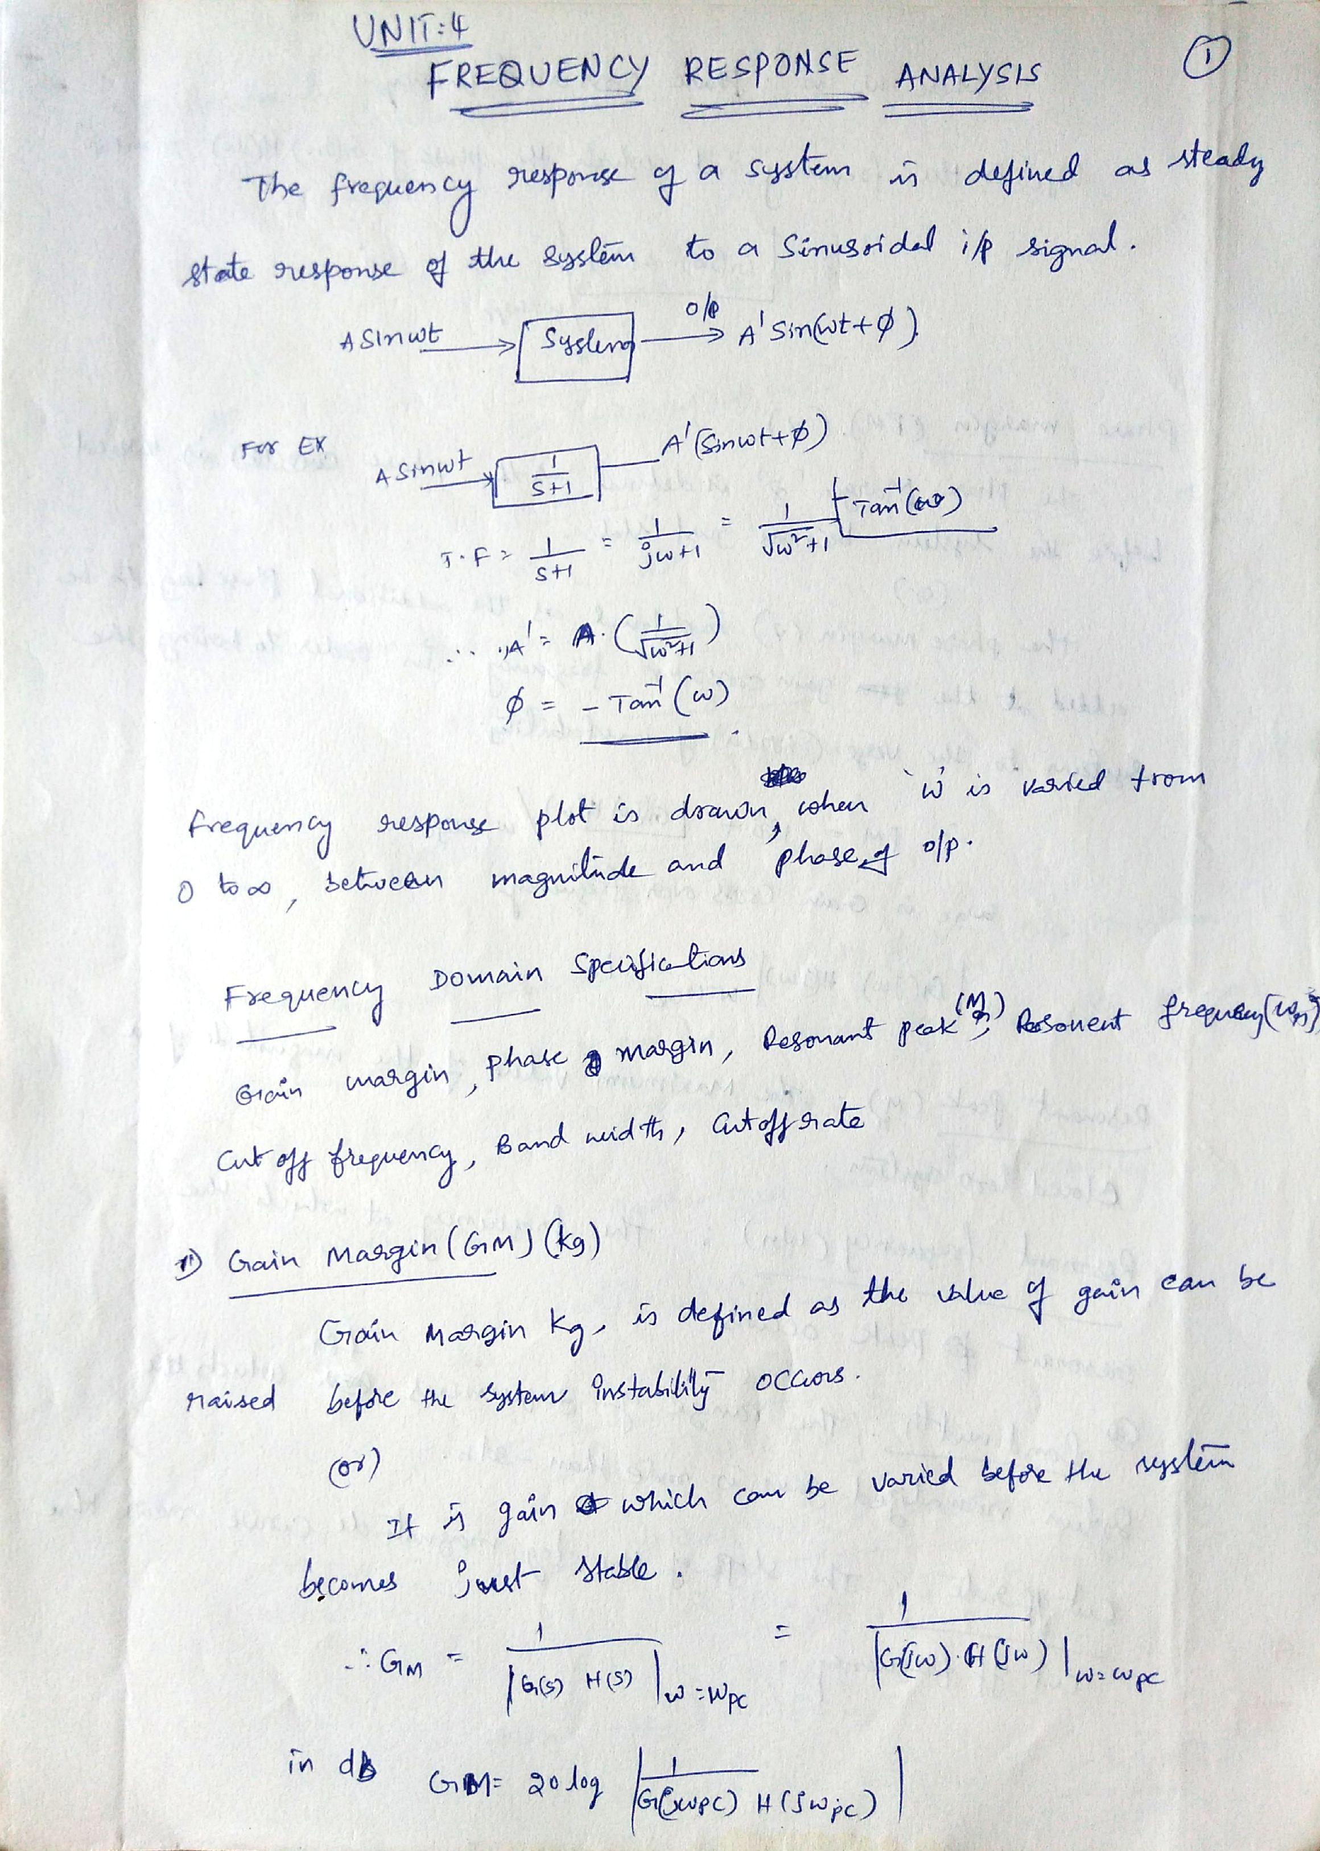

Scanned by CamScanner

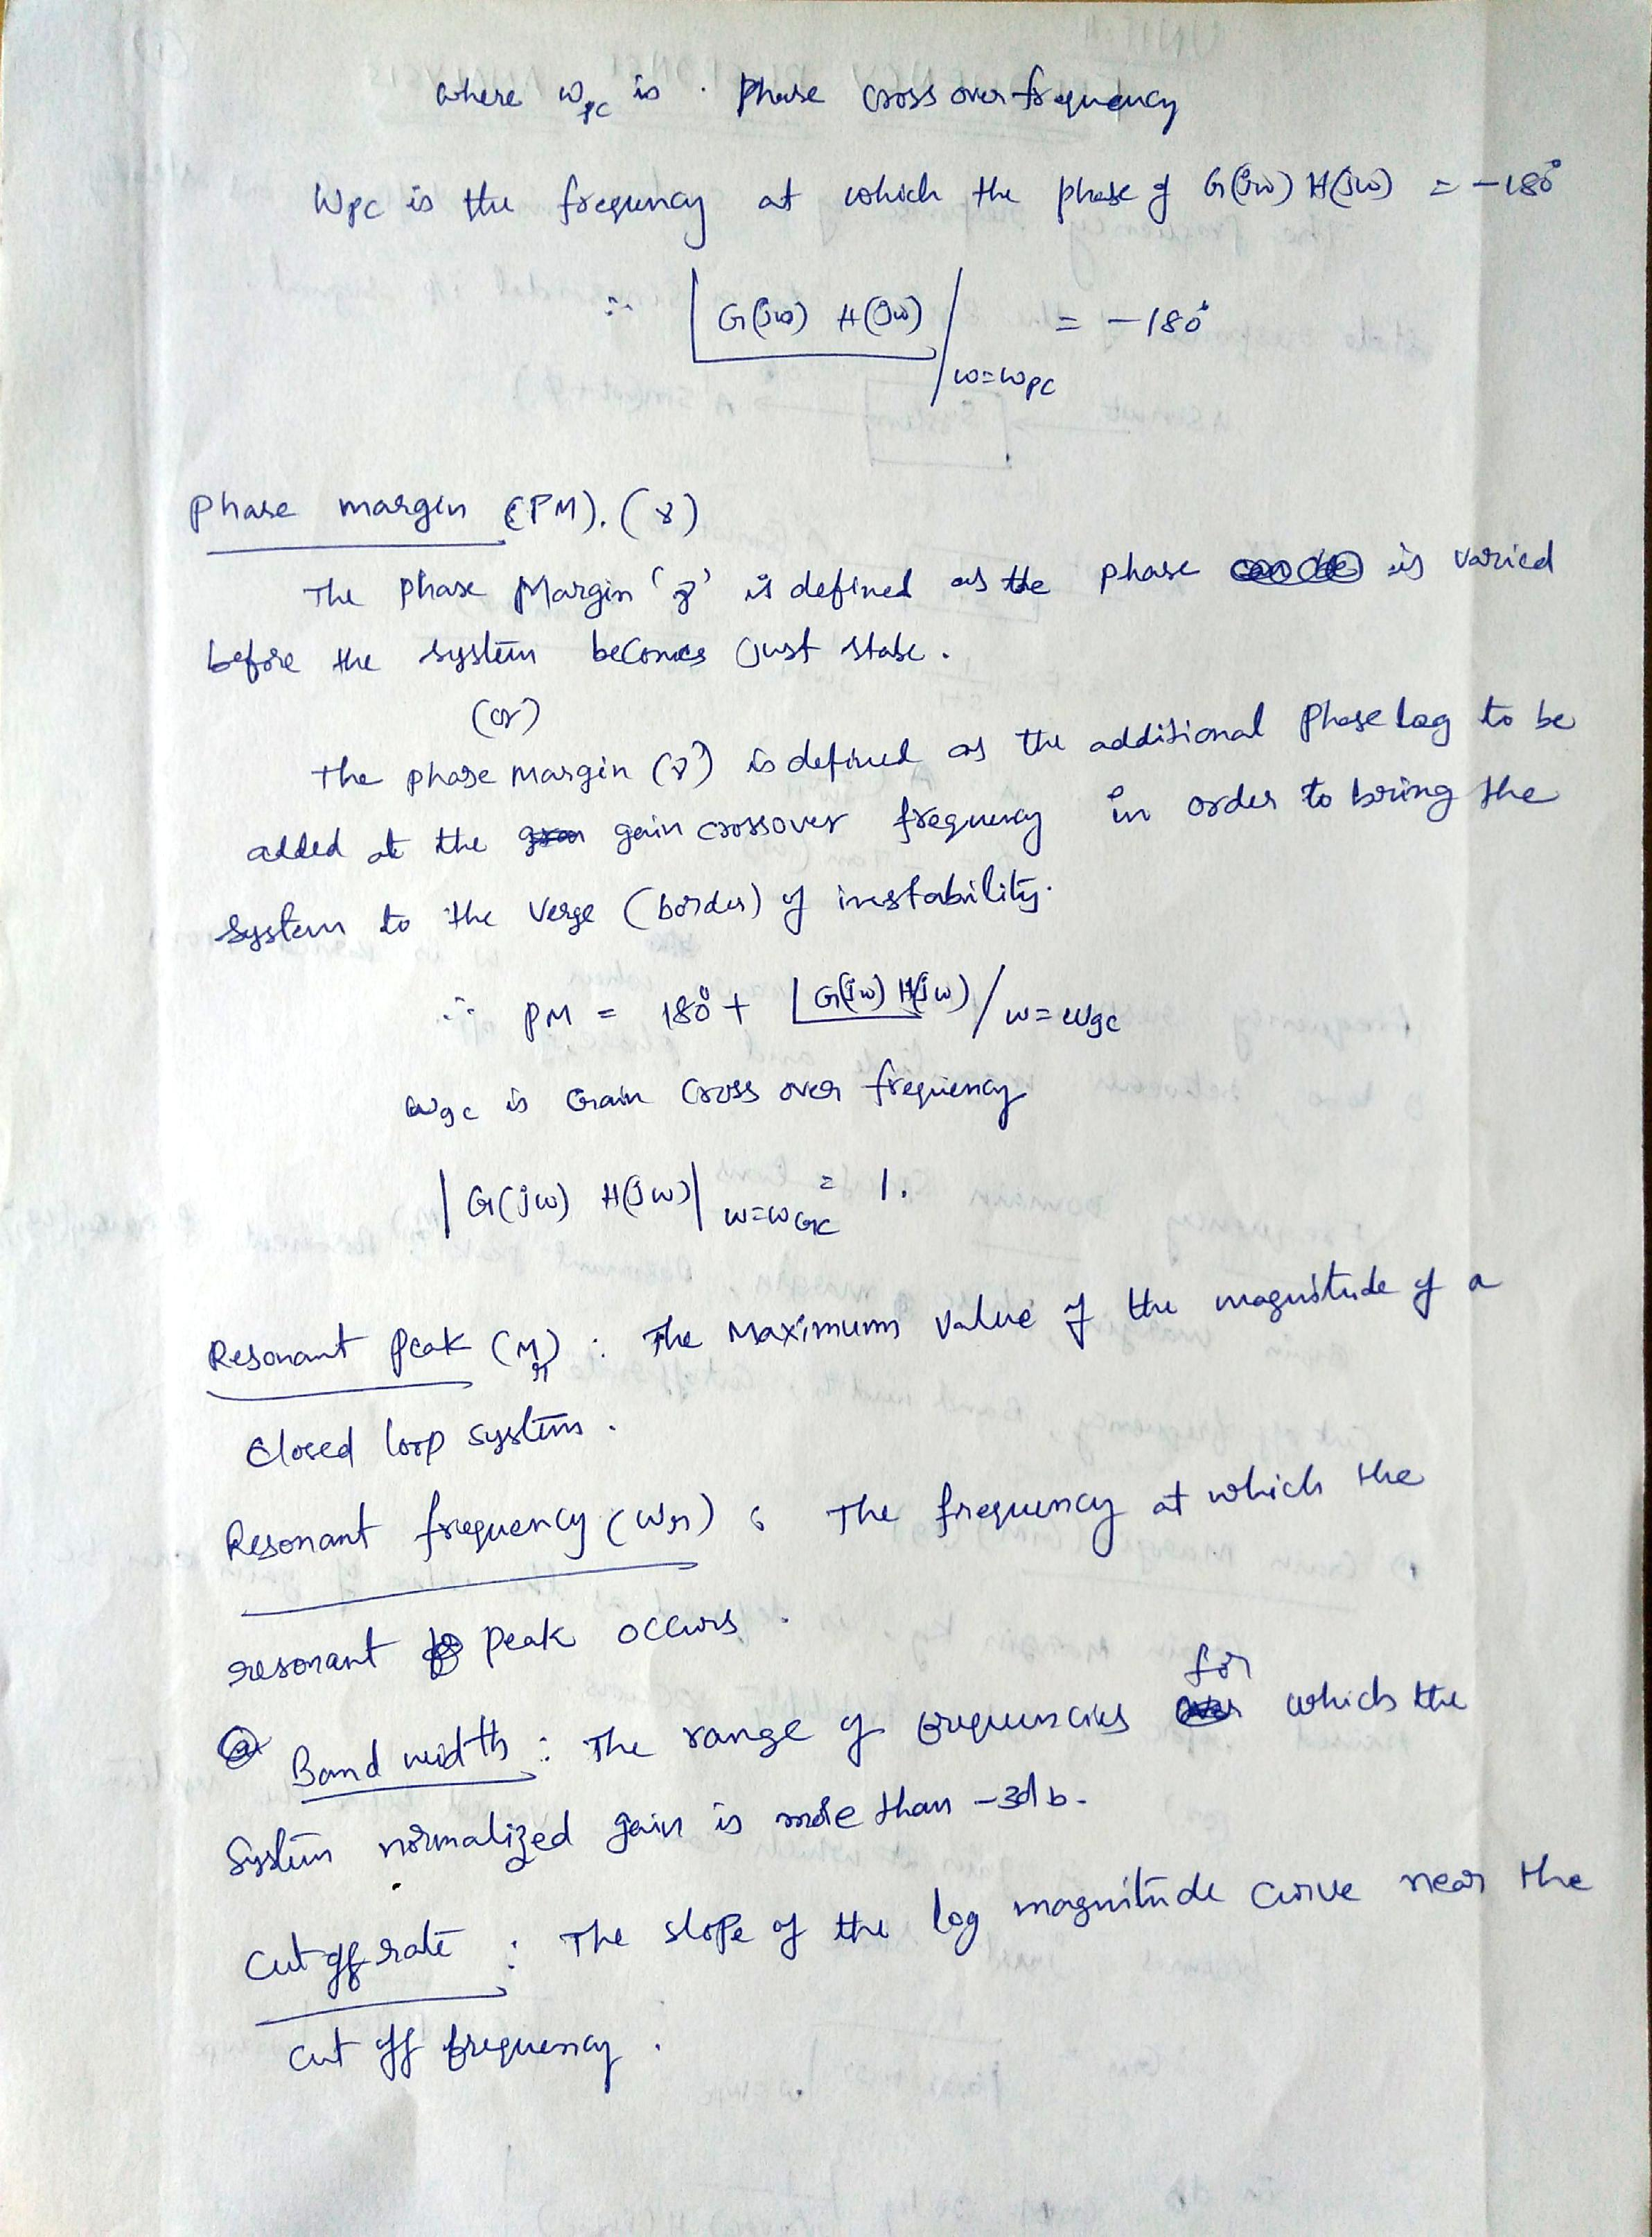

Scanned by CamScanner

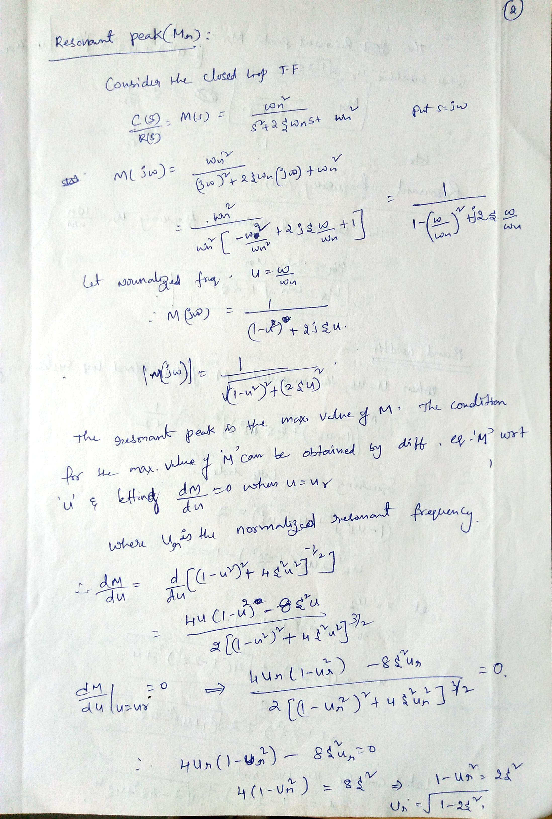

Scanned by CamScanner

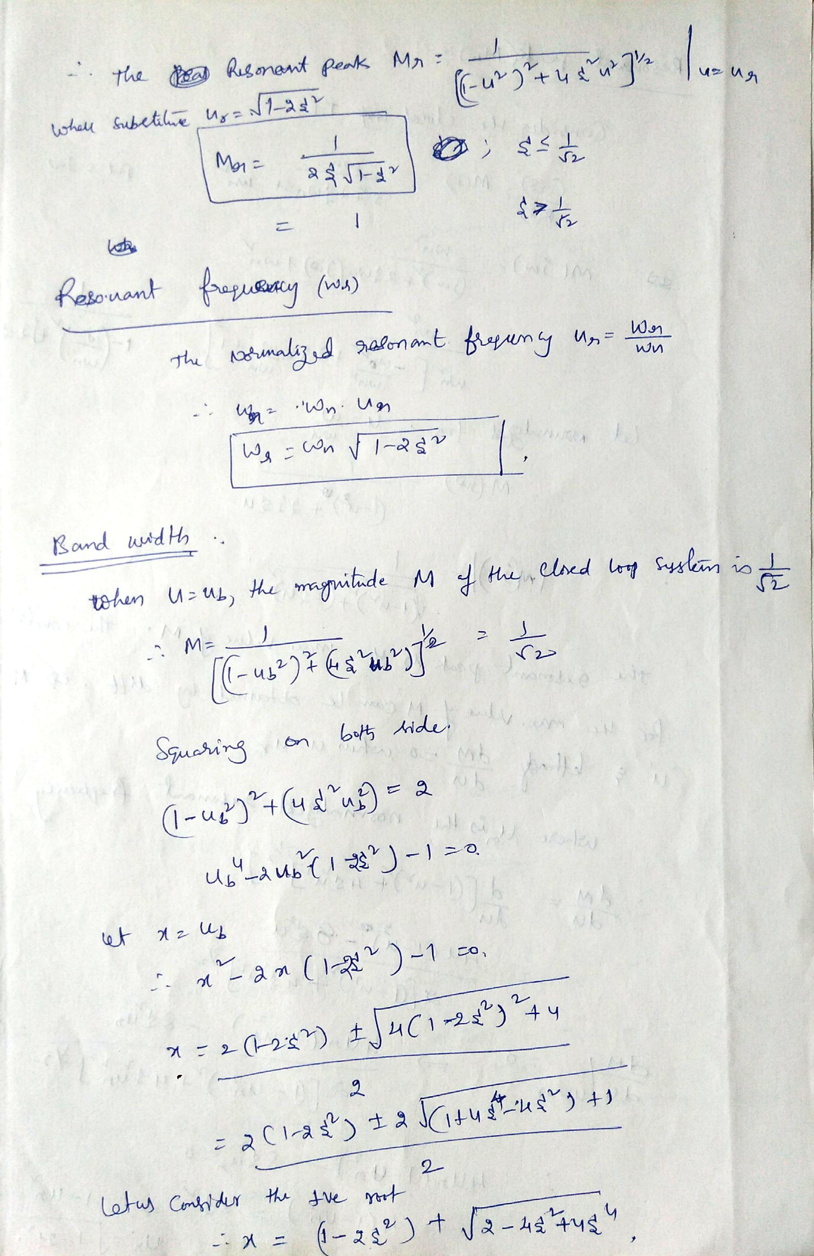

Scanned by CamScanner

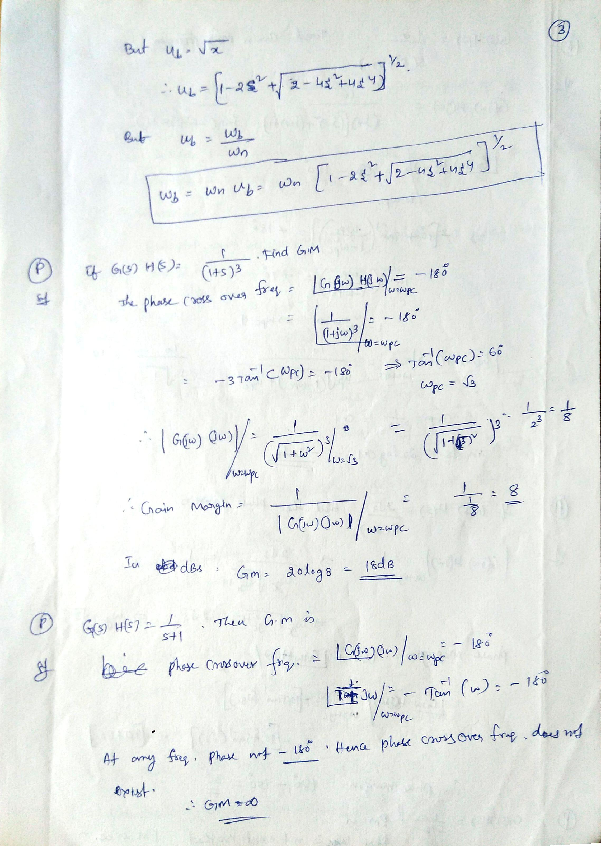

Scanned by CamScanner

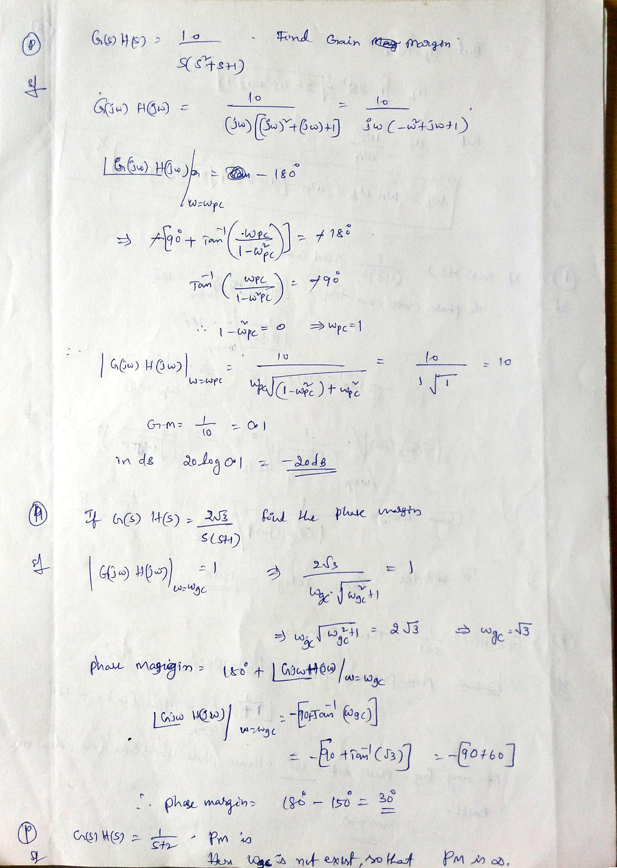

Scanned by CamScanner

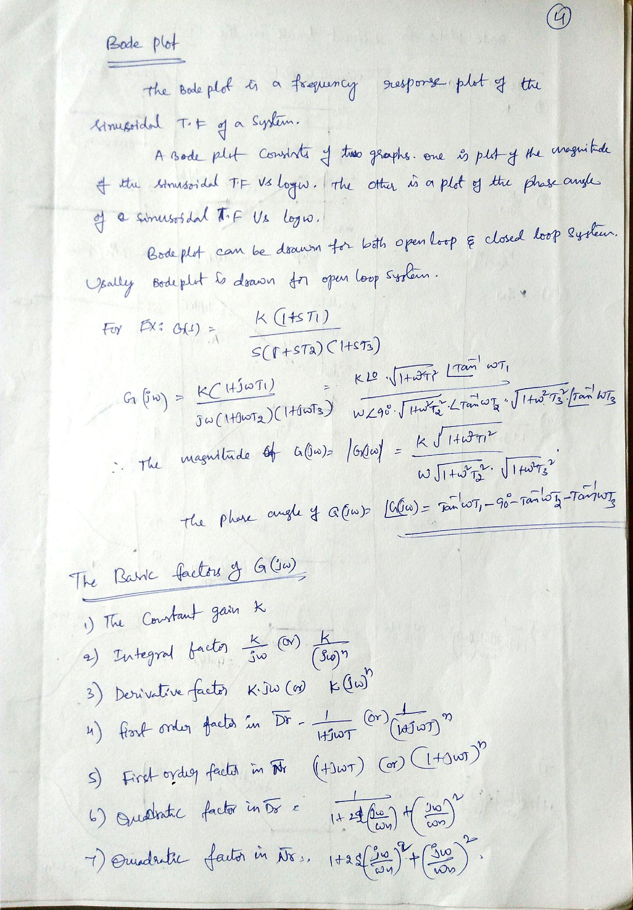

Scanned by CamScanner

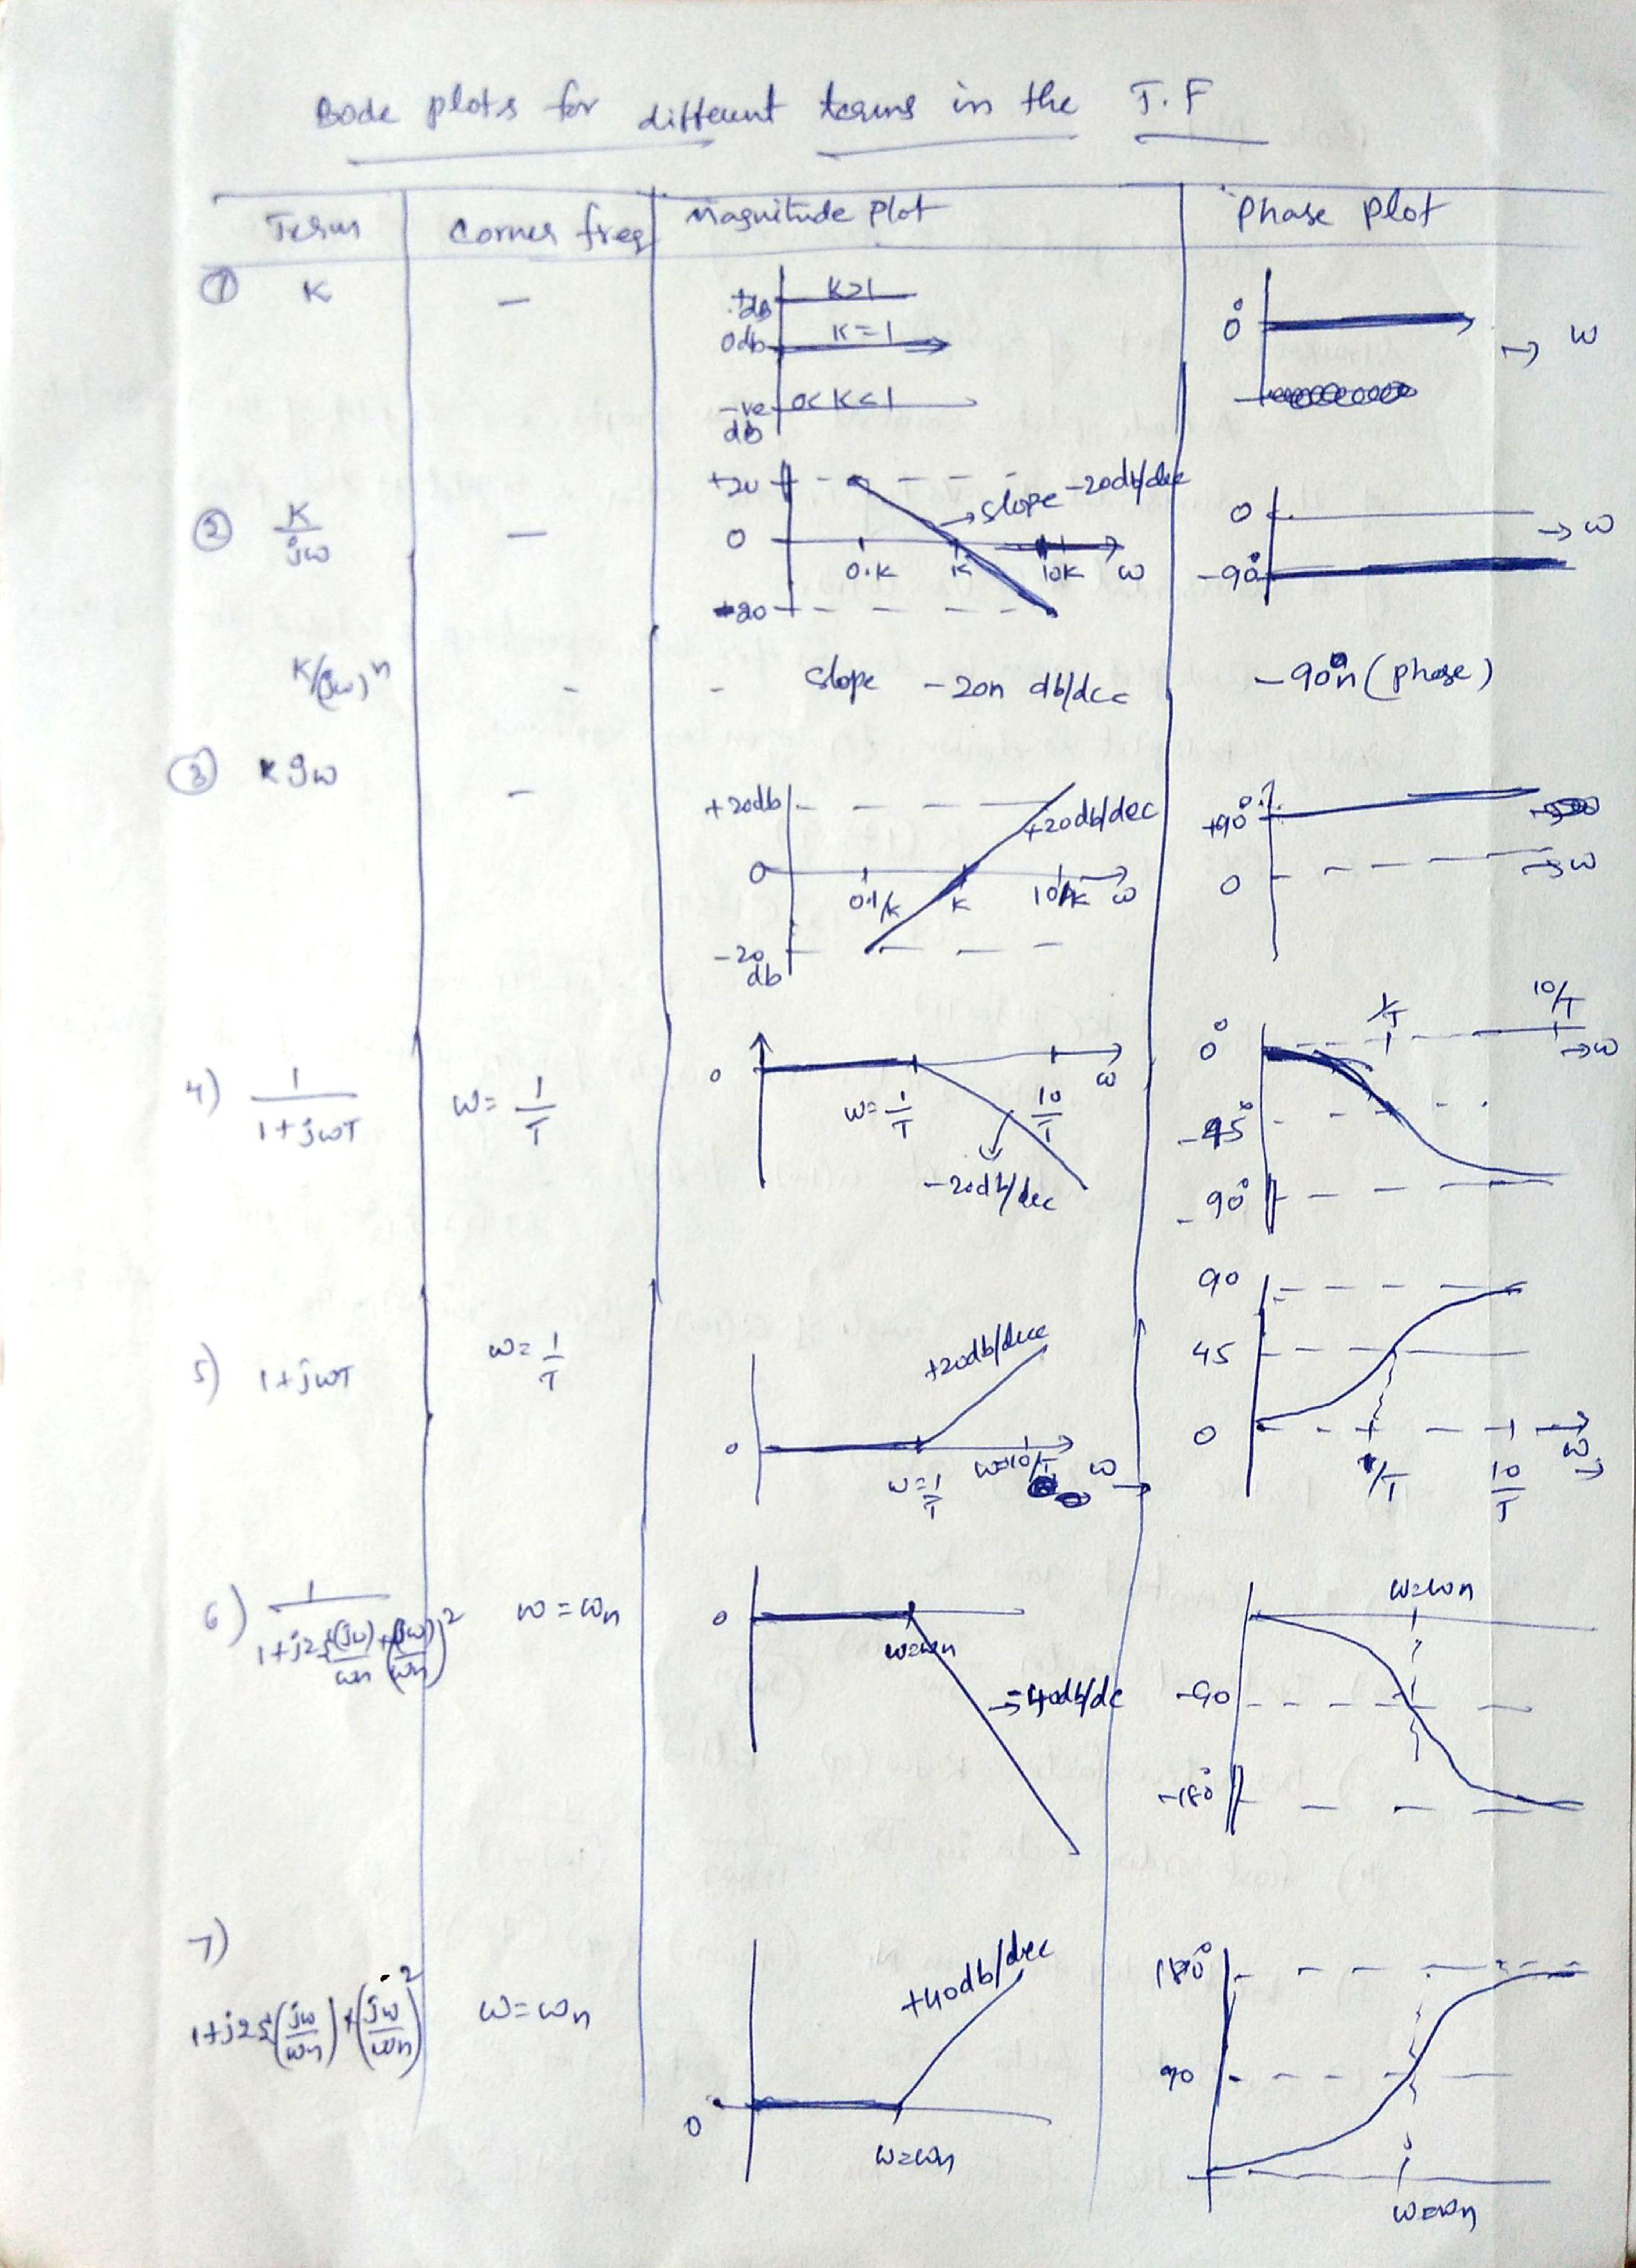

Scanned by CamScanner

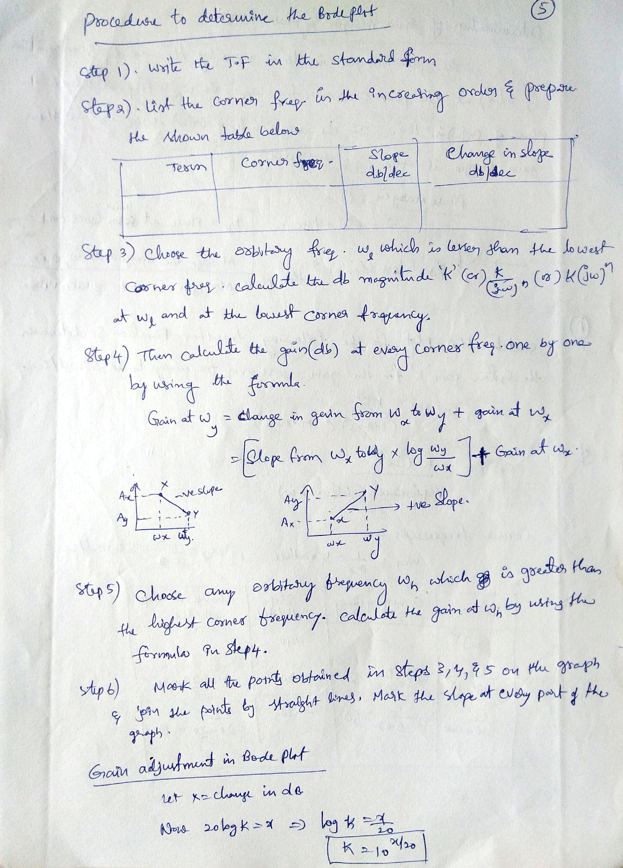

Scanned by CamScanner

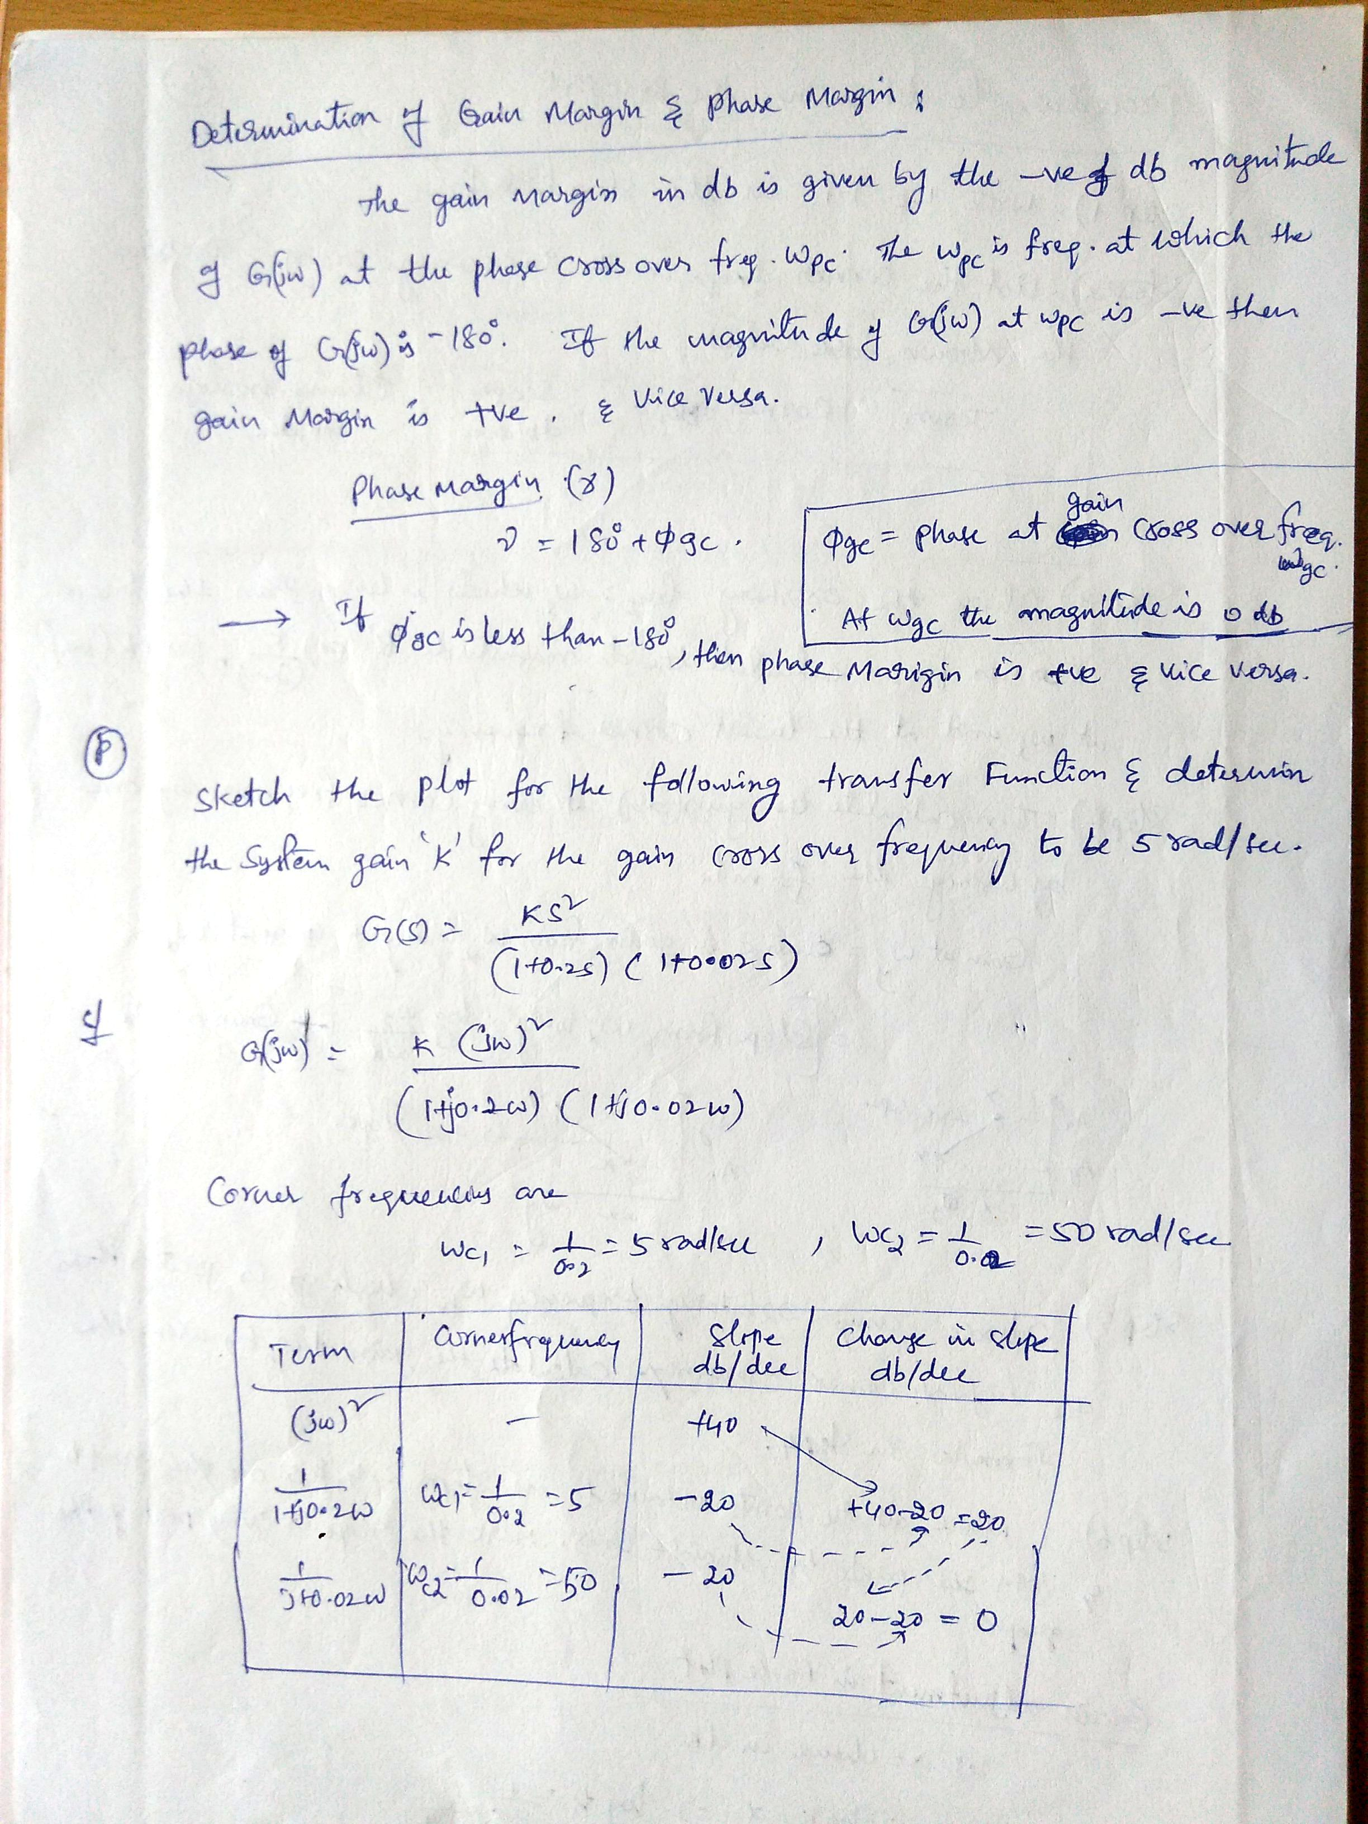

Scanned by CamScanner

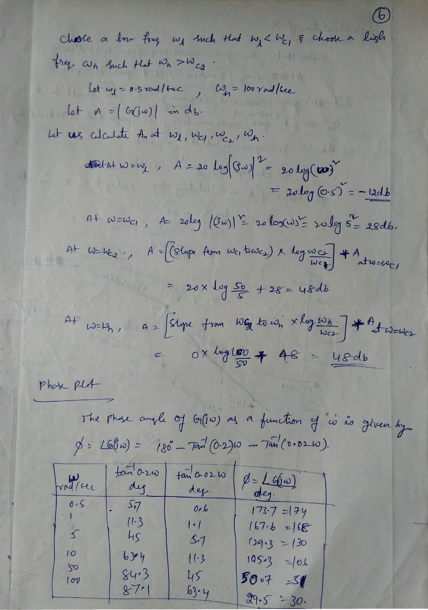

Scanned by CamScanner

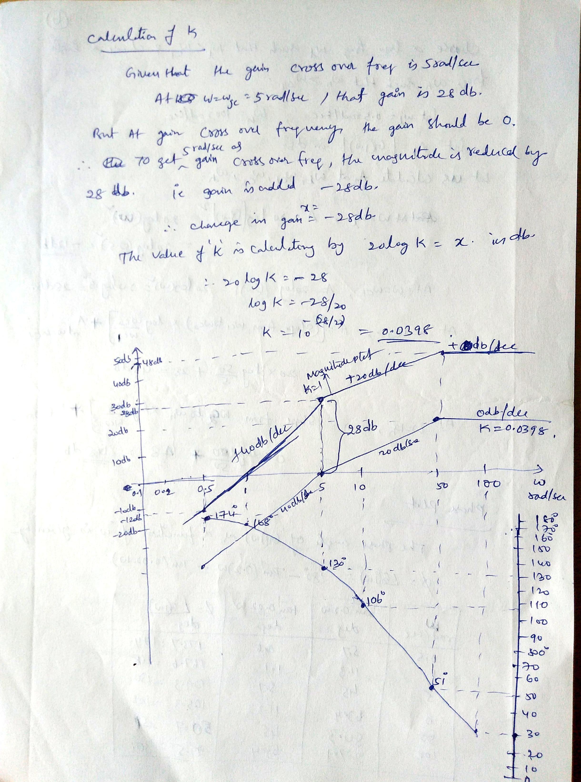

Scanned by CamScanner

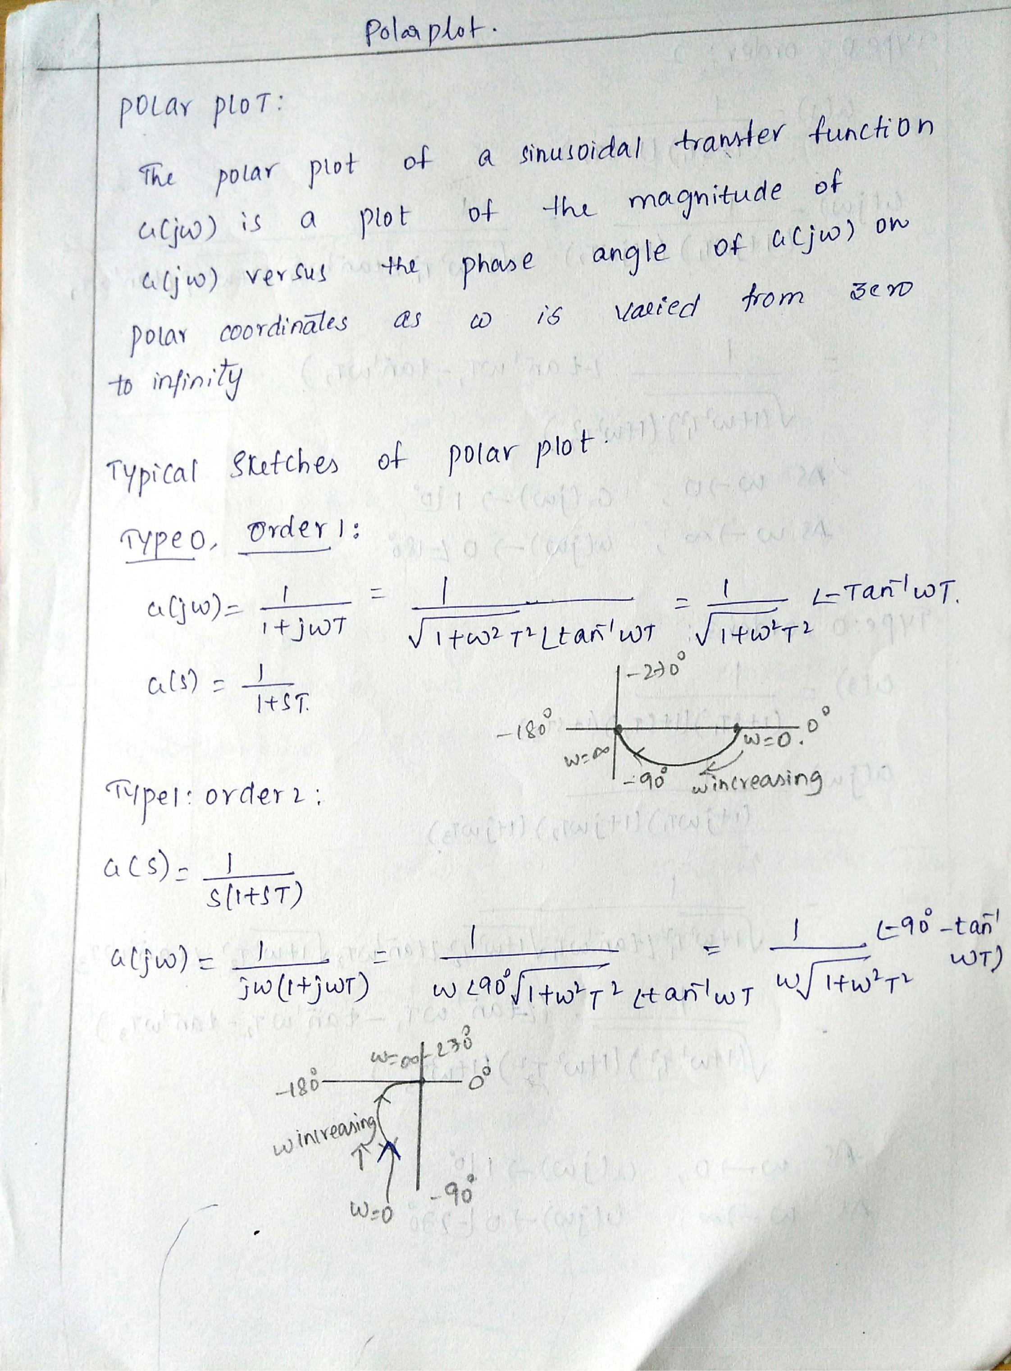

Scanned by CamScanner

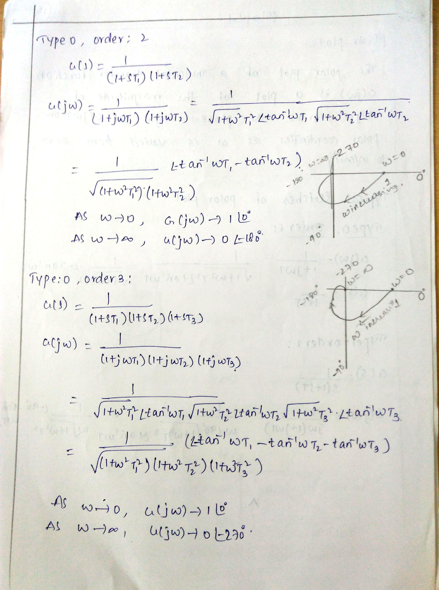

Scanned by CamScanner

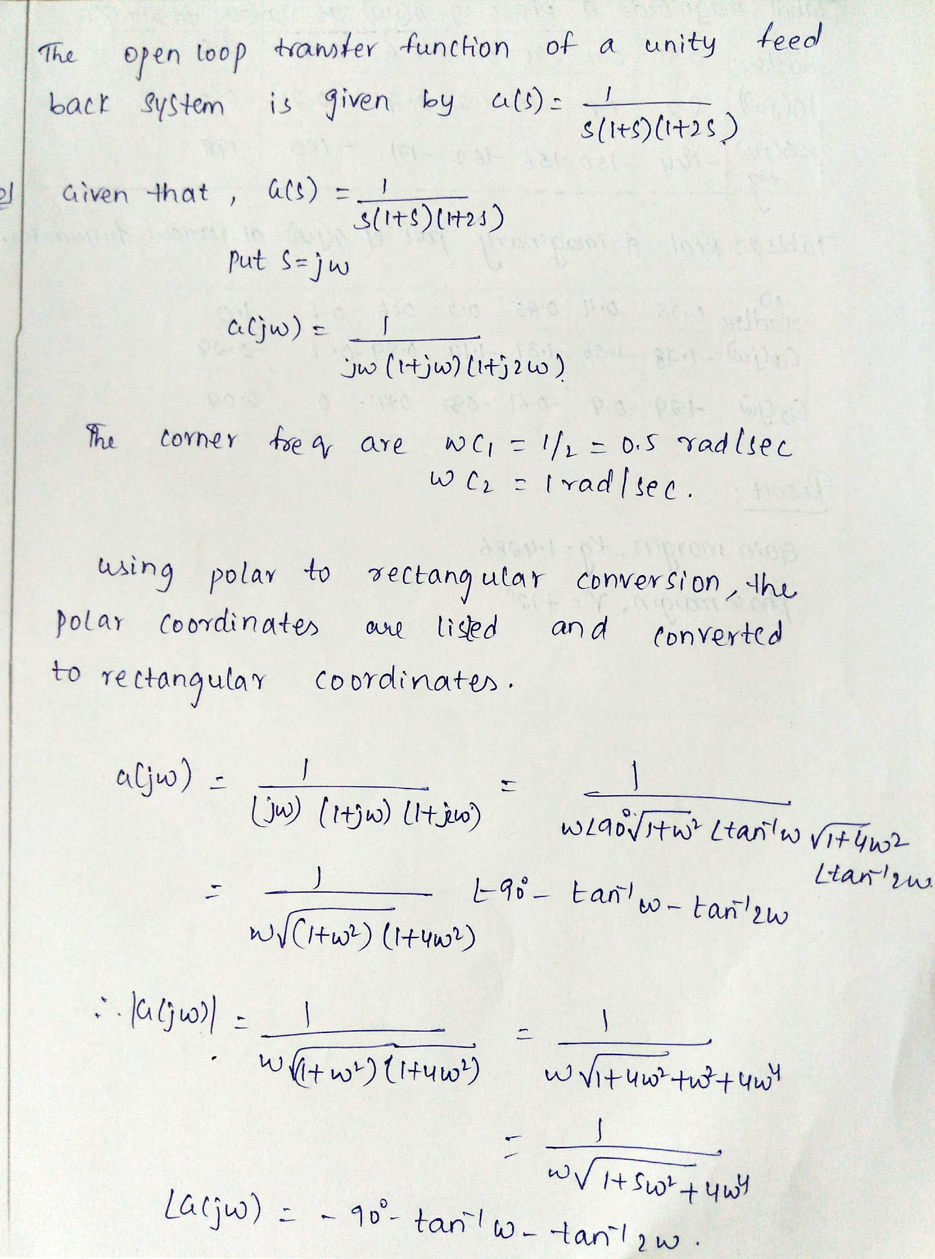

Scanned by CamScanner

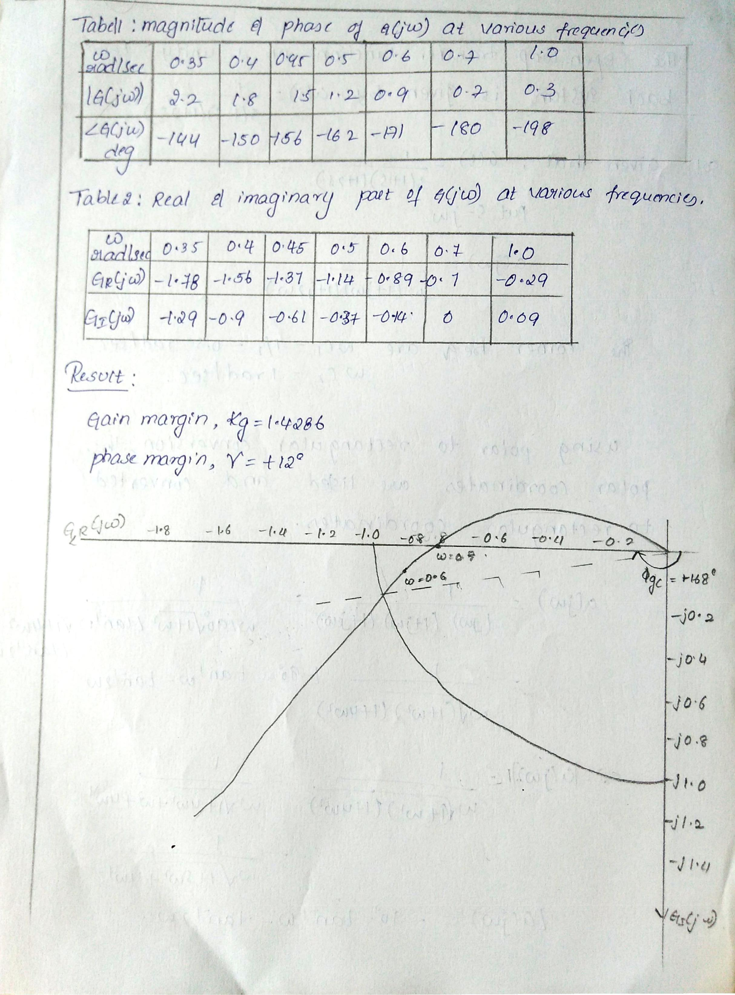

Scanned by CamScanner

UNIT-V
STATE SPACE ANALYSIS
Concept of State and State variables:
State: The State of a system is a mathematical structure consisting of a set of a n time- dependent variables x₁(t), x₂(t). . . x_{n}(t) referred as state variables.
The system inputs U_{j}(t) to-gether with the initial conditions of the state variables x₁(0), x₂(0), ..x_{n}(0) are sufficient to uniquely define the system’s future response.
Input U₁(t) y₁(t)
Controlled
System
State variables

Variables U₂(t) y₂(t) Output variables

U_{m}(t) y_{p}(t)

x₁(t) x₂(t) x_{n}(t)
State variables

x₁(t), x₂(t). . . x_{n}(t) State variables
U₁(t), U₂(t)… U_{n}(t) Inputs
y₁(t), y₂(t)… y_{n}(t) Outputs U₁(t)
U(t) = $\left\lfloor \begin{matrix}U_{1} \\ U_{2} \\ {\begin{aligned}. \\ . \\ U\end{aligned}}_{m}\end{matrix}\right\rfloor$ , y(t) = $\left\lfloor \begin{matrix}y_{1} \\ y_{2} \\ {\begin{aligned}. \\ . \\ y\end{aligned}}_{p}\end{matrix}\right\rfloor$ , x(t) = $\left\lfloor \begin{matrix}x_{1} \\ x_{2} \\ {\begin{aligned}. \\ . \\ x\end{aligned}}_{n}\end{matrix}\right\rfloor$
$\dot{X}$ = A X + Bu is a state equation, y(t) = C X +D u is output equation
Where A is n x n matrix, B is n x p matrix, C is m x n matrix and D is m x n matrix

STATE TRANSISITION MATRIX
$\dot{X}$ = A X Is a linear homogenous state equation
Let φ(t) be n x n matrix which satisfies $\frac{d}{dt}$ φ(t) = A φ(t), the φ(t) is called state transition matrix
Then solution to state homogenous equation is X(t) = φ(t) X(0) where X(0) is initial state at t = 0
Taking the Laplace transforms to State homogenous equation then
$\dot{X}$ = A X
S X(S) – x(0) = A X(S)
X(S) $\left[S I - A X(S)\right]$ = X(0)
X(S) = $\left[S I - A \right]$⁻¹ X(0) then x(t) = L⁻¹$\left[S I - A \right]$⁻¹ X(0)
Alternative solution is x(t) = e^{At}x(0), e^{At} = I + At + $\frac{1}{2!}$ A² t² ⁺ $\frac{1}{3!}$ A³ t³ + . . .
Solution of state equation is $\frac{d}{dt}$ e^{At} = A e^{At} then
State transition matrix is φ(t) = e^{At} = I + At + $\frac{1}{2!}$ A² t² ⁺ $\frac{1}{3!}$ A³ t³ + . . .

Properties of State transition matrix:
- φ(0) = I
Proof: φ(t) = e^{At} = I + At + $\frac{1}{2!}$ A² t² ⁺ $\frac{1}{3!}$ A³ t³ + . . . at t = 0 φ(0) = I
- φ⁻¹(t) = φ(-t)
Proof: φ(t) = e^{At} , φ⁻¹(t) = e^{-At} and φ(-t) = e^{-At} therefore φ⁻¹(t) = φ(-t)

- φ(t₂ – t₁) φ(t₁ – t₀) = φ(t₂ – t₀) for any t₀, t₁, t₂

Proof: φ(t₂ – t₁) φ(t₁ – t₀) = e^{A(t2 – t1)} e^{A(t1 – t0)} = e^{A(t2 – t0)} = φ(t₂ – t₀)

Solution to State transition equation:
State transition equation is $\frac{d}{dt}$ X(t) = A X(t) + Br(t)
Taking Laplace transform S X(S) – x(0) = A X(S) + BR(S)
S X(S) – A X(S) = x(0) + B R(S)
X(S) (SI - A) = x(0) + B R(S)
X(S) = (SI - A)⁻¹ x(0) + (SI - A)⁻¹ B R(S)
(using the convolution integral c(t) = $\int_{0 }^{t}{r\left(τ\right)g \left(t-τ\right)dτ}$ )
X(t) = φ(t) x(0) + $\int_{0 }^{t}{ φ\left(t-τ\right)B r \left(t\right)dτ}$ for t 0
Problem: Obtain the solution to a given state equation
$\left[\begin{matrix}\dot{x_{1}} \\ \dot{x_{2}}\end{matrix}\right]$ = $\left[\begin{matrix}0 & 1 \\ -2 & -3\end{matrix}\right]$ $\left[\begin{matrix}x_{1} \\ x_{2}\end{matrix}\right]$ + $\left[\begin{matrix}0 \\ 1\end{matrix}\right] r(t)$ Where A = $\left[\begin{matrix}0 & 1 \\ -2 & -3\end{matrix}\right]$, B = $\left[\begin{matrix}0 \\ 1\end{matrix}\right]$ are co-efficient matrix
S I – A = $\left[\begin{matrix}S & 0 \\ 0 & S\end{matrix}\right]$ - $\left[\begin{matrix}0 & 1 \\ -2 & -3\end{matrix}\right]$ = $\left[\begin{matrix}S & -1 \\ 2 & S+3\end{matrix}\right]$
$\left[S I – A \right]$⁻¹ = $\frac{1}{S^{2 }+3S+2 }$ $\left[\begin{matrix}S+3 & 1 \\ -2 & S\end{matrix}\right]$ = $\left[\begin{matrix}\frac{S+3}{S^{2 }+3S+2} & \frac{1}{S^{2 }+3S+2} \\ \frac{-2}{S^{2 }+3S+2} & \frac{S}{S^{2 }+3S+2}\end{matrix}\right]$ =
State transition matrix φ(t) = L⁻¹ $\left[S I – A \right]$⁻¹ = L⁻¹ $\left[\begin{matrix}\frac{S+3}{S^{2 }+3S+2} & \frac{1}{S^{2 }+3S+2} \\ \frac{-2}{S^{2 }+3S+2} & \frac{S}{S^{2 }+3S+2}\end{matrix}\right]$
= L⁻¹ $\left[\begin{matrix}\frac{2}{S+1}- \frac{1}{S+2} & \frac{1}{S+1}-\frac{1}{S+2} \\ \frac{-2}{S+1}+\frac{2}{S+2} & \frac{-1}{S+1}+ \frac{2}{S+2}\end{matrix} \right]$
= $\left[\begin{matrix}2e^{-t}-e^{-2t} & e^{-t}-e^{-2t} \\ -2e^{-t}+2e^{-2t} & -e^{-t}+2e^{-2t}\end{matrix}\right]$
We know X(t) = φ(t) x(0) + $\int_{0 }^{t}{ φ\left(t-τ\right)B r \left(t\right)dτ}$ for t 0
X(t) =$\left[\begin{matrix}2e^{-t}-e^{-2t} & e^{-t}-e^{-2t} \\ -2e^{-t}+2e^{-2t} & -e^{-t}+2e^{-2t}\end{matrix}\right]$X(0₊) +$\int_{0}^{t}{\left[\begin{matrix}2e^{-(t-τ)}-e^{-2(t-τ)} & e^{-(t-τ)}-e^{-2(t-τ)} \\ -2e^{-(t-τ)}+2e^{-2(t-τ)} & -e^{-(t-τ)}+2e^{-2(t-τ)}\end{matrix}\right]}$ $\left[\begin{matrix}0 \\ 1\end{matrix}\right]$d$τ$
X(t) = $\left[\begin{matrix}2e^{-t}-e^{-2t} & e^{-t}-e^{-2t} \\ -2e^{-t}+2e^{-2t} & -e^{-t}+2e^{-2t}\end{matrix}\right]$X(0₊) + $\left[\begin{matrix}\frac{1}{2}-e^{-t}+\frac{1}{2} e^{-2t} \\ e^{-t}-e^{-2t}\end{matrix}\right]$ for t 0 is the solution
Derive The Expression for the Transfer Function from the State Model :
$\dot{X}$ = A X + Bu is a state equation, y(t) = C X +D u is output equation
$\dot{X}$ = A X + Bu
S X(S) – X(0) = A X(S) + B U(S)
(S I – A) X(S) = X(0) + B U(S)
X(S) = $\left[S I – A \right]$⁻¹ X(0) + $\left[S I – A \right]$⁻¹ B U(S)
Y = CX + D U
Y(S) = C X(S) + D U(S) = C $\left[S I – A \right]$⁻¹ B U(S) + D U(S) Assuming zero initial conditions
Y(S) = C $\left[S I – A \right]$⁻¹ B U(S) + D U(S)
$\frac{Y(S)}{U(S)}$ = Transfer Function = C $\left[S I – A \right]$⁻¹ B + D
Determine the State Controllability and Observability of the system described by
$\dot{X}$ = $\left[\begin{matrix}-3 & 1 & 1 \\ -1 & 0 & 1 \\ 0 & 0 & 1\end{matrix}\right]$ X + $\left[\begin{matrix}0 & 1 \\ 0 & 0 \\ 2 & 1\end{matrix}\right]$ U , Y = $\left[\begin{matrix}0 & 0 & 1 \\ 1 & 1 & 0\end{matrix}\right]$X
Controllability Q_{c} = $\left\lceil B: AB: A^{2}B\right\rceil$ The determinant should be non-zer0 then it is controllable
Observability T = $\left[C^{T}: A^{T}C^{T}: A^{T}(A^{T}C^{T} ) \right]$ For observability the Determinant Should be Non-Zero then it is observable.
To check the controllability Calculate B, AB and $A^{2}B$
B = $\left[\begin{matrix}0 & 1 \\ 0 & 0 \\ 2 & 1\end{matrix}\right]$, AB = $\left[\begin{matrix}-3 & 1 & 1 \\ -1 & 0 & 1 \\ 0 & 0 & 1\end{matrix}\right] \left[\begin{matrix}0 & 1 \\ 0 & 0 \\ 2 & 1\end{matrix}\right]$= $\left[\begin{matrix}2 & -2 \\ 2 & 0 \\ 2 & 1\end{matrix}\right]$ , $A^{2}B= \left[\begin{matrix}-3 & 1 & 1 \\ -1 & 0 & 1 \\ 0 & 0 & 1\end{matrix}\right] \left[\begin{matrix}2 & -2 \\ 2 & 0 \\ 2 & 1\end{matrix}\right]$ = $\left[\begin{matrix}-2 & 5 \\ 0 & 3 \\ 2 & 1\end{matrix}\right]$
Q_{c} = $\left[\begin{matrix}0 & 1 & 2 \\ 0 & 0 & 2 \\ 2 & 1 & 2\end{matrix}\begin{matrix} -2 & -2 & 5 \\ 0 & 0 & 3 \\ 1 & 2 & 1\end{matrix}\right]$ Rank of Q_{c} is 3. Therefore it is controllable
To check the observability Calculate $C^{T},$ $A^{T}C^{T}$and $A^{T}(A^{T}C^{T} )$
A = $\left[\begin{matrix}-3 & 1 & 1 \\ -1 & 0 & 1 \\ 0 & 0 & 1\end{matrix}\right] and$ C = $\left[\begin{matrix}0 & 0 & 1 \\ 1 & 1 & 0\end{matrix}\right]$
$C^{T}=$= $\left[\begin{matrix}0 & 1 \\ 0 & 1 \\ 1 & 0\end{matrix}\right]$, $A^{T}= \left[\begin{matrix}-3 & -1 & 0 \\ 1 & 0 & 0 \\ 1 & 1 & 1\end{matrix}\right]$ , $A^{T}C^{T}$= $\left[\begin{matrix}0 & -4 \\ 0 & 1 \\ 1 & 2\end{matrix}\right]$
$A^{T}(A^{T}C^{T} )$ = $\left[\begin{matrix}-3 & -1 & 0 \\ 1 & 0 & 0 \\ 1 & 1 & 1\end{matrix}\right]$ $\left[\begin{matrix}0 & -4 \\ 0 & 1 \\ 1 & 2\end{matrix}\right]$ = $\left[\begin{matrix}0 & -11 \\ 0 & -4 \\ 1 & -1\end{matrix}\right]$
T = $\left[C^{T}: A^{T}C^{T}: A^{T}(A^{T}C^{T} ) \right]$ = $\left[\begin{matrix}0 & 1 \\ 0 & 1 \\ 1 & 0\end{matrix} \begin{matrix}0 & -4 \\ 0 & 1 \\ 1 & 2\end{matrix} \begin{matrix}0 & -11 \\ 0 & -4 \\ 1 & -1\end{matrix} \right]$
Rank of T is three. Therefore the system is observable.
Problem: For a given differential equation 5 $\frac{d^{3} x}{dt}$ ${+3\frac{d^{2} x}{dt} +2\frac{d^{ } x}{dt} +x=3u(t)}^{ }$
Let X₁ = X, X₂ = $\dot{X},$X₃ = $\ddot{X}$
X₁ = X, $\dot{X_{1}}$ = X_{2,} $\dot{X_{2}}$ = X₃
$\dot{X_{3}}$ = -1/5 X₁ -2/5 X₂ – 3/5 X₃ + 3 then $\left[\begin{matrix}\dot{X_{1}} \\ \dot{X_{2}} \\ \dot{X_{3}}\end{matrix}\right]$= $\left[\begin{matrix}0 & 1 & 0 \\ 0 & 0 & 1 \\ -1/5 & -2/5 & -3/5\end{matrix}\right]\left[\begin{matrix}X_{1} \\ X_{2} \\ X_{3}\end{matrix}\right]$ = $\left[\begin{matrix}0 \\ 0 \\ 3\end{matrix}\right]$ u(t) is the state model
And coefficient matrix are A = $\left[\begin{matrix}0 & 1 & 0 \\ 0 & 0 & 1 \\ -1/5 & -2/5 & -3/5\end{matrix}\right]$ , B = $\left[\begin{matrix}0 \\ 0 \\ 3\end{matrix}\right]$
Block diagram representation is given below:
3
1/s
-1/5
-2/5
-3/5
1/s
1/s
U(t) + $\dot{X_{3}}$ $\dot{X_{2}}$ $\dot{X_{1}}$ X₁
+
+
+

