UNIT-1: INTRODUCTION TO ELECTRICAL CIRCUITS

Q1. Define ideal voltage source.
Ans. In ideal conditions the voltage across a voltage source should be
constant for whatever current delivered by the source.

Q2. Define ideal current source.
Ans. It should deliver constant current for whatever voltage across its
terminals.

Q3. What are ideal elements?
Ans.The ideal elements are resistors which oppose the flow of current, the
inductor opposes to change in current. Capacitor offers only opposition to
change in voltage.

Q4. Define energy.
Ans. It is the capacity to do work. Unit is Joule.

Q5. Define charge.
Ans. It is the characteristic property of the elementary particles of the
matter.

Q6. What is meant by source transformation?
Ans. The voltage source can be converted in to equivalent practical current
source and vice versa with same terminal behavior.

Q7. Define Ohms Law.
Ans. The potential difference across any two ends of a conductor is directly
proportional to the current flowing between the two ends provided the temperature
of the conductor remains constant.

Q8. Define KCL
Ans. Kirchhoff’s current law:
It states that the sum of currents entering into any point is equal to the sum of the currents leaving that point.

Q9. Define KVL.
Ans. Kirchhoff’s voltage law:
It states that the algebraic sum of voltages around any closed path in a circuit is always zero.

Q10. Define power.
Ans. It is the rate at which work is done. Unit of power is watts.

Q11. What is meant by linear and nonlinear elements?
Ans. Linear elements shows linear characteristic of voltage Vs Current.
Nonlinear element the Current passing through it does not change linearly with the
linear change in applied voltage at a particular frequency.

Q12. What is meant by active and Passive elements?
Ans. Energy sources (voltage or current sources) are active elements, capable of delivering power to some external device. The passive elements are those which are capable only of receiving power.

Q13. What are Unilateral and bi lateral elements ?
Ans. In the bilateral element, the voltage - current relation is the same for current flowing in either direction. In contrast, a unilateral element has different relations between voltage and current for the two possible directions of current.

Q14. What are linear and nonlinear elements?
Ans. An element is said to be linear, if it satisfies the linear voltage current relationship. That means the current through the element is multiplied by some constant ‘α’, and results in the multiplication of voltage across the element by the same constant.
An element which does not satisfy this relation is called a nonlinear element.

Q15. What do you mean by an electric network and an electric circuit.
Ans. Interconnection of two or more simple circuit elements (voltage sources, resistors, inductors and capacitors) is called an electric network. If a network contains at least one closed path, it is called an electric circuit.

Q16. Classify the network elements
i) Active or passive
ii) Unilateral or bilateral
iii) Linear or non linear
- Lumped or distributed.

Q17. Define lumped and distributed elements in electric circuits.
Ans. The elements which are separated physically are known as lumped elements, like resistors, capacitors and inductors. Distributed elements, on the other hand, are those which are not separable for analytical purposes.

Q18. Write the equations of energy stored by an inductor and capacitor.
Ans. Energy stored by an inductor is,
W = LI2 / 2
I à Current flow through the inductor
Energy stored by a capacitor
W = CV2 / 2
V à Voltage across capacitor

Q19. Mention the disadvantages of Ohm’s Law.
Ans. It does not apply to all non metallic conductors
It also does not apply to non linear devices such as zener diode, vacuum tubes etc.
It is true for metal conductors at constant temperature. If the temperature changes the law is not applicable.

Q20. State voltage division rule.
Ans. Voltage across a resistor in series circuit is equal to the total voltage across the series elements multiplied by the value of that resistor divided by the total resistance of the series elements.

Q21. State current division rule.
Ans.. The current in any branch is equal to the ratio of the opposite parallel branch resistances to the total resistance value, multiplied by the total current in the circuit.

Q22. What is a graph of a network ?
Ans. When all the elements in a network is replaced by lines with circles or
dots at both ends.

Q23. What is tree of a network?
Ans. Tree is a connected sub graph containing all the nodes of the graph not forming a closed loop.

Q24. Properties of a tree in a graph.
• It consist of all the nodes of the graph
• If the graph has N no: of nodes the tree will have N-1 branches
• There will be no closed path in the tree
• There can be many possible different trees for a given graph depending
on the no: of nodes and branches

Q25. What do you mean by a planar and a non planar circuit?
Ans. A circuit is said to be planar, if it can be drawn on a plane surface without crossovers. A non planar circuit cannot be drawn on a plane surface without a crossover.

Q26. What is a node?
Ans. A node is a point in a network in which two or more elements have a common connection.

Q27. What is oriented and unoriented graph?
Ans. Oriented graph is a graph in which the orientations of the branches are known in the given network and the same are transferred on the graph. It is also called as directed graph.
When the direction of the currents are not given in the network and the graph is without such orientations, such a graph is called unoriented graph.

Q28. What is planar and non planar graph?
Ans. A planar graph is a graph drawn on a two dimensional plane so that no two branches intersect at a point which is not a node.
A non-planar graph is a graph drawn on a two dimensional plaine such that two or more branches intersect at a point other than node on a graph.

Q29. What is Rank of a Graph?
Ans. If there exists n number of nodes, then the rank R of a graph is given by the relation
R=(n-1)

Q30. What are twigs?
Ans. A branch of a tree is called twig.
If there are n number of nodes on a graph then the tree of a graph contains (n-1) twigs.

Q31. What is a co-tree?
Ans. A set of branches forming a complement of tree is called cotree.
The number of branches of a cotree (links) is equal to b-(n-1) where b is number of branches of a graph.

Q32. What are the properties of a incidence matrix?
Ans. 1. The sum of the entries in any column is zero.
2. The rank of a complete incidence matrix of a connected graph is (n-1)
3. The determinant of a loop of complete incident matrix is always zero.

Q33.What are the standard conventions to be followed while writing the incidence matrix?
Ans. The standard conventions to be followed wihile writing the incidence matrix are
1. A_{ij}=1 if branch j is associated with node I and oriented away from node i.
2. A_{ij}=-1 if branch j is associated with node I and oriented towards node i.
3. A_{ij}=0 if branch j is not associated with node i.

Q34. Write the steps to be followed while writing a tieset matrix?
Ans. Select a tree.
2. On adding a link to a tree at a time will result in the formation of one fundamental loop.
3. The direction of current in f-loop is selected as the direction of the link current.
4. The no. of f-loops formed will be equal to the no. of links present.
5. Apply KVL to the f-loop formed. These equations can be written in matrix form. The matrix thus obtained is a tie- set matrix.

Q35. Write the loop or mesh or KVL equilibrium equation.
Ans. BZ_{b}B^{T}I_{L}=BV_{s}-BZ_{b}I_{s}

Q36. Write node or KCL equilibrium equation.
Ans. QY_{b}Q^{T}V_{t}=QI_{s}-QY_{b}V_{s}

Q37. How many no of twigs, links are there in a given graph with n no. of nodes?
Ans. No. of twigs =n-1
No of links=b-(n-1)

Q38. How many no of cutsets and tiesets are there in a given graph with n no. of nodes?
Ans. No of cutsets =No. of twigs =n-1
No.of tiesets = No of links=b-(n-1)

Q39. Q14.What are the standard conventions to be followed while writing the incidence matrix?
Ans. The standard conventions to be followed wihile writing the incidence matrix are
1. B_{ij}=1 if branch j is in the f-loop i (loop current) and their directions coincide.
2. B_{ij}=-1 if branch j is in the f-loop i (loop current) and their directions are opposite.
3. B_{ij}=0 if branch j is not associated with node i.

Q40. What is the relation between the branch currents and link currents?
Ans. The relation between the branch currents and link currents is
[I_{b}]=[B^{T}][I_{L}]
Q41. What does series aiding mean.
Ans.When two coils are connected in series the current enters at dotted end
in both the coils and so the self and mutual induced emf will have same
polarity.

Q42. What does series opposing mean.
Ans. When two coils are connected in series the current enters at dotted end
in one coils and leaves at another coil so the self and mutual induced emf will
have opposite polarity.

Q43. What is magnetic coupling.
Ans. It refers to circuits involving elements with magnetic coupling. If the flux
produced by an element of a circuit links other elements of the same circuit then
the elements are said to be magnetic coupling.
Q44. What are coupled coils.
Ans. When two or more coils are linked by magnetic flux, then the coils are
called coupled coils.

Q45. Define self-inductance.
Ans. When permeability is constant the self inductance of a coil is defined as
the ratio of flux linkage and current.

Q46. Define mutual inductance.
Ans. When permeability is constant the mutual inductance between two coupled
coils is defined as the ratio of flux linkage in one coil due to common flux and
current through another coil.

Q47. Define coefficient of coupling.
Ans. In coupled coils the coefficient of coupling is defined as the fraction of the
total flux produced by one coil linking another coil.

Q48. What is DOT convention?
Ans. The sign of mutual induced emf depends on the winding sense and the
current through the coil. The winding sense is decided by the manufacturer and to
inform the user about the winding sense a dot is placed at one end of each coil.
When current enter at dotted end in one coil then the mutual induced emf in the
other coil is positive at dot end.

Q49. State dot rule for coupled coils.
Ans. a. It states that in coupled coils current entering at the dotted terminal of
one coil induce an emf in second coil which is +ve at dotted terminal
of second coil.
b. Current entering at the un dotted terminal of one coil induce an emf in
second coil which is +ve at un dotted terminal of second coil.

UNIT-2: RESONANCE

- What is the total response of the circuit?
Ans. When an input is suddenly applied to the network, the response will undergo transient nature before it settles to the final value. Hence the total response of the circuit can be catogerised into two parts.
- Transient response
- Steady state response.

2. Why transients occurs in electric circuits?
Ans . The inductance will not allow sudden change in current and the capacitance will not allow sudden change in voltage. Hence in inductive and capacitive circuits transient occurs during switching operation.

- What is transient state?
Ans. The state where the circuit response changes due to sudden changes in the input is called transient state i.e., the behavior of voltage and current changes from one state to another state.

- What is steady state?
Ans. A state or condition of a system or process that does not change in time i.e., the voltages and currents does not change with time is called as a steady state. In steady state the amplitude and frequency of a sinusoidal function never changes.

- What is transient time?
Ans. The time taken by the circuit to change from one steady state to another steady state is called as transient time.

- When is the transient behavior observed?
Ans. 1. When the circuit contains energy storage elements like inductors and capacitors.
- When the input of the circuit changes suddenly.

- What is free and forced response.
Ans. The response of the circuit due to stored energy alone is called free response. The response of a circuit due to an external source is called forced response.

- What is complementary function?
Ans. The part of the response which becomes zeroes t tends to infinite is called complementary function.

- What is particular solution?
Ans. The part of the solution which attains a steady value as t tents to infinity is called particular solution.

- How does the inductor and a capacitor act during the steady state ?
Ans. Steady state: Under steady state condition inductor acts as short circuit (V=0)
Under transient state capacitor acts as a open circuit (I=0)

- How does the inductor and a capacitor act during the transient state?
Ans. Steady state: Under steady state condition inductor acts as open circuit (I=0)
Under transient state capacitor acts as a short circuit (V=0)

- What is an inductor?
Ans. Inductor is an element which can store energy in form of magnetic field. Initially charged inductor acts as current source.
Voltage across an inductor:
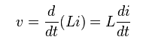
Energy stored in an inductor= ½(LI²)
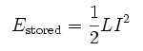
- What is a capacitor?
Ans. Capacitor is an element which can store energy in form of electric field. Initially charged inductor acts as voltage source.
Current equation of a capacitor:
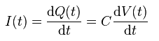
Energy stored in an capacitor= ½ (CV²)

- Define time constant of RL circuit.
Ans. It is defined as the time taken by the current through the inductance to reach steady value if initial rate of rise is maintained. Time constant of RL circuit is г=L/R

- Define time constant of RC circuit.
Ans. The time constant RC circuit is defined as the time taken by the voltage across the capacitance to reach steady value if initial rate of rise is maintained. Г= RC

- What is damping ratio.
Ans. The ratio of resistance of the circuit and resistance for critical damping is called damping ratio.

- What is critical damping.
Ans. It is the condition of the circuit at which the oscillations in the response are just eliminated. This is possible by increasing the value of resistance in the circuit.

- What are initial conditions?
Ans. Initial conditions are those condition that sexists in the circuit immediately after switching operation. At t=0, one or more switches are operated which disturbs the equilibrium of the circuit. The switch is assumed to operate in zero time.
We use t=0- and t=0+. The initial conditions will depend on the past history of the circuit and the network structure immediately after switching operation (t=0+).
After switching at t=0+, the new voltages and currents may appear in the network as the result of the initial capacitor voltages and the initial inductor currents.

Q19. Define quality factor.
Ans. The quality factor is defined as the ratio of maximum energy stored to the
energy dissipated in one period.

Q20. What are half power frequencies?
Ans. In RLC circuits the frequencies at which the power is half the max /min
power are called half power frequencies.

Q 21Define resonance frequency for a series RLC circuit.
Ans. The frequency at which resonance occurs is called the resonant frequency.
fr = 1 / (2π√LC)
L à Inductance of the circuit
C à Capacitance of the circuit

Q22. Write the characteristics of series resonance.
Ans. a) At resonance impedance is mim and equal to resistance therefore current is
max.
b) Before resonant frequency the circuit behave as capacitive circuit and above
resonant frequency the circuit will behave as inductive circuit.
c) At resonance the magnitude of voltage across inductance and capacitance will
be Q times the supply voltage but they are in phase opposition.

Q23. Write the characteristics of parallel resonance.
a) At resonance admittance is min and equal to conductance therefore the current
is min.
b) Below resonant frequency the circuit behave as inductive circuit and above
resonant frequency the circuit behave as capacitive circuit.
c) At resonance the magnitude of current through inductance and capacitance
will be q times the current supplied by the source but they are in phase
opposition.

Q24. What is Band width?
Ans. It is the range of frequencies for which the current or output voltage is equal to 70.7 % of its value at the resonant frequency.
(or)
The frequency band within the limits of lower and upper half
frequency is called Bandwidth.
B.W = f2-f1

Q25. Properties of a series RLC circuit.
• The applied voltage and the resulting current are in phase, which also
means that the p.f of RLC circuit is unity.
• The net reactance is zero at resonance and the impedance does have the
resistive part only.
• The current in the circuit is max: and is V/R amperes
• At resonance the circuit has got minimum impedance and max: current
• Frequency of resonance is given by fr = 1/(2π√LC)

Q26. Properties of a parallel RLC circuit.
• PF is unity
• Current at resonance is (V/(L/RC)) and is in phase with the applied
voltage. The value of current at resonance is minimum.
• Net impedance at resonance is max: & is equal to L/RC
• The admittance is min: and the net susceptance is zero at resonance.

Q27. Give any one application of resonance.
Ans. In the area of communications, the ability of a radio receiver to select a certain frequency, transmitted by a station and to eliminate frequencies from other stations is based on the principle of resonance.

Q28. Define the Q factor of a RLC series circuit.
Ans. The Quality factor, Q, is the ratio of the reactive power in the inductor or capacitor to the true power in the resistance in series with the coil or capacitor.
Q = 2π * (maximum energy stored / energy dissipated per cycle)

Q29. Define Magnification in resonance.
Ans. The ratio of voltage across either L or C to the voltage applied at resonance can be defined as magnification.
Magnification = (VL / V) or (VC / V)

Q30. What is tank circuit?
Ans. The parallel resonant circuit is generally called a tank circuit, because of the fact that, the circuit stores energy in the magnetic field of the coil and in the electric field of the capacitor. The stored energy is transferred back and forth between the capacitor and coil, and vice-versa.

UNIT-3: SINGLE PHASE AC CIRCUITS:

Q1.Obtain the s-domain equivalent for resistor.
Ans. Resistor:
Representation of resistance in time and s-domain are shown in the fig.

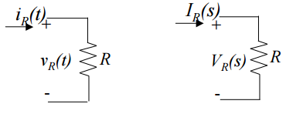
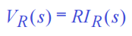

Q2. Obtain the s-domain equivalent for Inductor.
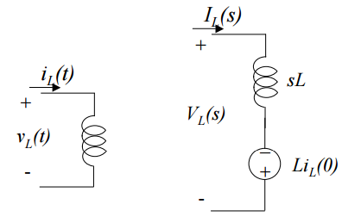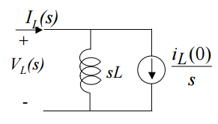

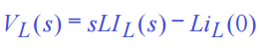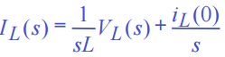

Q3.Obtain the s-domain equivalent for Capacitor.
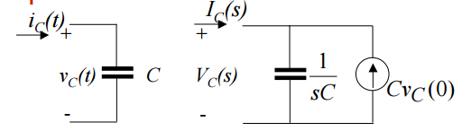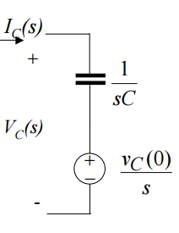

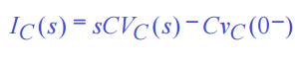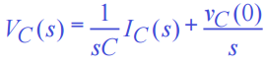

Q4. Write the equation for Instantaneous active power, Average power, Apparent power
Ans.. Instantaneous active power: P(t) = VmIm[Cos(2ωt+θ)+Cos θ] / 2
Average power: Pav = VmIm Cos θ / 2
Apparent power, Papp = Veff Ieff

Q5. Write down few applications of RL, RC and RLC circuits.
Ans. The few applications of RL,RC and RLC circuits are given below.
Coupling circuits,
Phase-shift circuits,
Filters,
Resonant circuits,
AC bridge circuits, and
Transformers.

Q6. What is steady state?
Ans. A circuit consisting of constant sources is said to be in steady state if the voltages and currents do not change with time.

Q7. Define Power factor.
Ans. It is defined as the ratio of average power to the apparent power, whereas the apparent power is the product of the effective values of the current and the voltage.
Power factor = Pav / (Veff Ieff)
It is also defined as the factor with which the volt amperes are to be multiplied to get true power in the circuit.

Q8. Define form factor.
Ans. It is the ratio between rms voltage and average value of a periodic
wave form. Form factor of sine wave is 1.11

Q9. Define peak factor.
Ans. It is the ratio of peak value and the rms value of a periodic waveform. It is also called as crest factor. Peak factor of sine wave is 1.414

Q10. In pure inductive circuit, relation between voltage and current are…
Ans.: Current lags voltage by 90o

Q11. What is alternating voltage or current?
Ans. It is defined as the voltage (current) that fluctuates with time periodically with change in polarity and direction.

Q12. What is a radian?
Ans. A radian is defined as the angular distance measured along the circumference of a circle which is equal to the radius of the circle.
1 radian = 57.3 degrees.

Q13. Define average value.
Ans. The average value of the sine wave is the total area under the half cycle curve divided by the distance of the curve.
Average value of the sine wave is given as 0.637 Vp

Q14. Define root mean square value.
Ans. The root mean square (rms) value of a sine wave is the measure of the heating effect of the wave. It is also called as effective value.
RMS value of a sine wave is given as 0.707Vp.

Q15. Define phase.
Ans. The phase of a sine wave is an angular measurement that specifies the position of the sine wave relation to a reference.

Q16. Define apparent power.
Ans. The apparent power is defined as the product of magnitude of voltage and magnitude of current.

Q17. What is power factor and reactive power?
Ans. The power factor is defined as the cosine of the phase difference between voltage and current.
The reactive power of the circuit is defined as the sine of the phase angle.

Q18. What is impedance?
Ans. Impedance is a complex quantity having real and imaginary parts, where real part is resistance and imaginary part is reactance of the circuit. Unit is ohm.

Q19. What is admittance?
Ans. It is the reciprocal of impedance. It is denoted by Y and is measured in mho or siemens.

Q20. What is susceptance?
Ans. It is the imaginary part of admittance. It is denoted by B and is measured in mho or siemens.
Significance: It predicts the nature of electrical circuits as either inductive or capacitive.

Q21. What is the relation between the voltage and current in a pure inductor? Write the impedance of the pure inductor.
Ans. The current lags inductor behing the voltage by 90 degrees in a pure inductor.
Impedance is given by Z=jωL

Q22 What is the relation between the voltage and current in a pure capacitor? Write the impedance of the pure capacitor.
Ans. The current leads behing the voltage by 90 degrees in a pure capacitor.
Impedance is given by Z=jωC

Q23. What is the relation between the voltage and current in a pure resistor. Write . the impedance of the pure resistor.
Ans. The current leads behing the voltage by 90 degrees in a pure resistor.
Impedance is given by Z=R

.

UNIT-4

1. What is a TWO PORT n/w?
A Two port n/w is simply a n/w inside a black box and the n/w has only two pairs of accessible terminals, one pair is for input and the other for output. Such a building block is common in electronic system, power transmission system.
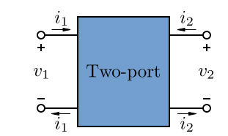

2. What are the types of network parameters?
Ans. There are four types of network parameters. They are
- Z parameters (Open circuit parameters)
- Y parameters( Short circuit parameters)
- ABCD parameters (Transmission parameters)
- h parameters (Hybrid parameters)

- What are Z-parameters?
Ans.
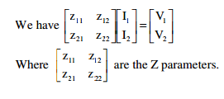
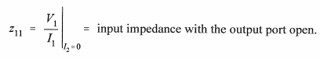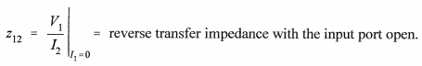
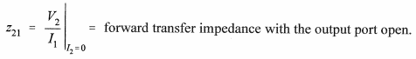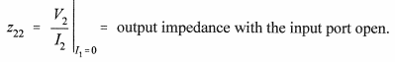

- What are Y- parameters?
Ans.
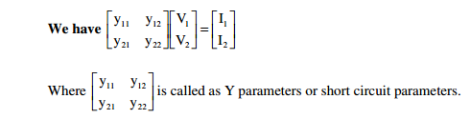
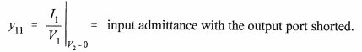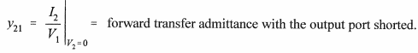
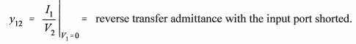
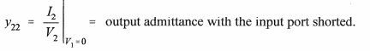

- What are ABCD parameters?
Ans. V1=AV2-BI2
I1=CV2-DI2
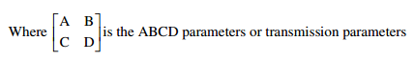
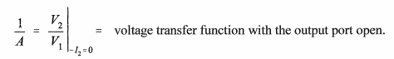
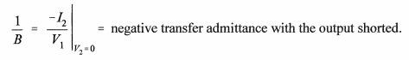
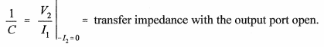
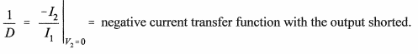

- What are hybrid parameters?
Ans.
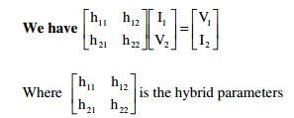
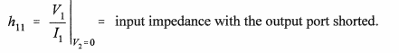
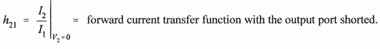
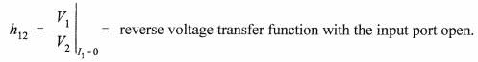
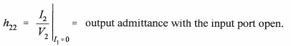

- Why Z parameters are called as open circuit parameters?
Ans. The Z parameters such as Z_{11,} Z_{12,} Z_{21,} Z_{22,} are found out by opening port 1 or port 2 terminals. Hence Z parameters are called as the open circuit parameters.

- Why Y parameters are called as short circuit parameters?
Ans. The Y parameters such as Y_{11,} Y_{12,} Y_{21,} Y_{22,} are found out by shorting port 1 or port 2 terminals. Hence Y parameters are called as the short circuit parameters.

- Why ABCD parameters are called as transmission parameters or general circuit parameters?
Ans. ABCD parameters are used for the analysis of power transmission lines. Hence they are called Transmission parameters. In the analysis of power transmission lines these parameters are also known as general circuit parameters. The transmission parameters are useful to analyze the networks which are connected in cascade or chain arrangement. Therefore these parameters are also called as chain or ABCD parameters.

- Why h parameters are called as hybrid parameters?
Ans. H parameters contains impedance, admittance, voltage gain, current gain. Since the parameters like impedance, admittance, voltage gain and current gain are represented by a single term H, they are called hybrid parameters.
These parameters are used to specify a transistor performance conveniently for small voltages and currents in a particular circuit.

- What is driving point impedance?
It is defined as the ratio of transform voltage to current at the same port.

- What is Transfer impedance?
It is defined as the ratio of transform voltage at one port to the current transform at the other port.

- When is the network said to be symmetrical?
Ans. A network is said to be symmetrical if it offers same amount of impedance on either sides i.e., input impedance of the network at one port is equals to the impedance of the network at the other port.
The condition for the network to be symmetrical is V₁/I₁=V₂/I₂

- When is the network said to be reciprocal?
Ans. A network is said to be reciprocal it should satisfy the condition that V₁/I₂=V₂/I₁. (since reciprocity means ratio of excitation to response should be constant)

- What is the condition for symmetry for Z, Y, ABCD and h parameters?
Ans. For Z parameters Z₁₁=Z₁₁
For Y parameters Y₁₁=Y₁₁
For ABCD parameters A=D
For h parameters Δh=1

- What is the condition for reciprocity for Z, Y, ABCD, h parameters?
Ans. For Z parameters Z₁₂=Z₂₁
For Y parameters Y₁₂=Y₂₁
For ABCD parameters AD-BC=1
For h parameters h₁₂= - h₂₁

- What do u observe when two or more two port networks are connected in (i) series, (ii) parallel and (iii) cascasded configuration.
Ans. (i) When two or more two port networks are connected in series then we observe that each Z-parameter of the series network is given as the sum of the corresponding parameters of the individual networks.
(ii) When two or more two port networks are connected in parallel then we observe that each Y-parameter of the parallel network is given as the sum of the corresponding parameters of the individual networks.
(iii) When two or more two port networks are connected in cascaded then we observe that each ABCD parameter of the two port network is given as the product of the corresponding parameters of the individual networks.

UNIT-5: NETWORK THEOREMS:

- What is a Filter?
Ans. A Filter is an electrical network that can transmit signals within a specified frequency range. It is a purely reactive network.

- What is pass band?
Ans. The range of frequencies which are passing through the filter is known as pass band or transmission band.

- What is stop band?
Ans. The range of frequencies which are eliminated by the filter is known as stop band or attenuation band.

- What is an Ideal filter?
Ans. An Ideal filter would transmits signals under the pass band frequencies without attenuation and completely suppressed the signal with attenuation band of frequencies with sharp cutoff profile.

- What is meant by practical filters?
Ans. Practical filters do not ideally transmit the pass band signal unattenuated due to absorption reflection or due to other loss.

- What are the properties of filters
  - Characteristic impedance
  - Pass band characteristic
  - Cutoff frequency characteristic
- What are the applications of Filters?
  - Used in various stages in TV receivers
  - Audio amplifiers
  - Electronic measuring equipments
  - In thyristor controlled circuits
  - In AM detection
- Classification of Filters.
• Lowpass filter
• Highpass filter
• Bandpass filter
• Band stop filter
- What is a low pass filter?
Ans. A low pass filter is one which passes all the frequencies upto cut off frequency, and attenuates all other frequencies.
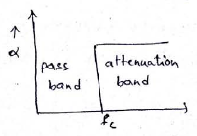
- What is a high pass filter?
Ans. A high pass filter is one which attenuates all the frequencies below a designated cutoff frequency and passes all frequencies above cut-off.
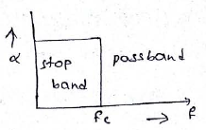
- What is a band pass filter?
Ans. A band pass filter is one which passes frequencies between two designated cut-off frequency and attenuates all other frequencies.
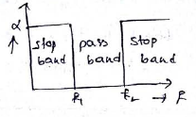
- What s a band elimination filter?
Ans. A band elimination filter is one frequencies lying b/w f1 and f2 are attenuated and all other frequencies are passed.
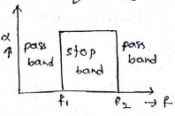
- What is the characteristic impedance for a symmetrical T and π networks.
Ans. Characteristic impedance for a symmetrical T network is
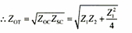

Characteristic impedance for a symmetrical π network is

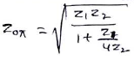

- Draw constant k type low pass filters (both T and π)
Ans. Constant k type low pass filters ( T-section and π section

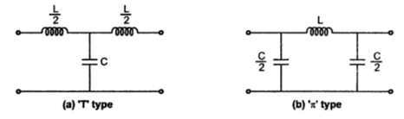
Where
C= 1/ πkf_{c}
L= k/πf_{c}

- Draw constant k type high pass filters (both T and π)
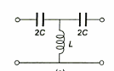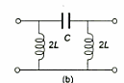
Where
C= 1/4 πkf_{c}
L= k/4 πf_{c}

15.Draw the m-derived low pass T n π type filter.
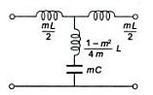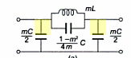
Where
C= 1/ πkf_{c}
L= k/πf_{c}

16.Draw the m-derived high pass T and π type filter.
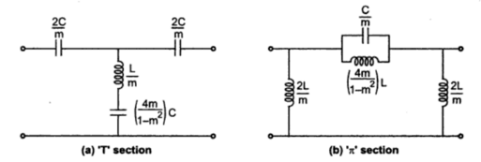
Where
C= 1/4 πkf_{c} ; L= k/4 πf_{c}
17.Draw the Band pass T and π type filter.
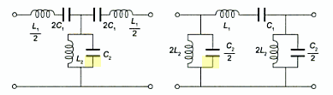
Where
L₁=k/ π(f₂-f₁) C1=(f₂-f₁)/4 πkf₁f₂
L2= k(f₂-f₁)/ 4 πkf₁f₂ C2=1/πk(f₂-f₁)

- Draw the Band elimination T and π type filter.
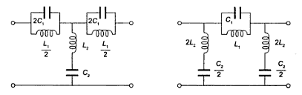
Where
L₁=k(f₂-f₁)/ πf₁f₂ C1=1/4 πk(f₂-f₁)
L2= k(f₂-f₁)/ 4 πkf₁f₂ C2=1/πk(f₂-f₁)

- What is an attenuator?
Ans. An attenuator is a purely resistive network which is used to reduce the strength of the signal. It is represented by α and is expressed in terms of nepers or decibels.

- Classify the attenuators?
Ans. Attenuators are classified based on three categories
- Based on amount of attenuation
- Fixed attenuator
- Variable attenuator
- Based on type of structure:
- T-type attenuator
- Π type attenuator
- Lattice type attenuator
- Bridged T-type attenuator
- Based on characteristic behavior:
- Symmetrical attenuator
- Asymmetrical attenuator

- Draw the symmetrical T type attenuator.
Ans.
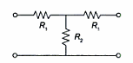
Where
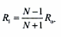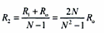

- Draw the symmetrical π type attenuator.
Ans.
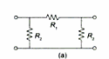
Where
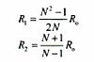

- Draw the symmetrical Lattice type attenuator.
Ans.
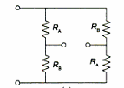

Where
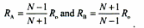

- Draw the symmetrical Bridged T type attenuator.
Ans.
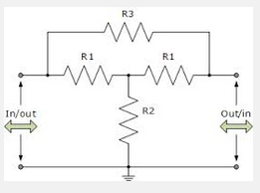
Where
R₃= R₀(N-1) R₂= R_{0/}(N-1)

