**STEP MATERIAL FOR ELECTRONICS MEASURINGS AND INSTRUMENTS**

**1. Define the performance characteristics terms of an instrument?**

Ans**:** The performance characteristics of an instruments explained in two ways. These are

a. static characteristics b. dynamic characteristics

**a. static characteristics:**

**l. Instrument:** A device or mechanism used to determine the present value of the quantity under

measurement.

**2**. **Measurement:** The process of determining the amount, degree, or capacity by comparison (direct or indirect) with the accepted standards of the system units being used.

**3. Accuracy**: The degree of exactness (closeness) of a measurement compared to the expected (desired) value.

**4. Resolution:** The smallest change in a measured variable to which an instrument will respond.

**5. Precision**: A measure of the consistency or repeatability of measurements, i.e. successive readings does not differ. (Precision is the consistency of the instrument output for a given value of input).

**6. Expected value**: The design value, i.e. the most probable value that calculations indicate one should expect to measure.

**7** Error**:** The deviation of the true value from the desired value.

**8. Sensitivity**: The ratio of the change in output (response) of the instrument to a change of input or measured variable

**b. Dynamic behavior:** The dynamic behavior of an instrument is determined by subjecting its primary element (sensing

element) to some unknown and predetermined variations in the measured quantity. The three most common variations in the measured quantity are as follows:

l. Step change in which the primary element is subjected to an instantaneous and finite change in

measured variable.

2*.* Linear change, in which the primary element is following a measured variable, changing linearly with time.

3, Sinusoidal change, in which the primary element follows a measured variable, the magnitude of which changes in accordance with a sinusoidal function of constant amplitude

The dynamic characteristics of an instrument are

(i) Speed of response

(ii) Fidelity

(iii) Lag

(iv). Dynamic error

(v). repeatability

(vi). Reproducibility

(i) **Speed of Response:** It is the rapidity with which an instrument responds to changes in the measured quantity.

(ii) **Fidelity:** It is the degree to which an instrument indicates the changes in the measured variable without dynamic error (faithful reproduction).

(iii) **Lag:** It is the retardation or delay in the response of an instrument to changes in the measured variable.

(iv) **Dynamic Error:** It is the difference between the true values of a quantity changing with time and the value indicated by the instrument, if no static error is assumed.When measurement problems are concerned with rapidly varying quantities, the dynamic relations between the instruments input and output are generally Defined by the use of differential equations.

**Repeatability:** defined as Variation of scale reading when the input is randomly applied.

**Reproducibility:** it is scale reading over a given period of time when the input is constantly applied.

2. Define precision and accuracy.

ANS:

**Precision**: A measure of the consistency or repeatability of measurements, i.e. successive readings does not differ. (Precision is the consistency of the instrument output for a given value of input).

**. Accuracy**: The degree of exactness (closeness) of a measurement compared to the expected (desired) value.

3. Explain the types of errors possible in an instrument?

ANS:

GROSS ERRORS: The complete elimination of gross errors is not possible, but one can minimize them .Some errors are easily detected while others may be elusive. One of the basic gross errors that occur frequently is the improper use of an Instrument the error can be minimized by taking proper care in reading and recording the measurement parameter. In general, indicating instruments change ambient conditions to some extent when connected into a complete circuit

. **2. Systematic Errors**

There are basically three types of systematic errors

1. Instrumental,
2. Environmental,
3. Observational
4. **(i) Instrumental Errors**
5. Instrumental errors are inherent in measuring instruments, because of their mechanical structure
6. improper handling or over loading of the instrument. Instrumental errors can be avoided by
7. (a) Selecting a suitable instrument for the particular measurement applications.
8. (b) Applying correction factors after determining the amount of instrumental error.
9. (c) Calibrating the instrument against a standard.
10. **(ii) Environmental Errors**
11. Environmental errors are due to conditions external to the measuring device, including conditions in the area surrounding the instrument, such as the effects of change in temperature, humidity, barometric pressure or of magnetic or electrostatic fields.

4. Explain ohmmeter and its classification.

##### ANS: There are two types of ohmmeters

1. Series type.
2. Shunt type.

#### Series-Type Ohmmeter

This meter consists of a D'Arsonval movement connected in series with a resistance and a battery to a pair of terminals where the unknown resistance Rx is connected. The current passing through the meter depends on the value of Rx. Therefore, the deflection of the pointer is proportional to Rx. The circuit diagram is shown in

           R1 = current-limiting resistor

          R2 = zero-adjust resistor

          E = internal battery

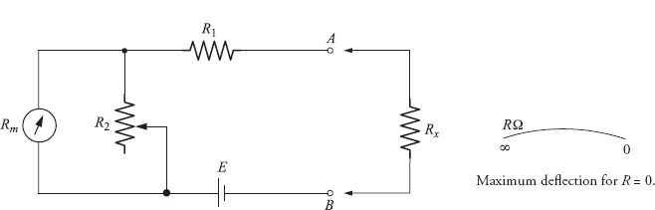

**Figure 1.G** Series-type ohmmeter

            Rm = internal resistance of D'Arsonval movement

           Rx = unknown resistor

The disadvantage with the series-type ohmmeter is that it does not compensate for the decrease in battery voltage due to aging. As the source voltage decreases,the deflection or full-scale current decreases.

#### Shunt-Type Ohmmeter

The circuit diagram of a shunt-type ohmmeter is shown in Fig

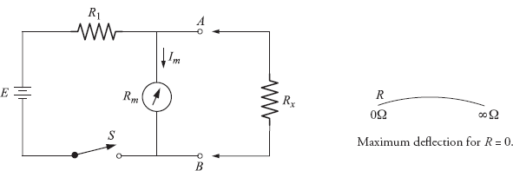

**Figure 1.H** Shunt-type ohmmeter

 The battery is in series with an adjustable resistance R1 and the D'Arsonval movement. The unknown resistance is connected across terminals A and B in parallel with the meter. An on–off switch is to be provided to disconnect the battery from the circuit when not being used. If Rx = 0, the meter current is zero. If Rx = 8, the current finds a path only through the meter. The meter can be made to read full scale by adjusting R. Thus, the meter deflection is proportional to the value of the unknown resistance Rx.

This meter is more suitable for measuring low values of resistances, upto 100kO.

**2. SIGNAL ANALYSERS AND SIGNAL GENERATORS**

1. Define wave analyzers

ANS: A wave analyser is a instrument it is used to

1. Electrical measurements

2. Sound measurements

3. Vibration measurements.

In industries there are heavy machineries which produce a lot of sound and vibrations, it is very important to determine the amount of sound and vibrations because if it exceeds the permissible level it would create a number of problems. The source of noise and vibrations is first identified by wave analyzer and then it is reduced by further circuitry

2. List out the applications of wave analyzers

ANS:

Application of wave analyzer

1. Electrical measurements

2. Sound measurements

3. Vibration measurements.

In industries there are heavy machineries which produce a lot of sound and vibrations, it is very important to determine the amount of sound and vibrations because if it exceeds the permissible level it would create a number of problems. The source of noise and vibrations is first identified by wave analyzer and then it is reduced by further circuitry

.

3.Define spectrum analyzer

ANS:

The most common way of observing signals is to display them on an oscilloscope with time as the X-axis (i.e. amplitude of the signal versus time). This is the time domain. It is also useful to display signals in the frequency domain.

The providing this frequency domain view is the spectrum analyzer.

A spectrum analyzer provides a calibrated graphical display on its CRT, with frequency on the horizontal axis and amplitude (voltage) on the vertical axis.

1. List out the applications of the spectrum analyzers?

ANS:

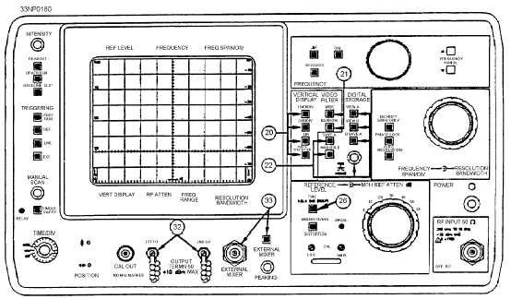

Present-day spectrum analyzers can measure segments of the frequency spectra from 0 hertz to as high as 300 gigahertz when used with waveguide mixers.

SPECTRUM ANALYZER APPLICATIONS:

The previously mentioned measurement capabilities can be seen with a spectrum analyzer. However, you will find that the spectrum analyzer generally is used to measure spectral purity of multiplex signals, percentage of modulation of AM signals, and modulation characteristics of fm and pulse-modulated signals.

The spectrum analyzer is also used to interpret the displayed spectra of pulsed RF emitted from a radar transmitter.

4. Define harmonic distortion analyzer?

ANS: These Distortion analyzer measures the total harmonic power present in the test wave rather than the distortion caused by each component. The simplest method is to suppress the fundamental frequency by means of a high pass filter whose cut off frequency is a little above the fundamental frequency.

This high pass allows only the harmonics to pass and the total harmonic distortion can then be measured. Other types of harmonic distortion analyzers based on fundamental suppression type.

1. Define a Function Generator

ANS: A function generator delivers a choice of different waveforms. The most common output waveforms are the sine, triangular, square, and saw-tooth waves. This equipment can usually supply output waveforms at very low frequencies. Since the low frequency of a simple RC oscillator is limited, a different approach is used in the circuit. The instrument can deliver sine, triangular, and square waves with a frequency range of 0.01 Hz to 100 kHz.

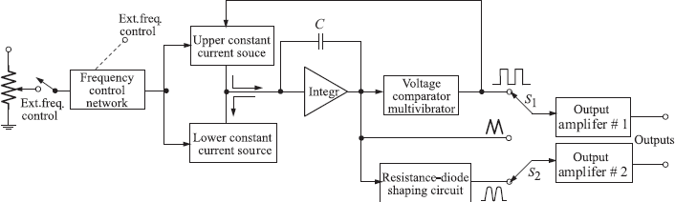

**Figure A** Block schematic of a function generator

5. Distinguish between square and pulse wave generators

ANS: The difference between the pulse and square waveform is with respect to the duty cycle. The duty cycle is 50% for the square wave. The duty cycle is defined as the ratio of the average value of the pulse over one cycle to the peak value of the pulse. The average value and the peak value are inversely related to the time duration.

images

 The duty cycle of a pulse waveform varies. It is not 50%. Very short duration pulses give a low duty cycle. Pulse generation can supply more power during its ON period than a square wave generator can. A stable or free-running multivibrator circuit is widely used to generate square wave and pulse waveforms.

6. Distinguish between the oscillator and function generator

The basic differences are a signal generator can provide several typical types of waves - square, triangle, sine, etc, and can do so for varying frequencies. In truth, a signal generator is just a very advanced oscillator.

A basic discrete oscillator will only be able to provide 1 type of wave, and usually at a very limited frequency range (control of this can be had in the use of varying inductors and capacitors).

7. Applications of Function Generator

A **function generator** is usually a piece of [electronic test equipment](https://en.wikipedia.org/wiki/Electronic_test_equipment) or [software](https://en.wikipedia.org/wiki/Software) used to generate different types of electrical [waveforms](https://en.wikipedia.org/wiki/Waveform) over a wide range of frequencies. Some of the most common waveforms produced by the function generator are the sine, square, triangular and sawtooth shapes. These waveforms can be either repetitive or single-shot (which requires an internal or external trigger source).[Integrated circuits](https://en.wikipedia.org/wiki/Integrated_circuit) used to generate waveforms may also be described as function generator ICs.

Although function generators cover both audio and RF frequencies, they are usually not suitable for applications that need low distortion or stable frequency signals. When those traits are required, other [signal generators](https://en.wikipedia.org/wiki/Signal_generator) would be more appropriate.

Some function generators can be phase-locked to an external signal source (which may be a frequency reference) or another function generator.

Function generators are used in the development, test and repair of electronic equipment. For example, they may be used as a signal source to test amplifiers or to introduce an error signal into a control loop.

**3. OSCILLOSCOPE**

**1.** Define CRO?

ANS: The cathode-ray oscilloscope (CRO) is a common laboratory instrument that provides accurate time and amplitude measurements of voltage signals over a wide range of frequencies. Its reliability, stability, and ease of operation make it suitable as a general purpose laboratory instrument. The heart of the CRO is a cathode-ray tube.

2. Draw the block diagram of CRO

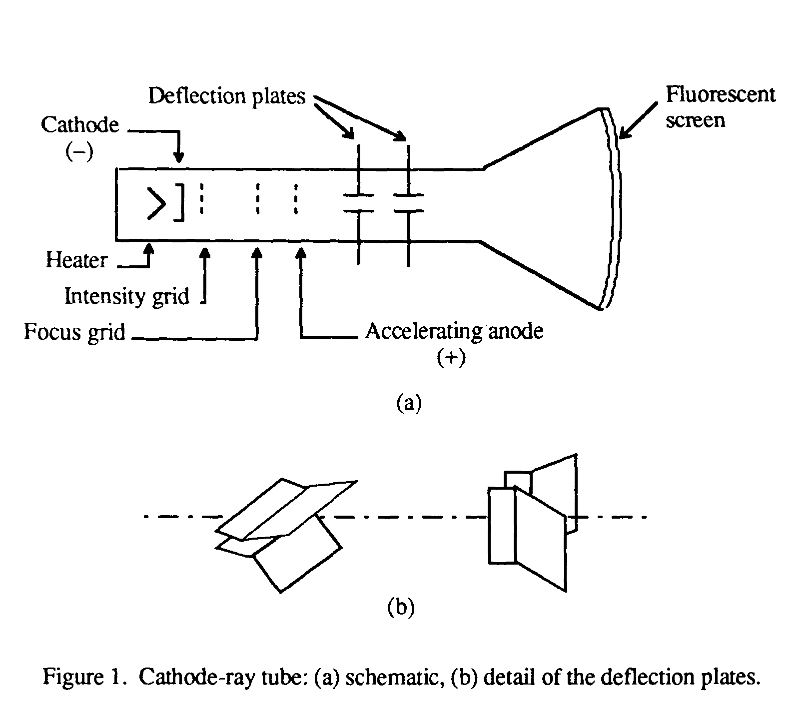

**3. What is vertical amplifier and horizontal amplifier in CRO?**

**ANS:**

**VERTICAL AMPLIFIER SECTION:**

Position:  Controls vertical positioning of oscilloscope display.

Sensitivity:  Selects the sensitivity of the vertical amplifier in calibrated steps.

Variable Sensitivity:  Provides a continuous range of sensitivities between the calibrated steps. Normally the sensitivity is calibrated only when the variable knob is in the fully clockwise position.

AC-DC-GND:  Selects desired coupling (ac or dc) for incoming signal applied to vertical amplifier, or grounds the amplifier input. Selecting dc couples the input directly to the amplifier; selecting ac send the signal through a capacitor before going to the amplifier thus blocking any constant component.

**HORIZONTAL-SWEEP SECTION:**

Sweep time/cm:  Selects desired sweep rate from calibrated steps or admits external signal to horizontal amplifier.

Sweep time/cm Variable:  Provides continuously variable sweep rates. Calibrated position is fully clockwise.

Position:  Controls horizontal position of trace on screen.

Horizontal Variable:  Controls the attenuation (reduction) of signal applied to horizontal amplifier through Ext. Horiz. connector.

**4. What is meant by CRT?**

**ANS:** A cathode ray tube (CRT) is a specialized vacuum tube in which images are produced when an electron beam strikes a phosphorescent surface. Most desktop computer displays make use of CRTs. The CRT in a computer display is similar to the "picture tube" in a television receiver.

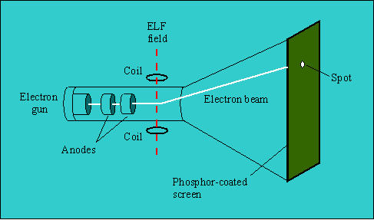

5. Define dual trace oscilloscope

ANS: A **dual-beam oscilloscope** was a type of oscilloscope once used to compare one signal with another. There were two beams produced in a special type of [CRT](https://en.wikipedia.org/wiki/Cathode_ray_tube).

Unlike an ordinary "dual-trace" oscilloscope (which time-shared a single electron beam, thus losing about 50% of each signal), a dual-beam oscilloscope simultaneously produced two separate electron beams, capturing the entirety of both signals. One type (Cossor, UK) had a beam-splitter plate in its CRT, and single-ended vertical deflection following the splitter. (There is more about this type of oscilloscope near the end of this article.)

Other dual-beam oscilloscopes had two complete electron guns, requiring tight control of axial (rotational) mechanical alignment in manufacturing the CRT. In the latter type, two independent pairs of vertical plates deflect the beams. Vertical plates for channel A had no effect on channel B's beam. Similarly for channel B, separate vertical plates existed which deflected the B beam only.

6. Define sampling oscilloscope?

ANS:

A sampling oscilloscope is a special type of DSO that exclusively uses a technique called “sequential equivalent-time sampling” or just “sequential sampling”.

This type of sampling is best suited to repetitive waveforms such as serial data streams, clock waveforms and pulses in digital circuits, some of the data patterns used in semiconductor testing, and amplifier pulse-response and rise-time tests .

**4. TRANSDUCERS**

1. Define transducer

ANS: A transducer is an electronic device that converts energy from one form to another. Common examples include microphones, loudspeakers, thermometers, position and pressure sensors, and [antenna](http://searchmobilecomputing.techtarget.com/definition/antenna). Although not generally thought of as transducers, photocells, LEDs (light-emitting diodes), and even common light bulbs are transducers.

Efficiency is an important consideration in any transducer. Transducer efficiency is defined as the ratio of the power output in the desired form to the total power input. Mathematically, if P represents the total power input and Q represents the power output in the desired form, then the efficiency E, as a ratio between 0 and 1, is given by:

E = Q/P

If E% represents the efficiency as a percentage, then:

E% = 100Q/P

No transducer is 100 percent efficient; some power is always lost in the conversion process.

## 2. Write about Primary and Secondary Transducers

* Primary transducers work on the principle of an input sensor detecting or sensing immeasurable data, such as mass, heat, depth and density. It then converts the received energy signal into readable information, usually controlled by an on/off switch. Examples of primary transducers include thermistors and thermocouples.
* Secondary transducers are best exemplified by reluctive accelerometers and piezoelectric transducers. These types of transducers define how mechanical displacement produces electric signals.

## 3. Write about Passive and Active Transducers

* Passive and active transducers are classified based on the type of power source they have. Passive transducers rely on producing power output from palpable mechanisms, such as external power. Examples of this type include capacitive, inductive and resistive transformers.
* On the other hand, active transducers source their power from physical loads and then produce their own voltage and current outputs. Active transducers include thermocouples, piezoelectric crystals and photovoltaic cells.

## Analog and Digital Transducers

* Analog transducers transmit a readable continuous analog reading of whatever input it receives. Typical of this type of transducer are the thermistor and strain gauge.
* In contrast, digital transducers create non-continuous pulses which are naturally disjoined. Common examples are laser beam instruments and vortex flow meters.

## Write about Linear Displacement and Rotary Displacement Transducers

* Linear displacement transducers produce electrical signal outputs directly proportional to what their sensor detects. This type of transducer exhibits constancy, dependability and sensitivity.
* On the other hand, rotary displacement transducers measure shaft settings using non-contact capacitance (measurement of energy). Optical rotary and magnetic rotary position sensors are examples of this type.

1. Define strain gauge

**ANS:** A **strain gauge (or strain gage)** is a device used to measure [strain](https://en.wikipedia.org/wiki/Deformation_%28mechanics%29#Strain) on an object. Invented by [Edward E. Simmons](https://en.wikipedia.org/wiki/Edward_E._Simmons) and [Arthur C.Ruge](https://en.wikipedia.org/wiki/Arthur_C._Ruge) in 1938, the most common type of strain gauge consists of an [insulating](https://en.wikipedia.org/wiki/Electrical_insulation) flexible backing which supports a metallic foil pattern.

The gauge is attached to the object by a suitable adhesive, such as [cyanoacrylate](https://en.wikipedia.org/wiki/Cyanoacrylate).As the object is deformed, the foil is deformed, causing its [electrical resistance](https://en.wikipedia.org/wiki/Electrical_resistance) to change. This resistance change, usually measured using a [Wheatstone bridge](https://en.wikipedia.org/wiki/Wheatstone_bridge), is related to the strain by the quantity known as the [*gauge factor*](https://en.wikipedia.org/wiki/Gauge_factor).

7. Discuss about LVDT

ANS: The **linear variable differential transformer** (LVDT) (also called just a **differential transformer**, **linear variable displacement transformer**, or **linear variable displacement transducer** is a type of electrical [transformer](https://en.wikipedia.org/wiki/Transformer) used for measuring linear displacement (position). A counterpart to this device that is used for measuring rotary displacement is called a rotary variable differential transformer ([RVDT](https://en.wikipedia.org/wiki/RVDT)).

The linear variable differential transformer has three [solenoidal](https://en.wikipedia.org/wiki/Solenoid) coils placed end-to-end around a tube. The center coil is the primary, and the two outer coils are the top and bottom secondaries.

A cylindrical ferromagnetic core, attached to the object whose position is to be measured, slides along the axis of the tube. An [alternating current](https://en.wikipedia.org/wiki/Alternating_current) drives the primary and causes a [voltage](https://en.wikipedia.org/wiki/Potential_difference) to be induced in each secondary proportional to the length of the core linking to the secondary. The [frequency](https://en.wikipedia.org/wiki/Frequency) is usually in the range 1 to 10[kHz](https://en.wikipedia.org/wiki/Kilohertz).

1. Write short notes on thermocouples

ANS: A Thermocouple is a sensor used to measure temperature. Thermocouples consist of two wire legs made from different metals. The wires legs are welded together at one end, creating a junction. This junction is where the temperature is measured. When the junction experiences a change in temperature, a voltage is created. The voltage can then be interpreted using thermocouple [reference tables](http://www.thermocoupleinfo.com/thermocouple-reference-tables.htm) to calculate the temperature.

1. Write the applications of thermo couples

ANS: Thermocouples are used in many industrial, scientific, and OEM applications. They can be found in nearly all industrial markets: Power Generation, Oil/Gas, Pharmaceutical, BioTech, Cement, Paper & Pulp, etc. Thermocouples are also used in everyday appliances like stoves, furnaces, and toasters.   
Thermocouples are typically selected because of their low cost, high temperature limits, wide temperature ranges, and durable nature.

**5. Bridges, Measurement of Physical parameters**

1**.** Discuss the principle of Maxwell’s bridge

ANS: The Maxwell’s bridge is used to measure unknown inductance in terms of calibrated resistance and capacitance. Calibration-grade inductors are more difficult to manufacture than capacitors of similar precision, and so the use of a simple "symmetrical" inductance bridge is not always practical.

Because the phase shifts of inductors and capacitors are exactly opposite each other, a capacitive impedance can balance out an inductive impedance if they are located in opposite legs of a bridge, as they are here.



Another advantage of using a Maxwell bridge to measure inductance rather than a symmetrical inductance bridge is the elimination of measurement error due to mutual inductance between two inductors. Magnetic fields can be difficult to shield, and even a small amount of coupling between coils in a bridge can introduce substantial errors in certain conditions. With no second inductor to react with in the Maxwell bridge, this problem is eliminated.

2. Explain the basic principle of Kelvin Bridge?

ANS: The Kelvin Bridge is a variation of the Wheatstone bridge which enables low resistances to be measured. The measurement range would typically be 1mΩ to 1kΩ with the smallest resolution of 1µΩ.

The limitations of the Kelvin bridge are:-

1. requires manual balancing
2. sensitive null detector or galvanometer is required to detect balance condition
3. measurement current needs to be reasonably high to achieve sufficient sensitivity

The Kelvin Double Bridge has generally been replaced by digital ohmmeters

3. Write a short note on Data Acquisition System

ANS: Data acquisition (DAQ) is the process of measuring an electrical or physical phenomenon such as voltage, current, temperature, pressure, or sound with a computer. A DAQ system consists of sensors, DAQ measurement hardware, and a computer with programmable software.

Compared to traditional measurement systems, PC-based DAQ systems exploit the processing power, productivity, display, and connectivity capabilities of industry-standard computers providing a more powerful, flexible, and cost-effective measurement solution.

4. Write about measurement of temperature

ANS: Temperature can be measured via a diverse array of sensors. All of them infer temperature by sensing some change in a physical characteristic. Six types with which the engineer is likely to come into contact are: thermocouples, resistive temperature devices (RTDs and thermistors), infrared radiators, bimetallic devices, liquid expansion devices, and change-of-state devices.

1. Write about measurement of pressure

ANS: Many techniques have been developed for the measurement of [pressure](https://en.wikipedia.org/wiki/Pressure) and [vacuum](https://en.wikipedia.org/wiki/Vacuum). Instruments used to measure pressure are called **pressure gauges** or **vacuum gauges**. A **manometer** is an instrument that uses a column of liquid to measure pressure, although the term is currently often used to mean any pressure [measuring instrument](https://en.wikipedia.org/wiki/Measuring_instrument).

A vacuum gauge is used to measure the pressure in a vacuum—which is further divided into two subcategories: high and low vacuum (and sometimes [ultra-high vacuum](https://en.wikipedia.org/wiki/Ultra-high_vacuum)). The applicable pressure ranges of many of the techniques used to measure vacuums have an overlap. Hence, by combining several different types of gauge, it is possible to measure system pressure continuously from 10 [mbar](https://en.wikipedia.org/wiki/Bar_%28unit%29) down to 10−11 mbar.