Unit 1:
1.Discuss various types of biosignals.
A biosignal is any signal in living beings that can be continually measured and monitored. The term biosignal is often used to refer to bioelectrical signals, but it may refer to both electrical and non-electrical signals. The usual understanding is to refer only to time-varying signals, although spatial parameter variations
Electrical biosignals, or bioelectrical time signals, usually refers to the change in electric current produced by the sum of an electrical potential difference across a specialized tissue, organ or cell system like the nervous system. Thus, among the best-known bioelectrical signals are:
- Electroencephalogram (EEG)
- Electrocardiogram (ECG)
- Electromyogram (EMG)
- Mechanomyogram (MMG)
- Electrooculography (EOG)
- Galvanic skin response (GSR)
- Magnetoencephalogram (MEG)

EEG, ECG, EOG and EMG are measured with a differential amplifier which registers the difference between two electrodes attached to the skin. However, the galvanic skin response measures electrical resistance and the MEG measures the magnetic field induced by electrical currents (electroencephalogram) of the brain.
With the development of methods for remote measurement of electric fields using new sensor technology, electric biosignals such as EEG^{[1][2][3][4]} and ECG^{[1][2][3][4][5][6][7]} can be measured without electric contact with the skin. This can be applied for example for remote monitoring of brain waves and heart beat of patients who must not be touched, in particular patients with serious burns.
Electrical currents and changes in electrical resistances across tissues can also be measured from plants.
Biosignals may also refer to any non-electrical signal that is capable of being monitored from biological beings, such as mechanical signals (e.g. the mechanomyogram or MMG), acoustic signals (e.g. phonetic and non-phonetic utterances, breathing), chemical signals (e.g. pH, oxygenation) and optical signals (e.g. movements).
2.What is bio amplifier. Explain its features with a block diagram.
Bio-Amplifiers are an important part of modern instrumentation systems for measuring biopotentials. Such measurements involve voltages that often are at low levels, have high source impedances, or both. Amplifiers are required to increase signal strength while maintaining high fidelity. Amplifiers that have been designed specifically for this type of processing of biopotentials are known as biopotential amplifiers. The biopotential amplifier function is to take a weak electric signal of biological origin and increase its amplitude so that it can be further processed, recorded, or displayed. Usually such amplifiers are in the form of voltage amplifiers, because they are capable of increasing the voltage level of a signal. Nonetheless, voltage amplifiers also serve to increase power levels, so they can be considered power amplifiers as well. In some cases, biopotential amplifiers are used to isolate the load from the source. In this situation, the amplifiers provide only current gain, leaving the voltage levels essentially unchanged. The biopotential amplifiers must meet certain basic requirements such as; they must have high input impedance, so that they provide minimal loading of the signal being measured. The characteristics of biopotential electrodes can be affected by the electric load they see, which, combined with excessive loading can result in distortion of the signal.
Loading effects are minimized by making the amplifier input impedance as high as possible, thereby reducing this distortion. Modern biopotential amplifiers have input impedances of at least 10 MΩ. The input circuit of a biopotential amplifier must also provide protection to the organism being studied. Any current or potential appearing across the amplifier input terminals that is produced by the amplifier is capable of affecting the biological potential being measured. In clinical systems, electric currents from the input terminals of a biopotential amplifier can result in micro shocks or macro shocks in the patient being studied a situation that can have grave consequences. To avoid these problems, the amplifier should have isolation and protection circuitry, so that the current through the electrode circuit can be kept at safe levels and any artifact generated by such current can be minimized. The output circuit of a biopotential amplifier does not present so many critical problems as the input circuit. Its principal function is to drive the amplifier load, usually an indicating or recording device, in such a way as to maintain maximal fidelity and range in this readout. Therefore, the output impedance of the amplifier must be low with respect to the load impedance, and the amplifier must be capable of supplying the power required by the load. Biopotential amplifiers must operate in that portion of the frequency spectrum in which the biopotentials that they amplify exist. Because of the low level of such signals, it is important to limit the bandwidth of the amplifier so that it is just great enough to process the signal adequately. In this way, we can obtain optimal signal-to-noise ratios. Biopotential signals usually have amplitudes of the order of a few millivolts or less. Such signals must be amplified to levels compatible with recording and display
3. List out various static and dynamic characteristics of a medical instrument.
•The system characteristics are to be known, to choose an instrument that most suited to a particular measurement application.
•The performance characteristics may be broadly divided into two groups, namely ‘static ’ and 'dynamic' characteristics.
•Static characteristics
•the performance criteria for the measurement of quantities that remain constant, or vary only quite slowly.
•Dynamic characteristics
•the relationship between the system input and output when the measured quantity (measurand) is varying rapidly.
Static characteristics
Determination of static characteristics is mostly done by calibration:
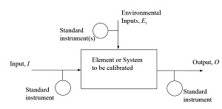
Static and Dynamic Characteristics
•Instrument systems are usually built up from a serial linkage of distinguishable building blocks.
•The actual physical assembly may not appear to be so but it can be broken down into a representative diagram of connected blocks.
•The sensor is activated by an input physical parameter and provides an output signal to the next block that processes the signal into a more appropriate state.
•A fundamental characterization of a block is to develop a relationship between the input and output of the block.
•All signals have a time characteristic.•It is essential to consider the behavior of a block in terms of both the static and dynamic states.
•The behavior of the static regime alone and the combined static and dynamic regime can be found through use of an appropriate mathematical model of each block.
Instruments formed from a connection of blocks.
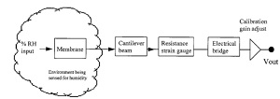
The output/input ratio of the whole cascaded chain of blocks 1, 2, 3, etc. is given as:
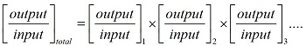
The output/input ratio of a block that includes both the static and dynamic characteristics is
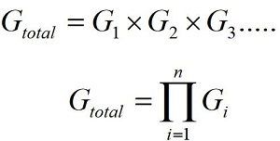
called the transfer function and is given the symbol G.
The equation for Gi can be written as two parts multiplied together.
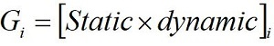
•One expresses the static behavior of the block, that is, the value it has after all transient (time varying) effects have settled to their final state.
•The other part tells us how that value responds when the block is in its dynamic state.
•The static part is known as the transfer characteristic and is often all that is needed to be known for block description.
•The static and dynamic response of the cascade of blocks is simply the multiplication of all individual blocks.•As each block has its own part for the static and dynamic behavior, the cascade equations can be rearranged to separate the static from the dynamic parts
•Multiplying the static set and the dynamic set gets the overall response in the static and dynamic states.
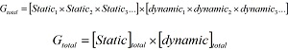
Static Performance of Instrument
•The static characteristics of instruments are related with steady state response.
•The relationship between the output and the input when the input does not change, or the input is changing at a slow rate.
•Range & Span
•Linearity & Sensitivity
•Environmental effects
•Hysteresis
•Resolution
•Repeatability
•Death space Linearity & Sensitivity
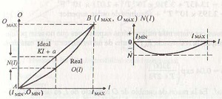
Environmental effects
•All calibrations and specifications of an instrument are only valid under controlled conditions of temperature, pressure etc.
•These standard ambient conditions are usually defined in the instrument specification.
•As variations occur in the ambient temperature, etc., certain static instrument characteristics change, and the sensitivity to disturbance is a measure of the magnitude of this change.
•Such environmental changes affect instruments in two main ways, known as zero drift and sensitivity drift.
•Zero drift is sometimes known by the alternative term, bias. Instrument Drift
•This is caused by variations taking place in the parts of the instrumentation/environment over time.
•Prime sources occur as chemical structural changes and changing mechanical stresses.
•Drift is a complex phenomenon for which the observed effects are that the sensitivity and offset values vary.
•It also can alter the accuracy of the instrument differently at the various amplitudes of the signal present. 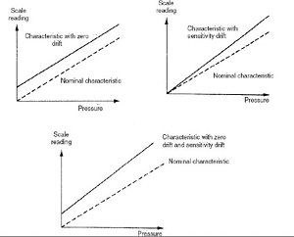

6. What are components of a generalized medical instrumentation.

Generalized Medical Instrumentation System
The major difference between this system and a conventional instrumentation system is:
The source of the signals (measurand) is a living tissue or energy is applied to living tissue.
Measurand
Physical quantity, property, or condition that is being measured by the
system.
* most important issue : accessibility
- internal (blood pressure), on body surface (ECG, EEG)
- emanate from the body (infra-red radiation)
- derived from a tissue sample (blood or biopsy)
Medically important measurands
• Biopotentials (ECG, EEG, EMG, EOG, etc.)
• Pressure, flow, dimensions (imaging)
• Displacement (velocity dx/dt, acceleration d2x/d2t, and force =
md2x/d2t)
• Impedance, temperature and chemical concentration
The measurand may be localized to a specific organ or anatomical
Sensor
* The transducer or sensor should only respond to the form of energy present in the measurand to the exclusion of all others!
* The sensor should interface with the living system to minimize the energy extracted and being minimally invasive!
Signal conditioning
Usually the sensor output can not directly drive the display, therefore
signal processing or conditioning is required
Examples of signal processing:
1. Impedance matching
2. Amplification
3. Filtering
4. Mathematical mapping
5. Linearizing
6. Analog-to-digital conversion (ADC)
7. Digital-to-analog conversion (DAC)
8. Signal averaging to reduce noise (i.e. evoked response)
9. Transformation (time domain
frequency domain)
10. Compensation for undesirable sensor characteristics
11. Etc.
Output displays
Examples of output displays:
1. Numerical
2. Graphical
3. Discrete
4. Continuous
5. Permanent or temporary
• Most displays rely on our vision, but auditory sense is also sometimes used (for example, Doppler ultrasonic signals)
• User controls and output displays should conform to human factors engineering guidelines for the design of medical devices
Auxiliary Elements
*Calibration signal with the properties of the measurand should be applied to the sensor input or as early in the signal processing chain as possible
**Many forms of feedback (automatic or manual) may be required to elicit the measurand, to adjust the sensor and signal conditioner and to direct the flow of output (display, storage, transmission)
***Data storage for signal conditioning or examination of alarm conditions or implementation of different processing algorithms
**** Data communication transmission of patient data to remote display at nurse’s station and medical center
Operation Modes
1. Direct and Indirect Modes
• Direct: Measurand directly to sensor
- readily accessible or
- acceptable invasive procedure
For example: direct blood pressure measurement
• Indirect: measurand not accessible
- Use another measurand with known relation to the desired one
- Use some form of energy or material that interacts with the
desired measurand to generate a new accessible one
For example:
Cardiac output (volume of blood pumped/min by the heart)
- Measurements of respiration & blood gas concentration
- Dye dilution
- Morphology of internal organs determined from X-rays
2. Sampling or Continuous Modes
• Sampling: Parameters that change slowly do not require continuous measurements
For example: body temperature, ionic concentrations, etc.
• Continuous: Parameters that change fast enough to require continuous measurements
For example: ECG, EEG, EMG, respiratory gas flow, etc.
Note: Frequency content of the measurand, the objective of the measurement, the condition of the patient and the potential liability of the physician influence how often data should be acquired
3. Generating and Modulating Sensors
• Generating: Produce output from energy taken directly from measurand
For example: photovoltaic cell (output voltage related to irradiation)
• Modulating: Measurand changes flow of energy from an external source that affects the output of a sensor
For example: photoconductive cell (apply external power to the sensor to measure changes in resistance with irradiation)
4. Analog and Digital Modes
• Analog: Continuous (parameter takes on any value within the dynamic range)
For example: Parameters that change fast enough to require continuous measurements: ECG, EEG, EMG, respiratory gas flow, etc.

Unit 2:
1.Give the classification of electrodes.
Many different forms of electrodes have been developed for different types of biomedical measurements.The following is a brief classification of bio potential electrodes.
Body-Surface Biopotential Electrodes
This category includes electrodes that can be placed on the body surface for recording bioelectric signals. The integrity of the skin is not compromised when these electrodes are applied, and they can be used for short-term diagnostic recording such as taking a clinical electrocardiogram or long-term chronic recording such as occurs in cardiac monitoring
Metal Plate Electrodes : The basic metal plate electrode consists of a metallic conductor in contact with the skin with a thin layer of an electrolyte gel between the metal and the skin to establish this contact. Examples of metal plate electrodes are seen in Fig. below. Metals commonly used for this type of electrode include German silver (a nickel-silver alloy), silver, gold, and platinum. Sometimes these electrodes are made of a foil of the metal so as to be flexible, and sometimes they are produced in the form of a suction electrode to make it easier to attach the electrode to the skin to make a measurement and then move it to another point to repeat the measurement. These types of electrodes are used primarily for diagnostic recordings of biopotentials such as the electrocardiogram or the electroencephalogram. Metal disk electrodes with a gold surface in a conical shape are frequently used for EEG recordings. The apex of the cone is open so that electrolyte gel or paste can be introduced to both make good contact between the electrode and the head and to allow this contact medium to be replaced should it dry out during its use.
Fig. metal cap electrode
Fig. Suction cup electrodes

Intracavitary and Intratissue Electrodes
Electrodes can be placed within the body for biopotential measurements. These electrodes are generally smaller than skin surface electrodes and do not require special electrolytic coupling fluid, since natural body fluids serve this function. There are many different designs for these internal electrodes, and only a few examples are given in the following paragraphs. Basically these electrodes can be classified as needle electrodes, which can be used to penetrate the skin and tissue to reach the point where the measurement is to be made, or they are electrodes that can be placed in a natural cavity or surgically produced cavity in tissue. Figure 48.5 illustrates some of these internal electrodes. A catheter tip or probe electrode is placed in a naturally occurring cavity in the body such as in the gastrointestinal system. A metal tip or segment on a catheter makes up the electrode. The catheter or, in the case where there is no hollow lumen, probe, is inserted into the cavity so that the metal electrode
Fig. a. Needle electrode b. coaxial needle electrode
Microelectrodes
The electrodes described in the previous paragraphs have been applied to studying bioelectric signals at the organism, organ, or tissue level but not at the cellular level. To study the electric behavior of cells, electrodes that are themselves smaller than the cells being studied need to be used. Three types of electrodes have been described for this purpose: etched metal electrodes, micropipette electrodes, and metal-film-coated micropipette electrodes. The metal microelectrode is essentially a subminiature version of the needle electrode . In this case, a strong metal such as tungsten is used. One end of this wire is etched electrolytically to give tip diameters on the order of a few micrometers. The structure is insulated up to its tip, and it can be passed through the membrane of a cell to contact the cytosol. The advantage of these electrodes is that they are both small and robust and can be used for neurophysiologic studies. Their principal disadvantage is the difficulty encountered in their fabrication and their high source impedance. The second and most frequently used type of microelectrode is the glass micropipette. This structure, as illustrated in consists of a fine glass capillary drawn to a very narrow point and filled with an electrolytic solution. The point can be as narrow as a fraction of a micrometer, and the dimensions of this electrode are strongly dependent on the skill of the individual drawing the tip. The electrolytic solution in the lumen serves as the contact between the interior of the cell through which the tip has been impaled and a larger conventional electrode located in the shank of the pipette. These electrodes also suffer from high source impedances and fabrication difficulty
Fig. a. micro pipette

2.What is reference electrode. give various types of ref. Electrodes.
Reference electrodes and their usage
A reference electrode has a stable and well defined electrochemical potential (at constant temperature) against which the applied or measured potentials in an electrochemical cell are referred. A good reference electrode is therefore non-polarizable, in other words, the potential of such an electrode will remain stable upon passage of a small current. One could also say that the impedance of an ideal reference electrode is zero. In practice the non-polarizability only holds at small currents, and therefore the input impedance of the reference electrode input on a potentiostat should be as high as possible.
An absolute standard for the measurement of electrochemical potentials is not available. It is therefore that the equilibrium potential of the so- called Standard Hydrogen Electrode (SHE) is defined as being 0 Volt at aH +=1 and PH2=10 5 Pa. In practice this means that the following reaction:
The SHE is difficult to use in practice as it involves bubbling H2 gas through solution, therefore a number of other reference electrodes are available, the most important of which are shortly discussed below:
Silver/Silver Chloride (Ag/AgCl in saturated KCl) This is probably the most widely used reference electrode, since the use of mercury became less popular. This electrode consists of a Ag wire in contact with AgCl in a saturated KCl solution. This results in an electrode potential of +0.197 Volt vs SHE at 25° C.
Although most electrodes of this type use saturated KCl as electrolyte, 3 M and 1 M solutions are used as well. The electrode potential then also changes. The main disadvantage of this reference electrode is the use of chloride, which is unwanted in some cases. Electrodes of this type can be used up to fairly high temperatures (80-100°C). The reference solution is separated from the electrochemical cell by a ceramic frit, or by a glass sleeve (as shown above). Slow leakage of electrolyte takes care of electrical contact.
Saturated Calomel Electrode (SCE) (Hg/Hg2Cl2 in saturated KCl)
The electrode potential is +0.241 V vs. SHE at 25°C. Compared to the Ag/AgCl electrode, this electrode has the disadvantage that it cannot be used above 50°C due to instability of the Hg2Cl2.
Mercury/mercury sulphate (Hg/Hg2SO4 in 0.5 M H2SO4)
This reference electrode is used in some cases where the use of chloride ions is not desirable. The electrode potential of this system is +0.680 Volt vs SHE Mercury/mercury oxide (Hg/HgO in 1 M NaOH) Used in alkaline solutions only.
3. Explain in detail electrical conduction system of heart .
The pumping action of the heart (heartbeat) is controlled by the heart’s electrical system or the cardiac conduction system. This is a group of specialised cells located in the wall of the heart which send electrical impulses to the cardiac muscle causing it to contract.
The cardiac conduction system comprises of the: 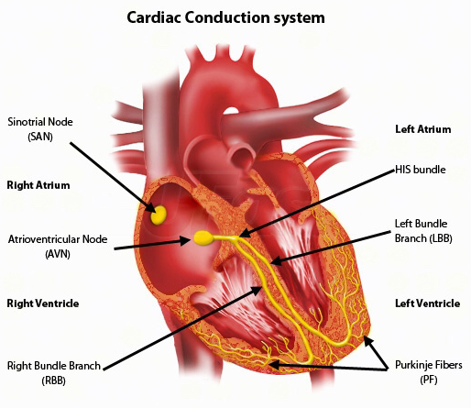
- Sinoatrial (SA) node
- Atrioventricular (AV) node
- Bundle of His
- Bundle branches
- Purkinje fibres

Contractions in the heart begin when electrical impulses are sent from the SA node (also known as the natural pacemaker) which is located in the right atrium. The impulse from the SA node causes the atria to contract, pushing blood through the open valves into the ventricles. The electric signal arrives at the AV node which is located between the two atria. From here it travels through the bundle of His, divides into the left and right bundle branches and through the Purkinje fibres. This causes the ventricles to contract. Both ventricles do not contract at precisely the same time, the left ventricle contracts slightly before the right. When the ventricles contract blood from the right ventricle is pumped through the pulmonary valves and onto the lungs, blood from the left ventricle is pumped through the aortic valves and onto the rest of the body. After contraction the ventricles relax, and wait for the next electric impulse. The atria fill with blood and an impulse from the SA node starts the cycle over again.
4.What is the relation between electrical and mechanical Activities of heart.
Relation between Electrical And Mechanical Activities Of Heart
Wigger’s diagram is actually a very useful tool to learn the components of the cardiac cycle which I have indicated in blue.
The sequence of events, starting with contraction of the LV (red line): LV contracts: pressure begins to rise in the LV and mitral valve closes (First heart sound – S1 – follow vertical line down to heart sounds) Pressure rises in LV until it exceeds the pressure in the aorta – aortic valve opens. Pressure in the LV and aorta peak (systolic BP), then diastolic relaxation begins and pressure begins to fall. LV pressure falls below the “back pressure” in the aorta, aortic valve closes (Second heart sound –S2) Aortic pressure falls a bit further as blood runs off into peripheral vessels but then stabilizes as the diastolic pressure you measure with your BP cuff. Pressure in the LV continues to fall; when it drops below the pressure in the LA, the MV opens, and the LV begins to fill from the LA. In pathological states, when the LV is enlarged and the muscle function is abnormal, the initial rapid inflow of blood from LA to LV is associated with an abnormal “thud”, or third heart sound (S3) At end diastole, the LA contracts into the LV, causing the small “blip” in pressure you see just before the onset of ventricular contraction (go back to beginning of diagram). In pathological states, if the LV is abnormally stiff and non-compliant, LA contraction is associated with an abnormal fourth heart sound – S4. After LA contraction, the LV begins to contract, LV pressure rises above LA pressure, the MV closes and the sequence starts again.
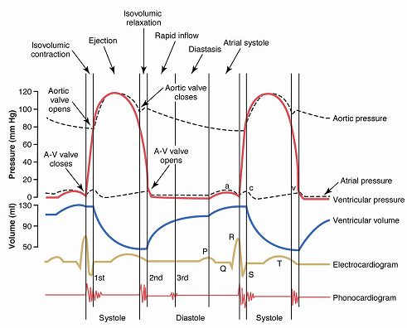

5.explain about the cardiac cycle.
The cardiac cycle describes all the activities of the heart through one complete heartbeat—that is, through one contraction and relaxation of both the atria and ventricles. A contraction event (of either the atria or ventricles) is referred to as systole, and a relaxation event is referred to as diastole. The cardiac cycle includes a description of the systolic and diastolic activities of the atria and ventricles, the blood volume and pressure changes within the heart, and the action of the heart valves. A description of each period of the cardiac cycle follows:
- The isovolumetric ventricular relaxation is the period during which the ventricles are relaxed and both AV and semilunar valves are still closed. The volume of the ventricles remains unchanged (isovolumetric) during this period.
- Ventricular filling begins as the AV valves open and blood fills the ventricles. The ventricles remain in diastole during this period. The filling of the ventricles can be described as three successive events:
  - Rapid ventricular filling occurs as blood flows into the empty and relaxed ventricles. Volume of the ventricles increases rapidly.
  - Diastasis is a slower filling event than that of the preceding because most of the volume of the ventricle is already occupied by blood.
  - Atrial systole (and the P wave of the ECG) occurs and forces the remaining blood from the atria into the ventricles. The blood volume at the end of this interval is called the end‐diastolic volume (EDV).
- Ventricular contraction (ventricular systole) begins as the action potential from the AV node enters the ventricles, the ventricles depolarize, and the QRS complex is observed on the ECG. The following intervals during this phase are observed:
  - Isovolumetric contraction occurs when the AV valves are forced shut. During this brief period, while the semilunar valves are still closed, the volume of the ventricles remains unchanged.
  - Ventricular ejection occurs as the continuing contraction of the ventricles increases the pressure in the ventricles and forces the semilunar valves open. At this point, blood is forced out of the ventricles. This interval ends when the ventricles begin to relax, and the semilunar valves close. The closing of the semilunar valves causes a small increase in blood pressure visible as the dicrotic notch on a plot of blood pressure against time. The amount of blood remaining in the ventricles at this time is called the end‐systolic volume (ESV).
The 4 stages of cardiac cycle are:
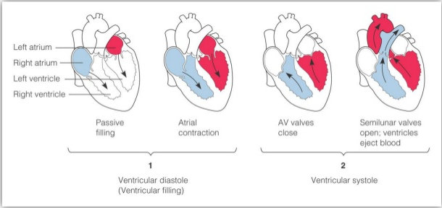

Unit 3:
1.explain in detail the process of blood pressure measurement in heart.

SPHYGMOMANOMETER
A sphygmomanometer is a device that measures blood pressure. It is composes of an inflatable rubber cuff, which is wrapped around the arm. A measuring device indicates the cuff's pressure. A bulb inflates the cuff and a valve releases pressure. A stethoscope is used to listen to arterial blood flow sounds.
As the heart beats, blood forced through the arteries cause a rise in pressure, called systolic pressure, followed by a decrease in pressure as the heart's ventricles prepare for another beat. This low pressure is called the diastolic pressure.
The sphygmomanometer cuff is inflated to well above expected systolic pressure. As the valve is opened, cuff pressure (slowly) decreases. When the cuff's pressure equals the arterial systolic pressure, blood begins to flow past the cuff, creating blood flow turbulence and audible sounds. Using a stethoscope, these sounds are heard and the cuff's pressure is recorded. The blood flow sounds will continue until the cuff's pressure falls below the arterial diastolic pressure. The pressure when the blood flow sounds stop indicates the diastolic pressure.
Systolic and diastolic pressures are commonly stated as systolic 'over' diastolic. For example, 120 over 80. Blood flow sounds are called Korotkoff sound
Types
There are three types of sphygmomanometers. Digital sphygmomanometers are automated, providing blood pressure reading without needing someone to operate the cuff or listen to the blood flow sounds. However digital types are less accurate. Some healthcare providers use digital for screening but use manual sphygmomanometers to validate readings in some situations.
Manual sphygmomanometers consist of aneroid (dial) and mercury (column) devices. Operating these aneroid and mercury devices is nearly the same, except that aneroid devices require periodic calibration.
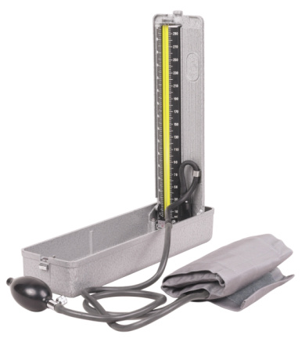

How To Use a Sphygmomanometer

Procedures
- To begin blood pressure measurement, use a properly sized blood pressure cuff. The length of the cuff's bladder should be at least equal to 80% of the circumference of the upper arm.
- Wrap the cuff around the upper arm with the cuff's lower edge one inch above the antecubital fossa.
- Lightly press the stethoscope's bell over the brachial artery just below the cuff's edge. Some health care workers have difficulty using the bell in the antecubital fossa, so we suggest using the bell or the diaphragm to measure the blood pressure.
- Rapidly inflate the cuff to 180mmHg. Release air from the cuff at a moderate rate (3mm/sec).
- Listen with the stethoscope and simultaneously observe the dial or mercury gauge. The first knocking sound (Korotkoff) is the subject's systolic pressure. When the knocking sound disappears, that is the diastolic pressure (such as 120/80).
- Record the pressure in both arms and note the difference; also record the subject's position (supine), which arm was used, and the cuff size (small, standard or large adult cuff).
- If the subject's pressure is elevated, measure blood pressure two additional times, waiting a few minutes between measurements.
- a blood pressure of 180/120mmhg or more requires immediate attention!

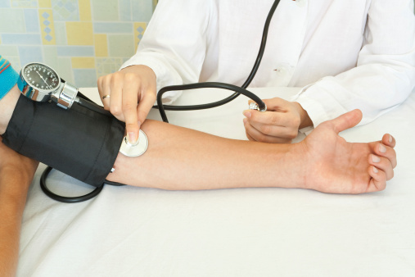
Precautions
- Aneroid and digital manometers may require periodic calibration.
- Use a larger cuff on obese or heavily muscled subjects.
- Use a smaller cuff for pediatric patients.
- For pediatric patients a lower blood pressure may indicate the presence of hypertension.
- Don't place the cuff over clothing.
- Flex and support the subject's arm.
- In some patients the Korotkoff sounds disappear as the systolic pressure is bled down. After an interval, the Korotkoff sounds reappear. This interval is referred to as the "auscultatory gap." This pathophysiologic occurrence can lead to a marked under-estimation of systolic pressure if the cuff pressure is not elevated enough. It is for this reason that the rapid inflation of the blood pressure cuff to 180mmHg was recommended above. The "auscultatory gap" is felt to be associated with carotid atherosclerosis and a decrease in arterial compliance in patients with increased blood pressure.
2. explain in detail about the blood flow measurement in heart.
Blood flow meters are used to monitor the blood flow in various blood vessels and to measure cardiac output.
Types
· Electromagnetic blood flow meters
· Ultrasonic blood flow meters
· Laser based blood flow meters
1. ELECTROMAGNETIC FLOWMETERS
▪ Electromagnetic blood flow meters measure blood flow in blood vessels
▪ Consists of a probe conneected to a flow sensor box
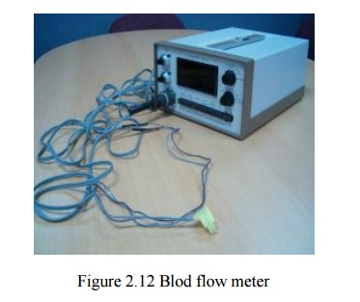
An Electromagnetic Flow Meter is a device capable of measuring the mass flow of a fluid. Unlike the common flow meter you can find on the market it has no moving parts, and for this reason it can be made to withstand any pressure (without leakage)and any fluid(corrosive and non corrosive). This kind of flow m eter use a magnet and two electrodes to p eek the voltage that appears across the fluid moving in the magnetic field.
The Neumann Law (or Lenz Law) states that if a conductive wire is moving at right angle through a magnetic field, a voltage E [Volts] will appear at the end of the conductor (Fig.1):
E= B*L*V
Where
B = Magnetic Induction [Weber/m2]
L = Length of the portion of the wire 'wetted' by the magnetic field [m]
V = Velocity of the wire [m/sec ]
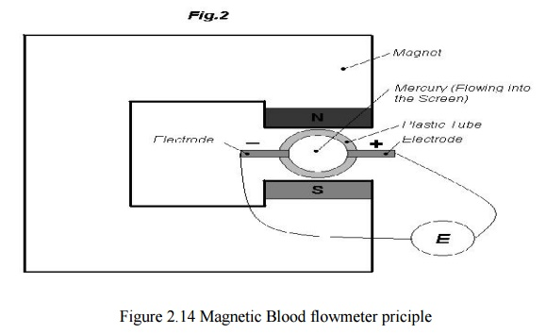
Now imagine you have a plastic tube with two electrodes on the diameter and Mercury flowing into it (fig.2). A voltage will appear on the electrodes and it will be
E=B*L*V
As in the previous example (L in this case is the inner diameter of the tube).Mercury as tiny conductive wires next to each other: each wire, moving in the tube, will touch the two electrodes ,and thus you can mea sure their voltage.
An interesting fact is t hat if you reverse the flow, you still get a voltage but with reverse polarity (Fig.1). Till n ow we have talked about a conductive fluid ,Mercury, but this stuff will also work with non conductive fluid, provided that you use an alternating magnetic field. Two physicists, Middleman and Cushing, in an unpublished work, stated that when using a non conductive f luid, if the frequency of the alternating magnetic field is v the voltage at the electrodes will be attenuated by a factor a so that:
Measuring the flow
`A perfect axisimmetric construction cannot be achieved and thus some magnetic flux lines will 'wet' the connecting wires to the electrodes. The alternating magnetic field will create an of fset voltage in this wire and even if the fluid is not moving, the measured voltage will not be zero.
2. ULTRASONIC FLOWMETERS
The blood cells in the fluid scatter the Doppler signal diffusively .In the recent years ultrasound contrast agents have been used in order to increase the echoes. The ultrasound beam is focused by a suitable transducer geometry and a lens.
In order to know where a long the beam the blood flow data is collected, a pulsed Doppler must be used. The flow velocity is obtained from the spectral estimation of the received Doppler signal The ultrasound Doppler device can be either a continuous wave or a pulsed Doppler 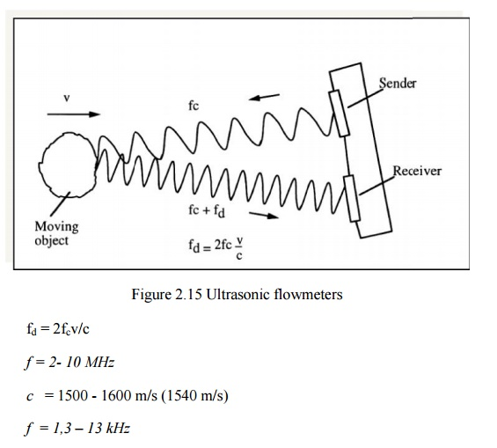
- Continuous Wave has
No minimum range
Simpler hardware
Range ambiguity
Low flow cannot be dete cted
- Pulsed Doppler has
Accuracy
No minimum flow
Minimum range
(Maximum flow) x (range) = limited the power decays exponentially because of the heating of the tissue. The absorption coefficient ~ proportional to frequency the far fi eld operation should be avoided due to beam divergence.

D = Transducer diam eter (e.g. 1 – 5 mm) the backscattered power is proportional to f.The resolution and SNR are related to the pulse duration. Improving either one of the parameters always affects inversely to the other
3. LASER DOPPLER FLOWMETRY
The principle of measurement is the same as with ultrasound Doppler.The laser parameter may have the following properties:5 mWH e-Ne-laser 632,8 nm wavelength.
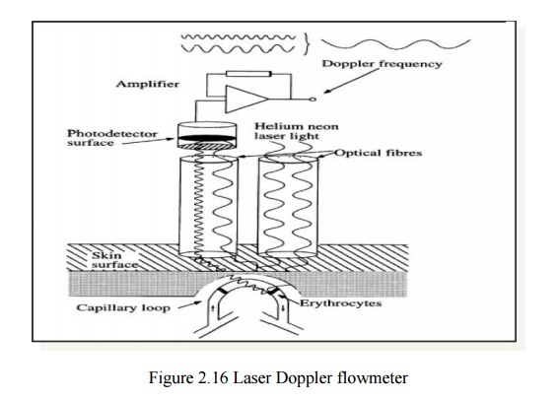
The moving red blood cells cause Doppler frequency 30 – 12 0 00 Hz.The method is used for capillary (microvascular) blood flow measurements

4.explain the Einthoven triangle.
Einthoven's triangle is an imaginary formation of three limb leads in a triangle used in electrocardiography, formed by the two shoulders and the pubis. The shape forms an inverted equilateral triangle with the heart at the center that produces zero potential when the voltages are summed. It is named after Willem Einthoven, who theorized its existence
Einthoven used these measuring points, by immersing the hands and foot in pails of salt water, as the contacts for his string galvanometer, the first practical ECG machine.

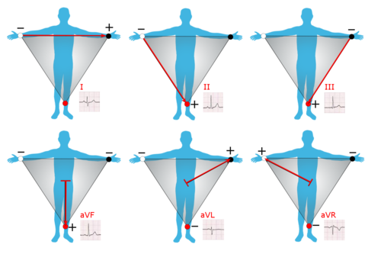
Graphical representation of Einthoven's triangle
Einthoven's triangle is an imaginary formation of three limb leads in a triangle used in electrocardiography, formed by the two shoulders and the pubis. The shape forms an inverted equilateral triangle with the heart at the center that produces zero potential when the voltages are summed. It is named after Willem Einthoven, who theorized its existence
Einthoven used these measuring points, by immersing the hands and foot in pails of salt water, as the contacts for his string galvanometer, the first practical ECG machine.

Lead placements
- Lead I — This axis goes from shoulder to shoulder, with the negative electrode placed on the right shoulder and the positive electrode placed on the left shoulder. This results in a 0 degree angle of orientation.
- Lead II — This axis goes from the right arm to the left leg, with the negative electrode on the shoulder and the positive one on the leg. This results in a +60 degree angle of orientation.
- Lead III — This axis goes from the left shoulder (negative electrode) to the right or left leg (positive electrode). This results in a +120 degree angle of orientation
Electrodes may be placed distally or proximally on the limb without affecting the recording. The leg electrode acts as a grounding lead, and either the right or left leg can be used as a grounding lead without an effect on the ECG results.
Each lead measures the electric field created by the heart during the depolarization and repolarization of myocytes. The electric field can be represented as a vector that changes continuously and can be measured by recording the voltage difference between electrodes.

Using Einthoven's triangle to identify lead misplacements
Though Einthoven's triangle is no longer used in contemporary ECGs, Einthoven's triangle can be helpful in the identification in incorrect placement of leads. (Incorrect placement of leads can lead to error in the recording, which can ultimately lead to misdiagnosis.)
If the arm electrodes are reversed, lead I changes polarity, causing lead II and lead III to switch. If the right arm electrode is reversed with the leg's electrode, lead II changes polarity, causing lead I to become lead III, and vice versa. Reversal of the left arm and leg causes a change in polarity of lead III and switching of leads I and II
Standard 12 lead ecg :
A 12-lead ECG gives a complete picture of the heart's electrical activity by recording information through 12 different perspectives. Think of it as 12 different points of view of an object woven together to create a cohesive story - the ECG interpretation.
These 12 views are collected by placing electrodes or small, sticky patches on the chest (precordial), wrists, and ankles. These electrodes are connected to a machine that registers the heart's electrical activity.

5.what is the interpretation of ECG waveform with respect to electro mechanical activity of the heart.
Wigger’s diagram is actually a very useful tool to learn the components of the cardiac cycle which I have indicated in blue.
The sequence of events, starting with contraction of the LV (red line): LV contracts: pressure begins to rise in the LV and mitral valve closes (First heart sound – S1 – follow vertical line down to heart sounds) Pressure rises in LV until it exceeds the pressure in the aorta – aortic valve opens. Pressure in the LV and aorta peak (systolic BP), then diastolic relaxation begins and pressure begins to fall. LV pressure falls below the “back pressure” in the aorta, aortic valve closes (Second heart sound –S2) Aortic pressure falls a bit further as blood runs off into peripheral vessels but then stabilizes as the diastolic pressure you measure with your BP cuff. Pressure in the LV continues to fall; when it drops below the pressure in the LA, the MV opens, and the LV begins to fill from the LA. In pathological states, when the LV is enlarged and the muscle function is abnormal, the initial rapid inflow of blood from LA to LV is associated with an abnormal “thud”, or third heart sound (S3) At end diastole, the LA contracts into the LV, causing the small “blip” in pressure you see just before the onset of ventricular contraction (go back to beginning of diagram). In pathological states, if the LV is abnormally stiff and non-compliant, LA contraction is associated with an abnormal fourth heart sound – S4. After LA contraction, the LV begins to contract, LV pressure rises above LA pressure, the MV closes and the sequence starts again.
6.what is the standard 12 -led configurations, explain about it.
The main purpose of the 12-lead ECG is to screen patients for possible cardiac ischemia. It helps EMS and hospital staff to quickly identify patients who have STEMI (ST elevation myocardial infarction or in other words, heart attack) and perform appropriate medical intervention based on initial readings.
12 LEAD ELECTRODE PLACEMENT:
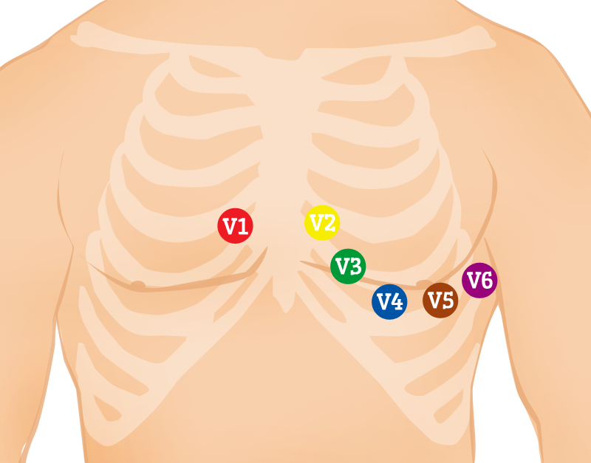
To measure the heart's electrical activity accurately, proper electrode placement is crucial.
In a 12-lead ECG, there are 12 leads calculated using 10 electrodes.Chest (Precordial) Electrodes and Placement
» V1 - Fourth intercostal space on the right sternum
» V2 - Fourth intercostal space at the left sternum
» V3 - Midway between placement of V2 and V4
» V4 - Fifth intercostal space at the midclavicular line
» V5 - Anterior axillary line on the same horizontal level as V4
» V6 - Mid-axillary line on the same horizontal level as V4 and V5 Limb (Extremity) Electrodes and Placement
» RA (Right Arm) - Anywhere between the right shoulder and right elbow
» RL (Right Leg) - Anywhere below the right torso and above the right ankle
» LA(Left Arm) - Anywhere between the left shoulder and the left elbow
» LL (Left Leg) - Anywhere below the left torso and above the left ankle
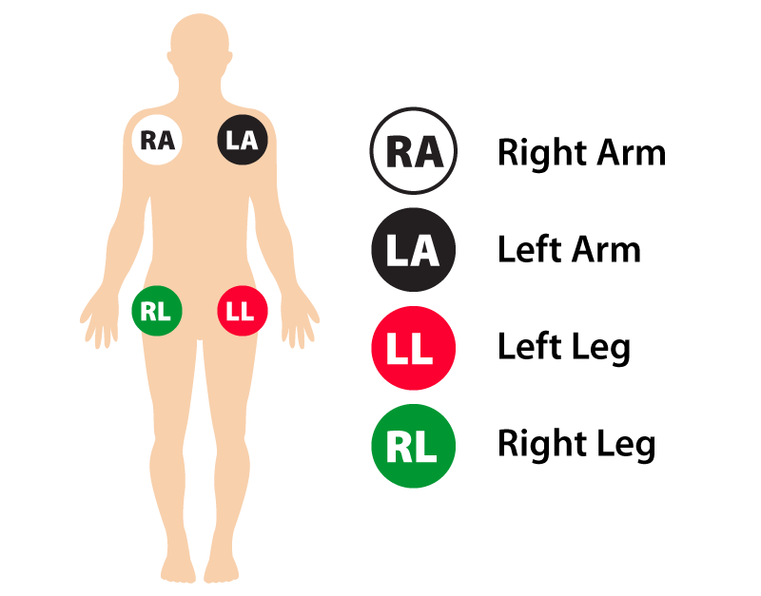

12 LEAD GROUPS
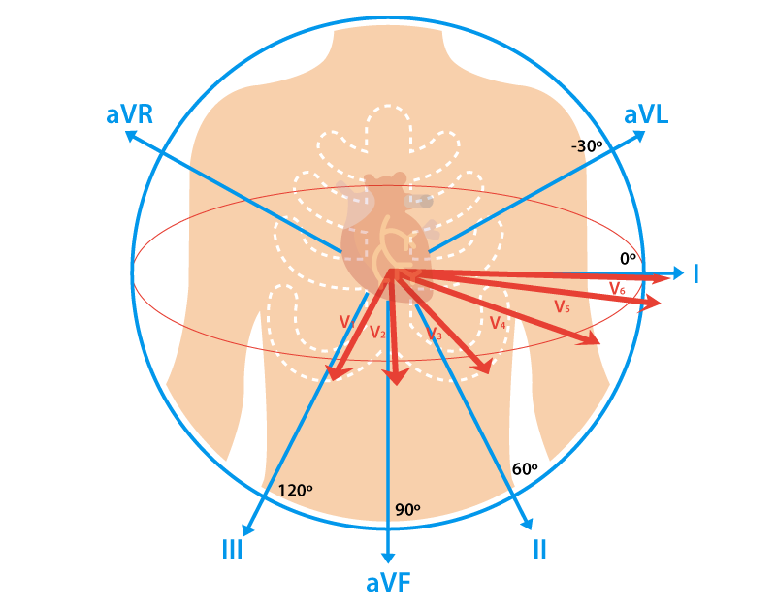
A lead is a glimpse of the electrical activity of the heart from a particular angle.
Put simply, a lead is like a perspective. In 12-lead ECG, there are 10 electrodes providing 12 perspectives of the heart's activity using different angles through two electrical planes - vertical and horizontal planes.

Vertical plane (Frontal Leads):
By using 4 limb electrodes, you get 6 frontal leads that provide information about the heart's vertical plane:
- Lead I
- Lead II
- Lead III
- Augmented Vector Right (aVR)
- Augmented Vector Left (aVL)
- Augmented vector foot (aVF)
Leads I, II, and III require a negative and positive electrode (bipolarity) for monitoring. On the other hand, the augmented leads-aVR, aVL, and aVF-are unipolar and requires only a positive electrode for monitoring.

Patient Positioning for 12-Lead ECG Placement
- Ensure that electronic devices (e.g. smartphone) are removed from the patient. These devices can produce artifact (interference) and cause problems with the readings.
- Place patient in supine or Semi-Fowler's position. If both positions are impossible, you can perform ECG with the patient in a more elevated position.
- With arms lying flat on the side, ask the patient to relax the shoulders and keep the legs uncrossed.
- For patients that do not fit comfortably on the bed or exam table due to size, ask them to cross their arms on their stomach to reduce muscle tension and movement.
- Unless you're performing a stress ECG test, ask the patient to lie still and quietly until the test is done.
ARTIFACT REMOVAL:
A slight ECG artifact is not uncommon. However, you can reduce further interference through the following steps:
- Switch off non-essential electrical devices and equipment within the vicinity if possible.
- Check for cable loops and avoid running cables adjacent to metallic objects as they can affect the signal.
- Inspect wires and cables for cracks or breaks. Replace as needed.
- If possible, use surge suppressors with the power supply.
- Ensure that filters and preamplifiers are appropriately adjusted.
- Ensure securely connection between patient cable and the ECG device. Double check for gaps between connectors.
Skin preparation:
- Skin should be dry, hairless, and oil-free. Shave hair that can possibly impede electrode placement. Electrodes should have full contact with the patient's skin.
- For better electrode adhesion and oil-free skin, rub the area with an alcohol prep pad or gauze paid with benzoin tincture.
- Reduce electrical resistance minus the skin redness with 5 to 10 gentle strokes. This will help ensure that the heart's electrical signals are transmitted to the electrodes.
- Promote an environment that prevents the patient from sweating profusely.
Electrode Application:
Exact placement of each electrode on the patient is important. Incorrect placement can lead to false or misleading diagnosis.
- Make sure the electrode conducting gel is fresh and adequately moist. A dry electrode with inadequate gel reduces the conduction of the ECG signal.
- Often, electrode gel dry-out is a result of incorrect storage. Store electrodes as instructed by manufacturer and do not remove from their pouch until they're ready for use.
- Do not place electrodes on skin over bones, incisions, irritated skin, and body parts where there is lots of possible muscle movement.
- Use electrodes of the same brand. Using different brands with dissimilar composition can hinder an accurate ECG trace.

Unit 4:
1.explain the pacemaker and defibrillator.
A pacemaker is a small device that helps your heart beat more regularly. It does this with a small electric stimulation that helps control your heartbeat. Your doctor puts the pacemaker under the skin on your chest, just under your collarbone. It’s hooked up to your heart with tiny wires. You may need a pacemaker to keep your heart beating properly. This helps your body get the blood and oxygen it needs. Some people just need a pacemaker for a short time (like after a heart attack) and may use a kind that’s outside the skin. The battery unit for this type can be worn on a belt. A pacemaker is implanted under the skin, just under the collarbone. It should help your heart pump almost as well as it did before. Today many people with pacemakers lead full, active lives.
TYPES OF PACEMAKER:
- Temporary pacemaker:
- Provide a temporary rate to support metabolic needs
Due to:
- Reversible problem
- Awaiting for a permanent pacemaker
2. Permanent pacemaker:
  - Implantable Pulse Generators (IPG):
- Provide a rate to support metabolic needs
- Provide various diagnostics
- Single chamber (AAI,VVI)
- dual chamber (DDD)
- About 8-10 years longevity
  - 2.2) Cardiac Resynchronization Therapy-Pacing (CRT-P):
- Restore ventricular synchrony
- Uses a specially designed lead placed usually on the posterior-lateral wall of the LV via the Coronary Sinus circulation
- Provides RV and LV synchronous pacing
- Provides a rate to support metabolic needs o CRT pacing only (Low-Power CRT)
- Provides various diagnostics
2.3 Cardiac Resynchronization Therapy-Defibrilator(CRT-D):
- restore rhythms in presence of lethal tachycardia
- CRT pacing +ICD (High-Power C.
2.explain the defibrillator.
Defibrillation is the definitive treatment for the lifethreatening cardiac arrhythmias ventricular
fibrillation and pulseless ventricular tachycardia
- Ventricular fibrillation results from:
- Coronary occlusion
- Electrical shock
- Abnormalities of body chemistry
- This irregular contraction of the muscle fibers causes non effectively blood pumping and that
- Results in a steep fall of cardiac output.

VENTRICULAR FIBRILLATION
Ventricular fibrillation can be converted into a more efficient rhythm by applying high energy shock to the heart.This causes all muscle fibers to contract simultaneously, which may then respond to normal physiological pacemaking pulses
- Restoration of normal rhythm in fibrillating heart as achieved by direct
current shock (arrow) across the chest wall. The horizontal line after the shock shows that the cardiograph was blocked or disconnected for its protection during the period of shock.

DEFIBRILATOR:
1.Defibrillator is a device that deliver a therapeutic dose of electrical energy (electric shock) to the affected heart (fibrillated heart or other shockable rhythm) to force the heart to produce more normalcardiac rhythm.
2.The shock can be delivered by means electrodes placed on the chest of the patient (external defibrillation) or the electrodes may be held directly against the heart when the chest is open (internal
defibrillation).
3.Higher voltage are required for external defibrillation than internal defibrillation.
DC DEFIBRILATOR:
An energy storage capacitor is charged at a relatively slow rate from:
1. The AC line by means of a step-up transformer and rectifier arrangement or.
2. A battery and DC to DC converter arrangement
3. During defibrillation the energy stored in the capacitor is then delivered (Discharged) at a relatively rapid rate (in order of milliseconds) to the chest of subject through the patient’s own resistance
4.Energy level of defibrillators is from 2 to 400 Joules (J) (depends on the size of the patient and skin resistance)
5. Required voltage in the range of 1000 to 6000 V (depend on the duration of the DC pulse)
6. Current range 1 to 20 A

Energy Level of DC Defibrillator
Energy level of a defibrillator can be controlling:
- The voltage amplitude VP of the defibrillator by varying the setting on the varactor or
- Duration of the defibrillator pulse
- The energy (WA) stored in the capacitor C and available for the defibrillation is:
WA=(1/2)VC^2
􀂙 L
Waveforms of DC Defibrillator
Lown waveform: Curve shows a typical discharge pulse of defibrillator which called “Lown” waveform.
- I rises rapidly to app. 20 A
- Then I decays to 0 with 5 ms
- A negative pulse is produced for 1 to 2 ms
- The pulse width defined as the time that elapses between the start of the impulse and the moment that the current intensity passes the zero line for the first time and changes direction (5 ms or 2.5 ms)

- Mono-phasic waveform: The delivered energy through the patient's chest is in a single direction current flows in one direction from one electrode to the other High level of energy

2.explain the shortwave diathermy and hemodialysis machine.
Hemodialysis Machines
- Single-patient hemodialysis machines deliver a patient’s dialysis prescription by controlling blood and dialysate flows through the dialyzer.
- Removal of waste metabolites
- Removal of water
- Hemodialysis machines incorporate monitoring and alarm systems that protect the patient against adverse events that may arise from equipment malfunction during the dialysis treatment.

Hemodialysis System Components:

3.write about the mechanisms of respiration.

4.what is the spirometry and exaplain it.
Spirometry (meaning the measuring of breath) is the most common of the pulmonary function tests (PFTs). It measures lung function, specifically the amount (volume) and/or speed (flow) of air that can be inhaled and exhaled. Spirometry is helpful in assessing breathing patterns that identify conditions such as asthma, pulmonary fibrosis, cystic fibrosis, and COPD. It is also helpful as part of a system of health surveillance, in which breathing patterns are measured over time.
Spirometry generates pneumotachographs, which are charts that plot the volume and flow of air coming in and out of the lungs from one inhalation and one exhalation.

Indications:
Spirometry is indicated for the following reasons:
- to diagnose or manage asthma
- to detect respiratory disease in patients presenting with symptoms of breathlessness, and to distinguish respiratory from cardiac disease as the cause
- to measure bronchial responsiveness in patients suspected of having asthma
- to diagnose and differentiate between obstructive lung disease and restrictive lung disease
- to follow the natural history of disease in respiratory conditions[to assess of impairment from occupational asthma
- to identify those at risk from pulmonary barotrauma while scuba diving
- to conduct pre-operative risk assessment before anaesthesia or cardiothoracic surgery
- to measure response to treatment of conditions which spirometry detects
- to diagnose the vocal cord dysfunction.

Contraindications
Forced expiratory maneuvers may aggravate some medical conditions Spirometry should not be performed when the individual presents with:
- Hemoptysis of unknown origin
- Pneumothorax
- Unstable cardiovascular status (angina, recent myocardial infarction, etc.)
- Thoracic, abdominal, or cerebral aneurysms
- Cataracts or recent eye surgery
- Recent thoracic or abdominal surgery
- Nausea, vomiting, or acute illness
- Recent or current viral infection
- Undiagnosed hypertension

Spirometry testing

A modern USB PC-based spirometer.
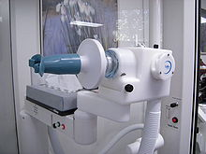
Device for spirometry. The patient places his or her lips around the blue mouthpiece. The teeth go between the nubs and the shield, and the lips go over the shield. A noseclip guarantees that breath will flow only through the mouth.
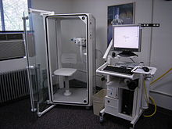
Screen for spirometry readouts at right. The chamber can also be used for body plethysmography.

Spirometer
The spirometry test is performed using a device called a spirometer, which comes in several different varieties. Most spirometers display the following graphs, called spirograms:
- a volume-time curve, showing volume (litres) along the Y-axis and time (seconds) along the X-axis
- a flow-volume loop, which graphically depicts the rate of airflow on the Y-axis and the total volume inspired or expired on the X-axis

Procedure
The basic forced volume vital capacity (FVC) test varies slightly depending on the equipment used.
Generally, the patient is asked to take the deepest breath they can, and then exhale into the sensor as hard as possible, for as long as possible, preferably at least 6 seconds. It is sometimes directly followed by a rapid inhalation (inspiration), in particular when assessing possible upper airway obstruction. Sometimes, the test will be preceded by a period of quiet breathing in and out from the sensor (tidal volume), or the rapid breath in (forced inspiratory part) will come before the forced exhalation.
During the test, soft nose clips may be used to prevent air escaping through the nose. Filter mouthpieces may be used to prevent the spread of microorganisms.

Limitations of test
The maneuver is highly dependent on patient cooperation and effort, and is normally repeated at least three times to ensure reproducibility. Since results are dependent on patient cooperation, FVC can only be underestimated, never overestimated.
Due to the patient cooperation required, spirometry can only be used on children old enough to comprehend and follow the instructions given (6 years old or more), and only on patients who are able to understand and follow instructions — thus, this test is not suitable for patients who are unconscious, heavily sedated, or have limitations that would interfere with vigorous respiratory efforts. Other types of lung function tests are available for infants and unconscious persons.
Another major limitation is the fact that many intermittent or mild asthmatics have normal spirometry between acute exacerbation, limiting spirometry's usefulness as a diagnostic. It is more useful as a monitoring tool: a sudden decrease in FEV1 or other spirometric measure in the same patient can signal worsening control, even if the raw value is still normal. Patients are encouraged to record their personal best measures.

Technologies used in spirometers
- Volumetric Spirometers
  - Water bell
  - Bellows wedge
- Flow measuring Spirometers
  - Fleisch-pneumotach
  - Lilly (screen) pneumotach
  - Turbine/Stator Rotor (normally incorrectly referred to as a turbine. Actually a rotating vane which spins because of the air flow generated by the subject. The revolutions of the vane are counted as they break a light beam)
  - Pitot tube
  - Hot-wire anemometer
  - Ultrasound

- explain the pnemuotachograph ventilators.
Air-Pressure Pneumograph In the pneumograph method, an air-filled length of flexible tubing is stretched around a subject's chest. This tubing is connected to a pressure sensor, amplification circuitry, and a recording system. During inspiration, the chest expands and causes the tube to stretch, which increases the pressure inside the tube. During exhalation, a decrease in pressure is realized inside the tube. This technique yields an accurate measure of breathing rate but only relative indications of amplitude. The obtrusiveness of the pneumograph technique is comparable to that of the strain gauge method. Furthermore, location points on the chest are highly variable across subjects, the tubing may slip or roll on the body, and the elastic tubing may cause discomfort, especially in long experiments.
PNEUMOTACHOGRAPH AIRFLOW MEASUREMENT:
- Patient airflow may be measured by changes in resistance of a thermistor in the airstream due to the cooling effect of flowing air.
  - But it must be calibrated to compensate for changing ambient temperature.
- To eliminate this disadvantage, a strain-gauge wire mesh is often used.
- The airflow in either direction puts a strain on the screen and changes the resistance of its strain gauge.
Unit 5:
- write about the specification of eeg machines.
Specifications of a eeg machine:
Minimum Technical Requirements for Performing Clinical Electroencephalography Introduction Although no single best method exists for recording EEGs under all circumstances, the following standards are considered the minimum for the usual clinical recording of EEGs in all age groups except the very Recording at minimum standards should not give pride to the EEG department working at this level and cannot ensure a satisfactory test. Minimum standards provide barely adequate fulfillment of responsibilities to the patient and the referring physician. To the minimum standards have been added recommendations to improve standardization of procedures and also facilitate interchange of recordings and assessment among laboratories in North America
1. Equipment
1.1 To find the distribution of EEG activity, it is necessary to record simultaneously from as many regions of the scalp as possible. When too few channels are used simultaneously, the chances of interpretive errors increase, and, conversely, when more channels are utilized, the likelihood of such errors decreases. This is particularly true for transient activity. Sixteen channels of simultaneous recording are now considered the minimum number required to show the areas producing most normal and abnormal EEG patterns. Additional channels are often needed for monitoring other physiologic activities.
1.2 Alternating current (AC) wiring should meet the Underwriters Laboratories standards required for hospital service. Adequate grounding of the instrument must be provided by all AC receptacles. All equipment in each patient area in the EEG laboratory must be grounded to a common point.
1.3 In the usual clinical setting, electrical shielding of the patient and equipment is not necessary, and such shielding need not be installed unless proven necessary.
1.4 Ancillary equipment should include a device for delivering rhythmic, high-intensity flash stimuli to the patient.
2. Electrodes
2.1 Recording electrodes should be free of inherent noise and drift. They should not significantly attenuate signals between 0.5 and 70 Hz. Experimental evidence suggests that silver—silver chloride or gold disk electrodes held on by collodion are the best, but other electrode materials and electrode pastes have been effectively used especially with contemporary amplifiers having high input impedances.
2.2 Needle electrodes are not recommended. If circumstances necessitate their use, they must be completely sterilized or discarded after use, and the technologist who employs them should have been taught the exact techniques, as well as the disadvantages and hazards, of their use. Parallel anteroposterior alignment of the needles is important; misalignment may cause artifactual amplitude asymmetries or distortions.
2.3 All 21 electrodes and placements recommended by the International Federation of Clinical Neurophysiology should be used. The 10-20 System is the only one officially recommended by the IFCN. It is the most commonly used existing system, and it should be used universally.
2.4 Interelectrode impedances should be checked as a routine prerecording procedure. Ordinarily, electrode impedance should not exceed 5000 Ohms (5 KOhms.) Electrode impedances should be rechecked during the recording when any pattern that might be artifactual appears.
3. Recordings
3.1 Montages should be designed in conformity with Guidelines 6: A Proposal for Standard Montages to Be Used in Clinical Electroencephalography. It is desirable that at least some montages in all laboratories be uniform to facilitate communication and comparison.
3.2 The record should have written on it as a minimum the name and age of the patient, the date of the recording, an identification number, and the name or initials of the technologist. Identifications should be made at the time of recording.
3.3 Appropriate calibrations should be made at the beginning and end of every EEG recording. If feasible, a recording with all channels connected to the same pair of electrodes should follow at the beginning.
3.explain the electrode placement for eeg and emg recording.
EEG Electrode Placement
For eeg electrode placement a method called the 10-20 system has been developed for placement of electrodes on the scalp during EEG recordings. The 10 and 20 in the name refer to the percent distances that the electrodes are from each other in proportion to the size of the head. The 10-20 system relates the locations on the scalp to the locations of the cerebral cortex. The electrode locations used in the 10-20 system are indicated with a letter followed by a number. The letters that are used include F, T, C, P, and O. These letters correspond to frontal, temporal, central, parietal, and occipital, respectively. These are all lobes of the brain except for the central location. The number in the indicated position corresponds to the left or right side of the head. Even numbers are located on the right hemisphere while odd numbers are on the left. Some letters are followed by a Z instead of a number. The Z indicates the midline of the head.
The following diagram illustrates these standard electrode positions:

Noise
Several sources of noise and artifact can interfere with accurately recording the EEG signal. One
of the most common artifacts is an eye blink which creates spikes in the EEG. These spikes can
sometimes be difficult to distinguish from those due to an epileptic attack. When the eye blinks,
the eyelids act as a sliding potential source. Other sources of noise in include electromyographic (EMG) activity from muscles near the recording electrodes, such as muscles of the face and neck, and eye movements (EOG). Several techniques exist for removing the artifacts generated by EMG, EOG, and blinking. These techniques include filtering the data, performing correction on the data, or just completely throwing out any data with artifact. In order to minimize noise for this laboratory, the subject should relax their face and neck muscles and keep their eyes relatively still while recording EEG data.

2.write about the specification of emg machines.

