Short Questions: (unit wise)
Unit -1:
- What is sole proprietorship?

The sole trader is the simplest, oldest and natural form of business organization. It is also called sole proprietorship. ‘Sole’ means one. ‘Sole trader’ implies that there is only one trader who is the owner of the business.

- Characteristics of partnership and Partnership definition?

Indian Partnership Act, 1932 defines partnership as the relationship between two or more persons who agree to share the profits of the business carried on by all or any one of them acting for all.

Characteristics:

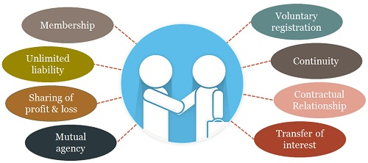

- Characteristics of joint stock company and JSC definition?
The word ‘ company’ has a Latin origin, com means ‘ come together’, pany means ‘ bread’, joint stock company means, people come together to earn their livelihood by investing in the stock of company jointly

The Companies Act 1956 defines a joint stock company as an artificial person created by law, having separate legal entity from its owner with perpetual succession and a common seal. Shareholders of Joint Stock Company have limited liability i.e liability limited by guarantee or shares. Shares of such company are easily transferable.

Characteristics:

- Artificial Person:
A Joint Stock Company is an artificial person as it does not possess any physical attributes of a natural person and it is created by law. Thus it has a legal entity separate from its members.
2. Separate legal Entity:
Being an artificial person a company has its own legal entity separate from its members. It can own assets or property enters into contracts, sue or can be sued by anyone in the court of law. Its shareholders cannot be held liable for any conduct of the company.
3. Perpetual Existence:
A company once formed continues to exist as long as it is fulfilling all the conditions prescribed by the law. Its existence is not affected by the death, insolvency or retirement of its members.
4. Limited liability of shareholders:
Shareholders of a joint stock company are only liable to the extent of shares they hold in a company not more than that. Their liability is limited by guarantee or shares held by them.
5. Common Seal:
Being an artificial person a joint stock company cannot sign any documents thus this common seal is the company’s representative while dealing with the outsiders. Any document having common seal and the signature of the officer is binding on the company.
6. Transferability of Shares:
Members of a joint stock company are free to transfer their shares to anyone.

7. Capital:
A joint stock company can raise large amount of capital by issuing its shares.
8. Management:
A joint stock company has a democratic management which is managed by the elected representatives of shareholders, known as directors of the company.
9. Membership:
To form a private limited company minimum number of members prescribed in the companies Act is 2 and the maximum number is 50. But in the case of public limited company the minimum limit is 7 and no limit on maximum number of members.
10. Formation:
Generally a company is formed with the initiative of group of members who are also known as promoters but it comes into existence after completing all the formalities prescribed in Companies Act 1956.

4. Long term sources of finance?

Long term finance means capital requirements for a period of more than 5 years to 10, 15, and 20 years or maybe more depending on other factors:

- Equity shares
- Preference shares
- Debentures
- Long term financial institutions etc.
5. Economics definition?

Adam Smith’s Wealth Definition:
Economics as a science of wealth which studies the process of production, consumption and accumulation of wealth.

Marshall’s Welfare Definition:
Marshall defines economics as “a study of men as they live and move and think in the ordinary business of life.” He argued that economics, on one side, is a study of wealth and, on the other, is a study of man.

Robbins’ Scarcity Definition
“Economics is the science which studies human behaviour as a relationship between ends and scarce means which have alternative uses.”
6. What is micro and macro economics?
Micro economics:
Study of small economic units such as individuals, firms, and industries (competitive markets, labor markets, personal decision making, etc.)
Macro economics:
Study of the large economy as a whole or in its basic subdivisions (National Economic Growth, Government Spending, Inflation, Unemployment, etc.)
7. What is national income and concept?
National income measures the total value of goods and services produced within the economy over a period of time.

Concepts:

Gross domestic product (GDP): is defined as "an aggregate measure of production equal to the sum of the gross values adde Per Capita Income (PCI)

Per Capita Income: of a country is derived by dividing the national income of the country by the total population of a countryd of all resident institutional units engaged in production

Gross national product (GNP): is the market value of all the productsand services produced in one year by labor and property supplied by the citizens of a country.

PersonalIncome(PI):
Personal Income i s the total money income received by individuals and households of a country from all possible sources before direct taxes.

8. What is Business cycle and phases?

The business cycle occurs when economic activity speeds up or slows down. A business cycle is a swing in total national output, income and employment, usually lasting for a period of 2 to 10 years, marked by widespread expansion or contraction in many sectors of the economy

Phases:

- Boom stage
- Growth stage
- Maturity stage
- Decline stage

9. Inflations definition?
Inflation is the rate at which the general level of prices for goods and services is rising and, consequently, the purchasing power of currency is falling.
10. Cost plus inflation?
Cost-push inflation is a situation in which the overall price levels go up (inflation) due to increases in the cost of wages and raw materials.
Cost-push inflation develops because the higher costs of production factors decrease in aggregate supply (the amount of total production) in the economy. Since there are fewer goods being produced (supply weakens) and demand for these goods remains consistent, the prices of finished goods increase (inflation).

11. What is business?

Business is an economic activity carried on with the intention of to earn profit. The main aim of business is to earn profit. Business includes Industry and Commerce.

Types of business entities:;

1. Sole trader business
2. Partnership business
3. Joint stock company

12. Types of partnership business?
1. Active partner
2. Sleeping partner
3. Nominal partner
4. Partner by estoppels
5. Partner by holding out
13. Content of partnership deed?
Partnership deeds, in very simple words, are an agreement between partners of a firm. This agreement defines details like the nature of the firm, duties, and rights of partners, their liabilities and the ratio in which they will divide profits or losses of the firm.
Contents:
- The name of the firm
- Name and details of all partners
- Date of commencement of business
- Duration of the firm’s existence
- Capital contributed by each partner
- Profit/loss sharing ratio
- Interest on capital payable to partners
- The extent of borrowings each partner can draw
- Salary payable to partners, if any
- The procedure of admission or retirement of a partner
- The method used for calculating goodwill
- Preparation of accounts of the firm
- Mode of settlement of dues with a deceased partner’s executors
- The procedure followed in case disputes arise between partners

14. What is the difference between private and public company?
BASISFOR COMPARISON | PUBLIC COMPANY | PRIVATE COMPANY
Meaning | A public company is a company which is owned and traded publicly | A private company is a company which is owned and traded privately.
Minimum members | 7 | 2
Maximum members | Unlimited | 200
Minimum Directors | 3 | 2
Suffix | Limited | Private Limited
Start of business | After receiving certificate of incorporation and certificate of commencement of business. | After receiving certificate of incorporation.
Statutory Meeting | Compulsory | Optional
Issue of prospectus / Statement in lieu of prospectus | Obligatory | Not required
Public subscription | Allowed | Not allowed
Quorum at AGM | 5 members must present in person. | 2 members must present in person.
Transfer of shares | Free | Restricted

15. Theory of firms?

The theory of the firm is the microeconomic concept founded in neoclassical economics that states that firms exist and make decisions to maximize profits. The theory holds that the overall nature of companies is to maximize profits meaning to create as much of a gap between revenue and costs. The firm's goal is to determine pricing and demand within the market and allocate resources to maximize net profits.

16. What is meant by nominal partner?

Person who has an interest in the success of a partnership firm but, legally, is not partner because he or she neither owns a part of the firm nor actively participates in its affairs. Often a nominal partner is a well known, well connected individual whose name lends credibility and recognition to the firm, and is paid a fee for this service. Also called limited partner or ostensible partner.

17. What is the role of Business economist?
Business economist taking the decision about
- Production
- Capital Management Decisions
- Pricing Decisions
- Promotion Strategies
- Demand Analyses and Forecasting
- Resource Allocation
- Profit analysis

18. What is normative statement?

A normative statement expresses a value judgment about whether a situation is desirable or undesirable. Normative statements are characterized by the modal verbs "should", "would", "could" or "must". They form the basis of normative economics, and are the opposite of positive statements.

19. What is marginal cost?

Marginal cost is the additional cost incurred in the production of one more unit of a good or service. Marginal cost is significant in economic theory because a profit maximizing firm will produce up to the point where marginal cost (MC) equals marginal revenue (MR).

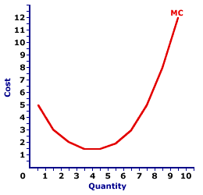
Unit -2:

- What is demand?
Demand refers to the quantity of a commodity or a service that people are willing to buy at a certain price during a certain time interval. It can be termed as a desire with the ‘willingness’ and ‘ability’ to pay for a commodity.
A product or services is said to have demand when tree conditions are satisfied:
Desire + Ability to pay + Willingness to pay for it

2. Demand function?
Demand function is an algebraic expression that shows the functional relationship between the demand for a commodity and its various determinants affecting it. This includes income and price along with other determining factors.

Q=F(P,I,T,Pr,Ep,Ei,Sp,Ac,A,O)
Where
Q= Quantity of demand
I=Income
P=price
Pr= Price of related goods;
Y= Income of the individual consumer;
T= Tastes and preferences;
3. Explain law of demand and assumptions?

Law of demand shows the relation between price and quantity demanded of a commodity in the market. In the words of Marshall, “the amount demand increases with a fall in price and diminishes with a rise in price”.
Generally, a person demands more at a lower price and less at a higher price. The relation of price to demand or sales is known in Economics as the Law of Demand.
The Law of Demand states that “higher the price, lower the demand and vice versa, other things remaining the same”.

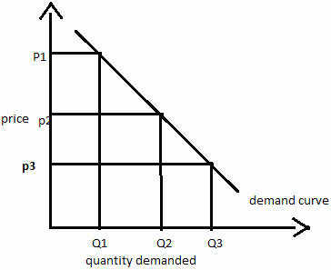

Assumption:
- Law is demand is based on certain assumptions:
- This is no change in consumers taste and preferences.
- Income should remain constant.
- Prices of other goods should not change

4. What are the factors affecting demand?
There are factors on which the demand for a commodity depends. These factors are economic, social as well as political factors. The effect of all the factors on the amount demanded for the commodity is called Demand Function.
These factors are as follows:
- Price
- income of the buyer,
- the price of related goods,
- the tastes of the consumer, and
- Any expectation the consumer has of future supply, prices, etc.

5. What is perfect elasticity of demand?

When small change in price leads to an infinitely large change is quantity demand, it is called perfectly or infinitely elastic demand. In this case E=∞

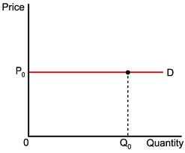

6. What is unitary elasticity of demand?

The change in demand is exactly equal to the change in price. When both are equal E=1 and elasticity if said to be unitary.

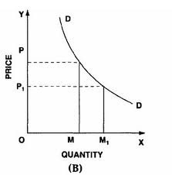

When price falls from ‘OP’ to ‘OP1’ quantity demanded increases from ‘OP’ to ‘OP1’, quantity demanded increases from ‘OM’ to ‘OM1’. Thus a change in price has resulted in an equal change in quantity demanded so price elasticity of demand is equal to unity.
7. Elasticity of demand?
The demand elasticity (elasticity of demand) refers to how sensitive the demand for a good is to changes in other economic variables, such as prices and consumer income. Demand elasticity is calculated as the percent change in the quantity demanded divided by a percent change in another economic variable.

9. Giffen goods
A Giffen good is a product for which demand increases as the price increases, and falls when the price decreases. A Giffen good has an upward-sloping demand curve, which is contrary to the fundamental law of demand which states that quantity demanded for a product falls as the price increases, resulting in a downward slope for the demand curve. Generally speaking, Giffen good are typically inferior products that do not have readily available substitutes.
10. Demand forecasting?
Demand Forecasting refers to the process of predicting the future demand for the firm’s product. In other words, demand forecasting is comprised of a series of steps that involves the anticipation of demand for a product in future under both controllable and non-controllable factors.

11. Collective opinion survey?
This method is also known as “Sales Force Opinion” or “Sales Force Polling” or “Reaction Survey” method. • Under this method the responsibility for estimating the expected sales is placed on salesmen. • Salesmen being closest to the consumers have the knowledge of the requirements of the consumers, their reactions to the product. • These estimates of individual salesmen are consolidated to find out the total estimated sales.
12. Delphi method?
The Delphi method is a forecasting process framework based on the results of multiple rounds of questionnaires sent to a panel of experts. Several rounds of questionnaires are sent out to the group of experts, and the anonymous responses are aggregated and shared with the group after each round. The experts are allowed to adjust their answers in subsequent rounds, based on how they interpret the "group response" that has been provided to them. Since multiple rounds of questions are asked and the panel is told what the group thinks as a whole, the Delphi method seeks to reach the correct response through consensus.
13. Supply definition?
The total amount of a product (good or service) available for purchase at any specified price.
Supply is determined by:

- Price:
Producers will try to obtain the highest possible price whereas the buyers will try to pay the lowest possible price both settling at the equilibrium price where supply equals demand.
- Cost of inputs:
The lower the input price the higher the profit at a price level and more products will be offered at that price.

- Price of other goods:
Lower prices of competing goods will reduce the price and the supplier may switch to switch to more profitable products thus reducing the supply.

14. Supply function and law of supply?
The law of supply is the microeconomic law that states that, all other factors being equal, as the price of a good or service increases, the quantity of goods or services that suppliers offer will increase, and vice versa. The law of supply says that as the price of an item goes up, suppliers will attempt to maximize their profits by increasing the quantity offered for sale.
Law of supply:
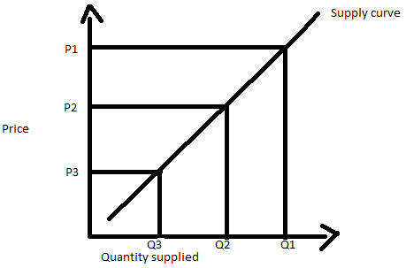

- What is price elasticity of demand and explain types?
Elasticity of demand refers to price elasticity of demand. It is the degree of responsiveness of quantity demanded of a commodity due to change in price, other things remaining the same.
The price elasticity of demand is defined as the percentage change in quantity demanded due to certain percentage change in price.
TYPES:
- Perfectly elasticity of demand
- Perfectly inelasticity of demand
- Relatively elasticity of demand
- Relatively inelasticity of demand
- Unity elasticity of demand
16. Demand forecasting steps?
The objective of demand forecasting is attained only when the forecasting is done systematically and scientifically. Thus, the following steps in demand forecasting are followed to facilitate a systematic estimation of future demand for product:
STEPS:
- Specifying the Objective
- Determining the Time Perspective
- Choice of method for Demand Forecasting
- Collection of Data and Data Adjustment
- Estimation and Interpretation of Results
17. What is Barometric demand?
The Barometric Method of Forecasting was developed to forecast the trend in the overall economic activities. This method can nevertheless be used in forecasting the demand prospects, not necessarily the actual quantity expected to be demanded.
18. What are complementary goods with example?
A complementary good is a good whose use is related to the use of an associated or paired good. Two goods (A and B) are complementary if using more of good A requires the use of more of good B.
For example, the demand for one good (printers) generates demand for the other (ink cartridges). If the price of one good falls and people buy more of it, they will usually buy more of the complementary good also, whether or not its price also falls. Similarly, if the price of one good rises and reduces its demand, it may reduce the demand for the paired or complementary good as well.
19. What is close substitutes with example
In economics, you may often hear about substitute goods. These are the opposite of complementary goods and are a whole other topic by themselves. For instance, Microsoft Windows-based personal computers and Apple Macs are substitutes. If you buy one, you probably don't buy the other. Sprite and 7-UP are another example of substitute goods.

20. What is enumeration method?
The Census Method is also called as a Complete Enumeration Survey Method wherein each and every item in the universe is selected for the data collection. The universe might constitute a particular place, a group of people or any specific locality which is the complete set of items and which is of interest in any particular situation.
20. What is survey method?
Survey Methods: Under the survey method, the consumers are contacted directly and are asked about their intentions for a product and their future purchase plans. This method is often used when the forecasting of a demand is to be done for a short period of time. The survey method includes:
- Consumer Survey Method
- Opinion Poll Methods

21. What is trend projection method?
The Trend Projection Method is the most classical method of business forecasting, which is concerned with the movement of variables through time. This method requires a long time-series data.

Unit-3

- Definition of production and production function?
Production Definition
Defined production function as “the relation between a firm’s physical production (output) and the material factors of production (inputs).” Prof. Watson
Production function:
“The production function is a technical or engineering relation between input and output. As long as the natural laws of technology remain unchanged, the production function remains unchanged.” Prof. L.R. Klein
The relationship between inputs and outputs is summarized in what is called the production function. This is a technological relation showing for a given state of technological knowledge how much can be produced with given amounts of inputs.” Prof. Richard J. Lipsey
F=Q(L,L,K,O,T)
- Assumptions of law variable proportion?
The assumptions of the law of variable proportion are given as below:
- It is assumed that the technique of production should remain constant during production.
- It operates in the short-run because in the long run, fixed inputs become variable.
- Some inputs must be kept constant.
- The various factors are not to be used in rigidly fixed proportions but the law is based upon the possibility of varying proportions. It is also called the law of proportionality.
- It is assumed that all the units of variable factors of production are homogeneous in amount and quality.
- It is assumed that labor is a single variable factor.
- Increasing return to scale?
Increasing returns to scale or diminishing cost refers to a situation when all factors of production are increased, output increases at a higher rate. It means if all inputs are doubled, output will also increase at the faster rate than double. Hence, it is said to be increasing returns to scale. This increase is due to many reasons like division external economies of scale. Increasing returns to scale can be illustrated with the help of a diagram 8.

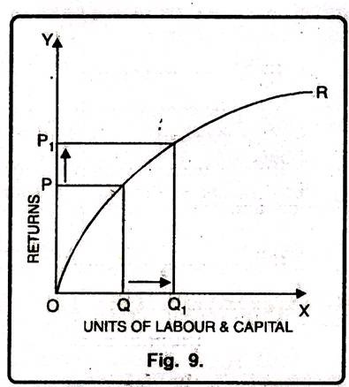
In this diagram 9, diminishing returns to scale has been shown. On OX axis, labour and capital are given while on OY axis, output. When factors of production increase from Q to Q₁ (more quantity) but as a result increase in output, i.e. P to P₁ is less. We see that increase in factors of production is more and increase in production is comparatively less, thus diminishing returns to scale apply.
- Opportunity cost and sunk cost with example?
Opportunity cost:
Opportunity costs represent the benefits an individual, investor or business misses out on when choosing one alternative over another. While financial reports do not show opportunity cost, business owners can use it to make educated decisions when they have multiple options before them.
Sunk cost
A sunk cost is a cost that has already been incurred and cannot be recovered. A sunk cost differs from future costs that a business may face, such as decisions about inventory purchase costs or product pricing. Sunk costs (past costs) are excluded from future business decisions because the cost will be the same regardless of the outcome of a decision.
- Explicit cost and implicit cost with example?
Explicit cost
The costs which involve outflow of cash due to the use of factors of production is known as Explicit Cost.
Ex: Salaries, rent, advertisement, wages, etc.
Implicit cost
The costs in which there is no cash outlay, is known as Implicit Cost
Ex: Interest on owner's capital, Salary to owner, rent of owner's building, etc. which do not occur in reality.
- What is Law of diminishing returns?
Diminishing returns, also called law of diminishing returns or principle of diminishing marginal productivity, economic law stating that if one input in the production of a commodity is increased while all other inputs are held fixed, a point will eventually be reached at which additions of the input yield progressively smaller, or diminishing, increases in output.

- Fixed cost and variable cost with example with graphs?
Fixed cost:
A fixed cost is an expense that does not change as production volume increases or decreases within a relevant range.
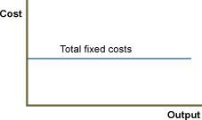

Variable cost:
Variable costs are costs that change as the quantity of the good or service that a business produces changes

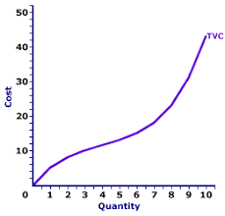

- What is isoquant and isocot?
ISOCOST:
In economics an isocost line shows all combinations of inputs which cost the same total amount. The isocost line is combined with the isoquant map to determine the optimal production point at any given level of output. Specifically, the point of tangency between any isoquant and an isocost line gives the lowest-cost combination of inputs that can produce the level of output associated with that isoquant.
ISOQUANT:
Anisoquant is a curve that shows all the combinations of inputs that yield the same level of output. 'Iso' means equal and 'quant' means quantity. Therefore, anisoquant represents a constant quantity of output.
- Define Market and market structure?
Definition market:
A market is a place where two parties can gather to facilitate the exchange of goods and services. The parties involved are usually buyers and sellers. The market may be physical like a retail outlet, where people meet face-to-face, or virtual like an online market, where there is no direct physical contact between buyers and sellers.
Market structure:
The Market Structure refers to the characteristics of the market either organizational or competitive, that describes the nature of competition and the pricing policy followed in the market
Features:

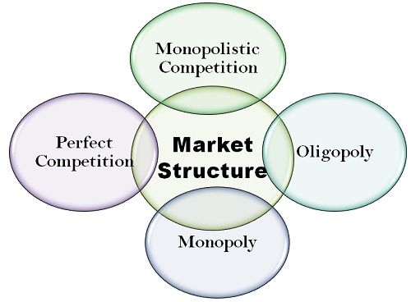

- Define Perfect competition and explain features?
The Perfect Competition is a market structure where a large number of buyers and sellers are present, and all are engaged in the buying and selling of the homogeneous products at a single price prevailing in the market.
Features:

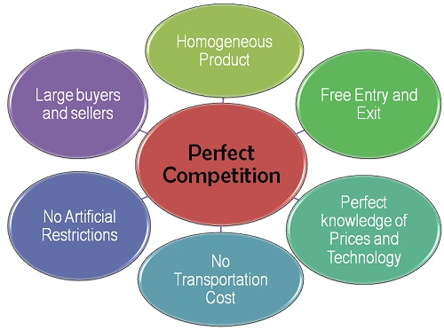
- Define Oligopoly Market and Features?
The Oligopoly Market characterized by few sellers, selling the homogeneous or differentiated products. In other words, the Oligopoly market structure lies between the pure monopoly and monopolistic competition, where few sellers dominate the market and have control over the price of the product.
Features:

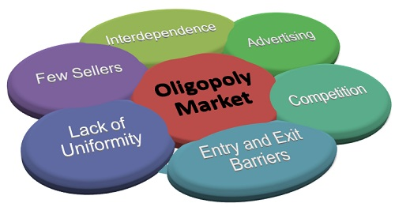
- Define Monopoly and explain features?
The Monopoly is a market structure characterized by a single seller, selling the unique product with the restriction for a new firm to enter the market. Simply, monopoly is a form of market where there is a single seller selling a particular commodity for which there are no close substitutes.
Features:
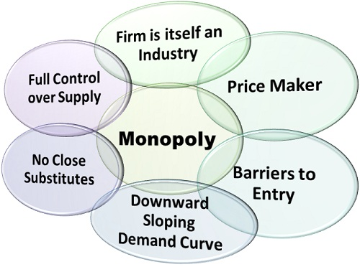
- Define Monopolistic market and explain features?
Under, the Monopolistic Competition, there are a large number of firms that produce differentiated products which are close substitutes for each other. In other words, large sellers selling the products that are similar, but not identical and compete with each other on other factors besides price.
Features:

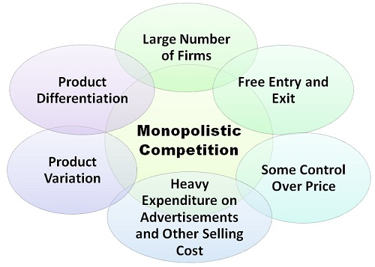
- Sealed bid pricing?
This kind of method is very common in the case of Government or industrial purchases, wherein tenders are floated in the market, and potential suppliers submit their bids in a closed envelope, not disclosing the bid to anyone.
- Market penetration and skimming pricing?
Skimming pricing is used when a product, which is new in the market or just launched, is sold at a relatively high price because of its uniqueness, benefits to customers or its current Wow factor. However, slowly but surely when the product gets older in the market, then the price is dropped and the product is brought at competitive pricing
Penetration pricing is a marketing strategy used by businesses to attract customers to a new product or service. Penetration pricing includes presenting a low price for a new product or service during its initial offering. The lower price helps to lure customers away from competitors. This marketing strategy relies on the idea of low prices making a customer aware of a new product. The price entices the customer to try the new product.
- Breakeven point and L imitations of break even analysis
In simple words, the break-even point can be defined as a point where total costs (expenses) and total sales (revenue) are equal. Break-even point can be described as a point where there is no net profit or loss. The firm just “breaks even.” Any company which wants to make abnormal profit, desires to have a break-even point. Graphically, it is the point where the total cost and the total revenue curves meet.
L imitations:
- The cost and revenue functions remain linear.
- The price of the product is assumed to be constant.
- The volume of sales and volume of production are equal.
- The fixed costs remain constant over the volume under consideration.
- It assumes constant rate of increase in variable cost.
- It assumes constant technology and no improvement in labour efficiency.

- What are the different types of production functions

Cobb-Douglas Production Function:

Cobb-Douglas production function refers to the production function in which one input can be substituted by other but to a limited extent. For example, capital and labor can be used as a substitute of each other, but to a limited extent only

Leontief Production Function:

Leontief production function uses fixed proportion of inputs having no substitutability between them. It is regarded as the limiting case for constant elasticity of substitution.

CES Production Function:

CES stands for constant elasticity substitution. CES production function shows a constant change produced in the output due to change in input of production.
- Assumptions of cost volume profit (CVP) analysis?

Assumptions:
  - Constant sales price;
  - Constant variable cost per unit;
  - Constant total fixed cost;
  - Units sold equal units produced.
  - contribution stands for sales minus variable costs

- What is meant by CVP?
Cost-volume-profit (CVP) analysis is used to determine how changes in costs and volume affect a company's operating income and net income. In performing this analysis, there are several assumptions made, including: Sales price per unit is constant. Variable costs per unit are constant. Total fixed costs are constant.

- What is cost?
An amount that has to be paid or given up in order to get something.
In business, cost is usually a monetary valuation of (1) effort, (2) material, (3) resources, (4) time and utilities consumed, (5) risks incurred, and (6) opportunity forgone in production and delivery of a good or service. All expenses are costs, but not all costs (such as those incurred in acquisition of an income-generating asset) are expenses.
- What is economics and accounting cost’
Accounting costs account only for the explicit costs incurred in conducting a business and not the implicit costs. The explicit costs include the direct costs to the company, such as employee wages, utility bills (water, electricity, etc.), raw material cost, premises cost, transportation and storage costs, etc.
Economic costs, on the other hand, account for both explicit and implicit costs. Implicit costs is the opportunity cost in terms of revenue lost by forgoing the next best alternative, say renting out premises instead of conducting the business there.
- What is the difference between monopoly and perfect market
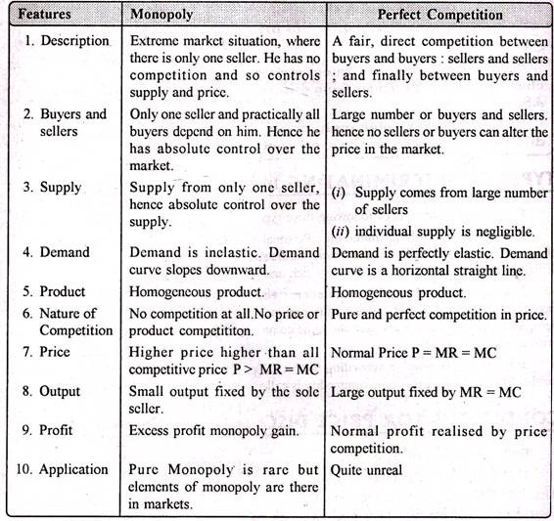
- Pricing definition and explain pricing objectives?
Price, the amount of money that has to be paid to acquire a given product. Insofar as the amount people are prepared to pay for a product represents its value, price is also a measure of value.
Pricing objectives:
- Price-Profit Satisfaction
- Sales Maximization and Growth
- Making Money
- Preventing Competition
- Market Share
- Survival

- What is cost based pricing methods?

Cost-Plus Pricing: It is one of the simplest pricing method wherein the manufacturer calculates the cost of production incurred and add a certain percentage of markup to it to realize the selling price. The markup is the percentage of profit calculated on total cost i.e. fixed and variable cost.

- What is going rate pricing method?

The Going-Rate Pricing is a method adopted by the firms wherein the product is priced as per the rates prevailing in the market especially on par with the competitors.

- Product life cycle meaning with diagram?
A product processes through a number of stages, such as from introduction to growth, maturity, and decline.
This sequence of stages is called Product Life Cycle (PLC). The PLC influences the marketing strategy and marketing mix of an organization.

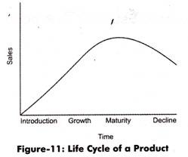

Unit -4:

- Accounting definition ?

Accounting is the process of systematically recording, measuring, and communicating information about financial transactions. accounting is the double-entry bookkeeping method. This involves making at least two recording entries for every transaction: a debit in one account and a credit in another account.

- Separate entity concept?
The separate entity concept states that we should always separately record the transactions of a business and its owners. Otherwise, there is a considerable risk that the transactions of the two will become intermingled
The separate entity concept is useful for determining the true profitability and financial position of a business. It should also be applied to the operating divisions of a business, so that we can separately determine the same information for each division.

- Going concern concept
The going concern concept is a fundamental principle of accounting. It assumes that during and beyond the next fiscal period a company will complete its current plans, use its existing assets and continue to meet its financial obligations. Simply put, it is an assumption that the company will stay in business and that the value of its assets will endure. This underlying principle is also known as the continuing concern concept.

- Money measurement concept
The money measurement concept states that a business should only record an accounting transaction if it can be expressed in terms of money. This means that the focus of accounting transactions is on quantitative information, rather than on qualitative information. Thus, a large number of items are never reflected in a company's accounting records, which means that they never appear in its financial statements.
Examples of items that cannot be recorded as accounting transactions because they cannot be expressed in terms of money include:
- Employee skill level
- Employee working conditions
- Expected resale value of a patent
- Value of an in-house brand
- Product durability
- The quality of customer support or field service
- The efficiency of administrative processes
- Accounting period concept
An accounting period is the span of time covered by a set of financial statements. This period defines the time range over which business transactions are accumulated into financial statements, and is needed by investors so that they can compare the results of successive time periods. For internal financial reporting, an accounting period is generally considered to be one month. A few firms compile financial information in four-week increments, so that they have 13 accounting periods per year.
- Accounting equation
The accounting equation is considered to be the foundation of the double-entry accounting system. The accounting equation shows on a company's balance sheetwhereby the total of all the company's assets equals the sum of the company's liabilities and shareholders' equity.
Based on this double-entry system, the accounting equation ensures that the balance sheet remains “balanced,” and each entry made on the debit side should have a corresponding entry (or coverage) on the credit side.
Assets= liabilities +Owners equity

- Conventions of full disclosure
He full disclosure principle requires a company to provide the necessary information so that people who are accustomed to reading financial information are able to make informed decisions regarding the company.
- Journal with proforma
Journal entry is the first step in the accounting cycle and are used to record all business transactions and events in the accounting system. As business events occur throughout the accounting period, journal entries are recorded in the general journal to show how the event changed in the accounting equation. For example, when the company spends cash to purchase a new vehicle, the cash account is decreased or credited and the vehicle account is increased or debited.

- Ledger with proforma
A ledger records classified and summarized financial information from journals (the 'books of first entry') as debits and credits, and shows their current balances. In manual accounting systems, a ledger is usually a loose leaf binder with a separate page for each ledger account.
Date | Particulars | Lfno | Amount | Date | Particulars | Lfno | amount

- Trial balance
A trial balance is a bookkeeping worksheet in which the balances of all ledgers are compiled into debit and credit account column totals that are equal. A company prepares a trial balance periodically, usually at the end of every reporting period. The general purpose of producing a trial balance is to ensure the entries in a company's bookkeeping system are mathematically correct.
Trail balance for MR…………………………………… as on …………
NO | NAME OF ACCOUNT  (PARTICULARS) | DEBIT  AMOUNT (RS.) | CREDIT  AMOUNT (RS.)

- Advantages of trial balance.
  - It presents to the businessman a consolidated list of all ledger balances.
  - It is the shortest method of verifying the arithmetical accuracy of entries made in the ledger.:
  - If the total of debit side/column is equal to the total of credit side/column, the trial balance is said to agree. Otherwise, it is implied that some errors have been committed in the preparation of accounts.
  - It helps in the preparation of the final accounts i.e., Trading a/c. Profit and loss a/c and Balance Sheet.
- Comparative statements
A comparative statement is a document that compares a particular financial statement with prior period statements or with the same financial report generated by another company. Analysts and business managers use the income statement, balance sheet and cash flow statement for comparative purposes. The process reveals trends in the financials and compares one company's performance with another business.
- Trading account
A trading account can be any investment account containing securities, cash or other holdings. Most commonly, trading account refers to a day trader’s primary account. These investors tend to buy and sell assets frequently, often within the same trading session, and their accounts are subject to special regulation as a result. The assets held in a trading account are separated from others that may be part of a long-term buy and hold strategy.
- Profit and loss account
Every business wants to know the incomes earned and expenses incurred during a particular period, usually at the end of the year.
Profit & Loss Statement/Account shows the profits/losses earned/incurred by a business for a month or a year. Companies use Profit & Loss Statement and others use “T Account” for these below mentioned reasons.

Profit & Loss Statement/Account is prepared for two main reasons.
  - To know the profits/losses earned/incurred by a business,
  - Statutory requirements (Companies Act, Partnership Act or any other law)
- Balance sheet
The balance sheet is one of the three fundamental financial statements and is key to both financial modelingand accounting. The balance sheet displays the company’s total assets, and how these assets are financed, through either debt or equity. It can also be referred to as a statement of net worth, or a statement of financial position. The balance sheet is based on the fundamental equation: Assets = Liabilities + Equity
- Dual aspect concept
The dual aspect concept states that every business transaction requires recordation in two different accounts. This concept is the basis of double entry accounting, which is required by all accounting frameworks in order to produce reliable financial statements. The concept is derived from the accounting equation, which states that:
- Periodic matching of costs and revenue concept
The concept is based on the accounting period concept. The objective of maintaining accounts is to prepare the income statement to ascertain the profit/loss of the entity. In order to fulfil this objective the 'revenues' of the period for which income statement is prepared should be matched with costs. 'Matching' means the appropriate association of related 'revenues' and 'costs'. Profit/loss could be ascertained only when the revenue earned during the period is compared with the expenditure incurred during the same period.
- Realization concept/Accrual concept
In Accounting Accrual means to recognize an event/transaction in the financial statements which involves transfer of value between two parties whether the business immediately has received the cash or not for that particular event. An event causes a change in either the Assets, liability or equity section of the balance sheet.
- Double entry system of Book-keeping.
The double entry system of accounting or bookkeeping means that for every business transaction, amounts must be recorded in a minimum of two accounts. The double entry system also requires that for all transactions, the amounts entered as debits must be equal to the amounts entered as credits.

- Rules of accounting
To understand the Golden Rules of Accounting we must first understand the types of accounts.
There are three types of accounts:
- Real Account
- Personal Account
- Nominal Account
. Personal Accounts: Accounts which are transactions with persons are called “Personal Accounts”.
A separate account is kept on the name of each person for recording the benefits received from, or given to the person in the course of dealings with him.
E.g.: Krishna’s A/C, Gopal’s A/C, SBI A/C, NagarjunaFinanaceLtd.A/C, ObulReddy& Sons A/C , HMT Ltd. A/C, Capital A/C, Drawings A/C etc.
2. Real Accounts: The accounts relating to properties or assets are known as “Real Accounts” .Every business needs assets such as machinery, furniture etc, for running its activities .A separate account is maintained for each asset owned by the business.
E.g.: cash A/C, furniture A/C, building A/C, machinery A/C etc.
3.NominalAccounts: Accounts relating to expenses, losses, incomes and gains are known as “Nominal Accounts”. A separate account is maintained for each item of expenses, losses, income or gain.
E.g.: Salaries A/C, stationery A/C, wages A/C, postage A/C, commission A/C, interest A/C, purchases A/C, rent A/C, discount A/C, commission received A/C, interest received A/C, rent received A/C, discount received A/C.
Before recording a transaction, it is necessary to find out which of the accounts is to be debited and which is to be credited. The following three different rules have been laid down for the three classes of accounts….

1. Personal Accounts: The account of the person receiving benefit (receiver) is to be debited and the account of the person giving the benefit (given) is to be credited.
Rule: “Debit----The Receiver
Credit---The Giver”

2. Real Accounts: When an asset is coming into the business, account of that asset is to be debited .When an asset is going out of the business; the account of that asset is to be credited.
Rule: “Debit----What comes in
Credit---What goes out”

3. Nominal Accounts: When an expense is incurred or loss encountered, the account representing the expense or loss is to be debited. When any income is earned or gain made, the account representing the income of gain is to be credited.
Rule: “Debit----All expenses and losses
Credit---All incomes and gains”

- Conservatism
Conservatism principle is the general concept of recognizing expenses and liabilities as soon as possible when there is uncertainty about the outcome, but to only recognize revenues and assets when they are assured of being received.
Under the conservatism principle, if there is uncertainty about incurring a loss, you should tend toward recording the loss. Conversely, if there is uncertainty about recording a gain, you should not record the gain.
- Current assets and current liabilities with example
Current assets are short-term assets either in form of cash or a cash equivalent which can be liquidated within 12 months or within an accounting period.

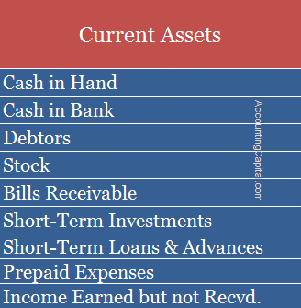
Current Liabilities are short-term liabilities of a business which are expected to be settled within 12 months or within an accounting period.

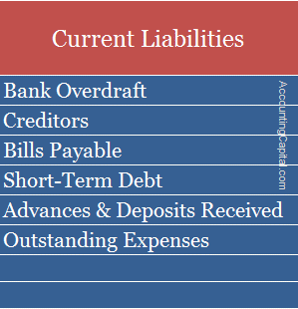
Unit – 5:

- Ratio analysis

Ratio analysis is a quantitative method of gaining insight into a company's liquidity, operational efficiency, and profitability by comparing information contained in its financial statements. Ratio analysis is a cornerstone of fundamental analysis.

- Advantages of ratio analysis?

Ratio analysis refers to the analysis and interpretation of the figures appearing in the financial statements (i.e., Profit and Loss Account, Balance Sheet and Fund Flow statement etc.).
Advantages:
- Forecasting and Planning:

Budgeting:

Measurement of Operating Efficiency:

Communication:

Control of Performance and Cost:

Inter-firm Comparison:

Indication of Liquidity Position

- Limitations of ratio analysis

The technique of ratio analysis is a very useful device for making a study of the financial health of a firm. But it has some limitations which must not be lost sight of before undertaking such analysis.

Limitations of Financial Statements:
Ratios are calculated from the information recorded in the financial statements. But financial statements suffer from a number of limitations and may, therefore, affect the quality of ratio analysis.

Historical Information:
Financial statements provide historical information. They do not reflect current conditions. Hence, it is not useful in predicting the future.

Different Accounting Policies:
Different accounting policies regarding valuation of inventories, charging depreciation etc. make the accounting data and accounting ratios of two firms non-comparable.

Changes in Price Level:
Fixed assets show the position statement at cost only. Hence, it does not reflect the changes in price level. Thus, it makes comparison difficult.

Lack of Standard of Comparison:

No fixed standards can be laid down for ideal ratios. For example, current ratio is said to be ideal if current assets are twice the current liabilities. But this conclusion may not be justifiable in case of those concerns which have adequate arrangements with their bankers for providing funds when they require, it may be perfectly ideal if current assets are equal to or slightly more than current liabilities.

- Fund?

A fund is a source of money that is allocated for a specific purpose. A fund can be established for any purpose whatsoever, whether it is a city government setting aside money to build a new civic center, a college setting aside money to award a scholarship, or an insurance company setting aside money to pay its customers’ claims.

- Funds flow statement?

If a company needs to report its changes in net working capital, the company prepares a fund flow statement. Fund flow statement isn’t a financial statement; rather it typically compares the sources of funds and the application of funds.

- Working capital
Working capital, also known as net working capital (NWC), is the difference between a company’s current assets, such as cash, accounts receivable (customers’ unpaid bills) and inventories of raw materials and finished goods, and its current liabilities, such as accounts payable.

- Funds from operation
Funds from operations is the cash flows generated by the operations of a business. The term is most commonly used in relation to the cash flows from real estate investment trusts (REITs). This measure is commonly used to judge the operational performance of REITs, especially in regard to investing in them. Funds from operations does not include any financing-related cash flows, such as interest income or interest expense. It also does not include any gains or losses from the disposition of assets, or any depreciation or amortization of fixed assets.

- Importance of funds flow

The significance or importance of funds flow statement can be well followed from its various uses given below:

It Helps in the Analysis of Financial Operations:

It Helps in the Formation of a Realistic Dividend Policy:

It Helps in the Proper Allocation of Resources:

It Acts as a Future Guide:

It Helps in Appraising the Use of Working Capital:

It Helps Knowing the Overall Creditworthiness of a Firm:

- Limitations of fund flow

The funds flow statement has a number of uses, however, it has certain limitations also, which are listed below:
It should be remembered that a funds flow statement is not a substitute of an income statement or a balance sheet. It provides only some additional information as regards changes in working capital.
- It cannot reveal continuous changes.
- It is not an original statement but simply are-arrangement of data given in the financial statements.
- It is essentially historic in nature and projected funds flow statement cannot be prepared with much accuracy.
- Changes-in .cash-are more important and relevant for financial management than the working capital.

- Cash flow statement

A cash flow statement is a financial statement that provides aggregate data regarding all cash inflows a company receives from its ongoing operations and external investment sources, as well as all cash outflows that pay for business activities and investments during a given period.

- Advantages of cash flow:
- Cash Flow Statements help in knowing the liquidity / actual cash position of the company which funds flow and P&L are unable to specify.
- As the liquidity position is known, any shortfalls can be arranged for or excess can be used for the growth of the business
- Any discrepancy in the financial reporting can be gauged through the cash flow statement by comparing the cash position of both.
- Cash is the basis of all financial operations. Therefore, a projected cash flow statement will enable the management to plan and control the financial operations properly.
- Cash Flow analysis together with the ratio analysis helps measure the profitability and financial position of business.
- Cash flow statement helps in internal financial management as it is useful in formulation of financial plans.

- Limitations of cash flow:

- Through the cash flow statement alone, it is not possible to arrive at actual P&L of the company as it shows only the cash position. It has limited usage and in isolation it is of no use and requires BL, P&L for its projections. Cash flow statement does not disclose net income from operations. Therefore, it cannot be a substitute for income statement
- The cash balance as shown by the cash flow statement may not represent the real liquidity position of the business because it can be easily influenced by postponing the purchases and other payments
- Cash flow statement cannot replace the funds flow statement. Each of the two has a separate function to perform.

- Classifications of cash flow statement?
Operating activities:
Operating activities are the activities that comprise of the primary / main activities of an enterprise during an accounting period. For example, for a garment manufacturing company, operating activities include procurement of raw material, sale of garments, incurrence of manufacturing expenses, etc. These are the principal revenue generating activities of the enterprise.
Investing activities:
Cash flow from investing activities includes the movement in cash flows owing to the purchase and sale of assets. It relates to purchase and sale of long-term assets or fixed assets such as machinery, furniture, land and building, etc.
Financing activities:
It includes financing activities related to long-term funds or capital of an enterprise. Financing activities are activities that result in changes in the size and composition of the owners’ capital and borrowings of the enterprise.
e.g., cash proceeds from issue of equity shares, debentures, raising long-term loans, repayment of bank loans, etc.

- Financial ratio?

Financial ratios are mathematical comparisons of financial statement accounts or categories. These relationships between the financial statement accounts help investors, creditors, and internal company management understand how well a business is performing and of areas needing improvement.

- Difference between funds flow and income statement

Funds flow:

- Funds Flow Statement presents various ways from which funds have been procured and the applications for the same.

- Funds Flow Statement incorporates both capital and revenue transactions. It maintains records from all sources of funds, irrespective of capital and revenue.

- It helps the management to take decisions relating to finance.

Income:

- Income Statement presents only the financial results of a firm, i.e. profit or loss of a firm.

- Income Statement records only revenue items, i.e. operating expenses and operating incomes, which are required for ascertaining profit or loss.

- Income Statement does not depend on Funds Flow Statement.

- Liquidity

Liquidity ratios are an important class of financial metrics used to determine a debtor's ability to pay off current debt obligations without raising external capital. Liquidity ratios measure a company's ability to pay debt obligations and its margin of safety through the calculation of metrics including the current ratio, quick ratio, and operating cash flow ratio.

- Networking capital

Net working capital is the aggregate amount of all current assets and current liabilities. It is used to measure the short-term liquidity of a business, and can also be used to obtain a general impression of the ability of company management to utilize assets in an efficient manner. To calculate net working capital

- Solvency Ratios
The solvency ratio is a key metric used to measure an enterprise’s ability to meet its debt obligations and is used often by prospective business lenders. The solvency ratio indicates whether a company’s cash flow is sufficient to meet its short-and long-term liabilities. The lower a company's solvency ratio, the greater the probability that it will default on its debt obligations.

- Funds from operations
Funds from Operations (FFO) is a measure of cash generated by a real estate investment trust (REIT). It is important to note that FFO is not the same as Cash from Operations, which is a key component of the indirect-method cash flow statement.
Funds from Operations = Net Income + Depreciation + Amortization - Gains on Sales of Property

END

