
CMR ENGINEERING COLLEGE

( Approved by AICTE, Affiliated to JNTU, Hyderabad)

KANDLAKOYA (V), MEDCHAL ROAD, HYDERABAD-501401.

Ph: 08418 200037, 92470 22662, Fax: 08418 200240, www.cmrec.ac.in
Department of Information Technology

IOT STEP MATERIAL (R18)

STEP MATERIAL FOR INTERNET OF THINGS

UNIT I
1. Choose the correct answer
1. In SDN-based sensor network, one can manage [c]
a) Sensor nodes b) Sensing delay c) Network connectivity d) All of the above
2. Internet of Things (IoT) can be integrated with which of these separate domains [ ]
a. Cloud-based storage and computing .b. Cyber Physical Systems.c. Big-data networks.d. All of these
3. In the current market scenario, IOT captures the maximum share in which one of these?[ ]
a. Industry b. Security c. Healthcare d. Home automation
4. The main function of the IOT Gateway can be summarized as: [ ]
a. Forwarding packets between LAN and WAN on the IP layer. b. Performs application layer functions between IoT nodes and other entities. c. Enables local, short-range communication between IoT devices. d. All of these
5. In cloud computing IaaS is [ ]
a. Industry as a service b. Instrument as a service c. Internet as a service d. Infrastructure as a Service
6. Which of these is NOT related to IOT scalability? [ ]
a. Flexibility within Internet. b. Large scale deployment. c. Real-time connectivity of billions of devices.d. Range of each sensor
7.Which protocol is lightweight?[ ]
a. MQTT b)HTTP c)COAP d)None of these
8._______is a web protocol that runs over the UDP for Iot?[ ]
a. UPNP b. COAP c. MQTT d. HTTP
9.________is an open application layer protocol for business messaging [ ]
a. MQTT b.DDS c. AMQP d. Web sockets
10._______model is stateless communication model and each requesr-response pair is independent
Of others [ ]
a.Exclusive pair b. Request-Response c. Publish-Subscribe d.Push-pull

Short Answer

1. Define Iot?

The internet of things (IoT) is a computing concept that describes the idea of everyday physical objects being connected to the internet and being able to identify themselves to other devices. It has dynamic global network infrastructure with self-configuring capabilities based on standard and interoperable communication protocols where physical and virtual “things” have identities, physical attributes and virtual network and use intelligent interfaces.

2. List of Iot protocols?
- Link Layer
  - 802.3 – Ethernet,802.11 – WiFi ,802.16 – WiMax ,802.15.4 – LR-WPAN,2G/3G/4G
- Network/Internet Layer
  - IPv4,IPv6,6LoWPAN
- Transport Layer
  - TCP,UDP
- Application Layer
  - HTTP, CoAP ,WebSocket ,MQTT,XMPP,DDS,AMQP

3. list the applications of Iot?
- Smart Grids
- Smart cities
- Smart homes
- Healthcare
- Earthquake detection
- Radiation detection/hazardous gas detection
- Smartphone detection
- Water flow monitoring

4. List Iot communication model?

1. Request-Response communication model

2. Publish-Subscribe communication model

3. Push-Pull communication model

4. Exclusive Pair communication model

5.Iot enabling technologies?

1. Wireless Sensor Networks

2. Cloud Computing

3. Big Data Analytics

4. Embedded Systems

Long Answer Questions

1.What is Iot? Characteristics of Iot?
The internet of things (IoT) is a computing concept that describes the idea of everyday physical objects being connected to the internet and being able to identify themselves to other devices. It has dynamic global network infrastructure with self-configuring capabilities based on standard and interoperable communication protocols where physical and virtual “things” have identities, physical attributes and virtual network and use intelligent interfaces.
Dynamic and Self-Adapting:- IoT devices and system may have the capability to change dynamically depending upon the system and operating conditions or sensed environment. For example, the surveillance cameras can change their modes based on day or night
Self-configuring:- IoT devices have self-configuring capability which allows large number of devices to work together to work provide certain functionality they can change their networking and update the software automatically.
Interoperable Communication Protocol: - IoT devices can communicate with number of interoperable (communicate with other devices without special effort) communication protocols.
Unique ID: - IoT devices have a unique identity differentiated with unique IP address.
Integrated into Information Network: - IoT devices are integrated into the information network that allows them to communicate and exchange data with other devices and system.
2.Generic block diagram of an iot device?
- An IoT device may consist of several interfaces for connections to other devices, both wired and wireless.
  - I/O interfaces for sensors
  - Interfaces for Internet connectivity
3. Memory and storage interfaces
4. Audio/video interfaces
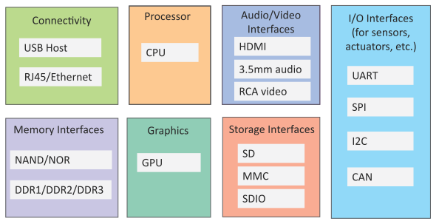

2.List Iot communication model with diagrams?

1. Request-Response communication model

2. Publish-Subscribe communication model

3. Push-Pull communication model

4. Exclusive Pair communication model

Request-response communication model
- Request-Response is a communication model in which the client sends requests to the server and the server responds to the requests.
- When the server receives a request, it decides how to respond, fetches the data, retrieves resource representations, prepares the response, and then sends the response to the client.

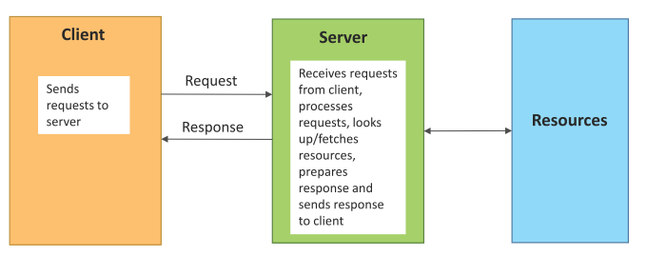
Publish-Subscribe communication model
- Publish-Subscribe is a communication model that involves publishers, brokers and consumers.
- Publishers are the source of data. Publishers send the data to the topics which are managed by the broker. Publishers are not aware of the consumers.
- Consumers subscribe to the topics which are managed by the broker.
- When the broker receives data for a topic from the publisher, it sends the data to all the
subscribed consumers
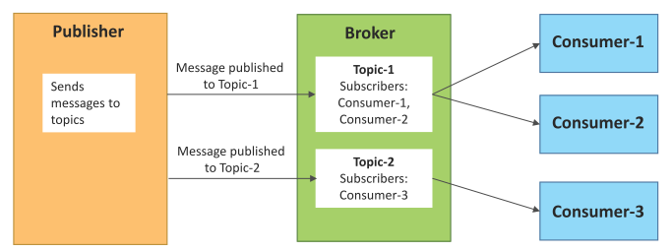
Push-Pull communication model
- Push-Pull is a communication model in which the data producers push the data to queues and the consumers pull the data from the queues. Producers do not need to be aware of the consumers.
- Queues help in decoupling the messaging between the producers and consumers.
- Queues also act as a buffer which helps in situations when there is a mismatch between the rate at which the producers push data and the rate rate at which the consumers pull data
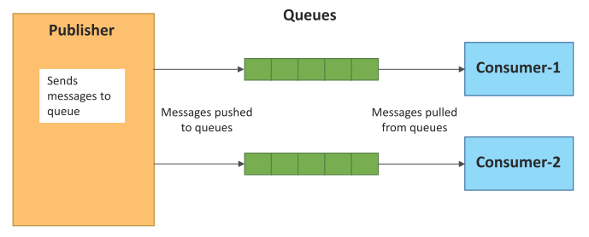
Exclusive Pair communication model
- Exclusive Pair is a bidirectional, fully duplex communication model that uses a persistent connection between the client and server.
- Once the connection is setup it remains open until the client sends a request to close the connection.
- Client and server can send messages to each other after connection setup.

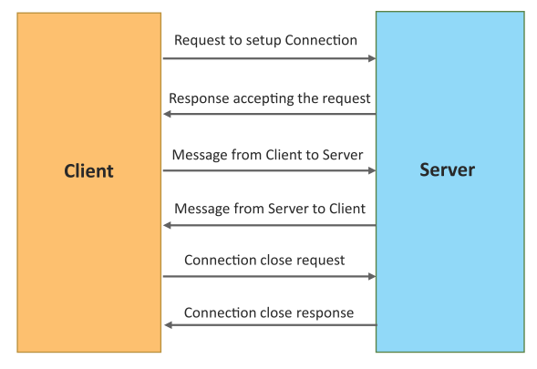
2. Iot levels & deployment templates?
1. Database: Database can be either local or in the cloud and stores the data generated by the IoT device.
2. Web Service: Web services serve as a link between the IoT device, application, database and analysis components. Web service can be either implemented using HTTP and REST principles (REST service) or using WebSocket protocol (Web Socket service).
3. Analysis Component: The Analysis Component is responsible for analyzing the IoT data and generate results in a form which are easy for the user to understand.
4. Application: IoT applications provide an interface that the users can use to control and monitor various aspects of the IoT system. Applications also allow users to view the system status and view the processed data.
level-1
1. A level-1 IoT system has a single node/device that performs sensing and/or actuation, stores data, performs analysis and hosts the application
2. Level-1 IoT systems are suitable for modeling low-cost and low-complexity solutions where the data involved is not big and the analysis requirements are not computationally intensive.
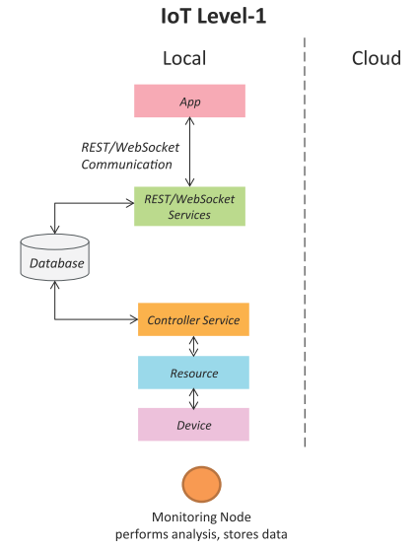

Iot level-2
- A level-2 IoT system has a single node that performs sensing and/or actuation and local analysis.
- Data is stored in the cloud and application is usually cloud-based.
- Level-2 IoT systems are suitable for solutions where the data involved is big, however, the primary analysis requirement is not computationally intensive and can be done locally itself.

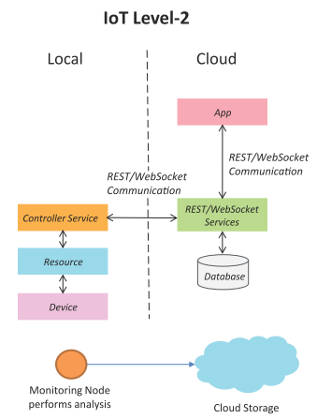
Iot level-3
- A level-3 IoT system has a single node. Data is stored and analyzed in the cloud and application is cloud-based.
- Level-3 IoT systems are suitable for solutions where the data involved is big and the analysis requirements are computationally intensive.
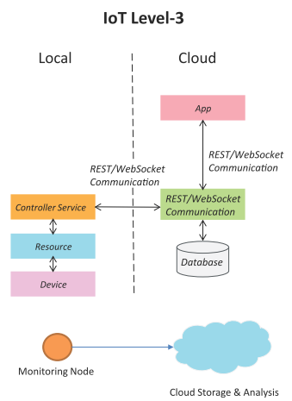
Iot level-4
- A level-4 IoT system has multiple nodes that perform local analysis. Data is stored in the cloud and application is cloud-based.
- Level-4 contains local and cloud-based observer nodes which can subscribe to and receive information collected in the cloud from IoT devices.
- Level-4 IoT systems are suitable for solutions where multiple nodes are required, the data involved is big and the analysis requirements are computationally intensive.
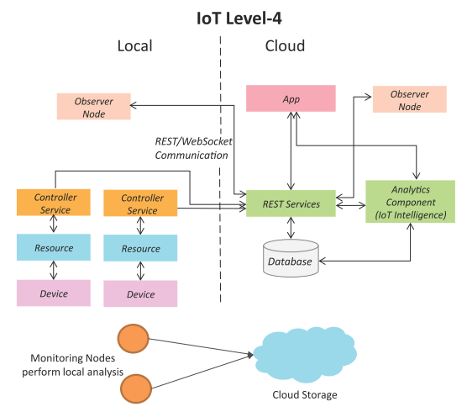
Iot level-5
- A level-5 IoT system has multiple end nodes and one coordinator node.
- The end nodes that perform sensing and/or actuation.
- Coordinator node collects data from the end nodes and sends to the cloud.
- Data is stored and analyzed in the cloud and application is cloud-based.
- Level-5 IoT systems are suitable for solutions based on wireless sensor networks, in which the data involved is big and the analysis requirements are computationally intensive.

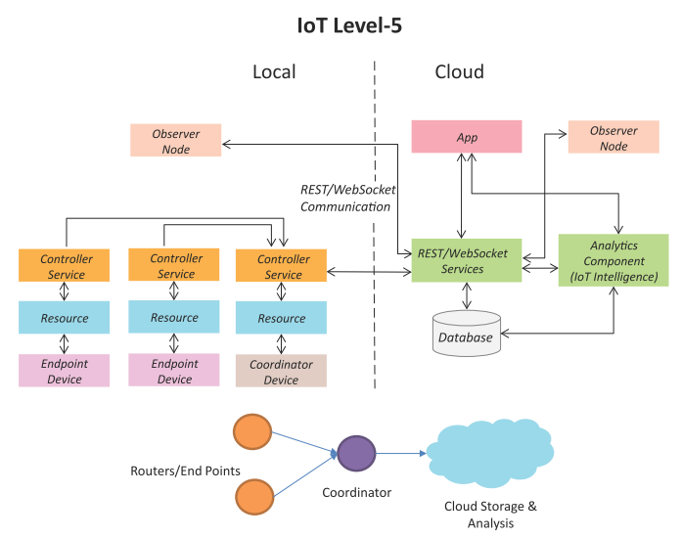

IoT Level-6
- A level-6 IoT system has multiple independent end nodes that perform sensing and/or actuation and send data to the cloud.
- Data is stored in the cloud and application is cloud-based.
- The analytics component analyzes the data and stores the results in the cloud database.
- The results are visualized with the cloud-based application.
- The centralized controller is aware of the status of all the end nodes and sends control commands to the nodes.

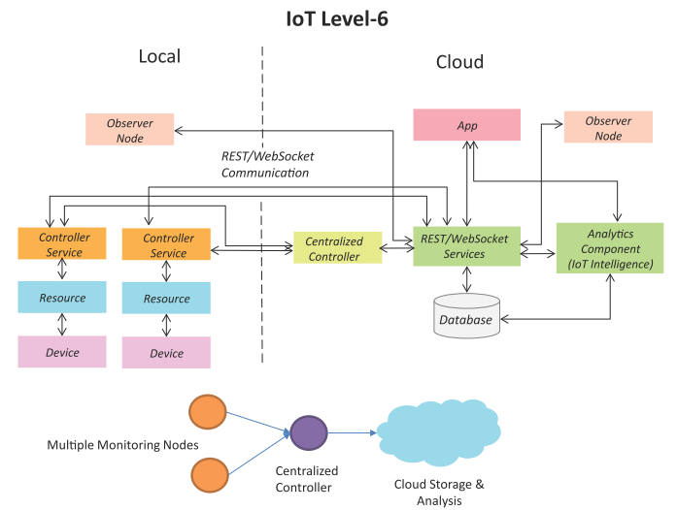

3.Explain about Domains of IOT?

o Smart Lighting

o Smart Appliances

o Intrusion Detection o Smoke / Gas Detectors

Home Automation Smart Lighting : Smart lighting achieve energy savings by sensing the human movements and their environments and controlling the lights accordingly.

Key enabling technologies for smart lighting include :

- Solid state lighting (such as LED lights) - IP-enabled lights • Wireless-enabled and Internet connected lights can be controlled remotely from IoT applications such as a mobile or web application.

Home Automation Smart Appliances :

Smart appliances make the management easier and provide status information of appliances to the users remotely. E.g: smart washer/dryer that can be controlled remotely and notify when the washing/drying cycle is complete. •

OpenRemote is an open source automation platform for smart home and building that can control various appliances using mobile and web applications.

It comprises of three components: - a Controller ◊ manages scheduling and runtime integration between devices. - a Designer ◊ allows to create both configuration for the controller and user interface designs. - Control Panel ◊ allows to interact with devices and control them.

Home Automation Intrusion Detection : Home intrusion detection systems use security cameras and sensors to detect intrusions and raise alerts. The form of the alerts can be in form: - SMS - Email - Image grab or a short video clip as an email attachment .

Home Automation Smoke / Gas Detectors : Smoke detectors are installed in homes and buildings to detect smoke that is typically an early sign of fire. It uses optical detection, ionization or air sampling techniques to detect smoke .

The form of the alert can be in form : Signals that send to a fire alarm system .Gas detector can detect the presence of harmful gases such as carbon monoxide (CO), liquid petroleum gas (LPG), etc. . Cities IoT applications for smart cities:

1. Smart Parking

2. Smart Lighting for Road

3. Smart Road

4. Structural Health Monitoring

5. Surveillance

6. Emergency Response

Cities Smart Parking :

Finding the parking space in the crowded city can be time consuming and frustrating • Smart parking makes the search for parking space easier and convenient for driver. • It can detect the number of empty parking slots and send the information over the Internet to the smart parking applications which can be accessed by the drivers using their smartphones, tablets, and in car navigation systems. Sensors are used for each parking slot to detect whether the slot is empty or not, and this information is aggregated by local controller and then sent over the Internet to database.

Cities Smart Lighting for Roads :

It can help in saving energy Smart lighting for roads allows lighting to be dynamically controlled and also adaptive to ambient conditions. Smart light connected to the Internet can be controlled remotely to configure lighting schedules and lighting intensity. Custom lighting configurations can be set for different situations such as a foggy day, a festival, etc.

Cities Smart Roads : Smart Roads provides information on driving conditions, travel .time estimates and alerts in case of poor driving conditions, traffic congestions and accidents. Such information can help in making the roads safer and help in reducing traffic jams . Information sensed from the roads can be communicated via internet to cloud-based applications and social media and disseminated to the drivers who subscribe to such applications.

Cities Structural Health Monitoring :

It uses a network of sensors to monitor the vibration levels in the structures such as bridges and buildings. The data collected from these sensors is analyzed to assess the health of the structures. By analyzing the data it is possible to detect cracks and mechanical breakdowns, locate the damages to a structure and also calculate the remaining life of the structure. Using such systems, advance warnings can be given in the case of imminent failure of the structure

Cities Surveillance:

Surveillance of infrastructure, public transport and events in cities is required to ensure safety and security. City wide surveillance infrastructure comprising of large number of distributed and Internet connected video surveillance cameras can be created. The video feeds from surveillance cameras can be aggregated in cloud-based scalable storage solutions. Cloud-based video analytics applications can be developed to search for patterns of specific events from the video feeds.

Cities Emergency Response : IoT systems can be used for monitoring the critical infrastructure cities such as buildings, gas, and water pipelines, public transport and power substations. IoT systems for critical infrastructure monitoring enable aggregation and sharing of information collected from lager number of sensors. Using cloud-based architectures, multi-modal information such as sensor data, audio, video feeds can be analyzed I near real-time to detect adverse events. The alert can be in the form : Alerts sent to the public. Re-rerouting of traffic .Evacuations of the affected area.

Environment IoT applications for smart environments:

1. Weather Monitoring

2. Air Pollution Monitoring

3. Noise Pollution Monitoring

4. Forest Fire Detection

5. River Flood Detection

Environment Weather Monitoring :

It collects data from a number of sensor attached such as temperature, humidity, pressure, etc and send the data to cloud-based applications and store back-ends. The data collected in the cloud can then be analyzed and visualized by cloud-based applications. Weather alert can be sent to the subscribed users from such applications. AirPi is a weather and air quality monitoring kit capable of recording and uploading information about temperature, humidity, air pressure, light levels, UV levels, carbon monoxide, nitrogen dioxide and smoke level to the Internet. Environment Air Pollution Monitoring. IoT based air pollution monitoring system can monitor emission of harmful gases by factories and automobiles using gaseous and meteorological sensors. The collected data can be analyzed to make informed decisions on pollutions control approaches.

Environment Noise Pollution Monitoring :

Noise pollution monitoring can help in generating noise maps for cities. It can help the policy maker in making policies to control noise levels near residential areas, school and parks. It uses a number of noise monitoring stations that are deployed at different places in a city. The data on noise levels from the stations is collected on servers or in the cloud and then the collected data is aggregate to generate noise maps.

Environment Forest Fire Detection: IoT based forest fire detection system use a number of monitoring nodes deployed at different location in a forest. • Each monitoring node collects measurements on ambient condition including temperature, humidity, light levels, etc. • Early detection of forest fires can help in minimizing the damage.

Environment River Flood Detection : IoT based river flood monitoring system uses a number of sensor nodes that monitor the water level using ultrasonic sensors and flow rate using velocity sensors. • Data from these sensors is aggregated in a server or in the cloud, monitoring applications raise alerts when rapid increase in water level and flow rate is detected.

Energy IoT applications for smart energy systems:

1. Smart Grid

2. Renewable Energy Systems

3. Prognostics

4.Energy Smart Grids

Smart grid:

It technology provides predictive information and recommendation s to utilize, their suppliers, and their customers on how best to manage power. Smart grid collect the data regarding : - Electricity generation - Electricity consumption - Storage - Distribution and equipment health data By analyzing the data on power generation, transmission and consumption of smart grids can improve efficiency throughout the electric system. Storage collection and analysis of smarts grids data in the cloud can help in dynamic optimization of system operations, maintenance, and planning. Cloud-based monitoring of smart grids data can improve energy usage usage levels via energy feedback to users coupled with real-time pricing information. Condition monitoring data collected from power generation and transmission systems can help in detecting faults and predicting outages.

Energy Renewable Energy System:

Due to the variability in the output from renewable energy sources (such as solar and wind), integrating them into the grid can cause grid stability and reliability problems.

IoT based systems integrated with the transformer at the point of interconnection measure the electrical variables and how much power is fed into the grid . To ensure the grid stability, one solution is to simply cut off the overproductions.

Energy Prognostics: IoT based prognostic real-time health management systems can predict performance of machines of energy systems by analyzing the extent of deviation of a system from its normal operating profiles. In the system such as power grids, real time information is collected using specialized electrical sensors called Phasor Measurement Units (PMU) Analyzing massive amounts of maintenance data collected from sensors in energy systems and equipment can provide predictions for impending failures. OpenPDC is a set of applications for processing of streaming time-series data collected from Phasor Measurements Units (PMUs) in real-time.

Logistic IoT applications for smart logistic systems:

1. Fleet Tracking

2. Shipment Monitoring

3. Remote Vehicle Diagnostics

1. Logistics Fleet Tracking - Vehicle fleet tracking systems use GPS technology to track the locations of the vehicles in the real- time. - Cloud-based fleet tracking systems can be scaled up on demand to handle large number of vehicles, - The vehicle locations and routers data can be aggregated and analyzed for detecting bottlenecks I the supply chain such as traffic congestions on routes, assignments and generation of alternative routes, and supply chain optimization - Paper: - A Fleet Monitoring System for Advanced Tracking of commercial Vehicles [IEEE International Conference in Systems, Man and Cybernetics, 2006] ◊ provided a system that can analyze messages sent from the vehicles to identify unexpected incidents and discrepancies between actual and planned data, so that remedial actions can be taken.

Logistics Shipment Monitoring : Shipment monitoring solutions for transportation systems allow monitoring the conditions inside containers. - E.g : Containers carrying fresh food produce can be monitored to prevent spoilage of food. IoT based shipment monitoring systems use sensors such as temperature, pressure, humidity, for instance, to monitor the conditions inside the containers and send the data to the cloud, where it can be analyzed to detect food spoilage.

Logistics Remote Vehicle Diagnostics : It can detect faults in the vehicles or warn of impending faults. - These diagnostic systems use on-board IoT devices for collecting data on vehicle operation such as speed, engine RPM, coolent temperature, fault code number and status of various vehicle sub- system. - Modern commercial vehicles support on-board diagnostic (OBD) standard such as OBD-II - OBD systems provide real-time data on the status of vehicle sub-systems and diagnostic trouble codes which allow rapidly identifying the faults in the vehicle. - IoT based vehicle diagnostic systems can send the vehicle data to centralized servers or the cloud where it can be analyzed to generate alerts and suggest remedial actions.

Agriculture IoT applications for smart agriculture:

1. Smart Irrigation

2. Green House Control

Agriculture Smart Irrigation - Smart irrigation system can improve crop yields while saving water. - Smart irrigation systems use IoT devices with soil moisture sensors to determined the amount of moisture on the soil and release the flow of the water through the irrigation pipes only when the moisture levels go below a predefined threshold. - It also collect moisture level measurements on the server on in the cloud where the collected data can be analyzed to plan watering schedules. - Cultivar’s RainCould is a device for smart irrigation that uses water valves, soil sensors, and a WiFi enabled programmable computer.

Agriculture Green House Control - It controls temperature, humidity, soil, moisture, light, and

carbon dioxide level that are monitored by sensors and climatological conditions that are controlled automatically using actuation devices. - IoT systems play an importance role in green house control and help in improving productivity. - The data collected from various sensors is stored on centralized servers or in the cloud where analysis is performed to optimize the control strategies and also correlate the productivity with different control strategies.

UNIT-II
I.Choose the correct answer

1. Which of the following is true[ ]

a. IOT is subset of M2M b. M2M is subset of IOT c. IOT is subset of CPS d. CPS is subset of WOT

2. REST stands for [ ]

a. Representational state transfer b. Resourceful sensor transfer c. Resourceful state transport d. None of these

3. IIOT stands for
a. International Internet of Things b. Instrument Internet of Things c. Industrial Internet of Thingsd. None of the above
4. Which of these is NOT related to IoT scalability?[ ]

a. Flexibility within Internet b. Large scale deployment. c. Real-time connectivity of billions of devices.
d. Range of each sensor node.

5. IPv6 address consists of [ ]
a. 64 bits b. 24 bits c. 16 bits d. 128 bits

6. M2M is a term introduced by[ ]
a. IOT service providers b. Fog computing service providers c. Telecommunication service providers
d. None of these

7. Machine to Machine (M2M) is designed for
a. isolated systems using proprietary solutions b. cross platform integration c. home automation only
d. none of the above
8. Low end M2M nodes are [ ]
a. Mobile b. Energy efficient c. Complex d. Costly

9. In SDN-based sensor network, one can manage[ ]
a. Sensor nodes b. Sensing delay c. Network connectivity d. All of the above

10._________works on SSH transport protocol [ ]
a. YANG b.SDN c .NETCONF d. NETOPPER

2 Mark Questions

1.What is M2M?

Machine-to-Machine (M2M) • An M2M area network comprises of machines (or M2M nodes) which have embedded hardware modules for sensing, actuation and communication. Various communication protocols can be used for M2M local area networks such as ZigBee, Bluetooh, ModBus, M-Bus, Wirless M-Bus, Power Line Communication (PLC), 6LoWPAN, IEEE 802.15.4, etc.

2.Difference between M2M and Iot?

Difference between IoT and M2M :

Hardware vs Software Emphasis

• While the emphasis of M2M is more on hardware with embedded modules, the emphasis of IoT is more on software.

• Data Collection & Analysis :

M2M data is collected in point solutions and often in on-premises storage infrastructure. In contrast to M2M, the data in IoT is collected in the cloud (can be public, private or hybrid cloud).

Applications: M2M data is collected in point solutions and can be accessed by on-premises applications such as diagnosis applications, service management applications, and on- premisis enterprise applications.

• IoT data is collected in the cloud and can be accessed by cloud applications such as analytics applications, enterprise applications, remote diagnosis and management applications, etc.

3.What are the two types of networking software?

1. SDN- Software-Deﬁned Networking

2. NFV- Network Function Virtualization.

4. Need for IoT Systems Management?

• Automating Configuration

• Monitoring Operational & Statistical Data

• Improved Reliability

• System Wide Configurations

• Multiple System Configurations

• Retrieving & Reusing Configurations

5.Discuss about SNMP?

Simple Network Management Protocol (SNMP) • SNMP is a well-known and widely used network management protocol that allows monitoring and conﬁguring network devices such as routers, switches, servers, printers, etc.
6.Network Operator Requirements ?
• Ease of use • Distinction between configuration and state data • Fetch configuration and state data separately • Configuration of the network as a whole • Configuration transactions across devices • Configuration deltas • Dump and restore configurations • Configuration validation • Configuration database schemas • Comparing configurations • Role-based access control • Consistency of access control lists: • Multiple configuration sets • Support for both data-oriented and task- oriented access control.
7.About NETCONF ?
• Network Configuration Protocol (NETCONF) is a session-based network management protocol. NETCONF allows retrieving state or configuration data and manipulating configuration data on network devices .
8.About YANG ?
YANG is a data modeling language used to model configuration and state data manipulated by the NETCONF protocol ,YANG modules contain the definitions of the configuration data, state data, RPC calls that can be issued and the format of the notifications.
Long Answers
1..Explain about SDN and NFV in detail with diagram?
• Software-Deﬁned Networking (SDN) is a networking architecture that separates the control plane from the data plane and centralizes the network controller.
• Software-based SDN controllers maintain a uniﬁed view of the network and make conﬁ guration, management and provisioning simpler. • The underlying infrastructure in SDN uses simple packet forwarding hardware as opposed to specialized hardware in conventional networks.
Key elements of SDN : Centralized Network Controller With decoupled control and data planes and centralized network controller, the network administrators can rapidly configure the network. , Programmable Open APIs
• SDN architecture supports programmable open APIs for interface between the SDN application and control layers (Northbound interface). Standard Communication Interface (OpenFlow) SDN architecture uses a standard communication interface between the control and infrastructure layers (Southbound interface). • OpenFlow, which is deﬁned by the Open Networking Foundation (ONF) is the broadly accepted SDN protocol for the Southbound interface.

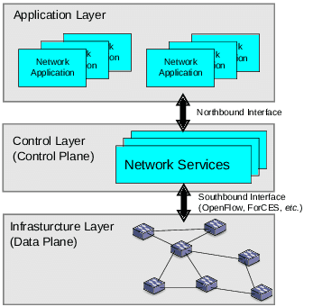
NFV:
NFV • Network Function Virtualization (NFV) is a technology that leverages virtualization to consolidate the heterogeneous network devices onto industry standard high volume servers, switches and storage. • NFV is complementary to SDN as NFV can provide the infrastructure on which SDN can run.
Key elements of NFV • Virtualized Network Function (VNF): • VNF is a software implementation of a network function which is capable of running over the NFV Infrastructure (NFVI). •
NFV Infrastructure (NFVI): • NFVI includes compute, network and storage resources that are virtualized. • NFV Management and Orchestration: • NFV Management and Orchestration focuses on all virtualization-specific management tasks and covers the orchestration and life-cycle management of physical and/or software resources that support the infrastructure virtualization, and the life-cycle management of VNFs.

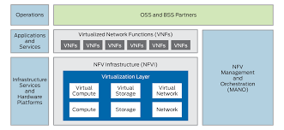

3. Explain about NETCONF in detail with diagram?
• Network Configuration Protocol (NETCONF) is a session-based network management protocol. NETCONF allows retrieving state or configuration data and manipulating configuration data on network devices .
NETCONF • NETCONF works on SSH transport protocol. • Transport layer provides end-to-end connectivity and ensure reliable delivery of messages. • NETCONF uses XML-encoded Remote Procedure Calls (RPCs) for framing request and response messages. • The RPC layer provides mechanism for encoding of RPC calls and notifications. • NETCONF provides various operations to retrieve and edit configuration data from network devices. • The Content Layer consists of configuration and state data which is XML-encoded. • The schema of the configuration and state data is defined in a data modeling language called YANG. • NETCONF provides a clear separation of the configuration and state data. • The configuration data resides within a NETCONF configuration datastore on the server.
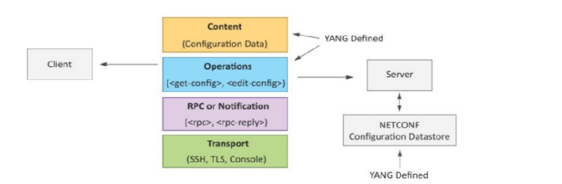
3. Explain about YANG in detail with diagram?

YANG is a data modeling language used to model configuration and state data manipulated by the NETCONF protocol • YANG modules contain the definitions of the configuration data, state data, RPC calls that can be issued and the format of the notifications. • YANG modules defines the data exchanged between the NETCONF client and server. • A module comprises of a number of 'leaf' nodes which are organized into a hierarchical tree structure. • The 'leaf' nodes are specified using the 'leaf' or 'leaf-list' constructs. • Leaf nodes are organized using 'container' or 'list' constructs. • A YANG module can import definitions from other modules. • Constraints can be defined on the data nodes, e.g. allowed values. • YANG can model both configuration data and state data using the 'config' statement.

YANG Module Example : This YANG module is a YANG version of the toaster MIB • The toaster YANG module begins with the header information followed by identity declarations which define various bread types. • The leaf nodes (‘toasterManufacturer’, ‘toasterModelNumber’ and oasterStatus’) are defined in the ‘toaster’ container. • Each leaf node definition has a type and optionally a description and default value. • The module has

make-toast’ and ‘cancel-toast’.

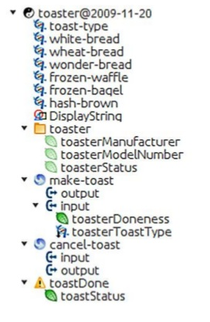
4. IOT System Management with NETCONG_YANG?
IoT Systems Management with NETCONF-YANG are :
Management System , Management API , Transaction Manager, Rollback Manager
Data Model Manager, Configuration Validator, Configuration Database
Configuration API, Data Provider API.

.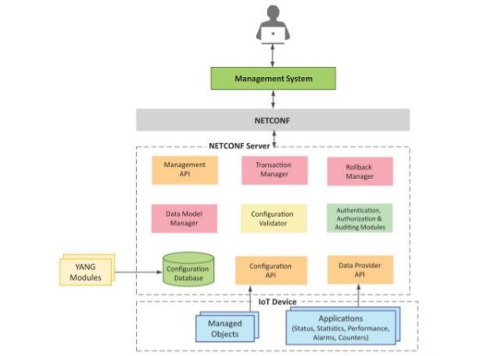

Unit-3

Choose the Best Answer
1.Python supports [ ]
a. Object oriented b. Procedure oriented c. Structure oriented d. All of the above
2.Which none of the following statement is true[ ]
a. High level language b. Interpreted language c. Object oriented language d. All of the above
3. Python package support what type of file structure [ ]
a. Binary b. Text c. Hierarchical d. ASCII
4. JSON stands for
a. Java script order notation b.Java script object notation c.Java script object number d.All of these [ ]
5. Python functions have how many length of argument
a. Variable b. Fixed c. Keyword d. All of these
6. Which command in Linux is used to create empty files or change time stamp for existing files [ ]
a. Touch b. Mk dir c. Ls d. Who
7. d={1:'item','k':2} data type in python represents:
a. Dictionary b. Array c. String d. List
8.JSON stands for[ ]
A .Java script Order Notation b. Java script Object Notation c. Java script Object Number d. All of these
9.The following python snippet does the following task:
file=open('data.txt','r')
a. Opens a file (data.txt) in write mode b. Opens a file (data.txt) in read mode.c. Opens a file (data.txt) in append mode. d. None of these
10. The following python snippet does the following task:
file=open('data.txt','r+')
a. Opens a file (data.txt) in write mode b. Opens a file (data.txt) in read mode c. Opens a file (data.txt) in append mode.d. Both a and b.
Short Answers
- Brief about Python?
Python is a general-purpose high level programming language and suitable for providing a solid foundation to thereader in the area of cloud computing.
The main characteristics of Python are:
Multi-paradigm programming language , Python supports more than one programming paradigms including object-oriented programming and structured programming , Interpreted Language , Python is an interpreted language and does not require an explicit compilation step. The Python interpreter executes the program source code directly, statement by statement, as a processor or scripting engine does. , Interactive Language , Python provides an interactive mode in which the user can submit commands at the Python prompt and interact with the interpreter directly.
2. List the benefits of python?
• Easy-to-learn, read and maintain , Python is a minimalistic language with relatively few keywords, uses English keywords and has fewer syntactical constructions as compared to other languages. Reading Python programs feels like English with pseudo-code like constructs. Python is easy to learn yet an extremely powerful language for a wide range of applications. , Object and Procedure Oriented , Python supports both procedure-oriented programming and object-oriented programming. Procedure oriented paradigm allows programs to be written around procedures or functions that allow reuse of code.
3. What are the ways to download python?
1)Windows
• Python binaries for Windows can be downloaded from
http://www.python.org/getit . • For the examples and exercise in this book, you would require Python 2.7 which can be directly downloaded from: http://www.python.org/ftp/python/2.7.5/python-2.7.5.msi .
Once the python binary is installed you can run the python shell at the command prompt using > python
2) Linux #Install Dependencies
sudo apt-get install build-essential
sudo apt-get install libreadline-gplv2-dev
#Download Python
wget http://python.org/ftp/python/2.7.5/Python-2.7.5.tgz tar -xvf
Python-2.7.5.tgz cd Python-2.7.5
#Install Python
4.Type conversion with examples in python?
Type Conversions :Convert one data type to another data type is called Type conversion.
#Convert to string
>>>a=10000 >>>
str(a) ’10000’
#Convert to int
>>>b="2013"
>>>int(b) 2013
#Convert to float
>>>float(b) 2013.0
#Convert to long
>>>long(b) 2013L
#Convert to list
>>>s="aeiou"
>>>list(s) [’a’, ’e’, ’i’, ’o’, ’u’]
#Convert to set
>>>x=[’mango’,’apple’,’banana’,’mango’,’banana’] >>>set(x) set([’mango’, ’apple’, ’banana’]) •
5. What is Modules in python?
• Python allows organizing the program code into different modules which improves the code readability and management. A module is a Python ﬁle that deﬁnes some functionality in the form of functions or classes. Modules can be imported using the import keyword.
3.List the data types used in python with examples?
1)Numbers :
Number data type is used to store numeric values. Numbers are immutable data types, therefore changing the value of a number data type results in a newly allocated object. #Integer
>>>a=5
>>>type(a) <type ’int’>

#Floating Point
>>>b=2.5 >>>
type(b) <type ’float’>
#Long
>>>x=9898878787676L
>>>type(x) <type ’long’>
#Complex
>>>y=2+5j >>>y (2+5j)
>>>type(y) <type ’complex’>
>>>y.real 2 >>>y.imag 5
#Addition
>>>c=a+b
>>>c 7.5
>>>type(c)
<type ’float’>
#Subtraction
>>>d=a-b >>>d 2.5
>>>type(d)
<type ’float’>
#Multiplication
>>>e=a*b
>>>e 12.5
>>>type(e)
<type ’float’>
#Division
>>>f=b/a >>>f 0.5
>>>type(f)
<type float’>
#Power
>>>g=a**2
>>>g 25
2.Strings
• A string is simply a list of characters in order. There are no limits to the number of characters you can have in a string.
#Create string
>>>s="Hello World!"
>>>type(s) <type ’str’>
#String concatenation
>>>t="This is sample program."
>>>r = s+t
>>>r ’Hello World!This is sample program.’
#Get length of string
>>>len(s) 12
#Convert string to integer
>>>x="100"
>>>type(s)
<type ’str’>
>>>y=int(x)
>>>y 100
#Print string
>>>print s Hello World!
#Formatting output
>>>print "The string (The string (Hello World!) has 12 characters
#Convert to upper/lower case
>>>s.upper() ’HELLO WORLD!’
>>>s.lower() ’hello world!’
#Accessing sub-strings
>>>s[0] ’H’ >>>s[6:] ’World!’
>>>s[6:-1] ’World’
#strip:
Returns a copy of the string with the
#leading and trailing characters removed.
>>>s.strip("!") ’Hello World’
3.Lists
List a compound data type used to group together other values. List items need not all have the same type. A list contains items separated by commas and enclosed within square brackets
. #Create List
>>>fruits=[’apple’,’orange’,’banana’,’mango’]
>>>type(fruits) <type ’list’>
#Get Length of List
>>>len(fruits) 4
#Access List Elements
>>>fruits[1] ’orange’
>>>fruits[1:3] [’orange’, ’banana’]
>>>fruits[1:] [’orange’, ’banana’, ’mango’]
#Appending an item to a list
>>>fruits.append(’pear’)
>>>fruits [’apple’, ’orange’, ’banana’, ’mango’, ’pear’]
#Removing an item from a list
>>>fruits.remove(’mango’)
>>>fruits [’apple’, ’orange’, ’banana’, ’pear’]
#Inserting an item to a list
>>>fruits.insert(1,’mango’)
>>>fruits [’apple’, ’mango’, ’orange’, ’banana’, ’pear’]
#Combining lists
>>>vegetables=[’potato’,’carrot’,’onion’,’beans’,’r adish’]
>>>vegetables [’potato’, ’carrot’, ’onion’, ’beans’, ’radish’]
>>>eatables=fruits+vegetables
>>>eatables [’appl e’, ’mang o’, ’orang e’, ’banan a’, ’pear’, ’potato’, ’carrot’, ’onion’, ’beans’, ’radish’]
#Mixed data types in a list
>>>mixed=[’data’,5,100.1,8287398L]
>>>type(mixed) <type ’list’>
>>>type(mixed[0]) <type ’str’>
>>>type(mixed[1]) <type ’int’>
>>>type(mixed[2])
<type ’float’>
>>>type(mixed[3]) <type ’long’>
#Change individual elements of a list
>>>mixed[0]=mixed[0]+" items"
>>>mixed[1]=mixed[1]+1
>>>mixed[2]=mixed[2]+0.05
>>>mixed [’data items’, 6, 100.14999999999999, 8287398L]
#Lists can be nested
>>>nested=[fruits,vegetables]
>>>nested [[’apple’, ’mango’, ’orange’, ’banana’, ’pear’],
[’potato’, ’carrot’, ’onion’, ’beans’, ’radish’]]
4.Tuples
A tuple is a sequence data type that is similar to the list. A tuple consists of a number of values separated by commas and enclosed within parentheses. Unlike lists, the elements of tuples cannot be changed, so tuples can be thought of as read-only lists.
#Create a Tuple
>>>fruits=("apple","mango","banana","pineapple")
>>>fruits (’apple’, ’mango’, ’banana’, ’pineapple’)
>>>type(fruits) <type ’tuple’>
#Get length of tuple
>>>len(fruits) 4
#Get an element from a tuple
>>>fruits[0] ’apple’
>>>fruits[:2] (’apple’, ’mango’)
#Combining tuples
>>>vegetables=(’potato’,’carrot’,’onion’,’radish’)
>>>eatables=fruits+vegetables
>>>eatables (’apple’, ’mango’, ’banana’, ’pineapple’, ’potato’, ’carrot’, ’onion’, ’radish’)
4.Dictionaries
Dictionary is a mapping data type or a kind of hash table that maps keys to values. Keys in a dictionary can be of any data type, though numbers and strings are commonly used for keys. Values in a dictionary can be any data type or object. #Create a dictionary >>>student={’name’:’Mary’,’id’:’8776’,’major’:’CS’}
>>>student {’major’: ’CS’, ’name’: ’Mary’, ’id’: ’8776’}
>>>type(student) <type ’dict’>
#Get length of a dictionary
>>>len(student) 3
#Get the value of a key in dictionary
>>>student[’name’] ’Mary’
#Get all items in a dictionary
>>>student.items() [(’gender’, ’female’), (’major’, ’CS’), (’name’, ’Mary’), (’id’, ’8776’)] #Get all keys in a dictionary
>>>student.keys() [’gender’, ’major’, ’name’, ’id’]
#Get all values in a dictionary
>>>student.values() [’female’, ’CS’, ’Mary’, ’8776’]
#Add new key-value pair
>>>student[’gender’]=’female’
>>>student {’gende r’: ’female’, ’major’: ’CS’, ’name’: ’Mary’, ’id’: ’8776’}
#A value in a dictionary can be another dictionary >>>student1={’name’:’David’,’id’:’9876’,’major’:’ECE’}
>>>students={’1’: student,’2’:student1}
>>>students {’1’: {’gende r’: ’female’, ’major’: ’CS’, ’name’: ’Mary’, ’id’: ’8776’}, ’2’: {’ major’: ’ECE’, ’name’: ’David’, ’id’: ’9876’}}
#Check if dictionary has a key
>>>student.has_key(’name’) True
>>>student.has_key(’grade’) False
4.Explain in detail about modules with examples?

Modules :

• Python allows organizing the program code into different modules which improves the code readability and management. A module is a Python ﬁle that deﬁnes some functionality in the form of functions or classes. Modules can be imported using the import keyword. Modules to be imported must be present in the search path.

#student module - saved as student.py
def average Grade(students):
sum = 0.0 for key in students: sum = sum + students[key]['grade']
average = sum/len(students) return average
def print Records(students):
print "There are %d students" %(len(students))
i=1 for key in students:
print "Student-%d: " % (i)
print "Name: " + students[key]['name']
print "Grade: " + str(students[key]['grade']) i = i+1

#Using student module

>>>import student
>>>students = '1': 'name': 'Bob', 'grade': 2.5, '2': 'name': 'Mary', 'grade': 3.5, '3': 'name': 'David', 'grade': 4.2, '4': 'name': 'John', 'grade': 4.1, '5': 'name': 'Alex', 'grade': 3.8
>>>student.print Records(students)
There are 5 students Student-1: Name: Bob Grade: 2.5 Student-2: Name: David Grade: 4.2 Student-3: Name: Mary Grade: 3.5 Student-4: Name: Alex Grade: 3.8 Student-5: Name: John Grade: 4.1
>>>avg = student. Average Grade(students)
>>>print "The average garde is: %0.2f" % (avg) 3.62
# Importing a specific function from a module
>>>from student import average Grade
# Listing all names deﬁnes in a module
>>>dir(student)

5. Explain about File Handling in python?

File Handling :
Python allows reading and writing to ﬁles using the ﬁle object.
The open(ﬁlename, mode) function is used to get a ﬁle object.
The mode can be read (r), write (w), append (a), read and write (r+ or w+), read-binary (rb), write-binary (wb), etc.
After the ﬁle contents have been read the close function is called which closes the ﬁle object.

# Example of reading line by line
>>>fp = open('file1.txt','r')
>>>print "Line-1: " + fp.readline()
Line-1: Python supports more than one programming paradigms.
>>>print "Line-2: " + fp.readline()
Line-2: Python is an interpreted language.
>>>fp.close() # Example of reading an entire file
>>>fp = open('file.txt','r')
>>>content = fp.read()
>>>print content This is a test file.
>>>fp.close()

# Example of reading lines in a loop
>>>fp = open(’file1.txt’,’r’)
>>>lines = fp.readlines()
>>>for line in lines: print line Python supports more than one programming paradigms

# Example of seeking to a certain position
>>>fp = open('file.txt','r')
>>>fp.seek(10,0)
>>>content = fp.read(10)
>>>print content ports more
>>>fp.close()

# Example of reading a certain number of bytes
>>>fp = open('file.txt','r')
>>>fp.read(10) 'Python sup'
>>>fp.close()

# Example of getting the current position of read
>>>fp = open('file.txt','r')
>>>fp.read(10) 'Python sup'
>>>currentpos = fp.tell >>>
print currentpos <built-in method tell of file object at 0x0000000002391390>
>>>fp.close()

# Example of writing to a file
>>>fo = open('file1.txt','w')
>>>content='This is an example of writing to a file in Python.' >>>
fo.write(content)
>>>fo.close()

6.List the python packages?
Python Packages of Interest

• JSON :
JavaScript Object Notation (JSON) is an easy to read and write data-interchange format.
JSON is used as an alternative to XML and is is easy for machines to parse and generate.
JSON is built on two structures - a collection of name-value pairs (e.g. a Python dictionary) and ordered lists of values (e.g.. a Python list).

• XML :
XML (Extensible Markup Language) is a data format for structured document interchange.
The Python minidom library provides a minimal implementation of the Document Object Model interface and has an API similar to that in other languages.

HTTPLib & URLLib
HTTPLib2 and URLLib2 are Python libraries used in network/internet programming

SMTPLib : Simple Mail Transfer Protocol (SMTP) is a protocol which handles sending email and routing e-mail between mail servers.
The Python smtplib module provides an SMTP client session object that can be used to send email.

NumPy :
NumPy is a package for scientific computing in Python. NumPy provides support for large multi-dimensional arrays and matrices • Scikit-learn • Scikit-learn is an open source machine learning library for Python that provides implementations of various machine learning algorithms for classification, clustering, regression and dimension reduction problems.

Unit-4
Choose the Best Answer

1. Which instruction set architecture is used in Raspberry pi [ ]
a) X86 b) MSP c) AVR d) ARM
2. Raspberry Pi has how many pin expansion header [ ]
a) 16 b) 24 c)40 d)48
3. The Raspberry Pi models A support how many number of USB port [ ]
a) 1 b)2 c)4 d)8
4.The Raspberry Pi3 has how many GPIO pins? [ ]
a. 20 b. 30 c. 40 d. 50
5. The raspberry pi zero has the following core specification associated with it?[ ]
a. ATMEGA32 b. PIC16 c. ARM-11 d. Quad Cortex A53
7. The command raspistill-o image.jpg on a Raspberry Pi terminal:[ ]
a. Captures an image. b. Stores an image from any camera.c. Reads an image.d. Captures and stores an image using the raspberry pi camera.
8. What are the types of GPIO pin modes in Raspberry Pi 2/3?[ ]
a. Board b. BCM c. Both a and b d. None of these
9. Which one is correct for the nested controlling statement in python?[ ]
a. else if b. el-if c. if while d. None
10. Which of the following is mutable object in python?[ ]
a. Tuple b. Bool c. Int d. List

Short Questions

1.What is an IoT Device?

A "Thing" in Internet of Things (IoT) can be any object that has a unique identiﬁer and which can send/receive data (including user data) over a network (e.g., smart phone, smart TV, computer, refrigerator, car, etc. ). IoT devices are connected to the Internet and send information about themselves or about their surroundings (e.g. information sensed by the connected sensors) over a network (to other devices or servers/storage) or allow actuation upon the physical entities/environment around them remotely.

2. Basic building blocks of an IoT Device ?

• Sensing • Sensors can be either on-board the IoT device or attached to the device. • Actuation • IoT devices can have various types of actuators attached that allow taking • actions upon the physical entities in the vicinity of the device. • Communication • Communication modules are responsible for sending collected data to other devices or cloud-based servers/storage and receiving data from other devices and commands from remote applications. • Analysis & Processing • Analysis and processing modules are responsible for making sense of the collected data.

3. Brief about Raspberry pi?

Raspberry Pi is a low-cost mini-computer with the physical size of a credit card. Raspberry Pi runs various ﬂavors of Linux and can perform almost all tasks that a normal desktop computer can do. Raspberry Pi also allows interfacing sensors and actuators through the general purpose I/O pins.

4. Explain about Raspberry Pi Interfaces?

The serial interface on Raspberry Pi has receive (Rx) and transmit (Tx) pins for communication with serial peripherals. • SPI • Serial Peripheral Interface (SPI) is a synchronous serial data protocol used for communicating with one or more peripheral devices. • I2C • The I2C interface pins on Raspberry Pi allow you to connect hardware modules. I2C interface allows synchronous data transfer with just two pins - SDA (data line) and SCL (clock line).

Long questions
1. Raspberry Pi is a low-cost mini-computer with the physical size of a credit card. Raspberry Pi runs various ﬂavors of Linux and can perform almost all tasks that a normal desktop computer can do. Raspberry Pi also allows interfacing sensors and actuators through the general purpose I/O pins.

Here are the various components on the Raspberry Pi board:
- ARM CPU/GPU -- This is a Broadcom BCM2835 System on a Chip (SoC) that's made up of an ARM central processing unit (CPU) and a Videocore 4 graphics processing unit (GPU). The CPU handles all the computations that make a computer work (taking input, doing calculations and producing output), and the GPU handles graphics output.
- GPIO -- These are exposed general-purpose input/output connection points that will allow the real hardware hobbyists the opportunity to tinker.
- RCA -- An RCA jack allows connection of analog TVs and other similar output devices.
- Audio out -- This is a standard 3.55-millimeter jack for connection of audio output devices such as headphones or speakers. There is no audio in.
- LEDs -- Light-emitting diodes, for all of your indicator light needs.
- USB -- This is a common connection port for peripheral devices of all types (including your mouse and keyboard). Model A has one, and Model B has two. You can use a USB hub to expand the number of ports or plug your mouse into your keyboard if it has its own USB port.
- HDMI -- This connector allows you to hook up a high-definition television or other compatible device using an HDMI cable.
- Power -- This is a 5v Micro USB power connector into which you can plug your compatible power supply.
- SD cardslot -- This is a full-sized SD card slot. An SD card with an operating system (OS) installed is required for booting the device. They are available for purchase from the manufacturers, but you can also download an OS and save it to the card yourself if you have a Linux machine and the wherewithal.
- Ethernet -- This connector allows for wired network access and is only available on the Model B.

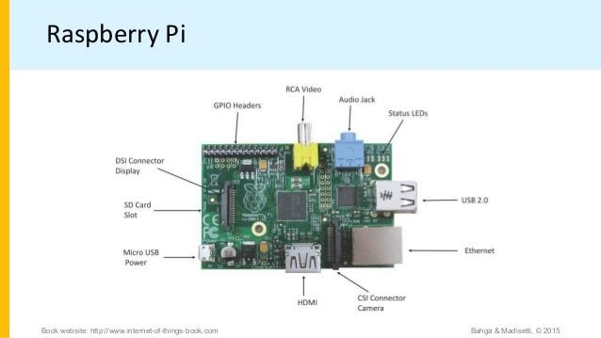

- Write a python program Interfacing LED and switch with Raspberry Pi?

from time import sleep
import RPi.GPIO as GPIO
GPIO.setmode(GPIO.BCM)
#Switch Pin GPIO.setup(25, GPIO.IN)
#LED Pin GPIO.setup(18, GPIO.OUT) state=false
def toggleLED(pin): state = not state
GPIO.output(pin, state)
while True: try: if (GPIO.input(25) == True): toggleLED(pin)
sleep(.01)
except KeyboardInterrupt: exit()

3. Blinking of led python program?

import RPi.GPIO as GPIO # Import Raspberry Pi GPIO library
from time import sleep # Import the sleep function from the time module
GPIO.setwarnings(False) # Ignore warning for now
GPIO.setmode(GPIO.BOARD) # Use physical pin numbering
GPIO.setup(8, GPIO.OUT, initial=GPIO.LOW) # Set pin 8 to be an output pin and set initial value to low (off)
while True: # Run forever
GPIO.output(8, GPIO.HIGH) # Turn on
sleep(1) # Sleep for 1 second
GPIO.output(8, GPIO.LOW) # Turn off
sleep(1) # Sleep for 1 second

4.Explain about the raspberry pi pins with diagram?

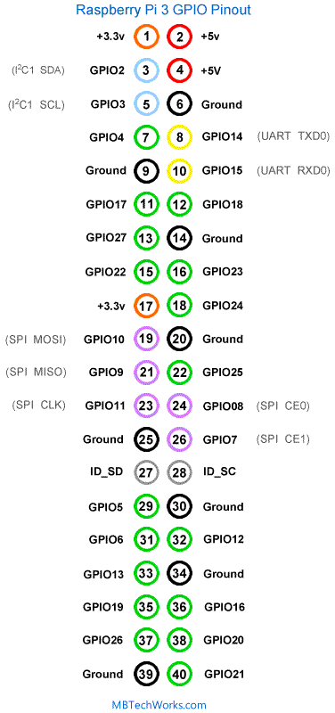

Note that each of the 40 pins has a "physical" pin number: 1, 2, 3, 4 . . . as well as a "BCM" designator like: GPI02, GPI027, ID_SD . . . BCM refers to the Broadcom processor chip. As you will see, you can use the pins by their physical board number or the BCM number. There are also a few specific pins reserved exclusively for power: +5v, +3.3v and Ground (and not programmable).

The programmable pins may be referenced by either the physical pin number on the board or by the BCM number (or simply GPIO number) at the end of the designator name (i.e. GPIO27). This choice is made in the initial configuration during program setup.

Board vs BCM Numbering
The programmable pins may be referenced by either the physical pin number on the board or by the BCM number (or simply GPIO number) at the end of the designator name (i.e. GPIO27). This choice is made in the initial configuration during program setup.

Some examples of board vs BCM/GPIO numbering
Board Pin Number | BCM/GPIO Name | BCM Pin Number
3 | GPIO2 | 2
5 | GPIO3 | 3
7 | GPIO4 | 4
8 | GPIO14 | 14
It is important to understand that board numbering and BCM numbering use the same physical set of pins, but they are numbered differently. For example, board pin number 3 is the same physical pin as BCM pin number 2 (GPIO2) - see the GPIO Pinout image above.

Unit-5
Multiple choice questions

1.Django is what the of framework [ ]
a) Model Template View b) Message Template View c) Machine Template View

2. WAMP is a sub-protocol of Web sockets which provides a RPC messaging patterns [ ]
a) Push-pull b)Client-server c)Publish –Subscribe d)All of these

3. Django is a web framework which is coded in which language [ ]
a) Java b)Python c)Linux d)C++

4.. Which of the following is an edge-storage or content-delivery system that caches data in different physical locations?[ ]
a) Amazon Relational Database Service b) Amazon SimpleDB c) Amazon Cloudfront
d) Amazon Associates Web Services

5. Point out the wrong statement.[ ]
a) Amazon Machine Instances are sized at various levels and rented on a computing/hour basis
b) The metrics obtained by CloudWatch may be used to enable a feature called Auto Scaling
c) A number of tools are used to support EC2 services
d) None of the mentioned

6. Which of the following allows you to create instances of the MySQL database to support your Web sites?[ ]
a) Amazon Elastic Compute Cloud b) Amazon Simple Queue Service c) Amazon Relational Database Service
d) Amazon Simple Storage System

7. Which of the following is a structured data store that supports indexing and data queries to both EC2 and S3?
a) Cloud Watch b) Amazon Simple DBc) Amazon Cloud front d) All of the mentioned

8.Which of the following is a billing and account management service?[ ]
a) Amazon Elastic Map Reduce b) Amazon Mechanical Turk c) Amazon Dev Pay d) Multi-Factor Authentication

9. Which of the following is a means for accessing human researchers or consultants to help solve problems on a contractual or temporary basis?[ ]
a) Amazon Elastic Map Reduce b) Amazon Mechanical Turk c) Amazon Dev Pay d) Multi-Factor Authentication

10. 10. Which of the following is built on top of a Hadoop framework using the Elastic Compute Cloud?
a) Amazon Elastic Map Reduce b) Amazon Mechanical Turk c) Amazon Dev Payd) Multi-Factor Authentication

Short Answers

1.What is WAMP for IoT?
• Web Application Messaging Protocol (WAMP) is a sub-protocol of Websocket which provides publish-subscribe and remote procedure call (RPC) messaging patterns.

- 2. List of Amazon Web Services?
- Amazon EC2
- Amazon RDS
- Amazon S3
- Amazon Cloud Front
- Amazon VPC
- Amazon SNS
- Amazon Elastic Beanstalk
- Amazon Lambda.

- 3.what is cloud services?
A cloud service is any service made available to users on demand via the Internet from a cloud computing provider's servers as opposed to being provided from a company's own on-premises servers. Cloud services are designed to provide easy, scalable access to applications, resources and services, and are fully managed by a cloud services provider.

- 4.Essential characteristics of cloud services?
- On-demand self-service
- Broad network access
- Resource pooling
- Rapid elasticity
- Measured service.

5. What is API?
An API is a set of definitions and protocols for building and integrating application software. API stands for application programming interface. APIs let your product or service communicate with other products and services without having to know how they're implemented.

6.What is cloud computing?

cloud computing means storing and accessing data and programs over the Internet instead of your computer's hard drive. The cloud is just a metaphor for the Internet. When you store data on or run programs from the hard drive, that's called local storage and computing.

Long questions

1.Explain in detail about WAMP with Diagram?

WAMP –
Transport: Transport is channel that connects two peers.

Session: Session is a conversation between two peers that runs over a transport.

Client: Clients are peers that can have one or more roles.

In publish-subscribe model client can have following roles

Publisher: Publisher publishes events (including payload) to the topic maintained by the Broker.

Subscriber: Subscriber subscribes to the topics and receives the events including the payload.
In RPC model client can have following roles.
Caller: Caller issues calls to the remote procedures along with call arguments.
Callee: Callee executes the procedures to which the calls are issued by the caller and returns the results back to the caller.
Router: Routers are peers that perform generic call and event routing.

In publish-subscribe model Router has the role :
Broker: – Broker: Broker acts as a router and routes messages published to a topic to all subscribers subscribed to the topic.

In RPC model Router has the role of a Broker:
Dealer: Dealer acts a router and routes RPC calls from the Caller to the Callee and routes results from Callee to Caller.

Application Code: Application code runs on the Clients (Publisher, Subscriber, Callee or Caller.

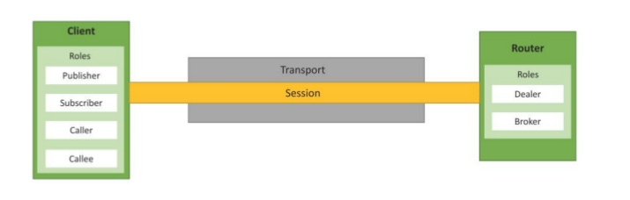

WAMP FOR IOT

2.Explain about Django Architecture ?

• Django is Model-Template-View (MTV) framework. The model acts as a definition of some stored data and handles the interactions with the database. In a web application, the data can be stored in a relational database, non-relational database, an XML file, etc. A Django model is a Python class that outlines the variables and methods for a particular type of data.

Template In a typical Django web application, the template is simply an HTML page with a few extra placeholders. Django’s template language can be used to create various forms of text files (XML, email, CSS, Javascript, CSV, etc.) • View • The view ties the model to the template. The view is where you write the code that actually generates the web pages. View determines what data is to be displayed, retrieves the data from the database and passes the data to the template
.

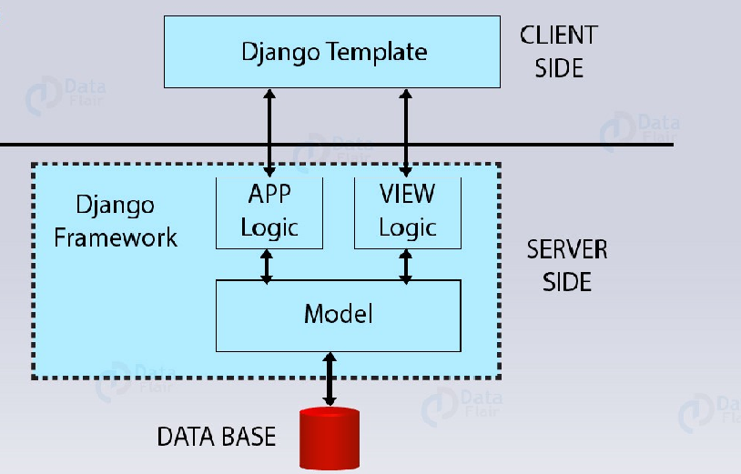

3.Explain the Amazon Web Services?
Amazon EC2
Python Example
Boto is a Python package that provides interfaces to Amazon Web Services (AWS)
#Python program for launching an EC2 instance
import boto.ec2 from time
import sleep ACCESS_KEY="<enter access key>"
SECRET_KEY="<enter secret key>"
REGION="us-east-1" AMI_ID = "ami-d0f89fb9"
EC2_KEY_HANDLE = "<enter key handle>" INSTANCE_TYPE="t1.micro" SECGROUP_HANDLE="default"
conn = boto.ec2.connect_to_region(REGION, aws_access_key_id=ACCESS_KEY, aws_secret_access_key=SECRET_KEY)
reservation = conn.run_instances(image_id=AMI_ID, key_name=EC2_KEY_HANDLE, instance_type=INSTANCE_TYPE, security_groups = [ SECGROUP_HANDLE, ] )
connection to EC2 service is ﬁ rst established by calling boto.ec2.connect_to_region.
The EC2 region, AWS access key and AWS secret key are passed to this function.
After connecting to EC2 , a new instance is launched using the conn.run_instances function.
The AMI-ID, instance type, EC2 key handle and security group are passed to this function
2. Amazon AutoScaling
Python Example
#Python program for creating an AutoScaling group (code excerpt)
import boto.ec2.autoscale :
print "Connecting to Autoscaling Service" conn =boto.ec2.autoscale.connect_to_region(REGION, aws_access_key_id=ACCESS_KEY, aws_secret_access_key=SECRET_KEY)
print "Creating launch configuration"
lc = LaunchConfiguration(name='My-Launch-Config-2', image_id=AMI_ID, key_name=EC2_KEY_HANDLE, instance_type=INSTANCE_TYPE, security_groups = [ SECGROUP_HANDLE, ])
conn.create_launch_configuration(lc)
print "Creating auto-scaling group"
ag = AutoScalingGroup(group_name='My-Group', availability_zones=['us-east-1b'], launch_config=lc, min_size=1, max_size=2, connection=conn)
conn.create_auto_scaling_group(ag)
• AutoScaling Service
A connection to AutoScaling service is first established by calling boto.ec2.autoscale.connect_to_region function.
Launch Configuration : After connecting to AutoScaling service, a new launch configuration is created by calling conn.create_launch_con f iguration.
Launch configuration contains instructions on how to launch new instances including the AMI-ID, instance type, security groups, etc.
AutoScaling Group
After creating a launch configuration, it is then associated with a new AutoScaling group. AutoScaling group is created by calling conn.create_auto_scaling_group. The settings for AutoScaling group such as the maximum and minimum number of instances in the group, the launch configuration, availability zones, optional load balancer to use with the group, etc.
3.Amazon S3
Python Example
# Python program for uploading a ﬁle to an S3 bucket
import boto.s3 conn = boto.connect_s3(aws_access_key_id='<enter>', aws_secret_access_key='<enter>')
def percent_cb(complete, total):
print ('.') def upload_to_s3_bucket_path(bucketname, path, filename):
mybucket = conn.get_bucket(bucketname)
fullkeyname=os.path.join(path,filename)
key = mybucket.new_key(fullkeyname)
key.set_contents_from_filename(filename, cb=percent_cb, num_cb=10)
In this example, a connection to S3 service is first established by calling boto.connect_s3 function.

