UNIT-1: INTRODUCTION TO ELECTRICAL CIRCUITS

Q1. Define ideal voltage source.
Ans. In ideal conditions the voltage across a voltage source should be constant for whatever current delivered by the source.
Ideal Voltage Sources
The concept of an ideal voltage source is pretty simple, and it was really embedded in the previous discussion.
- An ideal voltage source is a voltage source that maintains the same voltage across the source's terminals no matter what current is drawn from the terminals of the source or what current flows into the terminals.
That's it in a nutshell. If the source is a DC Source, we can plot a voltage current plot for an ideal voltage source. The plot is shown below. However, we need to define terms. Here is a circuit symbol for an ideal voltage source. In this symbol, we assume the following.
- The voltage across the terminals is denoted as V_{t}.
- The load current flowing from the source to a load (presumably a load is attached when the source is in a circuit) is denoted as I_{L}.
- With those definitions, here is the source symbol. It's just a circle with polarity indicated.
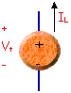
And, here is the plot of terminal voltage against load current.
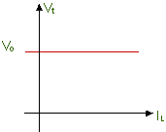
Given the discussion above, we can say:
- V_{t} = constant, no matter what the load current is.
That's pretty much the description of the ideal voltage source. It's not too complex, but it is an important concept. In the next section we'll look at how you can put this concept to use. For the rest of this section we'll look at ideal current sources starting next.
Q2. Define ideal current source.
Ans. It should deliver constant current for whatever voltage across its terminals.
An ideal current source is a simple model for many current sources. It is reminiscent of the ideal voltage source - but with voltage and current interchanged. Here is the story.
- There is a special circuit symbol for an ideal current source. See below.
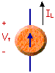
- I_{L} = constant, no matter what the terminal voltage is.
- The plot of load current against terminal voltage is similar to the plot for an ideal voltage source, but voltage and current are interchanged. Here is the plot.
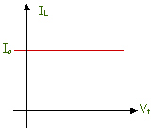
Notice that an ideal current source is somewhat similar to an ideal voltage source. However, when you use an ideal source - usually when doing circuit analysis- there is a significant difference in the analysis. However, that's getting ahead of the story. We first have to worry about how you would "use" an ideal source, when we know that there is no such thing as an ideal source, i.e. a source that is "perfect" in some way.
Q3. What are ideal elements?
Ans.The ideal elements are resistors which oppose the flow of current, the inductor opposes to change in current. Capacitor offers only opposition to change in voltage.
An electric circuit is made of elements. Elements include at least one source. The source is connected to a bunch of components.
Elements are either sources or components.
Sources provide energy to a circuit. There are two basic types.
- Voltage source
- Current source
Components come in three basic types, each characterized by a different voltage-current relationship.
- Resistor
- Capacitor
- Inductor
These sources and components have two terminals or connection points.
Q4. Define energy.
Ans. It is the capacity to do work. Unit is Joule.
Energy is defined as the capacity of a physical system to perform work.

Forms of Energy
Energy exists in several forms such as heat, kinetic or mechanical energy, light, potential energy, and electrical energy.
- Heat - Heat or thermal energy is ​energy from the movement of atoms or molecules. It may be considered as energy relating to temperature.
- Kinetic Energy - Kinetic energy is energy of motion. A swinging pendulum has kinetic energy.
- Potential Energy - This is energy due to an objects position. For example, a ball sitting on a table has potential energy with respect to the floor because gravity acts upon it.
- Mechanical Energy - Mechanical energy is the sum of the kinetic and potential energy of a body.
- Light - Photons are a form of energy.
- Electrical Energy - This is energy from the movement of charged particles, such as protons, electrons, or ions.

Q5. Define charge.
Ans. It is the characteristic property of the elementary particles of the matter.
Electric charge is the physical property of matter that causes it to experience a force when placed in an electromagnetic field. There are two types of electric charges: positive and negative. Like charges repel and unlike attract. An object is negatively charged if it has an excess of electrons, and is otherwise positively charged or uncharged. The SI derived unit of electric charge is the coulomb (C). In electrical engineering, it is also common to use the ampere-hour (Ah), and, in chemistry, it is common to use the elementary charge (e) as a unit. The symbol Q often denotes charge. Early knowledge of how charged substances interact is now called classical electrodynamics, and is still accurate for problems that don't require consideration of quantum effects.
------------------------------------------------------------------------------------------------------------------------------------------
Q6. What is meant by source transformation?
Ans. The voltage source can be converted in to equivalent practical current source and vice versa with same terminal behavior.
Source transformations are easy to perform as long as there is a familiarity with Ohm's law. If there is a voltage source in series with an impedance, it is possible to find the value of the equivalent current source in parallel with the impedance by dividing the value of the voltage source by the value of the impedance. The converse also applies here: if a current source in parallel with an impedance is present, multiplying the value of the current source with the value of the impedance will result in the equivalent voltage source in series with the impedance. A visual example of a source transformation can be seen in Figure 1.

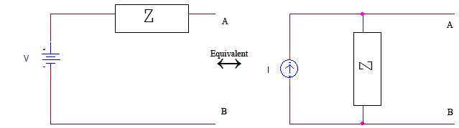
Figure 1. An example of a DC source transformation. Notice that the impedance Z is the same in both configurations.
Q7. Define Ohms Law.
Ans. The potential difference across any two ends of a conductor is directly proportional to the current flowing between the two ends provided the temperature of the conductor remains constant.
Ohm's law states that the current through a conductor between two points is directly proportional to the voltage across the two points. Introducing the constant of proportionality, the resistance, one arrives at the usual mathematical equation that describes this relationship:

where I is the current through the conductor in units of amperes, V is the voltage measured across the conductor in units of volts, and R is the resistance of the conductor in units of ohms. More specifically, Ohm's law states that the R in this relation is constant, independent of the current.
In physics, the term Ohm's law is also used to refer to various generalizations of the law originally formulated by Ohm.

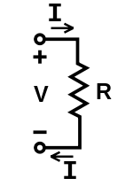
V, I, and R, the parameters of Ohm's law.

Q8. Define KCL
Ans. Kirchhoff’s current law:
It states that the sum of currents entering into any point is equal to the sum of the currents leaving that point.
This law is also called Kirchhoff's first law, Kirchhoff's point rule, or Kirchhoff's junction rule (or nodal rule).
The principle of conservation of electric charge implies that:
At any node (junction) in an electrical circuit, the sum of currents flowing into that node is equal to the sum of currents flowing out of that node or equivalently
The algebraic sum of currents in a network of conductors meeting at a point is zero.
Recalling that current is a signed (positive or negative) quantity reflecting direction towards or away from a node, this principle can be stated as:
∑ I=0
The law is based on the conservation of charge whereby the charge (measured in coulombs) is the product of the current (in amperes) and the time (in seconds).
KCL is applicable to any lumped network irrespective of the nature of the network; whether unilateral or bilateral, active or passive, linear or non-linear.
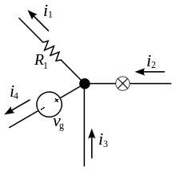
The current entering any junction is equal to the current leaving that junction. i₂ + i₃ = i₁ + i₄
Q9. Define KVL.
Ans. It states that the algebraic sum of voltages around any closed path in a circuit is always zero.
Kirchhoff's Voltage Law
Kirchhoff's Voltage Law (or Kirchhoff's Loop Rule) is a result of the electrostatic field being conservative. It states that the total voltage around a closed loop must be zero. If this were not the case, then when we travel around a closed loop, the voltages would be indefinite. So  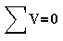  In Figure 1 the total voltage around loop 1 should sum to zero, as does the total voltage in loop2. Furthermore, the loop which consists of the outer part of the circuit (the path ABCD) should also sum to zero. | 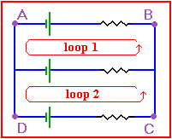  Figure 1 Around a closed loop, the total voltage should be zero
We can adopt the convention that potential gains (i.e. going from lower to higher potential, such as with an emf source) is taken to be positive. Potential losses (such as across a resistor) will then be negative. However, as long as you are consistent in doing your problems, you should be able to choose whichever convention you like. It is a good idea to adopt the convention used in your class.
- Here are a number of simulated experiments based on Kirchoff's Laws. They are in order of increasing difficulty. Use the "back" button to return to this place.
Q10. Define power.
Ans. It is the rate at which work is done. Unit of power is watts.
Electrical power is the rate at which electrical energy is converted to another form, such as motion, heat, or an electromagnetic field. The common symbol for power is the uppercase letter P. The standard unit is the watt,symbolized by W. In utility circuits, the kilowatt (kW) is often specified instead;1 kW = 1000 W.
One watt is the power resulting from an energy dissipation, conversion, or storage process equivalent to one joule per second. When expressed in watts, power is sometimes called wattage. The wattage in a direct current (DC) circuit is equal to the product of the voltage in volts and the current in amperes. This rule also holds for low-frequency alternating current (AC) circuits in which energy is neither stored nor released. At high AC frequencies, in which energy is stored and released (as well as dissipated or converted), the expression for power is more complex.
In a DC circuit, a source of E volts, deliveringIamperes, produces P watts according to the formula:
P = EI
When a current of I amperes passes through a resistance of Rohms, then the power in watts dissipated or converted by that component is given by:
P = I²R
When a potential difference of E volts appears across a component having a resistance of R ohms, then the power in watts dissipated or converted by that component is given by:
P = E²/R
In a DC circuit, power is a scalar (one-dimensional) quantity. In the general AC case, the determination of power requires two dimensions, because AC power is a vector quantity. Assuming there is no reactance (opposition to AC but not to DC) in an AC circuit, the power can be calculated according to the above formulas for DC, using root-mean-square values for the alternating current and voltage. If reactance exists, some power is alternately stored and released by the system. This is called apparent power or reactive power. The resistance dissipates power as heat or converts it to some other tangible form; this is called true power. The vector combination of reactance and resistance is known as impedance.
Q11. What is meant by linear and nonlinear elements?
Ans. Linear elements:
Linear elements shows linear characteristic of voltage Vs Current.
In an electric circuit, a linear element is an electrical element with a linear relationship between input current and output voltage. The resistance, inductance or capacitance offered by an element does not change with the change in applied voltage or circuit current, the element is termed as linear element. Resistors are the most common example of a linear element; other examples include capacitors, inductors, and transformers.
Nonlinear elements:
Nonlinear element the Current passing through it does not change linearly with the linear change in applied voltage at a particular frequency.
In an electric circuit, a nonlinear element or nonlinear device is an electrical element which does not have a linear relationship between current and voltage. A diode is a simple example.
Nonlinear elements are avoided in some electronic circuits, called linear circuits, because they have the potential to distort electrical signals. A nonlinear curve that consists of linear curves called piece-wise linear.
Q12. What is meant by active and Passive elements?
Ans. Energy sources (voltage or current sources) are active elements, capable of delivering power to some external device. The passive elements are those which are capable only of receiving power.
Active Components:
Those devices or components which required external source to their operation is called Active Components.
For Example: Diode, Transistors, SCR etc…
Explanation and Example: As we know that Diode is an Active Components. So it is required an External Source to its operation.
Because, If we connect a Diode in a Circuit and then connect this circuit to the Supply voltage., then Diode will not conduct the current Until the supply voltage reach to 0.3(In case of Germanium) or 0.7V(In case of Silicon).

Passive Components:
Those devices or components which do not required external source to their operation is called Passive Components.
For Example: Resistor, Capacitor, Inductor etc…
Explanation and Example: Passive Components do not require external source to their operation.
Like a Diode, Resistor does not require 0.3 0r 0.7 V. I.e., when we connect a resistor to the supply voltage, it starts work automatically without using a specific voltage.

Q13. What are Unilateral and bi lateral elements ?
Ans. In the bilateral element, the voltage - current relation is the same for current flowing in either direction. In contrast, a unilateral element has different relations between voltage and current for the two possible directions of current.
Unilateral circuits
In unilateral circuits, the property of circuit changes with the change of direction of supply voltage or current. In other words, unilateral circuit allows the current to flow only in one direction. Diode rectifier is the best example of unilateral circuit because it does not perform the rectification in both direction of supply.
Bi-lateral circuits
In bilateral circuits, the property of circuit does not change with the change of direction of supply voltage or current. In other words, bilateral circuit allows the current to flow in both directions. Transmission line is the best example of bilateral circuit because, if you give supply from any direction, the circuit properties remain constant.

Q14. What are linear and nonlinear elements?
Ans. Nonlinear element:
An element which does not satisfy this relation is called a nonlinear element.
In an electric circuit, a nonlinear element or nonlinear device is an electrical element which does not have a linear relationship between current and voltage. A diode is a simple example.
Nonlinear elements are avoided in some electronic circuits, called linear circuits, because they have the potential to distort electrical signals. A nonlinear curve that consists of linear curves called piece-wise linear.
Linear element:
An element is said to be linear, if it satisfies the linear voltage current relationship. That means the current through the element is multiplied by some constant ‘α’, and results in the multiplication of voltage across the element by the same constant.
In an electric circuit, a linear element is an electrical element with a linear relationship between input current and output voltage. The resistance, inductance or capacitance offered by an element does not change with the change in applied voltage or circuit current, the element is termed as linear element. Resistors are the most common example of a linear element; other examples include capacitors, inductors, and transformers.

Q15. What do you mean by an electric network and an electric circuit.
Ans. Interconnection of two or more simple circuit elements (voltage sources, resistors, inductors and capacitors) is called an electric network. If a network contains at least one closed path, it is called an electric circuit.
An electrical network is an interconnection of electrical components (e.g. batteries, resistors, inductors, capacitors, switches) or a model of such an interconnection, consisting of electrical elements (e.g. voltage sources, current sources, resistances, inductances, capacitances). An electrical circuit is a network consisting of a closed loop, giving a return path for the current. Linear electrical networks, a special type consisting only of sources (voltage or current), linear lumped elements (resistors, capacitors, inductors), and linear distributed elements (transmission lines), have the property that signals are linearly superimposable. They are thus more easily analyzed, using powerful frequency domain methods such as Laplace transforms, to determine DC response, AC response, and transient response.
A resistive circuit is a circuit containing only resistors and ideal current and voltage sources. Analysis of resistive circuits is less complicated than analysis of circuits containing capacitors and inductors. If the sources are constant (DC) sources, the result is a DC circuit.
A network that contains active electronic components is known as an electronic circuit. Such networks are generally nonlinear and require more complex design and analysis tools.

A simple electric circuit made up of a voltage source and a resistor. Here V=iR , according to Ohm's law.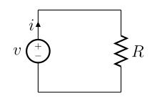

Q16. Classify the network elements
i) Active or passive
ii) Unilateral or bilateral
iii) Linear or non linear
- Lumped or distributed.
Resistance, inductance and capacitance are called network parameters and may be in the form of lumped or distributed.
There are different types of classifications of networks:
- Linear circuits: It is a circuit whose parameters remain constant with change in voltage or current. Examples are a resistance, inductance or capacitance.
- Non-linear Circuits: It is a circuit whose parameters change with voltage or current. A semi-conductor resistor is an example of this circuit.
A linear circuit obeys ohm’s Law i.e current remains directly proportional with applied voltage, while in non linear circuit, ohm’s Law is not satisfied.
- Unilateral Circuit: when the direction of current is changed, the characteristics or properties of the circuit may change. Example; diode, transistors etc.
- Bilateral circuit: when with change in direction of current, the characterstics or properties of the circuit may not change, it is then called bilateral circuit. Mostly, elements made of high conductivity materials are bilateral circuits.
- Active Network: It is a network which contains one or more than one source of e.m.f. An active network consists of an active element like a battery or transistor.
- Passive Network: When a network does not contain any source of e.m.f., it is called passive network. A passive network consists of resistance, inductance or capacitance aspassive element. A passive network does not contains any source of energy and the input port serve as load terminal. It may have output terminal.
- Lumped and Distributed Network:physically separate network elements like R, L, or C are know as lumped elements. A transmission line or a cable is an example of distributed parameter network as throughout the line they are not physically separate. If the network is fabricated with its element in lumped form, it is called lumped network and if in distributed form it is called as distributed network.
- Recurrent and Non Recurrent Network: when a large circuit consists of similar network one after another, the network is called as recurrent network or cascade network or ladder network. A single network is called as non-recurrent network.
Q17. Define lumped and distributed elements in electric circuits.
Ans. The elements which are separated physically are known as lumped elements, like resistors, capacitors and inductors. Distributed elements, on the other hand, are those which are not separable for analytical purposes.
The elements building a lumped system are thought of being concentrated at singular points in space. The classical example is an electrical circuit with passive elements like resistor, inductance and capacitor. The physical quantities current and voltage are functions of time (only). E. g. the current at a capacitor with capacity CC is given by
i(t)=Cdv(t)/dt
Where C is a constant (and so are R and L). This leads to ordinary differential equations.
In contrast, the elements in distributed systems are thought of being distributed in space, so that physical quantities depend on both time and space. The classical example is the electrical line where inductance, capacity and resistance are not constant but functions of length xx. This leads to partial derivatives of i(t,x) and v(t,x) in t and x.

Q18. Write the equations of energy stored by an inductor and capacitor.
Ans.
Energy in an Inductor
When a electric current is flowing in an inductor, there is energy stored in the magnetic field. Considering a pure inductor L, the instantaneous power which must be supplied to initiate the current in the inductor is
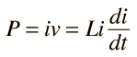
so the energy input to build to a final current i is given by the integral
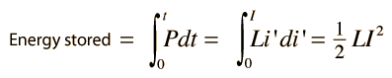
Energy Stored on a Capacitor
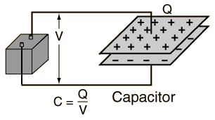 | The energy stored on a capacitor can be calculated from the equivalent expressions:  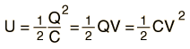  This energy is stored in the electric field.
Top of Form
A capacitor |  | = |  | = x 10^ F
which is charged to voltage V= V
will have charge Q = x10^ C
and will have stored energy E = x10^ J.
Bottom of Form
From the definition of voltage as the energy per unit charge, one might expect that the energy stored on this ideal capacitor would be just QV. That is, all the work done on the charge in moving it from one plate to the other would appear as energy stored. But in fact, the expression above shows that just half of that work appears as energy stored in the capacitor. For a finite resistance, one can show that half of the energy supplied by the battery for the charging of the capacitor is dissipated as heat in the resistor, regardless of the size of the resistor.
Q19. How can a practical voltage source, having an ideal voltage VS and internal series resistance RV be replaced by a current source?
Ans. The practical voltage source, having an ideal voltage Vs and internal series resistance RV be replaced by a current source I = VS / RV in parallel with an internal resistance RI = RV
Q20. Mention the disadvantages of Ohm’s Law.
Ans. 1. It does not apply to all non metallic conductors
2.It also does not apply to non linear devices such as zener diode, vacuum tubes etc.
3.It is true for metal conductors at constant temperature. If the temperature changes the law is not applicable.
Q21. What are dependent and independent sources?
Ans. The electrical energy supplied by dependent sources a source of electrical energy.
The electrical energy supplied by independent source does not depend on another electrical source. They convert some energy in to electrical form.

Independent and Dependent Sources
There are two principal types of source, namely voltage source and current source. Sources can be either independent or dependent upon some other quantities.
An independent voltage source maintains a voltage (fixed or varying with time) which is not affected by any other quantity. Similarly an independent current source maintains a current (fixed or time-varying) which is unaffected by any other quantity. The usual symbols are shown in figure 1.3.
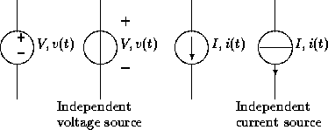
Figure 1.3: Symbols for independent sources
Some voltage (current) sources have their voltage (current) values varying with some other variables. They are called dependent voltage (current) sources or controlled voltage (current) sources , and their usual symbols are shown in figure 1.4.
Remarks -- It is not possible to force an independent voltage source to take up a voltage which is different from its defined value. Likewise, it is not possible to force an independent current source to take up a current which is different from its defined value. Two particular examples are short-circuiting an independent voltage source and open-circuiting an independent current source. Both are not permitted.
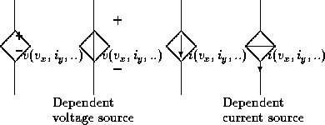
Figure 1.4: Symbols for dependent sources. Variables in brackets are the controlling variables whose values affect the value of the source.
Q22. State voltage division rule.
Ans. Voltage across a resistor in series circuit is equal to the total voltage across the series elements multiplied by the value of that resistor divided by the total resistance of the series elements.

Voltage Division Rule:
The voltage division rule can be understood by considering a series circuit shown below. In a series circuit, voltage is divided, whereas the current remains the same.
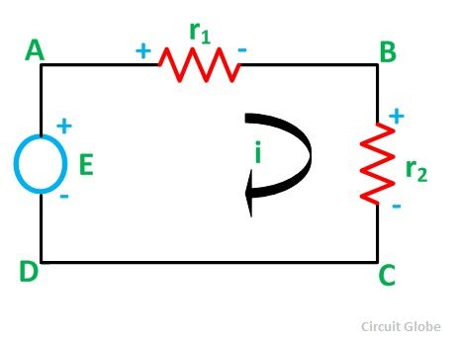Let us consider a voltage source E with the resistance r₁ and r₂ connected in series across it.
As we know
I = V/R or we can say I = E/R
Therefore, the current (i) in the loop ABCD will be
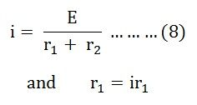
By putting the value of i from equation (8) in the equation (9) the voltage across the resistance r₁ and r₂ respectively is given by the equation shown below as
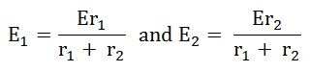
Thus, the voltage across a resistor in a series circuit is equal to the value of that resistor times the total impressed voltage across the series elements divided by the total resistance of the series elements.
Q23. State current division rule.
Ans.. The current in any branch is equal to the ratio of the opposite parallel branch resistances to the total resistance value, multiplied by the total current in the circuit.

Current Division Rule:
A parallel circuit acts as a current divider as the current divides in all the branches in a parallel circuit and the voltage remains the same across them. The current division is explained with the help of the circuit shown below
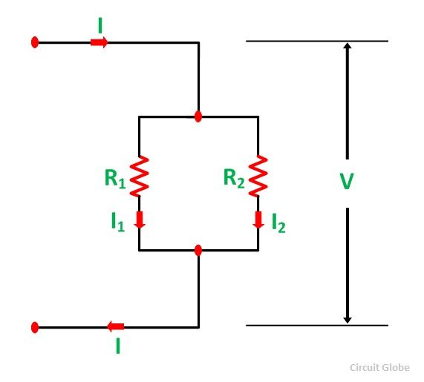The current I has been divided into I₁ and I₂ in two parallel branches with the resistance R₁ and R₂ and V is the voltage drop across the resistance R₁ and R₂.
As we know
V = IR ……..(1)
Then the equation of the current is written as
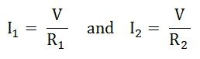
Let the total resistance of the circuit be R and is given by the equation shown below
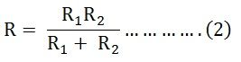
Equation (1) can also be written as
I = V/R ……….(3)
Now, putting the value of R from the equation (2) in the equation (3) we will get
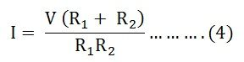
But
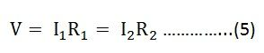
Putting the value of V = I₁R₁ from the equation (5) in the equation (4), we finally get the equation as
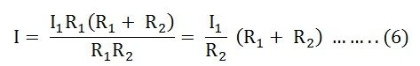
And now considering V = I₂R₂ the equation will be
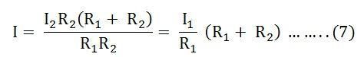
Thus, from the equation (6) and (7) the value of the current I₁ and I₂ respectively is given by the equation below
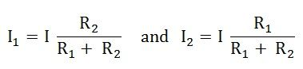
Thus, in the current division rule, it is said that the current in any of the parallel branches is equal to the ratio of opposite branch resistance to the total resistance, multiplied by the total current.
------------------------------------------------------------------------------------------------------------------------------------------Q24. Define mesh.
Ans. A mesh is defined as a loop which does not contain any other loops within it.
Mesh analysis (or the mesh current method) is a method that is used to solve planar circuits for the currents (and indirectly the voltages) at any place in the electrical circuit. Planar circuits are circuits that can be drawn on a plane surface with no wires crossing each other. A more general technique, called loop analysis (with the corresponding network variables called loop currents) can be applied to any circuit, planar or not. Mesh analysis and loop analysis both make use of Kirchhoff’s voltage law to arrive at a set of equations guaranteed to be solvable if the circuit has a solution. Mesh analysis is usually easier to use when the circuit is planar, compared to loop analysis.
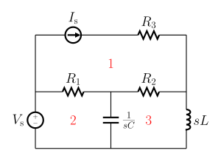
Figure 1: Essential meshes of the planar circuit labeled 1, 2, and 3. R₁, R₂, R₃, 1/sc, and Ls represent the impedance of the resistors, capacitor, and inductor values in the s-domain. V_{s} and i_{s} are the values of the voltage source and current source, respectively.

Q25. Define super mesh.
Ans. The loop existing around a current source which is common to the two loops is called super mesh.

SUPERMESH Circuit Analysis | Step by Step with Solved Example

Supermesh or Supermesh Analysis is a better technique instead of using Mesh analysis to analysis such a complex electric circuit or network, where two meshes have a current source as a common element. This is the same where we use Supernode circuit analysis instead of Node or Nodal circuit analysis to simplify such a network where the assign supernode, fully enclosing the voltage source inside the supernode and reducing the number of none reference nodes by one (1) for each voltage source.
In supermesh circuit analysis technique, the current source is in the inner area of the supermesh. Therefore, we are able to reduce the number of meshes by one (1) for each current source which is present in the circuit.
The single mesh can be ignored, if current source (in that mesh) lies on the perimeter of the circuit. Alternatively, KVL (Kirchhoff’s Voltage Law) is applied only to those meshes or supermeshes in the renewed circuit.
By the way, it is difficult to understand by Preamble, so we will first solve a simple circuit by supermesh circuit analyses, and then, we will summarize the whole supermesh analysis (step by step).

Solved Example of Supermesh Analysis
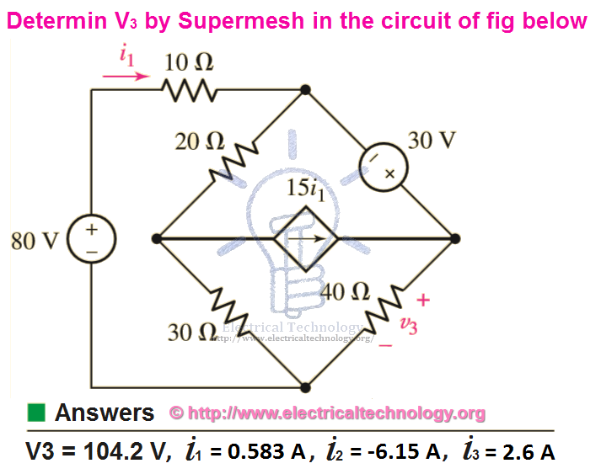Example:
Use Mesh analysis to find V₃ and Current i₁, i₂ and i₃ in the following fig?

Solution:
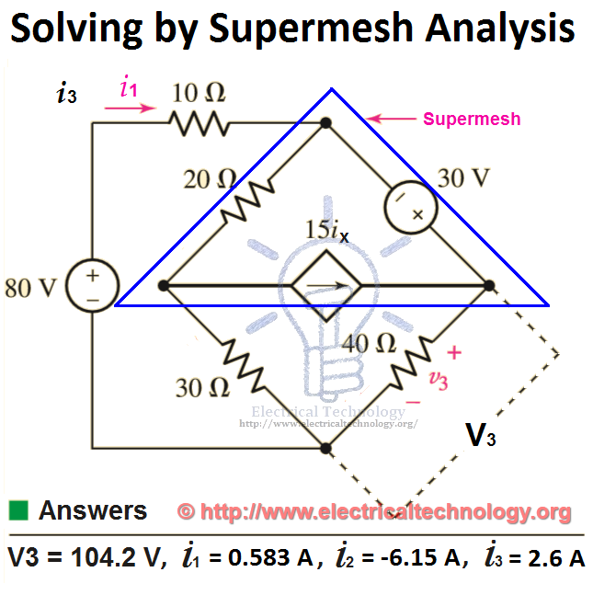
Supermesh Circuit Analysis. Step by step with solved example
Using KVA on Mesh 1.
80 = 10i₁ + 20(i₁–i₂) + 30 (i₁–i₃)
Simplifying
80 = 10i₁ + 20i₁ -20i₂ + 30i₁-30i₃
80 = 60i₁ – 20i₂ – 30i₃ ….. → Eq 1.
Now apply KVL on Supermesh (which is integration of mesh 2 and mesh 3, but we have reduced it by single mesh which is known as supermesh)
30 = 40i₃ + 30(i₃–i₁) +20(i₂–i₁)
30 = 40i₃ + 30i₃ – 30i₁ +20i₂-20i₁
30 = 70i₃ – 50i₁ +20i₂ ….. → Eq 2.
But here, we have three (3) variables i.e. i1, 12 and i3. And there are two equations. So we must need three equations as well.
The independent current source (in the supermesh) is related to the assumed mesh currents, i.e.

15ix= i₃–i₂
I3=15ix+i₂ ….. → Eq 3.
Solving equations 1, 2 and 3 by Cramer’s rule or Cramer’r rule calculator, Elimination, Gauss Elimination or computer aided program such as MATLAB, we find
i₁ =0.583A
i₂ =-6.15A
i₃ = 2.6 A
Also, we can find the value of v₃,
V₃ = i₃ x R₃
Putting the values,
V₃ =2.6Ax40Ω
V₃ = 104 V.
Q26. Explain the purpose of star delta transformation.
Ans.The transformation of a given set of resistances in star to delta or vice versa proves extremely useful in circuit analysis and the apparent complexity of a given circuit can sometime by very much reduced.
Star Delta Transformation
Star Delta Transformations allow us to convert impedances connected together in a 3-phase configuration from one type of connection to another.
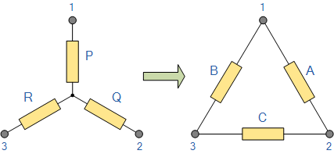
We can now solve simple series, parallel or bridge type resistive networks using Kirchhoff´s Circuit Laws, mesh current analysis or nodal voltage analysis techniques but in a balanced 3-phase circuit we can use different mathematical techniques to simplify the analysis of the circuit and thereby reduce the amount of math’s involved which in itself is a good thing.
Standard 3-phase circuits or networks take on two major forms with names that represent the way in which the resistances are connected, a Star connected network which has the symbol of the letter, Υ (wye) and a Delta connected network which has the symbol of a triangle, Δ (delta).
If a 3-phase, 3-wire supply or even a 3-phase load is connected in one type of configuration, it can be easily transformed or changed it into an equivalent configuration of the other type by using either the Star Delta Transformation or Delta Star Transformation process.

SINGLE PHASE AC CIRCUITS:

Q1. Write the equation for Instantaneous active power, Average power, Apparent power
Ans.. Instantaneous active power: P(t) = VmIm[Cos(2ωt+θ)+Cos θ] / 2
Average power: Pav = VmIm Cos θ / 2
Apparent power, Papp = Veff Ieff
In AC circuit analysis, what is this power that we talk about. The main problem is that the AC voltage and current varies sinusoidally with time. Moreover the presence of circuit reactive elements like Inductor and capacitor shift the current wave with respect to voltage wave (angle of phase difference).
Power is rate at which energy is consumed by load or produced by generator. Whether it is DC circuit or AC circuit, the value of instantaneous power is obtained by multiplying instantaneous voltage with instantaneous current. If at any instant of time t the voltage and current values are represented by sine functions as
v = V_{m} sin ωt
i = I_{m} sin (ωt-φ)
V_{m} and I_{m} are the maximum values of the sinusoidal voltage and current. Here ω=2 π f
f is the frequency and ω is the angular frequency of rotating voltage or current phasors. It should be clear that for a power system f is usually 50 or 60 Hz
φ is the phase difference between the voltage and current.
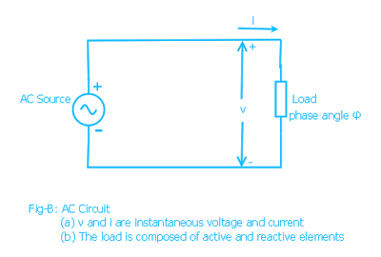
As we said the instantaneous power is the product of instantaneous voltage and current, if we name instantaneous power as p then
p = v.i = V_{m} sin ωt . I_{m} sin (ωt-φ)
or p = V_{m} I_{m} sin ωt sin (ωt-φ)
Applying trigonometric formula 2.sin A.sin B = cos(A-B) - cos (A+B) we get
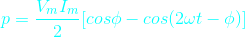
It can be written as
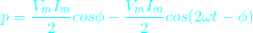
This is the equation of instantaneous power
In the Fig-C is drawn all the three waves corresponding to v, i and p. Graphically also we can get the value of instantaneous power (p) at any instant of time t by simply multiplying the value of current i and voltage v at that particular instant t. (You can verify that in the diagram p is negative when either v or i is negative otherwise p is positive. See the points where p is zero). In the graph we have shown horizontal axis as angle φ instead of time t for easy visualization. It should be clear that both way it is correct.
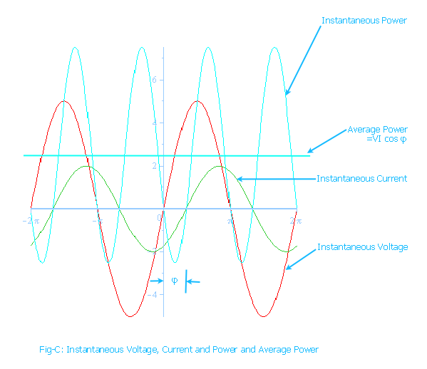

Clearly the instantaneous power p is composed of two terms. The first term is constant because for a given load the phase angle φ is fixed. It does not change unless the load is changed. The second term is varying with time sinusoidally due to the presence of the term cos (2ωt-φ). Look that the instantaneous power frequency is twice the frequency of voltage or current.
So the instantaneous power in a single phase circuit varies sinusoidally.
The instantaneous power, p = constant term + sinusoidal oscillating term.
In one complete period the average of oscillating term is zero.

Then what is the average power within a given time, say one Time Period of the wave?
It is the constant term.
Here is another way to think about the average power.
Just observe that the instantaneous power is negative for a small time. For any time interval you just find the total +ve area A+ (above horizontal-axis (blue line) and below p curve) and total -ve area A- (below horizontal axis and above p curve). The net area is obtained by subtracting A- from A+. By dividing this net area ( by the time interval T_{i} we get the average power(P). You can do this using calculus. What you will ultimately get is only the first term in the above formula for instantaneous power p.
In still another way it is easier to realize that the formula for instantaneous power p has a constant term (V_{m}.I_{m} / 2) cos φ and the other sinusoidal term (V_{m}.I_{m} / 2) cos (2 wt - φ). Actually p is the oscillating power which oscillates about the average constant term (V_{m}.I_{m} / 2) cos φ .
So the average power is
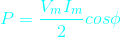

The above formula can be written as
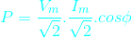

Or,

here,
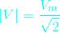
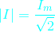
V and I are the phasor representation of RMS values* of voltage and current sinusoids. The symbols |V| and |I| are the magnitudes of phasors V and I. (See at the buttom for definition of RMS value).
This above formula is your favorite formula for useful power that we are most concerned about. This average power formula is used to find the power consumed by the load. The monthly electric energy bill at home is based on this power. The engineers and technicians in power or electrical industry simply use the term power instead of average power. So whenever we simply call power it means average power.
Of course the instantaneous power is oscillating in nature. As we already said it does not oscillates about the horizontal-axis rather about the average power P (cyan color horizontal line).

P will be zero when cos φ =0 or φ = 90 degree, that is when the phase angle between voltage and current waves is 90 degrees. It is only when the load is pure inductive or capacitive. In this case the second term only remains in the instantaneous power formula.
From the above figure for some time the power becomes negative that means the load supply energy to source for this period. This is due to the presence of reactive element in load.
The above formula for instantaneous power can be written in another form. This form actually is an attempt to distinguish the oscillating reactive power from the instantaneous power formula. Rearranging the terms in equation for instantaneous power above we get
p = |V| | I | cos φ (1-cow2ωt) - |V| | I | sin φ sin2ωt
In this equation the first term |V| | I | cos φ (1-cow2ωt) is oscillatory whose average value is |V| | I | cos φ. We already talked about this average power.
The second term |V| | I | sin φ sin2ωt which is also oscillatory but with zero average value. The maximum value of this term is |V| | I | sin φ. This is the so called Reactive power. So Reactive power is the maximum value of a oscillatory power that is repeatedly drawn from the source and again returned to the source within each cycle. So the average of this reactive power is zero.
The average power P is called as Real Power. It is also sometimes called active power.
Real power = P = |V| | I | cos φ
It is usually written as P = VI cos φ. But it should be remembered that V and I are the rms values of voltage and current. For example when we say single phase 220 volt AC it means the rms value of voltage is 220 volts ( it is not maximum value of voltage sinusoid)
Reactive power = Q = |V| | I | sin φ
Real power is measured in Watt and the reactive power is measured in VAR (VoltAmpereReactive). In power sector these units are too small so real power is measured in Megawatt (MW) and reactive power in Megavar (MVAR). The letter R at the end denotes reactive power.

Q2. Write down few applications of RL, RC and RLC circuits.
Ans. The few applications of RL,RC and RLC circuits are given below.
Coupling circuits,
Phase-shift circuits,
Filters,
Resonant circuits,
AC bridge circuits, and
Transformers.
------------------------------------------------------------------------------------------------------------------------------------------
Q3. What is steady state?
Ans. A circuit consisting of constant sources is said to be in steady state if the voltages and currents do not change with time.
In systems theory, a system or a process is in a steady state if the variables (called state variables) which define the behavior of the system or the process are unchanging in time. In continuous time, this means that for those properties p of the system, the partial derivative with respect to time is zero and remains so:
∂P/∂t=0 for all t.
In discrete time, it means that the first difference of each property is zero and remains so:
P_{t}-P_{t-1}=0 for all t.
The concept of a steady state has relevance in many fields, in particular thermodynamics, economics, and engineering. If a system is in a steady state, then the recently observed behavior of the system will continue into the future. In stochastic systems, the probabilities that various states will be repeated will remain constant. See for example Linear difference equation#Conversion to homogeneous form for the derivation of the steady state.
In many systems, a steady state is not achieved until some time after the system is started or initiated. This initial situation is often identified as a transient state, start-up or warm-up period.^{[1]} For example, while the flow of fluid through a tube or electricity through a network could be in a steady state because there is a constant flow of fluid or electricity. a tank being drained or filled with fluid is a system in transient state, because its volume of fluid changes with time.

Q4. Define Power factor.
Ans. It is defined as the ratio of average power to the apparent power, whereas the apparent power is the product of the effective values of the current and the voltage.
Power factor = Pav / (Veff* Ieff)
It is also defined as the factor with which the volt amperes are to be multiplied to get true power in the circuit.
The Power Factor is an indicator of the quality of design and management of an electrical installation. It relies on two very basic notions: active and apparent power.
The active power P (kW) is the real power transmitted to loads such as motors, lamps, heaters, and computers. The electrical active power is transformed into mechanical power, heat or light.
In a circuit where the applied r.m.s. voltage is V_{rms} and the circulating r.m.s. current is I_{rms}, the apparent power S (kVA) is the product: V_{rms} x I_{rms}.
The apparent power is the basis for electrical equipment rating.
The Power Factor λ is the ratio of the active power P (kW) to the apparent power S (kVA):
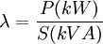
The load may be a single power-consuming item, or a number of items (for example an entire installation).
The value of power factor will range from 0 to 1.

Q5. Define form factor.
Ans. It is the ratio between rms voltage and average value of a periodic wave form. Form factor of sine wave is 1.11
Definition: The ratio of the root mean square value to the average value of an alternating quantity (current or voltage) is called Form Factor.
The average of all the instantaneous values of current and voltage over one complete cycle is known as the average value of the alternating quantities.
Mathematically, the it is expressed as
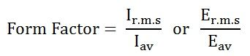
I_{r.m.s} and E_{r.m.s} are the root mean square value of the current and the voltage respectively, and I_{av} and E_{av} are the average value of the alternating current and the voltage respectively.
For the current varying sinusoidally, the Form Factor is given as
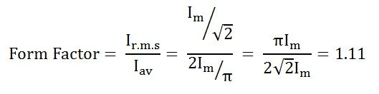
The value of Form Factor is 1.11
There is a relation between the peak value, the average value, and the root mean square (R.M.S) value of an alternating quantity. Therefore, to express the relationship between all these three quantities, the two factors are used, namely as Peak Factor and Form Factor.
Q6. Define peak factor.
Ans. It is the ratio of peak value and the rms value of a periodic waveform. It is also called as crest factor. Peak factor of sine wave is 1.414
Definition: Peak Factor is defined as the ratio of maximum value to the R.M.S value of an alternating quantity.
The alternating quantities can be voltage or current. The maximum value is the peak value or the crest value or the amplitude of the voltage or current and the root mean square value is the amount of heat produced by the alternating current will be same when the direct supply of current is passed through the same resistance in the same given time.
Mathematically it is expressed as
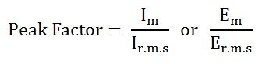
Where,
I_{m} and E_{m} are the maximum value of the current and the voltage respectively, and I_{r.m.s} and E_{r.m.s} are the root mean square value of the alternating current and the voltage respectively.
For the current varying sinusoidally, the peak factor is given as
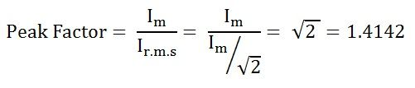
The value of Peak Factor is 1.4142.
---------------------------------------------------------------------------------------------------------------------

Q7. In pure inductive circuit, relation between voltage and current are…
Ans.: Current lags voltage by 90º.
AC Inductance and Inductive Reactance
Inductors and chokes are basically coils or loops of wire that are either wound around a hollow tube former (air cored) or wound around some ferromagnetic material (iron cored) to increase their inductive value called inductance.
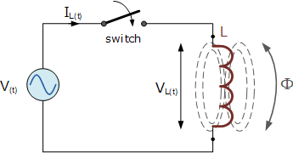
Inductors store their energy in the form of a magnetic field that is created when a voltage is applied across the terminals of an inductor. The growth of the current flowing through the inductor is not instant but is determined by the inductors own self-induced or back emf value. Then for an inductor coil, this back emf voltage V_{L} is proportional to the rate of change of the current flowing through it.
This current will continue to rise until it reaches its maximum steady state condition which is around five time constants when this self-induced back emf has decayed to zero. At this point a steady state current is flowing through the coil, no more back emf is induced to oppose the current flow and therefore, the coil acts more like a short circuit allowing maximum current to flow through it.
However, in an alternating current circuit which contains an AC Inductance, the flow of current through an inductor behaves very differently to that of a steady state DC voltage. Now in an AC circuit, the opposition to the current flowing through the coils windings not only depends upon the inductance of the coil but also the frequency of the applied voltage waveform as it varies from its positive to negative values.
The actual opposition to the current flowing through a coil in an AC circuit is determined by the AC Resistance of the coil with this AC resistance being represented by a complex number. But to distinguish a DC resistance value from an AC resistance value, which is also known as Impedance, the term Reactance is used.
Like resistance, reactance is measured in Ohm’s but is given the symbol “X” to distinguish it from a purely resistive “R” value and as the component in question is an inductor, the reactance of an inductor is called Inductive Reactance, ( X_{L} ) and is measured in Ohms. Its value can be found from the formula.

Inductive Reactance

Where: X_{L} is the Inductive Reactance in Ohms, ƒ is the frequency in Hertz and L is the inductance of the coil in Henries.
We can also define inductive reactance in radians, where Omega, ω equals 2πƒ.

So whenever a sinusoidal voltage is applied to an inductive coil, the back emf opposes the rise and fall of the current flowing through the coil and in a purely inductive coil which has zero resistance or losses, this impedance (which can be a complex number) is equal to its inductive reactance. Also reactance is represented by a vector as it has both a magnitude and a direction (angle). Consider the circuit below.

AC Inductance with a Sinusoidal Supply

This simple circuit above consists of a pure inductance of L Henries ( H ), connected across a sinusoidal voltage given by the expression: V(t) = V_{max} sin ωt. When the switch is closed this sinusoidal voltage will cause a current to flow and rise from zero to its maximum value. This rise or change in the current will induce a magnetic field within the coil which in turn will oppose or restrict this change in the current.
But before the current has had time to reach its maximum value as it would in a DC circuit, the voltage changes polarity causing the current to change direction. This change in the other direction once again being delayed by the self-induced back emf in the coil, and in a circuit containing a pure inductance only, the current is delayed by 90º.
The applied voltage reaches its maximum positive value a quarter ( 1/4ƒ ) of a cycle earlier than the current reaches its maximum positive value, in other words, a voltage applied to a purely inductive circuit “LEADS” the current by a quarter of a cycle or 90º as shown below.

Sinusoidal Waveforms for AC Inductance
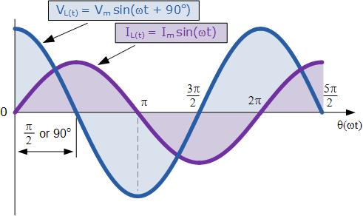

This effect can also be represented by a phasor diagram were in a purely inductive circuit the voltage “LEADS” the current by 90º. But by using the voltage as our reference, we can also say that the current “LAGS” the voltage by one quarter of a cycle or 90º as shown in the vector diagram below.

Phasor Diagram for AC Inductance
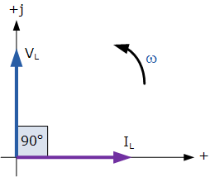

So for a pure loss less inductor, V_{L} “leads” I_{L} by 90º, or we can say that I_{L}“lags” V_{L} by 90º.
Q8. What is alternating voltage or current?
Ans. It is defined as the voltage (current) that fluctuates with time periodically with change in polarity and direction.

Alternating Current vs. Direct Current
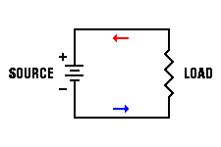
The figure to the right shows the schematic diagram of a very basic DC circuit. It consists of nothing more than a source (a producer of electrical energy) and a load (whatever is to be powered by that electrical energy). The source can be any electrical source: a chemical battery, an electronic power supply, a mechanical generator, or any other possible continuous source of electrical energy. For simplicity, we represent the source in this figure as a battery.
At the same time, the load can be any electrical load: a light bulb, electronic clock or watch, electronic instrument, or anything else that must be driven by a continuous source of electricity. The figure here represents the load as a simple resistor.
Regardless of the specific source and load in this circuit, electrons leave the negative terminal of the source, travel through the circuit in the direction shown by the arrows, and eventually return to the positive terminal of the source. This action continues for as long as a complete electrical circuit exists.
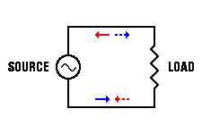
Now consider the same circuit with a single change, as shown in the second figure to the right. This time, the energy source is constantly changing. It begins by building up a voltage which is positive on top and negative on the bottom, and therefore pushes electrons through the circuit in the direction shown by the solid arrows. However, then the source voltage starts to fall off, and eventually reverse polarity. Now current will still flow through the circuit, but this time in the direction shown by the dotted arrows. This cycle repeats itself endlessly, and as a result the current through the circuit reverses direction repeatedly. This is known as an alternating current.
This kind of reversal makes no difference to some kinds of loads. For example, the light bulbs in your home don't care which way current flows through them. When you close the circuit by turning on the light switch, the light turns on without regard for the direction of current flow.
Properties of Alternating Current
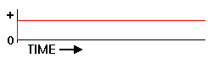
A DC power source, such as a battery, outputs a constant voltage over time, as depicted in the top figure to the right. Of course, once the chemicals in the battery have completed their reaction, the battery will be exhausted and cannot develop any output voltage. But until that happens, the output voltage will remain essentially constant. The same is true for any other source of DC electricity: the output voltage remains constant over time.
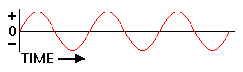
By contrast, an AC source of electrical power changes constantly in amplitude and regularly changes polarity, as shown in the second figure to the right. The changes are smooth and regular, endlessly repeating in a succession of identical cycles, and form a sine wave as depicted here.
Because the changes are so regular, alternating voltage and current have a number of properties associated with any such waveform. These basic properties include the following list:

- Frequency. One of the most important properties of any regular waveform identifies the number of complete cycles it goes through in a fixed period of time. For standard measurements, the period of time is one second, so the frequency of the wave is commonly measured in cycles per second (cycles/sec) and, in normal usage, is expressed in units of Hertz (Hz). It is represented in mathematical equations by the letter 'f.' In North America (primarily the US and Canada), the AC power system operates at a frequency of 60 Hz. In Europe, including the UK, Ireland, and Scotland, the power system operates at a frequency of 50 Hz.
- Period. Sometimes we need to know the amount of time required to complete one cycle of the waveform, rather than the number of cycles per second of time. This is logically the reciprocal of frequency. Thus, period is the time duration of one cycle of the waveform, and is measured in seconds/cycle. AC power at 50 Hz will have a period of 1/50 = 0.02 seconds/cycle. A 60 Hz power system has a period of 1/60 = 0.016667 seconds/cycle. These are often expressed as 20 ms/cycle or 16.6667 ms/cycle, where 1 ms is 1 millisecond = 0.001 second (1/1000 of a second).
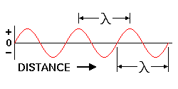
- Wavelength. Because an AC wave moves physically as well as changing in time, sometimes we need to know how far it moves in one cycle of the wave, rather than how long that cycle takes to complete. This of course depends on how fast the wave is moving as well. Electrical signals travel through their wires at nearly the speed of light, which is very nearly 3 × 10⁸ meters/second, and is represented mathematically by the letter 'c.' Since we already know the frequency of the wave in Hz, or cycles/second, we can perform the division of c/f to obtain a result in units of meters/cycle, which is what we want. The Greek letter (lambda) is used to represent wavelength in mathematical expressions. Thus, = c/f. As shown in the figure to the right, wavelength can be measured from any part of one cycle to the equivalent point in the next cycle. Wavelength is very similar to period as discussed above, except that wavelength is measured in distance per cycle where period is measured in time per cycle.
- Amplitude. Another thing we have to know is just how positive or negative the voltage is, with respect to some selected neutral reference. With DC, this is easy; the voltage is constant at some measurable value. But AC is constantly changing, and yet it still powers a load. Mathematically, the amplitude of a sine wave is the value of that sine wave at its peak. This is the maximum value, positive or negative, that it can attain. However, when we speak of an AC power system, it is more useful to refer to the effective voltage or current. This is the rating that would cause the same amount of work to be done (the same effect) as the same value of DC voltage or current would cause. We won't cover the mathematical derivations here; for the present, we'll simply note that for a sine wave, the effective voltage of the AC power system is 0.707 times the peak voltage. Thus, when we say that the AC line voltage in the US is 120 volts, we are referring to the voltage amplitude, but we are describing the effective voltage, not the peak voltage of nearly 170 volts. The effective voltage is also known as the rms voltage.
When we deal with AC power, the most important of these properties are frequency and amplitude, since some types of electrically powered equipment must be designed to match the frequency and voltage of the power lines. Period is sometimes a consideration, as we'll discover when we explore electronic power supplies. Wavelength is not generally important in this context, but becomes much more important when we start dealing with signals at considerably higher frequencies.
Q9. What is a radian?
Ans. A radian is defined as the angular distance measured along the circumference of a circle which is equal to the radius of the circle.
1 radian = 57.3 degrees.
The radian is the standard unit of angular measure, used in many areas of mathematics. The length of an arc of a unit circle is numerically equal to the measurement in radians of the angle that it subtends; one radian is just under 57.3 degrees . The unit was formerly an SI supplementary unit, but this category was abolished in 1995 and the radian is now considered an SI derived unit.^{[1]}
Separately, the SI unit of solid angle measurement is the steradian.
The radian is represented by the symbol rad. An alternative symbol is ^{c}, the superscript letter c, for "circular measure", or the letter r, but both of those symbols are infrequently used as it can be easily mistaken for a degree symbol (°) or a radius (r). So for example, a value of 1.2 radians could be written as 1.2 rad, 1.2 r, 1.2^{rad}, or 1.2^{c}.
Radian
Unit system | SI derived unit
Unit of | Angle
Symbol | or rad^{c}
Unit conversions
1 rad in ... | ... is equal to ...
turns | 1/ 2π turn
degrees | ≈ 57.296°
gons | ≈ 63.662^{g}

Q10. Define average value.
Ans. The average value of the sine wave is the total area under the half cycle curve divided by the distance of the curve.
Average value of the sine wave is given as 0.637 Vp

Average Value
Definition: The average of all the instantaneous values of an alternating voltage and currents over one complete cycle is called Average Value.
If we consider symmetrical waves like sinusoidal current or voltage waveform, the positive half cycle will be exactly equal to negative half cycle. Therefore, the average value over a complete cycle will be zero. The work is done by both, positive and negative cycle and hence the average value is determined without considering the signs.
So the only positive half cycle is considered to determine the average value of alternating quantities of sinusoidal waves. Let us take an example to understand it.
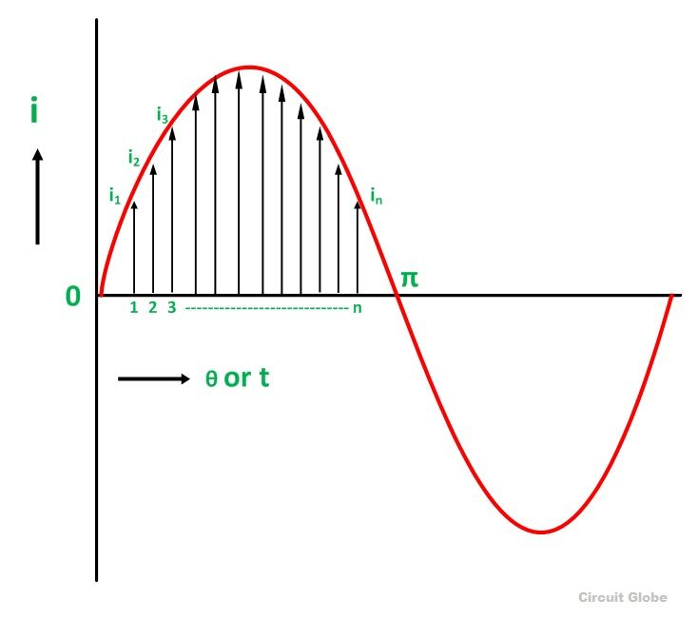Divide the positive half cycle into (n) number of equal parts as shown in the above figure
Let i₁, i₂, i₃…….. i_{n} be the mid ordinates
The Average value of current I_{av} = mean of the mid ordinates

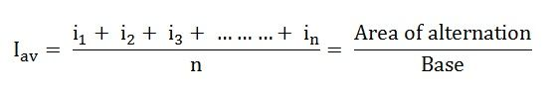

Q11. Define root mean square value.
Ans. The root mean square (rms) value of a sine wave is the measure of the heating effect of the wave. It is also called as effective value.
RMS value of a sine wave is given as 0.707Vp.
Definition: That steady current which, when flows through a resistor of known resistance for a given period of time than as a result the same quantity of heat is produced by the alternating current when flows through the same resistor for the same period of time is called R.M.S or effective value of the alternating current.
In other words, the R.M.S value is defined as the square root of means of squares of instantaneous values.
Let I be the alternating current flowing through a resistor R for time t seconds, which produces the same amount of heat as produced by the direct current (I_{eff}). The base of one alteration is divided into n equal parts so that each interval is of t/n seconds as shown in the figure below.
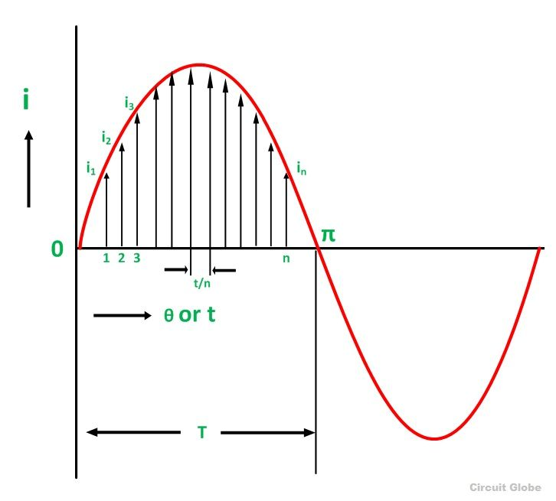Let i₁, i₂, i₃,………..in be the mid ordinates
Then the heat produced in
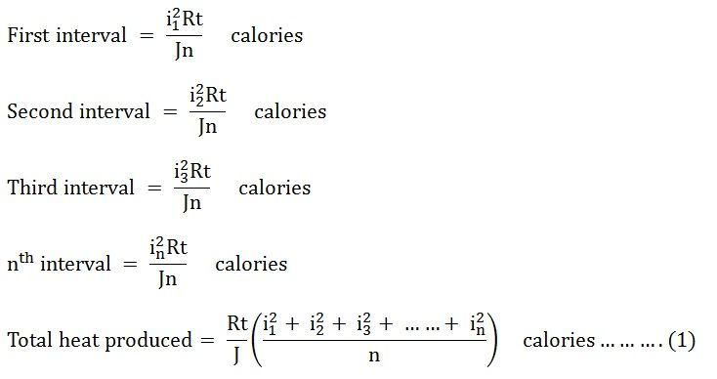Since Ieff is considered as the effective value of this current, then the total heat produced by this current will be
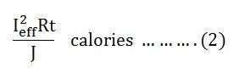
Now, equating equation (1) and (2) we will get
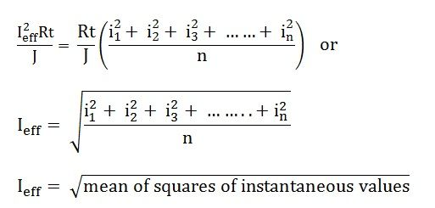
I_{eff} = square root of mean of squares of instantaneous values = R.M.S value
Root Mean Square is the actual value of an alternating quantity which tells us an energy transfer capability of an AC source. The ammeter records the RMS value of alternating current and voltmeter record’s the root mean square (R.M.S) value of alternating voltage. The domestic single phase AC supply is 230 V, 50 hertz, where 230 V is the R.M.S value of alternating voltage.
------------------------------------------------------------------------------------------------------------------------------------------
Q12. Define phase.
Ans. The phase of a sine wave is an angular measurement that specifies the position of the sine wave relation to a reference.
In electronic signaling, phase is a definition of the position of a point in time (instant) on a waveform cycle. A complete cycle is defined as 360 degrees of phase as shown in Illustration A below. Phase can also be an expression of relative displacement between or among waves having the same frequency .
Phase difference , also called phase angle , in degrees is conventionally defined as a number greater than -180, and less than or equal to +180. Leading phase refers to a wave that occurs "ahead" of another wave of the same frequency. Lagging phase refers to a wave that occurs "behind" another wave of the same frequency. When two signals differ in phase by -90 or +90 degrees, they are said to be in phase quadrature . When two waves differ in phase by 180 degrees (-180 is technically the same as +180), the waves are said to be in phase opposition . Illustration B shows two waves that are in phase quadrature. The wave depicted by the dashed line leads the wave represented by the solid line by 90 degrees.
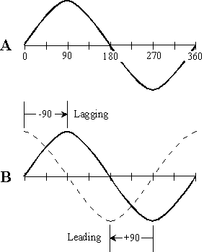
Phase is sometimes expressed in radians rather than in degrees. One radian of phase corresponds to approximately 57.3 degrees. Engineers and technicians generally use degrees; physicists more often use radians.
The time interval for one degree of phase is inversely proportional to the frequency. If the frequency of a signal (in hertz ) is given by f , then the time t _{deg} (in seconds) corresponding to one degree of phase is:
t _{deg} = 1 / (360 f )
The time t _{rad} (in seconds) corresponding to one radian of phase is approximately:
t _{rad} = 1 / (6.28 f )

Q13. Define apparent power.
Ans. The apparent power is defined as the product of magnitude of voltage and magnitude of current.
Apparent power is a measure of alternating current (AC) power that is computed by multiplying the root-mean-square (rms) current by the root-mean-square voltage. In a direct current (DC) circuit, or in an AC circuit whose impedance is a pure resistance, the voltage and current are in phase, and the following formula holds:
P = E_{rms}I_{rms}
where P is the power in watts, E_{rms} is the root-mean-square (rms) voltage in volts, and I_{rms} is the rms current in amperes. But in an AC circuit whose impedance consists of reactance as well as resistance, the voltage and current are not in phase. This complicates the determination of power.
In an AC circuit, the product of the rms voltage and the rms current is called apparent power. When the impedance is a pure resistance, the apparent power is the same as the true power. But when reactance exists, the apparent power is greater than the true power. The vector difference between the apparent and true power is called reactive power.
If P_{a} represents the apparent power in a complex AC circuit, P_{t} represents the true power, and P_{r} represents the reactive power, then the following equation holds:
P_{a}² = P_{t}² + P_{r}²

Q14. What is power factor and reactive power?
Ans. The power factor is defined as the cosine of the phase difference between voltage and current.
The reactive power of the circuit is defined as the sine of the phase angle.

Power Factor:
For a DC circuit the power is P=VI, and this relationship also holds for the instantaneous power in an AC circuit. However, the average power in an AC circuit expressed in terms of the rms voltage and current is
where is the phase angle between the voltage and current. The additional term is called the power factor
REACTIVE POWER: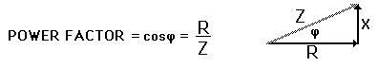
From the phasor diagram for AC impedance, it can be seen that the power factor is R/Z. For a purely resistive AC circuit, R=Z and the power factor = 1.
A sinusoidally alternating voltage applied to a purely resistive load results in an alternating current that is fully in phase with the voltage. However, in many applications it is common for there to be a reactive component to the system, that is, the system possesses capacitance, inductance, or both. These electrical properties cause the current to change phase with respect to the voltage: capacitance tending the current to lead the voltage in phase, and inductance to lag it.
For sinusoid currents and voltages at the same frequency, reactive power in vars is the product of the RMS voltage and current, or the apparent power, multiplied by the sine of (phase angle between the voltage and the current). The reactive power (measured in units of volt-amperes reactive or var) is given by:
Q=V_{rms} I_{rms} sin(ø)
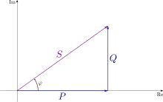
The apparent power S (measured in units of volt-amperes) is the [vector sum] of the reactive power Q (in volt-amperes reactive) and the real power P (in watts).

where is the phase angle between the current and voltage. Q refers to the maximum value of the instantaneous power absorbed by the reactive component of the load.
Only effective power, the actual power delivered to or consumed by the load, is expressed in watts. The imaginary part is properly expressed in volt-amperes reactive.

Q15. What is impedance?
Ans. Impedance is a complex quantity having real and imaginary parts, where real part is resistance and imaginary part is reactance of the circuit. Unit is ohm.
Impedance, denoted Z, is an expression of the opposition that an electronic component, circuit, or system offers to alternating and/or direct electric current.Impedance is a vector (two-dimensional)quantity consisting of two independent scalar (one-dimensional) phenomena: resistance and reactance.
Resistance, denoted R, is a measure of the extent to which a substance opposes the movement of electrons among its atoms.The more easily the atoms give up and/or accept electrons, the lower the resistance, which is expressed in positive real number ohms.Resistance is observed with alternating current (AC) and also with direct current (DC). Examples of materials with low resistance, known as electrical conductors, include copper, silver, and gold.High-resistance substances are called insulators or dielectrics, and include materials such as polyethylene, mica, and glass.A material with an intermediate levels of resistance is classified as a semiconductor. Examples are silicon, germanium, and gallium arsenide.
Reactance, denoted X, is an expression of the extent to which an electronic component, circuit, or system stores and releases energy as the current and voltage fluctuate with each AC cycle.Reactance is expressed in imaginary number ohms.It is observed for AC, but not for DC.When AC passes through a component that contains reactance, energy might be stored and released in the form of a magnetic field, in which case the reactance is inductive (denoted +jX_{L}); or energy might be stored and released in the form of an electric field, in which case the reactance is capacitive (denoted -jX_{C}). Reactance is conventionally multiplied by the positive square root of -1, which is the unit imaginary number called the j operator, to express Z as a complex number of the form R + jX_{L} (when the net reactance is inductive) or R - jX_{C} (when the net reactance is capacitive).
The illustration shows a coordinate plane modified to denote complex-number impedances.Resistance appears on the horizontal axis, moving toward the right.(The left-hand half of this coordinate plane is not normally used because negative resistances are not encountered in common practice.)Inductive reactance appears on the positive imaginary axis, moving upward.Capacitive reactance is depicted on the negative imaginary axis, moving downward.As an example, a complex impedance consisting of 4 ohms of resistance and +j5 ohms of inductive reactance is denoted as a vector from the origin to the point on the plane corresponding to 4 + j5.
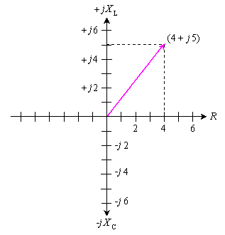
In series circuits, resistances and reactances add together independently. Suppose a resistance of 100.00 ohms is connected in a series circuit with an inductance of 10.000 ?H.At 4.0000 MHz, the complex impedance is:
Z_{RL} = R + jX_{L} = 100.00 + j251.33
If a capacitor of 0.0010000 ?F is put in place of the inductor, the resulting complex impedance at 4.0000 MHz is:
Z_{RC} = R - jX_{C} = 100.00 - j39.789
If all three components are connected in series, then the reactances add, yielding a complex impedance of:
Z_{RLC} = 100 + j251.33 - j39.789 = 100 + j211.5
This is the equivalent of a 100-ohm resistor in series with an inductor having +j211.5 ohms of reactance.At 4.0000 MHz, this reactance is presented by an inductance of 8.415 ?H, as determined by plugging the numbers into the formula for inductive reactance and working backwards.(See the definition of for this formula, and for the corresponding formula for capacitive reactance.)
Q16. What is admittance?
Ans. It is the reciprocal of impedance. It is denoted by Y and is measured in mho or siemens.
In electrical engineering, admittance is a measure of how easily a circuit or device will allow a current to flow. It is defined as the inverse of impedance. The SI unit of admittance is the siemens (symbol S). Oliver Heaviside coined the term admittance in December 1887.
Admittance is defined as
Y=1/Z
where
Y is the admittance, measured in siemens
Z is the impedance, measured in ohms
The synonymous unit mho, and the symbol ℧ (an upside-down uppercase omega Ω), are also in common use.
Resistance is a measure of the opposition of a circuit to the flow of a steady current, while impedance takes into account not only the resistance but also dynamic effects (known as reactance). Likewise, admittance is not only a measure of the ease with which a steady current can flow, but also the dynamic effects of the material's susceptance to polarization:
Y=G+jB
where
- Y is the admittance, measured in siemens.
- G is the conductance, measured in siemens.
- B is the susceptance, measured in siemens.
- j²=-1.

Q17. What is susceptance?
Ans. It is the imaginary part of admittance. It is denoted by B and is measured in mho or siemens.
In electrical engineering, susceptance (B) is the imaginary part of admittance. The inverse of admittance is impedance, and the real part of admittance is conductance. In SI units, susceptance is measured in siemens.
The general equation defining admittance is given by

Y=G+jB
where
Y is the admittance, measured in siemens.
G is the conductance, measured in siemens.
j is the imaginary unit, and
B is the susceptance, measured in siemens.
The admittance (Y) is the inverse of the impedance (Z)
$Y=\frac{1}{Z}=\frac{1}{R+jX}=\left(\frac{R}{R^{2}+X^{2}}\right)+j(-\frac{X}{R^{2}+X^{2}}$)
or
$$B=Im\left(Y\right)=-\frac{X}{R^{2}+X^{2}}=-X/{\left|Z\right|}^{2}$$
where
Z is the impedance, measured in ohms
R is the resistance, measured in ohms
X is the reactance, measured in ohms.
The magnitude of admittance is given by:
$$\left|\right|\left| Y\right|=\sqrt{G^{2}+B^{2}}$$

Q18. What is the relation between the voltage and current in a pure inductor? Write the impedance of the pure inductor.
Ans. The current lags inductor behing the voltage by 90 degrees in a pure inductor.
Impedance is given by Z=jωL
Inductance (L) results from the magnetic field around a current-carrying conductor; the electric current through the conductor creates a magnetic flux. Mathematically speaking, inductance is determined by how much magnetic flux φ through the circuit is created by a given current i
$L\frac{}{}L=\frac{ø}{i}$ --------------- (1)$LL$
Inductors that have ferromagnetic cores are nonlinear; the inductance changes with the current, in this more general case inductance is defined as
$L=\frac{dø}{di}$
Any wire or other conductor will generate a magnetic field when current flows through it, so every conductor has some inductance. The inductance of a circuit depends on the geometry of the current path as well as the magnetic permeability of nearby materials. An inductor is a component consisting of a wire or other conductor shaped to increase the magnetic flux through the circuit, usually in the shape of a coil or helix. Winding the wire into a coil increases the number of times the magnetic flux lines link the circuit, increasing the field and thus the inductance. The more turns, the higher the inductance. The inductance also depends on the shape of the coil, separation of the turns, and many other factors. By adding a "magnetic core" made of a ferromagnetic material like iron inside the coil, the magnetizing field from the coil will induce magnetization in the material, increasing the magnetic flux. The high permeability of a ferromagnetic core can increase the inductance of a coil by a factor of several thousand over what it would be without it.

Equation
Any change in the current through an inductor creates a changing flux, inducing a voltage across the inductor. By Faraday's law of induction, the voltage induced by any change in magnetic flux through the circuit is
$V=\frac{dø}{di}$
From (1) above
$V=\frac{d(Li)}{dt}=L*di/dt$ --------------- (2)

So inductance is also a measure of the amount of electromotive force (voltage) generated for a given rate of change of current. For example, an inductor with an inductance of 1 henry produces an EMF of 1 volt when the current through the inductor changes at the rate of 1 ampere per second. This is usually taken to be the constitutive relation (defining equation) of the inductor.

Q19 What is the relation between the voltage and current in a pure capacitor? Write the impedance of the pure capacitor.
Ans. The current leads behing the voltage by 90 degrees in a pure capacitor.
Impedance is given by Z=jωC
There is a relationship between the charge on a capacitor and the voltage across the capacitor. The relationship is simple. For most dielectric/insulating materials, charge and voltage are linearly related.
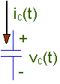
Q = C V
where:
- V is the voltage across the plates.
You will need to define a polarity for that voltage. We've defined the voltage above. You could reverse the "+" and "-".
- Q is the charge on the plate with the "+" on the voltage polarity definition.
- C is a constant - the capacitance of the capacitor.
The relationship between the charge on a capacitor and the voltage across the capacitor is linear with a constant, C, called the capacitance.
Q = C V
When V is measured in volts, and Q is measured in couloumbs, then C has the units of farads. Farads are really coulombs/volt.
The relationship, Q = C V, is the most important thing you can know about capacitance. There are other details you may need to know at times, like how the capacitance is constructed, but the way a capacitor behaves electrically is determined from this one basic relationship.
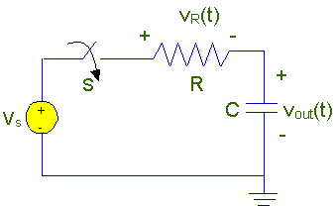
Shown to the right is a circuit that has a voltage source, V_{s}, a resistor, R, and a capacitor, C. If you want to know how this circuit works, you'll need to apply KCL and KVL to the circuit, and you'll need to know how voltage and current are related in the capacitor. We have a relationship between voltage and charge, and we need to work with it to get a voltage current relationship. We'll look at that in some detail in the next section.
The basic relationship in a capacitor is that the voltage is proportional to the charge on the "+" plate. However, we need to know how current and voltage are related. To derive that relationship you need to realize that the current flowing into the capacitor is the rate of charge flow into the capacitor. Here's the situation. We'll start with a capacitor with a time-varying voltage, v(t), defined across the capacitor, and a time-varying current, i(t), flowing into the capacitor. The current, i(t), flows into the "+" terminal taking the "+" terminal using the voltage polarity definition. Using this definition we have:
i_{c}(t) = C dv_{c}(t)/dt
This relationship is the fundamental relationship between current and voltage in a capacitor.
Q20. What is the relation between the voltage and current in a pure resistor. Write . the impedance of the pure resistor.
Ans. The current leads behind the voltage by 90 degrees in a pure resistor.
Impedance is given by Z=R

UNIT-2: LOCUS DIAGRAMS, RESONANCE

Q1. Define quality factor.
Ans. The quality factor is defined as the ratio of maximum energy stored to the energy dissipated in one period.
In physics and engineering the quality factor or Q factor is a dimensionless parameter that describes how under-damped an oscillator or resonator is,^{[1]} and characterizes a resonator's bandwidth relative to its center frequency.^{[2]} Higher Q indicates a lower rate of energy loss relative to the stored energy of the resonator; the oscillations die out more slowly. A pendulum suspended from a high-quality bearing, oscillating in air, has a high Q, while a pendulum immersed in oil has a low one. Resonators with high quality factors have low damping so that they ring or vibrate longer.
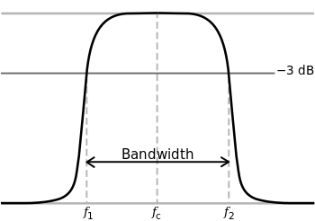
The bandwidth Δf = f₁ − f₂ of a damped oscillator is shown on a graph of energy versus frequency. The Q factor of the damped oscillator, or filter, is fc/Δf. The higher the Q, the narrower and 'sharper' the peak is.

Q2. What are half power frequencies?
Ans. In RLC circuits the frequencies at which the power is half the max /min power are called half power frequencies.
The half power point of an electronic amplifier stage is that frequency at which the output power has dropped to half of its mid-band value. That is a level of -3 dB. The half power point is a commonly used specific definition of cutoff frequency, although not the only one.
This occurs when the output voltage has dropped by 1/√2 or 0.707 of the maximum output voltage and the power has dropped by half (1/2 or 0.5) . A bandpass amplifier will have 2 half power points, whilst a low pass amplifier will have only one. A high pass amplifier stage will have only the lower half power point.
The bandwidth of an amplifier is usually defined as the difference between the lower and upper half power points. This is therefore also known as the −3 dB bandwidth.
Q3. Define resonance frequency for a series RLC circuit.
Ans. The frequency at which resonance occurs is called the resonant frequency.
fr = 1 / (2π√LC)
L à Inductance of the circuit
C à Capacitance of the circuit

Series Resonance Frequency
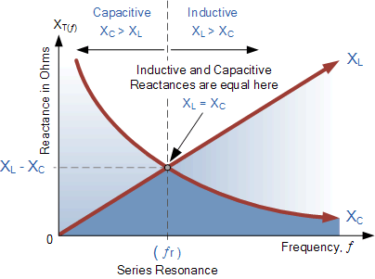

where: ƒ_{r} is in Hertz, L is in Henries and C is in Farads.
Electrical resonance occurs in an AC circuit when the two reactances which are opposite and equal cancel each other out as X_{L} = X_{C} and the point on the graph at which this happens is were the two reactance curves cross each other. In a series resonant circuit, the resonant frequency, ƒ_{r}point can be calculated as follows.
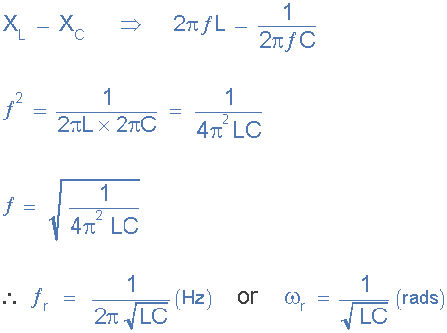

We can see then that at resonance, the two reactances cancel each other out thereby making a series LC combination act as a short circuit with the only opposition to current flow in a series resonance circuit being the resistance, R. In complex form, the resonant frequency is the frequency at which the total impedance of a series RLC circuit becomes purely “real”, that is no imaginary impedance’s exist. This is because at resonance they are cancelled out. So the total impedance of the series circuit becomes just the value of the resistance and therefore: Z = R.
Q4. Write the characteristics of series resonance.
Ans. a) At resonance impedance is mim and equal to resistance therefore current is
max.
b) Before resonant frequency the circuit behave as capacitive circuit and above
resonant frequency the circuit will behave as inductive circuit.
c) At resonance the magnitude of voltage across inductance and capacitance will
be Q times the supply voltage but they are in phase opposition.
Q5. Write the characteristics of parallel resonance.
a) At resonance admittance is min and equal to conductance therefore the current is min.
b) Below resonant frequency the circuit behave as inductive circuit and above resonant frequency the circuit behave as capacitive circuit.
c) At resonance the magnitude of current through inductance and capacitance will be q times the current supplied by the source but they are in phase opposition.

Q6. What is Band width?
Ans. It is the range of frequencies for which the current or output voltage is equal to 70.7 % of its value at the resonant frequency.
(or)
The frequency band within the limits of lower and upper half
frequency is called Bandwidth.
B.W = f2-f1
------------------------------------------------------------------------------------------------------------------------------------------
Q7. Properties of a series RLC circuit.
• The applied voltage and the resulting current are in phase, which also
means that the p.f of RLC circuit is unity.
• The net reactance is zero at resonance and the impedance does have the
resistive part only.
• The current in the circuit is max: and is V/R amperes
• At resonance the circuit has got minimum impedance and max: current
• Frequency of resonance is given by fr = 1/(2π√LC)
------------------------------------------------------------------------------------------------------------------------------------------
Q8. Properties of a parallel RLC circuit.
• PF is unity
• Current at resonance is (V/(L/RC)) and is in phase with the applied
voltage. The value of current at resonance is minimum.
• Net impedance at resonance is max: & is equal to L/RC
• The admittance is min: and the net susceptance is zero at resonance.

Q9. Give any one application of resonance.
Ans. In the area of communications, the ability of a radio receiver to select a certain frequency, transmitted by a station and to eliminate frequencies from other stations is based on the principle of resonance.
Q10. Define the Q factor of a RLC series circuit.
Ans. The Quality factor, Q, is the ratio of the reactive power in the inductor or capacitor to the true power in the resistance in series with the coil or capacitor.
Q = 2π * (maximum energy stored / energy dissipated per cycle)
------------------------------------------------------------------------------------------------------------------------------------------
Q11. Define Magnification in resonance.
Ans. The ratio of voltage across either L or C to the voltage applied at resonance can be defined as magnification.
Magnification = (VL / V) or (VC / V)
VOLTAGE MAGNIFICATION
Since the current at resonance is limited only by the resistance, it has maximum value. The voltage across L and C may therefore be very much higher than the supply the supply voltage V. Thus, there is a voltage magnification at series resonance. The ratio of voltage across L or C and the supply voltage is called the voltage magnification. That is,
Voltage magnification = voltage across L at resonance/supply voltage at resonance = V_{L0}/V
Also,
Voltage magnification = voltage across C at resonance/supply voltage at resonance =V_{C0}/V
At resonance, V =V_{R0}
V_{L0}/V = V_{L0}/V_{R0} = X_{L0}I₀/RI₀ = X_{L0}/R = ω₀L/R = Q₀
Also, V_{C0}/V = V_{C0}/V_{R0} = X_{C0}I₀/RI₀ = X_{C0}/R = X_{L0}/R = ω₀L/R = Q₀
Thus, for a series resonant circuit the factor Q0 is a measure of the voltage magnification. For a series RLC circuit Q0S can be found in terms of R, L and C as follow:
Q_{0S} = ω₀L/R = 1/√LC × L/R × 1/R √L/C
The effect of voltage magnification in series resonant circuit must be considered in the selection of circuit components.

Q12. What is tank circuit?
Ans. The parallel resonant circuit is generally called a tank circuit, because of the fact that, the circuit stores energy in the magnetic field of the coil and in the electric field of the capacitor. The stored energy is transferred back and forth between the capacitor and coil, and vice-versa.
Q13. What does series aiding mean.
Ans.When two coils are connected in series the current enters at dotted end in both the coils and so the self and mutual induced emf will have same polarity.
Series Aiding Connection
The cells are connected so that the positive terminal of the first connects to the negative terminal of the second; the positive terminal of the second connects to the negative terminal of the third etc.
This is a series connection because the same current flows through all three cells. It is an aiding connection because the voltage adds together. Since the individual emf of each cell is 1.5 volts, the overall emf is 4.5 volts.
Notice that the voltages add together because between cells the opposite polarity terminals are connected. That is, the negative terminal of the first cell connects to the positive terminal of the next and so on. Thus, the three 1.5 volts cells provide a total emf of 4.5 volts.
With the series aiding connection, the total voltage across the battery is equal to the sum of the individual values of each cell. However, the current capacity of the battery does not increase. Since the total circuit current flows through each cell, the current capacity is the same as for one cell.
Q14. What does series opposing mean.
Ans. When two coils are connected in series the current enters at dotted end in one coils and leaves at another coil so the self and mutual induced emf will have opposite polarity.
Series Opposing Connections
The series aiding connection just discussed is extremely important and is widely used. The series opposing connection of cells is just the opposite. It has no practical use and is usually avoided. It is mentioned here because an inexperienced person may inadvertently connect cells in this way.
The two cells are connected in series, but like terminals of the cells are connected together. Here the two voltages cancel each other so that the overall emf is 0 volts. Because the two voltages cancel, this arrangement cannot produce current flow.
Three cells are connected in series but cell number 2 is connected backwards. Consequently, its voltage is subtracted from the voltage of the two cells connected in series aiding. The total voltage for cells 1 and 2 is 0 volts. This leaves the output voltage of cell 3. Therefore, the total output of the three cells is only 1.5 volts.

Q15. What is magnetic coupling.
Ans. It refers to circuits involving elements with magnetic coupling. If the flux produced by an element of a circuit links other elements of the same circuit then the elements are said to be magnetic coupling.
A magnetic coupling is a coupling that transfers torque from one shaft, but using a magnetic field rather than a physical mechanical connection.
Magnetic shaft couplings are most often used for liquid pumps and propeller systems, since a static, physical barrier can be placed between the two shafts to separate the fluid from the motor operating in air. Magnetic shaft couplings preclude the use of shaft seals, which eventually wear out and fail from the sliding of two surfaces against each another. Magnetic couplings are also used for ease of maintenance on systems that typically require precision alignment, when physical shaft couplings are used, since they allow a greater off axis error between the motor and driven shaft.
------------------------------------------------------------------------------------------------------------------------------------------
Q16. What are coupled coils.
Ans. When two or more coils are linked by magnetic flux, then the coils are called coupled coils.
Mutual Inductance is the basic operating principal of the transformer, motors, generators and any other electrical component that interacts with another magnetic field. Then we can define mutual induction as the current flowing in one coil that induces an voltage in an adjacent coil.
The amount of mutual inductance that links one coil to another depends very much on the relative positioning of the two coils. If one coil is positioned next to the other coil so that their physical distance apart is small, then nearly all of the magnetic flux generated by the first coil will interact with the coil turns of the second coil inducing a relatively large emf and therefore producing a large mutual inductance value.

Mutual Inductance between Coils
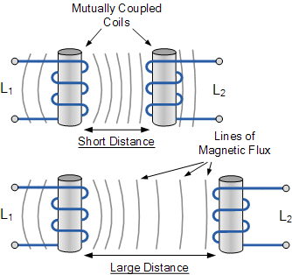

The mutual inductance that exists between the two coils can be greatly increased by positioning them on a common soft iron core or by increasing the number of turns of either coil as would be found in a transformer.
If the two coils are tightly wound one on top of the other over a common soft iron core unity coupling is said to exist between them as any losses due to the leakage of flux will be extremely small. Then assuming a perfect flux linkage between the two coils the mutual inductance that exists between them can be given as.
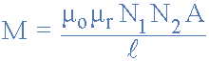
- Where:
- µ_{o} is the permeability of free space (4.π.10⁻⁷)
- µ_{r} is the relative permeability of the soft iron core
- N is in the number of coil turns
- A is in the cross-sectional area in m²
- l is the coils length in meters

Q17. Define self-inductance.
Ans. When permeability is constant the self inductance of a coil is defined as the ratio of flux linkage and current.
The property of self-inductance is a particular form of electromagnetic induction. Self inductance is defined as the induction of a voltage in a current-carrying wire when the current in the wire itself is changing. In the case of self-inductance, the magnetic field created by a changing current in the circuit itself induces a voltage in the same circuit. Therefore, the voltage is self-induced.
The term inductor is used to describe a circuit element possessing the property of inductance and a coil of wire is a very common inductor. In circuit diagrams, a coil or wire is usually used to indicate an inductive component. Taking a closer look at a coil will help understand the reason that a voltage is induced in a wire carrying a changing current. The alternating current running through the coil creates a magnetic field in and around the coil that is increasing and decreasing as the current changes. The magnetic field forms concentric loops that surround the wire and join to form larger loops that surround the coil as shown in the image below. When the current increases in one loop the expanding magnetic field will cut across some or all of the neighboring loops of wire, inducing a voltage in these loops. This causes a voltage to be induced in the coil when the current is changing.
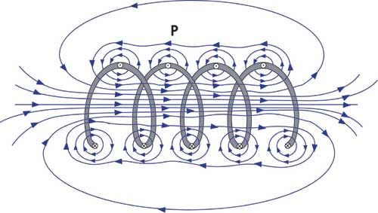
By studying this image of a coil, it can be seen that the number of turns in the coil will have an effect on the amount of voltage that is induced into the circuit. Increasing the number of turns or the rate of change of magnetic flux increases the amount of induced voltage. Therefore, Faraday's Law must be modified for a coil of wire and becomes the following.
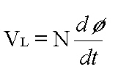
Where:
VL = induced voltage in volts
N = number of turns in the coil
dø/dt = rate of change of magnetic flux in
webers/second
The equation simply states that the amount of induced voltage (VL) is proportional to the number of turns in the coil and the rate of change of the magnetic flux (dø/dt). In other words, when the frequency of the flux is increased or the number of turns in the coil is increased, the amount of induced voltage will also increase.
In a circuit, it is much easier to measure current than it is to measure magnetic flux, so the following equation can be used to determine the induced voltage if the inductance and frequency of the current are known. This equation can also be reorganized to allow the inductance to be calculated when the amount of inducted voltage can be determined and the current frequency is known.
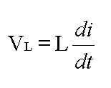
Where:
VL = the induced voltage in volts
L = the value of inductance in henries
di/dt = the rate of change of current in amperes per second
------------------------------------------------------------------------------------------------------------------------------------------
Q18. Define mutual inductance.
Ans. When permeability is constant the mutual inductance between two coupled coils is defined as the ratio of flux linkage in one coil due to common flux and current through another coil.

Mutual Inductance
The mutual inductance M can be defined as the proportionalitiy between the emf generated in coil 2 to the change in current in coil 1 which produced it.
When an emf is produced in a coil because of the change in current in a coupled coil , the effect is called mutual inductance. The emf is described by Faraday's lawand it's direction is always opposed the change in the magnetic field produced in it by the coupled coil (Lenz's law ). The induced emf in coil 1 is due to self inductance L.  The induced emf in coil #2 caused by the change in current I₁can be expressed as  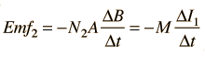 | 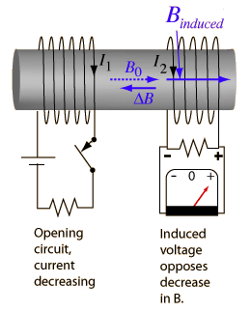

Q19. Define coefficient of coupling.
Ans. In coupled coils the coefficient of coupling is defined as the fraction of the total flux produced by one coil linking another coil.
Two coils are taken coil A and coil B, When current flows through one coil it produces flux; the whole flux may not link with the other coil coupled, and this is because of leakage flux by a fraction (k) known as Coefficient Of Coupling.
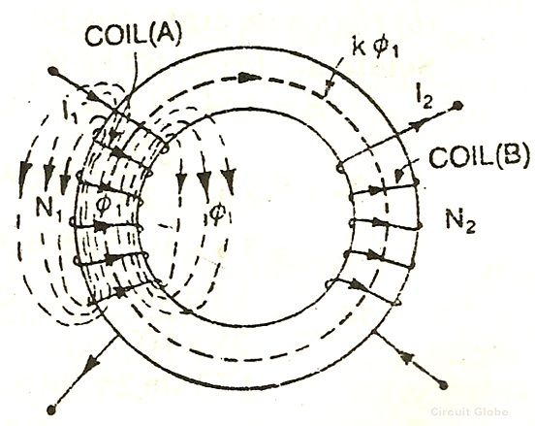
k=1 when the flux produced by one coil completely links with the other coil and is called magnetically tightly coupled.
k=0 when the flux produced by one coil does not link at all with the other coil and thus the coils are said to be magnetically isolated.
Q20. What is DOT convention?
Ans. The sign of mutual induced emf depends on the winding sense and the current through the coil. The winding sense is decided by the manufacturer and to inform the user about the winding sense a dot is placed at one end of each coil. When current enter at dotted end in one coil then the mutual induced emf in the other coil is positive at dot end.
------------------------------------------------------------------------------------------------------------------------------------------
Q21. State dot rule for coupled coils.
Ans. a. It states that in coupled coils current entering at the dotted terminal of one coil induce an emf in second coil which is +ve at dotted terminal of second coil.
b. Current entering at the un dotted terminal of one coil induce an emf in second coil which is +ve at un dotted terminal of second coil.
Q22. What is the use of locus diagram?
Ans: Determining the response of RLC circuit when one of its parameter is varied while the frequency and voltage kept constant.

Q23. What are locus diagrams?
Ans. Locus diagram: It is the curve in the complex plane traced by a point as one of theparameter of the circuit is varied.

Q24. What are the types of locus diagrams?
Ans. There are different types of locus diagrams:
1. Impedance locus diagram
2. Admittance locus diagram
3. Current locus diagrams.

NETWORK THEOREMS:

Q1. State superposition theorem.
Ans. It states that the response of a linear circuit with multiple sources is
given by algebraic sum of responses due to individual sources acting alone.

Q2. State Thevenin’s theorem.
Ans. It states that any linear bilateral network can be replaced by a single
voltage source, Vth , in series with a single impedance, Zth

Q3. State Norton’s theorem.
Ans. It states that any linear bilateral network can be replaced by a single
Current source, IN, in parallel with a single impedance, Zth

Q4. State max power transfer theorem.
Ans. Max. Power is transferred to load impedance if the Load impedance is
the complex conjugate of the source impedance.

Q5. State reciprocity theorem.
Ans. It states that in a linear, bilateral ,single source circuit the ratio of
excitation to the response is constant when the position of excitation and
response are interchanged.

Q6. State compensation theorem.
a. Let I be the current through an impedance Z in a branch of circuit.
b. It states that the change in current due to change in impedance in a
branch will be produced by a compensation voltage source in the same
branch with polarity opposing the original current.

Q7. State Millman’s theorem.
Ans. It states that if n number of voltage sources with internal impedance are in
parallel then they can be combined to give a voltage source with an equivalent
emf and internal impedance.

Q8. State Tellegen’s theorem.
Ans. It states that the summation of all the product of branch voltage and its
current of a circuit is zero. 9 Steps to solve Superposition Theorem
• Take only one independent voltage or current source
• Obtain the branch currents
• Repeat the above for other sources
• To determine the net branch current just add the currents obtained
above.

Q10. Steps to solve Thevenin’s Theorem.
• Remove the load resistance and find the open circuit voltage VOC
• Deactivate the constant sources ( for voltage source remove it by internal
resistance & for current source delete the source by OC ) and find the
internal resistance (RTH) of the source side looking through the open
circuited load terminals
• Obtain the Thevenin’s equivalent circuit by connecting VOC in series with
RTH
• Re connect the load resistance across the load terminals

Q11. Steps to solve Norton’s Theorem
• Remove the load resistor and find the internal resitance of the source
N/W by deactivating the constant source
• Short the load terminals and find the short circuit current
• Norton’s equivalent circuit is drawn by keeping RTH in parallel with ISC

Q12. What is the load current in a Norton’s circuit?
Ans. IL = (ISC. RTH) / ( RTH + RL)

Q13. What is the load current in a Thevenin’s circuit?
IL= VOC /( RTH + RL)

Q14. What is the max power in a circuit ?
Max: power = VOC2 / 4 RTH

Q15. What is the power equation of Tellegen’s Theorem?
ΣVbIb=0, where b=1 to n

Q16. Steps to solve Reciprocity Theorem
• The branches b/w which reciprocity is to be established are to be
selected first
• The current in the branch is obtained using conventional n/w analysis
• The voltage source is interchanged b/w the branches concerned
• The current in the branch where the voltage source was existing earlier
is calculated

Q17 Steps to solve Max: power transfer Theorem
• Remove the load resistance and find Thevenin’s resistance
• Find the VTH
• Max: power is given by VOC2/ 4 RTH

Q18. Write some applications of maximum power transfer theorem.
Ans. Power amplifiers
Communication system
Microwave transmission

Q19. What is the limitation of superposition theorem?
Ans. This theorem is valid only for linear systems. This theorem can be applied for calculating the current through or voltage across in particular element. But this superposition theorem is not applicable for calculation of the power.

Q20. What are the limitations of maximum power transfer theorem?
Ans. The maximum efficiency can be obtained by using this theorem is only 50% . It is because of 50% of the power is unnecessarily wasted in Rth.
Therefore this theorem only applicable for communication circuits and not for power circuits where efficiency is greater importance rather than power delivered.

Q21. List the applications of Thevinins theorem.
Ans. It is applied to all linear circuits including electronic circuits represented by the controlled source.
This theorem is useful when t is desired to know the effect of the response in network or varying part of the network.

