**Unit-III**

1. **Explain Formation Of depletion Layer**

Ans) P-n junctions are formed by joining n-type and p-type semiconductor materials, as shown below. Since the n-type region has a high electron concentration and the p-type a high hole concentration, electrons diffuse from the n-type side to the p-type side. Similarly, holes flow by diffusion from the p-type side to the n-type side. If the electrons and holes were not charged, this diffusion process would continue until the concentration of electrons and holes on the two sides were the same, as happens if two gasses come into contact with each other. However, in a p-n junction, when the electrons and holes move to the other side of the junction, they leave behind exposed charges on dopant atom sites, which are fixed in the crystal lattice and are unable to move. On the n-type side, positive ion cores are exposed. On the p-type side, negative ion cores are exposed. An electric field Ê forms between the positive ion cores in the n-type material and negative ion cores in the p-type material. This region is called the "depletion region" since the electric field quickly sweeps free carriers out, hence the region is depleted of free carriers. A "built in" potential Vbi due to Ê is formed at the junction. The animation below shows the formation of the Ê at the junction between n and p-type material.

1. **What is forward bias**

Ans) **When the positive terminal of the battery is connected to the p-type material and the negative terminal of the battery is connected to the n-type material, such a connection is called forward bias**.

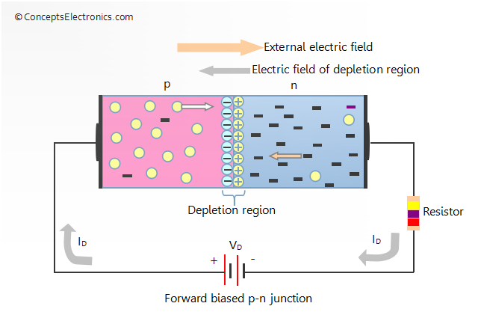

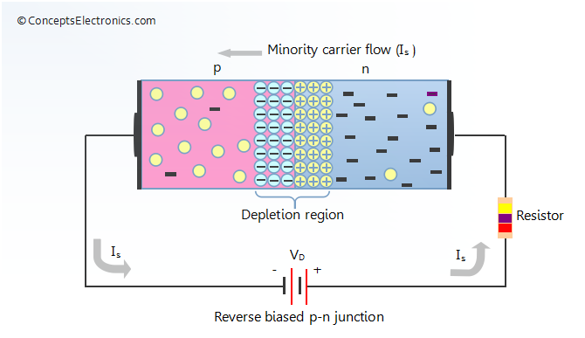

1. **Explain Reverse bias**

Ans) **When the positive terminal of the battery is connected to n-type material and the negative terminal of the  battery is connected to p-type material, such a connection is called reverse bias.**

1. **Define Static and Dynamic Resistance**

The resistance offered by the p-n junction diode under forward biased condition is denoted by Rf.Ans) Static resistance or DC resistance

### Dynamic resistance or AC resistance

### Dynamic resistance is also defined as the ratio of change in forward voltage to the change in forward current. It is denoted as rf.

1. **Define Diffussion and Transistion Capacitance**

**Ans) Diffusion capacitance:**

When the junction is forward biased, a capacitance comes into play , that is known as diffusion capacitance denoted as CD. It is much greater than the transition capacitance.

**Transition capacitances:**  
  
When P-N junction is reverse biased the depletion region act as an insulator or as a dielectric medium and the p-type an N-type region have low resistance and act as the plates. Thus this P-N junction can be considered as a parallel plate capacitor. This junction capacitance is called as space charge capacitance or transition capacitance and is denoted as CT .

1. **Diode current Equation.**

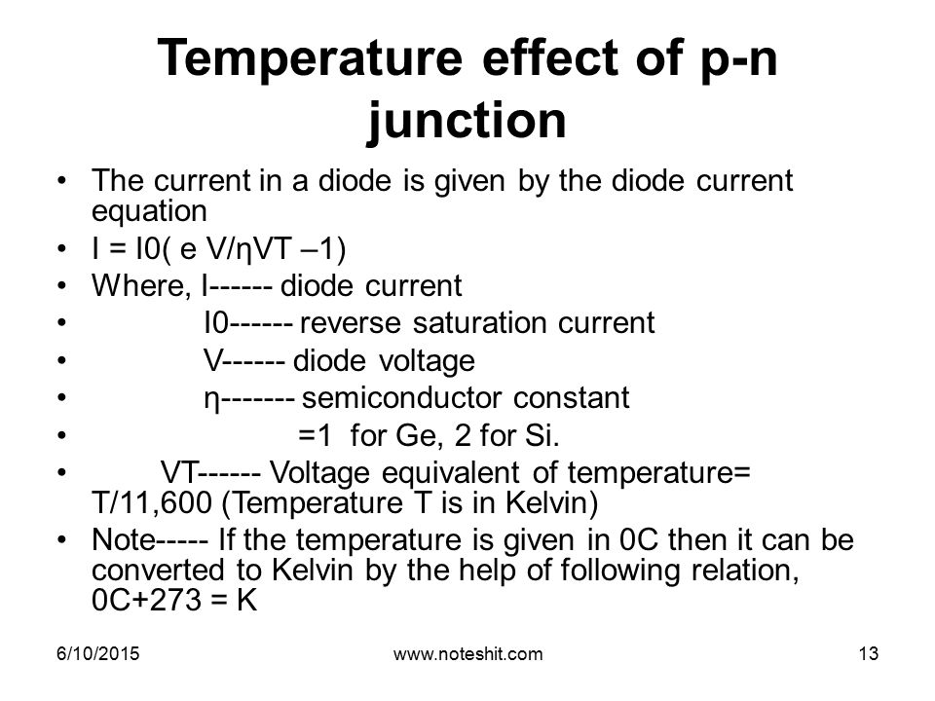**Ans)**

1. **Diode Equivalent Models**

## Ans) Piece-wise linear model

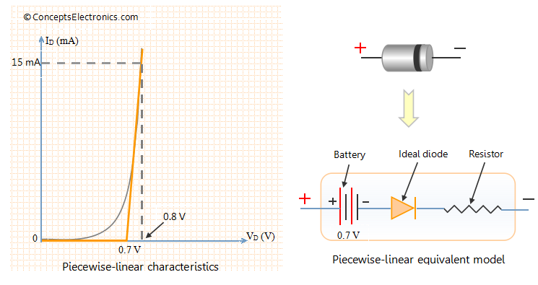

## Simplified model

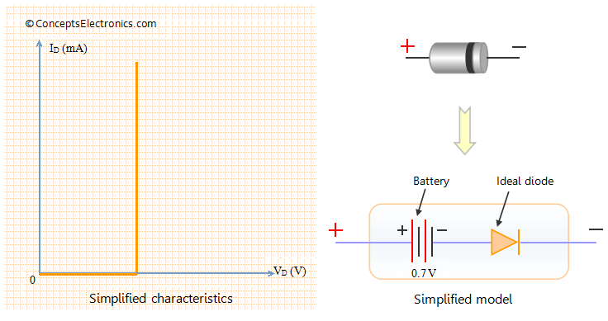

**Ideal Diode:**

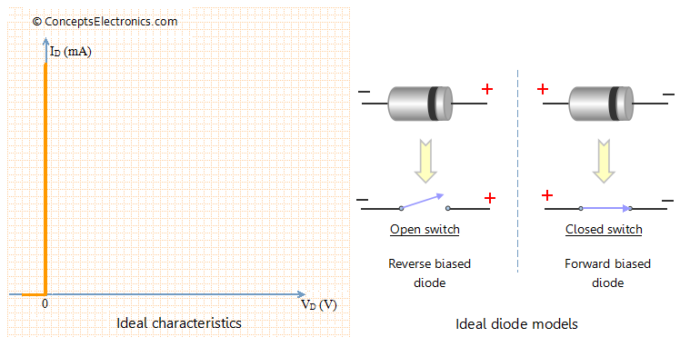

1. **What is Rectifiers**

Ans) An electrical device which converts an alternating current into a direct one by allowing a current to flow through it in one direction only.

1. **Comparison Of Different Rectifiers**

|  |  |  |  |
| --- | --- | --- | --- |
| Parameters | Half-wave | Centre tapped Full-wave | Bridge |
| No of Diodes | 1 | 2 | 4 |
| Max. Efficiency | 40.6% | 81.2% | 81.2% |
| Peak Inverse Voltage | VM | 2VM | VM |
| Average Current/Diode | Idc | Idc/2 | Idc/2 |
| Vdc (no load) | Vm/π | 2Vm/π | 2Vm/π |
| Output Frequency | f | 2f | 2f |
| Transformer Utilisation Factor | 0.287 | 0.693 | 0.812 |
| Ripple Factor | 1.21 | 0.48 | 0.48 |
| Form Factor | 1.57 | 1.11 | 1.11 |
| Peak Factor | 2 | √2 | √2 |

**Unit- IV**

### Q1. Explain why an ordinary junction transistor is called bipolar?

Because the transistor operation is carried out by two types of charge carriers (majority and minority carriers), an ordinary transistor is called bipolar.

### Q2. Why transistor is called current controlled device?

The output voltage, current or power is controlled by the input current in a transistor. So it is called the current controlled device.

### Q3. What is the significance of the arrow-head in the transistor symbol?

Arrow head is always marked on the emitter. The direction indicated the conventional direction of current flow( from emitter-to-base in case of p-n-p transistor and from base-to-emitter in case of n-p-n transistor). Generally no arrow head is marked for collector since its reverse leakage current is always opposite to the direction of emitter current.

The two types of BJTs are shown in the figure below.

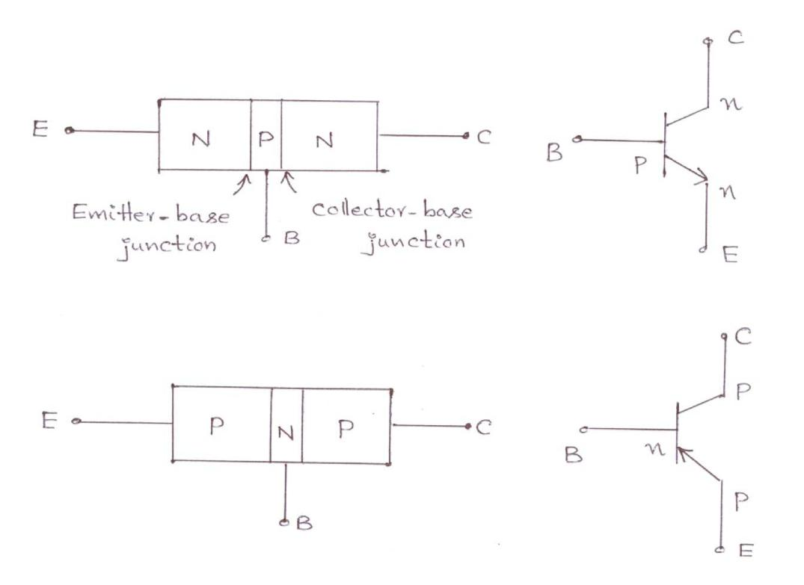

### Q4. Discuss the need for biasing the transistor.

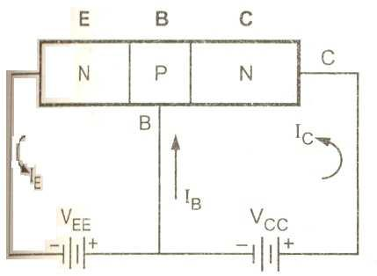For normal operation, base-emitter junction should be forward biased and the collector-base junction reverse biased. The amount of bias required is significant for the establishment of the operating or the Q-point which is dictated by the mode of operation desired.

In case the transistor is not biased properly, it would :

* work inefficiently
* produce distortion in the output signal
* with the change in transistor parameters or temperature rise, the operating point may shift and the amplifier output will be unstable.

### Q5. What are ‘emitter injection efficiently’ and ‘base transport factor’ and how do they influence the transistor operation?

The ratio of current of injected carriers at emitter junction to the total emitter current is called the emitter junction efficiency. The ratio of collector current to base current is known as transport factor

i.e. β\* = IC/IB

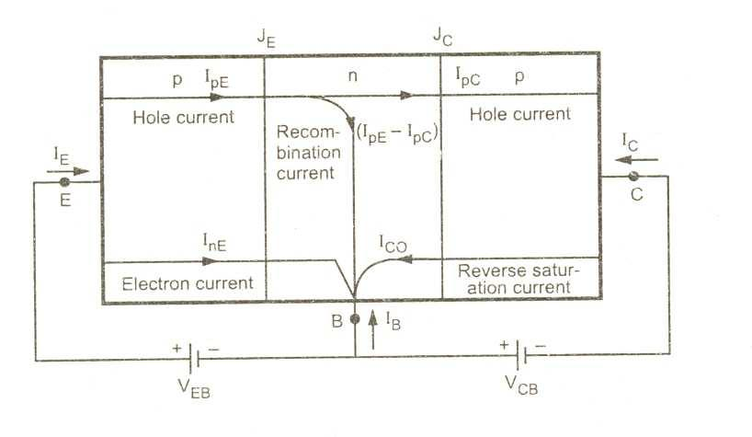

The larger the value of emitter injection efficiency, the larger the injected carriers at emitter junction and this increases the collector current. The larger the β\* value the larger the injected carriers across collector junction and hence collector current increases.

### Q6. Which of the transistor currents is always the largest? Which is always the smallest? Which two currents are relatively close in magnitude?

The emitter current IE is always the largest one. The base current IB is always the smallest. The collector current IC and emitter current IE are relatively close in magnitude.

### Q7. Why silicon type transistors are more often used than germanium type?

Because silicon transistor has smaller cut-off current ICBO, small variations in ICBO due to variations in temperature and high operating temperature as compared to those in case of germanium type.

### Q8. Why collector is made larger than emitter and base?

Collector is made physically larger than emitter and base because collector is to dissipate much power.

### Q9. Why the width of the base region of a transistor is kept very small compared to other regions?

Base region of a transistor is kept very small and very lightly doped so as to pass most of the injected charge carriers to the collector.

### Q10. Why emitter is always forward biased?

Emitter is always forward biased w.r.t base so as to supply majority charge carriers to the base.

### Q11. Why collector is always reverse-biased w.r.t base?

Collector is always reverse-biased w.r.t baseso as to remove the charge carriers from the base-collector junction.

### Q12. Can a transistor be obtained by connecting tow semiconductor diodes back-to-back?

No. Because in case of two discrete back-to-back connected diodes there are four doped regions instead of three and there is nothing that resembles a thin base region between an emitter and a collector.

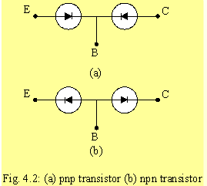

### Q13. How α and β are related to each other?

α and β are related as below:

α= β/(1+ β)     or     β= α/(1- α)

**Q14. Define beta of a transistor.**

The β factor transistor is the common emitter current gain of that transistor and is defined as the ratio of collector current to the base current :

Β = IC/IB

### Q15. Why is there a maximum limit of collector supply voltage for a  transistor?

Although collector current is practically independent of collector supply voltage over the transistor operating range, but if VCB is increase beyond a certain vale collector current IC is eventually increases rapidly and possibly destroys the device.

### Q16. Explain why ICEO >> ICBO?

The collector cut-off current denoted by ICBO is much larger than ICBO. ICEO is given as :

ICEO = ICBO/(1-α)

Because α is nearly equal to unity (slightly less than unity), ICEO >> ICBO

### Q17. Why CE configuration is most popular in amplifier circuits?

CE configuration is mainly used because its current, voltage and power gains are quite high and the ratio of output impedance and input impedance are quite moderate.

### Q18. Why CC configuration is called a voltage buffer? What is other name?

Because of its high input impedance and low output impedance, the common collector circuit finds wide application as a buffer amplifier between a high impedance source and low impedance load. it is called a voltage buffer. Its other name is emitter follower.

### Q19. What are the main purposes for which a CC amplifier may be used.

Because of its high input impedance and low output impedance, the common collector circuit finds wide application as a buffer amplifier between a high impedance source and low impedance load.

### Q20.Which configuration among CE, CB, CC gives highest input impedance and no voltage gain?

Common collector configuration has the highest input impedance and has voltage gain less than unity.

### Q21. What do you understand by collector reverse saturation? In which configuration does it have a greater value?

When input current (IE in case of CB configuration and IB in case of CE configuration) is zero, collector current IC is not zero although it is very small. In fact this is the reverse leakage current or collector reverse saturation current (ICBO or simply ICO in CB configuration and ICEO in CE configuration). In case of CE configuration it is much more than that in case of CB configuration.

### Q22. What is meant by operating point?

Quiescent point is a point on the dc load line which represents VCE and IC in the absence of ac signal and variations in VCE and IC take place around this point when ac signal is applied.

### Q23. Explain how BJT can be used as an amplifier.

A transistor operates as an amplifier by transfer of the current from low impedance loop to high impedance loop

**Q24. What is Biasing and need for biasing**

The basic function transistor is to do amplification. The process of raising the strength of a weak signal without any change in its shape is known as faithful amplification.

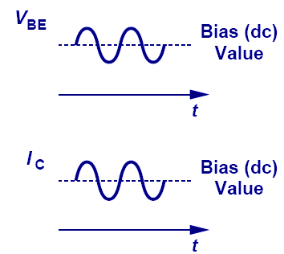For faithful amplification, the following three conditions must be satisfied:

1. The emitter-base junction should be forward biased,
2. The collector-base junction should be reverse biased.
3. Three should be proper zero signal collector current.

The proper flow of zero signal collector current (proper operating point of a transistor) and the maintenance of proper collector-emitter voltage during the passage of signal is known as ‘transistor biasing’.

When a transistor is not properly biased, it work inefficiently and produces distortion in the output signal. Hence a transistor is to be biased correctly. A transistor is biased either with the help of battery (or) associating a circuit with the transistor. The latter method is generally employed. The circuit used with the transistor is known as biasing circuit.

In order to produce distortion-free output in amplifier circuits, the supply voltages and resistances in the circuit must be suitably chose. These voltages and resistances establish a set of d.c. voltage VCEQ and current ICQ to operate the transistor in the active region. These voltages and currents are called quiescent values which determine the operating point (or) Q-Point for the transistor.

The process of giving proper supply voltages and resistances for obtaining the desired Q-Point is called biasing.

**Q 25. What is thermal runaway**

When a collector current flows in a transistor, it is heated i.e., its temperature increases. If no stabilization is done, the collector leakage current also increases. This further increases the transistor temperature. Consequently, there is a further increase in collector leakage current. The action becomes cumulative and the transistor may ultimately burn out. The self-destruction of an unstabilized transistor is known as thermal runaway*.*

**Q 26. Define Stability factor**

**

**Q 27. Mention the methods of transistor biasing? Or what are the t ypes of bias circuits**

**for BJT amplifiers**

Five common biasing circuits are used with bipolar transistor amplifiers:

1. Fixed Bias or base resistor Bias

2 Emitter-feedback bias

3 Collector to Base bias or collector feet back bias

4 Collector-emitter feedback bias

5 Self-bias or emitter bias or potential divides Bias.

**Q28 comparison of CB, CE and CC configurations**

|  |  |  |  |
| --- | --- | --- | --- |
| **Property** | **CB** | **CE** | **CC** |
|  |  |  |  |
| Input Resistance | Low | Moderate | High |
| (About 100I) | (About 750I) | (About 750kI) |
|  |
|  |  |  |  |
| Output Resistance | High | Moderate | Low |
| (About 450kI) | (About 45kI) | (About 25I) |
|  |
|  |  |  |  |
| Current Gain | 1 | High | High |
|  |  |  |  |
| Voltage Gain | About 150 | About 500 | Less than 1 |
|  |  |  |  |
| Phase Shift between |  |  |  |
| input and output | 0o (or) 360o | 180o | 0o (or) 360o |
| voltages |  |  |  |
|  |  |  |  |
| Applications | For high frequency | For Audio frequency | For impedance |
| circuits | circuits | matching |
|  |
|  |  |  |  |

**Q29 Problem:**

* A Germanium transistor used in a complementary symmetry amplifier has ICBO=10µ A at 27oC and hfe=50.
  1. find IC when IB=0.25mA and
  2. Assuming hfe does not increase with temperature; find the value of new collector current, if the transistor’s temperature rises to 50oC.

|  |  |  |
| --- | --- | --- |
| **Solution:** |  |  |
| Given data: | | ICBO = 10µ A and hfe (=β) = 50 |
| **a)** | IC | = βIB+(1+β)ICBO |
|  |  | = 50x(0.25x10-3)+(1+50)x(10x10-6)A |
|  |  | =**13.01mA** |
| **b)** | I’CBO (β=50) = ICBO x 2(T2-T1)/10 | |

= 10 X 2(50-27)/10

= 10 x 22.3 µ A

**= 49.2µ A**

IC at 50oC is

IC= βIB+(1+β)I’CBO

= 50x(0.25x10-3)+(1+50)x(49.2x10-6)

**=15.01 mA.**

**Q30 H-parameters of Bipolar Junction Transistor**

|  |  |  |  |
| --- | --- | --- | --- |
| Common  Base | Common  Emitter | Common  Collector | Definitions |
| hib | hie | hic | Input Impedance  with Output Short Circuit |
| hrb | hre | hrc | Reverse Voltage Ratio Input Open Circuit |
| hfb | hfe | hfc | Forward Current Gain Output Short Circuit |
| hob | hoe | hoc | Output Admittance Input Open Circuit |

**Q31 Hybrid Model and Equations for the transistor in three different configurations**

Hybrid Model and Equations for the transistor in three different configurations are are given below.

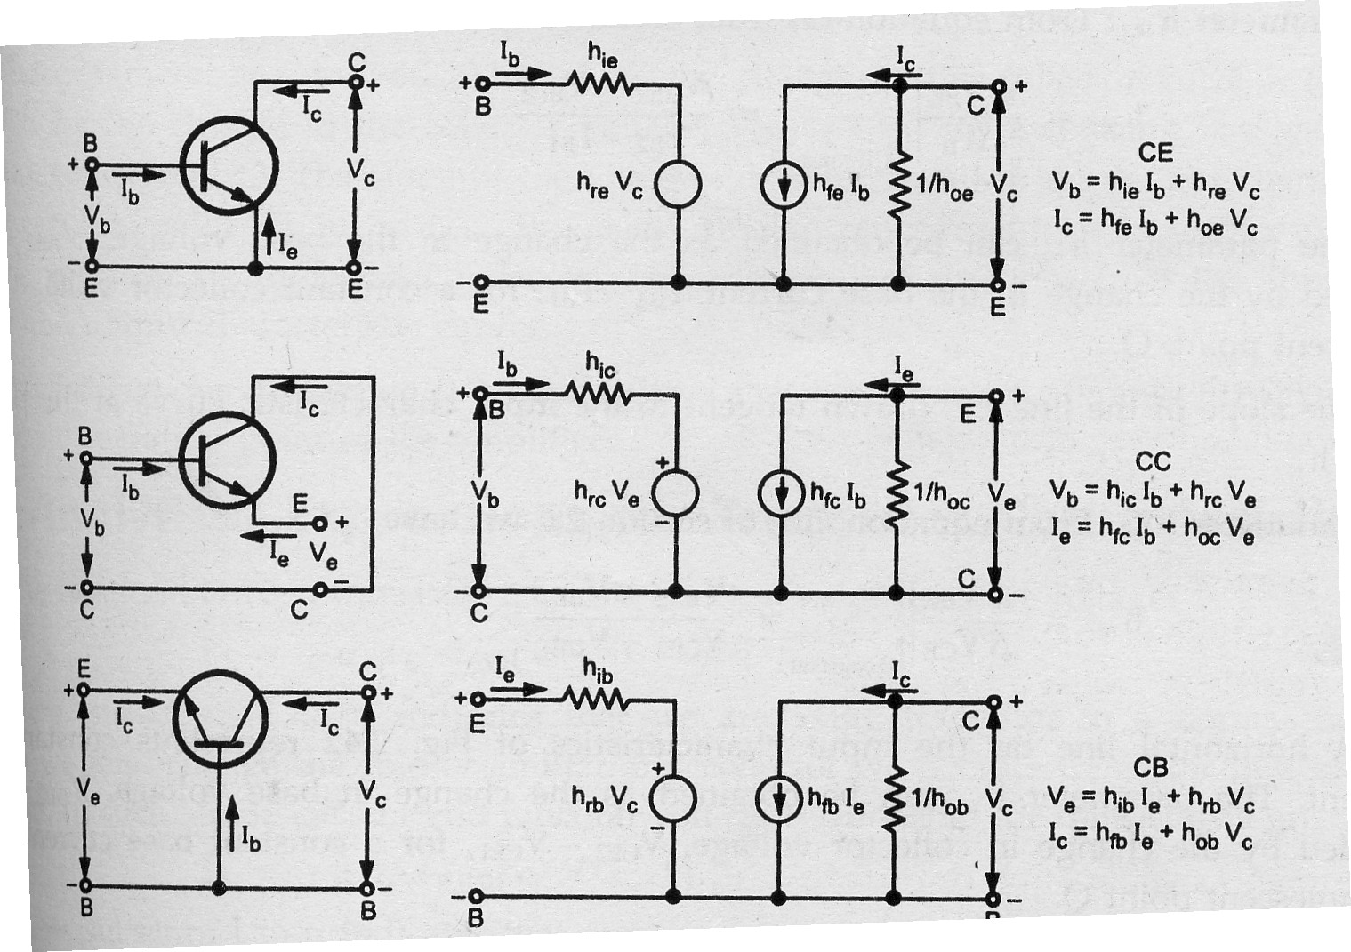

**Q32 Use of Transistor Hybrid model:-**

Use of h – parameters to describe a transistor have the following advantages.

1. h – parameters are real numbers up to radio frequencies .
2. They are easy to measure
3. They can be determined from the transistor static characteristics curves.
4. They are convenient to use in circuit analysis and design.
5. Easily convert able from one configuration to other.
6. Readily supplied by manufactories.

**Unit – V**

**1) What is MOSFET?**

**Ans**: MOSFET stands for Metal oxide Semiconductor field effect transistor. A type of transistor that is controlled by voltage rather than current. The power MOS field effect transistor (MOSFET) evolved from the MOS integrated circuit technology. The new device promised extremely low input power levels and no inherent limitation to the switching speed. Thus, it opened up the possibility of increasing the operating frequency in power electronic systems resulting in reduction in size and weight.At high frequency of operation the required gate drive power becomes substantial. MOSFETs also have comparatively higher on state resistance per unit area of the device cross section which increases with the blocking [voltage](http://www.oureducation.in/answers/?p=747) rating of the device.

MOSFET  is a special type of field-effect transistor ( FET ) that works by electronically varying the width of a channel along which charge carriers  flow. The wider the channel, the better the device conducts. The charge carriers enter the channel at the source , and exit via the drain . The width of the channel is controlled by the voltage on an electrode called the gate , which is located physically between the source and the drain and is insulated from the channel by an extremely thin layer of metal oxide.

[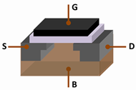](http://blog.oureducation.in/important-questions-on-mosfet/mosfet_structure/)

**2) Explain how MOSFET functions?**

Ans:There are two ways in which a MOSFET can function.

* The first is known as depletion mode . When there is no voltage on the gate, the channel exhibits its maximum conductance . As the voltage on the gate increases (either positively or negatively, depending on whether the channel is made of P-type or N-type semiconductor material), the channel conductivity decreases.
* The second way in which a MOSFET can operate is called enhancement mode . When there is no voltage on the gate, there is in effect no channel, and the device does not conduct. A channel is produced by the application of a voltage to the gate. The greater the gate voltage, the better the device conducts.

**3) Explain constructional features of a MOSFET.**

**[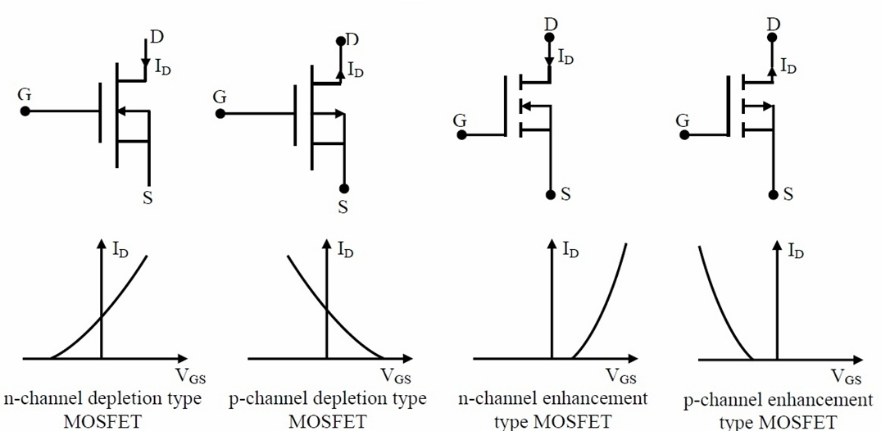](http://blog.oureducation.in/important-questions-on-mosfet/mosfet/)Ans:** Power MOSFET is a device that evolved from MOS integrated circuit technology. The first attempts to develop high voltage MOSFETs were by redesigning lateral MOSFET to increase their voltage blocking capacity. The resulting technology was called lateral double deffused MOS (DMOS). However it was soon realized that  
much larger breakdown voltage and current ratings could be achieved by resorting to a vertically oriented structure. Since then, vertical DMOS (VDMOS) structure has been adapted by virtually all manufacturers of Power MOSFET. A power MOSFET using VDMOS technology has vertically oriented three layer structure of alternating p type and n type semiconductors. A large number of cells are connected in parallel  to form a complete device.

The two n+ end layers labeled “Source” and “Drain” are heavily doped to approximately the same level. The p type middle layer is termed the body (or substrate) and has moderate doping level (2 to 3 orders of magnitude lower than n+ regions on both sides). The n- drain drift region has the lowest doping density. Thickness of this region determines the breakdown voltage of the device. The gate terminal is placed over the n- and p type regions of the cell structure and is insulated from the semiconductor body be a thin layer of silicon dioxide (also called the gate oxide). The source and the drain region of all cells on a wafer are connected to the same metallic contacts to form the Source and the Drain terminals of the complete device. Similarly all gate terminals are also connected together. The source is constructed of many (thousands) small polygon shaped areas that are surrounded by the gate regions. The geometric shape of the source regions, to same extent, influences the ON state resistance of the MOSFET.  
One interesting feature of the MOSFET cell is that the alternating n+ n- p n+ structure embeds a parasitic BJT (with its base and emitter shorted by the source metallization) into each MOSFET cellThe nonzero resistance between the base and the emitter of the parasitic npn BJT arises due to the body spreading resistance of the p type substrate. In the design of the MOSFET cells special care is taken so that this resistance is minimized and switching operation of the parasitic BJT is suppressed. With an effective short circuit between the body and the source the BJT always remain in cut off and its collector-base junction is represented as an anti parallel diode (called the body diode) in the circuit symbol of a Power MOSFET..

**4) Explain the three regions of operation of a MOSFET.**

**Ans: Cut-off region:** When VGS < Vt, no channel is induced and the MOSFET will be in cut-off region. No current flows.  
**Triode region:** When VGS ≥ Vt, a channel will be induced and current starts flowing if VDS > 0. MOSFET will be in triode region as long as VDS < VGS – Vt.  
**Saturation region:** When VGS ≥ Vt, and VDS ≥ VGS – Vt, the channel will be in saturation mode, where the current value saturates. There will be little or no effect on MOSFET when VDS is further increased.

**5) What are the main constructional differences between a MOSFET and a BJT? What effect do they have on the current conduction mechanism of a MOSFET?**

**Ans:** A MOSFET like a BJT has alternating layers of p and n type semiconductors. However, unlike BJT the p type body region of a MOSFET does not have an external electrical connection. The gate terminal is insulated for the semiconductor by a thin layer of SiO2. The body itself is shorted with n+ type source by the source metallization. Thus minority carrier injection across the source-body interface is prevented. Conduction in a MOSFET occurs due to formation of a high density n type channel in the p type body region due to the electric field produced by the gate-source voltage. This n type channel connects n+ type source and drain regions. Current conduction takes place between the drain and the source through this channel due to flow of electrons only (majority carriers). Where as in a BJT, current conduction occurs due to minority carrier injection across the Base-Emitter junction. Thus a MOSFET is a voltage controlled majority carrier device while a BJT is a minority carrier bipolar device.

**6) write down advantages of MOSFET.**

**Ans:**The MOSFET has certain advantages over the conventional junction FET, or JFET. Because the gate is insulated electrically from the channel, no current flows between the gate and the channel, no matter what the gate voltage (as long as it does not become so great that it causes physical breakdown of the metallic oxide layer). Thus, the MOSFET has practically infinite impedance . This makes MOSFETs useful for power amplifiers. The devices are also well suited to high-speed switching applications. Some integrated circuits ( [IC](http://www.oureducation.in/answers/?p=1037" \t "_blank) s) contain tiny MOSFETs and are used in computers.Because the oxide layer is so thin, the MOSFET is susceptible to permanent damage by electrostatic charges. Even a small electrostatic buildup can destroy a MOSFET permanently. In weak-signal radio-frequency ( RF ) work, MOSFET devices do not generally perform as well as other types of FET.

**7) I-V characteristic of MOSFET.**

**Ans:**

**[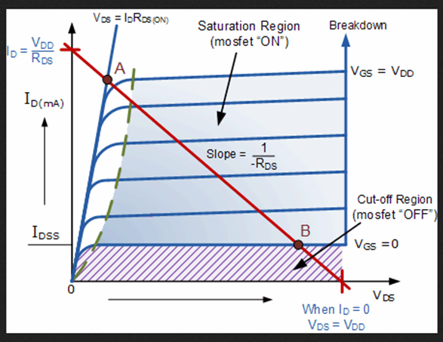](http://blog.oureducation.in/important-questions-on-mosfet/iv/)**The MOSFET, like the BJT is a three terminal device where the voltage on the gate terminal controls the flow of current between the output terminals, Source and Drain. The source terminal is common between the input and the output of a MOSFET. The output characteristics of a MOSFET is then a plot of drain current (iD) as a function of the Drain –Source voltage (vDS) with gate source voltage (vGS) as a parameter.With gate-source voltage (VGS) below the threshold voltage (vGS (th)) the MOSFET operates in the cut-off mode. No drain current flows in this mode and the applied drain–source voltage (vDS) is supported by the body-collector p-n junction. Therefore, the maximum applied voltage should be below the avalanche break down voltage of this junction (VDSS) to avoid destruction of the device.  
When VGS is increased beyond vGS(th) drain current starts flowing. For small values of vDS (vDS < (vGS – vGS(th)) iD is almost proportional to vDS. Consequently this mode of operation is called “ohmic mode” of operation. In power electronic applications a MOSFET is operated either in the cut off or in the ohmic mode. The slope of the vDS – iD characteristics in this mode is called the ON state resistance of the MOSFET .At still higher value of vDS (vDS > (vGS – vGS (th)) the iD – vDS characteristics deviates from the linear relationship of the ohmic region and for a given vGS, iD tends to saturate with increase in vDS. The exact mechanism behind this is rather complex. It will suffice to state that, at higher drain current the voltage drop across the channel resistance tends to decrease the channel width at the drain drift layer end. In addition, at large value of the electric field, produced by the large Drain – Source voltage, the drift velocity of free electrons in the channel tends to saturate.As a result the drain current becomes independent of VDS and determined solely by the gate – source voltage vGS. This is the active mode of operation of a MOSFET. Due to the presence of the anti parallel “body diode”, a MOSFET can not block any reverse voltage. The body diode, however, can carry an RMS current equal to IDM. It also has a substantial surge current carrying capacity. When reverse biased it can block a voltage equal to VDSS.  
For safe operation of a MOSFET, the maximum limit on the gate source voltage (VGS (Max)) must be observed. Exceeding this voltage limit will cause dielectric break down of the thin gate oxide layer and permanent failure of the device. It should be noted that even static charge inadvertently put on the gate oxide by careless handling may destroy it. The device user should ground himself before handling any MOSFET to avoid any static charge related problem.

**8) what is Forward Transconductance?**

Ans:It is the **ratio** of iD and (vGS – vGS(th)). In a MOSFET switching circuit it determines the clamping voltage level of the gate – source voltage and thus influences dvDS/dt during turn on and turn off.

**9) What does it mean “the channel is pinched off”?**

**Ans:** For a MOSFET when VGS is greater than Vt, a channel is induced. As we increase VDS current starts flowing from Drain to Source (triode region). When we further increase VDS, till the voltage between gate and channel at the drain end to become Vt, i.e. VGS – VDS = Vt, the channel depth at Drain end decreases almost to zero, and the channel is said to be pinched off. This is where a MOSFET enters saturation region.

**10) What is body effect?**

**Ans:** in an integrated circuit there will be several MOSFETs and in order to maintain cut-off condition for all MOSFETs the body substrate is connected to the most negative power supply (in case of PMOS most positive power supply). Which causes a reverse bias voltage between source and body that effects the transistor operation, by widening the depletion region. The widened depletion region will result in the reduction of channel depth. To restore the channel depth to its normal depth the VGS has to be increased. This is effectively seen as change in the threshold voltage – Vt. This effect, which is caused by applying some voltage to body is known as body effect.

So here we are with the important MOSFET questions with answers. Hope it will be helpful for your knowledge.

**11) What is pinch off voltage in junction field effect transistor (JFET)?**

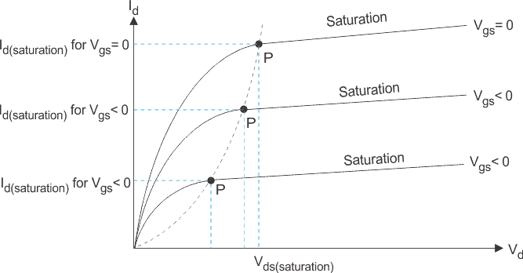It is minimum drain to source voltage in Junction Field Effect Transistor where Id (drain current) enters in to the saturation, in this region JFET acts as a constant current source. Pinch of voltage (Vp) is a function of Vgs (gate to source voltage). In JFET maximum pinch-off voltage occurs when Vgs=0, is applied. When Vgs is decreses from 0 V to negative value respectively the locus of pinch-off voltage corresponds to a parabola. Below pinch-off voltage when Vds (drain to source voltage) is increased, Id (drain current) increases proportionally, therefore JFET act as a variable resistor. Output characteristics of n-channel JFET with Vgs (gate to source voltage) = 0 and Vgs (gate to source voltage) <0

## 12) Differences between a FET and a Bipolar Transistor

Field Effect Transistors can be used to replace normal Bipolar Junction Transistors in electronic circuits and a simple comparison between FET’s and Transistors stating both their advantages and their disadvantages is given below.

|  |  |  |
| --- | --- | --- |
|  | Field Effect Transistor (FET) | Bipolar Junction Transistor (BJT) |
| 1 | Low voltage gain | High voltage gain |
| 2 | High current gain | Low current gain |
| 3 | Very high input impedance | Low input impedance |
| 4 | High output impedance | Low output impedance |
| 5 | Low noise generation | Medium noise generation |
| 6 | Fast switching time | Medium switching time |
| 7 | Easily damaged by static | Robust |
| 8 | Some require an input to turn it “OFF” | Requires zero input to turn it “OFF” |
| 9 | Voltage controlled device | Current controlled device |
| 10 | Exhibits the properties of a Resistor |  |
| 11 | More expensive than bipolar | Cheap |
| 12 | Difficult to bias | Easy to bias |

## 13) What are CS, CD, and CG amplifiers?

Common Source amplifier is on in which the Source terminal is common to both input and output circuit.

Common Drain amplifier is on in which the Drain terminal is common to both input and output circuit.

Common Gate amplifier is on in which the Gate terminal is common to both input and output circuit.

## 14) Give expressions for Ri, Ro, Voltage gain of CS, CD, CG?

The following equations are provided for MOSFET’s with voltage divider bias arrangement having Rg1 and Rg2 as biasing resistors at the gate terminal and constant current source at the source terminal.

|  |  |  |  |
| --- | --- | --- | --- |
| **Amplifier/Parameter** | **Input resistance** | **output resistance** | **Voltage gain** |
| **Common Source amplifier** | Rg | ro//Rd | -gm\*(ro//Rd//Rl) |
| **Common Drain amplifier(Neglecting ro)** | Rg | Rd | -gm\*(Rd//Rl) |
| **Common Gate amplifier(Neglecting ro)** | 1/gm | Rd | gm\*(Rd//Rl) |

### 15) Comparison of Connections between a JFET and a BJT

|  |  |
| --- | --- |
| Bipolar Transistor | Field Effect Transistor |
| Emitter – (E)      >>      Source – (S) |
| Base – (B)      >>      Gate – (G) |
| Collector – (C)      >>      Drain – (D)  **16) What is a JFET?**  The junction gate field-effect transistor (**JFET** or JUGFET) is the simplest type of field-effect transistor. They are three-terminal semiconductor devices that can be used as electronically-controlled switches, amplifiers, or voltage-controlled resistors.  JFET circuit symbols  **17) Why is FET known as a unipolar device?**  All **FETs** can be **called UNIPOLAR** devices because the charge carriers that carry the current through the device are all of the same type i.e. either holes or electrons, but not both. This distinguishes **FETs** from the bipolar devices in which both holes and electrons are responsible for current flow in any one device.  **18) Explain the Construction of JFET**  ..\..\pictures unit v\jfet const.jpg  A JFET consists of p type or N type silicon bar containing two PN junction at the sides. the bar forms the conducting channel for the charge carriers.. If the bar is of n type it is called n channel JFET. And if the bar is Ptype it is called p channel JFET. the two pn junctions forming diodes are connected internally and common terminal called gate. is taken out. other terminal are source and drain taken out from the bar.  **19) Explain FET AS A VOLTAGE –VARIABLE RESISTOR (VVR):**  FET is operated in the constant current portion of its output characteristics for the linear applications .In the region before pinch off , where Vds is small the drain to source resistance rd can be controlled by the bias voltage Vgs.The FET is useful as a voltage variable resistor (VVR) or Voltage Dependent resistor.  In JFET the drain source conductance gd = Id/Vds for small values of Vds which may be expressed as gd = gdo [ 1-( Vgs/Vp)1/2  ] where gdo is the value of drain conductance when the bias voltage Vgs is zero.  JFET Characteristics CurvesThe variation of the rd with vgs can be closely approximated by rd = ro / 1- KVgs ro – drain resistance at zero gate bias and K constant dependent upon FET type.  Small signal FET drain resistance rd varies with applied gate voltage Vgs and FET act like a VARIABLE PASSIVE RESISTOR. |