WT-UNIT-I PHP
STEP LONG ANSWER QUESTIONS AND ANSWERS
- Define PHP? Explain How to run a simple PHP program on server
Ans:
- PHP is a server scripting language, and a powerful tool for making dynamic and interactive Web pages.
- PHP is a widely-used, free, and efficient alternative to competitors such as Microsoft's ASP.
- PHP scripts are executed on the server.
- Before you continue you should have a basic understanding HTML, CSS & JavaScript
- PHP is an acronym for "PHP: Hypertext Preprocessor"
- PHP is a widely-used, open source scripting language
- PHP scripts are executed on the server
- PHP is free to download and use
- PHP files can contain text, HTML, CSS, JavaScript, and PHP code
- PHP code are executed on the server, and the result is returned to the browser as plain HTML
- PHP files have extension ".php"
- PHP can generate dynamic page content
- PHP can create, open, read, write, delete, and close files on the server
- PHP can collect form data
- PHP can send and receive cookies
- PHP can add, delete, modify data in your database
- PHP can be used to control user-access
- PHP can encrypt data
- PHP runs on various platforms (Windows, Linux, Unix, Mac OS X, etc.)
- PHP is compatible with almost all servers used today (Apache, IIS, etc.)
- PHP supports a wide range of databases
- PHP is free. Download it from the official PHP resource: www.php.net
- PHP is easy to learn and runs efficiently on the server side
- A PHP script is executed on the server, and the plain HTML result is sent back to the browser.
- Basic PHP Syntax
- A PHP script can be placed anywhere in the document.
- A PHP script starts with <?php and ends with ?>:
- Note: PHP statements end with a semicolon (;).

WampServer: A Windows web development environment.
WampServer is a Windows web development environment. It allows you to create web applications with Apache2, PHP and a MySQL database. Alongside, PhpMyAdmin allows you to manage databases.

Download Wampserver (32 bits & PHP 5.5) 2.5: http://www.wampserver.com/en/

Download Wampserver (64 bits & PHP 5.5) 2.5: http://www.wampserver.com/en/

Installation procedure:
http://www.steptoinstall.com/installation-of-wamp-server.html
- Double click on the downloaded file and just follow the instructions. Everything is automatic. The WampServer package is delivered with the latest releases of Apache, MySQL and PHP.
- Once WampServer is installed, you can manually add aditionals Apache, Php or MySql
Using wampserver
- The “www” directory will be automatically created (usually c:\wamp\www)
- Create a subdirectory in “www” and put your PHP files inside.
- Click on the “localhost” link in the WampSever menu or open your internet browser and go to the URL : http://localhost

Installation of WAMP Server – step to install
- Download the WAMP Server
I’ll give you simple steps for ‘Installation of WAMP Server’. We need to download the WAMP server Package .exe file from official WAMP server page. Choose file with Config of your system.
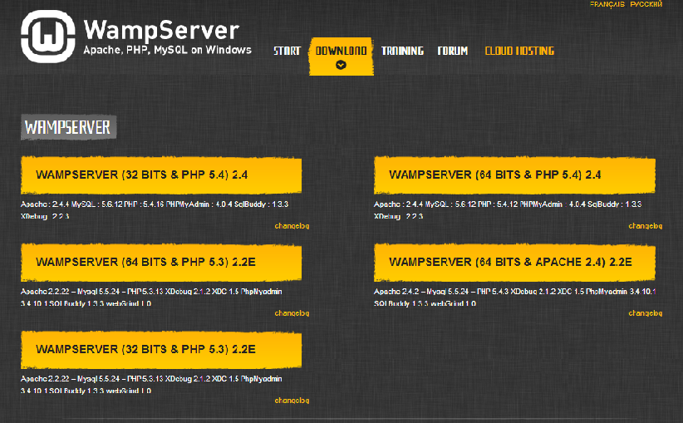
after select your file, It’ll ask following Popup. Don’t worry about this. Just click ‘you can download it directly’
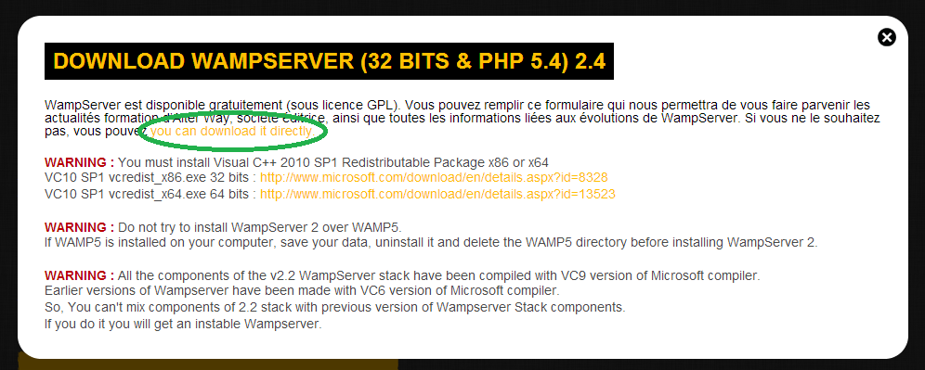
- Start Setup Wizard
You’ll get below Setup Wizard window, When you Run WAMP server .exe file. It shows config of WAMP. Click ‘Next’ button to continue.
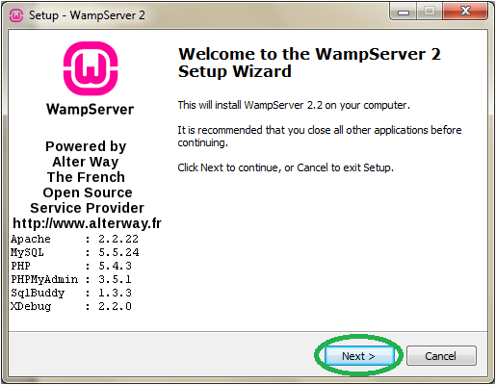
You should agree the license of WampServer before Installation of WAMP Server.
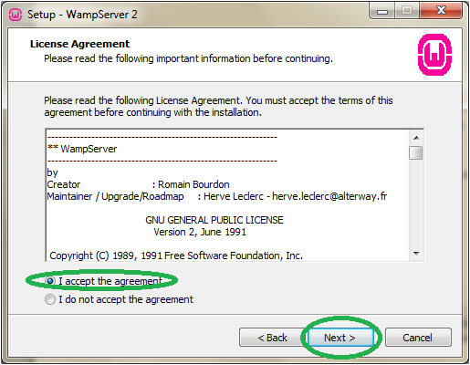
- Select Destination and Icon
Here, You should select the Server Location. Most of the server installing into C drive only. Me too installing into C drive. You can browse any other location and click ‘Next’.
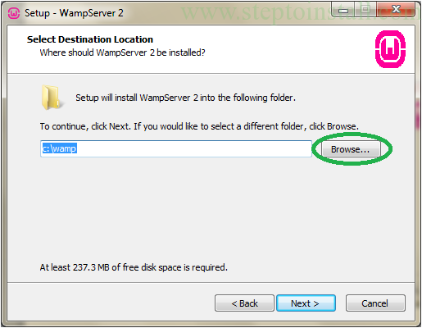
And choose which icons you want.
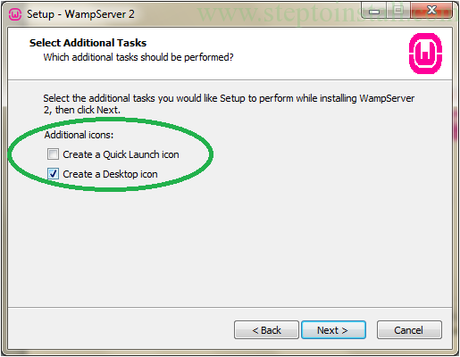
- Installing and Complate
In ‘Ready to Install’ window, just click ‘Install’ button.
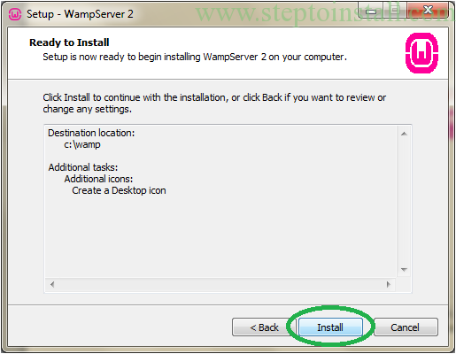
Now wait up-to finish the installing.
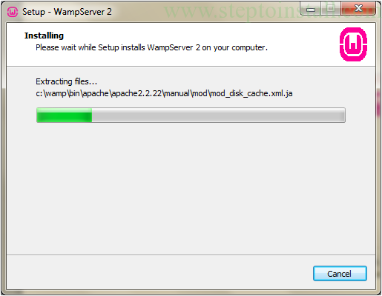
In following window, just leave Default value and Click ‘Next’.
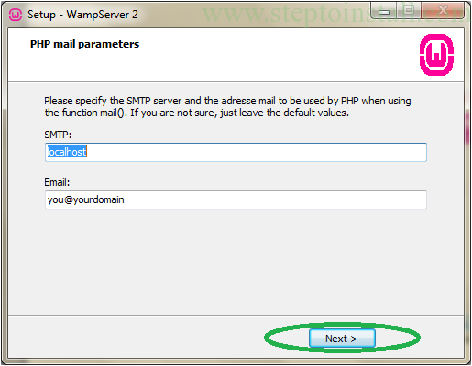
Now Installation Process is almost done. Tic the Launch and Finish it.
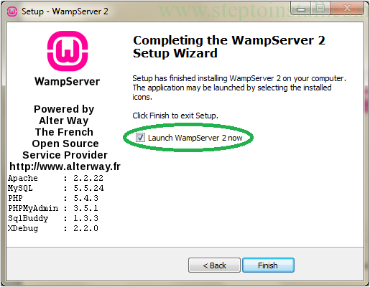
- Run WAMP Server.
Just double click the Wamp Server icon. You’ll get following small icon in TaskBar. First it’s color is Red and change to Orange. At-last it goes to Green color. If green color comes, Your WAMP server running successful.

Now see your WAMP server Home Page with following URL ‘http://localhost/’.
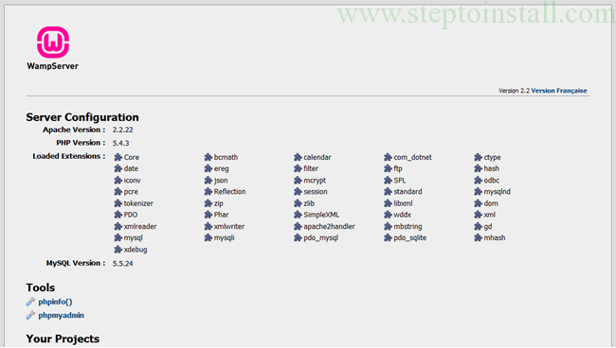

Example (sample program) File name: sample.php (save the file in the following link: c:/wamp/www/)
<!DOCTYPE html>
<html>
<body>
<h1>My first PHP page</h1>
<?php
echo "Hello World!";
?>
</body>
</html>
Output
http://www.localhost/sample.php

My first PHP page
Hello World!

- Discuss various data types in PHP?

Ans:

PHP Data Types

Variables can store data of different types, and different data types can do different things.
PHP supports the following data types:
- String
- Integer
- Float (floating point numbers - also called double)
- Boolean
- Array
- Object
- NULL

PHP String
- A string is a sequence of characters, like "Hello world!".
- A string can be any text inside quotes. You can use single or double quotes:
Filename: string1.php
<!DOCTYPE html>
<html>
<body>
<?php
$x = "Hello world!";
$y = 'Hello world!';
echo $x;
echo "<br>";
echo $y;
?>
</body>
</html>
Output
http://www.localhost/string1.php
Hello world!
Hello world!

PHP Integer
An integer data type is a non-decimal number between -2,147,483,648 and 2,147,483,647.
Rules for integers:
- An integer must have at least one digit
- An integer must not have a decimal point
- An integer can be either positive or negative
- Integers can be specified in three formats: decimal (10-based), hexadecimal (16-based - prefixed with 0x) or octal (8-based - prefixed with 0)
In the following example $x is an integer. The PHP var_dump() function returns the data type and value:
Filename: integer1.php
<!DOCTYPE html>
<html>
<body>
<?php
$x = 5985;
var_dump($x);
?>
</body>
</html>
Output
http://www.localhost/integer1.php
int(5985)

PHP Float
A float (floating point number) is a number with a decimal point or a number in exponential form.
In the following example $x is a float. The PHP var_dump() function returns the data type and value:
Filename: float1.php
<?php
$x = 10.365;
var_dump($x);
?>
Output
http://www.localhost/float1.php
float(10.365)

PHP Boolean
A Boolean represents two possible states: TRUE or FALSE.
$x = true;
$y = false;
Booleans are often used in conditional testing. You will learn more about conditional testing in a later chapter of this tutorial.

PHP Array
An array stores multiple values in one single variable.
In the following example $cars is an array. The PHP var_dump() function returns the data type and value:
Filename: array1.php
<?php
$cars = array("Volvo","BMW","Toyota");
var_dump($cars);
?>
Output
http://www.localhost/array1.php
array(3) { [0]=> string(5) "Volvo" [1]=> string(3) "BMW" [2]=> string(6) "Toyota" }

PHP Object
An object is a data type which stores data and information on how to process that data.
In PHP, an object must be explicitly declared.
First we must declare a class of object. For this, we use the class keyword. A class is a structure that can contain properties and methods:
Filename: object1.php
<?php
class Car {
function Car() {
$this->model = "VW";
}
}
// create an object
$herbie = new Car();
// show object properties
echo $herbie->model;
?>
Output
http://www.localhost/object1.php
VW

PHP NULL Value
Null is a special data type which can have only one value: NULL.
A variable of data type NULL is a variable that has no value assigned to it.
Tip: If a variable is created without a value, it is automatically assigned a value of NULL.
Variables can also be emptied by setting the value to NULL:
Filename: Null1.php
<?php
$x = "Hello world!";
$x = null;
var_dump($x);
?>
Output
http://www.localhost/Null1.php
NULL
- Explain Function Handling in PHP
Ans:
- The real power of PHP comes from its functions; it has more than 1000 built-in functions.

PHP User Defined Functions
- Besides the built-in PHP functions, we can create our own functions.
- A function is a block of statements that can be used repeatedly in a program.
- A function will not execute immediately when a page loads.
- A function will be executed by a call to the function.
- A user defined function declaration starts with the word "function":

Syntax
function functionName() {
code to be executed;
}
- Note: A function name can start with a letter or underscore (not a number).
- Function names are NOT case-sensitive.
Example
Filename: function1.php
<?php
function writeMsg() {
echo "Hello world!";
}
writeMsg();
?>
Output
http://www.localhost/function1.php
Hello world!

PHP Function Arguments
- Information can be passed to functions through arguments. An argument is just like a variable.
- Arguments are specified after the function name, inside the parentheses. You can add as many arguments as you want, just separate them with a comma.
- The following example has a function with one argument ($fname).
- When the familyName() function is called, we also pass along a name (e.g. Jani), and the name is used inside the function, which outputs several different first names, but an equal last name:
Filename: function2.php
<?php
function familyName($fname) {
echo "$fname Refsnes.<br>";
}
familyName("Jani");
familyName("Hege");
familyName("Stale");
familyName("Kai Jim");
familyName("Borge");
?>
Output
http://www.localhost/function2.php
Jani Refsnes.
Hege Refsnes.
Stale Refsnes.
Kai Jim Refsnes.
Borge Refsnes.
The following example has a function with two arguments ($fname and $year)
Filename: function3.php
<?php
function familyName($fname, $year) {
echo "$fname Refsnes. Born in $year <br>";
}
familyName("Hege","1975");
familyName("Stale","1978");
familyName("Kai Jim","1983");
?>
Output
http://www.localhost/function3.php
Hege Refsnes. Born in 1975
Stale Refsnes. Born in 1978
Kai Jim Refsnes. Born in 1983

PHP Default Argument Value
The following example shows how to use a default parameter. If we call the function setHeight() without arguments it takes the default value as argument:
Filename: function4.php
<?php
function setHeight($minheight = 50) {
echo "The height is : $minheight <br>";
}
setHeight(350);
setHeight();
setHeight(135);
setHeight(80);
?>
Output
http://www.localhost/function4.php
The height is : 350
The height is : 50
The height is : 135
The height is : 80

PHP Functions - Returning values
To let a function return a value, use the return statement:
Filename: function5.php
<?php
function sum($x, $y) {
$z = $x + $y;
return $z;
}
echo "5 + 10 = " . sum(5,10) . "<br>";
echo "7 + 13 = " . sum(7,13) . "<br>";
echo "2 + 4 = " . sum(2,4);
?>
Output
http://www.localhost/function5.php
5 + 10 = 15
7 + 13 = 20
2 + 4 = 6
- List various operators that are used in PHP
Ans: PHP Operators
Operators are used to perform operations on variables and values.
PHP divides the operators in the following groups:
- Arithmetic operators
- Assignment operators
- Comparison operators
- Increment/Decrement operators
- Logical operators
- String operators
- Array operators
The PHP arithmetic operators are used with numeric values to perform common arithmetical operations, such as addition, subtraction, multiplication etc.
Operator | Name | Example | Result
+ | Addition | $x + $y | Sum of $x and $y
- | Subtraction | $x - $y | Difference of $x and $y
* | Multiplication | $x * $y | Product of $x and $y
/ | Division | $x / $y | Quotient of $x and $y
% | Modulus | $x % $y | Remainder of $x divided by $y
** | Exponentiation | $x ** $y | Result of raising $x to the $y'th power (Introduced in PHP 5.6)
Example:
<?php
$x = 10;
$y = 6;
echo $x + $y;
?>
Output:
16
<?php
$x = 10;
$y = 6;
echo $x - $y;
?>
Output:
4
<?php
$x = 10;
$y = 6;
echo $x * $y;
?>
Output:
60
<?php
$x = 10;
$y = 6;
echo $x / $y;
?>
Output:
1.6666666666667
<?php
$x = 10;
$y = 6;
echo $x % $y;
?>
Output:
4

PHP Assignment Operators
The PHP assignment operators are used with numeric values to write a value to a variable.
The basic assignment operator in PHP is "=". It means that the left operand gets set to the value of the assignment expression on the right.
Assignment | Same as... | Description
x = y | x = y | The left operand gets set to the value of the expression on the right
x += y | x = x + y | Addition
x -= y | x = x - y | Subtraction
x *= y | x = x * y | Multiplication
x /= y | x = x / y | Division
x %= y | x = x % y | Modulus

Example:
<?php
$x = 20;
$x += 100;
echo $x;
?>
Output:
120
<?php
$x = 10;
$x /= 5;
echo $x;
?>
Output:
2

PHP Comparison Operators
The PHP comparison operators are used to compare two values (number or string):
Operator | Name | Example | Result
== Equal $x == $y Returns true if $x is equal to $y
=== Identical $x === $y Returns true if $x is equal to $y, and they are of the same type
!= Not equal $x != $y Returns true if $x is not equal to $y
<> Not equal $x <> $y Returns true if $x is not equal to $y
!== Not identical $x !== $y Returns true if $x is not equal to $y, or they are not of the same type
> Greater than $x > $y Returns true if $x is greater than $y
< Less than $x < $y Returns true if $x is less than $y
>= Greater than or equal to $x >= $y Returns true if $x is greater than or equal to $y
<= Less than or equal to $x <= $y Returns true if $x is less than or equal to $y

PHP Increment / Decrement Operators
The PHP increment operators are used to increment a variable's value.
The PHP decrement operators are used to decrement a variable's value.
Operator Name Description
++$x Pre-increment Increments $x by one, then returns $x
$x++ Post-increment Returns $x, then increments $x by one
--$x Pre-decrement Decrements $x by one, then returns $x
$x-- Post-decrement Returns $x, then decrements $x by one

PHP Logical Operators
The PHP logical operators are used to combine conditional statements.
Operator Name Example Result
and And $x and $y True if both $x and $y are true
or Or $x or $y True if either $x or $y is true
xor Xor $x xor $y True if either $x or $y is true, but not both
&& And $x && $y True if both $x and $y are true
|| Or $x || $y True if either $x or $y is true
! Not !$x True if $x is not true

PHP String Operators
has two operators that are specially designed for strings.
Operator Name Example Result
. Concatenation $txt1 . $txt2 Concatenation of $txt1 and $txt2
.= Concatenation assignment $txt1 .= $txt2 Appends $txt2 to $txt1P

PHP Array Operators
The PHP array operators are used to compare arrays.
Operator Name Example Result
+ Union $x + $y Union of $x and $y
== Equality $x == $y Returns true if $x and $y have the same key/value pairs
=== Identity $x === $y Returns true if $x and $y have the same key/value pairs in the same order and of the same types
!= Inequality $x != $y Returns true if $x is not equal to $y
<> Inequality $x <> $y Returns true if $x is not equal to $y
!== Non-identity $x !== $y Returns true if $x is not identical to $y
- Explain Cookie management in PHP
Ans:

PHP Cookies:
A cookie is often used to identify a user.

What is a Cookie?
A cookie is often used to identify a user. A cookie is a small file that the server embeds on the user's computer. Each time the same computer requests a page with a browser, it will send the cookie too. With PHP, you can both create and retrieve cookie values.

Create Cookies With PHP
A cookie is created with the setcookie() function.

Syntax
setcookie(name, value, expire, path, domain, secure, httponly);
Only the name parameter is required. All other parameters are optional.

PHP Create/Retrieve a Cookie
The following example creates a cookie named "user" with the value "John Doe". The cookie will expire after 30 days (86400 * 30). The "/" means that the cookie is available in entire website (otherwise, select the directory you prefer).
We then retrieve the value of the cookie "user" (using the global variable $_COOKIE). We also use the isset() function to find out if the cookie is set:
Example
Filename: setcookie.php
<?php
$cookie_name = "user";
$cookie_value = "John Doe";
setcookie($cookie_name, $cookie_value, time() + (86400 * 30), "/"); // 86400 = 1 day
?>
Filename: readcookie.php
<html>
<body>
<?php
if(!isset($_COOKIE[$cookie_name])) {
echo "Cookie named '" . $cookie_name . "' is not set!";
} else {
echo "Cookie '" . $cookie_name . "' is set!<br>";
echo "Value is: " . $_COOKIE[$cookie_name];
}
?>
<p><strong>Note:</strong> You might have to reload the page to see the value of the cookie.</p>
</body>
</html>
Output
http://www.localhost/readcookie.php
Cookie named 'user' is not set!
Note: You might have to reload the page to see the value of the cookie.

Modify a Cookie Value
To modify a cookie, just set (again) the cookie using the setcookie() function:
Filename: modifycookie.php
<!DOCTYPE html>
<?php
$cookie_name = "user";
$cookie_value = "Alex Porter";
setcookie($cookie_name, $cookie_value, time() + (86400 * 30), "/");
?>
<html>
<body>
<?php
if(!isset($_COOKIE[$cookie_name])) {
echo "Cookie named '" . $cookie_name . "' is not set!";
} else {
echo "Cookie '" . $cookie_name . "' is set!<br>";
echo "Value is: " . $_COOKIE[$cookie_name];
}
?>
<p><strong>Note:</strong> You might have to reload the page to see the new value of the cookie.</p>
</body>
</html>
Output
http://www.localhost/modifycookie.php
Cookie 'user' is set!
Value is: John Doe
Note: You might have to reload the page to see the new value of the cookie.

Delete a Cookie
To delete a cookie, use the setcookie() function with an expiration date in the past:
Filename: deletecookie.php
<!DOCTYPE html>
<?php
// set the expiration date to one hour ago
setcookie("user", "", time() - 3600);
?>
<html>
<body>
<?php
echo "Cookie 'user' is deleted.";
?>
</body>
</html>
Output
http://www.localhost/deletecookie.php
Cookie 'user' is deleted.

- Explain Session management in PHP
Ans:

PHP Sessions:
A session is a way to store information (in variables) to be used across multiple pages.
Unlike a cookie, the information is not stored on the users computer.

What is a PHP Session?
When you work with an application, you open it, do some changes, and then you close it. This is much like a Session. The computer knows who you are. It knows when you start the application and when you end. But on the internet there is one problem: the web server does not know who you are or what you do, because the HTTP address doesn't maintain state.
Session variables solve this problem by storing user information to be used across multiple pages (e.g. username, favorite color, etc). By default, session variables last until the user closes the browser.
So; Session variables hold information about one single user, and are available to all pages in one application.

Start a PHP Session
A session is started with the session_start() function.
Session variables are set with the PHP global variable: $_SESSION.
Now, let's create a new page called "demo_session1.php". In this page, we start a new PHP session and set some session variables:
Filename: session1.php
<?php
// Start the session
session_start();
?>
<!DOCTYPE html>
<html>
<body>
<?php
// Set session variables
$_SESSION["favcolor"] = "green";
$_SESSION["favanimal"] = "cat";
echo "Session variables are set.";
?></body></html>
Output
http://www.localhost/session1.php
Session variables are set.

Get PHP Session Variable Values
Next, we create another page called "demo_session2.php". From this page, we will access the session information we set on the first page ("demo_session1.php").
Notice that session variables are not passed individually to each new page, instead they are retrieved from the session we open at the beginning of each page (session_start()).
Also notice that all session variable values are stored in the global $_SESSION variable:
Filename: session2.php
<?php
session_start();
?>
<!DOCTYPE html>
<html>
<body>
<?php
// Echo session variables that were set on previous page
echo "Favorite color is " . $_SESSION["favcolor"] . ".<br>";
echo "Favorite animal is " . $_SESSION["favanimal"] . ".";
?></body></html>
Output
http://www.localhost/session2.php
Favorite color is green.
Favorite animal is cat.

Destroy a PHP Session
To remove all global session variables and destroy the session, use session_unset() and session_destroy():
Filename: session3.php
<?php
session_start();
?>
<!DOCTYPE html>
<html>
<body>
<?php
// remove all session variables
session_unset();
// destroy the session
session_destroy();
echo "All session variables are now removed, and the session is destroyed."
?>
</body>
</html>
Output
http://www.localhost/session3.php
All session variables are now removed, and the session is destroyed.

- Discuss form handling in PHP
Ans:

PHP Global Variables - Superglobals
Several predefined variables in PHP are "superglobals", which means that they are always accessible, regardless of scope - and you can access them from any function, class or file without having to do anything special.
The PHP superglobal variables are:
- $GLOBALS
- $_SERVER
- $_REQUEST
- $_POST
- $_GET
- $_FILES
- $_ENV
- $_COOKIE
- $_SESSION

PHP Form Handling:
The PHP superglobals $_GET and $_POST are used to collect form-data.

Example
<!DOCTYPE HTML>
<html>
<body>
<form action="welcome.php" method="post">
Name: <input type="text" name="name"><br>
E-mail: <input type="text" name="email"><br>
<input type="submit">
</form>
</body>
</html>
Output
Name:
E-mail:
When the user fills out the form above and clicks the submit button, the form data is sent for processing to a PHP file named "welcome.php". The form data is sent with the HTTP POST method.
To display the submitted data you could simply echo all the variables. The "welcome.php" looks like this:
Filename: welcome.php
<html>
<body>
Welcome <?php echo $_POST["name"]; ?><br>
Your email address is: <?php echo $_POST["email"]; ?></body></html>
Output
Welcome John
Your email address is john.doe@example.com
NOTE: In case of POST method we can use GET method

GET vs. POST
Both GET and POST create an array (e.g. array( key => value, key2 => value2, key3 => value3, ...)). This array holds key/value pairs, where keys are the names of the form controls and values are the input data from the user.
Both GET and POST are treated as $_GET and $_POST. These are superglobals, which means that they are always accessible, regardless of scope - and you can access them from any function, class or file without having to do anything special.
$_GET is an array of variables passed to the current script via the URL parameters.
$_POST is an array of variables passed to the current script via the HTTP POST method.

When to use GET?
Information sent from a form with the GET method is visible to everyone (all variable names and values are displayed in the URL). GET also has limits on the amount of information to send. The limitation is about 2000 characters. However, because the variables are displayed in the URL, it is possible to bookmark the page. This can be useful in some cases.
GET may be used for sending non-sensitive data.
Note: GET should NEVER be used for sending passwords or other sensitive information!

When to use POST?
Information sent from a form with the POST method is invisible to others (all names/values are embedded within the body of the HTTP request) and has no limits on the amount of information to send.
Moreover POST supports advanced functionality such as support for multi-part binary input while uploading files to server.
- Explain File Handling in PHP
Ans:
File Handling:
File handling is an important part of any web application. You often need to open and process a file for different tasks.

PHP Manipulating Files
PHP has several functions for creating, reading, uploading, and editing files.

PHP readfile() Function
The readfile() function reads a file and writes it to the output buffer.
Assume we have a text file called "webdictionary.txt", stored on the server, that looks like this:
Filename: webdictionary.txt
AJAX = Asynchronous JavaScript and XML
CSS = Cascading Style Sheets
HTML = Hyper Text Markup Language
PHP = PHP Hypertext Preprocessor
SQL = Structured Query Language
SVG = Scalable Vector Graphics
XML = EXtensible Markup Language
Filename: form1.php
<?php
echo readfile("webdictionary.txt");
?>
Output
AJAX = Asynchronous JavaScript and XML CSS = Cascading Style Sheets HTML = Hyper Text Markup Language PHP = PHP Hypertext Preprocessor SQL = Structured Query Language SVG = Scalable Vector Graphics XML = EXtensible Markup Language236

PHP Open File - fopen()
A better method to open files is with the fopen() function. This function gives you more options than the readfile() function.
<?php
$myfile = fopen("webdictionary.txt", "r") or die("Unable to open file!");
echo fread($myfile,filesize("webdictionary.txt"));
fclose($myfile);
?>
he file may be opened in one of the following modes:
Modes | Description
r | Open a file for read only. File pointer starts at the beginning of the file
w | Open a file for write only. Erases the contents of the file or creates a new file if it doesn't exist. File pointer starts at the beginning of the file
a | Open a file for write only. The existing data in file is preserved. File pointer starts at the end of the file. Creates a new file if the file doesn't exist
x | Creates a new file for write only. Returns FALSE and an error if file already exists
r+ | Open a file for read/write. File pointer starts at the beginning of the file
w+ | Open a file for read/write. Erases the contents of the file or creates a new file if it doesn't exist. File pointer starts at the beginning of the file
a+ | Open a file for read/write. The existing data in file is preserved. File pointer starts at the end of the file. Creates a new file if the file doesn't exist
x+ | Creates a new file for read/write. Returns FALSE and an error if file already exists

PHP Read File - fread()
The fread() function reads from an open file.
The first parameter of fread() contains the name of the file to read from and the second parameter specifies the maximum number of bytes to read.
The following PHP code reads the "webdictionary.txt" file to the end:
fread($myfile,filesize("webdictionary.txt"));

PHP Close File - fclose()
The fclose() function is used to close an open file.

PHP Read Single Line - fgets()
The fgets() function is used to read a single line from a file.

PHP Check End-Of-File - feof()
The feof() function checks if the "end-of-file" (EOF) has been reached.
The feof() function is useful for looping through data of unknown length.

PHP Read Single Character - fgetc()
The fgetc() function is used to read a single character from a file.

